Supplementary Table 1. Characteristics of SNPs as IVs in GWAS dataset ukb-b-7337 (Walking for pleasure)
SNP | chr | pos | Effect  allele | Other  allele | EAF | Beta | SE | p-val | R² | F
rs12042107 | 1 | 91196176 | C | T | 0.54923 | 0.00530215 | 0.000942872 | 1.89998E-08 | 6.86841E-05 | 31.62253307
rs6739738 | 2 | 22522833 | T | C | 0.493537 | -0.00562931 | 0.000936803 | 1.89998E-09 | 7.84273E-05 | 36.10870378
rs11896330 | 2 | 60235568 | A | G | 0.6331 | -0.00594477 | 0.000976222 | 1.09999E-09 | 8.05425E-05 | 37.08267418
rs2910829 | 5 | 59469899 | A | G | 0.534643 | 0.00546852 | 0.0009513 | 8.99995E-09 | 7.17729E-05 | 33.04476969
rs2670012 | 8 | 57434276 | T | C | 0.545137 | 0.00582567 | 0.000946359 | 7.49998E-10 | 0.000082306 | 37.89466219
rs1927902 | 9 | 120518991 | C | T | 0.745501 | 0.0061759 | 0.00107623 | 9.59997E-09 | 7.15231E-05 | 32.92975019
rs3026380 | 11 | 31818298 | C | G | 0.331196 | 0.00571482 | 0.00100974 | 0.000000015 | 6.95734E-05 | 32.03200352
rs2679059 | 11 | 43599791 | T | A | 0.595739 | 0.00579609 | 0.000957644 | 1.40001E-09 | 7.95637E-05 | 36.63196117
rs1827089 | 12 | 24269807 | A | G | 0.778923 | -0.00634604 | 0.00113219 | 0.000000021 | 6.82377E-05 | 31.41702765
rs7133277 | 12 | 13508899 | A | G | 0.64071 | 0.00541499 | 0.000980372 | 3.29997E-08 | 6.62631E-05 | 30.50785216
rs34898535 | 16 | 31025641 | T | C | 0.377823 | 0.00601487 | 0.000965602 | 4.70002E-10 | 8.42766E-05 | 38.80201603
rs11648192 | 16 | 28618708 | T | C | 0.435784 | 0.00602079 | 0.000981825 | 8.70001E-10 | 8.16753E-05 | 37.6042473
rs7207400 | 17 | 43824360 | C | T | 0.271351 | 0.00585611 | 0.00105208 | 2.59998E-08 | 6.72944E-05 | 30.98268385
rs34224566 | 17 | 79382416 | T | C | 0.26614 | -0.00616836 | 0.00105771 | 5.49997E-09 | 7.38689E-05 | 34.00981872
rs968807 | 18 | 50935815 | G | A | 0.541059 | -0.0052677 | 0.000940533 | 0.000000021 | 6.81321E-05 | 31.36838101
Supplementary Table 2. Characteristics of SNPs as IVs in GWAS dataset ukb-b-7663 (Strenuous sports)
SNP | chr | pos | Effect  allele | Other  allele | EAF | Beta | SE | p-val | R² | F
rs141093358 | 2 | 59781432 | C | T | 0.011409 | -0.0151794 | 0.00301085 | 4.60002E-07 | 0.000055207 | 25.41728069
rs1530654 | 3 | 125287997 | T | G | 0.469274 | -0.003559 | 0.00063051 | 0.000000017 | 6.92037E-05 | 31.8617871
rs7617323 | 3 | 85625852 | T | G | 0.627455 | -0.0045616 | 0.000650427 | 2.29985E-12 | 0.000106826 | 49.18530753
rs362307 | 4 | 3241845 | T | C | 0.074557 | -0.00633217 | 0.00120657 | 0.00000015 | 5.98221E-05 | 27.54217284
rs9379833 | 6 | 26207175 | A | C | 0.264904 | 0.00430158 | 0.000713277 | 1.6E-09 | 7.89937E-05 | 36.36952939
rs62422095 | 6 | 97991825 | A | T | 0.235835 | 0.00441862 | 0.000741657 | 2.59998E-09 | 7.70941E-05 | 35.49483985
rs12571549 | 10 | 111770013 | A | G | 0.13761 | 0.0053641 | 0.000913587 | 4.30002E-09 | 0.000074877 | 34.47402738
rs568546 | 11 | 107321156 | T | C | 0.521065 | 0.00321239 | 0.000632415 | 3.79997E-07 | 5.60422E-05 | 25.80181871
rs1239707 | 13 | 51151633 | A | G | 0.578514 | 0.00333619 | 0.000637711 | 0.00000017 | 0.000059445 | 27.36855381
rs8083024 | 18 | 64086647 | A | G | 0.468623 | 0.00336106 | 0.000632602 | 1.09999E-07 | 6.13129E-05 | 28.22861189

Supplementary Table 3. Summary on sensitivity analyses for two-sample MR analyses
Exposure | Outcome | Heterogeneity Test |  |  | Pleiotropy Test |  |  | MR-PRESSO |  |  |  | Global Test for Outlier
Exposure | Outcome | Cochran’s  Q | df | p-value | MR-Egger  Intercept | SE | p-value | logOR | SD | T | p-value | p-value | Outlier(s)  Deleted
ukb-b-7663 | ieu-a-1188 | 8.4452 | 8 | 0.3912 | 0.0102 | 0.0114 | 0.4024 | 0.5261 | 0.7668 | 0.6860 | 0.5121 | 0.409 | -
ukb-b-7663 | ebi-a-GCST90086060 | 10.8115 | 8 | 0.2126 | 0.0613 | 0.0297 | 0.0779 | -2.7890 | 2.5166 | -1.1083 | 0.2999 | 0.224 | -
ukb-b-7663 | ieu-b-102 | 9.1586 | 5 | 0.1029 | 0.0055 | 0.0090 | 0.5711 | -0.1417 | 0.7107 | -0.1993 | 0.8498 | 0.128 | rs7617323
ukb-b-7663 | ieu-b-4840 | 9.3701 | 6 | 0.1538 | -0.0176 | 0.0112 | 0.1746 | -1.5322 | 0.8833 | -1.7346 | 0.1335 | 0.173 | -
ukb-b-7663 | ieu-a-1000 | 13.6038 | 7 | 0.0587 | 0.0051 | 0.0112 | 0.6621 | -0.2023 | 0.5242 | -0.3859 | 0.7110 | 0.069 | -
ukb-b-7663 | ebi-a-GCST90018833 | 6.1565 | 8 | 0.6297 | 0.0134 | 0.0206 | 0.5378 | -0.0811 | 1.1612 | -0.0699 | 0.9460 | 0.632 | -
ukb-b-7663 | ebi-a-GCST005902 | 13.5564 | 8 | 0.0941 | 0.0011 | 0.0021 | 0.6276 | -0.1153 | 0.1437 | -0.8022 | 0.4456 | 0.097 | -
ukb-b-7663 | finn-b-F5_DEPRESSIO | 7.9414 | 8 | 0.4392 | 0.0112 | 0.0171 | 0.5344 | 0.7175 | 1.0625 | 0.6752 | 0.5186 | 0.379 | -
ukb-b-7337 | ieu-a-1188 | 13.1346 | 7 | 0.0689 | 0.0737 | 0.0603 | 0.2676 | -2.9363 | 0.7241 | -4.0551 | 0.0048 | 0.126 | rs2670012, rs2910829,  rs34224566, rs34898535
ukb-b-7337 | ebi-a-GCST90086060 | 6.5032 | 11 | 0.8378 | -0.1342 | 0.1284 | 0.3206 | 0.8385 | 0.9989 | 0.8394 | 0.4191 | 0.831 | -
ukb-b-7337 | ieu-b-102 | 7.8491 | 6 | 0.2494 | 0.0384 | 0.0289 | 0.2412 | -2.5333 | 0.3408 | -7.4327 | 0.0003 | 0.444 | rs2910829, rs34898535, rs7133277
ukb-b-7337 | ieu-b-4840 | 15.1115 | 11 | 0.1774 | 0.0350 | 0.0395 | 0.3967 | 0.2915 | 0.4111 | 0.7089 | 0.4931 | 0.186 | rs11896330
ukb-b-7337 | ieu-a-1000 | 16.6481 | 11 | 0.1187 | -0.0217 | 0.0241 | 0.3879 | -0.8677 | 0.2460 | -3.5265 | 0.0047 | 0.161 | -
ukb-b-7337 | ebi-a-GCST90018833 | 14.9801 | 12 | 0.2425 | 0.0018 | 0.0821 | 0.9825 | -0.9668 | 0.8006 | -1.2076 | 0.2505 | 0.245 | -
ukb-b-7337 | ebi-a-GCST005902 | 10.0140 | 7 | 0.1878 | 0.0098 | 0.0080 | 0.2645 | -0.4609 | 0.0916 | -5.0300 | 0.0015 | 0.276 | rs11648192, rs2910829, rs34224566, rs34898535,  rs7207400
ukb-b-7337 | finn-b-F5_DEPRESSIO | 12.6058 | 10 | 0.2466 | 0.0276 | 0.0713 | 0.7080 | -1.9266 | 0.7053 | -2.7318 | 0.0927 | 0.270 | rs11648192, rs7133277

Supplementary Table 4. Summary of reverse two-sample MR analyses
Outcome | Exposure | IVW Regression |  |  | Weighted Median |  |  | MR-PRESSO |  |  |  | Global Test for outlier
Outcome | Exposure | logOR | SE | p-value | logOR | SE | p-value | logOR | SD | T | p-value | p-value | Outlier(s) Deleted
ukb-b-7663 | ieu-a-1188 | -0.0020 | 0.0026 | 0.4428 | 0.0019 | 0.0038 | 0.6249 | -0.0020 | 0.0026 | -0.7675 | 0.4471 | 0.207 | -
ukb-b-7663 | ebi-a-GCST90086060 | -0.0015 | 0.0017 | 0.3778 | -0.0018 | 0.0022 | 0.4100 | -0.0015 | 0.0013 | -1.1118 | 0.2880 | 0.820 | -
ukb-b-7663 | ieu-b-102 | 0.0024 | 0.0055 | 0.6564 | 0.0108 | 0.0068 | 0.1132 | 0.0024 | 0.0055 | 0.4449 | 0.6601 | 0.055 | rs17641524,rs1931388,rs2522831,rs30266,rs7241572,rs7538938,  rs7551758,rs9364755,rs9529218,  rs9831648
ukb-b-7663 | ieu-b-4840 | -0.0016 | 0.0040 | 0.6975 | -0.0035 | 0.0049 | 0.4833 | -0.0016 | 0.0040 | -0.3886 | 0.7004 | 0.077 | -
ukb-b-7663 | ieu-a-1000 | -0.0150 | 0.0086 | 0.0821 | -0.0089 | 0.0109 | 0.4126 | -0.0150 | 0.0086 | -1.7386 | 0.0975 | 0.092 | rs652714
ukb-b-7663 | ebi-a-GCST90018833 | 0.0017 | 0.0013 | 0.2138 | 0.0024 | 0.0018 | 0.2017 | 0.0017 | 0.0013 | 1.2899 | 0.2134 | 0.604 | -
ukb-b-7663 | ebi-a-GCST005902 | -0.0684 | 0.0351 | 0.0515 | -0.0562 | 0.0379 | 0.1382 | -0.0684 | 0.0351 | -1.9474 | 0.0801 | 0.054 | -
ukb-b-7663 | finn-b-F5_DEPRESSIO | -0.0004 | 0.0027 | 0.8738 | -0.0014 | 0.0034 | 0.6826 | -0.0004 | 0.0027 | -0.1588 | 0.8754 | 0.072 | -
ukb-b-7337 | ieu-a-1188 | -0.0075 | 0.0044 | 0.0896 | -0.0068 | 0.0058 | 0.2397 | -0.0075 | 0.0044 | -1.6974 | 0.0980 | 0.072 | rs117473501,rs12200766,  rs17499892,rs2509805,rs7531118
ukb-b-7337 | ebi-a-GCST90086060 | -0.0009 | 0.0025 | 0.7073 | 0.0018 | 0.0034 | 0.6030 | -0.0009 | 0.0021 | -0.4502 | 0.6606 | 0.722 | -
ukb-b-7337 | ieu-b-102 | -0.0612 | 0.0336 | 0.0683 | -0.0015 | 0.0104 | 0.8826 | 0.0020 | 0.0083 | 0.2365 | 0.8149 | 0.280 | rs1021363,rs1367635,rs17641524,rs2522831,rs4799949,rs7241572,  rs7538938,rs76954012,rs843812,  rs9831648
ukb-b-7337 | ieu-b-4840 | 0.0019 | 0.0061 | 0.7526 | 0.0026 | 0.0079 | 0.7444 | 0.0019 | 0.0061 | 0.3152 | 0.7551 | 0.125 | rs114492382,rs73218170,  rs78490240
ukb-b-7337 | ieu-a-1000 | 0.0050 | 0.0142 | 0.7244 | 0.0208 | 0.0162 | 0.2003 | 0.0050 | 0.0142 | 0.3526 | 0.7285 | 0.053 | rs652714,rs7074335,rs72939513
ukb-b-7337 | ebi-a-GCST90018833 | -0.0017 | 0.0023 | 0.4598 | -0.0023 | 0.0027 | 0.3934 | -0.0017 | 0.0023 | -0.7392 | 0.4688 | 0.186 | -
ukb-b-7337 | ebi-a-GCST005902 | -0.0180 | 0.0533 | 0.7362 | -0.0254 | 0.0553 | 0.6458 | -0.0180 | 0.0533 | -0.3370 | 0.7431 | 0.053 | rs10127497
ukb-b-7337 | finn-b-F5_DEPRESSIO | -0.0019 | 0.0034 | 0.5782 | -0.0042 | 0.0049 | 0.3962 | -0.0019 | 0.0034 | -0.5561 | 0.5840 | 0.384 | -

- MR REGRESSION  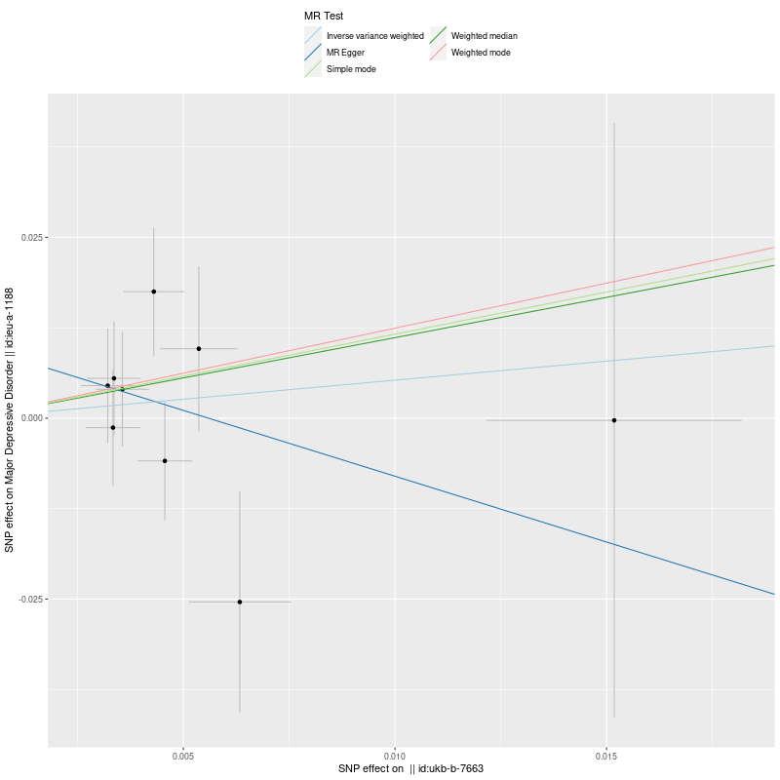 | B. FOREST PLOT FOR EACH SNP’s EFFECT  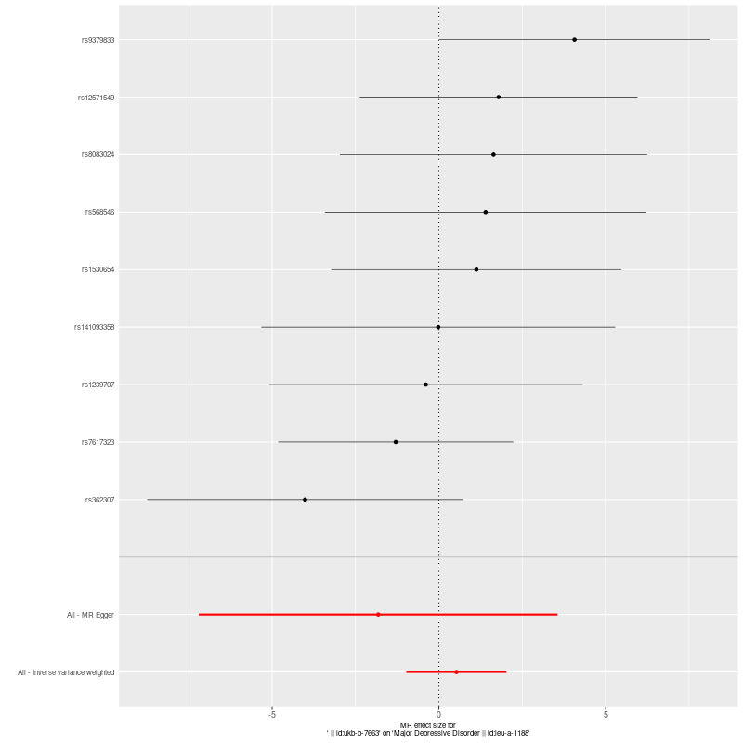
C. FUNNEL PLOT  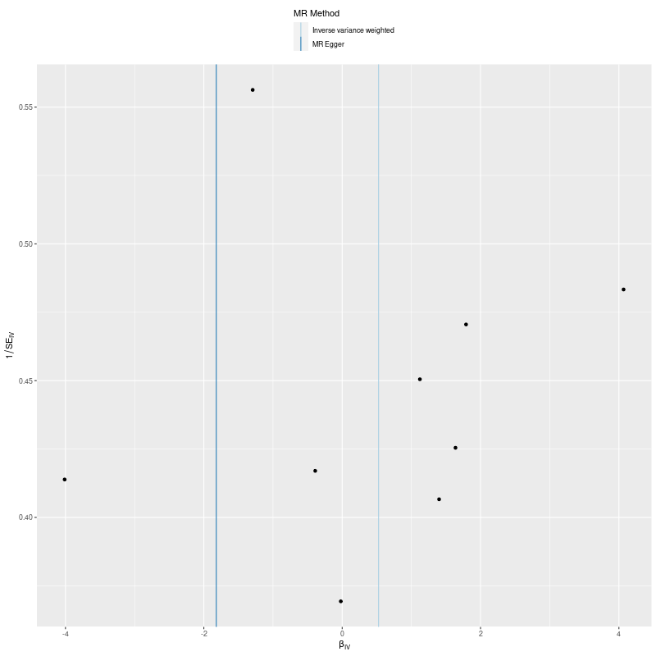 | D. LEAVE-ONE-OUT FOREST PLOT  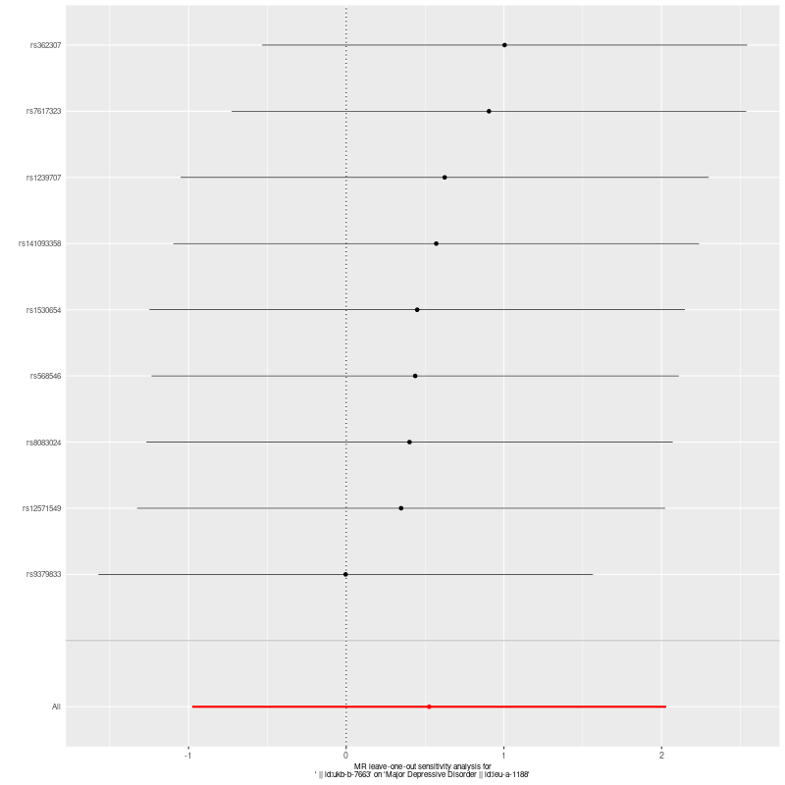
Supp. Figure 1. MR Analysis (Exposure: Strenuous sports (ukb-b-7663), Outcome: Major Depressive Disorder(ieu-a-1188))

- MR REGRESSION  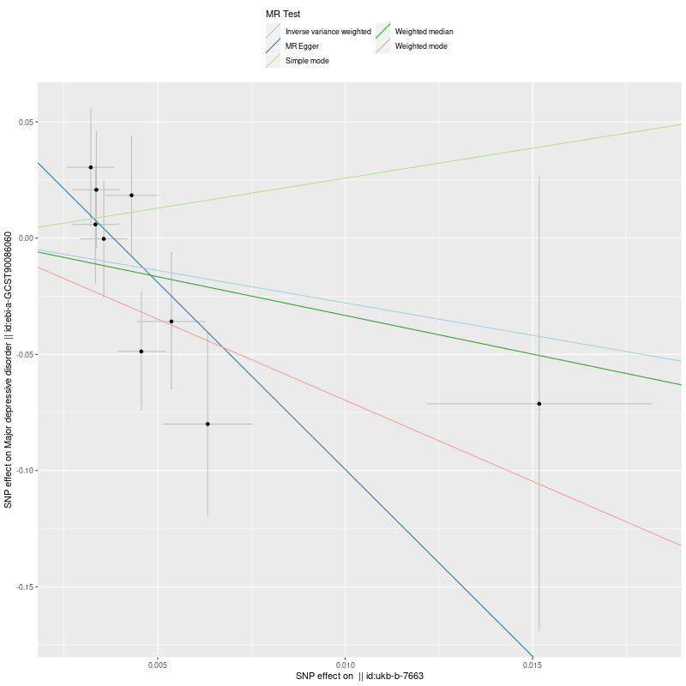 | B. FOREST PLOT FOR EACH SNP’s EFFECT  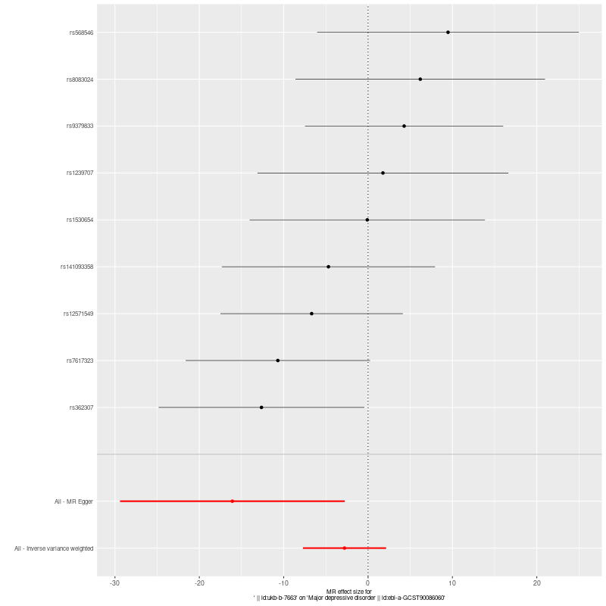
C. FUNNEL PLOT  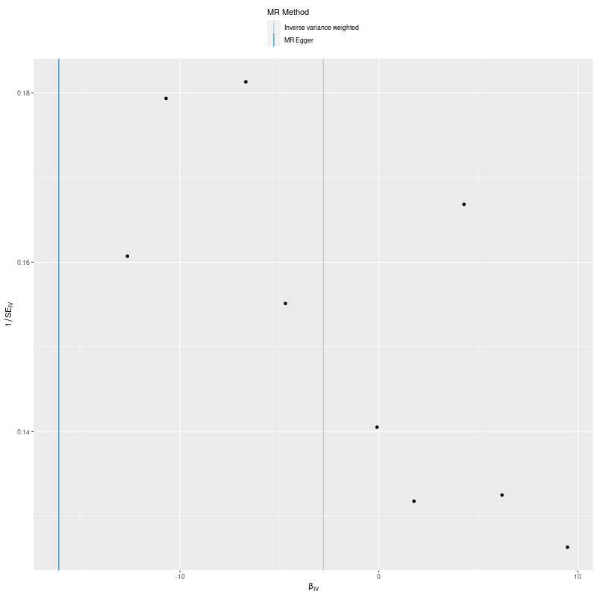 | D. LEAVE-ONE-OUT FOREST PLOT  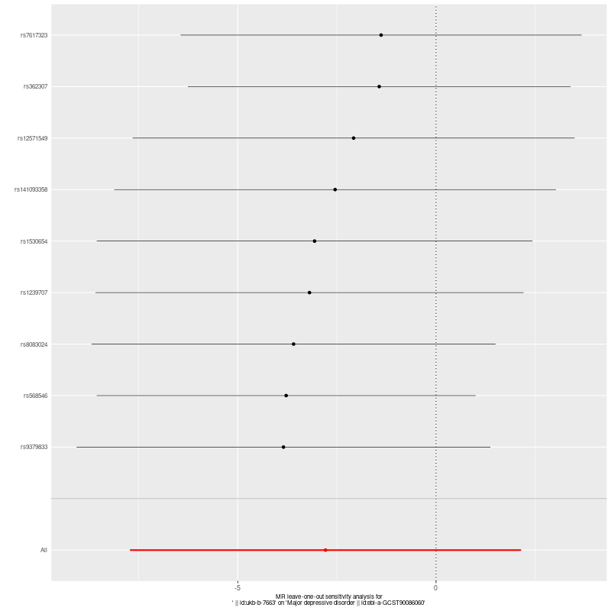
Supp. Figure 2. MR Analysis (Exposure: Strenuous sports (ukb-b-7663), Outcome: Major Depressive Disorder(ebi-a-GCST90086060))

- MR REGRESSION  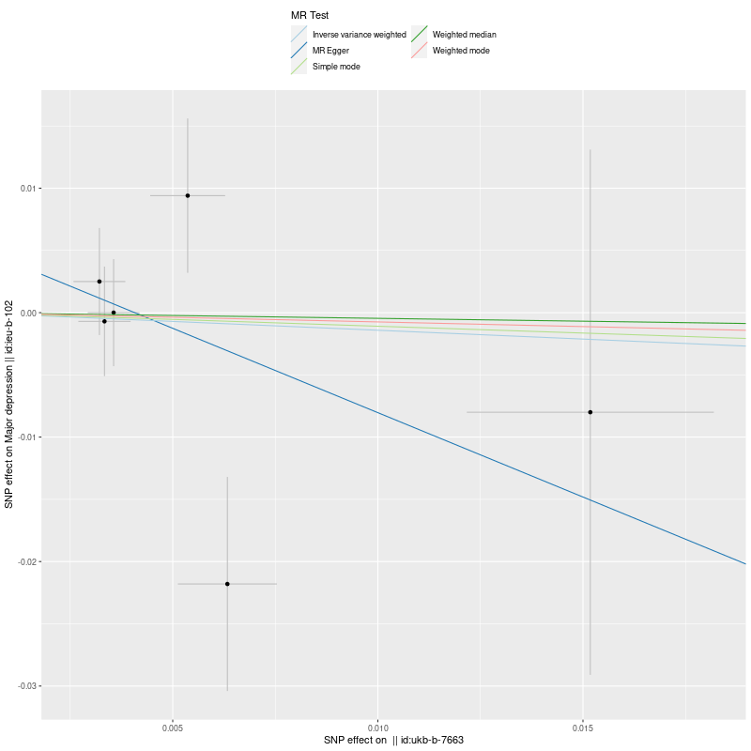 | B. FOREST PLOT FOR EACH SNP’s EFFECT  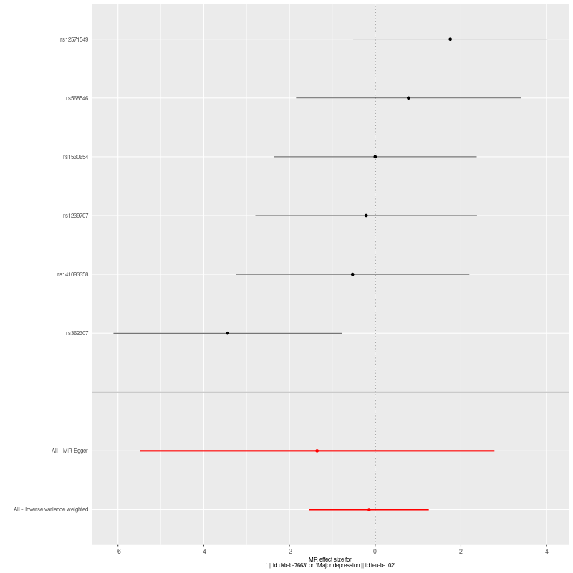
C. FUNNEL PLOT  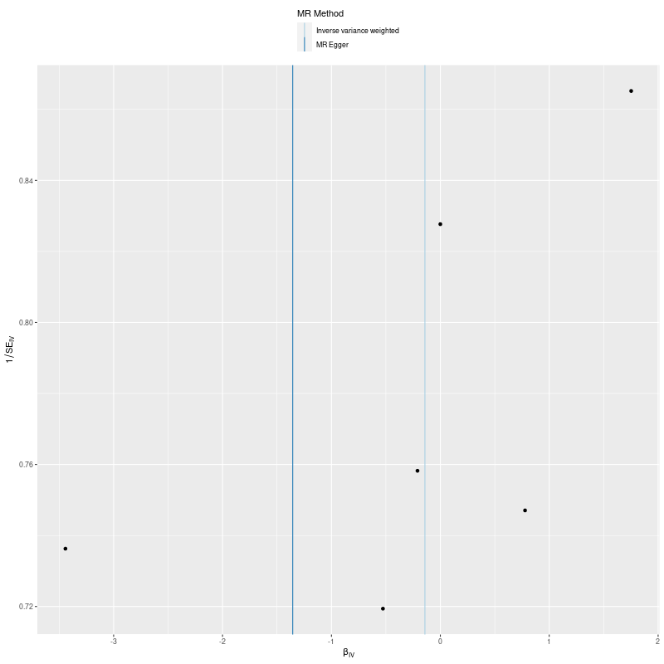 | D. LEAVE-ONE-OUT FOREST PLOT  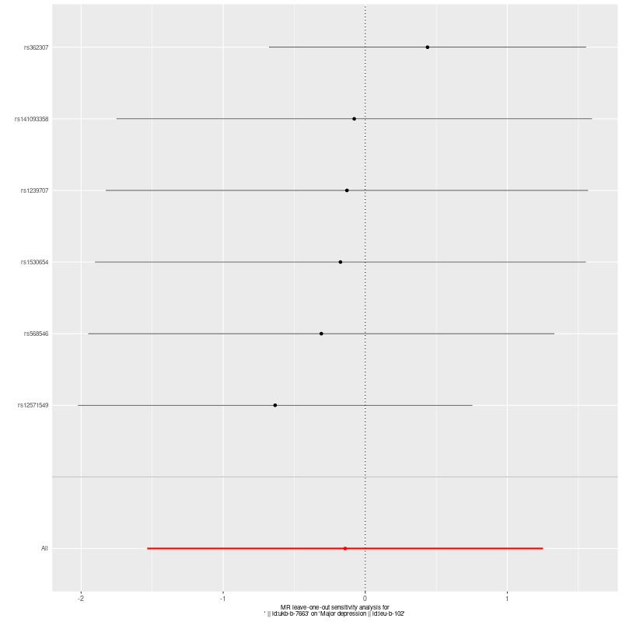
Supp. Figure 3. MR Analysis (Exposure: Strenuous sports (ukb-b-7663), Outcome: Major Depression(ieu-b-102))

- MR REGRESSION  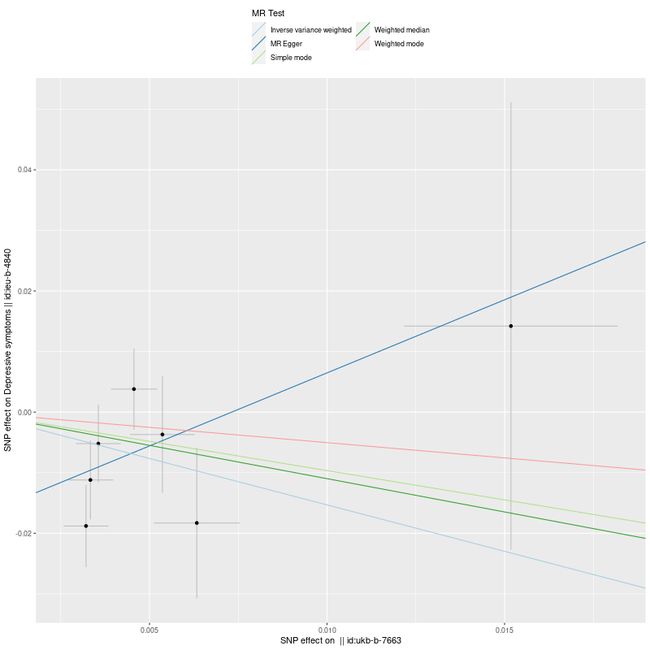 | B. FOREST PLOT FOR EACH SNP’s EFFECT  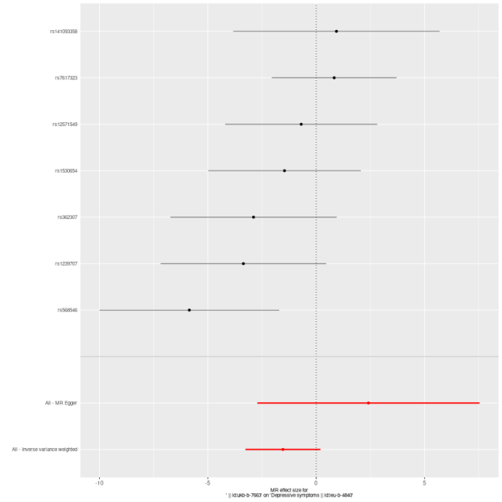
C. FUNNEL PLOT  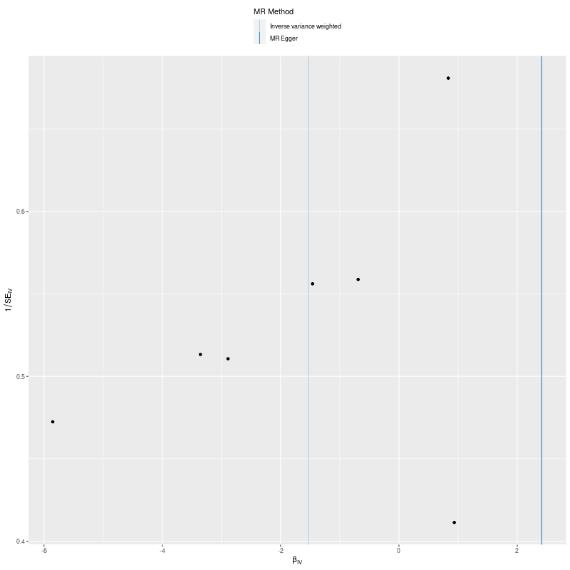 | D. LEAVE-ONE-OUT FOREST PLOT  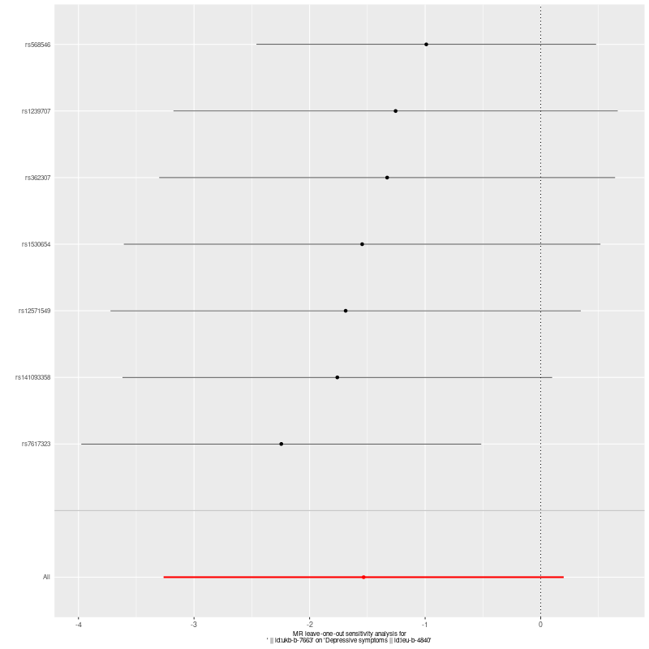
Supp. Figure 4. MR Analysis (Exposure: Strenuous sports (ukb-b-7663), Outcome: Depressive Symptoms(ieu-b-4840))

- MR REGRESSION  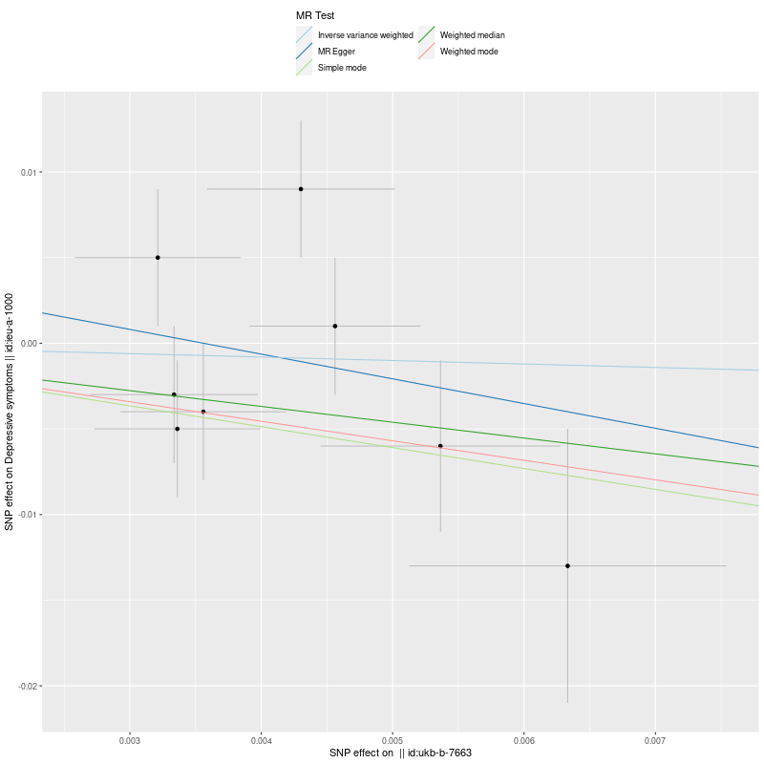 | B. FOREST PLOT FOR EACH SNP’s EFFECT  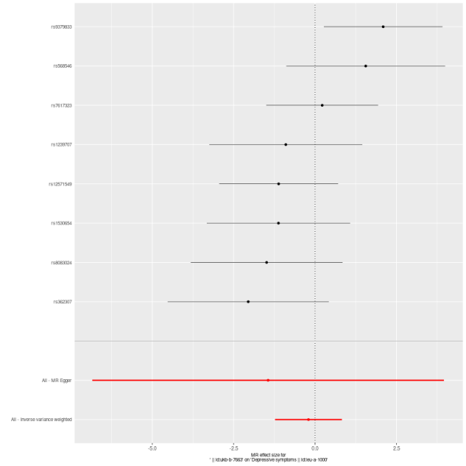
C. FUNNEL PLOT  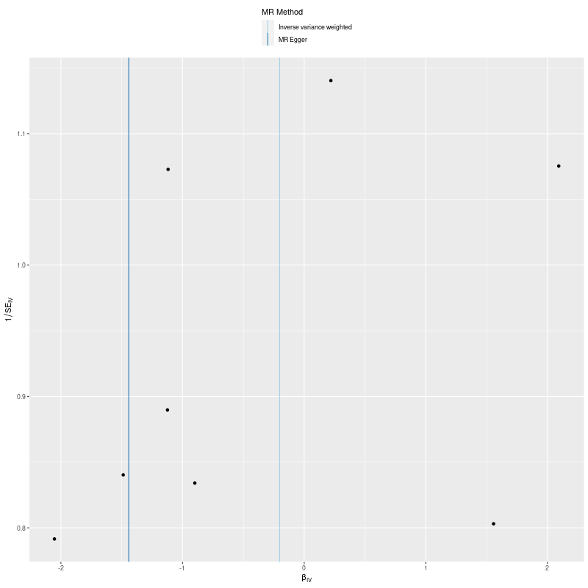 | D. LEAVE-ONE-OUT FOREST PLOT  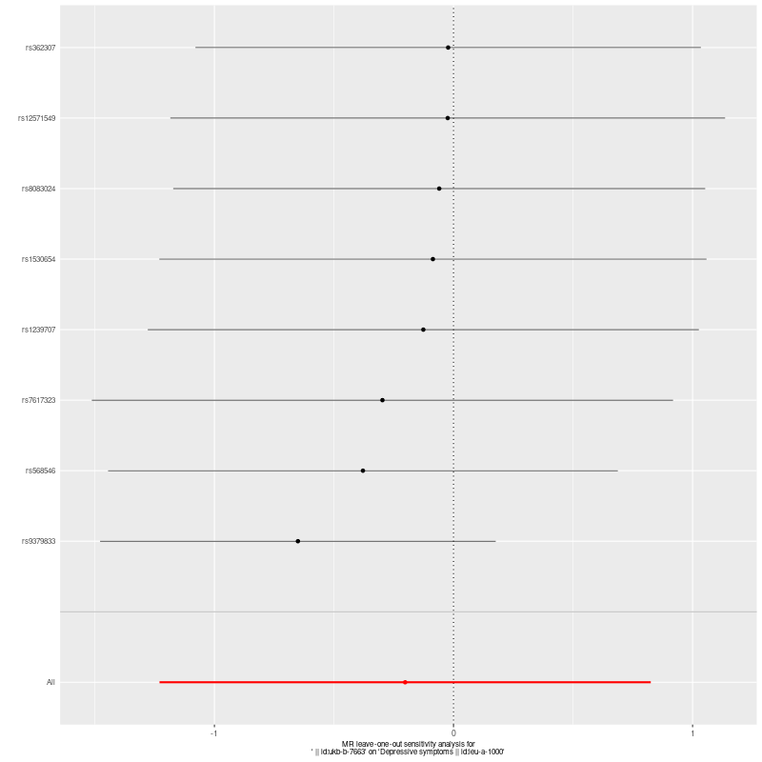
Supp. Figure 5. MR Analysis (Exposure: Strenuous sports (ukb-b-7663), Outcome: Depressive Symptoms(ieu-a-1000))

- MR REGRESSION  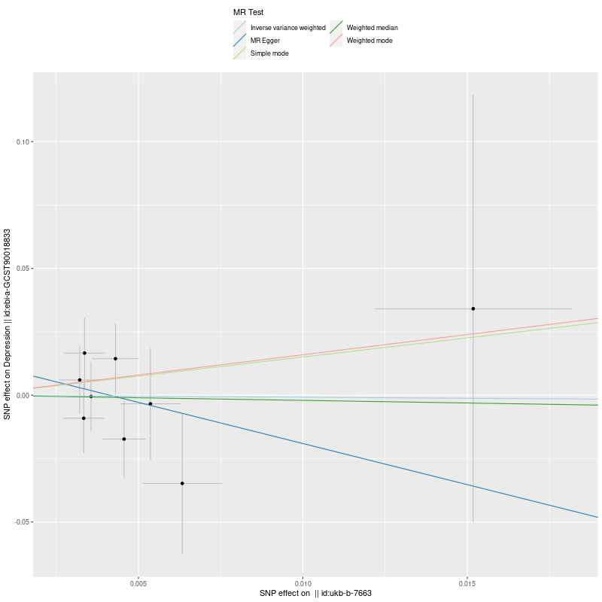 | B. FOREST PLOT FOR EACH SNP’s EFFECT  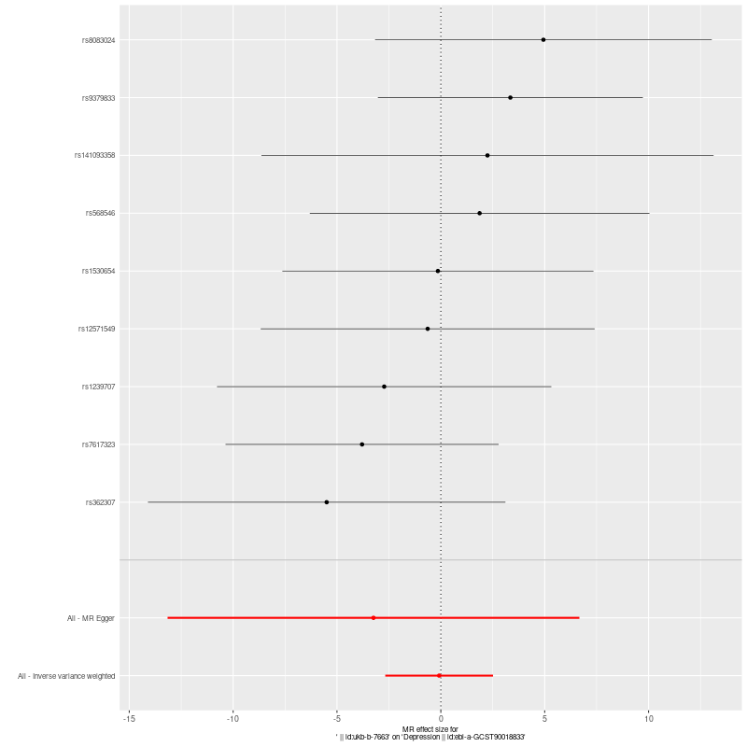
C. FUNNEL PLOT  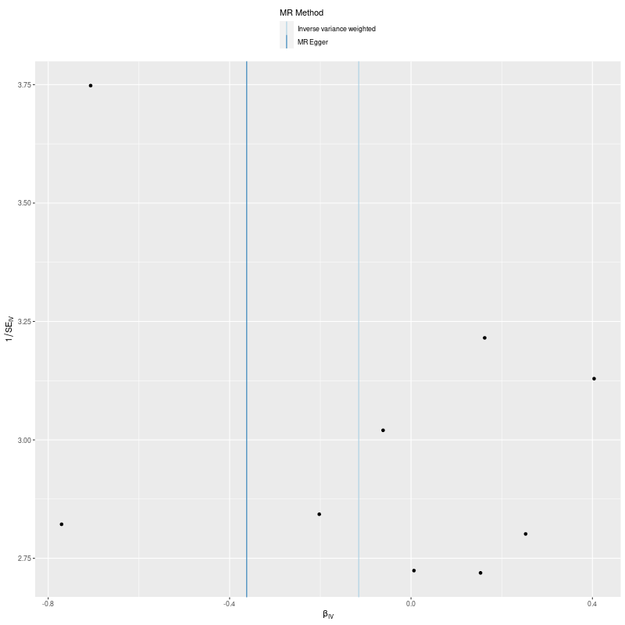 | D. LEAVE-ONE-OUT FOREST PLOT  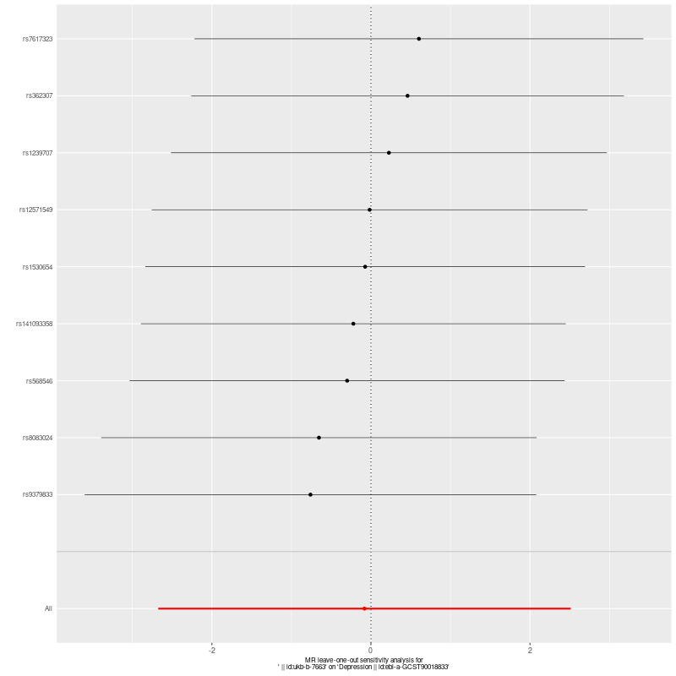
Supp. Figure 6. MR Analysis (Exposure: Strenuous sports (ukb-b-7663), Outcome: Depression(ebi-a-GCST90018833))

- MR REGRESSION  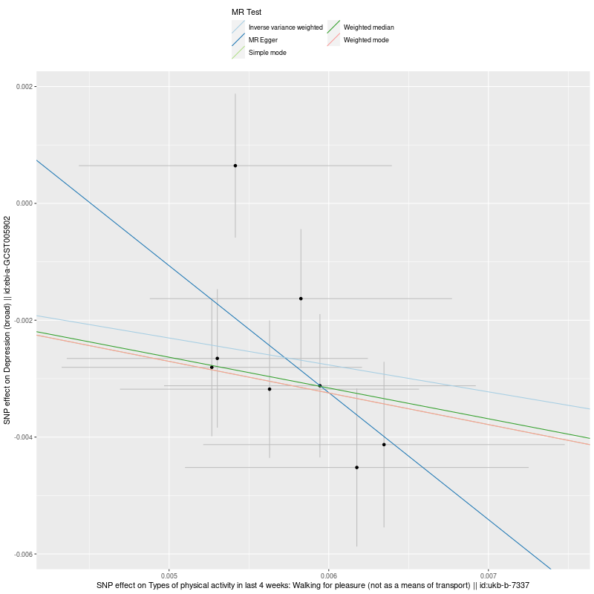 | B. FOREST PLOT FOR EACH SNP’s EFFECT
C. FUNNEL PLOT  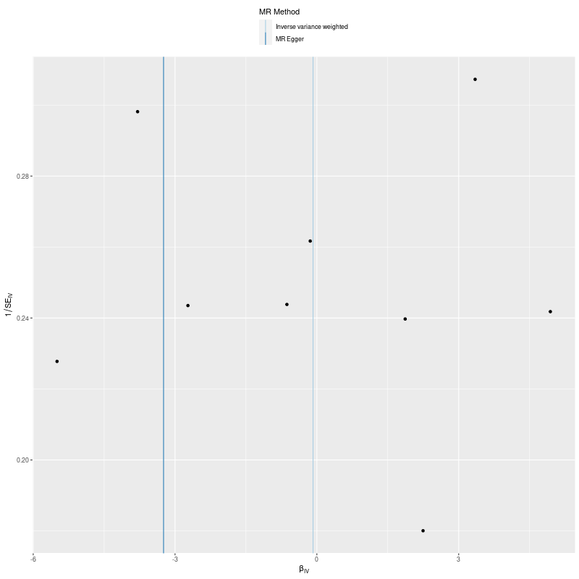 | D. LEAVE-ONE-OUT FOREST PLOT
Supp. Figure 7. MR Analysis (Exposure: Strenuous sports (ukb-b-7663), Outcome: Depression (broad)(ebi-a-GCST005902))

- MR REGRESSION  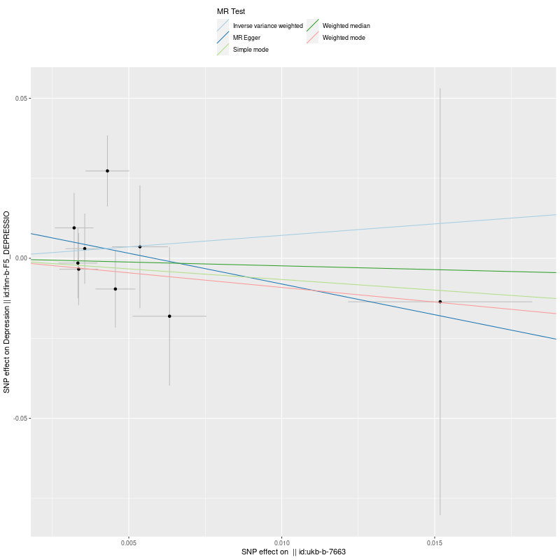 | B. FOREST PLOT FOR EACH SNP’s EFFECT  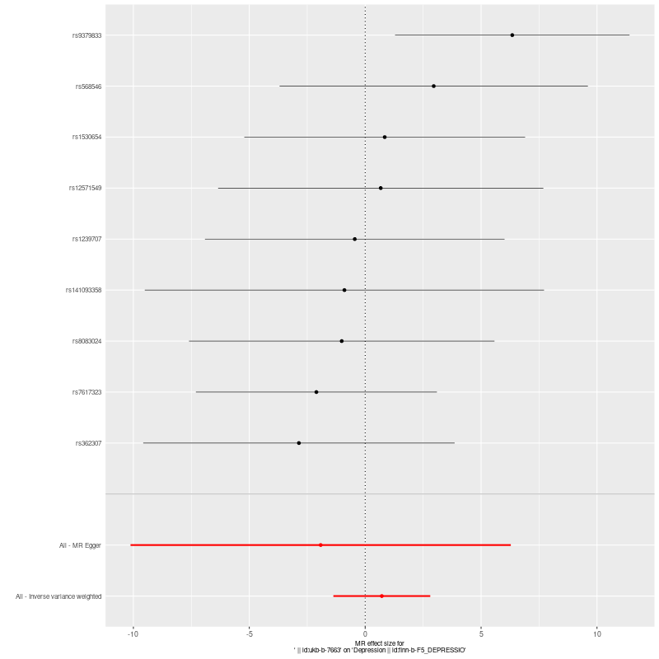
C. FUNNEL PLOT  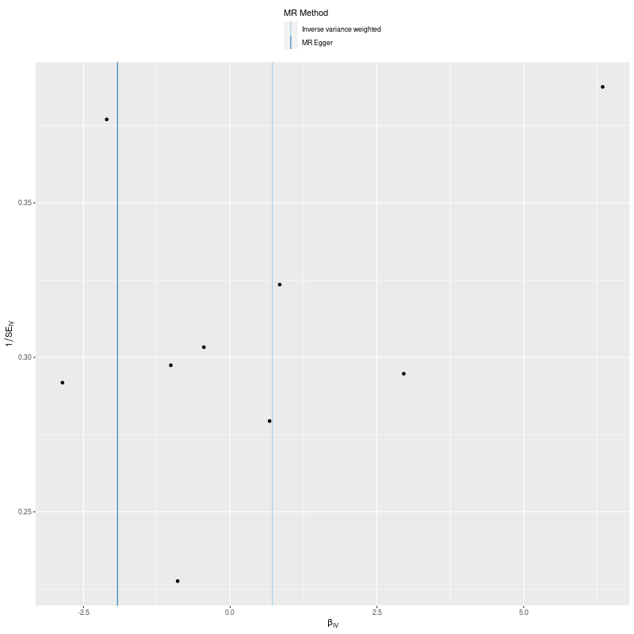 | D. LEAVE-ONE-OUT FOREST PLOT
Supp. Figure 8. MR Analysis (Exposure: Strenuous sports (ukb-b-7663), Outcome: Depression(finn-b-F5_DEPRESSIO))

- MR REGRESSION  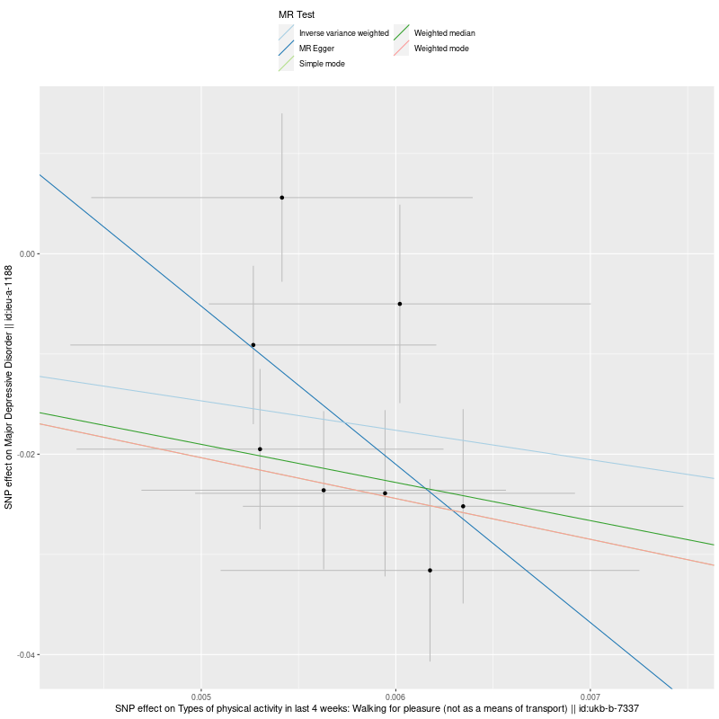 | B. FOREST PLOT FOR EACH SNP’s EFFECT  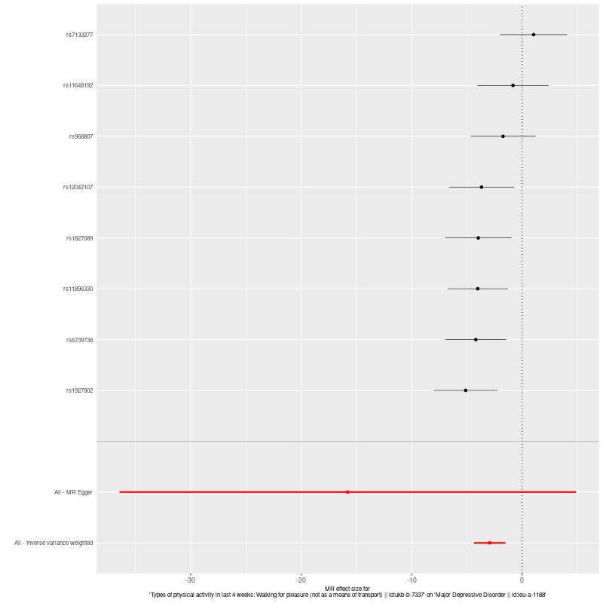
C. FUNNEL PLOT  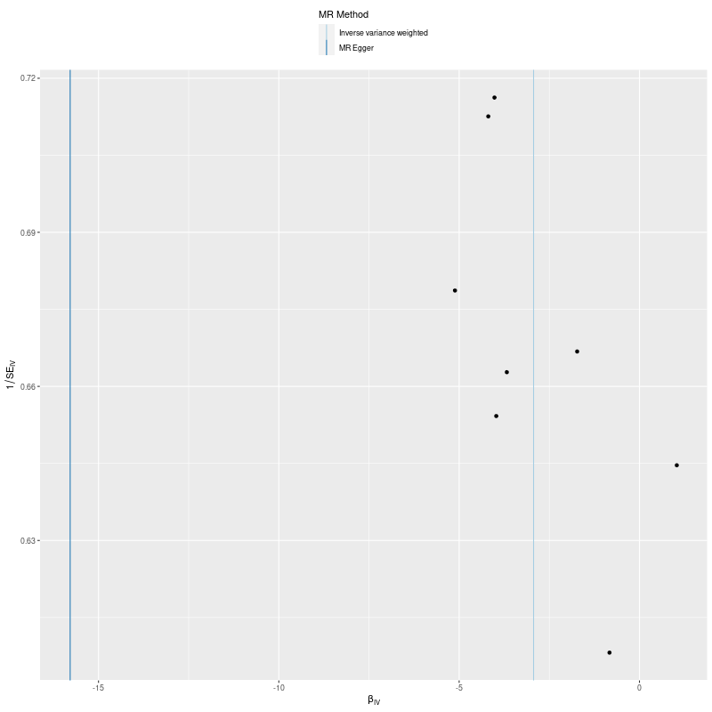 | D. LEAVE-ONE-OUT FOREST PLOT  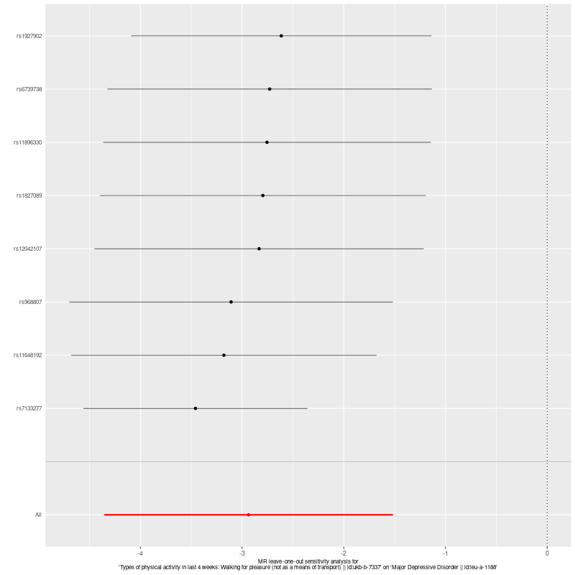
Supp. Figure 9. MR Analysis (Exposure: Walking for pleasure (ukb-b-7337), Outcome: Major Depressive Disorder(ieu-a-1188))

- MR REGRESSION  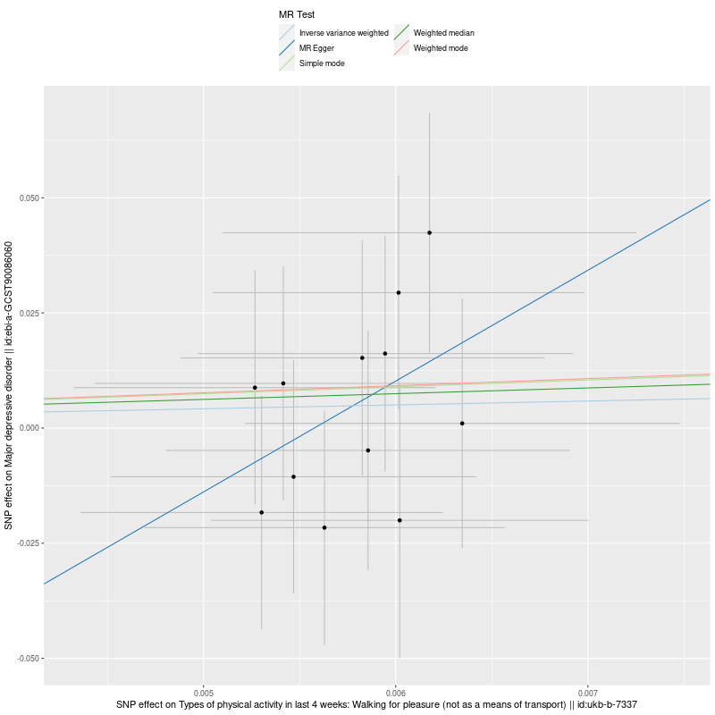 | B. FOREST PLOT FOR EACH SNP’s EFFECT  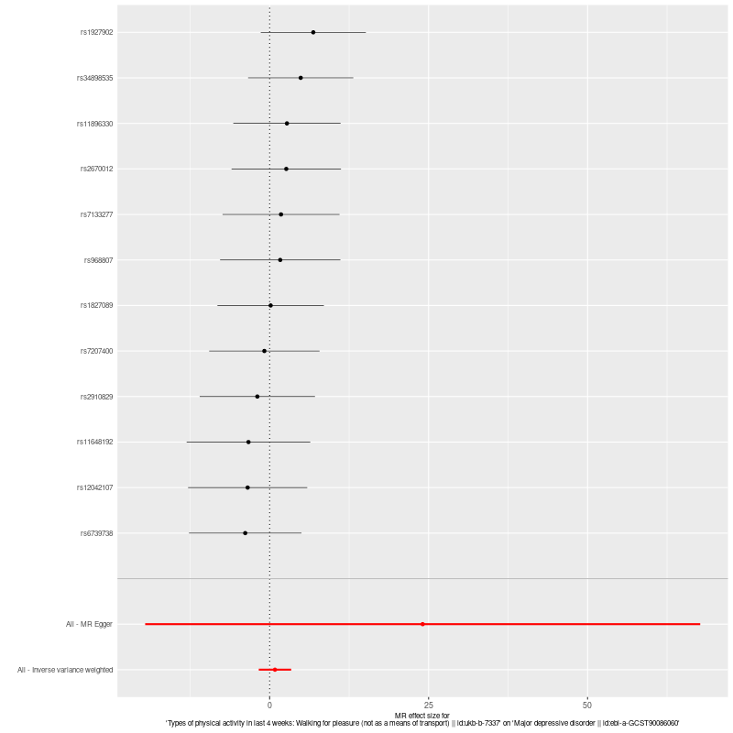
C. FUNNEL PLOT  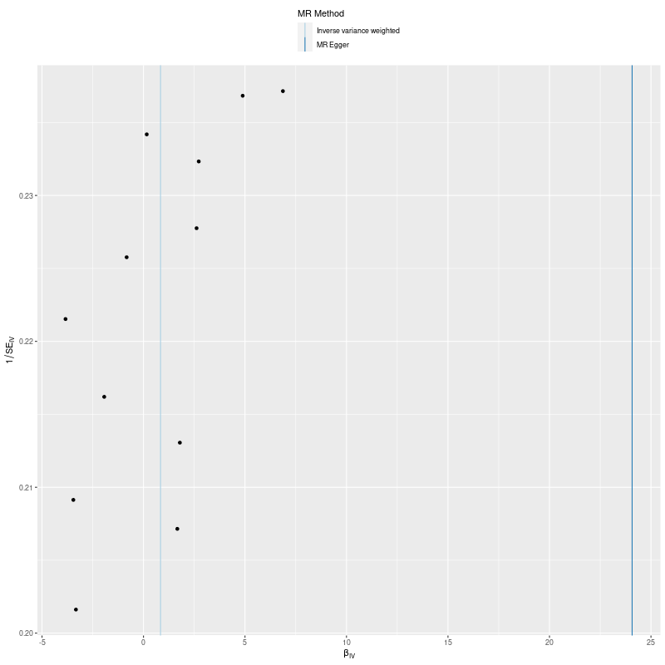 | D. LEAVE-ONE-OUT FOREST PLOT  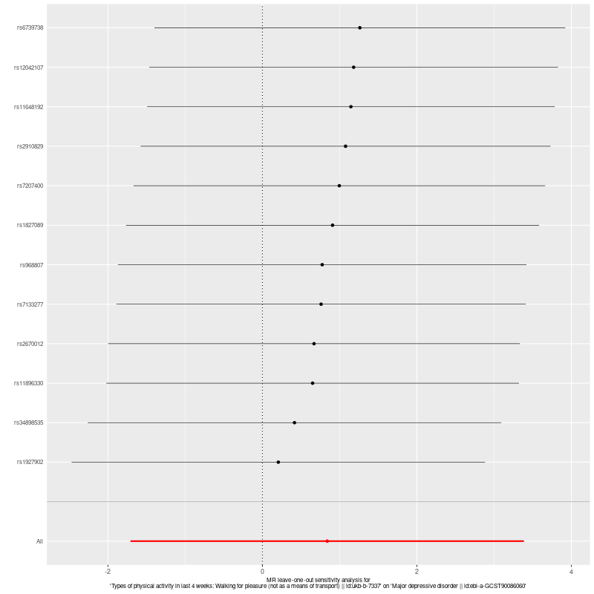
Supp. Figure 10. MR Analysis (Exposure: Walking for pleasure (ukb-b-7337), Outcome: Major Depressive Disorder(ebi-a-GCST90086060))

- MR REGRESSION  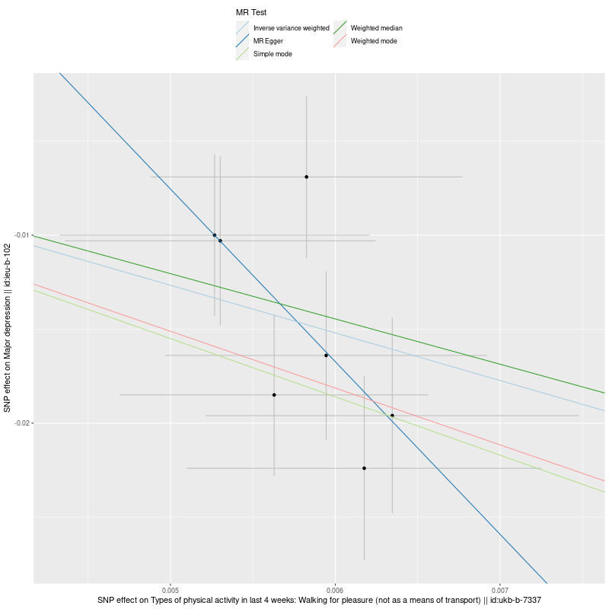 | B. FOREST PLOT FOR EACH SNP’s EFFECT  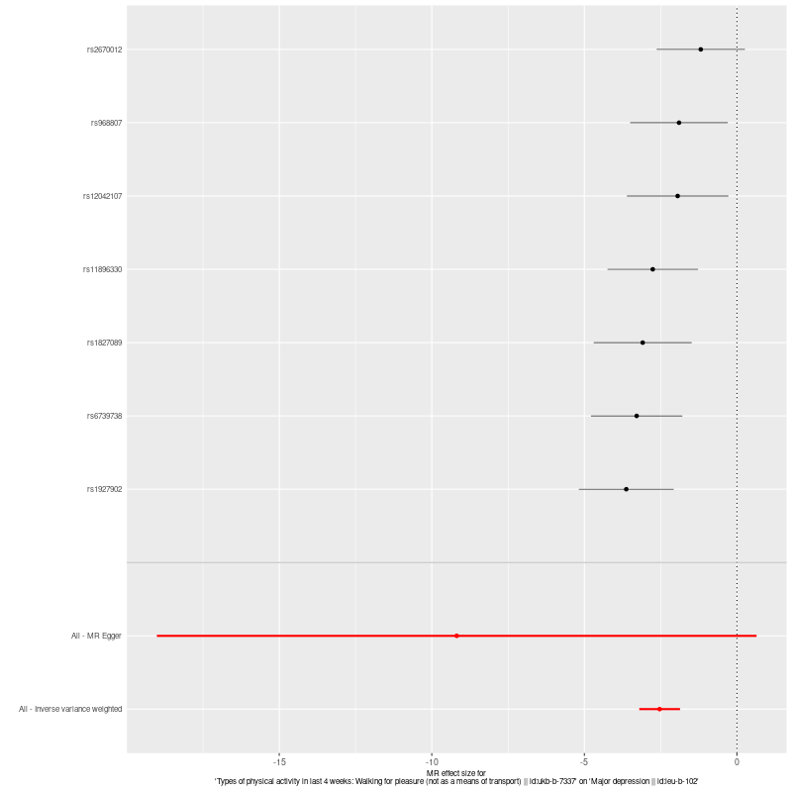
C. FUNNEL PLOT  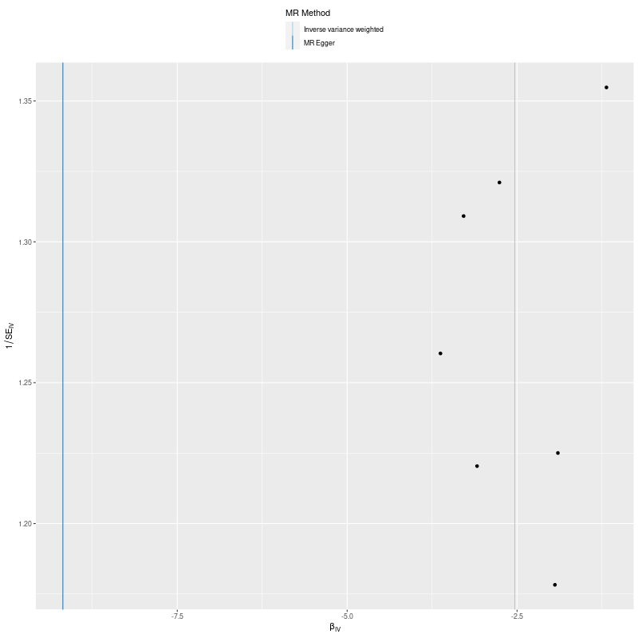 | D. LEAVE-ONE-OUT FOREST PLOT  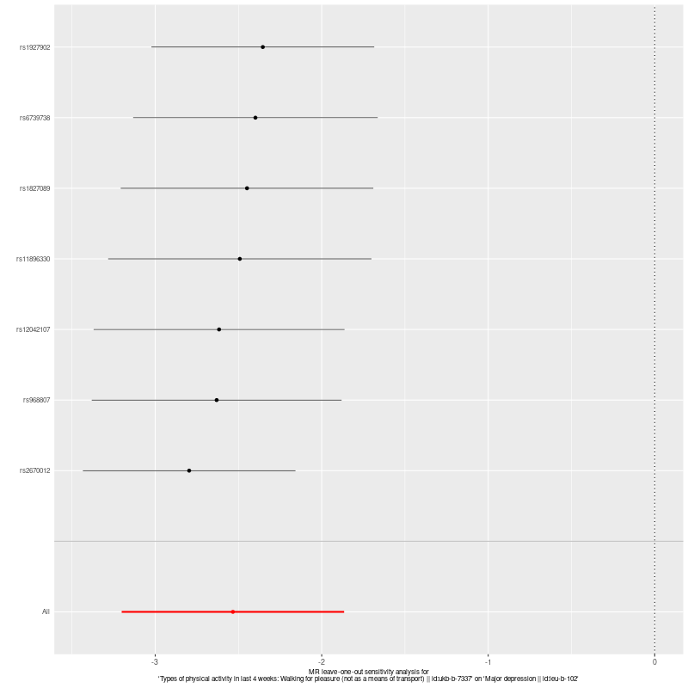
Supp. Figure 11. MR Analysis (Exposure: Walking for pleasure (ukb-b-7337), Outcome: Major Depression(ieu-b-102))

- MR REGRESSION  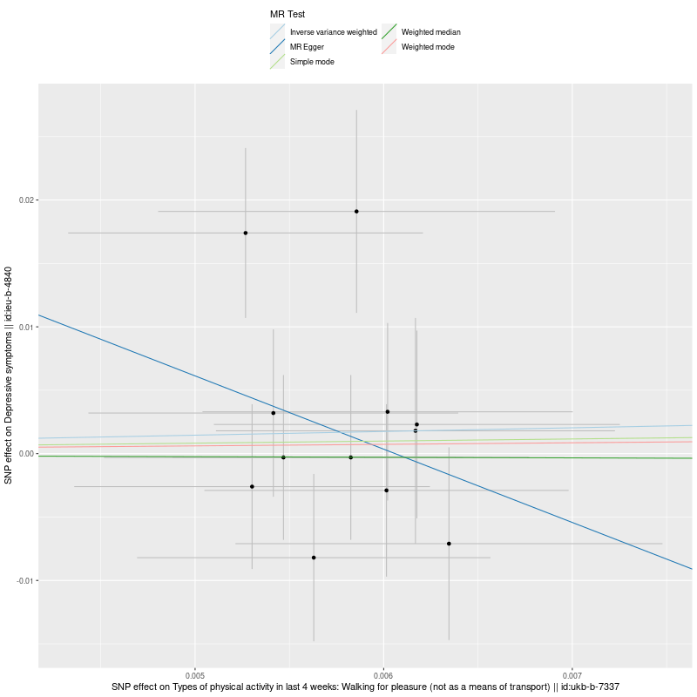 | B. FOREST PLOT FOR EACH SNP’s EFFECT  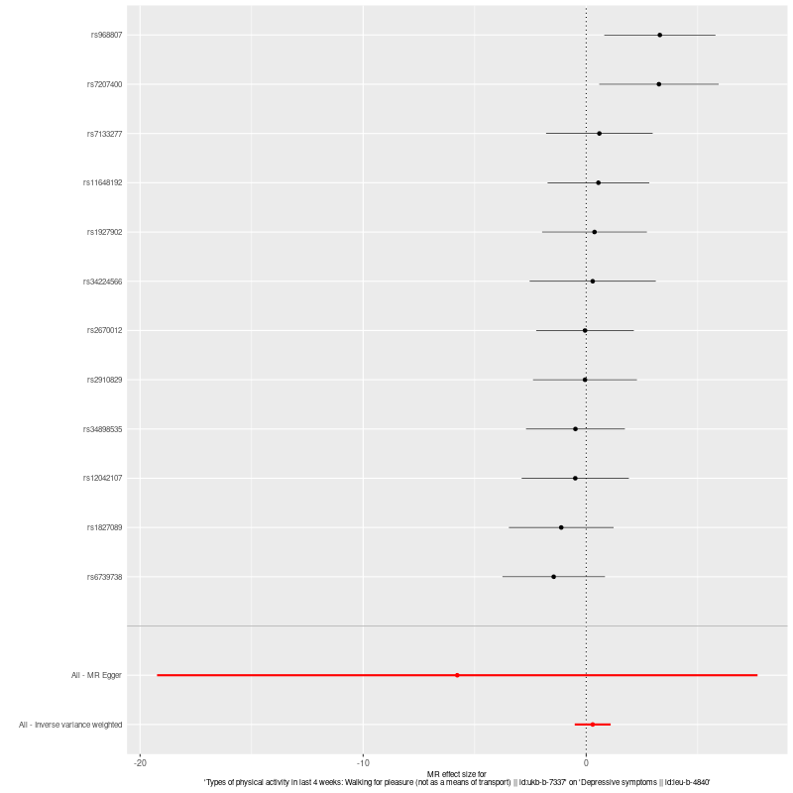
C. FUNNEL PLOT  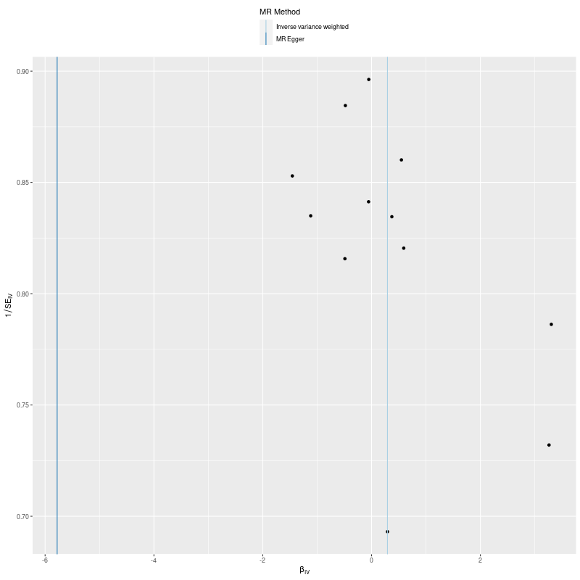 | D. LEAVE-ONE-OUT FOREST PLOT  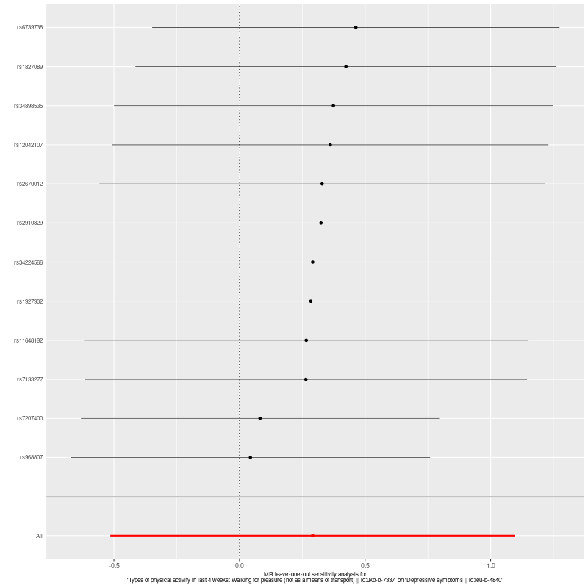
Supp. Figure 12. MR Analysis (Exposure: Walking for pleasure (ukb-b-7337), Outcome: Depressive Symptoms(ieu-b-4840))

- MR REGRESSION  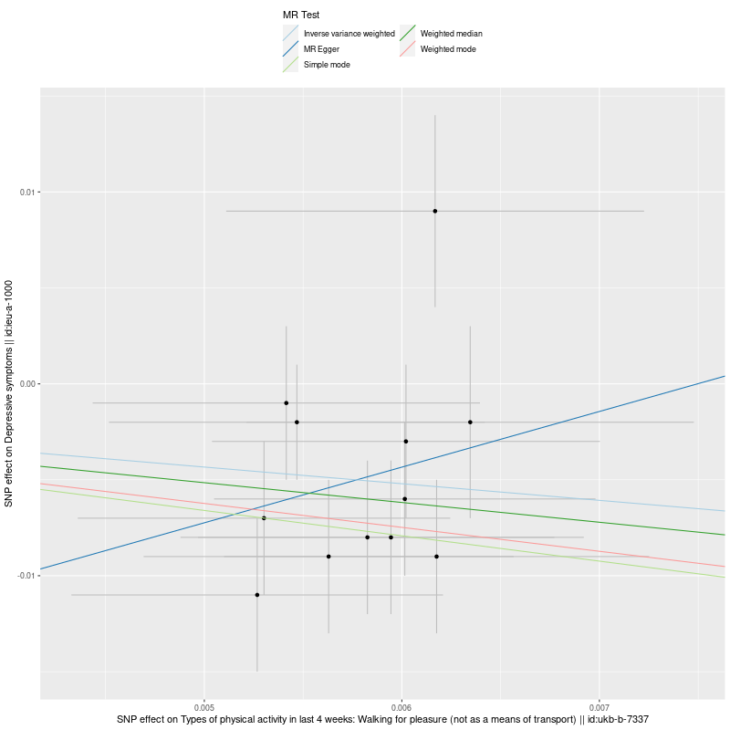 | B. FOREST PLOT FOR EACH SNP’s EFFECT  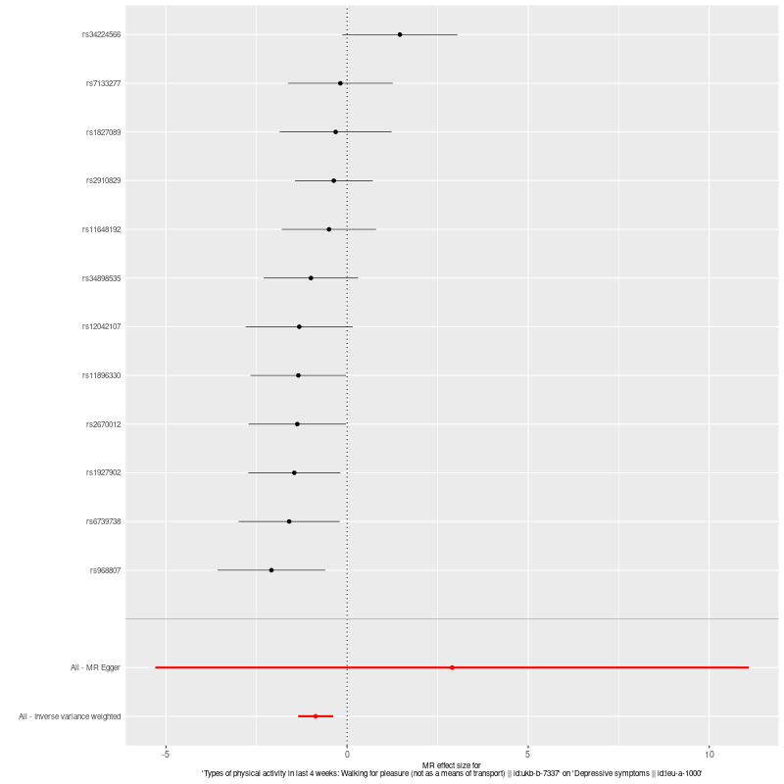
C. FUNNEL PLOT  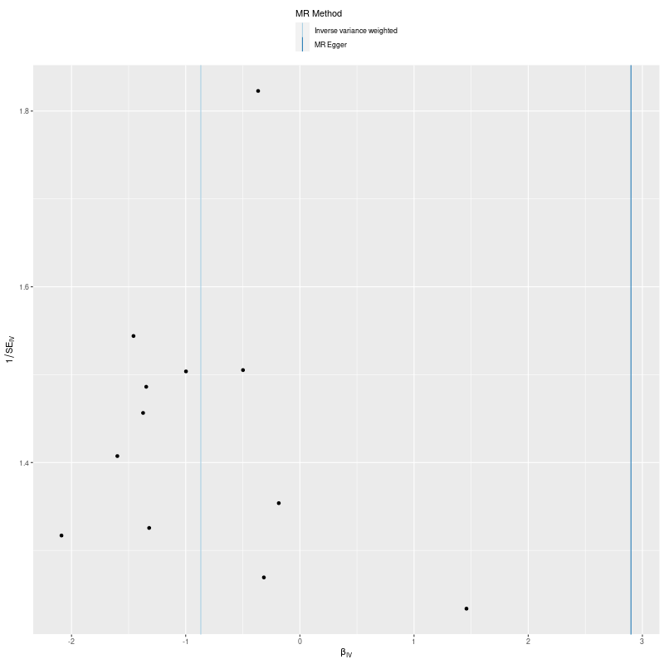 | D. LEAVE-ONE-OUT FOREST PLOT  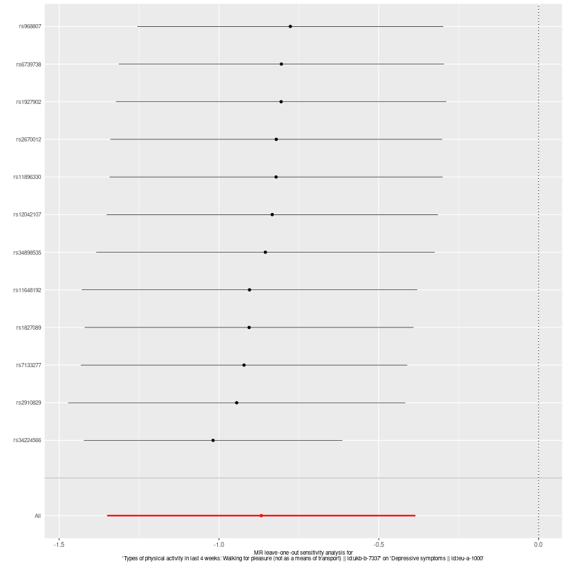
Supp. Figure 13. MR Analysis (Exposure: Walking for pleasure (ukb-b-7337), Outcome: Depressive Symptoms(ieu-a-1000))

A. MR REGRESSION  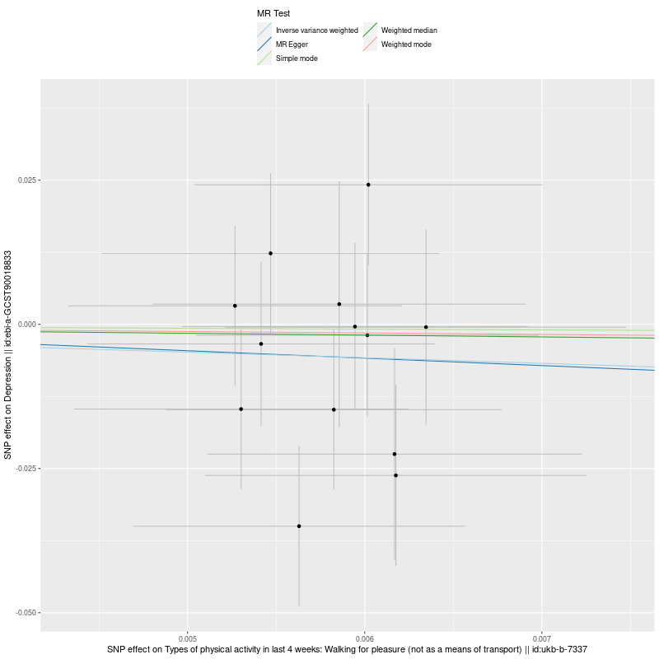 | B. FOREST PLOT FOR EACH SNP’s EFFECT  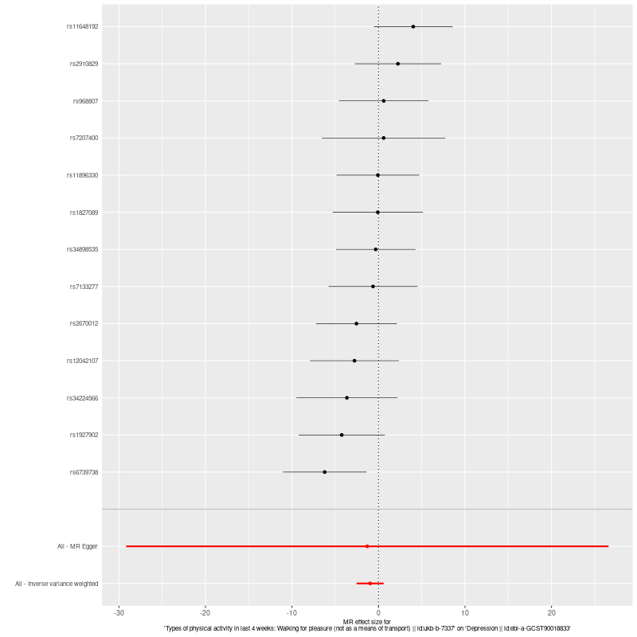
C. FUNNEL PLOT  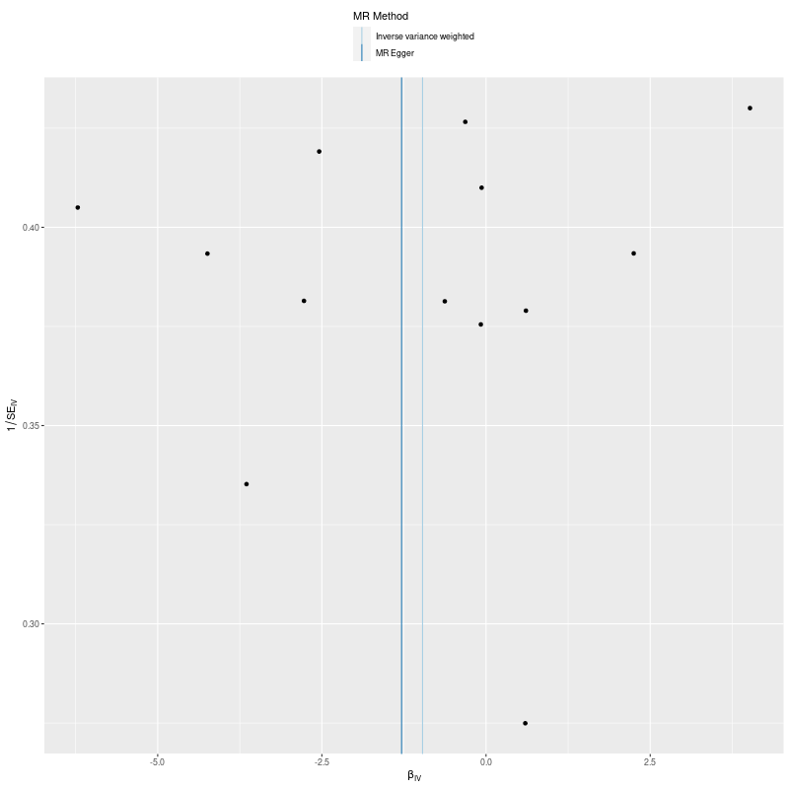 | D. LEAVE-ONE-OUT FOREST PLOT  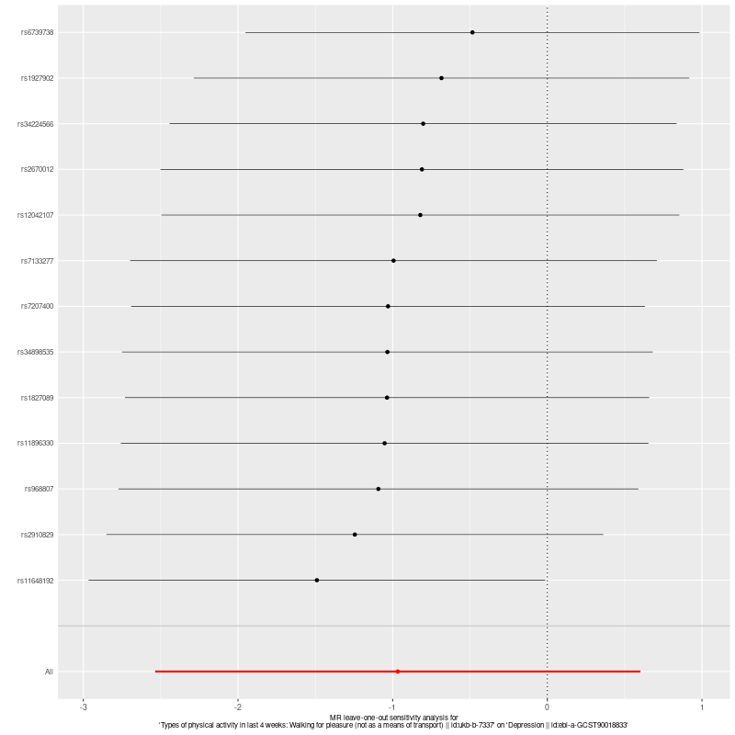
Supp. Figure14. MR Analysis (Exposure: Walking for pleasure (ukb-b-7337), Outcome: Depression(ebi-a-GCST90018833))

A. MR REGRESSION | B. FOREST PLOT FOR EACH SNP’s EFFECT  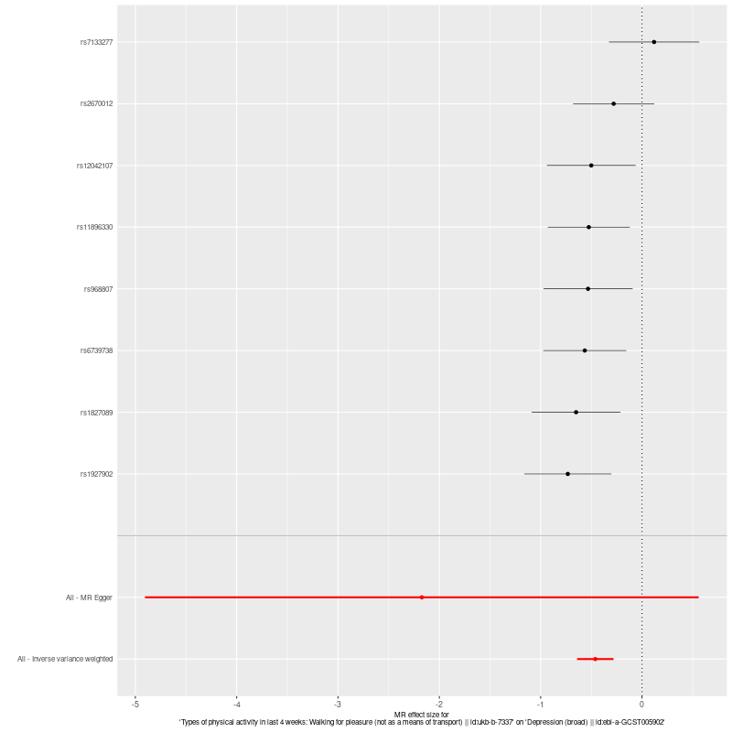
C. FUNNEL PLOT  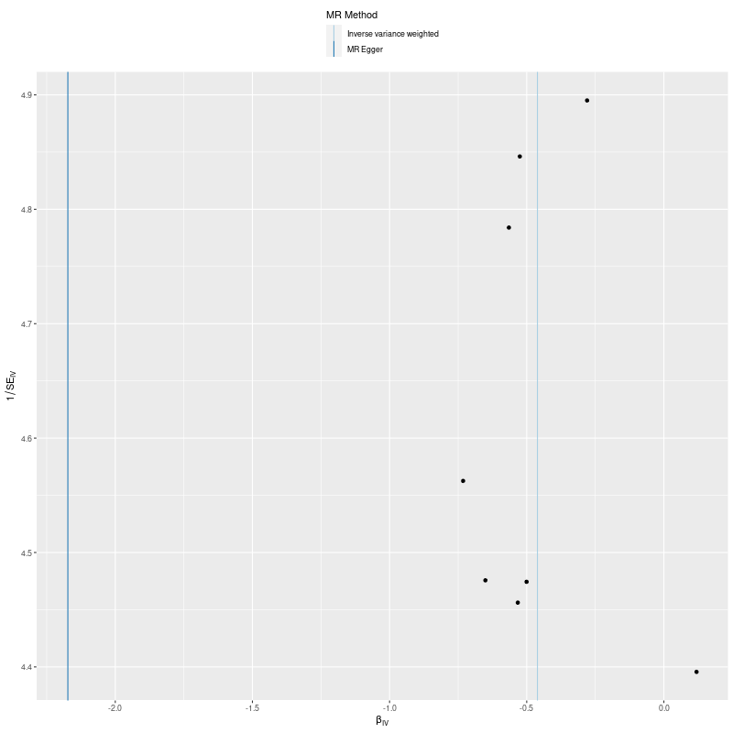 | D. LEAVE-ONE-OUT FOREST PLOT  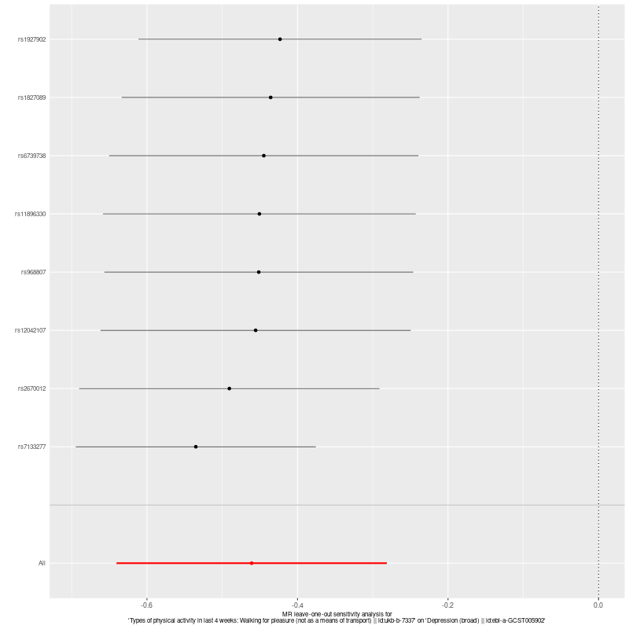
Supp. Figure 15. MR Analysis (Exposure: Walking for pleasure (ukb-b-7337), Outcome: Depression (broad)(ebi-a-GCST005902))

A. MR REGRESSION  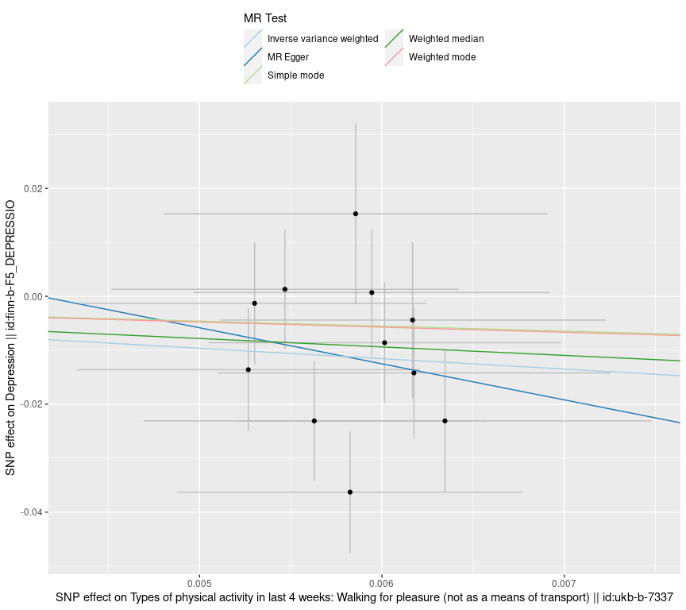 | B. FOREST PLOT FOR EACH SNP’s EFFECT  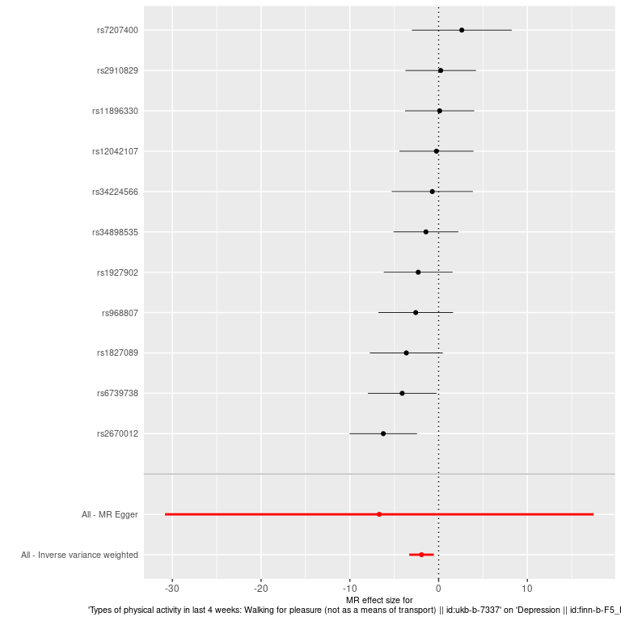
C. FUNNEL PLOT  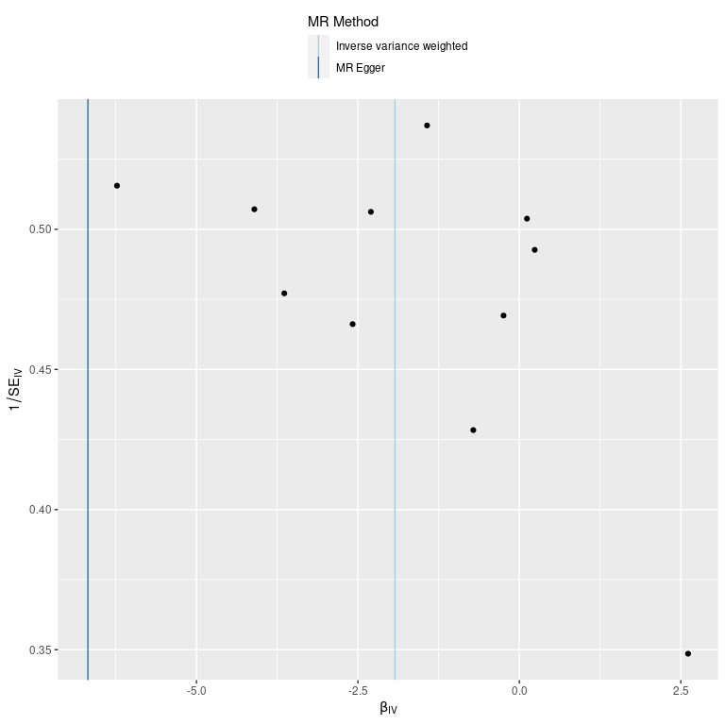 | D. LEAVE-ONE-OUT FOREST PLOT  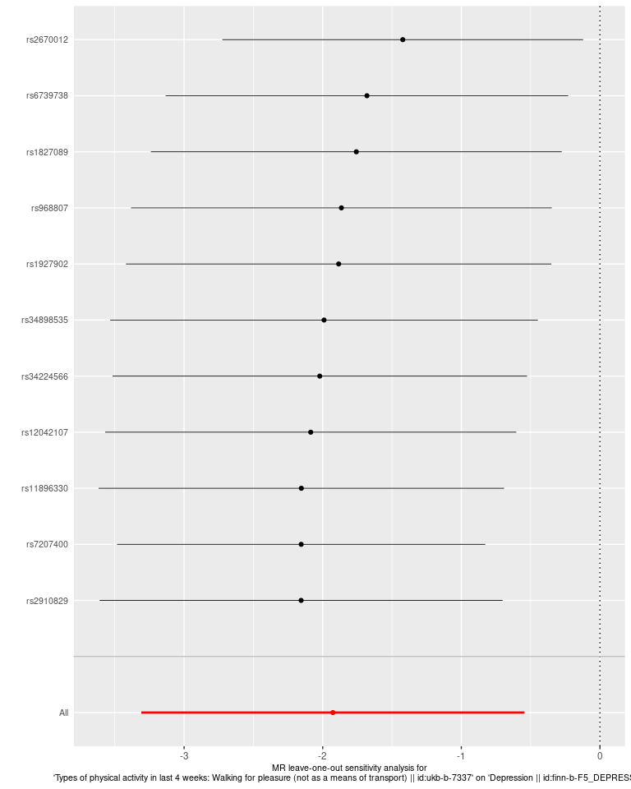
Supp. Figure 16. MR Analysis (Exposure: Walking for pleasure (ukb-b-7337), Outcome: Depression(finn-b-F5_DEPRESSIO))

