Extended Data Table 1 | Summary of the antimicrobial effect of RejuAgro A against phytopathogens
Pathogens and related diseases | MIC (µg/mL)
 | RejuAgro A | Streptomycin
Xanthomonas axonopodis pv. citri-Miami XC2002-00010 (Citrus canker) | 5 | 0.16
X. axonopodis pv. citri N40-SO5 (Citrus canker) | 5 | 0.16
X. campestris pv. Pruni (Bacterial Spot of Peach) | 40 | >40
X. campestris pv. vesicatoria XV-16 (Tomato bacterial spot) | 2.5 | 20
X. arboricola pv. Juglandis 219 (walnut blight) | 6.3 | 0.39
Ralstonia solanacearum K60 (bacterial wilt) | 3.1 | 12.5
R. solanacearum Pss4 (bacterial wilt) | 6.25 | 12.5
Pectobacterium parmentieri UPP163 936 (Produces soft rot in multiple crops) | 40 | 40
Pectobacterium atrosepticum 942 (Produces soft rot in multiple crops) | 20 | 20
Pectobacterium carotovorum subsp. brasiliensis 944 (Produces soft rot in multiple crops) | 40 | 40
Pectobacterium carotovorum subsp. carotovorum wpp14 945 (Produces soft rot in multiple crops) | 40 | 40
Dickeya dadantii 3937 (Produces soft rot in multiple crops) | 40 | 20
Pseudomonas savastanoi pv. savastanoi (Olive knot) | 40 | 0.3
Pseudomonas syringae pv. tomato PT30 (Tomato bacterial speck) | 40 | 2.5
Pseudomonas syringae pv syringae 7046 (Bacterial canker or blast (stone and pome fruits)) | 20 | 2.5
Pseudomonas syringae pv. lachrymans 1188-1 (Angular Leaf Spot of Cucurbits) | 10 | 5
Clavibacter michiganensis subsp. michiganensis NCPPB382 (Tomato canker) | 6.3 | 12.5
C. michiganensis subsp. michiganensis Cmm 0317 (Tomato canker) | 1.6 | 3.1
C. michiganensis subsp. michiganensis Cmm 0690 (Tomato canker) | 12.5 | 12.5
Phytophthora infestans Pi 1306 (Potato late blight) | 40 | NA
Phytophthora infestans Pi 88069 (Potato late blight) | 40 | NA
Venturia inaequalis (Apple scab) | 80 | NA

Extended Data Table 2 | AntiSMASH secondary metabolites biosynthetic gene clusters prediction in P. soli 0617-T307.
Region | Type | From | To | Most similar known cluster |  | Similarity
BGC 1 | NAGGN | 1,646,944 | 1,661,755 | N/A | N/A | N/A
BGC 2 | bacteriocin | 2,292,226 | 2,303,047 | N/A | N/A | N/A
BGC 3 | NRPS | 2,427,176 | 2,472,363 | Putisolvin | NRP | 50%
BGC 4 | NRPS | 2,766,176 | 2,845,389 | Viscosin | NRP | 31%
BGC 5 | NRPS, CDPS | 2,973,338 | 3,023,385 | Pseudomonine | NRP | 100%
BGC 6 | NRPS | 3,492,598 | 3,563,901 | Pyoverdin | NRP | 11%
BGC 7 | PpyS-KS | 3,808,513 | 3,829,562 | Pseudopyrionine A/ pseudopyriodine B | Fatty Acid | 50%
BGC 8 | NRPS | 3,996,102 | 4,409,049 | Pyoverdin | NRP | 12%
BGC 9 | T3PKS | 4,084,583 | 4,125,770 | N/A | N/A | N/A
BGC 10 | NRPS-like | 5,807,414 | 5,831,870 | Fragnin | NRP | 60%
Abbreviation: NAGGN N-acetylglutaminylglutamine amide; NRPS Non-ribosomal peptide synthase; PpyS-KS Photopyrone synthase-keto synthase; T3PKS Type III polyketide synthase; NRP Non-ribosomal peptide, CDPS tRNA-dependent cyclodipeptide synthases

Extended Data Table 3 | Predicted function of genes in BGC9
Name | BLAST Predicted Function | Strain/Identity | Accession
ras1 | Hydroxymethylglutaryl-CoA | Multispecies [Pseudomonas]/ 99.75% | WP_110704543
ras2 | Enoyl-CoA hydratase | Multispecies [Pseudomonas]/ 100% | WP_046856508
ras3 | Asparagine synthase (glutamine-hydrolyzing) | Multispecies [Pseudomonas]/ 100% | WP_102683557
ras4 | NAD(P)/FAD-dependent oxidoreductase | Multispecies [Pseudomonas]/ 100% | WP_102683558
ras5 | Acyl-CoA dehydrogenase | Multispecies [Pseudomonas]/ 100% | WP_062360728
ras6 | PaaI family thioesterase | Multispecies [Pseudomonas]/ 100% | WP_028692820

Extended Data Table 4 | Strains and plasmids used in this study.
Strains/ plasmid | Characteristics | Source
Escherichia coli
DH5α | F-, endA1, thi-1, recA1, Φ80lacZ, Δ M15. Competent E. coli | This study
S17-1 | pR SmR recA, thi, pro, hsdR-M+RP4: 2-Tc:Mu: Km Tn7 λpir. Conjugative E. coli | This study
P. soli 0617-T307 deletion mutants
Δras1 | Deletion mutant of ras1 BGC9 | This study
Δras2 | Deletion mutant of ras2 BGC9 | This study
Δras3 | Deletion mutant of ras3 BGC9 | This study
Δras4 | Deletion mutant of ras4 BGC9 | This study
Δras5 | Deletion mutant of ras5 BGC9 | This study
Δras6 | Deletion mutant of ras6 BGC9 | This study
Δras2Δras5 | Double deletion mutant of ras2 and ras5 BGC9 | This study
Complemented strains of P. soli 0617-T307
CΔras1 | Δras1 containing ras1 through homologous recombination | This study
CΔras2 | Δras2 containing ras2 through homologous recombination | This study
CΔras3 | Δras3 containing ras3 through homologous recombination | This study
CΔras4 | Δras4 containing ras4 through homologous recombination | This study
CΔras5 | Δras5 containing ras5 through homologous recombination | This study
CΔras6 | Δras6 containing ras6 through homologous recombination | This study
Plasmids and constructs
pEx18-Gm^{R} | suicide vector with sacB used for homologous recombination in Pseudomonas soli, Gm^{r} | ¹
pEx18-Gm^{R}-ras1 | Upstream and downstream fusion fragments of ras1 cloned in pEx18-Gm^{r} as a XbaI/EcoRI fragment, Gm^{r} | This study
pEx18-Gm^{R}-ras2 | Upstream and downstream fusion fragments of ras2 cloned in pEx18-Gm^{r} as a XbaI/EcoRI fragment, Gm^{r} | This study
pEx18-Gm^{R}-ras3 | Upstream and downstream fusion fragments of ras3 cloned in pEx18-Gm^{r} as a XbaI/EcoRI fragment, Gm^{r} | This study
pEx18-Gm^{R}-ras4 | Upstream and downstream fusion fragments of ras4 cloned in pEx18-Gm^{r} as a XbaI/EcoRI fragment, Gm^{r} | This study
pEx18-Gm^{R}-ras5 | Upstream and downstream fusion fragments of ras5 cloned in pEx18-Gm^{r} as a XbaI/EcoRI fragment, Gm^{r} | This study
pEx18-Gm^{R}-ras6 | Upstream and downstream fusion fragments of ras6 cloned in pEx18-Gm^{r}as a XbaI/EcoRI fragment, Gm^{r} | This study
pEx18-Gm^{R}-ras1c | Upstream, ras1 and downstream cloned in pEx18-Gm^{r} as a XbaI/EcoRI fragment, Gm^{r} for complementation by homologous recombination | This study
pEx18-Gm^{R}-ras2c | Upstream, ras2 and downstream cloned in pEx18-Gm^{r}as a XbaI/EcoRI fragment, Gm^{r} for complementation by homologous recombination | This study
pEx18-Gm^{R}-ras3c | Upstream, ras3 and downstream cloned in pEx18-Gm^{r}as a XbaI/EcoRI fragment, Gm^{r} for complementation by homologous recombination | This study
pEx18-Gm^{R}-ras4c | Upstream, ras4 and downstream cloned in pEx18-Gm^{r} as a XbaI/EcoRI fragment, Gm^{r} for complementation by homologous recombination | This study
pEx18-Gm^{R}-ras5c | Upstream, ras5 and downstream cloned in pEx18-Gm^{r} as a XbaI/EcoRI fragment, Gm^{r} for complementation by homologous recombination | This study
pEx18-Gm^{R}-ras6c | Upstream, ras6 and downstream cloned in pEx18-Gm^{r} as a XbaI/EcoRI fragment, Gm^{r} for complementation by homologous recombination | This study

References:
1. Huang, W. & Wilks, A. A rapid seamless method for gene knockout in Pseudomonas aeruginosa. BMC Microbiology 17, 199 (2017).

Extended Data Fig. 1 | Identification of the strain 0617-T307 as Pseudomonas soli
a, Maximum likelihood phylogeny of representative Pseudomonas lineages based on a concatenated alignment of 16S rRNA gene, gyrB, rpoB, and rpoD sequences. The bootstrap support values were labeled below the internal node that received < 100% support. For Pseudomonas soli, multiple strains were selected to illustrate the within-species diversity; the type strain (i.e., LMG 27941) was denoted with a superscript “T” denotes the type strain and the newly characterized strain is highlighted in bold. For the other species, the type strain was selected as the representative. b, Genome map of strain T307. Rings from outside in: (1) scale marks (major ticks: Mb, minor ticks: 0.1 Mb); (2) protein-coding genes on the forward strand (green); (3) protein-coding genes on the reverse strand (olive); (4) rRNA genes (black); (5) GC skew (positive: dark yellow; negative: light yellow); (6) GC content (above average: dark blue; below average: light blue).

Extended Data Fig. 2 | The mutation in BGC9 caused a completely abolished production of RAA.
a, Schematic of the biosynthetic gene clusters (BGCs) predicted by AntiSMASH. The red color indicates the core genes in the BGC. The names and potential functions of the predicted core genes are listed in Supplementary Table 2. The blue triangles indicate the insertion sites for the mutations. The numbers indicate the distance of the insertion sites from the start codon of the core genes. b, The production of RAA from WT and mutants with disruption of the core genes of BGCs, including ∆BGC1, ∆BGC2, ∆BGC7, ∆BGC8, and ∆BGC9. Error bars show values ± standard deviation (SD) (n = 3 biological independent replicates) and significant differences at ***P < 0.001, and *P < 0.05. One tailed T test was applied. ∆BGC2, *P=0.0383; ∆BGC9, ***P=0.000198.

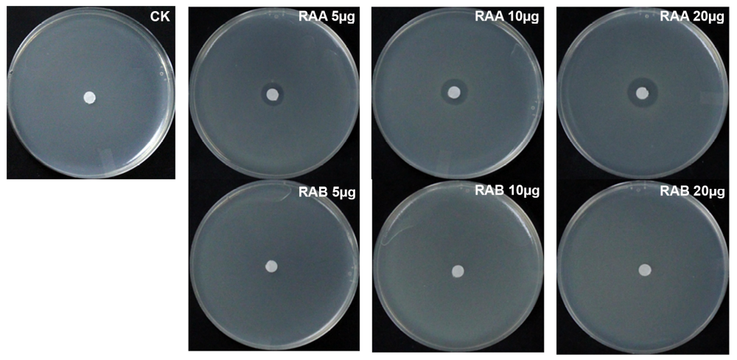
Extended Data Fig. 3 | Antagonistic activity assays of RAB
Comparative analysis of antagonistic activity against E. amylovora strain 110 using Methanol solvent control (CK), RAA, and RAB at various concentrations.

Extended Data Fig. 4 | LCMS analysis of ∆ras1, ∆ras3, ∆ras4, and ∆ras6 for detection of RAB at m/z 275
LCMS analysis of mutants Δras1, Δras2, Δras3, Δras4, Δras5, Δras6, Δras2Δras5, and complemented mutants CΔras1, CΔras2, CΔras3, CΔras4, CΔras5, CΔras6 for detection of RAA at m/z 184 showing peak at a retention time of 9.8 min indicates RAA produced from these strains.

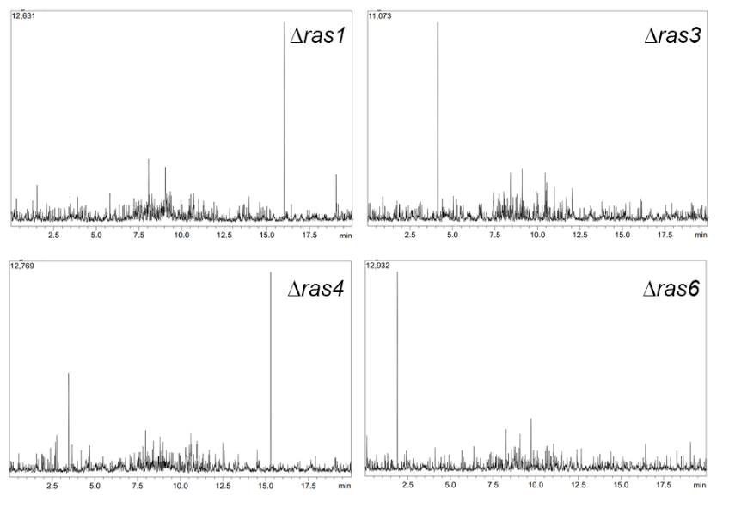
Extended Data Fig. 5 | LCMS analysis of ∆ras1, ∆ras3, ∆ras4, and ∆ras6 for detection of RAB at m/z 275
LCMS analysis of ∆ras1, ∆ras3, ∆ras4, and ∆ras6 for detection of RAB at m/z 275 showing no peak at retention time of 7.8 min indicates no RAB produced from these strains.

