Supplementary Data 1.

Cell culture and cell viability test
HaCat (human keratinocyte) cells (Thermo Fisher Scientific) were utilized to assess cell viability following treatment with Tryptophol (TOH). The cells were cultured in RPMI-1640 medium supplemented with 10% fetal bovine serum (FBS) (Gibco™, Grand Island, NY, USA) and 100 U/ml of penicillin-streptomycin (Pen-Strep) (Gibco™, Grand Island, NY, USA), under humidified conditions with 5% CO₂ at 37°C. Cell viability was evaluated using the MTT assay (3-(4,5-dimethylthiazol-2-yl)-2,5-diphenyl tetrazolium bromide) (Bio Basic Inc., Canada) following treatment with varying concentrations of TOH (Sigma-Aldrich, St. Louis, MO, USA). HaCat cells were seeded at a density of 5 × 10⁴ cells/ml in a 96-well plate and treated with 100 μl of TOH at concentrations of 100, 1000, and 10,000 μM. Positive and negative controls included 50% DMSO and 10% FBS-complete media, respectively. After 24 hours of incubation, 10 μl of MTT solution (0.5 μg/μl) was added, and absorbance was measured spectrophotometrically at 540 nm (Sunrise Tecan, Grödig, Austria). All experiments were conducted in triplicate.
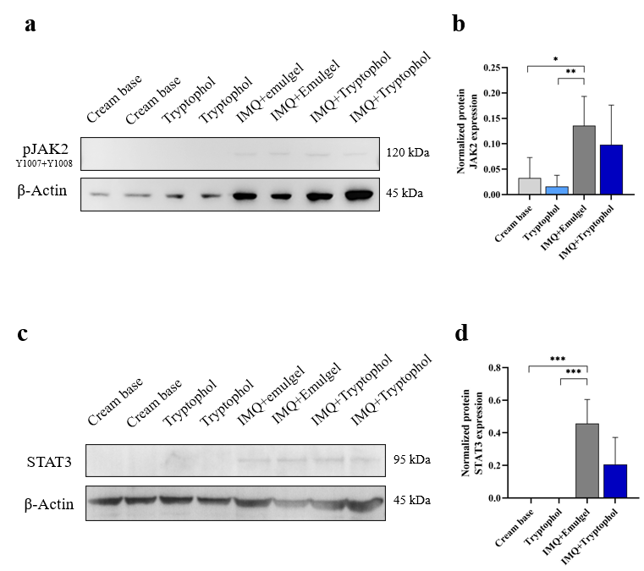
Supplementary Figure S1. The TOH-containing emulgel reduced the protein expression of JAK2 and STAT3 in IMQ-induced psoriasis in mice. (a) Representative images from the Western blot analysis of pJAK2 protein. Each blot was cropped from the same membranes, all exposed for the same duration. Each membrane comprised 8 lanes, with two samples from each experimental group. (b) Quantification of JAK2 protein expression was performed using ImageJ, normalized to β-actin (n=4). (c) Representative images from the Western blot analysis of STAT3 protein. Each blot was cropped from the same membranes, all exposed for the same duration. Each membrane comprised 8 lanes, with two samples from each experimental group. (d) Quantification of JAK2 protein expression was performed using ImageJ, normalized to β-actin (n=4).
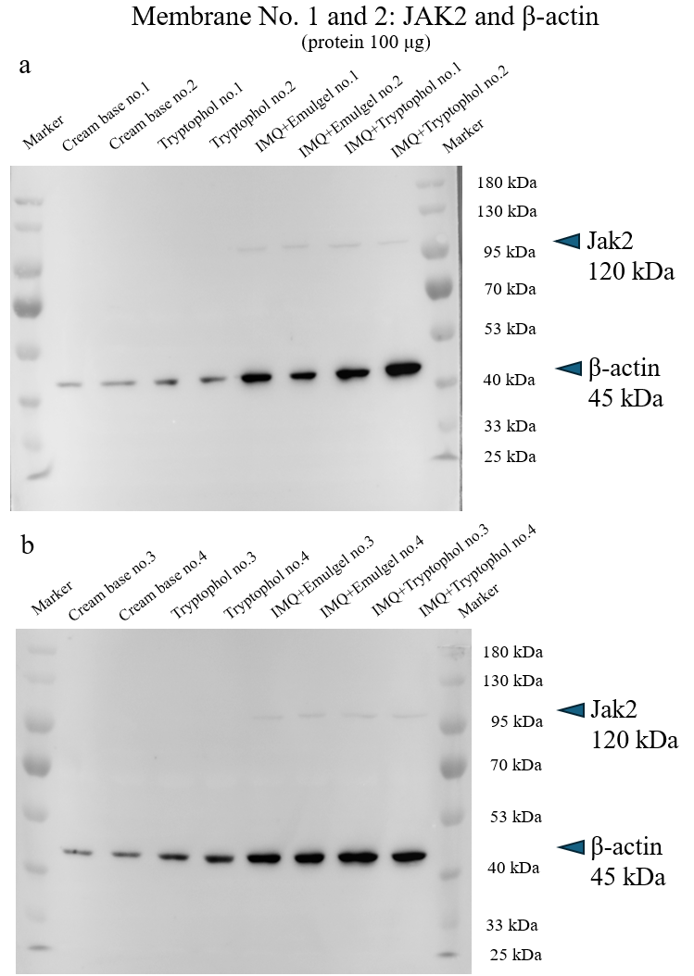
Supplementary Figure S2. Uncropped Western blot analysis of pJAK2 expression in all experimental groups. (a) Representative Western Blot results of pJAK2 and β-actin protein in the cream base group (sample no. 1 and 2), Tryptophol group (sample no. 1 and 2), IMQ+Emulgel group (sample no. 1 and 2) and IMQ+Tryptophol (sample no. 1 and 2). (b) Representative Western Blot results of pJAK2 and β-actin protein in the cream base group (sample no. 3 and 4), Tryptophol group (sample no. 3 and 4), IMQ+Emulgel group (sample no. 3 and 4) and IMQ+Tryptophol (sample no. 3 and 4). Each lane was loaded with 100 µg of protein in 7.5% SDS polyacrylamide gel.
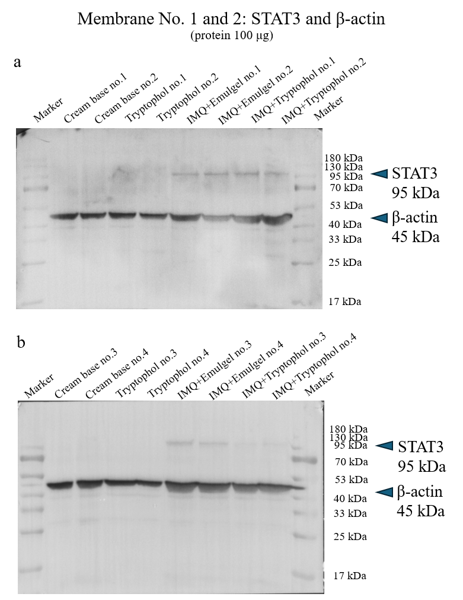
Supplementary Figure S3. Uncropped Western blot analysis of STAT3 expression in all experimental groups. (a) Representative Western Blot results of STAT3 and β-actin protein in the cream base group (sample no. 1 and 2), Tryptophol group (sample no. 1 and 2), IMQ+Emulgel group (sample no. 1 and 2) and IMQ+Tryptophol (sample no. 1 and 2). (b) Representative Western Blot results of STAT3 and β-actin protein in the cream base group (sample no. 3 and 4), Tryptophol group (sample no. 3 and 4), IMQ+Emulgel group (sample no. 3 and 4) and IMQ+Tryptophol (sample no. 3 and 4). Each lane was loaded with 100 µg of protein in 10% SDS polyacrylamide gel.
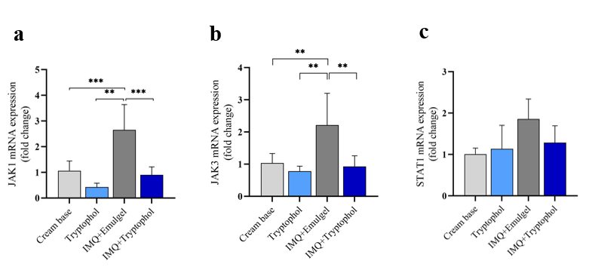
Supplementary Figure S4. Activation of JAK/STAT pathway. qRT-PCR analysis of representative genes associated with IMQ-induced mice psoriasis. (a) mRNA expression of JAK1, (b) mRNA expression of JAK3 and (c) mRNA expression of STAT1. Significance was determined by one-way ANOVA followed by Tukey’s test. *p < 0.05, **p < 0.01, ***p < 0.001.

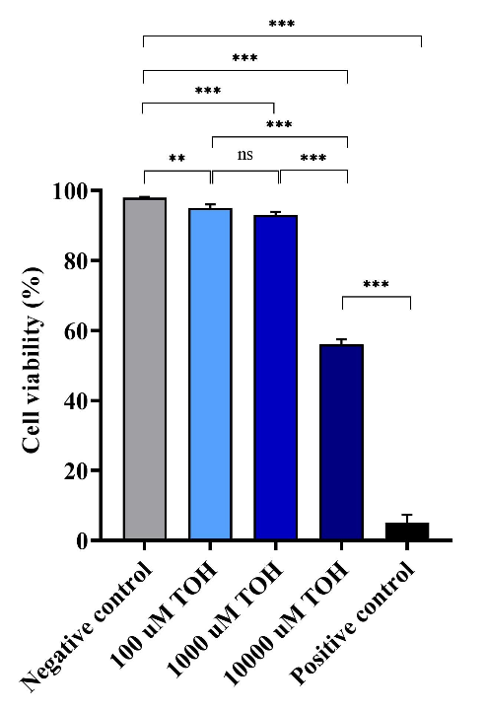
Supplementary Figure S5. HaCat cell viability after being treated with different concentration of TOH. Significance was determined by one-way ANOVA followed by Tukey’s test. *p < 0.05, **p < 0.01, ***p < 0.001.

Supplementary Table 1. Primers were used in this experiment.
Gene name | Primer | Sequence (5′-3′) | Accession No. | References
IL-1 | IL-1-F  IL-1-R | 5’- GCAACTGTTCCTGAACTCAACT-3’  5’- ATCTTTTGGGGTCCGTCCAACT-3’ | AK168047.1 | 1
IL-6 | IL-6-F  IL-6-R | 5’- GACAAAGCC AGAGTCCTTCAGAGAGA-3’  5’- GGTCTTGGTCCTTAGCCACTCCTT-3’ | M24221.1 | 1
IL-17 | IL-17A -F  IL-17A -R | 5′-CCTCAGACTACCTCAACCGTTCC-3′  5′- AGGCTCC CTCTTCAGGACCAG -3′ | BC119303.1 | 1
IL-23 | IL-23-F  IL-23-R | 5′- AATGTGCCCCGTATCCAGTG-3′  5′-GAAGATGTCAGAGTCAAGCAGGTG -3′ | BC019953.1 | 1
IL-33 | IL-33-F  IL-33-R | 5′- CTGCAGGAAAGTACAGCATTCA-3′  5′- TTGCCGGGGAAATCTTGGAG -3′ | NM_001164724.2 | 2
ST2 | ST2-F  ST2-R | 5′- AAAATTCTATGATGGGCGGGT-3′  5′- ATGGTGTGTTCACTAGGCGG-3′ | X60184.1 | 2
TNF-a | TNF-α F  TNF-α R | 5’-ACTGATGAGAGGGAGGCCAT-3’  5’-CCGTGGGTTGGACAGATGAA-3’ | AB039228.1 | 3
K6 | K6-F  K6-R | 5’-GTGGCCTCAGCTCTTCTACC-3’  5’-TCTGAGCACGGGATTCTGC-3’ | BC080820.1 | 4
K10 | K10-F  K10-R | 5’-GCCTCCTACATGGACAAAGTC-3’  5’-GCTTCTCGTACCACTCCTTGA-3’ | AF245658.1 | 3
K16 | K16-F  K16-R | 5’-TGGATGGCGAGAATATCCACAG-3’  5’-GCTCCTTGAGGATGGACCG-3’ | AF053235.1 | 4
Gene name | Primer | Sequence (5′-3′) | Accession No. | References
K17 | K17-F  K17-R | 5’-GCCCACCTGACTCAGTACAA-3’  5’-GGAGCTGAGTCCTTAACGGG-3’ | BC032161.2 | 4
Involucrin | Involucrin-F  Involucrin-R | 5’-ATGTCCCATCAACACACACTG-3’  5’-TGGAGTTGGTTGCTTTGCTTG-3’ | NM_008412.3 | 3
S100A8 | S100A8-F  S100A8-R | 5’- ATCACCATGCCCTCTACAAGAATG -3’  5’- GTCCAATTCTCTGAACAAGTTTCG -3’ | NM_013650.2 | 5
S100A9 | S100A9-F  S100A9-R | 5’- CTCTAGGAAGGAAGGACACC -3’  5’- GCCATCAGCATCATACACTC -3’ | NM_009114.3 | 5
JAK1 | JAK1-F  JAK1-R | 5’- CTCCGAACCGAATCATCACT -3’  5’- GCCGTTTTTCTGCTTCTTTG -3’ | NM_146145.2 | 6
JAK2 | JAK2-F  JAK2-R | 5’- TTGTGGTATTACGCCTGTGTATC -3’  5’- ATGCCTGGTTGACTCGTCTAT -3’ | L16956.1 | 7
JAK3 | JAK3-F  JAK3-R | 5’- CCATCACGTTAGACTTTGCCA -3’  5’- GGCGGAGAATATAGGTGCCTG -3’ | BC105577.1 | 7
STAT1 | STAT1-F  STAT1-R | 5’- TGGTGAAATTGCAAGAGCTG -3’  5’- TGTGTGCGTACCCAAGATGT -3’ | XM_030252467.2 | 6
STAT3 | STAT3-F  STAT3-R | 5’- AGCAGAATCTCAACTTCAGACC-3’  5’- TTCGTGGTAAACTGGACACC-3’ | NM_213659.4 | 8
BCL2 | BCL2-F  BCL2-R | 5’- AGGAGCAGGTGCCTACAAGA -3’  5’- GCATTTTCCCACCACTGTCT -3’ | AH001858.2 | 6
Gene name | Primer | Sequence (5′-3′) | Accession No. | References
CCND1 | CCND1-F  CCND1-R | 5’- GCGTACCCTGACACCAATCT -3’  5’- ATCTCCTTCTGCACGCACTT -3’ | NM_007631.3 | 6
B-Actin | B-Actin-F  B-Actin-R | 5’-GGCTGTATTCCCCTCCATCG-3’  5’-CCAGTTGGTAACAATGCCATGT-3’ | NM_007393.5 | 3

References
1. Zhang, S. et al. Hyperforin Ameliorates Imiquimod-Induced Psoriasis-Like Murine Skin Inflammation by Modulating IL-17A–Producing γδ T Cells. Front. Immunol. 12, 635076; 10.3389/fimmu.2021.635076 (2021).
2. Zeng, F. et al. An autocrine circuit of IL-33 in keratinocytes is involved in the progression of psoriasis. J. Invest. Dermatol. 141 (3), 596-606; 10.1016/j.jid.2020.07.027 (2021).
3. Chen, Y. et al. Esculetin ameliorates psoriasis-like skin disease in mice by inducing CD4+ Foxp3+ regulatory T cells. Front. Immunol. 9, 2092; 10.3389/fimmu.2018.02092 (2018).
4. Qiao, P. et al. Activation of the C3a anaphylatoxin receptor inhibits keratinocyte proliferation by regulating keratin 6, keratin 16, and keratin 17 in psoriasis. FASEB J, 36 (5), e22322; 10.1096/fj.202101458R (2022).
5. Christmann, C. et al. Interleukin 17 promotes expression of alarmins S100A8 and S100A9 during the inflammatory response of keratinocytes. Front. Immunol. 11, 599947; 10.3389/fimmu.2020.599947 (2021).
6. Chen, Y. et al. Topical application of berberine ameliorates imiquimod-induced psoriasis-like dermatitis in BALB/c mice via suppressing JAK1/STAT1 signaling pathway. Arab. J. Chem. 17 (3), 105612; 10.1016/j.arabjc.2024.105612 (2024).
7. Maglakelidze, N., Gao, T., Feehan, R. P., & Hobbs, R. P. AIRE deficiency leads to the development of alopecia areata‒like lesions in mice. J Invest Dermatol. 143 (4), 578-587; 10.1016/j.jid.2022.09.656 (2023).
8. Plaza, R., Vidal, S., Rodriguez-Sanchez, J. L., & Juarez, C. Implication of STAT1 and STAT3 transcription factors in the response to superantigens. Cytokine. 25 (1), 1-10; 10.1016/j.cyto.2003.09.006 (2004).

