Supplementary material:
List of Supplements: 1 Supplementary Figure and 2 Supplementary Tables
CA computes the chi-squared statistic between each variable of interest and the outcome and transforms this statistic into a Euclidean distance. The results below are in addition to the scatterplot that plotted the levels of the variables and outcome onto two dimensions of location and severity of inflammation that explain the largest portion of the variability in the data. The contribution to chi square and the Pearson residuals provides a framework of which variables contribute and to what extent to the identification and description of our proposed dimensional solution in CA which include location in the Y axis and severity on the X axis. In CA, the contribution to chi-square measures the extent to which each cell contributes to the overall chi-square statistic. Pearson residual measures the discrepancy between observed and expected frequencies in a contingency table and it is calculated as the difference between the observed and expected frequencies divided by the square root of the expected frequency.

eFigure 1: Multiple Correspondence analysis- Inertia and Chi-Square Decomposition
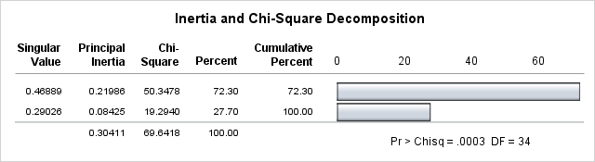

CA revealed distinct clustering of variables around the three diagnoses based on two the possible dimensions of severity of infiltrate (largest explained inertia, 72%) and location of inflammation (smaller explained inertia, 28%).

eTable S1: Multiple Correspondence analysis demonstrating contribution to chi-square and Pearson residual on basis of location (Y-axis)
Item | Contribution to Chi square | Pearson residual
Cortical and white matter angiocentric inflammation | 0.02 | -0.3 for both cortical and white matter
Cortical and white matter perivascular inflammation | 0.01 | -0.2 and -0.8 respectively
Cortical and white matter intramural inflammation | 0.005 and 0.02 respectively | 0.876 for both
Reactive endothelium | 0.5 | -0.724
CD3 inflammatory infiltrate- angiocentric | 0.2 | 0.41
CD4 inflammatory infiltrate- angiocentric | 0.225 | 0.4
CD8 inflammatory infiltrate- angiocentric | 0.017 | 0.6

eTable S2: Multiple Correspondence analysis demonstrating contribution to chi-square and Pearson residual on basis of severity (X-axis)
Item | Contribution to Chi square | Pearson residual
Cortical inflammation- moderate | 1.09 | 1.04
Cortical inflammation- severe | 0.26 | -0.51
White matter inflammation- moderate | 0.98 | 0.99
White matter inflammation – severe | 0.26 | -0.51
CD3 moderate inflammation | 1.42 | 1.19
CD3 severe inflammation | 2.15 | -1.4
CD4 moderate inflammation | 1.31 | 1.47
CD4 severe inflammation | 1.22 | 1.106
CD8 moderate inflammation | 0.76 | 0.87
CD8 severe inflammation | 1.22 | -1.10

