Title:
Climate change may increase the suitable habitats for invasive freshwater Cichlids in a Neotropical basin.

Author names and affiliations:
Cristian Martínez-González ^{1*} ccmartinez2@uc.cl
Lúcia Aparecida de Fatima Mateus ² lafmateus@gmail.com
Thadeu Sobral-Souza ³ thadeusobral@gmail.com
Yzel Rondon Súarez ⁴ yzelrondonsuarez@gmail.com
Jerry Magno Ferreira Penha ² jpenha.bio@gmail.com
¹ Graduate Program in Ecology and Biodiversity Conservation, Institute of Biological Sciences, Federal University of Mato Grosso, Av. Fernando Corrêa, 2367, Cuiabá, Mato Grosso, 78060-900, Brazil.
² Laboratory of Ecology and Management of Fisheries Resources, Institute of Biological Sciences, Federal University of Mato Grosso, Cuiabá, Mato Grosso, Brazil, Av. Fernando Corrêa, 2367, Cuiabá, Mato Grosso, 78060-900, Brazil.
³ Department of Botany, Institute of Biological Sciences, Federal University of Mato Grosso, Cuiabá, Brazil, Av. Fernando Corrêa, 2367, Cuiabá, Mato Grosso, 78060-900, Brazil.
⁴ State University of Mato Grosso do Sul, Mato Grosso do Sul, Rod. Dourados-Itahum, Km 12, Dourados, Mato Grosso do Sul, 79804-970, Brazil.

*Corresponding author:
Cristian Martínez-González ccmartinez2@uc.cl
Supplementary Material:

SM-1a. Variance Inflation Factor (VIF) values for selected hydroclimatic variables in the Br-UPRB + Nile basins for modeling the suitable habitats for Oreochromis niloticus.
Variables | Variable explanation | VIF
hydro_02 | Mean Diurnal Range (Mean of monthly (max temp - min temp)) | 2.864
hydro_03 | Isothermality (BIO2/BIO7) (×100) | 3.278
hydro_08 | Mean Temperature of Wettest Quarter | 1.629
hydro_09 | Annual Precipitation | 1.338
hydro_14 | Precipitation of Driest Month | 2.292
hydro_15 | Precipitation Seasonality (Coefficient of Variation) | 2.953
hydro_18 | Precipitation of Warmest Quarter | 3.076
hydro_19 | Precipitation of Coldest Quarter | 2.679

SM-1b. Variance Inflation Factor (VIF) values for selected hydroclimatic variables in the Br-UPRB + Araguaia - Tocantins basins for modeling the suitable habitats for Cichla spp.
Variables | Variable explanation | VIF
hydro_02 | Mean Diurnal Range (Mean of monthly (max temp - min temp)) | 1.700
hydro_04 | Temperature Seasonality (standard deviation ×100) | 4.833
hydro_10 | Mean Temperature of Warmest Quarter | 1.109
hydro_12 | Annual Precipitation | 3.439
hydro_15 | Precipitation Seasonality (Coefficient of Variation) | 2.319
hydro_18 | Precipitation of Warmest Quarter | 2.822
hydro_19 | Precipitation of Coldest Quarter | 3.861

SM-2a. Environmental variables predictor for modeling Oreochromis niloticus habitat suitability.
These climatic data, used in several ENMs, are considered standard for modeling terrestrial and freshwater species distributions ⁴.
Variable name | Scenarios | SSP | Variable explanation | Aggregation | Unit | Type | Source | Resolution | Raster type
dem_03 | Current; 2050 | - | Elevation range | range | [m] | Int32 | EarthEnv/HydroSHEDS | 30arcsec | .TIF
flow_02 | Current; 2050 | - | Number of upstream catchment grid cells | sum | count | Int32 | EarthEnv/HydroSHEDS | 30arcsec | .TIF
slope_avg | Current; 2050 | - | Slope range | range | [°] * 100 | Int32 | EarthEnv/HydroSHEDS | 30arcsec | .TIF
hydro_avg_02 | Current | - | Mean Diurnal Range (Mean of monthly (max temp - min temp)) | average | [°C] * 10 | Int32 | EarthEnv/HydroSHEDS | 30arcsec | .TIF
hydro_avg_03 | Current | - | Isothermality (BIO2/BIO7) (×100) | average | * 100 | Int32 | EarthEnv/HydroSHEDS | 30arcsec | .TIF
hydro_avg_08 | Current | - | Mean Temperature of Wettest Quarter | average | [°C] * 10 | Int32 | EarthEnv/HydroSHEDS | 30arcsec | .TIF
hydro_avg_09 | Current | - | Annual Precipitation | sum | [mm] | Float64 | EarthEnv/HydroSHEDS | 30arcsec | .TIF
hydro_avg_13 | Current | - | Precipitation of Wettest Month | sum | [mm] | Float64 | EarthsuarezEnv/HydroSHEDS | 30arcsec | .TIF
hydro_avg_14 | Current | - | Precipitation of Driest Month | sum | [mm] | Float64 | EarthEnv/HydroSHEDS | 30arcsec | .TIF
hydro_avg_15 | Current | - | Precipitation Seasonality (Coefficient of Variation) | sum | * 100 | Float64 | EarthEnv/HydroSHEDS | 30arcsec | .TIF
hydro_avg_18 | Current | - | Precipitation of Warmest Quarter | sum | [mm] | Float64 | EarthEnv/HydroSHEDS | 30arcsec | .TIF
hydro_avg_19 | Current | - | Precipitation of Coldest Quarter | sum | [mm] | Float64 | EarthEnv/HydroSHEDS | 30arcsec | .TIF
bio02_ensemble_ CMCC-ESM2_HadGEM3-GC31-LL | 2050 | 2 4.5 | Mean Diurnal Range (Mean of monthly (max temp - min temp)) | average | [°C] * 10 | Int32 | WorldClim⁷ | 30arcsec | .TIF
bio03_ensemble_ CMCC-ESM2_HadGEM3-GC31-LL | 2050 | 2 4.5 | Isothermality (BIO2/BIO7) (×100) | average | [°C] * 10 | Int32 | WorldClim⁷ | 30arcsec | .TIF
bio08_ensemble_ CMCC-ESM2_HadGEM3-GC31-LL | 2050 | 2 4.5 | Mean Temperature of Wettest Quarter | average | [°C] * 10 | Int32 | WorldClim⁷ | 30arcsec | .TIF
bio09_ensemble_ CMCC-ESM2_HadGEM3-GC31-LL | 2050 | 2 4.5 | Annual Precipitation | sum | [mm] | Float64 | WorldClim⁷ | 30arcsec | .TIF
bio13_ensemble_ CMCC-ESM2_HadGEM3-GC31-LL | 2050 | 2 4.5 | Precipitation of Wettest Month | sum | [mm] | Float64 | WorldClim⁷ | 30arcsec | .TIF
bio14_ensemble_ CMCC-ESM2_HadGEM3-GC31-LL | 2050 | 2 4.5 | Precipitation of Driest Month | sum | [mm] | Float64 | WorldClim⁷ | 30arcsec | .TIF
bio15_ensemble_ CMCC-ESM2_HadGEM3-GC31-LL | 2050 | 2 4.5 | Precipitation Seasonality (Coefficient of Variation) | sum | * 100 | Float64 | WorldClim⁷ | 30arcsec | .TIF
bio18_ensemble_ CMCC-ESM2_HadGEM3-GC31-LL | 2050 | 2 4.5 | Precipitation of Warmest Quarter | sum | [mm] | Float64 | WorldClim⁷ | 30arcsec | .TIF
bio19_ensemble_ CMCC-ESM2_HadGEM3-GC31-LL | 2050 | 2 4.5 | Precipitation of Coldest Quarter | sum | [mm] | Float64 | WorldClim⁷ | 30arcsec | .TIF

SM-2b. Environmental variables predictor for modelling Chila spp. habitat suitability.
These climatic data, used in various ENMs, are considered standard for modeling freshwater species distributions ⁴.
Variable name | Scenarios | SSP | Variable explanation | Aggregation | Unit | Type | Source | Resolution | Raster type
dem_03 | Current; 2050 | - | Elevation range | range | [m] | Int32 | EarthEnv/HydroSHEDS | 30arcsec | .TIF
flow_02 | Current; 2050 | - | Number of upstream catchment grid cells | sum | count | Int32 | EarthEnv/HydroSHEDS | 30arcsec | .TIF
slope_avg | Current; 2050 | - | Slope range | range | [°] * 100 | Int32 | EarthEnv/HydroSHEDS | 30arcsec | .TIF
hydro_avg_02 | Current | - | Mean Diurnal Range (Mean of monthly (max temp - min temp)) | average | [°C] * 10 | Int32 | EarthEnv/HydroSHEDS | 30arcsec | .TIF
hydro_avg_04 | Current | - | Temperature Seasonality (standard deviation ×100) | average | [°C] * 10 | Int32 | EarthEnv/HydroSHEDS | 30arcsec | .TIF
hydro_avg_10 | Current | - | Mean Temperature of Warmest Quarter | average | [°C] * 10 | Int32 | EarthEnv/HydroSHEDS | 30arcsec | .TIF
hydro_avg_12 | Current | - | Annual Precipitation | sum | [mm] | Float64 | EarthEnv/HydroSHEDS | 30arcsec | .TIF
hydro_avg_15 | Current | - | Precipitation Seasonality (Coefficient of Variation) | sum | * 100 | Float64 | EarthEnv/HydroSHEDS | 30arcsec | .TIF
hydro_avg_18 | Current | - | Precipitation of Warmest Quarter | sum | [mm] | Float64 | EarthEnv/HydroSHEDS | 30arcsec | .TIF
hydro_avg_19 | Current | - | Precipitation of Coldest Quarter | sum | [mm] | Float64 | EarthEnv/HydroSHEDS | 30arcsec | .TIF
bio02_ensemble_ CMCC-ESM2_HadGEM3-GC31-LL | 2050 | 2 4.5 | Mean Diurnal Range (Mean of monthly (max temp - min temp)) | average | [°C] * 10 | Int32 | WorldClim | 30arcsec | .TIF
bio04_ensemble_ CMCC-ESM2_HadGEM3-GC31-LL | 2050 | 2 4.5 | Temperature Seasonality (standard deviation ×100) | average | [°C] * 10 | Int32 | WorldClim | 30arcsec | .TIF
bio10_ensemble_ CMCC-ESM2_HadGEM3-GC31-LL | 2050 | 2 4.5 | Mean Temperature of Warmest Quarter | average | [°C] * 10 | Int32 | WorldClim | 30arcsec | .TIF
bio12_ensemble_ CMCC-ESM2_HadGEM3-GC31-LL | 2050 | 2 4.5 | Annual Precipitation | sum | [mm] | Float64 | WorldClim | 30arcsec | .TIF
bio15_ensemble_ CMCC-ESM2_HadGEM3-GC31-LL | 2050 | 2 4.5 | Precipitation Seasonality (Coefficient of Variation) | sum | * 100 | Float64 | WorldClim | 30arcsec | .TIF
bio18_ensemble_ CMCC-ESM2_HadGEM3-GC31-LL | 2050 | 2 4.5 | Precipitation of Warmest Quarter | sum | [mm] | Float64 | WorldClim | 30arcsec | .TIF
bio19_ensemble_ CMCC-ESM2_HadGEM3-GC31-LL | 2050 | 2 4.5 | Precipitation of Coldest Quarter | sum | [mm] | Float64 | WorldClim | 30arcsec | .TIF

SM-3a. Variable importance for each ensemble of ENMs of Oreochromis niloticus in current and future 2050 scenarios.
Variable name | Scenarios | SSP | Variable explanation | Variable weight
dem_03 | Current | - | Elevation range | 0.097
flow_02 | Current | - | Number of upstream catchment grid cells | 0.074
slope_avg | Current | - | Slope range | 0.027
hydro_avg_02 | Current | - | Mean Diurnal Range (Mean of monthly (max temp - min temp)) | 0.159
hydro_avg_03 | Current | - | Isothermality (BIO2/BIO7) (×100) | 0.084
hydro_avg_08 | Current | - | Mean Temperature of Wettest Quarter | 0.193
hydro_avg_09 | Current | - | Annual Precipitation | 0.044
hydro_avg_14 | Current | - | Precipitation of Driest Month | 0.071
hydro_avg_15 | Current | - | Precipitation Seasonality (Coefficient of Variation) | 0.11
hydro_avg_18 | Current | - | Precipitation of Warmest Quarter | 0.078
hydro_avg_19 | Current | - | Precipitation of Coldest Quarter | 0.063
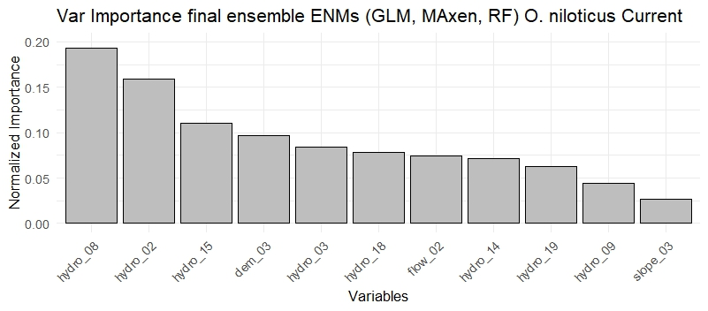 |  |  |  | 1
dem_03 | 2050 | - | Elevation range | 0.11
flow_02 | 2050 | - | Number of upstream catchment grid cells | 0.01
slope_avg | 2050 | - | Slope range | 0.02
bio02_ensemble_ CMCC-ESM2_HadGEM3-GC31-LL | 2050 | 2 4.5 | Mean Diurnal Range (Mean of monthly (max temp - min temp)) | 0.03
bio03_ensemble_ CMCC-ESM2_HadGEM3-GC31-LL | 2050 | 2 4.5 | Isothermality (BIO2/BIO7) (×100) | 0.135
bio08_ensemble_ CMCC-ESM2_HadGEM3-GC31-LL | 2050 | 2 4.5 | Mean Temperature of Wettest Quarter | 0.18
bio09_ensemble_ CMCC-ESM2_HadGEM3-GC31-LL | 2050 | 2 4.5 | Annual Precipitation | 0.03
bio14_ensemble_ CMCC-ESM2_HadGEM3-GC31-LL | 2050 | 2 4.5 | Precipitation of Driest Month | 0.035
bio15_ensemble_ CMCC-ESM2_HadGEM3-GC31-LL | 2050 | 2 4.5 | Precipitation Seasonality (Coefficient of Variation) | 0.1
bio18_ensemble_ CMCC-ESM2_HadGEM3-GC31-LL | 2050 | 2 4.5 | Precipitation of Warmest Quarter | 0.27
bio19_ensemble_ CMCC-ESM2_HadGEM3-GC31-LL | 2050 | 2 4.5 | Precipitation of Coldest Quarter | 0.08
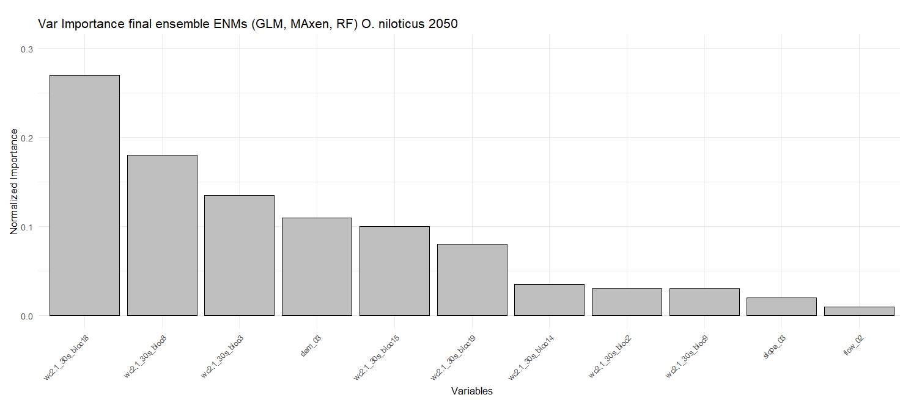 |  |  |  | 1

SM-3b. Variable importance for each ensemble of ENMs of Cichla kelberi in current and future 2050 scenarios.
Variable name | Scenarios | SSP | Variable explanation | Variable weight
dem_03 | Current | - | Elevation range | 0.064
flow_02 | Current | - | Number of upstream catchment grid cells | 0.098
slope_avg | Current | - | Slope range | 0.063
hydro_avg_02 | Current | - | Mean Diurnal Range (Mean of monthly (max temp - min temp)) | 0.043
hydro_avg_04 | Current | - | Temperature Seasonality (standard deviation ×100) | 0.158
hydro_avg_10 | Current | - | Mean Temperature of Warmest Quarter | 0.153
hydro_avg_12 | Current | - | Annual Precipitation | 0.104
hydro_avg_15 | Current | - | Precipitation Seasonality (Coefficient of Variation) | 0.186
hydro_avg_18 | Current | - | Precipitation of Warmest Quarter | 0.103
hydro_avg_19 | Current | - | Precipitation of Coldest Quarter | 0.028
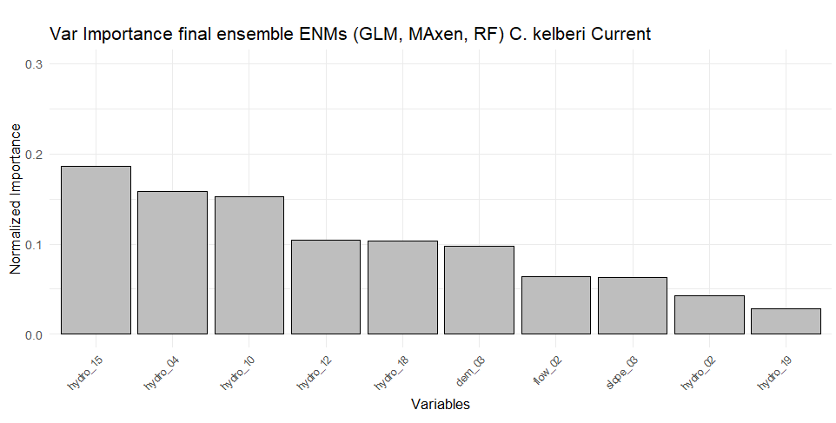 |  |  |  | 1
dem_03 | 2050 | - | Elevation range | 0.1161
flow_02 | 2050 | - | Number of upstream catchment grid cells | 0.0143
slope_avg | 2050 | - | Slope range | 0.0619
bio02_ensemble_ CMCC-ESM2_HadGEM3-GC31-LL | 2050 | 2 4.5 | Mean Diurnal Range (Mean of monthly (max temp - min temp)) | 0.0695
bio04_ensemble_ CMCC-ESM2_HadGEM3-GC31-LL | 2050 | 2 4.5 | Temperature Seasonality (standard deviation ×100) | 0.2592
bio10_ensemble_ CMCC-ESM2_HadGEM3-GC31-LL | 2050 | 2 4.5 | Mean Temperature of Warmest Quarter | 0.1371
bio12_ensemble_ CMCC-ESM2_HadGEM3-GC31-LL | 2050 | 2 4.5 | Annual Precipitation | 0.0352
bio15_ensemble_ CMCC-ESM2_HadGEM3-GC31-LL | 2050 | 2 4.5 | Precipitation Seasonality (Coefficient of Variation) | 0.2235
bio18_ensemble_ CMCC-ESM2_HadGEM3-GC31-LL | 2050 | 2 4.5 | Precipitation of Warmest Quarter | 0.0832
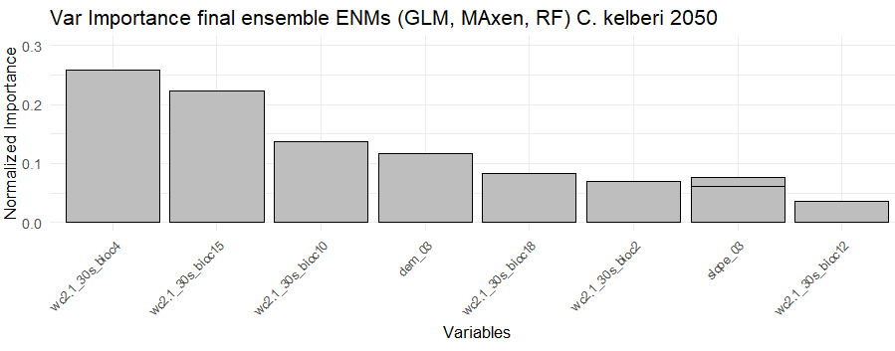 |  |  |  | 1

SM-3c. Variable importance for each ensemble of ENMs of Cichla piquiti in current and future 2050 scenarios.
Variable name | Scenarios | SSP | Variable explanation | Variable weight
dem_03 | Current | - | Elevation range | 0.065
flow_02 | Current | - | Number of upstream catchment grid cells | 0.075
slope_avg | Current | - | Slope range | 0.025
hydro_avg_02 | Current | - | Mean Diurnal Range (Mean of monthly (max temp - min temp)) | 0.1615
hydro_avg_04 | Current | - | Temperature Seasonality (standard deviation ×100) | 0.145
hydro_avg_10 | Current | - | Mean Temperature of Warmest Quarter | 0.035
hydro_avg_12 | Current | - | Annual Precipitation | 0.085
hydro_avg_15 | Current | - | Precipitation Seasonality (Coefficient of Variation) | 0.275
hydro_avg_18 | Current | - | Precipitation of Warmest Quarter | 0.095
hydro_avg_19 | Current | - | Precipitation of Coldest Quarter | 0.015
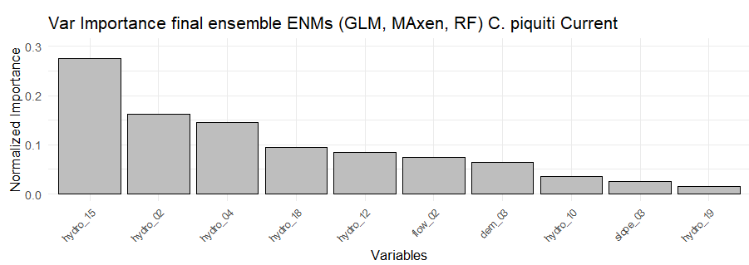
dem_03 | 2050 | - | Elevation range | 0.008
flow_02 | 2050 | - | Number of upstream catchment grid cells | 0.175
slope_avg | 2050 | - | Slope range | 0.053
bio02_ensemble_ CMCC-ESM2_HadGEM3-GC31-LL | 2050 | 2 4.5 | Mean Diurnal Range (Mean of monthly (max temp - min temp)) | 0.159
bio04_ensemble_ CMCC-ESM2_HadGEM3-GC31-LL | 2050 | 2 4.5 | Temperature Seasonality (standard deviation ×100) | 0.053
bio10_ensemble_ CMCC-ESM2_HadGEM3-GC31-LL | 2050 | 2 4.5 | Mean Temperature of Warmest Quarter | 0.043
bio12_ensemble_ CMCC-ESM2_HadGEM3-GC31-LL | 2050 | 2 4.5 | Annual Precipitation | 0.066
bio15_ensemble_ CMCC-ESM2_HadGEM3-GC31-LL | 2050 | 2 4.5 | Precipitation Seasonality (Coefficient of Variation) | 0.363
bio18_ensemble_ CMCC-ESM2_HadGEM3-GC31-LL | 2050 | 2 4.5 | Precipitation of Warmest Quarter | 0.007
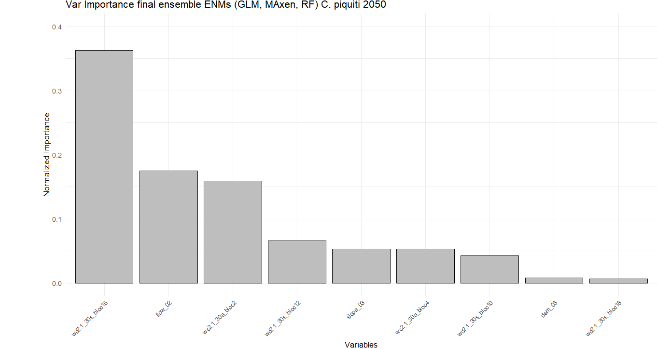 |  |  |  | 1

SM-4. TTS and AUC cabration and validation values for each ENMs algorithm: Generalized Linear Models (GLM), Random Forest (RF), and Maximum Entropy (MaxEnt).
Species | Scenario | Calibration
Oreochromis niloticus | Current  Calibration | 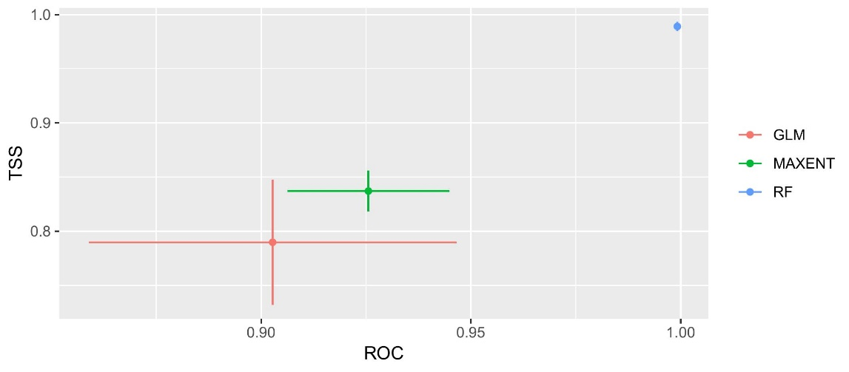
Oreochromis niloticus | Current  Validation | 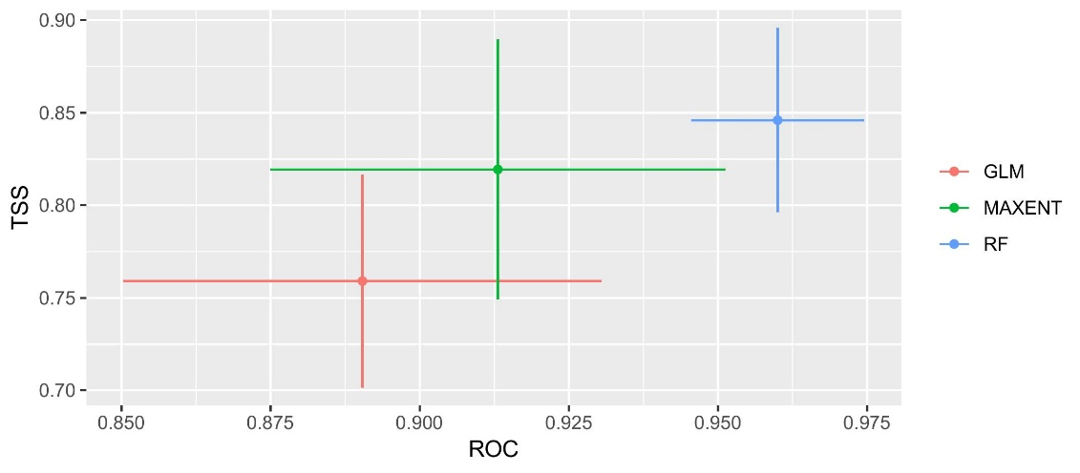
Oreochromis niloticus | 2050  (SSP2 4.5)  Calibration | 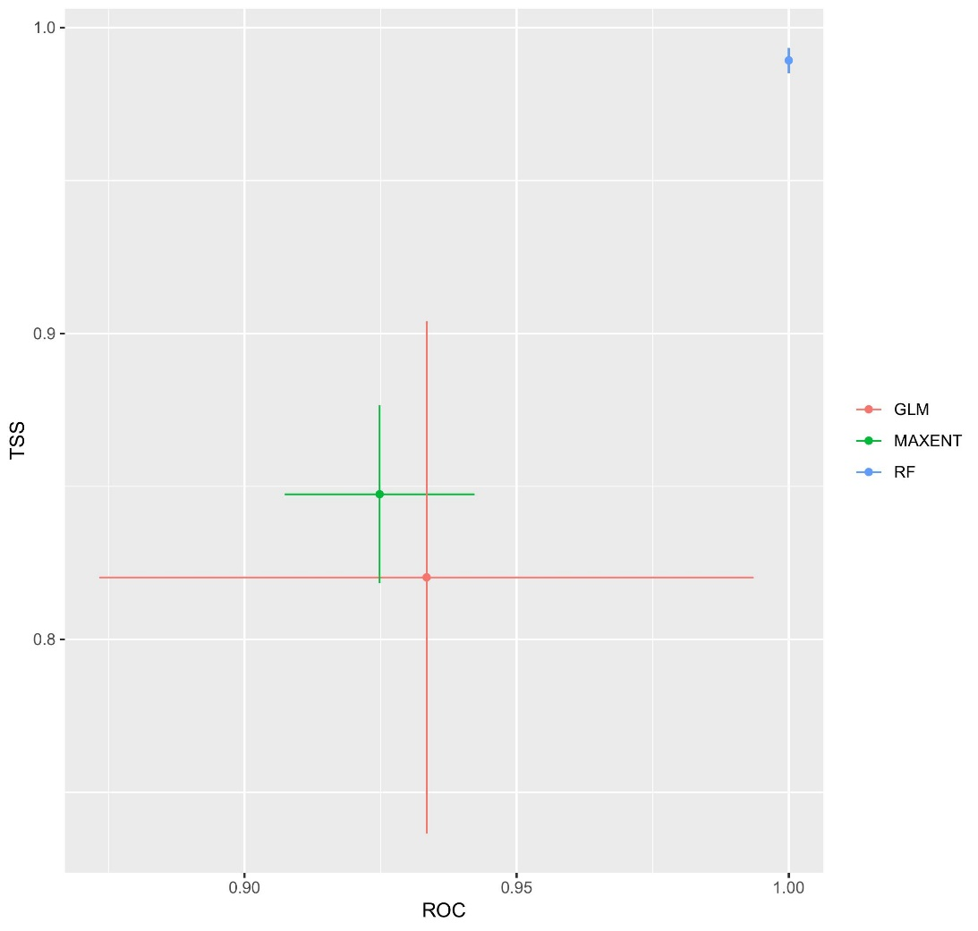
Oreochromis niloticus | 2050  (SSP2 4.5)  Validation | 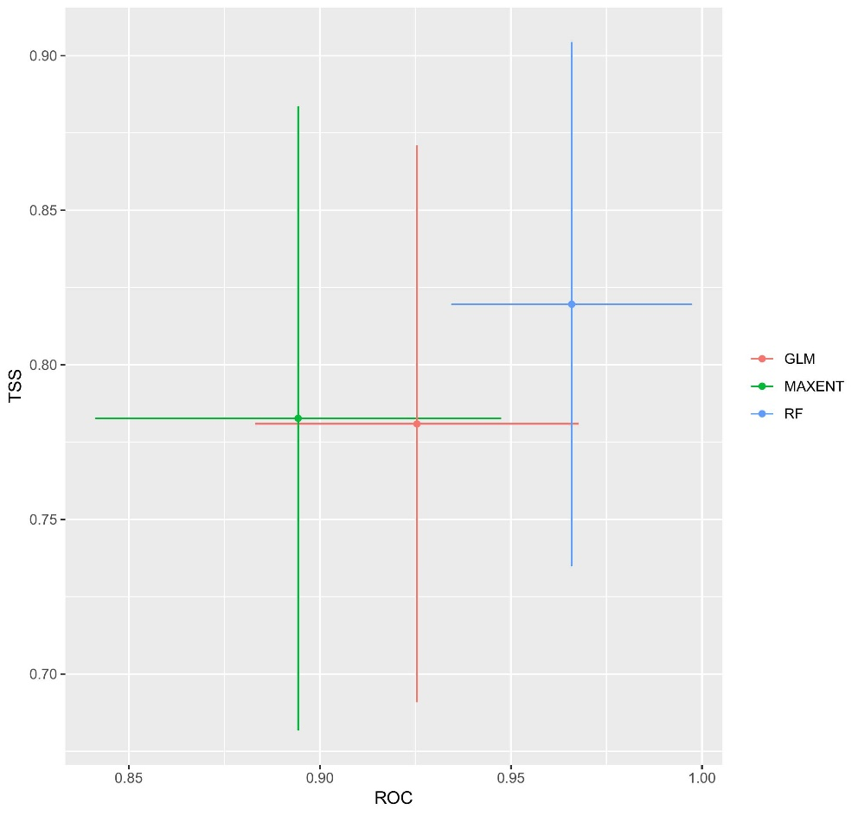
Cichla kelberi | Current  Calibration | 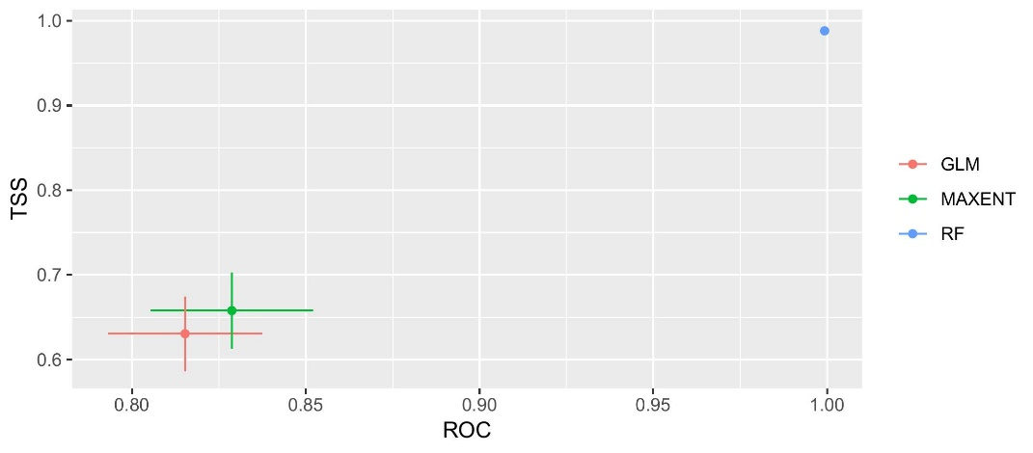
Cichla kelberi | Current  Validation | 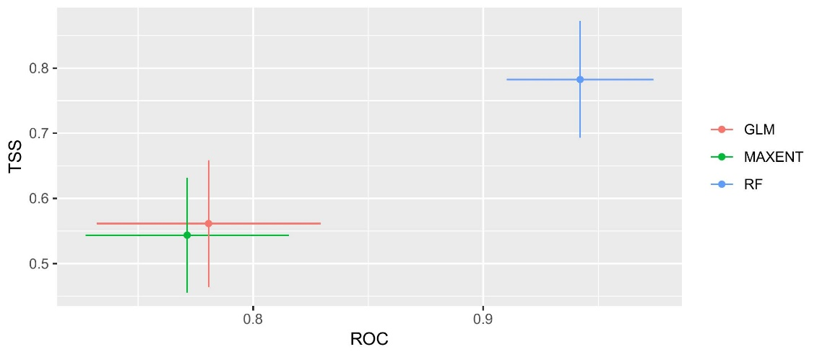
Cichla kelberi | 2050  (SSP2 4.5)  Calibration | 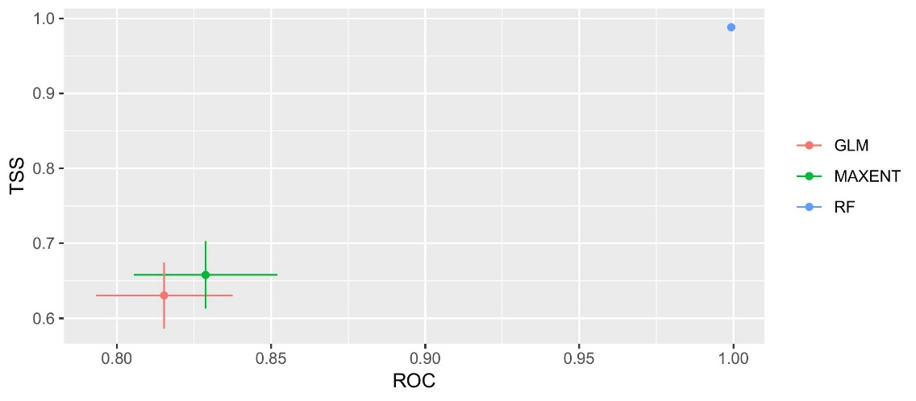
Cichla kelberi | 2050  (SSP2 4.5)  Validation | 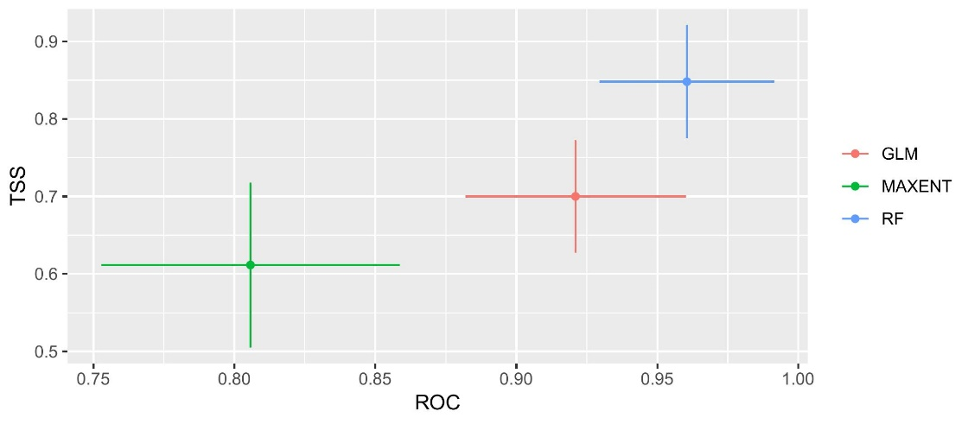
Cichla piquiti | Current  Calibration | 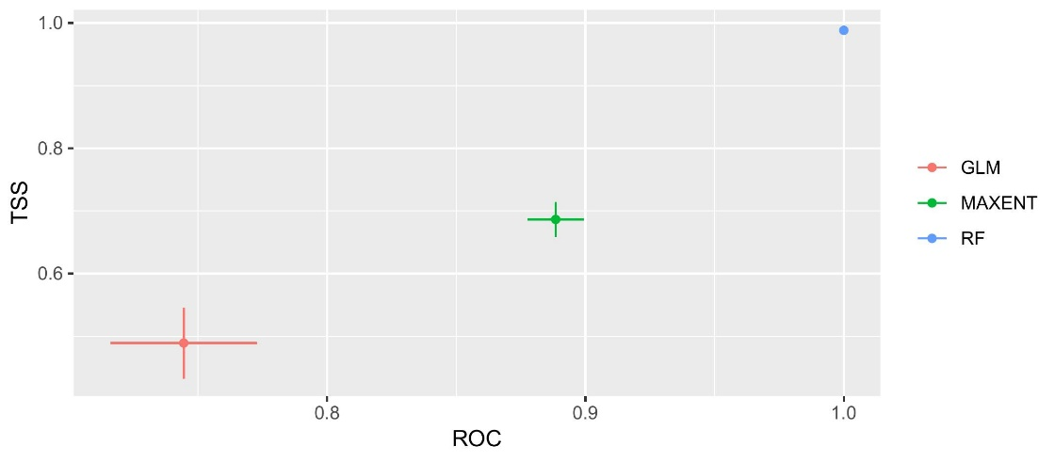
Cichla piquiti | Current  Validation | 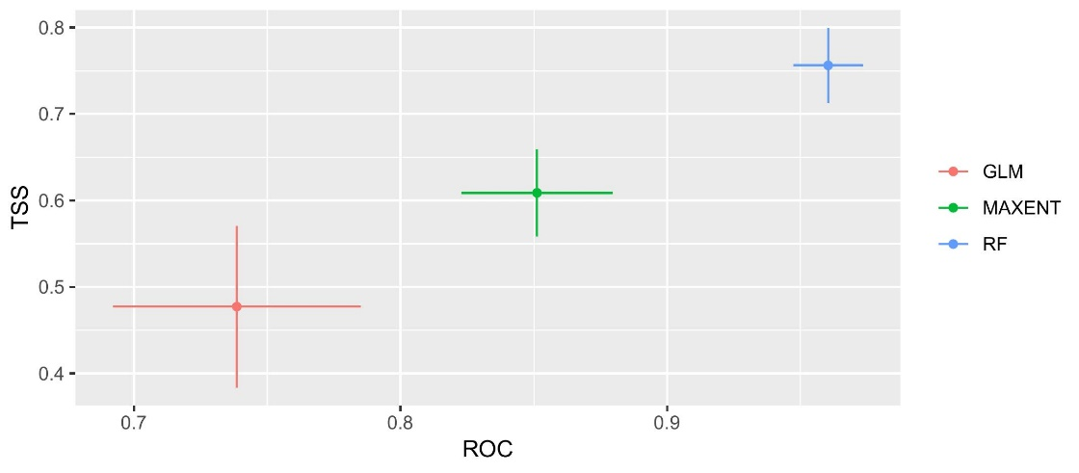
Cichla piquiti | 2050  (SSP2 4.5)  Calibration | 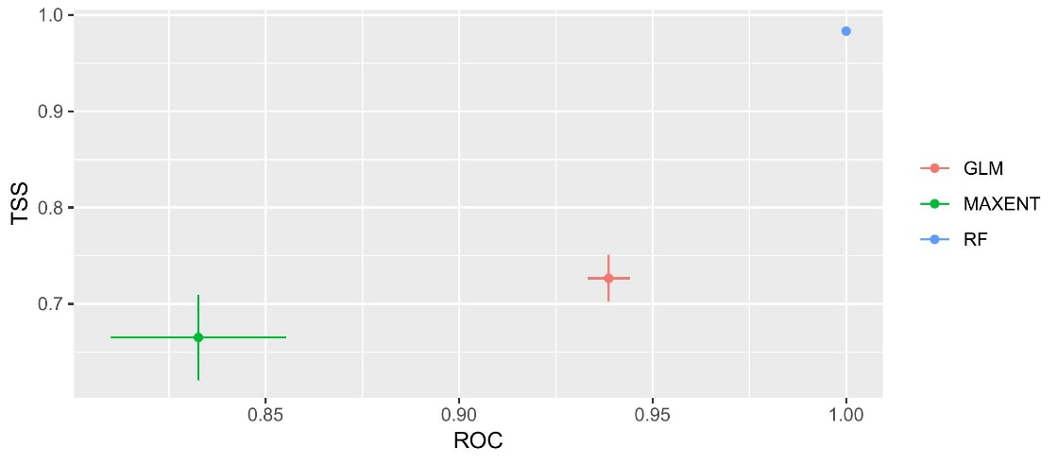
Cichla piquiti | 2050  (SSP2 4.5)  Validation | 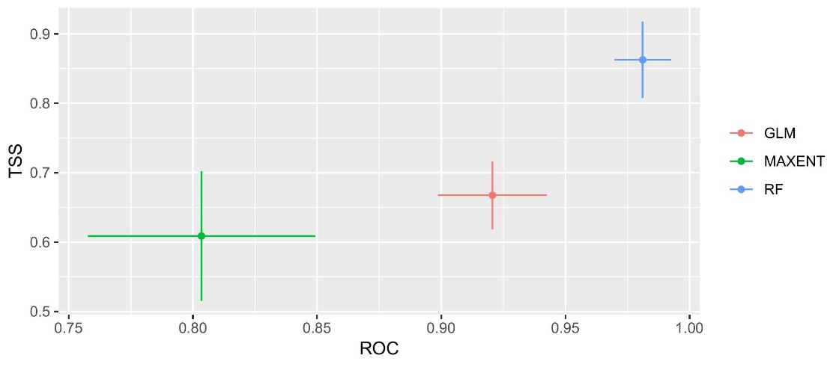

SM-5. Species data / Occurrence database
Fish presence data were collected from diverse sources, including online databases like the Global Biodiversity Information Facility (GBIF; http://www.gbif.org), Species Link (http://www.splink.org.br), FishBase (http://www.fishbase.org/search.php), and FishNet2 (http://www.fishnet2.net/). Additionally, direct records were obtained from ichthyology research groups operating within the Brazilian portion of the Upper Paraguay River Basin (BR-UPRB). The contribution of data came from the Laboratory of Ecology and Management of Fisheries Resources (LEMARPE) at the Universidade Federal de Mato Grosso in Mato Grosso, Brazil, and from the Reports of Diagnostic of ichthyofauna, ichthyoplankton, and fisheries in the Paraguay River basin. The data collection was part of a research project focused on assessing the impacts of hydroelectric project implementation in the Paraguay River Hydrographic Region, funded by the National Water Agency (ANA) in 2018 ¹.

The dataset underwent a rigorous review, including removing ambiguous, duplicate, or unreliable records. Entries lacking precise geographical location or taxonomic information were also excluded from the dataset. We follow the taxonomic classification of Kullander & Ferreira (2006)², and Eschmeyer's Catalog of Fishes (https://researcharchive.calacademy.org). We spatially thinned the occurrence localities by 1 km² to minimize a clustering of records due to biased sampling by using the script "Snap points" by Domisch et al. (2015)³ https://github.com/domisch/stream_layers/blob/master/snap_points.R. We considered a total of 907 occurrence records of 3 freshwater fish IAS introduced in the basin. The coordinates of fish records were reported using a Garmin® Map-62s GPS device in the CSG-WGS-84 geographic coordinate reference system. Ocurrence records are available in the Figshare repository: https://doi.org/10.6084/m9.figshare.26961754 and the following table:
ID | Longitude | Latitude | Spp. | date | Source_reference
1 | -57.95208333 | -15.90208333 | Cichla kelberi | 7-31-2008 | Biological colections UFMT UFMS
2 | -58.23125 | -16.76041667 | Cichla kelberi | 6-14-2013 | Biological colections UFMT UFMS
3 | -59.28958333 | -16.12291667 | Cichla kelberi | 8-27-2016 | Biological colections UFMT UFMS
4 | -57.88541667 | -15.79375 | Cichla kelberi | 8-25-2006 | Biological colections UFMT UFMS
5 | -57.70493878 | -16.00077211 | Cichla kelberi | 12-5-2011 | Biological colections UFMT UFMS
6 | -59.11263078 | -16.25403588 | Cichla kelberi | 8-6-2008 | Biological colections UFMT UFMS
7 | -57.984823 | -15.7103 | Cichla kelberi | 11-19-1992 | Biological colections UFMT UFMS
8 | -58.31041667 | -15.91875 | Cichla kelberi | 11-20-1992 | Biological colections UFMT UFMS
9 | -56.43720675 | -17.00387342 | Cichla piquiti | 5-18-1994 | Biological colections UFMT UFMS
10 | -56.33961983 | -16.97708333 | Cichla piquiti | 5-18-1994 | Biological colections UFMT UFMS
11 | -56.53125 | -17.31875 | Cichla piquiti | 5-18-1994 | Biological colections UFMT UFMS
12 | -57.39375 | -17.39791667 | Cichla piquiti | 6-22-1994 | Biological colections UFMT UFMS
13 | -56.27579811 | -17.24663144 | Cichla piquiti | 6-30-1994 | Biological colections UFMT UFMS
14 | -56.4957416 | -17.29592507 | Cichla piquiti | 6-30-1994 | Biological colections UFMT UFMS
15 | -56.7204736 | -17.30869307 | Cichla piquiti | 6-30-1994 | Biological colections UFMT UFMS
16 | -57.13958333 | -17.31875 | Cichla piquiti | 6-30-1994 | Biological colections UFMT UFMS
17 | -56.58875391 | -16.98875391 | Cichla piquiti | 6-30-1994 | Biological colections UFMT UFMS
18 | -56.33541667 | -16.94791667 | Cichla piquiti | 7-2-1994 | Biological colections UFMT UFMS
19 | -56.82708333 | -17.38958333 | Cichla piquiti | 7-2-1994 | Biological colections UFMT UFMS
20 | -57.07285849 | -16.41041667 | Cichla piquiti | 11-1-2008 | Biological colections UFMT UFMS
21 | -56.5506279 | -15.2881279 | Cichla piquiti | 11-2-2008 | Biological colections UFMT UFMS
22 | -55.68958333 | -17.37146027 | Cichla piquiti | 11-4-2008 | Biological colections UFMT UFMS
23 | -55.22904562 | -17.31654562 | Cichla piquiti | 11-5-2008 | Biological colections UFMT UFMS
24 | -56.73958333 | -17.31041667 | Cichla piquiti | 11-6-2008 | Biological colections UFMT UFMS
25 | -54.50694444 | -17.35555556 | Cichla piquiti | 11-7-2008 | Biological colections UFMT UFMS
26 | -55.0655873 | -17.56975397 | Cichla piquiti | 11-8-2008 | Biological colections UFMT UFMS
27 | -54.97894 | -17.62894 | Cichla piquiti | 11-1-1992 | Biological colections UFMT UFMS
28 | -55.53077045 | -17.29743712 | Cichla piquiti | 11-2-1992 | Biological colections UFMT UFMS
29 | -55.97195444 | -17.25208333 | Cichla piquiti | 11-3-1992 | Biological colections UFMT UFMS
30 | -57.383 | -19.03125 | Cichla piquiti | 11-4-1992 | Biological colections UFMT UFMS
31 | -57.40625 | -18.41041667 | Cichla piquiti | 11-5-1992 | Biological colections UFMT UFMS
32 | -57.33125 | -19.31875 | Cichla piquiti | 11-6-1992 | Biological colections UFMT UFMS
33 | -57.38328867 | -18.64375 | Cichla piquiti | 11-7-1992 | Biological colections UFMT UFMS
34 | -55.06458333 | -17.56700155 | Cichla piquiti | 11-8-1992 | Biological colections UFMT UFMS
35 | -54.98892695 | -17.63125 | Cichla piquiti | 11-9-1992 | Biological colections UFMT UFMS
36 | -55.4945702 | -17.33541667 | Cichla piquiti | 11-10-1992 | Biological colections UFMT UFMS
37 | -55.95983859 | -17.27708333 | Cichla piquiti | 11-11-1992 | Biological colections UFMT UFMS
38 | -57.33068632 | -18.13958333 | Cichla piquiti | 11-12-1992 | Biological colections UFMT UFMS
39 | -57.36458333 | -18.13541667 | Cichla piquiti | 11-13-1992 | Biological colections UFMT UFMS
40 | -57.34218893 | -18.18281107 | Cichla piquiti | 11-14-1992 | Biological colections UFMT UFMS
41 | -57.29791667 | -18.18541667 | Cichla piquiti | 11-15-1992 | Biological colections UFMT UFMS
42 | -57.38958333 | -18.18860328 | Cichla piquiti | 11-16-1992 | Biological colections UFMT UFMS
43 | -57.40139873 | -18.12776794 | Cichla piquiti | 11-17-1992 | Biological colections UFMT UFMS
44 | -57.31041667 | -18.81932495 | Cichla piquiti | 11-18-1992 | Biological colections UFMT UFMS
45 | -55.38125 | -14.83570278 | Cichla kelberi | 4-26-2014 | Field Fishers Interviews
46 | -55.68504128 | -15.10245872 | Cichla kelberi | 5-30-2014 | Field Fishers Interviews
47 | -58.47158382 | -15.82424952 | Cichla kelberi | 12-15-2018 | Field Fishers Interviews
48 | -58.43541667 | -15.86458333 | Cichla kelberi | 12-15-2018 | Field Fishers Interviews
49 | -58.54375 | -15.85625 | Cichla kelberi | 12-15-2018 | Field Fishers Interviews
50 | -54.79278186 | -19.81361519 | Cichla kelberi | 5-13-2019 | Field Fishers Interviews
51 | -55.04375 | -19.48958333 | Cichla kelberi | 5-14-2019 | Field Fishers Interviews
52 | -55.66875 | -14.80185284 | Cichla kelberi | 6-22-2019 | Field Fishers Interviews
53 | -54.79278186 | -19.81361519 | Cichla piquiti | 5-13-2019 | Field Fishers Interviews
54 | -55.04375 | -19.48958333 | Cichla piquiti | 5-14-2019 | Field Fishers Interviews
55 | -54.56636204 | -19.38780463 | Cichla piquiti | 5-15-2019 | Field Fishers Interviews
56 | -54.56247189 | -19.40413855 | Cichla piquiti | 5-15-2019 | Field Fishers Interviews
57 | -54.58798 | -19.38125 | Cichla piquiti | 5-15-2019 | Field Fishers Interviews
58 | -56.23958333 | -21.33958333 | Cichla piquiti | 5-23-2019 | Field Fishers Interviews
59 | -56.39282354 | -21.41782354 | Cichla piquiti | 5-24-2019 | Field Fishers Interviews
60 | -56.14791667 | -21.33541667 | Cichla piquiti | 5-24-2019 | Field Fishers Interviews
61 | -57.02257849 | -22.01075484 | Cichla piquiti | 5-23-2019 | Field Fishers Interviews
62 | -56.36458333 | -21.29791667 | Cichla piquiti | 5-23-2019 | Field Fishers Interviews
63 | -57.03125 | -21.98958333 | Cichla piquiti | 5-23-2019 | Field Fishers Interviews
64 | -56.06041667 | -22.10625 | Cichla piquiti | 5-22-2019 | Field Fishers Interviews
65 | -57.06041667 | -22.08139018 | Cichla piquiti | 5-23-2019 | Field Fishers Interviews
66 | -56.86458333 | -21.97708333 | Cichla piquiti | 5-22-2019 | Field Fishers Interviews
67 | -56.47708333 | -21.12708333 | Cichla piquiti | 5-24-2019 | Field Fishers Interviews
68 | -56.03859406 | -22.24375 | Cichla piquiti | 5-22-2019 | Field Fishers Interviews
69 | -56.47291667 | -21.11041667 | Cichla piquiti | 5-24-2019 | Field Fishers Interviews
70 | -54.95426552 | -19.50009886 | Oreochromis niloticus | 5-14-2019 | Field Fishers Interviews
71 | -54.91041667 | -19.52410805 | Oreochromis niloticus | 5-14-2019 | Field Fishers Interviews
72 | -54.57111313 | -19.35805354 | Oreochromis niloticus | 5-15-2019 | Field Fishers Interviews
73 | -54.99900053 | -19.5843328 | Oreochromis niloticus | 5-16-2019 | Field Fishers Interviews
74 | -56.14791667 | -21.33541667 | Oreochromis niloticus | 5-24-2019 | Field Fishers Interviews
75 | -57.02257849 | -22.01075484 | Oreochromis niloticus | 5-23-2019 | Field Fishers Interviews
76 | -56.40045958 | -14.89629292 | Oreochromis niloticus | 5-23-2019 | Field Fishers Interviews
77 | -56.21129962 | -21.28629962 | Oreochromis niloticus | 5-24-2019 | Field Fishers Interviews
78 | -56.06041667 | -22.10625 | Oreochromis niloticus | 5-22-2019 | Field Fishers Interviews
79 | -56.56733252 | -22.12850081 | Oreochromis niloticus | 5-22-2019 | Field Fishers Interviews
80 | -57.04791667 | -21.96875 | Oreochromis niloticus | 5-22-2019 | Field Fishers Interviews
81 | -57.06041667 | -22.08139018 | Oreochromis niloticus | 5-23-2019 | Field Fishers Interviews
82 | -56.86458333 | -21.97708333 | Oreochromis niloticus | 5-22-2019 | Field Fishers Interviews
83 | -56.47708333 | -21.12708333 | Oreochromis niloticus | 5-24-2019 | Field Fishers Interviews
84 | -56.52094385 | -22.12094385 | Oreochromis niloticus | 5-22-2019 | Field Fishers Interviews
85 | -56.47291667 | -21.11041667 | Oreochromis niloticus | 5-24-2019 | Field Fishers Interviews
86 | -54.29892518 | -18.66458333 | Oreochromis niloticus | 6-20-2018 | Field Fishers Interviews
87 | -54.17959615 | -18.64626282 | Oreochromis niloticus | 6-20-2018 | Field Fishers Interviews
223 | -57.90053487 | -15.9838682 | Cichla kelberi | 7-18-2019 | Instagram georeferenced photos/interviews
224 | -57.89375 | -15.95625 | Cichla kelberi | 7-18-2019 | Instagram georeferenced photos/interviews
225 | -57.8767964 | -15.97262973 | Cichla kelberi | 7-18-2019 | Instagram georeferenced photos/interviews
226 | -57.93252546 | -15.88681942 | Cichla kelberi | 7-18-2019 | Instagram georeferenced photos/interviews
227 | -57.97708333 | -15.97558102 | Cichla kelberi | 7-18-2019 | Instagram georeferenced photos/interviews
228 | -57.92573258 | -16.02843409 | Cichla kelberi | 7-18-2019 | Instagram georeferenced photos/interviews
229 | -57.82149314 | -16.02982648 | Cichla kelberi | 7-18-2019 | Instagram georeferenced photos/interviews
230 | -57.81458333 | -16.00625 | Cichla kelberi | 7-18-2019 | Instagram georeferenced photos/interviews
231 | -57.56520428 | -15.85553143 | Cichla kelberi | 7-18-2019 | Instagram georeferenced photos/interviews
232 | -58.05836289 | -15.69169622 | Cichla kelberi | 7-18-2019 | Instagram georeferenced photos/interviews
233 | -58.08125 | -15.70208333 | Cichla kelberi | 7-18-2019 | Instagram georeferenced photos/interviews
234 | -58.09375 | -15.72291667 | Cichla kelberi | 7-18-2019 | Instagram georeferenced photos/interviews
235 | -58.39689621 | -15.88227046 | Cichla kelberi | 7-18-2019 | Instagram georeferenced photos/interviews
236 | -57.79375 | -16.27434095 | Cichla kelberi | 7-18-2019 | Instagram georeferenced photos/interviews
237 | -57.35261664 | -16.8191837 | Cichla kelberi | 7-18-2019 | Instagram georeferenced photos/interviews
238 | -57.78541667 | -16.33125 | Cichla kelberi | 7-18-2019 | Instagram georeferenced photos/interviews
239 | -57.65625 | -16.86041667 | Cichla kelberi | 7-18-2019 | Instagram georeferenced photos/interviews
240 | -57.72708333 | -16.16041667 | Cichla kelberi | 7-18-2019 | Instagram georeferenced photos/interviews
241 | -57.26875 | -17.92708333 | Cichla piquiti | 7-18-2019 | Instagram georeferenced photos/interviews
242 | -54.81406237 | -17.59322904 | Cichla piquiti | 7-18-2019 | Instagram georeferenced photos/interviews
243 | -54.74375 | -17.51875 | Cichla piquiti | 7-18-2019 | Instagram georeferenced photos/interviews
244 | -54.75638087 | -17.56054754 | Cichla piquiti | 7-18-2019 | Instagram georeferenced photos/interviews
245 | -54.71879326 | -17.57291667 | Cichla piquiti | 7-18-2019 | Instagram georeferenced photos/interviews
246 | -54.81458333 | -17.10208333 | Cichla piquiti | 7-18-2019 | Instagram georeferenced photos/interviews
247 | -54.82760891 | -17.09725656 | Cichla piquiti | 7-18-2019 | Instagram georeferenced photos/interviews
248 | -54.82708333 | -17.09739747 | Cichla piquiti | 7-18-2019 | Instagram georeferenced photos/interviews
249 | -54.45366494 | -17.92708333 | Cichla piquiti | 7-18-2019 | Instagram georeferenced photos/interviews
250 | -54.92863512 | -17.94636488 | Cichla piquiti | 7-18-2019 | Instagram georeferenced photos/interviews
251 | -53.88936026 | -17.58519359 | Cichla piquiti | 7-18-2019 | Instagram georeferenced photos/interviews
252 | -54.47424975 | -19.41458333 | Cichla piquiti | 7-18-2019 | Instagram georeferenced photos/interviews
253 | -54.4460412 | -19.4164588 | Cichla piquiti | 7-18-2019 | Instagram georeferenced photos/interviews
254 | -54.52068099 | -19.47098568 | Cichla piquiti | 7-18-2019 | Instagram georeferenced photos/interviews
255 | -54.50130371 | -19.41380371 | Cichla piquiti | 7-18-2019 | Instagram georeferenced photos/interviews
256 | -55.44844305 | -17.33177639 | Cichla piquiti | 7-18-2019 | Instagram georeferenced photos/interviews
257 | -55.44120949 | -17.32454282 | Cichla piquiti | 7-18-2019 | Instagram georeferenced photos/interviews
258 | -57.37291667 | -18.74375 | Cichla piquiti | 7-18-2019 | Instagram georeferenced photos/interviews
259 | -57.37291667 | -18.72996612 | Cichla piquiti | 7-18-2019 | Instagram georeferenced photos/interviews
260 | -57.42291667 | -18.83541667 | Cichla piquiti | 7-18-2019 | Instagram georeferenced photos/interviews
261 | -57.18194284 | -18.76458333 | Cichla piquiti | 7-18-2019 | Instagram georeferenced photos/interviews
262 | -57.56647664 | -18.83541667 | Cichla piquiti | 7-18-2019 | Instagram georeferenced photos/interviews
263 | -57.51601483 | -18.85351483 | Cichla piquiti | 7-18-2019 | Instagram georeferenced photos/interviews
264 | -56.06458333 | -17.32291667 | Cichla piquiti | 7-18-2019 | Instagram georeferenced photos/interviews
265 | -56.04491558 | -17.32408224 | Cichla piquiti | 7-18-2019 | Instagram georeferenced photos/interviews
266 | -54.04672694 | -17.9866064 | Cichla piquiti | 7-18-2019 | Instagram georeferenced photos/interviews
267 | -54.03541667 | -17.99375 | Cichla piquiti | 7-18-2019 | Instagram georeferenced photos/interviews
268 | -54.06244417 | -17.9957775 | Cichla piquiti | 7-18-2019 | Instagram georeferenced photos/interviews
269 | -54.05770714 | -17.98687381 | Cichla piquiti | 7-18-2019 | Instagram georeferenced photos/interviews
270 | -54.94791667 | -16.16041667 | Cichla piquiti | 7-18-2019 | Instagram georeferenced photos/interviews
271 | -54.93958333 | -16.13125 | Cichla piquiti | 7-18-2019 | Instagram georeferenced photos/interviews
272 | -56.50835826 | -17.29375 | Cichla piquiti | 7-18-2019 | Instagram georeferenced photos/interviews
273 | -56.47708333 | -17.31875 | Cichla piquiti | 7-18-2019 | Instagram georeferenced photos/interviews
274 | -55.26582419 | -16.43131338 | Cichla piquiti | 7-18-2019 | Instagram georeferenced photos/interviews
275 | -55.84371158 | -19.51454491 | Cichla piquiti | 7-18-2019 | Instagram georeferenced photos/interviews
276 | -55.8530478 | -19.59201143 | Cichla piquiti | 7-18-2019 | Instagram georeferenced photos/interviews
277 | -58.05208333 | -15.58541667 | Oreochromis niloticus | 7-18-2019 | Instagram georeferenced photos/interviews
278 | -58.05409223 | -15.48958333 | Oreochromis niloticus | 7-18-2019 | Instagram georeferenced photos/interviews
279 | -56.69791667 | -20.11736211 | Oreochromis niloticus | 7-18-2019 | Instagram georeferenced photos/interviews
280 | -55.0920335 | -17.15870017 | Oreochromis niloticus | 7-18-2019 | Instagram georeferenced photos/interviews
281 | -55.0025462 | -16.28171287 | Oreochromis niloticus | 7-18-2019 | Instagram georeferenced photos/interviews
282 | -55.86234405 | -20.30208333 | Oreochromis niloticus | 7-18-2019 | Instagram georeferenced photos/interviews

SM-6. The Interviewer used the semi-structured Interview's schematic design to obtain information about the introduced species.

Interview #____
Point: |  |  |  | Date:
Latitude: |  |  |  | Longitude:
Description:
City/Municipality: |  |  |  | River:
Questions
1. What is your name (optional) and age?
2. Is this fish present here? (Show photos) |  |  | Present (1) Absent(0) | 3. Reproduction (Yes/No) | 5. Maximum size | 6. Abundance | 7. Time
Introduced species | 2.1 | Yellow peacock bass
Introduced species | 2.2 | Blue peacock bass
Introduced species | 2.3 | Tilapia
Introduced species | 2.4 | Tambacú
Introduced species | 2.5 | Roosterfish (Fake)
3. This fish reproduce here or nearby here?
4. How long is the reproductive season here?
5. What is the size (weight (g) or length (cm)) of the largest fish caught during its life, and in what year did it catch?
6. What is the largest catch (number of individuals caught) in a single 1-day fishery and the year of that catch?
7. If one of these species is now part of the region's fisheries, how long has it been in catches (months)?

SM-7. The pictures used showed the IAS fishes present in the basin in addition to a non-present species.

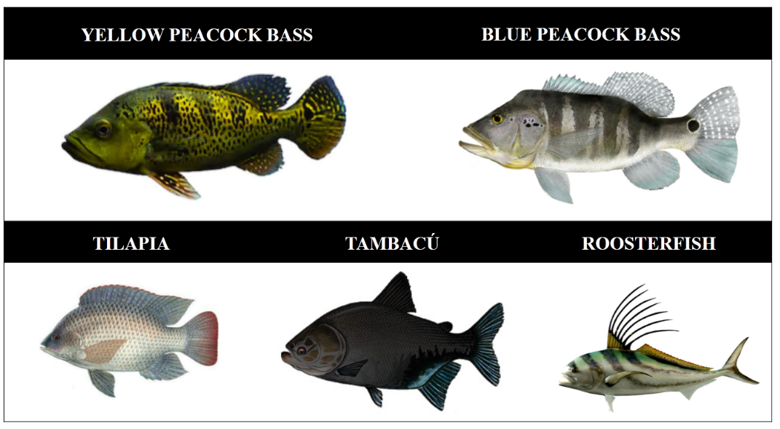
We used representations of IAS fishes, including photos, illustrations, and common names. A cross-validation of the interviews involved representations of common fish species absent in the basin, avoiding false-positive occurrence records.

SM-8a. Maps habitat-suitability O. Niloticus in its native area (right) and its invaded range (study area) (based on binary projections from the ensemble of Ecological Niche Models (ENMs): Generalized Linear Models (GLM), Random Forest (RF), and Maximum Entropy (MaxEnt)).
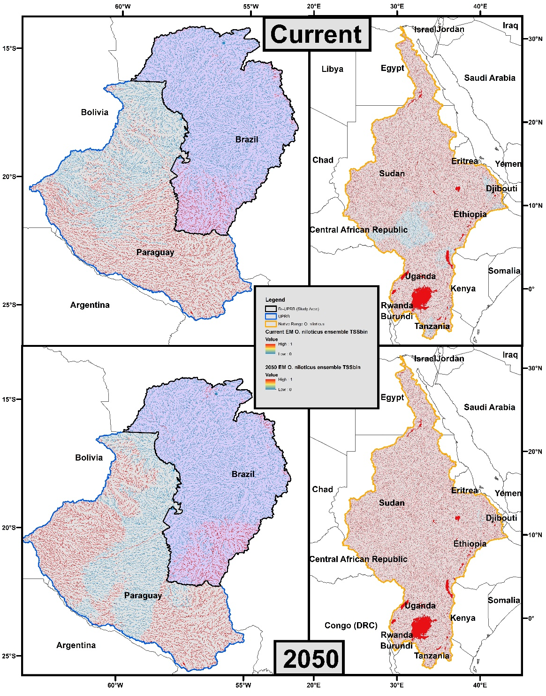

SM-8b. Maps habitat-suitability C. kelberi in its native area (right) and its invaded range (study area (based on binary projections from the ensemble of Ecological Niche Models (ENMs): Generalized Linear Models (GLM), Random Forest (RF), and Maximum Entropy (MaxEnt)).
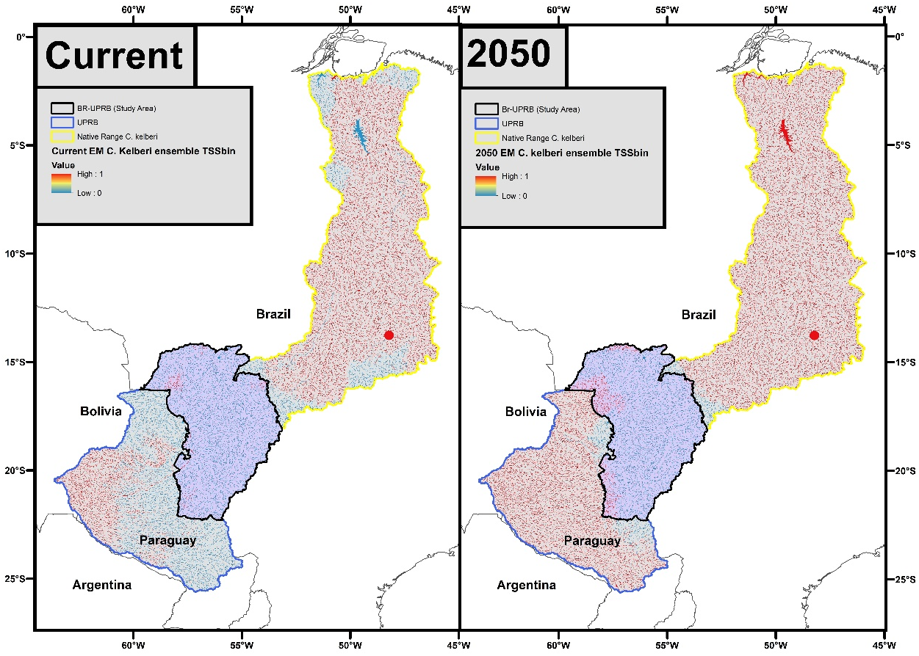

SM-8c. Maps habitat-suitability C. piquiti in its native area (right) and its invaded range (study area) (based on binary projections from the ensemble of Ecological Niche Models (ENMs): Generalized Linear Models (GLM), Random Forest (RF), and Maximum Entropy (MaxEnt)).
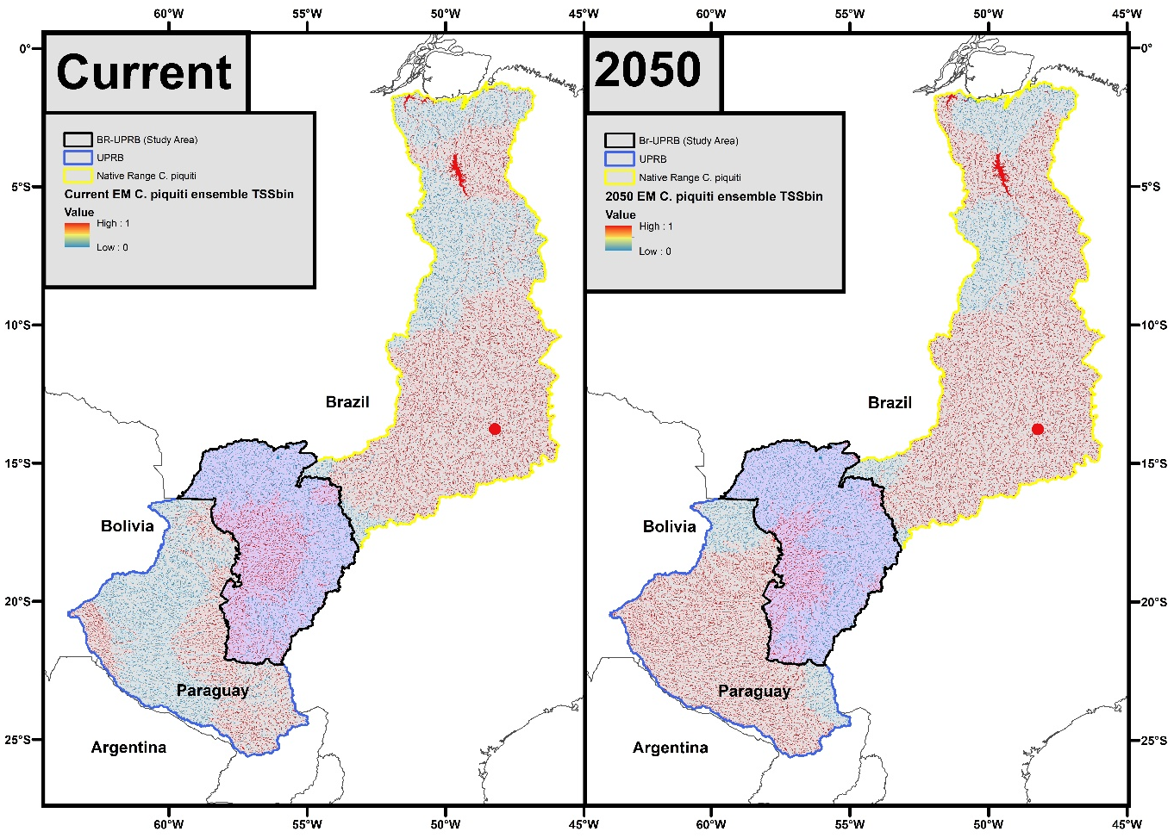

SM-9a. Function RangeSize from biomod2 R Package
This function allows us to calculate the absolute number of locations (pixels) lost, stable, and gained, as well as the corresponding relative proportions, between two binary projections of (ensemble) ecological niche models (which can represent new time scales or environmental scenarios, for example).
The selected models' probability is first transformed into binary data according to the thresholds defined when building the model.output object with the BIOMOD_Modeling function, maximizing the evaluation metric score over the testing dataset. The committee's averaging score is obtained by taking the average of these binary predictions. It is built on the analogy of a simple vote: each single model votes for the species being either present (1) or absent (0) the sum of 1 is then divided by the number of single models voting. This function is only relevant to compare binary projections, made on the same area with the same resolution.
Comparison between proj.current and proj.future depends on the number of projections in both objects:
proj.current | proj.future | Comparison
1 projection (e.g. data.frame with 1 column, SpatRaster with 1 layer) | 1 projection (e.g. data.frame with 1 column, SpatRaster with 1 layer) | comparison of both projection (e.g. current vs future conditions for the same model ; current vs current condition for two different models)
n projections (e.g. data.frame with n column, SpatRaster with n layer) | n projections (e.g. data.frame with n column, SpatRaster with n layer) | comparing projection i in proj.current to projection i in proj.future (e.g. comparing current vs future condition for n models)
1 projection (e.g. data.frame with 1 column, SpatRaster with 1 layer) | n projections (e.g. data.frame with n column, SpatRaster with n layer) | comparing projection in proj.current to each projection in proj.future (e.g. comparing current vs n different future condition (e.g. climate change scenario) for 1 model)

Diff.By.Pixel object is obtained by applying the following formula:
proj.future−2∗proj.current
A list containing two objects:
Compt.By.Species a data.frame containing the summary of range change for each comparison.

- Loss: number of pixels predicted to be lost
- Stable0: number of pixels not currently occupied and not predicted to be
- Stable1: number of pixels currently occupied and predicted to remain occupied
- Gain: number of pixels predicted to be gained
- PercLoss: percentage of pixels currently occupied and predicted to be lost (Loss / (Loss + Stable1))
- PercGain: percentage of pixels predicted to be gained compared to the number of pixels currently occupied (Gain / (Loss + Stable1))
- SpeciesRangeChange: percentage of pixels predicted to change (loss or gain) compare to the number of pixels currently occupied (PercGain - PercLoss)
- CurrentRangeSize: number of pixels currently occupied
- FutureRangeSize0Disp: number of pixels predicted to be occupied, assuming no migration
- FutureRangeSize1Disp: number of pixels predicted to be occupied, assuming migration
Diff.By.Pixel
an object in the same form than the input data (proj.current and proj.future) and containing a value for each point/pixel of each comparison among:
- -2: predicted to be lost.
- -1: predicted to remain occupied.
- 0: predicted to remain unoccupied.
- 1: predicted to be gained.

SM-9b. Potential suitable habitat (number of predictedcells) of the species predicted to current time and 2050 under climate change. Highlighted are IAS fish species that will gain habitat in the future. 1 pixel = 1 km².

Spp ID | Species | BIOMOD  RangeSize | Loss | Stable0 | Stable1 | Gain | Perc  Loss | Perc  Gain | Species Range Change | Current Range Size | Future RangeSize NoDisp | Future RangeSize. FullDisp
1 | Cichla piquiti | Emca
2 | Cichla kelberi | Emca
3 | Oreochromis niloticus | Emca
The predictive ensemble maps for the current and future (i.2050) were related to bioclimatic and topographic features. We extracted the environmental values of the grids corresponding to species presence from the current and future ensemble maps. Then, bar plots were drawn in R to compare the range values with the potential current and future habitats.
The model produces raster outputs with a 30 arc-second resolution, approximately 0.926 km² at latitudes near the equator. The potential invasion range values exhibit variation because of the substantial size of the study area and its distance from the equator (-15° to -22° S in the Br-UPRB). The results are presented in approximate values (≈ km²) rather than exact measurements ⁵.

Supplementary Material References
- ANA (Agência Nacional de Águas). 2018. Conjuntura dos Recursos Hídricos no Brasil. Available in: http://www3.ana.gov.br/portal/ANA/as-12-regioes-hidrograficas-brasileiras/paraguai Accessed 01 May 2018
- Kullander, S. O., Ferreira, E. J. 2006. A review of the South American cichlid genus Cichla, with descriptions of nine new species (Teleostei: Cichlidae). Ichthyological Exploration of Freshwaters, 22(2), 185–192. Available in: http://repositorio.inpa.gov.br/handle/123/2793 Accessed 17 July 2018
- Domisch, S., Amatulli, G. & Jetz, W. Near-global freshwater-specific environmental variables for biodiversity analyses in 1 km resolution. Sci Data 2, 150073 (2015). https://doi.org/10.1038/sdata.2015.73
- Booth, T.H., 2022. Checking bioclimatic variables that combine temperature and precipitation data before their use in species distribution models. Austral Ecology 47, 1506–1514. https://doi.org/10.1111/aec.13234
- Lovelace, R., Nowosad, J., Muenchow, J., 2019. Geocomputation with R, 1st ed. Chapman and Hall/CRC. https://doi.org/10.1201/9780203730058
- Fick, S. E. & Hijmans, R. J. WorldClim 2: new 1‐km spatial resolution climate surfaces for global land areas. Intl Journal of Climatology 37, 4302–4315 (2017).

