Appendix:
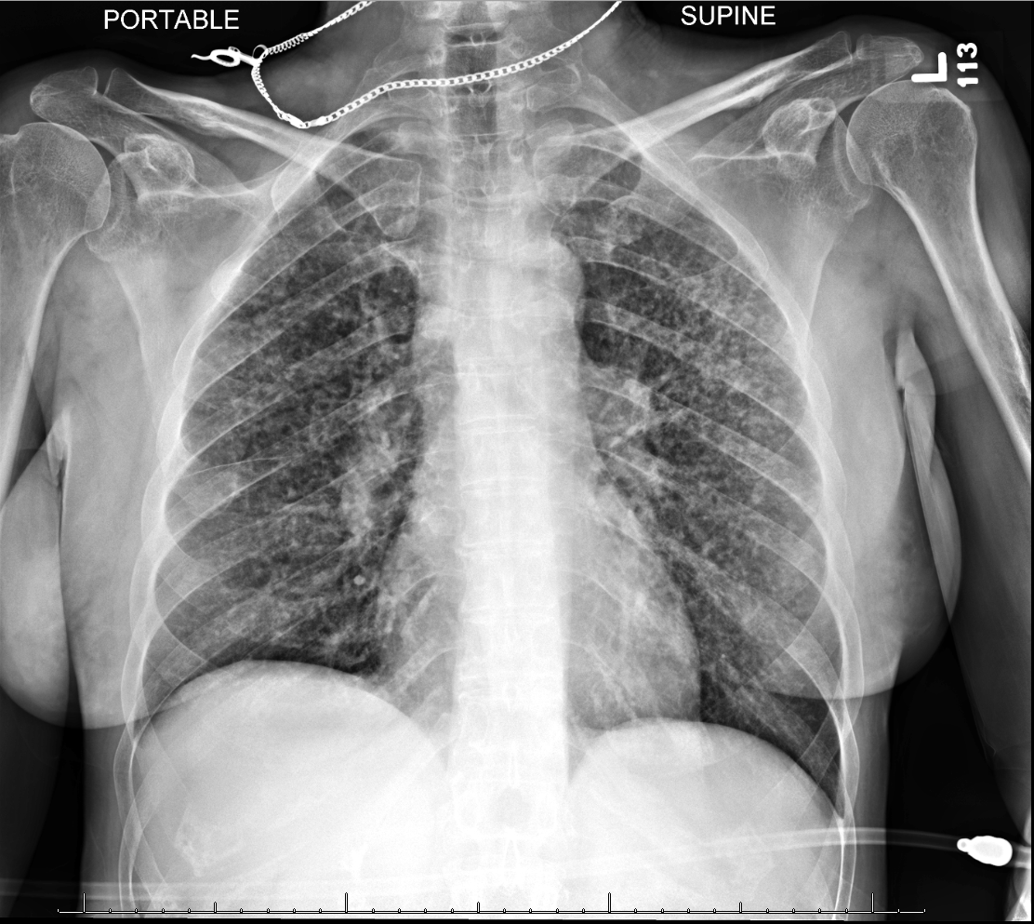
Image 1: Chest X Ray showing bilateral diffuse reticulonodular opacities in both lungs, concerning for atypical multifocal pneumonia, neoplasm or interstitial lung disease.
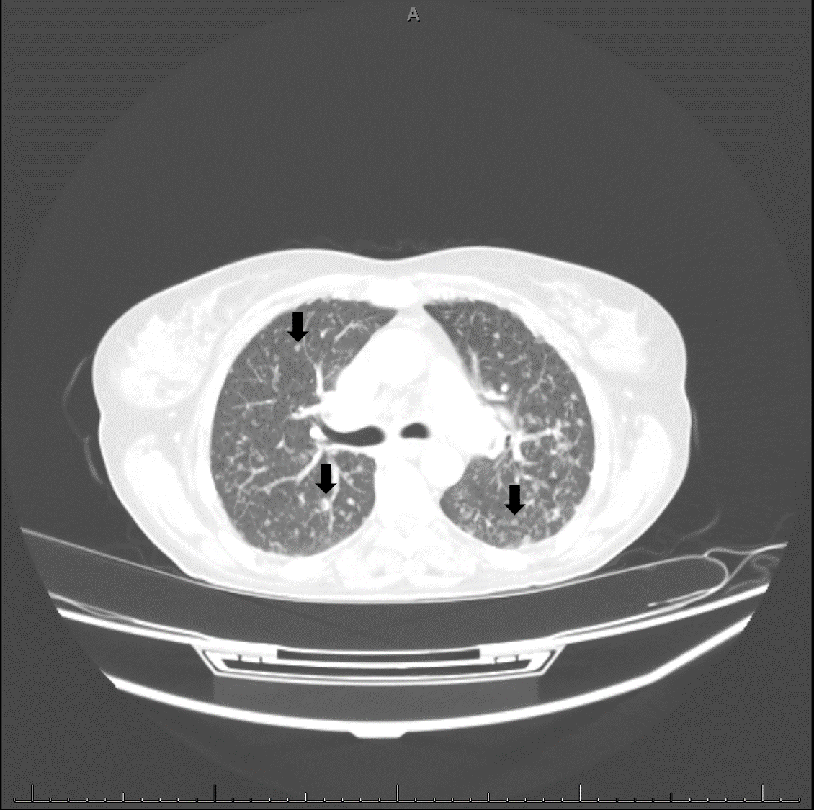
Image 2
Chest CT showing Innumerable scattered subcentimeter nodules throughout the bilateral lungs with associated mediastinal lymphadenopathy and biapical emphysematous changes
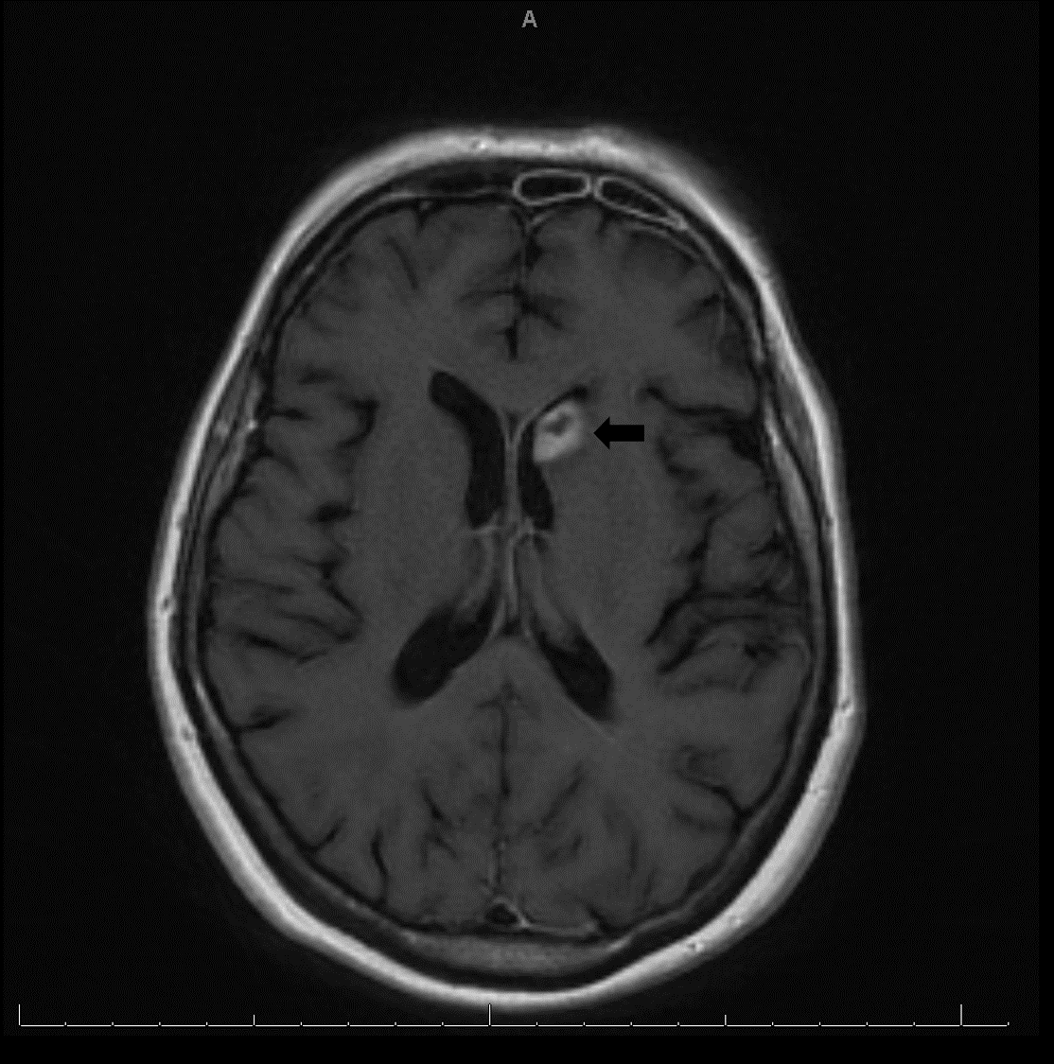
Image 3
T1-weighted magnetic resonance (MR) image with contrast medium showing a 1.6 cm rim enhancing lesion in the left caudate with surrounding edema and probable hemorrhagic components.


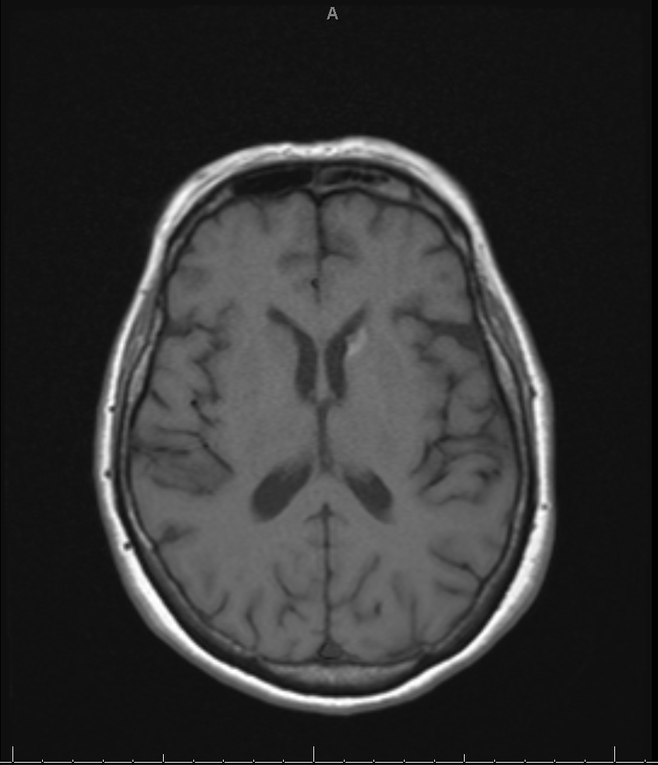
Image 4
The image shows a reduced mass to 0.7 cm after 2 weeks of therapy for toxoplasmosis.

