GNG2 inhibits brain metastases from colorectal cancer via cell cycle arrest and PI3K/Akt signaling pathway

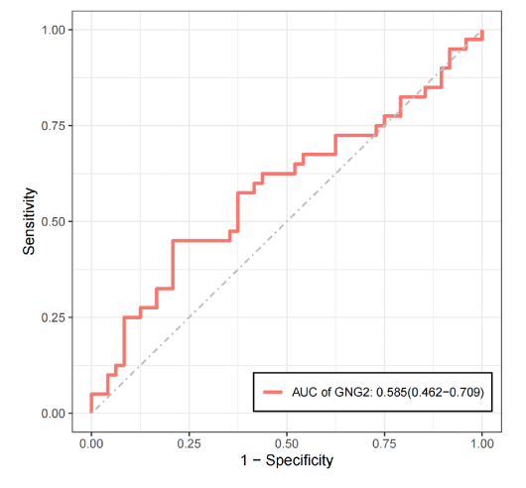

Figure S1. The ROC curve of GNG2 in TCGA dataset and showed that GNG2 may act as a perfect diagnostic marker.

Figure S2. GO analysis of differentially expressed genes (DEGs) between normal tissues and metastatic tumors.

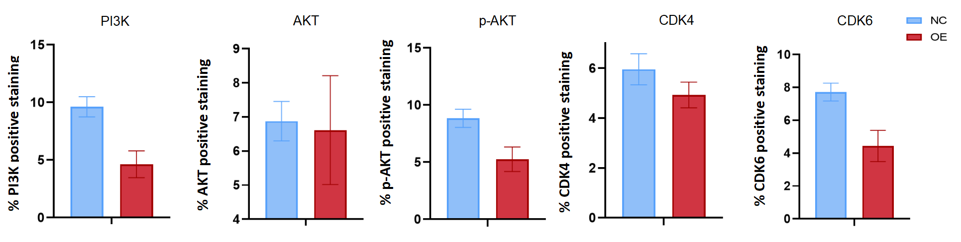
Figure S3. Quantitative analysis of PI3K, AKT, p-AKT, CDK4, and CDK6 positive areas in tumor tissue was performed using ImageJ software for immunohistochemistry data.

