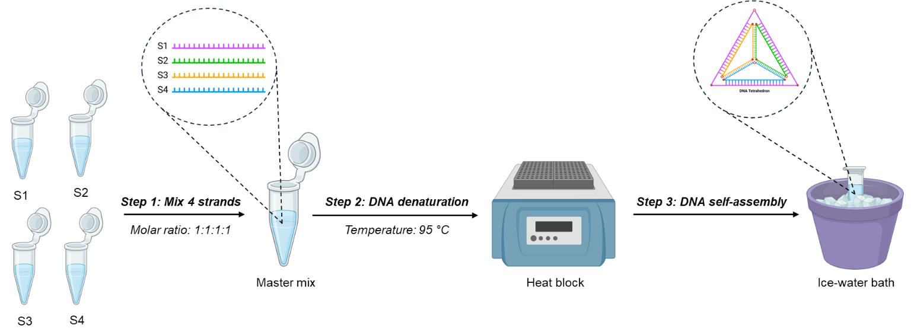
Fig. S1 | Schematic diagram showing the laboratory procedures of synthesizing TDN.

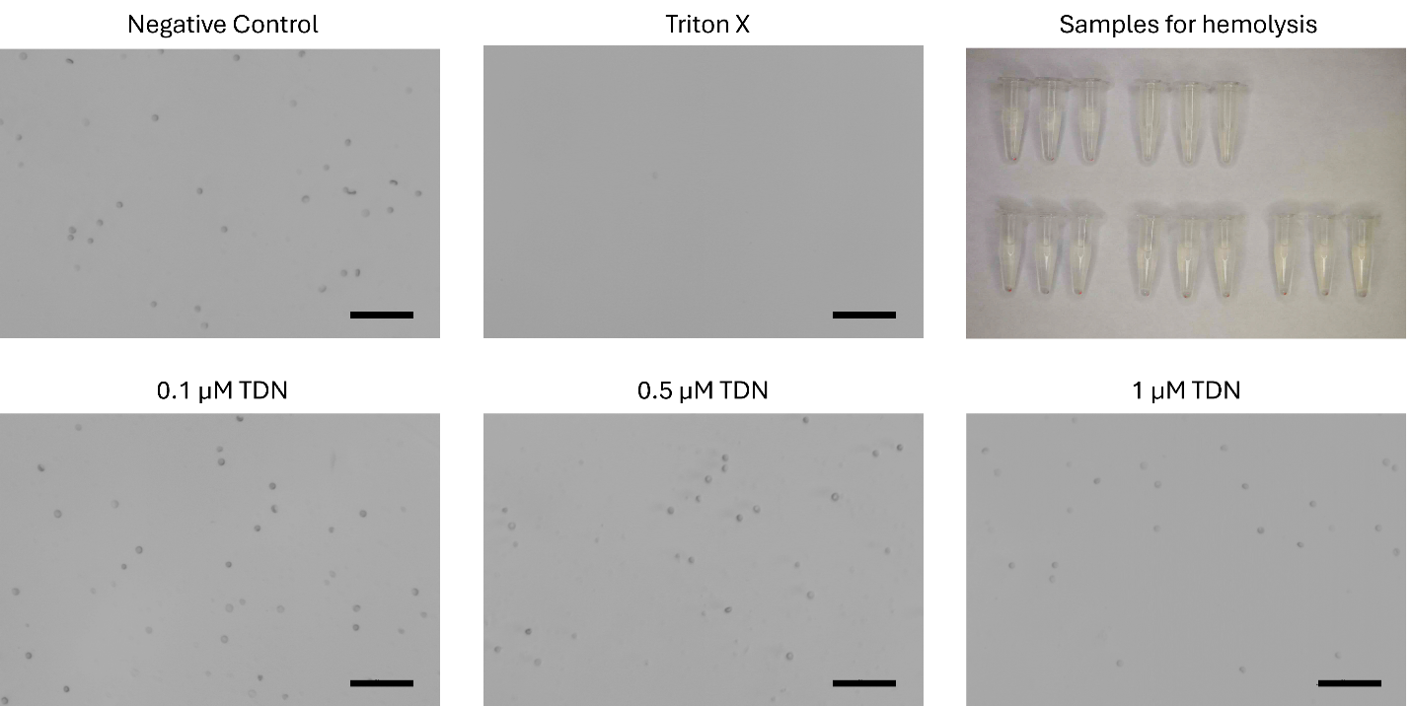
Fig. S2 | Phase-contrast images of mRBCs following the incubation with PBS (negative control), Triton-X 100 (positive control), 0.1 μm TDN, 0.5 μm TDN, 1 μm TDN. Scale bar 50 μm.

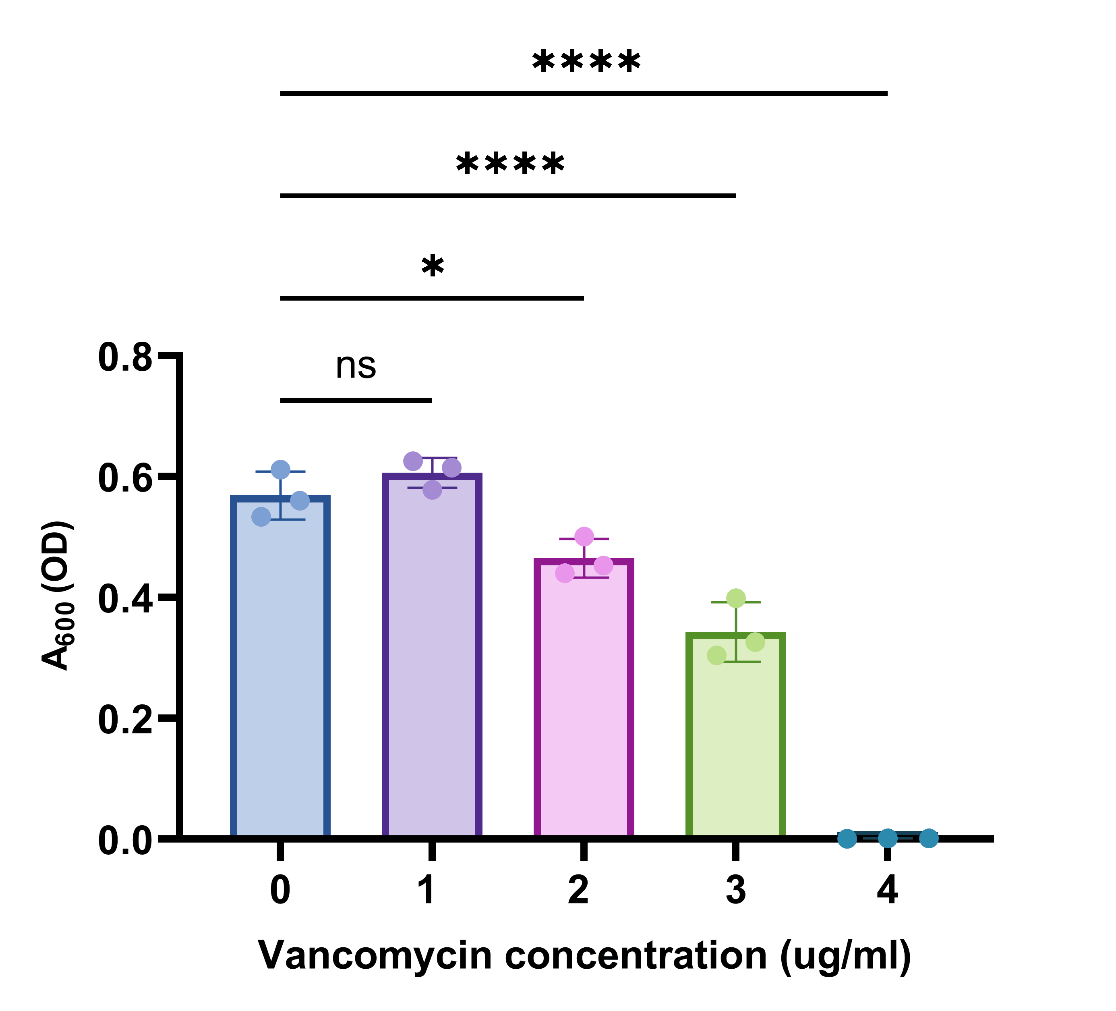
Fig. S3 | MIC test of vancomycin against MRSA.

