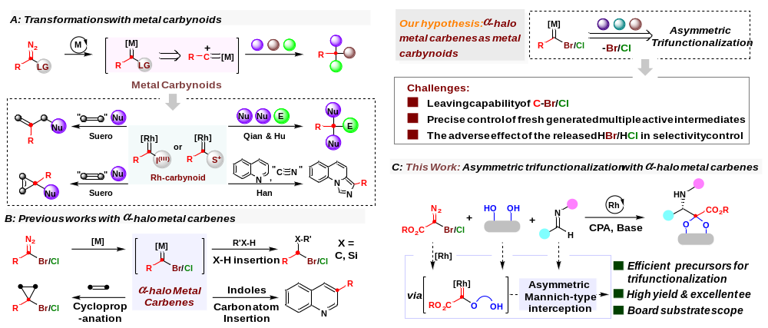
Scheme 1 | Transformations with metal carbynoids.
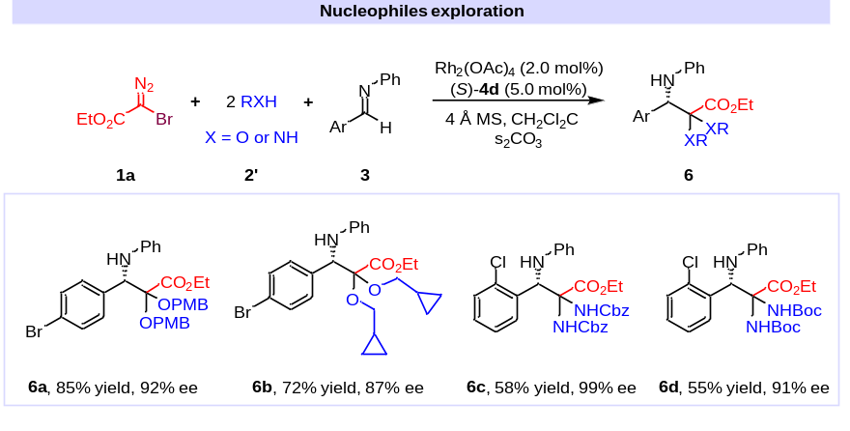
Scheme 2 | Synthetic generality.
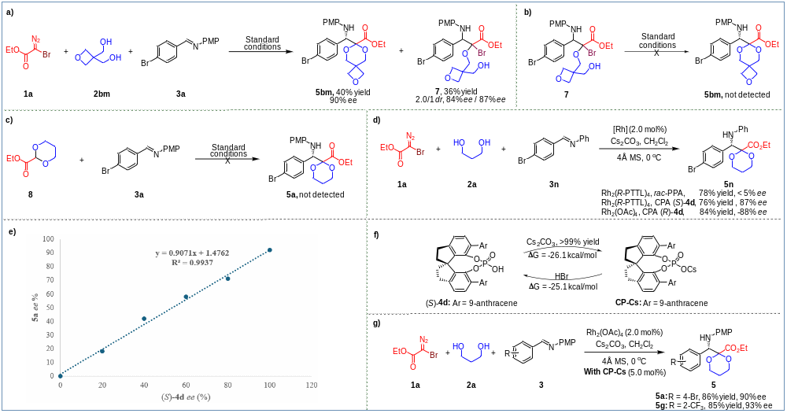
Scheme 3 | Control Experiments.

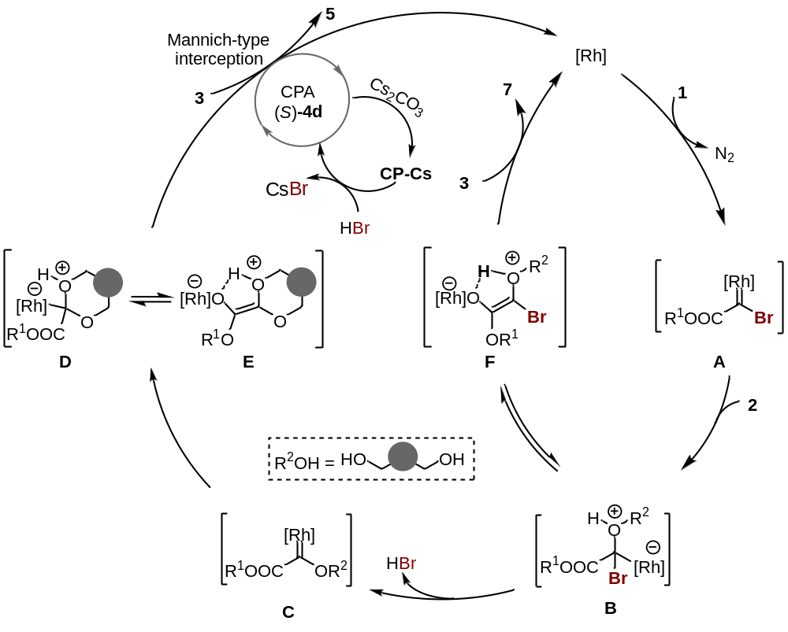
Scheme 4 | Proposed reaction mechanism.
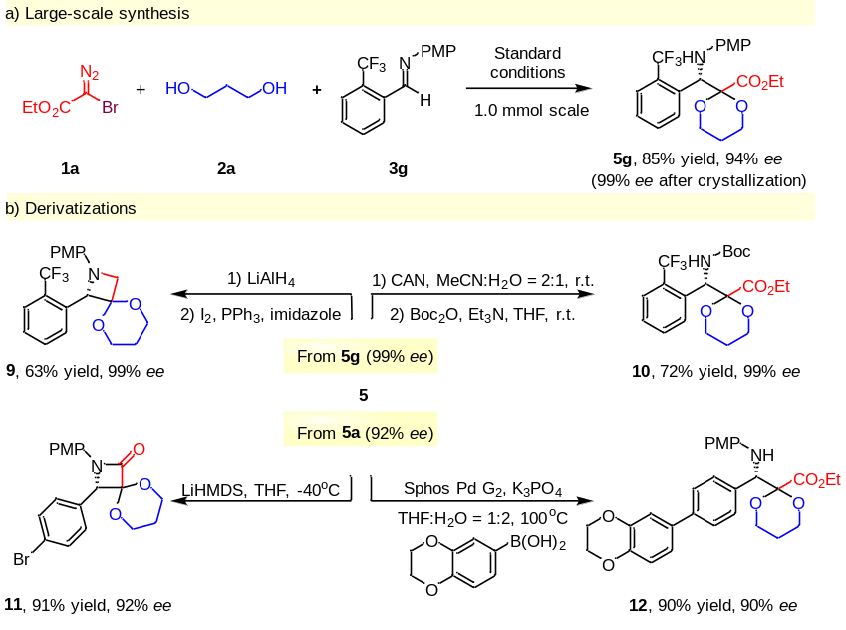
Scheme 5 | Synthetic applications.

