Table 1 | Reaction optimizationª
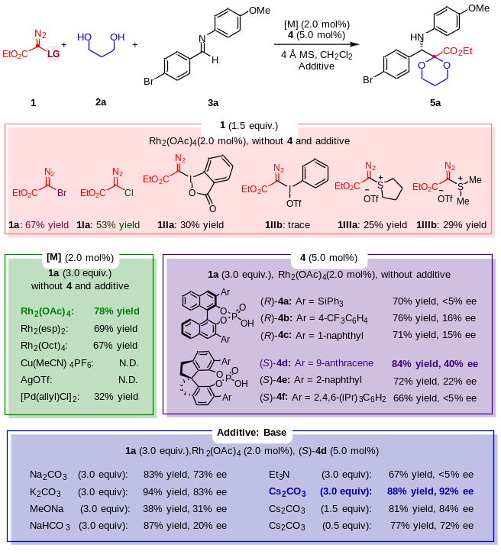
ªThe reactions were conducted on a 0.1 mmol scale: To the mixture of corresponding catalyst (2.0 mol%), CPA 4 (5.0 mol%), 2a (0.30 mmol), 3a (0.10 mmol), and 4 Å MS (150 mg) in CH₂Cl₂ (1.5 mL) was added a solution of diazo compound 1 in cold CH₂Cl₂ (1.5 mL) via a syringe pump in 0.5 h under a nitrogen atmosphere at 0 ℃; The yields were given as isolated yields, and the ee values were determined by chiral HPLC analysis; N.D. = not detected.
Table 2 | Substrate scope with α-bromo Rh-carbenesª
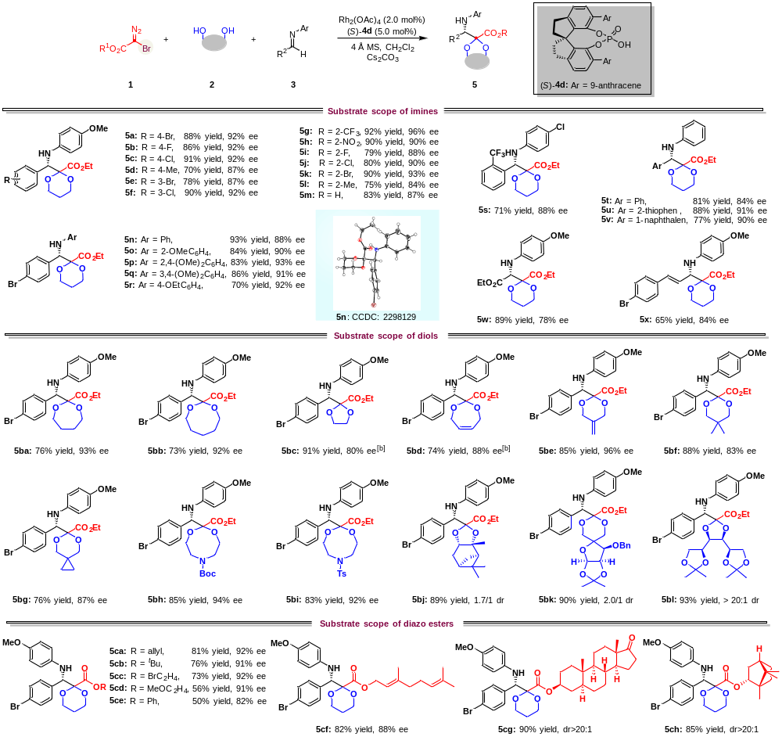
ªThe reactions were conducted on a 0.1 mmol scale: To the mixture of 3 (0.10 mmol), 2 (0.30 mmol), Rh₂(OAc)₄ (2.0 mol %), CPA 4d (3.3 mg, 5.0 mol %), Cs₂CO₃ (0.30 mmol ) and 4 Å MS (150 mg) in CH₂Cl₂ (1.5 mL) was added a solution of diazo compound 1 (0.30 mmol) in cold CH₂Cl₂ (1.5 mL) via a syringe pump in 0.5 h under a nitrogen atmosphere at 0 ℃, and the reaction was running for 4 h under these conditions; The yields were given as isolated yields, the dr were determined by crude NMR and the ee values were determined by chiral HPLC analysis. ^{b}5.0 mol % Rh₂(OAc)₄ was used.
Table 3 | Substrate scope with α-chloro Rh-carbenesª
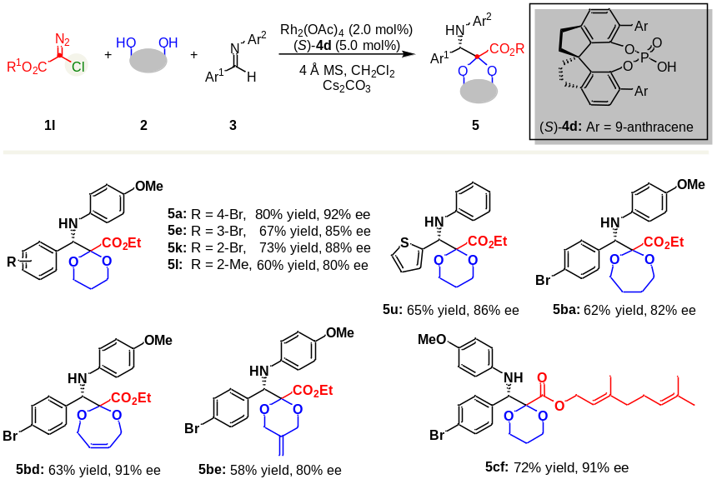
ªStandard conditions as in Table 2.

