Supplementary Material
Community characteristics of benthic macroinvertebrates and ecosystem health assessment in ten Reservoirs of Henan Province, China
Jiannan Zhao^{a,b}, Yunni Gao^{a,b*}, Jingxiao Zhang^{a,b}, Yongli Li^{c}, Xiaofei Gao^{a,b}, Huatao Yuan^{a,b}, Jing Dong^{a,b}, Xuejun Li^{a,b}
ª College of Fisheries, Henan Normal University, Xinxiang, 453007, Henan, China
^{b} Observation and Research Station on Water Ecosystem in Danjiangkou Reservoir of Henan Province, Nanyang, 474450, Henan, China
^{c} Center of Hydrology and Water resources of Henan Province, Zhengzhou, 450003, Henan, China

* Corresponding authors: Yunni Gao (gaoyn@htu.cn)

Appendix Table S1 Categories of candidate metrics and their responses to interference.
Types | Number | Candidate metrics | Response to disturbance
Species  composition | M1 | Number of taxa | Decrease
Species  composition | M2 | Number of EPT taxa | Decrease
Species  composition | M3 | Number of Plecoptera taxa | Decrease
Species  composition | M4 | Number of Ephemeroptera taxa | Decrease
Species  composition | M5 | Number of Trichoptera taxa | Decrease
Species  composition | M6 | Number of Crustacea+Mollusca Taxa | Decrease
Community  composition | M7 | % Pleccoptera | Decrease
Community  composition | M8 | % Ephemeroptera | Decrease
Community  composition | M9 | % Trichoptera | Decrease
Community  composition | M10 | % Chironomidae | Increase
Community  composition | M11 | % (Crustacea+Mollusca) | Decrease
Community  composition | M12 | % Dominant taxa | Increase
Pollution tolerance | M13 | Number of Intolerant taxa | Decrease
Pollution tolerance | M14 | Number of Tolerant taxa | Increase
Pollution tolerance | M15 | % Intolerant | Decrease
Pollution tolerance | M16 | % Tolerant | Increase
Tropic status | M17 | BI Index | Increase
Tropic status | M18 | BMWP Index | Decrease
Tropic status | M19 | ASPT Index | Decrease
Nutritional structure | M20 | % Predators | Decrease
Nutritional structure | M21 | % Filterer | Increase
Nutritional structure | M22 | % collector | Increase
Nutritional structure | M23 | % Scrapers | Decrease
Nutritional structure | M24 | % Shredders | Decrease
Habitat | M25 | Number of Clingers taxa | Decrease
Habitat | M26 | % Clingers | Decrease
Diversity index | M27 | Shannon-Wiener index | Decrease
Diversity index | M28 | Margalef's Index | Decrease
Diversity index | M29 | Evenness Index | Decrease
Diversity index | M30 | Simpson's Diversity | Decrease
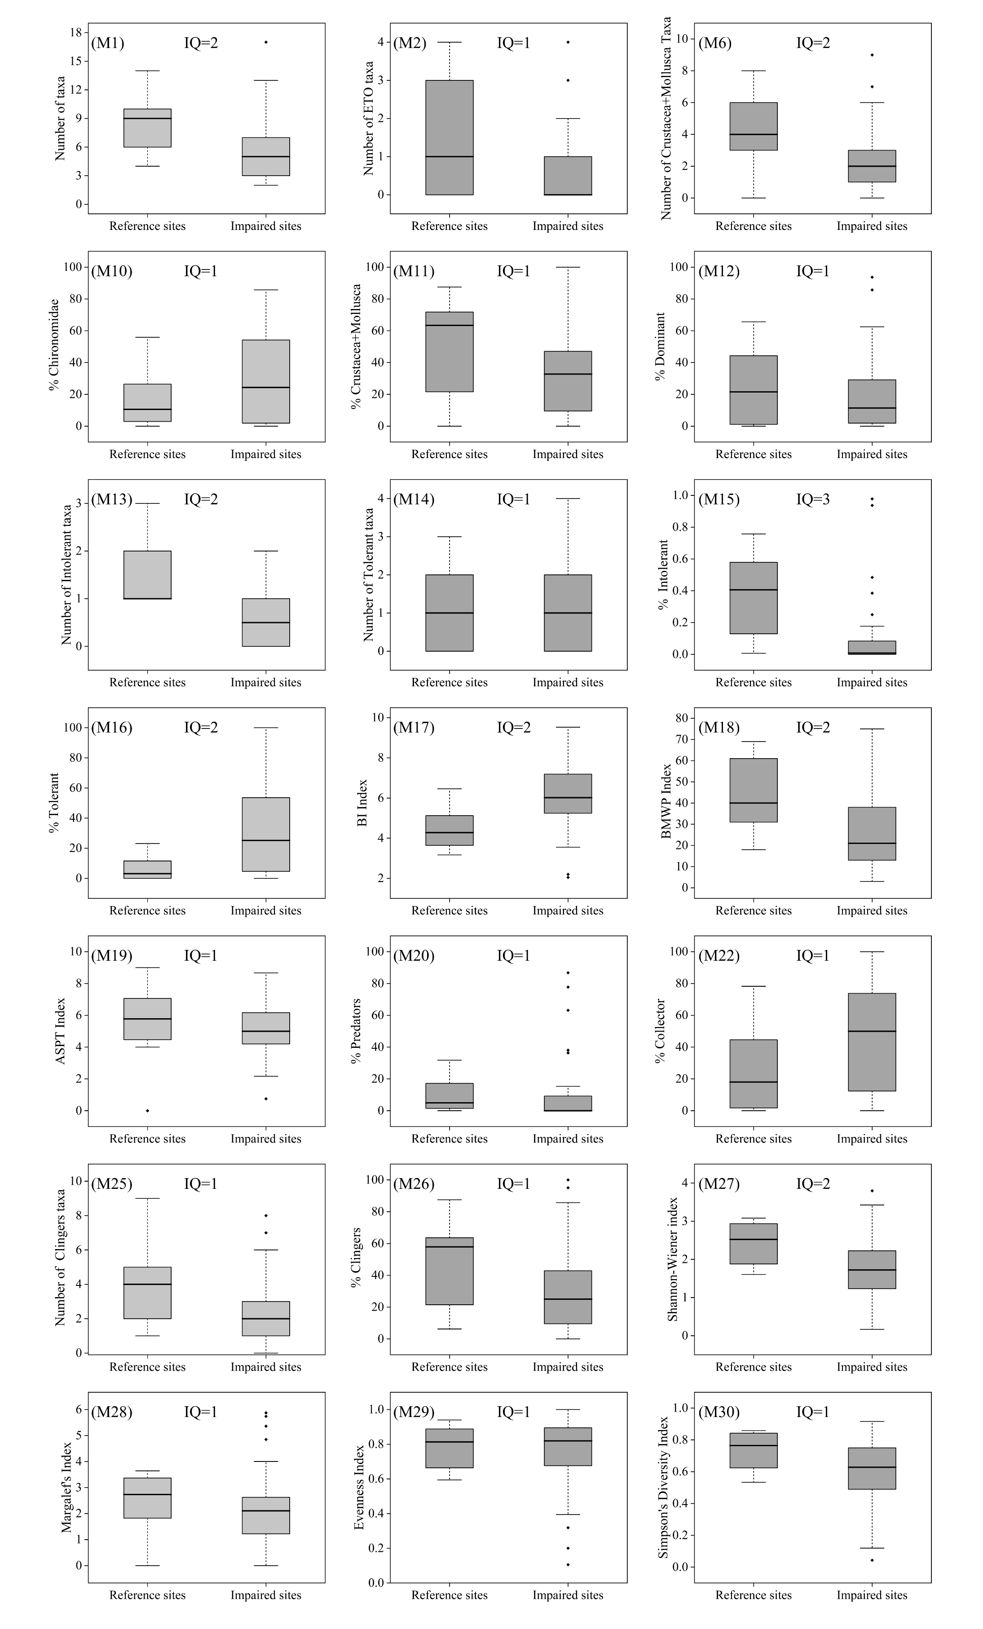
Appendix Fig. S1. Boxplot results of discriminative ability analysis of 30 candidate indicators.
Appendix Table S2 Correlation analysis results for 8 candidate metrics.
 | M1 | M6 | M13 | M15 | M16 | M17 | M18 | M27
M1 | 1
M6 | 0.661** | 1.000
M13 | 0.544** | 0.457** | 1.000
M15 | 0.260 | 0.379* | 0.819** | 1.000
M16 | -0.143 | -0.316* | -0.387** | -0.446** | 1.000
M17 | -0.189 | -0.291 | -0.561** | -0.713** | .0871** | 1.000
M18 | 0.634** | 0.484** | 0.479** | .0412** | -0.491** | -0.569** | 1.000
M27 | 0.827** | 0.489** | 0.399** | 0.141 | -0.016 | -0.012 | 0.290 | 1.000

Appendix Table S3 Construct the core index calculation formula of B-IBI.
Biological metric | Computational formula
Number of Crustacea+Mollusca Taxa (M6) | M6/7
% Intolerant (M15) | M15/73%
BI index(M17) | (9.09-MI7)/(9.09-3.25)
BMWP index(M18) | M18/186.05
Shannon-Wiener index(M27) | M27/73%

