Supporting information

Spiral Polycyclic Aromatic Hydrocarbons Embedded in the B/N Center for Constructing Highly Efficient Multiple Resonance TADF Emitters

General Information
The ¹H and ¹³C NMR spectra were recorded on Bruker NMR spectrometers operating at 400 and 151 MHz, respectively. Mass spectra were recorded by AB Sciex TripleTOF 4600 mass analyzer (AB Sciex, Framingham, MA, USA). UV-vis spectra were recorded using Perkin-Elmer Lambda 950-PKA UV-Vis. All the low-temperature steady-state fluorescence and phosphorescence spectra were recorded by (Horiba Jobin Yvon) FluoroMax-4 Spectro-fluorometer with a Dewar flask. Low-temperature fluorescence spectra can be measured using stable-state fluorescence mode without time delay. Low-temperature phosphorescence spectra can be recorded using phosphorescence mode after a time delay of 0.05 - 50 ms (delayed time adjusting range: 50 𝜇s – 100 ms) to eliminate the influences of low-temperature fluorescence spectra. Cyclic voltammetry measurement was conducted using the electrochemical workstation MULTIAUTOLAB M204. Photoluminescence quantum yields (PLQYs) in doped films were measured utilizing an integrating sphere of Hamamatsu absolute PLQY spectrometer (C11347-01). Transient PL decay was evaluated with 280 nm and 340 nm LED excitation sources. Thermogravimetric analyses (TGA) were conducted on a Netzsch TGA 2019F1, and differential scanning calorimetry (DSC) measurements were carried out on a Netzsch DSC 214. Both TGA and DSC measurements were under N₂ flow.

Quantum Chemical method
All the simulations were performed using the Gaussian 09_B01 program package^{[1].} The ground state (S₀) geometries were optimized for all the investigated molecules using the M06-2X functional with a 6-31G* basis set in a vacuum for an initial guess. All the excited state was optimized by TD-DFT/M06-2X/6-31G* in toluene with a polarizable continuum model (PCM).^{[2]} Frontier molecular orbitals (FMOs), natural transition orbitals (NTOs), Molecular polarity index (MPI), electrostatic potential (ESP)-colored isosurface, and areas on the isosurface in different ESP ranges for the target emitters were analyzed by the Multiwfn program, and Root mean square displacements (RMSDs) were further analyzed by wavefunction analyzers Multiwfn and VMD with calculated results of Gaussian 09_B01 program.^{[3]}

Device Fabrication and Characterization
Glass substrates pre-coated with a 95-nm-thin layer of indium tin oxide (ITO) with a sheet resistance of 10 Ω per square was thoroughly cleaned in an ultrasonic bath of tetrahydrofuran, isopropyl alcohol, detergent, deionized water, and isopropyl alcohol and was then treated with O2 plasma for 5 minutes in sequence. Organic layers were deposited onto the ITO-coated glass substrates by thermal evaporation under a high vacuum (~10⁻⁵ Pa). The cathode was patterned using a shadow mask with 3 mm х 3 mm openings. Deposition rates are 1 − 2 Å s⁻¹ for organic materials and 2 - 5 Å s⁻¹ for aluminum, respectively. The current density, luminance versus driving voltage characteristics, and EL spectra were measured by Keithley 2400 and Konica Minolta CS2000 chromameter. EQEs were automatically estimated from the current density, brightness, and EL spectra, assuming a Lambertian distribution.

Synthetic procedures
All the reagents were purchased from the Casmart Reagent Platform or Bidepharm and used as received without further purification. The target molecules' intermediates were synthesized via one-step common palladium-catalyzed Buchwald–Hartwig reactions. The target molecules were synthesized via one-step common borylation reactions. The synthetic procedures are shown below in detail.
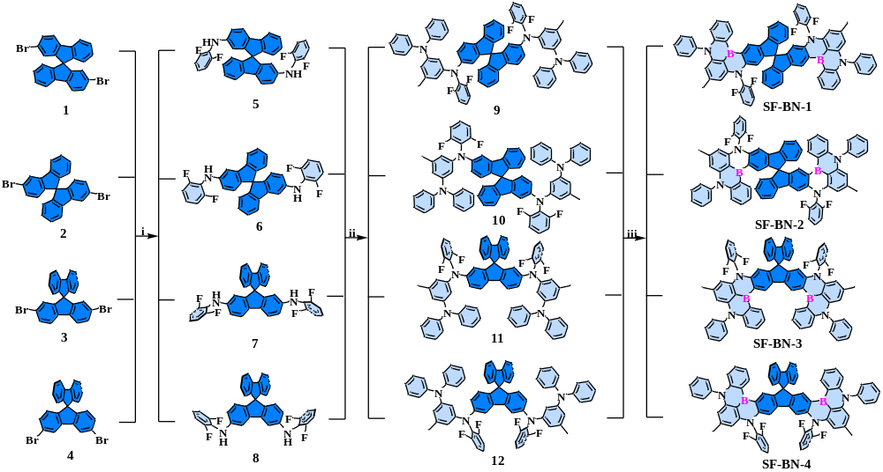
Scheme S1. One-shot synthesis procedure of SF-BN1, SF-BN2, SF-BN3, and SF-BN4, respectively. 9,9'-spirobi[fluorene] is embedded in the B/N-MR center to the molecular luminescent properties in all four molecules. Herein, i) 2,6-difluoroaniline, Pd₂(dba)₃, X-Phos, t-BuONa/Tolune, N₂, 110ºC; ii) 3-bromo-5-methyl-N,N-diphenylaniline, Pd₂(dba)₃, X-Phos, t-BuONa/Tolune, N₂, 110ºC; iii) BBr₃/1,2-Dichlorobenzene (o-DCB), 200 ºC.
Synthesis of Compound 1 (N²,N²'-bis(2,6-difluorophenyl)-9,9'-spirobi[fluorene]-2,2'-diamine): In a 100 mL flask charged with argon, a mixture of 2,2'-dibromo-9,9'-spirobi[fluorene] (4.74 g, 10.0 mmol), 2,6-difluoroaniline (2.84 g, 22.0 mmol ), Pd₂(dba)₃ (0.18 g, 0.2 mol), ^{t}Bu₃PHBF₄ (0.15 g, 0.5 mol), ^{t}BuONa (2.88 g, 30.0 mmol ) and 50 mL toluene were vigorously stirred together at 110 ℃ for overnight. The cooled mixture was filtered via diatomite and washed with dichloromethane. After removed the organic solvent, the residual solid was further purified by flash column chromatography on silica gel (eluting with petroleum ether/dichloromethane) to yield the pure product 1 as a white solid (5.13 g, 9.0 mmol, 90% yield). ¹H NMR (400 MHz, CDCl₃) δ [ppm]: δ 7.69 (dd, J = 16.0, 7.6 Hz, 4H), 7.32 (t, J = 7.6 Hz, 2H), 7.05 (t, J = 7.6 Hz, 2H), 6.98 – 6.85 (m, 6H), 6.76 – 6.73 (m, 4H), 6.32 (s, 2H), 5.37 (s, 2H). ¹³C NMR (150 MHz, CDCl₃) δ [ppm]: δ 156.2, 156.1, 154.5, 149.3, 147.5, 142.3, 140.7, 133.8, 126.6, 125.6, 123.0, 121.8, 119.2, 118.2, 118.0, 113.6, 111.6, 110.9, 110.7, 64.7.

Synthesis of Compound 2 (N³, N³'-bis(2,6-difluorophenyl)-9,9'-spirobi[fluorene]-3,3'-diamine): Compound 2 was synthesized according to the same procedure as that of Compound 1 using 3,3'-dibromo-9,9'-spirobi[fluorene], and white solid was obtained in 87% yield. ¹H NMR (400 MHz, CD₂Cl₂) δ [ppm]: δ 7.75 (d, J = 7.6 Hz, 2H), 7.32 (t, J = 7.6 Hz, 2H), 7.27 (s, 2H), 7.11 – 6.99 (m, 8H), 6.69 (d, J = 7.6 Hz, 2H), 6.59 (s, 4H), 5.62 (s, 2H).¹³C NMR (150 MHz, CDCl₃) δ [ppm]: δ 159.1, 159.0, 157.4, 151.2, 145.1, 144.0, 142.8, 142.2, 129.1, 128.8, 125.4, 125.0, 124.9, 121.2, 120.6, 117.0, 113.3, 113.2, 108.3, 66.2.

Synthesis of Compound 3 (N²,N⁷-bis(2,6-difluorophenyl)-9,9'-spirobi[fluorene]-2,7-diamine): Compound 3 was synthesized according to the same procedure as Compound 1 using 2,7-dibromo-9,9'-spirobi[fluorene], and white solid was obtained in 92% yield. ¹H NMR (400 MHz, CD₂Cl₂) δ [ppm]: δ 7.82 (d, J = 7.6 Hz, 2H), 7.57 (brs, 2H), 7.35 (t, J = 7.5 Hz, 2H), 7.14 (t, J = 7.9 Hz, 2H), 6.93 – 6.77 (m, 10H), 6.13 (s, 2H), 5.30 – 5.28 (m, 2H). ¹³C NMR (150 MHz, CDCl₃) δ [ppm]: δ 150.9, 150.5, 143.9, 142.9, 129.2, 129.1, 125.3, 124.4, 124.3, 124.2, 121.3, 120.9, 116.1, 113.2, 113.1, 113.0.
Synthesis of Compound 4 (N³,N6-bis(2,6-difluorophenyl)-9,9'-spirobi[fluorene]-3,6-diamine): Compound 4 was synthesized according to the same procedure as Compound 1 using 3,6-dibromo-9,9'-spirobi[fluorene]], and white solid was obtained in 85% yield. ¹H NMR (400 MHz, CD₂Cl₂) δ [ppm]: δ 7.82 (d, J = 7.6 Hz, 2H), 7.34 (t, J = 7.5 Hz, 2H), 7.19 (s, 2H), 7.14 – 7.09 (m, 2H), 7.08 – 7.04 (m, 2H), 7.02 – 6.95 (m, 4H), 6.74 (d, J = 7.6 Hz, 2H), 6.55 – 6.49 (m, 4H). ¹³C NMR (150 MHz, CDCl₃) δ [ppm]: δ 158.2, 156.6, 149.8, 149.2, 143.9, 141.5, 133.6, 128.5, 128.3, 124.5, 124.3, 120.8, 120.0, 119.1, 113.3, 112.7, 112.5, 110.8, 65.8, 55.4.

Synthesis of Compound 5 (N¹,N¹'-(9,9'-spirobi[fluorene]-2,2'-diyl)bis(N¹-(2,6-difluorophenyl)-5-methyl-N³,N³-diphenylbenzene-1,3-diamine): In a 100 mL flask charged with argon, a mixture of compound 1 (2.85 g, 5.0 mmol), 3-bromo-5-methyl-N,N-diphenylaniline (5.07 g, 15.0 mmol), Pd₂(dba)₃ (0.14 g, 0.15 mol), X-Phos (0.12 g, 0.25 mol), ^{t}BuONa (1.44 g, 15.0 mmol ) and 50 mL toluene were vigorously stirred together at 120 ℃ for overnight. The cooled mixture was filtered via diatomite and washed with dichloromethane. After removed the organic solvent, the residual solid was further purified by flash column chromatography on silica gel (eluting with petroleum ether/dichloromethane) to yield the pure product 5 as a white solid (4.34 g, 4.0 mmol, 80% yield). ¹H NMR (400 MHz, CD₂Cl₂) δ [ppm]: δ 7.70 (dd, J = 20.8, 7.6 Hz, 4H), 7.31 (t, J = 7.5 Hz, 2H), 7.20 (t, J = 7.9 Hz, 8H), 7.08 – 7.05 (m, 4H), 7.02 – 6.99 (m, 11H), 7.02 – 6.99 (m, 3H), 6.84 (t, J = 8.4 Hz, 4H), 6.70 (d, J = 7.5 Hz, 2H), 6.54 (d, J = 2.0 Hz, 2H), 6.43 – 6.42 (m, 6H), 2.02 (s, 6H). ¹³C NMR (150 MHz, CDCl₃) δ [ppm]: δ 160.7, 160.6, 159.0, 158.9, 149.8, 148.8, 148.2, 147.5, 146.8, 145.9, 141.3, 139.5, 136.4, 128.9, 127.5, 126.8, 126.4, 126.3, 123.9, 123.7, 122.6, 122.5, 122.4, 120.8, 120.3, 119.2, 118.9, 117.1, 115.6, 113.9, 112.4, 112.3, 112.2, 65.8, 21.3.

Synthesis of Compound 6 (N¹,N¹'-(9,9'-spirobi[fluorene]-3,3'-diyl)bis(N¹-(2,6-difluorophenyl)-5-methyl-N³,N³-diphenylbenzene-1,3-diamine): Compound 6 was synthesized according to the same procedure as Compound 2 using compound 6, and white solid was obtained with an 84% yield. ¹H NMR (400 MHz, CD₂Cl₂) δ [ppm]: δ 7.70 (d, J = 7.6 Hz, 2H), 7.47 (d, J = 2.0 Hz, 2H), 7.33 (t, J = 7.5 Hz, 2H), 7.24 – 7.18 (m, 2H), 7.15 – 7.09 (m, 10H), 7.04 (d, J = 7.2 Hz, 8H), 6.96 (t, J = 8.4 Hz, 4H), 6.88 (t, J = 7.2 Hz, 4H), 6.72 (dd, J = 8.4, 2.0 Hz, 2H), 6.64 (d, J = 7.2 Hz, 2H), 6.58 (s, 2H), 6.51 -6.48 (m, 4H), 6.42 (s, 2H), 2.14 (s, 6H). ¹³C NMR (150 MHz, CDCl₃) δ [ppm]: δ 162.6, 162.5, 160.9, 150.8, 149.8, 148.8, 147.6, 144.1, 144.0, 142.7, 141.2, 130.4, 129.1, 128.9, 128.5, 128.4, 125.7, 125.5, 125.1, 124.1, 124.0, 122.7, 121.3, 119.3, 116.5, 114.5, 113.9, 113.8, 66.3, 22.6.

Synthesis of Compound 7 (N¹,N1'-(9,9'-spirobi[fluorene]-2,7-diyl)bis(N¹-(2,6-difluorophenyl)-5-methyl-N³,N³-diphenylbenzene-1,3-diamine): Compound 7 was synthesized according to the same procedure as Compound 3 using compound 7, and white solid was obtained with a 78% yield. ¹H NMR (400 MHz, CD₂Cl₂) δ [ppm]: δ 7.74 (d, J = 7.6 Hz, 2H), 7.60 (d, J = 8.3 Hz, 2H), 7.29 (t, J = 7.5 Hz, 2H), 7.18 – 7.14 (m, 8H), 7.12 – 7.03 (m, 4H), 6.95 – 6.88 (m, 14H), 6.83 – 6.77 (m, 6H), 6.45 (d, J = 1.9 Hz, 2H), 6.33 (s, 2H), 6.29 – 6.28 (m, 4H), 1.95 (s, 6H). ¹³C NMR (150 MHz, CDCl₃) δ [ppm]: δ 162.1, 162.0, 160.4, 160.3, 151.2, 149.9, 149.7, 148.9, 148.3, 146.5, 142.9, 140.9, 137.8, 130.3, 129.1, 129.0, 128.0, 127.9, 125.3, 125.0, 123.8, 122.4, 121.3, 120.0, 118.4, 116.4, 114.7, 113.8, 113.7, 113.6, 67.1, 22.4.
Synthesis of Compound 8 (N¹, N¹'-(9,9'-spirobi[fluorene]-3,6-diyl)bis(N¹-(2,6-difluorophenyl)-5-methyl-N³,N³-diphenylbenzene-1,3-diamine): Compound 8 was synthesized according to the same procedure as Compound 4 using compound 8, and white solid was obtained with 82% yield. ¹H NMR (600 MHz, CD₂Cl₂) δ [ppm]: δ 7.88 (d, J = 7.6 Hz, 2H), 7.57 (d, J = 1.9 Hz, 2H), 7.41 (t, J = 7.5 Hz, 2H), 7.23 – 7.18 (m, 12H), 7.12 (d, J = 7.6 Hz, 8H), 7.02 – 6.94 (m, 8H), 6.80 – 6.74 (m, 4H), 6.65 (s, 2H), 6.56 (d, J = 8.3 Hz, 4H), 6.47 (s, 2H), 2.18 (s, 6H). ¹³C NMR (150 MHz, CDCl₃) δ [ppm]: δ 162.4, 160.7, 150.0, 149.7, 148.9, 148.7, 147.5, 145.0, 143.7, 142.8, 141.1, 130.3, 129.0, 128.9, 128.4, 128.3, 128.2, 125.7, 125.4, 125.2, 124.1, 124.0, 123.9, 123.8, 123.4, 121.2, 118.8, 115.8, 115.3, 113.9, 113.8, 113.7, 66.2, 22.6.

Synthesis of Target Compound SF-BN1: In a 120 mL sealed tube with argon, substrates 5 (1.09 g, 1.0 mmol) and 15 mL dichlorobenzene (o-DCB) were added. After boron bromide (3.00 g, 12.0 mmol) was added, the tube was sealed, and then the reaction was stirred at 200 ℃ for 36 h. After cooling to room temperature, the reaction was quenched by slowly adding ethanol (5.0 mL) under an ice bath. The organic solvent was concentrated in a vacuum condition, and the residual solid was further purified by flash column chromatography on silica gel (eluting with petroleum ether/dichloromethane) to yield the pure product as a bright yellow solid (0.83 g, 0.75 mmol, 75% yield). ¹H NMR (400 MHz, CD₂Cl₂) δ [ppm]: δ 9.30 (s, 2H), 9.12 (d, J = 7.2 Hz, 2H), 7.98 (d, J = 7.6 Hz, 2H), 7.75 (t, J = 7.6 Hz, 4H), 7.64 (t, J = 7.2 Hz, 2H), 7.52 (t, J = 8.0 Hz, 2H), 7.45 – 7.30 (m, 10H), 7.07 (t, J = 7.4 Hz, 2H), 7.00 – 6.93 (m, 4H), 6.80 (dd, J = 20.0, 8.4 Hz, 4H), 6.25 (s, 2H), 6.08 (s, 2H), 5.97 (s, 2H), 2.19 (s, 6H). ¹³C NMR (150 MHz, CDCl₃) δ [ppm]: δ 162.2, 160.5, 160.4, 154.5, 150.6, 149.2, 148.3, 148.2, 146.9, 144.8, 143.5, 142.5, 136.4, 136.2, 132.4, 132.0, 131.8, 130.0, 129.0, 128.4, 127.2, 125.5, 125.3, 124.8, 121.4, 121.0, 119.5, 118.6, 116.7, 114.6, 114.5, 114.3, 114.2, 111.7, 108.7, 105.5, 68.0, 24.1. HRMS (ESI⁺): calcd for [C₇₅H₄₆B₂F₄N₄ + H]⁺, 1101.8346; found 1101.3967.
Synthesis of compound SF-BN2: Compound SF-BN2 was synthesized according to the same procedure as Compound SF-BN1, utilizing Compound 6 and a bright yellow solid, obtaining an 82% yield. ¹H NMR (600 MHz, CD₂Cl₂) δ [ppm]: δ 8.31 (s, 2H), 8.23 (d, J = 7.6 Hz, 2H), 7.81 – 7.74 (m, 4H), 7.68 (t, J = 7.6 Hz, 4H), 7.59 (t, J = 7.6 Hz, 2H), 7.47 – 7.37 (m, 6H), 7.32 – 7.24 (m, 8H), 7.20 (t, J = 7.6 Hz, 2H), 6.93 (t, J = 7.3 Hz, 2H), 6.85 (d, J = 7.6 Hz, 2H), 6.61 (d, J = 8.6 Hz, 2H), 6.10 (s, 2H), 6.04 (s, 2H), 2.21 (s, 6H). ¹³C NMR (150 MHz, CDCl₃) δ [ppm]: δ 162.8, 162.8, 161.1, 152.5, 148.9, 148.3, 148.2, 147.1, 146.6, 144.6, 143.5, 142.8, 142.5, 135.8, 132.3, 132.0, 131.7, 131.5, 130.1, 129.8, 128.9, 126.2, 125.4, 125.0, 121.9, 121.1, 120.2, 118.2, 116.7, 115.0, 114.8, 108.6, 107.5, 105.4, 66.7, 24.1. HRMS (ESI⁺): calcd for [C₇₅H₄₆B₂F₄N₄ + H]⁺, 1101.8346; found 1101.3908.
Synthesis of compound SF-BN3: Compound SF-BN3 was synthesized according to the same procedure as Compound SF-BN1, utilizing Compound 7, and a bright yellow solid was obtained in 72% yield. ¹H NMR (600 MHz, CD₂Cl₂) δ [ppm]: δ 9.48 (s, 2H), 9.17 (d, J = 7.7 Hz, 2H), 7.72 (t, J = 7.6 Hz, 4H), 7.67 – 7.61 (m, 4H), 7.52 – 7.48 (m, 2H), 7.44 – 7.34 (m, 8H), 7.30 (t, J = 7.5 Hz, 2H), 7.10 (t, J = 7.5 Hz, 2H), 6.96 (t, J = 8.0 Hz, 4H), 6.80 (dd, J = 12.1, 8.1 Hz, 4H), 6.05 – 5.90 (m, 6H), 2.13 (s, 6H). ¹³C NMR (150 MHz, CDCl₃) δ [ppm]: δ 162.2, 160.5, 160.4, 154.5, 150.6, 149.2, 148.3, 148.2, 146.9, 144.8, 143.5, 142.5, 136.4, 136.2, 132.4, 132.4, 132.0, 131.8, 130.0, 129.0, 128.4, 127.2, 125.5, 125.3, 124.8, 121.4, 121.0, 119.5, 118.6, 116.7, 114.6, 114.3, 111.7, 108.7, 105.5, 68.0, 24.1. HRMS (ESI⁺): calcd for [C₇₅H₄₆B₂F₄N₄ + H]⁺, 1101.8346; found 1101.3957.
Synthesis of compound SF-BN4: Compound SF-BN4 was synthesized according to the same procedure as Compound SF-BN1, utilizing Compound 8, and a bright yellow solid was obtained in 77% yield. ¹H NMR (600 MHz, CD₂Cl₂) δ [ppm]: δ 8.20 (d, J = 5.3 Hz, 4H), 8.01 (d, J = 7.8 Hz, 2H), 7.72 – 7.66 (m, 6H), 7.58 (t, J = 7.5 Hz, 2H), 7.44 (t, J = 7.5 Hz, 2H), 7.36 – 7.27 (m, 10H), 7.16 (t, J = 7.4 Hz, 2H), 6.97 (t, J = 7.3 Hz, 2H), 6.90 – 6.88 (m, 4H), 6.64 (d, J = 8.6 Hz, 2H), 6.12 (s, 2H), 6.05 (s, 2H), 2.19 (s, 6H). ¹³C NMR (150 MHz, CDCl₃) δ [ppm]: δ 162.8, 162.7, 161.1, 151.1, 148.9, 148.3, 148.0, 146.8, 145.9, 144.8, 143.8, 143.4, 143.0, 135.6, 132.3, 132.1, 131.9, 131.7, 131.5, 129.9, 129.2, 129.0, 127.1, 125.3, 125.0, 121.5, 121.2, 120.1, 118.3, 116.6, 114.7, 114.6, 108.7, 107.5, 105.4, 66.8, 24.1. HRMS (ESI⁺): calcd for [C₇₅H₄₆B₂F₄N₄ + H]⁺, 1101.8346; found 1101.3908.

Thermo-stability Properties

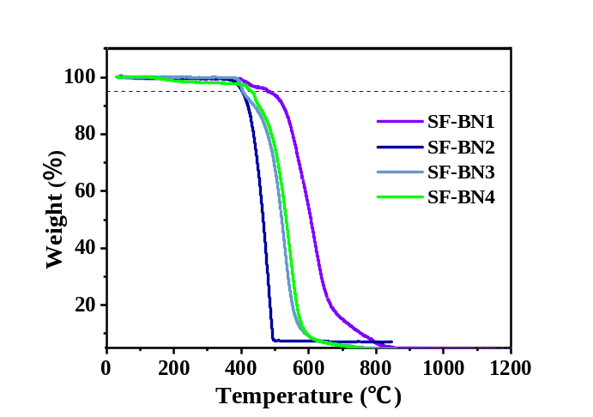
Figure S1. The thermogravimetric analysis curves of SF-BN1, SF-BN2, SF-BN3, and SF-BN4, respectively.
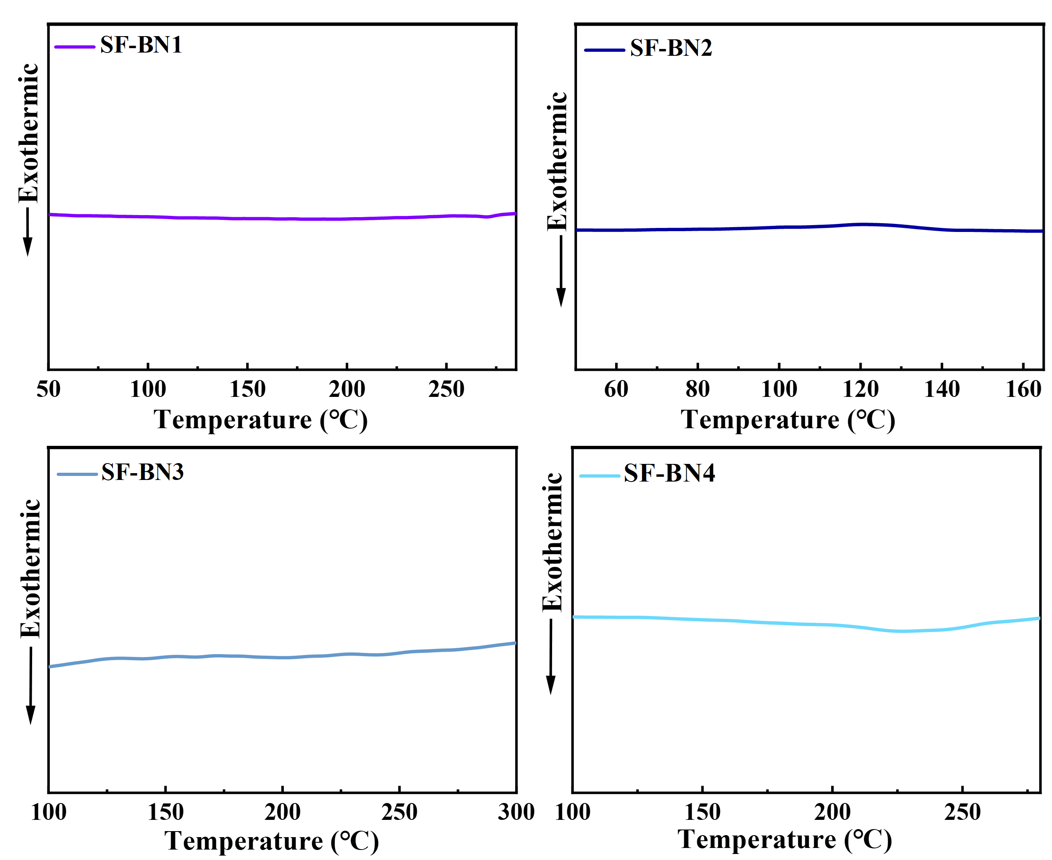
Figure S2. The differential scanning calorimetry curves of SF-BN1, SF-BN2, SF-BN3, and SF-BN4, respectively.

Computational Data

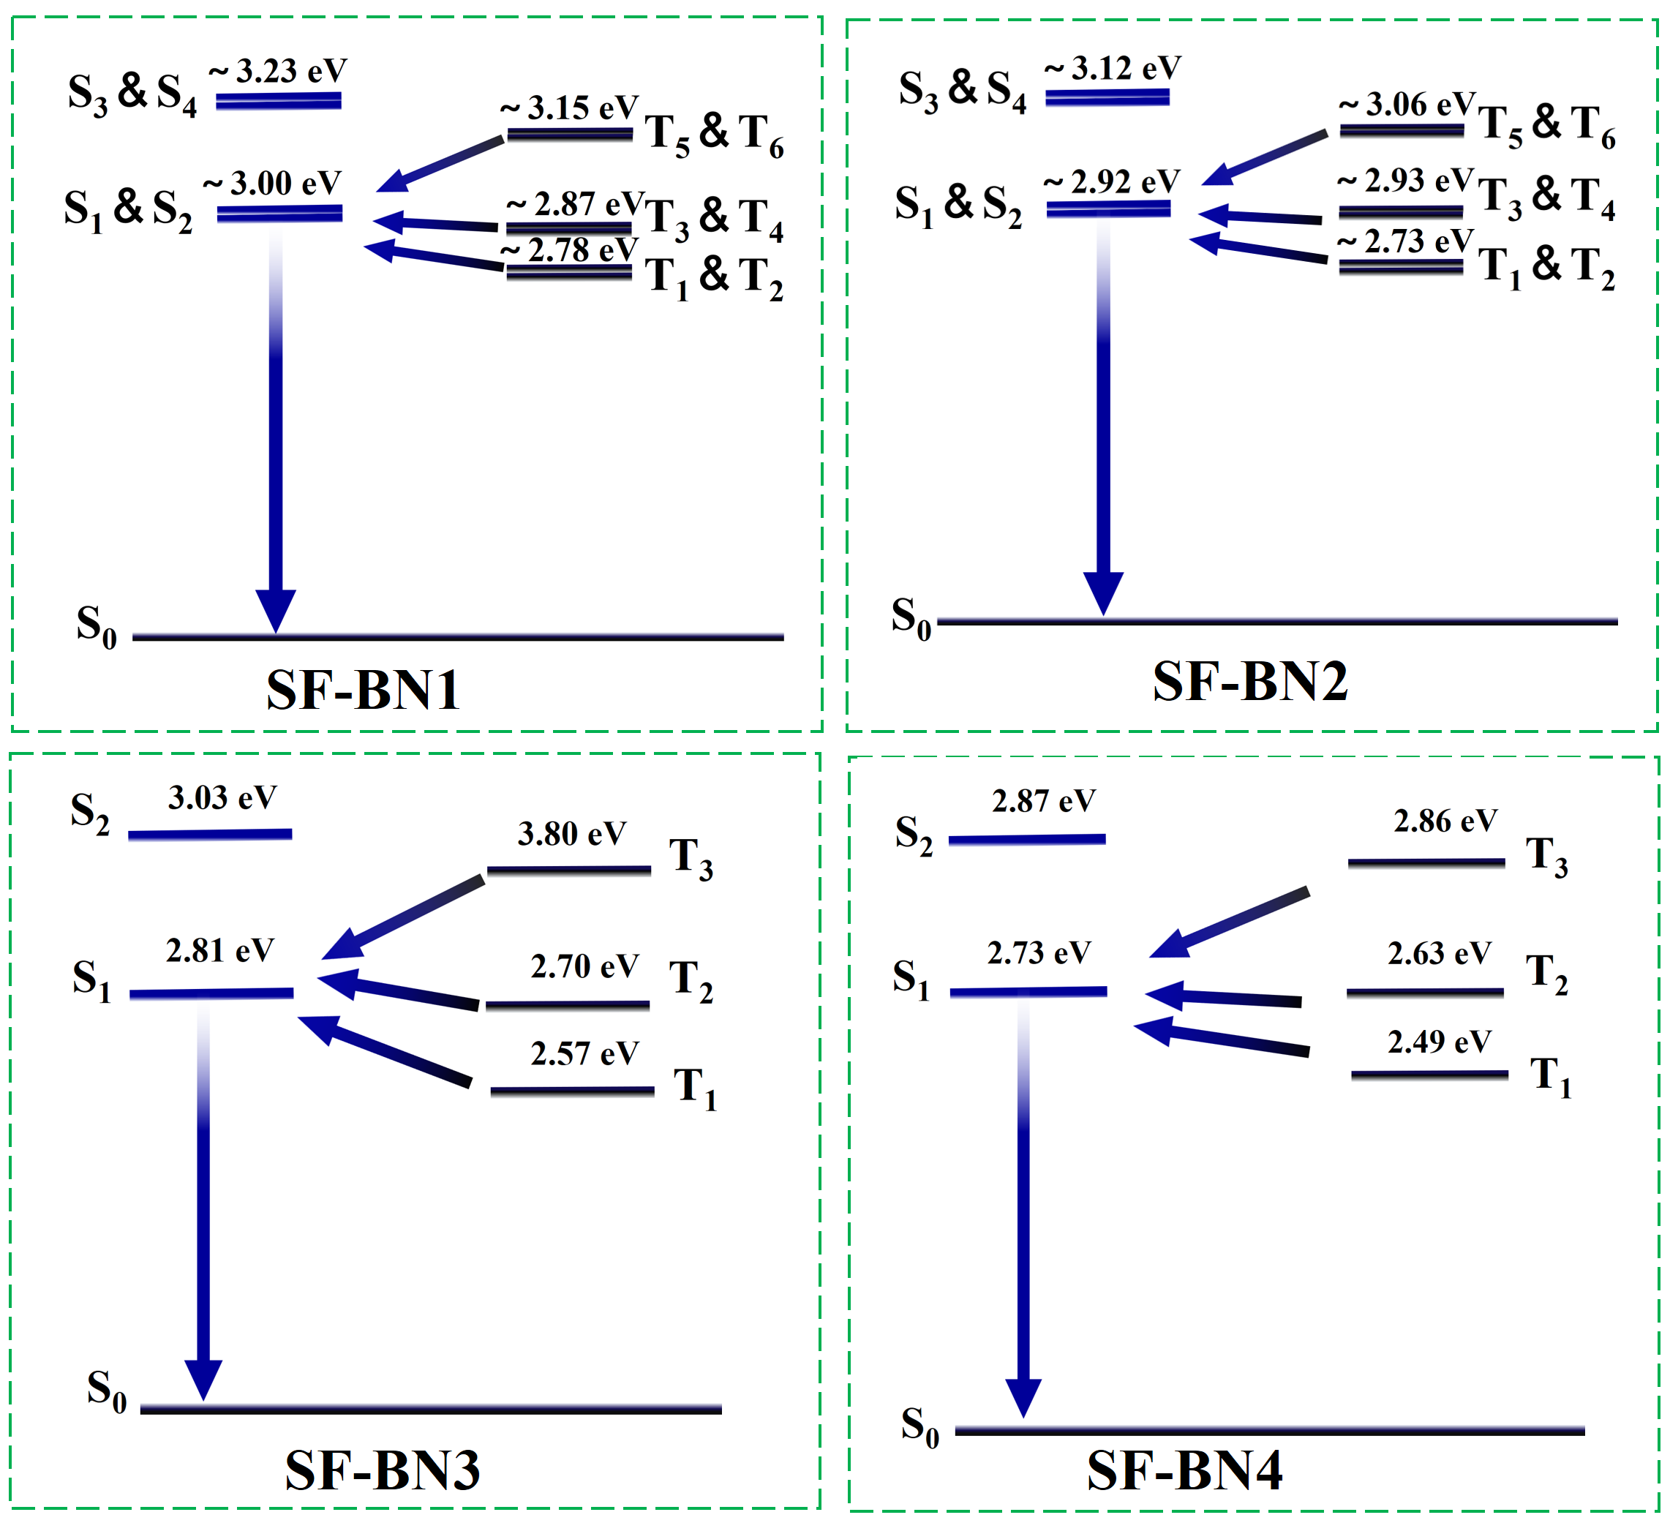
Figure S3. The energy distribution of singlet and triplet states of SF-BN1, SF-BN2, SF-BN3, and SF-BN4, respectively, in singlet and triplet excited states.

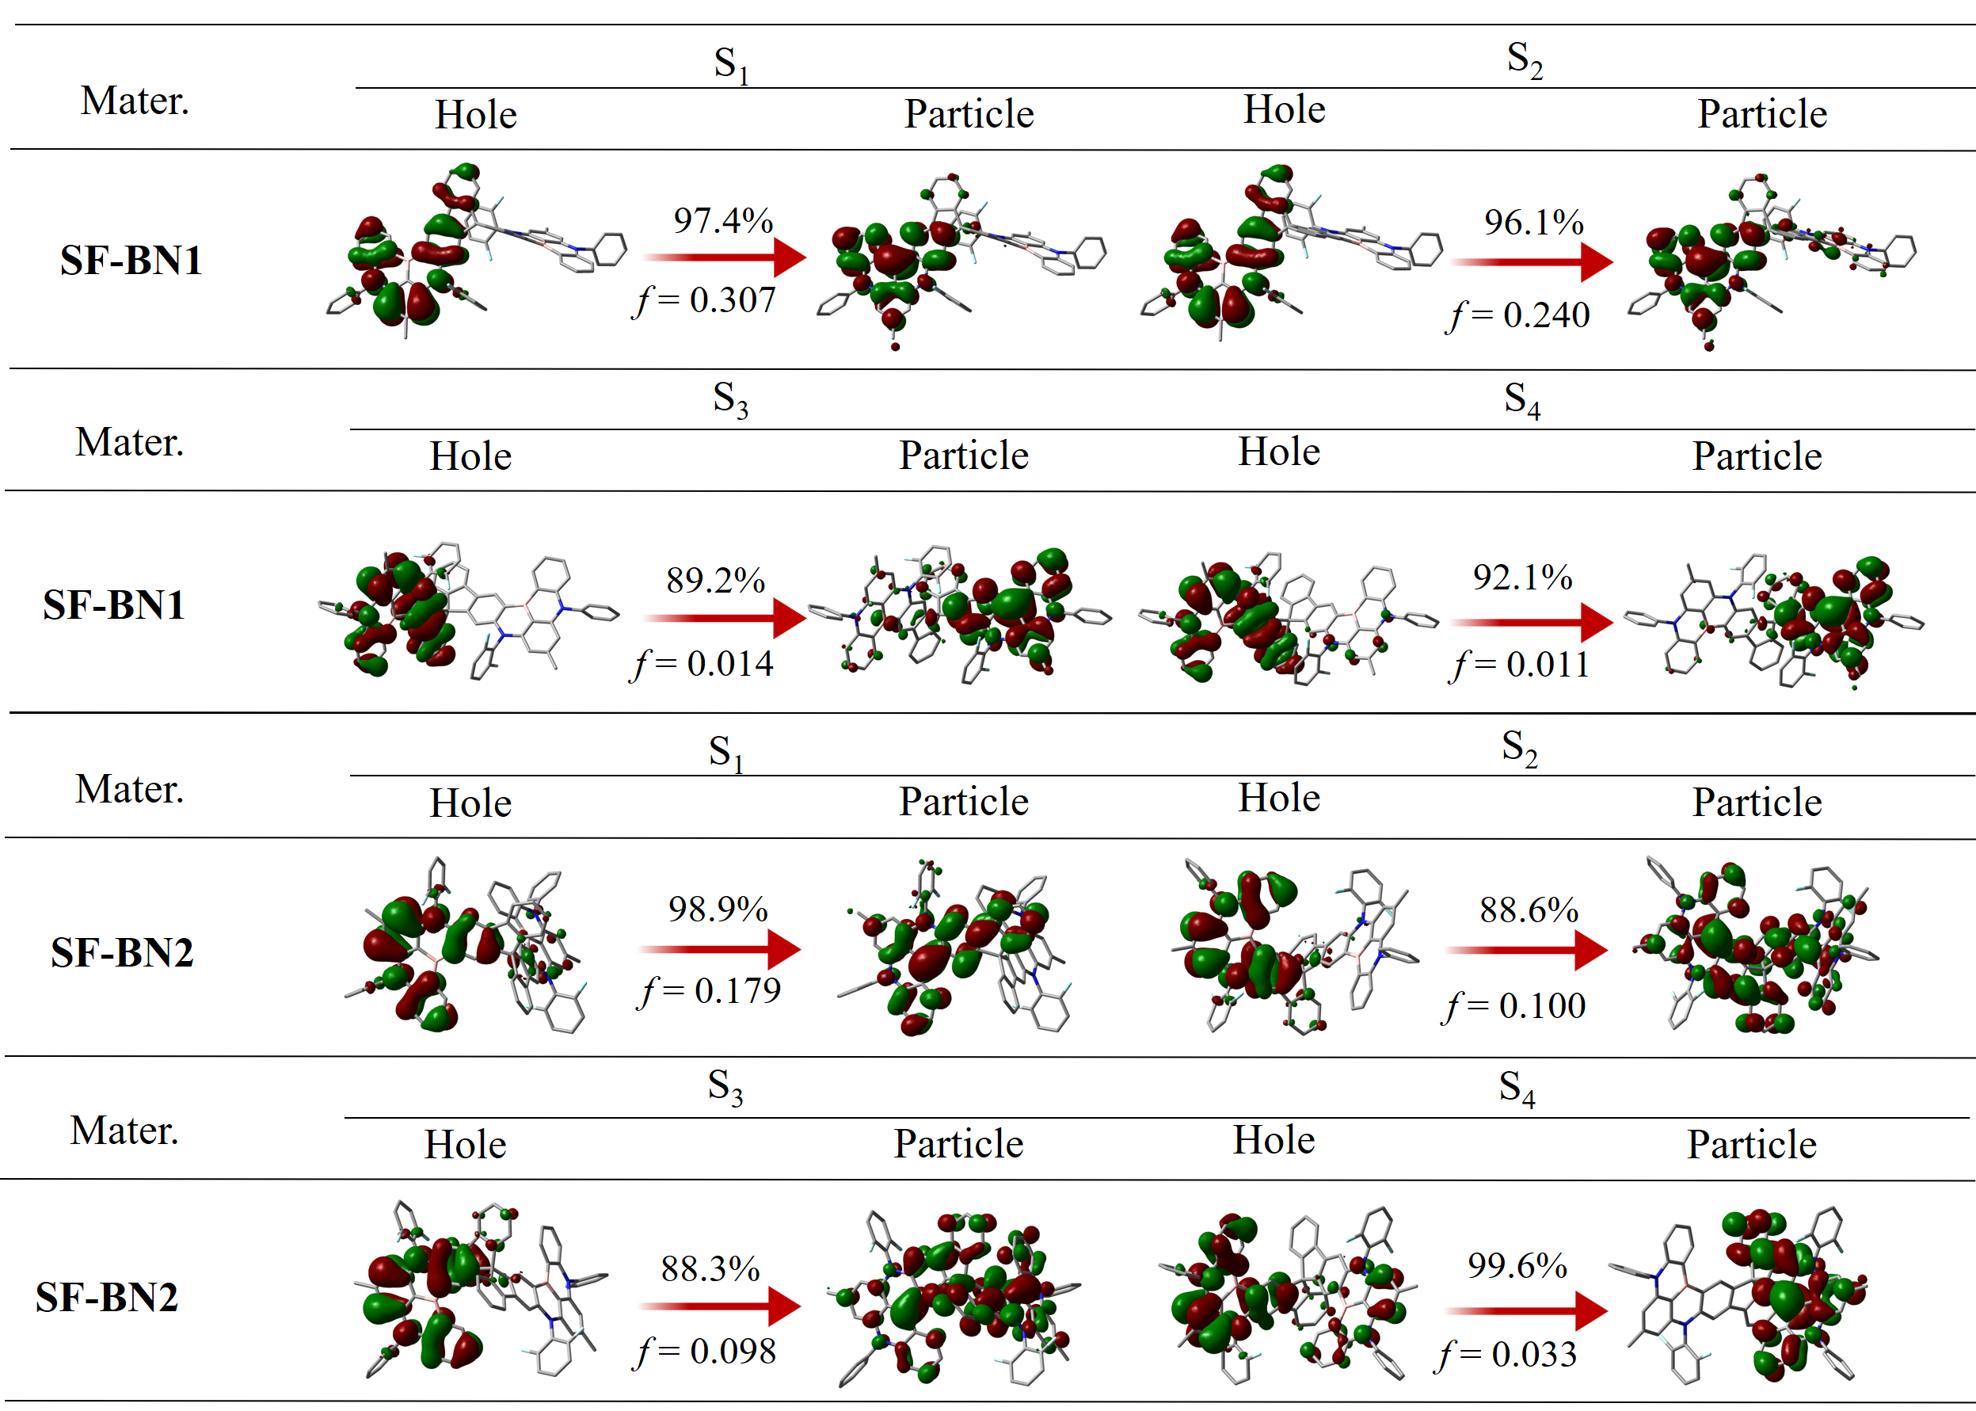
Figure S4. The natural transition orbits (NTOs) of SF-BN1 and SF-BN2 in S_{n} states (n≤4). Due to the intricate molecular structure, hydrogen atoms are omitted from the conformation for easy analysis.
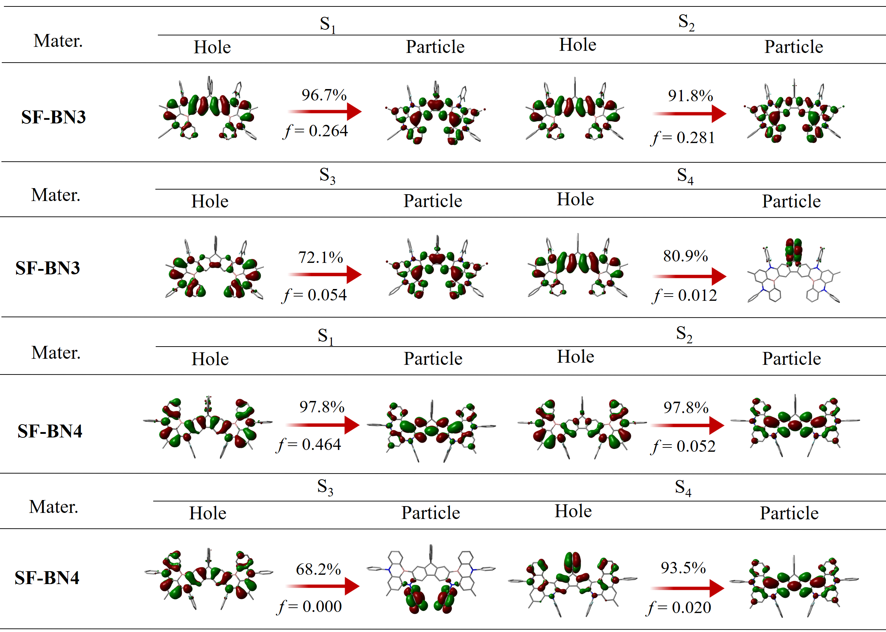
Figure S5. The NTOs of SF-BN3 and SF-BN4 in S_{n} states (n≤4). Due to the intricate molecular structure, hydrogen atoms are omitted from the conformation for easy analysis.
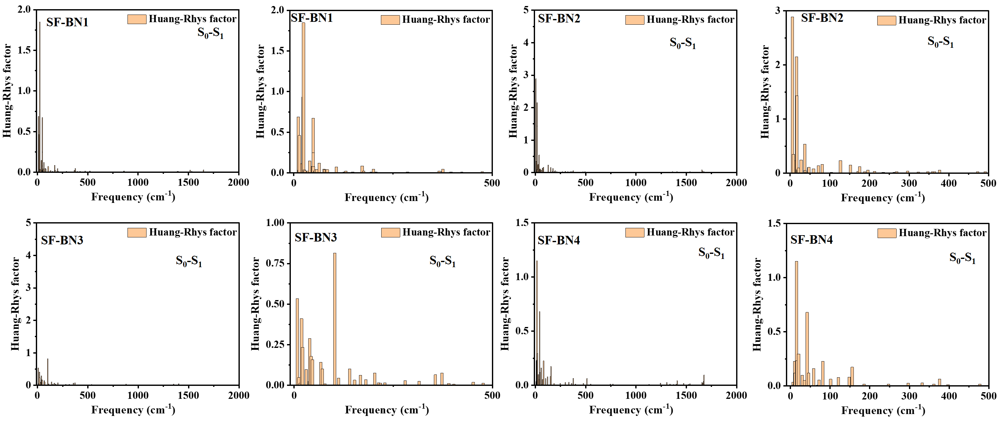
Figure S6. Calculated Huang-Rhys (HR) factor for the S₀→S₁ transition of SF-BN1, SF-BN2, SF-BN3, and SF-BN4, respectively. To facilitate the analysis, we provide two distinct frequency ranges.
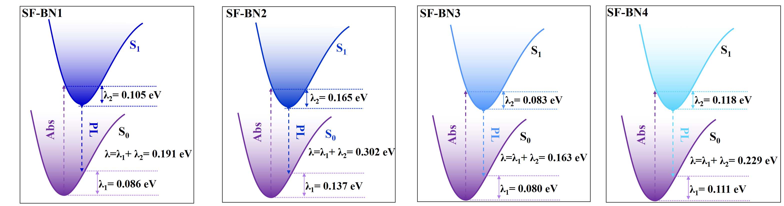
Figure S7. Calculated reorganization energy (λ) of SF-BN1, SF-BN2, SF-BN3, and SF-BN4, respectively.
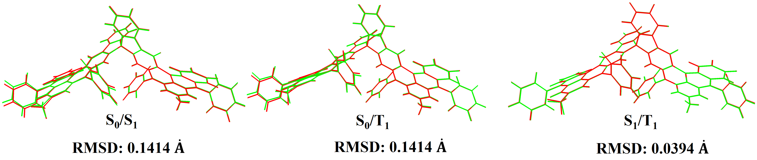
Figure S8. The calculated root-mean-square deviations (RMSDs) of SF-BN1 between the S₀ and S₁ states, the S₀ and T₁ states, and the S₁ and T₁ states, respectively.
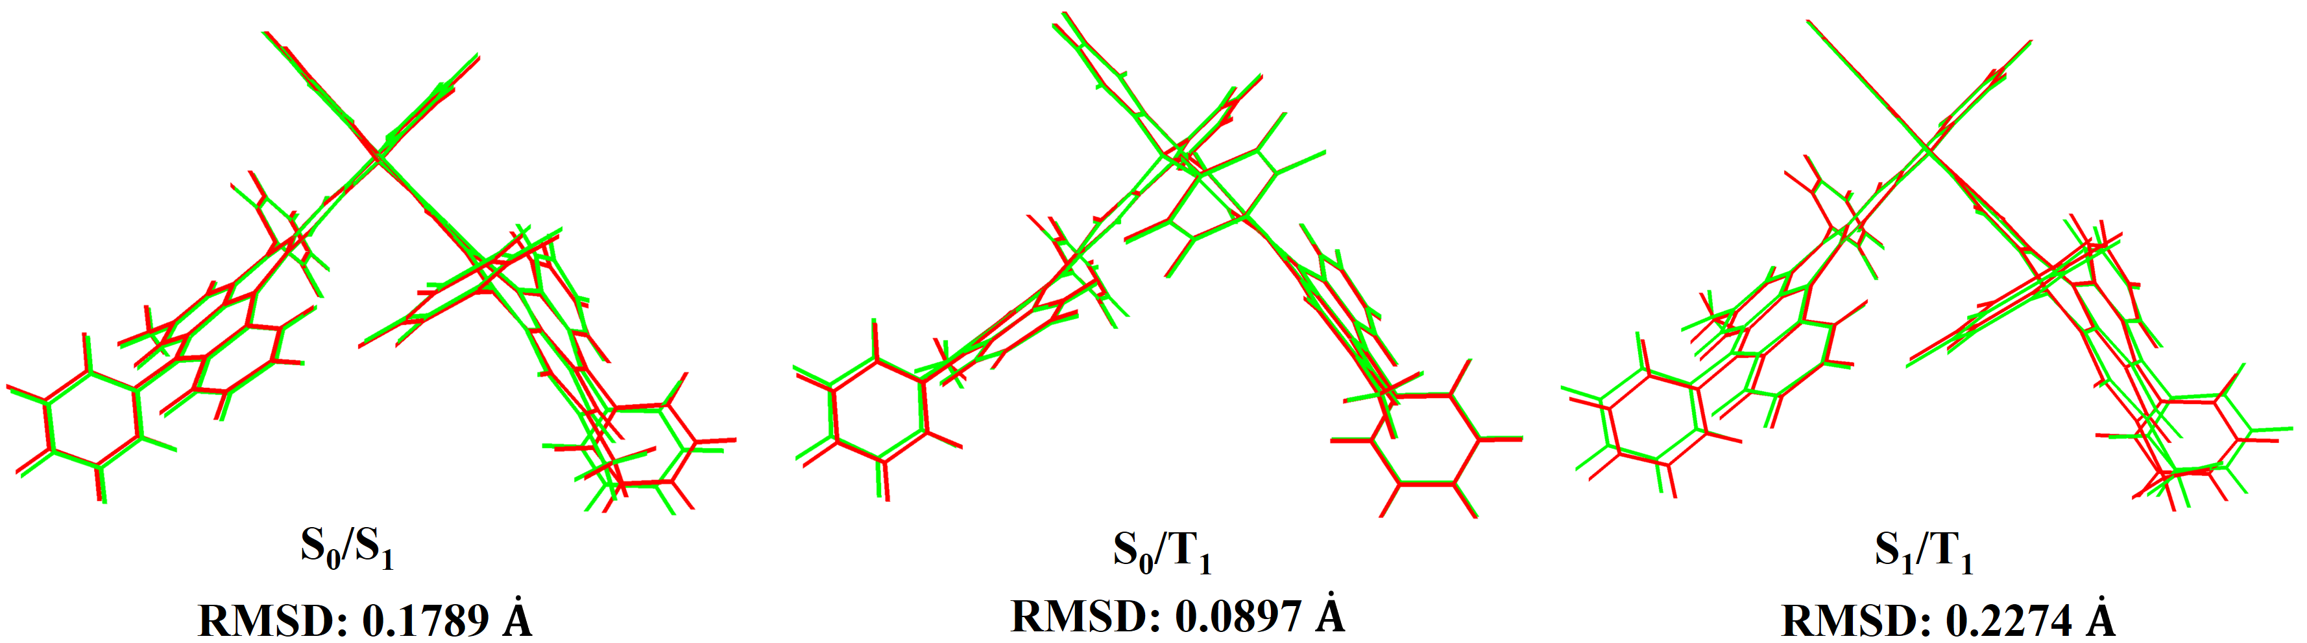
Figure S9. The calculated root-mean-square deviations (RMSDs) of SF-BN2 between the S₀ and S₁ states, the S₀ and T₁ states, and the S₁ and T₁ states, respectively.
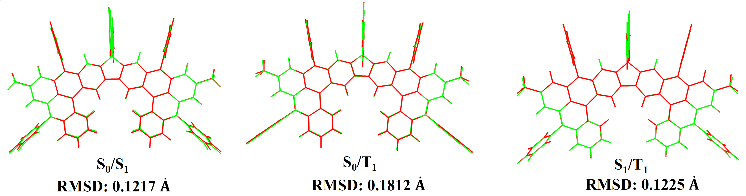
Figure S10. The calculated root-mean-square deviations (RMSDs) of SF-BN3 between the S₀ and S₁ states, the S₀ and T₁ states, and the S₁ and T₁ states, respectively.
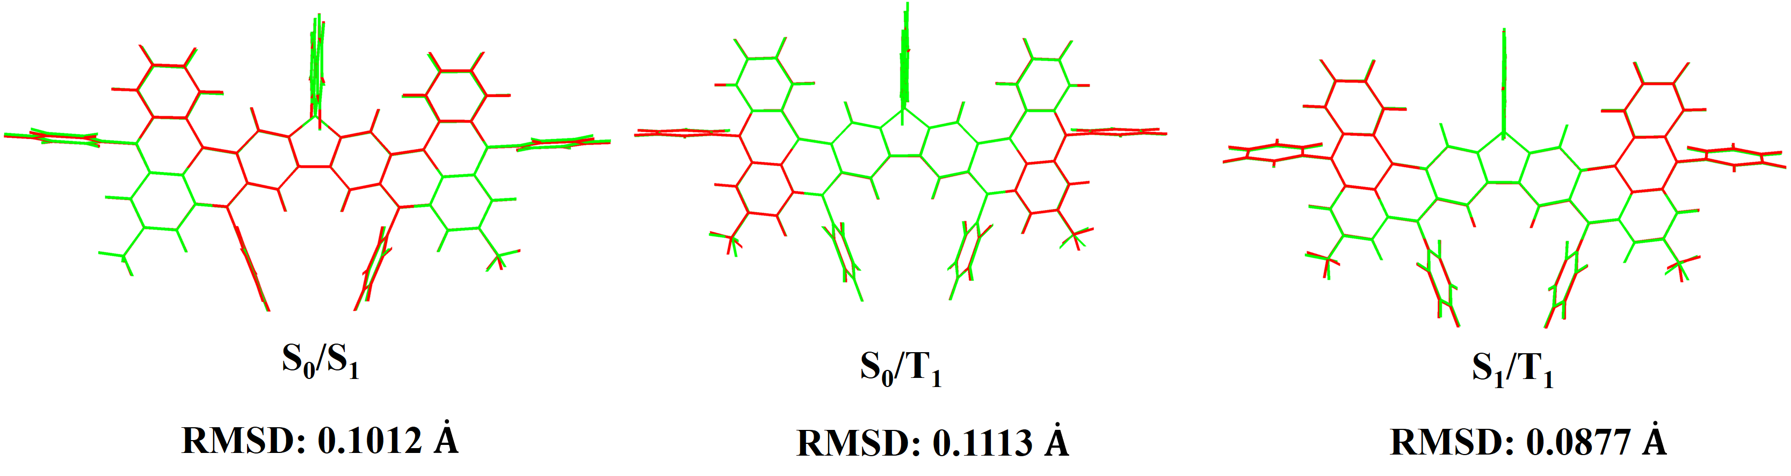
Figure S11. The calculated root-mean-square deviations (RMSDs) of SF-BN4 between the S₀ and S₁ states, the S₀ and T₁ states, and the S₁ and T₁ states, respectively.
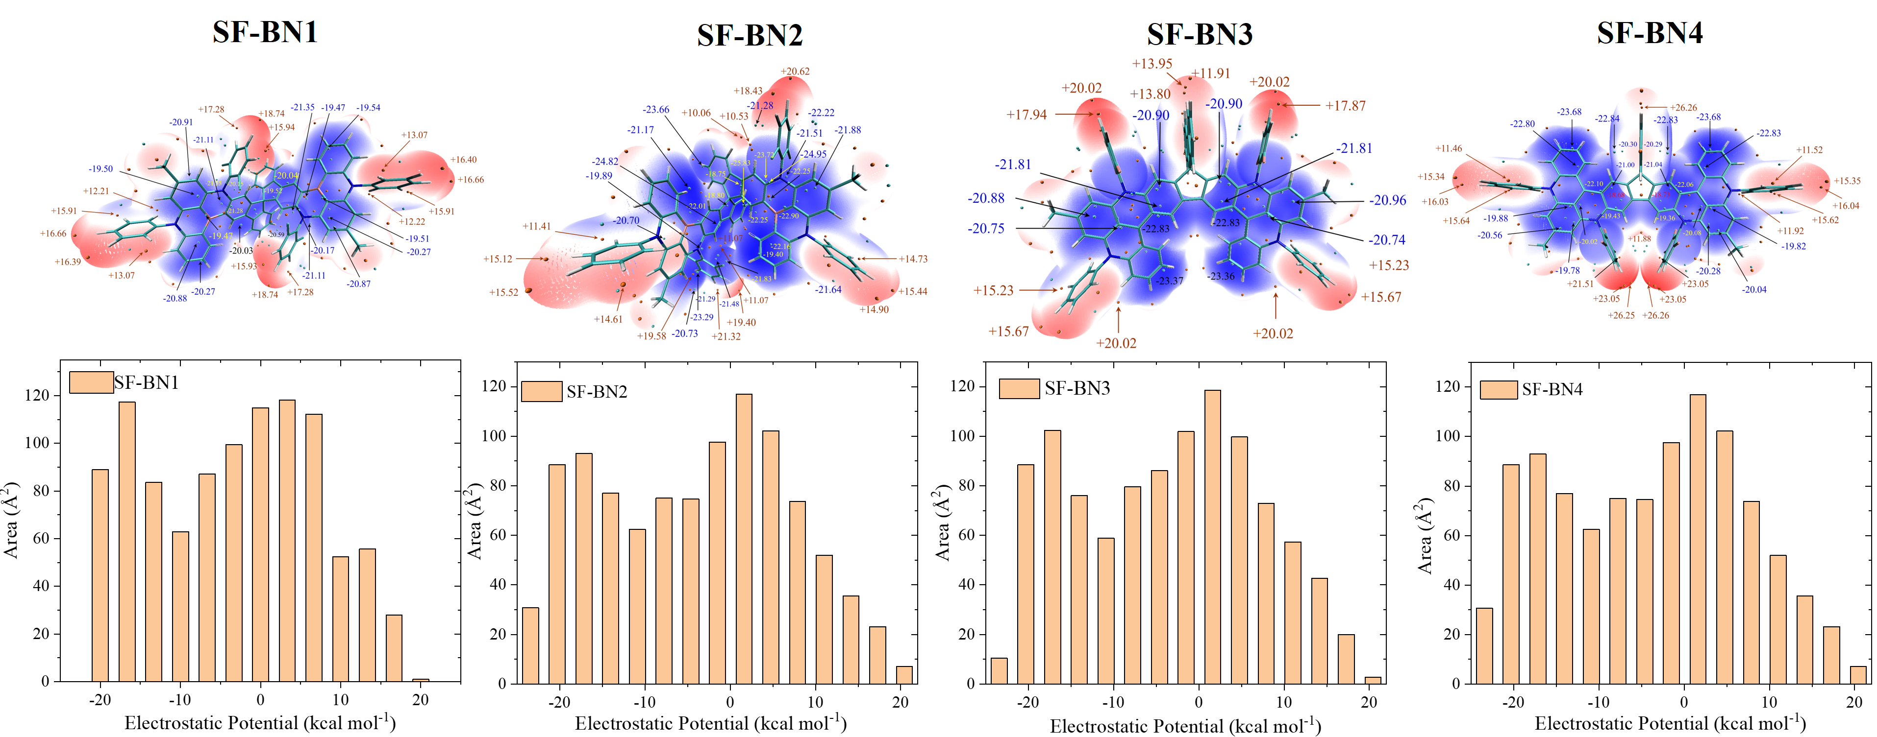
Figure S12. ESP colored isosurface and area on the isosurface in different ESP ranges for SF-BN1, SF-BN2, SF-BN3, and SF-BN4, respectively.
Table S1. The calculated energy levels of S₁ and T₁ states and the frontier molecular orbits (FMOs) of SF-BN1, SF-BN2, SF-BN3, and SF-BN4, respectively.
Compound | S₁ [eV] | T₁ [eV] | ΔE_{ST} [eV] | HOMO [eV] | LUMO [eV]
SF-BN1 | 3.00 | 2.78 | 0.22 | -4.69 | -1.10
SF-BN2 | 2.92 | 2.73 | 0.19 | -4.62 | -1.20
SF-BN3 | 2.81 | 2.57 | 0.14 | -4.46 | -1.15
SF-BN4 | 2.73 | 2.49 | 0.24 | -4.68 | -1.45

Table S2. The spin-orbit coupling matrix elements (SOCMEs) between multiple singlet and triplet energy levels of SF-BN1, SF-BN2, SF-BN3, and SF-BN4, respectively.
SOC [ cm⁻¹] | S₁-T₁ | S₁-T₂ | S₁-T₃ | S₁-T₄ | S₁-T₅ | S₁-T₆
SF-BN1 | 0.01 | 0.07 | 0.01 | 0.38 | 0.05 | 0.20
SF-BN2 | 0.07 | 0.14 | 0.08 | 0.13 | 0.17 | 0.11
SF-BN3 | 0.00 | 0.03 | 0.07 | 0.03 | 0.14 | 0.07
SF-BN4 | 0.01 | 0.11 | 0.04 | 0.03 | 0.09 | 0.24
SOC [ cm⁻¹] | S₂-T₁ | S₂-T₂ | S₂-T₃ | S₂-T₄ | S₂-T₅ | S₂-T₆
SF-BN1 | 0.04 | 0.03 | 0.28 | 0.03 | 0.20 | 0.08
SF-BN2 | 0.06 | 0.08 | 0.08 | 0.18 | 0.20 | 0.07
SF-BN3 | 0.04 | 0.08 | 0.38 | 0.04 | 0.04 | 0.07
SF-BN4 | 0.12 | 0.01 | 0.13 | 0.01 | 0.21 | 0.17

Table S3. Molecular polarity index (MPI) and dipole moment of SF-BN1, SF-BN2, SF-BN3, and SF-BN4, respectively.
 | SF-BN1 | SF-BN2 | SF-BN3 | SF-BN4
MPI/[ kcal/mol] | 9.11 | 9.14 | 9.47 | 9.68
Dipole Moment [Debye] | 3.91 | 2.68 | 2.86 | 5.20

Photophysical properties
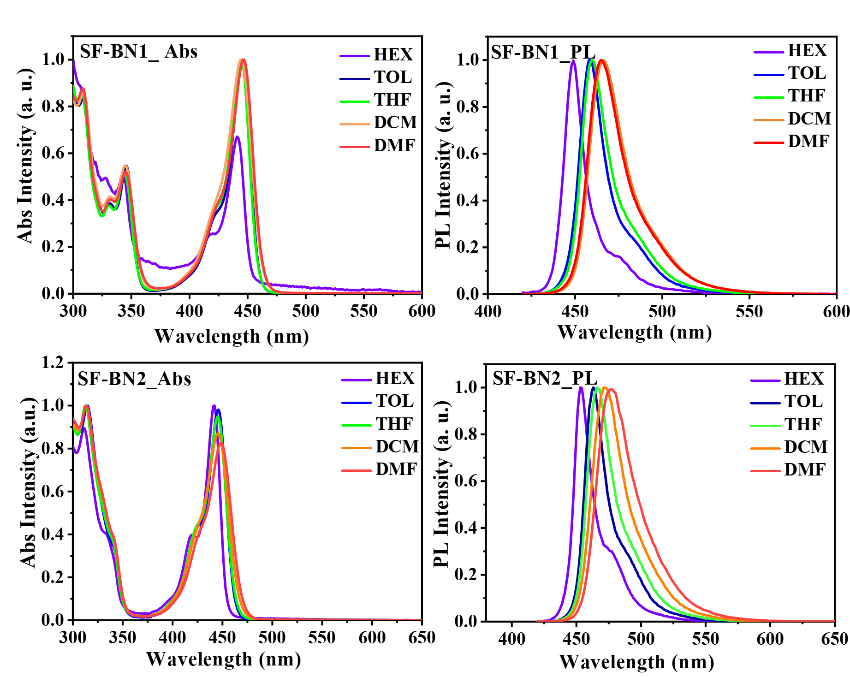
Figure S13. Solvation effect: the UV-vis and PL spectra of SF-BN1 and SF-BN2 in different solvents. Herein, HEX, TOL, THF, DCM, and DMF denote the solvents of n-hexane, toluene, tetrahydrofuran, 1,4-dioxane, and N, N-dimethylformamide, respectively.
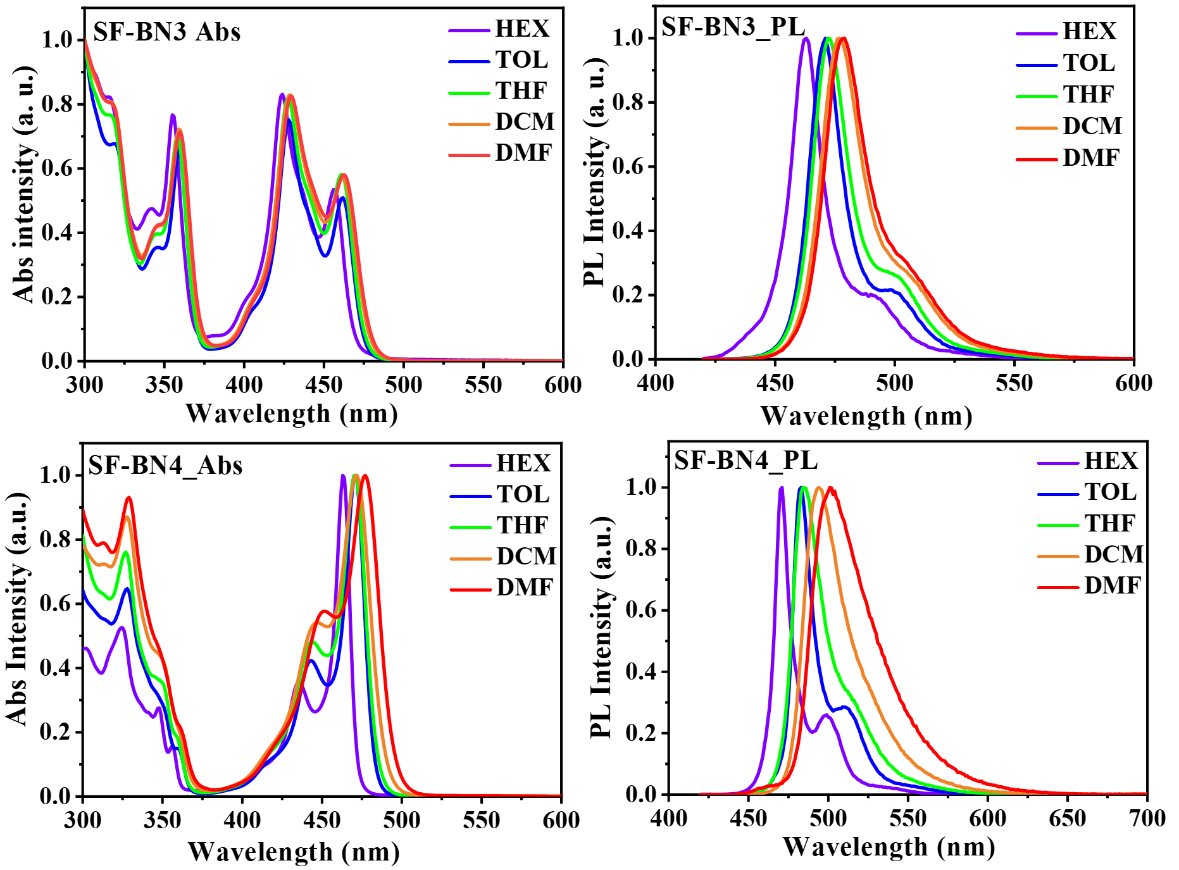
Figure S14. Solvation effect: the UV-vis and PL spectra of SF-BN3 and SF-BN4 in different solvents.
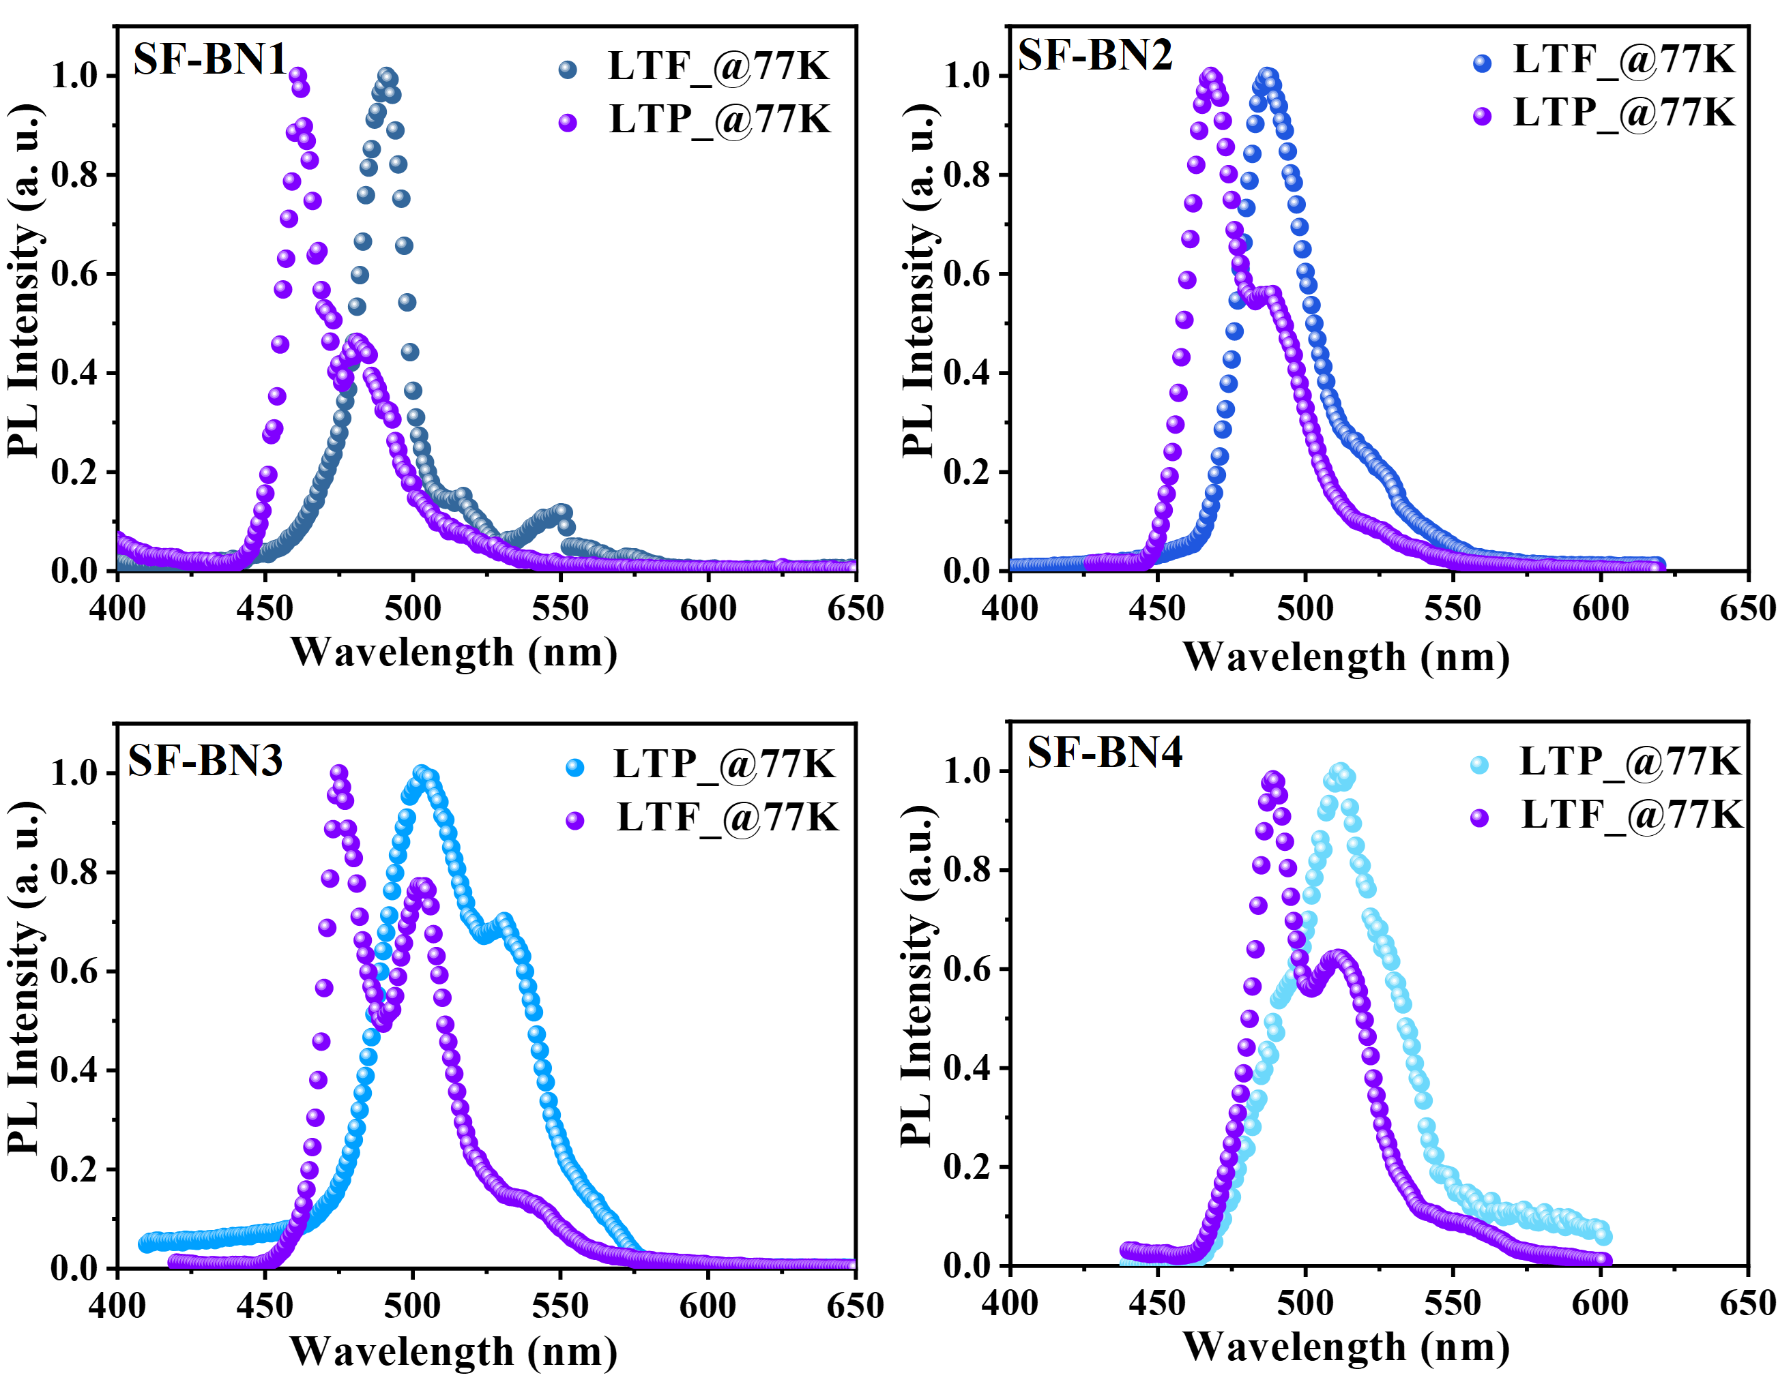
Figure S15. The low-temperature fluorescent and phosphorescent spectra of SF-BN1, SF-BN2, SF-BN3, and SF-BN4, respectively, in dilute toluene glasses at 77K.

Table S4. Summary of photophysical properties of SF-BN1, SF-BN2, SF-BN3, and SF-BN4, respectively.
Emitters | T_{d}^{a)} | λ_{abs}^{b)} | λ_{em}^{c)} | HOMO^{d)} | LUMO^{d)} | S₁^{e)} | T₁^{e)} | ΔE_{ST}^{e)}
Emitters | [ºC] | [nm] | [nm] | [eV] | [eV] | [eV] | [eV] | [eV]
SF-BN1 | 486 | 445 | 458 | -5.27 | -2.61 | 2.76 | 2.67 | 0.09
SF-BN2 | 491 | 446 | 463 | -5.28 | -2.63 | 2.76 | 2.67 | 0.09
SF-BN3 | 405 | 462 | 471 | -5.28 | -2.67 | 2.69 | 2.63 | 0.06
SF-BN4 | 430 | 471 | 483 | -5.28 | -2.72 | 2.70 | 2.63 | 0.07
^{a)} decomposition temperature (T_{d}) (5% weight loss); ^{b)} UV-vis absorption in toluene solutions at room temperature; ^{c)} PL peaks in dilute toluene solution at room temperature; ^{d)} experimental HOMO/LUMO determined from cyclic voltammetry; ^{d)} S₁, T₁, and ΔE_{ST}s were evaluated in dilute toluene at 77 K.
Table S5. The UV-vis characteristics of SF-BN1, SF-BN2, SF-BN3, and SF-BN4 in different solvents.
Emitters | λ_{em} (nm)
 | Hex | Tol | THF | DCM | DMF
SF-BN1 | 441 | 445 | 445 | 445 | 447
SF-BN2 | 442 | 446 | 446 | 446 | 447
SF-BN3 | 456 | 461 | 461 | 462 | 463
SF-BN4 | 463 | 471 | 471 | 471 | 477

Table S6. The PL characteristics of SF-BN1, SF-BN2, SF-BN3, and SF-BN4 in different solvents.
Emitters | λ_{em} (nm)/FWHM (nm)
 | Hex | Tol | THF | DCM | DMF
SF-BN1 | 449/13 | 458/17 | 460/18 | 466/24 | 465/24
SF-BN2 | 453/17 | 463/21 | 466/25 | 472/31 | 477/35
SF-BN3 | 463/16 | 471/17 | 472/19 | 477/21 | 479/22
SF-BN4 | 471/15 | 483/15 | 484/23 | 494/32 | 501/43

Table S7. Photo-physical properties of 1 wt.% SF-BN1, SF-BN2, SF-BN3, and SF-BN4 in p-PhBCzPh film deposited using the vacuum evaporation technique were measured at various temperatures.
Emitters | Φ_{PL} |  | Φ_{PF} |  | Φ_{TADF} | 𝜏_{PF} | 𝜏_{DF} | 𝜅_{r}^{s} | 𝜅_{isc}^{s} | 𝜅_{risc}^{s} | 𝜅_{TADF}
Emitters | [%] |  | [%] |  | [%] | [ns] | [μs] | [10⁷s⁻¹] | [10⁷s⁻¹] | [10⁵s⁻¹] | [10⁴s⁻¹]
SF-BN1 | 93.1 | 17.2 |  | 75.8 |  | 6.1 | 45.7 | 2.8 | 14 | 1.2 | 2.0
SF-BN2 | 90.3 | 18.9 |  | 71.4 |  | 8.2 | 267.5 | 2.3 | 10 | 0.17 | 0.3
SF-BN3 | 97.2 | 22.4 |  | 74.8 |  | 7.2 | 74.1 | 3.1 | 11 | 0.58 | 1.3
SF-BN4 | 96.5 | 1.7 |  | 94.8 |  | 5.8 | 473.4 | 0.3 | 17 | 1.2 | 0.2

Crystal properties
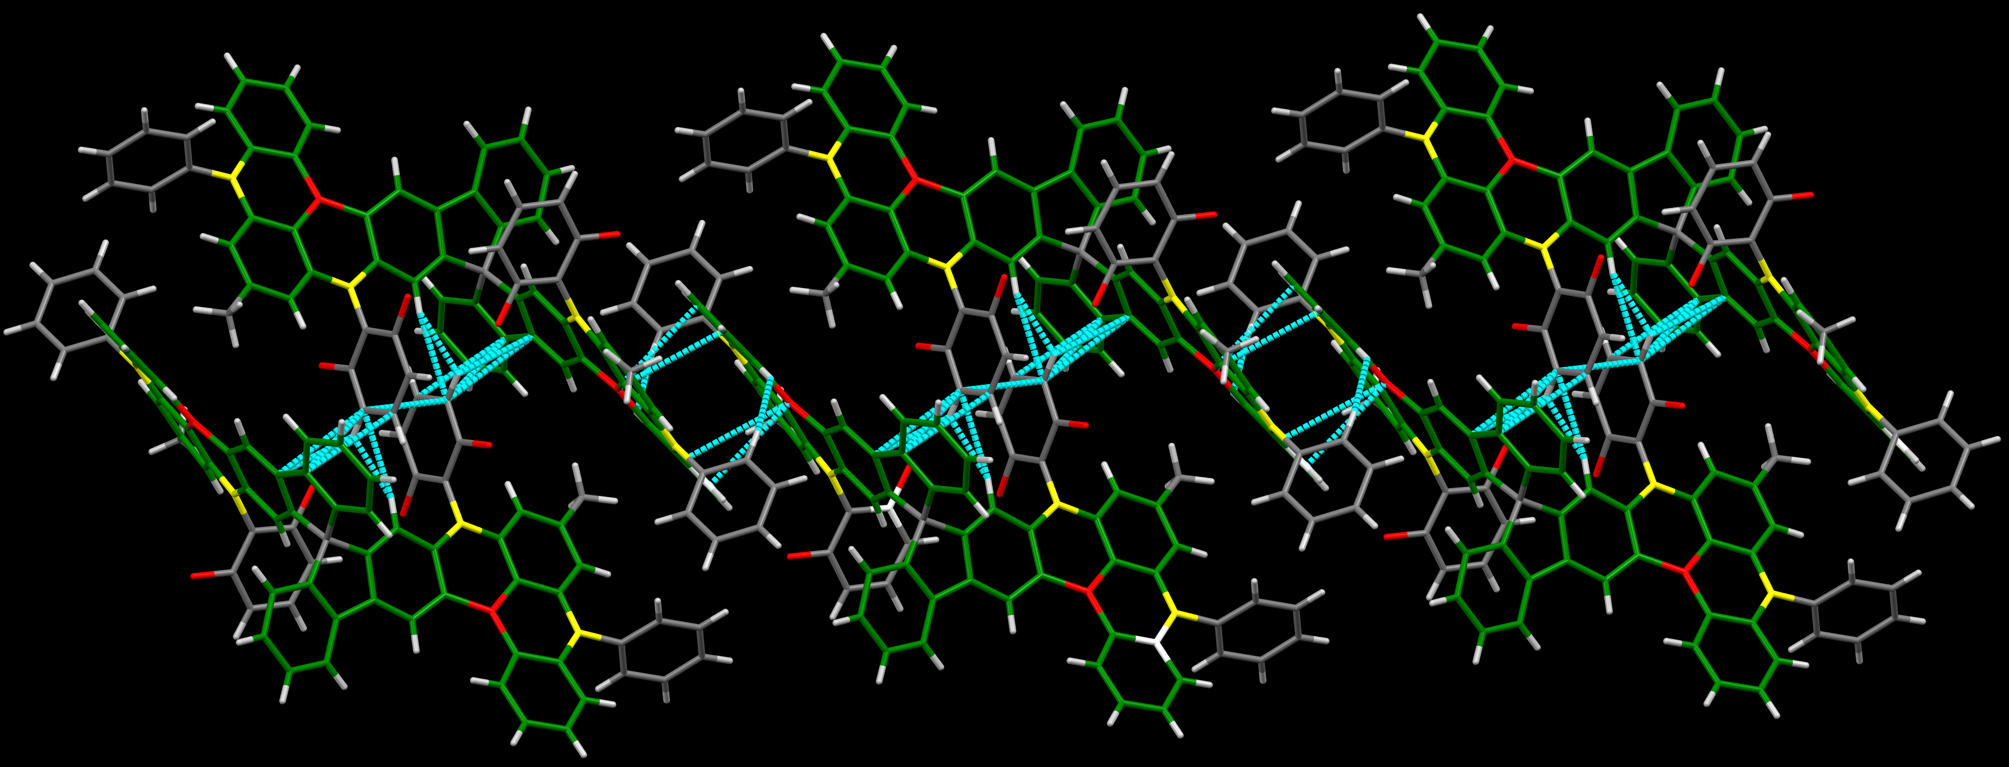
Figure S16. Packing patterns with abundant C-H···π and C-F···π bonds of SF-BN1 crystal. Intermolecular π-π interactions were not detected.
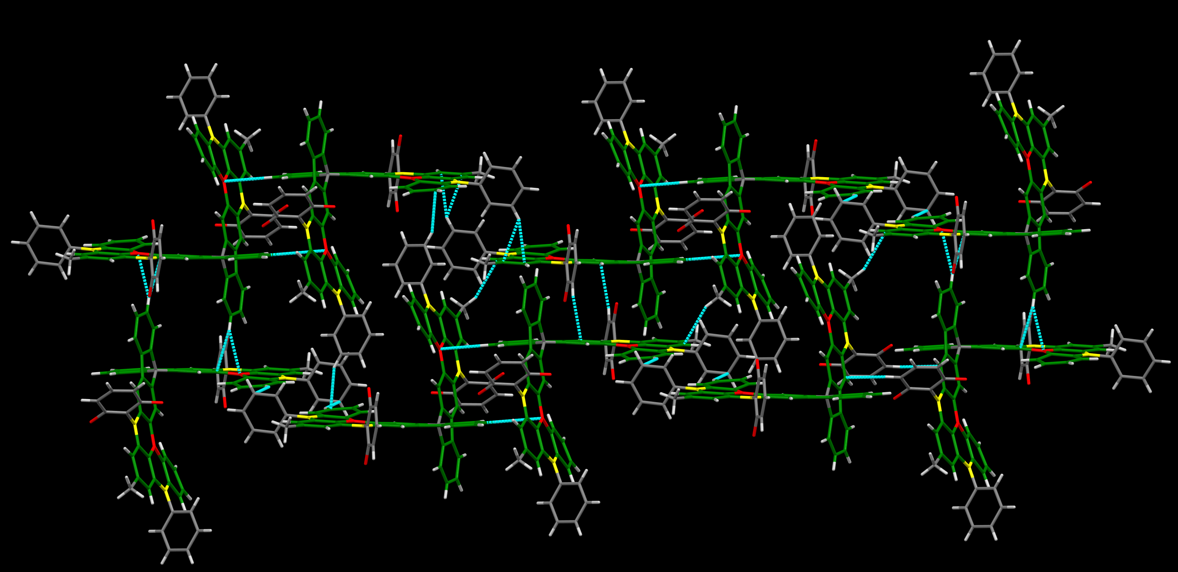
Figure S17. Packing patterns with abundant C-H···π and C-H···B bonds of SF-BN2 crystal. Intermolecular π-π interactions were not detected.
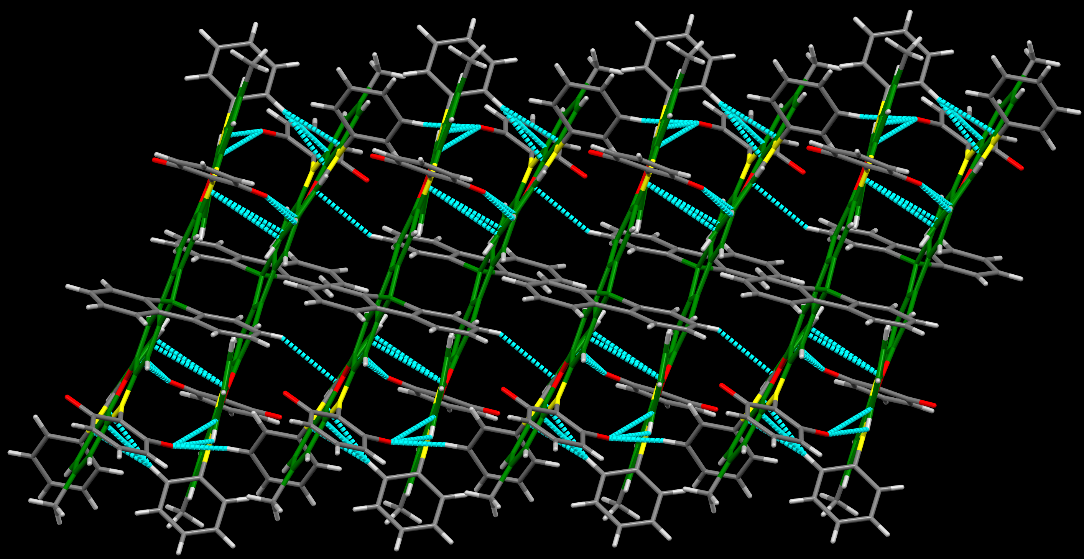
Figure S18. Packing patterns with abundant C-H···π, C-H···F, and C-B-π interactions of SF-BN3 crystal. The aromatic region of B/N-centers forms relatively tight π-π interactions with neighboring molecules.

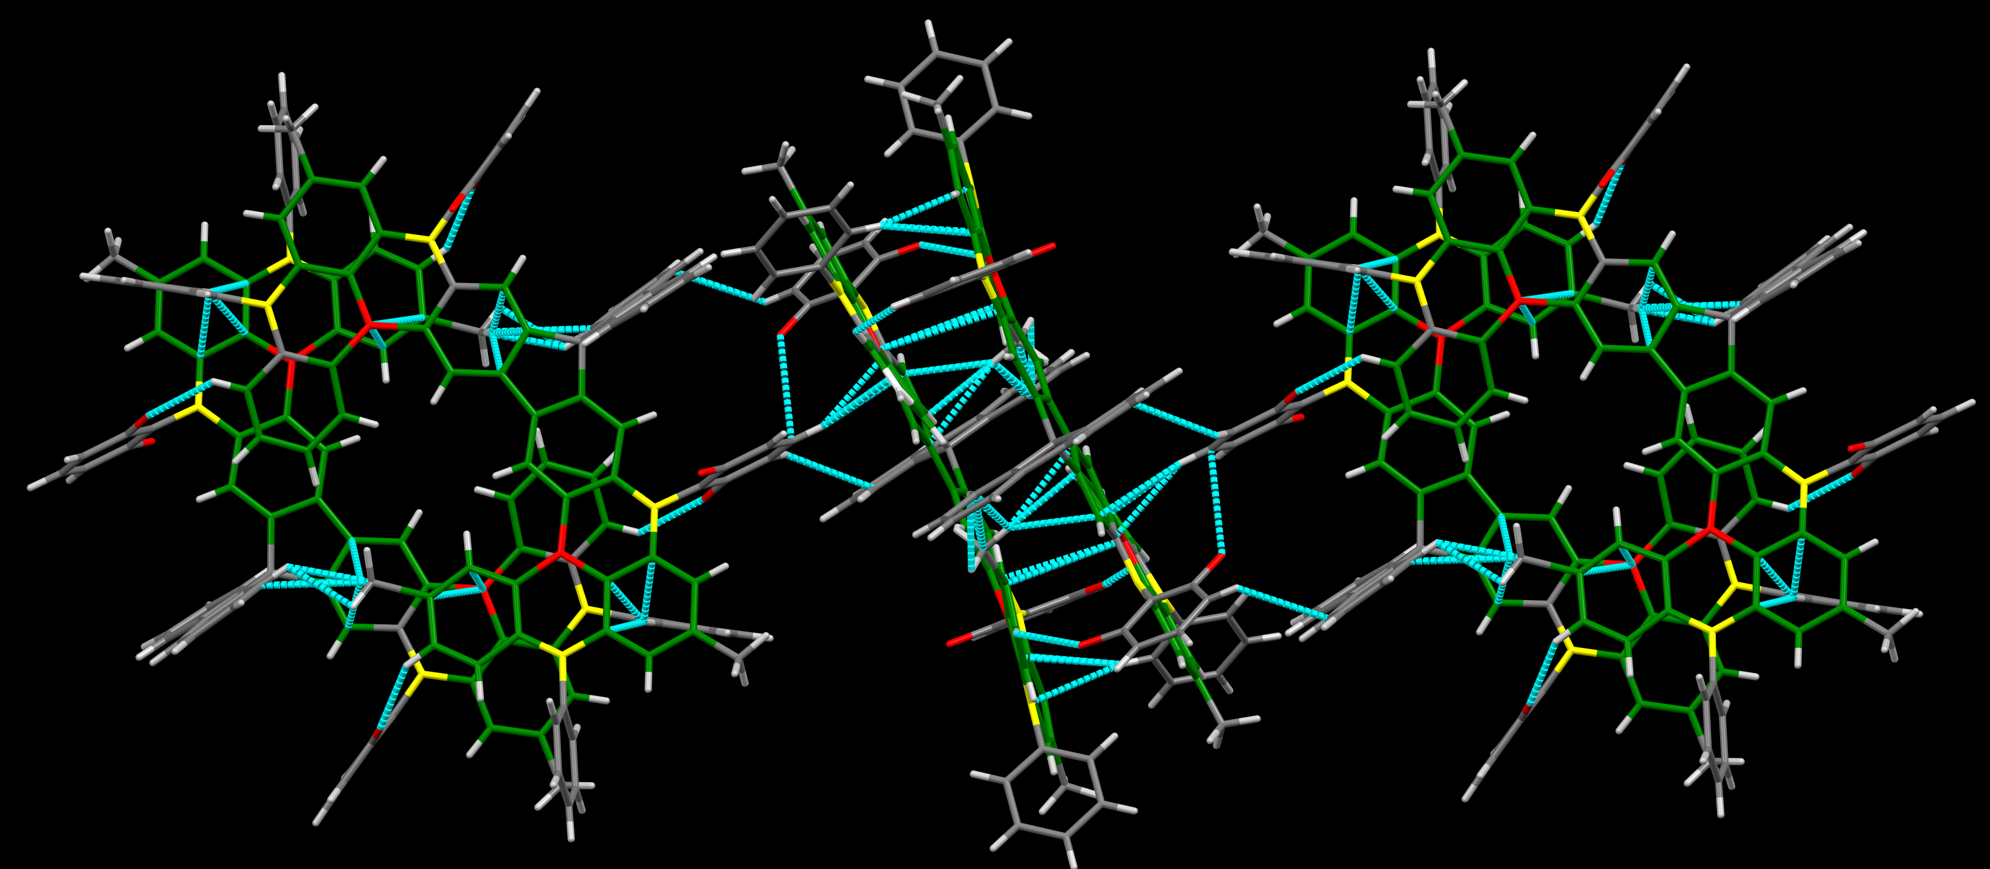
Figure S19. Packing patterns with abundant C-H···π and C-F···π, and (π)-π interactions of SF-BN4 crystal. We observe that molecules form tightly arranged dimers in pairs, connected via CH-π or CF-π bonds.

Table S8. Crystal data and structure refinement for SF-BN1, SF-BN2, SF-BN3, and SF-BN4
Identification code | SF-BN1 | SF-BN2 | SF-BN3 | SF-BN4
Empirical formula | C₇₅H₄₆B₂F₄N₄ | C₇₅H₄₆B₂F₄N₄ | C₇₅H₄₆B₂F₄N₄ | C₇₅H₄₆B₂F₄N₄•3(CH₂Cl₂)
Formula weight | 1100.78 | 1100.78 | 1100.78 | 1355.56
Temperature/K | 150 | 150 | 150 | 170
Crystal system | Monocrystal | Monocrystal | Monocrystal | Monocrystal
Space group | P-1 | P-1 | P 21/c | P-1
a/Å | 14.5391 (2) | 11.0234 (6) | 12.6662(5) | 10.5577(4)
b/Å | 14.5576 (2) | 16.3585 (10) | 27.0217(11) | 15.7514(5)
c/Å | 15.4748 (3) | 18.4675 (11) | 19.9702(8) | 20.4910(6)
α/° | 71.590 (1) | 84.299 | 90 | 80.293 (2)
β/° | 64.951 (1) | 80.863 (3) | 104.460 (2) | 85.690 (2)
γ/° | 76.110 (1) | 81.100 (4) | 90 | 71.499 (2)
Volume/Å³, z | 2793.76 (8) | 3238.8 (3) | 6618.5 (5) | 3184.39(19)
Density/g cm⁻³ | 1.309 | 1.129 | 1.105 | 1.414
μ/mm⁻¹ | 0.683 | 0.589 | 0.577 | 2.968
Z | 2 | 2 | 4 | 2
CCDC | 2377644 | 2377701 | 2377647 | 2377648

Electrochemical measurements
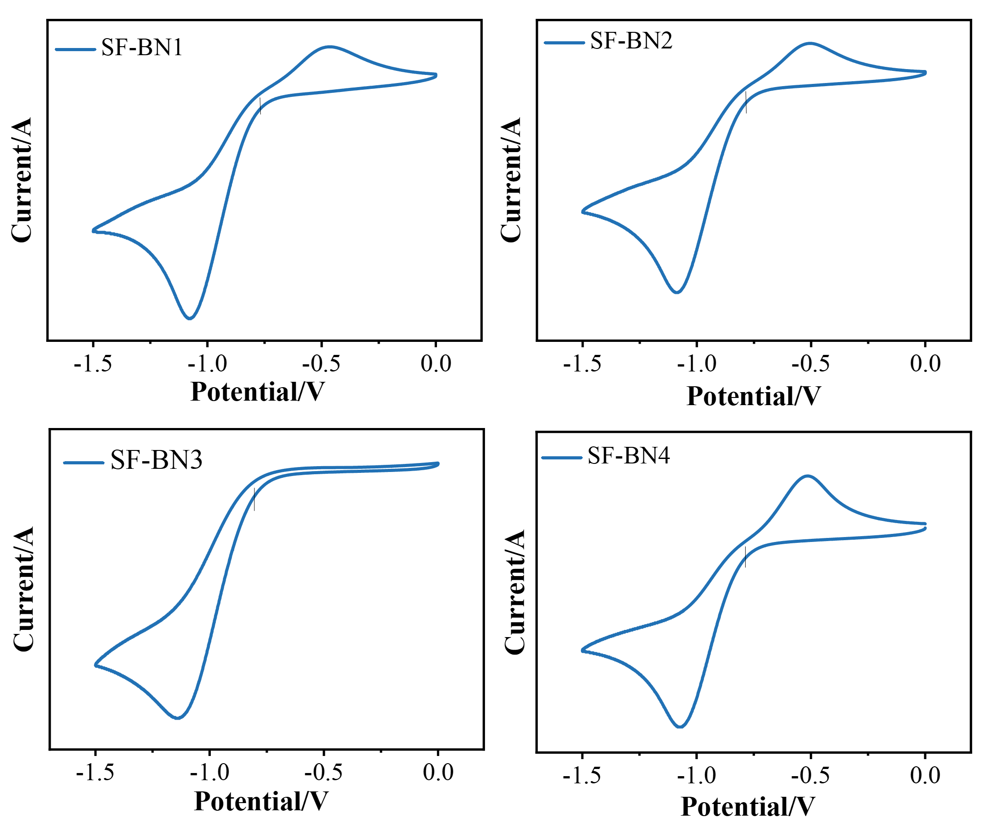
Figure S20. Cyclic voltammetry measurements of A-BN (red), DA-BN (blue), and A-DBN (green), respectively.

OLED characterization

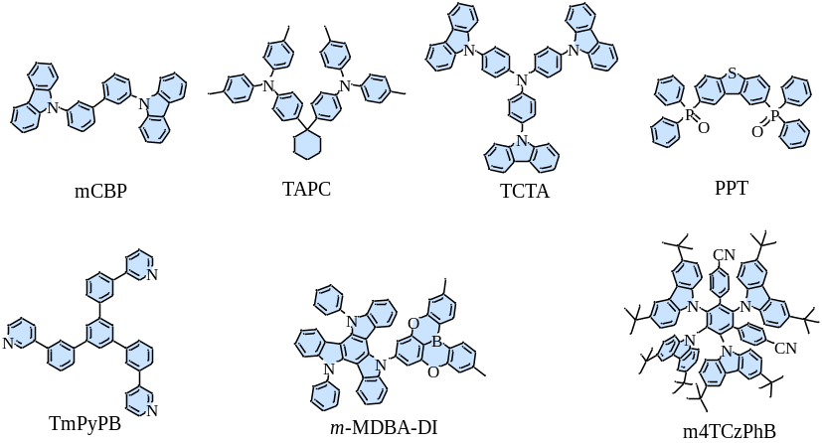
Figure S21. The molecular structures used in and ternary HF-OLEDs.
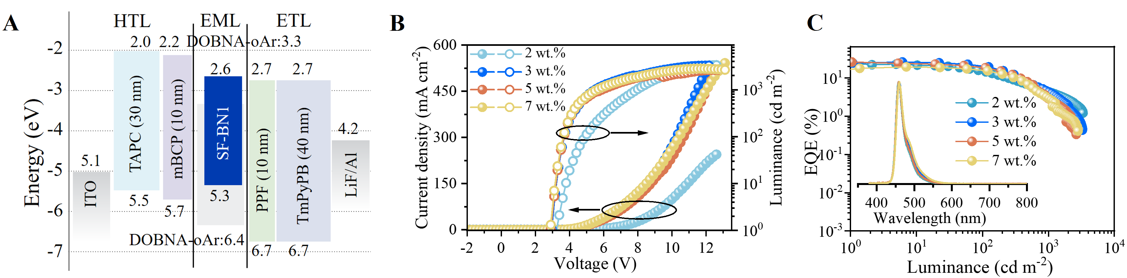
Figure S22. (A) Device architecture and energy diagram, (B) Current density-voltage-luminance curves, (C) EQE-luminance curves of binary emitting layer OLEDs based on SF-BN1 at the doping concentrations of 2, 3, 5, and 7 wt.%. Insert: the EL spectra at different doping concentrations.
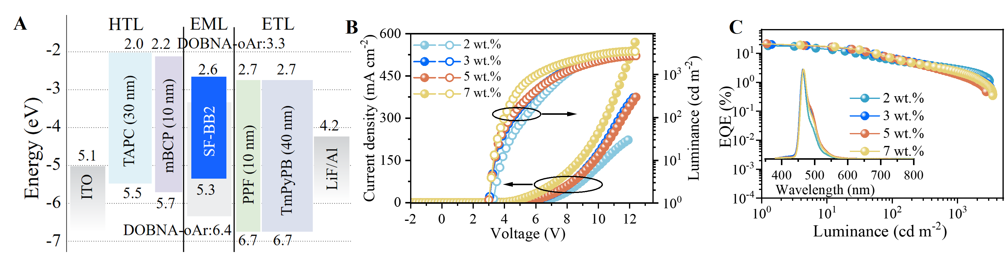
Figure S23. (A) Device architecture and energy diagram, (B) Current density-voltage-luminance curves, (C) EQE-luminance curves of binary emitting layer OLEDs based on SF-BN2 at the doping concentrations of 2, 3, 5, and 7 wt.%. Insert: the EL spectra at different doping concentrations.
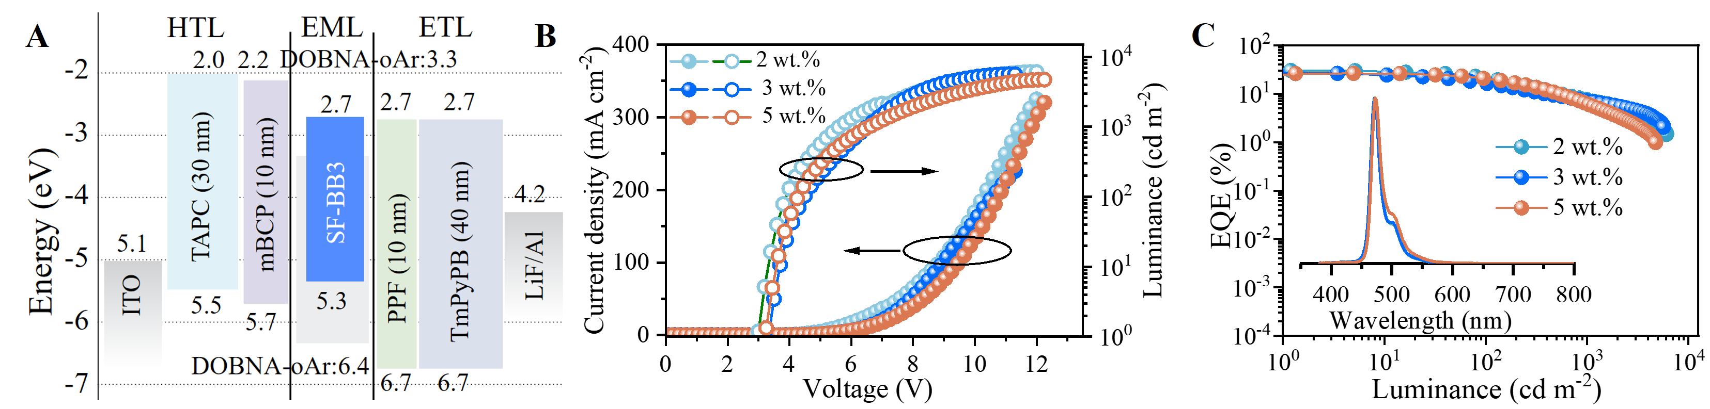
Figure S24. (A) Device architecture and energy diagram, (B) Current density-voltage-luminance curves, (C) EQE-luminance curves of binary emitting layer OLEDs based on SF-BN3 at the doping concentrations of 2, 3, 5, and 7 wt.%. Insert: the EL spectra at different doping concentrations.

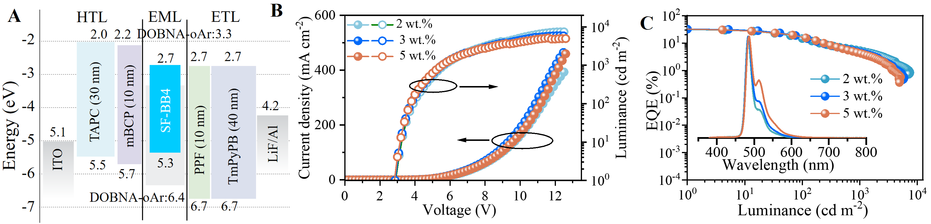
Figure S25. (A) Device architecture and energy diagram, (B) Current density-voltage-luminance curves, (C) EQE-luminance curves of binary emitting layer OLEDs based on SF-BN4 at the doping concentrations of 2, 3, 5, and 7 wt.%. Insert the EL spectra at different doping concentrations.

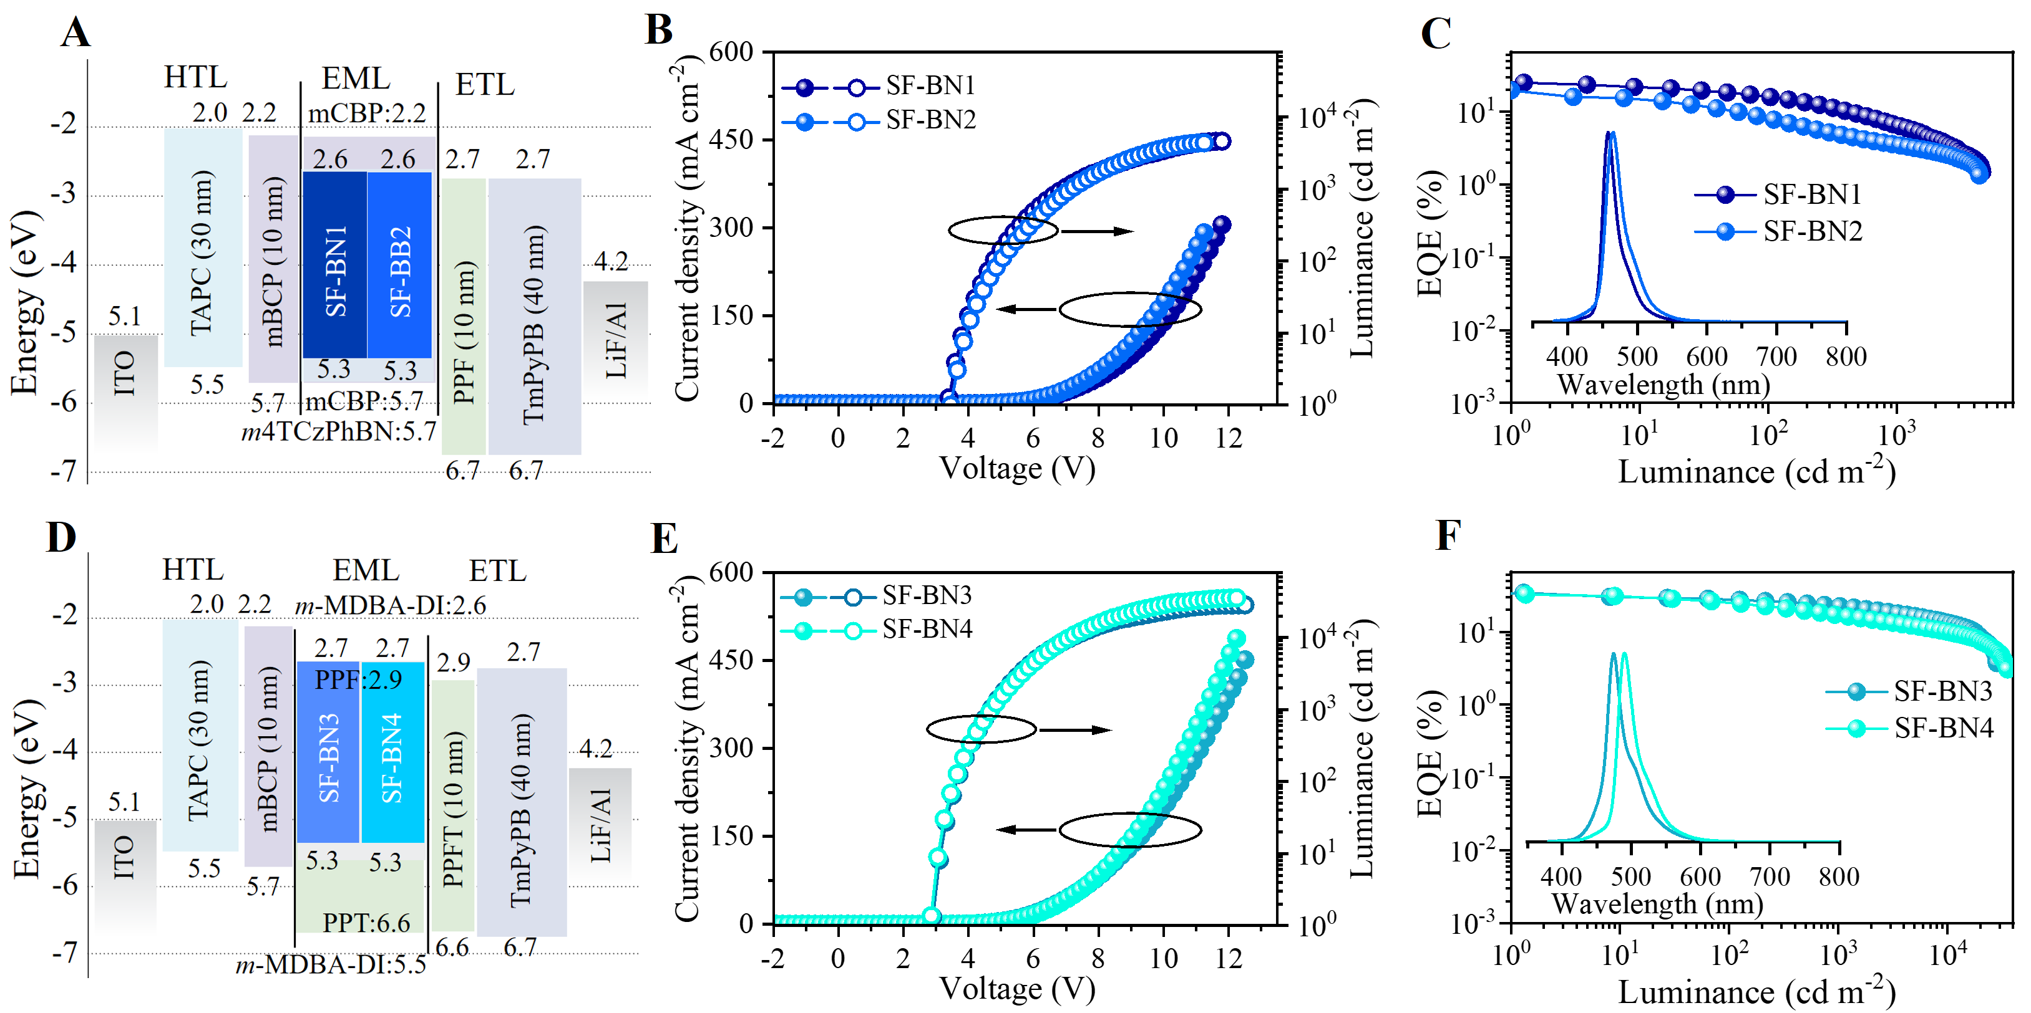
Figure S26. (a) The device architecture and energy diagram, (b) current density–voltage–luminance curves, and (c) EQE-luminance curves of ternary TSF-OLEDs based on SF-BN1, SF-BN2 with doping concentrations of 1 wt.%. Insert the EL spectra and images of ternary TSF-OLEDs based on SF-BN1 and SF-BN2. (d) The device architecture and energy diagram, (e) current density–voltage–luminance curves, and (f) EQE-luminance curves of ternary TSF-OLEDs based on SF-BN3, SF-BN4 with doping concentrations of 1 wt.%. Insert the EL spectra and images of ternary TSF-OLEDs based on SF-BN3 and SF-BN4.

Table S9. EL performance of the binary OLEDs based on SF-BN1, SF-BN2, SF-BN3, and SF-BN4.
Emitter | Dop. | V_{on} | EQE ^{a)} |  |  |  | CE_{max} ^{b)} | L_{max} | CIE^{c)} | Peak | FHWM
Emitter | [wt.%] | [V] | Max | @10² cd m⁻² |  | @10³ cd m⁻² | cd A⁻¹ | cd m⁻² | (x, y) | [nm] | [nm]
SF-BN1 | 2 | 3.2 | 23.1 | 15.4 | 4.5 |  | 19.1 | 2816 | (0.13, 0.09) | 460 | 23
SF-BN1 | 3 | 3.0 | 26.3 | 20.8 | 4.4 |  | 24.6 | 3280 | (0.13, 0.10) | 460 | 26
SF-BN1 | 5 | 2.9 | 26.2 | 19.1 | 2.9 |  | 28.0 | 2648 | (0.13, 0.10) | 460 | 28
SF-BN1 | 7 | 2.9 | 20.0 | 15.9 | 3.1 |  | 22.4 | 2816 | (0.14, 0.14) | 460 | 33
SF-BN2 | 2 | 3.2 | 22.0 | 5.8 | 2.8 |  | 18.5 | 3070 | (0.12, 0.13) | 464 | 29
SF-BN2 | 3 | 3.0 | 20.1 | 6.8 | 2.3 |  | 21.9 | 3189 | (0.13, 0.13) | 466 | 32
SF-BN2 | 5 | 3.0 | 21.4 | 6.8 | 1.9 |  | 24.4 | 2746 | (0.13, 0.15) | 467 | 37
SF-BN2 | 7 | 3.1 | 21.6 | 6.9 | 2.3 |  | 27.8 | 3472 | (0.13, 0.16) | 467 | 40
SF-BN3 | 2 | 3.0 | 29.8 | 21.3 | 7.7 |  | 34.3 | 6075 | (0.11, 0.17) | 471 | 18
SF-BN3 | 3 | 3.3 | 27.3 | 16.8 | 7.2 |  | 31.6 | 5660 | (0.12, 0.17) | 471 | 18
SF-BN3 | 5 | 3.2 | 26.2 | 20.4 | 6.2 |  | 36.9 | 4728 | (0.12, 0.21) | 473 | 20
SF-BN4 | 2 | 2.9 | 31.4 | 14.5 | 5.3 |  | 61.3 | 7414 | (0.11, 0.37) | 484 | 20
SF-BN4 | 3 | 2.9 | 32.2 | 16.6 | 4.7 |  | 67.5 | 5873 | (0.12, 0.41) | 485 | 22
SF-BN4 | 5 | 2.8 | 32.5 | 16.8 | 4.3 |  | 81.3 | 4939 | (0.15, 0.49) | 487 | 47
^{a)} EQE is external quantum efficiency; ^{b)} CE represents current efficiency; ^{c)} CIE denotes Commission Internationale de l’Eclairage.

Table S10. EL performance of the ternary TSF-OLEDs based on SF-BN1, SF-BN2, SF-BN3, and SF-BN4.
Emitter | Dop. | V_{on} | EQE ^{a)} |  |  | CE_{max} ^{b)} |  | L_{max} | CIE^{c)} | Peak | FHWM
Emitter | [wt.%] | [V] | Max | @10² cd m⁻² | @10³ cd m⁻² |  | cd A⁻¹ | cd m⁻² | (x, y) | [nm] | [nm]
SF-BN1 | 1 | 3.3 | 25.0 | 16.1 | 6.5 |  | 18.20 | 4600 | (0.13, 0.07) | 458 | 23
SF-BN1 | 3 | 3.3 | 29.0 | 15.7 | 5.5 |  | 21.4 | 4403. | (0.13, 0.08) | 460 | 23
SF-BN2 | 1 | 3.4 | 21.8 | 8.1 | 3.5 |  | 22.9 | 4373 | (0.13, 0.12) | 466 | 31
SF-BN2 | 3 | 3.5 | 22.2 | 8.0 | 2.6 |  | 24.5 | 4593 | (0.12, 0.15) | 469 | 32
SF-BN3 | 1 | 2.9 | 34.3 | 27.9 | 22.5 |  | 47.0 | 28260 | (0.12, 0.15) | 474 | 23
SF-BN3 | 3 | 2.9 | 35.5 | 26.5 | 18.0 |  | 50.6 | 22625 | (0.13, 0.23) (0.13, 0.23) | 479 | 26
SF-BN4 | 1 | 2.8 | 32.5 | 25.2 | 17.0 |  | 70.8 | 35299 | (0.13, 0.23) | 491 | 31
SF-BN4 | 3 | 2.8 | 33.6 | 19.8 | 9.7 |  | 89.6 | 25310 | (0.12, 0.35) | 493 | 40

NMR Spectra
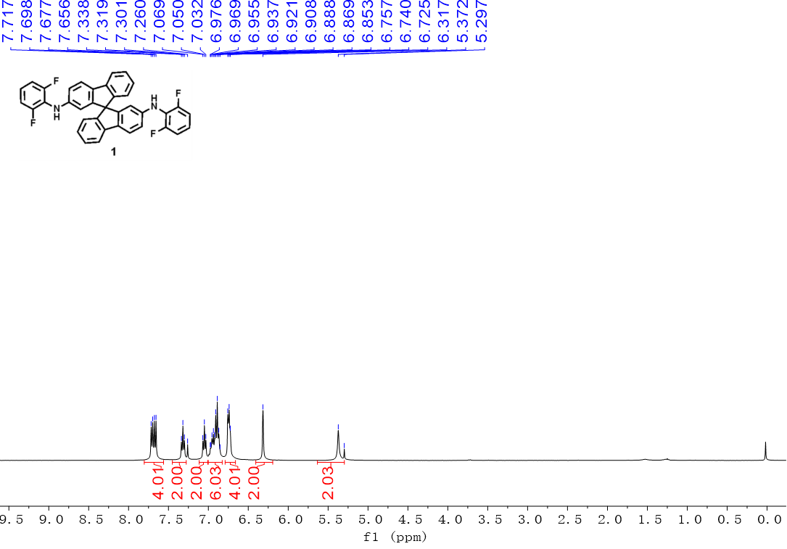
Figure S27. ¹H NMR spectrum of compound 1 in CDCl₃ solvent.

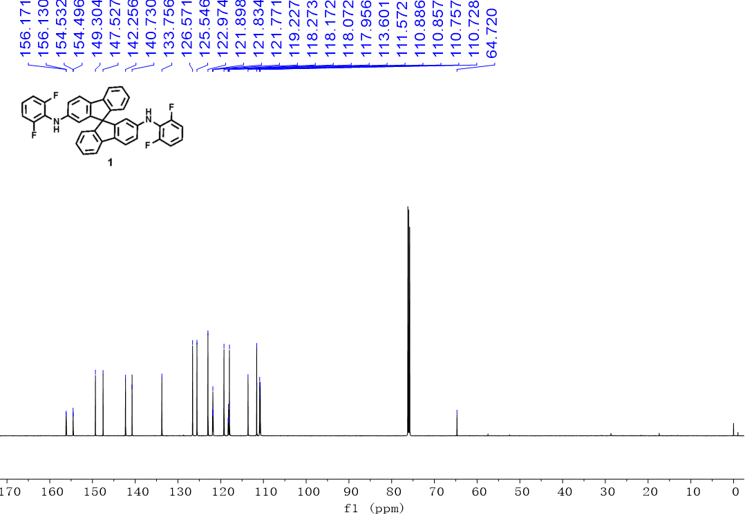
Figure S28. ¹H NMR spectrum of compound 1 in CDCl₃ solvent.

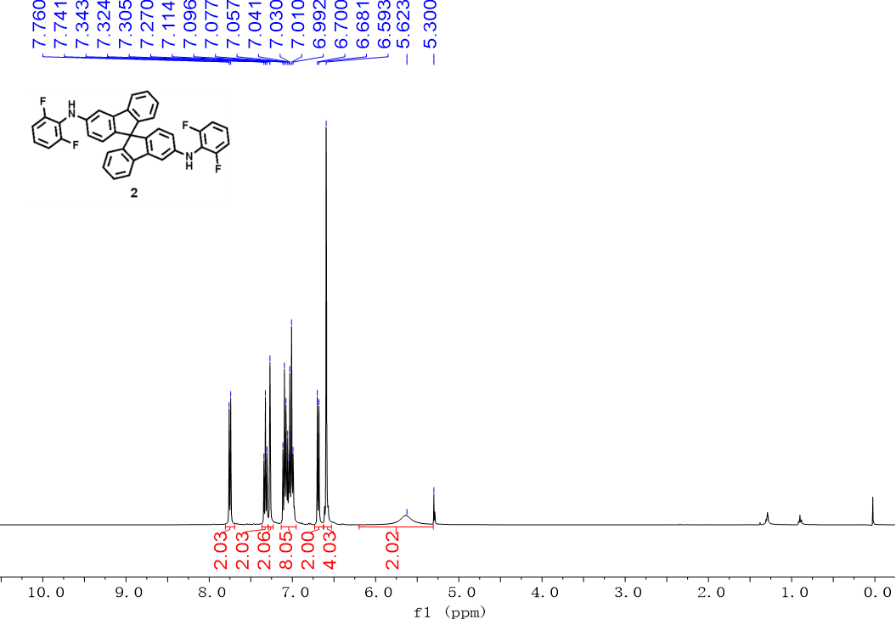Figure S29. ¹H NMR spectrum of compound 2 in CD₂Cl₂ solvent.

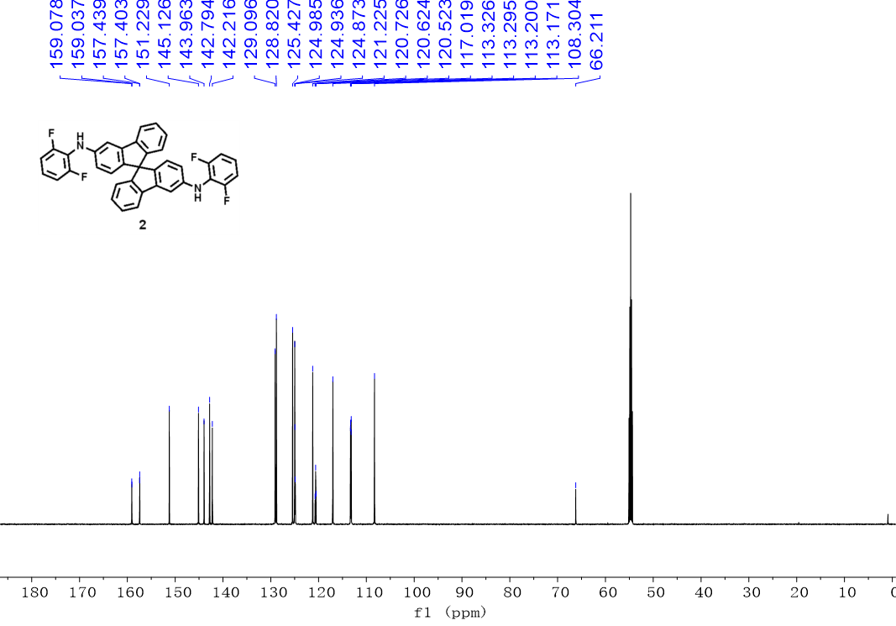
Figure S30. ¹³C NMR spectrum of compound 2 in CDCl₃ solvent.

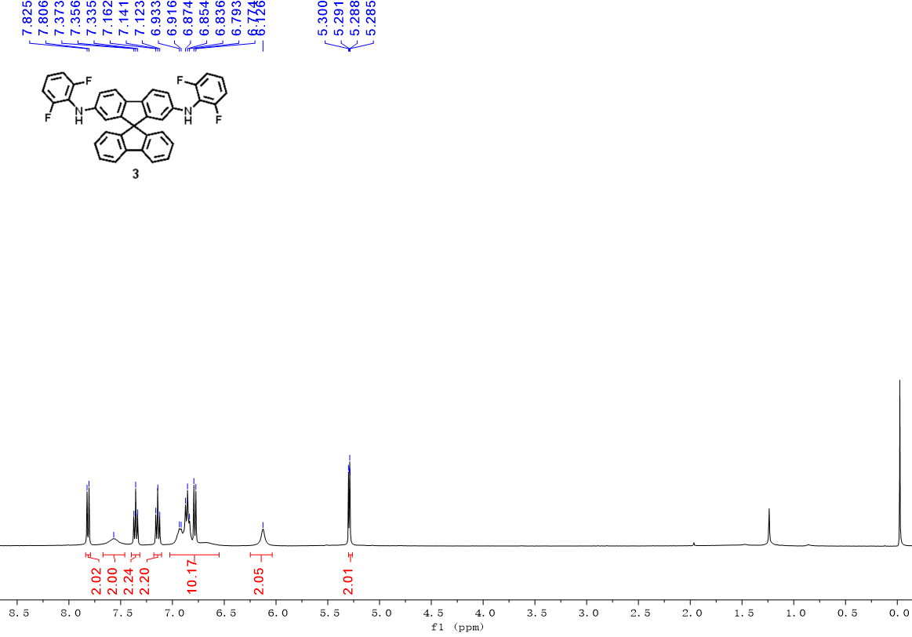
Figure S31. ¹H NMR spectrum of compound 3 in CD₂Cl₂ solvent.
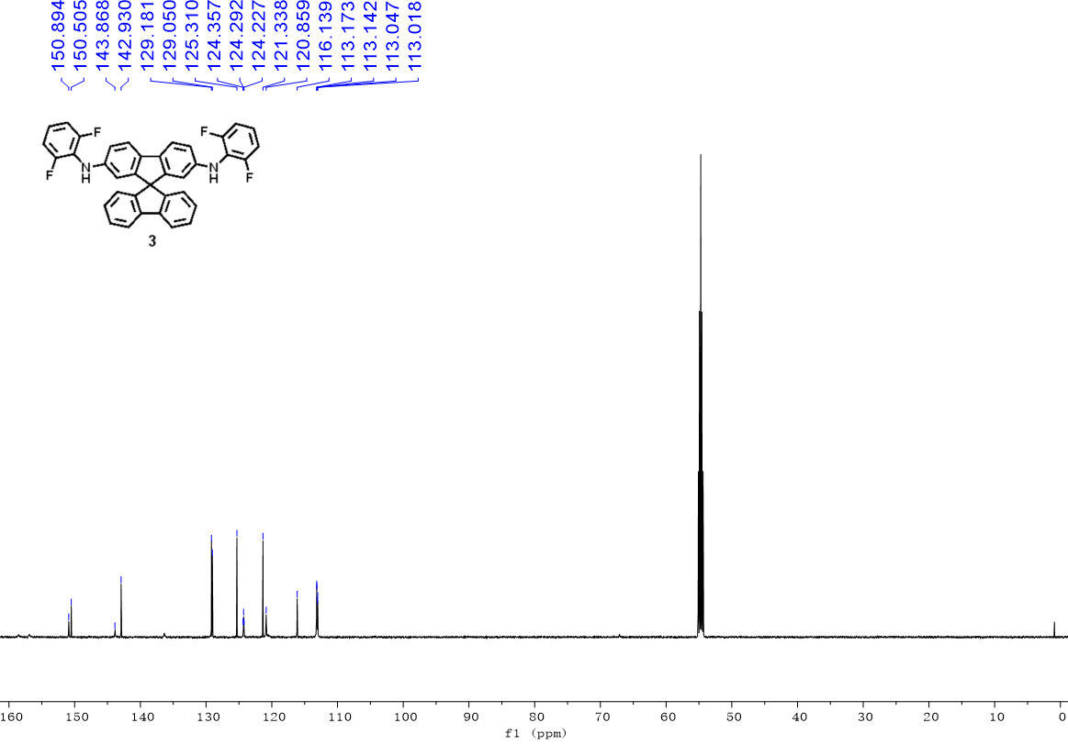
Figure S32. ¹³C NMR spectrum of compound 3 in CDCl₃ solvent.

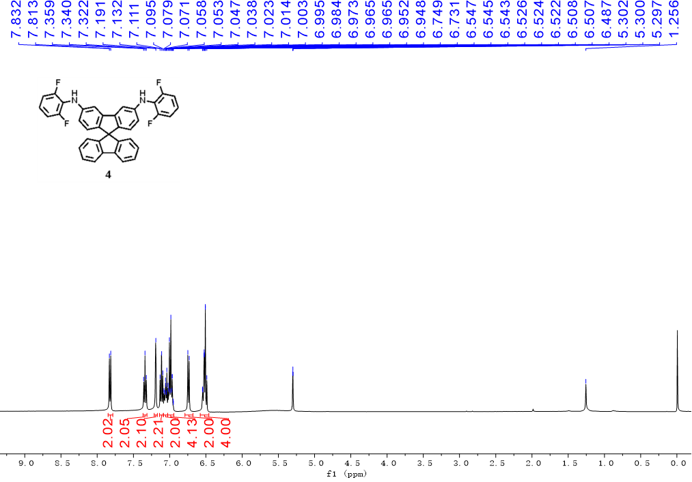
Figure S33. ¹H NMR spectrum of compound 4 in CD₂Cl₂ solvent.
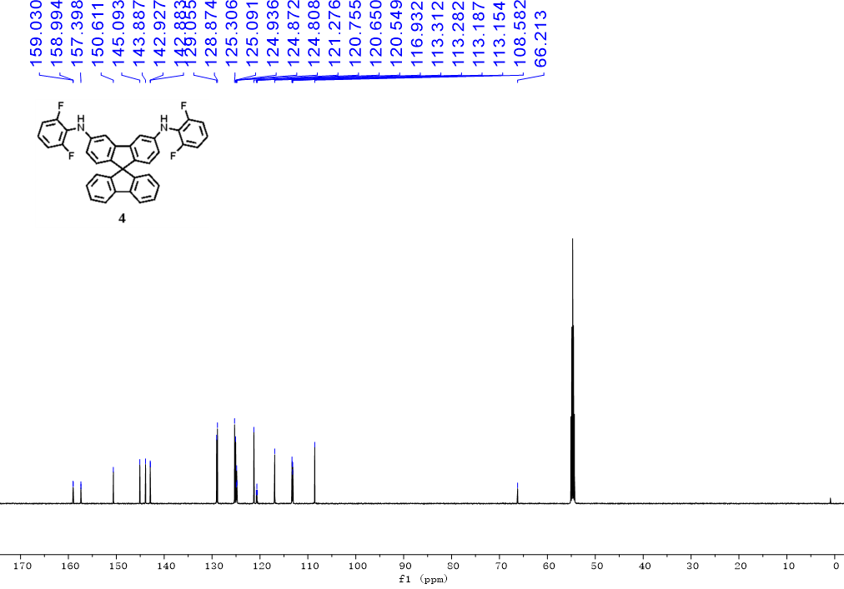
Figure S34. ¹³C NMR spectrum of compound 4 in CDCl₃ solvent.
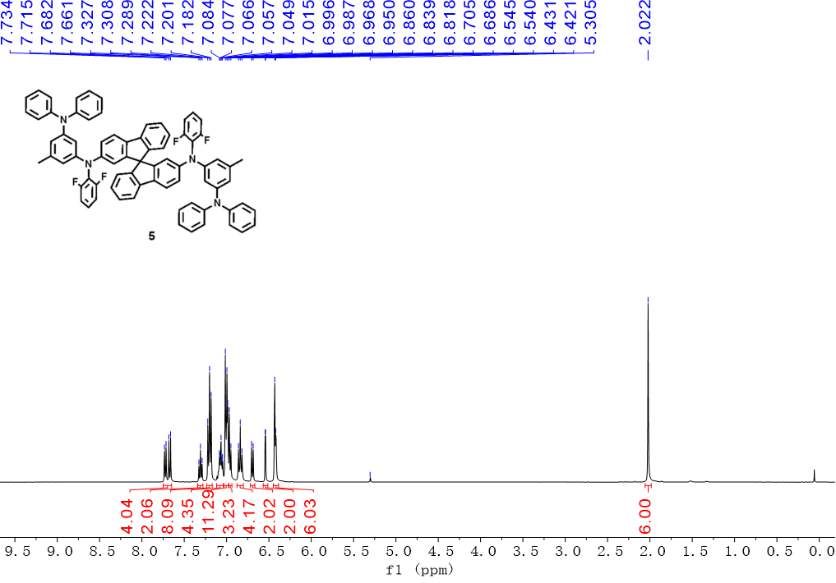Figure S35. ¹H NMR spectrum of compound 5 in CD₂Cl₂ solvent.
Figure S36. ¹³C NMR spectrum of compound 5 in CDCl₃ solvent.

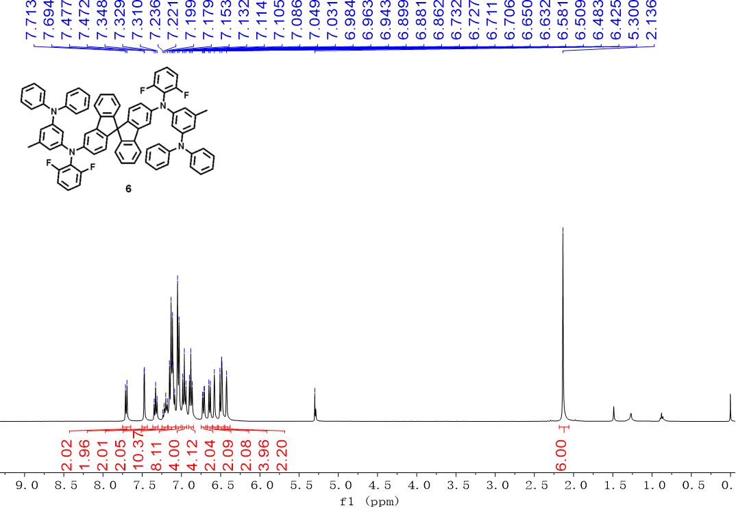
Figure S37. ¹H NMR spectrum of compound 6 in CD₂Cl₂ solvent.

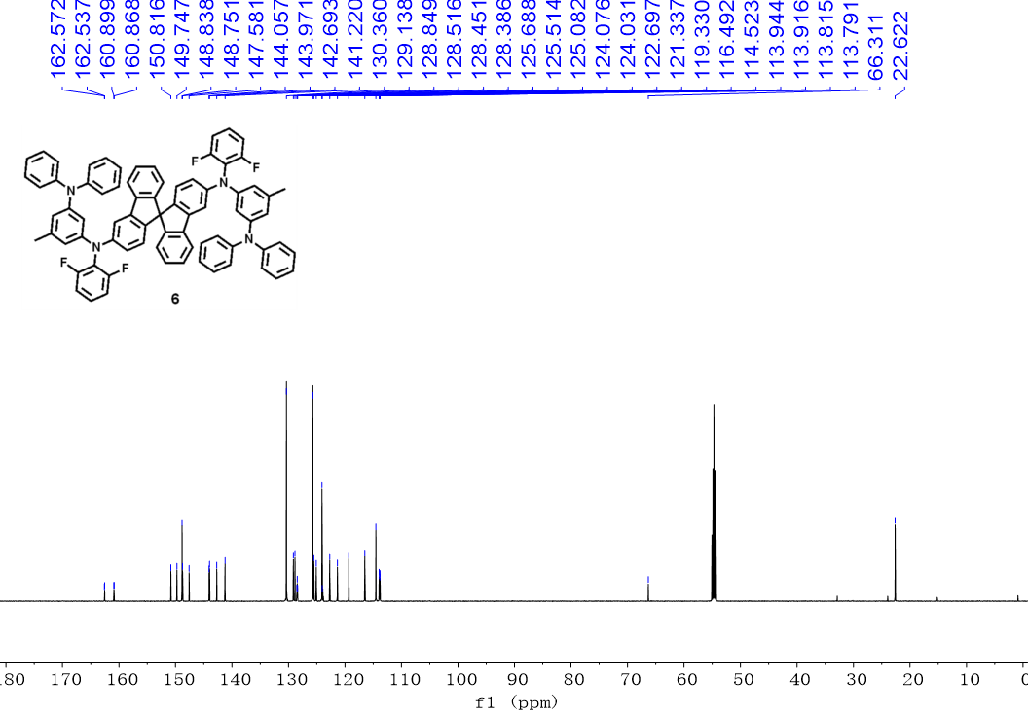
Figure S38. ¹³C NMR spectrum of compound 6 in CDCl₃ solvent.

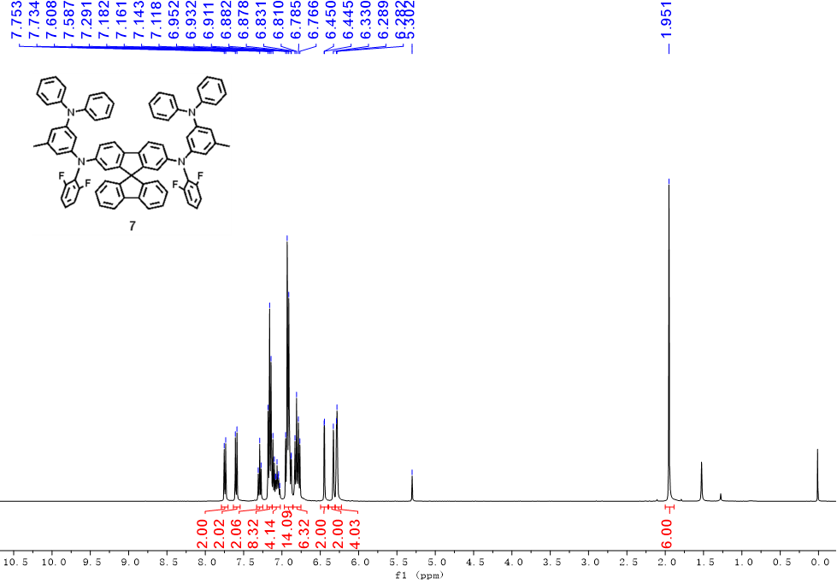
Figure S39. ¹H NMR spectrum of compound 7 in CD₂Cl₂ solvent.

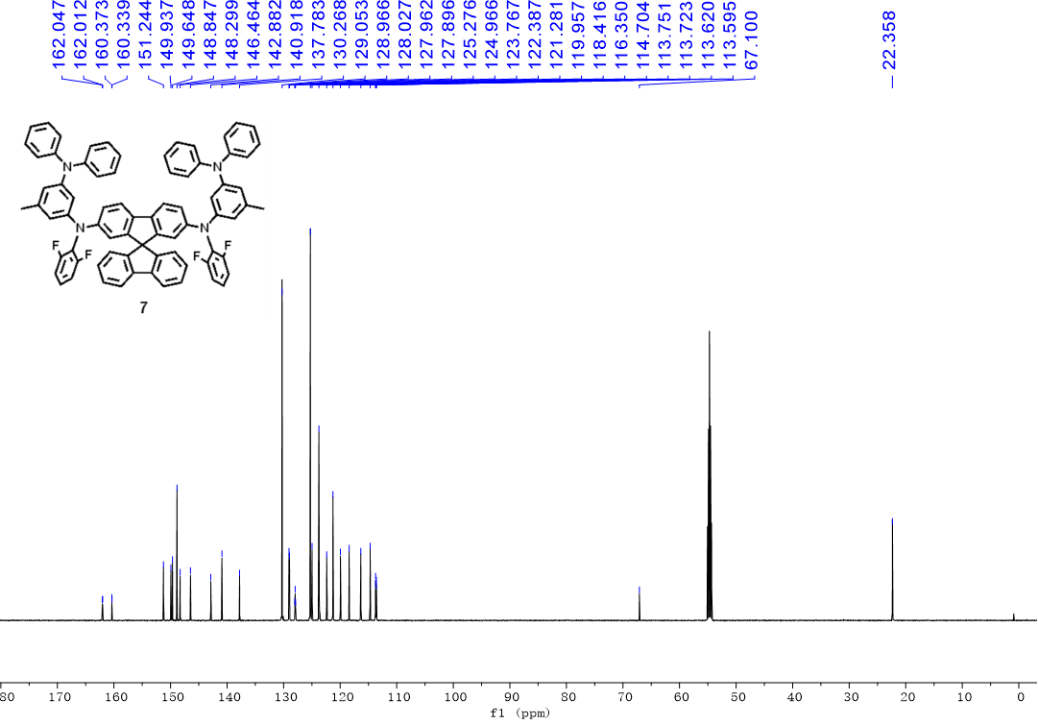
Figure S40. ¹³C NMR spectrum of compound 7 in CDCl₃ solvent.

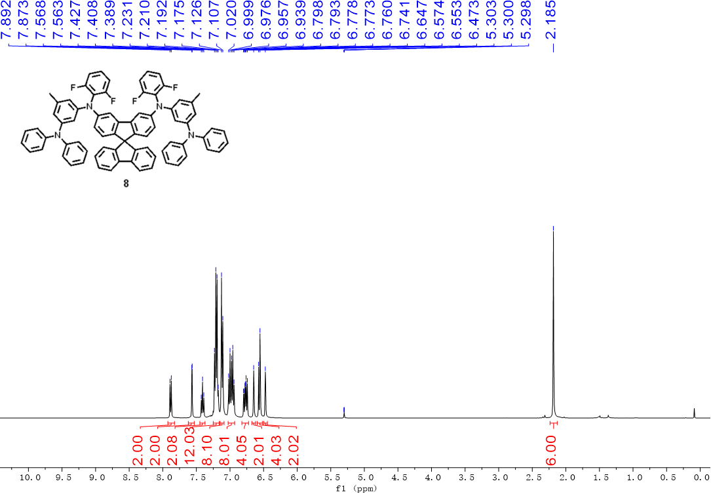
Figure S41. ¹H NMR spectrum of compound 8 in CD₂Cl₂ solvent.

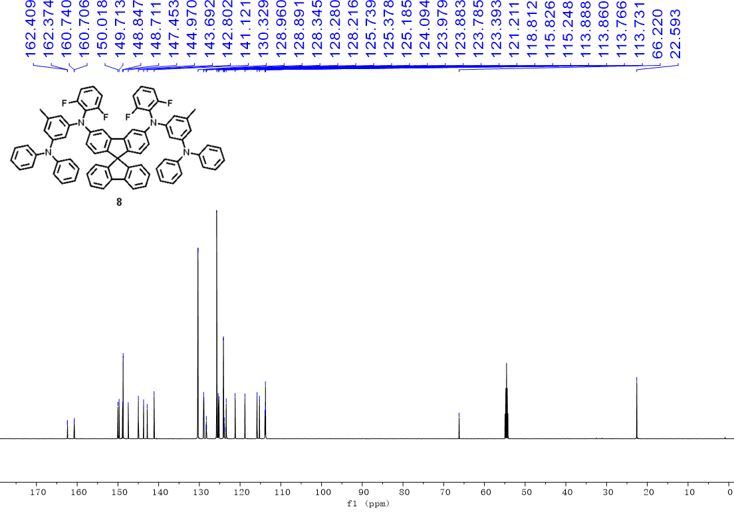
Figure S42. ¹³C NMR spectrum of compound 8 in CDCl₃ solvent.

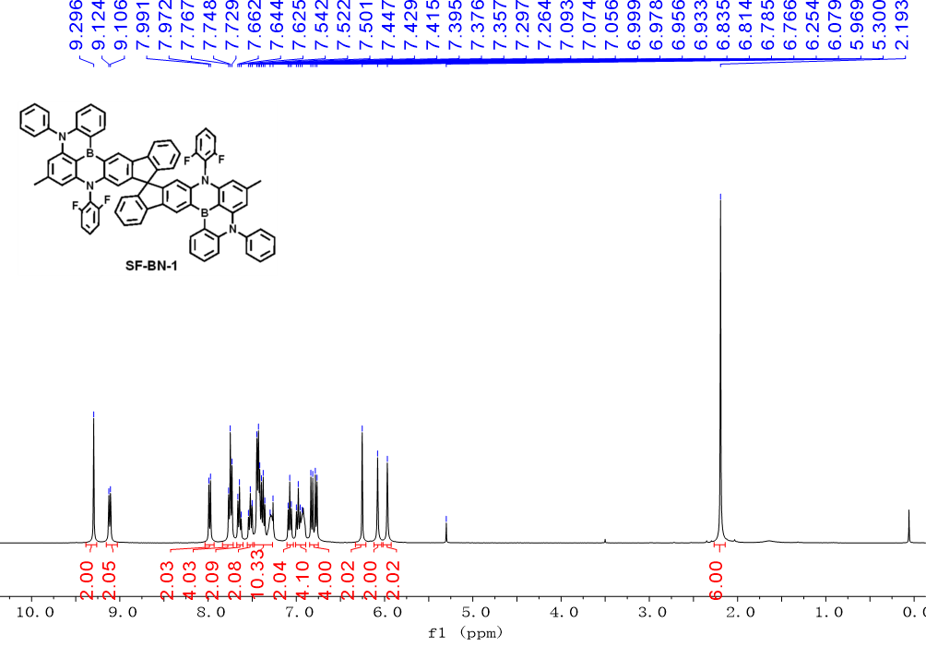
Figure S43. ¹H NMR spectrum of compound SF-BN1 in CD₂Cl₂ solvent.

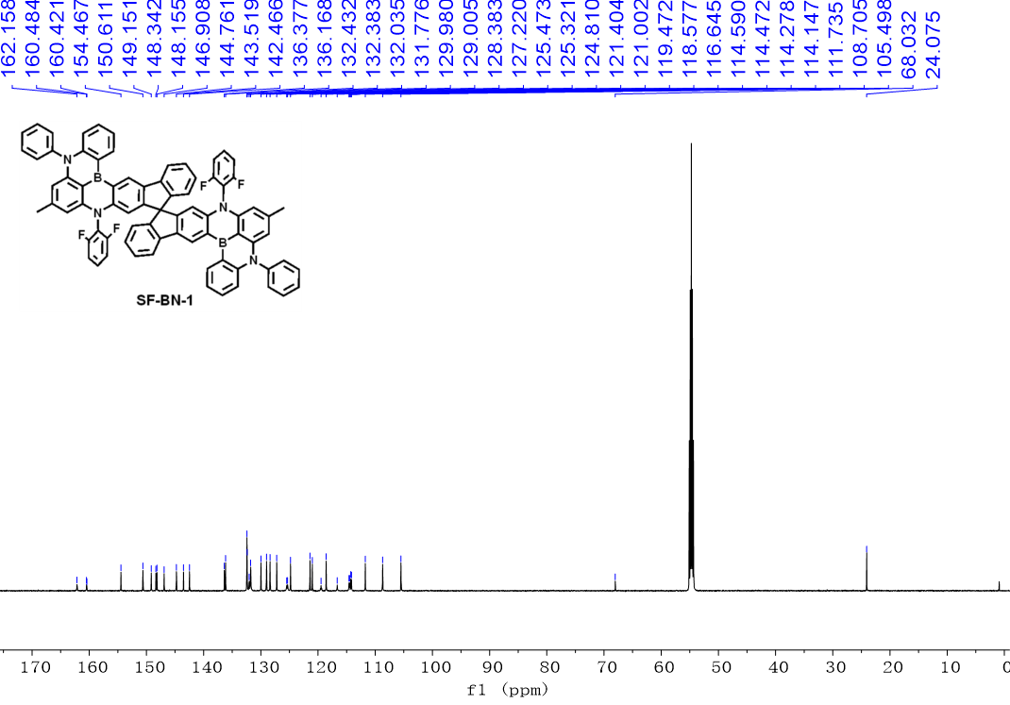
Figure S44. ¹³C NMR spectrum of compound SF-BN1 in CDCl₃ solvent.

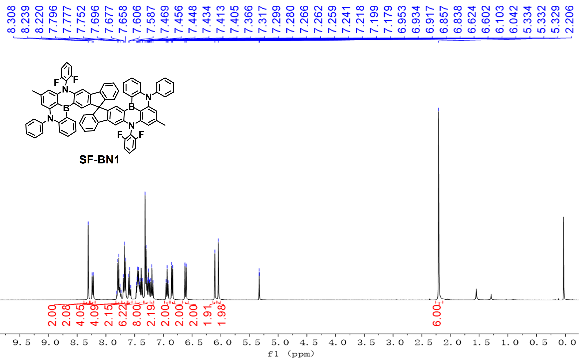
Figure S45. ¹H NMR spectrum of compound SF-BN2 in CD₂Cl₂ solvent.

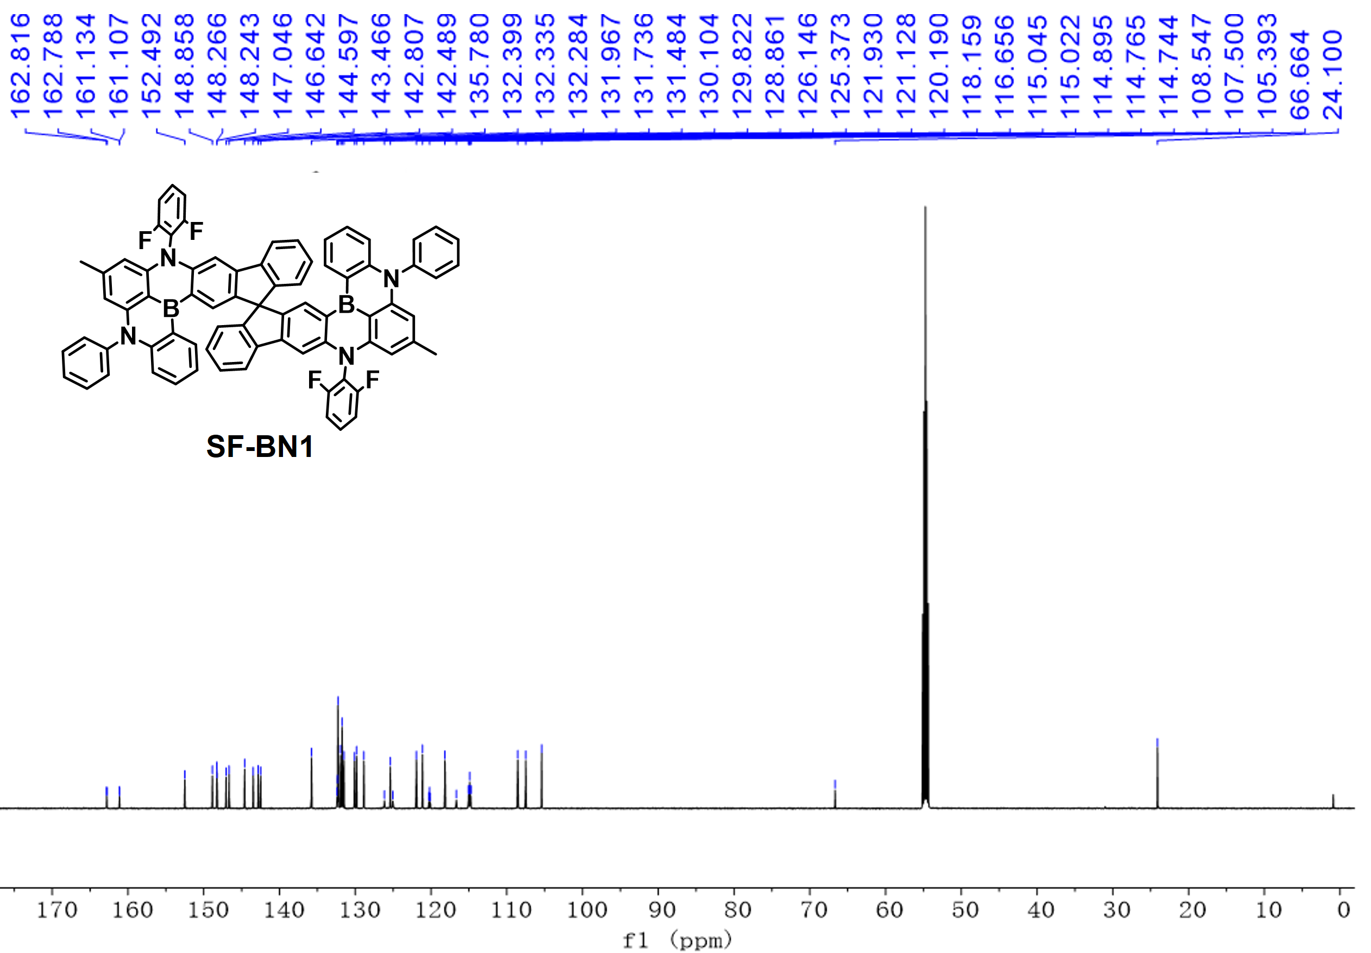
Figure S46. ¹³C NMR spectrum of compound SF-BN2 in CDCl₃ solvent.

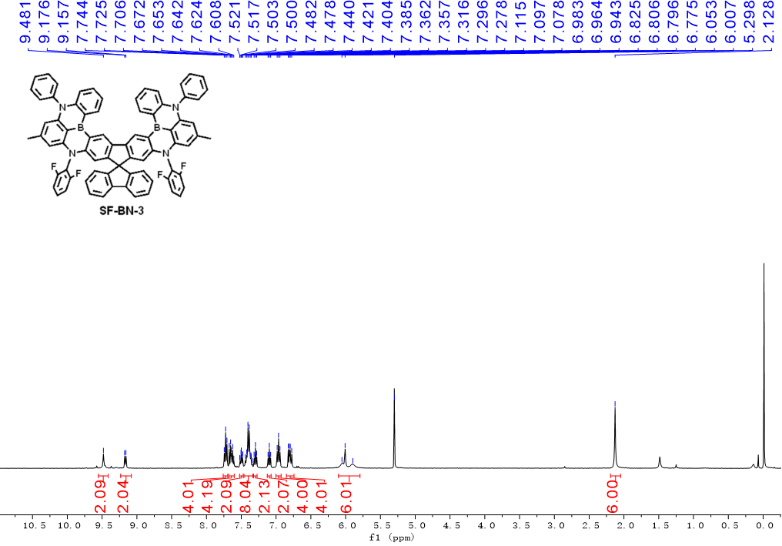
Figure S47. ¹H NMR spectrum of compound SF-BN3 in CD₂Cl₂ solvent.

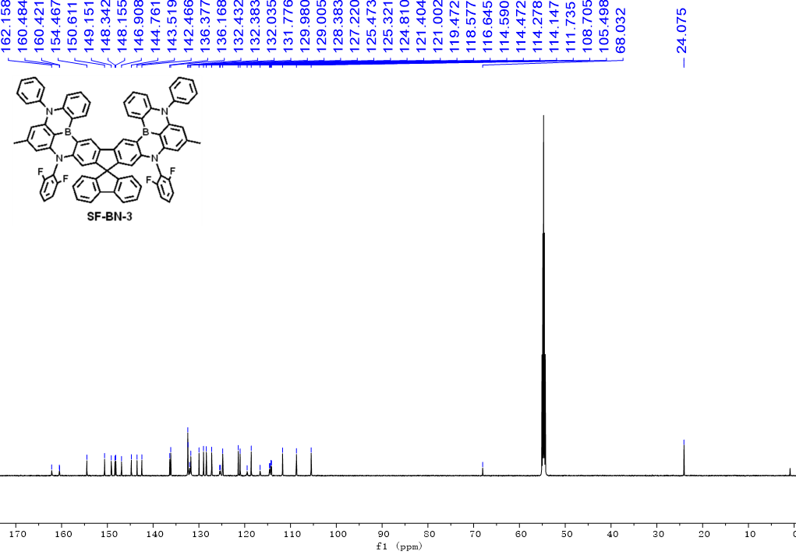
Figure S48. ¹³C NMR spectrum of compound SF-BN-3 in CDCl₃ solvent.

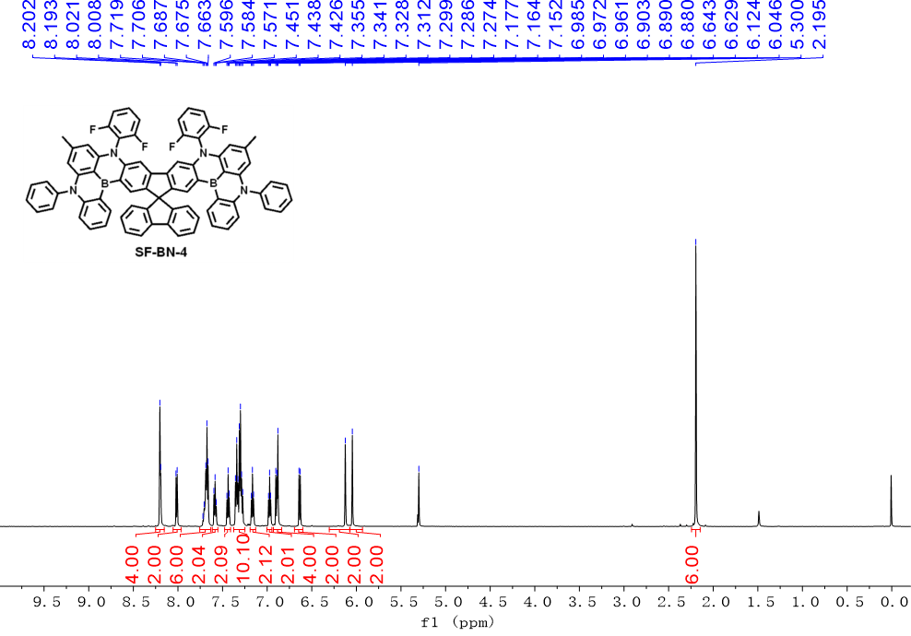
Figure S49. ¹H NMR spectrum of compound SF-BN-4 in CD₂Cl₂ solvent.

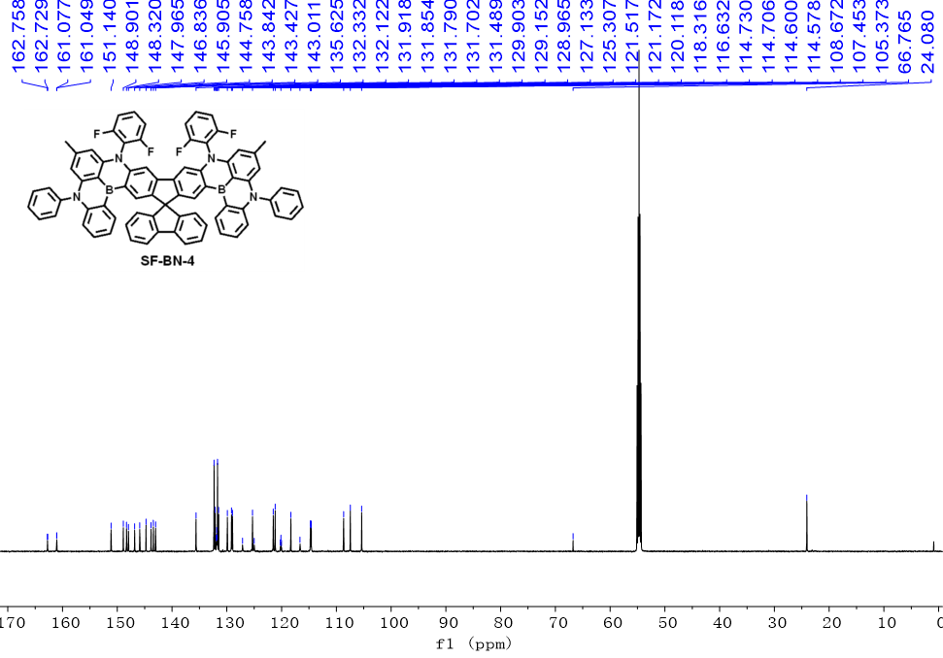
Figure S50. ¹³C NMR spectrum of compound SF-BN-4 in CDCl₃ solvent.

Reference
[1] Frisch, M. J.; Trucks, G. W.; Schlegel, H. B.; Scuseria, G. E.; Robb, M. A.; Cheeseman, J. R.; Scalmani, G.; Barone, V.; Mennucci, B.; Petersson, G. A.; Nakatsuji, H.; Caricato, M.; Li, X.; Hratchian, H. P.; Izmaylov, A. F.; Bloino, J.; Zheng, G.; Sonnenberg, J. L.; Hada, M.; Ehara, M.; Toyota, K.; Fukuda, R.; Hasegawa, J.; Ishida, M.; Nakajima, T.; Honda, Y.; Kitao, O.; Nakai, H.; Vreven, T.; Montgomery, Jr., J. A.; Peralta, J. E.; Ogliaro, F.; Bearpark, M.; Heyd, J. J.; Brothers, E.; Kudin, K. N.; Staroverov, V. N.; Keith, T.; Kobayashi, R.; Normand, J.; Raghavachari, K.; Rendell, A.; Burant, J. C.; Iyengar, S. S.; Tomasi, J.; Cossi, M.; Rega, N.; Millam, J. M.; Klene, M.; Knox, J. E.; Cross, J. B.; Bakken, V.; Adamo, C.; Jaramillo, J.; Gomperts, R.; Stratmann, R. E.; Yazyev, O.; Austin, A. J.; Cammi, R.; Pomelli, C.; Ochterski, J. W.; Martin, R. L.; Morokuma, K.; Zakrzewski, V. G.; Voth, G. A.; Salvador, P.; Dannenberg, J. J.; Dapprich, S.; Daniels, A. D.; Farkas, O.; Foresman, J. B.; Ortiz, J. V.; Cioslowski, J.; Fox, D. J. Gaussian 09, Revision B.01; Gaussian, Inc.: Wallingford, CT, 2010.
[2] a) E. Runge, E. K. U. Gross, Phys. Rev. Lett. 1984, 52, 997; b) M. A. L. Marques, E. K. U. Gross, Annu. Rev. Phys. Chem. 2004, 55, 427 – 455.
[3] T. Lu, F. Chen, J. Comput. Chem., 2012, 33, 580 – 592.

