Supplementary Information
Cascading impacts of food loss and waste on biodiversity through agricultural land use
Guoan Xiao^{1,2}, Liangjie Xin¹*, Xiaoyu Liu^{1,2}, Jiexin Deng^{2,3}, Xue Wang¹, Xiubin Li¹, Minghong Tan¹
¹Key Laboratory of Land Surface Pattern and Simulation, Institute of Geographic Sciences and Natural Resources Research, Chinese Academy of Sciences, Beijing, China.
²College of Resources and Environment, University of Chinese Academy of Sciences, Beijing, China.
³Key Lab of Urban Environment and Health, Institute of Urban Environment, Chinese Academy of Sciences, Xiamen, China.
*Corresponding author
E-mail address: xinlj@igsnrr.ac.cn
This file includes:
Supplementary Text 1 – 3
Supplementary Figure 1 – 9
Supplementary Table 1 – 7

S.1. Study framework
The study framework can be divided into three modules (Supplementary Figure 1): food loss and waste (FLW), land footprint, and biodiversity. We first obtained food production data from FAOSTAT¹ and fed it into the multi-region input-output (MRIO) framework. Food consumption was calculated by subtracting exports from production and adding imports. The consumption data was then combined with FLW percentage data obtained from the literature review and the FAO FLW database² to produce a new FLW database in million tonnes. We tracked the FLW flows in the supply-demand matrix provided by the MRIO framework and traced the countries where the food lost and wasted was actually produced. Here, the Food and Agriculture Biomass Input-Output (FABIO) model³ was used to obtain the food flow by weight, and the resolved MRIO (R-MRIO) model⁴ was used to obtain main matrices, such as the life cycle land use coefficient matrix. The global MRIO models can output virtual land flows, that is, trade-embedded and non-traded land footprints. We assume that land transformations associated with FLW for crops and meat are from cropland and pasture to extensive forestry, respectively. The potential biodiversity losses were then calculated by characterization factors⁵ (CFs). To explore where prioritizing FLW reduction measures can achieve higher benefits, we established four scenarios in the Global Trade Analysis Project (GTAP) model⁶, including halving FLW in all countries, halving FLW in the top ten countries with the highest FLW, halving FLW in meat and animal products, and halving FLW in 40 countries above biodiversity hotspots. Finally, we can get information on resource conservation and their distribution in various countries.
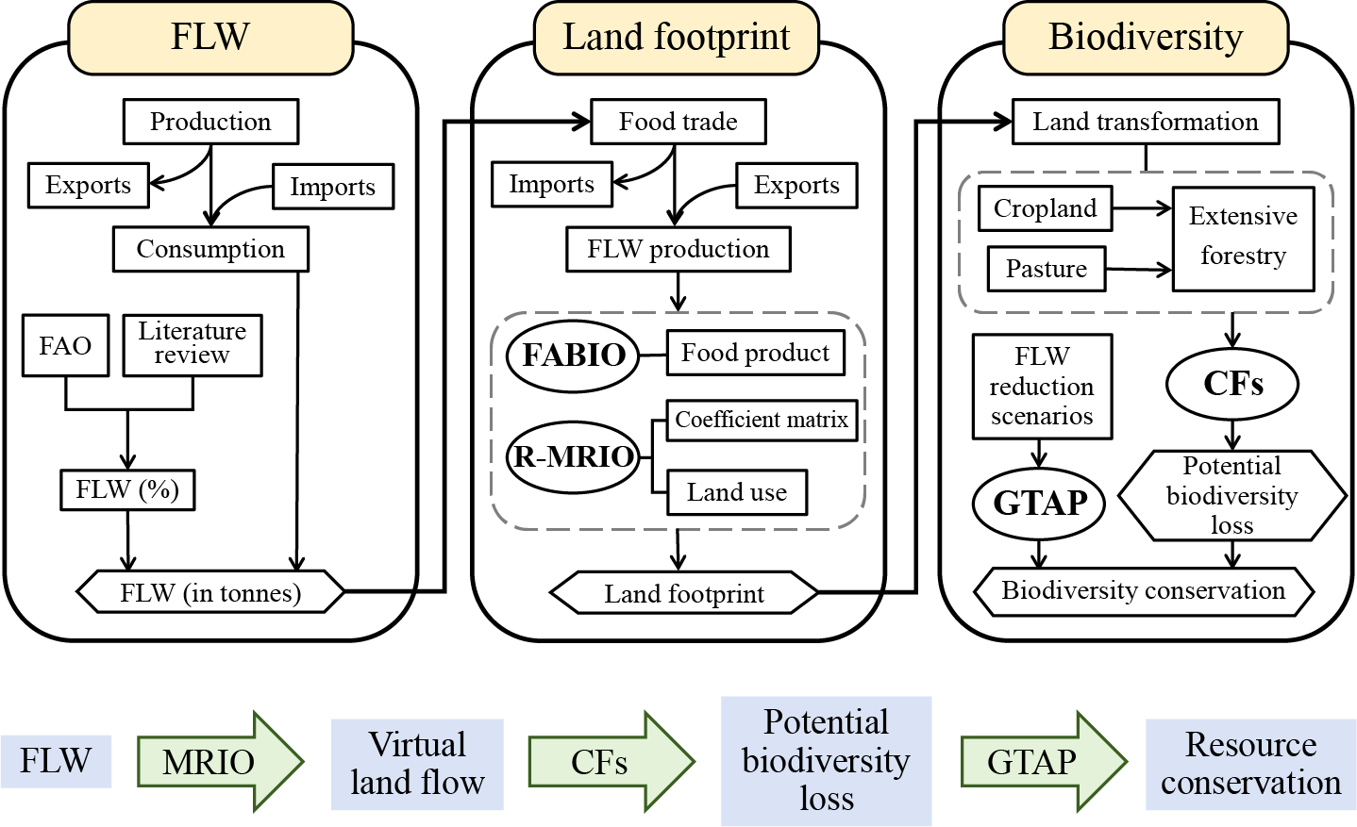
Supplementary Figure 1 | Schematic diagram of the methodological framework. Cascading impacts of FLW on agricultural land use and biodiversity. The FLW production is the food lost and wasted from domestic production minus imports plus exports, that is, the food actually produced by the country but lost and wasted by it and its exporters. The FABIO is the physical Food and Agriculture Biomass Input-Output model³. The R-MRIO is a highly resolved Multi-Regional Input-Output model⁴. The CFs are the characterization factors of biodiversity⁵. The GTAP is the Global Trade Analysis Project model⁶.

S.2. Tracing FLW in global MRIO framework
Food trade may result in different locations for food production and food lost and wasted. This circulation process is determined by the relationship between supply and demand, which can be represented by the following equations:
$$\begin{aligned}Z=AX\#\left(1\right)\end{aligned}$$
$$\begin{aligned}X=Z+\left(Y1\right)\#\left(2\right)\end{aligned}$$
where $Z$ is the transactions matrix with elements $z_{s,i}^{r,j}$ (flows), denoting the cost share of commodity $i$ supplied by region $s$ in the production process of commodity $j$ produced in region $r$; $A$ is the coefficient matrix with elements $a_{s,i}^{r,j}$; $X$ is the total output vector with elements $x_{s,i}$, corresponding the output of commodity $i$ in region $s$; $Y$ is the matrix of final demand with elements $y_{s,i}^{r}$, denoting the direct final consumption of commodity $i$ produced in region $s$ and consumed in region $r$; 1 represents the vector of ‘1’ with a dimension $r$. Solving for $X$ leads to the following equation：
$$\begin{aligned}X={\left(I-A\right)}^{-1}\left(Y1\right)\#\left(3\right)\end{aligned}$$
where $I$ is the identity matrix and ${(I-A)}^{-1}$ is the Leontief inverse, representing the total amount of direct and indirect inputs required to satisfy one unit of final demand.

S.3. Scenario Modeling
In the FLW reduction scenarios, although global FLW and related land footprint could be eliminated by reducing 100% of FLW in all countries, the actual distribution among countries is likely to be uneven. For example, if 100 countries produce 10 Mt of FLW in their original food production, the total amount of food saved after completely eliminating FLW is 1,000 Mt, but not all countries will necessarily reduce their food production by 10 Mt. Because if country A completely eliminates FLW, it should give priority to reducing the share of food imports from some countries from a policy or cost-benefit perspective, rather than just ‘returning’ the part of food that was originally wasted from various countries to each exporting country, and the GTAP model can simulate this process. Therefore, the phenomenon that some countries in the FLW reduction scenario have negatively wasted resources in Supplementary Table 5 means that their reduced domestic production and export shares not only make up for the resource losses caused by FLW but also supplement the food that was not wasted and lost. However, since the GTAP model does not directly provide shock options related to reducing food waste, we chose ‘intermediate input product technology’ to reflect the improved efficiency of food production, which may not fully reflect the response of countries to actual FLW reductions.

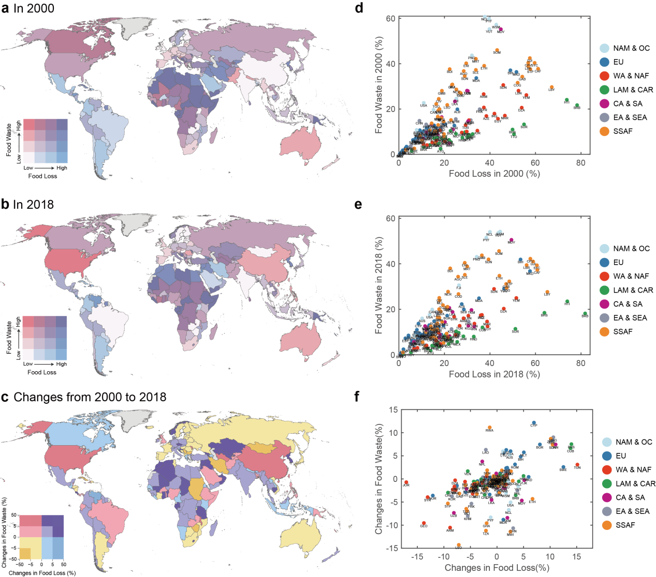

Supplementary Figure 2 | Spatio-temporal distribution of ratios of food loss and food waste. a,b, Quartile distribution of ratios of food loss and food waste in 2000 (a) and in 2018 (b). Ratios of food loss and food waste are expressed in percentages. Countries in grey were not included in the study. c, Quartile distribution of changes of ratios from 2000 to 2018. d,e, Ratios of food loss and food waste by country in 2000 (d) and in 2018 (e). The color denotes the geographic regions. f, Changes of ratios by country from 2000 to 2018. The country abbreviations are taken from the ISO-alpha3 code (https://unstats.un.org/unsd/methodology/m49/). NAM + OC: Northern America and Oceania; EU: Europe; WA + NAF: Western Asia and Northern Africa; LAM + CAR: Latin America and the Caribbean; CA + SA: Central Asia and Southern Asia; EA + SEA: Eastern Asia and South-eastern Asia; SSAF: Sub-Saharan Africa.
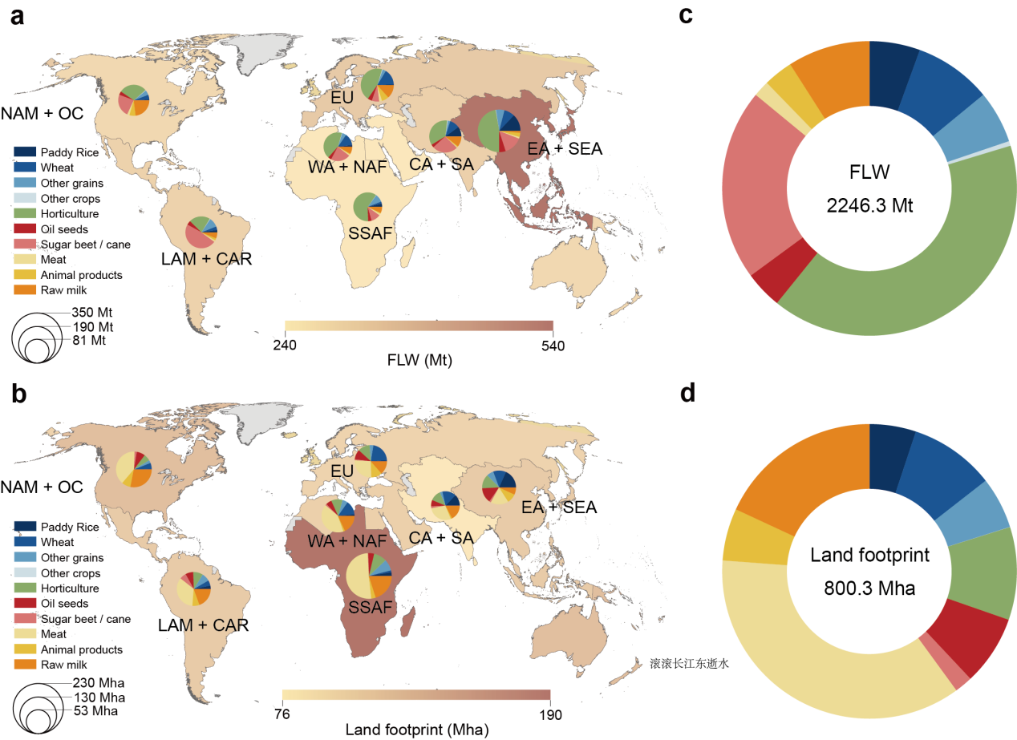

Supplementary Figure 3 | FLW and land footprint by food groups and geographic regions in 2018. a,b, The pie chart shows FLW (a) and land footprint (b) by food groups in each geographic region. The background map shows the amount of FLW (a) and land footprint (b). The geographical regions are classified according to the Standard Country or Area Codes for Statistical Use (M49)⁷, the country lists can be found at https://unstats.un.org/unsd/methodology/m49/. c,d, Global FLW (c) and land footprint (d) by food groups. The manuscript categorizes the 10 food groups as follows: ‘Cereals and others’ includes paddy rice, wheat, other grains, and other crops; ‘Horticulture’ includes horticulture; ‘Oil and sugar crops’ includes oil seeds and sugar beet and sugar cane; ‘Meat and dairy’ includes meat, other animal products, and raw milk. A detailed sectoral list of the 10 food groups can be found at https://www.gtap.agecon.purdue.edu/databases/contribute/detailedsector.asp.
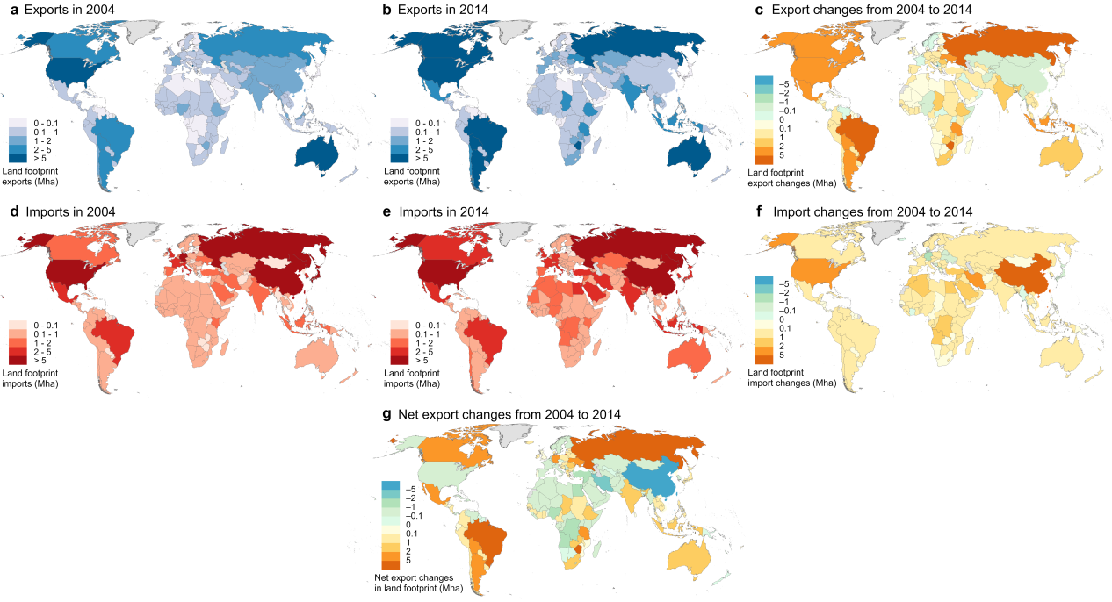

Supplementary Figure 4 | Spatiotemporal characteristics of land footprint embedded in global food trade. a, Land footprint exports in 2000. b, Land footprint exports in 2018. c, Changes in land footprint exports from 2000 to 2018. d, Land footprint imports in 2000. e, Land footprint imports in 2018. f, Changes in land footprint imports from 2000 to 2018. g, Changes in net land footprint exports from 2000 to 2018 (changes in export-embedded land footprint minus changes in import-embedded land footprint).
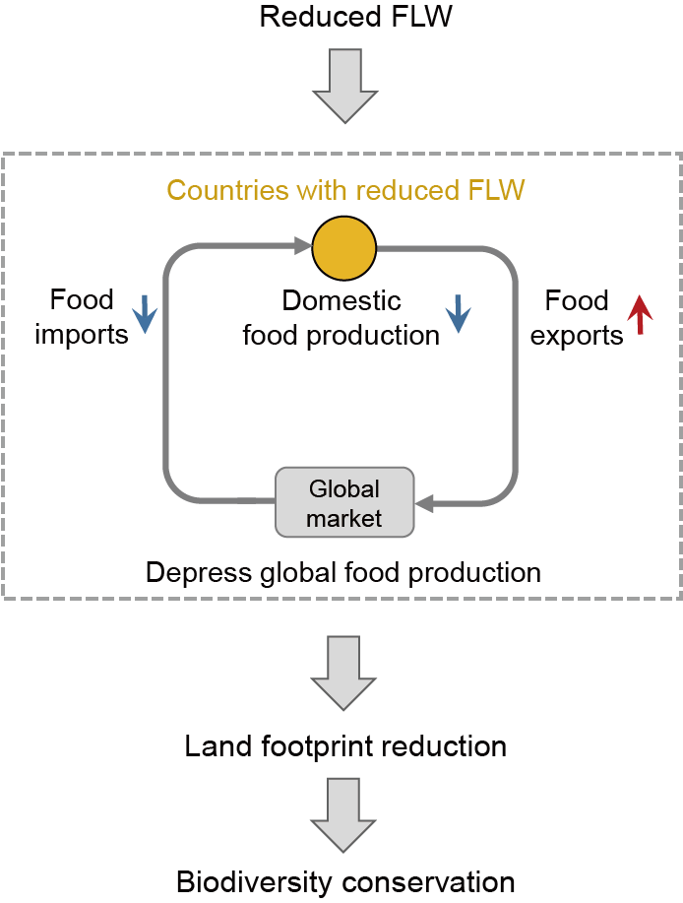

Supplementary Figure 5 | Cascading mechanisms triggered by FLW reduction. FLW reduction would depress domestic food production and imports and enhance food exports, triggering a cascading effect that contracted global food production scale through global food trade, thereby stimulating land abandonment and curbing cropland expansion to conserve biodiversity.
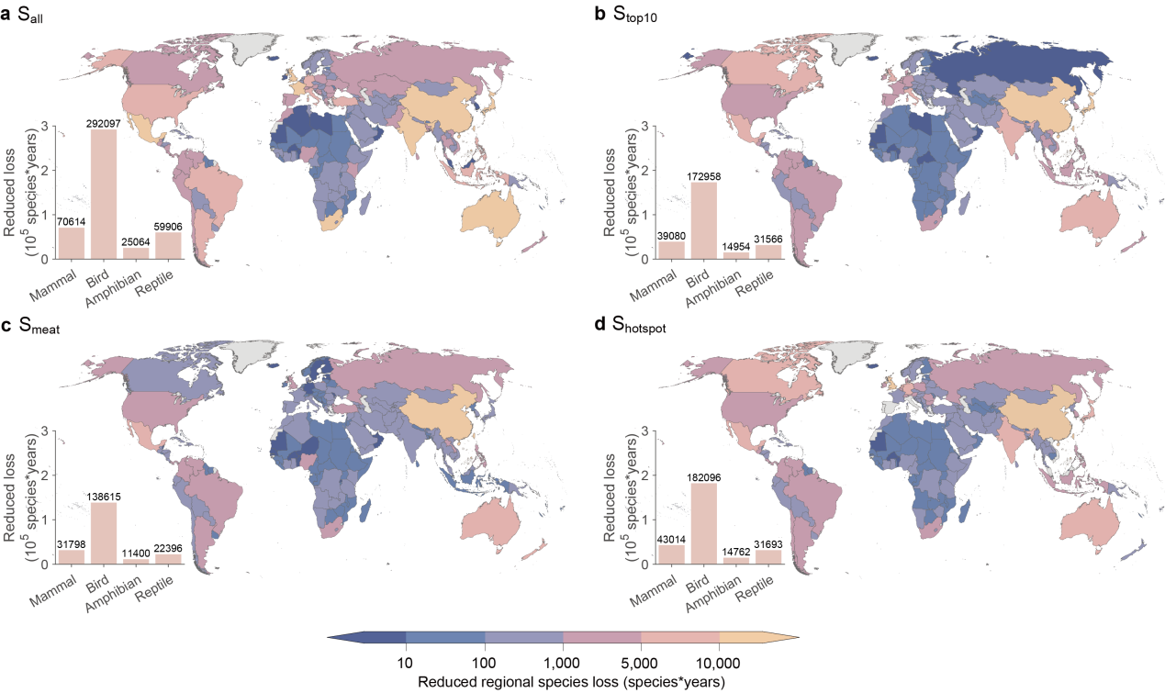

Supplementary Figure 6 | Reduced regional species loss by countries and regions. The map shows the total reduced regional species loss in species*years. The bar shows the amount of reduced regional species loss by four taxa, namely, mammal, bird, amphibian, and reptile. a, S_{all}. b, S_{top10}. c, S_{meat}. d, S_{hotspot}. The top seven countries account for 49.3% of the average reduction in regional species loss across all scenarios, including China (23.8%), United Kingdom (6.5%), Mexico (4.8%), Australia (4.8%), Japan (3.9%), South Africa (2.8%), and India (2.7%).

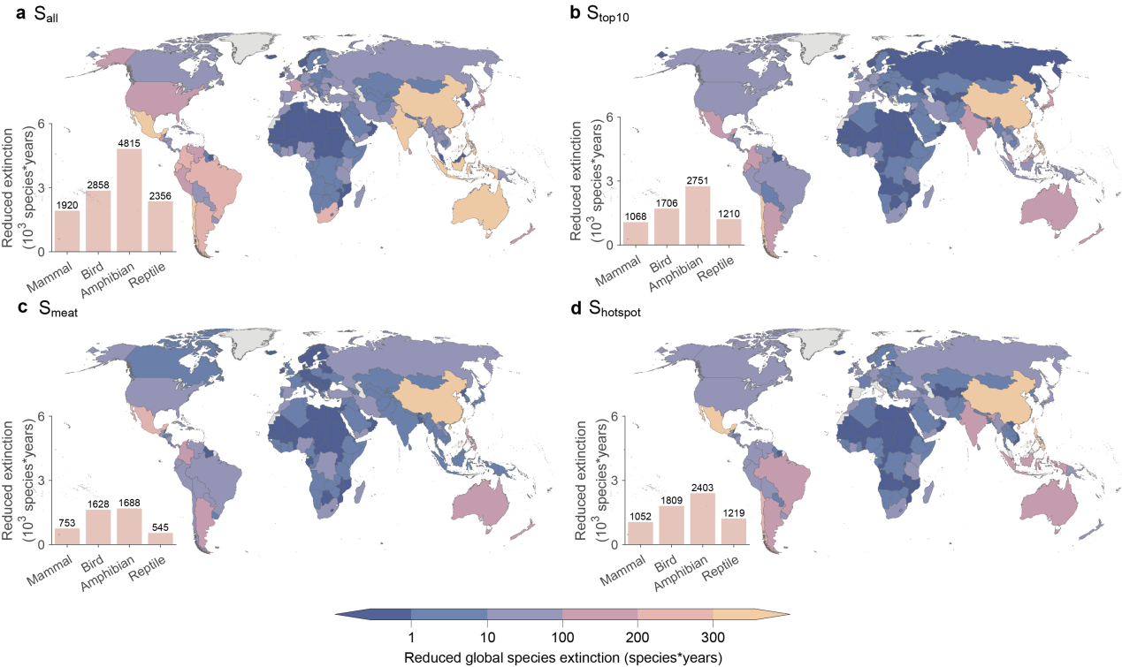

Supplementary Figure 7 | Reduced global species extinction by countries and regions. The map shows the total reduced global species extinction in species*years. The bar shows the amount of reduced global species extinction by four taxa, namely, mammal, bird, amphibian, and reptile. a, S_{all}. b, S_{top10}. c, S_{meat}. d, S_{hotspot}. The top seven countries account for 49.3% of the average reduction in global species extinction across all scenarios, including China (19.0%), the Philippines (7.3%), Mexico (7.1%), Chile (6.5%), Australia (4.1%), Argentina (3.4%), and India (3.4%).
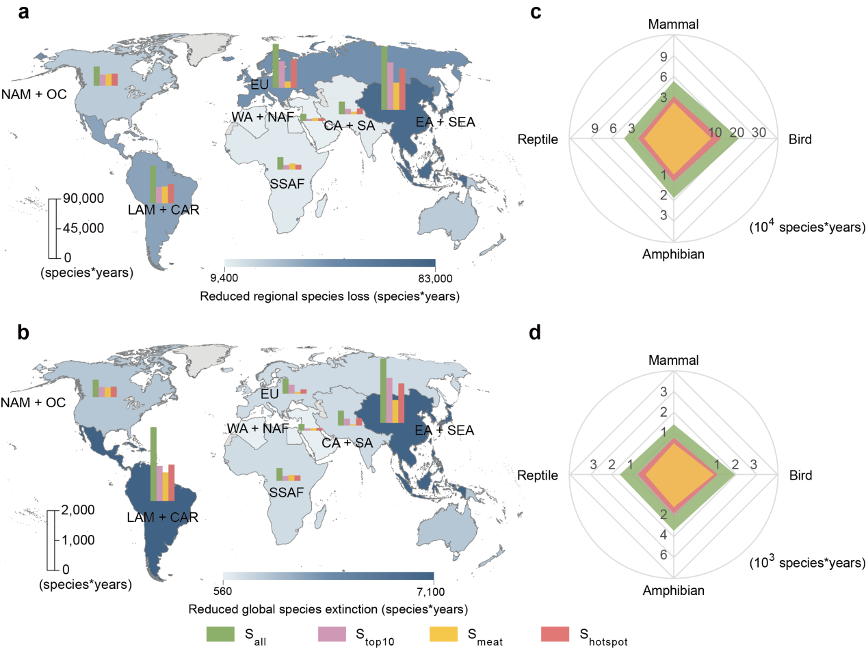
Supplementary Figure 8 | Biodiversity conservation by geographical regions and taxa. a,b, The bar chart shows reduced regional species loss (a) and global species extinction (b) under S_{all}, S_{top10}, S_{meat}, and S_{hotspot}. The background map shows the mean value of reduced biodiversity loss under four scenarios. c,d, Reduced regional species loss (c) and global species extinction (d) by taxa under four scenarios.

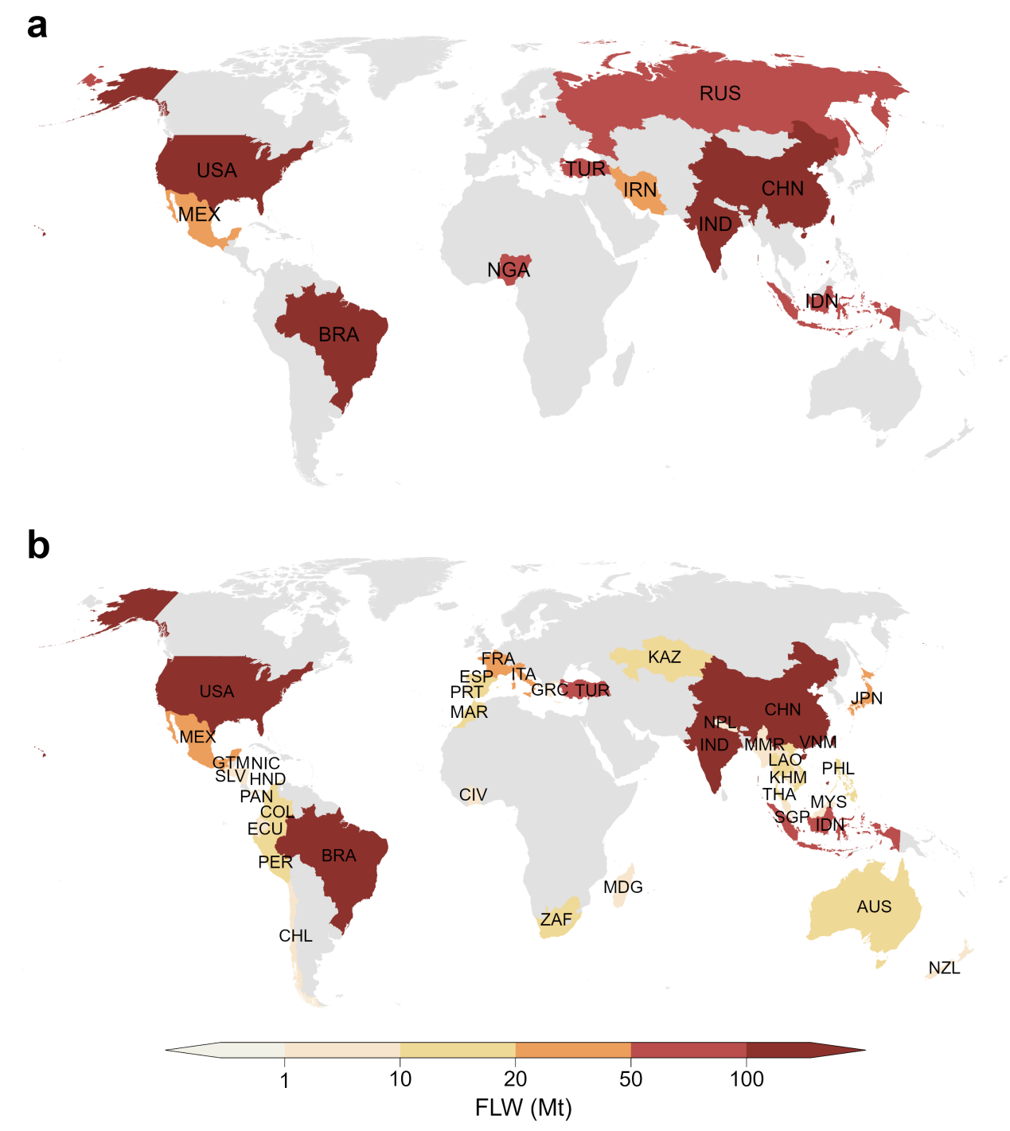

Supplementary Figure 9 | Countries involved in selected scenarios. a, The top 10 countries with the highest FLW, accounting for 54.2% of global FLW (1,216.6 Mt). b, The 40 countries with biodiversity hotspots, account for 60.6% of global FLW (1,361.4 Mt). The map shows FLW in million tonnes. The biodiversity hotspot map is available at https://zenodo.org/records/4311850.

Supplementary Table 1. Sourcing of FLW flows (Million Tons) by country in 2018.
Description of countries and regions | ISO-alpha3 code | FLW generated from domestic production (of domestically produced and exported food) | Export-embedded FLW | Import-embedded FLW | FLW generated from domestic consumption (of domestically produced and imported food)
Austria | AUT | 3.44 | 1.38 | 1.61 | 3.67
Belgium | BEL | 4.17 | 2.42 | 3.68 | 5.42
Bulgaria | BGR | 4.93 | 2.45 | 0.93 | 3.4
Cyprus | CYP | 2.33 | 1.44 | 0.16 | 1.04
Czech Republic | CZE | 3.72 | 0.96 | 1.59 | 4.35
Germany | DEU | 20.35 | 5.79 | 17.43 | 31.99
Denmark | DNK | 5.5 | 2.48 | 0.86 | 3.88
Estonia | EST | 1.28 | 0.77 | 0.11 | 0.62
Spain | ESP | 17.43 | 7.31 | 7.12 | 17.24
Finland | FIN | 1.68 | 0.2 | 0.65 | 2.13
France | FRA | 26.27 | 11.18 | 10.8 | 25.89
Greece | GRC | 5.33 | 1.44 | 1.78 | 5.67
Croatia | HRV | 3.12 | 1.04 | 0.5 | 2.58
Hungary | HUN | 4.38 | 2.37 | 0.64 | 2.65
Ireland | IRL | 2.89 | 1.77 | 1.08 | 2.2
Italy | ITA | 22.17 | 2.8 | 13.81 | 33.18
Lithuania | LTU | 1.78 | 0.9 | 0.29 | 1.17
Luxembourg | LUX | 0.64 | 0.55 | 0.2 | 0.28
Latvia | LVA | 1.56 | 1.06 | 0.21 | 0.71
Malta | MLT | 0.19 | 0.15 | 0.06 | 0.09
Netherlands | NLD | 5.66 | 3.83 | 5.01 | 6.85
Poland | POL | 16.75 | 4.06 | 3.05 | 15.73
Portugal | PRT | 4.29 | 0.86 | 2.57 | 6
Romania | ROM | 10.39 | 3.84 | 1.7 | 8.24
Sweden | SWE | 2.73 | 0.58 | 2.56 | 4.71
Slovenia | SVN | 2.51 | 0.95 | 0.46 | 2.02
Slovakia | SVK | 2.02 | 0.72 | 0.78 | 2.08
United Kingdom | GBR | 9.65 | 1.86 | 9.12 | 16.91
United States | USA | 203.39 | 37.87 | 68.44 | 233.95
Japan | JPN | 12.53 | 0.13 | 18.04 | 30.44
China | CHN | 296.89 | 6.85 | 57.17 | 347.21
Canada | CAN | 27.67 | 12.96 | 13.71 | 28.42
Republic of Korea | KOR | 10.63 | 0.09 | 16.11 | 26.65
Brazil | BRA | 168.99 | 32.71 | 6.84 | 143.11
India | IND | 165.06 | 20.89 | 12.23 | 156.4
Mexico | MEX | 58.71 | 21.95 | 7.43 | 44.18
Russian Federation | RUS | 65.6 | 15.95 | 17.12 | 66.77
Australia | AUS | 23.84 | 9.86 | 3.67 | 17.65
Switzerland | CHE | 1.84 | 0.37 | 0.98 | 2.44
Turkey | TUR | 55.36 | 4.4 | 7.91 | 58.87
Norway | NOR | 0.86 | 0.06 | 1.5 | 2.3
Indonesia | IDN | 57.44 | 11.04 | 6.95 | 53.35
South Africa | ZAF | 12.25 | 3.43 | 1.47 | 10.29
Afghanistan | AFG | 3.45 | 0.4 | 0.24 | 3.3
Armenia | ARM | 1.34 | 0.2 | 0.37 | 1.51
Azerbaijan | AZE | 4.88 | 1.05 | 1.07 | 4.9
Bangladesh | BGD | 23.47 | 3.03 | 1.11 | 21.55
Bhutan | BTN | 0.43 | 0.15 | 0.44 | 0.72
Brunei | BRN | 0.38 | 0.31 | 0.05 | 0.11
Cambodia | KHM | 6.78 | 3.38 | 0.18 | 3.58
Democratic People's Republic of Korea | PRK | 2.96 | 1.34 | 0.16 | 1.79
Fiji | FJI | 2.47 | 1.82 | 0.22 | 0.86
French Polynesia | PYF | 0.05 | 0 | 0.31 | 0.36
Georgia | GEO | 1.48 | 0.43 | 0.91 | 1.96
Kazakhstan | KAZ | 10.25 | 1.79 | 4.11 | 12.57
Kyrgyzstan | KGZ | 3.03 | 0.54 | 1.01 | 3.51
Laos | LAO | 3.45 | 2.47 | 0.08 | 1.06
Malaysia | MYS | 17.06 | 14.87 | 5.94 | 8.13
Maldives | MDV | 0.01 | 0 | 0.26 | 0.27
Mongolia | MNG | 0.45 | 0.15 | 0.25 | 0.55
Myanmar | MMR | 10.77 | 3.18 | 0.04 | 7.62
Nepal | NPL | 4.96 | 1.84 | 0.23 | 3.35
New Caledonia | NCL | 0.04 | 0 | 0.26 | 0.3
New Zealand | NZL | 3.94 | 3.08 | 2.54 | 3.4
Pakistan | PAK | 46.5 | 13.13 | 1.81 | 35.18
Papua New Guinea | PNG | 2.13 | 1.64 | 0.39 | 0.88
Philippines | PHL | 22.9 | 7.8 | 3.32 | 18.42
Samoa | WSM | 0.09 | 0 | 0.14 | 0.22
Singapore | SGP | 4.46 | 3.71 | 3.01 | 3.76
Srilanka | LKA | 3.87 | 2.16 | 1.16 | 2.87
Tajikistan | TJK | 3.42 | 2.42 | 0.48 | 1.48
Thailand | THA | 47.74 | 31.32 | 2.48 | 18.89
Turkmenistan | TKM | 2.47 | 0.85 | 2.15 | 3.77
Uzbekistan | UZB | 16.15 | 3.89 | 1.57 | 13.83
Vanuatu | VUT | 0.13 | 0.02 | 0.18 | 0.28
Viet Nam | VNM | 25.43 | 9.21 | 1.51 | 17.73
Antigua and Barbuda | ATG | 7.13 | 2.55 | 0.17 | 4.75
Argentina | ARG | 32.09 | 14.89 | 3.27 | 20.47
Barbados | BRB | 0.06 | 0.04 | 0.69 | 0.71
Belize | BLZ | 0.75 | 0.61 | 0.06 | 0.2
Bolivia | BOL | 5.25 | 3.55 | 0.72 | 2.42
Chile | CHL | 3.28 | 1.59 | 2.1 | 3.79
Colombia | COL | 18.27 | 2.65 | 2.62 | 18.24
Costa Rica | CRI | 4.92 | 3.51 | 0.44 | 1.85
Cuba | CUB | 9.16 | 1.19 | 0.65 | 8.61
Ecuador | ECU | 6.2 | 2.93 | 0.72 | 3.98
El Salvador | SLV | 2.58 | 1.03 | 0.37 | 1.92
Guatemala | GTM | 5.2 | 2.48 | 1.13 | 3.84
Guyana | GUY | 0.34 | 0.04 | 0.46 | 0.75
Haiti | HTI | 4.15 | 0.81 | 0.34 | 3.68
Honduras | HND | 4.24 | 1.65 | 0.62 | 3.22
Jamaica | JAM | 1.02 | 0.49 | 0.52 | 1.05
Nicaragua | NIC | 2.01 | 1.13 | 0.36 | 1.23
Panama | PAN | 1.44 | 0.52 | 0.45 | 1.37
Paraguay | PRY | 4.7 | 1.51 | 0.38 | 3.57
Peru | PER | 13 | 2.2 | 1.27 | 12.08
Suriname | SUR | 0.21 | 0.04 | 0.35 | 0.52
Trinidad and Tobago | TTO | 4.77 | 4.44 | 0.15 | 0.48
Uruguay | URY | 1.42 | 0.68 | 0.72 | 1.45
Venezuela | VEN | 5.34 | 0.12 | 2.26 | 7.48
Albania | ALB | 2.06 | 0.57 | 0.23 | 1.73
Belarus | BLR | 5.89 | 2.34 | 0.35 | 3.9
Bosnia and Herzegovina | BIH | 2.84 | 0.34 | 1.06 | 3.56
Iceland | ISL | 0.52 | 0.44 | 0.05 | 0.14
Montenegro | YUG | 0.29 | 0.03 | 0.96 | 1.22
Moldova | MDA | 2.33 | 1.38 | 0.03 | 0.98
Serbia | SEB | 5.22 | 2.27 | 2.55 | 5.5
The Former Yugoslav Republic of Macedonia | MKD | 2.07 | 0.28 | 0.72 | 2.5
Ukraine | UKR | 29.82 | 9.79 | 1.25 | 21.28
Algeria | DZA | 22.5 | 0.23 | 6.88 | 29.16
Angola | AGO | 13.13 | 0.13 | 3.22 | 16.23
Bahamas | BHS | 0.19 | 0.02 | 1.18 | 1.35
Benin | BEN | 3.66 | 0.7 | 0.32 | 3.29
Botswana | BWA | 0.2 | 0.01 | 0.35 | 0.54
Burkina Faso | BFA | 2.64 | 0.28 | 0.6 | 2.95
Burundi | BDI | 3.99 | 0.37 | 0.89 | 4.51
Cameroon | CMR | 9.2 | 2.44 | 0.48 | 7.24
Cape Verde | CPV | 0.17 | 0.02 | 0.96 | 1.1
Central African Republic | CAF | 3.06 | 0.3 | 0.67 | 3.44
Chad | TCD | 2.38 | 0.65 | 0.43 | 2.16
Congo | COG | 2.16 | 0.16 | 1.3 | 3.31
Cote d'Ivoire | CIV | 8.26 | 4.13 | 0.51 | 4.64
The Democratic Republic of the Congo | COD | 27.98 | 1.35 | 2.39 | 29.03
Djibouti | DJI | 0.13 | 0.04 | 0.79 | 0.88
Dominican Republic | DOM | 5.35 | 1 | 0.98 | 5.33
Eritrea | ERI | 0.41 | 0.04 | 0.5 | 0.88
Ethiopia | ETH | 8.16 | 8.11 | 1.46 | 1.5
Gabon | GAB | 1.19 | 0.11 | 1.37 | 2.45
Gambia | GMB | 0.21 | 0.03 | 0.46 | 0.64
Ghana | GHA | 12.68 | 6.62 | 1.26 | 7.31
Guinea | GIN | 3.14 | 0.7 | 0.4 | 2.84
Kenya | KEN | 7.88 | 0.96 | 3.32 | 10.24
Lesotho | LSO | 0.12 | 0.01 | 0.56 | 0.67
Liberia | LBR | 0.92 | 0.42 | 1.07 | 1.58
Libya | LBY | 2.47 | 0.02 | 2.24 | 4.7
Madagascar | MDG | 4 | 2.35 | 0.31 | 1.97
Malawi | MWI | 7.35 | 5.3 | 0.32 | 2.37
Mali | MLI | 6.79 | 0.78 | 0.76 | 6.77
Mauritania | MRT | 0.73 | 0.05 | 1.27 | 1.95
Mauritius | MUS | 0.43 | 0.41 | 0.27 | 0.28
Morocco | MAR | 16.5 | 1.91 | 4.16 | 18.74
Mozambique | MOZ | 4.49 | 1.06 | 0.49 | 3.93
Namibia | NAM | 0.36 | 0.1 | 0.42 | 0.69
Niger | NER | 6.96 | 0.28 | 1.09 | 7.77
Nigeria | NGA | 64.59 | 3.45 | 4.37 | 65.51
Rwanda | RWA | 3.59 | 0.24 | 0.6 | 3.95
Sao Tome and Principe | STP | 0.09 | 0.01 | 0.65 | 0.73
Senegal | SEN | 3.11 | 0.53 | 0.63 | 3.2
Seychelles | SYC | 0.01 | 0 | 0.88 | 0.89
Sierra Leone | SLE | 2.61 | 0.12 | 1.35 | 3.84
Somalia | SOM | 2.91 | 0.08 | 0.41 | 3.24
South Sudan | SSD | 5.26 | 0.2 | 0.47 | 5.53
Sudan | SDN | 21.24 | 0.13 | 0.32 | 21.43
Togo | TGO | 1.33 | 1.32 | 0.48 | 0.49
Tunisia | TUN | 4.37 | 0.7 | 3.77 | 7.44
Uganda | UGA | 5.2 | 2.41 | 0.33 | 3.11
Tanzania | TZA | 10.89 | 5.81 | 0.78 | 5.85
Zambia | ZMB | 3 | 1.43 | 0.3 | 1.87
Zimbabwe | ZWE | 3.6 | 3.43 | 0.34 | 0.5
Bahrain | BHR | 0.04 | 0.01 | 0.77 | 0.8
Egypt | EGY | 37.6 | 11.52 | 6.26 | 32.35
Iran | IRN | 41.97 | 5.65 | 10.94 | 47.26
Iraq | IRQ | 3.25 | 0.18 | 1.57 | 4.64
Israel | ISR | 2.62 | 1.3 | 3.39 | 4.71
Jordan | JOR | 1.25 | 0.57 | 1.8 | 2.49
Kuwait | KWT | 0.15 | 0.04 | 2.2 | 2.31
Lebanon | LBN | 1.86 | 0.86 | 6.23 | 7.22
Oman | OMN | 0.69 | 0.62 | 1.84 | 1.9
Qatar | QAT | 0.07 | 0 | 1.3 | 1.37
Saudi Arabia | SAU | 3.03 | 0.37 | 13.46 | 16.13
Syrian Arab Republic | SYR | 3.85 | 2.17 | 3.18 | 4.86
Former USSR | - | 13.3 | 2.14 | 0.35 | 11.51
United Arab Emirates | ARE | 0.33 | 0.19 | 5.55 | 5.69
Yemen | YEM | 2.27 | 0.16 | 2.27 | 4.37
Notes: Description of countries and regions can be found at: https://www.resdc.cn/data.aspx?DATAID=205. ISO-alpha3 code can be found at https://unstats.un.org/unsd/methodology/m49/.

Supplementary Table 2. Sourcing of land footprint flows (Million hectares) by country in 2018.
Description of countries and regions | ISO-alpha3 code | Land footprint generated from domestic production | Export-embedded land footprint | Import-embedded land footprint | Land footprint generated from domestic consumption
Austria | AUT | 0.64 | 0.28 | 0.39 | 0.75
Belgium | BEL | 0.7 | 0.37 | 0.91 | 1.24
Bulgaria | BGR | 1.36 | 0.63 | 0.22 | 0.95
Cyprus | CYP | 1.77 | 1.36 | 0.05 | 0.47
Czech Republic | CZE | 0.81 | 0.2 | 0.28 | 0.89
Germany | DEU | 3.53 | 1.02 | 3.84 | 6.35
Denmark | DNK | 0.63 | 0.31 | 0.19 | 0.51
Estonia | EST | 0.52 | 0.31 | 0.05 | 0.26
Spain | ESP | 3.46 | 1.19 | 1.77 | 4.04
Finland | FIN | 0.56 | 0.1 | 0.31 | 0.77
France | FRA | 4.2 | 1.6 | 3.05 | 5.65
Greece | GRC | 1.35 | 0.53 | 0.56 | 1.38
Croatia | HRV | 1.02 | 0.38 | 0.14 | 0.78
Hungary | HUN | 1.11 | 0.68 | 0.13 | 0.57
Ireland | IRL | 1.77 | 1.06 | 0.39 | 1.09
Italy | ITA | 3.63 | 0.44 | 3.74 | 6.93
Lithuania | LTU | 0.41 | 0.22 | 0.08 | 0.27
Luxembourg | LUX | 0.25 | 0.22 | 0.12 | 0.15
Latvia | LVA | 0.68 | 0.49 | 0.09 | 0.28
Malta | MLT | 0.04 | 0.03 | 0.04 | 0.05
Netherlands | NLD | 1.08 | 0.61 | 1.36 | 1.83
Poland | POL | 2.1 | 0.58 | 0.69 | 2.21
Portugal | PRT | 1.26 | 0.31 | 0.7 | 1.65
Romania | ROM | 2.6 | 1.3 | 0.36 | 1.66
Sweden | SWE | 0.91 | 0.19 | 0.5 | 1.22
Slovenia | SVN | 0.42 | 0.12 | 0.14 | 0.43
Slovakia | SVK | 0.55 | 0.21 | 0.17 | 0.51
United Kingdom | GBR | 4.3 | 0.5 | 3.15 | 6.95
United States | USA | 84.54 | 15.85 | 14 | 82.69
Japan | JPN | 2.27 | 0.02 | 4.87 | 7.12
China | CHN | 45.02 | 0.85 | 17.74 | 61.91
Canada | CAN | 15.66 | 7.64 | 2.06 | 10.07
Republic of Korea | KOR | 1.46 | 0.01 | 2.98 | 4.42
Brazil | BRA | 41.61 | 8.61 | 3.19 | 36.19
India | IND | 22.68 | 2.74 | 2.21 | 22.15
Mexico | MEX | 20 | 3.8 | 3.36 | 19.56
Russian Federation | RUS | 39.96 | 10.66 | 5.99 | 35.29
Australia | AUS | 29.11 | 8.07 | 1 | 22.04
Switzerland | CHE | 0.36 | 0.05 | 0.54 | 0.84
Turkey | TUR | 7.77 | 0.58 | 3 | 10.19
Norway | NOR | 0.2 | 0.01 | 0.69 | 0.89
Indonesia | IDN | 12.01 | 2.68 | 2.24 | 11.57
South Africa | ZAF | 18.64 | 1.7 | 0.71 | 17.66
Afghanistan | AFG | 4.35 | 0.4 | 0.13 | 4.08
Armenia | ARM | 0.44 | 0.09 | 0.13 | 0.48
Azerbaijan | AZE | 1.44 | 0.23 | 0.29 | 1.5
Bangladesh | BGD | 4.26 | 0.27 | 0.23 | 4.22
Bhutan | BTN | 0.15 | 0.01 | 0.34 | 0.49
Brunei | BRN | 0.13 | 0.08 | 0.02 | 0.07
Cambodia | KHM | 1.32 | 0.43 | 0.06 | 0.95
Democratic People's Republic of Korea | PRK | 0.55 | 0.17 | 0.04 | 0.41
Fiji | FJI | 1.44 | 1.09 | 0.2 | 0.55
French Polynesia | PYF | 0.06 | 0 | 0.22 | 0.27
Georgia | GEO | 0.46 | 0.16 | 0.26 | 0.56
Kazakhstan | KAZ | 12.21 | 1.12 | 1.14 | 12.23
Kyrgyzstan | KGZ | 1.93 | 0.42 | 0.4 | 1.9
Laos | LAO | 1.1 | 0.43 | 0.04 | 0.72
Malaysia | MYS | 3.11 | 2.35 | 1.54 | 2.3
Maldives | MDV | 0.01 | 0 | 0.16 | 0.17
Mongolia | MNG | 3.51 | 0.71 | 0.12 | 2.92
Myanmar | MMR | 1.98 | 0.41 | 0.01 | 1.58
Nepal | NPL | 1.3 | 0.23 | 0.11 | 1.18
New Caledonia | NCL | 0.17 | 0 | 0.24 | 0.41
New Zealand | NZL | 1.35 | 0.86 | 0.63 | 1.12
Pakistan | PAK | 8.34 | 1.59 | 0.5 | 7.25
Papua New Guinea | PNG | 1.25 | 0.64 | 0.16 | 0.77
Philippines | PHL | 5.51 | 1.19 | 0.95 | 5.27
Samoa | WSM | 0.03 | 0 | 0.11 | 0.15
Singapore | SGP | 0.17 | 0.13 | 1.16 | 1.19
Srilanka | LKA | 0.87 | 0.45 | 0.25 | 0.67
Tajikistan | TJK | 1.56 | 0.63 | 0.21 | 1.14
Thailand | THA | 3.61 | 1.64 | 0.85 | 2.83
Turkmenistan | TKM | 7.66 | 1.15 | 0.77 | 7.28
Uzbekistan | UZB | 5.94 | 0.93 | 0.7 | 5.71
Vanuatu | VUT | 0.08 | 0.01 | 0.14 | 0.2
Viet Nam | VNM | 3.33 | 0.8 | 0.61 | 3.14
Antigua and Barbuda | ATG | 0.47 | 0.18 | 0.26 | 0.55
Argentina | ARG | 26.34 | 8.8 | 0.97 | 18.51
Barbados | BRB | 0.02 | 0.01 | 0.38 | 0.39
Belize | BLZ | 0.07 | 0.06 | 0.02 | 0.03
Bolivia | BOL | 5.93 | 5.03 | 0.55 | 1.46
Chile | CHL | 3.48 | 2.81 | 1.32 | 1.98
Colombia | COL | 7.27 | 0.8 | 0.8 | 7.28
Costa Rica | CRI | 0.67 | 0.41 | 0.17 | 0.43
Cuba | CUB | 2.37 | 0.33 | 0.33 | 2.37
Ecuador | ECU | 1.35 | 0.54 | 0.26 | 1.07
El Salvador | SLV | 0.43 | 0.15 | 0.14 | 0.42
Guatemala | GTM | 1.5 | 0.74 | 0.53 | 1.29
Guyana | GUY | 0.11 | 0.01 | 0.12 | 0.21
Haiti | HTI | 1.3 | 0.2 | 0.28 | 1.38
Honduras | HND | 0.67 | 0.22 | 0.18 | 0.63
Jamaica | JAM | 0.25 | 0.11 | 0.11 | 0.25
Nicaragua | NIC | 0.96 | 0.64 | 0.18 | 0.5
Panama | PAN | 0.45 | 0.12 | 0.18 | 0.51
Paraguay | PRY | 2.32 | 0.66 | 0.13 | 1.79
Peru | PER | 3.58 | 0.64 | 0.42 | 3.37
Suriname | SUR | 0.07 | 0.01 | 0.08 | 0.14
Trinidad and Tobago | TTO | 0.24 | 0.21 | 0.08 | 0.1
Uruguay | URY | 1.33 | 0.64 | 0.16 | 0.84
Venezuela | VEN | 2.54 | 0.05 | 0.76 | 3.26
Albania | ALB | 0.37 | 0.09 | 0.06 | 0.34
Belarus | BLR | 0.97 | 0.23 | 0.09 | 0.83
Bosnia and Herzegovina | BIH | 1.52 | 0.11 | 0.28 | 1.69
Iceland | ISL | 1.85 | 1.6 | 0.03 | 0.28
Montenegro | YUG | 0.1 | 0.04 | 0.31 | 0.36
Moldova | MDA | 0.68 | 0.45 | 0.01 | 0.24
Serbia | SEB | 1.14 | 0.44 | 0.67 | 1.37
The Former Yugoslav Republic of Macedonia | MKD | 1.05 | 0.1 | 0.2 | 1.14
Ukraine | UKR | 6.88 | 2.95 | 0.32 | 4.25
Algeria | DZA | 9.77 | 0.17 | 1.89 | 11.48
Angola | AGO | 10.57 | 0.11 | 1.95 | 12.41
Bahamas | BHS | 0.04 | 0 | 1.06 | 1.1
Benin | BEN | 1.4 | 0.27 | 0.26 | 1.4
Botswana | BWA | 0.66 | 0.11 | 0.25 | 0.8
Burkina Faso | BFA | 2.87 | 0.47 | 0.42 | 2.83
Burundi | BDI | 1.46 | 0.11 | 0.98 | 2.33
Cameroon | CMR | 2.61 | 0.63 | 0.25 | 2.24
Cape Verde | CPV | 0.05 | 0.01 | 0.85 | 0.89
Central African Republic | CAF | 3.24 | 0.28 | 0.66 | 3.63
Chad | TCD | 9.01 | 2.11 | 0.32 | 7.22
Congo | COG | 1.72 | 0.08 | 1.14 | 2.79
Cote d'Ivoire | CIV | 3.9 | 1.35 | 0.26 | 2.81
The Democratic Republic of the Congo | COD | 9.62 | 0.32 | 1.97 | 11.27
Djibouti | DJI | 0.52 | 0.16 | 0.74 | 1.1
Dominican Republic | DOM | 0.64 | 0.11 | 0.34 | 0.86
Eritrea | ERI | 1.53 | 0.12 | 0.62 | 2.04
Ethiopia | ETH | 3.93 | 3.87 | 0.87 | 0.94
Gabon | GAB | 1.42 | 0.07 | 0.98 | 2.33
Gambia | GMB | 0.53 | 0.09 | 0.51 | 0.96
Ghana | GHA | 3.02 | 1 | 0.43 | 2.45
Guinea | GIN | 3.04 | 0.58 | 0.32 | 2.78
Kenya | KEN | 6.04 | 0.53 | 1.44 | 6.96
Lesotho | LSO | 0.19 | 0.02 | 0.58 | 0.75
Liberia | LBR | 0.86 | 0.26 | 0.98 | 1.58
Libya | LBY | 5.44 | 0.05 | 1.12 | 6.51
Madagascar | MDG | 3.02 | 0.83 | 0.34 | 2.53
Malawi | MWI | 1.88 | 1.04 | 0.26 | 1.1
Mali | MLI | 8.57 | 0.58 | 0.83 | 8.83
Mauritania | MRT | 4.03 | 0.31 | 1.34 | 5.06
Mauritius | MUS | 0.03 | 0.03 | 0.14 | 0.15
Morocco | MAR | 6.73 | 0.91 | 1.38 | 7.19
Mozambique | MOZ | 1.71 | 0.5 | 0.29 | 1.5
Namibia | NAM | 0.57 | 0.26 | 0.22 | 0.53
Niger | NER | 11.76 | 0.42 | 1.15 | 12.49
Nigeria | NGA | 20.23 | 0.91 | 1.4 | 20.72
Rwanda | RWA | 0.49 | 0.04 | 0.29 | 0.73
Sao Tome and Principe | STP | 0.03 | 0.01 | 0.68 | 0.7
Senegal | SEN | 2.73 | 0.43 | 0.36 | 2.66
Seychelles | SYC | 0.02 | 0.01 | 0.8 | 0.81
Sierra Leone | SLE | 2.13 | 0.11 | 1.31 | 3.33
Somalia | SOM | 10.66 | 0.28 | 0.52 | 10.9
South Sudan | SSD | 13.91 | 0.87 | 0.57 | 13.61
Sudan | SDN | 39.24 | 0.21 | 0.45 | 39.48
Togo | TGO | 0.61 | 0.59 | 0.36 | 0.38
Tunisia | TUN | 1.57 | 0.28 | 0.55 | 1.84
Uganda | UGA | 1.69 | 0.77 | 0.19 | 1.11
Tanzania | TZA | 11.15 | 3.21 | 0.47 | 8.41
Zambia | ZMB | 2.48 | 1.51 | 0.18 | 1.15
Zimbabwe | ZWE | 8.96 | 8.73 | 0.16 | 0.39
Bahrain | BHR | 0.02 | 0 | 0.17 | 0.19
Egypt | EGY | 3.29 | 0.79 | 2.44 | 4.94
Iran | IRN | 4.91 | 0.71 | 3.76 | 7.96
Iraq | IRQ | 0.92 | 0.02 | 0.97 | 1.87
Israel | ISR | 0.26 | 0.13 | 1.26 | 1.39
Jordan | JOR | 0.12 | 0.06 | 0.49 | 0.56
Kuwait | KWT | 0.02 | 0.01 | 0.46 | 0.47
Lebanon | LBN | 0.26 | 0.1 | 2.54 | 2.7
Oman | OMN | 0.11 | 0.09 | 0.59 | 0.62
Qatar | QAT | 0.03 | 0 | 0.31 | 0.34
Saudi Arabia | SAU | 3.03 | 0.24 | 2.46 | 5.24
Syrian Arab Republic | SYR | 1.43 | 0.46 | 1.7 | 2.68
Former USSR | - | 5.01 | 1.55 | 0.27 | 3.73
United Arab Emirates | ARE | 0.07 | 0.04 | 1.56 | 1.59
Yemen | YEM | 1.73 | 0.08 | 0.97 | 2.62

Supplementary Table 3. Potential regional species loss generated from FLW by country in 2018.
Description of countries and regions | ISO-alpha3 code | Mammal | Bird | Amphibian | Reptile | Total
Austria | AUT | 105 | 449 | 51 | 38 | 643
Belgium | BEL | 101 | 330 | 40 | 29 | 500
Bulgaria | BGR | 585 | 3017 | 218 | 355 | 4176
Cyprus | CYP | 110 | 9368 | 232 | 1882 | 11592
Czech Republic | CZE | 113 | 353 | 38 | 29 | 532
Germany | DEU | 468 | 1529 | 178 | 112 | 2286
Denmark | DNK | 215 | 839 | 81 | 31 | 1166
Estonia | EST | 19 | 91 | 7 | 3 | 119
Spain | ESP | 520 | 2935 | 254 | 475 | 4185
Finland | FIN | 5 | 63 | 2 | 1 | 71
France | FRA | 690 | 2872 | 314 | 300 | 4175
Greece | GRC | 373 | 1567 | 123 | 276 | 2340
Croatia | HRV | 336 | 1419 | 131 | 169 | 2054
Hungary | HUN | 255 | 792 | 76 | 59 | 1182
Ireland | IRL | 458 | 1561 | 82 | 46 | 2147
Italy | ITA | 1246 | 5369 | 594 | 638 | 7847
Lithuania | LTU | 27 | 96 | 8 | 5 | 136
Luxembourg | LUX | 24 | 72 | 9 | 7 | 113
Latvia | LVA | 31 | 147 | 11 | 5 | 193
Malta | MLT | 5 | 15 | 2 | 3 | 26
Netherlands | NLD | 151 | 476 | 60 | 42 | 729
Poland | POL | 376 | 1284 | 118 | 64 | 1842
Portugal | PRT | 138 | 1328 | 83 | 126 | 1677
Romania | ROM | 582 | 2112 | 185 | 179 | 3058
Sweden | SWE | 27 | 200 | 10 | 4 | 242
Slovenia | SVN | 138 | 625 | 56 | 67 | 886
Slovakia | SVK | 140 | 519 | 48 | 35 | 742
United Kingdom | GBR | 1301 | 4631 | 248 | 142 | 6322
United States | USA | 2562 | 9103 | 103 | 3068 | 14835
Japan | JPN | 522 | 7271 | 625 | 386 | 8804
China | CHN | 8698 | 34200 | 2743 | 4558 | 50199
Canada | CAN | 724 | 4045 | 218 | 108 | 5096
Republic of Korea | KOR | 671 | 2230 | 323 | 350 | 3575
Brazil | BRA | 2562 | 9281 | 1918 | 1357 | 15118
India | IND | 5469 | 19981 | 984 | 2345 | 28779
Mexico | MEX | 6604 | 15998 | 2257 | 6465 | 31324
Russian Federation | RUS | 1405 | 7289 | 269 | 337 | 9300
Australia | AUS | 1220 | 7231 | 616 | 2673 | 11739
Switzerland | CHE | 38 | 169 | 22 | 14 | 244
Turkey | TUR | 3030 | 9500 | 516 | 1902 | 14948
Norway | NOR | 6 | 71 | 2 | 1 | 80
Indonesia | IDN | 2498 | 13361 | 1161 | 3203 | 20222
South Africa | ZAF | 2411 | 6966 | 799 | 1743 | 11919
Afghanistan | AFG | 1494 | 1437 | 56 | 233 | 3221
Armenia | ARM | 110 | 248 | 18 | 73 | 449
Azerbaijan | AZE | 518 | 1269 | 74 | 326 | 2186
Bangladesh | BGD | 1675 | 5618 | 148 | 658 | 8099
Bhutan | BTN | 33 | 235 | 14 | 11 | 292
Brunei | BRN | -6 | 31 | 4 | 7 | 35
Cambodia | KHM | 390 | 1575 | 69 | 236 | 2270
Democratic People's Republic of Korea | PRK | 67 | 886 | 46 | 45 | 1044
Fiji | FJI | -41 | 601 | 16 | 99 | 675
French Polynesia | PYF | 0 | 896 | 0 | 550 | 1446
Georgia | GEO | 138 | 334 | 27 | 97 | 596
Kazakhstan | KAZ | 1392 | 2177 | 64 | 283 | 3915
Kyrgyzstan | KGZ | 694 | 1731 | 32 | 157 | 2614
Laos | LAO | 146 | 1106 | 66 | 132 | 1450
Malaysia | MYS | 778 | 3683 | 416 | 824 | 5700
Maldives | MDV | 12 | 346 | 0 | 41 | 399
Mongolia | MNG | 640 | 1173 | 24 | 30 | 1866
Myanmar | MMR | 835 | 3494 | 137 | 365 | 4831
Nepal | NPL | 613 | 2526 | 107 | 180 | 3426
New Caledonia | NCL | 3 | 92 | 0 | 39 | 133
New Zealand | NZL | 21 | 25094 | 9 | 127 | 25251
Pakistan | PAK | 1617 | 3250 | 108 | 627 | 5601
Papua New Guinea | PNG | -42 | 372 | 54 | 53 | 437
Philippines | PHL | 768 | 8428 | 762 | 2396 | 12355
Samoa | WSM | 9 | 169 | 0 | 41 | 219
Singapore | SGP | 53 | 214 | 31 | 62 | 360
Srilanka | LKA | 321 | 1701 | 256 | 401 | 2679
Tajikistan | TJK | 397 | 710 | 17 | 105 | 1228
Thailand | THA | 1817 | 6082 | 388 | 1087 | 9374
Turkmenistan | TKM | 1183 | 1633 | 40 | 610 | 3467
Uzbekistan | UZB | 768 | 1263 | 21 | 313 | 2366
Vanuatu | VUT | -1 | 38 | 0 | 8 | 46
Viet Nam | VNM | 1817 | 6671 | 336 | 933 | 9757
Antigua and Barbuda | ATG | 620 | 6250 | 335 | 2325 | 9530
Argentina | ARG | 1553 | 4169 | 534 | 1064 | 7320
Barbados | BRB | 8 | 92 | 10 | 57 | 167
Belize | BLZ | 40 | 208 | 19 | 50 | 317
Bolivia | BOL | 483 | 1084 | 138 | 138 | 1844
Chile | CHL | 294 | 889 | 163 | 111 | 1457
Colombia | COL | 1945 | 4290 | 832 | 950 | 8017
Costa Rica | CRI | 533 | 1732 | 314 | 498 | 3077
Cuba | CUB | 389 | 3606 | 541 | 1919 | 6455
Ecuador | ECU | 532 | 1239 | 351 | 359 | 2482
El Salvador | SLV | 215 | 413 | 114 | 227 | 969
Guatemala | GTM | 597 | 1434 | 334 | 704 | 3069
Guyana | GUY | 6 | 30 | 4 | 5 | 45
Haiti | HTI | 150 | 1906 | 343 | 1094 | 3493
Honduras | HND | 203 | 567 | 117 | 225 | 1112
Jamaica | JAM | 89 | 1113 | 110 | 227 | 1539
Nicaragua | NIC | 205 | 725 | 111 | 205 | 1245
Panama | PAN | 385 | 1037 | 197 | 316 | 1934
Paraguay | PRY | 61 | 189 | 67 | 52 | 370
Peru | PER | 325 | 1179 | 197 | 201 | 1902
Suriname | SUR | 9 | 45 | 4 | 6 | 64
Trinidad and Tobago | TTO | 280 | 3589 | 53 | 234 | 4155
Uruguay | URY | 32 | 71 | 37 | 23 | 162
Venezuela | VEN | 600 | 1360 | 135 | 111 | 2207
Albania | ALB | 127 | 563 | 48 | 77 | 815
Belarus | BLR | 65 | 194 | 18 | 11 | 288
Bosnia and Herzegovina | BIH | 369 | 2039 | 202 | 258 | 2868
Iceland | ISL | 1 | 20 | 0 | 0 | 21
Montenegro | YUG | 15 | 103 | 12 | 15 | 145
Moldova | MDA | 90 | 229 | 19 | 20 | 358
Serbia | SEB | 318 | 1229 | 100 | 156 | 1802
The Former Yugoslav Republic of Macedonia | MKD | 225 | 917 | 76 | 129 | 1347
Ukraine | UKR | 916 | 2628 | 214 | 260 | 4019
Algeria | DZA | 247 | 590 | 23 | 205 | 1065
Angola | AGO | 252 | 874 | 94 | 175 | 1394
Bahamas | BHS | 6 | 133 | 16 | 100 | 256
Benin | BEN | 12 | 36 | 3 | 9 | 60
Botswana | BWA | 18 | 44 | 3 | 11 | 76
Burkina Faso | BFA | 11 | 22 | 1 | 8 | 42
Burundi | BDI | 113 | 443 | 45 | 86 | 688
Cameroon | CMR | 240 | 1497 | 208 | 180 | 2126
Cape Verde | CPV | 4 | 78 | 3 | 22 | 108
Central African Republic | CAF | 8 | 71 | 8 | 13 | 100
Chad | TCD | 170 | 416 | 7 | 57 | 650
Congo | COG | 18 | 166 | 16 | 29 | 229
Cote d'Ivoire | CIV | 245 | 893 | 106 | 150 | 1395
The Democratic Republic of the Congo | COD | 389 | 1232 | 109 | 251 | 1981
Djibouti | DJI | 122 | 403 | 12 | 78 | 616
Dominican Republic | DOM | 94 | 1225 | 204 | 683 | 2205
Eritrea | ERI | 123 | 404 | 15 | 81 | 623
Ethiopia | ETH | 159 | 544 | 40 | 93 | 837
Gabon | GAB | 14 | 217 | 35 | 32 | 299
Gambia | GMB | 9 | 38 | 1 | 3 | 50
Ghana | GHA | 120 | 481 | 57 | 79 | 737
Guinea | GIN | 237 | 726 | 52 | 105 | 1121
Kenya | KEN | 579 | 1466 | 71 | 186 | 2301
Lesotho | LSO | 44 | 120 | 13 | 20 | 197
Liberia | LBR | 76 | 228 | 35 | 43 | 381
Libya | LBY | 53 | 109 | 5 | 40 | 206
Madagascar | MDG | 298 | 586 | 197 | 424 | 1506
Malawi | MWI | 272 | 865 | 98 | 103 | 1338
Mali | MLI | 85 | 220 | 8 | 45 | 357
Mauritania | MRT | 47 | 87 | 5 | 31 | 171
Mauritius | MUS | 4 | 73 | 1 | 21 | 99
Morocco | MAR | 1050 | 3180 | 123 | 960 | 5314
Mozambique | MOZ | 53 | 294 | 28 | 62 | 437
Namibia | NAM | 41 | 94 | 6 | 35 | 176
Niger | NER | 78 | 163 | 8 | 55 | 303
Nigeria | NGA | 1608 | 7414 | 589 | 1346 | 10957
Rwanda | RWA | 113 | 441 | 34 | 77 | 665
Sao Tome and Principe | STP | 11 | 249 | 27 | 47 | 333
Senegal | SEN | 13 | 41 | 2 | 9 | 65
Seychelles | SYC | 60 | 663 | 95 | 444 | 1262
Sierra Leone | SLE | 175 | 591 | 63 | 87 | 916
Somalia | SOM | 663 | 1390 | 158 | 373 | 2584
South Sudan | SSD | 142 | 358 | 14 | 65 | 578
Sudan | SDN | 399 | 1009 | 41 | 187 | 1635
Togo | TGO | 12 | 45 | 5 | 8 | 71
Tunisia | TUN | 127 | 368 | 11 | 114 | 620
Uganda | UGA | 130 | 457 | 31 | 84 | 703
Tanzania | TZA | 700 | 2537 | 233 | 382 | 3853
Zambia | ZMB | 64 | 245 | 18 | 33 | 360
Zimbabwe | ZWE | 126 | 643 | 48 | 109 | 927
Bahrain | BHR | 2 | 8 | 0 | 2 | 12
Egypt | EGY | 74 | 214 | 13 | 86 | 387
Iran | IRN | 1175 | 2150 | 101 | 927 | 4353
Iraq | IRQ | 118 | 270 | 5 | 79 | 473
Israel | ISR | 27 | 67 | 2 | 23 | 119
Jordan | JOR | 13 | 27 | 0 | 8 | 49
Kuwait | KWT | 2 | 9 | 0 | 3 | 14
Lebanon | LBN | 56 | 166 | 9 | 53 | 283
Oman | OMN | 6 | 17 | 0 | 7 | 29
Qatar | QAT | 2 | 6 | 0 | 2 | 10
Saudi Arabia | SAU | 83 | 187 | 2 | 65 | 337
Syrian Arab Republic | SYR | 357 | 724 | 16 | 177 | 1275
Former USSR | - | 159 | 821 | 29 | 34 | 1045
United Arab Emirates | ARE | 2 | 7 | 0 | 3 | 12
Yemen | YEM | 103 | 252 | 3 | 102 | 460

Supplementary Table 4. Potential global species extinction generated from FLW by country in 2018.
Description of countries and regions | ISO-alpha3 code | Mammal | Bird | Amphibian | Reptile | Total
Austria | AUT | 3 | 1 | 2 | 1 | 7
Belgium | BEL | 2 | 1 | 1 | 0 | 5
Bulgaria | BGR | 10 | 4 | 2 | 4 | 20
Cyprus | CYP | 37 | 3 | 1 | 161 | 201
Czech Republic | CZE | 2 | 2 | 1 | 0 | 5
Germany | DEU | 8 | 5 | 5 | 1 | 19
Denmark | DNK | 1 | 1 | 1 | 0 | 3
Estonia | EST | 0 | 1 | 0 | 0 | 1
Spain | ESP | 9 | 8 | 16 | 40 | 72
Finland | FIN | 0 | 1 | 0 | 0 | 1
France | FRA | 12 | 8 | 16 | 11 | 48
Greece | GRC | 8 | 2 | 13 | 13 | 35
Croatia | HRV | 4 | 2 | 6 | 6 | 18
Hungary | HUN | 4 | 2 | 3 | 1 | 10
Ireland | IRL | 1 | 3 | 0 | 0 | 4
Italy | ITA | 17 | 5 | 44 | 15 | 82
Lithuania | LTU | 1 | 1 | 0 | 0 | 2
Luxembourg | LUX | 1 | 0 | 0 | 0 | 1
Latvia | LVA | 1 | 1 | 0 | 0 | 2
Malta | MLT | 0 | 0 | 1 | 0 | 1
Netherlands | NLD | 3 | 2 | 2 | 1 | 7
Poland | POL | 6 | 4 | 2 | 0 | 12
Portugal | PRT | 8 | 13 | 4 | 7 | 31
Romania | ROM | 11 | 6 | 4 | 2 | 23
Sweden | SWE | 0 | 1 | 0 | 0 | 2
Slovenia | SVN | 2 | 1 | 2 | 2 | 7
Slovakia | SVK | 2 | 1 | 1 | 0 | 5
United Kingdom | GBR | 2 | 7 | 1 | 0 | 11
United States | USA | 62 | 24 | 2 | 114 | 202
Japan | JPN | 22 | 27 | 68 | 3 | 119
China | CHN | 206 | 231 | 451 | 91 | 979
Canada | CAN | 6 | 20 | 4 | 1 | 31
Republic of Korea | KOR | 6 | 12 | 50 | 2 | 71
Brazil | BRA | 74 | 170 | 271 | 20 | 534
India | IND | 101 | 202 | 355 | 228 | 885
Mexico | MEX | 147 | 136 | 379 | 411 | 1072
Russian Federation | RUS | 24 | 49 | 4 | 10 | 86
Australia | AUS | 49 | 112 | 60 | 17 | 239
Switzerland | CHE | 1 | 0 | 1 | 0 | 3
Turkey | TUR | 56 | 15 | 47 | 121 | 239
Norway | NOR | 0 | 0 | 0 | 0 | 0
Indonesia | IDN | 144 | 316 | 205 | 124 | 789
South Africa | ZAF | 61 | 61 | 83 | 25 | 230
Afghanistan | AFG | 9 | 5 | 3 | 2 | 18
Armenia | ARM | 6 | 1 | 1 | 9 | 17
Azerbaijan | AZE | 17 | 3 | 5 | 23 | 47
Bangladesh | BGD | 12 | 35 | 14 | 11 | 72
Bhutan | BTN | 1 | 3 | 3 | 1 | 8
Brunei | BRN | 0 | 1 | 0 | 0 | 1
Cambodia | KHM | 5 | 8 | 13 | 11 | 37
Democratic People's Republic of Korea | PRK | 1 | 3 | 4 | 0 | 8
Fiji | FJI | -7 | 43 | 2 | 14 | 53
French Polynesia | PYF | 0 | 90 | 0 | 0 | 90
Georgia | GEO | 7 | 1 | 1 | 11 | 20
Kazakhstan | KAZ | 18 | 9 | 1 | 1 | 29
Kyrgyzstan | KGZ | 6 | 3 | 3 | 0 | 13
Laos | LAO | 5 | 10 | 16 | 8 | 39
Malaysia | MYS | 30 | 56 | 88 | 54 | 228
Maldives | MDV | 0 | 0 | 0 | 0 | 0
Mongolia | MNG | 5 | 3 | 0 | 0 | 8
Myanmar | MMR | 14 | 28 | 30 | 26 | 97
Nepal | NPL | 10 | 21 | 23 | 8 | 62
New Caledonia | NCL | 0 | 7 | 0 | 14 | 22
New Zealand | NZL | 2 | 482 | 4 | 4 | 491
Pakistan | PAK | 20 | 18 | 10 | 10 | 58
Papua New Guinea | PNG | -3 | 14 | 10 | 1 | 22
Philippines | PHL | 90 | 326 | 181 | 275 | 872
Samoa | WSM | 0 | 18 | 0 | 5 | 22
Singapore | SGP | 4 | 4 | 8 | 5 | 21
Srilanka | LKA | 19 | 33 | 150 | 27 | 229
Tajikistan | TJK | 7 | 2 | 4 | 0 | 14
Thailand | THA | 25 | 34 | 46 | 46 | 151
Turkmenistan | TKM | 11 | 6 | 0 | 4 | 21
Uzbekistan | UZB | 10 | 5 | 2 | 3 | 21
Vanuatu | VUT | 0 | 3 | 0 | 1 | 3
Viet Nam | VNM | 29 | 48 | 95 | 62 | 235
Antigua and Barbuda | ATG | 13 | 30 | 26 | 7 | 76
Argentina | ARG | 123 | 82 | 97 | 25 | 328
Barbados | BRB | 0 | 1 | 1 | 0 | 2
Belize | BLZ | 0 | 1 | 3 | 1 | 5
Bolivia | BOL | 17 | 24 | 26 | 4 | 71
Chile | CHL | 34 | 25 | 72 | 11 | 142
Colombia | COL | 37 | 94 | 290 | 14 | 434
Costa Rica | CRI | 7 | 28 | 82 | 2 | 119
Cuba | CUB | 19 | 49 | 148 | 17 | 233
Ecuador | ECU | 15 | 44 | 149 | 8 | 215
El Salvador | SLV | 4 | 7 | 32 | 8 | 51
Guatemala | GTM | 10 | 19 | 92 | 27 | 147
Guyana | GUY | 0 | 1 | 1 | 0 | 1
Haiti | HTI | 6 | 36 | 157 | 22 | 221
Honduras | HND | 4 | 9 | 43 | 9 | 66
Jamaica | JAM | 4 | 27 | 43 | 5 | 79
Nicaragua | NIC | 2 | 10 | 29 | 3 | 44
Panama | PAN | 3 | 16 | 38 | 1 | 59
Paraguay | PRY | 4 | 5 | 6 | 1 | 16
Peru | PER | 14 | 44 | 91 | 5 | 154
Suriname | SUR | 0 | 0 | 0 | 0 | 1
Trinidad and Tobago | TTO | 7 | 12 | 28 | 9 | 56
Uruguay | URY | 2 | 2 | 2 | 0 | 7
Venezuela | VEN | 7 | 13 | 49 | 2 | 71
Albania | ALB | 1 | 0 | 2 | 2 | 6
Belarus | BLR | 1 | 1 | 0 | 0 | 3
Bosnia and Herzegovina | BIH | 5 | 2 | 6 | 9 | 22
Iceland | ISL | 0 | 0 | 0 | 0 | 0
Montenegro | YUG | 0 | 0 | 0 | 0 | 1
Moldova | MDA | 2 | 2 | 0 | 0 | 4
Serbia | SEB | 8 | 3 | 2 | 3 | 16
The Former Yugoslav Republic of Macedonia | MKD | 5 | 1 | 2 | 3 | 11
Ukraine | UKR | 18 | 12 | 4 | 6 | 40
Algeria | DZA | 10 | 4 | 3 | 16 | 32
Angola | AGO | 3 | 9 | 6 | 2 | 20
Bahamas | BHS | 0 | 1 | 1 | 1 | 3
Benin | BEN | 1 | 1 | 0 | 1 | 2
Botswana | BWA | 0 | 1 | 0 | 0 | 1
Burkina Faso | BFA | 1 | 1 | 0 | 1 | 2
Burundi | BDI | 9 | 10 | 17 | 1 | 37
Cameroon | CMR | 13 | 16 | 40 | 3 | 73
Cape Verde | CPV | 0 | 1 | 0 | 6 | 7
Central African Republic | CAF | 1 | 2 | 1 | 0 | 4
Chad | TCD | 3 | 2 | 0 | 1 | 5
Congo | COG | 0 | 3 | 1 | 0 | 5
Cote d'Ivoire | CIV | 14 | 15 | 27 | 10 | 65
The Democratic Republic of the Congo | COD | 20 | 22 | 25 | 3 | 70
Djibouti | DJI | 2 | 1 | 0 | 1 | 4
Dominican Republic | DOM | 3 | 22 | 93 | 12 | 130
Eritrea | ERI | 3 | 3 | 1 | 1 | 7
Ethiopia | ETH | 10 | 9 | 7 | 2 | 27
Gabon | GAB | 1 | 4 | 5 | 0 | 9
Gambia | GMB | 0 | 0 | 0 | 0 | 1
Ghana | GHA | 6 | 7 | 12 | 6 | 31
Guinea | GIN | 6 | 4 | 21 | 4 | 35
Kenya | KEN | 16 | 16 | 12 | 2 | 46
Lesotho | LSO | 0 | 1 | 1 | 0 | 2
Liberia | LBR | 6 | 6 | 11 | 2 | 26
Libya | LBY | 3 | 1 | 0 | 2 | 6
Madagascar | MDG | 70 | 29 | 89 | 120 | 308
Malawi | MWI | 4 | 4 | 11 | 0 | 19
Mali | MLI | 3 | 2 | 0 | 2 | 6
Mauritania | MRT | 2 | 1 | 0 | 1 | 4
Mauritius | MUS | 1 | 10 | 0 | 0 | 12
Morocco | MAR | 39 | 14 | 14 | 72 | 139
Mozambique | MOZ | 1 | 2 | 1 | 0 | 4
Namibia | NAM | 1 | 1 | 0 | 0 | 3
Niger | NER | 3 | 2 | 0 | 2 | 8
Nigeria | NGA | 37 | 36 | 59 | 37 | 170
Rwanda | RWA | 8 | 8 | 14 | 1 | 31
Sao Tome and Principe | STP | 3 | 23 | 4 | 2 | 33
Senegal | SEN | 1 | 1 | 0 | 1 | 3
Seychelles | SYC | 7 | 14 | 62 | 58 | 142
Sierra Leone | SLE | 11 | 11 | 21 | 6 | 48
Somalia | SOM | 18 | 25 | 6 | 5 | 54
South Sudan | SSD | 5 | 4 | 1 | 1 | 10
Sudan | SDN | 13 | 10 | 3 | 3 | 29
Togo | TGO | 1 | 1 | 1 | 1 | 3
Tunisia | TUN | 4 | 2 | 3 | 12 | 21
Uganda | UGA | 7 | 7 | 11 | 1 | 26
Tanzania | TZA | 18 | 34 | 70 | 8 | 129
Zambia | ZMB | 1 | 2 | 1 | 0 | 4
Zimbabwe | ZWE | 3 | 4 | 3 | 1 | 11
Bahrain | BHR | 0 | 0 | 0 | 0 | 0
Egypt | EGY | 2 | 1 | 0 | 1 | 4
Iran | IRN | 31 | 6 | 20 | 65 | 122
Iraq | IRQ | 2 | 1 | 1 | 4 | 7
Israel | ISR | 1 | 0 | 1 | 2 | 3
Jordan | JOR | 0 | 0 | 0 | 1 | 1
Kuwait | KWT | 0 | 0 | 0 | 0 | 0
Lebanon | LBN | 1 | 0 | 3 | 5 | 10
Oman | OMN | 0 | 0 | 0 | 0 | 1
Qatar | QAT | 0 | 0 | 0 | 0 | 0
Saudi Arabia | SAU | 2 | 2 | 0 | 4 | 7
Syrian Arab Republic | SYR | 7 | 1 | 3 | 12 | 23
Former USSR | - | 3 | 6 | 0 | 1 | 10
United Arab Emirates | ARE | 0 | 0 | 0 | 0 | 0
Yemen | YEM | 1 | 4 | 1 | 13 | 19

Supplementary Table 5. Total FLW production in FLW reduction scenarios.
Description of countries and regions | ISO-alpha3 code | S_{all} | S_{top10} | S_{meat} | S_{hotspot}
Austria | AUT | -1.24 | 1.17 | 2.87 | -1.49
Belgium | BEL | 1.44 | -1.2 | 2.16 | -7.97
Bulgaria | BGR | 2.93 | 4.07 | 4.69 | 3.35
Cyprus | CYP | 2.12 | 2.21 | 2.24 | 2.07
Czech Republic | CZE | 2.83 | 2.65 | 3.27 | 1.4
Germany | DEU | -6.18 | 2.45 | 21.4 | -17.31
Denmark | DNK | 4.81 | 0.25 | 4.37 | -3.31
Estonia | EST | 1.03 | 0.95 | 1.16 | 0.94
Spain | ESP | 3.58 | 5.17 | 15.2 | 31
Finland | FIN | -0.89 | 0.56 | 1 | 0.21
France | FRA | -20.41 | 8.18 | 19.85 | 24.34
Greece | GRC | 1.04 | 4.05 | 4.76 | 5.13
Croatia | HRV | 1.82 | 2.87 | 2.88 | 2.57
Hungary | HUN | 2.13 | 3.37 | 3.81 | 2.24
Ireland | IRL | 4.6 | -0.4 | 2.85 | -3.03
Italy | ITA | 10.03 | 11.59 | 19.65 | 34.69
Lithuania | LTU | -1.31 | 0.68 | 1.21 | 0.52
Luxembourg | LUX | -0.21 | 0.44 | 0.42 | 0.12
Latvia | LVA | 0.75 | 1.12 | 1.44 | 1.07
Malta | MLT | 0.03 | 0.12 | 0.15 | 0.05
Netherlands | NLD | 3.78 | -5.95 | 4.3 | -18.69
Poland | POL | 7.95 | 11.78 | 13.45 | 7.4
Portugal | PRT | 2.15 | 2.6 | 3.79 | 5.51
Romania | ROM | 5.87 | 9.07 | 9.67 | 7.72
Sweden | SWE | -0.32 | 0.99 | 2.25 | -0.53
Slovenia | SVN | 2.23 | 2.34 | 2.34 | 2.07
Slovakia | SVK | 0.7 | 1.74 | 1.77 | 1.35
United Kingdom | GBR | -11.94 | 0.41 | 4.98 | -9.05
United States | USA | 76.67 | 188.48 | 186.29 | 152.83
Japan | JPN | -4.3 | -1.59 | 9.65 | 5.84
China | CHN | -33.04 | 76.46 | 261.12 | 66.63
Canada | CAN | 8.05 | -0.08 | 24.61 | -6.8
Republic of Korea | KOR | 11.24 | 3.1 | 9.02 | 0.89
Brazil | BRA | 107.58 | 155.2 | 161.38 | 145.17
India | IND | 109.67 | 138.76 | 162.02 | 133.53
Mexico | MEX | 38.05 | 52.18 | 54.86 | 48.25
Russian Federation | RUS | 43.41 | 66.5 | 58.93 | 50.91
Australia | AUS | -3.43 | 8.64 | 19.17 | 10.9
Switzerland | CHE | -3.03 | -0.86 | 1.35 | -3.45
Turkey | TUR | 38.55 | 54.6 | 51.65 | 52.78
Norway | NOR | -1.48 | -1.29 | 0.64 | -2.32
Indonesia | IDN | 35.76 | 52.68 | 56.31 | 47.34
South Africa | ZAF | 3.86 | 9.32 | 11.21 | 9.74
Afghanistan | AFG | 2.92 | 3.27 | 3.36 | 3.21
Armenia | ARM | 0.87 | 1.07 | 1.23 | 1.15
Azerbaijan | AZE | 3.11 | 4.22 | 4.47 | 4.47
Bangladesh | BGD | 17.75 | 21.76 | 23.1 | 21.36
Bhutan | BTN | 0.36 | 0.41 | 0.42 | 0.4
Brunei | BRN | 0.37 | 0.37 | 0.38 | 0.36
Cambodia | KHM | 6.3 | 6.52 | 6.68 | 6.57
Democratic People's Republic of Korea | PRK | 2.2 | 2.51 | 2.8 | 2.41
Fiji | FJI | 2.05 | 2.17 | 2.4 | 1.89
French Polynesia | PYF | 0.04 | 0.05 | 0.05 | 0.04
Georgia | GEO | 0.76 | 1.13 | 1.37 | 1.18
Kazakhstan | KAZ | 7.46 | 8.92 | 9.85 | 9.81
Kyrgyzstan | KGZ | 2.74 | 2.86 | 2.94 | 2.88
Laos | LAO | 2.92 | 3.25 | 3.35 | 3.13
Malaysia | MYS | 18.34 | 9.49 | 16.64 | 22.41
Maldives | MDV | 0.01 | 0.01 | 0.01 | 0.01
Mongolia | MNG | 0.27 | 0.35 | 0.4 | 0.37
Myanmar | MMR | 8.76 | 9.8 | 10.33 | 9.56
Nepal | NPL | 4.52 | 4.7 | 4.9 | 4.68
New Caledonia | NCL | 0.04 | 0.04 | 0.04 | 0.03
New Zealand | NZL | -5.4 | -4.56 | 3.08 | 1.23
Pakistan | PAK | 35.72 | 44.15 | 43.83 | 43.31
Papua New Guinea | PNG | 1.77 | 1.88 | 2.07 | 1.63
Philippines | PHL | 13.87 | 18.51 | 21.37 | 18.16
Samoa | WSM | 0.07 | 0.08 | 0.08 | 0.07
Singapore | SGP | 2.37 | 2.43 | 4.12 | 3.83
Srilanka | LKA | 1.86 | 2.92 | 3.78 | 3.09
Tajikistan | TJK | 3.12 | 3.29 | 3.35 | 3.3
Thailand | THA | 38.49 | 38.48 | 46.81 | 45.47
Turkmenistan | TKM | 2.27 | 2.42 | 2.41 | 2.43
Uzbekistan | UZB | 14.82 | 15.84 | 15.74 | 15.87
Vanuatu | VUT | 0.1 | 0.11 | 0.12 | 0.1
Viet Nam | VNM | 22.78 | 20.51 | 25.03 | 26.42
Antigua and Barbuda | ATG | 6.55 | 6.76 | 6.98 | 6.64
Argentina | ARG | 13.69 | 20.72 | 30.2 | 16.74
Barbados | BRB | 0.06 | 0.06 | 0.06 | 0.06
Belize | BLZ | 0.65 | 0.68 | 0.73 | 0.65
Bolivia | BOL | 3.9 | 4.72 | 5.08 | 4.22
Chile | CHL | -5.93 | -3.14 | 2.57 | -0.13
Colombia | COL | 12.05 | 15.47 | 17.01 | 15.57
Costa Rica | CRI | 2.61 | 3.69 | 4.75 | 3.06
Cuba | CUB | 8.42 | 8.68 | 8.97 | 8.53
Ecuador | ECU | 0.9 | 3.62 | 5.92 | 4.35
El Salvador | SLV | 1.78 | 2.15 | 2.46 | 2.18
Guatemala | GTM | 2.21 | 3.7 | 4.8 | 3.73
Guyana | GUY | 0.06 | 0.2 | 0.32 | 0.09
Haiti | HTI | 3.81 | 3.93 | 4.06 | 3.86
Honduras | HND | 3.15 | 3.5 | 4.1 | 3.91
Jamaica | JAM | 0.64 | 0.79 | 0.96 | 0.72
Nicaragua | NIC | 1.23 | 1.48 | 1.78 | 1.77
Panama | PAN | 0.27 | 0.97 | 1.23 | 0.91
Paraguay | PRY | 2.12 | 3.39 | 4.15 | 3.13
Peru | PER | 5.31 | 9.78 | 12.12 | 9.17
Suriname | SUR | 0.04 | 0.12 | 0.19 | 0.05
Trinidad and Tobago | TTO | 4.7 | 4.53 | 4.75 | 4.45
Uruguay | URY | -1.15 | -0.71 | 1.19 | -1.04
Venezuela | VEN | -1.11 | 3.52 | 3.84 | 3.07
Albania | ALB | 1.85 | 1.98 | 1.98 | 1.9
Belarus | BLR | 3.09 | 2.89 | 4.86 | 4.54
Bosnia and Herzegovina | BIH | 2.2 | 2.59 | 2.76 | 2.45
Iceland | ISL | -0.46 | 0.04 | 0.47 | -0.18
Montenegro | YUG | 0.22 | 0.26 | 0.28 | 0.25
Moldova | MDA | 1.88 | 2.05 | 2.25 | 2
Serbia | SEB | 4.04 | 4.76 | 5.07 | 4.5
The Former Yugoslav Republic of Macedonia | MKD | 1.6 | 1.88 | 2.01 | 1.78
Ukraine | UKR | 22.88 | 25.33 | 28.76 | 24.31
Algeria | DZA | 22.51 | 21.67 | 21.99 | 21.04
Angola | AGO | 12.12 | 12.87 | 12.98 | 12.64
Bahamas | BHS | 0.17 | 0.18 | 0.18 | 0.17
Benin | BEN | 3.38 | 3.44 | 3.65 | 3.29
Botswana | BWA | -0.01 | 0.17 | 0.12 | 0.03
Burkina Faso | BFA | 2.38 | 2.55 | 2.59 | 2.47
Burundi | BDI | 3.81 | 3.89 | 3.93 | 3.85
Cameroon | CMR | 7.9 | 8.93 | 9.11 | 8.55
Cape Verde | CPV | 0.16 | 0.16 | 0.17 | 0.16
Central African Republic | CAF | 2.81 | 2.99 | 3.01 | 2.9
Chad | TCD | 2.19 | 2.32 | 2.34 | 2.26
Congo | COG | 1.98 | 2.11 | 2.13 | 2.05
Cote d'Ivoire | CIV | 5.57 | 7.29 | 8.21 | 7.15
The Democratic Republic of the Congo | COD | 25.82 | 27.42 | 27.65 | 26.93
Djibouti | DJI | 0.13 | 0.13 | 0.13 | 0.13
Dominican Republic | DOM | 3.41 | 4.4 | 5.08 | 4.09
Eritrea | ERI | 0.39 | 0.4 | 0.4 | 0.4
Ethiopia | ETH | 6.21 | 7.51 | 8.03 | 7.29
Gabon | GAB | 1.09 | 1.16 | 1.17 | 1.13
Gambia | GMB | 0.2 | 0.21 | 0.21 | 0.2
Ghana | GHA | 10.27 | 11.73 | 12.58 | 11.15
Guinea | GIN | 2.93 | 3.05 | 3.12 | 3.01
Kenya | KEN | 3.95 | 7.04 | 7.61 | 6.69
Lesotho | LSO | -0.2 | 0.04 | 0.1 | -0.14
Liberia | LBR | 0.86 | 0.89 | 0.92 | 0.87
Libya | LBY | 2.47 | 2.38 | 2.42 | 2.31
Madagascar | MDG | 3.44 | 3.77 | 3.99 | 3.82
Malawi | MWI | 6.88 | 7.2 | 7.33 | 7.1
Mali | MLI | 6.3 | 6.54 | 6.74 | 6.39
Mauritania | MRT | 0.68 | 0.71 | 0.73 | 0.69
Mauritius | MUS | 0.19 | 0.28 | 0.39 | 0.03
Morocco | MAR | 11.27 | 14.94 | 16.07 | 14.52
Mozambique | MOZ | 3.89 | 4.23 | 4.47 | 4.05
Namibia | NAM | -0.36 | 0.19 | 0.26 | -0.14
Niger | NER | 6.46 | 6.71 | 6.91 | 6.56
Nigeria | NGA | 57.79 | 60.68 | 62.31 | 62.65
Rwanda | RWA | 3.36 | 3.53 | 3.58 | 3.51
Sao Tome and Principe | STP | 0.08 | 0.09 | 0.09 | 0.09
Senegal | SEN | 2.49 | 2.85 | 3.03 | 2.63
Seychelles | SYC | 0.01 | 0.01 | 0.01 | 0.01
Sierra Leone | SLE | 2.42 | 2.51 | 2.59 | 2.45
Somalia | SOM | 2.77 | 2.83 | 2.86 | 2.8
South Sudan | SSD | 5.01 | 5.12 | 5.17 | 5.07
Sudan | SDN | 20.24 | 20.68 | 20.91 | 20.48
Togo | TGO | 1.08 | 1.18 | 1.31 | 1.1
Tunisia | TUN | 3.4 | 3.89 | 4.23 | 3.46
Uganda | UGA | 4.14 | 4.89 | 5.1 | 4.71
Tanzania | TZA | 8.95 | 10.13 | 10.75 | 9.77
Zambia | ZMB | 2.22 | 2.79 | 2.89 | 2.6
Zimbabwe | ZWE | 2.67 | 3.11 | 3.54 | 2.9
Bahrain | BHR | 0.24 | -0.06 | 0.06 | -0.1
Egypt | EGY | 29.9 | 34.56 | 36.9 | 33.92
Iran | IRN | 33.99 | 38.34 | 39.14 | 38.74
Iraq | IRQ | 1.78 | 2.22 | 2.76 | 2.03
Israel | ISR | 0.51 | 1.12 | 2.34 | 0.7
Jordan | JOR | -0.29 | 0.76 | 0.95 | 0.62
Kuwait | KWT | 0.58 | 0.03 | 0.16 | -0.01
Lebanon | LBN | 1.02 | 1.27 | 1.58 | 1.16
Oman | OMN | 1.2 | 0.48 | 0.74 | 0.4
Qatar | QAT | 0.08 | -0.06 | 0.04 | -0.11
Saudi Arabia | SAU | 1.08 | 1.16 | 2.87 | 0.53
Syrian Arab Republic | SYR | 2.11 | 2.63 | 3.27 | 2.4
Former USSR | - | 12.2 | 13.04 | 12.96 | 13.07
United Arab Emirates | ARE | -0.32 | -1.72 | 0.62 | -2.16
Yemen | YEM | 1.24 | 1.55 | 1.93 | 1.41
Notes: Total FLW production denotes FLW generated from domestic production (of domestically produced and exported food).

Supplementary Table 6. Total land footprint production in FLW reduction scenarios.
Description of countries and regions | ISO-alpha3 code | S_{all} | S_{top10} | S_{meat} | S_{hotspot}
Austria | AUT | -0.23 | 0.22 | 0.52 | -0.28
Belgium | BEL | 0.24 | -0.2 | 0.15 | -1.34
Bulgaria | BGR | 0.81 | 1.12 | 1.23 | 0.92
Cyprus | CYP | 1.61 | 1.68 | 1.76 | 1.58
Czech Republic | CZE | 0.62 | 0.58 | 0.72 | 0.3
Germany | DEU | -1.07 | 0.43 | 3.76 | -3.01
Denmark | DNK | 0.55 | 0.03 | 0.35 | -0.38
Estonia | EST | 0.42 | 0.38 | 0.48 | 0.38
Spain | ESP | 0.71 | 1.03 | 2.24 | 6.15
Finland | FIN | -0.29 | 0.19 | 0.43 | 0.07
France | FRA | -3.27 | 1.31 | 2.16 | 3.9
Greece | GRC | 0.26 | 1.03 | 1.09 | 1.3
Croatia | HRV | 0.59 | 0.94 | 0.91 | 0.84
Hungary | HUN | 0.54 | 0.85 | 0.88 | 0.57
Ireland | IRL | 2.81 | -0.25 | 1.74 | -1.85
Italy | ITA | 1.64 | 1.9 | 2.84 | 5.67
Lithuania | LTU | -0.3 | 0.16 | 0.31 | 0.12
Luxembourg | LUX | -0.08 | 0.18 | 0.18 | 0.05
Latvia | LVA | 0.33 | 0.49 | 0.66 | 0.47
Malta | MLT | 0.01 | 0.02 | 0.03 | 0.01
Netherlands | NLD | 0.72 | -1.14 | 0.74 | -3.57
Poland | POL | 1 | 1.48 | 1.47 | 0.93
Portugal | PRT | 0.63 | 0.76 | 0.99 | 1.61
Romania | ROM | 1.47 | 2.27 | 2.24 | 1.93
Sweden | SWE | -0.11 | 0.33 | 0.81 | -0.18
Slovenia | SVN | 0.37 | 0.39 | 0.39 | 0.34
Slovakia | SVK | 0.19 | 0.47 | 0.49 | 0.36
United Kingdom | GBR | -5.32 | 0.18 | 0.63 | -4.03
United States | USA | 31.87 | 78.35 | 71.44 | 63.53
Japan | JPN | -0.78 | -0.29 | 1.55 | 1.06
China | CHN | -5.09 | 11.54 | -11.82 | 10.05
Canada | CAN | 4.56 | -0.05 | 13.33 | -3.85
Republic of Korea | KOR | 1.54 | 0.42 | 1.01 | 0.12
Brazil | BRA | 26.49 | 38.22 | 30.78 | 35.74
India | IND | 15.07 | 19.06 | 22.16 | 18.35
Mexico | MEX | 12.96 | 17.78 | 11.63 | 16.44
Russian Federation | RUS | 26.44 | 40.51 | 30.37 | 31.01
Australia | AUS | -4.19 | 10.55 | 7.12 | 13.31
Switzerland | CHE | -0.59 | -0.17 | 0.26 | -0.67
Turkey | TUR | 5.41 | 7.67 | 6.22 | 7.41
Norway | NOR | -0.35 | -0.3 | 0.15 | -0.55
Indonesia | IDN | 7.48 | 11.01 | 11.79 | 9.9
South Africa | ZAF | 5.88 | 14.17 | 12.24 | 14.82
Afghanistan | AFG | 3.68 | 4.13 | 3.73 | 4.04
Armenia | ARM | 0.28 | 0.35 | 0.31 | 0.37
Azerbaijan | AZE | 0.92 | 1.24 | 0.9 | 1.32
Bangladesh | BGD | 3.22 | 3.95 | 4.16 | 3.88
Bhutan | BTN | 0.13 | 0.14 | 0.13 | 0.14
Brunei | BRN | 0.12 | 0.13 | 0.13 | 0.12
Cambodia | KHM | 1.22 | 1.27 | 0.49 | 1.28
Democratic People's Republic of Korea | PRK | 0.41 | 0.47 | 0.43 | 0.45
Fiji | FJI | 1.2 | 1.27 | 1.38 | 1.1
French Polynesia | PYF | 0.05 | 0.05 | 0.05 | 0.04
Georgia | GEO | 0.24 | 0.35 | 0.3 | 0.37
Kazakhstan | KAZ | 8.88 | 10.63 | 9.77 | 11.68
Kyrgyzstan | KGZ | 1.74 | 1.81 | 1.6 | 1.83
Laos | LAO | 0.94 | 1.04 | -0.48 | 1
Malaysia | MYS | 3.34 | 1.73 | 2.65 | 4.08
Maldives | MDV | 0.01 | 0.01 | 0.01 | 0.01
Mongolia | MNG | 2.13 | 2.73 | 2.9 | 2.87
Myanmar | MMR | 1.61 | 1.8 | 1.77 | 1.76
Nepal | NPL | 1.19 | 1.24 | 1.25 | 1.23
New Caledonia | NCL | 0.14 | 0.15 | 0.15 | 0.13
New Zealand | NZL | -1.85 | -1.56 | 0.95 | 0.42
Pakistan | PAK | 6.4 | 7.92 | 7.65 | 7.77
Papua New Guinea | PNG | 1.03 | 1.1 | 0.4 | 0.95
Philippines | PHL | 3.34 | 4.45 | 0.77 | 4.37
Samoa | WSM | 0.03 | 0.03 | 0.02 | 0.03
Singapore | SGP | 0.09 | 0.09 | -0.22 | 0.14
Srilanka | LKA | 0.42 | 0.66 | 0.82 | 0.69
Tajikistan | TJK | 1.43 | 1.5 | 1.39 | 1.51
Thailand | THA | 2.91 | 2.91 | 3.27 | 3.44
Turkmenistan | TKM | 7.03 | 7.51 | 7.13 | 7.53
Uzbekistan | UZB | 5.45 | 5.82 | 3.75 | 5.84
Vanuatu | VUT | 0.06 | 0.07 | 0.04 | 0.06
Viet Nam | VNM | 2.98 | 2.68 | 3.13 | 3.46
Antigua and Barbuda | ATG | 0.43 | 0.44 | 0.4 | 0.44
Argentina | ARG | 11.24 | 17.01 | 17.25 | 13.74
Barbados | BRB | 0.02 | 0.02 | 0.02 | 0.02
Belize | BLZ | 0.06 | 0.06 | 0.04 | 0.06
Bolivia | BOL | 4.4 | 5.33 | 3.43 | 4.77
Chile | CHL | -6.3 | -3.34 | 1.16 | -0.14
Colombia | COL | 4.8 | 6.16 | 3.79 | 6.2
Costa Rica | CRI | 0.36 | 0.5 | 0.56 | 0.42
Cuba | CUB | 2.18 | 2.25 | 1.95 | 2.21
Ecuador | ECU | 0.2 | 0.79 | 1.1 | 0.95
El Salvador | SLV | 0.3 | 0.36 | 0.34 | 0.37
Guatemala | GTM | 0.64 | 1.07 | 0.83 | 1.07
Guyana | GUY | 0.02 | 0.06 | -0.04 | 0.03
Haiti | HTI | 1.2 | 1.23 | 1.01 | 1.21
Honduras | HND | 0.5 | 0.55 | 0.51 | 0.62
Jamaica | JAM | 0.16 | 0.2 | 0.15 | 0.18
Nicaragua | NIC | 0.59 | 0.71 | 0.5 | 0.85
Panama | PAN | 0.08 | 0.3 | -0.07 | 0.28
Paraguay | PRY | 1.05 | 1.67 | -1.63 | 1.54
Peru | PER | 1.46 | 2.69 | 1.01 | 2.53
Suriname | SUR | 0.01 | 0.04 | 0.04 | 0.02
Trinidad and Tobago | TTO | 0.23 | 0.23 | 0.23 | 0.22
Uruguay | URY | -1.07 | -0.66 | 0.8 | -0.97
Venezuela | VEN | -0.53 | 1.68 | -1.32 | 1.46
Albania | ALB | 0.33 | 0.35 | 0.34 | 0.34
Belarus | BLR | 0.51 | 0.47 | 0.67 | 0.74
Bosnia and Herzegovina | BIH | 1.18 | 1.39 | 1.41 | 1.31
Iceland | ISL | -1.64 | 0.15 | 1.64 | -0.64
Montenegro | YUG | 0.07 | 0.09 | 0.09 | 0.08
Moldova | MDA | 0.55 | 0.6 | 0.65 | 0.58
Serbia | SEB | 0.88 | 1.04 | 1.08 | 0.98
The Former Yugoslav Republic of Macedonia | MKD | 0.81 | 0.95 | 0.95 | 0.9
Ukraine | UKR | 5.28 | 5.84 | 6.25 | 5.61
Algeria | DZA | 9.77 | 9.4 | 7.94 | 9.13
Angola | AGO | 9.75 | 10.36 | 8.23 | 10.17
Bahamas | BHS | 0.04 | 0.04 | 0.03 | 0.04
Benin | BEN | 1.29 | 1.32 | 1.36 | 1.26
Botswana | BWA | -0.05 | 0.53 | 0.15 | 0.11
Burkina Faso | BFA | 2.59 | 2.78 | 2.56 | 2.69
Burundi | BDI | 1.39 | 1.42 | 1.14 | 1.41
Cameroon | CMR | 2.24 | 2.53 | 2.38 | 2.43
Cape Verde | CPV | 0.04 | 0.05 | 0.05 | 0.05
Central African Republic | CAF | 2.98 | 3.16 | 2.76 | 3.08
Chad | TCD | 8.27 | 8.79 | 8.46 | 8.55
Congo | COG | 1.58 | 1.68 | 0.9 | 1.64
Cote d'Ivoire | CIV | 2.63 | 3.44 | 3.17 | 3.37
The Democratic Republic of the Congo | COD | 8.88 | 9.43 | 2.91 | 9.26
Djibouti | DJI | 0.5 | 0.51 | 0.51 | 0.5
Dominican Republic | DOM | 0.41 | 0.52 | 0.51 | 0.49
Eritrea | ERI | 1.46 | 1.49 | 1.48 | 1.47
Ethiopia | ETH | 2.99 | 3.62 | 3.71 | 3.52
Gabon | GAB | 1.31 | 1.39 | 1.23 | 1.35
Gambia | GMB | 0.49 | 0.51 | 0.53 | 0.5
Ghana | GHA | 2.44 | 2.79 | 1.95 | 2.65
Guinea | GIN | 2.83 | 2.95 | 2.85 | 2.91
Kenya | KEN | 3.03 | 5.4 | 5.4 | 5.13
Lesotho | LSO | -0.32 | 0.06 | 0.08 | -0.22
Liberia | LBR | 0.8 | 0.83 | 0.73 | 0.81
Libya | LBY | 5.44 | 5.24 | 4.81 | 5.09
Madagascar | MDG | 2.6 | 2.84 | 2.9 | 2.88
Malawi | MWI | 1.76 | 1.84 | 1.77 | 1.81
Mali | MLI | 7.96 | 8.26 | 8.27 | 8.08
Mauritania | MRT | 3.74 | 3.88 | 3.98 | 3.79
Mauritius | MUS | 0.01 | 0.02 | 0 | 0
Morocco | MAR | 4.6 | 6.09 | 5.58 | 5.92
Mozambique | MOZ | 1.48 | 1.61 | 1.48 | 1.54
Namibia | NAM | -0.59 | 0.31 | -0.19 | -0.23
Niger | NER | 10.91 | 11.33 | 11.44 | 11.07
Nigeria | NGA | 18.1 | 19.01 | 4.52 | 19.63
Rwanda | RWA | 0.45 | 0.48 | 0.47 | 0.47
Sao Tome and Principe | STP | 0.03 | 0.03 | 0.01 | 0.03
Senegal | SEN | 2.19 | 2.5 | 2.14 | 2.31
Seychelles | SYC | 0.02 | 0.02 | 0.02 | 0.02
Sierra Leone | SLE | 1.97 | 2.05 | 1.96 | 2
Somalia | SOM | 10.16 | 10.38 | 10.45 | 10.28
South Sudan | SSD | 13.25 | 13.54 | 13.55 | 13.41
Sudan | SDN | 37.39 | 38.2 | 37.15 | 37.83
Togo | TGO | 0.49 | 0.54 | 0.49 | 0.5
Tunisia | TUN | 1.22 | 1.4 | 1.4 | 1.24
Uganda | UGA | 1.35 | 1.59 | 1.58 | 1.53
Tanzania | TZA | 9.17 | 10.38 | 10.44 | 10.01
Zambia | ZMB | 1.83 | 2.3 | 1.23 | 2.15
Zimbabwe | ZWE | 6.65 | 7.73 | 8.09 | 7.22
Bahrain | BHR | 0.09 | -0.02 | 0.03 | -0.04
Egypt | EGY | 2.62 | 3.03 | 3.06 | 2.97
Iran | IRN | 3.98 | 4.49 | 3.99 | 4.53
Iraq | IRQ | 0.5 | 0.63 | 0.44 | 0.57
Israel | ISR | 0.05 | 0.11 | 0.19 | 0.07
Jordan | JOR | -0.03 | 0.07 | 0.02 | 0.06
Kuwait | KWT | 0.07 | 0 | 0.02 | 0
Lebanon | LBN | 0.14 | 0.18 | 0.16 | 0.16
Oman | OMN | 0.19 | 0.08 | 0.14 | 0.06
Qatar | QAT | 0.03 | -0.02 | -0.01 | -0.04
Saudi Arabia | SAU | 1.07 | 1.16 | 2.07 | 0.53
Syrian Arab Republic | SYR | 0.78 | 0.98 | 0.78 | 0.89
Former USSR | - | 4.6 | 4.92 | 4.38 | 4.93
United Arab Emirates | ARE | -0.07 | -0.36 | 0.18 | -0.46
Yemen | YEM | 0.95 | 1.18 | 0.66 | 1.08
Notes: Total land footprint production denotes land footprint generated from domestic production (of domestically produced and exported food).

Supplementary Table 7. Remaining resources loss in FLW reduction scenarios.
 | S_{all} | S_{top10} | S_{meat} | S_{hotspot}
FLW (Mt) | 1125.4 | 1640.2 | 2090.1 | 1568.1
Land footprint (Mha) | 445.3 | 624.9 | 554.5 | 586.0
Regional species loss (species*years) | 215500 | 354665 | 421099 | 352682
Mammal | 35720 | 59247 | 66802 | 57400
Bird | 145929 | 234009 | 280112 | 232951
Amphibian | 9376 | 17003 | 20659 | 17425
Reptile | 24475 | 44406 | 53527 | 44906
Global species extinction (species*years) | 5549 | 9300 | 10990 | 9592
Mammal | 869 | 1502 | 1786 | 1518
Bird | 1864 | 2714 | 2887 | 2699
Amphibian | 1621 | 3086 | 3889 | 3302
Reptile | 1196 | 1999 | 2429 | 2073

Reference
1 FAOSTAT (Food and Agriculture Organization of the United Nations, 2020).
2 Food Loss and Waste Database (FAO, 2022); https://www.fao.org/platform-food-loss-waste/flw-data/en/.
3 Bruckner, M. et al. FABIO—The Construction of the Food and Agriculture Biomass Input–Output Model. Environ. Sci. Technol. 53, 11302-11312 (2019).
4 Cabernard, L. & Pfister, S. A highly resolved MRIO database for analyzing environmental footprints and Green Economy Progress. Sci. Total Environ. 755, 142587 (2021).
5 Chaudhary, A., Verones, F., de Baan, L. & Hellweg, S. Quantifying Land Use Impacts on Biodiversity: Combining Species–Area Models and Vulnerability Indicators. Environ. Sci. Technol. 49, 9987-9995 (2015).
6 GTAP v.10 Data Base (Purdue University, 2019); https://www.gtap.agecon.purdue.edu/about/project.asp.
7 UN M49 (United Nations Statistics Division, 1999).

