Supplementary Materials for

Tackling intrinsic instability of mRNA vaccine by a rapid onsite microfluidic assembly (ROMA) technology

Zhouyi Zheng1#, Yue Jiang2#, Qiuhe Wang1, Zhiqi Dai1, Ru-Yue Yuan1, Zhibin Yu1, Yue Gong1, Fujun Hou1, Jun Ding1, Wen Zhang3,4, Zhen Gu5,6*, William Jia1,7*, and Jiang Xu1,7 *⁺
¹Shanghai Virogin Biotech Co. Ltd., Shanghai, 201802, China.
²College of Biological, Chemical Sciences and Engineering, Jiaxing University, Jiaxing, Zhejiang, 314001 China.
³Center for Cell and Gene Therapy, Fudan University Pudong Medical Center, Intelligent Medicine Institute, State Key Laboratory of Genetic Engineering, School of Life Sciences, Fudan University, Shanghai, 200032, China.
⁴The Department of Systems Biology for Medicine, School of Basic Medical Sciences, Fudan University, Shanghai, 200032, China.
⁵State Key Laboratory of Advanced Drug Delivery and Release Systems, College of Pharmaceutical Sciences, Zhejiang University, Hangzhou, China.
⁶Key Laboratory of Advanced Drug Delivery Systems of Zhejiang Province, College of Pharmaceutical Sciences, Zhejiang University, Hangzhou, China.
⁷Virogin Biotech Canada Ltd., Richmond, Canada.

*Correspondence to: guzhen@zju.edu.cn; wjia@virogin.com; xumicrofluidics@outlook.com
⁺Present Address: Zcapsule Pharmaceuticals, 188 Zijinghua North Road, Hangzhou, China.

This PDF file includes:
Methods
Figures S1 to S36
Tables S1 to S5
Captions for Videos S1 to S8
References

Other Supplementary Materials for this manuscript include the following:
Videos S1 to S8

Methods
Numerical simulations
The numerical simulations were performed using the FEA software package COMSOL Multiphysics (v5.6, COMSOL Inc.). We first performed a preliminary test of grid independence and applied a refined grid near the obstacles, ultimately choosing a grid consisting of 26, 000 cells. Two-dimensional steady state analysis was performed using laminar flow module and dilute material transfer module. The boundary conditions were set as a constant axial velocity at the inlet, a zero pressure at the outlet, diffusion coefficient D = 1×10¹¹ m²/s and a no-slip condition on all the walls.
We calculated the mixing efficiency (M.E.) at the outlet of the model by comparison of the integral of the point concentration in the mixing and non-mixing section, which could be expressed by the Equation (1):
$M.E.=1-\frac{\int_{0}^{H}{\left|c_{i}-c_{∞}\right|dy}}{\int_{0}^{H}{\left|c_{0}-c_{∞}\right|dy}}$ Eq. (1)
where, H is the width of the section, c_{i} is the point concentration, c₀ is the point concentration in the non-mixing section and c∞ is the complete mixed concentration.
We calculated the Reynolds number (Re) using the Equation (2):
$Re=\frac{ρvd}{μ}$ Eq. (2)
where, $ρ$ is the density of fluid, $v$ is the velocity of fluid, $d$ is the hydraulic equivalent diameter of microfluidic channel, and $μ$ is viscosity of fluid. In our experiments, fluid density and viscosity can be considered as same as water.
Design and optimization of the microfluidic chip in ROMA prototype
One crucial prerequiste for achieving encapsulation of mRNA into empty LNPs is the rapid and homogenerous mixing of mRNA and empty LNP solutions. Therefore, the first principle guiding our chip design is how to achieve efficient mixing inside the microfluidic channel. We have tested smooth straight channel and channels with different obstacles. It turned out that equilateral triangular obstacle outperforms other obstacles in terms of mixing efficiency (Supplementary Fig. S6). We thus chose the equilateral triangular obstacle for next round of iteration.
We further investigated the influence of obstacle side length on mixing efficiency. We have observed that as the side length increasing from 10 μm to 50 μm, the mixing efficiency also increases (Supplementary Fig. S7). However, considering that excessively large obstacles may reduce the effective cross-sectional area, namely flux, of the channel, we decided to choose a side length of 50 μm for the obstacles.
Considering the need for periodically changing the fluid direction, we planed to asymmertrically arrange obstacles at regular intervals on both sides of the channel. Numerical simulation results indicated that different obstacle spacings had varying impacts on mixing efficiency (Supplementary Fig. S8). In theory, very small obstacle spacings can achieve rapid and thorough mixing. However, this would pose significant challenges in practical chip manufacturing and may reduce the chip's throughput. We also noted that although mixing efficiency remained nearly constant once the chip spacing exceeding 300 μm, excessively large chip spacings would lower fluid frequency. Therefore, we ultimately opted for a 300 μm obstacle spacing, as a trade-off to balance mixing efficiency, fluid frequency, and chip throughput.
Next, we studied that how the number of obstacles impacts the mixing efficiency. With Re = 100 (flow rate = 0.3 mL/min in each inlet), we found that mixing efficiency of two fluids is close to 100 % at nearly after 12 obstacles (Supplementary Fig. S9), which was equivalent to a distance of 4000 μm. Even at much lower Re = 0.3 (flow rate = 0.001 mL/min in each inlet), mixing efficiency could reach to ~97% at only after 24 obstacles (Supplementary Fig. S10), which was equivalent to a distance of 7500 μm. In practice, we found chips with 1000 to 5000 pairs of obstacles had equivalently negligible affects on mRNA integrity (Supplementary Fig. S11). We finally chose the chip with 2000 pairs of obstacles meet an optimal mixing efficiency and convenience of fabrication and usage.

Microfluidic chip fabrication
Microfluidic chips were fabricated using polydimethylsiloxane (PDMS) replica molding processes. Briefly, the microfluidic chip was first designed using AutoCAD software. Next, standard lithographic techniques were used to produce a mold from a silicon master spin-coated with SU-8 photoresist. PDMS oligomer and cross-linking curing agent (Sylgard 184, Dow Corning Corporation, USA) were poured onto the silicon mold at a weight ratio of 10:1 into a mold after being degassed under vacuum. The mixture was cured at 85 ℃ for 2h and then peeled off from the mold to yield the microchannel design. Inlet and outlet holes were punched using a pin vise. PDMS and glass were activated by air plasma (Plasma cleaner, PC-6S, China) and bonded together to enclose the channels. In order to ensure the chip can withstand the high pressure in experiments, the cleaned chip was placed on a heating table at 120 ℃ for 30 min to improve bonding quality.

Manufacturing of ROMA prototype
The scaffold of ROMA prototype was made of steel. The plastic connections and accessories of ROMA prototype was designed and fabricated by 3D printing. The resin model was sliced using Preform (Formlabs Inc., USA) with a 25 μm layer thickness and printed with a Formlabs 3 SLA 3D printer (Formlabs Inc., USA) by using photopolymer resin. After printing, the structure was rinsed in isopropanol for 5 min, and cured in oven for 60 min at 40 ℃. These 3D printed components were used to assemble chip and mechanical devices.

Calculation of fluid frequency ($f$) and shearing force ($\dot{γ}$)
The fluid frequency $f$ was calculated using the equation (3):
$f=\frac{1}{t}=\frac{v}{S}=\frac{Q}{A*S}$ Eq. (3)
Where $t$, $S$, $Q$, and $A$ stand for time, distance between two fluid direction switching point (namely distance between vertices of two adjacent triangular obstacles), volume flow rate, area of cross-section of microfluidic channel, respectively.
The shearing force $\dot{γ}$ was calculated using the equation (4):
$\dot{γ}=2Q/w^{2}h$ Eq. (4)
Where $w$ and $h$ are the width and height of microfluidic channel, respectively. $w$ = $h$ = 100 μm.

Preparation of linear mRNA (renilla luciferase expressing mRNA~1000 nt, SARS-CoV-2 Omicron BA.1 spike expressing mRNA~4000 nt, firefly luciferase expressing self-amplifying mRNA~10000 nt)
The synthesis of linear mRNA was performed by Fraserna Life Sciences Limited (China).
Linearization of template plasmid DNA
Linearization of plasmids was carried out according to the configuration in the Supplementary Table S1, with a total enzyme digestion system volume of 1500 μL. All materials were gently mixed and centrifuged, and then incubated at 50°C for 1 hour enzyme digestion. The DNA template can be completely digested and be proceeded directly to the next step.
In vitro transcription to synthesize mRNA
Prior to experiments, all experimental materials were taken from the refrigerator and thawed at room temperature. All reagents were added to the reaction system according to the order in the Supplementary Table S2, nearly up to a 6 ml reaction volume. The linearized plasmid DNA was added at last. The reagents mixture was gently mixed and incubated at 37°C for 2 hours. After completion of the incubation, DNase I solution was added drop-wisely to reach to a final concentration of 0.1 U/μL, and incubated at 37°C for 15-30 minutes to remove residuals of the linearized DNA template.
Purification and recovery of mRNA products
At first, 7.5 M LiCl solution was added to the IVT system at a volume equal to half of the IVT product volume, resulting in a final LiCl concentration of 2.5 M. The mixture was precipitate at -20°C for 30 minutes. Second, the supernatant was removed by centrifugation at ≥ 13000g for 15 minutes at 4°C. The bottom precipitates were rinsed for 2 times using 70% ethanol (pre-cooled to 4°C, mixed with DEPC-treated water). Next, DEPC-treated water was added to fully dissolve the precipitated RNA. Finally, the RNA solution was aliquoted in EP tubes for storage at -80°C.

Preparation of circular RNA (SARS-CoV-2 Omicron BA.1 receptor binding domain (RBD) expressing mRNA~1600 nt)
The synthesis of circular mRNA was performed by Fraserna Life Sciences Limited (China).
Linearization of template plasmid DNA
Linearization of plasmids for cRNA was carried out per a similar protocol as mRNA.
In vitro transcription to synthesize cRNA
Prior to experiments, all experimental materials were taken from the refrigerator and thawed at room temperature. All reagents were added to the reaction system according to the order in the Supplementary Table S3, nearly up to a 6 ml reaction volume. The linearized plasmid DNA was added at last. The reagents mixture was gently mixed and incubated at 37°C for 3 hours. After completion of the incubation, DNase I solution was added drop-wisely to reach to a final concentration of 0.1 U/μL, and incubated at 37°C for 50 minutes to remove residuals of the linearized DNA template.
Purification and recovery of cRNA products
At first, 5.0 M LiCl solution was added to the IVT system at a volume equal to the IVT product volume, resulting in a final LiCl concentration of 2.5 M. The mixture was precipitate at -20°C for 30 minutes. Second, the supernatant was removed by centrifugation at 10000g for 5 minutes at 4°C. The bottom precipitates were rinsed for 2 times using 70% ethanol (pre-cooled to 4°C, mixed with DEPC-treated water). Next, DEPC-treated water was added to fully dissolve the precipitated RNA. Finally, the RNA solution was aliquoted in EP tubes for storage at -80°C.

Preparation of DNA (nano luciferase expressing plasmid~13000 nt)
The nano luciferase and EGFP fusion protein sequence was synthesized by Azenta Life Science, and cloned into pcDNA3.1 vector, then the plasmid for LNP encapsulation was prepared using EndoFree Plasmid Maxi Kit (Qiagen).

Encapsulation of mRNA under different mixing flow conditions
For the static flow experiment: First, 200 μL of empty LNP solution was placed in an EP tube. Next, 200 μL of mRNA solution was added without any intentional shaking. The mixture was gently placed in a hot water at 75°C. After 2 min, 200 μL of 10× DPBS solution was added to stop the reaction and neutralize the product pH.
For the unidirectional flow experiment: The mRNA solution and empty LNP solution were injected through a straight microfluidic mixing channel using a high precision syringe pump (ISPLab 02, DK INFUSETEK Inc., China) and the microfluidic chip was placed in hot water at 75°C. The product was collected from the outlet, and half the volume of the product was added to a 10× DPBS solution to step the reaction and neutralize the pH of the product.
For the stochastically oscillatory flow experiment: First, 200 μL of empty LNP solution was placed in an EP tube. Next, 200 μL of mRNA solution was added without any intentional shaking. The EP tube containing the mixture was then sealed and immersed in a 50 mL centrifuge tube filled with 75°C hot water. The whole setup was put on a vortex mixer and shaken for 2 min at a power of 3000 rpm. Finally, 200 μL of 10× DPBS solution was added to stop the reaction and neutralize the product pH.
For the periodically oscillatory flow experiment (ROMA encapsulation): The mRNA solution and LNP solution were injected simultaneously into the ROMA microfluidic chip at a flow rate of 0.05 mL/min, respectively, either using a ROMA prototype or a high-precision syringe pump (ISPLab02, INFUSETEK Inc., China). The microfluidic chip was heated to 75°C.The product was collected from the outlet, and half the volume of the product was added to a 10× DPBS solution to step the reaction and neutralize the pH of the product. All ROMA encapsulation experiments were carried out with ideal parameters (f~1200 Hz, pH = 4.5, T = 75℃, SARS-CoV-2 Omicron BA.1 spike mRNA/Empty LNPs = 10% (mass ratio), and molar ratio of ionizable lipid = 48%) unless otherwise specified.
Configuration of mRNA solution: The SARS-CoV-2 Omicron BA.1 spike mRNA stock solution was diluted to a target concentration of 1 mg/mL using pH = 4.5, 50 mM Citrate Buffer (CB). The size of empty LNPs was approximately 70 nm and the concentration of the solution was 10.17 mg/mL.

Quality inspection of mRNA-LNP using ROMA detector
ROMA mRNA-LNP solution is added to about 2/3 of the sample pool volume. After pressing the start button. the ROMA detector can automatically judge the quality of the product based on the OD value of the sample. A green light indicates that the product is qualified, while a red light indicates that the product is unqualified.

Estimation of ROMA prototype throughput
A typical high-throughput production cycle takes 3 minutes, including 40 s for mRNA-LNP fabrication and 2 min 20 s for conveniently conduction of necessary heating, disinfection, and cleaning. As mentioned, ROMA prototype could easily accommodate higher mRNA concentration (e.g., 3000 ug/mL) and flow rate (0.5 mL/min), which gives:
mRNA concentration (3000 μg/mL) * mRNA solution flow rate (0.5 mL/min) * Time (40 s) * Cycle number (1 hr/3 min) = 20000 μg = 200 doses* 100 μg/dose

Preparation of RNA-LNPs and DNA-LNPs by conventional method
Unless otherwise specified, conventional RNA and DNA-LNPs were prepared per a following classical protocol by microfluidics. In brief, RNA or DNA was dissolved in citrate buffer (pH 4.0, 50 mM) at a concentration of 0.2 mg/mL. Four-component lipids were dissolved in ethanol at concentration of 15.26 mg/mL, with molar ratios of 47.5:1.8:10.0:40.7 (ALC-0315(DHA): ALC-0159 (mPEG): DSPC: Cholesterol). The lipid and RNA or DNA solutions were rapidly mixed at a volume ratio of 1:3 (lipid: NA) with a total flow rate of 12 mL/min using a commercial microfluidic mixer (Precision NanoSystems Inc, Cytiva, USA). The raw RNA or DNA-LNPs solution was ultrafiltered in ultra-centrifugal filters (MWCO = 100 kDa, Pierce Protein Concentrator, Thermo Fisher Scientific, USA) against 1×DPBS (pH 7.4) buffer with a diafiltration ratio over 50:1. After buffer exchange, 1.2 M sucrose in RNase-free water was added to the RNA or DNA-LNPs solution as cryo-protectant at a volume ratio of 1:3. The final solution was sterilized using a 0.22 μm filter and stored at -80 ℃.

Lyophilization of mRNA and empty LNPs
The lyophilized mRNA was obtained from directly freeze-drying its stock solution (-45℃, 0.133 mbar). Prior to lyophilization of empty LNPs, 1.2 M sucrose solution was added to its stock solution at a volume ratio of 1:3 as cryoprotectant. Next, the empty LNPs solution was freeze-dried (-45℃, 0.133 mbar).

Characterization of encapsulation efficiency (E.E.) of RNA-LNPs
The E.E. of the RNA was evaluated using a Ribogreen test kit (Quant-iT™ RiboGreen™ RNA Reagent, R11490, Thermo Fisher Scientific, USA).
Step 1. Establishing the standard calibration curve of UV absorption: Commercial Ribosomal RNA sample (100 ng/μl) was diluted into a series of concentrations using 1× TE buffer as detailed in the Supplementary Table S4. A calibration curve of UV absorption (Ex: 485 nm, Em: 535 nm) was obtained using a SpectraMax iD3 plate reader (Molecular DEVICES, Shanghai, China).
Step 2. Determination of amount of unencapsulated RNA: Test samples were diluted in 1× TE buffer to an estimated concentration within the range shown in the Supplementary Table S4. The accurate concentration of unencapsulated RNA (defined as A) was confirmed by comparing the UV absorbance values of test sample to the standard calibration curve.
Step 3. Determination of amount of total RNA (encapsulated + unencapsulated): Test samples were dissolved in 2% Triton X-100 buffer to an estimated concentration within the range shown in the Supplementary Table S4. The accurate concentration of total RNA (defined as B) was confirmed by comparing the UV absorbance values of test sample to the standard calibration curve.
Step 4. Calculation of E.E.: The E.E.% was calculated following the Equation (4) below.
$E.E.\left(\%\right)=\frac{B-A}{B}×100\%$ Eq. (4)

Characterization of E.E. of DNA-LNPs
The E.E. of DNA was measured using a same protocol as RNA, except a different test kit (dsDNA HS Assay Kit, 12640ES60, Yeasen, Shanghai, China).

Characterization of mRNA integrity
Extraction of mRNA from mRNA-LNPs
Pre-cooled isopropanol was first added to mRNA-LNPs solution at a volume ratio of 10:1 The mixture was placed at room temperature for 10 minutes and then centrifuged at 12,000 rpm for 10 minutes at 4°C. The supernatant was discarded and the rest was centrifuged again at 12,000 rpm for 1 minute at 4°C. The remaining isopropanol was carefully removed without touching the precipitate that has settled at the bottom of the centrifuge tube. 75% ethanol was then added to the rest of the sample at a volume ratio of 10:1. The precipitate was resuspended gently by repeatedly pipetting for 1 minute and then centrifuged at 12,000 rpm for 3 minutes at 4°C. The supernatant was discarded, and the final product was precipitated mRNA.
Measurement of mRNA integrity
The precipitated mRNA was dissolved in RNase-free water to a concentration of 10-50ng/µL and transferred to a 96-well plate. Each sample was added as three replicates of 15-20 µL. All samples were denatured at 70°C for 2 minutes, and then immediately placed on ice for 5 minutes. A Qsep400 High-throughput analyzer was used to measure the mRNA samples following a programmed process.

Characterization of DNA integrity
The integrity of DNA was measured per a similar protocol as mRNA. The DNA was extracted by mixing the linear DNA-LNPs with an equal volume of isopropanol, then centrifugation at ≥ 13000g for 15 minutes at 4°C, the pellet was rinsed using 70% ethanol and dissolved in DEPC-treated water. The integrity of DNA was analyzed using the Qsep400 high-throughput nucleic acid protein analysis system (Bioptic) according to the manufacturer’s instructions.

Measurement of LNP size and surface potential
The hydrodynamic diameter, polydispersity index (PDI), and Zeta-potential of LNPs were measured by Zetasizer Ultra (Malvern Panalytical, Malvern, Worcestershire, UK). The LNPs samples were diluted in DI water at a volume ratio of 50 μL :950 μL to an adequate concentration. The results were auto-averaged from three replicates by ZS Xplorer software.

Cryo-TEM imaging
All LNPs were shipped to Shuimu Biosciences (Hang Zhou, China) on dry ice (-70 °C) prior to characterizations. The sample preparation was conducted using a Vitrobot cryo-plunger (Thermo Fisher Scientific, USA). Firstly, thawed LNPs (4 μL) were dropped onto a supporting grid (New Star BioScience, Catalog Number: T11032) to form a thin layer of liquid (the thickness of the liquid layer depends on the particle size of the sample). Subsequently, the grid was flash-frozen in liquid ethane to form an amorphous glass-like state, where ice crystals were absent. This state preserved the native structure of sample and maximumly eliminated electron diffraction interference during data collection.
A KriosTM G4 (Einstein) electron microscope with a maximum accelerating voltage of 300 kV was used to examine prepared cryo-samples. The magnification was set as follows: 53,000× (53 kV) with a pixel size of 0.48 nm, 81,000× (81 kV) with a pixel size of 0.31 nm, and 105,000× (105 kV) with a pixel size of 0.24 nm.

DSC (differential scanning calorimetry) measurement
DSC measurements were performed using a High-Pressure Differential Scanning Calorimeter (HP DSC 2+, METTLER TOLEDO, Switzerland) at a scan rate of 1 °C/min from 10 to 95 °C. The empty LNPs were prepared by microfluidics with a molar ratio of 47.5:1.8:10.0:40.7 (ALC-0315(DHA): ALC-0159 (mPEG): DSPC: Cholesterol), at a concentration of 10.17 mg/mL in 1× DPBS buffer. The results were shown in the Supplementary Fig. S17.

Particle number density measurement
The number density (particle number/volume) of empty LNPs and mRNA-LNPs were measured using a RESUN-03 NanoCoulter (RESUNTECH Inc., Shen Zhen, China) based on the Coulter Principle. All LNP solutions were diluted 2000 times for optimal particle counting. It is worthy mentioning that volume of initial empty LNPs solution was 1/3 of volume of final mRNA-LNPs solution (Supplementary Fig. S22). Therefore, the number density of mRNA-LNPs shown in the Fig. 3g was normalized for a more intuitive comparison.

Quantitative determination of free mRNA in mRNA-LNPs
Conventional and ROMA mRNA-LNPs were first prepared and characterized by Ribogreen method to determine the amount of total mRNA (free mRNA + encapsulated mRNA). Secondly, 1 mAU Monarch® RNase A (New England Biolabs, MA, USA) was used to treat mRNA-LNPs (containing 10 μg SARS-CoV-2 Omicron Spike mRNA) to remove free mRNA for 30 min at room temperature. Thirdly, 20 mAU Proteinase K (Catalog No. HH45022, Hyzmes Biotech Co., Ltd., Wuhan, China) was added to inactivate any residual RNase A for 10 min at 55 °C. The mixed solution was cooled down to room temperature and characterized by Ribogreen method to determine the amount of encapsulated mRNA. In a control group, double amount of Monarch® RNase A (2 mAU) and Proteinase K were used to ensure complete elimination of free RNA.

Confocal microscopy imaging
The microscopic images of empty and mRNA-LNPs were taken using a Leica STELLARIS Confocal Microscope (Leica Microsystems GmbH, Germany). The LNPs were labelled with Cy-5 fluorescent (Ex. 650 nm) by adding 0.2% molar ratio of DSPC-PEG-Cy5 to the lipid compositions. The mRNA was labelled with FITC fluorescent moiety (Ex. 480 nm).

SAXS measurement
For materials preparation, ROMA mRNA-LNPs were made with ideal parameters (f~1200 Hz, pH = 4.5, T = 75℃, SARS-CoV-2 Omicron BA.1 spike mRNA/Empty LNPs = 3.9% (mass ratio), and molar ratio of ionizable lipid = 48%). The conventional mRNA-LNPs were prepared with a mRNA/Empty LNPs mass ratio = 3.9%. The SAXS experiments were carried out at the BL9U2 beamline of the National Center for Protein Science Shanghai (NCPSS) at Shanghai Synchrotron Radiation Facility (SSRF), with the x-ray wavelength λ= 1.033 Å). The sample-to-detector distance was set as 2.8 m to cover a Q range of 0.007–0.4 Å−1 [Q=4πsin(θ)/λ, where 2θ is the scattering angle]. The samples of mRNA-LNPs (3 mg/mL) were prepared with PBS buffer at pH 7.0. For each sample, total 20 frames of SAXS data for each sample were collected within 2 second exposure time at temperature 8 °C by a Pilatus 2M detector. The acquired 2D patterns were normalized to an absolute intensity scale, and azimuthally averaged to obtain 1D scattered intensity profiles. Each sample scattering data was averaged from the similar curves and subtracted background scattering with the software package BioXTAS RAW¹. The final scattering profile was generated with Data PRIMUS in ATSAS software package².

Characterizations of in vitro mRNA-LNP expressions
DNA-LNP expressing assay
Based on DNA mass, 100 ng nano luciferase expressing DNA-LNP was mixed with 50μL Opti-MEM and then added into the medium to transfect HeLa cells. After 24 hours, the supernatant was collected for luciferase activity assay using the Nano-Glo® Luciferase Assay System (Promega, N1120).
Circular RNA-LNP expressing assay.
Based on mRNA mass, 500 ng spike-expressing circular RNA-LNP were mixed with 50 μL Opti-MEM and then added into the medium to transfect HeLa cells. After 24 hours, the transfected cells were trypsinized, collected, and stained using anti-SARS-CoV-2 Spike RBD antibody (1:1000, Sinobiological, 40592, T62) then stained with donkey anti-rabbit IgG H+L (1:2000, Abcam, ab150075). Finally, the spike-expressing cells were detected using FACS (Agilent, Novocyte).
Renilla luciferase mRNA-LNP expressing assay
293T cells were incubated in a 96 well-plate with a concentration of 4$×$10⁴ cells/well for 24 hours prior to transfection. Renilla luciferase mRNA-LNP was added to transfect 293T cells at concentrations of 100 ng/well or 200 ng/well based on mRNA mass. After 24 hours of transfection, luciferase expression was examined using SpectraMax iD3 following the standard protocol of Luciferase Reporter Gene Assay Kit (Yeasen, 11405ES80). Meanwhile, bright field photos were taken to check the cytotoxicity of mRNA-LNPs.
SARS-CoV-2 Omicron BA.1 spike mRNA-LNP expressing assay
293T cells were first incubated in a 24 well-plate for overnight, and the old medium was replaced with fresh one prior to transfection. Next, based on mRNA mass, 0.5 μg or 2.5 μg mRNA-LNPs were added to transfect the cells and cultured for 24 hours. After transfection, cells were collected, trypsinized, and stained with anti-SARS-CoV-2 Spike antibody (Mouse MAb40591-MM41-B, Sino Biological) and APC labeled anti-mouse IgG1 (406609, Biolegend). Finally, the cells were resuspended in PBS and subjected to FACS analysis (Agilent, Novocyte).
saRNA-LNP expressing assay
Based on mRNA mass, 100 ng firefly luciferase expressing saRNA-LNP was mixed with 50 μL Opti-MEM and then added into the medium to transfect Huh7.5.1 cells. After 24 hours, the cell was lysed, and cellular luciferase activity were detected using the Bio-Firefly Glo Luciferase Reporter Gene Assay Kit (Yeasen, 11409ES60).

In vivo imaging system (IVIS) animal imaging test
All ROMA mRNA-LNPs were prepared with ideal parameters (f~1200 Hz, pH = 4.5, T = 75℃, firefly luciferase expressing self-amplifying mRNA/Empty LNPs = 3.9% (mass ratio), and molar ratio of ionizable lipid = 48%) unless otherwise specified. The conventional mRNA-LNPs were prepared with a mRNA/Empty LNPs mass ratio = 3.9%. Twelve female BALB/c mice (6 weeks age) were used for this experiment. The dosing scheme was outlined in Supplementary Table S5. The appearance and behavior of each mouse was continuously monitored from the beginning of the experiment until its conclusion. Any abnormal morphological features and behavioral activities were recorded. Prior to imaging, mice were anesthetized using 3%-4% isoflurane. Live imaging of mice in a supine (or prone) position at 2 hours, 6 hours, 24 hours, and 48 hours post-dosing. At the conclusion of the experiment, all animals were euthanized using CO₂.

Characterizations of in vivo mRNA-LNP expressions
Anti-spike IgG detection
All ROMA mRNA-LNPs were prepared with ideal parameters (f~1200 Hz, pH = 4.5, T = 75℃, SARS-CoV-2 Omicron BA.1 spike mRNA/Empty LNPs = 3.9% (mass ratio), and molar ratio of ionizable lipid = 48%) unless otherwise specified. The conventional mRNA-LNPs were prepared with a mRNA/Empty LNPs mass ratio = 3.9%. The detection of anti-spike IgG in mouse serum samples was conducted according to a standard protocol provided by the Antibody IgG Titer Serologic Assay Kit (Mouse Anti-SARS-CoV-2 (B.1.1.529), Spike Trimer). In brief, 100 µL of diluted serum samples were added to pre-coated plates and then incubated at 37 ℃ for 1 hour. After washing the plates three times, 100 µL of HRP-conjugated antibody was added to each well, followed by another 1 hour of incubation at 37 ℃. Substrate solution and stop solution were added in sequence. The light intensity values at 450nm and 630nm were measured using a spectrophotometer (Thermo, Multiskan GO), and the absorbance value was calculated as the light intensity at 450 nm minus the light intensity at 630 nm.
All experimental animal procedures were approved by the Animal Care Committee of Shanghai Virogin Biotech Co., Ltd. (permission numbers: RD-VC-2023047; RD-VC-2023053)

Statistical analyses
Statistical analyses were performed using GraphPad Prism software. P values are represented by: *P ≤ 0.05; **P ≤ 0.01; ***P ≤ 0.001; ****P ≤ 0.0001.

Data availability
The data sets used for the current study are available from the corresponding author upon reasonable request.

Supplementary Figures and Tables
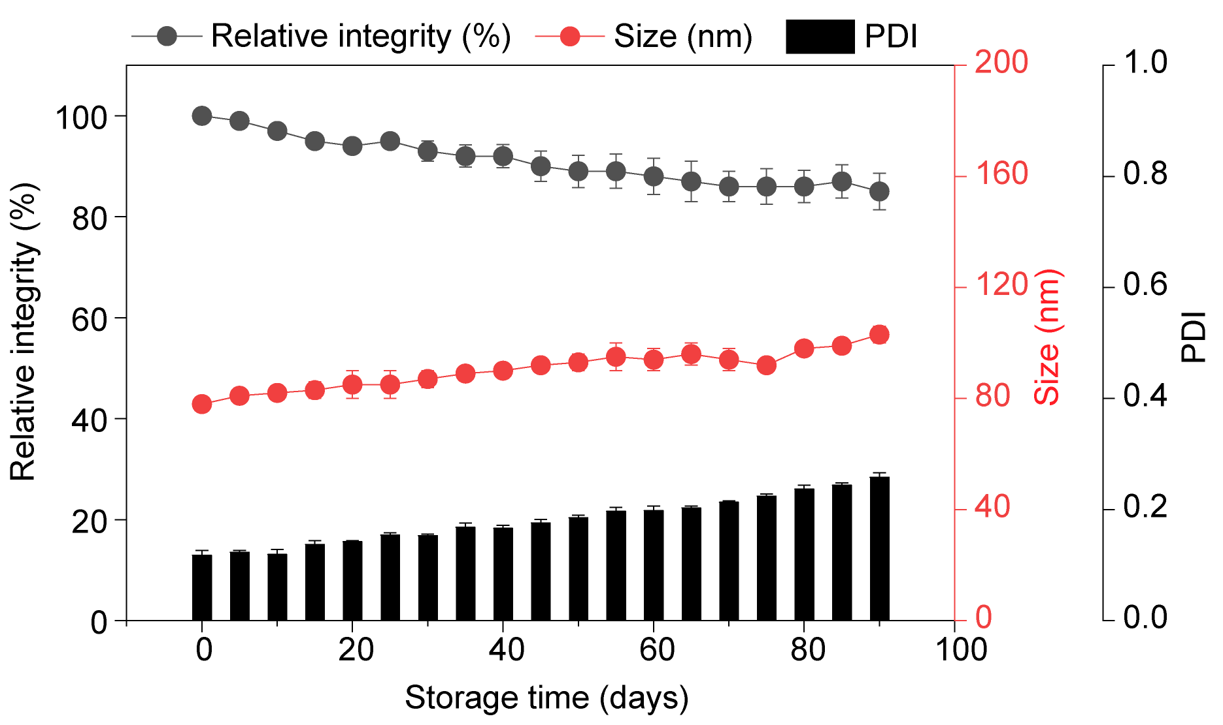
Figure S1. Long-term storage stability of conventional mRNA-LNPs at -80 ℃ storage conditions.
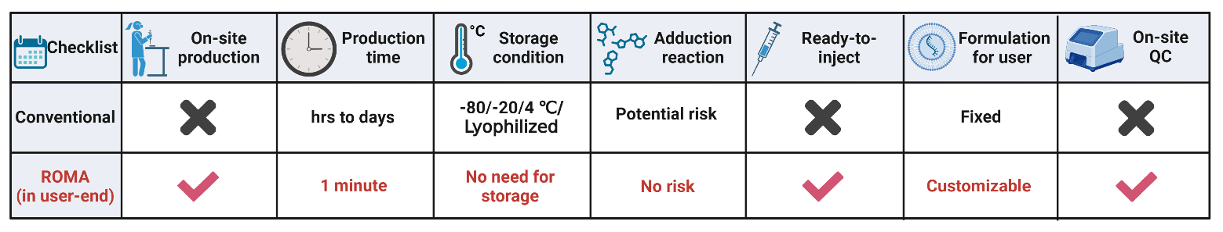
Figure S2. Head-to-head comparison of conventional and ROMA mRNA vaccines
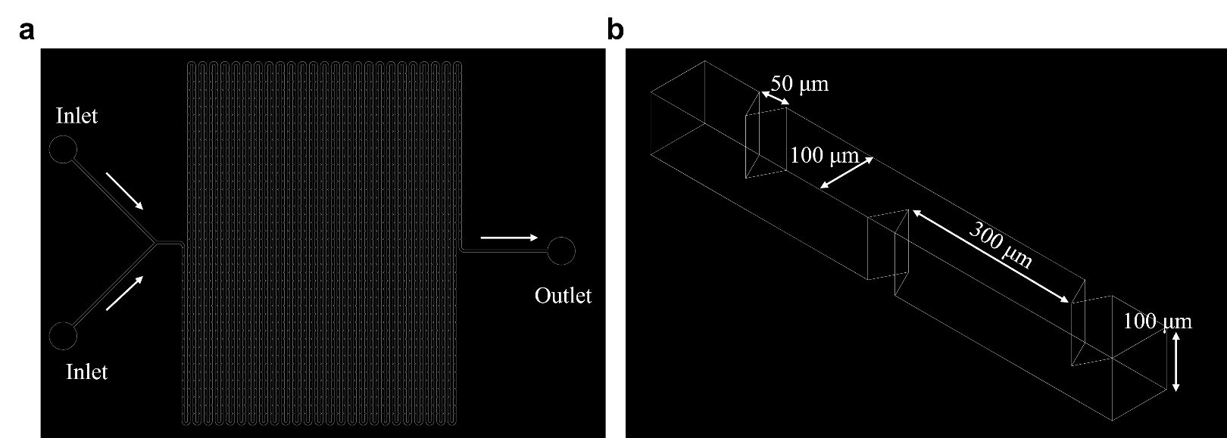
Figure S3. (a) AutoCAD design of a ROMA microfluidic chip with 2000 obstacle pairs. (b) The triangle obstacles were periodically arranged on both sides of a serpentine mixing channel, asymmetrically.
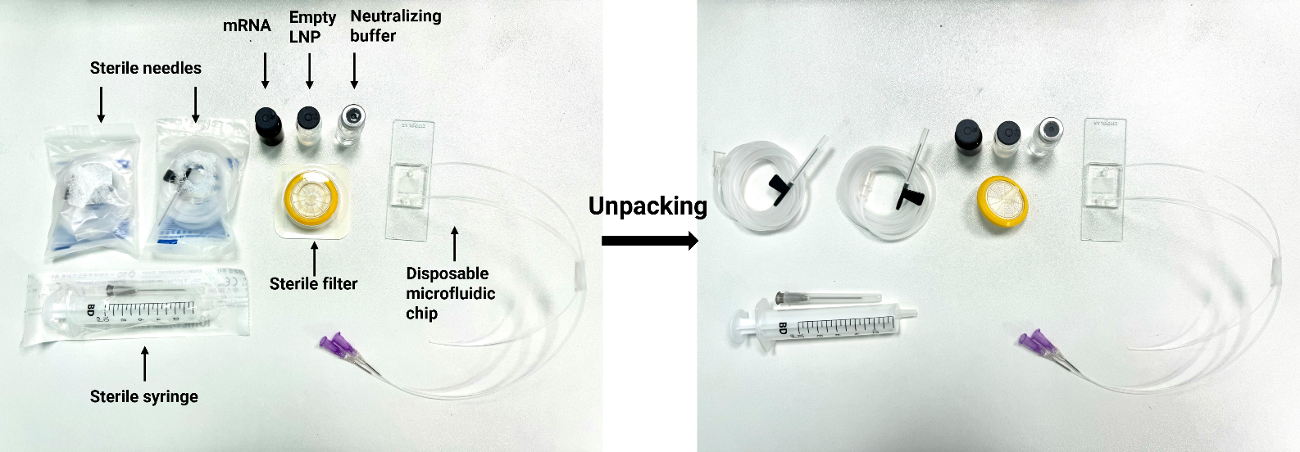
Figure S4. Raw materials and disposable consumables in a ROMA reaction package.

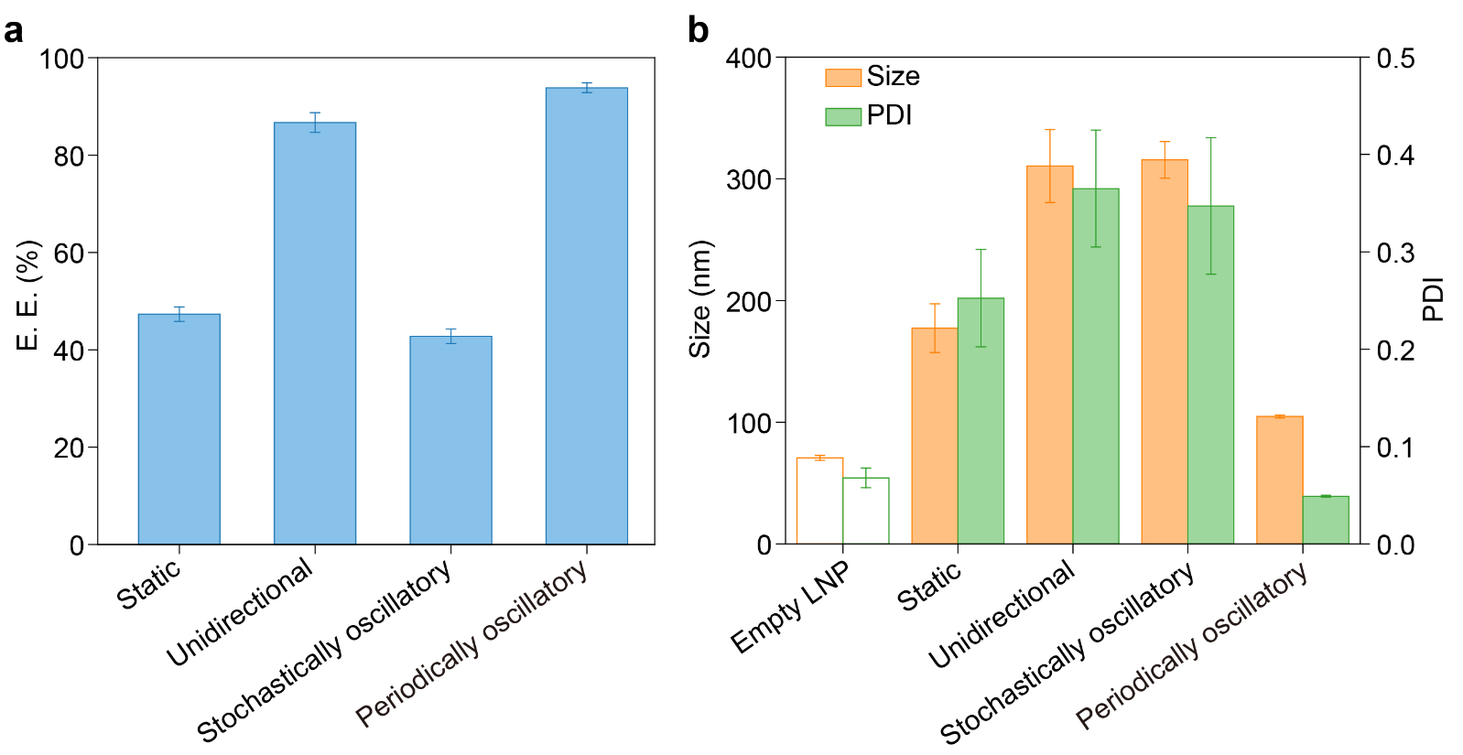
Figure S5. (a) E.E. and (b) Size and PDI of mRNA-LNPs generated under static, unidirectional, and stochastically oscillatory flow conditions.
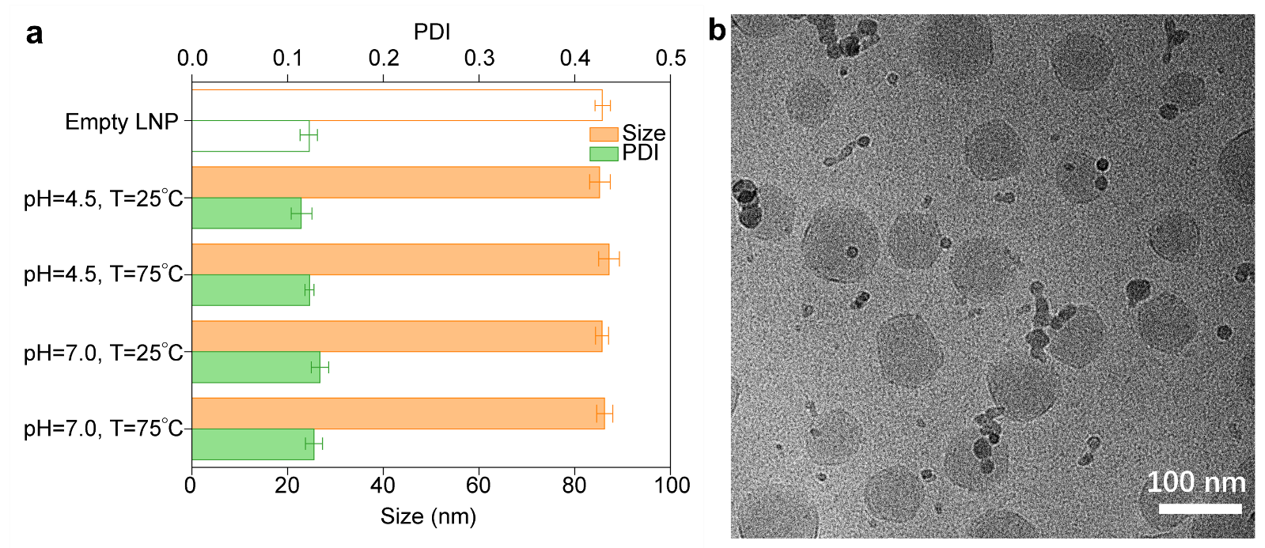
Figure S6. (a) Sizes and PDI of empty LNPs before and after running through a ROMA microfluidic chip at a flow rate of 0.05 mL/min under different treatments. (b) Cryo-TEM images shows that empty LNPs after ROMA encapsulation maintain individual structures without fusion or aggregation.

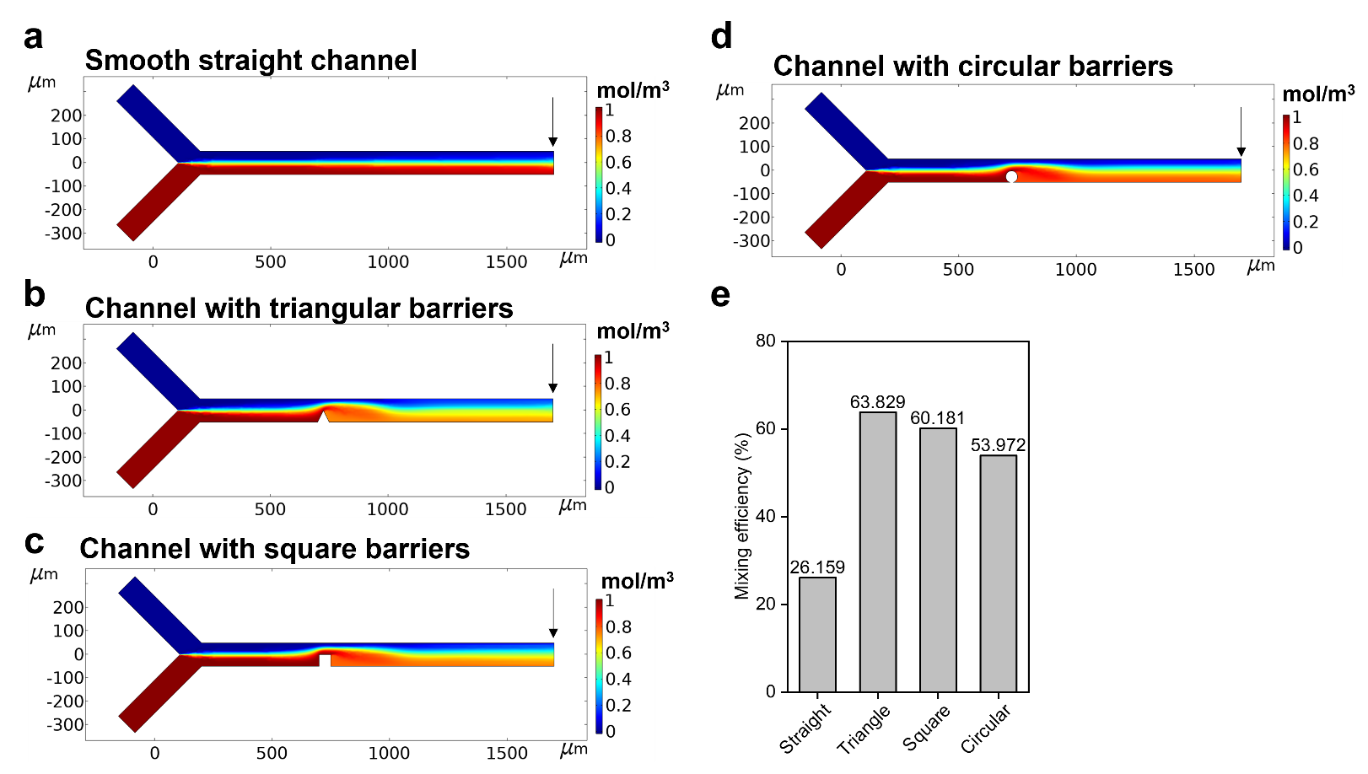
Figure S7. Influence of obstacles of different geometry on mixing efficiency. Results are obtained at a distance of 1000 μm after fluids passing the obstacle, where is pointed out by arrows. (a) Mixing efficiency of smooth straight channel. (b) Mixing efficiency of equilateral triangular obstacle with a side length of 50 μm. (c) Mixing efficiency of square obstacle with a side length of 50 μm. (d) Mixing efficiency of circular obstacle with a side length of 50 μm. (e) Comparison of mixing efficiency of different obstacles. Reynolds number = 100.
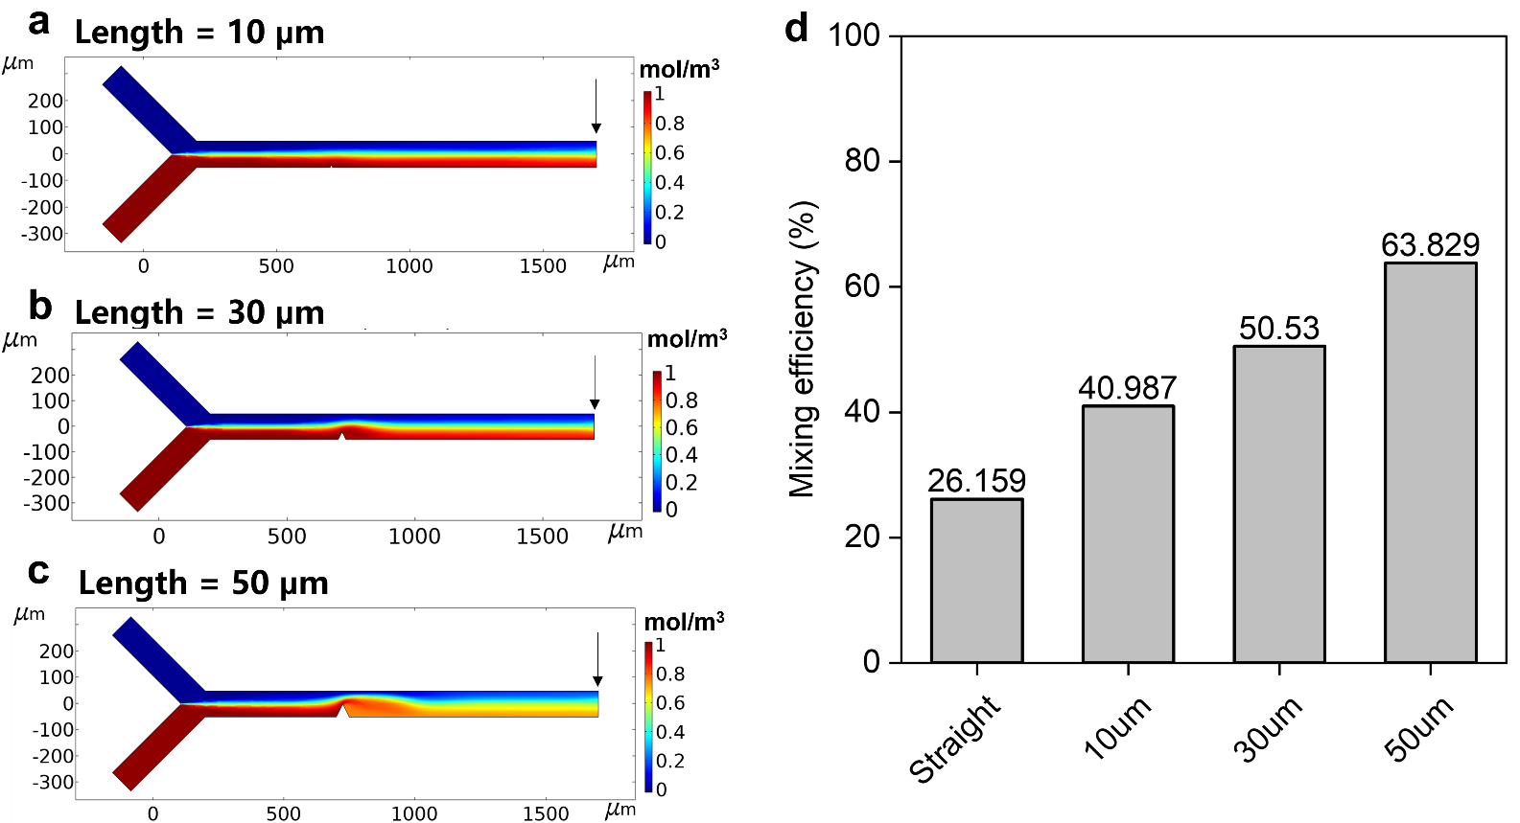
Figure S8. Influence of side length of equilateral triangular obstacle on mixing efficiency. Results are obtained at a distance of 1000 μm after fluids passing the obstacle, where is pointed out by arrows. (a) Mixing efficiency of equilateral triangular obstacle with a 10 μm side length. (b) Mixing efficiency of equilateral triangular obstacle with a 30 μm side length. (c) Mixing efficiency of equilateral triangular obstacle with a 50 μm side length. (d) Comparison of mixing efficiency of equilateral triangular obstacles with different side lengths. Reynolds number = 100.
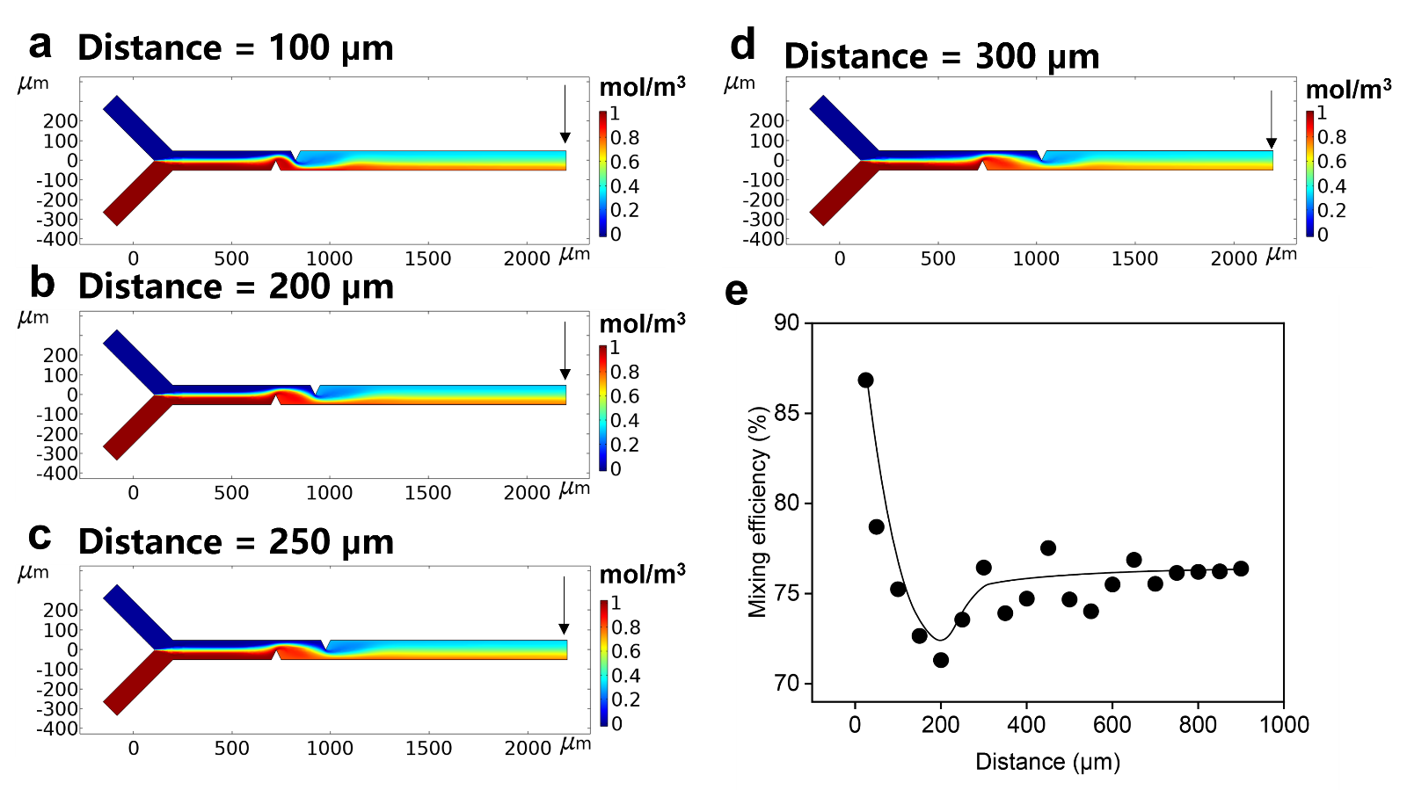
Figure S9. Influence of different interval distances between obstacles on mixing efficiency. Results are obtained at a distance of 1000 μm after fluids passing the last obstacle, where is pointed out by arrows. (a) Mixing efficiency of interval distance = 100 μm. (b) Mixing efficiency of interval distance = 200 μm. (c) Mixing efficiency of interval distance = 250 μm. (d) Mixing efficiency of interval distance = 300 μm. (e) Fitting curve of mixing efficiency of different interval distances. Reynolds number = 100.
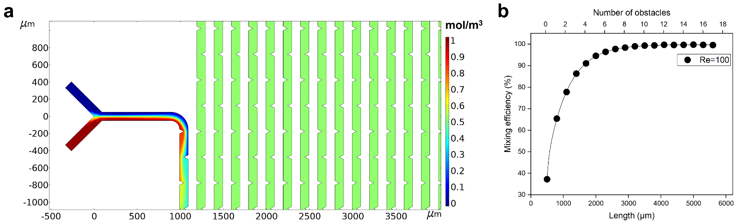
Figure S10. Influence of number of obstacles on mixing efficiency. Results are obtained at a distance of 1000 μm after fluids passing the last obstacle. (a) Simulation of two fluids mixing in a long microfluidic channel of 1000 obstacles. (b) Relationship between mixing efficiency and number of obstacles. Reynolds number = 100.
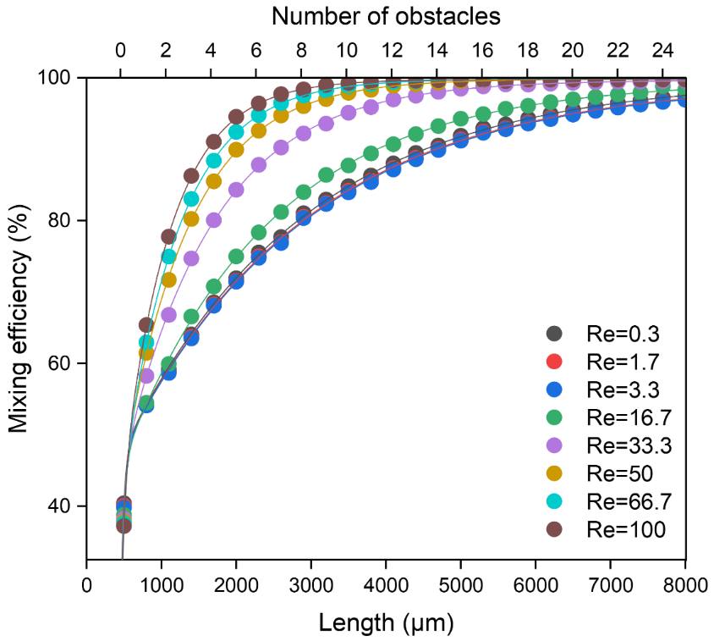
Figure S11. Influence of Reynolds number on the relationship between mixing efficiency and number of obstacles. Results are obtained at a distance of 1000 μm after fluids passing the last obstacle. 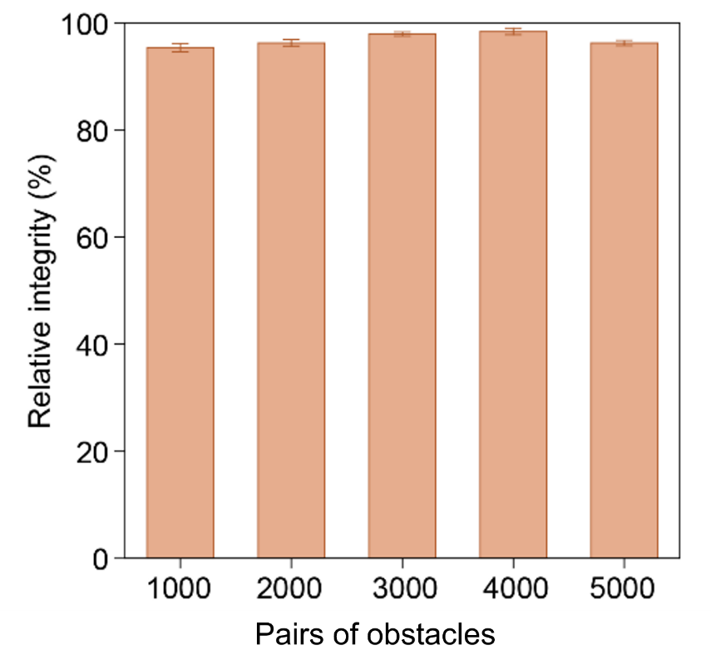
Figure S12. Relationship of relative mRNA intergrity (after/before running through the chip*100%) and numbers of obstacles.
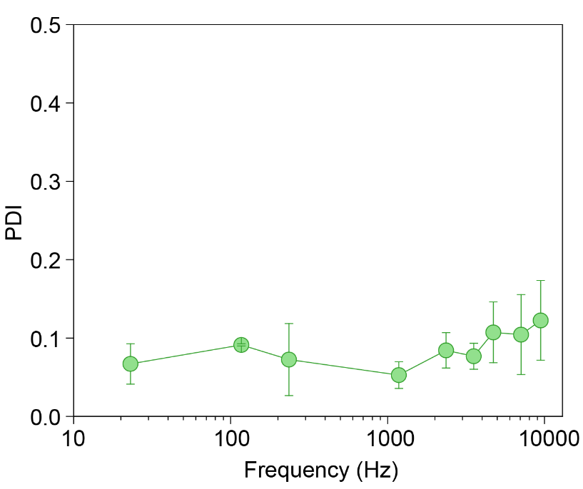
Figure S13. Relationship of polydispersity (PDI) of mRNA-LNPs and fluid frequency ($f$).
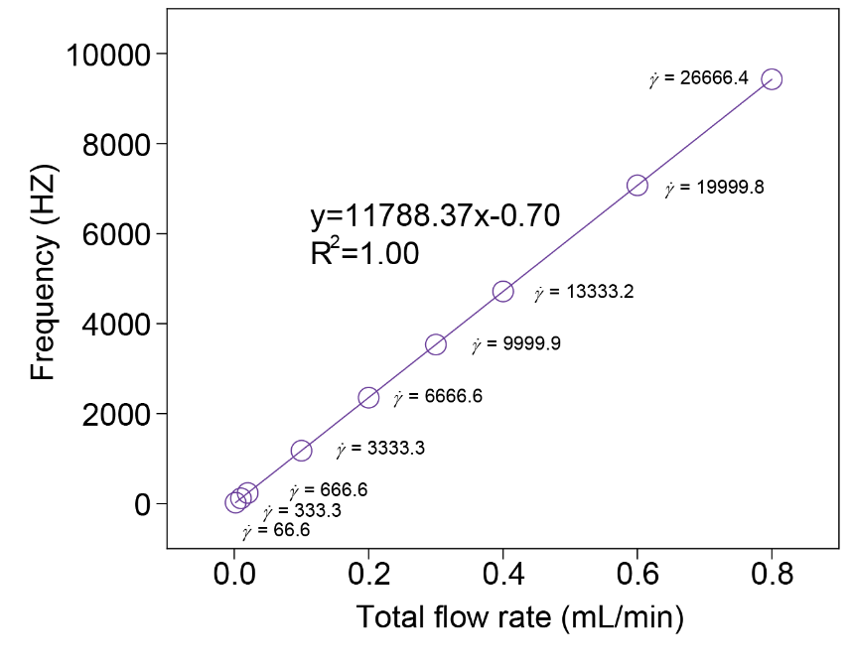
Figure S14. Relationship of total flow rate (mRNA solution + Empty LNP solution), fluid frequency ($f$), and shearing force ($\dot{γ}$).
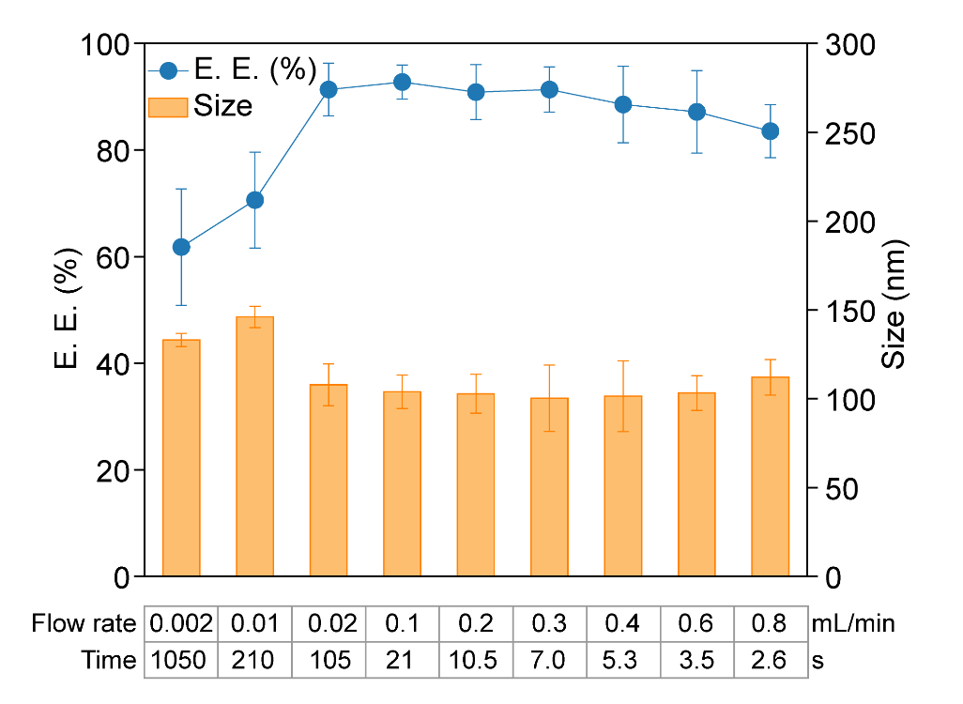
Figure S15. Relationship of total flow rate (mRNA solution + Empty LNP solution), mRNA travelling time inside the microfluidic channel, E.E., and resulting mRNA-LNP size.

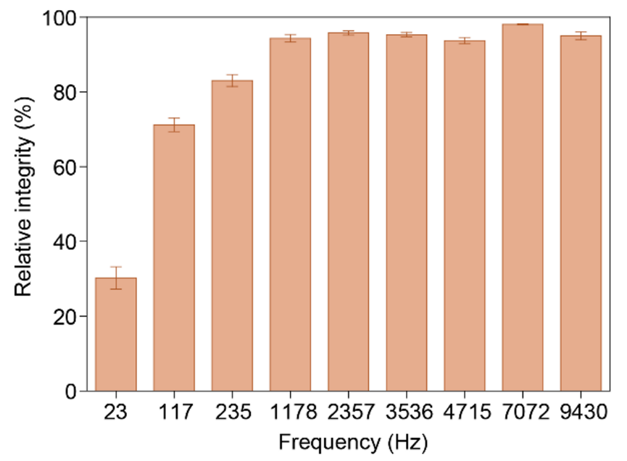
Figure S16. Relationship of relative mRNA intergrity (after/before encapsulation*100%) and fluid frequency ($f$).
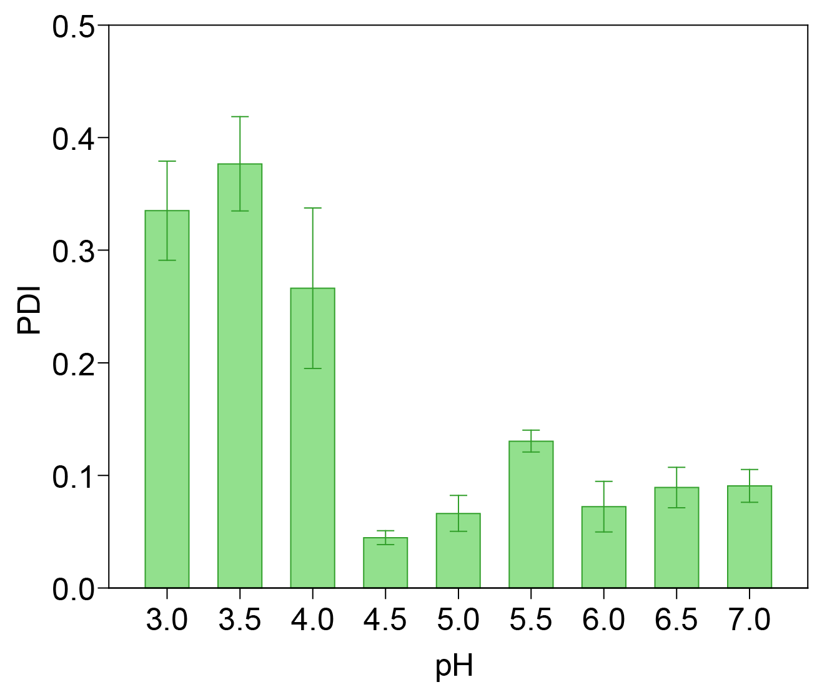
Figure S17. Relationship of polydispersity (PDI) of mRNA-LNPs and pH.
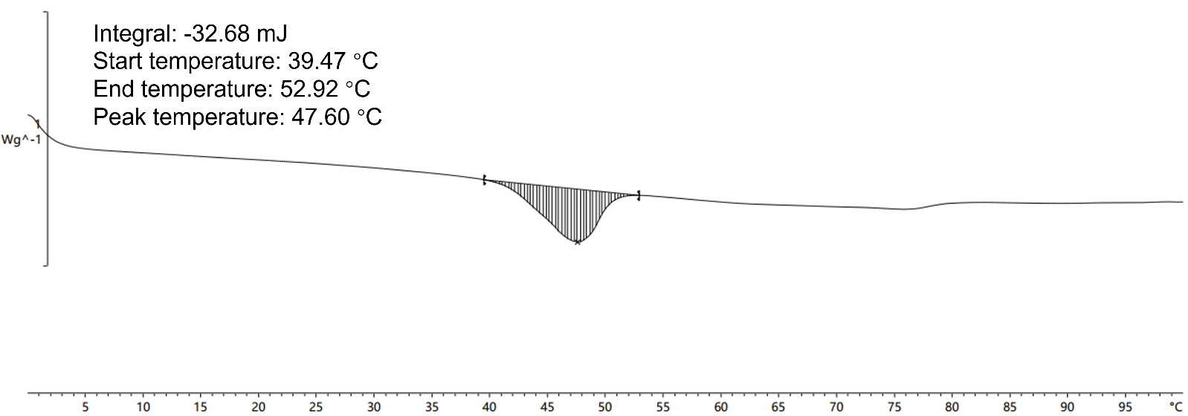
Figure S18. DSC results reveal that temperature-induced phase transition of empty LNPs occurs between 39.47 °C to 52.92 °C.
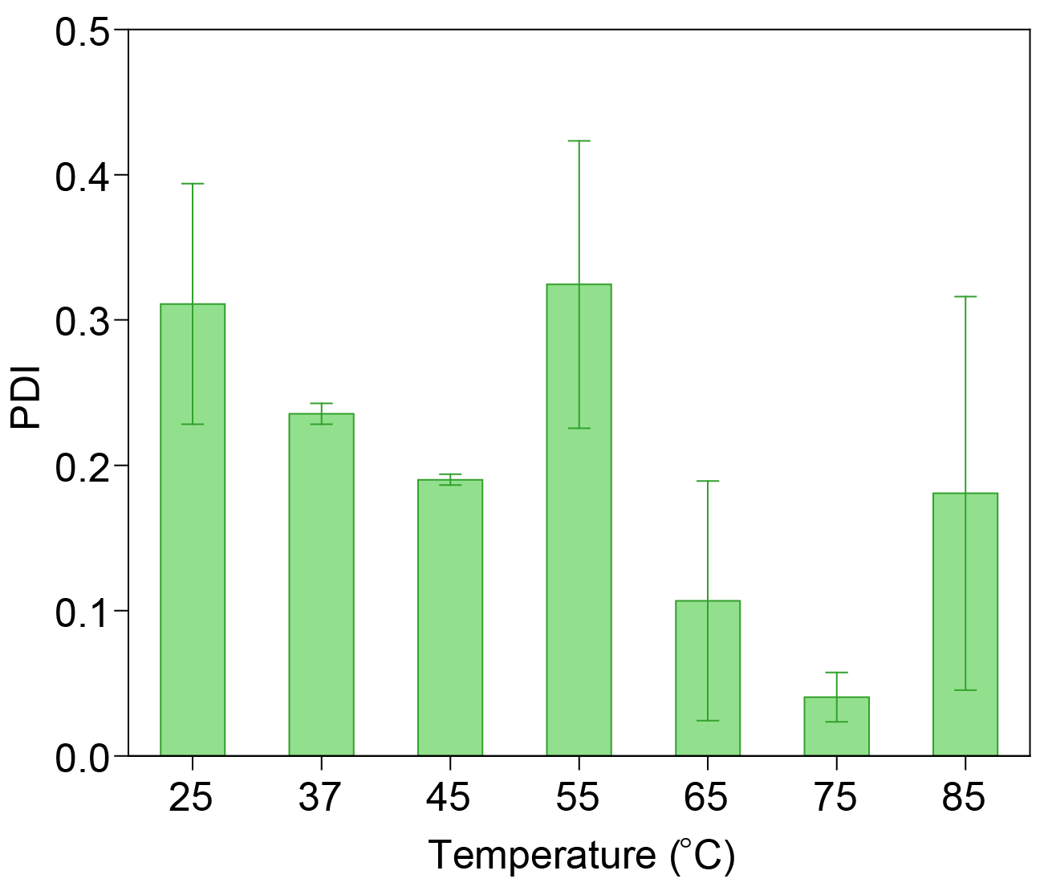
Figure S19. Relationship of polydispersity (PDI) of mRNA-LNPs and temperature.

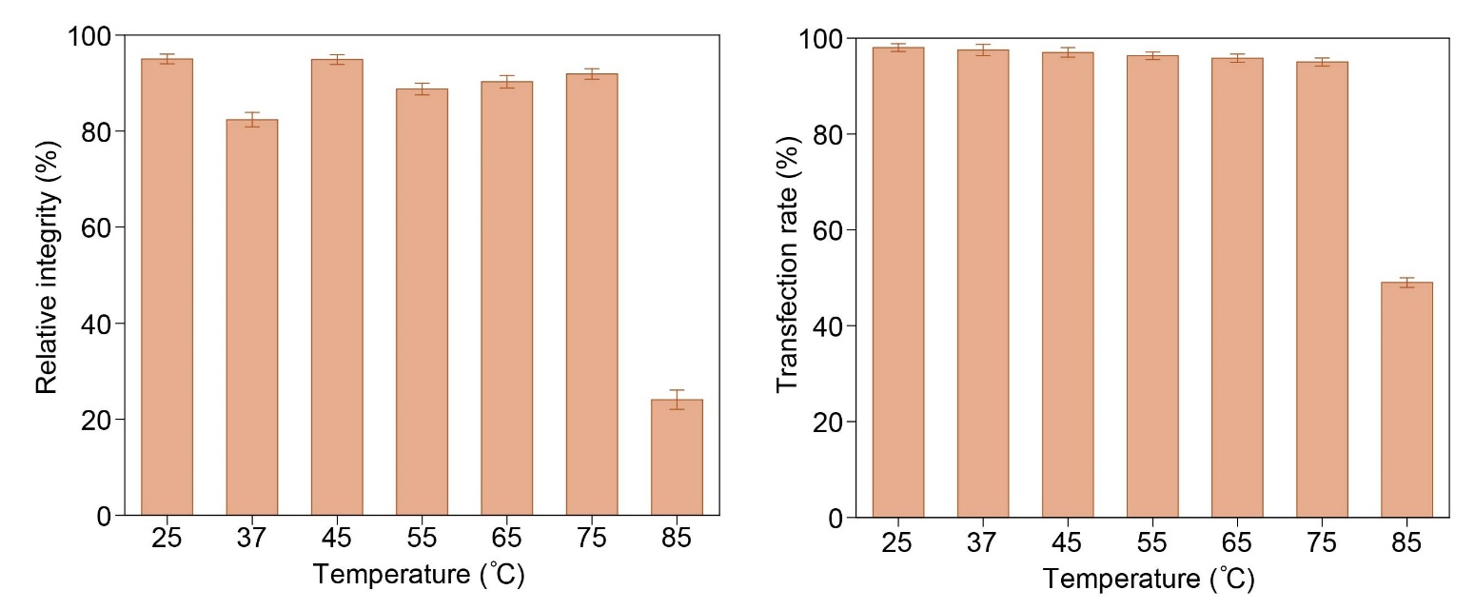
Figure S20. Relationship of relative mRNA intergrity (after/before encapsulation*100%) and in vitro transfection rate (%) and temperature.
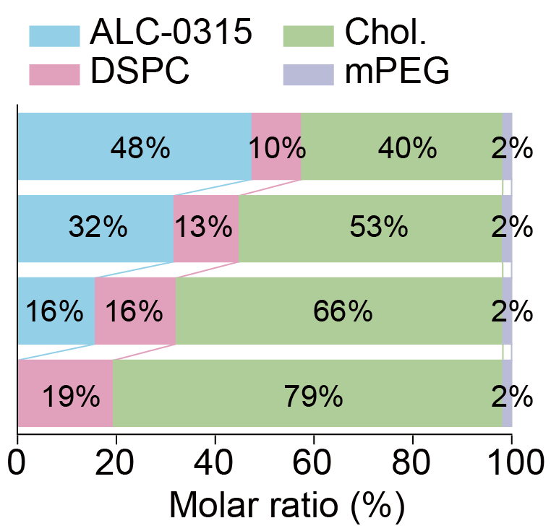
Figure S21. Formulation of empty LNPs of different molar ratios of ionizable lipid.
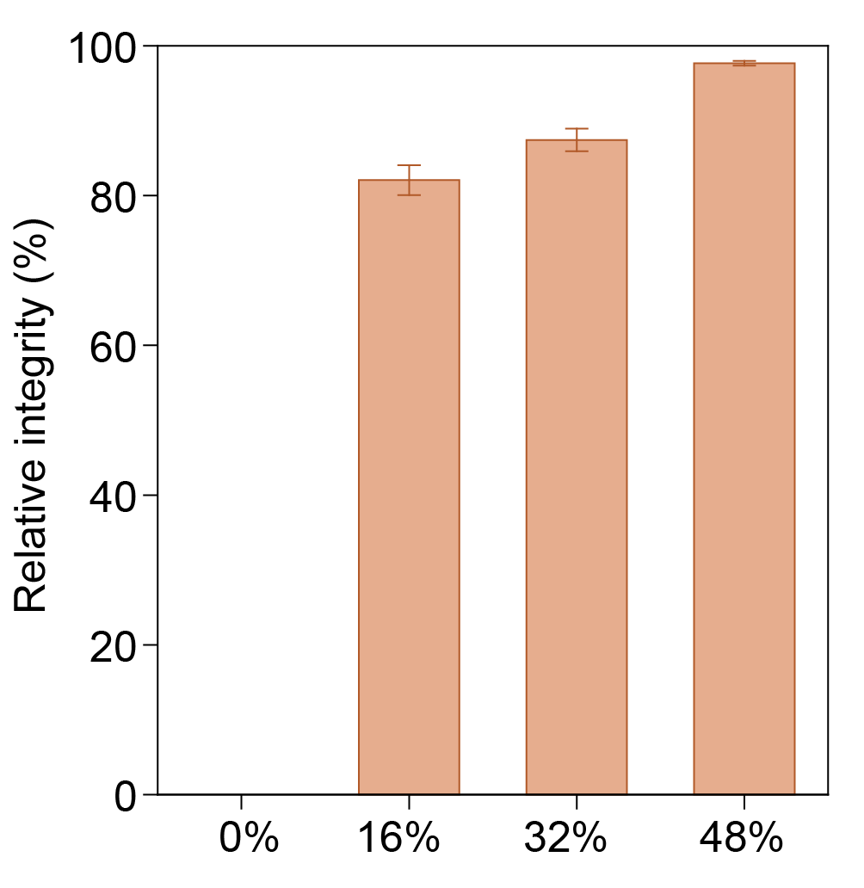
Figure S22. Relationship of relative mRNA intergrity (after/before encapsulation*100%) and molar ratio of ionizable lipid.

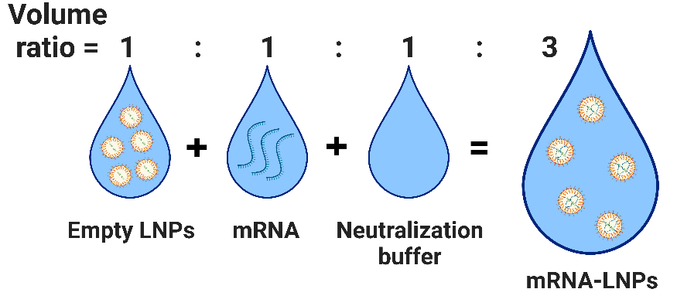
Figure S23. Illustration of volume changes of LNP solution during the encapsualtion.
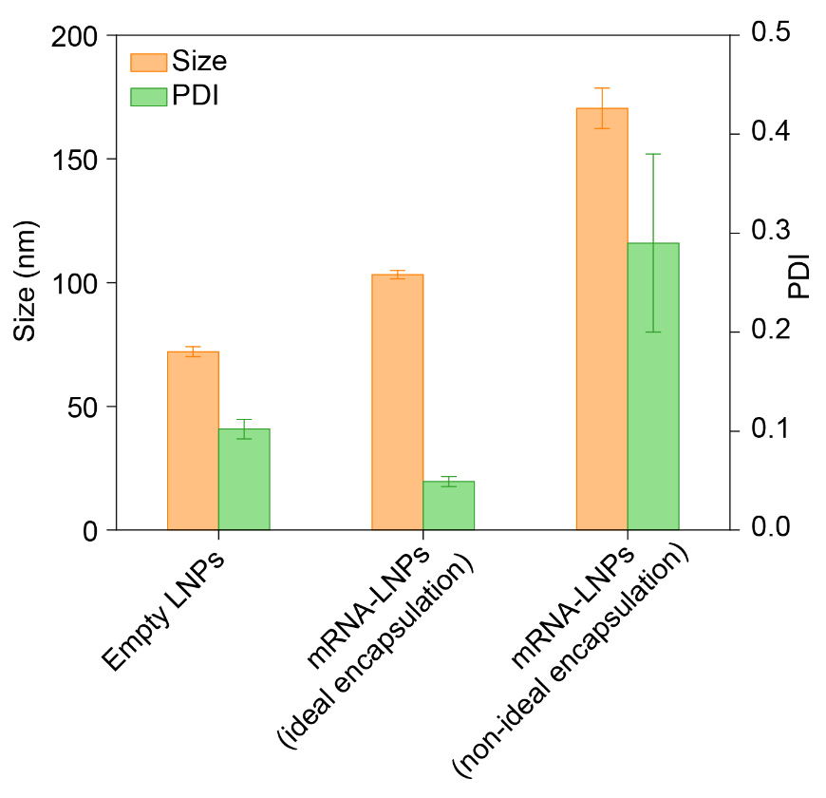
Figure S24. PDI of empty LNPs, ROMA and conventional mRNA-LNPs.
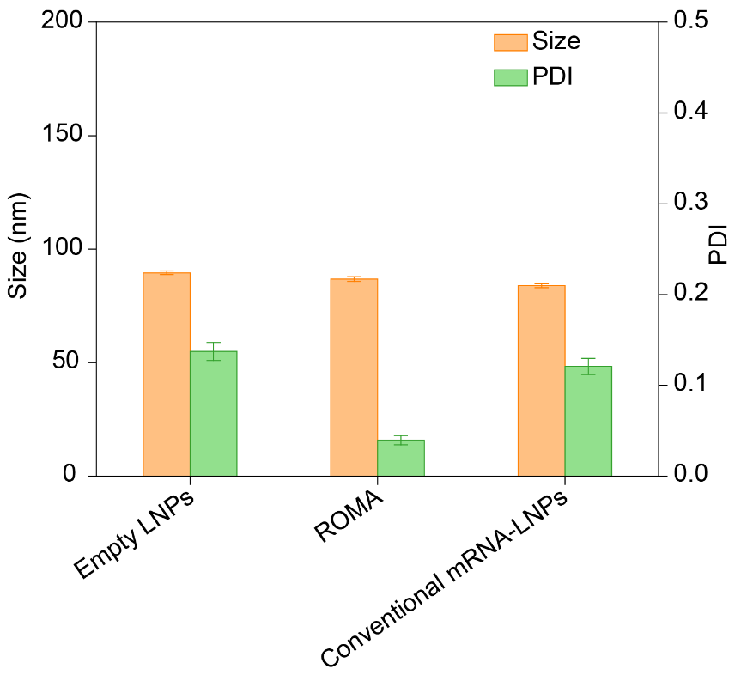
Figure S25. Size and PDI of empty LNPs, ROMA and conventional mRNA-LNPs prepared for SAXS measurement.

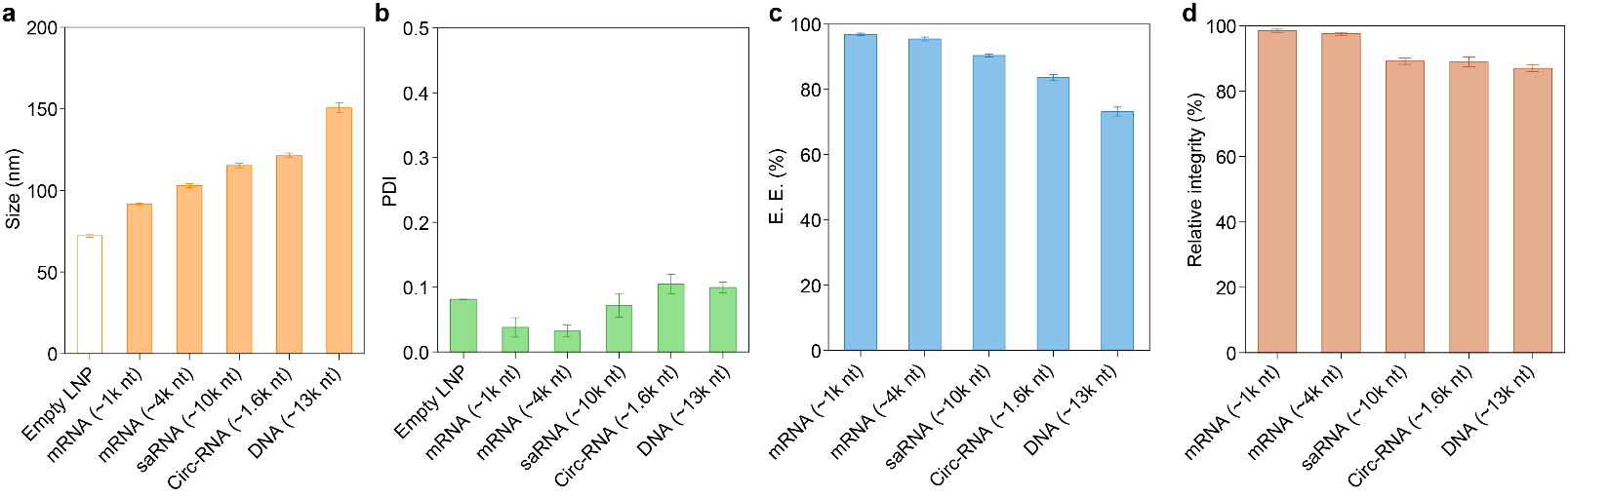
Figure S26. (a) Size, (b) PDI, (c) E.E., (d) Relative nuclei acid intergrity (after/before encapsulation*100%) of ROMA mRNA-LNPs encapsulating different nuclei acids.
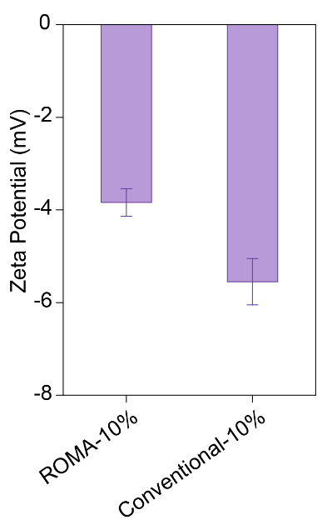
Figure S27. ROMA and conventional mRNA-LNPs show similar Zeta-potential. Both ROMA and conventional mRNA-LNPs contains 10% mass ratio (mRNA/Empty LNP) of SARS-CoV-2 Omicron BA.1 spike mRNA.
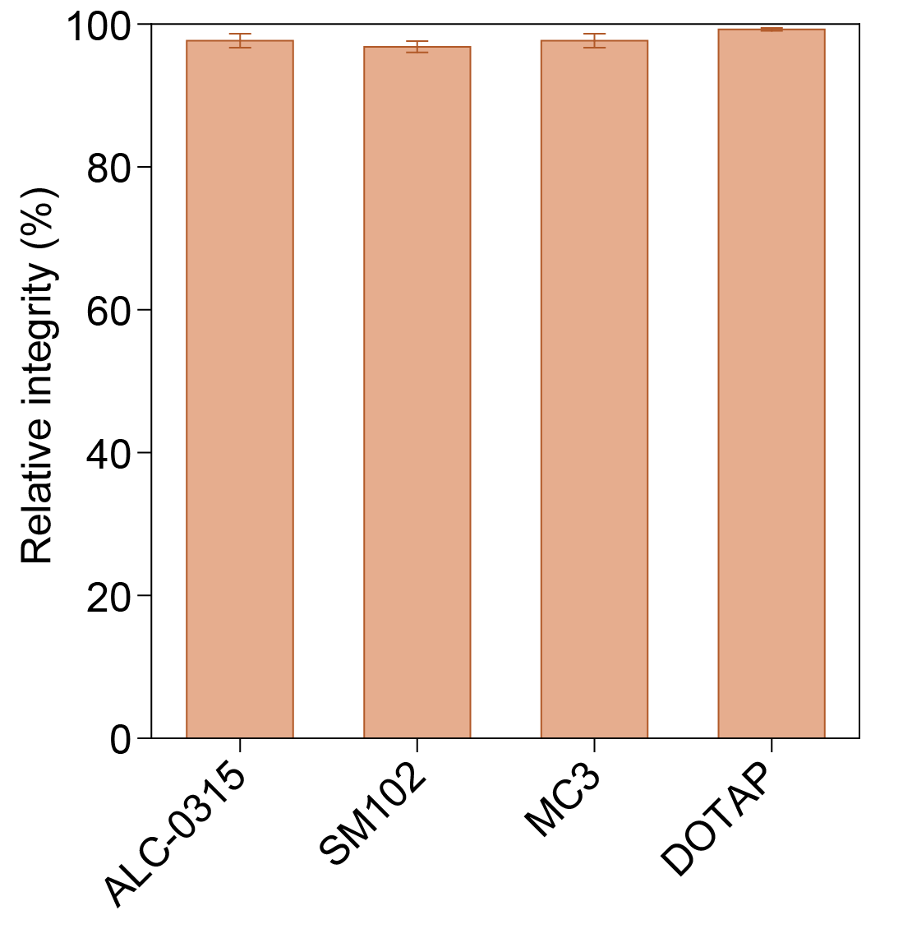
Figure S28. Relative mRNA intergrity (after/before encapsulation*100%) of mRNA-LNPs of different ionizable/cationic lipids formulations. NC stands for no cationic lipids.
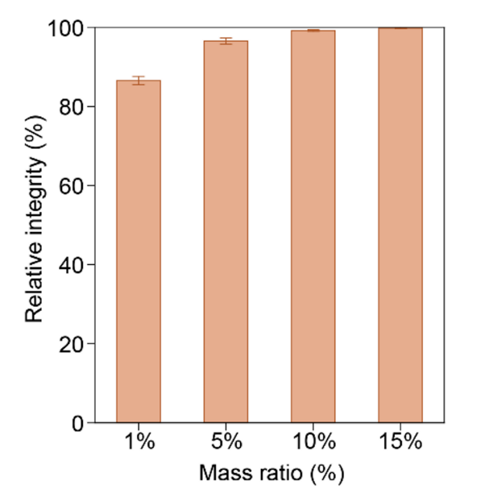
Figure S29. Relative mRNA intergrity (after/before encapsulation*100%) of different mRNA inputs.
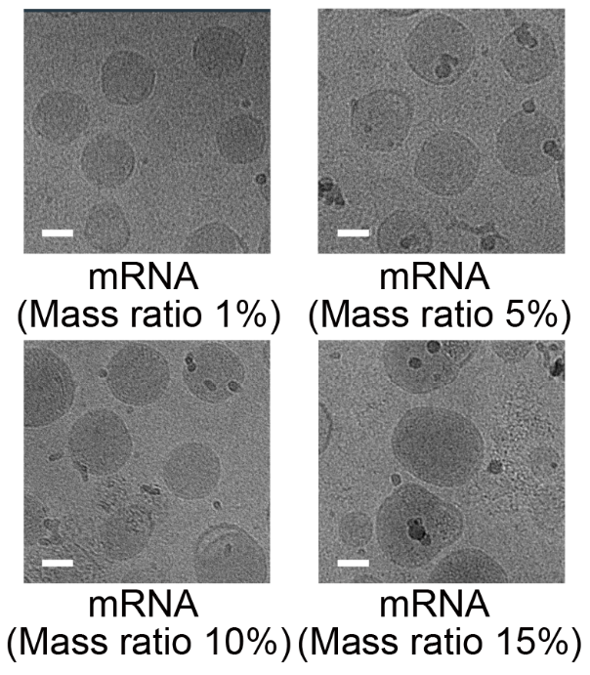
Figure S30. Cryo-TEM images of ROMA mRNA-LNPs formed of different mRNA inputs.
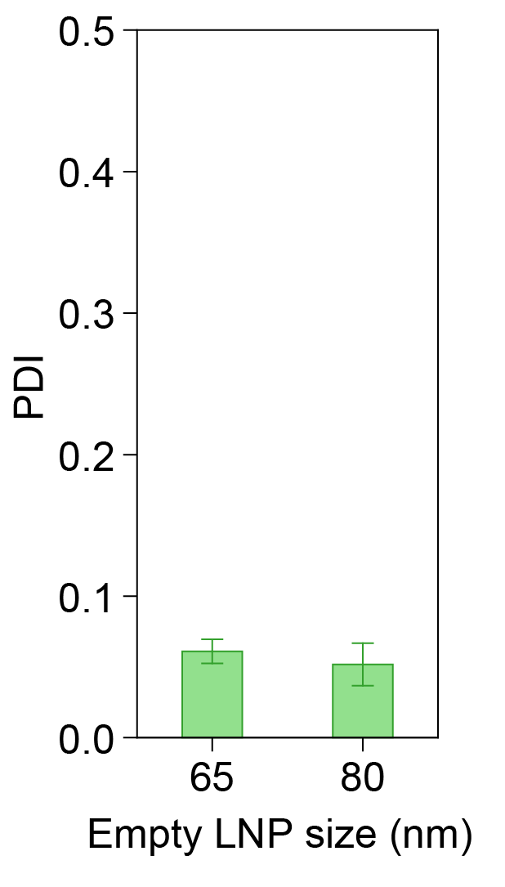
Figure S31. Polydispersity (PDI) of ROMA mRNA-LNPs formed of different initial empty LNP sizes.

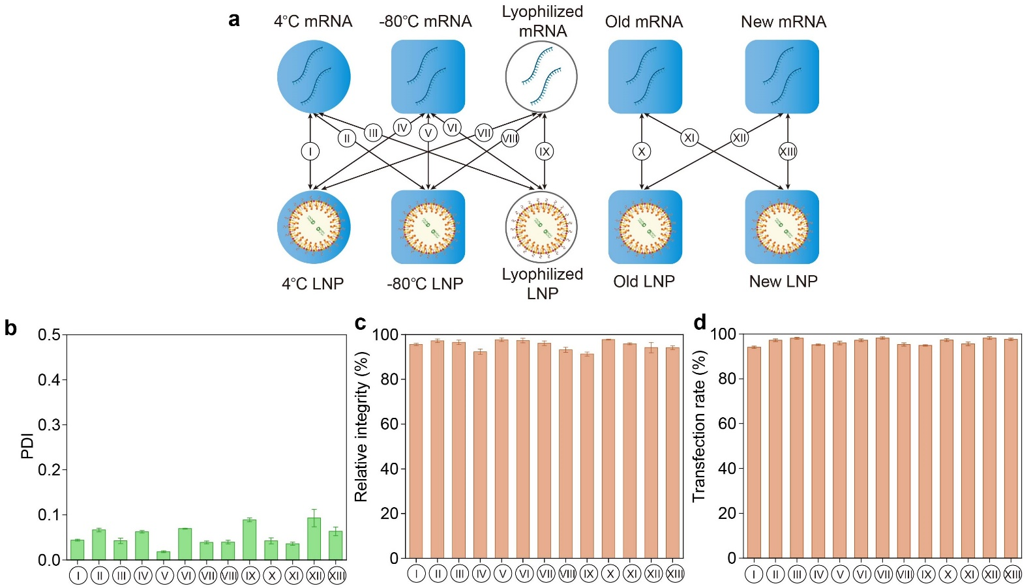
Figure S32. ROMA mRNA-LNPs generated from (a) thirteen different raw material storage status and their corresponding (b) Polydispersity (PDI), (c) Relative mRNA intergrity (after/before encapsulation*100%), and (d) In vitro cell transfection rate. Ⅰ) 4 ℃ stored mRNA × 4 ℃ stored LNP, II) 4 ℃ stored mRNA × RT stored LNP, III) 4 ℃ stored mRNA × RT-lyophilized LNP, IV) RT stored mRNA × 4 ℃ stored LNP, V) RT stored mRNA × RT stored LNP, VI) RT stored mRNA × Lrt-yophilized LNP, VII) rt-lyophilized mRNA × 4 ℃ stored LNP, Ⅷ) rt-lyophilized mRNA × RT stored LNP, IX) RT-lyophilized mRNA × RT-lyophilized LNP, X) old mRNA (-80 ℃ stored) × old LNP (-80 ℃ stored), XI) old mRNA (-80 ℃ stored) × new LNP, XII) new mRNA × old LNP (-80 ℃ stored), and XIII) new mRNA × new LNP. The raw materials in combinations I) to IX) are stored for 180 days and the old raw materials in combinations X) to XII) are stored for one year.
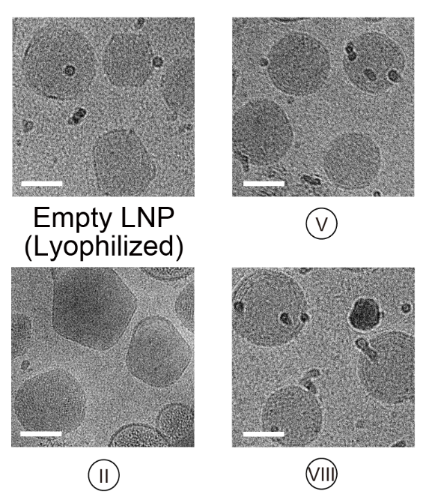
Figure S33. Representative Cryo-TEM images of ROMA mRNA-LNPs generated from different raw material combinations.
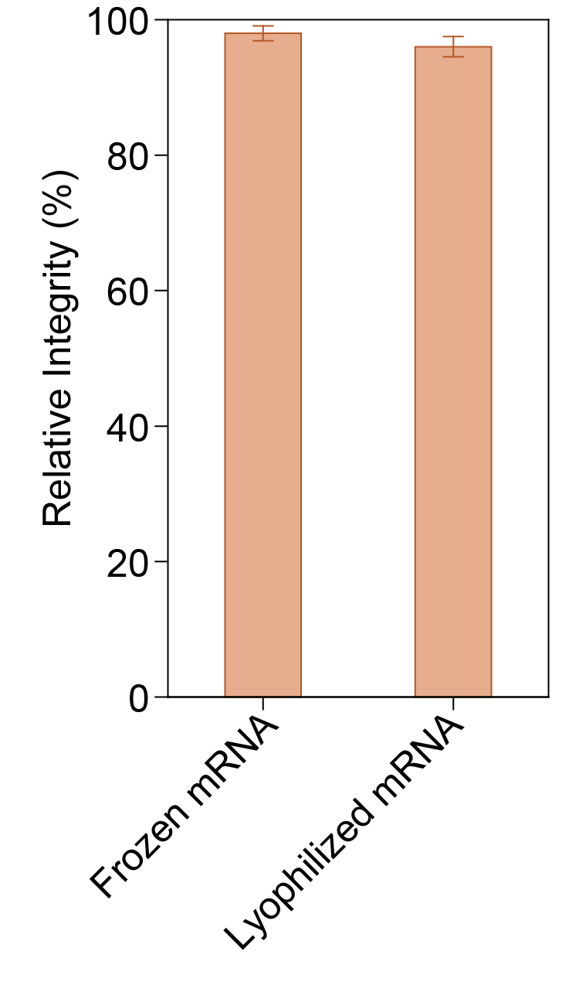
Figure S34. Relative mRNA intergrity (after/before process*100%) of Omicron BA.1 spike mRNA stored under different conditions.

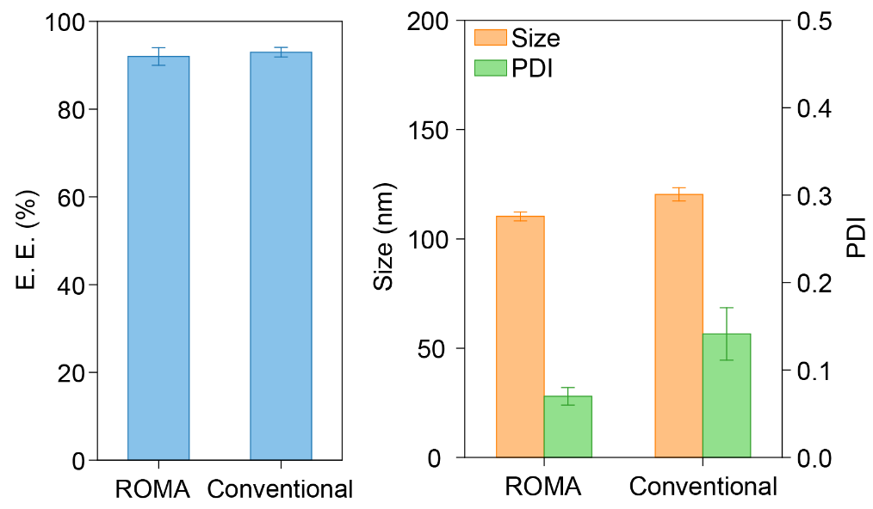
Figure S35. E.E., size, and PDI of ROMA and conventional mRNA-LNPs used in in vivo biodistribution experiments.
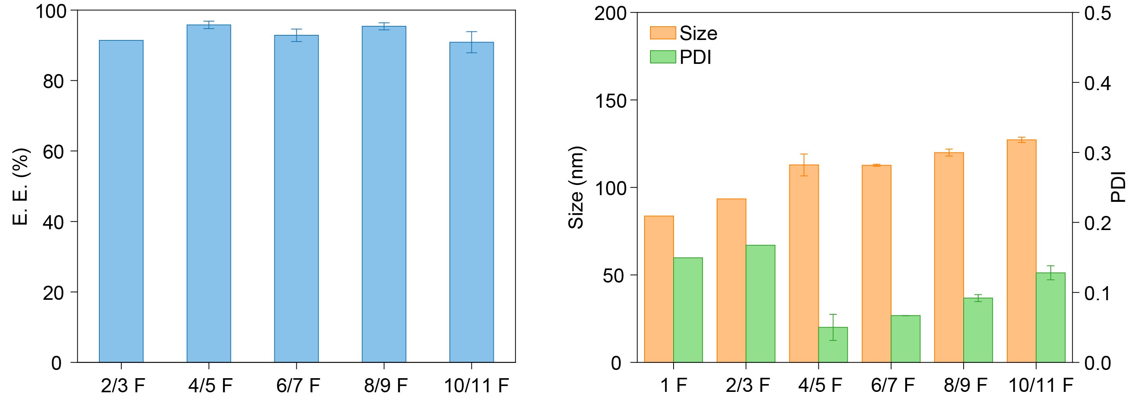
Figure S36. E.E., size, and PDI of ROMA and conventional mRNA-LNPs used in SARS-CoV-2 vaccination experiments.

Table S1. Lists of materials used in linearization of template plasmid DNA.
Materials | Concentration | Volume (μL)
Plasmid DNA | 200 ng/μL | 272.7
BspQ I（10 U/μL） | 5 U/μg，1 U/μL | 150
10 × Digestion Buffer I | 1× | 150
Nuclease-Free H2O | N/A | 927.3

Table S2. Lists of materials used in IVT of mRNA.
Materials | Concentration | Volume (μL)
Nuclease-Free H₂O | N/A | 840
10 × Transcription Buffer | 1× | 600
CAP GAU | 6 mM | 360
ATP Solution (100 mM) | 7.5 mM | 450
GTP Solution (100 mM) | 7.5 mM | 450
UTP Solution (100 mM) | 7.5 mM | 450
CTP Solution (100 mM) | 7.5 mM | 450
Pyrophosphatase, Inorganic  (Yeast，0.1 U/μL) | 0.0025 U/μL | 150
Murine RNase inhibitor (40 U/μl) | 1 U/μL | 150
T7 RNA Polymerase (200 U/μL) | 20 U/μL | 600
Unpurified linearization plasmid | 50 ng/μL | 1500

Table S3. Lists of materials used in IVT of cRNA.
Materials | Vendor | Catalog No.
4xIVT reaction buffer | Hongene | NA
ATP,200mM | Hongene | R1-051
GTP,200mM | Hongene | R2-057
CTP,200mM | Hongene | R3-056
UTP,200mM | Hongene | R5-065
IPPA,200mM | Hongene | ON-025
T7 RNA polymerase,200U/ul | Hongene | ON-004
DNase I(1U/ul) | Hongene | ON109
LiCl | Sigma | L7026

Table S4. Serial dilution of standard RNA sample.
Sample ID | Ribosomal RNA sample (μL) | 1× TE buffer (μL) | Concentration (ng/μL)
1 | 30 | 270 | 10
2 | 150 | 150 | 5
3 | 150 | 150 | 2.5
4 | 150 | 150 | 1.25
5 | 150 | 150 | 0.635
6 | 150 | 150 | 0.3125
7 | 150 | 150 | 0.156
8 | 150 | 150 | 0.078

Table S5. Group and dose scheme of IVIS experiments.
Group | Number | Dose (μg in μL) | Administration | Abnormal reports
1F | 3 | 5 μg in 100 μL | i.v. Day 0 | No
2F | 3 | 5 μg in 100 μL | i.v. Day 0 | No
3F | 3 | 5 μg in 100 μL | i.m. Day 0 | No
4F | 3 | 5 μg in 100 μL | i.m. Day 0 | No

Video S1. User interface and temperature regulator.
This movie shows the display of user interface and automatic heating function of ROMA prototype upon startup.

Video S2. UV disinfection.
The ROMA prototype has a UV disinfection LED to sterilize internal space..

Video S3. Control panel of ROMA encapsulation.
This video shows that users can conveniently set speed, volume, UV exposure time, and languages for ROMA encapsulation.

Video S4. Flexible movement of sample lifting platforms.
Both mRNA and empty LNPs samples can be easily loaded and unloaded by the control of lifting platforms.

Video S5. Collection of ROMA mRNA-LNPs.
The mRNA-LNP mixture flows through a sterile filter (0.22 µm) to a collection syringe pre-filled with neutralizing buffer. This ROMA vaccine can be used immediately after collection as a neutral, sterile, organic solvent-free agent.

Video S6. Characterization of a successful sample (ideal encapsulation) by ROMA detector.
The mRNA-LNP produced at proper pH is added to the sample pool. The green light on the ROMA detector indicates that the product is qualified.

Video S7. Characterization of a failed sample (low encapsulation) by ROMA detector.
The mRNA-LNP produced at excessively high pH is added to the sample pool. The red light on the ROMA detector indicates that the product is not qualified.

Video S8. Characterization of a failed sample (LNP aggregation) by ROMA detector.
The mRNA-LNP produced at excessively low pH is added to the sample pool. The red light on the ROMA detector indicates that the product is not qualified.

References
1. Nielsen, S. S. et al. BioXTAS RAW, a software program for high-throughput automated small-angle X-ray scattering data reduction and preliminary analysis. J Appl Crystallogr 42, 959–964 (2009).
2. Petoukhov, M. V et al. New developments in the ATSAS program package for small-angle scattering data analysis. J Appl Crystallogr 45, 342–350 (2012).

