Soil Respiration Response to Experimental Warming in a Temperate Harwood Forest Varies With Species Composition
Sharlène Laberge^{1,2}, Blandine Courcot^{1,2} and Nicolas Bélanger^{1,2*}
¹ Data Science Research Laboratory, Université du Québec (TELUQ), Montreal, Quebec, Canada
² Centre d’étude de la forêt, Université du Québec à Montréal, Montreal, Quebec, Canada
*Correspondence: nicolas.belanger@teluq.ca

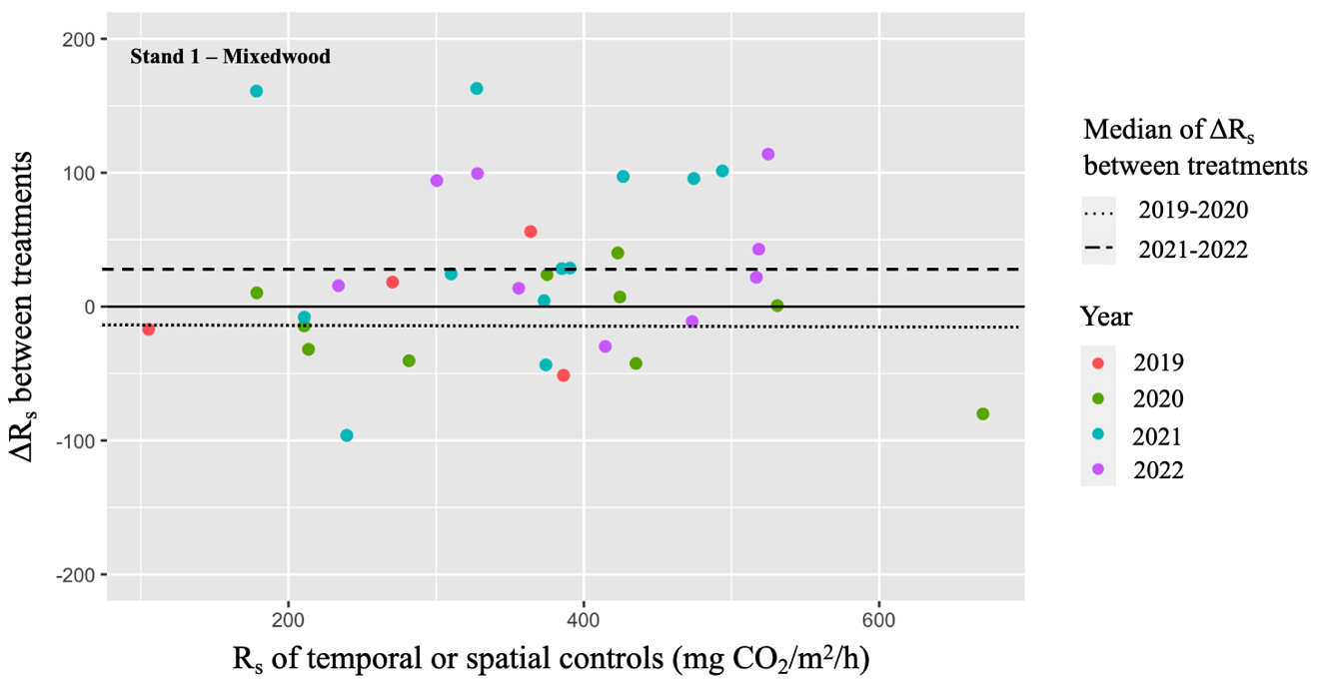
Supplementary materials
Fig. S1 Difference in soil respiration rate (R_{s}) between spatial and temporal controls (ΔR_{s}, pre-warming period in 2019 and 2020) as well as difference in R_{s} between heated plots and spatial controls (ΔR_{s}, warming period in 2021 and 2022) in stand 1, which are plotted against R_{s} of the two controls (temporal for 2019 and 2020; spatial for 2021 and 2022). The years are represented by data points of different colors, while the two dashed lines represent the median of the two sets of ΔR_{s}

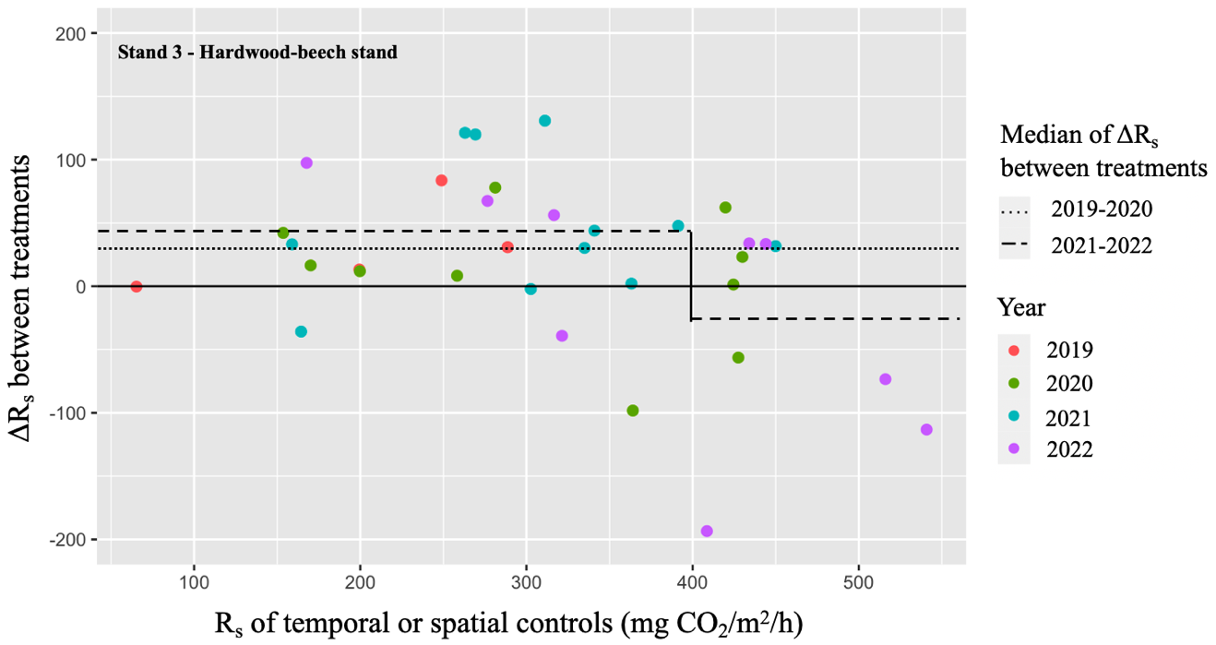
Fig. S2 Difference in soil respiration rate (R_{s}) between spatial and temporal controls (ΔR_{s}, pre-warming period in 2019 and 2020) as well as difference in R_{s} between heated plots and spatial controls (ΔR_{s}, warming period in 2021 and 2022) in stand 3, which are plotted against R_{s} of the two controls (temporal for 2019 and 2020; spatial for 2021 and 2022). The years are represented by data points of different colors, while the two dashed lines represent the median of the two sets of ΔR_{s}. The median of the 2021-2022 set is divided into two medians to highlight a breaking point in the scatter of data
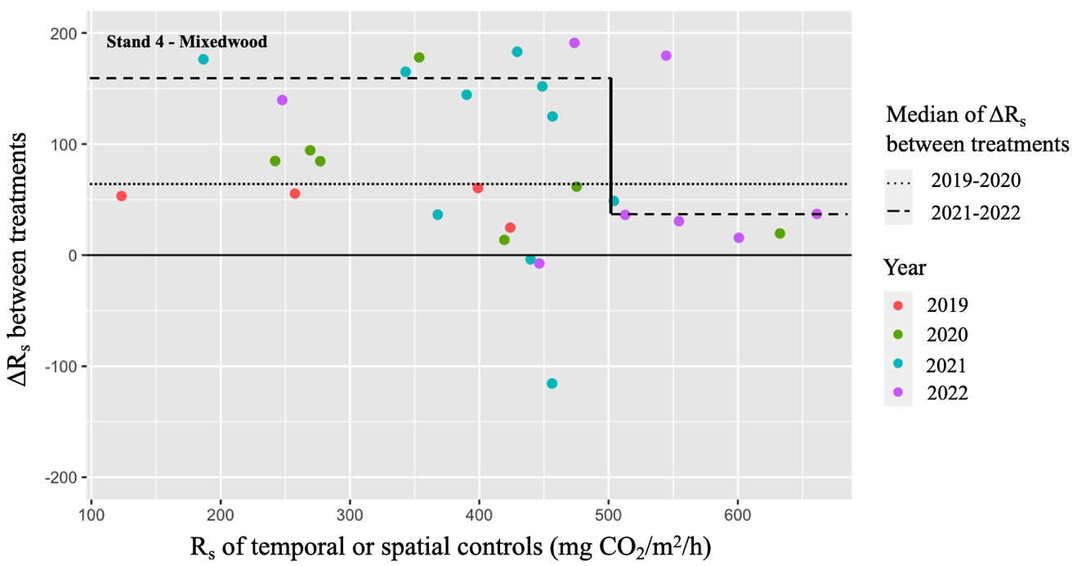
Fig. S3 Difference in soil respiration rate (R_{s}) between spatial and temporal controls (ΔR_{s}, pre-warming period in 2019 and 2020) as well as difference in R_{s} between heated plots and spatial controls (ΔR_{s}, warming period in 2021 and 2022) in stand 4, which are plotted against R_{s} of the two controls (temporal for 2019 and 2020; spatial for 2021 and 2022). The years are represented by data points of different colors, while the two dashed lines represent the median of the two sets of ΔR_{s}. The median of the 2021-2022 set is divided into two medians to highlight a breaking point in the scatter of data

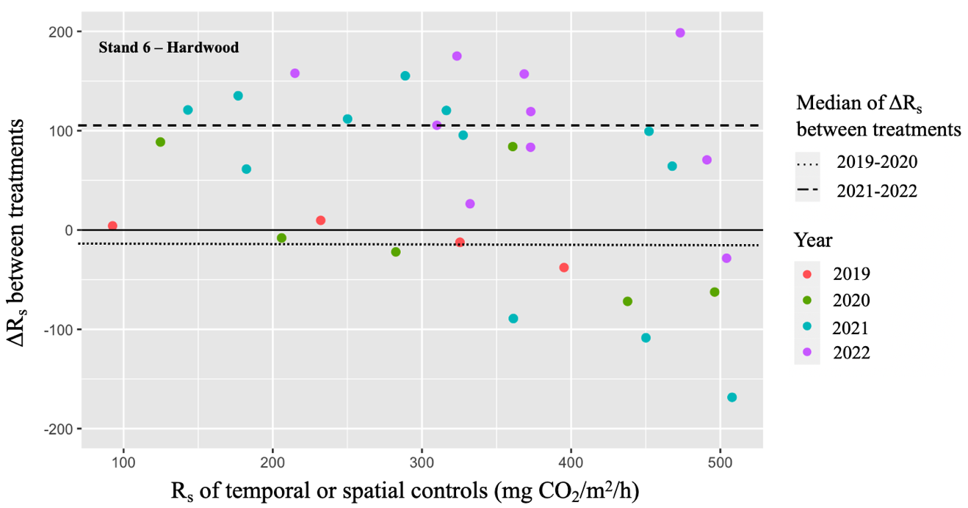
Fig. S4 Difference in soil respiration rate (R_{s}) between spatial and temporal controls (ΔR_{s}, pre-warming period in 2019 and 2020) as well as difference in R_{s} between heated plots and spatial controls (ΔR_{s}, warming period in 2021 and 2022) in stand 6, which are plotted against R_{s} of the two controls (temporal for 2019 and 2020; spatial for 2021 and 2022). The years are represented by data points of different colors, while the two dashed lines represent the median of the two sets of ΔR_{s}
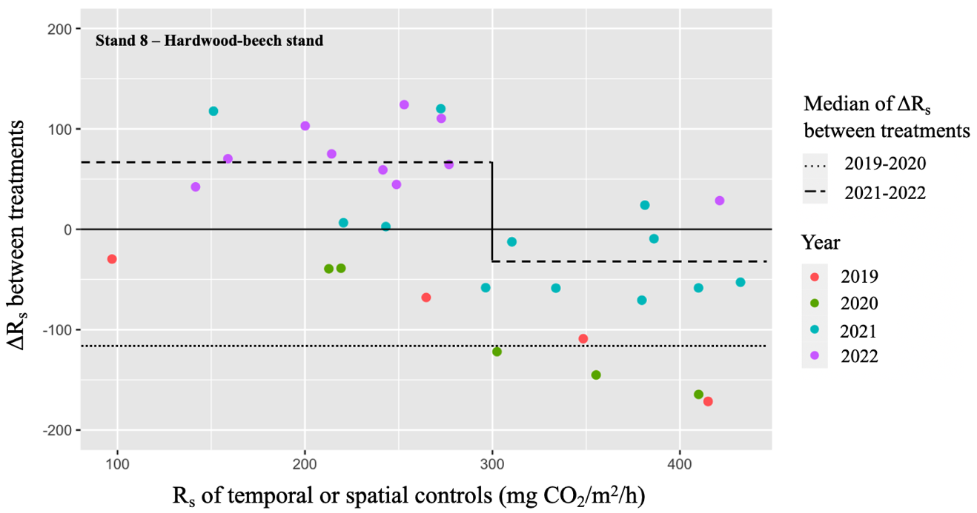
Fig. S5 Difference in soil respiration rate (R_{s}) between spatial and temporal controls (ΔR_{s}, pre-warming period in 2019 and 2020) as well as difference in R_{s} between heated plots and spatial controls (ΔR_{s}, warming period in 2021 and 2022) in stand 8, which are plotted against Rs of the two controls (temporal for 2019 and 2020; spatial for 2021 and 2022). The years are represented by data points of different colors, while the two dashed lines represent the median of the two sets of ΔRs. The median of the 2021-2022 set is divided into two medians to highlight a breaking point in the scatter of data

