Exploring Cellular Heterogeneity: Single-Cell and Spatial Transcriptomics of Alzheimer Disease Brains and iPSC-Derived Microglia

Anjali Garg^{1,2}, Sheeny Vo³, Logan Brase^{1,2}, Ekaterina Aladyeva^{1,2}, Ricardo D'O. Albanus^{1,2}, Aasritha Nallapu^{1,2}, Hongjun Fu^{3,4}, Oscar Harari^{1,2,5*}

Online Supplement

Table of Contents

Supplemental Figures

Fig S1. Optimization of integration algorithm. a Distribution of clusters across each cohort and normalized mutual information (NMI) within each integrated cluster using (a, e) CCA (b, f) MNN (c, g) RPCA (d, h) harmony algorithm are shown. | 3
Fig S2. Batch and sample entropy distributions in CCA integrated clusters. a Density plots of batch and sample entropy for each transcriptional state. b Line plots illustrating the normalized batch and sample entropy for each transcriptional state. (Δ) denotes the weighted sum or overall entropy for each transcriptional state. Source data are provided in the Source Data file. | 4
Fig S3. Genes expression analysis within each integrated cohort. Extended genes list collected from Sun et al. (2023). Cluster numbers and gene names are highlighted with the same color code if they show enrichment. | 5
Fig S4. Visium spots with the top 25% highest probability highlighted in red and blue for Homeostatic and Activated states, respectively, across AD samples. Each cohort was used as a reference to deconvolute the Visium spots. | 6
Fig S5. Quantification of transcriptional states around proximal and distal AT8 levels for Combined II-VI, External II-III, and Internal IV-VI cortical layers. Chi-square significance tests were used to calculate p-values. | 7
Fig S6. Quantification of transcriptional states around proximal and distal Aβ/AT8 spots in the External II-III layer across AD samples using each cohort as a reference. | 8

Fig S1. Optimization of integration algorithm. a Distribution of clusters across each cohort and normalized mutual information (NMI) within each integrated cluster using (a, e) CCA (b, f) MNN (c, g) RPCA (d, h) harmony algorithm are shown.

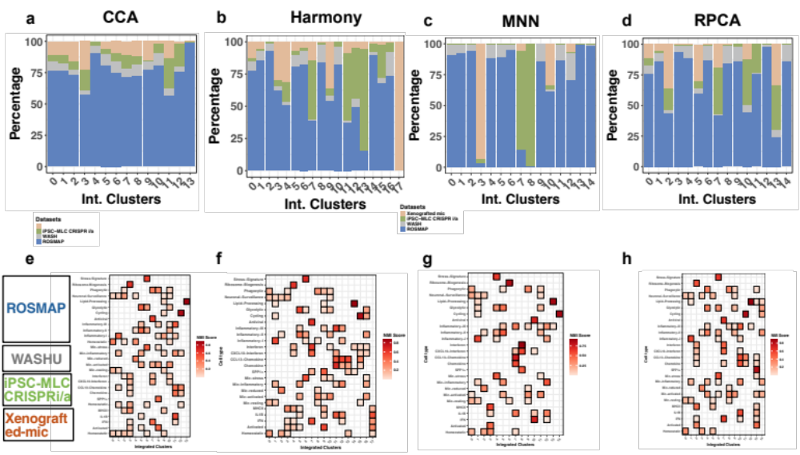

Fig S2. Batch and sample entropy distributions in CCA integrated clusters. a Density plots of batch and sample entropy for each transcriptional state. b Line plots illustrating the normalized batch and sample entropy for each transcriptional state. (Δ) denotes the weighted sum or overall entropy for each transcriptional state. Source data are provided in the Source Data file.

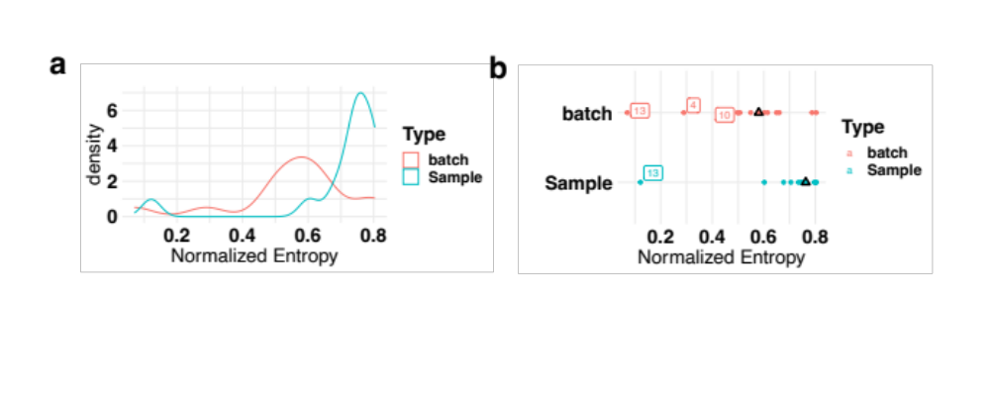

Fig S3. Genes expression analysis within each integrated cohort. Extended genes list collected from Sun et al. (2023). Cluster numbers and gene names are highlighted with the same color code if they show enrichment.

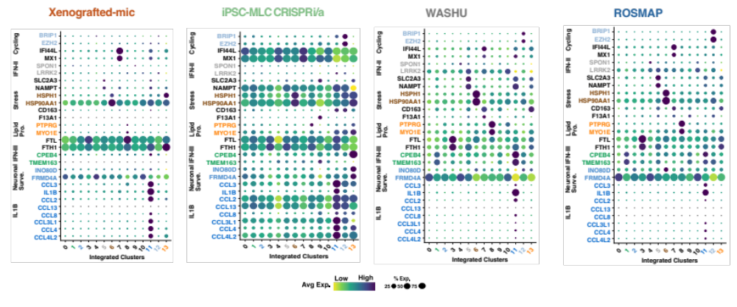

Fig S4. Visium spots with the top 25% highest probability highlighted in red and blue for Homeostatic and Activated states, respectively, across AD samples. Each cohort was used as a reference to deconvolute the Visium spots.

Fig S5. Quantification of transcriptional states around proximal and distal AT8 levels for Combined II-VI, External II-III, and Internal IV-VI cortical layers. Chi-square significance tests were used to calculate p-values.

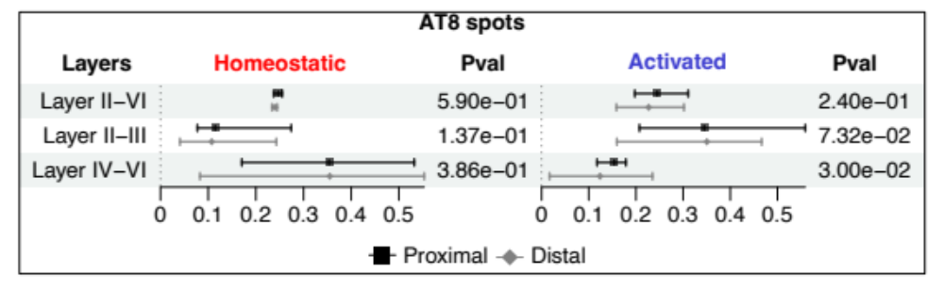

Fig S6. Quantification of transcriptional states around proximal and distal Aβ/AT8 spots in the External II-III layer across AD samples using each cohort as a reference.
