Supplementary Information

Sector-specific and carbon removal targets could limit adverse impacts of climate change and promote sustainability
Jeffrey Dankwa Ampah^{1,2}, Chao Jin^{1*}, Haifeng Liu^{2*}, Mingfa Yao², Yan Yin ^{2*},
Sandylove Afrane¹, Xuan Zhang², Humphrey Adun³, Page Kyle⁴, Jay Fuhrman⁴, Olusola Bamisile⁵, Michael O Dioha ⁶, David T. Ho^{7,8}, Yang Ou^{9,10}, Haewon McJeon¹¹
¹ School of Environmental Science and Engineering, Tianjin University, 300072 Tianjin, China
² State Key Laboratory of Engines, Tianjin University, 300072 Tianjin, China
³ Operational Research Centre in Healthcare, Near East University, TRNC Mersin 10, 99138 Nicosia, Turkey
⁴ Joint Global Change Research Institute, University of Maryland and Pacific Northwest National Laboratory, College Park, MD, USA
⁵ Centre for Environmental Planning, Imperial College London, United Kingdom.Imperial College London
⁶ Clean Air Task Force, Boston, MA 02109-2421, USA
⁷ Department of Oceanography, University of Hawaii at Mānoa, 1000 Pope Road, Honolulu, Hawaii 96822, USA
⁸ [C]Worthy, Boulder, Colorado 80302, USA
⁹ College of Environmental Sciences and Engineering, Peking University, Beijing, China
¹⁰ Institute of Carbon Neutrality, Peking
¹¹ KAIST Graduate School of Green Growth & Sustainability, Daejeon 34141, Korea
*Corresponding authors: Haifeng Liu (haifengliu@tju.edu.cn), Chao Jin (jinchao@tju.edu.cn), Yan Yin (yanyin@tju.edu.cn)

Contents
Supplementary Discussion 1 3
Supplementary Discussion 2 5
Supplementary Discussion 3 6
Supplementary Discussion 4 7
Additional results on climate, energy, land, water, and food 9
Supplementary Tables 30
Supplementary Note 1: Land use change as a carbon dioxide removal method in GCAM 33
Supplementary Note 2: BECCS as a carbon dioxide removal method in GCAM 33
Supplementary Note 3: DACCS as a carbon dioxide removal method in GCAM 34
Supplementary Note 4: ERW as a carbon dioxide removal method in GCAM 34
Supplementary Note 5: GCAM’s land module 35
Supplementary Note 6: GCAM’s water module 39
Supplementary Note 7: GCAM’s fertilizer module 41
Supplementary Note 8: Model parameterization 42
Supplementary Method 1: Global Change Assessment Model (GCAM) 50
Supplementary Method 2: Demand for energy services in GCAM 51
Supplementary Method 3: Economic choice function in GCAM 52
Supplementary Method 4: Total technology cost in GCAM 55
Supplementary Method 5: Renewable resource supply in GCAM 55
Supplementary References 56

Supplementary Discussion 1

The sectoral scenarios consistently exhibit substantially lower residual CO₂ emissions from transportation and electricity sectors compared to the conventional scenario (Supplementary Fig. 1). Fig. 2 shows different pathways to net zero CO₂ emissions by mid-century. All scenarios attain net-zero CO₂ emissions after 2050 but before 2055, with the sectoral scenarios reaching this climate milestone a few years earlier than CONV does. By 2050, CONV will still be about 6 Gt/yr away from transitioning from net positive to net zero, while the sectoral scenarios are only less than 1 Gt away. The CONV pathway leads to the lowest reduction in residual CO₂ emissions from fossil fuel and industry between 2015 and 2055, at 55%, compared to over 80% reductions under the sectoral scenarios (Fig. 2a). Following CONV’s emission reduction pathway, the electricity sector undergoes an 85% reduction, while the transport sector sees only a 35% reduction between 2015 and 2050. LULUCF emissions would have to reduce by 8 GtCO₂/yr to transition from net positive in 2015 (3.6 GtCO₂/yr) to net negative emissions by 2050 (-4.3 GtCO₂/yr).
The explicit sectoral targets from major emitters, coupled with limited CDR availability (SECT), would ensure an additional 15% and 45% decarbonization in the electricity and transport sectors, respectively, compared to CONV between 2015 and 2050. Compared to CONV, the SECT pathway reduces the reliance on "CO₂ removal" by 4 Gt/yr by 2050, leading to higher prioritization of non-CDR mitigation measures such as electrification, energy efficiency, and hydrogen deployment ¹. However, LULUCF removals would have to increase by 1 Gt/yr to support the limited availability of novel removal approaches and deliver net zero emissions (Fig. 2b).
If every country/region were to provide explicit emission reduction targets for electricity and transport alongside moderate CDR proposals but in an equitable manner (SECT-FAIR), an additional 15% decarbonization of the transport sector could be achieved between 2015-2050 compared to SECT. However, such an equitable sectoral approach could inadvertently slightly slow down decarbonization in other sectors like buildings, industry, and agriculture, compared to SECT, although about 0.7 Gt/yr of LULUCF removals could be avoided by pursuing SECT-FAIR over SECT (Fig. 2c).
While SECT-AMB represents the ‘most’ ambitious pathway, it is noteworthy that the level of decarbonization achieved across the various sectors under this pathway is largely comparable to the outcomes under the SECT-FAIR pathway (see Fig. 2d). This observation further emphasizes the critical need for more equitable climate action pathways, rather than relying solely on universally ratcheted ambition levels. If explicit sectoral targets were announced universally in upcoming LTS for major-emitting sectors beyond electricity and transport, the ambitious and fair pathways could be the quickest to achieve net zero and net-negative GHG emissions.
Higher energy demands for zero and low carbon energy-carriers would cause increased emissions from gas and hydrogen supply between 2015-2050 across all four pathways. SECT-AMB would result in the highest emissions growth during the period for gas and hydrogen supply, mainly due to its higher requirement for hydrogen to facilitate complete transport sector decarbonization by 2050.

Supplementary Discussion 2

The magnitude and regional distribution of CDR deployment vary significantly across 1.5°C scenarios. By 2050, gross CDR under CONV reaches 10 Gt/yr, approximately double that of the sectoral scenarios. Under CONV, the US, China, and EU collectively contribute 50% of global novel CDR by mid-century, while emerging economies in Africa and Asia (excluding China) contribute 25%. Under SECT-AMB, the contribution from major emitters increases to 45%, while those from emerging economies remain consistent with CONV (Fig. 3a). This novel CDR burden on emerging economies with no or limited experience with such technologies could risk higher residual emissions uncompensated for by mid-century if expectations are not met, consequently delaying net zero and subsequent net-negative emissions. The SECT-FAIR scenario shifts around 80% of the mid-century novel CDR burden to major emitters, with emerging economies relying solely on LULUCF negative emissions.
Regarding removals by LULUCF, the trends vary significantly across scenarios (Fig. 3b). The sectoral scenarios exhibit increased reliance on LULUCF removals compared to CONV due to their lower dependence on novel CDR technologies. This emphasis on LULUCF aims to facilitate near-term emission reductions and aid in achieving net-zero emissions by mid-century. An ambitious pathway with all countries setting explicit sectoral and CDR targets would lead to the highest utilization of LULUCF removals over the course of the remaining century.
Across scenarios, the US, EU, and China collectively contribute 10-15% of total LULUCF deployment by 2050, while emerging economies in Africa and Asia (excluding China) Asia contribute a substantial 30-35%. This disparity implies that countries in the Global North (including China in this case) may find emerging novel CDR technologies more economically viable, while emerging economies in the Global South would likely lean more heavily towards removals by LULUCF.
Limiting novel CDR deployment to 1Gt by 2050 presents climate and environmental benefits ^{1,2}, but rapid scale-up in the second half of the century may become costly and challenging. Under CONV, novel CDR deployment only grows by 2x from 2050-2055 and 3x from 2050-2060. However, the sectoral scenarios necessitate a significantly more accelerated growth trajectory during these periods, increasing by approximately 4-7 times. Regions' ability to meet their CDR needs would heavily depend on geological storage potential, sustainability impacts, costs, and governance factors. Without equity considerations for carbon removal, low-income regions facing little historical responsibility could become unfairly burdened by unsustainable CDR competition for land, water, and other resources ^{3–7}.

Supplementary Discussion 3

The analysis shows that setting explicit sectoral targets for electricity and transport decarbonization, coupled with constrained CDR deployment (sectoral scenarios), enables more rapid near-term net CO₂ emissions reductions compared to conventional economy-wide carbon pricing. Between 2020-2050, major emitters like the US and China achieve 95-110% net CO₂ reductions under sectoral scenarios, versus 80-85% under CONV which relies heavily on future large-scale CDR implementation.
Under CONV, several regions may find it more economically advantageous to rely on CDR rather than rapidly decarbonize, delaying their domestic net-zero CO₂ emissions beyond this century. In contrast, SECT-AMB leads to several countries attaining domestic net-zero earlier due to rapid reduction in net emissions and limited negative emissions reliance. While availability of CDR may help accelerate reductions in net emissions (aligning with Strefler et al. ⁸), our analysis shows a different trend for most. For example, for EU-15, total net zero CO₂ will be reached in 2095 compared to 2050-2055 under the sectoral scenarios. Similarly, EU-12 and Indonesia will reach total net zero CO₂ at least 10 and 30 years earlier under sectoral scenarios compared to the attainment years under CONV, respectively. South Korea does not achieve net zero in the 21st century under CONV but could be realized before 2065 under SECT-AMB/FAIR scenarios. Regions with high carbon lock-in such as the India, Pakistan, and South Africa may not attain domestic net-zero CO₂ emissions within this century, regardless of the pathway (Fig. 3c).
Interestingly, all pathways lead to China and the United States individually achieving net-zero emissions before 2055. However, the trajectories for most regions in Africa exhibit a distinct pattern. While these regions may attain net-zero emissions earlier in the century, they face challenges in sustaining this status throughout the entire period, potentially exhibiting net positive emissions later on.
While an equitable mitigation approach reduces emission reduction and CDR burden on emerging economies, delaying their decarbonization and excusing them from novel CDR participation risks several of these regions failing to achieve net-zero emissions this century.

Supplementary Discussion 4

Pursuing explicit sectoral and separate CDR targets promotes energy efficiency in end-use sectors. Electricity is characterized by high exergy, implying that 1 EJ of electricity can produce more usable work than an equivalent amount of liquid, solid, or gaseous fuel or heat ⁹. Thus, the higher electrification and defossilization leads to lower total energy demand under the sectoral scenarios especially before mid-century. Between 2020 and 2050, the sectoral scenarios can provide an additional 10% phase-down in coal and a 40% rise in electrification compared to the conventional pathway's. Compared to the CONV scenario, the sectoral scenarios show a more rapid phase-down of coal consumption for end-use applications in key regions such as North America, Asia, and the European Union, accelerating the reduction of coal consumption in these regions by an additional 25-30%, during the 2020-2050 timeframe.
The transformations in global energy supply and demand between the conventional pathway and the sectoral scenarios by 2050 are depicted in Fig. 6. Under the conventional pathway, carbon-based sources, including biomass and fossil fuels, provide approximately 70% of total primary energy consumption, which is reduced to 50-55% when explicit emission reduction targets for electricity and transport sectors are pursued alongside separate CDR targets. In an ambitious sectoral pathway (SECT-AMB), renewables’ and nuclear’s contribution could reach 50% of the energy mix by 2050, respectively, compared to less than 30% under CONV.
As electricity decarbonization is the ‘heart’ of any 1.5°C pathway, despite higher electrification rates under SECT-AMB and other sectoral pathways, it leads to an increase of less than 20% over the rates under CONV. The transport sector covers some of the world's most hard-to-abate sectors, such as aviation and shipping. Pursuing SECT-AMB would present significant energy demand reductions in transport, approximately 40% lower than demands compared to CONV, attributable to the sectoral pathway's rapid electrification (electricity and hydrogen) and the phase-out of fossil fuels from the transport sector. Furthermore, by 2050, a lower reliance on CDR and rapid cuts in sector emissions could lower energy demand for carbon removal. Without explicit targets for other sectors, such as industry and buildings, the two pathways (CONV vs SECT-AMB) result in similar energy demands in these two sectors. If countries were to provide explicit emission reduction targets for each sector of their economy, significant cuts in energy demands in end-use sectors could be realized, albeit at the expense of higher mitigation costs. However, countries can take advantage of the most cost-effective abatement opportunities within each sector to mitigate costs to some extent ¹⁰.
Moreover, an additional 10-17 EJ/yr of hydrogen consumption, primarily to deep-decarbonize the transport sector, would be achieved by 2050 under the sectoral scenarios. Nonetheless, the most significant reduction between CONV and the sectoral scenarios in energy carriers would occur in refined liquids. Refined liquids here comprise oil refining, biomass liquids, coal-to-liquids, and gas-to-liquids, and their demand could be reduced by 50% under SECT-AMB compared to demands under CONV.

Additional results on climate, energy, land, water, and food

The supplementary figures are additional results related to climate-energy-land-water-food system. Our comparison here is between the conventional pathway and our alternative sectoral pathways. Thus, our sectoral pathways are represented by the most ambitious scenario (AMB) and it is compared against CONV.

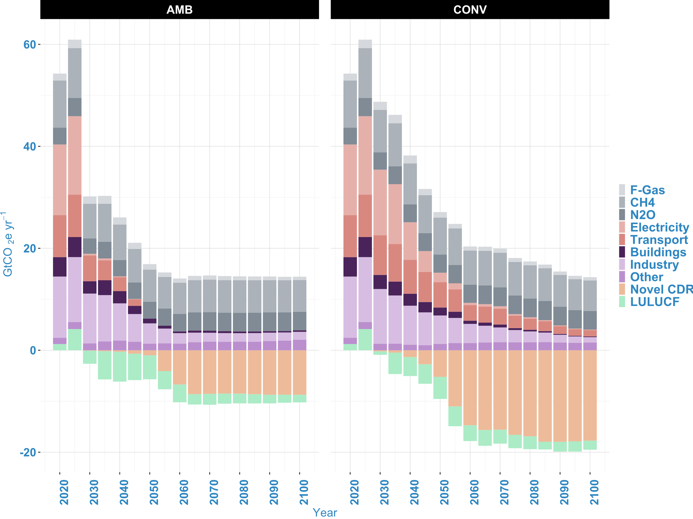
Supplementary Figure 1 Impact on GHG emissions. Positive GHG emissions and gross CDR under AMB and CONV. Non-CO₂ GHGs are calculated based on 100-year GWP equivalents. Novel CDR includes ERW: enhanced rock weathering, BECCS: bioenergy with carbon capture and storage, DACCS: direct air capture and carbon storage. “Other” includes residual CO₂ emissions from other energy transformation processes such as refining. Positive values in some periods for land use, land use change, and forestry (LULUCF) indicate higher deforestation rates than afforestation rates. AMB consistently exhibits substantially lower residual CO₂ emissions from transportation and electricity sectors compared to the conventional scenario. By 2050, these sectors will be completely decarbonized under AMB, while CONV will continue to have considerable emissions until 2100 (about 7 Gt/yr by 2100). This arises from explicit emission reduction targets in electricity and transportation, irrespective of abatement costs ¹¹, unlike CONV's least-cost approach which prioritizes emission reductions in sectors where abatement is more economically feasible, potentially delaying deeper decarbonization in the electricity and transportation sectors. While prioritizing zero-carbon electricity and transportation, the sectoral scenarios also drive rapid electrification in buildings and industry (also indirect electrification by hydrogen). They also lead to lower non-CO₂ emissions partly due to lower fossil fuel extraction, leading to lower methane emissions ¹². Furthermore, the low-price pathway under CONV increases bioenergy demand, which could also be a significant source of nitrous oxide emissions from fertilizers used in cultivating bioenergy crops ¹³. -F-Gas: Fluorinated gases, CH₄: methane, N₂O: nitrous oxide. By 2100, gross CDR deployment under CONV is expected to reach 20 Gt/yr, twice the deployment under AMB

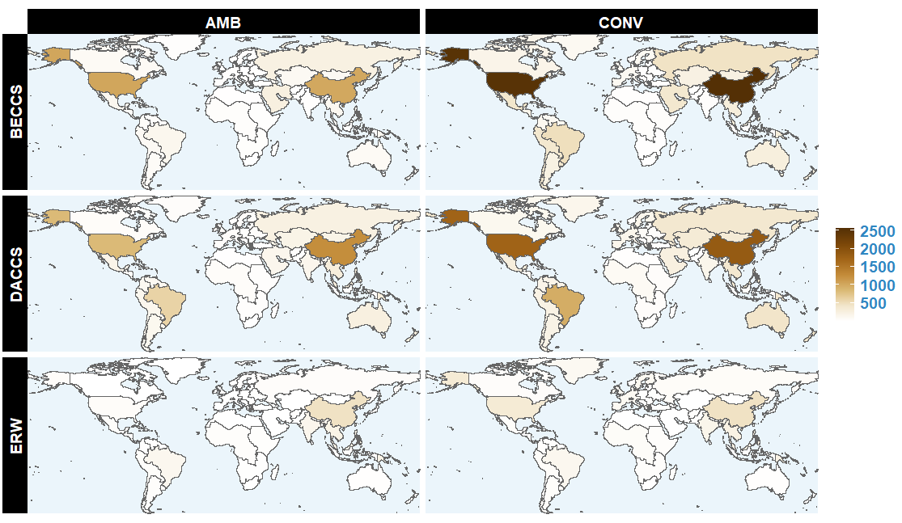
Supplementary Figure 2. Impact on CO₂ sequestration. Results here represent regional novel CDR deployment by 2100 according to technology type and it is reported in MtCO₂/yr. Explicit targets for sector decarbonization cut residual emissions faster and significantly, reducing the need for higher deployment of CDR technologies. Asia has the largest concentration of any CDR approach under both scenarios. By 2100, DACCS would be the main CDR approach in Africa at 205 and 121 million tons per year under CONV and AMB, respectively. Asia’s main CDR strategy by 2100 would be BECCS under CONV (at 3.6 billion tons per year) but DACCS under AMB (at 2.1 billion tons per year). In the case of North America, BECCS would be the main CDR approach by 2100 under both CONV (3.1 billion tons per year) and AMB (1.2 billion tons per year). Just like Africa, the main CDR approach in South America and Europe under both scenarios would be DACCS by 2100. ERW: enhanced rock weathering, BECCS: bioenergy with carbon capture and storage, DACCS: direct air capture and carbon storage

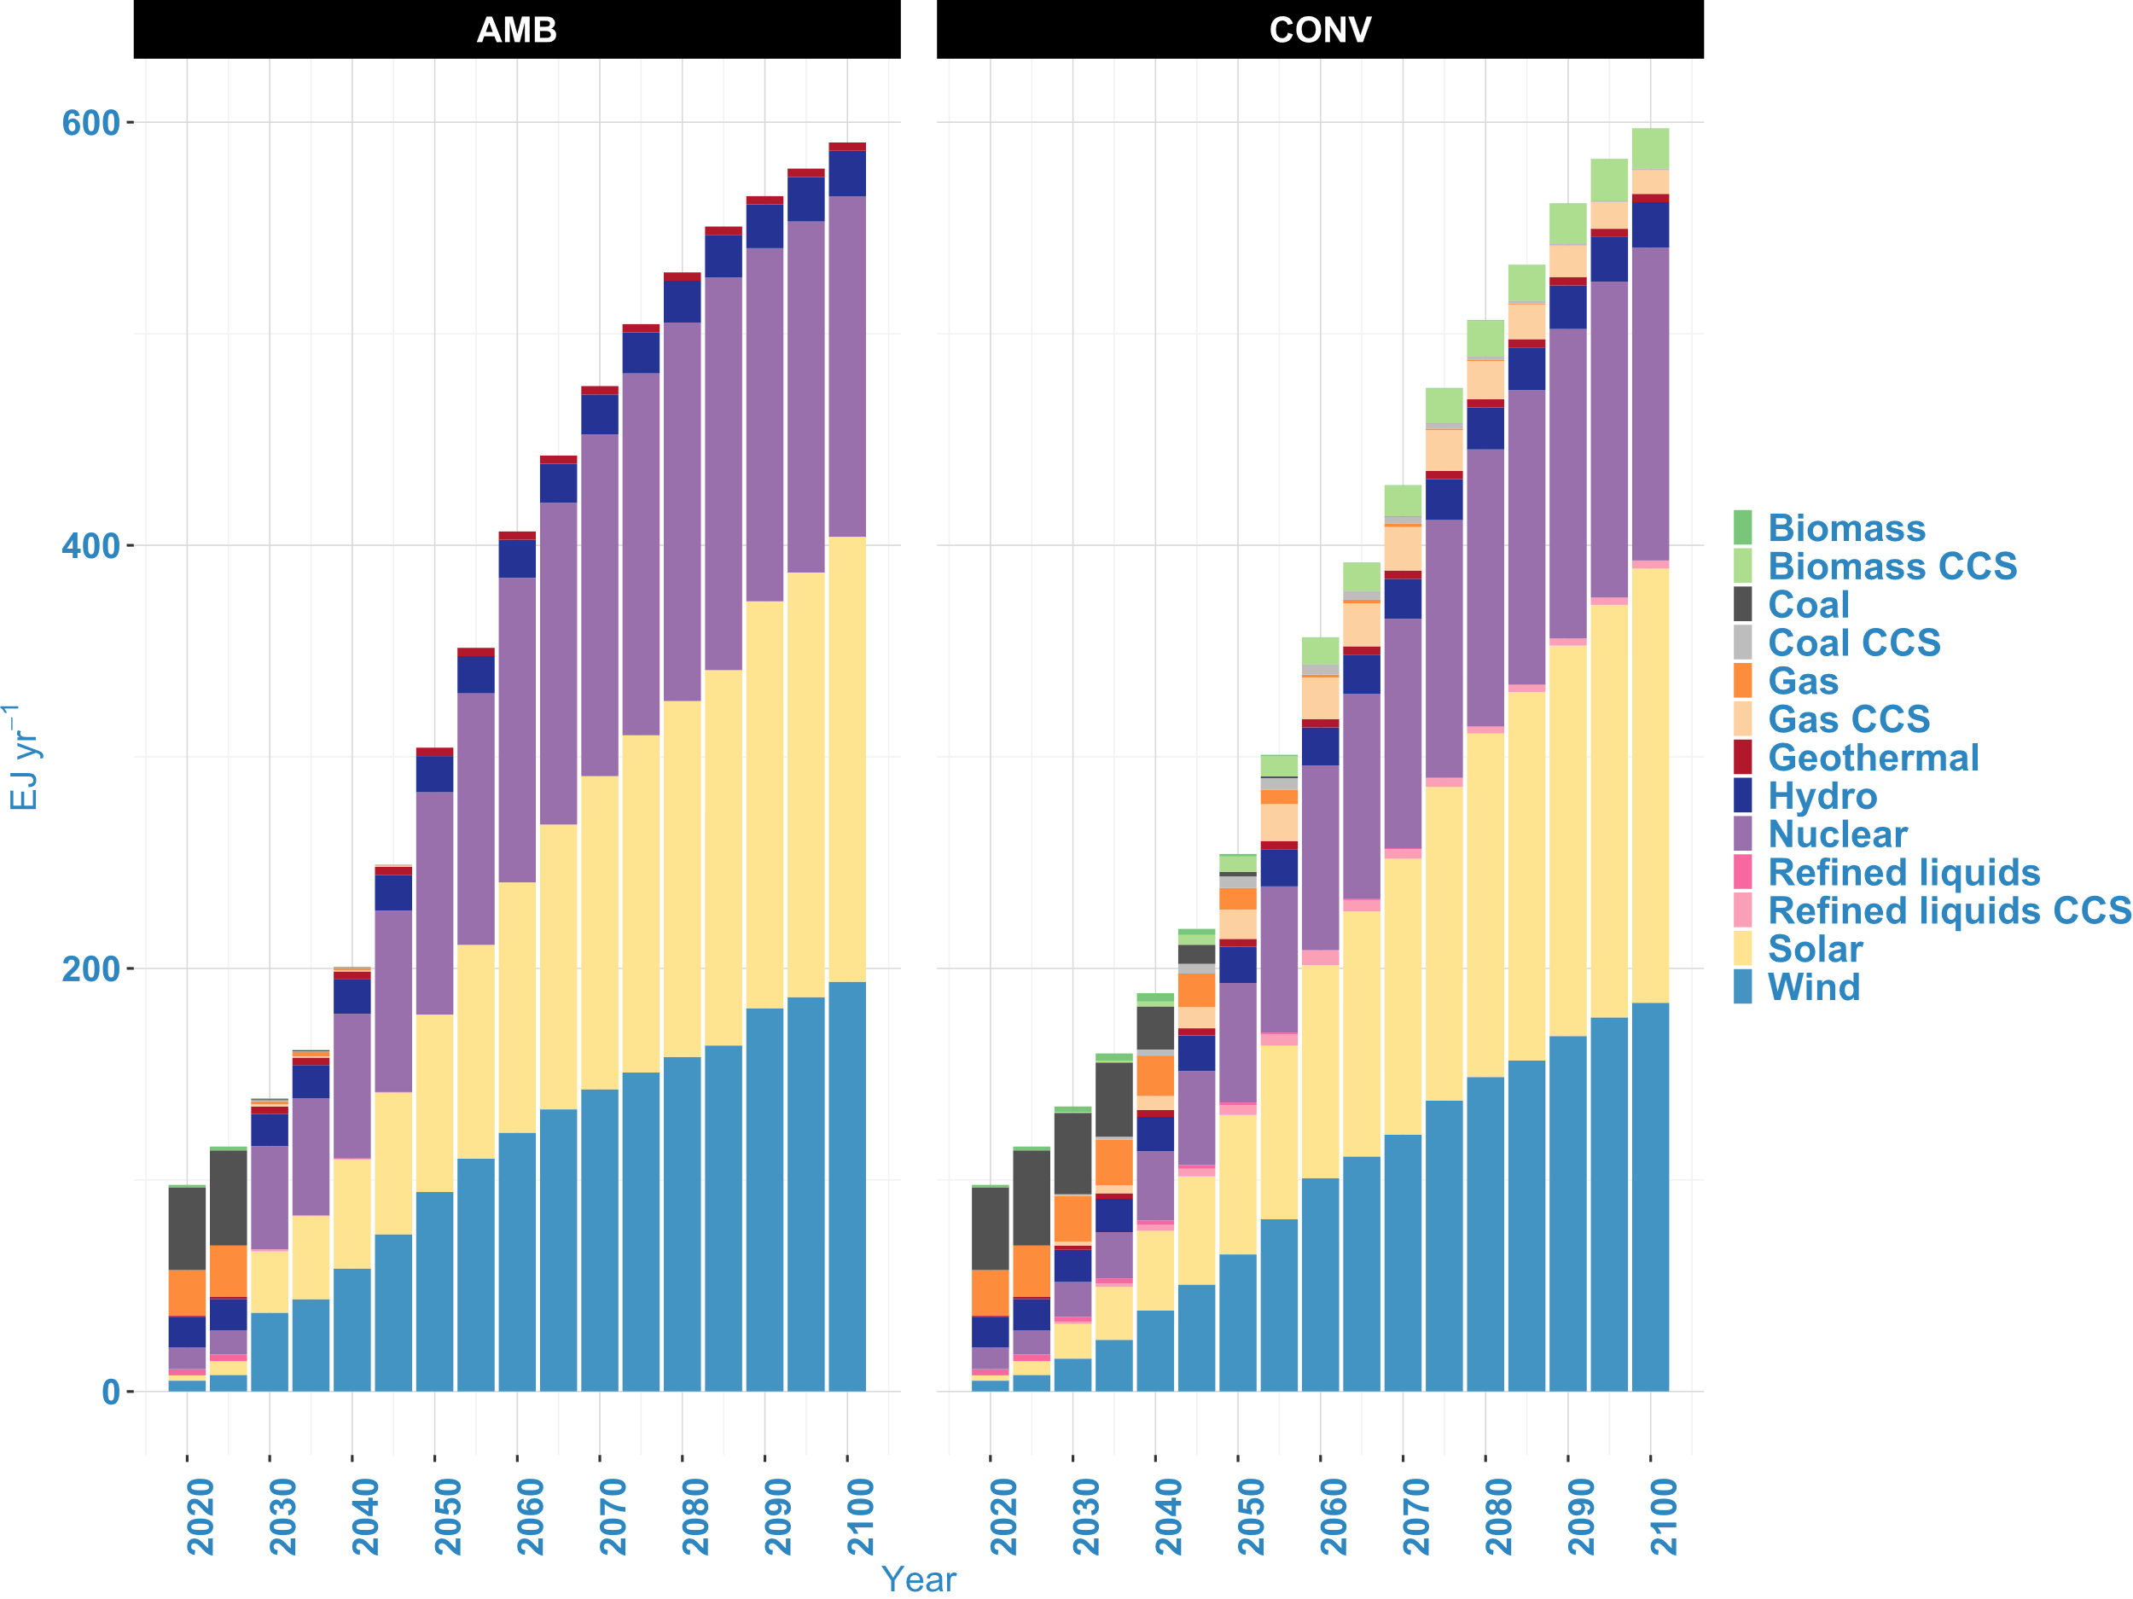
Supplementary Figure 3 Impact on electricity production. Annual electricity production by technology under CONV and AMB. Due to the requirement of zero-emissions electricity and transport alongside limited CDR reliance, there is rapid electricity production especially in the near-to-mid-term under AMB compared to SECT. From 2020-2050, the cumulative electricity generation under AMB reaches 430 EJ compared to 398 EJ under CONV. During that period AMB also records rapid electricity generation from cleaner energy sources, with a sharp phase-out of carbon-based sources over the long-term. Total electricity generation in the long-term may become higher under CONV, due to the rapid need to quickly decarbonize as a result of its earlier delay in emission reduction. CCS: Carbon capture and storage

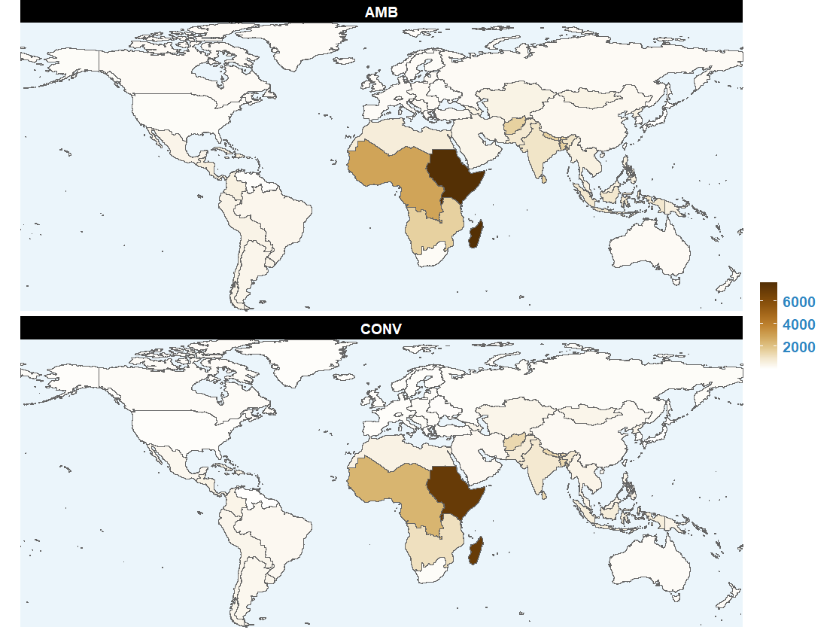
Supplementary Figure 4. Impact on regional electricity production. Results represent the percentage change in regional electricity production by 2050 relative to 2010 levels (%). AMB leads to higher electricity production compared to CONV. Africa’s growth in electricity production would be the most obvious under both pathways, due to the expected population and economic growth in the region compared to historical growth rates. Under both pathways, higher electricity growth rates are recorded under AMB for all regions compared to growth rates under CONV. For comparison, the average growth rates in the regions are, Africa: AMB (2620%) and CONV (2255%), Asia: AMB (610%) and CONV (475%), America: AMB (360%) and CONV (280%), Europe: AMB (184%) and CONV (137%)

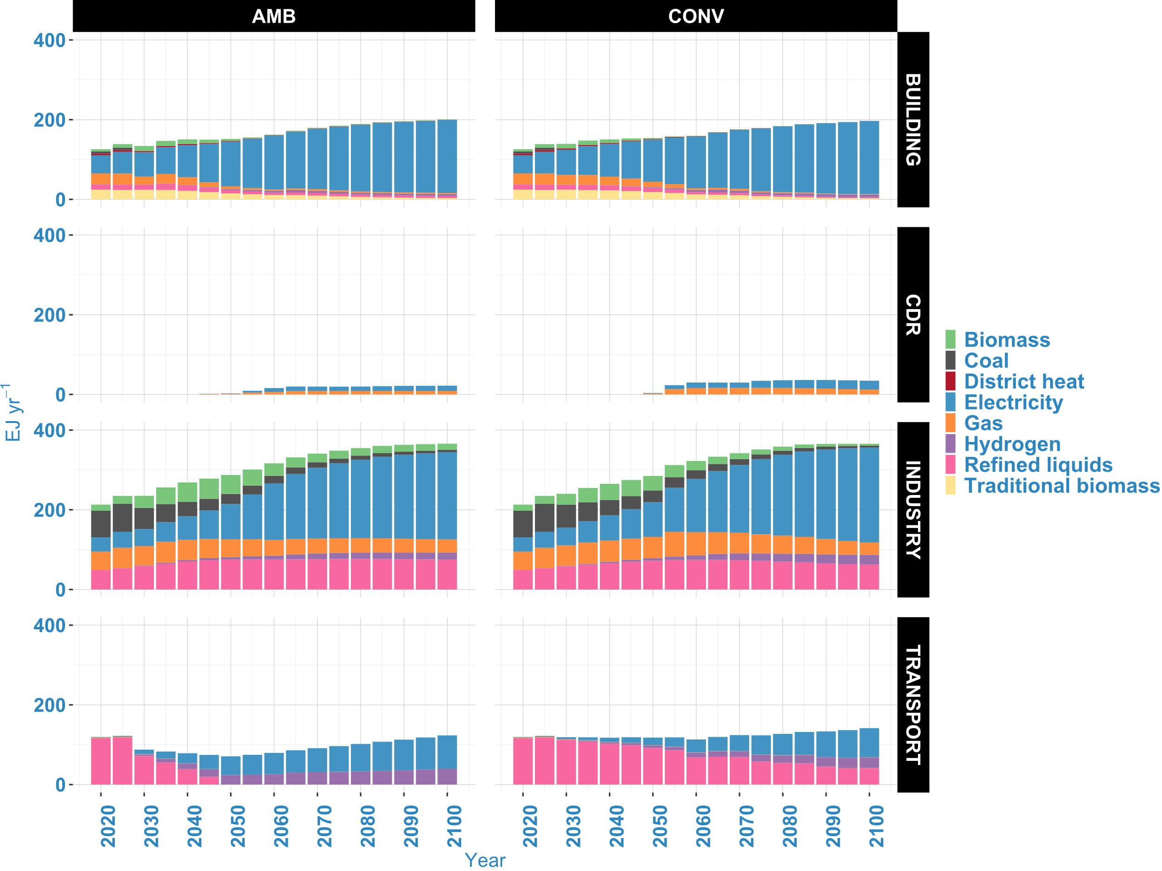
Supplementary Figure 5 Impact on global end-use sector fuel consumption. Higher phase-down of fossil fuels, especially in the transport sector, leads to an overall decrease in final energy demand under the AMB scenario. "CDR" represents the natural gas and electricity used by DACCS to remove CO₂. DACCS' role becomes more significant towards mid-century, with no noticeable energy consumption for CO₂ removal in the earlier years. Higher DACCS expectations under the CONV scenario result in greater energy demands for CDR compared to the AMB scenario. Without explicit targets for the building and industry sectors, the differences in fuel consumption patterns between CONV and AMB are less pronounced. However, in the transport sector, the AMB scenario achieves full decarbonization by mid-century, with hydrogen and electricity playing significant roles in heavy-duty (shipping and aviation) and light-duty vehicles, respectively. This contrasts with the CONV scenario, where refined liquids (oil and biofuel) reduce the roles of hydrogen and electricity in transport.

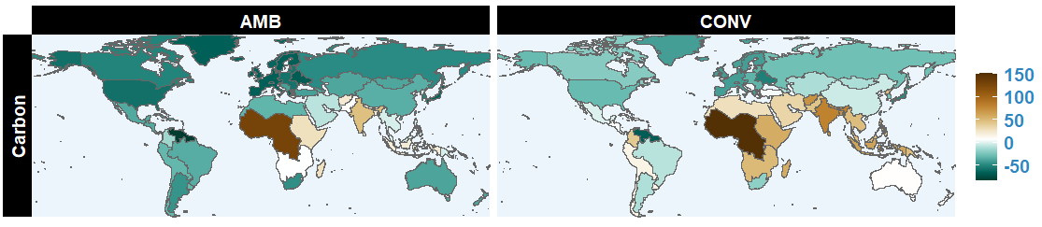
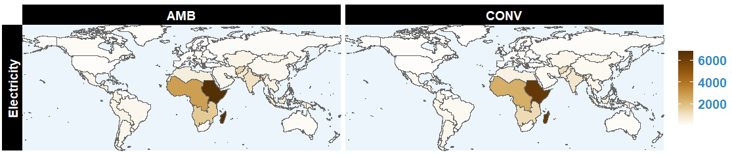
Supplementary Figure 6 Regional change in carbon-based (coal, biomass, oil, gas) and electricity in end-use sectors between 2010-2050 (%). Regions such as Western Africa, India, Indonesia, Eastern Africa, Southern Africa, and Pakistan experience positive growth rates during this period under both pathways. For example, under the CONV pathway, India's growth rate reaches 80% and Indonesia's 63%, compared to 47% and 21% under the AMB pathway, respectively. South America-Northern records the highest reduction rates, with -81% under AMB compared to 65% under CONV. For major emitters such as the US, China, EU-12, and EU-15, growth rates under CONV are -28%, 3%, 30%, and 40%, compared to 57%, 32%, 55%, and 64% under AMB, respectively. For electrification, all countries record positive growth rates between 2010-2050 due to the increasing need to cut emissions globally. The largest growth rates are projected in Global South countries with historically lower electricity access, particularly in Africa, South Asia, India, Indonesia, and Pakistan. This trend is more pronounced under the AMB scenario. For example, under AMB, the average growth rate for Global South countries is 1054%, compared to 907% under CONV. Similarly, during the same period, Global North countries under AMB are expected to record average growth rates of 148%, compared to 113% under CONV

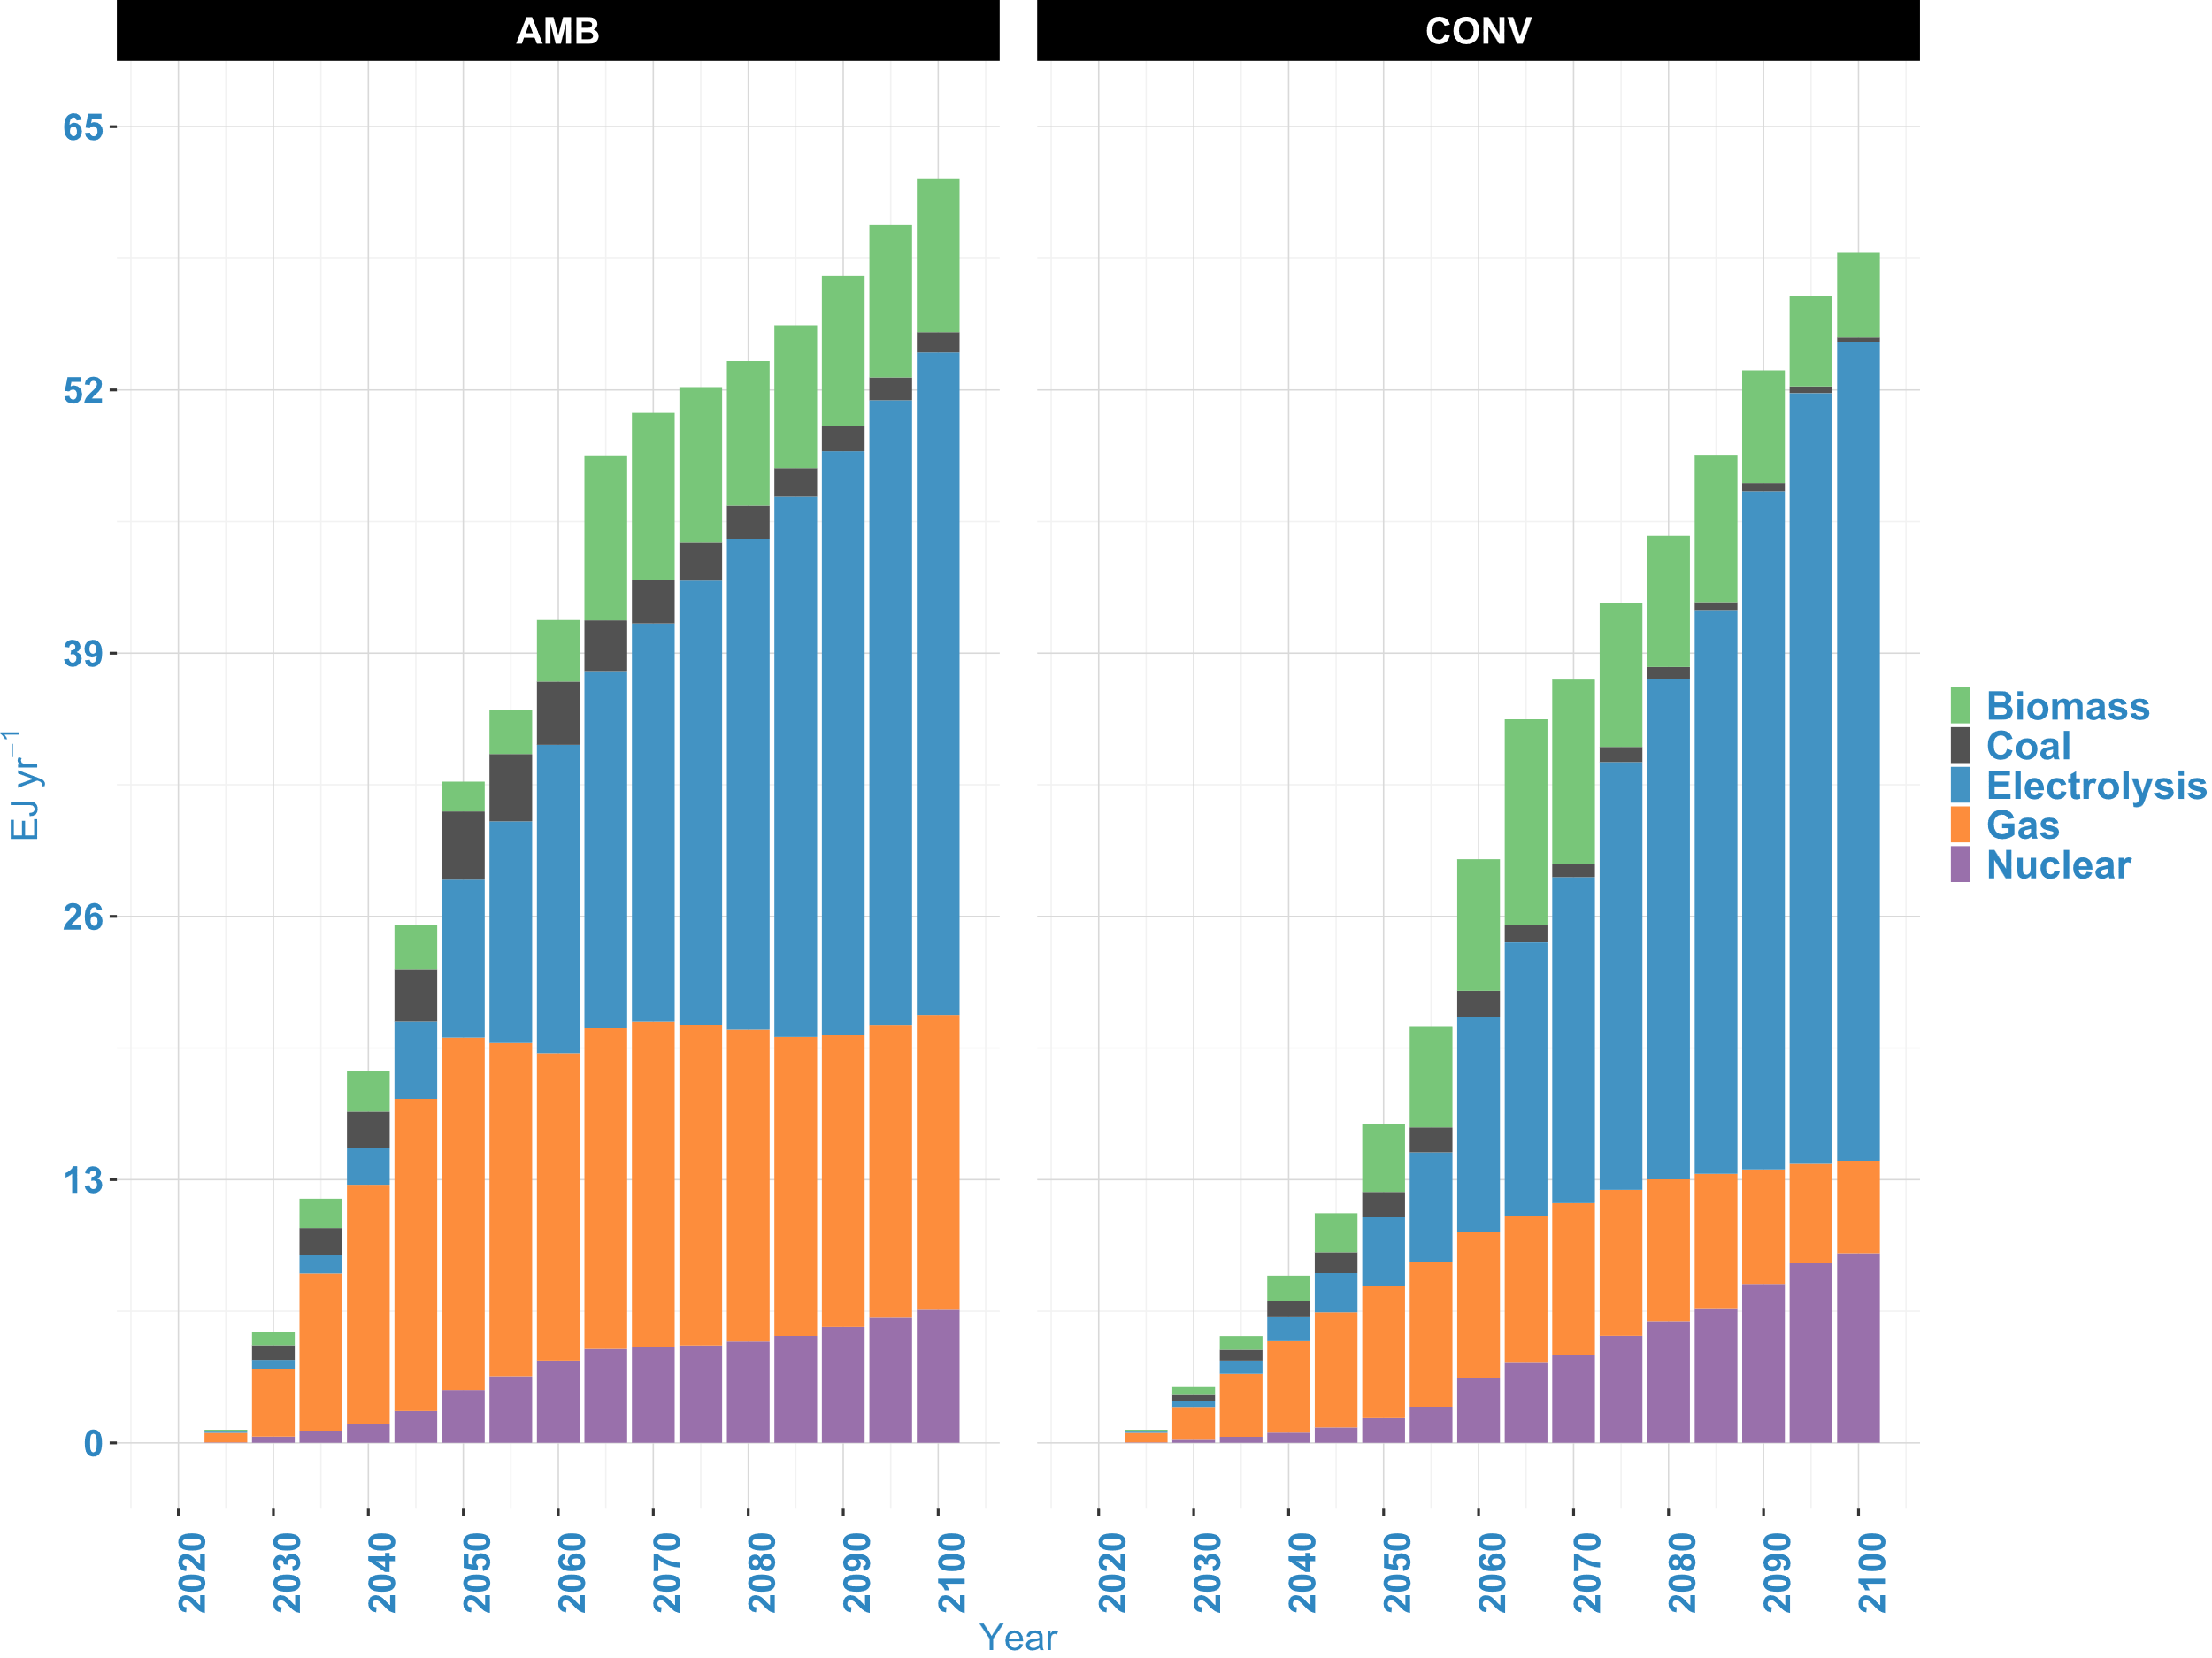
Supplementary Figure 7 Impact on hydrogen production by technology. Pursuing a carbon-free transport sector by 2050 with limited reliance on CDR would significantly increase hydrogen demand and production. The results indicate that from 2020 to 2100, the AMB pathway would record a cumulative hydrogen production of 2917 EJ compared to 2240 EJ under the CONV pathway. Due to the large-scale hydrogen requirements under AMB, more cost-effective technologies are sourced to reduce overall policy costs. Consequently, while AMB involves a rapid phase-down of fossil fuels across the entire energy sector, it still relies more on fossil-based hydrogen production compared to CONV. For example, under AMB, fossil-based and electrolysis hydrogen production shares reach an annual average of 48% and 32% from 2020 to 2100, respectively, compared to 36% and 37% under CONV.

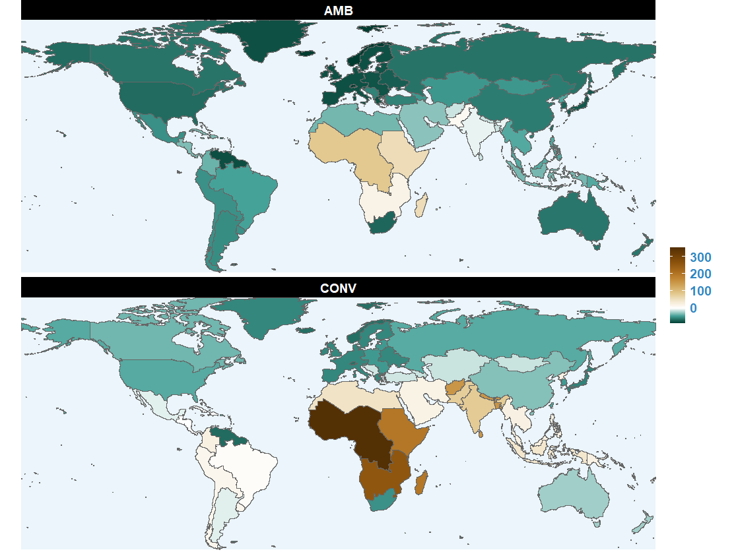
Supplementary Figure 8 Impact on primary energy supply. % change in fossil fuel consumption by region from 2010 to 2050. Both positive and negative growth rates are recorded depending on the region. Africa, except for South Africa, records positive growth rates under both AMB and CONV, with the highest growth occurring in Western Africa at 355% under CONV and 82% under AMB. Pursuing explicit sectoral decarbonization and separate CDR targets results in a rapid phase-down of fossil fuels across regions. For example, the EU records about an 82% reduction under AMB compared to 55% under CONV. Similarly, the USA and China each achieve an additional 30% reduction in fossil fuel growth under AMB compared to the reduction rates under CONV

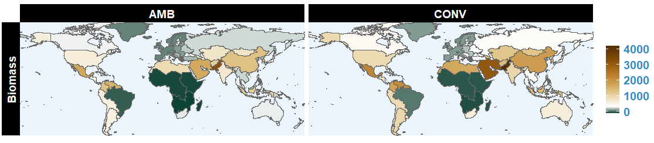
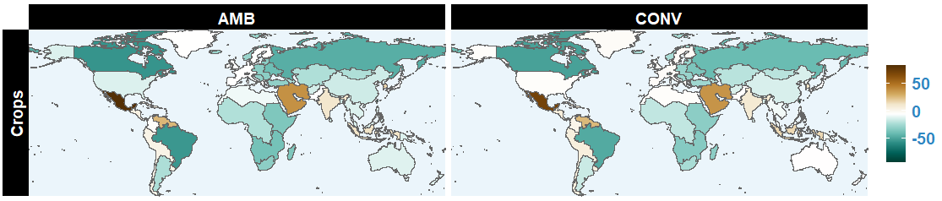
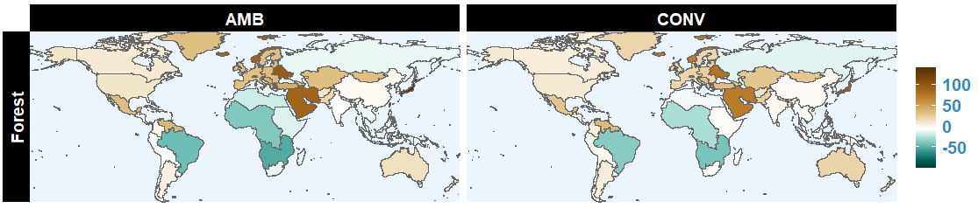
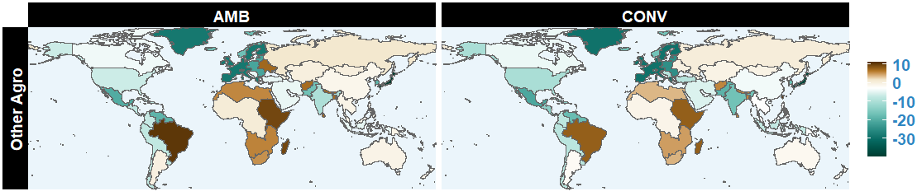
Supplementary Figure 9 Impact on regional land allocation. Change in land allocation from 2025 to 2050 (%). In this context, "Forest" refers to managed forest, and "Other Agro" represents land allocated for pasture, grass, shrubs, and other arable lands. Pursuing climate change mitigation would reduce cropland allocated for food and non-food crops ("Crops"). By 2050, the global average cropland is projected to decrease by 13% under AMB and 11% under CONV, relative to 2025 levels. The highest reductions in cropland are expected in Taiwan (China), Canada, and Brazil. For land allocated to bioenergy crop cultivation, an overall growing trend is expected globally, despite some regions experiencing negative growth. A large-scale reliance on CDR, particularly BECCS, under CONV is projected to lead to a global average increase in bioenergy cropland of about 970%, compared to 663% under AMB. The highest growth rates are anticipated in Pakistan. Both AMB and CONV also show similar patterns for the reduction in land for "Other Agro" activities, with Japan, the EU, and Mexico expected to record the highest reduction rates under both scenarios. Managed forests are generally expected to expand between 2025 and 2050, with global averages of 12% growth under AMB and 10% under CONV. The highest growth rates in forests are expected in Japan, Eastern Europe, and the Middle East, while Taiwan (China) is likely to see a complete loss of forests by 2050.
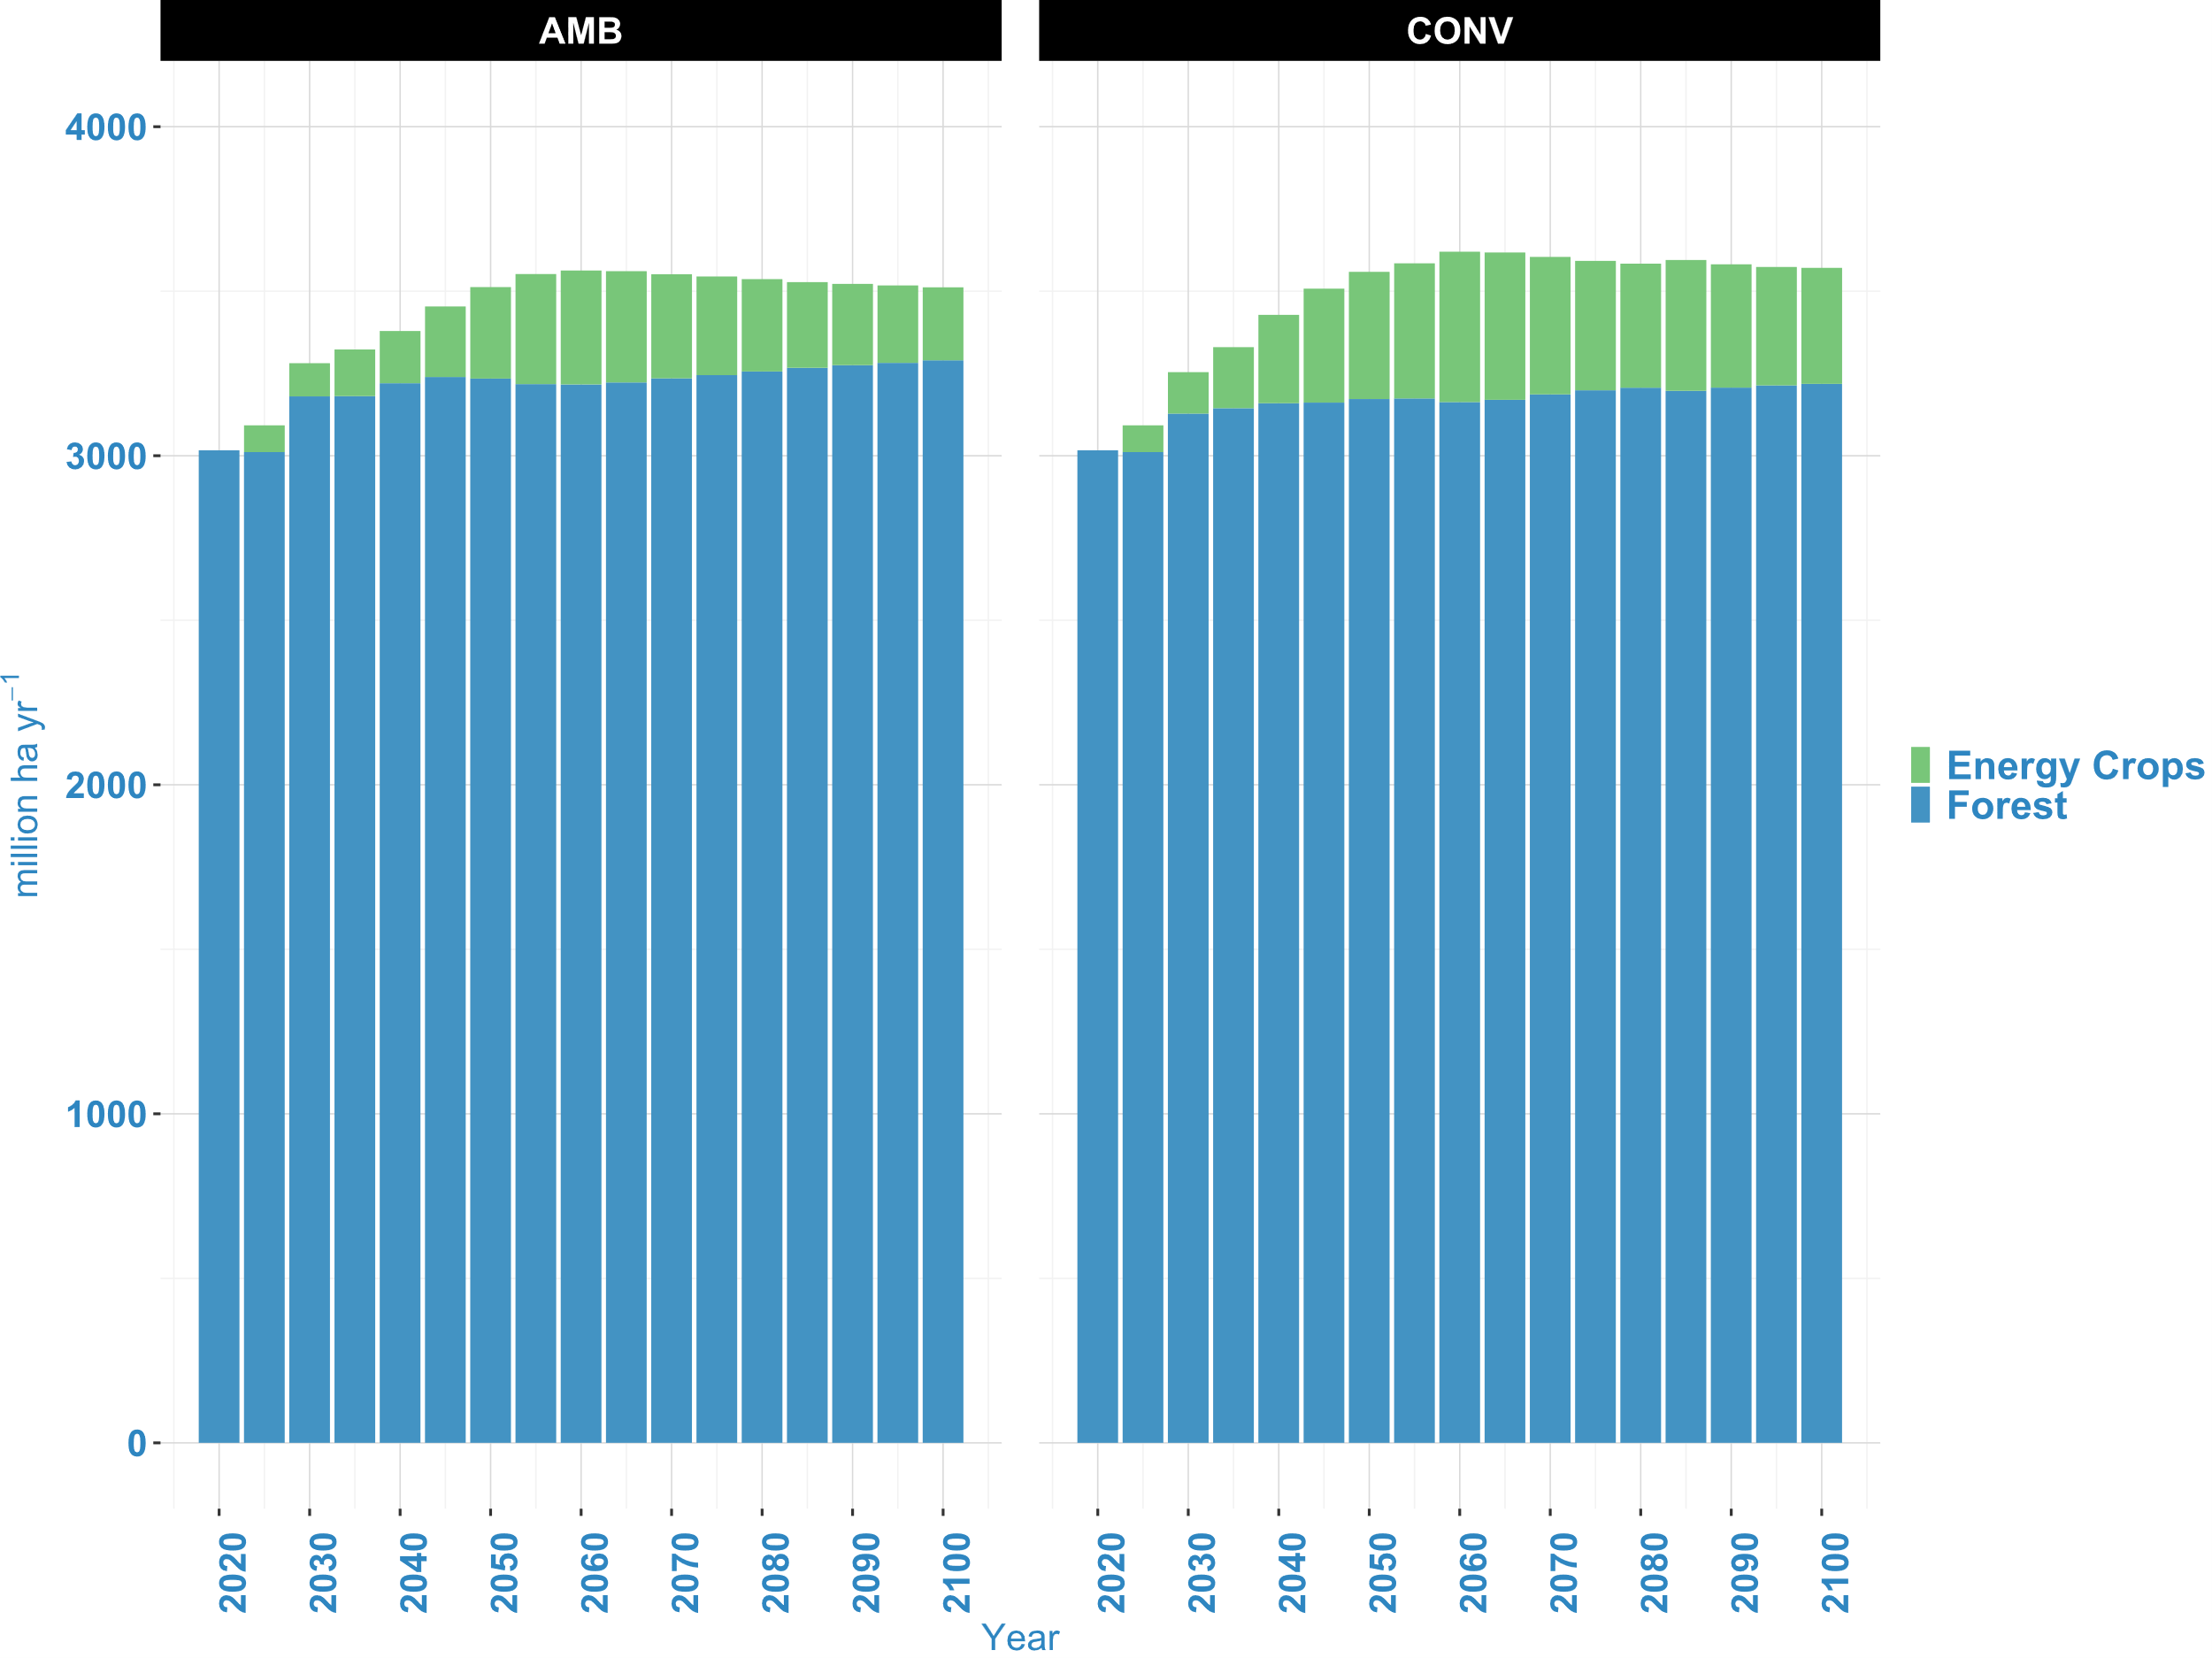
Supplementary Figure 10 Impact on global land allocation. Large expectations for CDR under the CONV pathway would result in more land being allocated for the cultivation of energy crops compared to the AMB pathway. However, AMB would allocate more land for forests to complement the limited availability of novel CDR approaches.
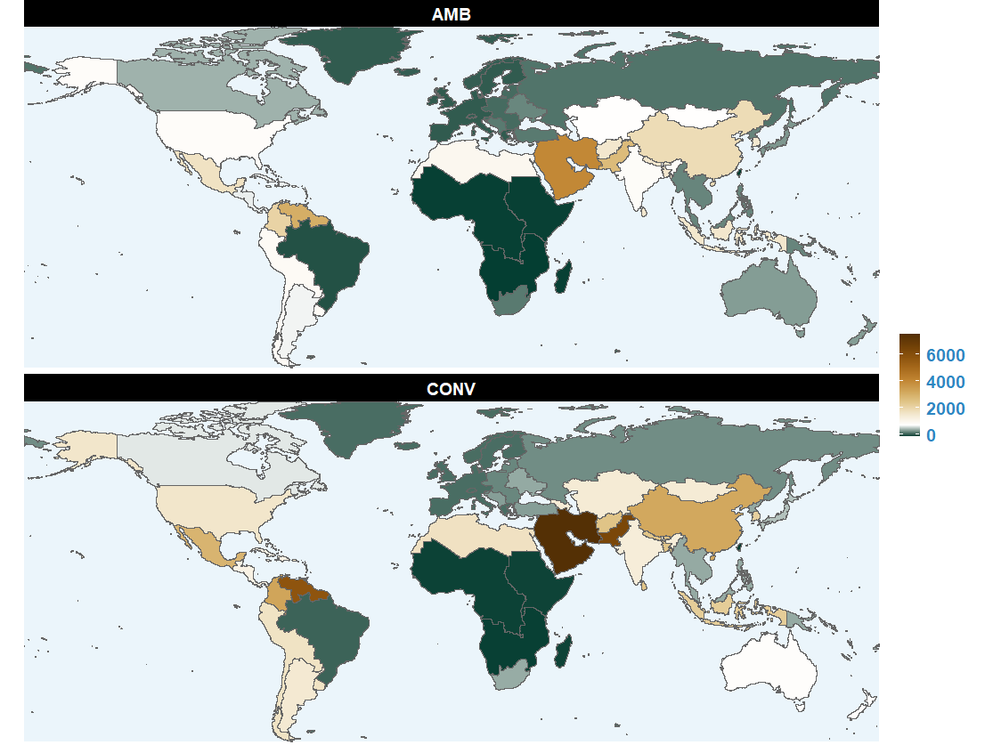
Supplementary Figure 11 Change in fertilizer demand by region for bioenergy crop cultivation 2025-2100 (%). There is a general increase in global fertilizer demand for bioenergy crop cultivation as energy demand rises and CO₂ removal efforts intensify. The expectation of multigigatonne CDR under the CONV pathway results in a significantly higher fertilizer demand for cultivating bioenergy crops, with a global average increase of 1580%, compared to an 875% increase under the AMB pathway. The highest increases are expected in the Middle East, Pakistan, and Northern South America, particularly under CONV. The lowest increases, excluding regions and countries with negative growth, are expected in Europe, especially under AMB.

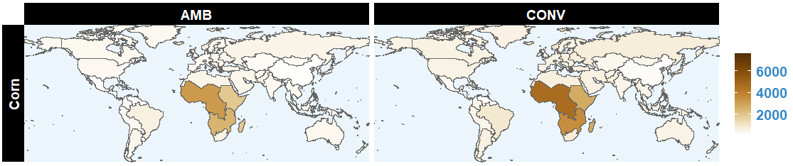
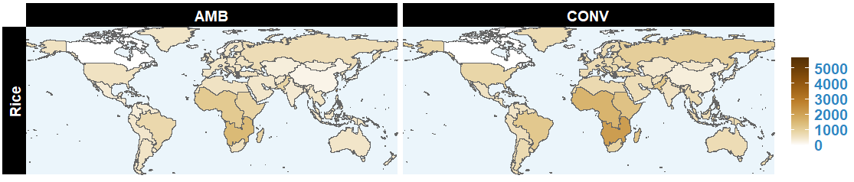
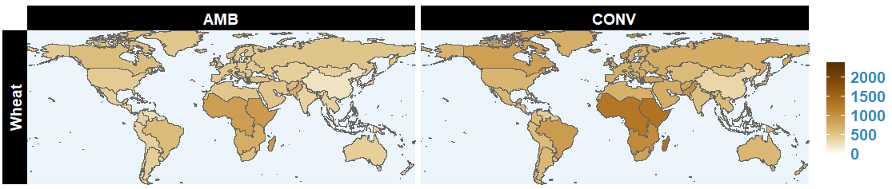
Supplementary Figure 12 Impact on agricultural commodity prices. Change in three major staple food prices by 2100 relative to 2010 levels (%). Among the three agricultural commodities, corn prices are expected to experience the most significant increase between 2010 and 2100. Following the CONV pathway leads to higher growth in staple food prices for all commodity types. On average, the global increase in prices for rice, wheat, and corn under CONV is projected to reach 913%, 781%, and 1123% by 2100, respectively, compared to 636%, 535%, and 777% under AMB. The highest price hikes across these three commodities are expected to be concentrated in Taiwan (China) and Africa.
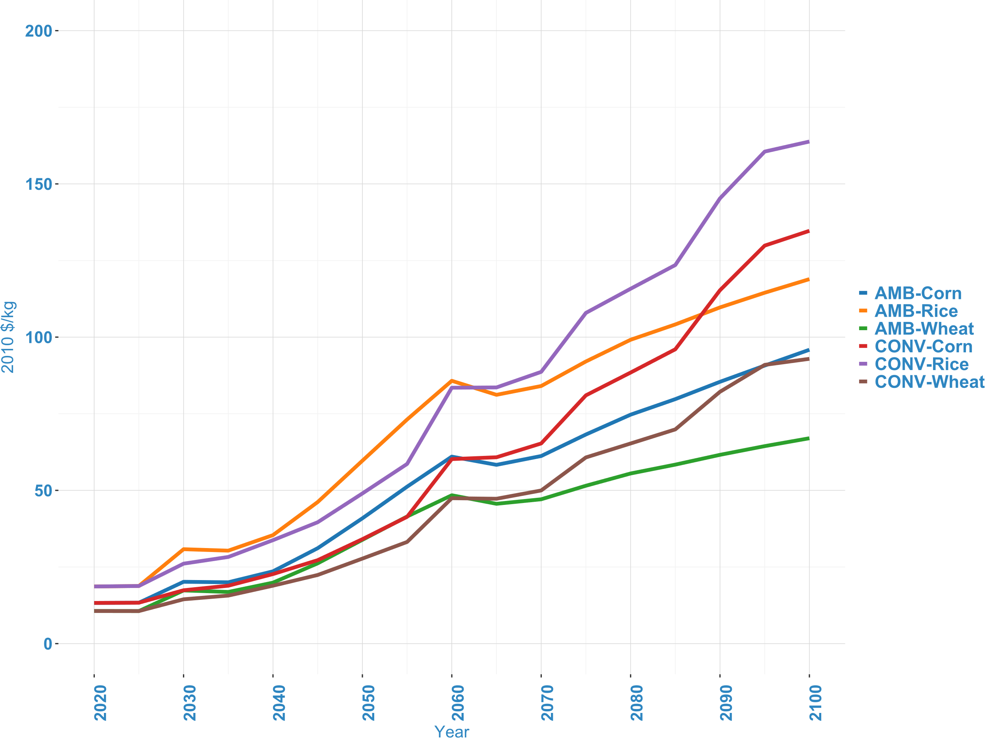
Supplementary Figure 13 Annual global projection of three major staple food prices (2010$/kg). Overall, the CONV pathway leads to increased land allocation towards energy crops, which negatively impacts food cropland. As a result, staple food prices increase more under the CONV pathway compared to the AMB pathway across all three commodities.
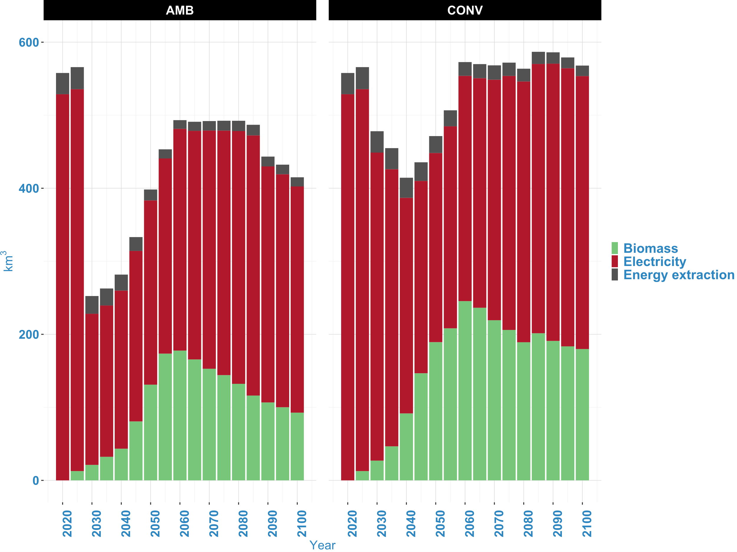
Supplementary Figure 14 Water withdrawal implications. Water withdrawal by three energy-related activities: bioenergy crop cultivation, electricity generation, and extraction of primary energy resources (coal, oil, gas, nuclear). Large-scale reliance on CDR under the CONV pathway increases bioenergy crop cultivation and their related water withdrawals compared to the AMB pathway. Although AMB requires higher electrification, especially in the near term, its related water withdrawal is relatively lower compared to CONV. This is due to the faster phase-out of carbon-based electricity generation technologies under AMB, which reduces the amount of water withdrawn for electricity generation.

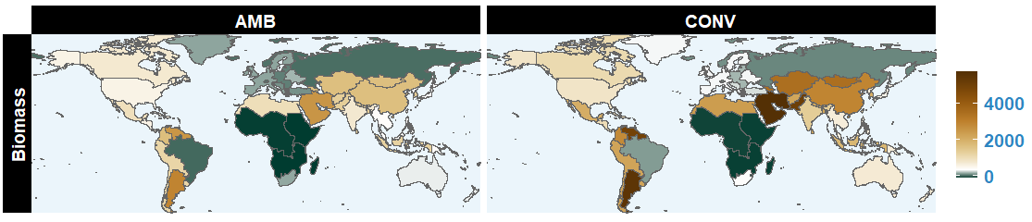
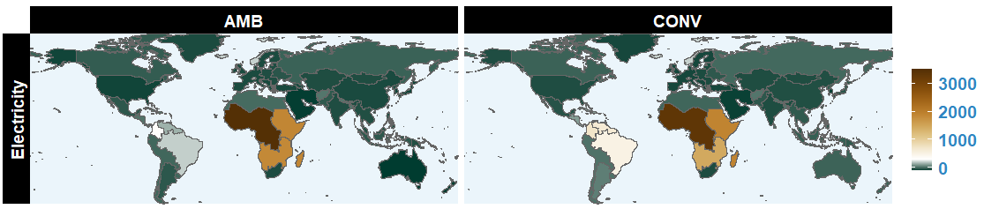
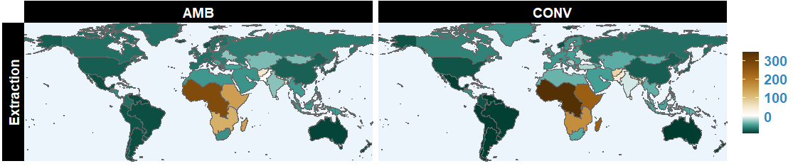
Supplementary Figure 15 Change in water withdrawal for energy-related purposes between 2025-2100 (%). Water withdrawals by three energy-related activities—bioenergy crop cultivation, electricity generation, and extraction of primary energy resources (coal, oil, gas, nuclear)—show different trends over time. For bioenergy crop cultivation and electricity generation, there is a general increase in water withdrawals due to rising energy demand, electrification of end-use sectors, and CO₂ removal efforts. However, water withdrawals for primary energy extraction generally decrease over time as fossil fuels phase down under climate change mitigation actions. For electricity generation and bioenergy crop cultivation (on a global average), water withdrawal increases are expected to be higher under the CONV pathway than under the AMB pathway. This is due to AMB’s lower CDR demand and the rapid phase-out of carbon-based electricity generation technologies. For example, under CONV, global average changes in water withdrawals for electricity generation and bioenergy crop cultivation are 260% and 1650%, respectively, compared to 225% and 830% under AMB. The largest growth in water withdrawals for bioenergy crop cultivation is expected in the Middle East and Argentina, particularly under CONV, while the largest growth in water withdrawals for electricity generation is expected to occur in Africa. Regarding water withdrawals for primary energy extraction, the highest reduction is expected under AMB, with a global average decrease of 35% compared to 20% under CONV. The most significant reductions in water withdrawals for primary energy extraction are expected in South America, Australia, and Mexico.
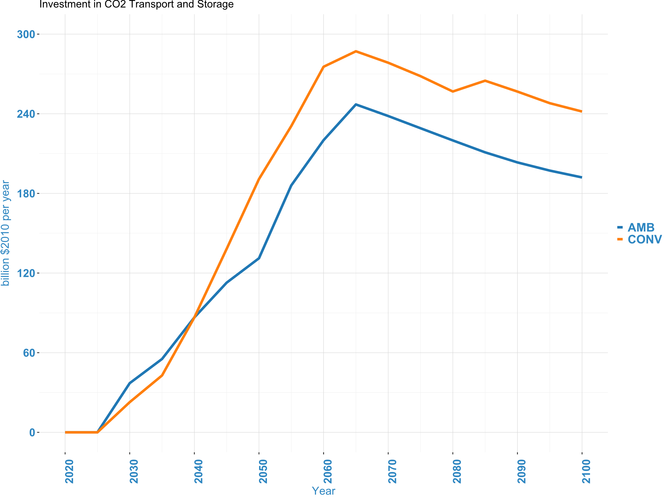
Supplementary Figure 16 Investment cost in energy supply related to CO₂ transport and storage

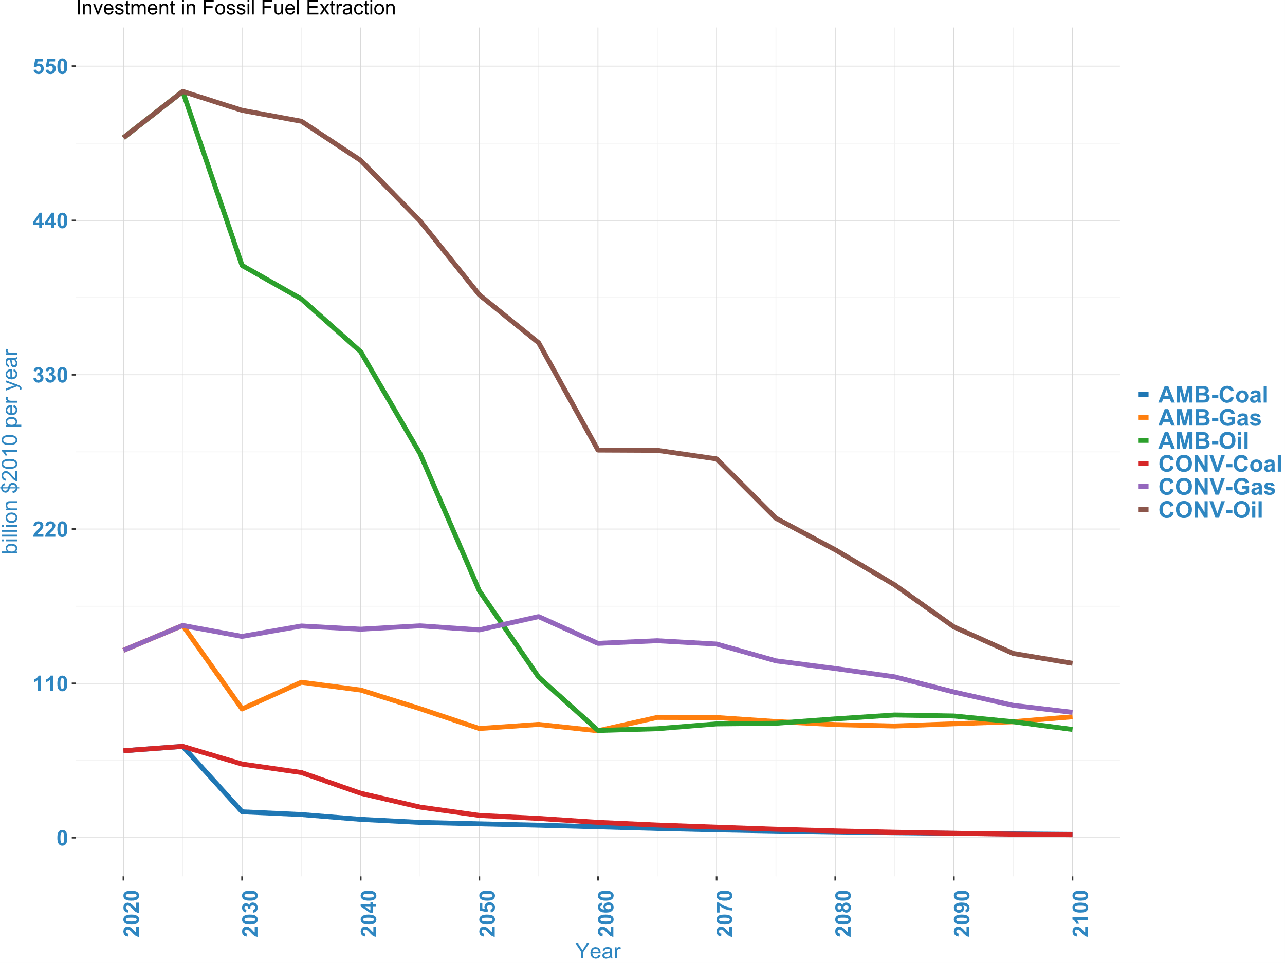
Supplementary Figure 17 Investment cost in energy supply related to fossil fuel (oil, coal, gas) extraction
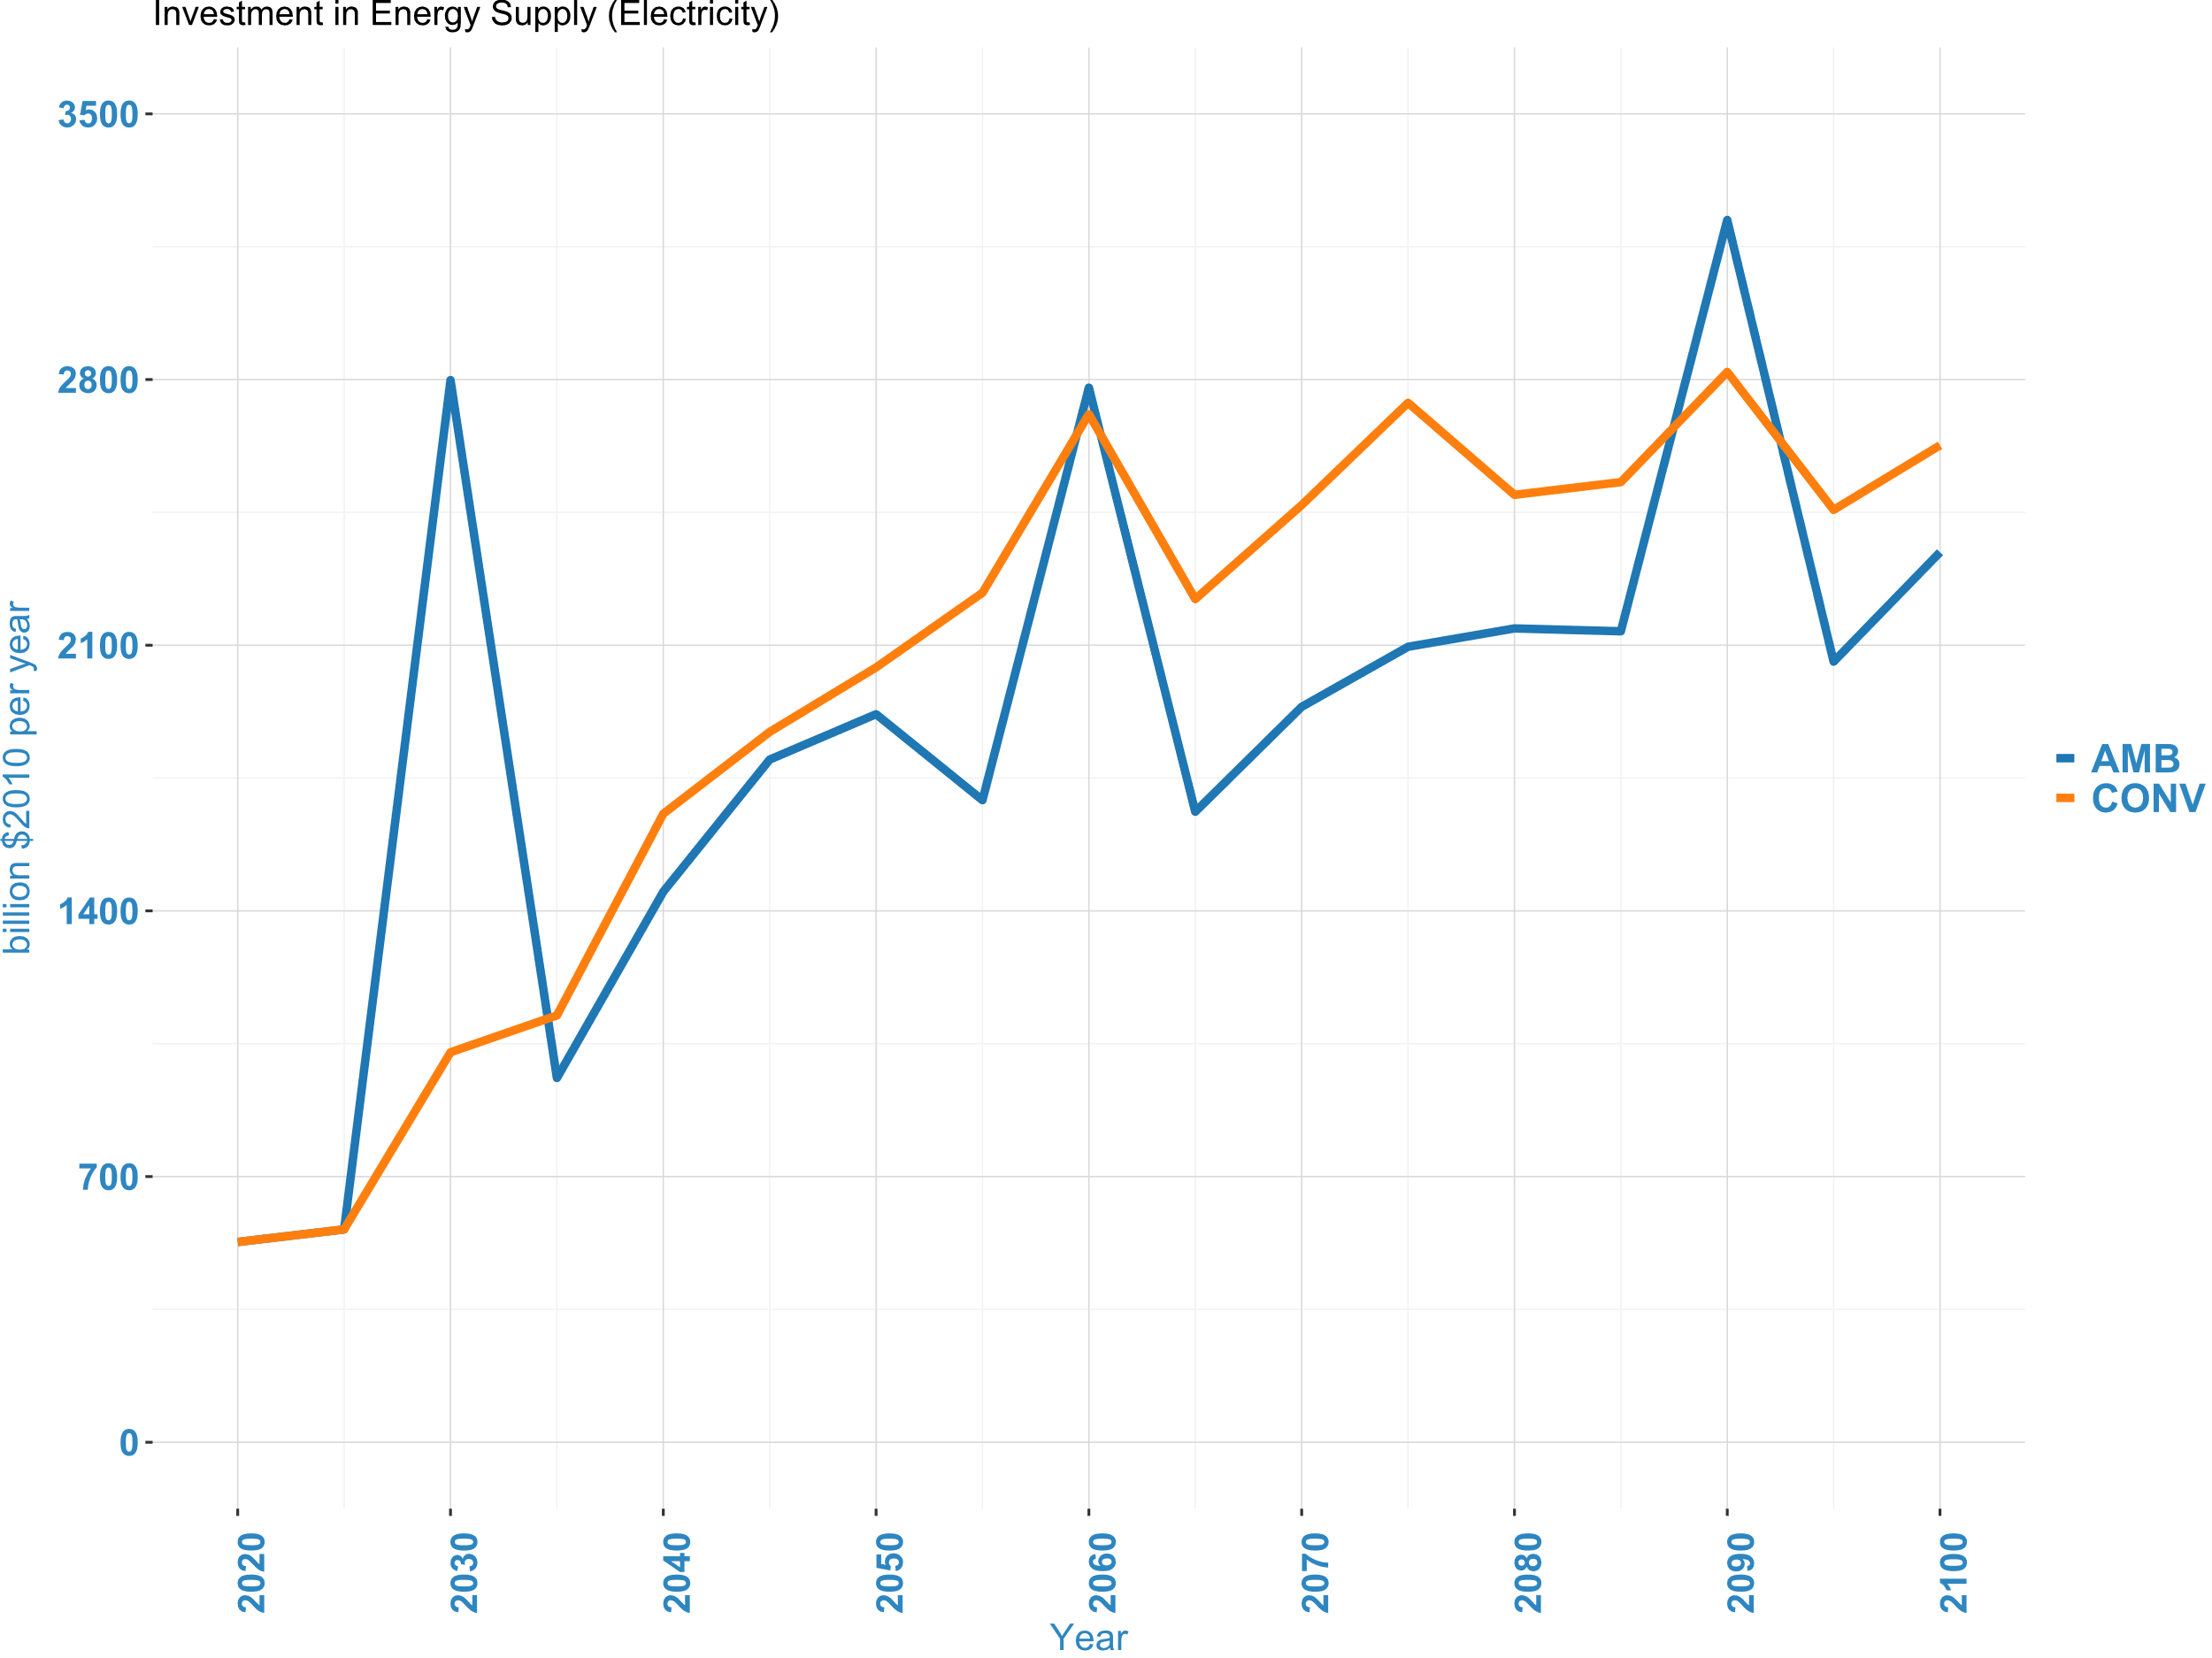
Supplementary Figure 18 Investment cost in energy supply related to electricity
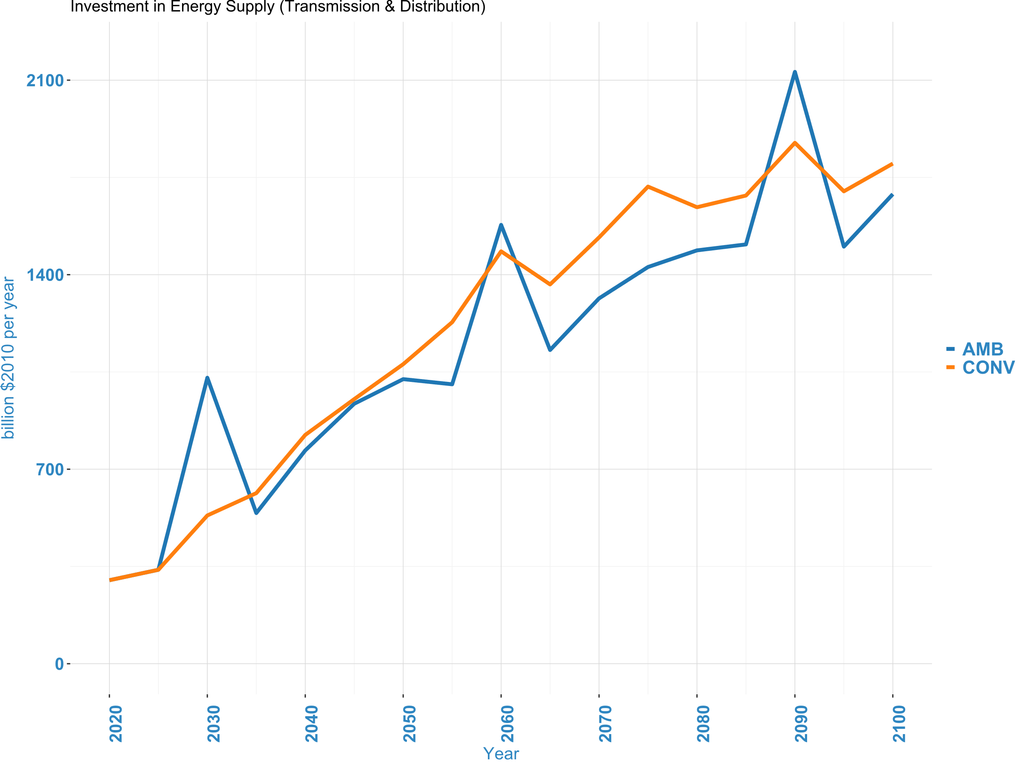
Supplementary Figure 19 Investment cost in energy supply related to electricity transmission and distribution

Supplementary Tables

Supplementary Table 1 Input assumptions for SECT-FAIR scenario
GCAM Region | Zero emissions power sector | Modeled period for power based on ‘ability to pay’ equity principle* | Zero emissions transport sector | Modeled period for transport based on ‘ability to pay’ equity principle*
Middle East | By 2040-2043 | 2045 | By 2055-2067 | 2065
European Non-EU | By 2038-2039 | 2040 | By 2049-2070 | 2070
Southeast Asia | By 2040 | 2040 | By 2055-2068 | 2070
Central Asia | By 2033-2040 | 2040 | By 2055-2058 | 2060
Africa Northern | By 2036-2039 | 2040 | By 2050-2065 | 2065
Africa Western | By 2030-2040 | 2040 | By 2047-2053 | 2055
South Asia | By 2040 | 2040 | By 2048-2065 | 2065
South America Southern | By 2030-2038 | 2040 | By 2049-2051 | 2050
South America Northern | By 2035-2039 | 2040 | By 2052 | 2050
European Eastern | By 2040-2041 | 2040 | By 2055-2066 | 2065
European Free Trade Association | By 2025 | 2025 | By 2046-2049 | 2045
Central America and the Caribbean | By 2038-2040 | 2040 | By 2036-2050 | 2050
Australia_New Zealand | By 2039-2040 | 2040 | By 2052-2057 | 2050
Africa Eastern | By 2025 | 2025 | By 2047-2050 | 2050
Africa Southern | By 2030-2031 | 2030 | By 2047-2050 | 2050
China (including Taiwan) | By 2030-2039 | 2030 | By 2049-2050 | 2050
India | By 2039-2040 | 2040 | By 2041-2059 | 2060
Indonesia | By 2035-2040 | 2040 | By 2055-2058 | 2060
Japan | By 2040-2043 | 2040 | By 2053-2057 | 2055
Pakistan | By 2038 | 2040 | By 2048-2066 | 2065
South Korea | By 2040-2045 | 2040 | By 2050-2062 | 2050
Argentina | By 2034-2038 | 2040 | By 2044-2049 | 2050
Brazil | By 2025-2030 | 2030 | By 2037-2048 | 2050
Colombia | By 2027-2035 | 2035 | By 2050-2063 | 2065
Mexico | By 2039 | 2040 | By 2051-2056 | 2055
South Africa | By 2036-2040 | 2040 | By 2037-2062 | 2060
Canada | By 2029-2030 | 2030 | By 2051-2054 | 2050
US | By 2036 | 2035 | By 2044-2054 | 2045
EU-27 (i.e. EU15 and 12) | By 2038-2040 | 2040 | By 2048-2053 | 2050
Russia | By 2039 | 2040 | By 2049-2054 | 2050
* Since the data from Climate Analytics has an upper and lower bound, we have to decide on which bound to model for each country. Thus, the regions were divided into two based on equity principle. The modeled period (highlighted in yellow) is based on the 'ability to pay' principle, where we assume that a country with more resources is more capable of financing its own decarbonization strategies. We assume that countries with GDP per capita below the global average would require more time and resources (financial assistance) to decarbonize their sectors, irrespective of their total GDP and cumulative emissions, compared to countries with GDP per capita higher than the global average. The lower bound (i.e., the country/region reaches zero carbon in the sector earlier) is applied when the GDP (at purchasing power parity) per capita is greater than the global average. The upper bound (i.e., the country/region reaches zero carbon in the sector late) is applied when the GDP (at purchasing power parity) per capita is lower than the global average. See the Method section from the main text for assumptions considered for regions not included in Climate Analytics’ assessment

Supplementary Note 1: Land use change as a carbon dioxide removal method in GCAM

GCAM tracks carbon flows between the atmosphere, biosphere, and anthroposphere resulting from land-use change (e.g., forest or grassland conversion to cropland). Under a carbon price policy, GCAM imposes a cost penalty on land-use change emissions and provides a subsidy for land-use carbon sequestration (e.g., expanding forest area). While fossil fuel emissions can theoretically be priced at the source, land-use change and agricultural emissions currently lack regulatory frameworks or mature market infrastructure. Realizing the full climate benefits of biospheric carbon management will require developing governance and pricing mechanisms for these diffuse emissions and sinks ¹⁴.
GCAM applies a carbon price to all anthropogenic carbon flows, despite the lack of existing policy levers for biospheric carbon. To better reflect real-world constraints, we implement a separate carbon price trajectory for land-use change emissions, starting at 10% in 2025 and linearly approaching the fossil fuel carbon price by 2100. This gradual convergence represents the long-term effort needed to implement land-use policies and infrastructure that address current barriers, including non-permanence risks of biospheric carbon storage. For sensitivity analysis, we have introduced two additional mitigation roles for the land use sector. These roles consist of a mid-range role, where a constant carbon price of 30% is applied to the land use sector from 2025 to 2050, and a low role, where a constant carbon price of 10% is applied to the land use sector over the same period.

Supplementary Note 2: BECCS as a carbon dioxide removal method in GCAM

GCAM includes bioenergy with carbon capture and storage (BECCS) technologies in the refining, electricity generation, hydrogen production and industrial sectors. The land, water, and fertilizer requirements for bioenergy supply and afforestation/reforestation are resolved endogenously in GCAM among 384 land-use regions. These regions represent the intersection of 32 geopolitical regions and 235 water basins. This accounts for the interactions with food crop production and natural lands ¹⁵. The parameterization of all biomass energy technologies, including BECCS, is based on previous GCAM studies ^{16–18}. In GCAM, land area allocated to biomass competes with other uses including cropland and natural lands. GCAM endogenously solves for irrigation water utilization (rainfed versus irrigated crops) and fertilizer application for biomass and all other agricultural commodities in each major river basin. It accounts for the yield effects of irrigation, fertilization, and any emissions tax or carbon sequestration subsidy ¹⁴.

Supplementary Note 3: DACCS as a carbon dioxide removal method in GCAM

We generally followed the detailed methodology of Fasihi et al. ¹⁹, adjusting the financial discount rate assumptions to derive more conservative early cost estimates for these emerging technologies. For low-temperature DACCS, we converted the required low-temperature thermal energy to electricity assuming an electric compression heat pump with a coefficient of performance of 3. We also accounted for the additional electricity required to compress the captured CO₂ to pressures suitable for subsurface injection. To better inform near-term deployment potential, we assumed cost and energy efficiency improvements over the next decade (by 2030) that remain constant thereafter. The 1.6- to 4-fold non-energy cost reductions for DACCS over 10 years are partly due to our initially conservative estimates but are within historical improvement rates for solar photovoltaics, batteries, and other mitigation technologies ²⁰. Given minimal biophysical constraints on global DACCS scaling, even our lower bound estimates of financial and energetic inputs represent relatively conservative technology advancement projections compared to other literature ^{19,21}.

Supplementary Note 4: ERW as a carbon dioxide removal method in GCAM

Enhanced rock weathering (ERW) accelerates natural processes that regulate Earth's carbon cycle over geological timescales ^{22–24}. Crushing calcium- or magnesium-bearing minerals increases their surface area, dramatically enhancing the reaction rate of atmospheric CO₂ into bicarbonate ions ^{25–27}. ERW has been demonstrated in lab experiments, small field trials, and idealized models ^{28–31}. Compared to DACCS, ERW may have lower removal costs per tonne CO₂ even considering crushing and transport energy inputs ^{19,32–34}. ERW poses less competition for land and water versus BECCS or afforestation/reforestation, as it can occur on already perturbed lands (e.g. cropland, managed forests/grasslands). Alkalinity addition may even boost crop yields and reduce irrigation needs in some climates and soils ^{35,36}. A portion of the bicarbonate precipitates into soils, while the remainder flows to oceans, ameliorating acidification ³⁷. However, dissolution along the land-aquatic-ocean continuum may reduce ERW efficacy ³⁸. Large material requirements may also cause local environmental damage from extraction, transport, crushing, and spreading ³⁹. We considered basalt ERW on croplands, using country-level potentials from Beerling et al. ²⁶ to develop regional supply curves in GCAM. For missing regions, we scaled the aggregated curve linearly by regional potentials from Strefler et al. ³². GCAM endogenously calculates regional electricity costs and carbon intensity, so we subtracted the fixed cost assumption from Strefler et al. ³². We assumed an electricity input declining from their 2020 upper bound of 2 Gigajoule per tonne of CO₂ (GJ per tCO₂) to their 2050 best estimate of 0.66 GJ per tCO₂. We also subtracted rock transport costs, with freight mode, fuel mix, and cost determined endogenously in GCAM. This leaves regional non-fuel cost supply curves. Assuming 300 km average transport and 0.3 tCO₂ per rock from Strefler et al. ³² gives a freight input of 1000 tonne-km per tCO₂ removed. This approach yields regional cost curves distinct from GCAM's existing geologic carbon disposal. For conservative 2020 estimates, each curve was shifted up by the "upper bound" versus "best estimate" differential in investment and operations/maintenance costs from Strefler et al. ³² ($138 per tCO₂). This adder declines to zero by 2050, leaving just the regional supply curves.

Supplementary Note 5: GCAM’s land module

In GCAM, economic land use decisions are based on a logit model sharing approach according to relative inherent profitability of competing purposes. This represents distributions of profit behind each land use rather than point estimates, with higher average profits conferring higher shares. At the margin, profits equalize across uses so allocation is optimal, unlike constrained linear optimization.
Land uses are nested within nodes, with higher logit exponents indicating tighter competition (e.g. substituting crops). Lower exponents govern harder substitution across nodes (e.g. cropland expansion into pasture). Although relative average profits determine shares, equal marginal profit rates across uses mean marginal land values equalize. If one use has higher average profit, its profit distribution has greater density exceeding the marginal rate, conferring higher share, unlike simple optimization. The nonlinear logit approach produces diminishing returns as land uses diverge from history, obviating explicit constraints. This contrasts linear models with constant returns. Logit exponents relate to land use change elasticities. See Wise et al. ⁴⁰ for further discussion.
The nesting strategy for competing land uses and substitution exponents (logit exponents) governing each nest involve expert judgement ⁴¹. In standard runs, historical calibration does not depend on this structure or exponents. Instead, they affect future projections as conditions diverge from history. At one extreme is a single nest with high exponent, representing completely unconstrained optimization and easy switching between any land uses. The other extreme is near-zero exponents, disallowing substitution. We employ positive exponents for economics-driven but constrained allocation. Our nesting approach captures varying substitutability across land categories. The hierarchy begins with total land, divided into agro-forestry and non-agricultural. The latter can subdivide further if needed. Agro-forestry comprises pasture and non-pasture nodes. Pasture includes managed grazing and unmanaged land. Non-pasture consists of shrub/grassland, forest, and cropland nodes, with forests competing against total croplands. Forests include managed, unmanaged, and woody biomass. Croplands encompass food, feed, fiber, and dedicated energy crops, plus fallow land. Crop areas further subdivide into irrigated/rainfed and high/low management. This structure balances model flexibility with computational constraints. The exponents aim to represent real-world frictions and transition costs limiting easy switching between all land uses.
The profit-based logit land sharing must be calibrated to match historical land use shares and profit rates. Conceptually, calibration infers distributions and parameters from data, given the chosen model structure. Based on the nesting, exponents, and base year data, the observed profit rates imply underlying economic land values. The approach is to solve for parameters that adjust observed profits to equal the potential average profits implied by base year shares and unmanaged land price. These implied rates represent average profit if all land went to that use; we refer to them as calibration profit rates. The resulting parameters (calibration profit scalers) rescale future projected profits in the logit sharing and profit equations. This grounds the future in history - with unchanged future conditions, shares and allocations reproduce the base year. As model dynamics shift future profits from historical values, shares also evolve. The absolute scaler values have meaning, unlike relative share weights. The calibration routine ensures internally consistent economics given the model structure, while allowing land use responses to diverging future conditions.
The equations that determine land allocation and the resulting carbon emissions from land-use and land-cover changes are described here.
The profit for managed land leafs is calculated in the supply module and passed to the land allocator. Profit for unmanaged land leafs is input into the model. Within the land allocator, profit is adjusted if land-related policies are included. Managed land leafs here generally refers to land areas that are under direct human management or influence. This can include agricultural lands, forest plantations, urban areas, and other land uses where human activities directly impact land cover and land use patterns.
The average profit of a node is calculated as (Supplementary Equation 1):
$$π_{i}={\left[\sum_{j=1}^{N}{λ_{j}^{ρ}π_{j}^{ρ}}\right]}^{\frac{1}{ρ}}$$ | (1)
Where $λ_{i}$ is the profit scaler for leaf or node $i$, $π_{i}$ is the profit for node $i$, $π_{j}$ is the profit for leaf or node $j$ contained within node $i$, and $ρ$ is the logit exponent.
The share of each leaf or node is calculated as (Supplementary Equation 2):
$$s_{i}=\frac{{\left(λ_{i}π_{i}\right)}^{ρ}}{\sum_{j=1}^{N}{{\left(λ_{j}π_{j}\right)}^{ρ}}}$$ | (2)
Where $s_{i}$ is the share of leaf or node $i,$ $λ_{i}$is the profit scaler for leaf or node $i,$ $π_{i}$ is the profit for leaf or node $i$, and $i,$ $ρ$ is the logit exponent.
To calculate land area, GCAM works its way down the nesting tree, starting from the top where the total land area in a region is provided as an input. For each node or leaf below, the area was calculated as (Supplementary Equation 3):
$$a_{i}=a_{above}*s_{i}$$ | (3)
where $a_{i}$ is the area for leaf or node $i,$ $s_{i}$is the share, and $a_{above}$ is the area of the parent node.
The total cumulative change in emissions is calculated as (Supplementary Equation 4):
$$E_{t}^{veg/soil}=∆C_{t}=A_{t}*D_{t}^{{veg}/{soil}}-A_{t-1}*D_{t-1}^{veg/soil}$$ | (4)
where $E$ indicates carbon emissions due to a land use change in time step $t$, $C$ indicates carbon stocks, $A$ indicates land area, and $D$ indicates the average carbon density of the land area. These emissions are allocated differently over time for vegetation and soil carbon.
If vegetation emissions are positive (i.e., $E_{t}^{veg}>0$), then all emissions are released in the current year $y$. That is, $E_{y}^{veg}=E_{t}^{veg}$.
If vegetation emissions are negative, then these emissions are spread over time using a sigmoid function (Supplementary Equation 5):
$$E_{y}^{veg}=E_{t}^{veg}*{\left[1-e^{\frac{-3.0*\left(y-t+1\right)}{M}}\right]}^{2}-{\left[1-e^{\frac{-3.0*\left(y-t\right)}{M}}\right]}^{2}$$ | (5)
where $t$ is the time of land conversion, $y$ is the current year, and $M$ is the mature age (specified by land type and region).
Soil carbon emissions followed an exponential approach (Supplementary Equation 6):
$$E_{y}^{soil}=E_{t}^{soil}*\left[\left(1.0-e^{-1.0*κ*(y-t)}\right)-\left(1.0-e^{-1.0*κ*(y-t-1)}\right)\right]$$ | (6)
where $κ=\frac{\log{(2)}}{s/{10.0}}$ and $s$ is the soil time scale, specified by region.
Total carbon stock, $C_{y}$ in year, $y$ is calculated as (Supplementary Equation 7):
$$C_{y}=C_{y-1}-\left[E_{y-1}^{veg}+E_{y-1}^{soil}\right]$$ | (7)
where $E_{y}^{veg}$ are vegetation carbon emissions in year $y$ and $E_{y}^{soil}$ are soil carbon emissions in year $y$.

Supplementary Note 6: GCAM’s water module

Water demand is calculated for six major sectors: agriculture, electricity generation, industrial manufacturing, primary energy production, livestock, and municipal uses.
Agriculture water demand is determined by exogenous water coefficients and endogenous crop production. For irrigated crops, GCAM tracks water withdrawals, consumption, and biophysical consumption. Withdrawals include crop evapotranspiration met by irrigation ("blue water") and field losses. Conveyance losses are represented in water distribution sectors. Loss coefficients are from Rohwer et al. ⁴². Consumption is the blue water evapotranspiration only, excluding rainfall ("green water"). Biophysical consumption sums blue and green water needs, excluding losses. It applies to both rainfed and irrigated technologies. More documentation is available in Chaturvedi et al. ⁴³ and Hejazi et al. ⁴⁴. The model accounts for different agricultural water flows and losses to represent water resource competition and agricultural production.
GCAM represents up to five cooling options for each thermal power technology: once-through, recirculating, pond, dry, and seawater once-through. These differ significantly in water withdrawal and consumption per National Energy Technology Laboratory (NETL) ⁴⁵. Technology-specific demand coefficients are from Macknick et al. ⁴⁶. Not all options are available in each region based on underlying data; for example, cooling ponds are often excluded. Currently there is no dry cooling option for nuclear plants. Cooling systems compete in a calibrated logit nest, like fuels. Capital costs vary per NETL ⁴⁵. Dry cooling has lower generation efficiency. Competition is endogenous and cost-based. Further documentation is in Davies et al. ⁴⁷ and Kyle et al. ⁴⁸. The model captures different power plant cooling technologies and associated water demands to represent electricity-water interlinkages.
The industrial manufacturing sector’s water demands include surface and groundwater that is self-supplied by industrial manufacturers. The water demanded by this sector excludes water demands of coal mining and oil and gas production, which are represented in the respective energy production sectors. It also excludes water withdrawn for cooling of on-site (i.e., located at industrial facilities) thermo-electric power generation, which is modeled in the electricity generation sector. Finally, industrial facilities’ use of municipal water is also excluded (modeled in the municipal water sector).
All animal production technologies in GCAM have region-specific water demand coefficients representing drinking water and operations. There is no withdrawal/consumption distinction; all water is consumed. Coefficients are in cubic meters per kg commodity produced. They are calculated from Mekonnen and Hoekstra ⁴⁹, which provides liters per animal per day by country around 2000. Computation also considers animal stocks from Food and Agriculture Organization Corporate Statistical Database ( FAOSTAT) ⁵⁰. The resulting demand coefficients are held constant over time. This approach captures livestock water needs and links them to regional production levels. The coefficients integrate data on water use per animal and animal inventories to represent total water demands.
The approach for modeling the water demands of primary energy production is documented in Hejazi et al. ⁴⁴, and includes bottom-up estimates of water demand per unit energy produced for the following fuels: coal, oil (conventional and unconventional), natural gas, and uranium. The main data source used for estimating water consumption per unit energy produced is Maheu ⁵¹, which offers global average water consumption coefficients for each fuel type. These coefficients are somewhat higher than the values used in GCAM, as they do not distinguish between seawater and freshwater. The values read into GCAM are therefore the Maheu ⁵¹ estimates less the fraction assumed to be seawater. This fraction is assumed to be 95% in the Middle East, and 43% in all other regions; the latter value is from a USA-based estimate in Kenny et al. ⁵². Water withdrawals are estimated as water consumption multiplied by an exogenous withdrawal to consumption ratio of 3.3, which comes from a 1995 USA assessment ⁵³.
Food and Agriculture Organization (FAO) Aquastat ⁵⁴ withdrawals are assigned to a municipal water sector in each region, growing with population, GDP, and moderated by technical change. Prices are from International Benchmarking Network (IBNET) ⁵⁵. The demand projection functional form accounts for future price increases. Consumption is also modeled, with the distinction from withdrawals based on an overall municipal supply efficiency from Shiklomanov ⁵⁶. Withdrawals indicate total input to the supply system, while consumption is the volume not returned. The future withdrawal/consumption ratio is static, so both scale with demand. This represents growing municipal water needs. Adaptation measures can explore altering intensity. See Hejazi et al.^{44,57} for details. The approach combines data on total use and supply efficiency to separately model withdrawn and consumed municipal water.

Supplementary Note 7: GCAM’s fertilizer module

GCAM includes a nitrogen (N) fertilizer module with regional production technologies and crop/AEZ consumption. Production and consumption by country use FAO ResourceSTAT data, with uniform downward adjustment of production so global totals match consumption excluding non-agricultural uses. Production shares by technology are from International Energy Agency (IEA), which also provides regional energy intensities. Consumption is downscaled to crops via International Fertilizer Association (IFA)/FAO data, then to AEZ based on crop production and USDA details for the USA. Non-fuel costs are calibrated to market prices in base years. Input-output coefficients (kgN per kg crop) are constant, so future demand scales with yield improvements. FAO provides historical production including non-agricultural uses, exceeding consumption by 5-10%. GCAM includes only agricultural fertilizer, so global production is uniformly adjusted downward to match consumption. With significant base year trade, GCAM includes exogenous fertilizer trade. Exporting regions have additional fixed final demand, while importers have extra production without energy inputs. This captures fertilizer production technologies, energy use, consumption by crop and location, and trade flows to represent agricultural nitrogen demands.

Supplementary Note 8: Model parameterization

In this section, some underlying parameters/modelling assumptions are presented. Unless cited otherwise, all information is obtained from Ref. ⁵⁸, and additional information not discussed or presented here can be obtained from the same source.
Supplementary Table 2 Capital cost assumptions for the electric power sector (2010 $ per kilowatt (kW))
Electricity Generation  Technology | Overnight Capital Costs (2010 $ per kW)
Electricity Generation  Technology | 2020 | 2030 | 2050
Biomass (conventional) | 3,951 | 3,818 | 3,702
Biomass (Integrated Gasification Combined Cycle) | 5,745 | 5,180 | 4,819
Biomass (conventional with Carbon Capture and Storage) | 7,317 | 6,568 | 6,168
Biomass (Integrated Gasification Combined Cycle with Carbon Capture and Storage) | 8,337 | 7,298 | 6,720
Coal (conventional pulverized) | 2,337 | 2,242 | 2,196
Coal (Integrated Gasification Combined Cycle) | 3,060 | 2,854 | 2,769
Coal (conventional pulverized with Carbon Capture and Storage) | 5,503 | 4,925 | 4,619
Coal (Integrated Gasification Combined Cycle with Carbon Capture and Storage) | 4,020 | 3,607 | 3,448
Gas (Combined Cycle) | 859 | 824 | 807
Gas (steam/Combustion Turbine) | 911 | 875 | 857
Gas (Combined Cycle with Carbon Capture and Storage) | 1,864 | 1,677 | 1,605
Refined liquids (steam/Combustion Turbine) | 742 | 717 | 694
Refined liquids (Combined Cycle) | 1,036 | 1,004 | 972
Refined liquids (Combined Cycle with Carbon Capture and Storage) | 2,356 | 2,079 | 1,937
Generation II Light Water Reactor (Nuclear) | 5,500 | 5,500 | 5,500
Generation III (Nuclear) | 4,400 | 4,044 | 3,901
Concentrated Solar Power | 3,415 | 3,077 | 2,946
Concentrated Solar Power with storage | 7,430 | 6,329 | 5,771
Photovoltaic | 1,856 | 1,534 | 1,514
Photovoltaic with storage | 4,212 | 3,799 | 3,534
Wind | 1,662 | 1,526 | 1,481
Wind with storage | 5,555 | 5,006 | 4,661
Rooftop Photovoltaic | 4,499 | 4,057 | 3,776
Geothermal | 4,348 | 4,199 | 4,073
This table presents only the overnight capital costs. A fixed charge rate of 13% is assumed to amortize capital costs over the capital lifetime of a power plant.
Supplementary Table 3 Physical lifetime assumptions for technologies in the electric power sector
Technology | Lifetime (years)
Biomass (conventional) | 60
Biomass (Integrated Gasification Combined Cycle) | 60
Biomass (conventional with Carbon Capture and Storage) | 60
Biomass (Integrated Gasification Combined Cycle with Carbon Capture and Storage) | 60
Coal (conventional pulverized) | 60
Coal (Integrated Gasification Combined Cycle) | 60
Coal (conventional pulverized with Carbon Capture and Storage) | 60
Coal (Integrated Gasification Combined Cycle with Carbon Capture and Storage) | 60
Gas (Combined Cycle) | 45
Gas (steam/Combustion Turbine) | 45
Gas (Combined Cycle with Carbon Capture and Storage) | 45
Refined liquids (steam/Combustion Turbine) | 45
Refined liquids (Combined Cycle) | 45
Refined liquids (Combined Cycle with Carbon Capture and Storage) | 45
Generation II Light Water Reactor (Nuclear) | 60
Generation III (Nuclear) | 60
Wind | 30
Wind with storage | 30
Photovoltaic | 30
Photovoltaic with storage | 30
Concentrated Solar Power | 30
Concentrated Solar Power with storage | 30
Geothermal | 30

Supplementary Table 4 Fraction of CO₂ captured by transformation technologies
Supply sector | Subsector | Technology | 1971 | 2100
Refining | Coal to liquids | Coal to liquids ccs level 1 | 0.818 | 0.818
Refining | Coal to liquids | Coal to liquids ccs level 2 | 0.9 | 0.9
Refining | Biomass liquids | Cellulosic ethanol ccs level 1 | 0.26 | 0.26
Refining | Biomass liquids | Cellulosic ethanol ccs level 2 | 0.9 | 0.9
Refining | Biomass liquids | Ft biofuels ccs level 1 | 0.818 | 0.818
Refining | Biomass liquids | Ft biofuels ccs level 2 | 0.9 | 0.9
Ft: Fischer-Tropsch; ccs: carbon capture and storage

Supplementary Table 5 Primary energy transformation technologies default cost assumptions (1975$ per GJ)
Supply sector | Technology | 1971 | 2010 | 2100 | Improvement max | Improvement rate
Gas processing | Natural gas | 0.2 | 0.2 | 0.2
Gas processing | Biomass gasification | 7.030087 | 7.030087 |  | 0.7 | 0.03
Gas processing | Coal gasification | 5.285779 | 5.285779 |  | 0.7 | 0.03
Nuclear fuel generation II | Enriched uranium | 0.124464 | 0.124464 | 0.124464
Nuclear fuel generation III | Enriched uranium | 0.124464 | 0.124464 | 0.124464
Refining | Oil refining | 0.84 | 0.84 | 0.84
Refining | Coal to liquids | 5.294118 | 5.294118 |  | 0.7 | 0.03
Refining | Coal to liquids ccs level 1 | 5.980615 | 5.980615 |  | 0.6 | 0.05
Refining | Coal to liquids ccs level 2 | 6.467671 | 6.467671 |  | 0.6 | 0.05
Refining | Gas to liquids | 3.970588 | 3.970588 |  | 0.7 | 0.03
Refining | Cellulosic ethanol | 4.74 | 4.74 |  | 0.7 | 0.03
Refining | Cellulosic ethanol ccs level 1 | 4.991818 | 4.991818 |  | 0.6 | 0.05
Refining | Cellulosic ethanol ccs level 2 | 6.850562 | 6.850562 |  | 0.6 | 0.05
Refining | Fischer Tropsch (Ft) biofuels | 7.802308 | 7.802308 |  | 0.7 | 0.03
Refining | Ft biofuels ccs level 1 | 8.516923 | 8.516923 |  | 0.6 | 0.05
Refining | Ft biofuels ccs level 2 | 8.97527 | 8.97527 |  | 0.6 | 0.05
Refining | Corn ethanol | 2.38 | 2.38 | 2.38
Refining | Sugar cane ethanol | 2 | 2 | 2
Refining | Biodiesel | 1.88 | 1.88 | 1.88
Ft: Fischer-Tropsch; ccs: carbon capture and storage

Supplementary Table 6 Electricity technology capacity factors
Supply sector | Subsector | Technology | 1971 | 2100
Electricity | Coal | Coal (Conventional Pulverized Coal | 0.85 | 0.85
Electricity | Coal | Coal (Conventional Pulverized Coal with CCS) | 0.8 | 0.8
Electricity | Coal | Coal (Integrated Gasification Combined Cycle) | 0.8 | 0.8
Electricity | Coal | Coal (Integrated Gasification Combined Cycle with CCS) | 0.8 | 0.8
Electricity | Gas | Gas (Steam Cycle/Turbine) | 0.8 | 0.8
Electricity | Gas | Gas (Combined Cycle) | 0.85 | 0.85
Electricity | Gas | Gas (Combined Cycle with CCS) | 0.8 | 0.8
Electricity | Refined liquids | Refined liquids (Steam Cycle/Turbine) | 0.8 | 0.8
Electricity | Refined liquids | Refined liquids (Combined Cycle) | 0.85 | 0.85
Electricity | Refined liquids | Refined liquids (Combined Cycle with CCS) | 0.8 | 0.8
Electricity | Biomass | Biomass (conventional) | 0.85 | 0.85
Electricity | Biomass | Biomass (conventional with CCS) | 0.85 | 0.85
Electricity | Biomass | Biomass ((Integrated Gasification Combined Cycle) | 0.8 | 0.8
Electricity | Biomass | Biomass ((Integrated Gasification Combined Cycle with CCS) | 0.8 | 0.8
Electricity | Nuclear | Generation II Light Water Reactor | 0.9 | 0.9
Electricity | Nuclear | Generation III | 0.9 | 0.9
Electricity | Wind | Wind | 0.37 | 0.37
Electricity | Wind | Wind with storage | 0.37 | 0.37
Electricity | Solar | Photovoltaic (PV) | 0.2 | 0.2
Electricity | Solar | PV with storage | 0.2 | 0.2
Electricity | Solar | Concentrated solar power (CSP) | 0.25 | 0.25
Electricity | Solar | CSP with storage | 0.5 | 0.5
Electricity | Geothermal | Geothermal | 0.9 | 0.9
Electricity | Rooftop Photovoltaic (PV) | Rooftop Photovoltaic (PV) | 0.17 | 0.17

Supplementary Table 7 Electricity technology capture fractions (portion of CO₂ emissions that are captured)
Supply sector | Subsector | Technology | 1971 | 2020 | 2100
Electricity | Coal | Coal (Conventional Pulverized Coal with CCS) | 0.85 | 0.85 | 0.95
Electricity | Coal | Coal (Integrated Gasification Combined Cycle with CCS) | 0.85 | 0.85 | 0.95
Electricity | Gas | Gas (Combined Cycle with CCS) | 0.85 | 0.85 | 0.95
Electricity | Refined liquids | Refined liquids (Combined Cycle with CCS) | 0.85 | 0.85 | 0.95
Electricity | Biomass | Biomass (conventional with CCS) | 0.85 | 0.85 | 0.95
Electricity | Biomass | Biomass ((Integrated Gasification Combined Cycle with CCS) | 0.85 | 0.85 | 0.95

Supplementary Table 8 Electricity technology retirement parameters
Subsector | Technology | Year | Lifetime | Half life | Steepness
Coal | Coal (Conventional Pulverized Coal) | Final-calibration-year | 60 | 30 | 0.1
Gas | Gas (Steam Cycle/Turbine) | Final-calibration-year | 45 | 22.5 | 0.1
Gas | Gas (Combined Cycle) | Final-calibration-year | 45 | 22.5 | 0.1
Refined liquids | Refined liquids (Steam Cycle/Turbine) | Final-calibration-year | 45 | 22.5 | 0.1
Biomass | Biomass (conventional) | Final-calibration-year | 60 | 30 | 0.1
Nuclear | Generation II Light Water Reactor | Final-historical-year | 60 | 30 | 0.1
Wind | Wind | Final-calibration-year | 30 | - | -
Solar | Photovoltaic | Final-calibration-year | 30 | - | -
Solar | Concentrated solar power | Final-calibration-year | 30 | - | -
Geothermal | Geothermal | Final-calibration-year | 30 | - | -
Coal | Coal (Conventional Pulverized Coal) | Initial-future-year | 60 | - | -
Coal | Coal (Integrated Gasification Combined Cycle) | Initial-future-year | 60 | - | -
Coal | Coal (Integrated Gasification Combined Cycle with Carbon Capture and Storage) | Initial-future-year | 60 | - | -
Gas | Gas (Combined Cycle with Carbon Capture and Storage) | Initial-future-year | 45 | - | -
Refined liquids | Refined liquids (Combined Cycle) | Initial-future-year | 45 | - | -
Refined liquids | Refined liquids (Combined Cycle with Carbon Capture and Storage) | Initial-future-year | 45 | - | -
Biomass | Biomass (conventional with CCS) | Initial-future-year | 60 | - | -
Biomass | Biomass (Integrated Gasification Combined Cycle) | Initial-future-year | 60 | - | -
Biomass | Biomass (Integrated Gasification Combined Cycle with Carbon Capture and Storage) | Initial-future-year | 60 | - | -
Nuclear | Generation III | Initial-nonhistorical-year | 60 | - | -
Wind | Wind with storage | Initial-future-year | 30 | - | -
Solar | Photovoltaic with storage | Initial-future-year | 30 | - | -
Solar | Concentrated solar power with storage | Initial-future-year | 30 | - | -
Wind | Wind offshore | Final-calibration-year | 25 | - | -
Wind | Wind offshore | Initial-future-year | 25 | - | -
Note: lifetime: maximum lifetime of cohort. If no retirement function is used; the entire cohort is retired in this number of years. half life: number of years at which 50% of the cohort is retired; using the s-curve-shutdown-decider retirement function. steepness: shape parameter used by the s-curve-shutdown-decider retirement function.
Supplementary Table 9 Industrial energy use default efficiencies
Technology | Energy input | Secondary output | 1971 | 2020 | 2050 | 2080 | 2100
Biomass | Delivered biomass |  | 0.746423 | 0.797 | 0.81 | 0.823 | 0.828
Biomass cogeneration | Delivered biomass | Electricity | 0.515677 | 0.56 | 0.577 | 0.595 | 0.604
Coal | Delivered coal |  | 0.80808 | 0.891 | 0.909 | 0.926 | 0.936
Coal cogeneration | Delivered coal | Electricity | 0.582005 | 0.629 | 0.644 | 0.661 | 0.67
District heat | District heat |  | 1 | 1 | 1 | 1 | 1
Electricity | Electricity (industry) |  | 0.934197 | 1.015 | 1.046 | 1.078 | 1.094
Gas | Wholesale gas |  | 0.82583 | 0.898 | 0.926 | 0.955 | 0.969
Gas cogeneration | Wholesale gas | Electricity | 0.563321 | 0.612 | 0.63 | 0.649 | 0.659
Hydrogen | Hydrogen enduse |  | 1 | 1 | 1.03 | 1.062 | 1.078
Hydrogen cogeneration | Hydrogen enduse | Electricity | 0.457 | 0.457 | 0.471 | 0.485 | 0.492
Refined liquids | Refined liquids industrial |  | 0.917381 | 1.001 | 1.033 | 1.062 | 1.077
Refined liquids cogeneration | Refined liquids industrial | Electricity | 0.565189 | 0.614 | 0.632 | 0.652 | 0.662
Coal | Delivered coal |  | 1 | 1 | 1 | 1 | 1
Gas | Wholesale gas |  | 1 | 1 | 1 | 1 | 1
Refined liquids | Refined liquids industrial |  | 1 | 1 | 1 | 1 | 1

Supplementary Table 10 Carbon storage resource supply curve points (2005$ per tCO₂)
Resource | Subresource | Grade | Fraction | Cost
Onshore carbon-storage | Onshore carbon-storage | Grade 1 | 0 | 0
Onshore carbon-storage | Onshore carbon-storage | Grade 2 | 0.005 | 0.1
Onshore carbon-storage | Onshore carbon-storage | Grade 3 | 0.1 | 5
Onshore carbon-storage | Onshore carbon-storage | Grade 4 | 0.6 | 10
Onshore carbon-storage | Onshore carbon-storage | Grade 5 | 0.295 | 75
Onshore carbon-storage | Onshore carbon-storage | Grade 6 | 0 | 3500

Supplementary Table 11 CO₂ capture rates for direct air capture (DAC) and process heat DAC technology
Supply sector | Subsector | Technology | 1971 | 2100
Process heat DAC | Gas ccs | Gas ccs | 0.95 | 0.95
CO₂ removal | DAC | High temperature DAC (natural gas) | 1 | 1
CO₂ removal | DAC | High temperature DAC (electricity) | 1 | 1
CO₂ removal | DAC | Low temperature DAC (heat pump) | 1 | 1
DAC: direct air capture; ccs: carbon capture and storage

Supplementary Table 12 Parametrizations for DACCS Technologies ⁵⁹
Technology | Scenario | Natural gas (GtCO₂) |  | Electricity (GtCO₂) |  | Non-energy cost (2015 $tCO₂) |  | Water cubic metres per tonne of CO₂ (m³ per tCO₂)
Technology | Scenario | 2020 | 2030 | 2020 | 2030 | 2020 | 2030 | 2020 | 2030
High temperature direct air capture and carbon storage (DACCS) (natural gas) | Shared Socio-economic pathway (SSP) 2-middle of the road |  | 5.3 |  | 1.3 |  | 185 | 4.7
High temperature DACCS (fully electric) | SSP2-middle of the road | _ |  |  | 5 |  | 186 | 4.7
Low temperature DACCS (electric heat pump) | SSP2-middle of the road | _ |  |  | 2.5 |  | 235 | _
Values are assumed to remain constant after 2030

Supplementary Table 13 Enhanced Weathering Cost Adder ^{15,32}
Cost type | Upper bound | Best estimate | Units
Investment | $14 | $6 | $ per t rock
Operating and maintenance (O&M) | $59 | $26 | $ per t rock
Total non-cost fuel | $73 | $31 | $ per t rock
Total non-cost fuel | $242 | $104 | $ per t CO₂
Difference between upper bound + best estimate (2020 cost adder for GCAM assumption; declines to zero by 2050) | $138 |  | $ per t CO₂

Supplementary Table 14 Electrical energy inputs for enhanced weathering ^{15,32}
Best estimate | 0.66 | Gigajoule (GJ) per tCO₂
Lower bound | 0.23 | GJ per tCO₂
Upper bound | 2.03 | GJ per tCO₂

Supplementary Table 15 Average vegetation carbon density by SAGE biome type ⁶⁰
GCAM category | SAGE category | C density (Megagrams of Carbon per Hectare (MgC per ha))
AllForestLand | Tropical Evergreen Forest/Woodland | 200
AllForestLand | Tropical Deciduous Forest/Woodland | 140
AllForestLand | Temperate Broadleaf Evergreen Forest/Woodland | 154
AllForestLand | Temperate Needleaf Evergreen Forest/Woodland | 160
AllForestLand | Temperate Deciduous Forest/Woodland | 135
AllForestLand | Boreal Evergreen Forest/Woodland | 90
AllForestLand | Boreal Deciduous Forest/Woodland | 90
AllForestLand | Evergreen/Deciduous Mixed Forest/Woodland | 103 (Agro-Ecological Zone (AEZs) 1-12)
AllForestLand | Evergreen/Deciduous Mixed Forest/Woodland | 50 (AEZs 13-18)
GrassLand | Savanna | 25
GrassLand | Grassland/Steppe | 4-10*ª
ShrubLand | Dense Shrubland | 55
ShrubLand | Open Shrubland | 27
Tundra | Tundra | 9
RockIceDesert | Desert | 1
RockIceDesert | Polar Desert/Rock/Ice | 0
A: Grassland carbon contents are assumed to increase with moisture, such that AEZs 1,7, and 13 have 4 MgC per ha, and AEZs 6, 12, and 18 have 10 MgC per ha

Supplementary Table 16 Average soil carbon density by SAGE biome type ⁶⁰
GCAM category | SAGE category | C density (MgC per ha)
AllForestLand | Tropical Evergreen Forest/Woodland | 98
AllForestLand | Tropical Deciduous Forest/Woodland | 98
AllForestLand | Temperate Broadleaf Evergreen Forest/Woodland | 71
AllForestLand | Temperate Needleaf Evergreen Forest/Woodland | 134
AllForestLand | Temperate Deciduous Forest/Woodland | 134
AllForestLand | Boreal Evergreen Forest/Woodland | 206
AllForestLand | Boreal Deciduous Forest/Woodland | 206
AllForestLand | Evergreen/Deciduous Mixed Forest/Woodland | 111 (AEZs 1-12)
AllForestLand | Evergreen/Deciduous Mixed Forest/Woodland | 206 (AEZs 13-18)
GrassLand | Savanna | 95
GrassLand | Grassland/Steppe | 60-185*
ShrubLand | Dense Shrubland | 69
ShrubLand | Open Shrubland | 69
Tundra | Tundra | 100-300*
RockIceDesert | Desert | 38
RockIceDesert | Polar Desert/Rock/Ice | 85

Supplementary Method 1: Global Change Assessment Model (GCAM)

The Global Change Analysis Model (GCAM), developed by the Joint Global Change Research Institute (JGCRI), serves as a pivotal tool in the exploration of the consequences and responses to global changes, with a particular focus on climate change. This model is an integrated assessment tool designed to provide comprehensive insights into the multifaceted impacts of climate change across various regions of the world and diverse sectors of the global economy. The primary objective of GCAM is to facilitate a profound understanding of the potential ramifications of climate mitigation actions, thereby aiding in the formulation of informed and effective policies and international agreements aimed at limiting greenhouse gas emissions.
“GCAM includes representations of five systems: economy, energy, agriculture and land-use, water and climate in 32 geopolitical regions across the globe and the associated land allocation, water use and agriculture production across 384 land subregions and 235 water basins. GCAM operates in 5-year time-steps from 2015 (calibration year) to 2100 by solving for the equilibrium prices and quantities of various energy, agricultural, water, land-use and GHG markets in each time period and in each region. GCAM is a dynamic recursive model. Hence, solutions for each modelling period only depend on conditions in the last modelling period. Outcomes of GCAM are driven by exogenous assumptions about population growth, labour participation rates and labour productivity in the 32 geopolitical regions, along with representations of resources, technologies and policy. GCAM tracks emissions of 24 gases, including GHGs, short-lived species and ozone precursors, endogenously based on the resulting energy, agriculture and land-use systems as discussed in the following subsections. Selected underlying modelling equations are also presented as follows ^{58,61}: The model reduces greenhouse gases by placing a price on GHG emissions. This price then filters down through all the systems in the model and alters production and demand. For example, a price on carbon would put a cost on emitting fossil fuels. This cost would then influence the cost of producing electricity from fossil-fired power plants that emit CO₂, which would then influence their relative cost compared to other electricity-generating technologies and increase the price of electricity. The increased price of electricity would then make its way to consumers who use electricity, potentially decreasing its competitiveness relative to other fuels ^{58,61}.
When a policy is initiated, such as a target to achieve net-zero emissions in 2050, the carbon price begins to increase and follows the steps described above to achieve the emission target across every modeling period.

Supplementary Method 2: Demand for energy services in GCAM

In GCAM, the growth of the energy system is driven fundamentally by the demand for energy services from end-use sectors such as industry, transportation, and buildings. The GCAM models the link between this demand side and the supply side that meets energy service needs. The demand for energy services in the end-use sectors can be calculated using Supplementary Equation 8 ⁶².
$$D_{t}=D_{bs}×{\left(\frac{G_{t}}{G_{bs}}\right)}^{α}×{\left(\frac{E_{t}}{E_{bs}}\right)}^{β}×\frac{N_{t}}{N_{bs}}$$ | (8)
Where;
$D_{t}$ = Energy service demand in year $t$; $D_{bs}$ = Energy service demand in reference year; $E_{t}$ = Energy service price in year $t;$ $E_{bs}$ = Energy service price in reference year; $N_{t}$ = Population in year $t$; $N_{bs}$ = Population in reference year; $G_{t}$ = GDP in year $t$; $G_{bs}$= GDP in reference year; $α$ = Economic activity elasticity; and $β$ = Price elasticity. The equation relates current year demand $D_{t}$ to reference year demand $D_{bs}$ adjusted for changes in population $N$, economic activity $G$, and energy prices $E$ between the current year $t$ and base year $bs$. The elasticities $α$ and $β$ determine demand sensitivity to changes in economic activity and prices.

Supplementary Method 3: Economic choice function in GCAM

In GCAM, various economic operations offer multiple methods for achieving the same final outcome. This includes options such as selecting among energy sources like coal or natural gas, technologies like solar panels or wind turbines, and transportation methods like trains or cars. Sometimes, the decision involves distributing a finite resource among different uses, such as allocating land between competing uses like farming or housing. GCAM makes choices by ranking alternatives on a single numeric scale. This is referred to as choice indicator $p,$ which is usually cost or profitability, though other metrics can be employed theoretically. In situations where several factors affect the decision, these additional elements are translated into a cost penalty. This penalty is then added to the base cost, resulting in a comprehensive indicator that encompasses all pertinent aspects.
A "choice function" is a specialized function used to convert a set of indicators into corresponding market shares for different choice alternatives. This concept is vital because it acknowledges that the optimal choice, according to the indicators alone, doesn't always dominate the market. Various unmodeled elements such as personal preferences, local cost differences, and random occurrences lead to some market share being captured by options that are not the best according to their indicator values alone. GCAM’s design allows for dynamic specification of choice functions, tailored for each sector. These functions are programmed as classes adhering to the IDiscreteChoice interface. GCAM currently provides two such classes: Logit and Modified Logit. Both options belong to a category of choice functions that consider the suitability of an option based on two factors: one is directly related to the choice indicator (like cost), and the other encompasses elements not included in the model, treated as a random variable with a specific distribution. The choice of this distribution is crucial as it defines the type of discrete choice model being applied. This dual-component approach in choice functions helps in better reflecting the complexity and variability of market behaviors in the GCAM framework.
In the Logit model ^{63,64}, the market share $s_{i}$​ of each choice alternative $i$, which is associated with a cost $p_{i}$​, is calculated using Supplementary Equation 9.
$$s_{i}=\frac{α_{i}exp⁡(βp_{i})}{\sum_{j=1}^{N}{α_{j}exp⁡(βp_{j})}}$$ | (9)
In this equation, the share weights, denoted as $α_{i}$​, play a crucial role and serve two main purposes. Firstly, they are instrumental in the calibration process of the model to align with historical data. This calibration helps in integrating region-specific preferences into the model. These preferences can stem from various factors such as cultural inclinations, existing infrastructure, market entry barriers, or similar influences, and are captured within the share weight parameters. Secondly, share weights are used to manage the introduction and progression of new technologies in the market. This is achieved by initially assigning low share weights to new technologies when they first appear. Over time, these weights are incrementally increased towards a neutral value. This gradual adjustment reflects the realistic market adoption of new technologies, considering factors like development, acceptance, and increasing competitiveness over time. The $β$parameter in the Logit model, known as the logit coefficient, plays a significant role in determining the sensitivity of market share to differences in cost between various options. Essentially, it quantifies the extent to which a change in cost influences the distribution of market shares among different choices. To illustrate this concept more clearly, we can consider the expression for the ratio of market shares of two different options, $i$ and $j$
$$\frac{s_{i}}{s_{j}}=\frac{α_{i}}{α_{j}}exp\left(β\left(p_{i}-p_{j}\right)\right)$$ | (10)
Supplementary Equation 10 shows that, holding share weights constant, the market share ratio depends entirely on the cost difference. The role of the logit coefficient in this context is to determine the scale at which cost differences become significant in affecting market shares.
In the Modified Logit model ⁶⁵, the formula for determining the market share $s_{i}$​ of each choice option$i$ is calculated as (Supplementary Equation 11):
$$s_{i}=\frac{α_{i}p_{i}^{γ}}{\sum_{j=1}^{N}{α_{j}p_{j}^{γ}}}$$ | (11)
Similar to the Logit model, $α_{i}$ represent share weights in the Modified Logit model. There is also a new parameter, $γ$ called the logit exponent that plays a similar role to the logit coefficient in the Logit model. The ratio of shares between options $i$ and $j$ is:
$$\frac{s_{i}}{s_{j}}=\frac{α_{i}}{α_{j}}{\left(\frac{p_{i}}{p_{j}}\right)}^{γ}$$ | (12)
The Modified Logit model in GCAM employs the ratio of choice indicators in a way that parallels the use of the difference in indicators in the standard Logit model. In Supplementary Equation 12, the value of the logit exponent $γ$ is critical in determining the extent to which the ratio of the choice indicators influences the market shares. A notable implication of this modeling approach is that the Modified Logit model can exhibit problematic behavior when any of the choice indicators approach zero. To address this issue, GCAM implements a practical solution by establishing a minimum threshold, or a 'floor', for the choice indicator values. Specifically, any alternative with a choice indicator $p_{i}<$​ 0.001 is treated as its $p_{i}=$0.001. This floor ensures that the model can always compute a valid share value, preventing the calculation from becoming undefined or nonsensical due to very small indicator values.

Supplementary Method 4: Total technology cost in GCAM

The total cost of a technology is the sum of the cost of the technology, the cost of its inputs, and any greenhouse gas (GHG) value (Supplementary Equation 13):
$$C=t+\sum_{j=1}^{n}{i_{j}}+\sum_{k=1}^{m}{g_{k}}-\sum_{l=1}^{o}{v_{l}}$$ | (13)
where $C$ is the total cost, $t$ $ is the exogenously specified technology cost (capturing capital and O&M costs), $i_{j}$ is the cost of input $j$ (e.g., fuel), $g_{k}$ is the GHG value of gas $k$, and $v_{l}$ is the value of secondary output $l$. Costs vary by region, technology, and year.

Supplementary Method 5: Renewable resource supply in GCAM

The specific supply curve in each region for wind and solar energy is assigned three parameters, as detailed in the following equation (Supplementary Equation 14):
$$Q=maxSubResource*\frac{P^{CurveExponent}}{({MidPrice}^{CurveExponent}+P^{CurveExponent})}$$ | (14)
where $Q$ refers to the quantity of electricity produced, $P$ is the price, and the remaining parameters are exogenous, with the names in the Extensible Markup Language (XML) input files corresponding to the names in the equation above. $maxSubResource$ indicates the maximum quantity of renewable energy that can be produced at any price, $CurveExponent$ is a shape parameter, and $MidPrice$ indicates the price at which 50% of the maximum available resource is produced.

Supplementary References

1. Ampah, J. D. et al. Prioritizing Non-Carbon Dioxide Removal Mitigation Strategies Could Reduce the Negative Impacts Associated with Large-Scale Reliance on Negative Emissions. Environ. Sci. Technol. (2024) doi:10.1021/acs.est.3c06866.
2. Liu, H. et al. Deployment of hydrogen in hard-to-abate transport sectors under limited carbon dioxide removal (CDR): Implications on global energy-land-water system. Renew. Sustain. Energy Rev. 184, 113578 (2023).
3. Fyson, C. L., Baur, S., Gidden, M. & Schleussner, C.-F. Fair-share carbon dioxide removal increases major emitter responsibility. Nat. Clim. Change 10, 836–841 (2020).
4. Fuss, S. et al. Negative emissions—Part 2: Costs, potentials and side effects. Environ. Res. Lett. 13, 063002 (2018).
5. Fuss, S. et al. Betting on negative emissions. Nat. Clim. Change 4, 850–853 (2014).
6. Bednar, J., Obersteiner, M. & Wagner, F. On the financial viability of negative emissions. Nat. Commun. 10, 1783 (2019).
7. Minx, J. C. et al. Negative emissions—Part 1: Research landscape and synthesis. Environ. Res. Lett. 13, 063001 (2018).
8. Strefler, J. et al. Carbon dioxide removal technologies are not born equal. Environ. Res. Lett. 16, 074021 (2021).
9. Luderer, G. et al. Impact of declining renewable energy costs on electrification in low-emission scenarios. Nat. Energy 7, 32–42 (2022).
10. Wood, T., Reeve, A. & Ha, J. Towards net zero: Practical policies to reduce industrial emissions. Grathan Inst. (2021).
11. Bistline, J. E. T. & Blanford, G. J. Impact of carbon dioxide removal technologies on deep decarbonization of the electric power sector. Nat. Commun. 12, 3732 (2021).
12. Shen, L. et al. National quantifications of methane emissions from fuel exploitation using high resolution inversions of satellite observations. Nat. Commun. 14, 4948 (2023).
13. Feng, R. & Li, Z. Current investigations on global N2O emissions and reductions: Prospect and outlook. Environ. Pollut. 338, 122664 (2023).
14. Fauvel, C. et al. Regional implications of carbon dioxide removal in meeting net zero targets for the United States. Environ. Res. Lett. 18, 094019 (2023).
15. Fuhrman, J. et al. Diverse carbon dioxide removal approaches could reduce impacts on the energy–water–land system. Nat. Clim. Change (2023) doi:10.1038/s41558-023-01604-9.
16. Wise, M. et al. Implications of Limiting CO2 Concentrations for Land Use and Energy. Science 324, 1183–1186 (2009).
17. Wise, M. A., McJeon, H. C., Calvin, K. V., Clarke, L. E. & Kyle, P. Assessing the Interactions among U.S. Climate Policy, Biomass Energy, and Agricultural Trade. Energy J. 35, 165–180 (2014).
18. Muratori, M. et al. Carbon capture and storage across fuels and sectors in energy system transformation pathways. Int. J. Greenh. Gas Control 57, 34–41 (2017).
19. Fasihi, M., Efimova, O. & Breyer, C. Techno-economic assessment of CO2 direct air capture plants. J. Clean. Prod. 224, 957–980 (2019).
20. Shiraki, H. & Sugiyama, M. Back to the basic: toward improvement of technoeconomic representation in integrated assessment models. Clim. Change 162, 13–24 (2020).
21. Breyer, C., Fasihi, M. & Aghahosseini, A. Carbon dioxide direct air capture for effective climate change mitigation based on renewable electricity: a new type of energy system sector coupling. Mitig. Adapt. Strateg. Glob. Change 25, 43–65 (2020).
22. Goddéris, Y. et al. Onset and ending of the late Palaeozoic ice age triggered by tectonically paced rock weathering. Nat. Geosci. 10, 382–386 (2017).
23. Walker, J. C. G., Hays, P. B. & Kasting, J. F. A negative feedback mechanism for the long-term stabilization of Earth’s surface temperature. J. Geophys. Res. Oceans 86, 9776–9782 (1981).
24. Schuiling, R. D. & Krijgsman, P. Enhanced Weathering: An Effective and Cheap Tool to Sequester Co2. Clim. Change 74, 349–354 (2006).
25. Renforth, P. The negative emission potential of alkaline materials. Nat. Commun. 10, 1401 (2019).
26. Beerling, D. J. et al. Potential for large-scale CO2 removal via enhanced rock weathering with croplands. Nature 583, 242–248 (2020).
27. Hartmann, J. et al. Enhanced chemical weathering as a geoengineering strategy to reduce atmospheric carbon dioxide, supply nutrients, and mitigate ocean acidification. Rev. Geophys. 51, 113–149 (2013).
28. Renforth, P., Pogge von Strandmann, P. A. E. & Henderson, G. M. The dissolution of olivine added to soil: Implications for enhanced weathering. Appl. Geochem. 61, 109–118 (2015).
29. Amann, T. et al. Enhanced Weathering and related element fluxes – a cropland mesocosm approach. Biogeosciences 17, 103–119 (2020).
30. Kantzas, E. P. et al. Substantial carbon drawdown potential from enhanced rock weathering in the United Kingdom. Nat. Geosci. 15, 382–389 (2022).
31. Goll, D. S. et al. Potential CO2 removal from enhanced weathering by ecosystem responses to powdered rock. Nat. Geosci. 14, 545–549 (2021).
32. Strefler, J., Amann, T., Bauer, N., Kriegler, E. & Hartmann, J. Potential and costs of carbon dioxide removal by enhanced weathering of rocks. Environ. Res. Lett. 13, 034010 (2018).
33. Keith, D. W., Holmes, G., Angelo, D. S. & Heidel, K. A Process for Capturing CO2 from the Atmosphere. Joule 2, 1573–1594 (2018).
34. Beuttler, C., Charles, L. & Wurzbacher, J. The Role of Direct Air Capture in Mitigation of Anthropogenic Greenhouse Gas Emissions. Front. Clim. 1, 10 (2019).
35. Beerling, D. J. et al. Farming with crops and rocks to address global climate, food and soil security. Nat. Plants 4, 138–147 (2018).
36. Kantola, I. B., Masters, M. D., Beerling, D. J., Long, S. P. & DeLucia, E. H. Potential of global croplands and bioenergy crops for climate change mitigation through deployment for enhanced weathering. Biol. Lett. 13, 20160714 (2017).
37. Taylor, L. L. et al. Enhanced weathering strategies for stabilizing climate and averting ocean acidification. Nat. Clim. Change 6, 402–406 (2016).
38. Bertagni, M. B. & Porporato, A. The Carbon-Capture Efficiency of Natural Water Alkalinization: Implications For Enhanced weathering. Sci. Total Environ. 838, 156524 (2022).
39. Smith, P. et al. Land-Management Options for Greenhouse Gas Removal and Their Impacts on Ecosystem Services and the Sustainable Development Goals. Annu. Rev. Environ. Resour. 44, 255–286 (2019).
40. Wise, M., Calvin, K., Kyle, P., Luckow, P. & Edmonds, J. ECONOMIC AND PHYSICAL MODELING OF LAND USE IN GCAM 3.0 AND AN APPLICATION TO AGRICULTURAL PRODUCTIVITY, LAND, AND TERRESTRIAL CARBON. Clim. Change Econ. 05, 1450003 (2014).
41. Zhao, X., Calvin, K. V. & Wise, M. A. THE CRITICAL ROLE OF CONVERSION COST AND COMPARATIVE ADVANTAGE IN MODELING AGRICULTURAL LAND USE CHANGE. Clim. Change Econ. 11, 2050004 (2020).
42. Rohwer, J., Gerten, D. & Lucht, W. Development of functional irrigation types for improved global crop modelling. PIK Rep. 1–61 (2007).
43. Chaturvedi, V. et al. Climate mitigation policy implications for global irrigation water demand. Mitig. Adapt. Strateg. Glob. Change 20, 389–407 (2015).
44. Hejazi, M. et al. Long-term global water projections using six socioeconomic scenarios in an integrated assessment modeling framework. Technol. Forecast. Soc. Change 81, 205–226 (2014).
45. NETL. Water Requirements for Existing and Emerging Thermoelectric Plant Technologies. (2008).
46. Macknick, J., Newmark, R., Heath, G. & Hallet, K. A Review of Operational Water Consumption and Withdrawal Factors for Electricity Generating Technologies. (2011).
47. Davies, E. G. R., Kyle, P. & Edmonds, J. A. An integrated assessment of global and regional water demands for electricity generation to 2095. Adv. Water Resour. 52, 296–313 (2013).
48. Kyle, P. et al. Influence of climate change mitigation technology on global demands of water for electricity generation. Int. J. Greenh. Gas Control 13, 112–123 (2013).
49. Mekonnen, M. M. & Hoekstra, A. Y. A Global Assessment of the Water Footprint of Farm Animal Products. Ecosystems 15, 401–415 (2012).
50. FAOSTAT. FAOSTAT Statistics Database. https://data.apps.fao.org/aquastat/?lang=en (2016).
51. Maheu, A. Energy Choices and Their Impacts on Demand for Water Resources: An Assessment of Current and Projected Water Consumption in Global Energy Production. https://unisfera.org/sn_uploads/0Energy_demand_on_water_Finalversion.pdf (2009).
52. Keeny, J. F. et al. Estimated Use of Water in the United States in 2005. (2009).
53. Solley, W. B., Pierce, R. R. & Perlman, H. A. Estimated Use of Water in the United States in 1995. https://pubs.usgs.gov/publication/cir1200 (1998) doi:10.3133/cir1200.
54. FAO. AQUASTAT Main Database. https://www.fao.org/faostat/en/#home (2016).
55. IBNET. Benchmarking Database. https://www.ib-net.org/ (2016).
56. Shiklomanov, I. A. World Water Resources and Water Use: Present Assessment and Outlook for 2025. (2000).
57. Hejazi, M., Edmonds, J., Chaturvedi, V., Davies, E. & Eom, J. Scenarios of global municipal water-use demand projections over the 21st century. Hydrol. Sci. J. 58, 519–538 (2013).
58. Bond-Lamberty, B. et al. JGCRI/Gcam-Core: GCAM 6.0. https://zenodo.org/record/6619287 (2022) doi:10.5281/ZENODO.6619287.
59. Fuhrman, J. et al. The role of direct air capture and negative emissions technologies in the shared socioeconomic pathways towards +1.5 °C and +2 °C futures. Environ. Res. Lett. 16, 114012 (2021).
60. Kyle, G. P. et al. GCAM 3.0 Agriculture and Land Use: Data Sources and Methods. PNNL-21025, 1036082 http://www.osti.gov/servlets/purl/1036082/ (2011) doi:10.2172/1036082.
61. Bond-Lamberty, B. et al. JGCRI/gcam-core: GCAM 5.4. (2021) doi:10.5281/zenodo.5093192.
62. Ma, X., Peng, T., Zhang, Y., Wang, L. & Pan, X. Accelerating carbon neutrality could help China’s energy system align with below 1.5 °C. J. Environ. Manage. 337, 117753 (2023).
63. Train, K. Discrete Choice Methods with Simulation. (Cambridge University Press, New York, 2003).
64. Mcfadden, D. L. Conditional Logit Analysis of Qualitative Choice Behavior. (Frontiers in Econometrics, Academic Press: New York, 1973).
65. Clarke, J. F. & Edmonds, J. A. Modelling energy technologies in a competitive market. Energy Econ. 15, 123–129 (1993).

