Extended Data
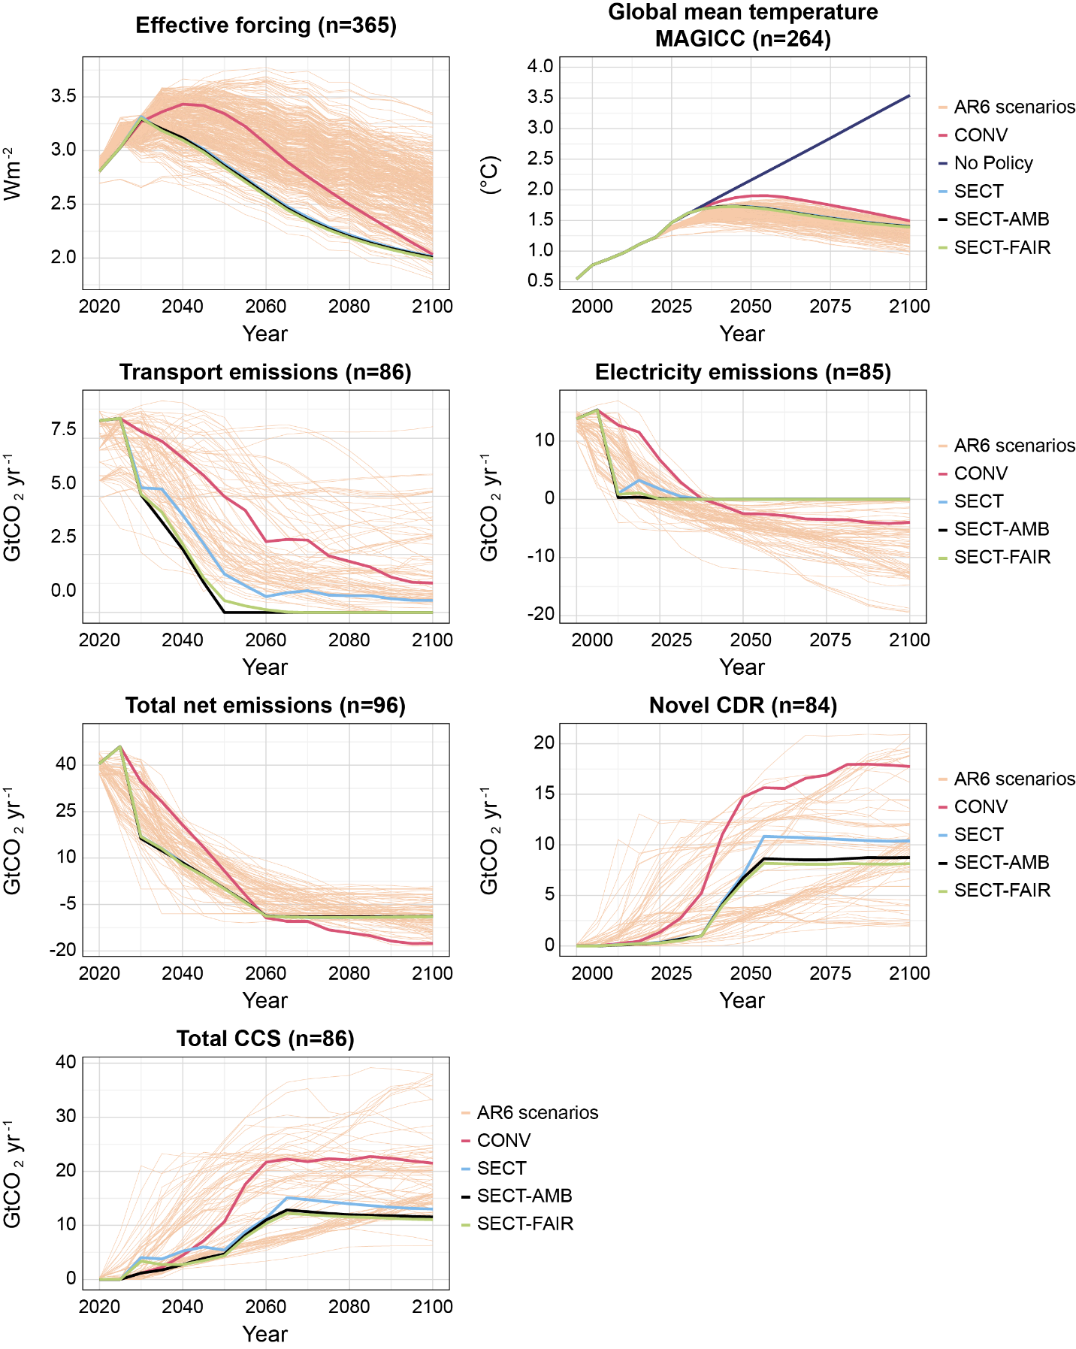
Extended Data Fig. 1 Temperature change, effective forcing, positive and net emissions, carbon removal, and geologic carbon storage results of our scenarios compared to 1.5ºC scenarios in the AR6 database ³³. Excluding temperature and effective forcing results, AR6 scenarios are explicitly C1 and C2 scenarios that passed vetting according to the AR6 vetting process. n is the number of AR6 scenarios with non-empty data at any point in the century (for CDR and carbon storage, this includes scenarios with non-zero values from 2025 onwards)

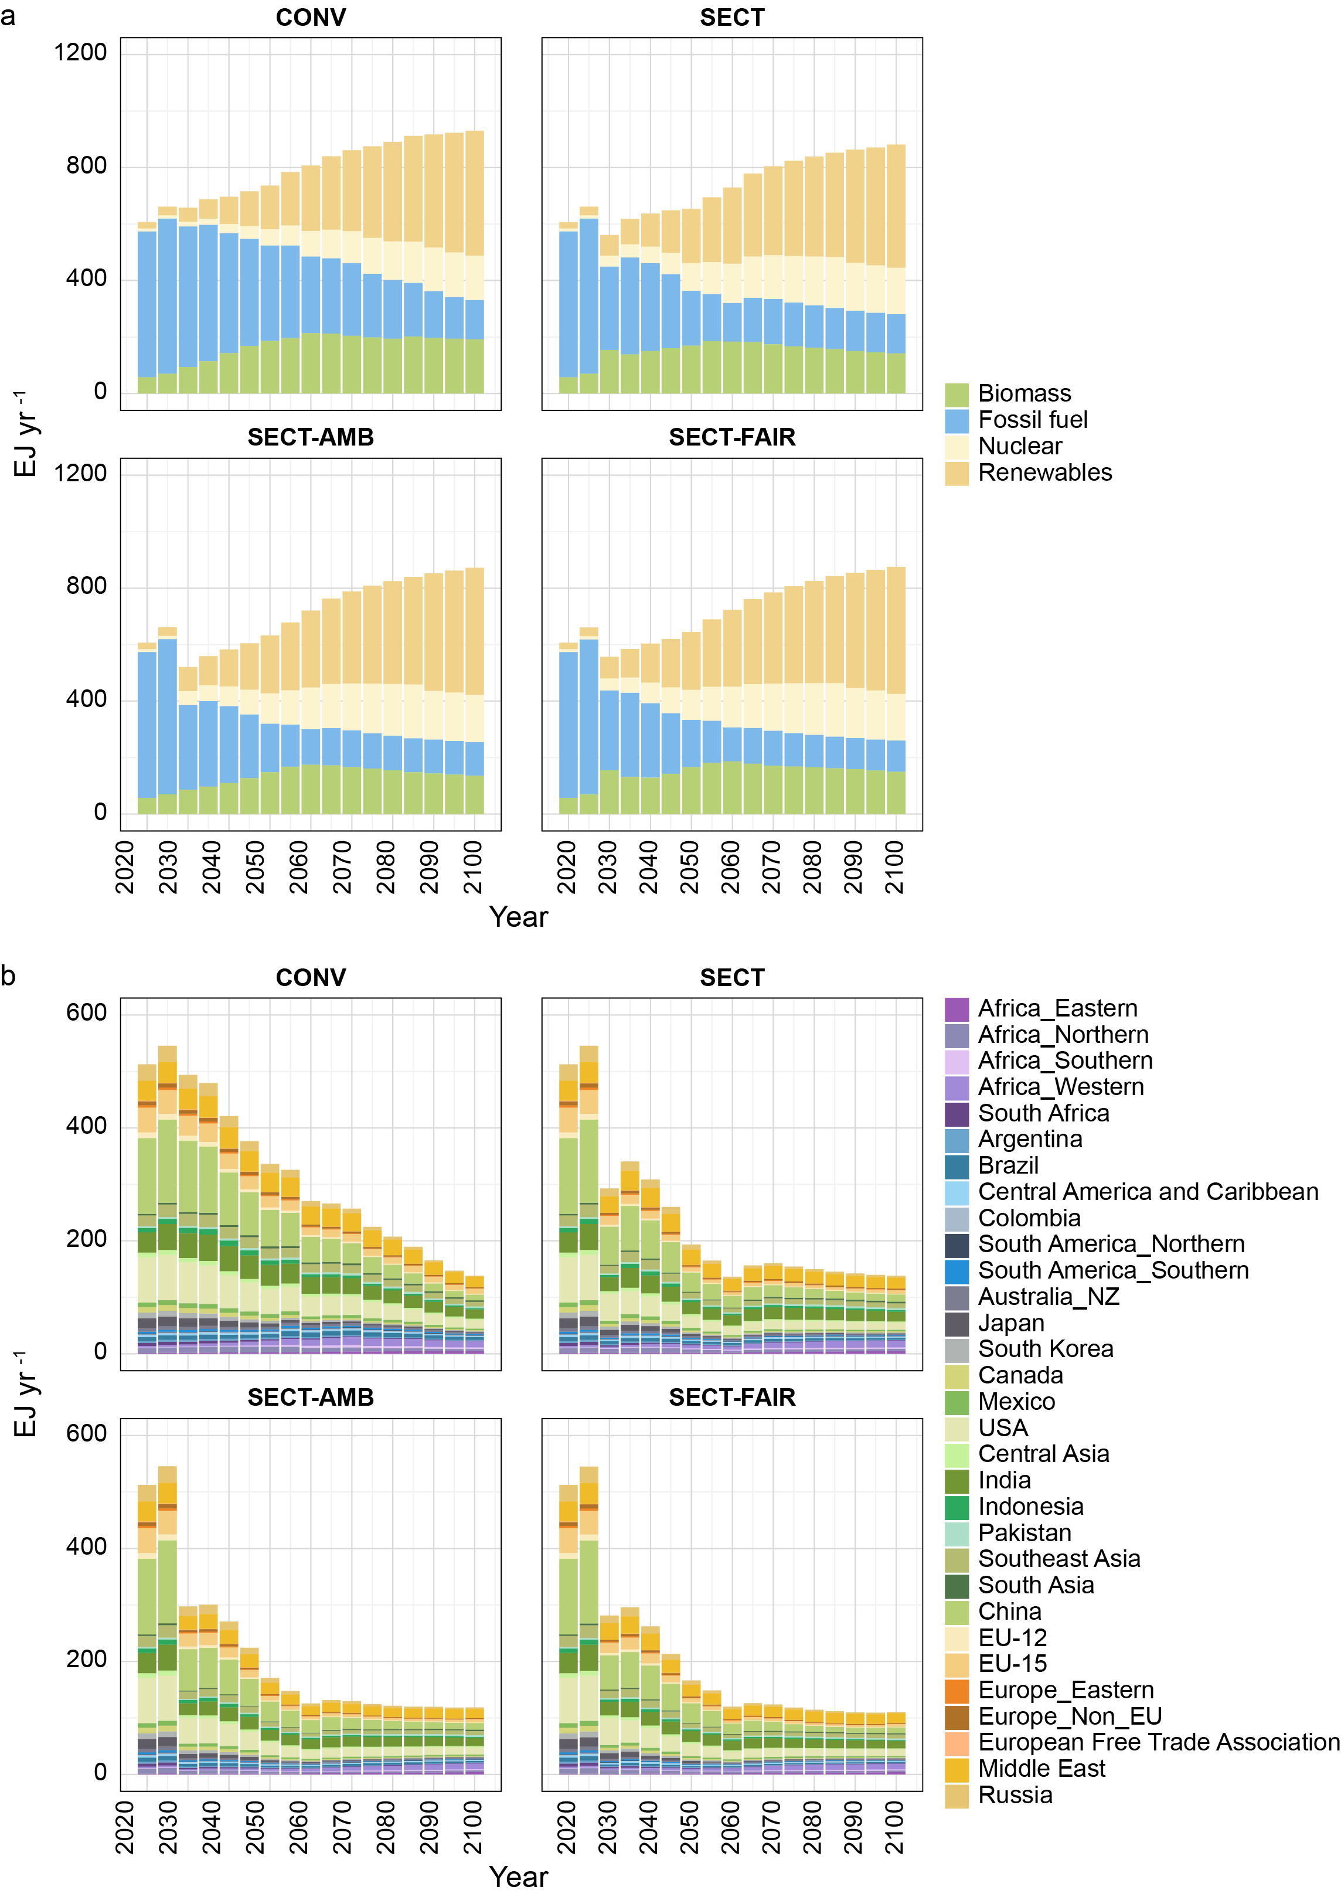
Extended Data Fig. 2 Impact on primary energy consumption from 2020-2100 (a) Global primary energy consumption under various scenarios. Fossil fuel includes unabated and abated oil, gas, and coal, and renewables include hydro, geothermal, solar, and wind. Modern and traditional biomass are categorized under biomass. Our analysis reveals that fossil fuel demand persists across all scenarios, but the sectoral pathways (SECT, SECT-AMB, SECT-FAIR) substantially reduce this demand especially in the near-term as carbon price quickly rises, compared to the demand under the conventional economy-wide scenario (CONV). In the CONV scenario, a uniform carbon price is applied across the entire economy, aiming to minimize overall system costs. However, this approach may not generate sufficiently high carbon prices in the near-to-medium term to discourage the continued use of coal and other fossil fuels. Consequently, the CONV scenario is likely to prolong the operation of existing fossil fuel infrastructure, delaying their premature retirement compared to the sectoral scenarios. (b) Regional fossil fuel consumption.

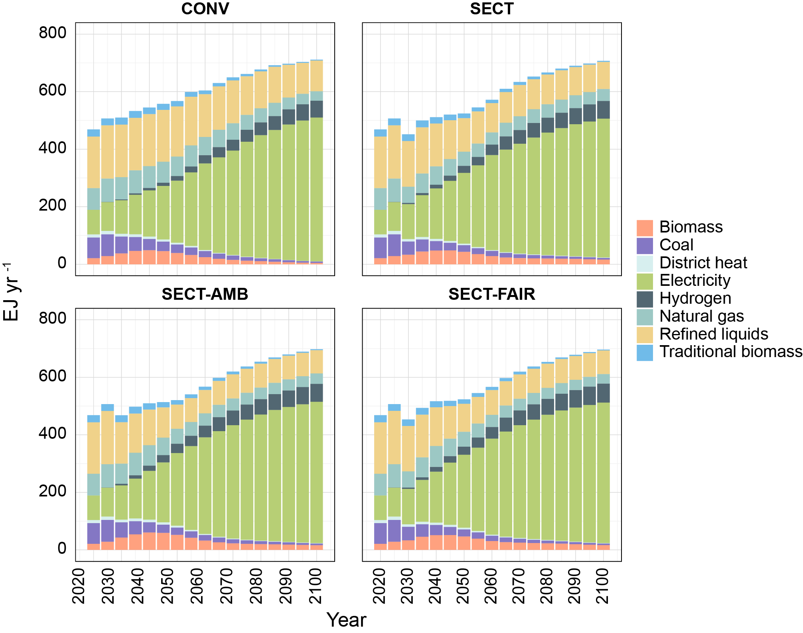
Extended Data Fig. 3 Impact on final energy consumption from 2020-2100. Results represent global final energy consumption over time according to fuel type

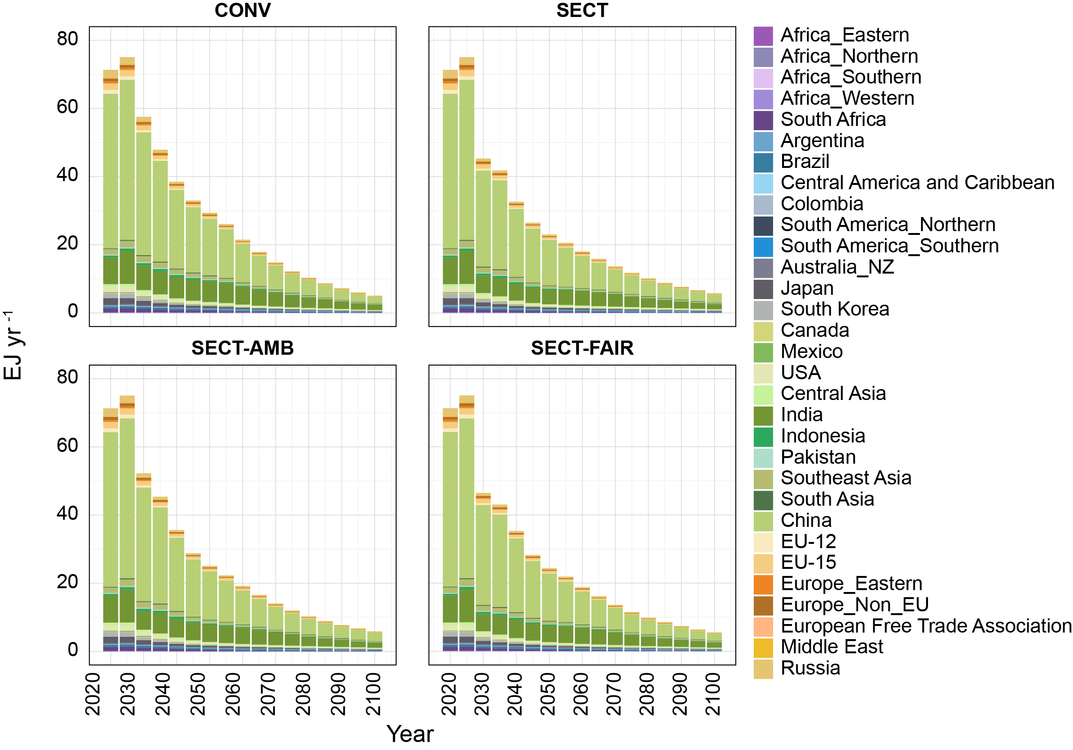
Extended Data Fig. 4 Impact on final energy consumption from 2020-2100. Results represent regional-level coal phase-down over time

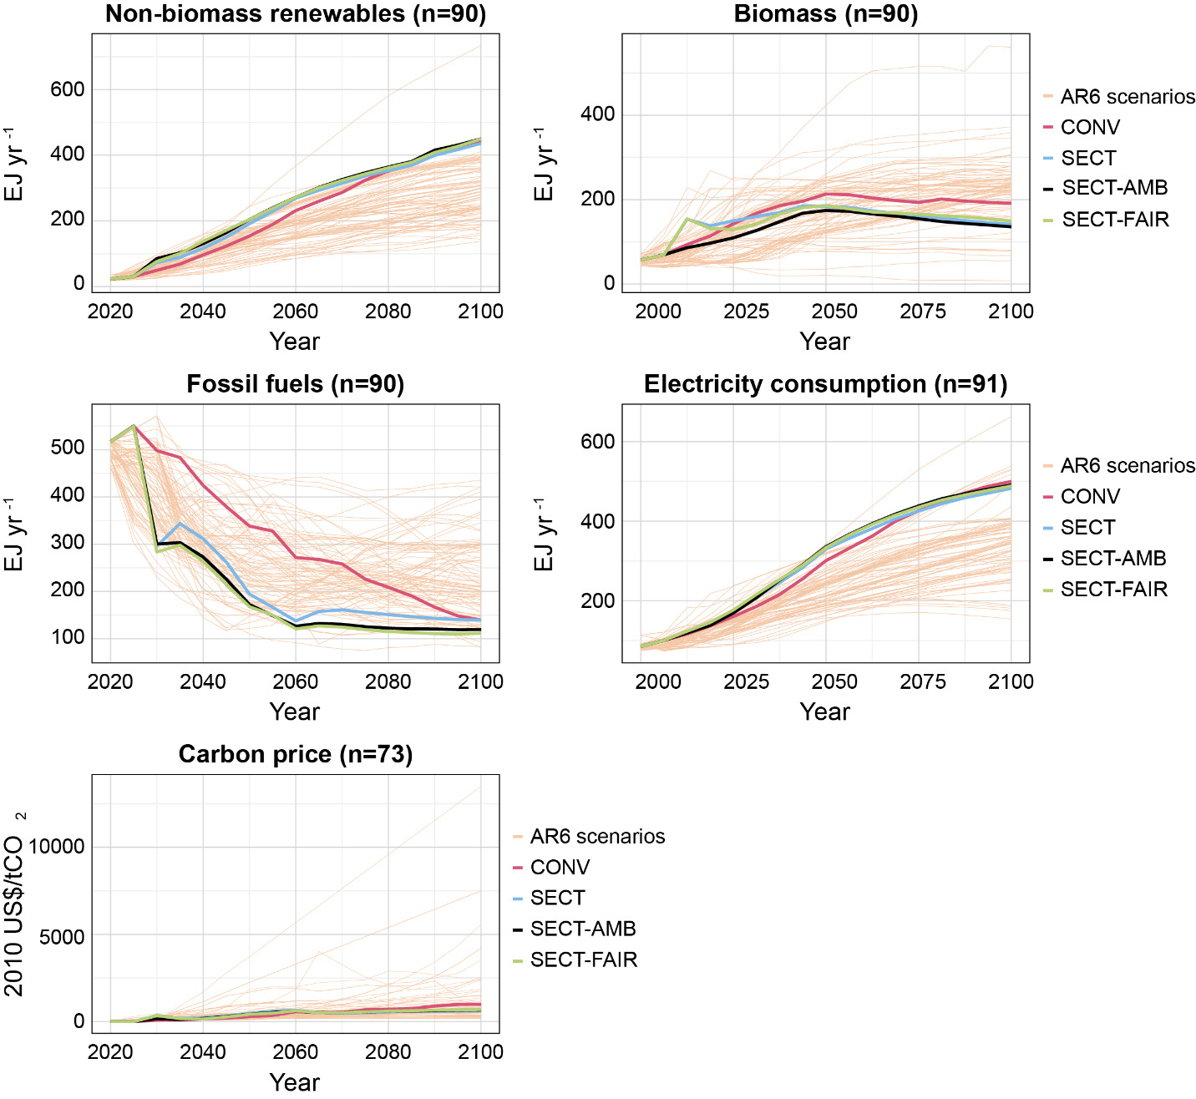
Extended Data Fig. 5 Energy-related and carbon price results of our scenarios compared to 1.5ºC scenarios in the AR6 database ³³. Non-biomass renewables, fossil fuels, and biomass are related to primary energy consumption. AR6 scenarios are C1 and C2 scenarios that passed vetting according to the AR6 vetting process. n is the number of AR6 scenarios with non-empty data at any point in the century (for carbon price, this includes scenarios with non-zero values from 2025 onwards)

