Supplementary materials

In vitro and in silico studies on α-glucosidase inhibitory properties of bioactive components from the rhizomes of Alpinia officinarum Hance

Zakhele Mphatsi Dlamini ¹ ∙ Bongani Sicelo Dlamini ¹ ∙ Shih-Han Fu ² ∙ Ya-Lin Chang² ∙ Chi-Chien Lin ³ ∙ Yu-Kuo Chen ⁴ ∙ Kok-Tong Tan ^{5,6} ∙ Chi-I Chang ^{2,7}
¹Department of Tropical Agriculture and International Cooperation, National Pingtung University of Science and Technology, Pingtung 912301, Taiwan
² Department of Biological Science and Technology, National Pingtung University of Science and Technology, Pingtung 912301, Taiwan
³ Institute of Biomedical Science, The iEGG and Animal Biotechnology Center, National Chung-Hsing University, Taichung 402202, Taiwan
⁴ Department of Food Science, National Pingtung University of Science and Technology, Pingtung 912301, Taiwan
⁵ Department of Surgery, Tungs’ Taichung Metro Harbor Hospital, Taichung 435403, Taiwan
⁶ College of Medicine, National Chung Hsing University, Taichung 402202, Taiwan
⁷ Traditional Herbal Medicine Research Center, Taipei Medical University Hospital, Taipei 110301, Taiwan

Corresponding author(s):
Chi-I Chang
changchii@mail.npust.edu.tw
Kok-Tong Tan
t1840@ms.sltung.com.tw
Table of Contents

Fig. S1 ¹H-NMR spectrum for compound 1 in acetone-d₆
Fig. S2 ¹³C-NMR spectrum and DEPT for compound 1 in acetone-d₆
Fig. S3 Mass spectrum of compound 1
Fig. S4 ¹H-NMR spectrum for compound 2 in acetone-d₆
Fig. S5 ¹³C-NMR spectrum and DEPT for compound 2 in acetone-d₆
Fig. S6 Mass spectrum of compound 2
Fig. S7 ¹H-NMR spectrum for compound 3 in CDCl₃
Fig. S8 ¹³C-NMR spectrum and DEPT for compound 3 in CDCl₃
Fig. S9 Mass spectrum of compound 3
Fig. S10 ¹H-NMR spectrum for compound 4 in CDCl₃
Fig. S11 ¹³C-NMR spectrum and DEPT for compound 4 in CDCl₃
Fig. S12 Mass spectrum of compound 4
Fig. S13 ¹H-NMR spectrum for compound 5 in CDCl₃
Fig. S14 ¹³C-NMR spectrum and DEPT for compound 5 in CDCl₃
Fig. S15 Mass spectrum of compound 5

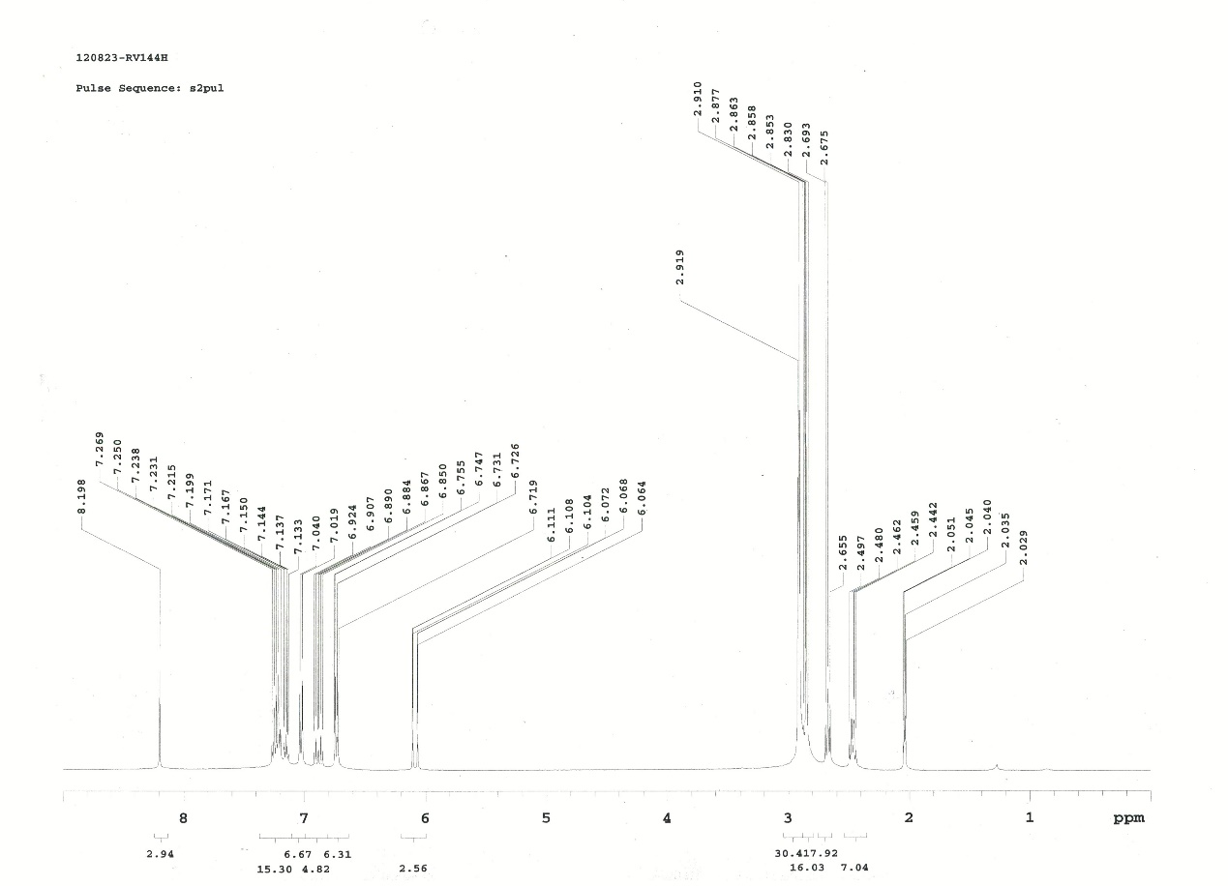
Fig. S1 ¹H-NMR spectrum for compound 1 in acetone-d₆
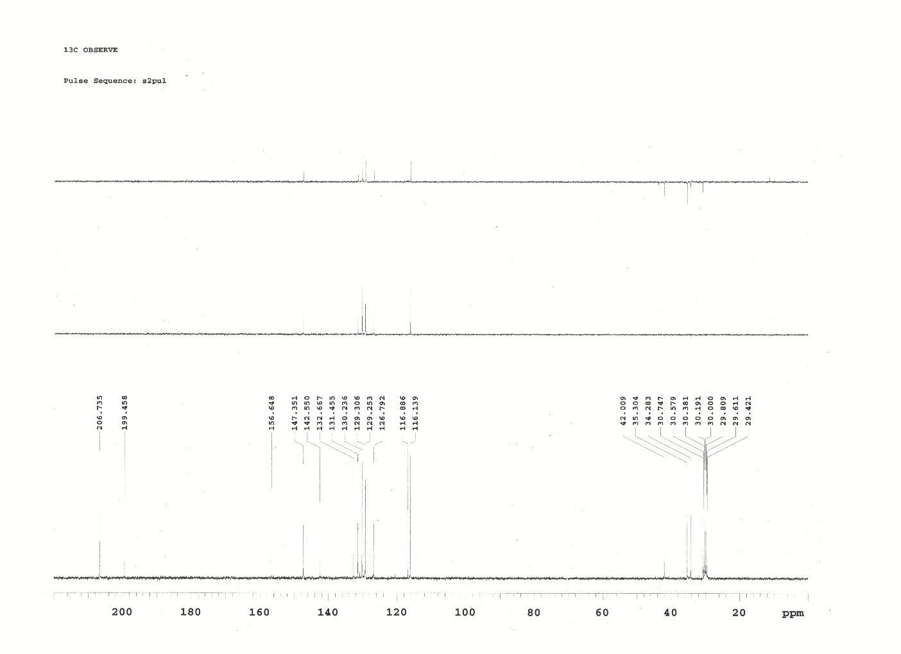
Fig. S2 ¹³C-NMR spectrum and DEPT for compound 1 in acetone-d₆

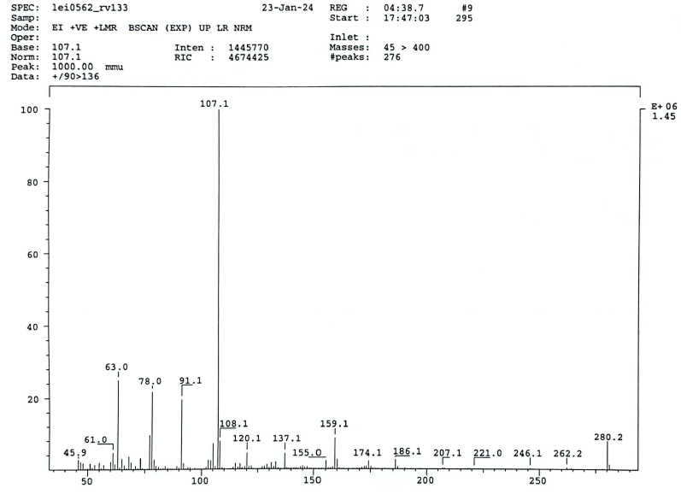
Fig. S3 Mass spectrum of compound 1
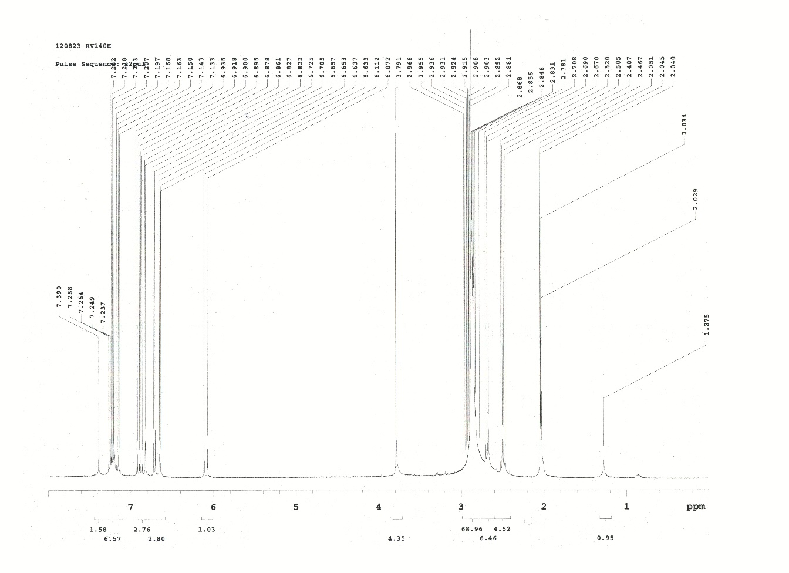
Fig. S4 ¹H-NMR spectrum of compound 2 in acetone-d₆
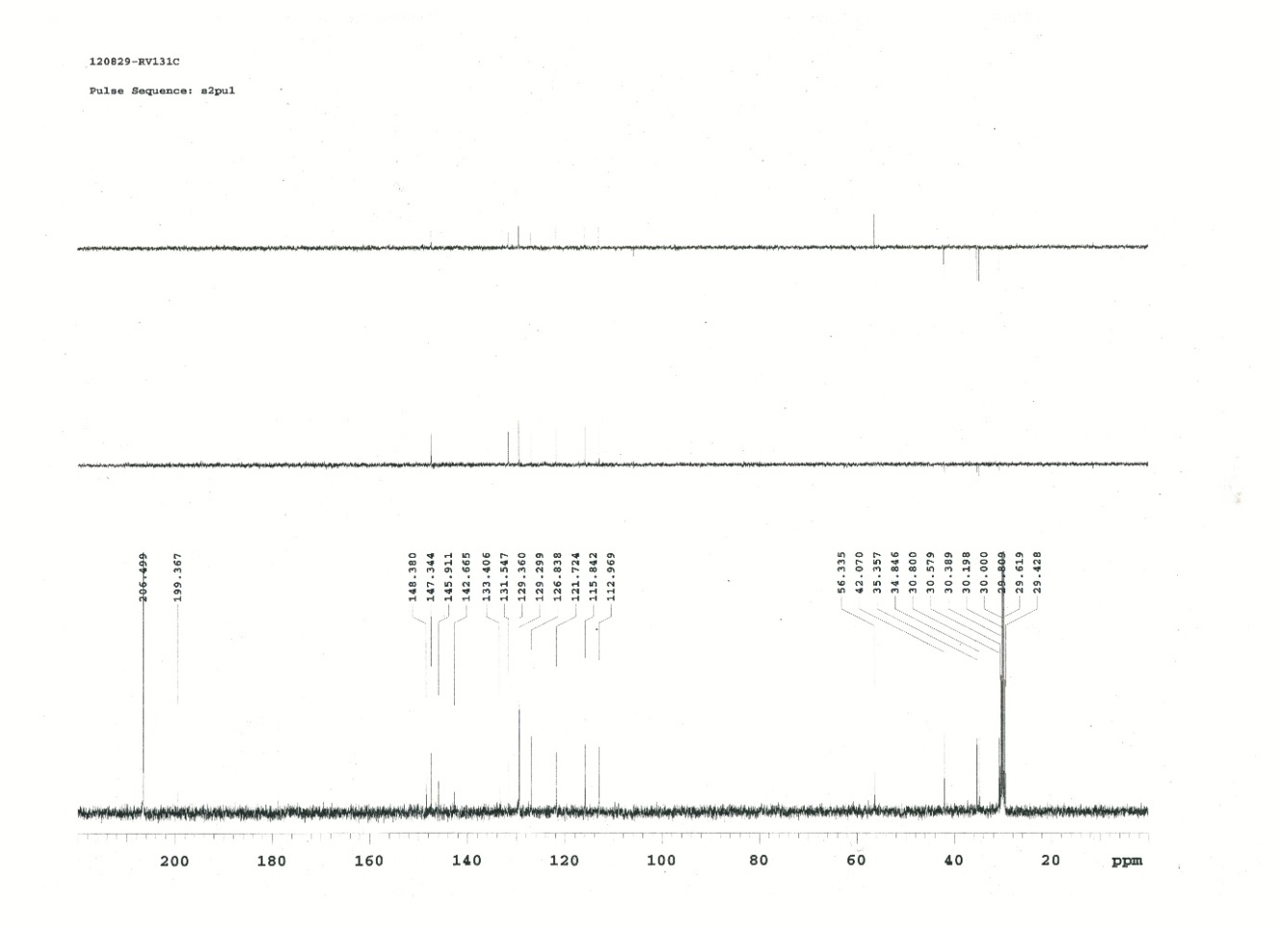
Fig. S5 ¹³C-NMR spectrum and DEPT of compound 2 in acetone-d₆

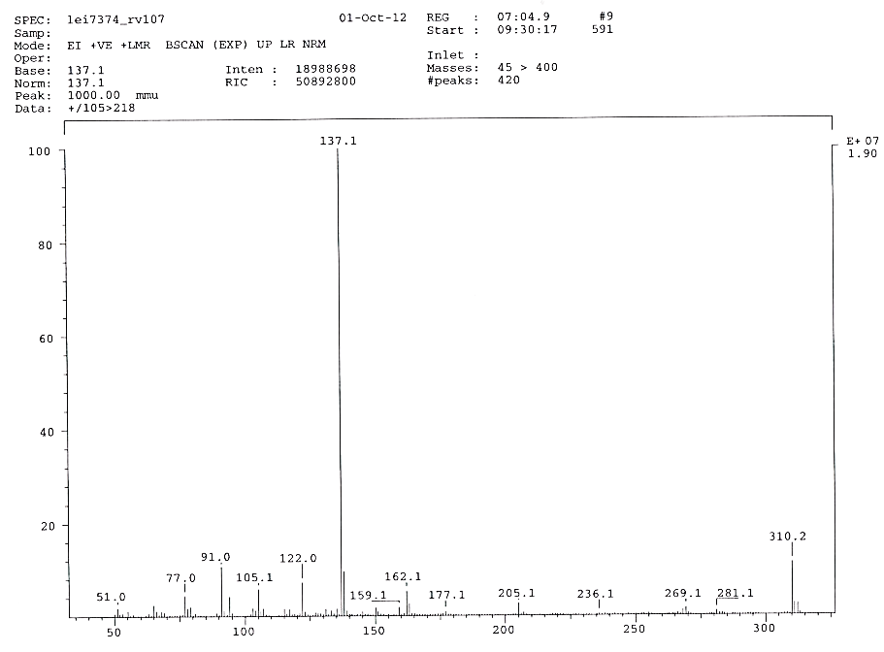
Fig. S6 Mass spectrum of compound 2
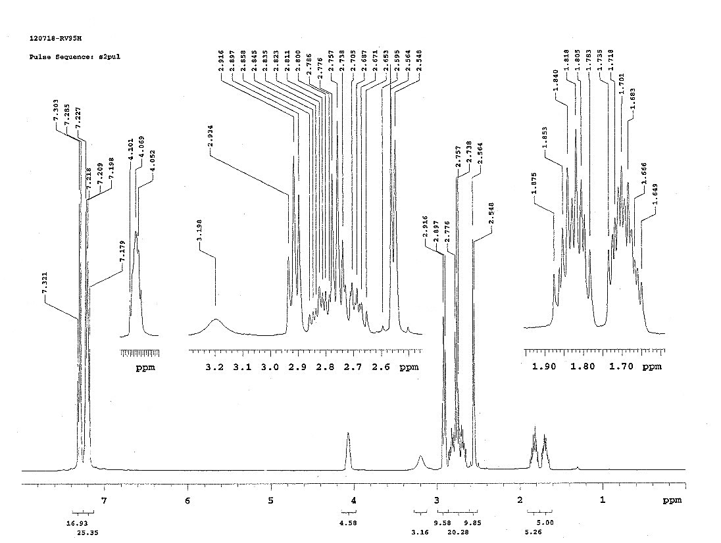
Fig. S7 ¹H-NMR spectrum of compound 3 in CDCl₃
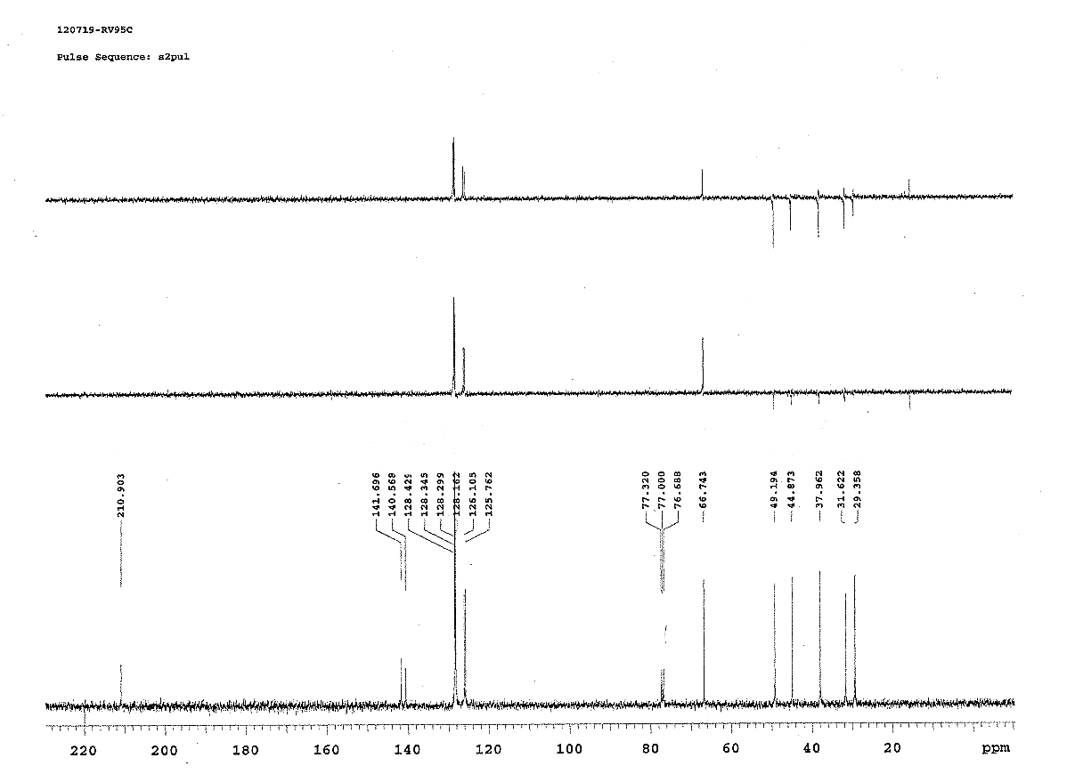
Fig. S8 ¹³C-NMR spectrum and DEPT of compound 3 in CDCl₃
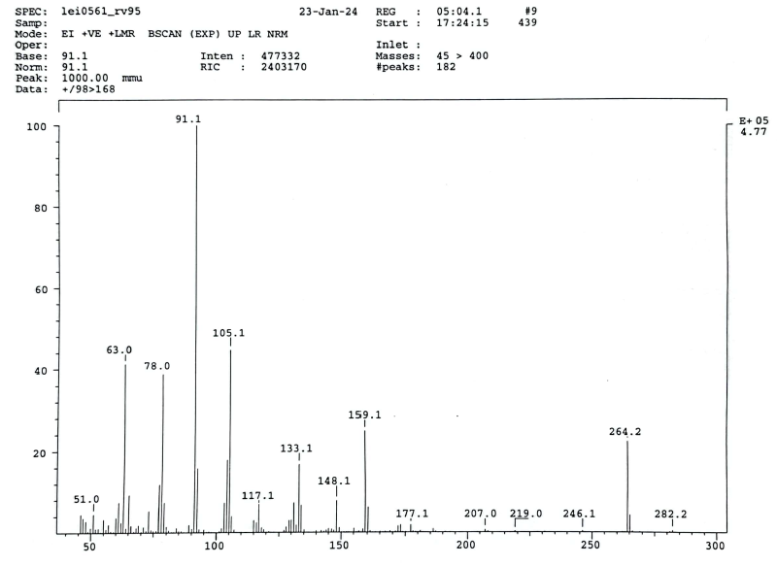
Fig. S9 Mass spectrum of compound 3
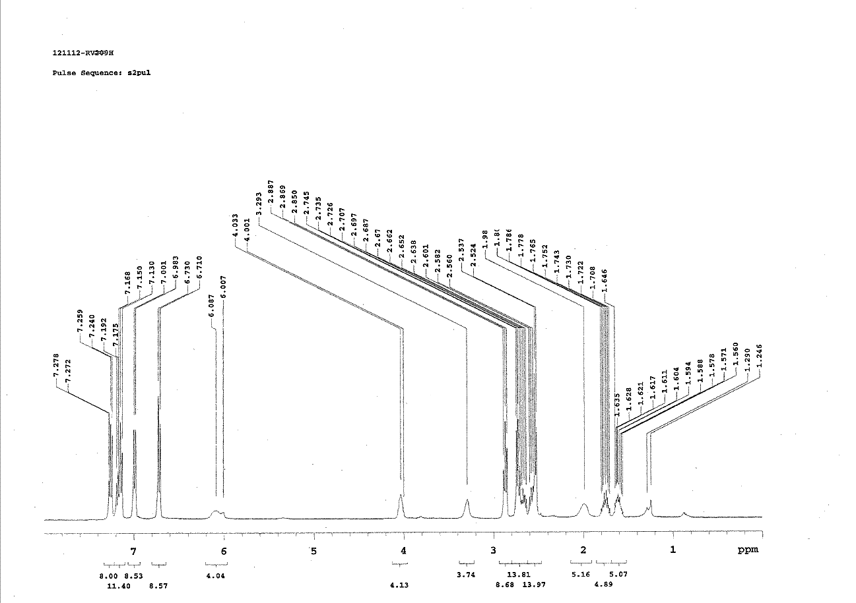
Fig. S10 ¹H-NMR spectrum for compound 4 in CDCl₃
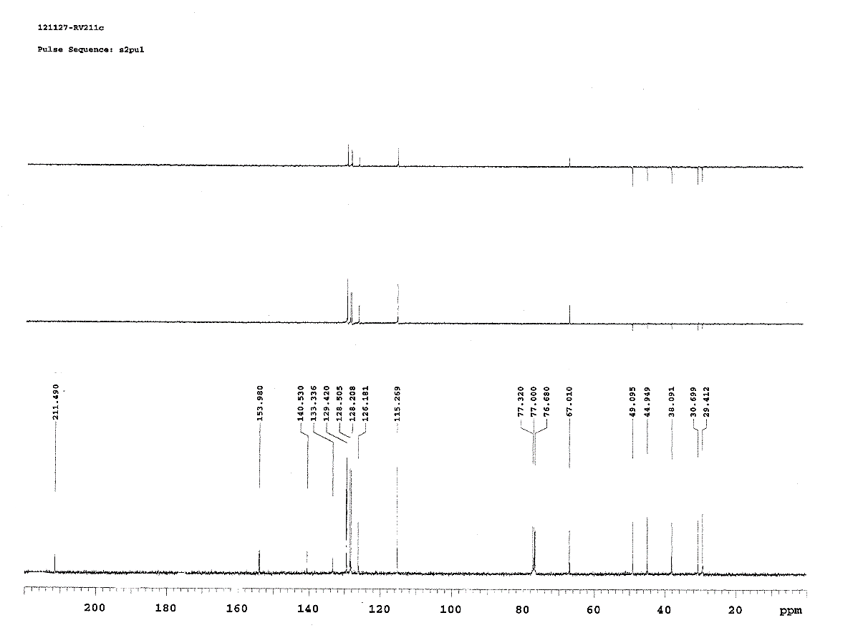
Fig. S11 ¹³C-NMR spectra and DEPT for compound 4 in CDCl₃
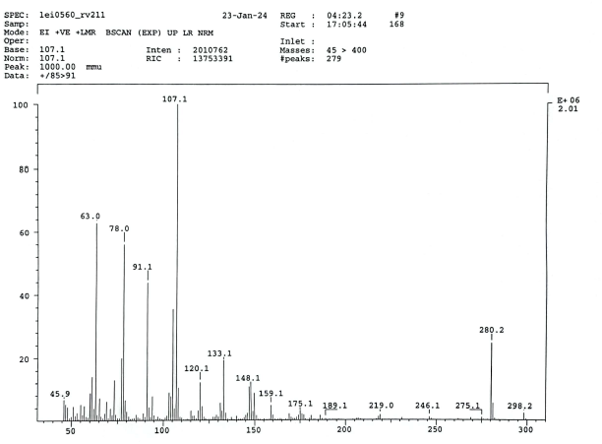
Fig. S12 Mass spectrum of compound 4

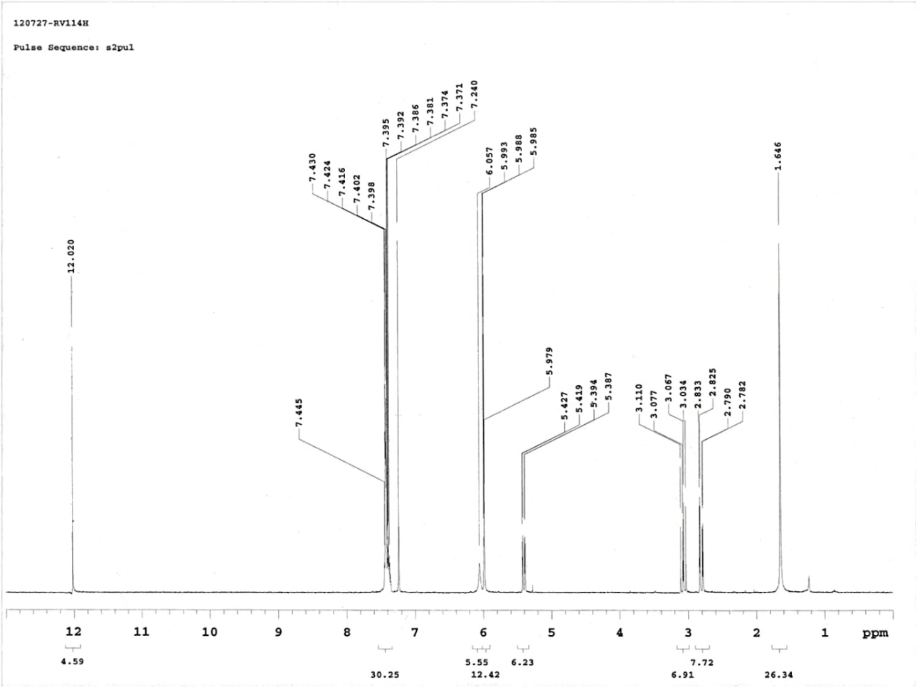
Fig. S13 ¹H-NMR spectrum for compound 5 in CDCl₃
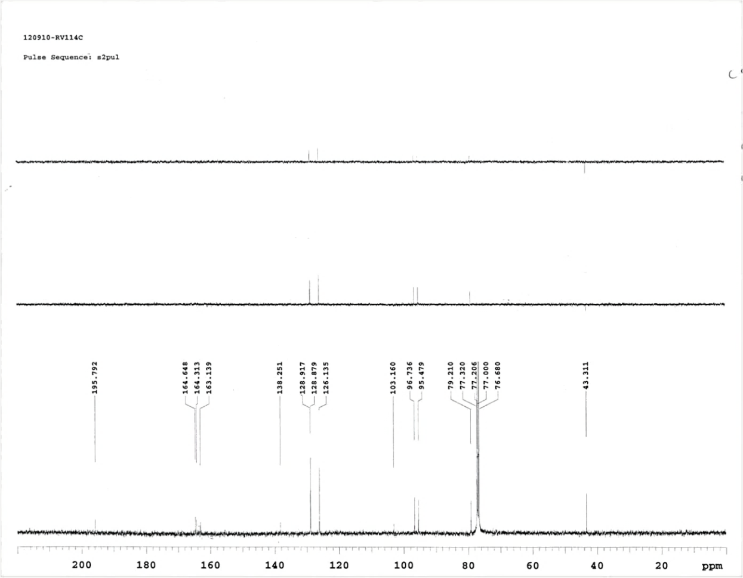
Fig. S14 ¹³C-NMR spectrum and DEPT for compound 5 in CDCl₃
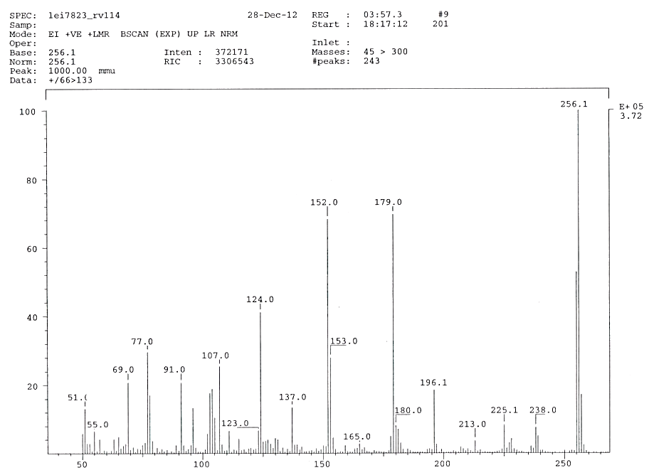
Fig. S15 Mass spectrum of compound 5

