Supplementary data
Table S1. Average nucleotide identity (ANI) analysis and digital DNA-DNA hybridization analysis between strain Hymenobacter humicola BT186^{T} and some related type strains of Hymenobacter species for which genomes have been published. Data of related type strains were taken from EzBioCloud (https://www.ezbiocloud.net/genome).
Strains | BT186^{T}
Strains | DDH(%) | ANI(%)
Hymenobacter norwichensis NS/50^{T} | 30.2 % | 85.6 %
Hymenobacter aquaticus 16F3P^{T} | 21.7 % | 76.9 %
Hymenobacter swuensis DY53^{T} | 22.5 % | 76.7 %
Hymenobacter elongatus VUG-A112^{T} | 21.7 % | 75.7 %
Hymenobacter metallilatus 9PBR-2^{T} | 22.3 % | 76.5 %
Hymenobacter rigui KCTC 12533^{T} | 22.2 % | 76.8 %
Hymenobacter mucosus YIM 77969^{T} | 21.9 % | 75.2 %
Hymenobacter persicinus 1-3-3-3^{T} | 21.2 % | 76.4 %
Hymenobacter metallilatus 9PBR-2^{T} | 22.3 % | 76.5 %
Hymenobacter jejuensis 17J68-5^{T} | 20.0 % | 76.0 %
Hymenobacter coccineus HMF4947^{T} | 20.7 % | 74.8 %
Hymenobacter arizonensis DSM 17870^{T} | 21.0 % | 74.2 %
Hymenobacter ginkgonis DSM 15439^{T} | 20.3 % | 73.0 %
Hymenobacter gelipurpurascens HMF4947^{T} | 21.9 % | 76.5 %

Table. S2 The negative results of strain BT186^{T} in API 20NE, API ZYM and API ID32GN tests.
Physiological characteristics | BT186^{T}
API ZYM
Lipase (C14) | -
Trypsin | -
α-Chymotrypsin | -
Acid phosphatase | -
Naphtol-AS-BI-phosphohydrolase | -
α-Galactosidase | -
β-Galactosidase (ONPG) | -
β-Glucuronidase | -
α-Glucosidase (starch hydrolysis) | -
β-Glucosidase | -
N–Acetyl-β-glucosaminidase | -
α-Mannosidase | -
α-Fucosidase | -
API 20 NE
Nitrate reduction
Nitrate reduction to NO₂ | -
Nitrate reduction to N₂ | -
Production of Indole | -
Production of acid from glucose | -
Arginine dihydrolase | -
Urease | -
Protease (gelatin hydrolysis) | -
D-Mannitol | -
N-Acetyl-D-glucosamine | -
Gluconate | -
Caprate | -
Adipate | -
L-Malate | -
Citrate | -
Phenyl acetate | -
API ID32GN
L-Rhamnose | -
N-Acetyl-D-glucosamine | -
D-Ribose | -
myo-Inositol | -
Itaconate | -
Suberate | -
Malonate | -
Acetate | -
L-Alanine | -
5-Ketogluconate | -
3-Hydroxybenzoate | -
L-Serine | -
Salicin | -
L-Fucose | -
Propionate | -
Caprate | -
n-Valerate | -
Citrate | -
L-Histidine | -
2-Ketogluconate (α) | -
D,L-3-Hydroxybutyrate | -
4-Hydroxybenzoate | -
L-Proline | -

Fig. S1 Maximum-Parsimony phylogenetic tree based on 16S rRNA gene sequences, showing the relationships of strains BT186^{T} and BT505 with closely related validly published species. Bootstrap values (> 70%) based on 1,000 replications are shown at the branch nodes. Cytophaga hutchinsonii DSM 1761^{T} were used as an outgroup.
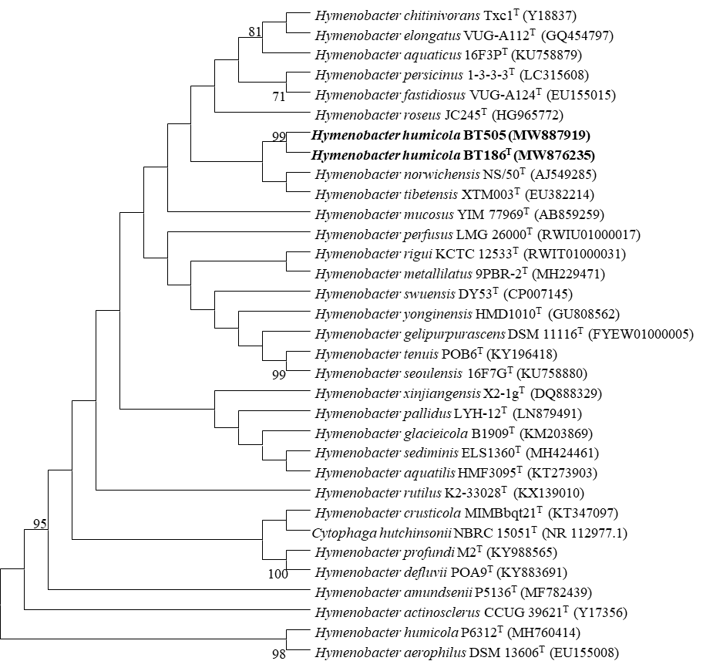
Fig. S2 Maximum-Likelihood phylogenetic tree based on 16S rRNA gene sequences showing the relationships of strains BT186^{T} and BT505 with closely related validly published species. Bootstrap values (> 70%) based on 1,000 replications are shown at the branch nodes. Bar, 0.020 substitutions per nucleotide position. Cytophaga hutchinsonii DSM 1761^{T} were used as an outgroup.
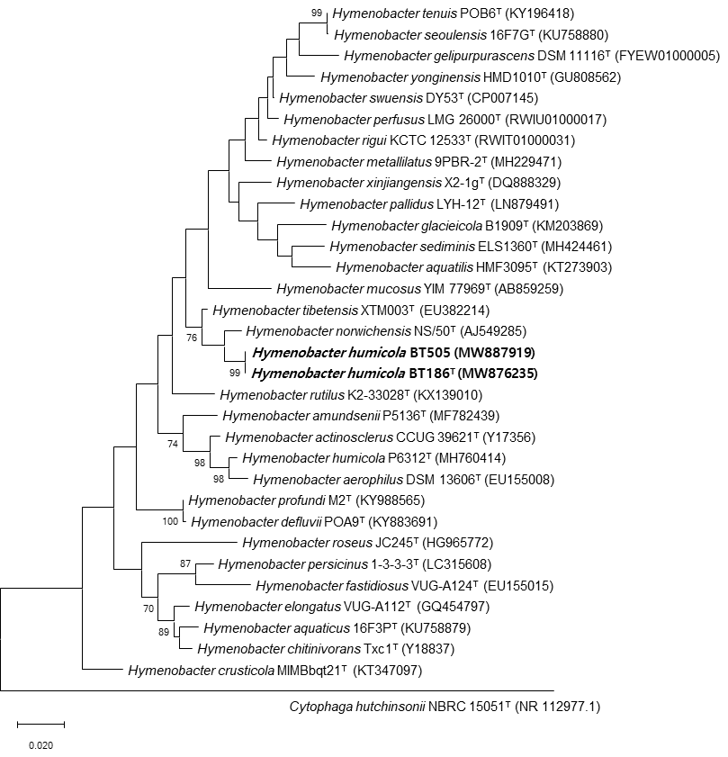

Fig. S3. Polar lipid profile of strain BT186^{T} after two-dimensional chromatography.
(a) total lipids; (b) phospholipids; (c) aminolipids; (d) glycolipids.
Abbreviations: L₁-L₃, unknown lipids; PL, an unknown phospholipid; APL₁-APL₅, unknown aminophospholipids; AL, an unknown aminolipid; PE, an unknown phosphatidylethanolamine.
