Supplementary Information
Table 1. MS/MS spectrum database search analysis summary
Identified  proteins | Quantifiable proteins | Identified  sites | Quantifiable  sites
570 | 534 | 2368 | 2138

Table 2. Differentially changed modification sites (modified proteins) summary (Filtered with threshold value of expression fold change)
Compare  group | Regulated  type | fold  change  >1.2 | fold  change  >1.3 | fold  change  >1.5 | fold  change  >2
PDGF/Con | up-regulated | 241 (107) | 200 (94) | 100 (58) | 14 (9)
PDGF/Con | down-regulated | 49 (35) | 45 (31) | 31 (20) | 14 (7)

Table 3. Modification site information of pyruvate kinase
Position | Amino acid | Protein description | Score | Modified sequence | Mass error [ppm] | MS/MS Count
269 | K | Pyruvate kinase | 104.05 | VFLAQK(1)MMIGR | 1.4519 | 12
380 | K | Pyruvate kinase | 48.686 | VEASFK(1)CCSGAIIVLTK | 0.84548 | 1
260 | K | Pyruvate kinase | 81.525 | K(0.006)VLGEK(0.994)VFLAQK | -2.6483 | 2
266 | K | Pyruvate kinase | 104.05 | VFLAQK(1)MMIGR | 1.4519 | 12
261 | K | Pyruvate kinase PKM | 91.906 | VLGEK(1)GK | -0.41152 | 5
305 | K | Pyruvate kinase PKM | 116.58 | GDLGIEIPAEK(1)VFLAQK | 0.27956 | 23
115 | K | Pyruvate kinase PKM | 151.91 | PVAVALDTK(1)GPEIR | -1.5825 | 15
367 | K | Pyruvate kinase PKM | 112.26 | IMLSGETAK(1)GDYPLEAVR | 0.53367 | 8
498 | K | Pyruvate kinase PKM | 109.15 | VNLAMNVGK(1)AR | 2.312 | 11
186 | K | Pyruvate kinase PKM | 97.823 | IYVDDGLISLQVK(1)EK | 2.1065 | 10
89 | K | Pyruvate kinase PKM | 124.84 | THEYHAETIK(1)NVR | 1.6963 | 14
125 | K | Pyruvate kinase PKM | 67.846 | TGLIK(1)GSGTAEVELK | 0.46409 | 1
224 | K | Pyruvate kinase PKM | 137.72 | LPAVSEK(1)DIQDLK | 0.39533 | 19
62 | K | Pyruvate kinase PKM | 94.692 | SVEMLK(1)EMIK | 0.82137 | 30
311 | K | Pyruvate kinase PKM | 104.05 | VFLAQK(1)MMIGR | 1.4519 | 12
270 | K | Pyruvate kinase PKM | 143.97 | IISK(1)IENHEGVR | 0.5539 | 9

Table 4. Characteristic sequence of modified site obtained by motif analysis

Motif | Motif Score | Foreground |  | Background |  | Fold Increase
Motif | Motif Score | Matches | Size | Matches | Size | Fold Increase
.........AK.......... | 16 | 247 | 2270 | 35327 | 601417 | 1.85
..........KF......... | 16 | 149 | 2023 | 17268 | 566090 | 2.41
..........KL......... | 14.75 | 277 | 1874 | 49987 | 548822 | 1.62
..........KD......... | 16 | 190 | 1597 | 31385 | 498835 | 1.89
..........KE......... | 12.92 | 238 | 1407 | 48851 | 467450 | 1.62
..........K.D........ | 9.94 | 100 | 1169 | 17939 | 418599 | 2
........A.K.......... | 9.62 | 121 | 1069 | 24850 | 400660 | 1.82
.........EK.......... | 6.66 | 137 | 948 | 34965 | 375810 | 1.55
.........FK.......... | 6.62 | 60 | 811 | 12313 | 340845 | 2.05
.........YK.......... | 6.49 | 52 | 751 | 10534 | 328532 | 2.16
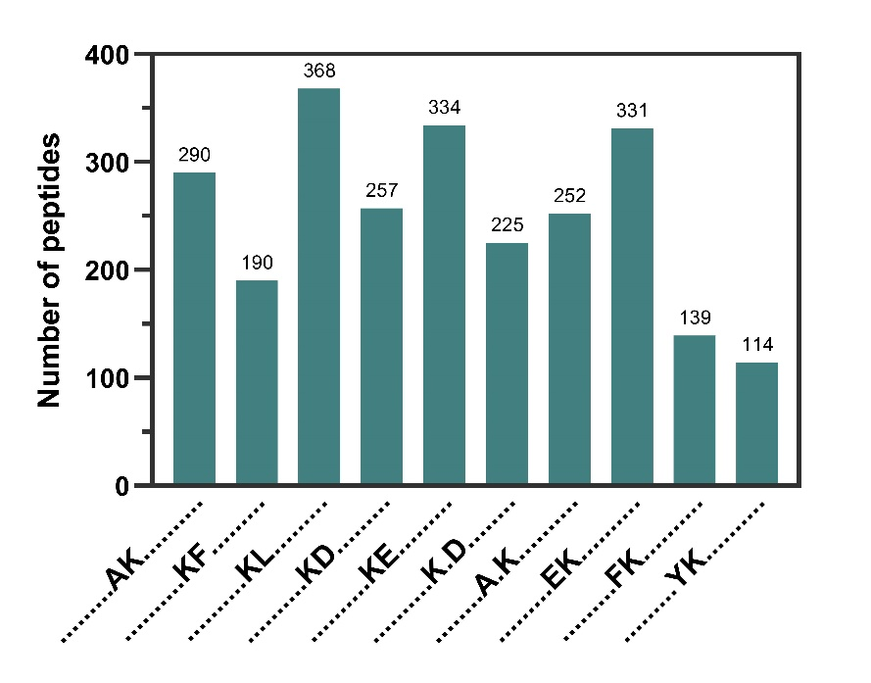
Figure S1 Statistics of consensus motifs of polypeptides containing crotonylation modification sites

Bioinformatics Methods
1. Annotation Methods
GO Annotation
The Gene Ontology, or GO, is a major bioinformatics initiative to unify the representation of gene and gene product attributes across all species. More specifically, the project aims to:
1. Maintain and develop its controlled vocabulary of gene and gene product attributes;
2. Annotate genes and gene products, and assimilate and disseminate annotation data;
3. Provide tools for easy access to all aspects of the data provided by the project.
The ontology covers three domains:
1. Cellular component: A cellular component is just that, a component of a cell, but with the proviso that it is part of some larger object; this may be an anatomical structure (e.g. rough endoplasmic reticulum or nucleus) or a gene product group (e.g. ribosome, proteasome or a protein dimer).
2. Molecular function: Molecular function describes activities, such as catalytic or binding activities, that occur at the molecular level. GO molecular function terms represent activities rather than the entities (molecules or complexes) that perform the actions, and do not specify where or when, or in what context, the action takes place.
3. Biological process: A biological process is series of events accomplished by one or more ordered assemblies of molecular functions. It can be difficult to distinguish between a biological process and a molecular function, but the general rule is that a process must have more than one distinct steps.
Gene Ontology (GO) annotation proteome was derived from the UniProt-GOA database (www.http://www.ebi.ac.uk/GOA/). Firstly, Converting identified protein ID to UniProt ID and then mapping to GO IDs by protein ID. If some identified proteins were not annotated by UniProtGOA database, the InterProScan soft would be used to annotated protein’s GO functional based on protein sequence alignment method. Then proteins were classified by Gene Ontology annotation based on three categories: biological process, cellular component and molecular function.
Domain Annotation
A protein domain is a conserved part of a given protein sequence and structure that can evolve, function and exist independently of the rest of the protein chain. Each domain forms a compact three-dimensional structure and often can be independently stable and folded. Many proteins consist of several structural domains. One domain may appear in a variety of differentially modified proteins. Molecular evolution uses domains as building blocks and these may be recombined in different arrangements to create proteins with different functions. Domains vary in length from between about 25 amino acids up to 500 amino acids in length. The shortest domains such as zinc fingers are stabilized by metal ions or disulfide bridges. Domains often form functional units, such as the calcium-binding EF hand domain of calmodulin. Because they are independently stable, domains can be "swapped" by genetic engineering between one protein and another to make chimeric proteins. Identified proteins domain functional description were annotated by InterProScan (a sequence analysis application) based on protein sequence alignment method, and the InterPro domain database was used. InterPro (http://www.ebi.ac.uk/interpro/) is a database that integrates diverse information about protein families, domains and functional sites, and makes it freely available to the public via Web-based interfaces and services. Central to the database are diagnostic models, known as signatures, against which protein sequences can be searched to determine their potential function. InterPro has utility in the large-scale analysis of whole genomes and meta-genomes, as well as in characterizing individual protein sequences.
KEGG Pathway Annotation
KEGG connects known information on molecular interaction networks, such as pathways and complexes (the "Pathway" database), information about genes and proteins generated by genome projects (including the gene database) and information about biochemical compounds and reactions (including compound and reaction databases). These databases are different networks, known as the "protein network", and the "chemical universe" respectively. There are efforts in progress to add to the knowledge of KEGG, including information regarding ortholog clusters in the KEGG Orthology database. KEGG Pathways mainly including: Metabolism, Genetic Information Processing, Environmental Information Processing, Cellular Processes, Rat Diseases, Drug development. Kyoto Encyclopedia of Genes and Genomes (KEGG) database was used to annotate protein pathway. Firstly, using KEGG online service tools KAAS to annotated protein’s KEGG database description. Then mapping the annotation result on the KEGG pathway database using KEGG online service tools KEGG mapper.
1. Subcellular Localization
The cells of eukaryotic organisms are elaborately subdivided into functionally distinct membrane bound compartments. Some major constituents of eukaryotic cells are: extracellular space, cytoplasm, nucleus, mitochondria, Golgi apparatus, endoplasmic reticulum (ER), peroxisome, vacuoles, cytoskeleton, nucleoplasm, nucleolus, nuclear matrix and ribosomes. Bacteria also have subcellular localizations that can be separated when the cell is fractionated. The most common localizations referred to include the cytoplasm, the cytoplasmic membrane (also referred to as the inner membrane in Gram-negative bacteria), the cell wall (which is usually thicker in Gram-positive bacteria) and the extracellular environment. Most Gramnegative bacteria also contain an outer membrane and periplasmic space. Unlike eukaryotes, most bacteria contain no membrane-bound organelles, however there are some exceptions. There, we used wolfpsort a subcellular localization predication soft to predict subcellular localization. Wolfpsort is an updated version of PSORT/PSORT II for the prediction of eukaryotic sequences. Special for protokaryon species, Subcellular localization prediction soft CELLO was used.
2. Motif Analysis
Soft motif-x was used to analysis the model of sequences constituted with amino acids in specific positions of modify-21-mers (10 amino acids upstream and downstream of the site， but phosphorylation with modify-13-mers that 6 amino acids upstream and downstream of the site) in all protein sequences. And all the database protein sequences were used as background database parameter, other parameters with default.
3. Functional Enrichment
Enrichment of Gene Ontology analysis
Proteins were classified by GO annotation into three categories: biological process, cellular compartment and molecular function. For each category, a two-tailed Fisher’s exact test was employed to test the enrichment of the differentially modified protein against all identified proteins. The GO with a corrected p-value < 0.05 is considered significant.
Enrichment of pathway analysis
Encyclopedia of Genes and Genomes (KEGG) database was used to identify enriched pathways by a two-tailed Fisher’s exact test to test the enrichment of the differentially modified protein against all identified proteins. The pathway with a corrected p-value < 0.05 was considered significant. These pathways were classified into hierarchical categories according to the KEGG website.
Enrichment of protein domain analysis
For each category proteins, InterPro (a resource that provides functional analysis of protein sequences by classifying them into families and predicting the presence of domains and important sites) database was researched and a two-tailed Fisher’s exact test was employed to test the enrichment of the differentially modified protein against all identified proteins. While p-value < 0.05 was considered significant.
4. Enrichment-based Clustering
For further hierarchical clustering based on differentially modified protein functional classification (such as: GO, Domain, Pathway, Complex). We first collated all the categories obtained after enrichment along with their P values, and then filtered for those categories which were at least enriched in one of the clusters with P value <0.05. This filtered P value matrix was transformed by the function x = -log10 (P value). Finally， these x values were transformed for each functional category. These z scores were then clustered by one-way hierarchical clustering (Euclidean distance, average linkage clustering) in Genesis. Cluster membership was visualized by a heat map using the “heatmap.2” function from the “gplots” R-package.
5. Protein-protein Interaction Network
All identified protein name identifiers were searched against the STRING database version 10.5 for protein-protein interactions. Only interactions between the proteins belonging to the searched data set were selected, thereby excluding external candidates. STRING defines a metric called “confidence score” to define interaction confidence; we fetched all interactions that had a confidence score ≥ 0.9 (high confidence). Interaction network form STRING was visualized in Cytoscape. The oretical clustering algorithm, molecular complex detection (MCODE) was utilized to analyze densely connected regions. MCODE is part of the plug-in tool kit of the network analysis and visualization software Cytoscape.

