Supplementary Information for

Residue-free wafer-scale direct imprinting of two-dimensional materials

Zhiwei Li¹, Xiao Liu¹, Jiayu Shi², Xiangbin Cai¹, Yan Zhang¹, Wenduo Chen³, Yuhao Jin³, Chao Zhu², Ya Deng², Yanran Liu¹, X. Renshaw Wang^{1,3}, Hongbing Cai⁴, Taotao Li⁵, Zheng Liu², Weibo Gao^{1,3,6*}
Corresponding author. Email: wbgao@ntu.edu.sg

Table of Contents
Supplementary Figure 1 | Schematics and photographs of stamp-assisted patterning process
Supplementary Figure 2 | Optical images of scalable MoS₂ arrays with various shapes.
Supplementary Figure 3 | Raman spectrum and AFM measurements of monolayer MoS₂.
Supplementary Figure 4 | Large-field STEM images of patterned monolayer MoS₂.
Supplementary Figure 5 | Output characteristics of 50 measured back-gated transistors.
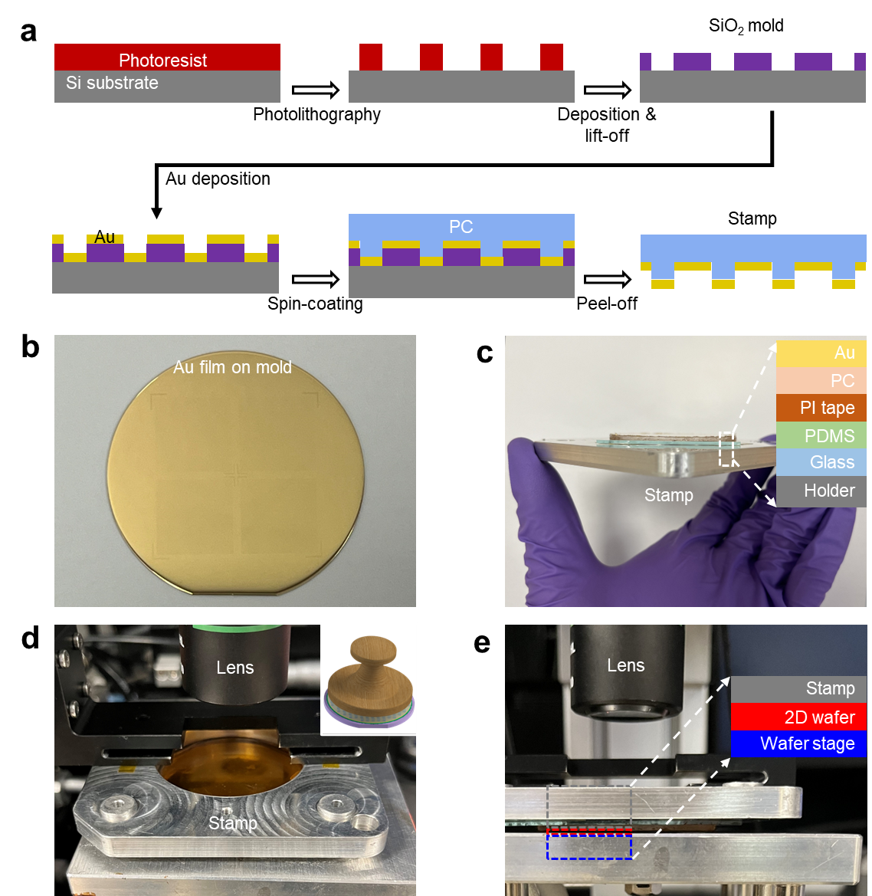
Supplementary Figure 1 | Schematics and photographs of stamp-assisted patterning process. a, Cross-section schematics of the 3D metal-stamp fabrication process. b, Photograph of 50 nm Au film on 3D SiO₂ mold. c, Photograph of Au stamp peeled-off from mold, the inset shows that it consists of six layers. d, e, Photographs of the stamp touching the 2D wafer.

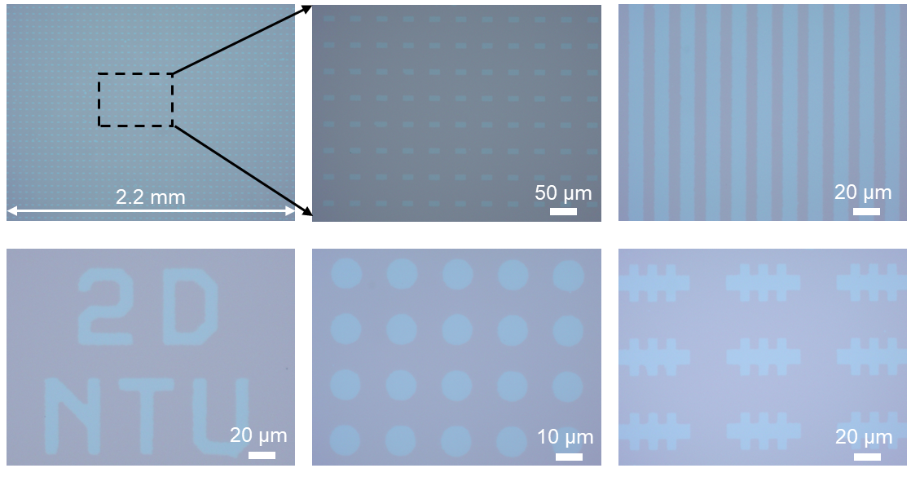
Supplementary Figure 2 | Optical images of scalable MoS₂ arrays with various shapes.

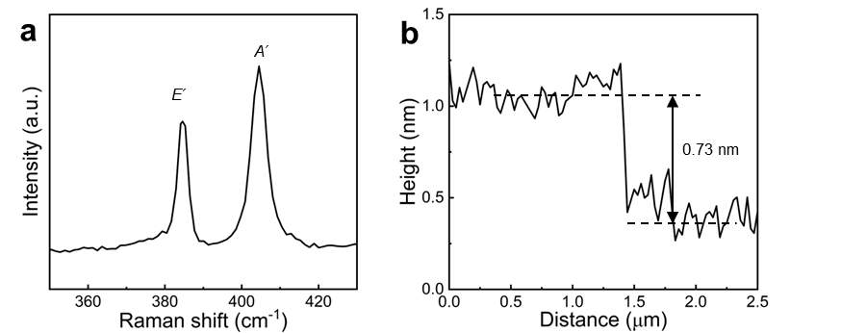
Supplementary Figure 3 | Raman spectrum and AFM measurements of monolayer MoS₂.

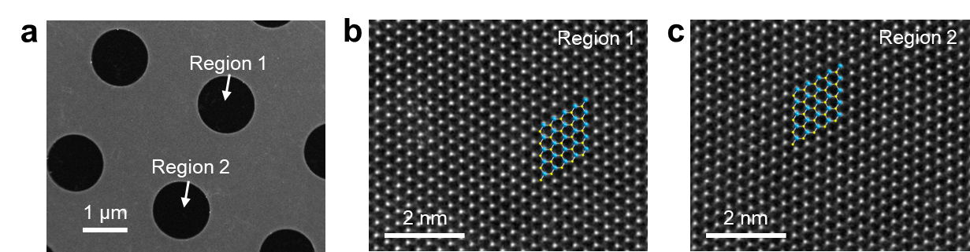
Supplementary Figure 4 | Large-field STEM images of patterned monolayer MoS₂. a, Low-magnification STEM image of patterned MoS₂. b, c, Atomic-resolution HAADF-STEM images taken at the locations marked in (a), demonstrating the damage-free lattice and high uniformity.

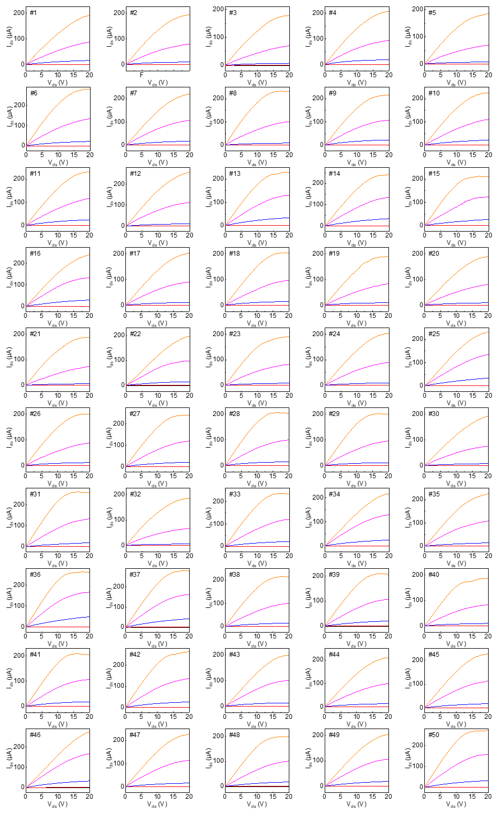
Supplementary Figure 5 | Output characteristics of 50 measured back-gated transistors. V_{g} from -60 V (black line) to 60 V (orange line) in steps of 30 V.

