Supplemental Material
Mapping benthic biodiversity variables of coral reefs using spatial interpolation of circular plot sampling
Léo Broudic^{1,2,3}, Mathieu Pinault^{4,5}, Romain Claud², Touria Bajjouk⁶, Tévamie Rungassamy⁷, Natacha Nikolic^{2,8,9}, Estelle Crochelet², Camille Mazé³, Benjamin Bergerot¹
1. UMR 6553 University of Rennes CNRS - ECOBIO, Rennes, France
2. ARBRE - Agence de Recherche pour la Biodiversité à La Réunion (ARBRE) - Reunion Island Biodiversity Research Agency, Saint-Gilles, La Réunion, France.
3. UMR 7048 CNRS Sciences Po - CEVIPOF - IRN Apolimer Chaire Outre-mer, 75007 Paris, France
4. MAREX Ltd- Marine Expertise Company. Saint Leu, Reunion Island
5. UMR 9220 UR CNRS IRD – ENTROPIE, Saint-Denis, Reunion Island.
6. IFREMER Centre de Brest, DYNECO/LEBCO, BP 70, 29280 Plouzané, France
7. Réserve Naturelle Marine de La Réunion, Saint-Paul, France
8. INRAE AQUA ECOBIOP, Saint Pée sur Nivelle, France
9. Centre de Recherche sur la Biodiversité et l'Environnement (CRBE), Université de Toulouse, CNRS, IRD, Toulouse INP, Université Toulouse 3 – Paul Sabatier (UT3), Toulouse, France

Corresponding author:
Léo Broudic
Affiliation University of Rennes, CNRS, ECOBIO - UMR 6553, Rennes, France – IRN APOLIMER – Science Po CNRS CEVIPOF Chaure Outre-mer Paris, France – Reunion Island Biodiversity Reseach Agency
E-mail address: leo.broudic@univ-rennes.fr – leobroudic@proton.me

Fig. S1 Prediction maps generated by ordinary kriging with a pixel size of 10 meters. Interpolation was performed by distinguishing the outer slope from the reef flat. The two maps were juxtaposed.
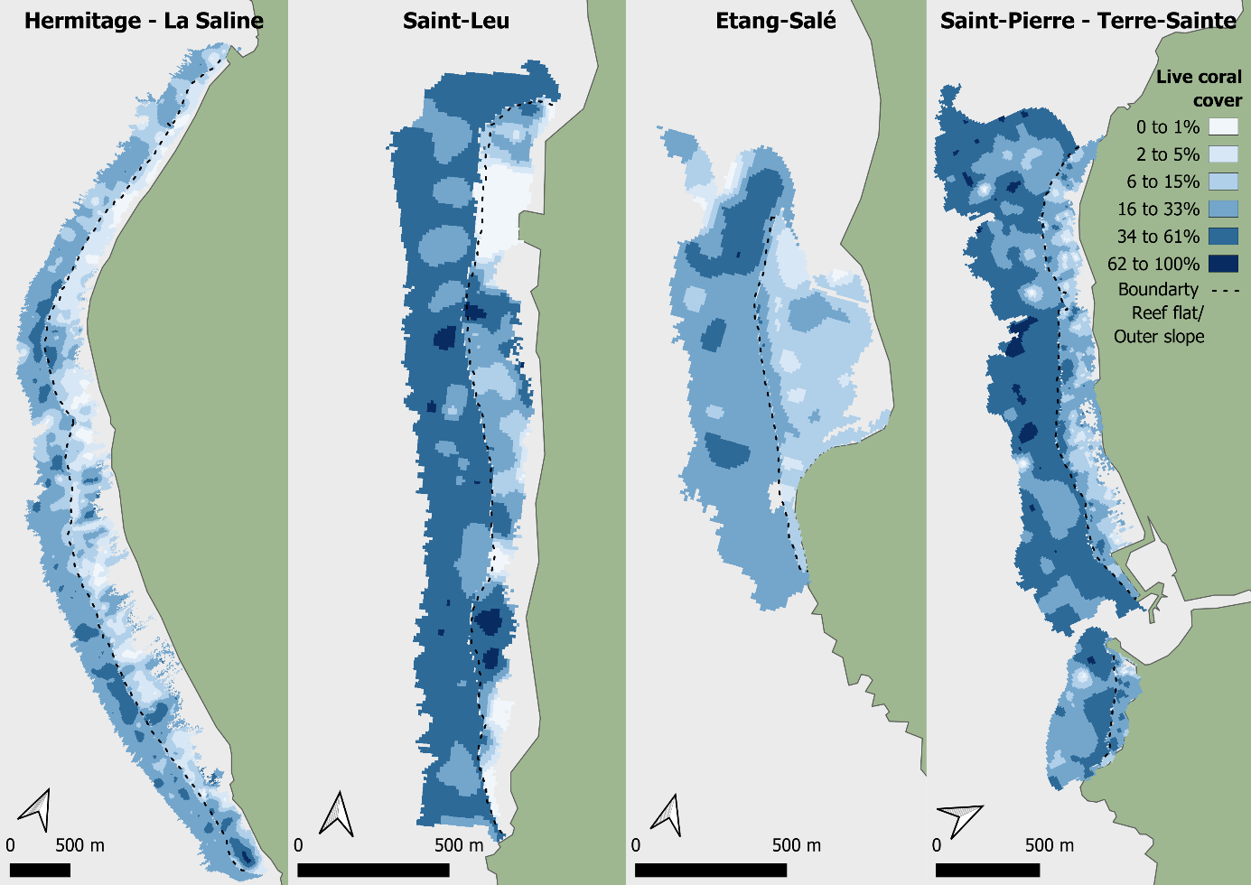
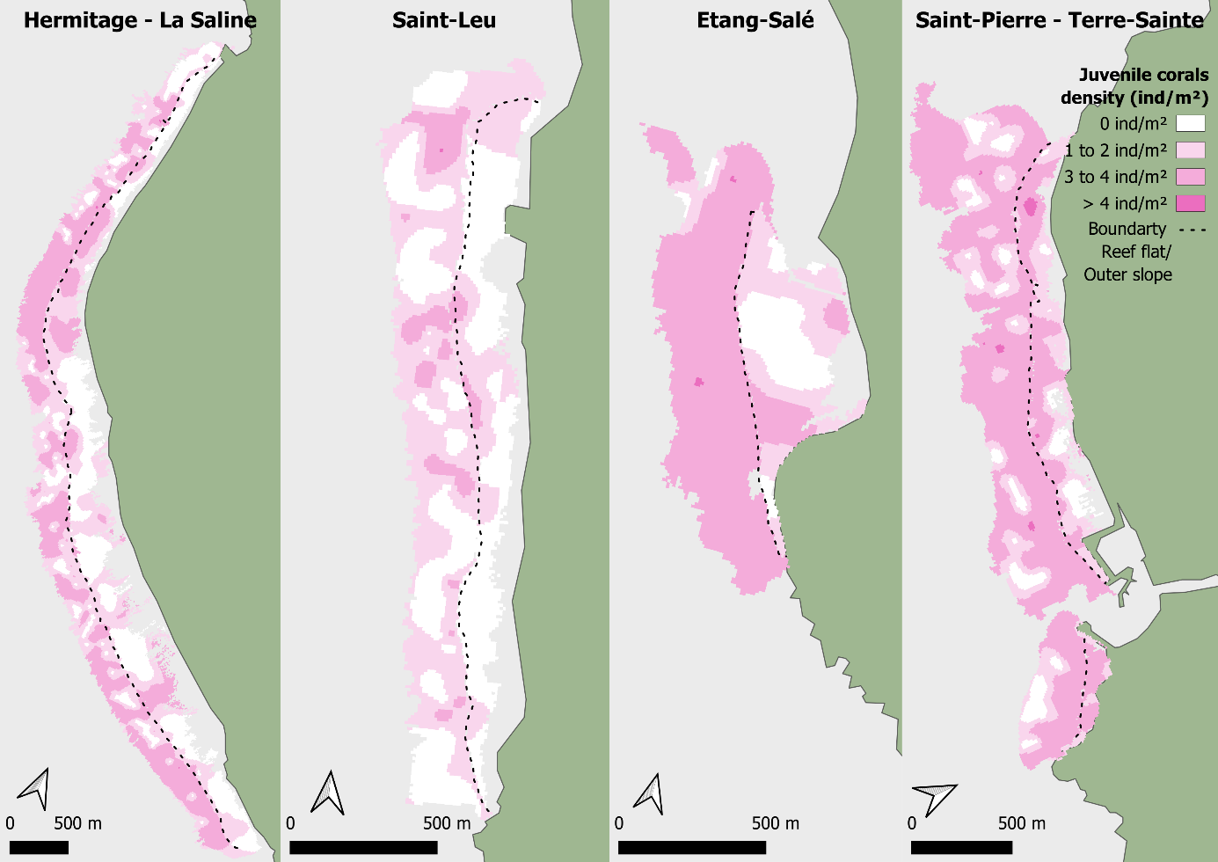
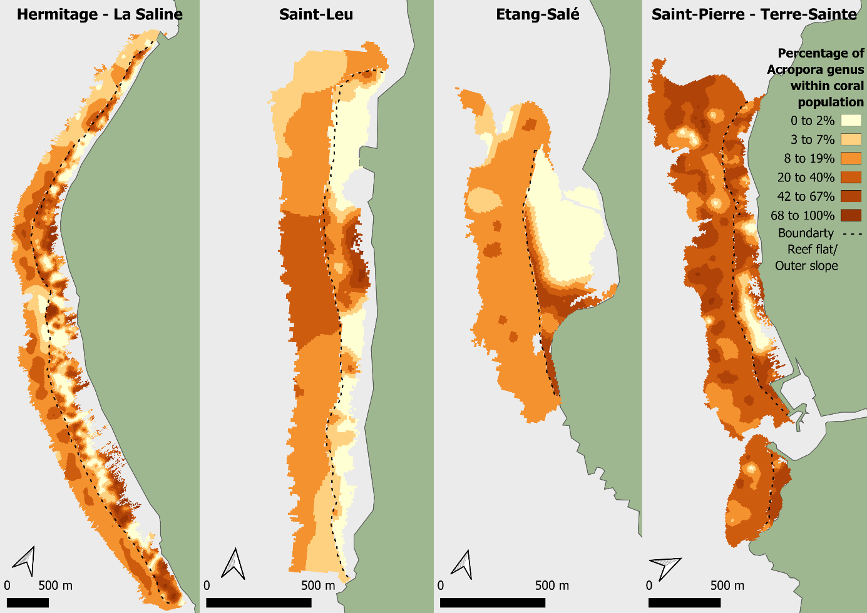
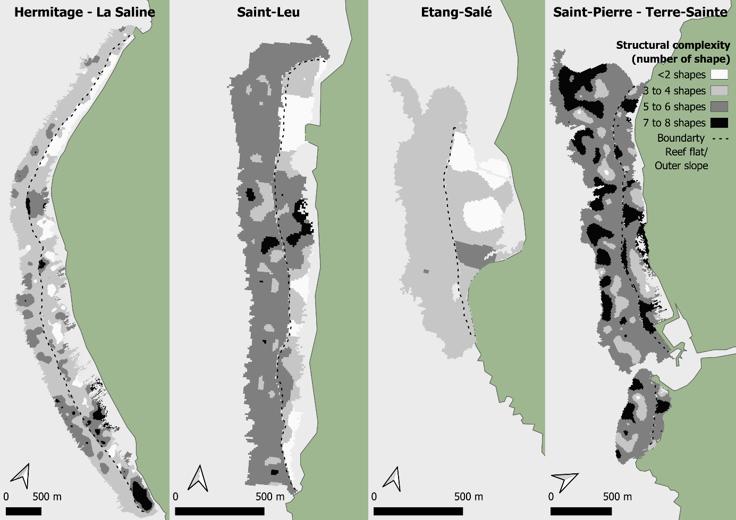

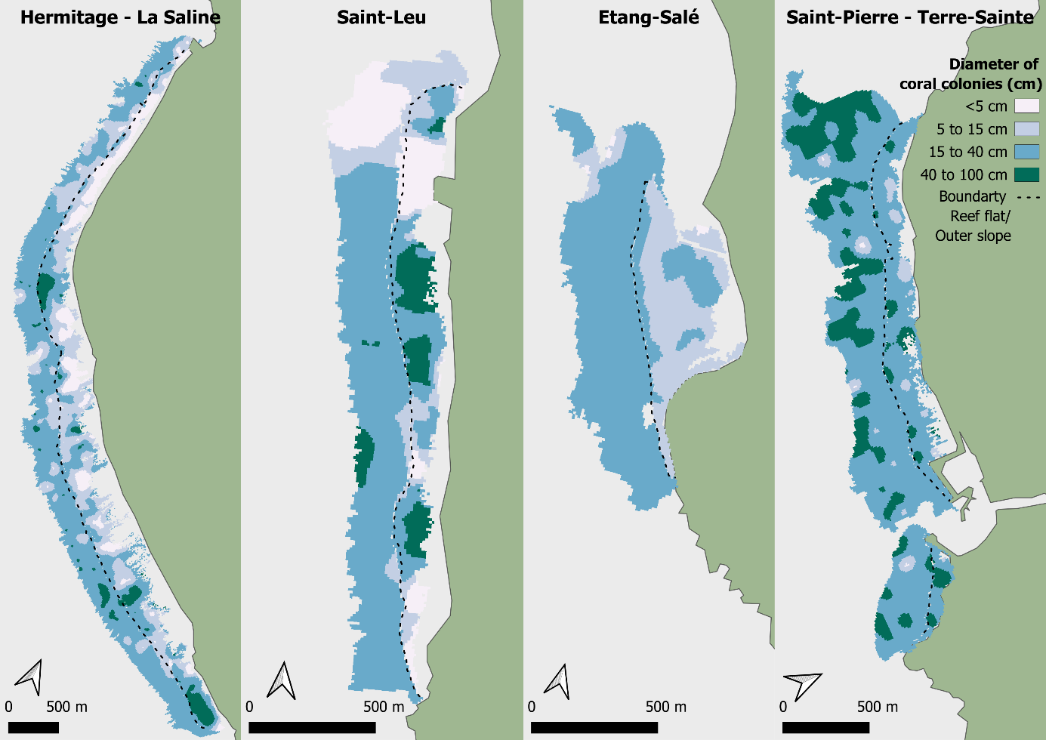
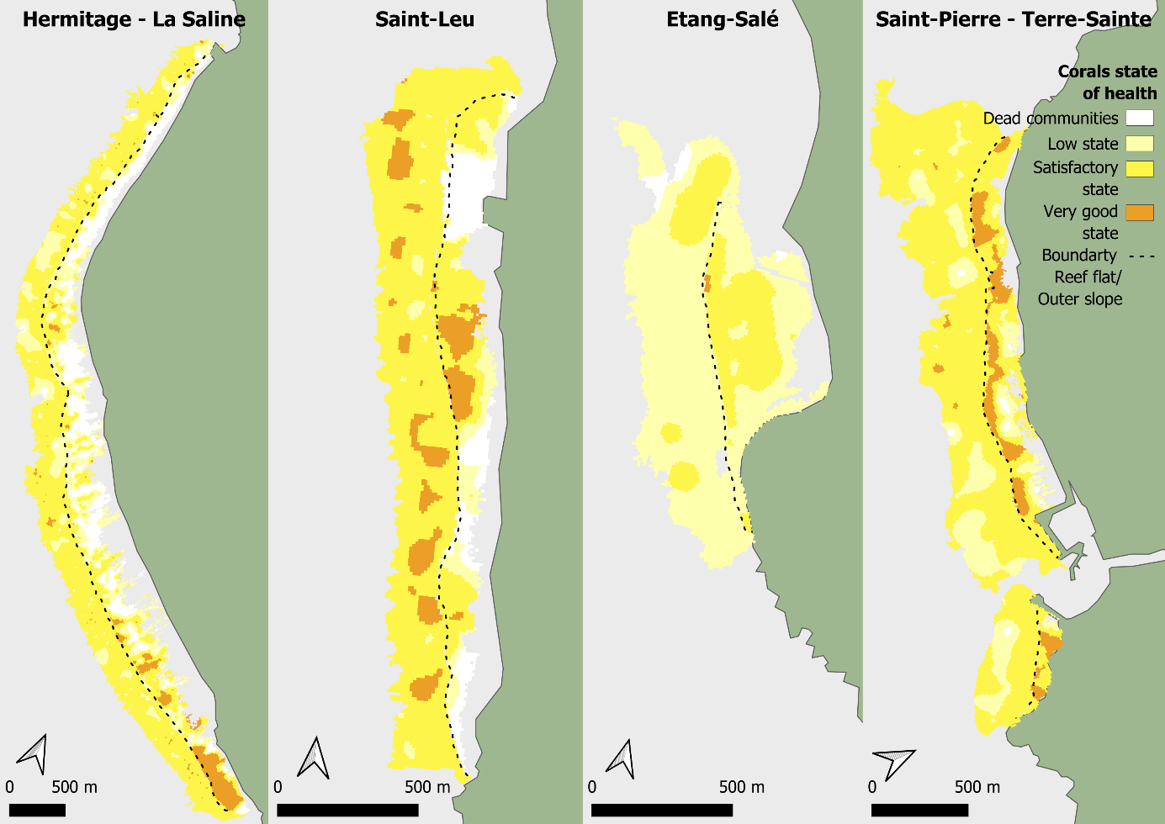

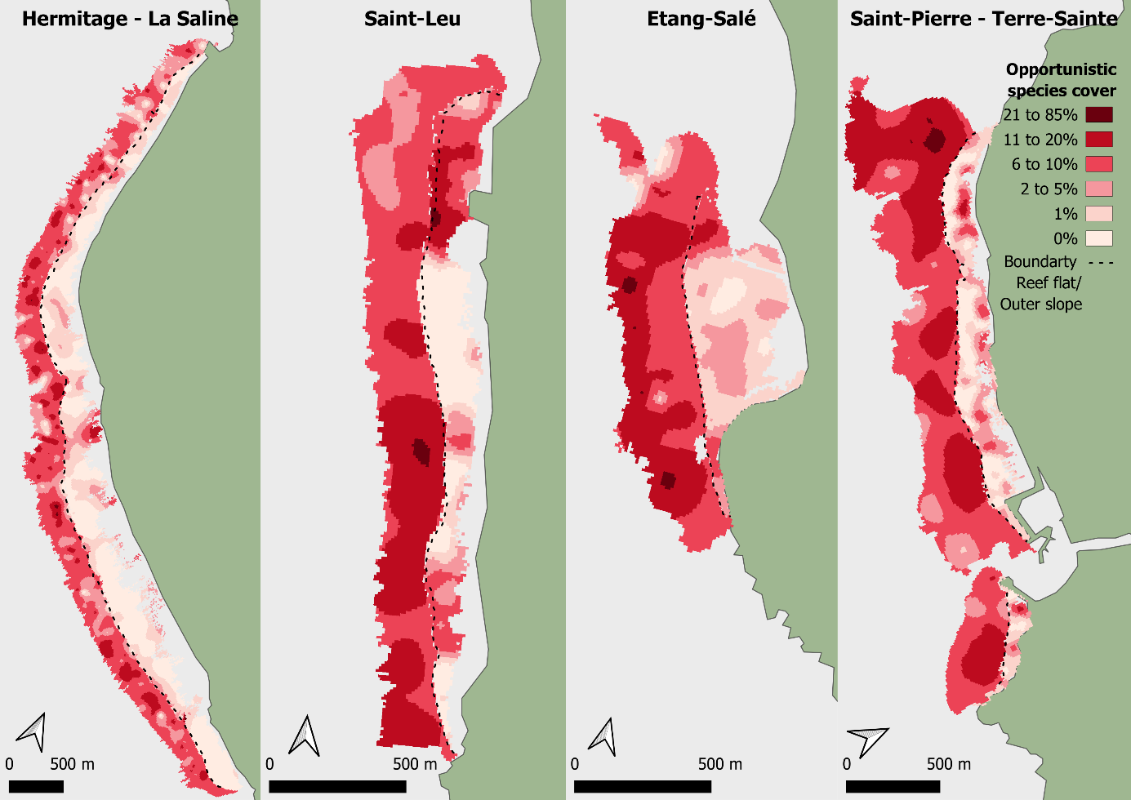
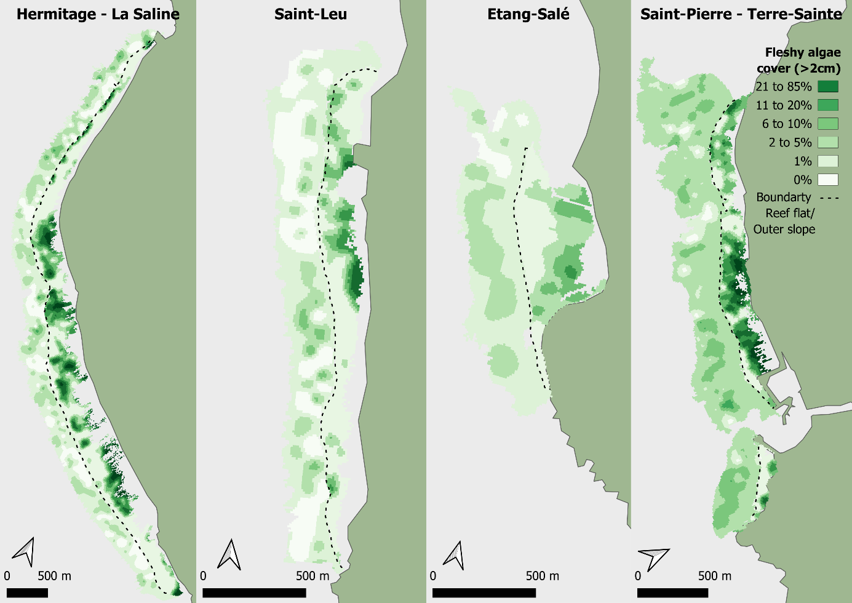

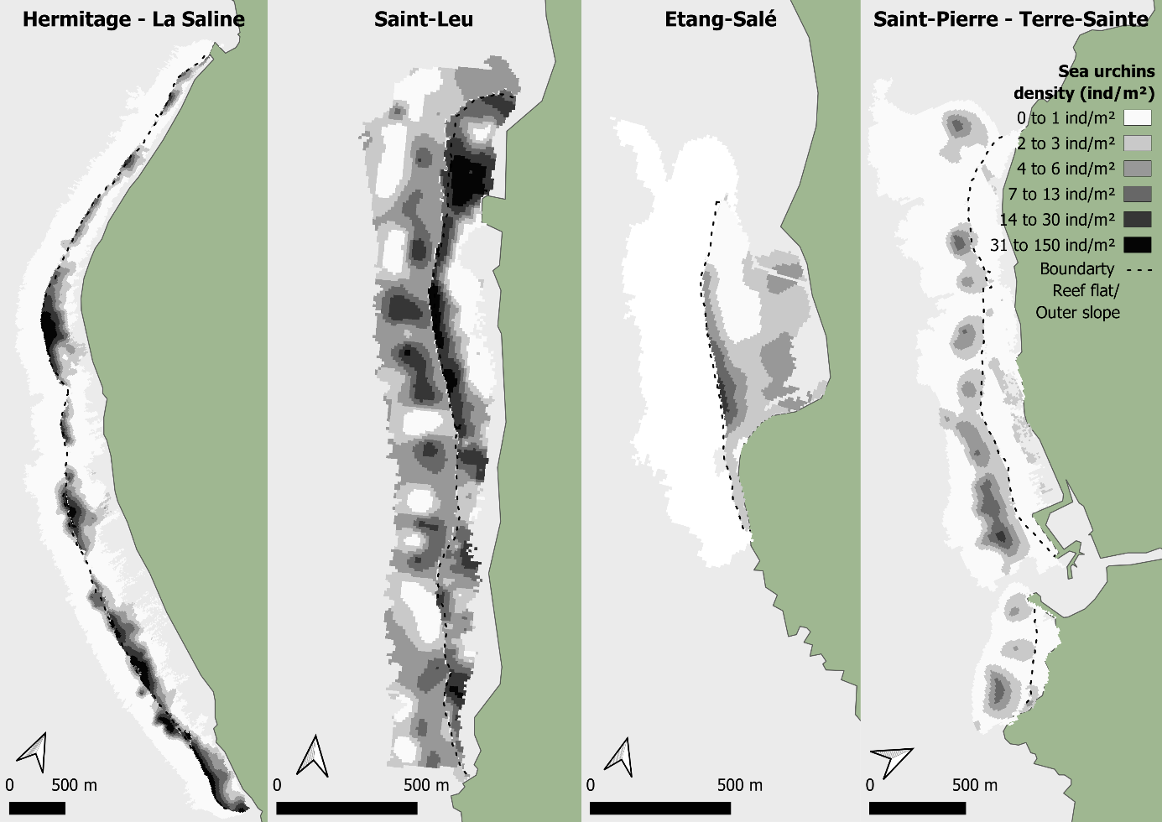

Fig. S2 Variation maps generated by ordinary kriging with a pixel size of 10 meters. Interpolation was performed by distinguishing the outer slope from the reef flat. The two maps were juxtaposed. For the variable of coral health conditions, the range goes from 0 (dead communities) to 3 (very good state).
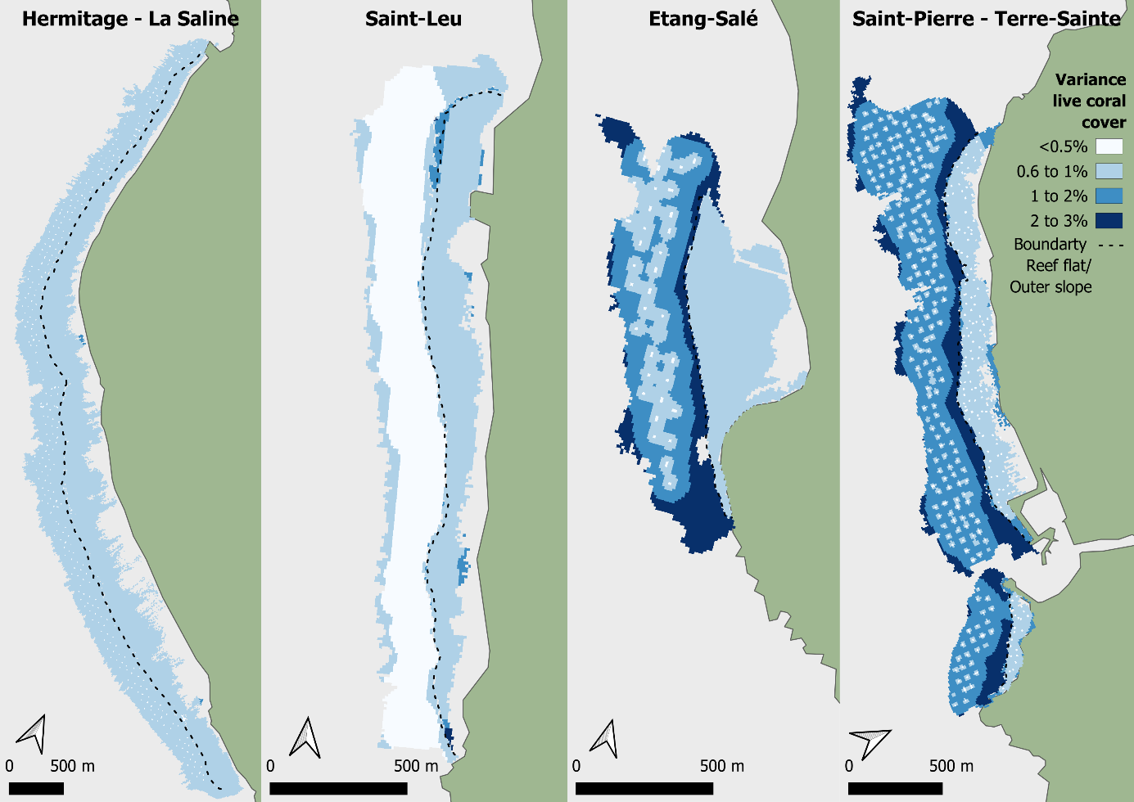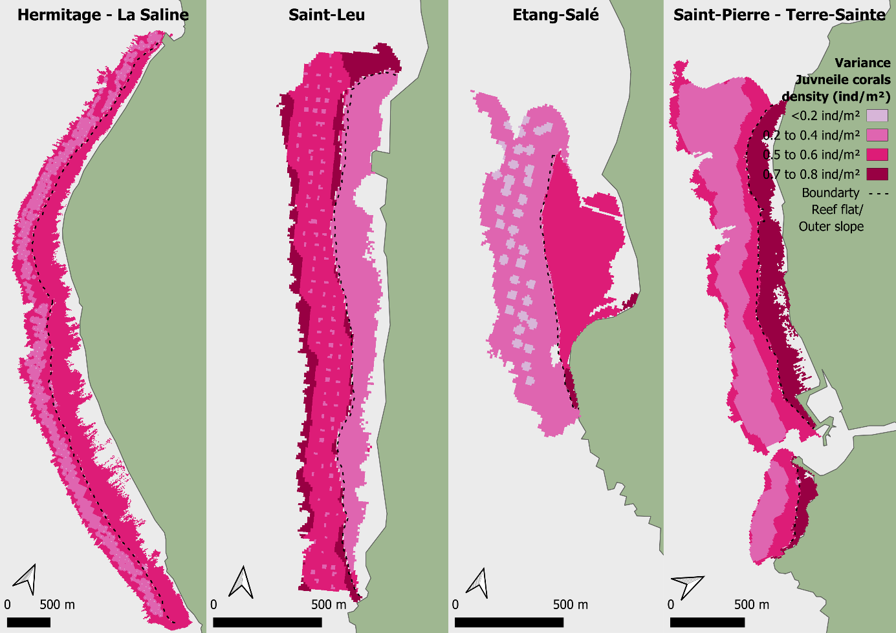
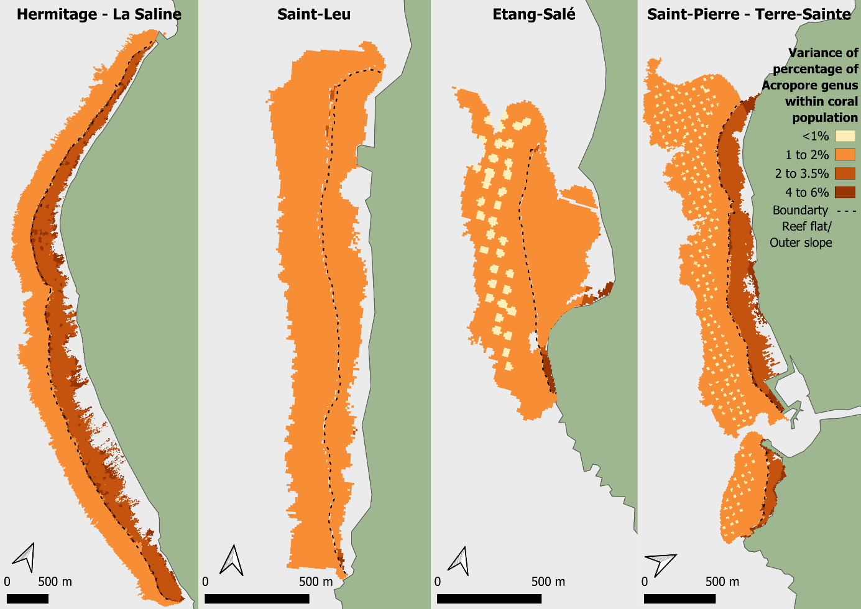
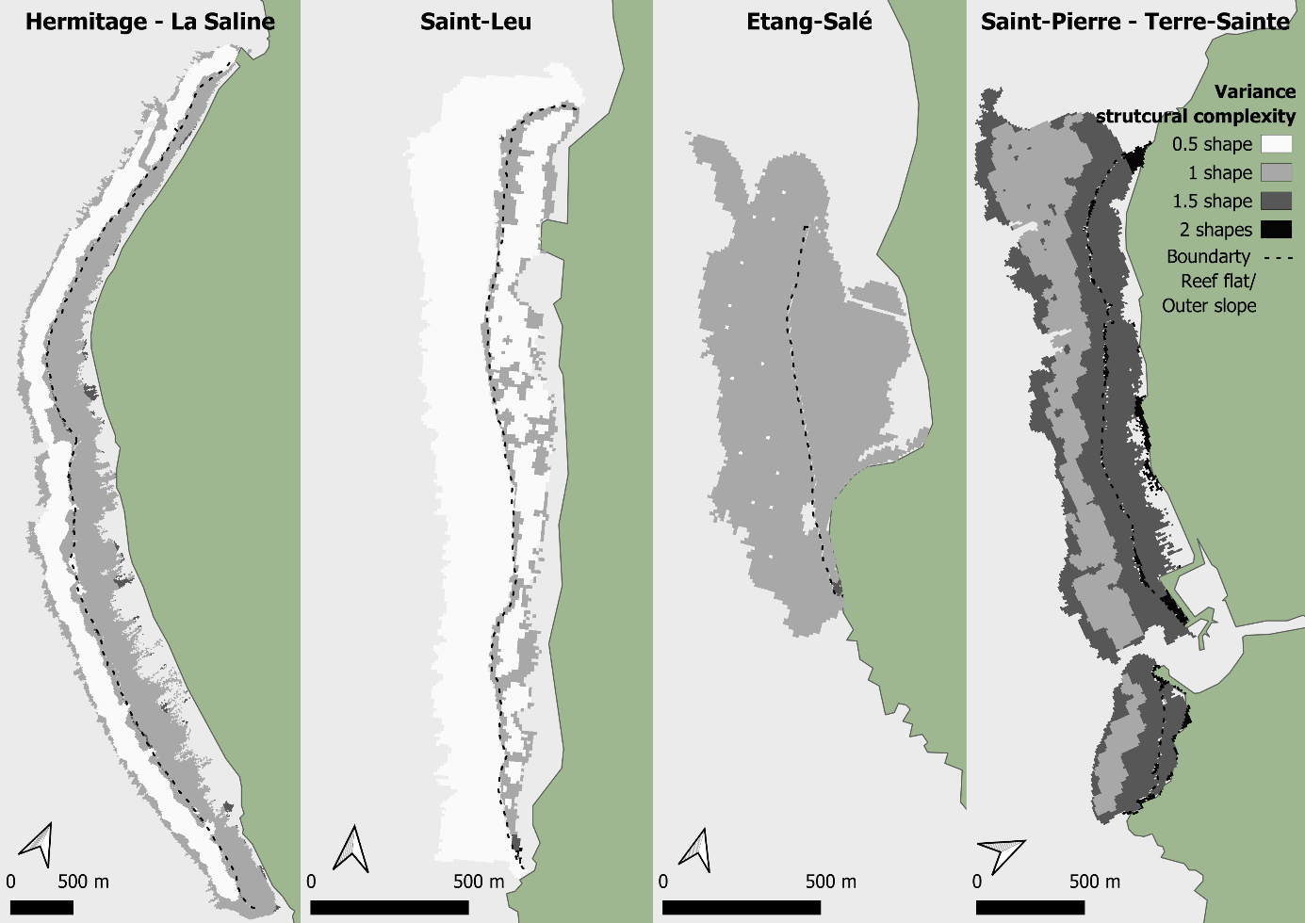
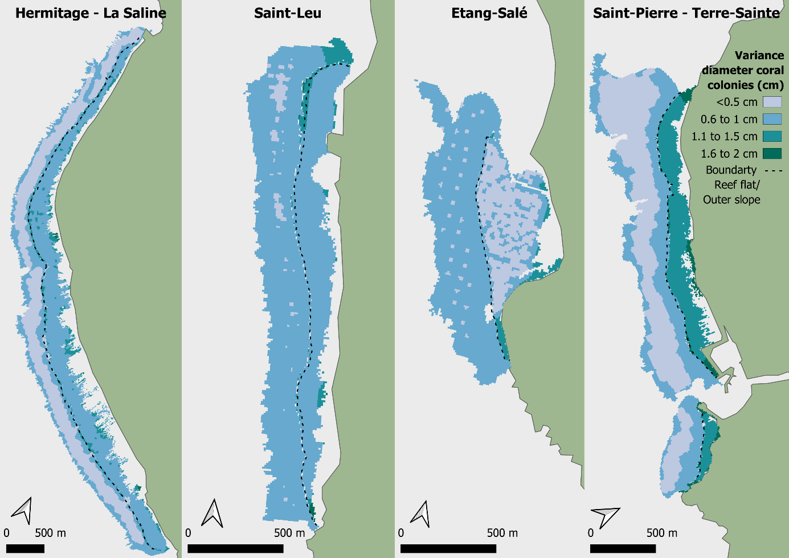
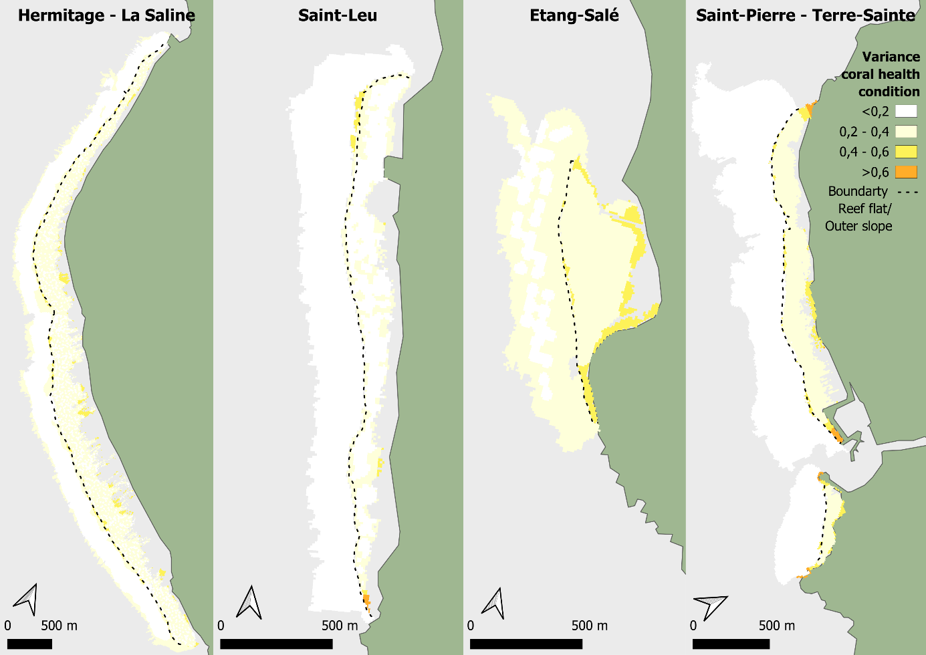
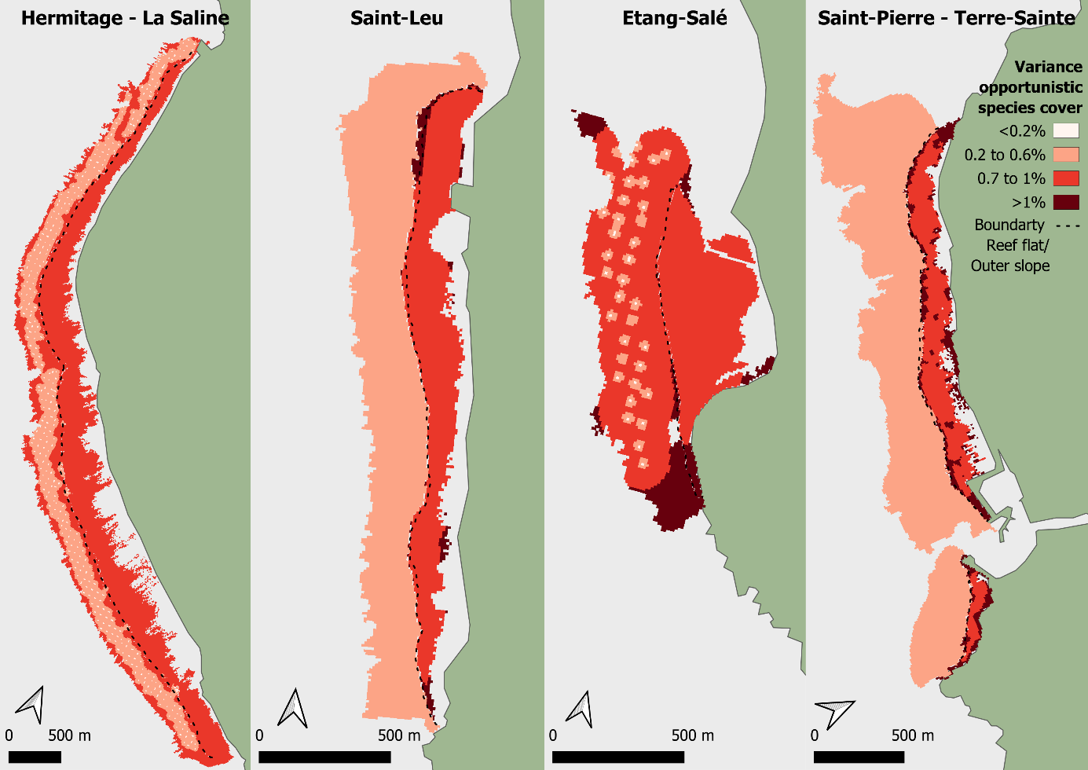

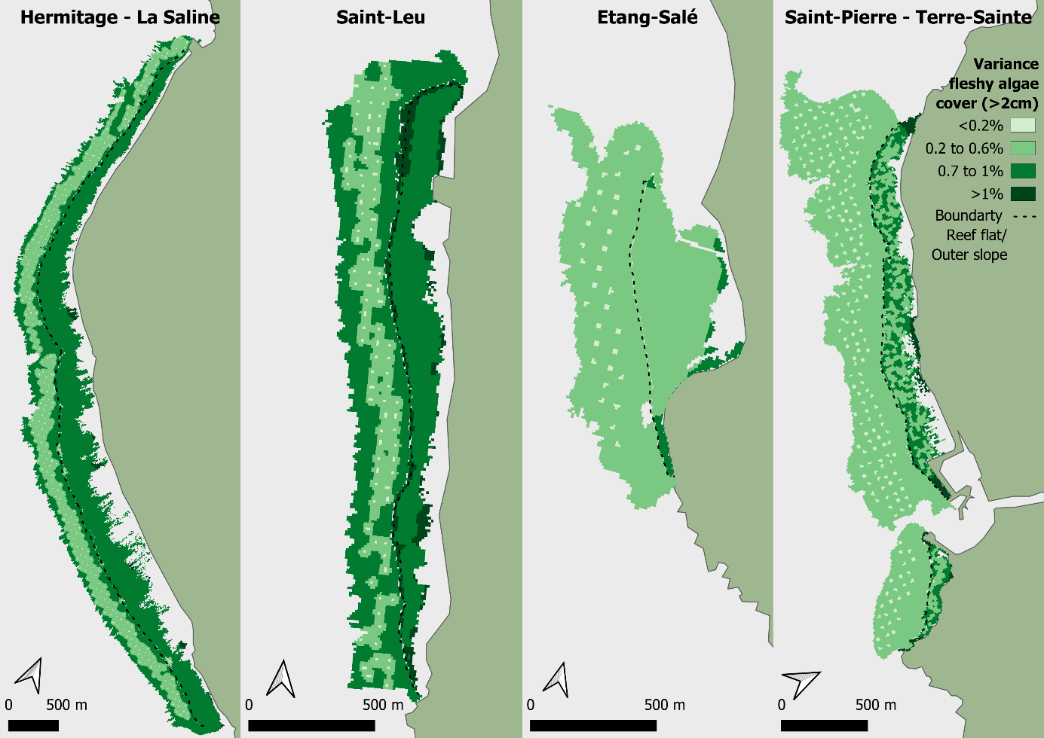
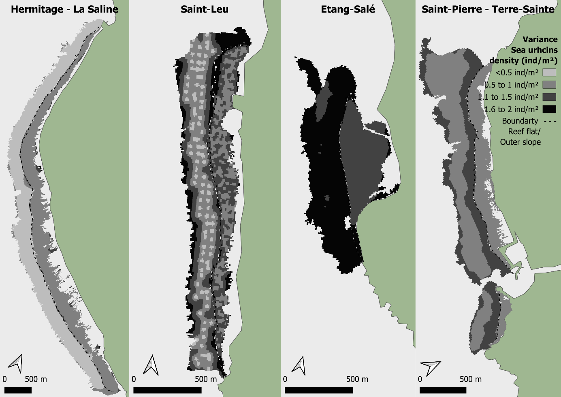

Table. S1 Mean and standard deviation of residual cross-validation between estimated values and predictive values for each BBVs on each site and zone.
Metric | Hermitage – La Saine |  | Saint-Leu |  | Etang-Salé |  | Saint-Pierre – Terre-Sainte
Metric | Outer slope | Reef flat | Outer slope | Reef flat | Outer slope | Reef flat | Outer slope | Reef flat
Live coral cover | -0.002 ± 0.438 | 1^{e-04} ± 0.416 | 0.002 ± 0.311 | -0.003 ± 0.524 | 8^{e-04} ± 0.608 | 0.002 ± 0.386 | -7^{e-04} ± 0.432 | 0.002 ± 0.530
Juvenile corals density | 8^{e-04} ± 0.688 | 0.000 ± 0.690 | -8^{e-04} ± 0.754 | 4^{e-04} ± 0.600 | 0.002 ± 0.572 | 9^{e-04} ± 0.696 | -0.001 ± 0.663 | -0.003 ± 0.924
Percentage of Acropora genus within coral population | -0.005 ± 0.543 | 0.002 ± 0.851 | -7^{e-04} ± 0.344 | 0.002 ± 0.567 | 0.001 ± 0.409 | 0.005 ± 0.531 | -0.002 ± 0.483 | 0.009 ± 0.767
Structural complexity | 0.001 ± 0.470 | 5^{e-04} ± 0.574 | 0.001 ± 0.367 | -0.003 ± 0.506 | 0.000 ± 0.567 | -2^{e-04} ± 0.494 | -0.003 ± 0.710 | 0.006 ± 0.694
Diameter of coral colonies | -1^{e-04} ± 0.507 | -0.001 ± 0.628 | -0.006 ± 0.482 | -0.004 ± 0.618 | 3^{e-04} ± 0.583 | 0.000 ± 0.623 | -4^{e-04} ± 0.511 | 0.003 ± 0.735
Corals health condition | 6^{e-04} ± 0.466 | 8^{e-04} ± 0.604 | -0.002 ± 0.311 | -0.001 ± 0.523 | 0.001 ± 0.506 | 0.017 ± 0.605 | -4^{e-04} ± 0.401 | 0005 ± 0.593
Opportunistic species cover | 0.002 ± 0.627 | -0.001 ± 0.671 | 3^{e-04} ± 0.550 | -0.002 ± 0.738 | -0.011 ± 0.733 | -4^{e-04} ± 0.677 | 0.004 ± 0.480 | 0.006 ± 0.782
Fleshy algae cover | 7^{e-04} ± 0.645 | -0.035 ± 0.702 | 0.005 ± 0.736 | 0.055 ± 0.806 | -0.002 ± 0.494 | 4^{e-04} ± 0.488 | 0.002 ± 0.489 | -0.008 ± 0.667
Sea urchins density | 0.005 ± 0.361 | 7^{e-04} ± 0.579 | -0.009 ± 0.668 | 0.004 ± 0.679 | 0.003 ± 0.628 | 0.025 ± 0.706 | 0.001 ± 0.669 | 0.001 ± 0.526

Fig. S3 Evolution of the absolute values of correlation coefficient obtained by spatial correlation function of station density for each metric. Irregularity in the absolute values of the correlation coefficient reflects heterogeneity between reef complexes. Dotted red lines are the thresholds 0.5 and 0.7 defined by Dorman et al., (2013) and the 0.9 defined for this study. a: outer slope, b: reef flat.
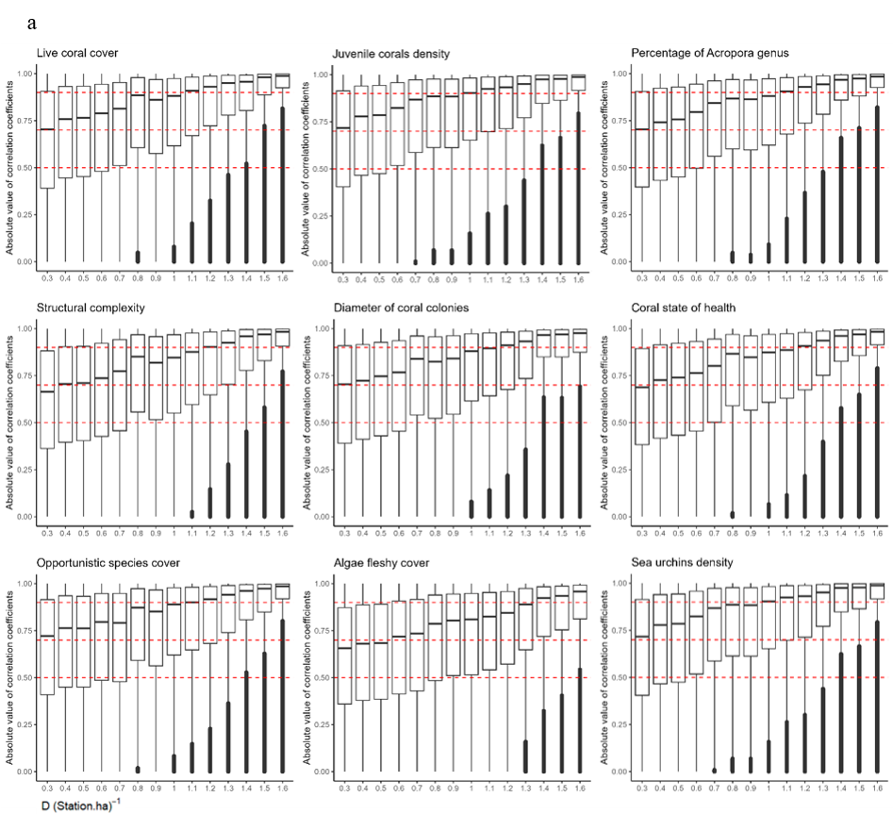

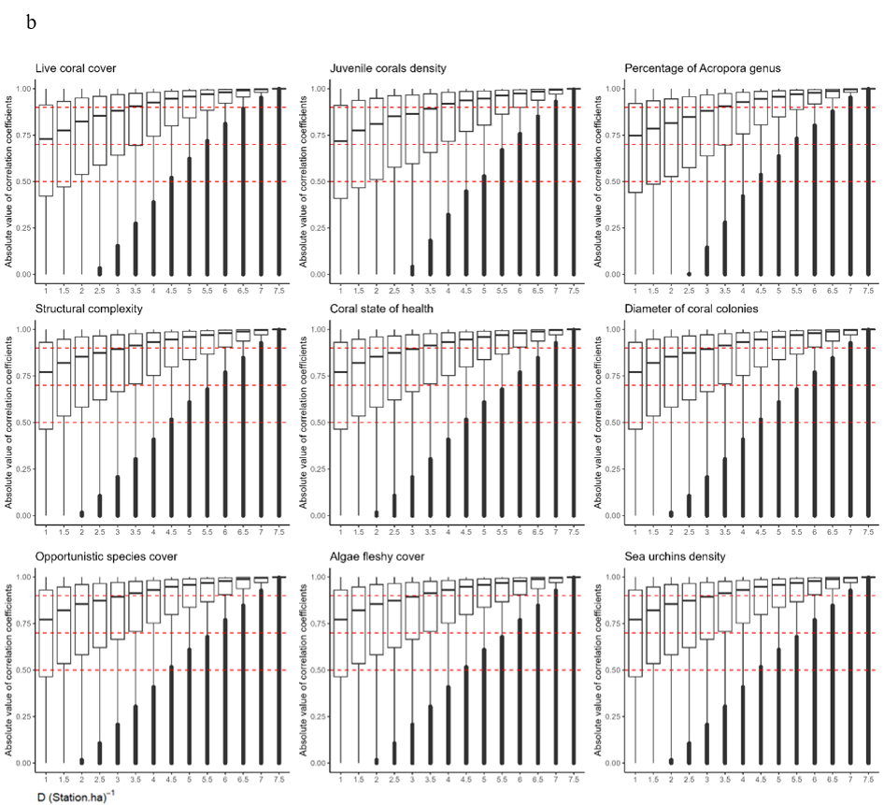

Fig. S4 Evolution of the absolute values of correlation coefficient obtained by spatial correlation function of station density for each metric. Irregularity in the absolute values of the correlation coefficient reflects heterogeneity between reef complexes. Dotted red lines are the thresholds 0.5 and 0.7 defined by Dorman et al., (2013) and the 0.9 defined for this study. a: outer slope, B: reef flat.
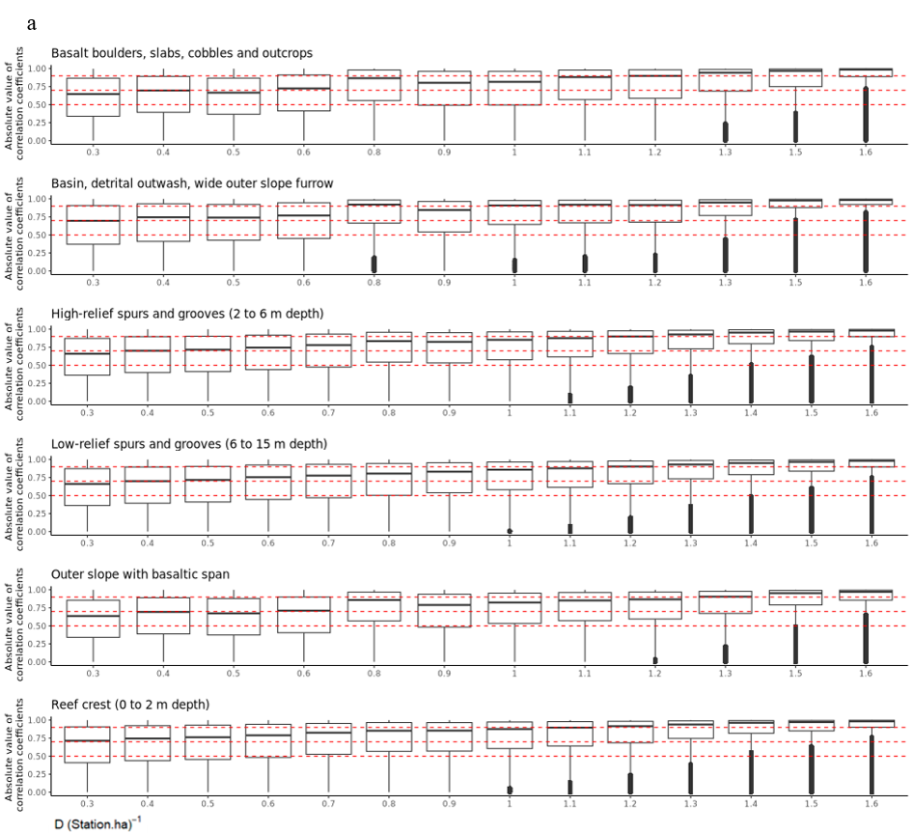

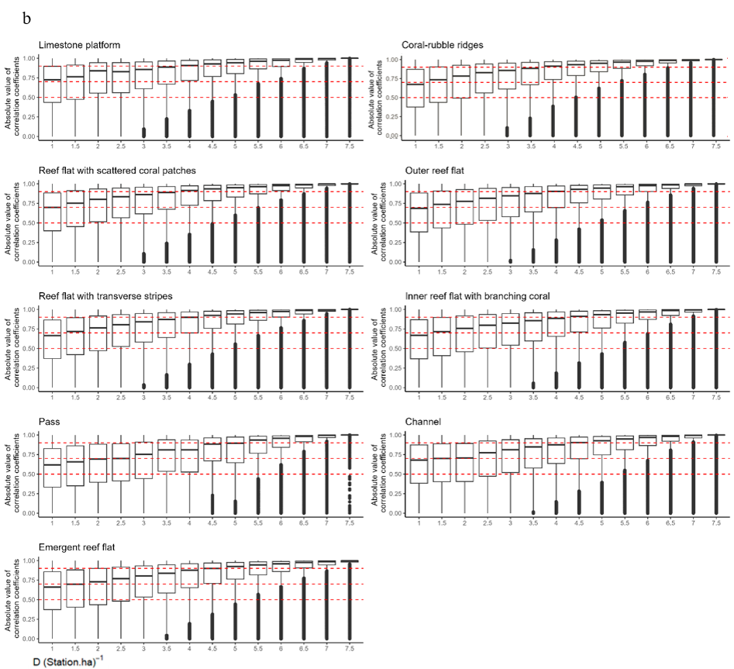

Fig. S5 Choropleth map obtained by averaging the ecological values of each metric within the circular plot. Saint-Leu, Etang-Salé and Saint-Pierre – Terre-Sainte reef crest, as well as Etang-Salé basalt fore reef are not included as no stations could be established in these areas.
