SUPPLEMENTARY MATERIAL

Section 1

Table S.1. Description of the text tasks used in current study.
Task label | Task type and frequency | Task instruction | Replicated from
A | SMS retrieval: Every two days, participants were asked to retrieve their most recent SMS. Task was repeated 5 times in the intervention period. | Please copy and paste a private message that you have sent to any close friend of yours in the past two weeks. Pick a message that has the most amount of written text and reflects a personal relationship. Don't worry about what the message says (for example, swear words)! For this activity, we are interested in how you write, not what you write. | (Tlachac & Rundensteiner, 2020)
B | Social media post: Every three days, participants were asked to make a fictional post on social media. Task was repeated 4 times in the intervention period. | Tell us, what’s on your mind right now? We'd like you to imagine that you are writing a post about how you are feeling right now to share on a social media platform (e.g. Facebook, Instagram, Twitter). Imagine that people you know will read it. We understand that many of you may not use social media or wouldn't normally share a post like this. We are interested to see what you would write if you did. For this task, the maximum character limit is set at 5000 to match the limit of common social media platforms. | (Kawasaki et al., 2020)
C | Emotion diary: Every four days, participants were asked to write about an event that impacted their mood. Task was repeated 3 times in the intervention period. | Please write about an event today that affected your mood. Please write about your feelings related to this event. Are there any words (e.g. compliment, encouragement, enlightenment) that you’d like to tell yourself? | (Lee et al., 2016)
D | Expressive essay: Every four days, participants were asked to write about their deepest thoughts and feelings. This task was repeated 3 times in the intervention period. | We want you to write about your deepest thoughts and feelings about an extremely important emotional issue that has affected you and your life. We’d like you to really let go and explore your deepest emotions and thoughts. Think about what the issue or experience means for you, your relationships with others, the past, present, your future, who you would like to be, and who you are now. | (Pennebaker et al., 2014; Pennebaker, 1997; Pennebaker, 2011; Pennebaker & Beall, 1986; Reinhold et al., 2018; Ullrich & Lutgendorf, 2002)
V | Personal writing task: Scheduled once on day 14, completed prior to mental health questionnaire. | Imagine you are meeting someone for the first time. How would you describe yourself? Tell us about you! Include things like your personality traits, your values, hobbies and interests, what you look like, your family, your work, favourite activities etc. | (Minori et al., 2020)
W | Neutral writing task: Scheduled once on day 28, completed prior to mental health questionnaire. | Tell us about your friends. How do you usually spend time together? Tell us about the things you and your friends enjoy. You can also share any challenges you may be having with your friends right now. | (Minori et al., 2020)
X | Narrative imagery task – Description of a complex picture: Scheduled once on day 42, completed prior to mental health questionnaire. | Tell us in your own words, what you think is happening in this image? (Cookie Theft from the Boston Diagnostic Aphasia Examination Battery). | (Minori et al., 2020)
Y | Holidaying letter to a friend: Scheduled once on day 56, completed prior to mental health questionnaire. | Imagine you are enjoying your time on an amazing holiday. Everything is going well, and you are having fun doing all your favourite things. We want you to write a letter to your friend to convince him/her to come and enjoy this fun time with you. | (Havigerová et al., 2019)

Section 2

S.2. Linguistic analysis and data preparation
Prior to running the LIWC-22 analysis, data was prepared according to the manual of the LIWC-22 analysis tool. The following cleaning processes were applied:
- When a participant entered the default distress response (i.e., “I feel too distressed to complete this task today”) to any task, the response was classified as task “attempted” but “Invalid for analysis – participant distressed”.
- For task A (SMS) only, content was reviewed by a research assistant to ensure that participants had only entered their own SMS data, rather than SMS conversations with others. If conversations with others could be identified, the text content that was not authored by the participant was removed for analysis. These responses were then coded as “Valid for analysis – SMS edited”. Participants who reported that they did not have suitable SMS data available (i.e., did not send SMS during that period) were also classified as task “attempted” but “Invalid for analysis– no SMS sent”. Participants who attempted to deidentify their SMS content by replacing personal names with “XXX” within the SMS had their responses classified as “Valid – name edited” and the “XXX” was replaced with a formal placeholder [name] and this was excluded from the LIWC. For Task A (SMS), emoticons and emojis remained unedited as LIWC ignores this in the analysis.
- A spell check was run on all responses with spelling errors amended.
- As guided by the LIWC analysis guide, if the following entry types were entered in any responses, the recommended replacement was inserted:
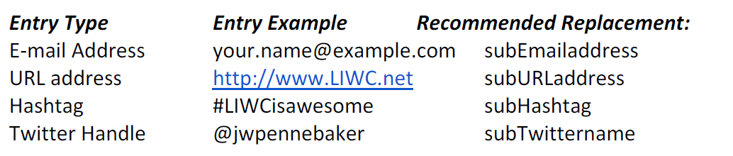

Section 3

S.3.1 Sample selection
The sequences were collapsed into one sample because at baseline, there were no significant differences in depressive (F(3,214) = 0.676, P= .568) or anxiety symptoms (F(3,214) = 0.714, P = .545) between the sequences and the results remain unchanged when age, sex and education were accounted for (P=.568-.545). There were some significant changes over time for participants’ depressive symptoms (F(4,771) = 5.289, P <.001) but no significant differences across sequences (F(3,215) = 0.158, P=.924) and no significant interaction between time and sequence (F(12,771) = 1.393, P=.163). There was also no change over time in participants’ anxiety symptoms (F(4,769) = 1.224, P=.299), no differences across the sequences (F(3,213) = 0.802, P=.494) and no significant interaction between time and sequence (F(12,769) = 0.576, P=.862).

S.3.2. Model selection and validation
Nested cross-validation was selected as it maximises use of the whole dataset for testing overall performance while maintaining the split between training and testing samples, and provides the next best estimate of real-world predictive performance when external datasets are not available (Lewis et al., 2023; Vabalas et al., 2019; Varma & Simon, 2006). For the nested cross-validation, data were first split into 10 outer and 10 inner cross-validation folds stratified by mental health scores to ensure representative distributions of participants in each fold. Inner folds were used to evaluate the performance of each models hyperparameters. For each outer fold, the hyperparameter configuration with the lowest root mean squared error (RMSE) across the inner folds was selected, retrained on all inner-fold data of that outer fold, and used to predict on the held-out outer fold data. These predictions on held-out data had not been seen during training and were used to compute the final performance reported in the results. Models were also developed with recursive feature elimination embedded within the outer CV loops to test whether this improved performance.
S.3.2.1. Details of hyperparameter tuning
Elastic Net: We optimized the hyperparameters of the Elastic Net model, which combines the properties of both ridge and lasso regression. The parameters tuned were the mixing parameter α and the regularization parameter λ. The mixing parameter α determines the balance between lasso (L1) and ridge (L2) regularization, ranging from 0 (ridge-only) to 1 (lasso-only). We varied α linearly, testing 11 evenly spaced values from 0 to 1. The regularization parameter λ, which controls the overall strength of the regularization, was explored over a logarithmic scale, with values ranging from 2⁻¹⁵ to 2⁵. This approach allows for a detailed investigation into the effects of both mild and strong regularization on model performance.
Random forest: We optimized the hyperparameter mtry, which specifies the number of features randomly sampled as candidates at each split in the construction of the trees within the Random Forest model. The parameter mtry controls the diversity of the trees and thus the bias-variance trade off of the overall model. The values of mtry investigated were chosen to encompass a broad range, starting from 1 up to 20, and including specific larger values at 30, 40, 50, and 70. This selection was designed to evaluate the model's performance across a diverse set of scenarios, from using very few features at each split, which tends to produce more biased trees, to using many features, which can reduce bias but increase variance and computational demand.
Support Vector Machines: We optimized the hyperparameters of the Support Vector Machine (SVM) using both linear and non-linear configurations to ensure robust model performance. For the linear SVM, we tuned the regularization parameter C, while for the non-linear SVM with a radial basis function (RBF) kernel, we tuned both C and the kernel coefficient γ. For C, the values tested ranged from 2⁻¹⁵ to 2⁵, allowing exploration from very high regularization (to prevent overfitting) to very low regularization (to capture more complex patterns in the data). Similarly, γ was varied across the same range, from to 2⁻¹⁵ 2⁵, to thoroughly investigate the influence of kernel scale on the decision boundary smoothness and model flexibility.

Section 4

S.4. Results
Table S.4.1. Participant characteristics within sequences.
 | Total sample |  | Sequence 1 |  | Sequence 2 |  | Sequence 3 |  | Sequence 4
 | M | SD | M | SD | M | SD | M | SD | M | SD
Age | 39.33 | 12.37 | 40.64 | 11.93 | 37.63 | 11.59 | 37.90 | 12.27 | 41.00 | 13.51
PHQ9 | 13.50 | 4.13 | 13.34 | 4.20 | 14.11 | 4.19 | 13.00 | 3.91 | 13.54 | 4.22
GAD7 | 10.83 | 4.51 | 11.16 | 4.54 | 11.33 | 4.12 | 10.19 | 4.97 | 10.60 | 4.42
 | N | % | N | % | N | % | N | % | N | %
Female | 163 | 74.8 | 43 | 76.8 | 40 | 74.1 | 36 | 69.2 | 44 | 78.6
University education | 105 | 48.2 | 36 | 64.3 | 21 | 38.9 | 22 | 42.3 | 26 | 46.4
Married/Partnered | 115 | 52.8 | 32 | 57.1 | 27 | 50.0 | 29 | 55.8 | 27 | 48.2
Paid employment | 163 | 74.8 | 41 | 73.2 | 45 | 83.3 | 39 | 75.0 | 38 | 67.9
Born in Australia | 175 | 80.3 | 42 | 75.0 | 41 | 75.9 | 46 | 88.5 | 46 | 82.1
First Nations | 5 | 2.3 | 1 | 1.8 | 0 | 0.0 | 1 | 1.9 | 3 | 5.4
LGBTQI+ | 45 | 20.6 | 12 | 21.4 | 13 | 24.1 | 10 | 19.2 | 10 | 17.9
English only | 198 | 90.8 | 47 | 83.9 | 50 | 92.6 | 51 | 98.1 | 50 | 89.3
Literacy support (Never) | 186 | 85.3 | 48 | 85.7 | 45 | 83.3 | 43 | 82.7 | 50 | 89.3
Formally diagnosed mental illness | 202 | 92.7 | 54 | 96.4 | 50 | 92.6 | 46 | 88.5 | 52 | 92.9
Age of onset | 19.91 | 10.83 | 22.80 | 11.02 | 19.10 | 11.11 | 20.47 | 11.23 | 17.19 | 9.64
Age of diagnosis | 26.94 | 10.93 | 25.97 | 10.36 | 24.24 | 10.85 | 27.61 | 11.76 | 27.02 | 10.64
Taking prescribed medication | 130 | 59.6 | 38 | 67.9 | 33 | 61.1 | 27 | 51.9 | 31 | 55.4
Likely case of MDD | 193 | 88.5 | 48 | 85.7 | 48 | 88.9 | 47 | 90.4 | 50 | 89.3
Likely case of GAD | 134 | 61.5 | 37 | 66.1 | 39 | 72.2 | 26 | 50.0 | 32 | 57.1

Table S.4.2. Mean values (proportions) for LIWC-22 features averaged across tasks
Mean (SD) | Category | Abbreviation | Descriptor
122 (69.9) | Word count | WC | Total word count
15.7 (5.3) | Words per sentence | WPS | Average words per sentence
14.8 (2.6) | Big words | BigWords | Percent words 7 letters or longer
94 (1.7) | Dictionary words | Dic | Percent words captured by LIWC
75.6 (3.1) | Linguistic Dimensions | Linguistic
59.5 (3.8) | Total function words | function | the, to, and, I
16.9 (2.8) | Total pronouns | pronoun | I, you, that, it
12.4 (2.3) | Personal pronouns | ppron | I, you, my, me
8.1 (2) | 1st person singular | i | I, me, my, myself
0.8 (0.6) | 1st person plural | we | we, our, us, lets
1.3 (0.8) | 2nd person | you | you, your, u, yourself
1.4 (1) | 3rd person singular | shehe | he, she, her, his
0.6 (0.5) | 3rd person plural | they | they, their, them, themsel*
4.6 (1.5) | Impersonal pronouns | ipron | that, it, this, what
12.8 (1.9) | Determiners | det | the, at, that, my
5.7 (1.3) | Articles | article | a, an, the, alot
1 (0.9) | Numbers | number | one, two, first, once
12.9 (1.7) | Prepositions | prep | to, of, in, for
10.9 (1.7) | Auxiliary verbs | auxverb | is, was, be, have
6.7 (1.5) | Adverbs | adverb | so, just, about, there
7.7 (1.4) | Conjunctions | conj | and, but, so, as
1.9 (0.8) | Negations | negate | not, no, never, nothing
20.1 (2.4) | Common verbs | verb | is, was, be, have
6.9 (2.7) | Common adjectives | adj | more, very, other, new
4.3 (1.4) | Quantities | quantity | all, one, more, some
4.9 (1.4) | Drives | Drives | we, our, work, us
2.9 (1.2) | Affiliation | affiliation | we, our, us, help
1.3 (0.6) | Achievement | achieve | work, better, best, working
0.7 (0.4) | Power | power | own, order, allow, power
13.8 (2.4) | Cognition | Cognition | is, was, but, are
1.3 (0.7) | All-or-none | allnone | all, no, never, always
12.4 (2.3) | Cognitive processes | cogproc | but, not, if, or, know
3 (1) | Insight | insight | know, how, think, feel
1.4 (0.7) | Causation | cause | how, because, make, why
2.1 (0.7) | Discrepancy | discrep | would, can, want, could
2.6 (1.1) | Tentative | tentat | if, or, any, something
0.8 (0.6) | Certitude | certitude | really, actually, of course, real
3.6 (1.1) | Differentiation | differ | but, not, if, or
0.1 (0.1) | Memory | memory | remember, forget, remind, forgot
7.7 (3.3) | Affect | Affect | good, well, new, love
4.5 (1.4) | Positive tone | tone_pos | good, well, new, love
2.9 (3.1) | Negative tone | tone_neg | bad, wrong, too much, hate
3.7 (3) | Emotion | emotion | good, love, happy, hope
1.7 (0.8) | Positive emotion | emo_pos | good, love, happy, hope
1.8 (2.9) | Negative emotion | emo_neg | bad, hate, hurt, tired
0.5 (1) | Anxiety | emo_anx | worry, fear, afraid, nervous
0.2 (0.2) | Anger | emo_anger | hate, mad, angry, frustr*
0.3 (0.5) | Sadness | emo_sad | :(, sad, disappoint*, cry
0.2 (0.3) | Swear words | swear | shit, fuckin*, fuck, damn
11 (2.6) | Social processes | Social | you, we, he, she
3.5 (1.4) | Social behavior | socbehav | said, love, say, care
0.9 (1) | Prosocial behavior | prosocial | care, help, thank, please
0.4 (0.9) | Politeness | polite | thank, please, thanks, good morning
0.2 (0.2) | Interpersonal conflict | conflict | fight, kill, killed, attack
0.2 (0.3) | Moralization | moral | wrong, honor*, deserv*, judge
1.2 (0.6) | Communication | comm | said, say, tell, thank*
7.2 (1.9) | Social referents | socrefs | you, we, he, she
0.9 (0.7) | Family | family | parent*, mother*, father*, baby
0.5 (0.4) | Friends | friend | friend*, boyfriend*, girlfriend*, dude
1.5 (1) | Female references | female | she, her, girl, woman
0.8 (0.8) | Male references | male | he, his, him, man
0.2 (0.2) | Culture | Culture | car, united states, govern*, phone
0 (0.1) | Politics | politic | united states, govern*, congress*, senat*
0 (0) | Ethnicity | ethnicity | american, french, chinese, Indian
0.1 (0.2) | Technology | tech | car, phone, comput*, email*
3 (1.1) | Lifestyle | lifestyle | work, home, school, working
0.9 (0.6) | Leisure | leisure | game*, fun, play, party*
0.5 (0.4) | Home | home | home, house, room, bed
1.3 (0.8) | Work | work | work, school, working, class
0.4 (0.3) | Money | money | business*, pay*, price*, market*
0.1 (0.3) | Religion | relig | god, hell, christmas*, church
3.1 (1.9) | Physical | physical | medic*, food*, patients, eye*
1.4 (1.6) | Health | health | medic*, patients, physician*, health
0.3 (0.3) | Illness | illness | hospital*, cancer*, sick, pain
0.1 (0.1) | Wellness | wellness | healthy, gym*, supported, diet
0.4 (0.7) | Mental health | mental | mental health, depressed, suicid*, trauma*
0.1 (0.2) | Substances | substances | beer*, wine, drunk, cigar*
0 (0.2) | Sexual | sexual | sex, gay, pregnan*, dick
0.8 (0.6) | Food | food | food*, drink*, eat, dinner*
0.1 (0.2) | Death | death | death*, dead, die, kill
0.5 (0.3) | Need | need | have to, need, had to, must
0.5 (0.3) | Want | want | want, hope, wanted, wish
0.9 (0.4) | Acquire | acquire | get, got, take, getting
0.3 (0.5) | Lack | lack | don’t have, didn’t have, *less, hungry
0.3 (0.3) | Fulfilled | fulfill | enough, full, complete, extra
0.4 (1.6) | Fatigue | fatigue | tired, bored, don’t care, boring
0.1 (0.1) | Reward | reward | opportun*, win, gain*, benefit*
0.3 (0.9) | Risk | risk | secur*, protect*, pain, risk*
0.3 (0.3) | Curiosity | curiosity | scien*, look* for, research*, wonder
9.7 (1.8) | Allure | allure | have, like, out, know
10.2 (1.7) | Perception | Perception | in, out, up, there
0.6 (0.4) | Attention | attention | look, look* for, watch, check
1.9 (0.7) | Motion | motion | go, come, went, came
5.9 (1.4) | Space | space | in, out, up, there
1 (0.5) | Visual | visual | see, look, eye*, saw
0.3 (0.3) | Auditory | auditory | sound*, heard, hear, music
1.2 (0.7) | Feeling | feeling | feel, hard, cool, felt
4.9 (1.3) | Time | time | when, now, then, day
3.8 (1.2) | Past focus | focuspast | was, had, were, been
7 (1.6) | Present focus | focuspresent | is, are, I’m, can
1.8 (0.8) | Future focus | focusfuture | will, going to, have to, may
0.6 (0.6) | Conversational | Conversation | yeah, oh, yes, okay
0.4 (0.5) | Netspeak | netspeak | :), u, lol, haha*
0.2 (0.3) | Assent | assent | yeah, yes, okay, ok
0 (0.1) | Nonfluencies | nonflu | oh, um, uh, i i
0 (0.1) | Fillers | filler | rr*, wow, sooo*, youknow
16.3 (13.4) | All Punctuation | AllPunc
6.8 (4) | Periods | Period | .
2.6 (1.7) | Commas (,) | Comma | ,
1.4 (5.6) | Question Marks (?) | QMark | ?
1.3 (7.3) | Exclamation Marks (!) | Exclam | !
3.1 (1.5) | Apostrophes (') | Apostro | ‘
1.1 (1.1) | Other Punctuation | OtherP | :);-;@

Figure S.4.3. Plots of the significant correlations of linguistic features and depressive symptoms within Task B (social media posts).
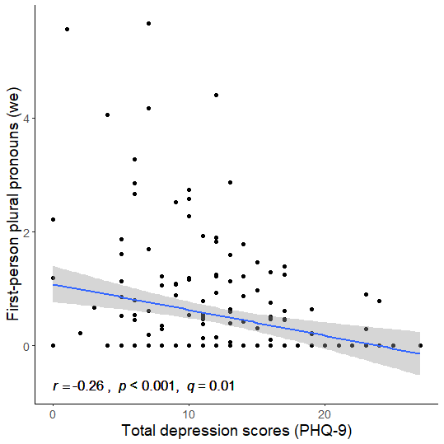
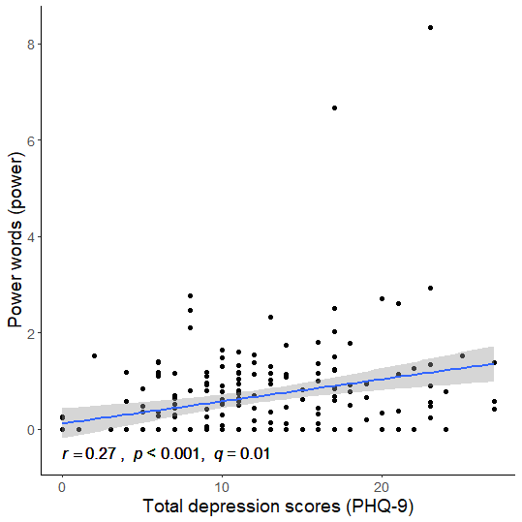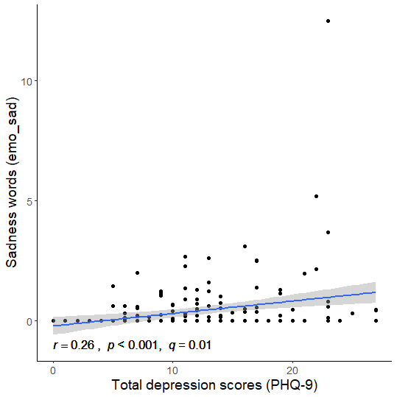
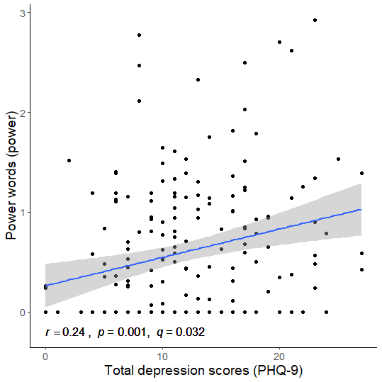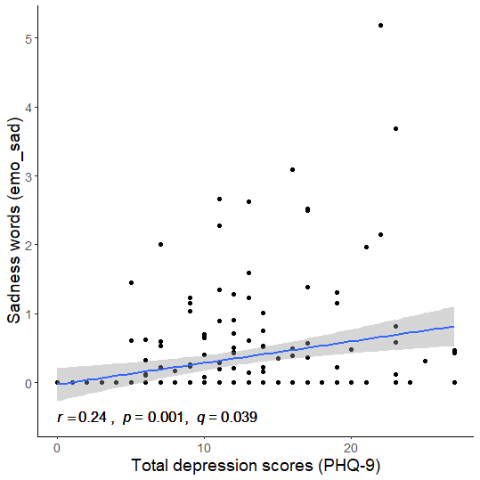
Outliers removed
Outliers removed

Figure S.4.4. Plots of the significant correlations of linguistic features and depressive symptoms within Task V
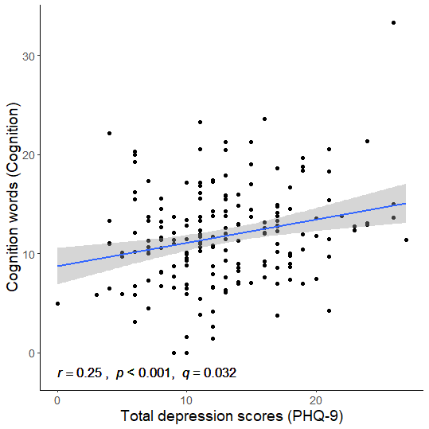
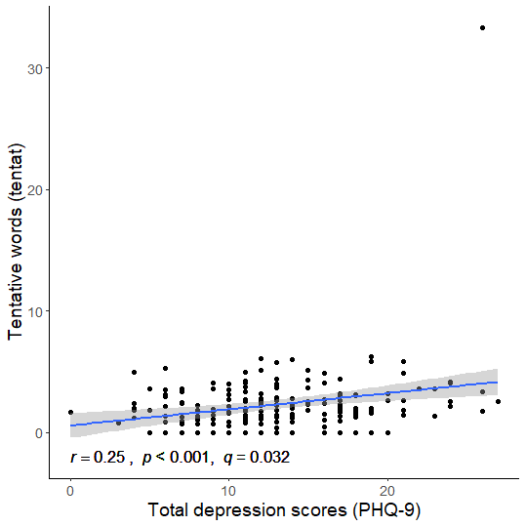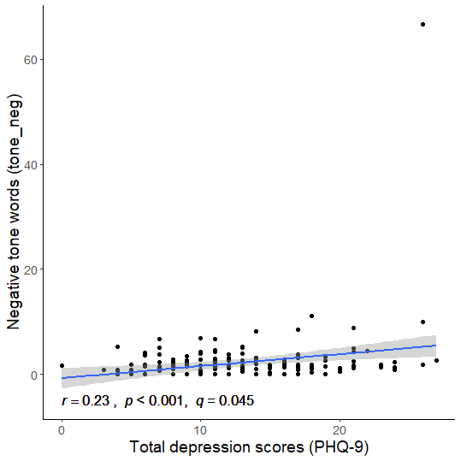
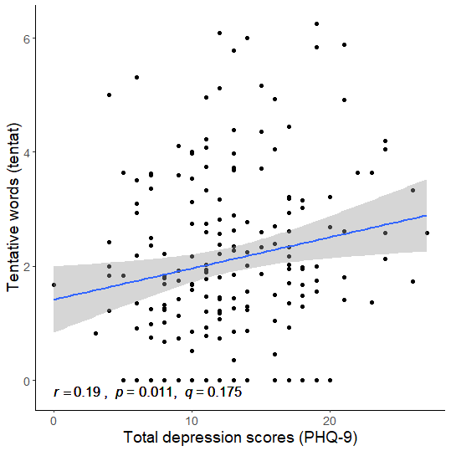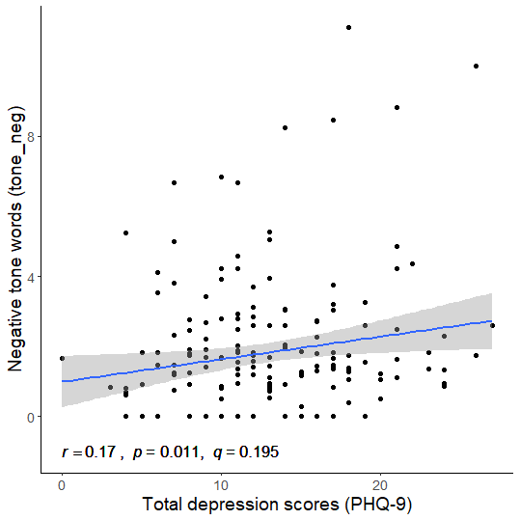
Outliers removed
Outliers removed
Figure S.4.5 Plots of the significant correlations of linguistic features and depressive symptoms within Task W
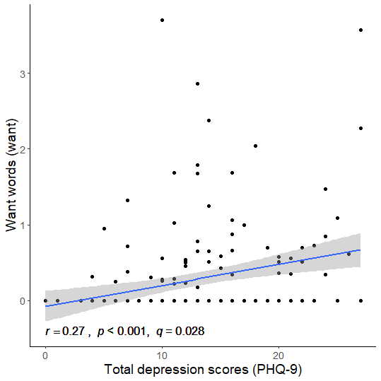

Figure S.4.6 Feature importance from best performing machine learning models within tasks predicting depressive symptoms.
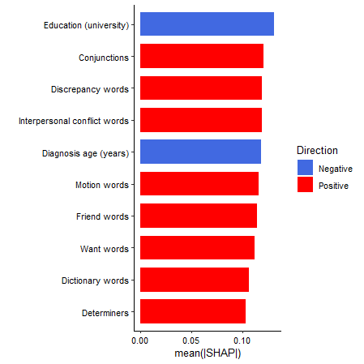
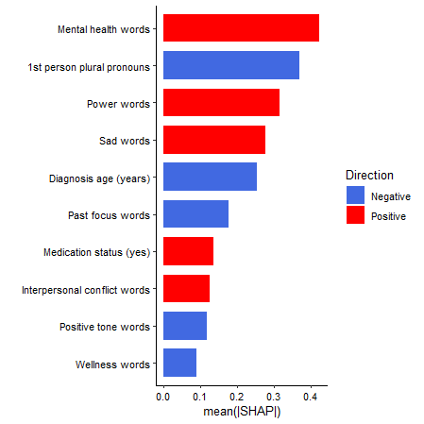
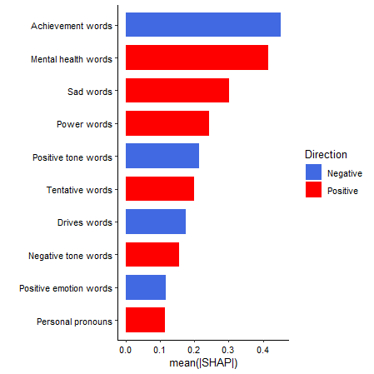
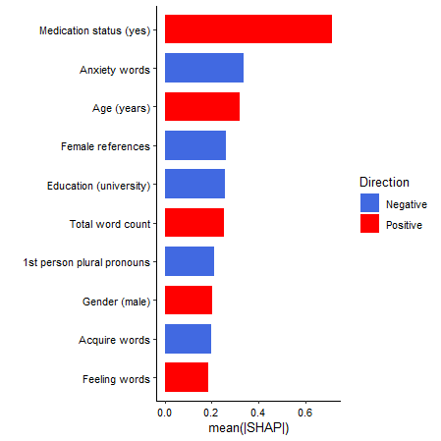
Task A
Task B
Task C
Task D

Negative
Positive
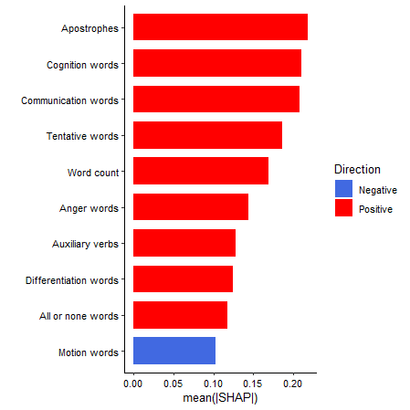
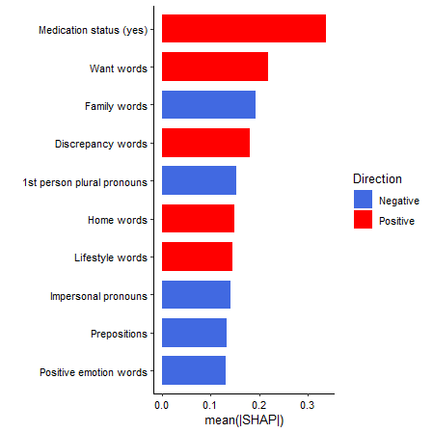
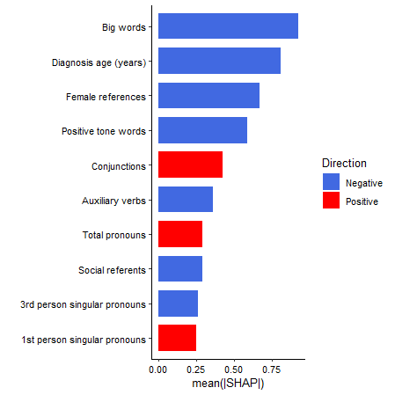
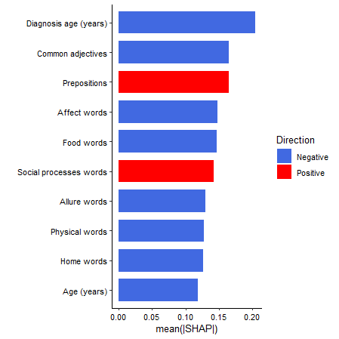
Negative
Positive
Task V
Task W
Task X
Task Y
Supplementary Figures S.4.7. Feature importance from best performing machine learning models within tasks predicting anxiety.

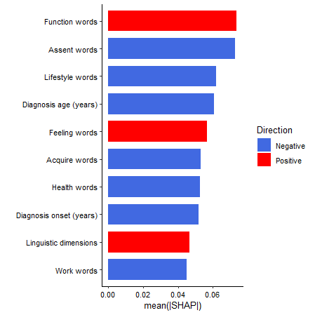
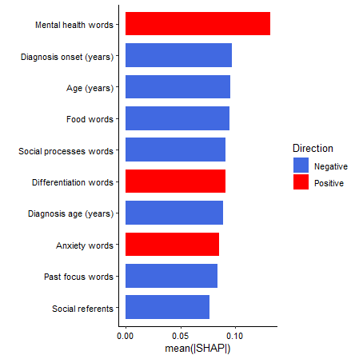
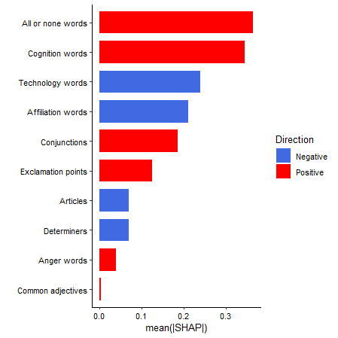
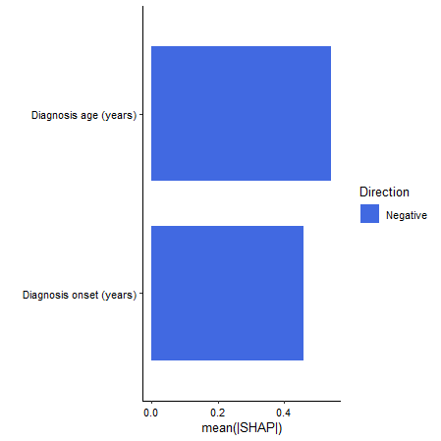
Negative
Positive
Task A
Task B
Task V
Task X
Supplementary Figure S.4.8. Individual SHAP values for best performing machine learning models within tasks predicting depression.
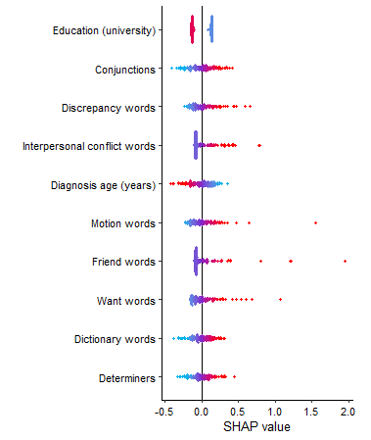
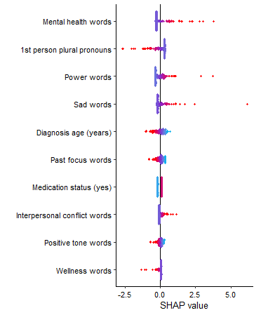
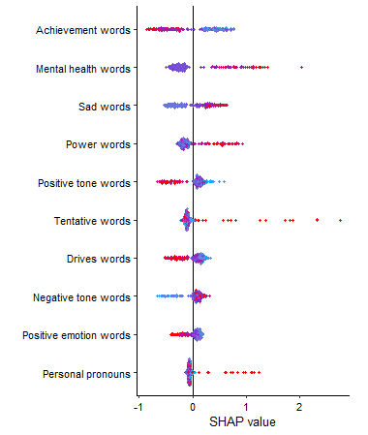
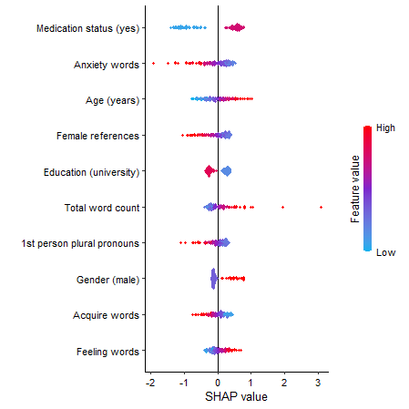
Task A
Task B
Task C
Task D

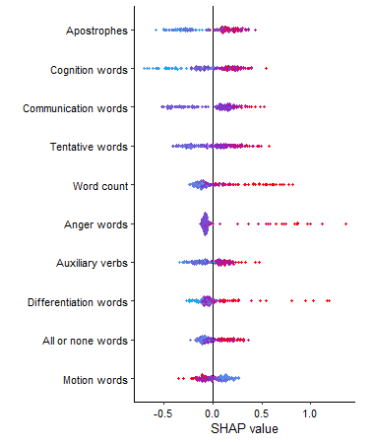
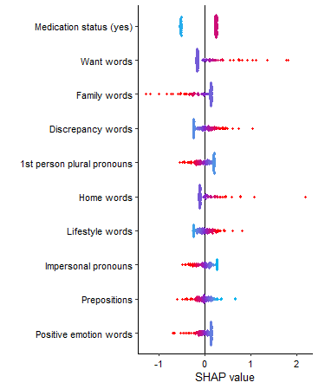
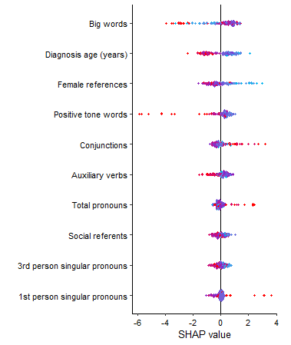
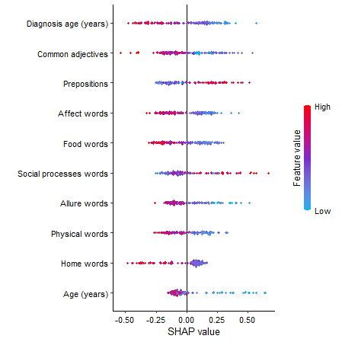
Task V
Task W
Task X
Task Y
Supplementary Figure S.4.9. Individual SHAP values for best performing machine learning models within tasks predicting anxiety.
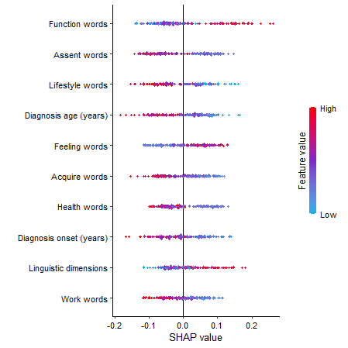
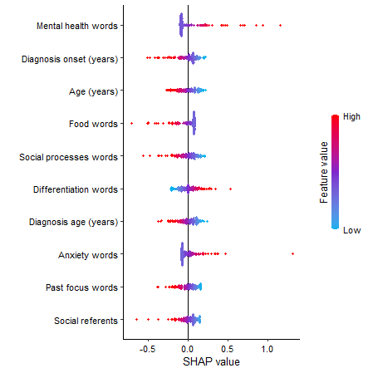
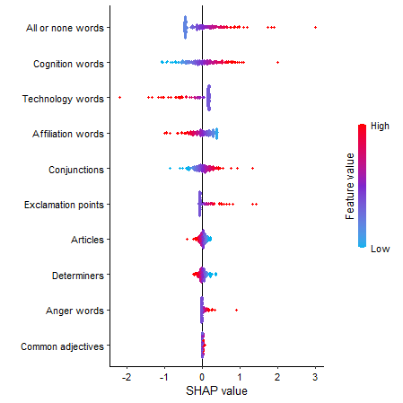
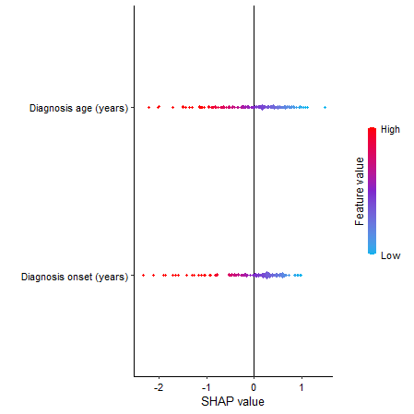
Task A
Task B
Task V
Task X

Supplementary Figure S.4.10. Variable stability plots for best performing machine learning models within tasks predicting depression.
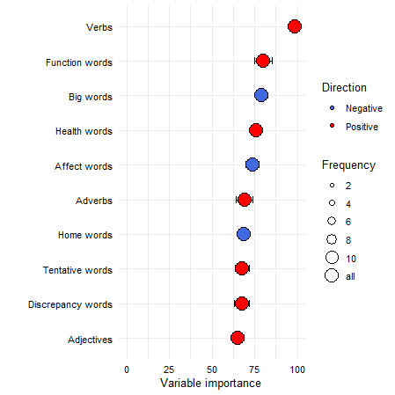
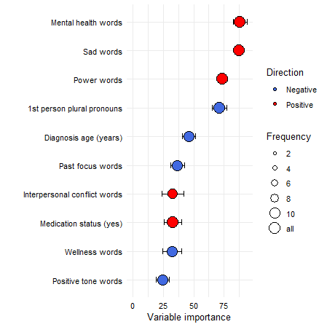
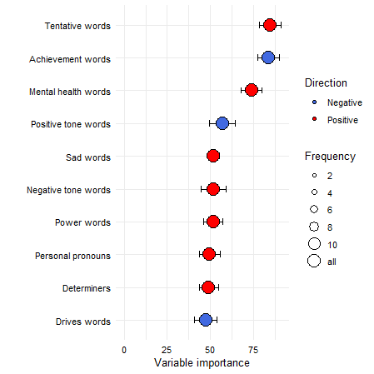
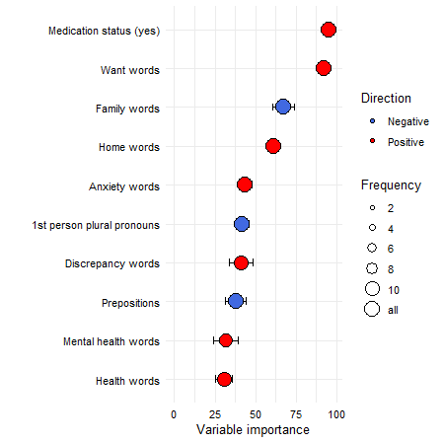
Task A
Task B
Task C
Task D

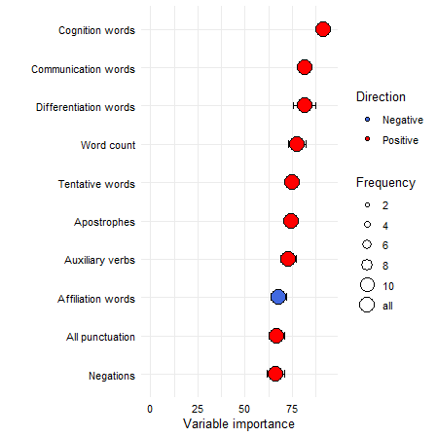
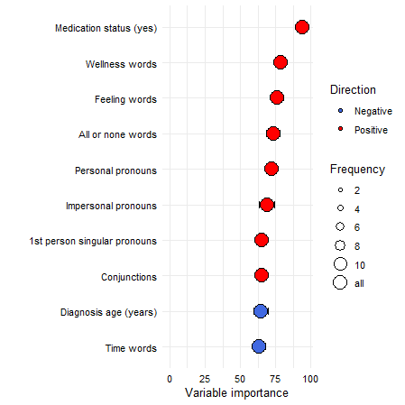
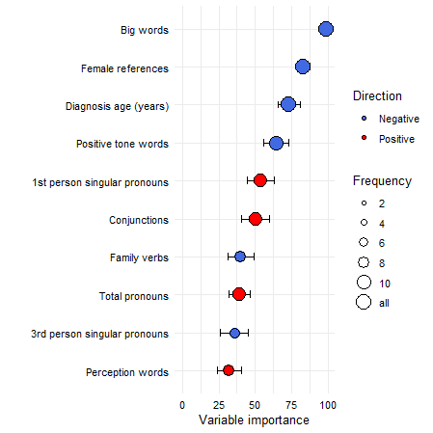
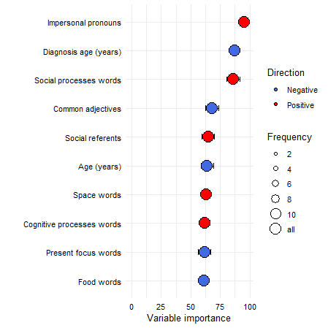
Task V
Task W
Task X
Task Y

Negative
Positive
Supplementary Figure S.4.11 Variable stability plots for best performing machine learning models within tasks predicting anxiety in Task A.

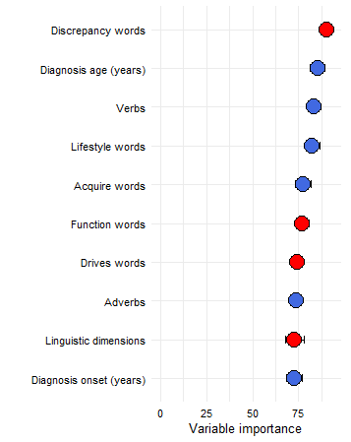

Negative
Positive

Supplementary Figure S.4.12 Variable stability plot for best performing machine learning models within tasks predicting anxiety in Task B.

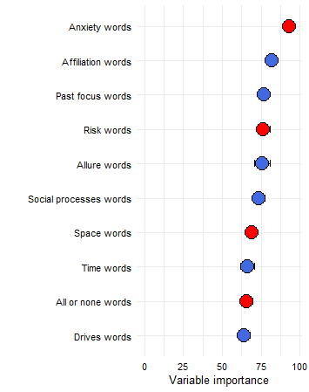
Negative
Positive
Supplementary Figure S.4.13 Variable stability plot for best performing machine learning models within tasks predicting anxiety in Task V.

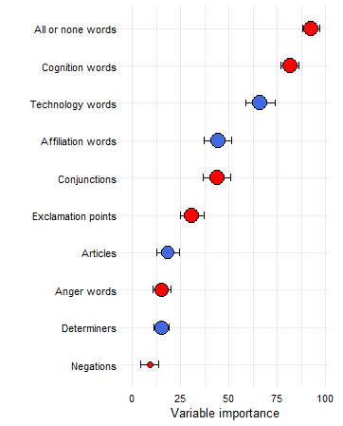

Negative
Positive
Supplementary Figure S.4.14 Variable stability plot for best performing machine learning models within tasks predicting anxiety in Task X.

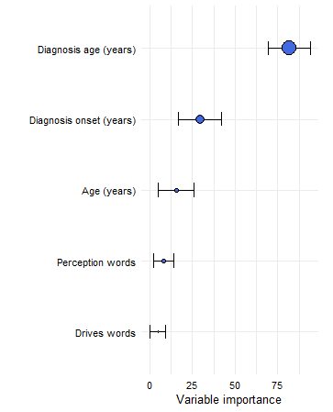

Negative
Positive
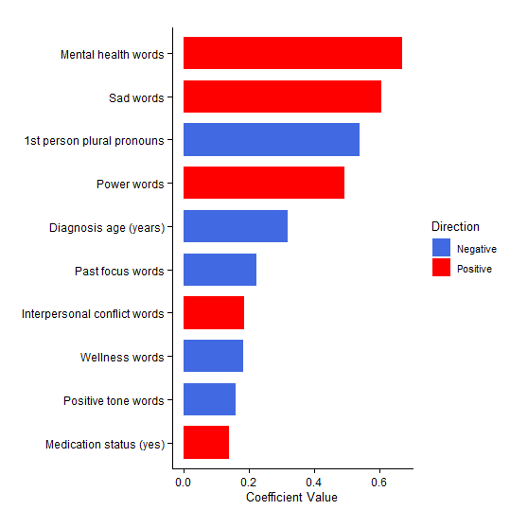
Figure S.4.15. Coefficient values from best performing elastic net models for predicting depression (PHQ-9) and anxiety (GAD-7) within Task B and Task V.

Negative
Positive
Depression - Task B
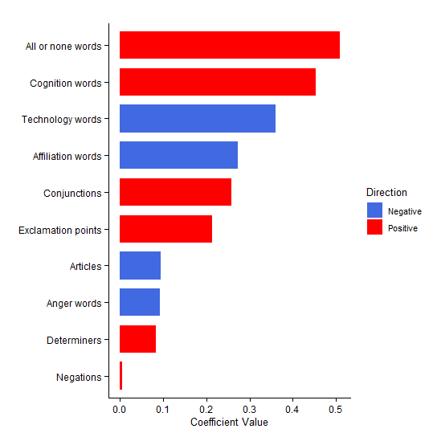

Anxiety - Task V
Figure S.4.16. Coefficient values from best performing SVM-L models for predicting anxiety (GAD-7) scores within task B and task X.
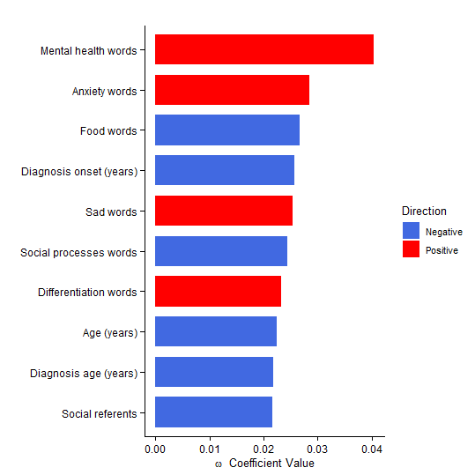
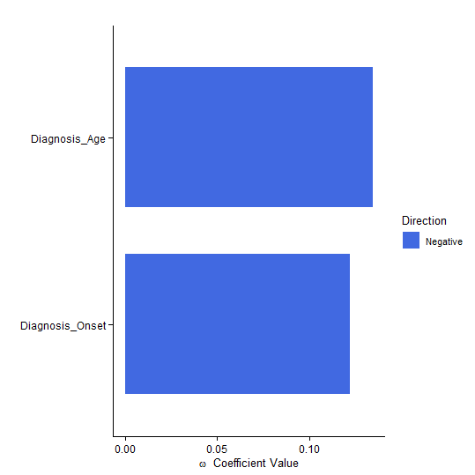
Anxiety - Task B
Anxiety - Task X

Negative
Positive
Figure S.4.17. Plots of the significant correlations of linguistic features and depressive and anxiety symptoms when all tasks combined
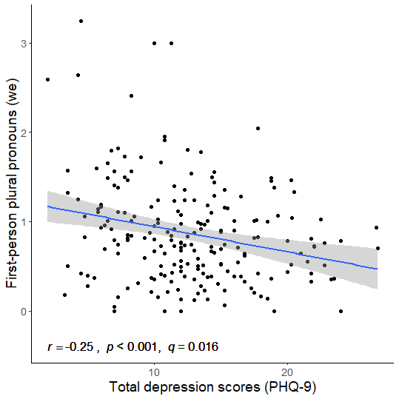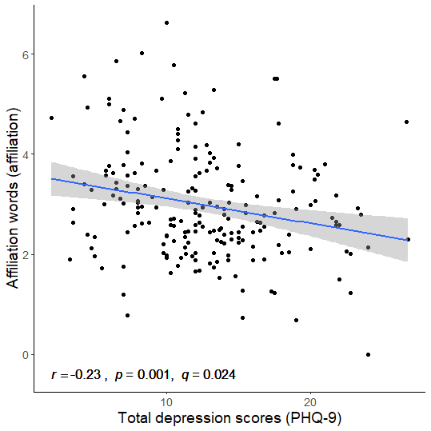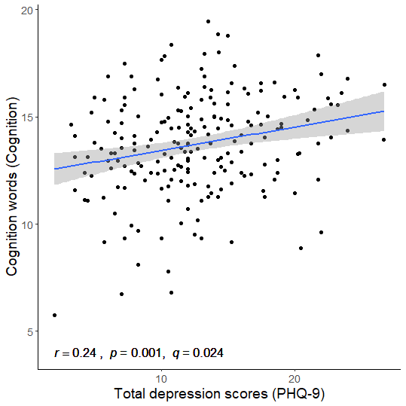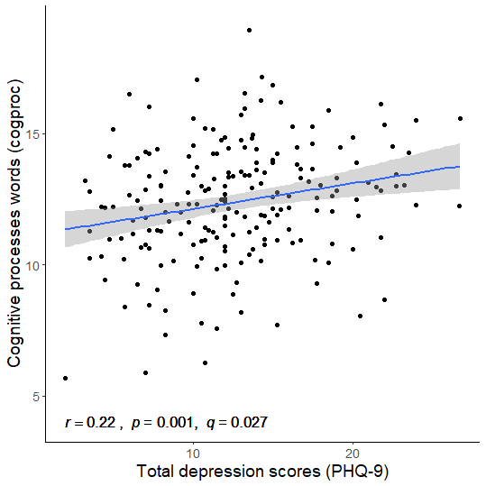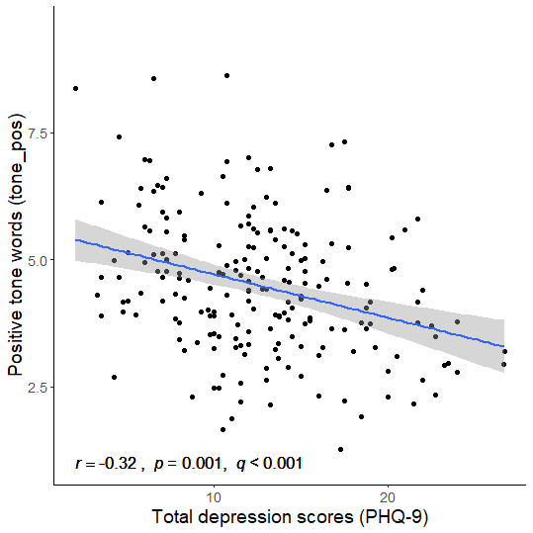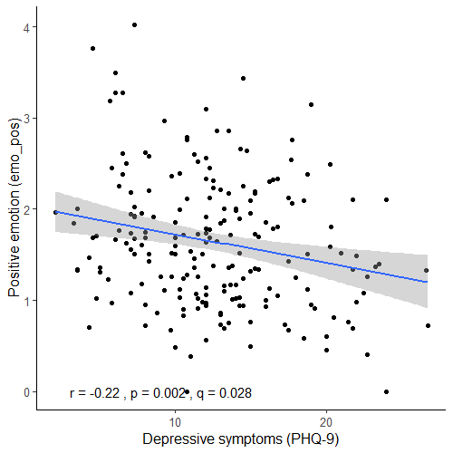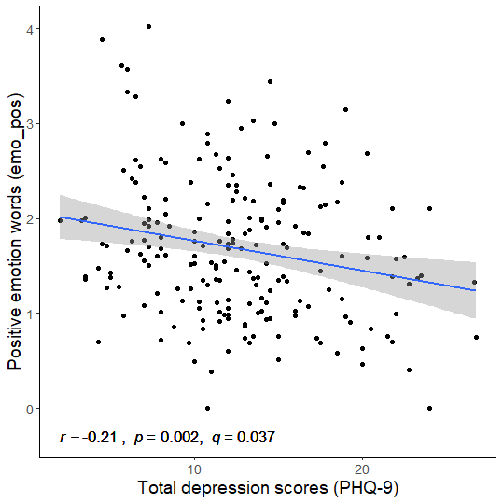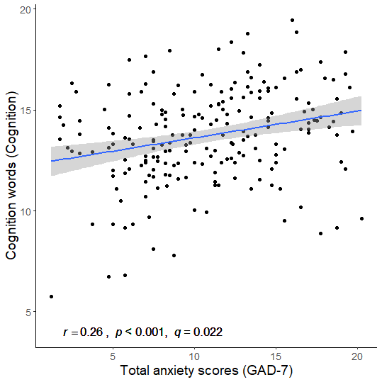

Supplementary Figure S.4.18. Variable stability plots for best performing machine learning models for depression when all tasks combined.

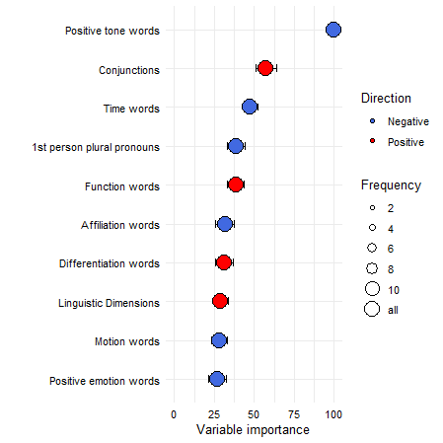
Negative
Positive

Supplementary Figure S.4.19. Variable stability plots for best performing machine learning models for depression when all tasks combined.
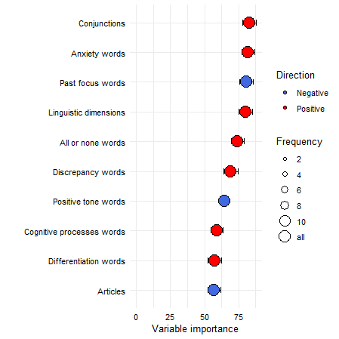
Negative
Positive
S.4.1. Impact of expressive writing tasks on participants’ mood and acceptability ratings
For the expressive writing tasks, participants reported significantly higher levels of fatigue after their first (MD: 0.46, P<.001), second (MD: 0.30, P=.030) and third completions (MD: 0.28, P=.045). Participants were also significantly less content after their first (MD: 0.60, P =.000), second (MD: 0.46, P =.005) and third completions (MD: 0.41, P =.007). Participants were also significantly more agitated after their first (MD: 0.86, P =<.000), second (MD: 0.54, P <.001) and third completions (MD: 0.56, P <.001). Participants also reported significantly lower levels of energy after their first (MD: 0.34, P =.002), second (MD: 0.29, P=.012) and third completions (MD: 0.23, P=.040). Participants’ also reported that they felt significantly more unwell after their first (MD: 0.47, P<.001), second (MD: 0.32, P=.006) and third completion (MD: 0.27, P=.023). Participants also reported significantly lower levels of relaxation after their first (MD: 0.80, P <.001), second (MD: 0.45, P <.001) and third completions (MD: 0.34, P <.001).

Figure S.4.20. Participants’ acceptability scores across tasks only
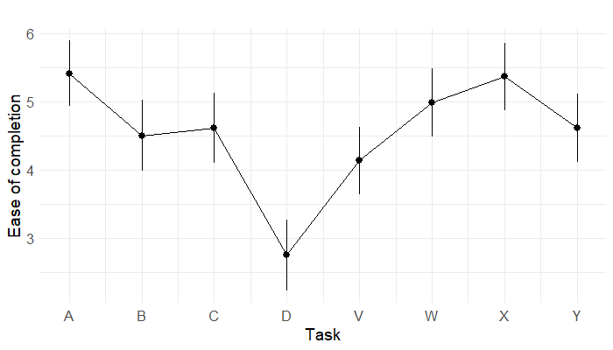
Figure note: Differences across sequences is not shown as there was no significant effect for sequence.
Figure S.4.21. Differences in participants’ level of interests scores for each of the tasks and across the sequences.
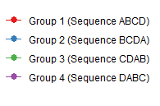
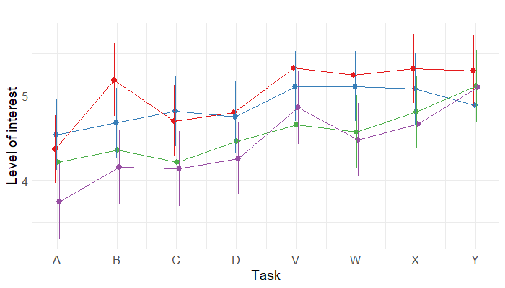

Figure S.4.22. Differences in participants’ willingness to repeat scores for each of the tasks and across the sequences.

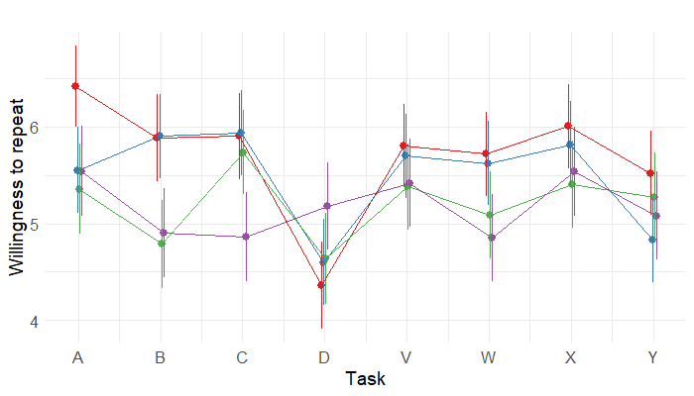

References
Havigerová, J. M., Haviger, J., Kučera, D., & Hoffmannová, P. (2019, 2019-March-18). Text-Based Detection of the Risk of Depression. Frontiers in Psychology, 10(513). https://doi.org/10.3389/fpsyg.2019.00513

Kawasaki, M., Yamashita, N., Lee, Y.-C., & Nohara, K. (2020). Assessing Users' Mental Status from their Journaling Behavior through Chatbots Proceedings of the 20th ACM International Conference on Intelligent Virtual Agents, Virtual Event, Scotland, UK. https://doi.org/10.1145/3383652.3423870

Lee, S. W., Kim, I., Yoo, J., Park, S., Jeong, B., & Cha, M. (2016, 2016/09/01/). Insights from an expressive writing intervention on Facebook to help alleviate depressive symptoms. Computers in Human Behavior, 62, 613-619. https://doi.org/10.1016/j.chb.2016.04.034

Lewis, M. J., Spiliopoulou, A., Goldmann, K., Pitzalis, C., McKeigue, P., & Barnes, M. R. (2023). nestedcv: an R package for fast implementation of nested cross-validation with embedded feature selection designed for transcriptomics and high-dimensional data. Bioinformatics Advances, 3(1), vbad048. https://doi.org/10.1093/bioadv/vbad048

Minori, G., Gagliardi, G., cuteri, v., Tamburini, F., Malaspina, E., Gualandi, P., Rossi, F., Moscano, F., Francia, V., & Parmeggiani, A. (2020). Linguistic Markers of Anorexia Nervosa: Preliminary Data from a Prospective Observational Study.

Pennebaker, J., Chung, C., Frazee, J., Lavergne, G., & Beaver, D. (2014). When Small Words Foretell Academic Success: The Case of College Admissions Essays. PloS One, 9(12), e115844. https://doi.org/10.1371/journal.pone.0115844

Pennebaker, J. W. (1997). Writing about emotional experiences as a therapeutic process. Psychological Science, 8(3), 162-166. https://doi.org/10.1111/j.1467-9280.1997.tb00403.x

Pennebaker, J. W. (2011). The secret life of pronouns: what our words say about us. Bloomsbury.

Pennebaker, J. W., & Beall, S. K. (1986). Confronting a traumatic event: Toward an understanding of inhibition and disease. Journal of Abnormal Psychology, 95(3), 274-281. https://doi.org/10.1037/0021-843X.95.3.274

Reinhold, M., Bürkner, P.-C., & Holling, H. (2018). Effects of expressive writing on depressive symptoms—A meta-analysis. Clinical Psychology, 25(1), e12224. https://doi.org/10.1111/cpsp.12224

Tlachac, M. L., & Rundensteiner, E. (2020, Nov). Screening For Depression With Retrospectively Harvested Private Versus Public Text. IEEE J Biomed Health Inform, 24(11), 3326-3332. https://doi.org/10.1109/jbhi.2020.2983035

Ullrich, P. M., & Lutgendorf, S. K. (2002, Summer). Journaling about stressful events: effects of cognitive processing and emotional expression. Annals of Behavioral Medicine, 24(3), 244-250. https://doi.org/10.1207/s15324796abm2403_10

Vabalas, A., Gowen, E., Poliakoff, E., & Casson, A. J. (2019). Machine learning algorithm validation with a limited sample size. PLoS ONE, 14(11), e0224365. https://doi.org/10.1371/journal.pone.0224365

Varma, S., & Simon, R. (2006). Bias in error estimation when using cross-validation for model selection. BMC Bioinformatics, 7(1), 91. https://doi.org/10.1186/1471-2105-7-91

