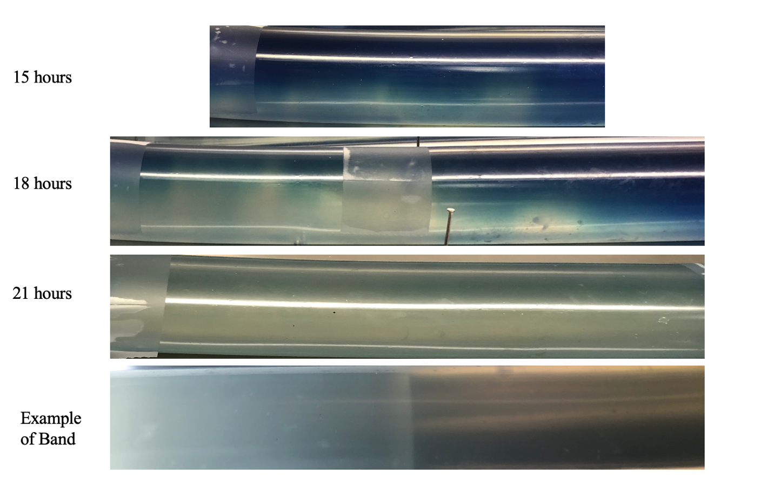
Extended Data Fig. 1: Example photos of community formation between 15- and 21-hours using methylene blue indicator. The ‘Example of Band’ image was taken after 21 hours in the absence of methylene blue indicator to improve image clarity.

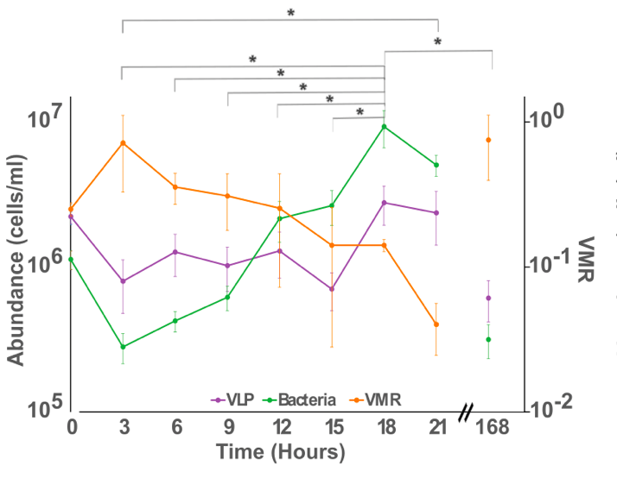
Extended Data Fig. 2: Flow cytometry quantified bacterial and viral populations during community formation and migration. a, Population abundances of the bacterial and viral community during band formation. The virus-to-microbe ratio (VMR) shows the viral abundance divided by the bacterial abundance. Stars denote significant differences (P < 0.05)(Supplementary Table 10) between timepoints using a two-way ANOVA for time and sewage replicated with Tukey post-hoc test.
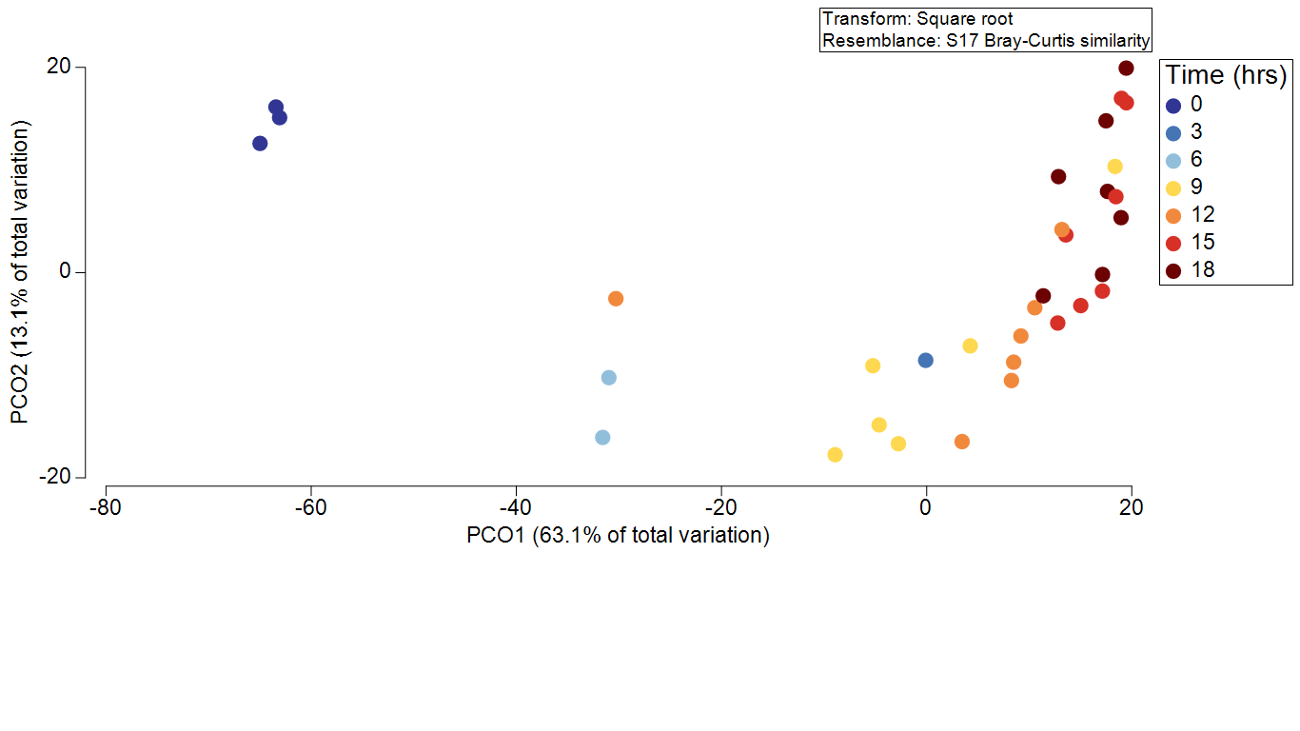
Extended Data Fig. 3: PCoA of community formation samples. Data was square root transformed then used Bray-Curtis dissimilarity. Performing a Pearson correlation, the taxa with the highest correlation with PCo1 are Blautia, Cloacibacterium, Roseburia, Faecalibacterium, and Bacteroides with correlations of -0.960, -0.959, -0.957, -0.967, and -0.978 respectively. The taxa with the highest loading explaining PCo2 are Aeromonadaceae, Aeromonas, Shewanella, and Lactococcus with Pearson correlations of -0.839, -0.786, -0.645 and 0.636 respectively.
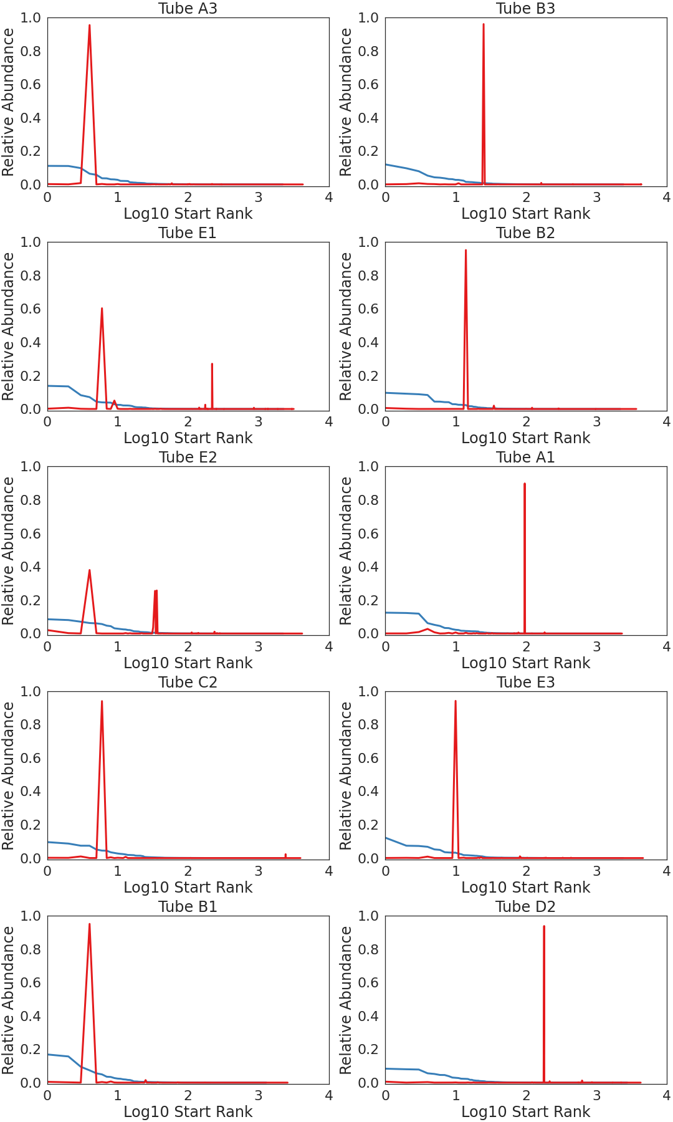
Extended Data Fig. 4: Rank abundance curves of bacterial taxa detected at the start (blue) and end (red) of one week of continual migration. Each plot denotes a separate sequenced tube. The rank for the communities for the end samples is retained in each plot.
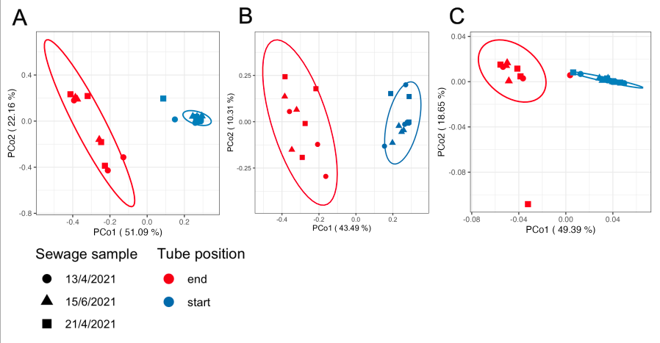
Extended Data Fig. 5: Principal Coordinate Analysis of square root transformed, Bray-Curtis transformed profiles before (start) and after (end) long term community migration. a, Relative abundance of bacterial genera b, Relative abundance of viral species. c, Relative abundance of Level 3 SEED Subsystems
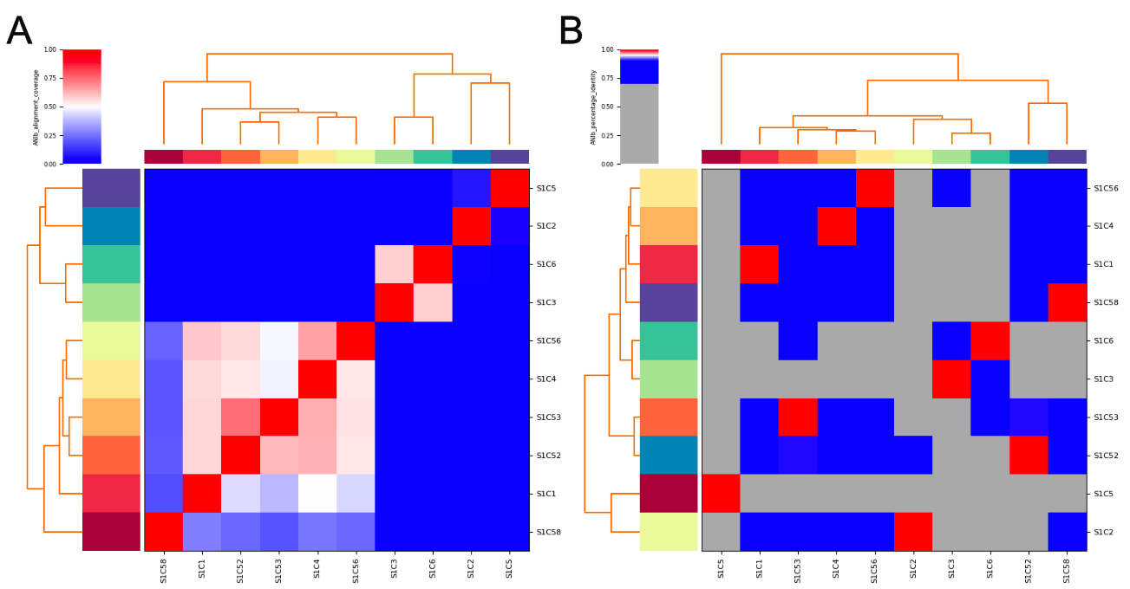
Extended Data Fig. 6: Similarity of MAGs recovered from the community migration experiment. a, Alignment coverage and b, Percentage of identity calculated using pyani of high-quality MAGs generated from the residual community.

