Supplementary Information for
Multivariate compound events drive historical floods and associated losses along the U.S. East and Gulf coasts
Javed Ali^{1,2*}, Thomas Wahl^{1,2}, Joao Morim^{1,2}, Alejandra Enriquez^{1,2,3}, Melanie Gall⁴, Christopher T. Emrich^{2,5}
¹Department of Civil, Environmental and Construction Engineering, University of Central Florida, Orlando, FL, 32816 USA.
²National Center for Integrated Coastal Research, University of Central Florida, Orlando, FL, 32816 USA.
³Institute for Environmental Studies (IVM), Vrije Universiteit Amsterdam, 1081 HV Amsterdam, the Netherlands
⁴Center for Emergency Management and Homeland Security, School of Public Affairs, Arizona State University, Phoenix, AZ, 85004
⁵School of Public Administration, University of Central Florida, Orlando, FL 32816, USA
*Corresponding author email: javed.ali@ucf.edu

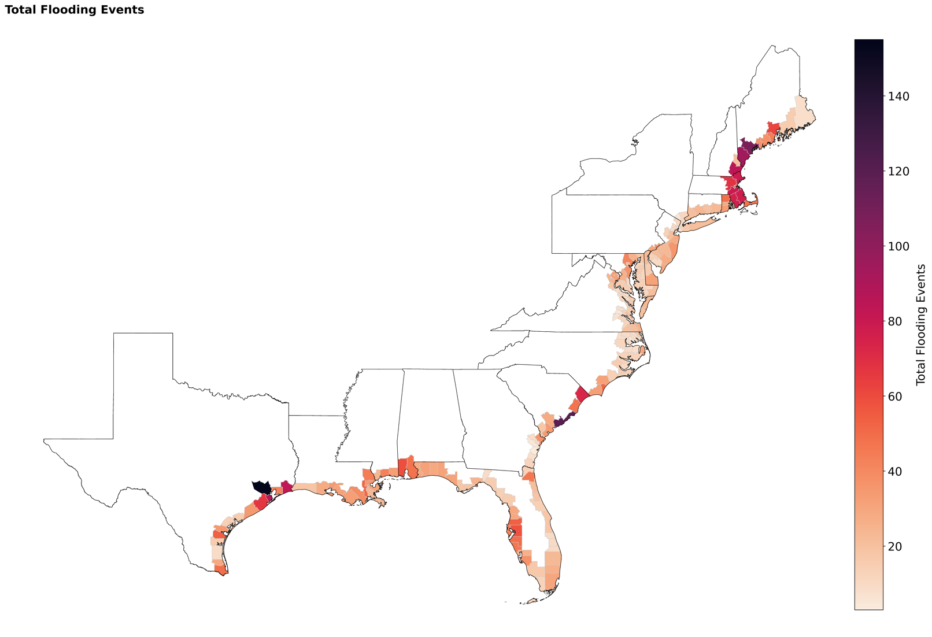
Fig. S1: Total number of flooding events in 203 counties along the U.S. Atlantic and Gulf of Mexico coasts

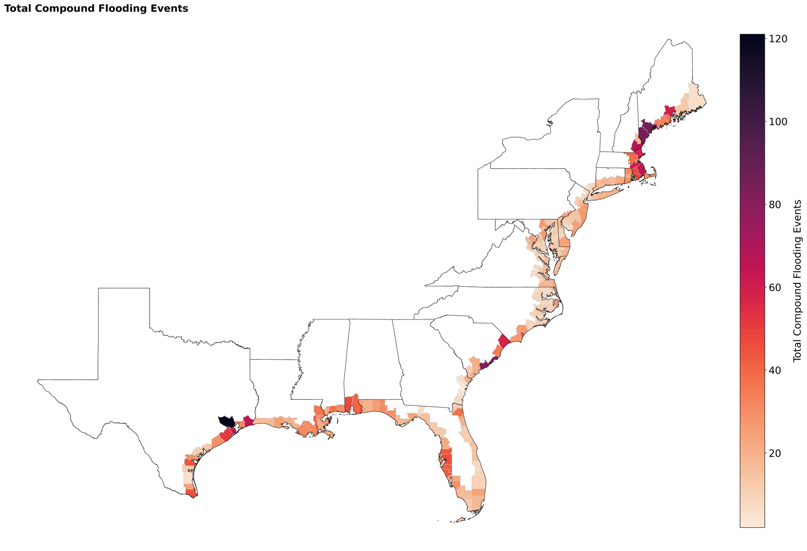
Fig. S2: Total number of compound flooding events in 203 counties along the U.S. Atlantic and Gulf of Mexico coasts

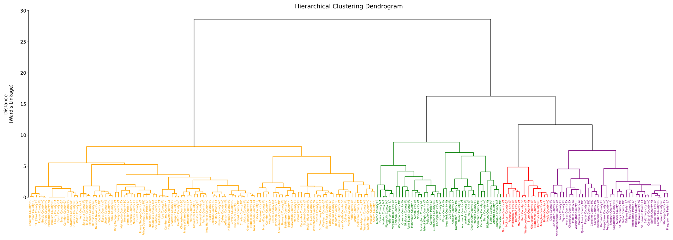
Fig. S3: Hierarchical clustering analysis of the compound flooding impacts and drivers. The x-axis displays the county names while the y-axis indicates the distance or dissimilarity metric used to merge clusters at each level of the hierarchy. Counties within the same color group exhibit comparable patterns in the relative influence of the compound flooding drivers, suggesting potential regional similarities in the dominant hazard mechanisms.

Sensitivity analysis using 99th percentile threshold
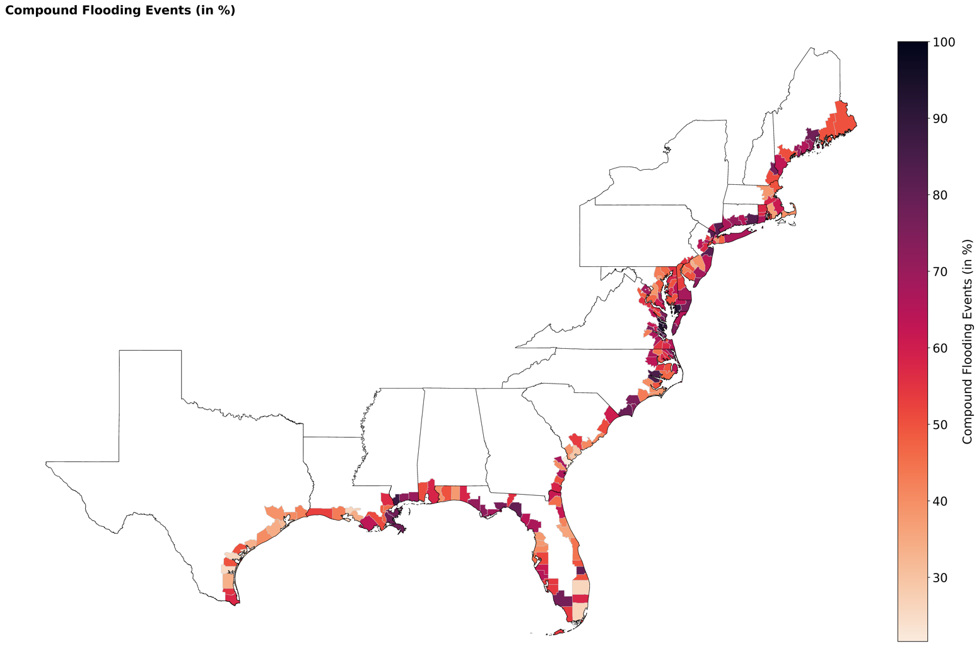
Fig. S4: Percentage of compound flooding events in 203 counties along the U.S. East and Gulf coasts

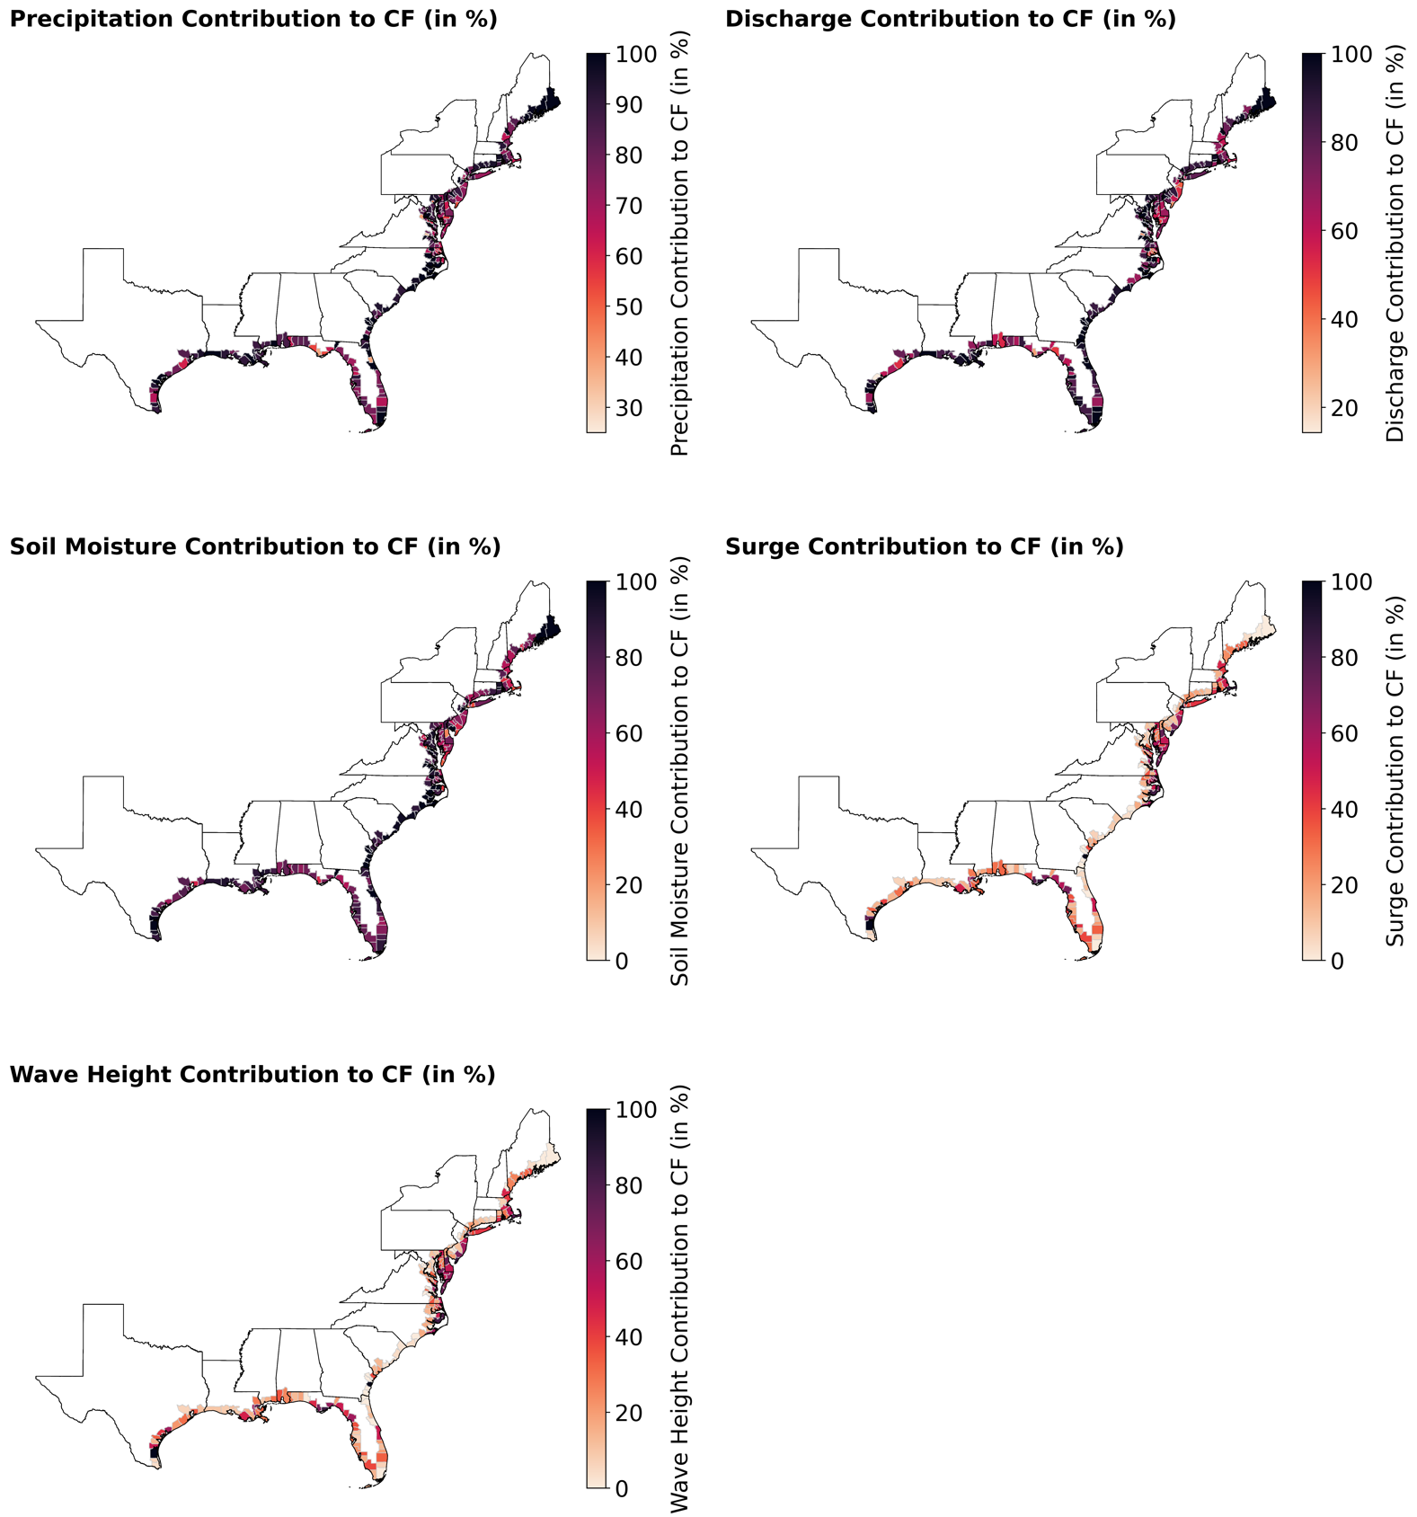
Fig. S5: Spatial distribution of the frequency contribution (%) of different flooding drivers to compound events, precipitation, river discharge, soil moisture, storm surge, and significant wave height. Drivers are considered to have contributed to a compound event when they exceeded their 99th percentile values.

Fig. S6: Contribution of compound events to recorded losses. Percentage (%) of historical losses attributable to compound flooding for (a) property and (c) crop losses. The grey color indicates counties where there are no historical crop losses from flooding events. The colorbar is cutoff at 90% with lower values shown in the same color for property loss and crop loss.

