SPIRIT-Outcomes 2022 Checklist (for combined completion of SPIRIT 2013 and SPIRIT- Outcomes 2022 items)a

Section | Item No. | SPIRIT 2013 Item | SPIRIT-Outcomes 2022 item | Location Reported^{b}
Administrative information
Title | 1 | Descriptive title identifying the study design, population, interventions, and, if applicable, trial acronym | - | Page 1
Trial registration | 2a | Trial identifier and registry name.  If not yet registered, name of intended registry | - | Page 1
Trial registration | 2b | All items from the World Health Organization Trial Registration Data Set | - | Page 1
Protocol version | 3 | Date and version identifier | - | Page 1
Funding | 4 | Sources and types of financial, material, and other support | - | Page 2
Roles and responsibilities | 5a | Names, affiliations, and roles of protocol contributors | - | Page 1 – 2
Roles and responsibilities | 5b | Name and contact information for the trial sponsor | - | Page 2
Roles and responsibilities | 5c | Role of study sponsor and funders, if any, in study design; collection, management, analysis, and interpretation of data; writing of the report; and the decision to submit the report for publication, including whether they will have ultimate authority over any of  these activities | - | Page 2
Roles and responsibilities | 5d | Composition, roles, and responsibilities of the coordinating centre, steering committee, endpoint adjudication committee, data management team, and other individuals or groups overseeing the trial, if applicable  (see Item 21a for data monitoring committee) | - | Page 1 – 2
Introduction
Background and rationale | 6a | Description of research question and justification for undertaking the trial, including summary of relevant studies (published and unpublished) examining benefits  and harms for each intervention | - | Page 4
Background and rationale | 6b | Explanation for choice of comparators | - | Page 4 - 5
Objectives | 7 | Specific objectives or hypotheses | - | Page 5
Section | Item  No. | SPIRIT 2013 Item | SPIRIT-Outcomes 2022 item | Location  Reported^{b}
Trial design | 8 | Description of trial design including type of trial (eg, parallel group, crossover, factorial, single group), allocation ratio, and framework (eg, superiority, equivalence, noninferiority, exploratory) | - | Page 5 - 6
Methods: Participants, interventions, and outcomes
Study setting | 9 | Description of study settings (eg, community clinic, academic hospital) and list of countries where data will be collected.  Reference to where list of study sites can be obtained | - | Page 5 - 6
Eligibility criteria | 10 | Inclusion and exclusion criteria for participants. If applicable, eligibility criteria for study centres and individuals who will perform  the interventions (eg, surgeons, psychotherapists) | - | Page 7
Interventions | 11a | Interventions for each group with sufficient detail to allow replication, including how and when they will be administered  (for specific guidance see TIDieR checklist and guide) | - | Page 10 - 13
Interventions | 11b | Criteria for discontinuing or modifying allocated interventions for a given trial participant (eg, drug dose change in response to harms, participant request, or  improving/worsening disease) | - | Page 5 and 13
Interventions | 11c | Strategies to improve adherence to intervention protocols, and any procedures for monitoring adherence (eg, drug tablet return,  laboratory tests) | - | Page 12
Interventions | 11d | Relevant concomitant care and interventions that are permitted or  prohibited during the trial | - | Page 12
Outcomes | 12 | Primary, secondary, and other outcomes, including the specific measurement variable (eg, systolic blood pressure), analysis metric (eg, change from baseline, final value, time to event), method of aggregation (eg, median, proportion), and time point for each outcome. Explanation of the clinical relevance of chosen efficacy and harm outcomes is strongly recommended | - | Page 7 - 9
Section | Item  No. | SPIRIT 2013 Item | SPIRIT-Outcomes 2022 item | Location  Reported^{b}
 | 12.1 |  | Provide a rationale for the selection of the domain for the trial’s primary  outcome | Page 7 - 8
 | 12.2 |  | If the analysis metric for the primary outcome represents within-participant change, define and justify the minimal important change in  individuals | Page 7 - 8
 | 12.3 |  | If the outcome data collected are continuous but will be analyzed as categorical (method of aggregation),  specify the cutoff values to be used | Page 7 - 8
 | 12.4 |  | If outcome assessments will be performed at several time points after randomization, state the time  points that will be used for analysis | Page 7 - 8
 | 12.5 |  | If a composite outcome is used, define all individual components of the composite outcome | Page 7 - 8
Participant timeline | 13 | Time schedule of enrolment, interventions (including any run- ins and washouts), assessments, and visits for participants. A schematic diagram is highly  recommended (see Figure) | - | Page 7
Sample size | 14 | Estimated number of participants needed to achieve study objectives and how it was determined, including clinical and statistical assumptions supporting  any sample size calculations | - | Page 7
Sample size | 14.1 |  | Define and justify the target difference between treatment groups  (eg, the minimal important difference) | Page 7
Recruitment | 15 | Strategies for achieving adequate participant enrolment to reach target sample size | - | Page 7
Methods: Assignment of interventions (for controlled trials)
Allocation:
Sequence generation | 16a | Method of generating the allocation sequence (eg, computer-generated random numbers), and list of any factors for stratification. To reduce predictability of a random sequence, details of any planned restriction (eg, blocking) should be provided in a separate document that is unavailable to  those who enrol participants or assign interventions | - | Page 6 - 7
Section | Item  No. | SPIRIT 2013 Item | SPIRIT-Outcomes 2022 item | Location  Reported^{b}
Allocation concealment mechanism | 16b | Mechanism of implementing the allocation sequence (eg, central telephone; sequentially numbered, opaque, sealed envelopes), describing any steps to conceal the sequence until  interventions are assigned | - | Page 6 - 7
Implementation | 16c | Who will generate the allocation sequence, who will enrol participants, and who will assign participants to interventions | - | Page 6 - 7
Blinding (masking) | 17a | Who will be blinded after assignment to interventions (eg, trial participants, care providers, outcome assessors, data  analysts), and how | - | Page 6 - 7
Blinding (masking) | 17b | If blinded, circumstances under which unblinding is permissible, and procedure for revealing a  participant’s allocated intervention  during the trial | - | Page 6 – 7
Methods: Data collection, management, and analysis
Data collection methods | 18a | Plans for assessment and collection of outcome, baseline, and other trial data, including any related processes to promote data quality (eg, duplicate measurements, training of assessors) and a description of study instruments (eg, questionnaires, laboratory tests) along with their reliability and validity, if known. Reference to where data collection forms can  be found, if not in the protocol | - | Page 7 - 8
Data collection methods | 18a.1 |  | Describe what is known about the responsiveness of the study instruments in a population similar to the study sample | Page 7 - 8
Data collection methods | 18a.2 |  | Describe who will assess the outcome (eg, nurse, parent) | Page 8
Data collection methods | 18b | Plans to promote participant retention and complete follow-up, including list of any outcome data to be collected for participants  who discontinue or deviate from intervention protocols | - | Page 5 and  page 13
Section | Item  No. | SPIRIT 2013 Item | SPIRIT-Outcomes 2022 item | Location  Reported^{b}
Data management | 19 | Plans for data entry, coding, security, and storage, including any related processes to promote data quality (eg, double data entry; range checks for data values). Reference to where details of data management procedures can be found, if not in  the protocol | - | Page 6
Statistical methods | 20a | Statistical methods for analysing primary and secondary outcomes. Reference to where other details of the statistical analysis plan can  be found, if not in the protocol | - | Page 13 - 14
Statistical methods | 20a.1 |  | Describe any planned methods to account for multiplicity in the analysis or interpretation of the primary and secondary outcomes (eg, coprimary outcomes, same outcome assessed at multiple time points, or subgroup  analyses of an outcome) | Page 13 - 14
Statistical methods | 20b | Methods for any additional analyses (eg, subgroup and  adjusted analyses) | - | Page 13 - 14
Statistical methods | 20c | Definition of analysis population relating to protocol non- adherence (eg, as randomised analysis), and any statistical methods to handle missing data  (eg, multiple imputation) | - | Page 13 - 14
Methods: Monitoring
Data monitoring | 21a | Composition of data monitoring committee (DMC); summary of its role and reporting structure; statement of whether it is independent from the sponsor and competing interests; and reference to where further details about its charter can be found, if not in the protocol. Alternatively, an explanation of why a DMC is  not needed | - | Page 22
Data monitoring | 21b | Description of any interim analyses and stopping guidelines, including who will have access to these interim results and make  the final decision to terminate the trial | - | Page 22
Harms | 22 | Plans for collecting, assessing, reporting, and managing solicited and spontaneously reported adverse events and other unintended effects of trial interventions or trial conduct | - | Page 22
Section | Item  No. | SPIRIT 2013 Item | SPIRIT-Outcomes 2022 item | Location  Reported^{b}
Auditing | 23 | Frequency and procedures for auditing trial conduct, if any, and whether the process will be independent from investigators  and the sponsor | - | Page 23
Ethics and dissemination
Research ethics approval | 24 | Plans for seeking research ethics committee/institutional review  board (REC/IRB) approval | - | Page 6
Protocol amendments | 25 | Plans for communicating important protocol modifications (eg, changes to eligibility criteria, outcomes, analyses) to relevant parties (eg, investigators, REC/IRBs, trial participants, trial  registries, journals, regulators) | - | Page 23
Consent or assent | 26a | Who will obtain informed consent or assent from potential trial participants or authorised surrogates, and how (see Item  32) | - | Page 6
Consent or assent | 26b | Additional consent provisions for collection and use of participant  data and biological specimens in ancillary studies, if applicable | - | Page 6
Confidentiality | 27 | How personal information about potential and enrolled participants will be collected, shared, and maintained in order to protect confidentiality before, during, and  after the trial | - | Page 6
Declaration of interests | 28 | Financial and other competing interests for principal investigators for the overall trial and each study  site | - | Page 16
Access to data | 29 | Statement of who will have access to the final trial dataset, and disclosure of contractual  agreements that limit such access for investigators | - | Page 22
Ancillary and post-trial care | 30 | Provisions, if any, for ancillary and post-trial care, and for compensation to those who suffer  harm from trial participation | - | Page 23
Dissemination policy | 31a | Plans for investigators and sponsor to communicate trial results to participants, healthcare professionals, the public, and other relevant groups (eg, via publication, reporting in results databases, or other data sharing arrangements), including any  publication restrictions | - | Page 23
Dissemination policy | 31b | Authorship eligibility guidelines and any intended use of  professional writers | - | Page 23
Section | Item No. | SPIRIT 2013 Item | SPIRIT-Outcomes 2022 item | Location Reported^{b}
 | 31c | Plans, if any, for granting public access to the full protocol, participant-level dataset, and  statistical code | - | Page 23
Appendices
Informed consent materials | 32 | Model consent form and other related documentation given to participants and authorised surrogates | - | Page 6
Biological specimens | 33 | Plans for collection, laboratory evaluation, and storage of biological specimens for genetic or molecular analysis in the current trial and for future use in ancillary studies, if applicable | - | Not applicable
Supplemental material - appendix A .1: Recommendations for Interventional Trials 2013 checklist
ªIt is strongly recommended that this checklist be read in conjunction with the SPIRIT (Standard Protocol Items: Recommendatio ns for Interventional Trials) Statement paper for important clarification on the items. Amendments to the protocol should be tracked and dated. The SPIRIT checklist is copyrighted by the SPIRIT Group under the Creative Commons “Attribution-NonCommercial-NoDerivs 3.0 Unported” license and is reproduced with permission.
^{b}Indicates page numbers and/or manuscript location: to be completed by authors.


The TIDieR (Template for Intervention Description and Replication) Checklist*:
Information to include when describing an intervention and the location of the information
Item number | Item | Where located **
Item number |  | Primary paper  (page or appendix  number) | Other † (details)
 | BRIEF NAME
1. | Provide the name or a phrase that describes the intervention. | Page 1 | ______________
 | WHY
2. | Describe any rationale, theory, or goal of the elements essential to the intervention. | Page 4 - 5 | _____________
 | WHAT
3. | Materials: Describe any physical or informational materials used in the intervention, including those provided to participants or used in intervention delivery or in training of intervention providers. Provide information on where the materials can be accessed (e.g. online appendix, URL). | Page 10 - 13  Supplementary material C.1, C.2, D.1 and D.2 | _____________
4. | Procedures: Describe each of the procedures, activities, and/or processes used in the intervention, including any enabling or support activities. | Page 10 - 13  Supplementary material C.1, C.2, D.1 and D.2 | _____________
 | WHO PROVIDED
5. | For each category of intervention provider (e.g. psychologist, nursing assistant), describe their expertise, background and any specific training given. | Page 10 | _____________
 | HOW
6. | Describe the modes of delivery (e.g. face-to-face or by some other mechanism, such as internet or telephone) of the intervention and whether it was provided individually or in a group. | Page 10 | _____________
 | WHERE | Page 10 - 11
7. | Describe the type(s) of location(s) where the intervention occurred, including any necessary infrastructure or relevant features. | Page 10 | _____________
 | WHEN and HOW MUCH
8. | Describe the number of times the intervention was delivered and over what period of time including the number of sessions, their schedule, and their duration, intensity or dose. | Page 10 and table 3 | _____________
 | TAILORING
9. | If the intervention was planned to be personalised, titrated or adapted, then describe what, why, when, and how. | Page 10 and table 3 | _____________
 | MODIFICATIONS
10.^{ǂ} | If the intervention was modified during the course of the study, describe the changes (what, why, when, and how). | Page 12 | _____________
 | HOW WELL
11. | Planned: If intervention adherence or fidelity was assessed, describe how and by whom, and if any strategies were used to maintain or improve fidelity, describe them. | Page 10 – 13 | _____________
12.^{ǂ} | Actual: If intervention adherence or fidelity was assessed, describe the extent to which the intervention was delivered as planned. | Page 12 | _____________
Supplemental material appendix B.1: Template for Intervention Description and Replication
** Authors - use N/A if an item is not applicable for the intervention being described. Reviewers – use ‘?’ if information about the element is not reported/not sufficiently reported.
† If the information is not provided in the primary paper, give details of where this information is available. This may include locations such as a published protocol or other published papers (provide citation details) or a website (provide the URL).
ǂ If completing the TIDieR checklist for a protocol, these items are not relevant to the protocol and cannot be described until the study is complete.
* We strongly recommend using this checklist in conjunction with the TIDieR guide (see BMJ 2014;348:g1687) which contains an explanation and elaboration for each item.
* The focus of TIDieR is on reporting details of the intervention elements (and where relevant, comparison elements) of a study. Other elements and methodological features of studies are covered by other reporting statements and checklists and have not been duplicated as part of the TIDieR checklist. When a randomised trial is being reported, the TIDieR checklist should be used in conjunction with the CONSORT statement (see www.consort-statement.org) as an extension of Item 5 of the CONSORT 2010 Statement. When a clinical trial protocol is being reported, the TIDieR checklist should be used in conjunction with the SPIRIT statement as an extension of Item 11 of the SPIRIT 2013 Statement (see www.spirit-statement.org). For alternate study designs, TIDieR can be used in conjunction with the appropriate checklist for that study design (see www.equator-network.org).

CIRCUIT A - GTCir
Sit to stand  (Component: Strength and balance) | 
Stationary step RLL  (Component: balance, strength, and coordination) | 
Touching targets  (Component: conditioning, balance, and functionality of upper limbs) | 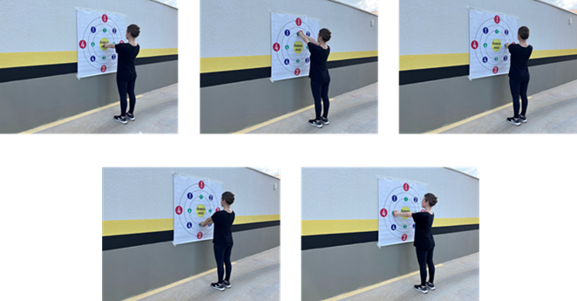
Step up/down RLL  (Components: conditioning) | 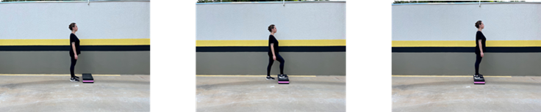
Sideways gait  (Components: conditioning, balance, and coordination) | 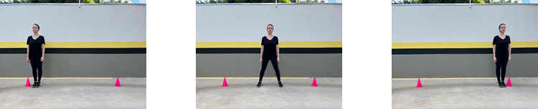
CIRCUIT B - GTCir
Step up/down LLL  (Components: conditioning) | 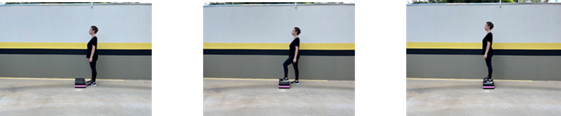
Stacking blocks  (Component: conditioning and functionality of upper limbs) | 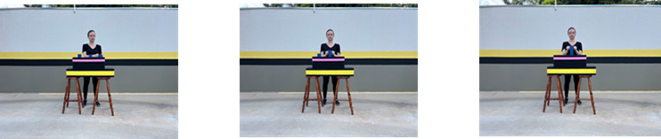
Walking around obstacles and picking up objects  (Components: balance and upper limbs) | 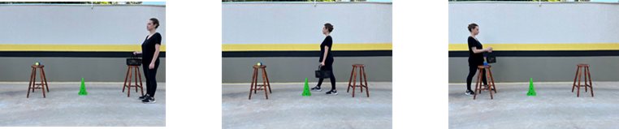
Stationary step LLL  (Component: balance, strength, and coordination) | 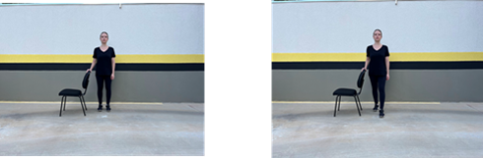
Fast gait  (Components: balance and conditioning) | 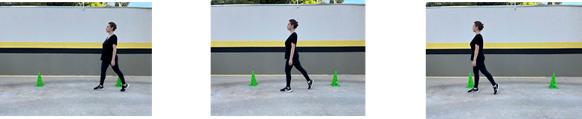
CIRCUIT C - GTCir
Ankle propulsion  (Component: Strength) | 
Walking overcoming obstacles  (Component: balance and conditioning) | 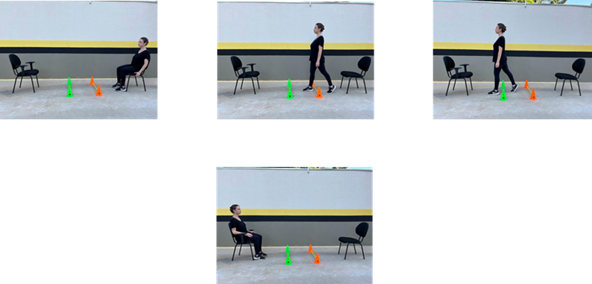
Placing objects on side targets  (Component: conditioning and functionality of upper limbs) | 
Knee flexion  (Component: Strength) | 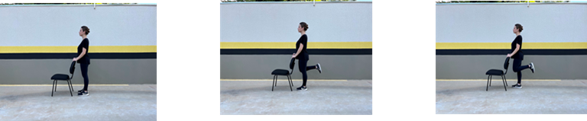
Figure-eight gait  (Component: balance) | 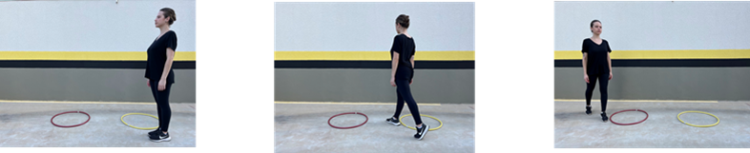

Supplemental material C.1: Exercises performed by the multimodal circuit training with moderate to vigorous intensity. Legend: RLL = Right Lower Limb; LLL = Left Lower Limb;
EXERCISE | ADAPTATION/PROGRESSION | MATERIALS TO BE USED | ECOLOGICAL APPROACH | OBSERVATIONS/SUGGESTIONS*
CIRCUIT A - GTCir
Sit to stand  (Component: Strength and balance) | With support  Without support  Weighted vest  Seat height | 1 Chair  1 Step  1 gait assistance device  Ankle weights | The step can be used as a facilitator for sitting (increasing the height), or as a challenge when placed on the floor (adds difficulty to sitting). | -
Stationary step RLL  (Component: balance, strength, and coordination) | Height of target on the floor  Ankle weight on right ankle  Avoid touching the right foot on the ground | 1 Plate  1 Cone  Ankle weights | The target will be positioned at the participant's step distance | May use wall support
Touching targets  (Component: conditioning, balance, and functionality of upper limbs) | Different diameters  Wrist weights  Reduced base of support | 1 Banner with targets  Wrist weights | Distance between intertwined and extended upper limbs from the wall | -
Step up/down RLL  (Components: conditioning) | No step  Step height  Ankle weights | 2 Steps of different heights  Ankle weights | The step will be positioned at the individual's step distance | It can be performed without a step by taking a step forward and backward
Sideways gait  (Components: conditioning, balance, and coordination) | Increase triple flexion of lower limbs  Ankle weights  Increase distance to walk; | 2 Cones  Ankle weights | - | -
CIRCUIT B - GTCir
Step up/down LLL  (Components: conditioning) | No step  Step height  Ankle weights | 2 Steps of different heights  Ankle weights | The step will be positioned at the individual's step distance | It can be performed without a step by taking a step forward and backward
Stacking blocks  (Component: conditioning and functionality of upper limbs) | Wrist weights  Put object above head level. | 4 Large blocks  4 Medium blocks | Distance between intertwined and extended upper limbs from the table marking | Ask them to leave the blocks together at the marking after finishing the exercise;  Adjust the block size to the participant (medium or large)
Walking around obstacles and picking up objects  (Components: balance and upper limbs) | Load in basket/bag  Ankle weights  Basket positioning height  Increase the distance to walk. | 1 Market basket  1 Bag  2 Steps  3 Cones  Ankle weights | - | Differ the height of the basket with the steps
Stationary step LLL  (Component: balance, strength, and coordination) | Height of target on the floor  Ankle weight on right ankle  Avoid touching the right foot on the ground | 1 Plate  1 Cone  Ankle weights | The target will be positioned at the participant's step distance | May use wall support
Fast gait  (Components: balance and conditioning) | Ankle weights  Abduction of upper limbs on the return  Increase the distance to walk | 2 Cones  Ankle weights | - | Fast forward and return at normal speed
CIRCUIT C - GTCir
Ankle propulsion  (Component: Strength) | Ankle weights  Reduced support of upper limbs | Ankle weights | Distance between intertwined and extended upper limbs from the wall/chair | Sit and stand with ankle propulsion;  Wall support
Walking overcoming obstacles  (Component: balance and conditioning) | Floor marking  Height of obstacles  Ankle weights | Continuous alternating steps  3 Obstacles (cones and bars)  Ankle weights | - | Line marking  From a seated position, stand up, overcome the obstacles, and sit down again
Placing objects on side targets  (Component: conditioning and functionality of upper limbs) | Height for placing objects  Wrist weights | 1 1L PET bottle  2 Steps  3 Chairs | Distance between intertwined and extended upper limbs concerning the object | The same goes for both sides, always bringing to the center in the transfer.
Knee flexion  (Component: Strength) | Ankle weights  Reduced support of upper limbs | Ankle weights | - | Wall support  *When the volunteer cannot perform knee flexion, replace it with hip extension + isometric squat.
Figure-eight gait  (Component: balance) | Ankle weights  Marching  Elevation of upper limbs | 2 Cones  1 Bar  Ankle weights | - | -

Supplementary material C.2: Possible adaptations and modifications to maintain the target heart rate during multimodal circuit training. Legend: RLL = Right Lower Leg; LLL = Left Lower Leg;

CIRCUIT A - CONTROL GROUP
Functional seated reach while seated | 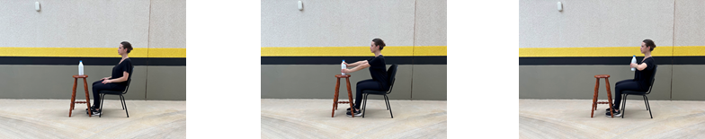
Walking with visual cues | 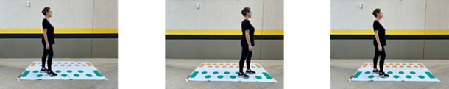
Static standing balance | 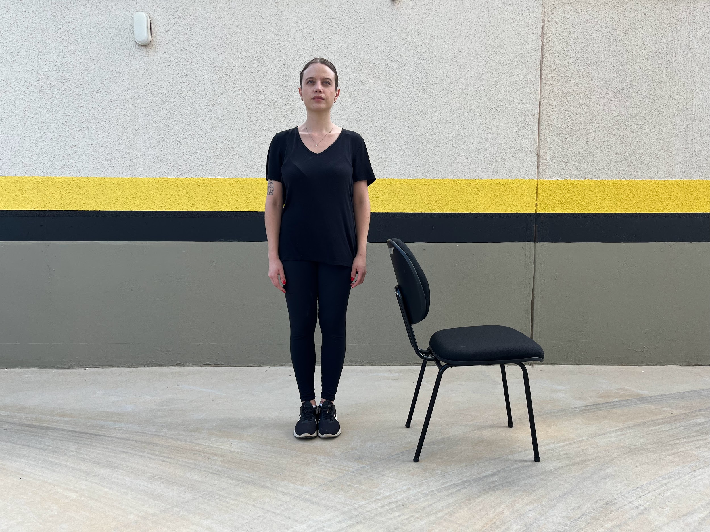
Walking on the line | 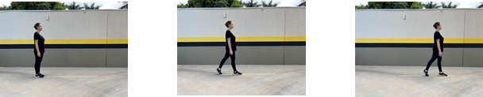
Walking around obstacles | 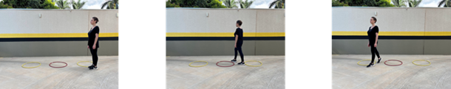
CIRCUIT B - CONTROL GROUP
Walking on the line
Walking overcoming obstacles | 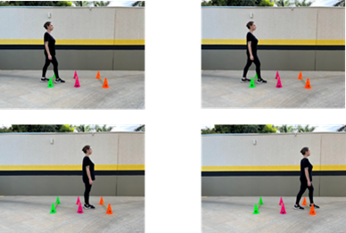
Functional reach with the RLL | 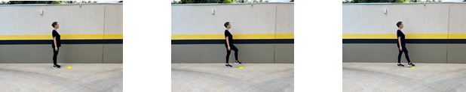
Placing objects on lateral targets | 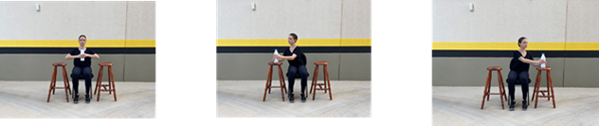
Functional reach with the LLL | 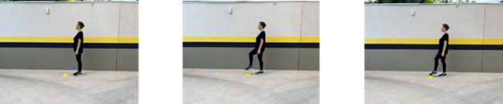
CIRCUIT C - CONTROL GROUP
Touching targets
Walking around obstacles and picking up objects
Chair-to-chair transfer | 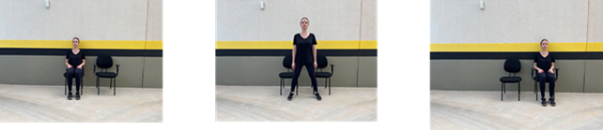
Functional reach while seated - lateral and frontal displacement | 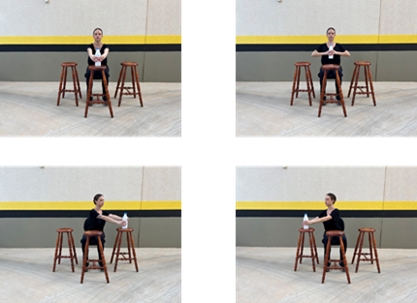
Static standing balance

Supplementary material D.1: Exercises performed by the balance training - control group. Legend: RLL = Right Lower Leg; LLL = Left Lower Leg.

EXERCISE | ADAPTATION/PROGRESSION | MATERIALS TO BE USED | ECOLOGICAL APPROACH | OBSERVATIONS/SUGGESTIONS*
CIRCUIT A - CONTROL GROUP
Functional seated reach while seated | Shape and size of the object  Material of the object  Target orientation  Distance for reaching | 1 Rigid cup  1 Disposable cup  1 Large cube  1 Small cube | An object positioned at the distance of extended upper limbs | Different objects will be used
Walking with visual cues | Distance of steps  Direction of steps | 1 Rug with visual cues | - | -
Static standing balance | Reduced base of support  Type of surface  Eyes closed | 2 Mats | - | Base of lower limbs in a stable and adapted width according to the participant's progress
Walking on the line | Type of surface  Reduced base of support | 1 Mat  1 Rug | - | The distance is set at 2 meters;  Next to the wall
Walking around obstacles | Distance between obstacles  Diameter of obstacles | 3 Cones  3 Medium rings  3 Hula hoops | - | -
CIRCUIT B - CONTROL GROUP
Walking on the line | Type of surface  Reduced base of support | 1 Mat  1 Rug | - | The distance is set at 2 meters;  Next to the wall
Walking overcoming obstacles | Ground marking  Height of obstacles  Continuous alternating steps | 3 Obstacles (cones and bars) | - | Line marking
Functional reach with the RLL | Marking on the floor  Support reduction  Height of targets | 1 Plate 1 Cone | The target will be positioned at the individual's step distance | Support on the wall or chair
Placing objects on lateral targets | Height for object placement Distance to targets | 1 1L plastic bottle  2 Steps  3 Chairs | - | The same goes for both sides, always bringing to the center during transfer
Functional reach with the LLL | Marking on the floor  Support reduction  Height of targets | 1 Plate 1 Cone | The target will be positioned at the individual's step distance | Support on the wall or chair
CIRCUIT C CONTROL GROUP
Touching targets | Different diameters  Reduction of support base Distance to target | 1 Banner with targets | Initial distance of intertwined and extended upper limbs from the wall | -
Walking around obstacles and picking up objects | Height of basket placement | 1 Market basket  2 Steps  3 Cones | - | Vary the height of the basket with the steps.
Chair-to-chair transfer | Chairs with support  Chairs without support  Distance between chairs | 2 Chairs | - | -
Functional reach while seated - Lateral and frontal displacement | Shape and size of the object  Material of the object  Reach distance  Sitting on an unstable surface | 1 Rigid cup  1 Disposable cup  1 Large cube  1 Small cube | Object positioned at the distance of extended upper limbs | Different objects will be used
Static standing balance | Reduced base of support  Type of surface  Eyes closed | 2 Mats | - | Base of lower limbs in a stable and adapted width according to the participant's progress

Supplementary material D.2: Description of possible adaptations and modifications to maintain the target heart rate during balance training - control group.

