SUPPLEMENTARY INFORMATION

for

Demographic Variation and Childhood Predictors of Perceived Discrimination Across 22 Countries

1. Demographic Variation in Perceived Discrimination across 22 Countries 2
1.1. Population Weighted Meta-Analysis 2
1.2. Post-hoc Sensitivity Analysis with Alternative Dichotomization Point for Perceived Discrimination 4
1.3. Forest Plots 5
1.4. Demographic Variation in Perceived Discrimination by Country 22
2. Childhood Predictors of Perceived Discrimination across 22 Countries 113
2.1. Population Weighted Meta-Analysis 113
2.2. Post-hoc Sensitivity Analysis with Alternative Dichotomization Point for Perceived Discrimination 116
2.3. Forest Plots 118
2.4. Childhood Predictors of Perceived Discrimination by Country 132

Demographic Variation in Perceived Discrimination across 22 Countries

Population Weighted Meta-Analysis

Table S1. Population weighted meta-analysis of results demographic group means.
Variable | Category | Proportion | 95% CI of Proportion | SE Analogue (CI Width/4)
Age group
 | 18-24 | 0.26 | (0.24,0.29) | 0.01
 | 25-29 | 0.25 | (0.23,0.28) | 0.01
 | 30-39 | 0.25 | (0.23,0.27) | 0.01
 | 40-49 | 0.24 | (0.22,0.27) | 0.01
 | 50-59 | 0.22 | (0.20,0.25) | 0.01
 | 60-69 | 0.20 | (0.18,0.22) | 0.01
 | 70-79 | 0.19 | (0.17,0.21) | 0.01
 | 80 or older | 0.18 | (0.17,0.20) | 0.01
Gender
 | Male | 0.24 | (0.22,0.26) | 0.01
 | Female | 0.23 | (0.20,0.25) | 0.01
 | Other | 0.40 | (0.37,0.43) | 0.01
Marital status
 | Married | 0.22 | (0.20,0.25) | 0.01
 | Separated | 0.32 | (0.29,0.34) | 0.01
 | Divorced | 0.22 | (0.20,0.24) | 0.01
 | Widowed | 0.19 | (0.17,0.21) | 0.01
 | Domestic partner | 0.23 | (0.20,0.25) | 0.01
 | Single, never married | 0.25 | (0.23,0.28) | 0.01
Employment status
 | Employed for an employer | 0.24 | (0.22,0.27) | 0.01
 | Self-employed | 0.24 | (0.22,0.26) | 0.01
 | Retired | 0.19 | (0.17,0.21) | 0.01
 | Student | 0.24 | (0.22,0.27) | 0.01
 | Homemaker | 0.22 | (0.20,0.25) | 0.01
 | Unemployed and looking for a job | 0.25 | (0.23,0.28) | 0.01
 | None of these/other | 0.26 | (0.24,0.28) | 0.01
Education
 | Up to 8 years | 0.26 | (0.24,0.28) | 0.01
 | 9-15 years | 0.22 | (0.20,0.24) | 0.01
 | 16+ years | 0.21 | (0.19,0.23) | 0.01
Religious service attendance
 | >1/week | 0.27 | (0.25,0.30) | 0.01
 | 1/week | 0.27 | (0.24,0.29) | 0.01
 | 1-3/month | 0.25 | (0.23,0.27) | 0.01
 | A few times a year | 0.21 | (0.19,0.24) | 0.01
 | Never | 0.23 | (0.21,0.25) | 0.01
Immigration status
 | Born in this country | 0.23 | (0.21,0.26) | 0.01
 | Born in another country | 0.27 | (0.24,0.29) | 0.01

Post-hoc Sensitivity Analysis with Alternative Dichotomization Point for Perceived Discrimination

Table S2. Ordered means of perceived discrimination with standard deviations.
Country | Mean | 95% CI | Standard Deviation
Egypt | 0.16 | (0.14, 0.17) | 0.36
South Africa | 0.16 | (0.14, 0.18) | 0.37
Turkey | 0.14 | (0.11, 0.16) | 0.34
India | 0.13 | (0.12, 0.14) | 0.34
Nigeria | 0.13 | (0.12, 0.15) | 0.34
Brazil | 0.11 | (0.10, 0.11) | 0.31
Kenya | 0.10 | (0.09, 0.11) | 0.30
Philippines | 0.10 | (0.09, 0.11) | 0.30
Hong Kong | 0.09 | (0.08, 0.10) | 0.28
Indonesia | 0.09 | (0.08, 0.10) | 0.28
Argentina | 0.08 | (0.07, 0.09) | 0.27
Mexico | 0.08 | (0.07, 0.08) | 0.26
Israel | 0.05 | (0.04, 0.06) | 0.22
Tanzania | 0.05 | (0.04, 0.06) | 0.22
United Kingdom | 0.05 | (0.04, 0.06) | 0.22
United States | 0.05 | (0.04, 0.05) | 0.21
Spain | 0.04 | (0.04, 0.05) | 0.20
Australia | 0.03 | (0.02, 0.04) | 0.17
Germany | 0.02 | (0.02, 0.03) | 0.15
Japan | 0.02 | (0.02, 0.02) | 0.14
Poland | 0.02 | (0.01, 0.02) | 0.14
Sweden | 0.02 | (0.01, 0.02) | 0.13

Forest Plots
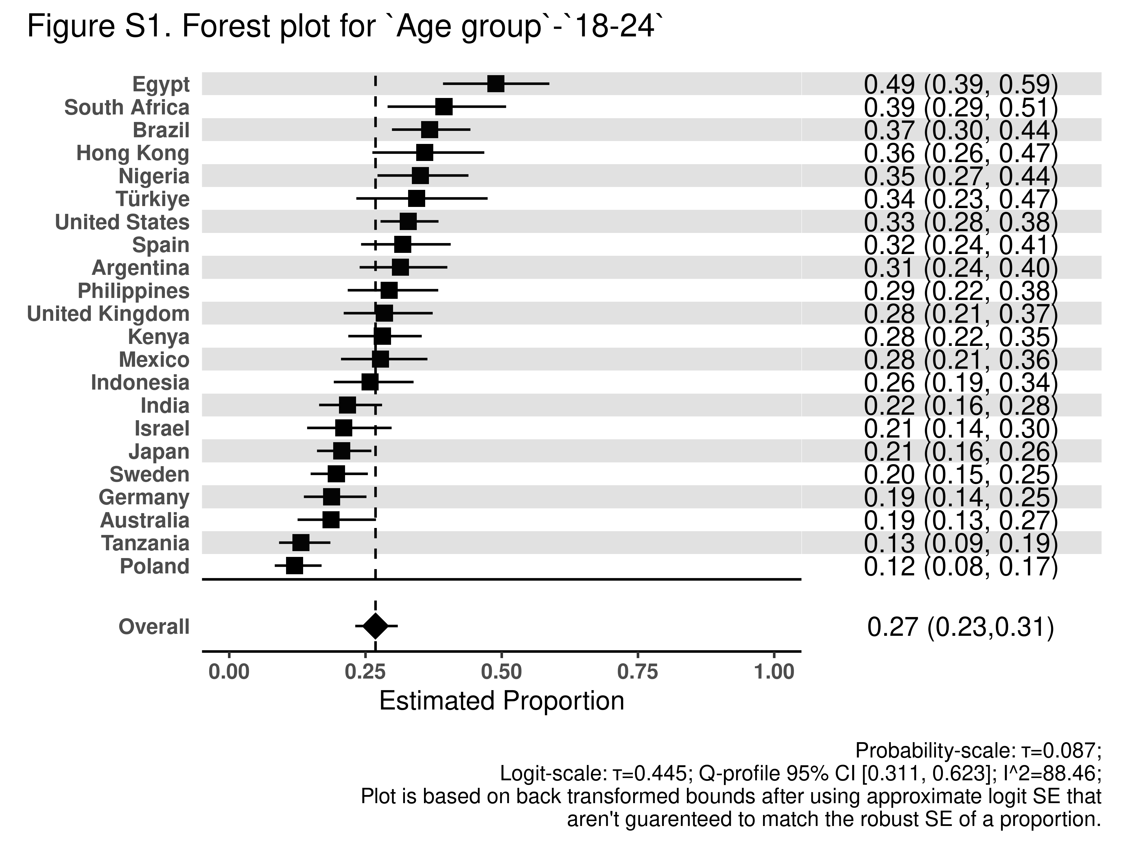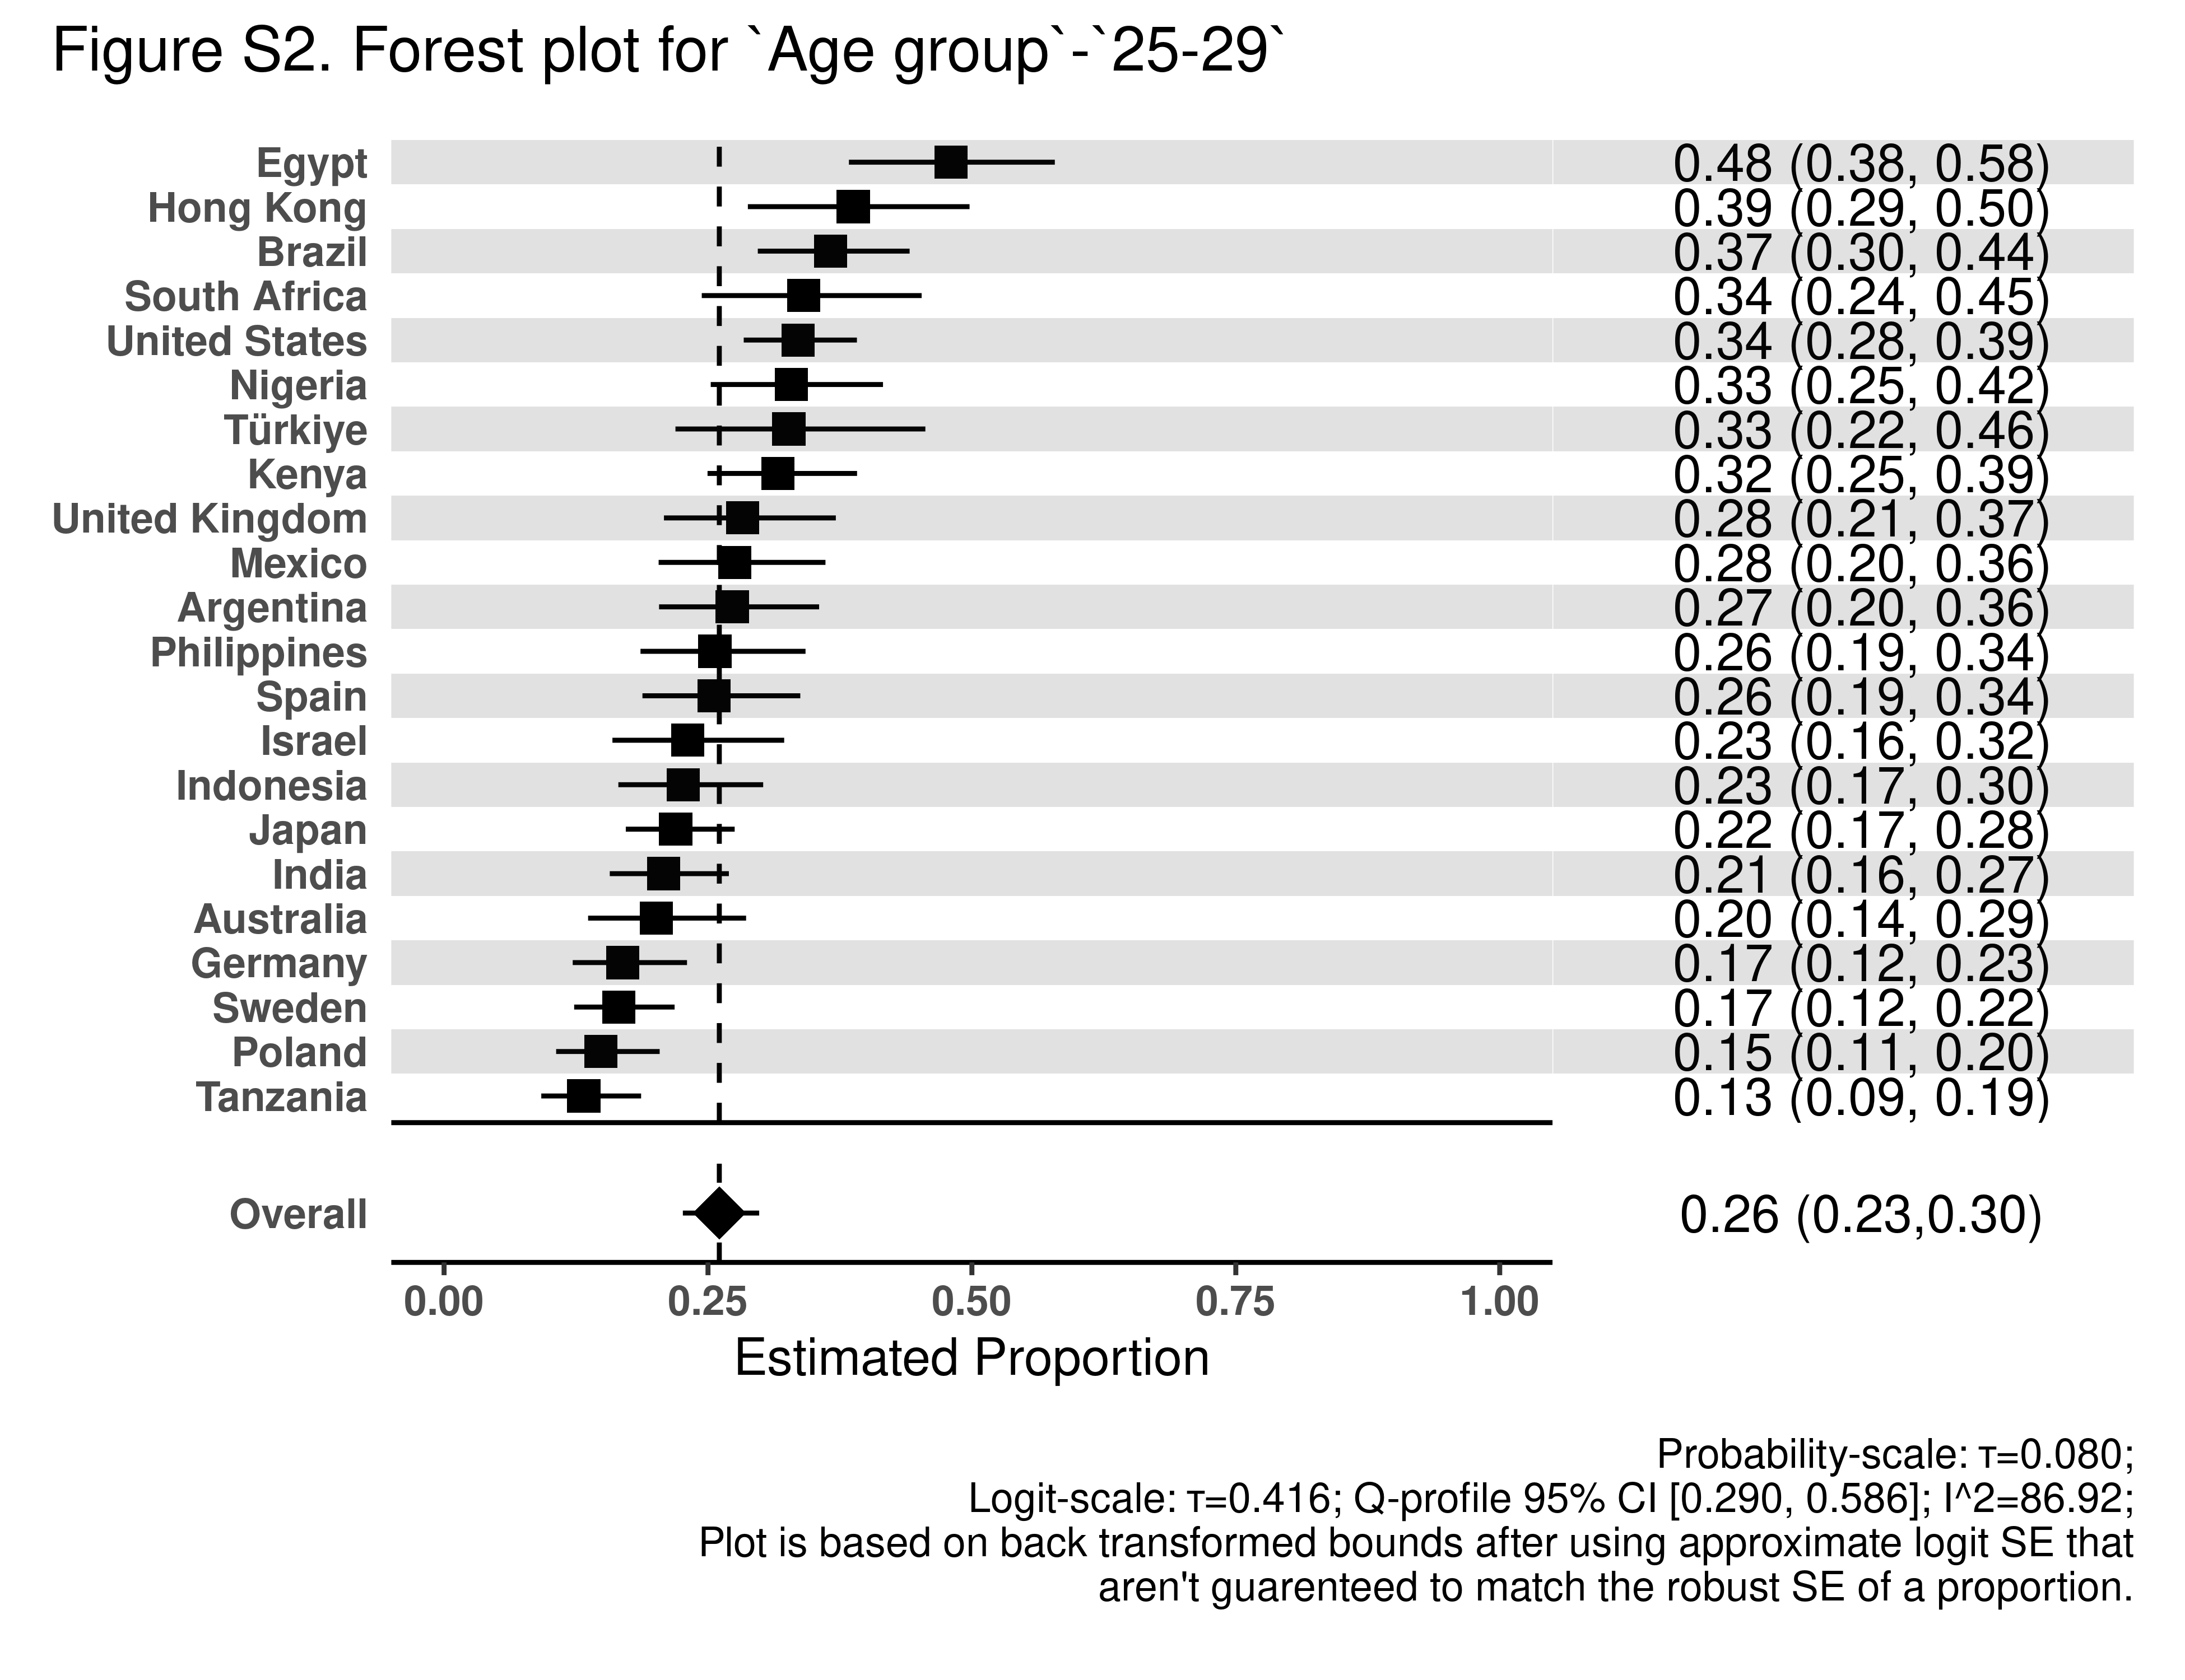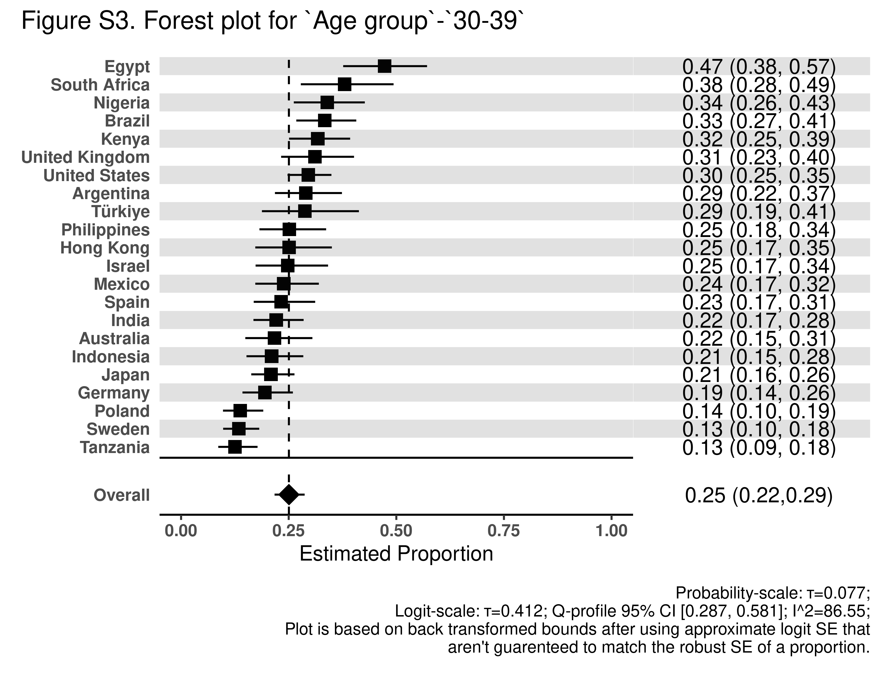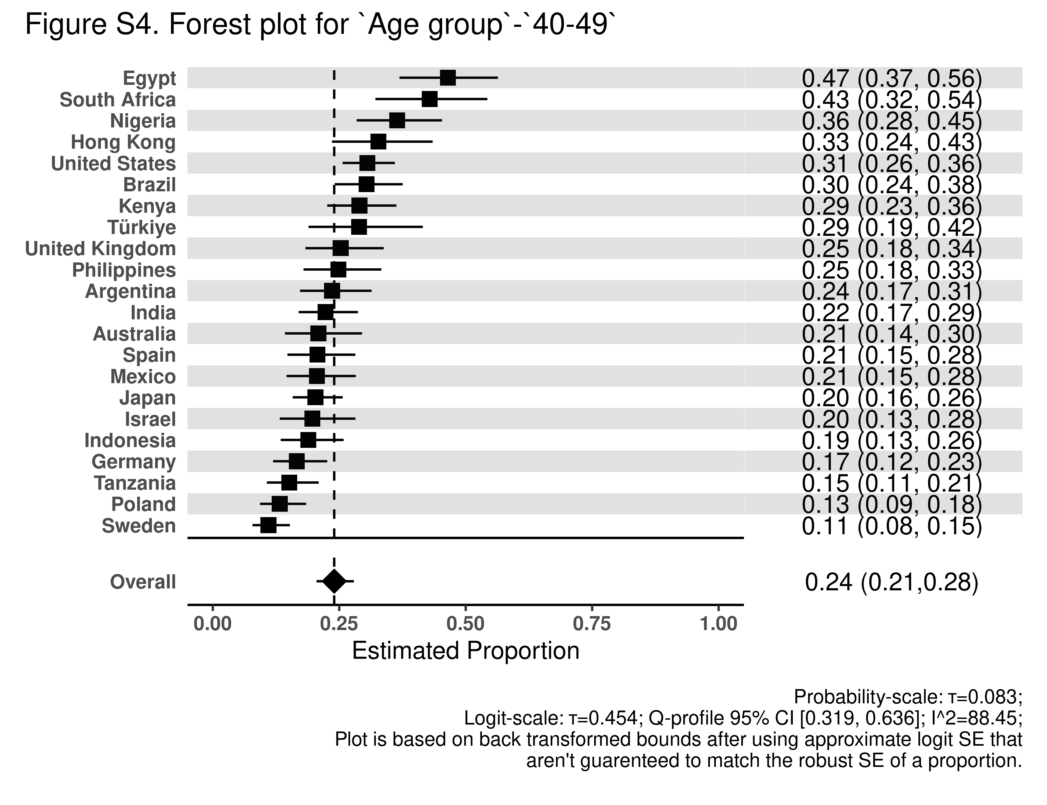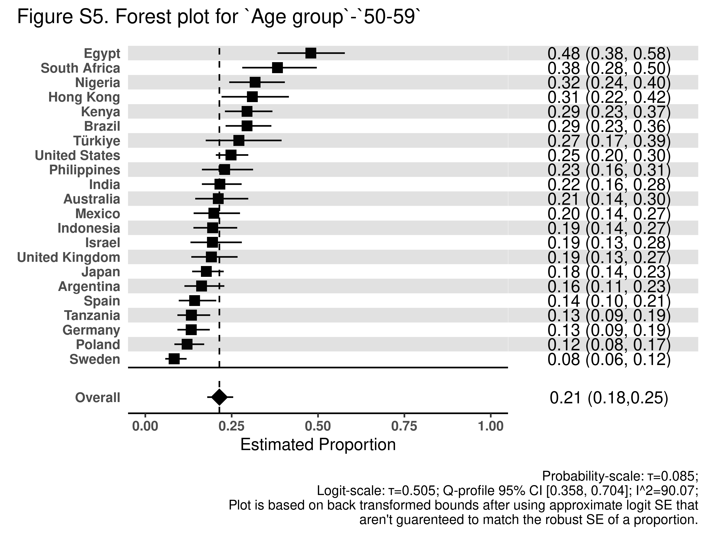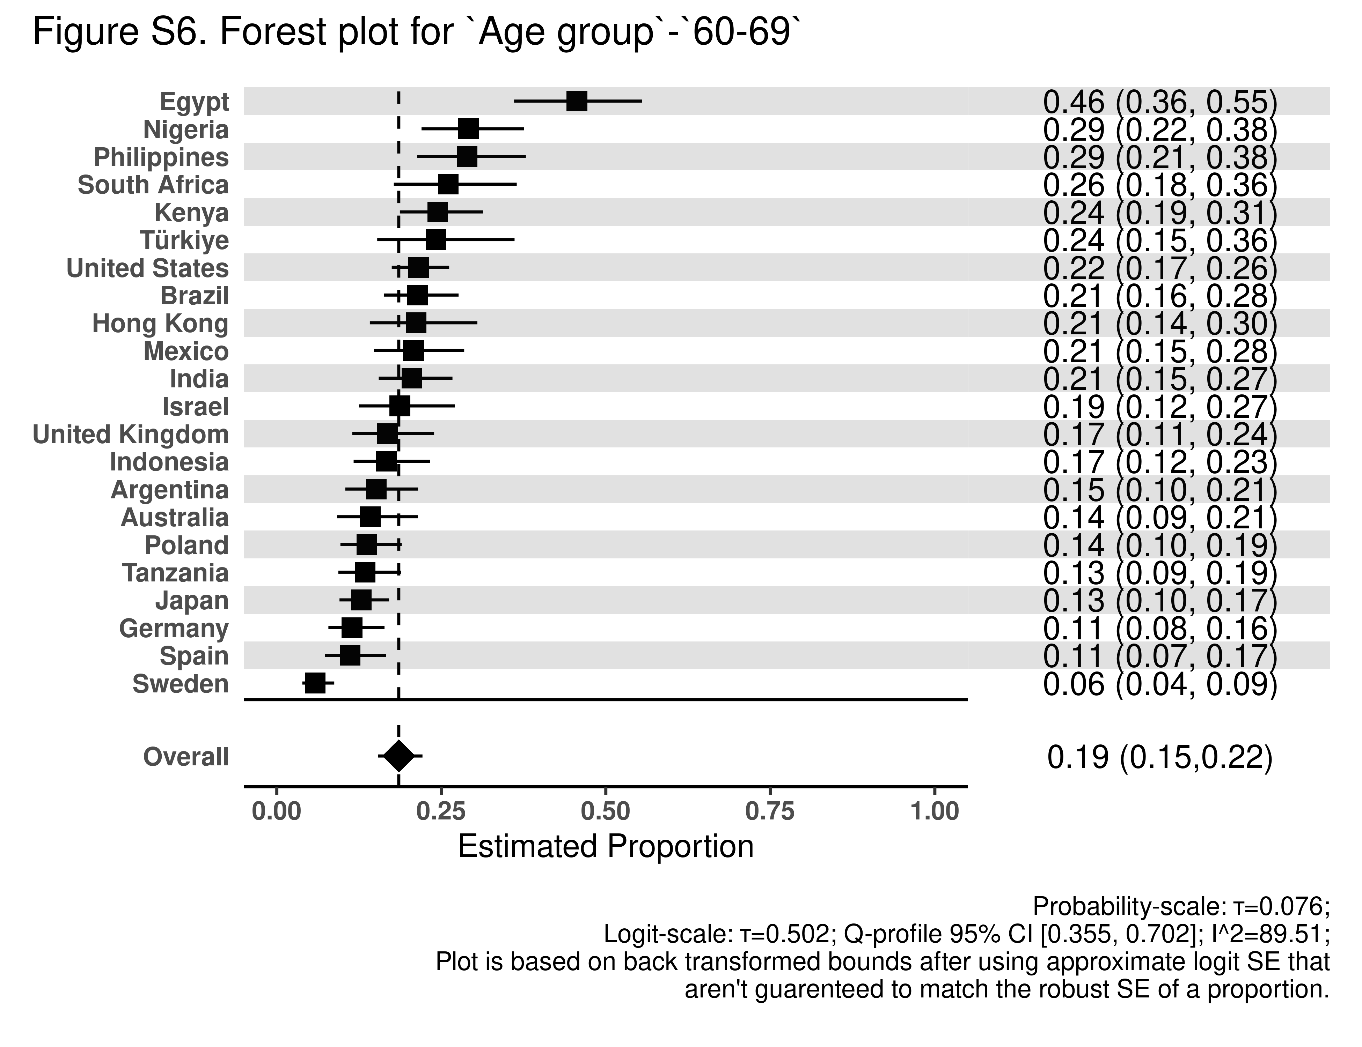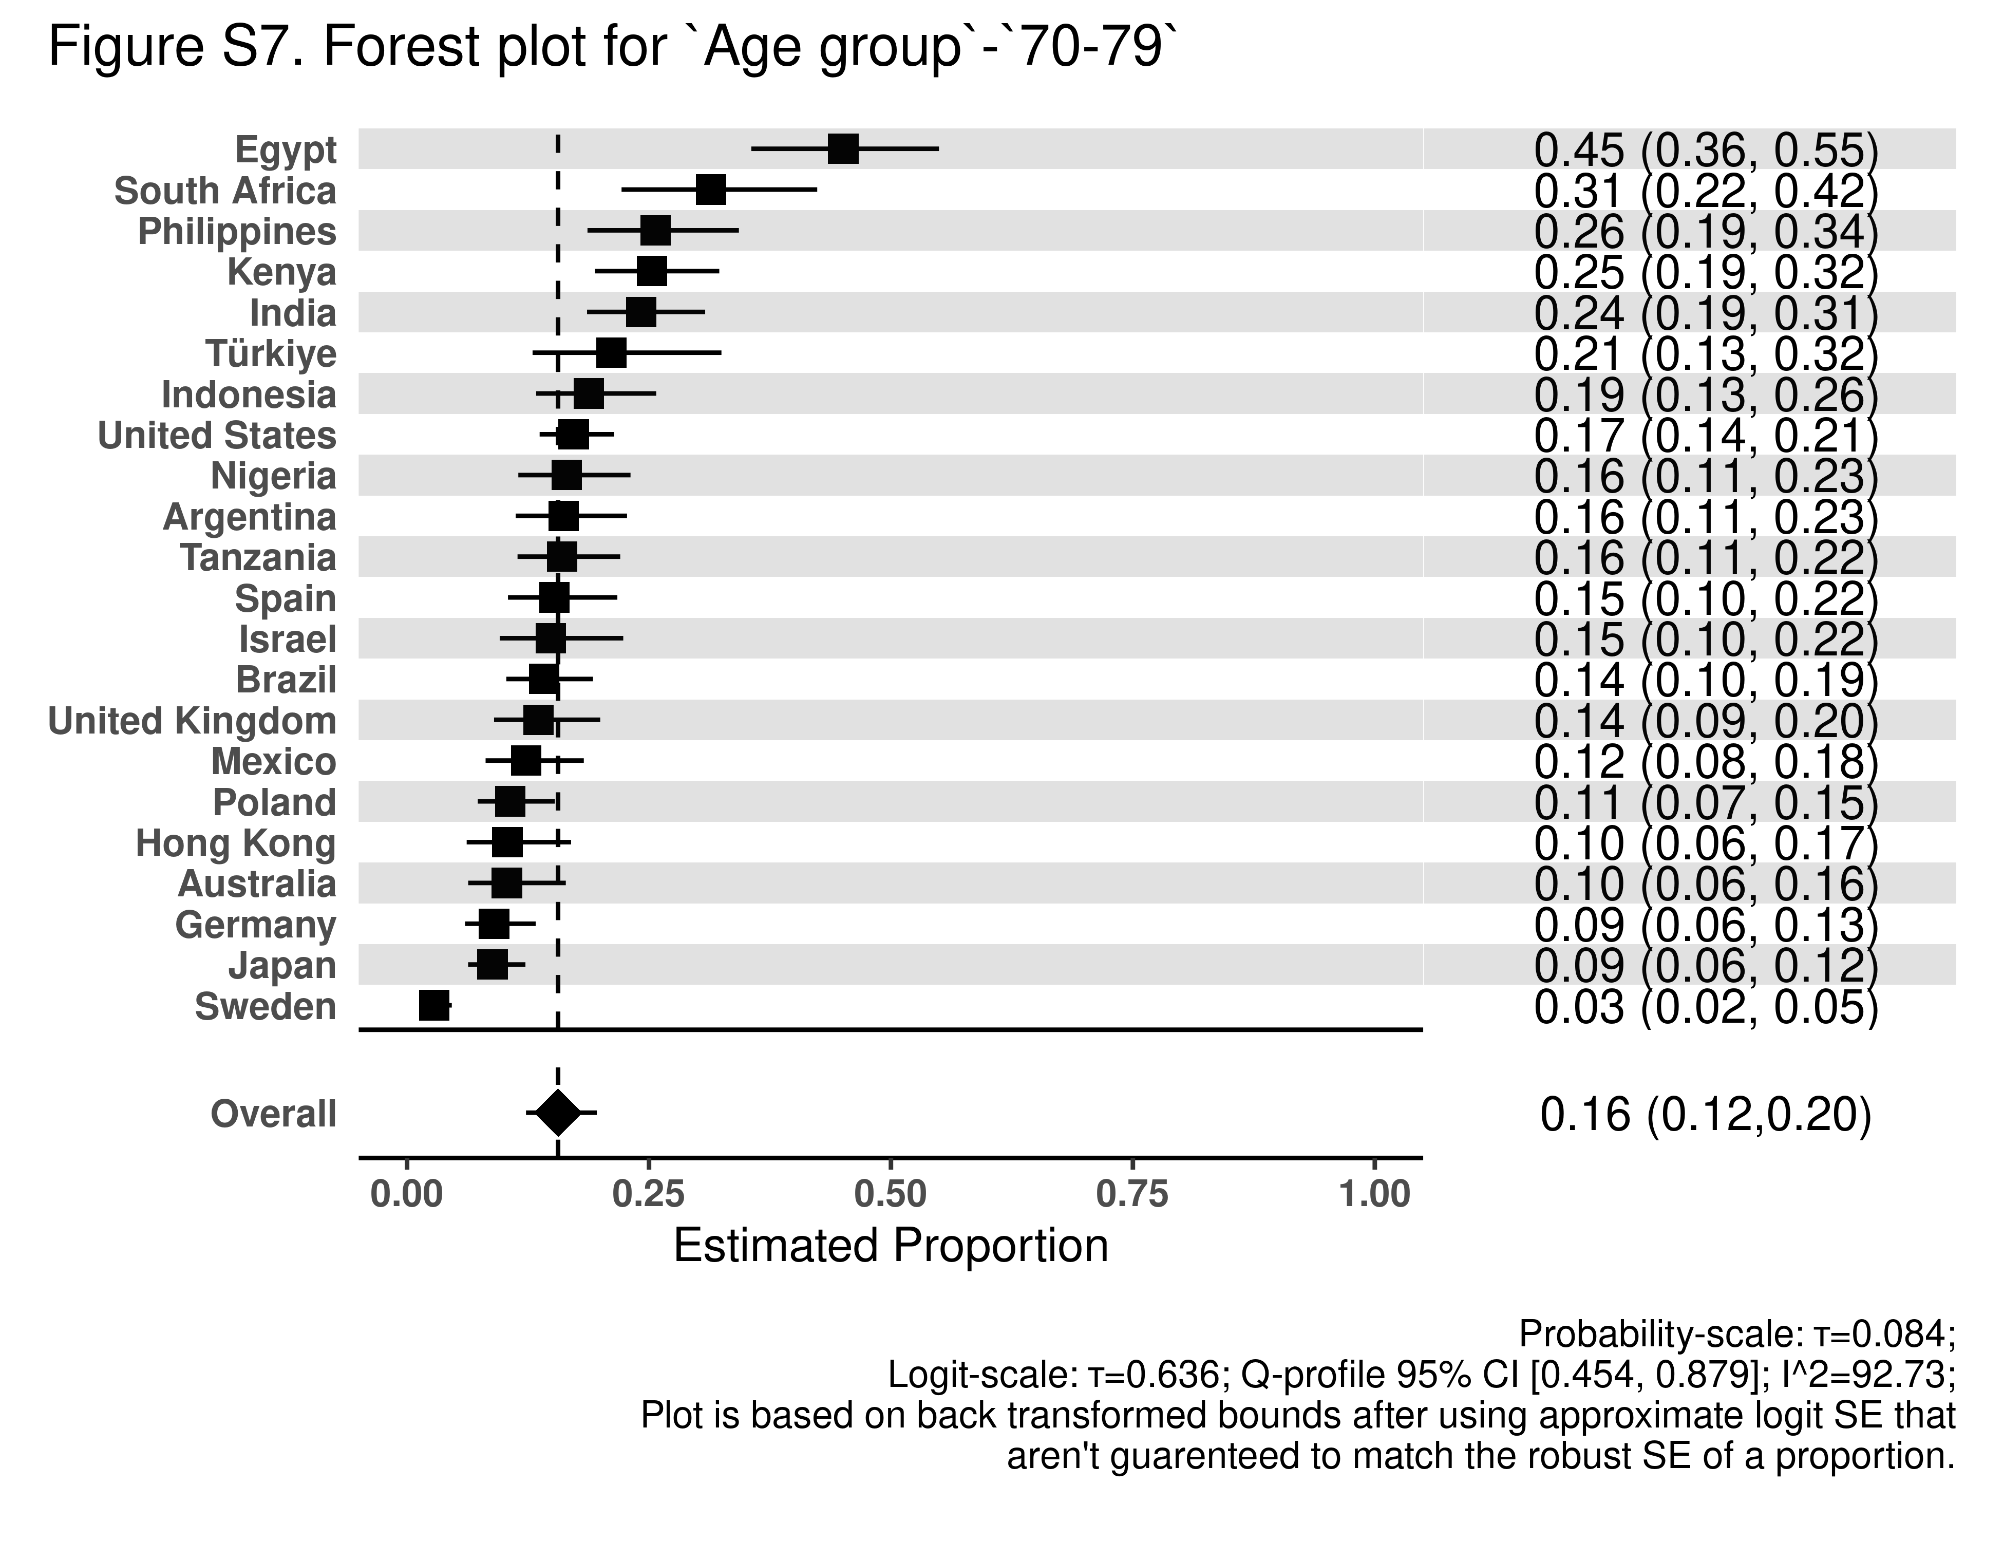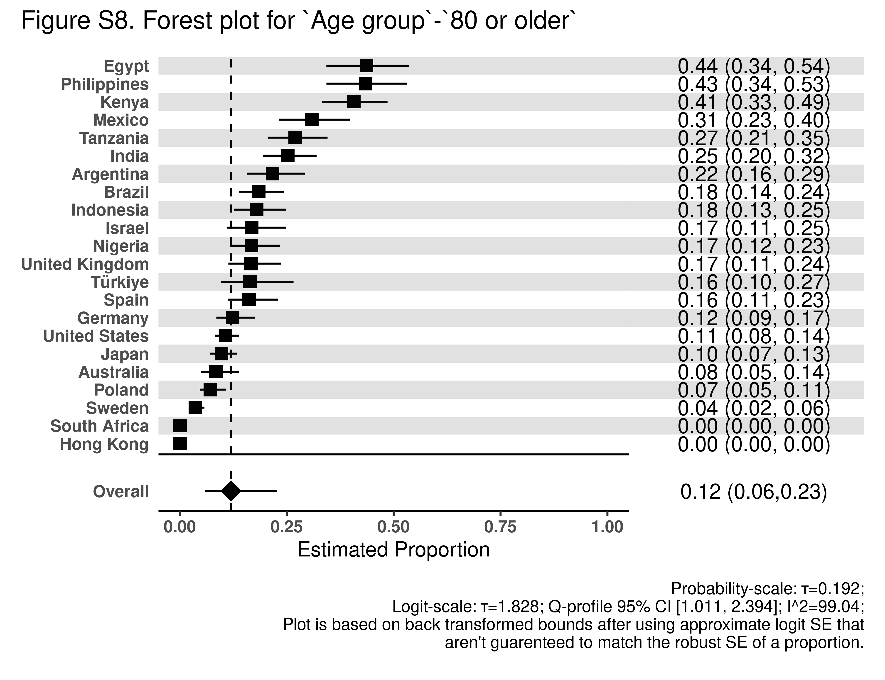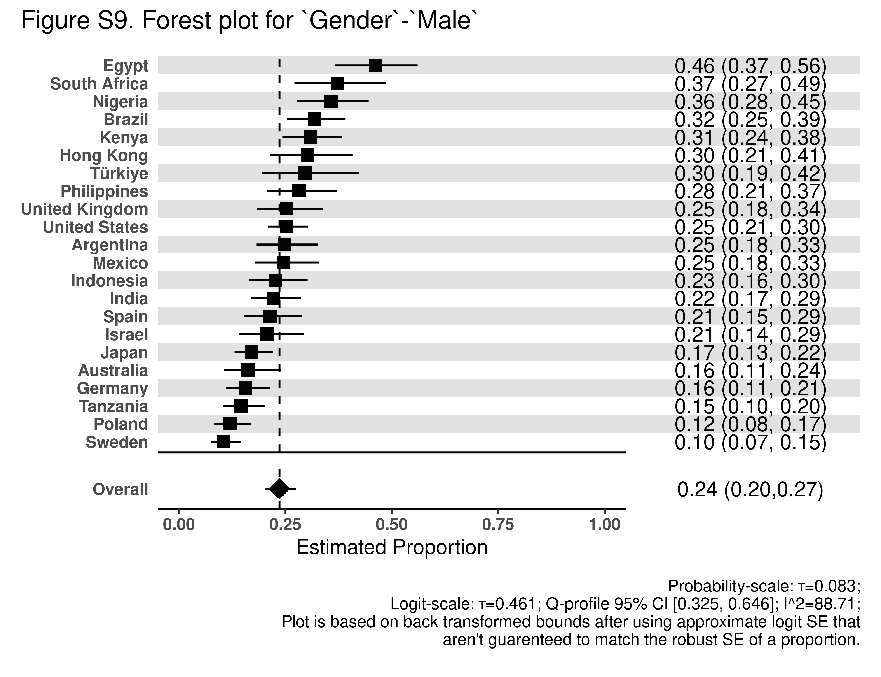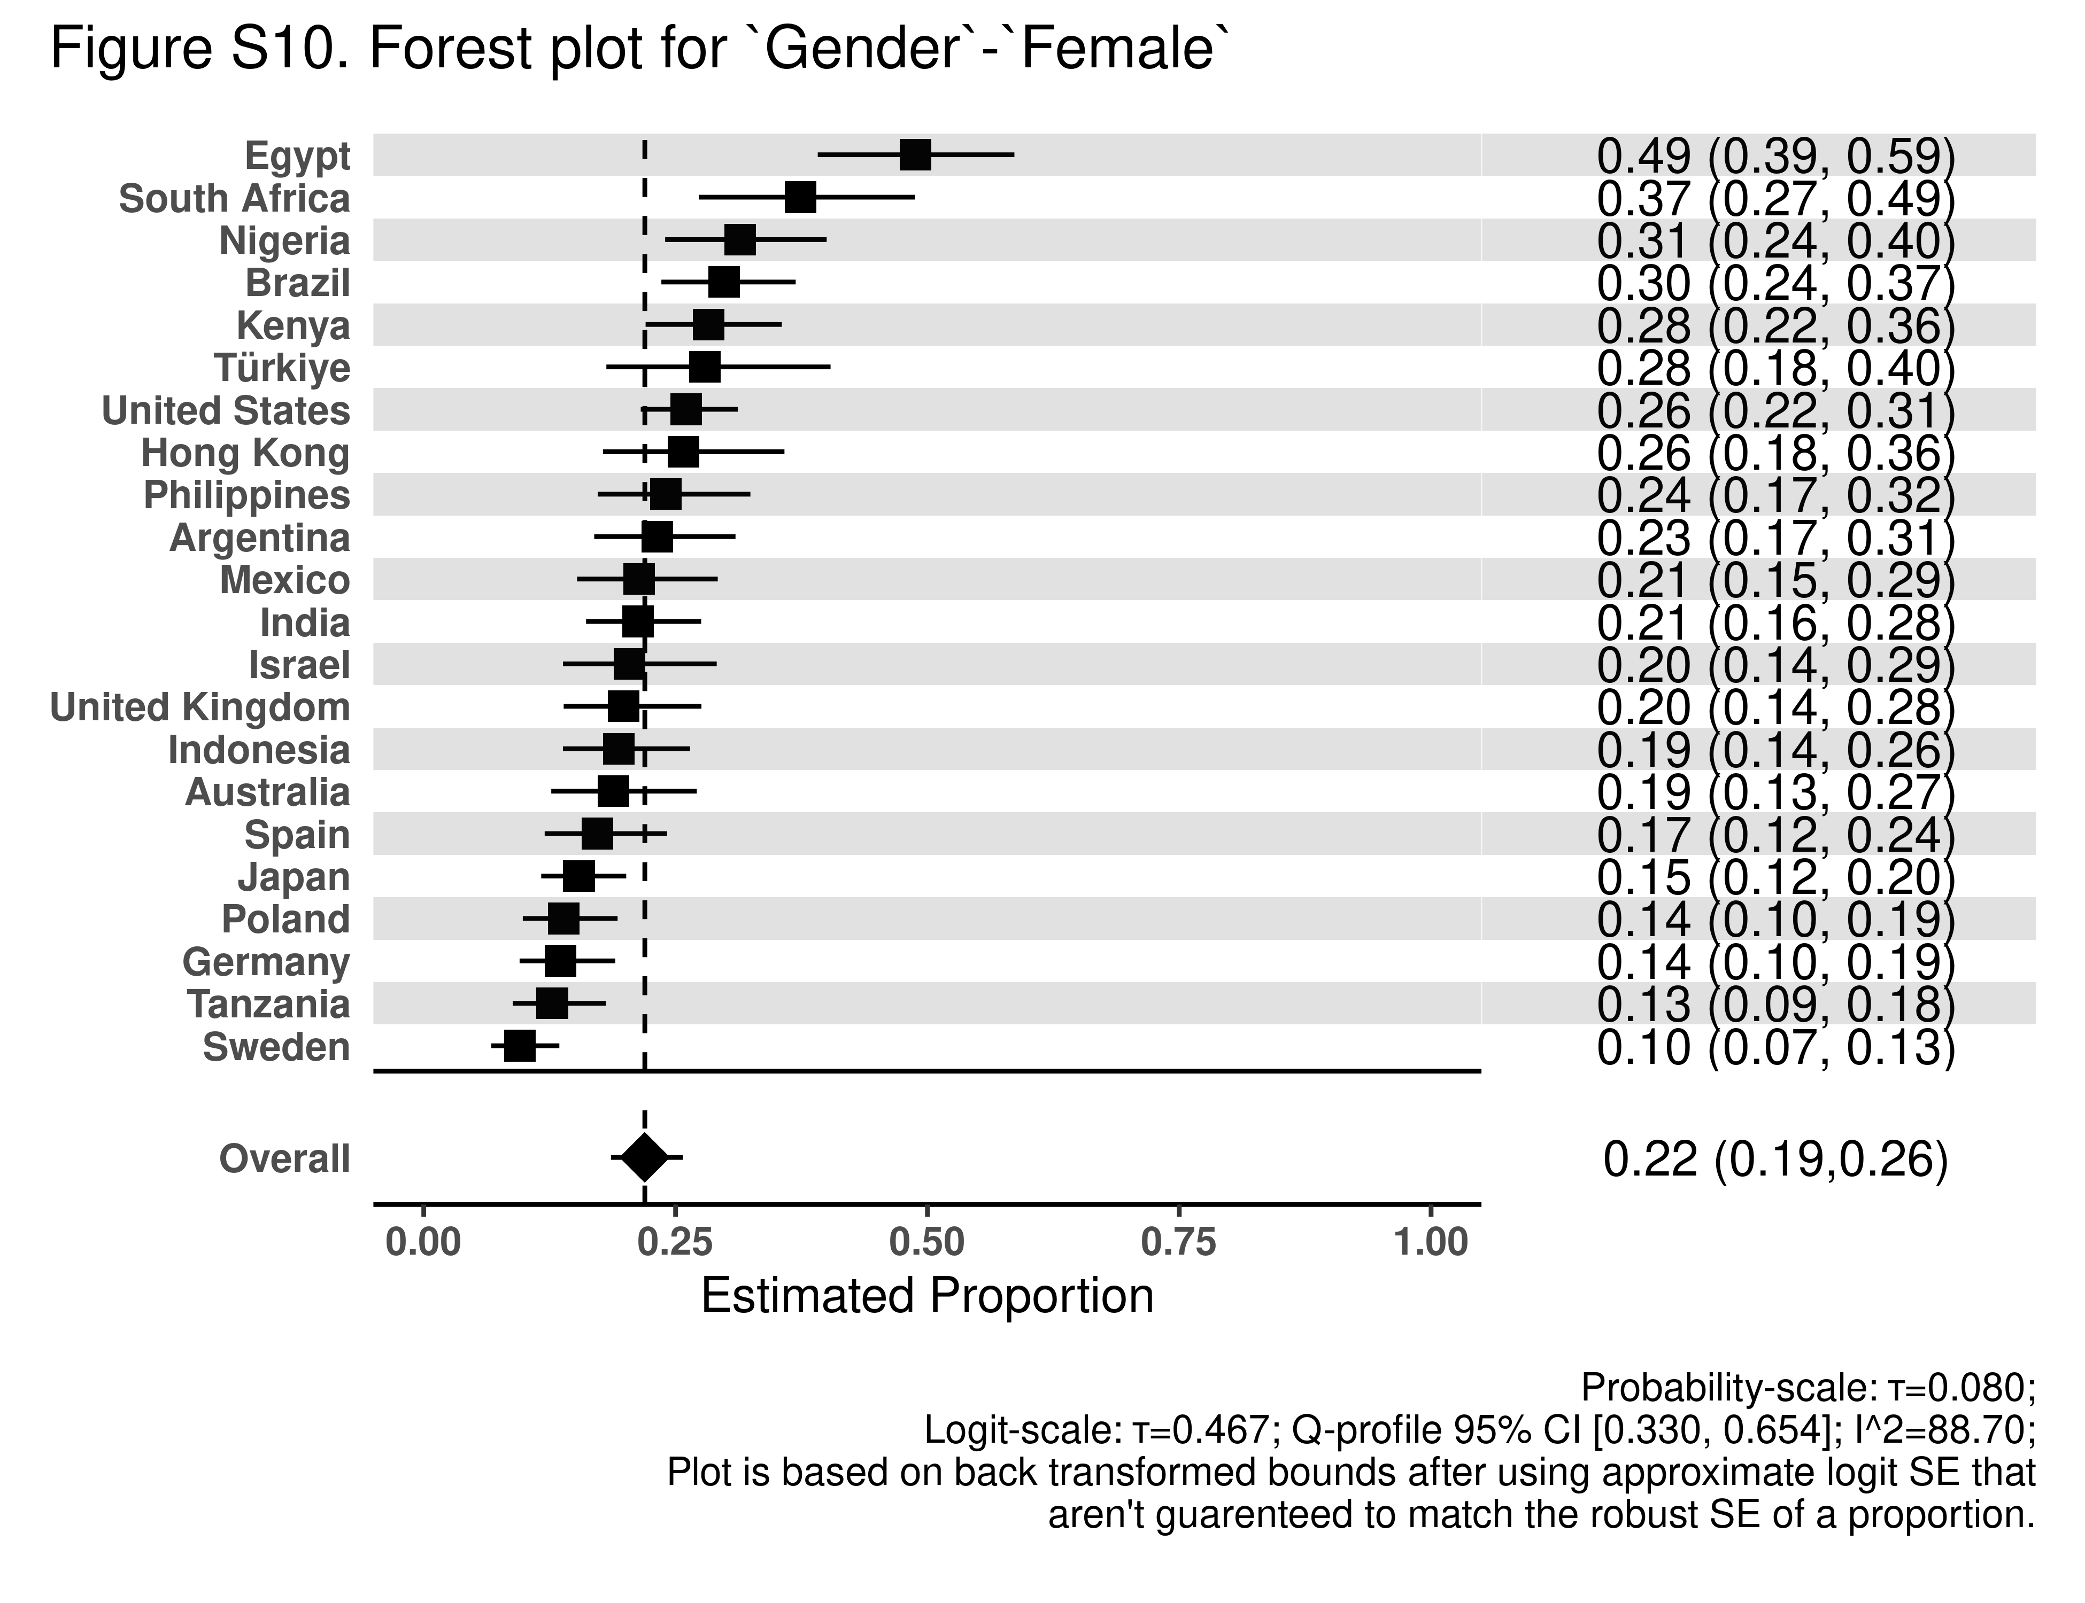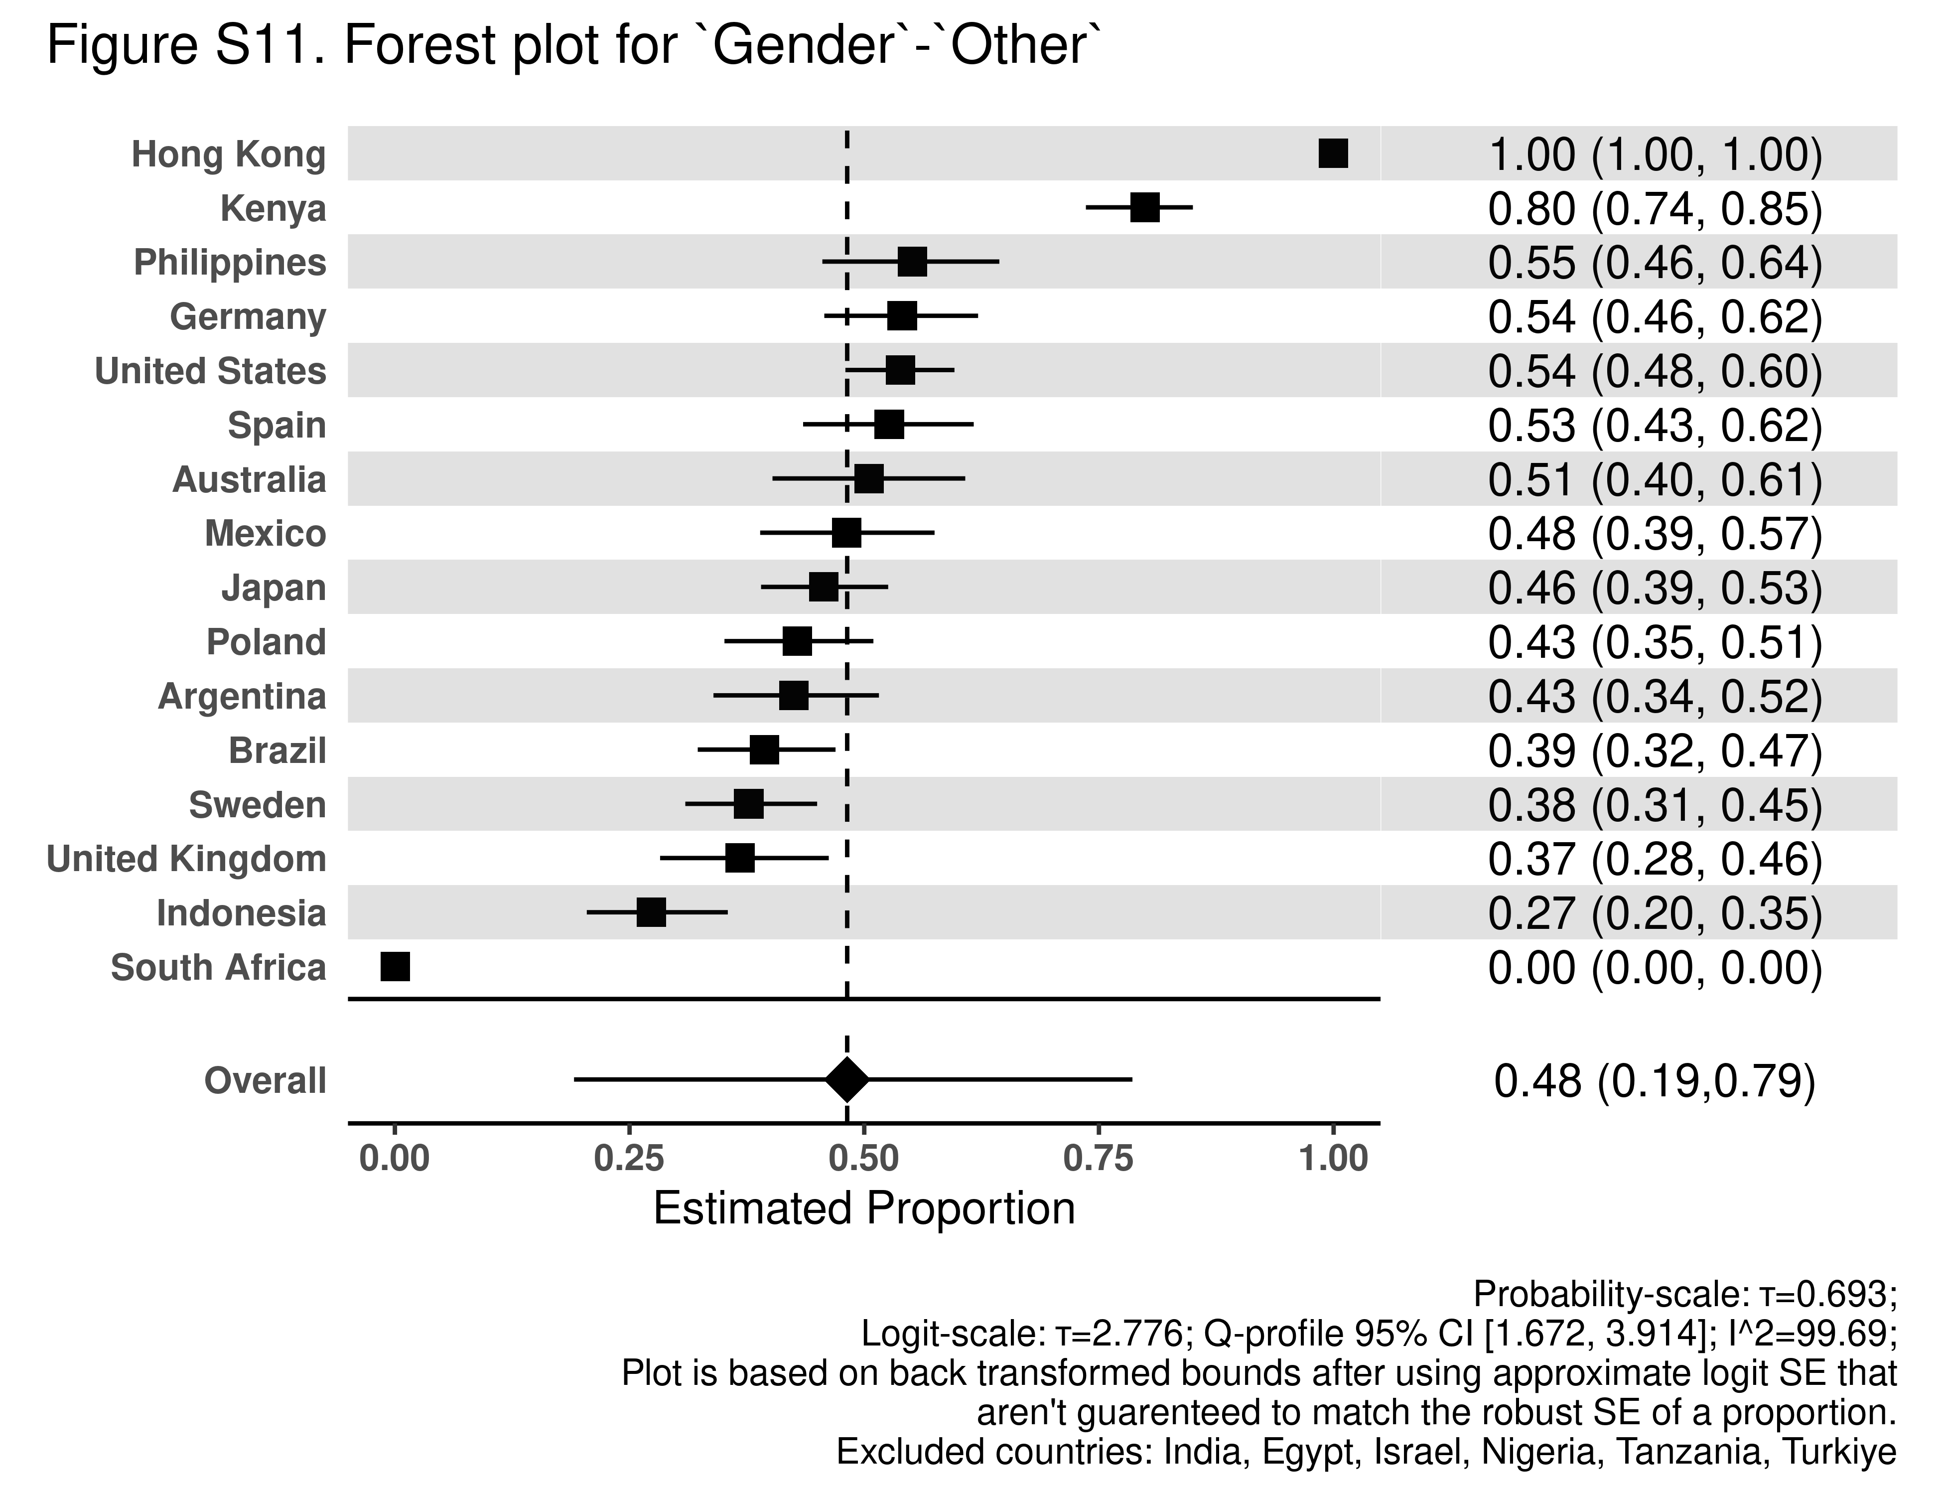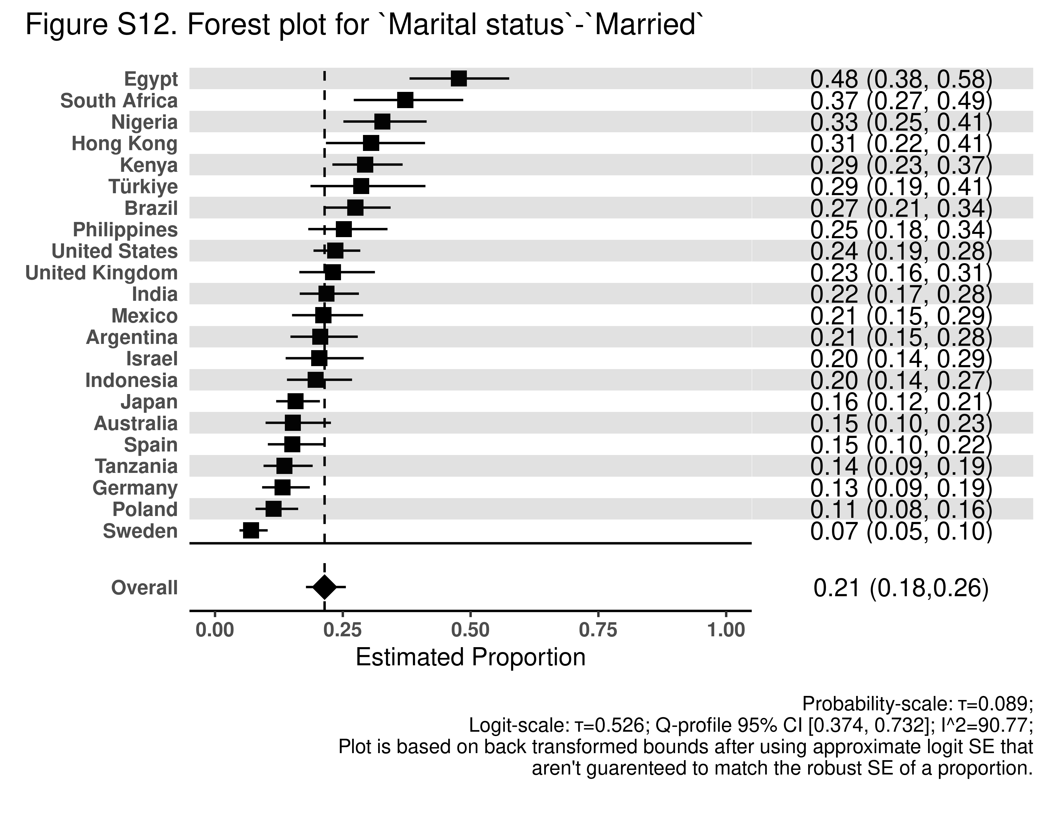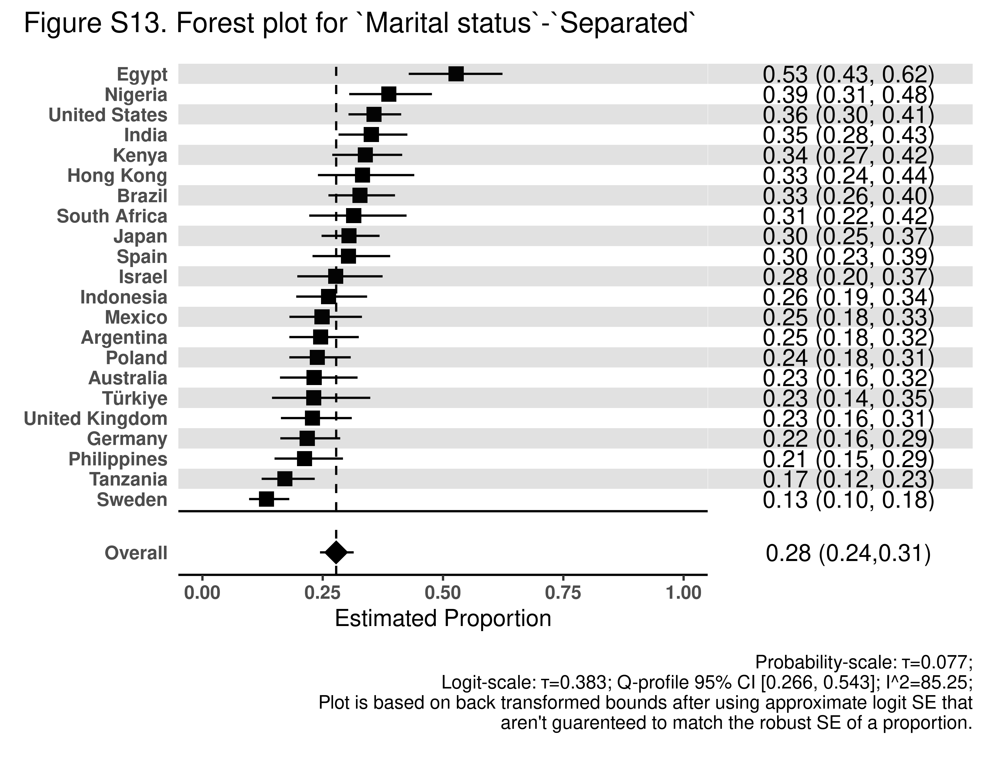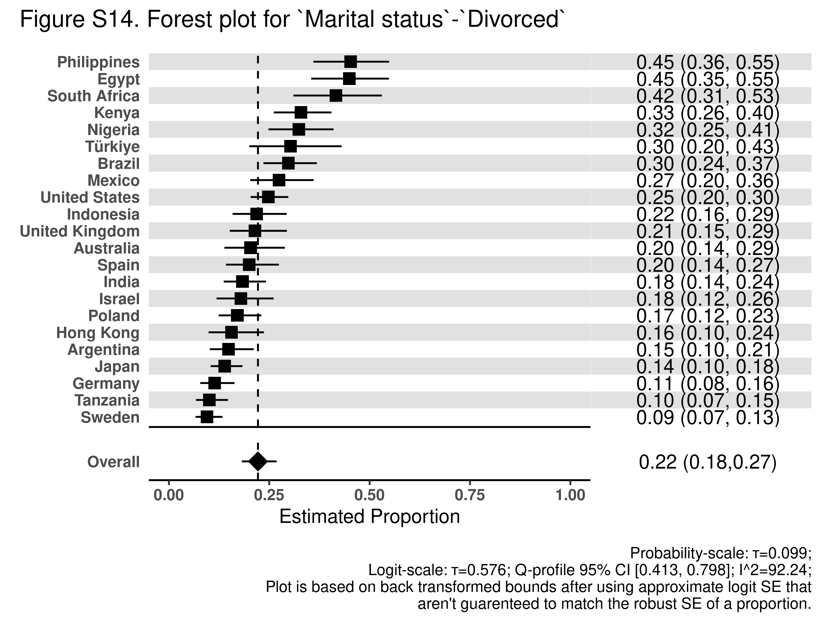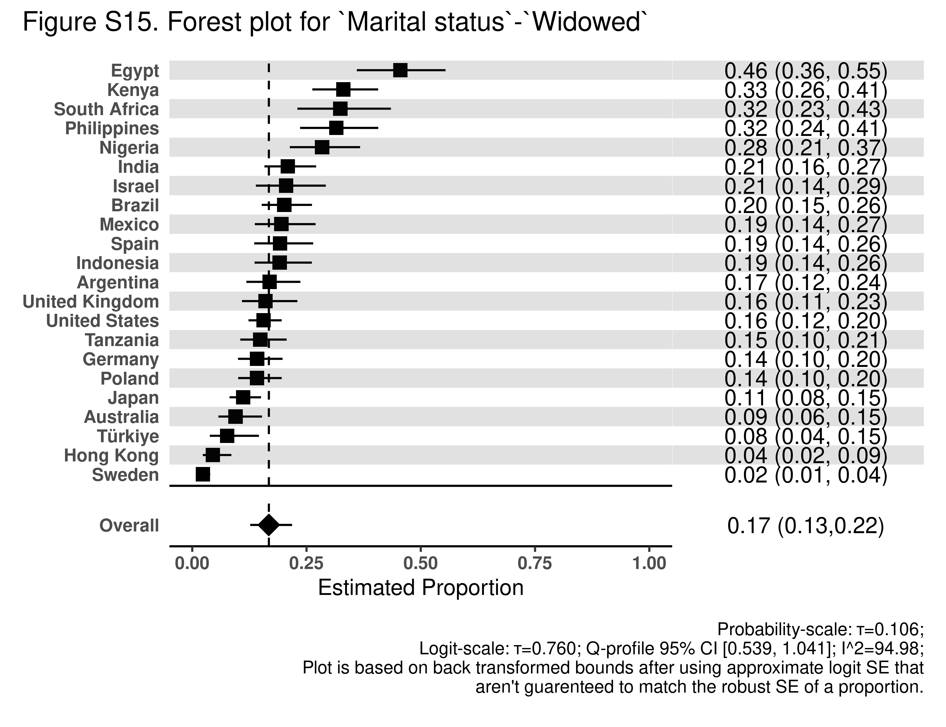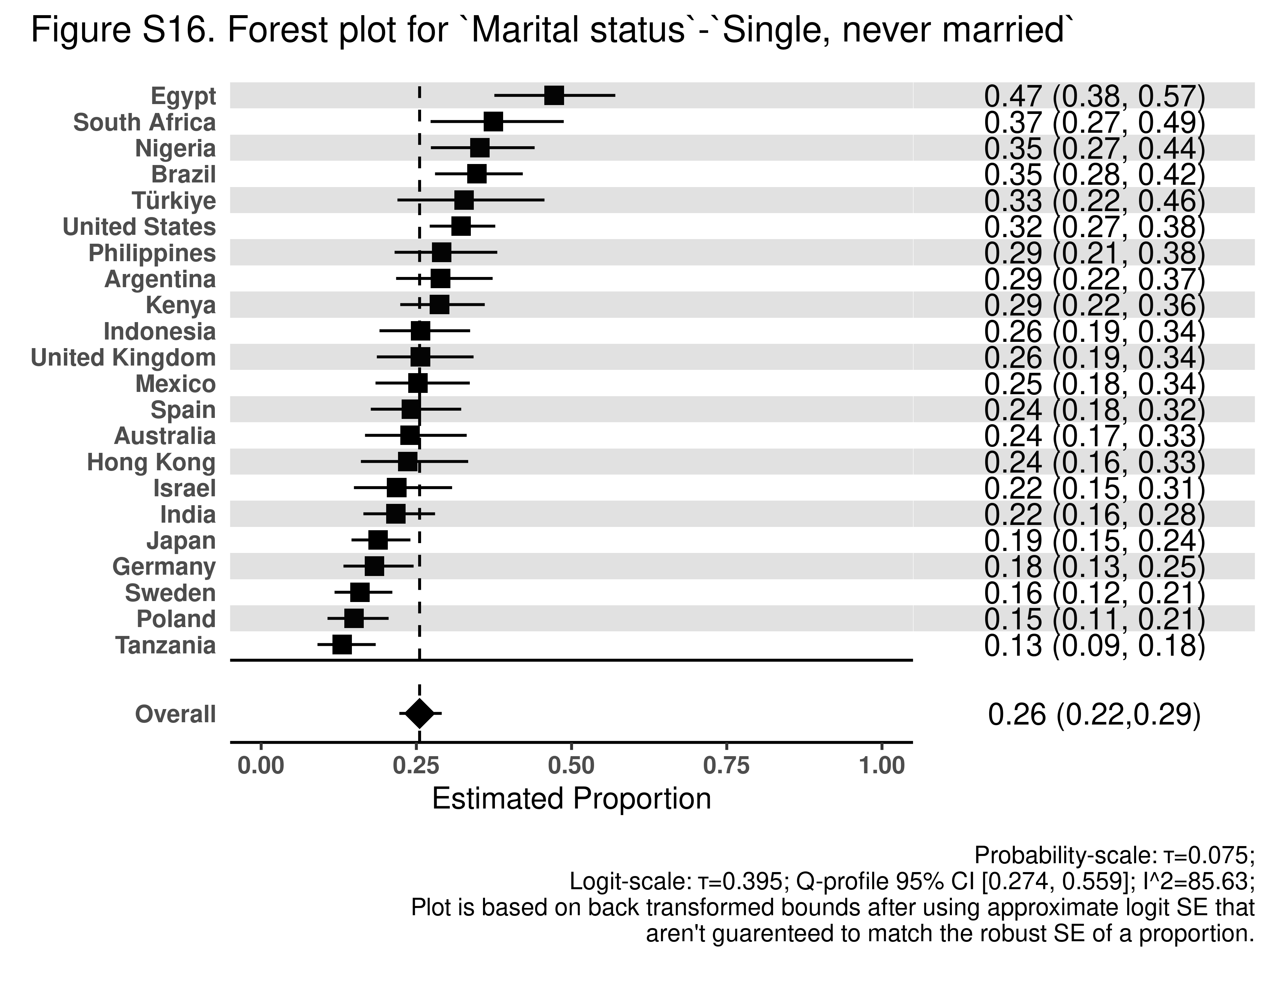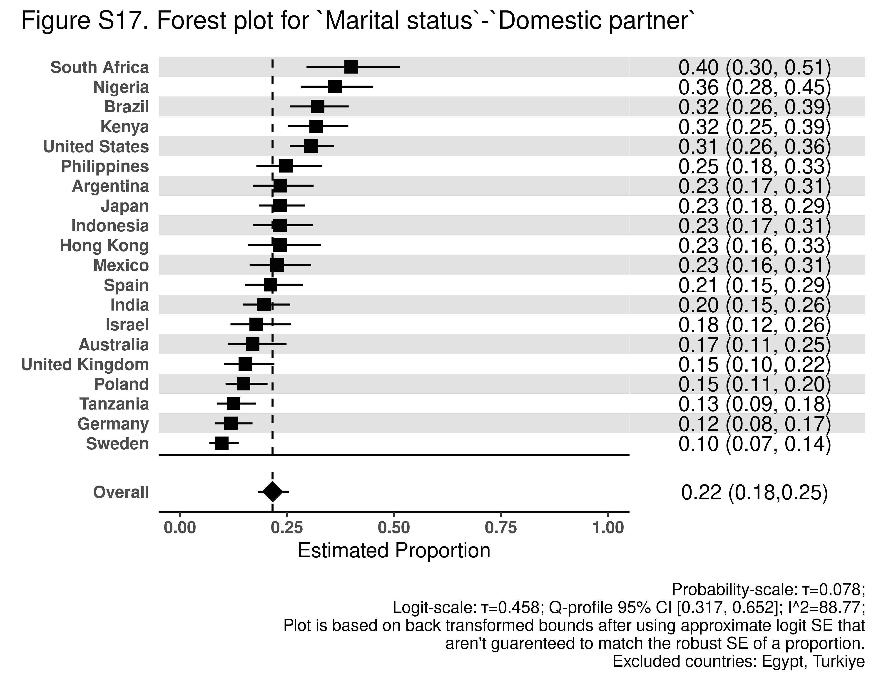

Demographic Variation in Perceived Discrimination by Country

Table S1a. Nationally representative descriptive statistics for Argentina
Characteristic | N = 6,724¹
Age group
18-24 | 1,108 (16%)
25-29 | 719 (11%)
30-39 | 1,432 (21%)
40-49 | 1,254 (19%)
50-59 | 1,014 (15%)
60-69 | 730 (11%)
70-79 | 356 (5.3%)
80 or older | 112 (1.7%)
Missing | 0 (0%)
Gender
Male | 3,143 (47%)
Female | 3,542 (53%)
Other | 21 (0.3%)
Missing | 18 (0.3%)
Marital status
Married | 1,565 (23%)
Separated | 455 (6.8%)
Divorced | 321 (4.8%)
Widowed | 401 (6.0%)
Never | 2,381 (35%)
Domestic Partner | 1,514 (23%)
Missing | 88 (1.3%)
Employment
Employed for an employer | 2,440 (36%)
Self-employed | 1,748 (26%)
Retired | 773 (11%)
Student | 354 (5.3%)
Homemaker | 639 (9.5%)
Unemployed and looking for a job | 569 (8.5%)
None of these/other | 179 (2.7%)
Missing | 22 (0.3%)
Religious service attendance
>1/week | 532 (7.9%)
1/week | 773 (12%)
1-3/month | 461 (6.8%)
A few times a year | 1,949 (29%)
Never | 2,982 (44%)
Missing | 27 (0.4%)
Education
up to 8 years | 2,263 (34%)
9-15 years | 3,823 (57%)
16+years | 635 (9.4%)
Missing | 3 (<0.1%)
Immigration
Born in this country | 6,346 (94%)
Born in another country | 348 (5.2%)
Missing | 29 (0.4%)
Religious affiliation
Christianity | 4,992 (74%)
Islam | 9 (0.1%)
Hinduism | 6 (<0.1%)
Buddhism | 35 (0.5%)
Judaism | 40 (0.6%)
Sikhism | 0 (<0.1%)
Taoism | 2 (<0.1%)
Confucianism | 0 (<0.1%)
Primal, Animist, or Folk religion | 19 (0.3%)
Some other religion | 156 (2.3%)
No religion/Atheist/Agnostic | 1,352 (20%)
Missing | 111 (1.7%)
Race and ethnicity
Asian | 43 (0.6%)
Black | 95 (1.4%)
Indigenous | 129 (1.9%)
Mestizo(a) | 1,801 (27%)
Mullato(a) | 75 (1.1%)
Other | 104 (1.5%)
White | 3,406 (51%)
Missing | 1,070 (16%)
¹n (%)

Table S1b. Means by demographic category for Argentina
Variable | Category | Mean | SE | 95% CI | Global p-value
Age group | 18-24 | 0.31 | 0.02 | (0.27, 0.36) | <0.001
 | 25-29 | 0.27 | 0.02 | (0.23, 0.32)
 | 30-39 | 0.29 | 0.02 | (0.26, 0.32)
 | 40-49 | 0.24 | 0.02 | (0.20, 0.27)
 | 50-59 | 0.16 | 0.02 | (0.13, 0.19)
 | 60-69 | 0.15 | 0.02 | (0.11, 0.19)
 | 70-79 | 0.16 | 0.03 | (0.10, 0.23)
 | 80 or older | 0.22 | 0.07 | (0.08, 0.35)
Gender | Male | 0.25 | 0.01 | (0.22, 0.27) | 0.216
 | Female | 0.23 | 0.01 | (0.21, 0.25)
 | Other | 0.43 | 0.15 | (0.11, 0.74)
Marital status | Married | 0.21 | 0.01 | (0.18, 0.23) | <0.001
 | Separated | 0.25 | 0.03 | (0.19, 0.30)
 | Divorced | 0.15 | 0.02 | (0.10, 0.20)
 | Widowed | 0.17 | 0.03 | (0.11, 0.23)
 | Never | 0.29 | 0.01 | (0.26, 0.32)
 | Domestic Partner | 0.23 | 0.02 | (0.20, 0.26)
Employment | Employed for an employer | 0.23 | 0.01 | (0.21, 0.26) | <0.001
 | Self-employed | 0.23 | 0.01 | (0.20, 0.26)
 | Retired | 0.17 | 0.02 | (0.13, 0.21)
 | Student | 0.25 | 0.03 | (0.20, 0.31)
 | Homemaker | 0.26 | 0.02 | (0.21, 0.31)
 | Unemployed and looking for a job | 0.31 | 0.03 | (0.25, 0.36)
 | None of these/other | 0.38 | 0.05 | (0.28, 0.48)
Religious service attendance | >1/week | 0.34 | 0.03 | (0.28, 0.39) | <0.001
 | 1/week | 0.32 | 0.02 | (0.27, 0.37)
 | 1-3/month | 0.30 | 0.03 | (0.24, 0.37)
 | A few times a year | 0.20 | 0.01 | (0.18, 0.23)
 | Never | 0.22 | 0.01 | (0.20, 0.24)
Education | up to 8 years | 0.27 | 0.02 | (0.23, 0.30) | 0.001
 | 9-15 years | 0.23 | 0.01 | (0.21, 0.24)
 | 16+years | 0.21 | 0.02 | (0.18, 0.25)
Immigration status | Born in this country | 0.24 | 0.01 | (0.22, 0.25) | 0.967
 | Born in another country | 0.25 | 0.04 | (0.18, 0.32)
Religious affiliation | Christianity | 0.24 | 0.01 | (0.22, 0.25) | <0.001
 | Islam | 0.08 | 0.08 | (-0.12, 0.28)
 | Hinduism | 0.83 | 0.14 | (0.44, 1.22)
 | Buddhism | 0.25 | 0.09 | (0.06, 0.44)
 | Judaism | 0.11 | 0.05 | (0.01, 0.21)
 | Taoism | 0.52
 | Primal, Animist, or Folk religion | 0.39 | 0.18 | (0.02, 0.77)
 | Some other religion | 0.28 | 0.06 | (0.17, 0.39)
 | No religion/Atheist/Agnostic | 0.25 | 0.02 | (0.22, 0.28)
Race and ethnicity | Asian | 0.49 | 0.13 | (0.20, 0.77) | <0.001
 | Black | 0.48 | 0.08 | (0.32, 0.64)
 | Indigenous | 0.33 | 0.06 | (0.21, 0.45)
 | Mestizo(a) | 0.26 | 0.01 | (0.24, 0.29)
 | Mullato(a) | 0.27 | 0.08 | (0.11, 0.42)
 | Other | 0.27 | 0.06 | (0.16, 0.37)
 | White | 0.21 | 0.01 | (0.19, 0.23)

Table S2a. Nationally representative descriptive statistics for Australia
Characteristic | N = 3,844¹
Age group
18-24 | 345 (9.0%)
25-29 | 282 (7.3%)
30-39 | 641 (17%)
40-49 | 618 (16%)
50-59 | 691 (18%)
60-69 | 589 (15%)
70-79 | 498 (13%)
80 or older | 178 (4.6%)
Missing | 2 (<0.1%)
Gender
Male | 1,861 (48%)
Female | 1,941 (50%)
Other | 36 (0.9%)
Missing | 6 (0.2%)
Marital status
Married | 1,797 (47%)
Separated | 158 (4.1%)
Divorced | 332 (8.6%)
Widowed | 215 (5.6%)
Never | 855 (22%)
Domestic Partner | 450 (12%)
Missing | 38 (1.0%)
Employment
Employed for an employer | 1,881 (49%)
Self-employed | 380 (9.9%)
Retired | 912 (24%)
Student | 190 (5.0%)
Homemaker | 137 (3.6%)
Unemployed and looking for a job | 134 (3.5%)
None of these/other | 206 (5.4%)
Missing | 4 (0.1%)
Religious service attendance
>1/week | 162 (4.2%)
1/week | 299 (7.8%)
1-3/month | 135 (3.5%)
A few times a year | 656 (17%)
Never | 2,584 (67%)
Missing | 7 (0.2%)
Education
up to 8 years | 70 (1.8%)
9-15 years | 2,434 (63%)
16+years | 1,330 (35%)
Missing | 10 (0.3%)
Immigration
Born in this country | 2,953 (77%)
Born in another country | 885 (23%)
Missing | 6 (0.2%)
Religious affiliation
Christianity | 1,592 (41%)
Islam | 45 (1.2%)
Hinduism | 31 (0.8%)
Buddhism | 36 (0.9%)
Judaism | 26 (0.7%)
Sikhism | 8 (0.2%)
Baha’i | 7 (0.2%)
Taoism | 5 (0.1%)
Primal, Animist, or Folk religion | 23 (0.6%)
Some other religion | 39 (1.0%)
No religion/Atheist/Agnostic | 2,020 (53%)
Missing | 15 (0.4%)
Race and ethnicity
Aboriginal | 53 (1.4%)
Australian | 1,946 (51%)
Australian British/European | 1,047 (27%)
Chinese | 75 (1.9%)
Indian | 58 (1.5%)
Japanese | 1 (<0.1%)
Malay | 11 (0.3%)
New Zealander | 91 (2.4%)
Other | 163 (4.2%)
Other European | 357 (9.3%)
Russian | 7 (0.2%)
Samoan | 4 (0.1%)
Sinhalese | 1 (<0.1%)
Spanish | 2 (<0.1%)
Sri Lankan Moor | 1 (<0.1%)
Sri Lankan Tamil | 7 (0.2%)
Vietnamese | 7 (0.2%)
Missing | 14 (0.4%)
¹n (%)

Table S2b. Means by demographic category for Australia
Variable | Category | Mean | SE | 95% CI | Global p-value
Age group | 18-24 | 0.19 | 0.03 | (0.13, 0.25) | <0.001
 | 25-29 | 0.20 | 0.04 | (0.13, 0.27)
 | 30-39 | 0.22 | 0.02 | (0.17, 0.26)
 | 40-49 | 0.21 | 0.02 | (0.17, 0.25)
 | 50-59 | 0.21 | 0.02 | (0.17, 0.25)
 | 60-69 | 0.14 | 0.02 | (0.11, 0.17)
 | 70-79 | 0.10 | 0.02 | (0.07, 0.13)
 | 80 or older | 0.08 | 0.02 | (0.04, 0.13)
Gender | Male | 0.16 | 0.01 | (0.14, 0.18) | <0.001
 | Female | 0.19 | 0.01 | (0.17, 0.21)
 | Other | 0.51 | 0.12 | (0.26, 0.75)
Marital status | Married | 0.15 | 0.01 | (0.13, 0.17) | <0.001
 | Separated | 0.23 | 0.05 | (0.14, 0.32)
 | Divorced | 0.20 | 0.03 | (0.15, 0.26)
 | Widowed | 0.09 | 0.02 | (0.05, 0.14)
 | Never | 0.24 | 0.02 | (0.20, 0.28)
 | Domestic Partner | 0.17 | 0.02 | (0.12, 0.22)
Employment | Employed for an employer | 0.17 | 0.01 | (0.15, 0.20) | <0.001
 | Self-employed | 0.21 | 0.03 | (0.15, 0.26)
 | Retired | 0.11 | 0.01 | (0.08, 0.13)
 | Student | 0.25 | 0.05 | (0.15, 0.34)
 | Homemaker | 0.22 | 0.05 | (0.12, 0.31)
 | Unemployed and looking for a job | 0.28 | 0.06 | (0.17, 0.39)
 | None of these/other | 0.34 | 0.04 | (0.25, 0.43)
Religious service attendance | >1/week | 0.28 | 0.04 | (0.19, 0.37) | <0.001
 | 1/week | 0.13 | 0.02 | (0.09, 0.18)
 | 1-3/month | 0.26 | 0.05 | (0.16, 0.35)
 | A few times a year | 0.20 | 0.02 | (0.16, 0.24)
 | Never | 0.17 | 0.01 | (0.15, 0.19)
Education | up to 8 years | 0.20 | 0.07 | (0.05, 0.35) | 0.822
 | 9-15 years | 0.18 | 0.01 | (0.16, 0.21)
 | 16+years | 0.17 | 0.01 | (0.15, 0.19)
Immigration status | Born in this country | 0.17 | 0.01 | (0.16, 0.19) | 0.511
 | Born in another country | 0.19 | 0.02 | (0.16, 0.22)
Religious affiliation | Christianity | 0.17 | 0.01 | (0.15, 0.20) | <0.001
 | Islam | 0.46 | 0.10 | (0.26, 0.65)
 | Hinduism | 0.03 | 0.03 | (-0.03, 0.09)
 | Buddhism | 0.31 | 0.09 | (0.14, 0.49)
 | Judaism | 0.29 | 0.10 | (0.07, 0.50)
 | Sikhism | 0.33 | 0.26 | (-0.33, 0.99)
 | Baha’i | 0.14 | 0.14 | (-0.22, 0.51)
 | Taoism | 0.08 | 0.09 | (-0.23, 0.39)
 | Primal, Animist, or Folk religion | 0.55 | 0.15 | (0.24, 0.87)
 | Some other religion | 0.27 | 0.10 | (0.07, 0.47)
 | No religion/Atheist/Agnostic | 0.17 | 0.01 | (0.15, 0.19)
Race and ethnicity | Other | 0.25 | 0.04 | (0.16, 0.33) | <0.001
 | Aboriginal | 0.50 | 0.10 | (0.30, 0.70)
 | Australian | 0.16 | 0.01 | (0.14, 0.18)
 | Australian British/European | 0.17 | 0.02 | (0.14, 0.20)
 | Chinese | 0.26 | 0.07 | (0.12, 0.39)
 | Indian | 0.23 | 0.08 | (0.08, 0.39)
 | Japanese | 0.54
 | Malay | 0.17 | 0.15 | (-0.18, 0.52)
 | New Zealander | 0.24 | 0.06 | (0.12, 0.37)
 | Other European | 0.17 | 0.02 | (0.13, 0.22)
 | Russian | 0.17 | 0.16 | (-0.26, 0.60)
 | Samoan | 0.39 | 0.34 | (-0.85, 1.63)
 | Sinhalese | 0.61
 | Spanish | 0.00
 | Sri Lankan Moor | 0.28
 | Sri Lankan Tamil | 0.42 | 0.24 | (-0.21, 1.04)
 | Vietnamese | 0.00

Table S3a. Nationally representative descriptive statistics for Brazil
Characteristic | N = 13,204¹
Age group
18-24 | 1,986 (15%)
25-29 | 1,468 (11%)
30-39 | 2,908 (22%)
40-49 | 2,638 (20%)
50-59 | 2,131 (16%)
60-69 | 1,435 (11%)
70-79 | 510 (3.9%)
80 or older | 126 (1.0%)
Missing | 0 (0%)
Gender
Male | 6,320 (48%)
Female | 6,820 (52%)
Other | 35 (0.3%)
Missing | 30 (0.2%)
Marital status
Married | 4,646 (35%)
Separated | 594 (4.5%)
Divorced | 865 (6.5%)
Widowed | 408 (3.1%)
Never | 4,347 (33%)
Domestic Partner | 2,081 (16%)
Missing | 263 (2.0%)
Employment
Employed for an employer | 3,756 (28%)
Self-employed | 2,918 (22%)
Retired | 1,536 (12%)
Student | 624 (4.7%)
Homemaker | 1,305 (9.9%)
Unemployed and looking for a job | 2,419 (18%)
None of these/other | 448 (3.4%)
Missing | 199 (1.5%)
Religious service attendance
>1/week | 2,386 (18%)
1/week | 2,272 (17%)
1-3/month | 1,398 (11%)
A few times a year | 3,978 (30%)
Never | 3,110 (24%)
Missing | 61 (0.5%)
Education
up to 8 years | 3,139 (24%)
9-15 years | 7,665 (58%)
16+years | 2,390 (18%)
Missing | 10 (<0.1%)
Immigration
Born in this country | 12,688 (96%)
Born in another country | 153 (1.2%)
Missing | 363 (2.7%)
Religious affiliation
Christianity | 9,911 (75%)
Islam | 6 (<0.1%)
Hinduism | 1 (<0.1%)
Buddhism | 37 (0.3%)
Judaism | 31 (0.2%)
Baha’i | 2 (<0.1%)
Jainism | 2 (<0.1%)
Shinto | 1 (<0.1%)
Taoism | 1 (<0.1%)
Confucianism | 6 (<0.1%)
Primal, Animist, or Folk religion | 15 (0.1%)
Spiritism | 696 (5.3%)
Umbanda, Candomblé, and other African-derived religions | 525 (4.0%)
Some other religion | 144 (1.1%)
No religion/Atheist/Agnostic | 1,712 (13%)
Missing | 113 (0.9%)
Race and ethnicity
Amarela | 238 (1.8%)
Branca | 5,169 (39%)
Indígena | 131 (1.0%)
Other | 61 (0.5%)
Parda | 5,125 (39%)
Preta | 1,615 (12%)
Missing | 865 (6.6%)
¹n (%)

Table S3b. Means by demographic category for Brazil
Variable | Category | Mean | SE | 95% CI | Global p-value
Age group | 18-24 | 0.37 | 0.01 | (0.34, 0.39) | <0.001
 | 25-29 | 0.37 | 0.02 | (0.34, 0.40)
 | 30-39 | 0.33 | 0.01 | (0.31, 0.35)
 | 40-49 | 0.30 | 0.01 | (0.28, 0.33)
 | 50-59 | 0.29 | 0.01 | (0.27, 0.32)
 | 60-69 | 0.21 | 0.02 | (0.18, 0.25)
 | 70-79 | 0.14 | 0.03 | (0.09, 0.20)
 | 80 or older | 0.18 | 0.05 | (0.08, 0.29)
Gender | Male | 0.32 | 0.01 | (0.30, 0.33) | 0.011
 | Female | 0.30 | 0.01 | (0.28, 0.31)
 | Other | 0.39 | 0.10 | (0.20, 0.59)
Marital status | Married | 0.27 | 0.01 | (0.26, 0.29) | <0.001
 | Separated | 0.33 | 0.03 | (0.28, 0.38)
 | Divorced | 0.30 | 0.02 | (0.26, 0.34)
 | Widowed | 0.20 | 0.03 | (0.14, 0.26)
 | Never | 0.35 | 0.01 | (0.33, 0.36)
 | Domestic Partner | 0.32 | 0.01 | (0.30, 0.35)
Employment | Employed for an employer | 0.30 | 0.01 | (0.28, 0.32) | <0.001
 | Self-employed | 0.31 | 0.01 | (0.29, 0.33)
 | Retired | 0.18 | 0.02 | (0.15, 0.22)
 | Student | 0.37 | 0.02 | (0.32, 0.41)
 | Homemaker | 0.31 | 0.02 | (0.27, 0.34)
 | Unemployed and looking for a job | 0.38 | 0.01 | (0.35, 0.40)
 | None of these/other | 0.32 | 0.03 | (0.26, 0.38)
Religious service attendance | >1/week | 0.36 | 0.01 | (0.34, 0.39) | <0.001
 | 1/week | 0.33 | 0.01 | (0.30, 0.36)
 | 1-3/month | 0.35 | 0.02 | (0.32, 0.39)
 | A few times a year | 0.27 | 0.01 | (0.25, 0.29)
 | Never | 0.28 | 0.01 | (0.26, 0.30)
Education | up to 8 years | 0.34 | 0.01 | (0.32, 0.37) | <0.001
 | 9-15 years | 0.31 | 0.01 | (0.30, 0.33)
 | 16+years | 0.24 | 0.01 | (0.22, 0.26)
Immigration status | Born in this country | 0.31 | 0.01 | (0.30, 0.32) | 1.000
 | Born in another country | 0.31 | 0.05 | (0.21, 0.41)
Religious affiliation | Christianity | 0.29 | 0.01 | (0.28, 0.31) | <0.001
 | Islam | 0.51 | 0.17 | (0.05, 0.97)
 | Hinduism | 0.47
 | Buddhism | 0.19 | 0.06 | (0.06, 0.31)
 | Judaism | 0.58 | 0.14 | (0.29, 0.86)
 | Baha’i | 1.00
 | Jainism | 1.00
 | Shinto | 0.66
 | Taoism | 0.68
 | Confucianism | 0.40 | 0.30 | (-0.42, 1.23)
 | Primal, Animist, or Folk religion | 0.45 | 0.16 | (0.12, 0.79)
 | Spiritism | 0.29 | 0.02 | (0.25, 0.33)
 | Umbanda, Candomblé, and other African-derived religions | 0.46 | 0.03 | (0.41, 0.52)
 | Some other religion | 0.28 | 0.05 | (0.18, 0.37)
 | No religion/Atheist/Agnostic | 0.35 | 0.01 | (0.32, 0.38)
Race and ethnicity | Other | 0.37 | 0.09 | (0.20, 0.55) | <0.001
 | Amarela | 0.33 | 0.04 | (0.26, 0.40)
 | Branca | 0.27 | 0.01 | (0.25, 0.28)
 | Indígena | 0.37 | 0.05 | (0.26, 0.47)
 | Parda | 0.31 | 0.01 | (0.30, 0.33)
 | Preta | 0.41 | 0.02 | (0.38, 0.44)

Table S4a. Nationally representative descriptive statistics for Egypt
Characteristic | N = 4,729¹
Age group
18-24 | 960 (20%)
25-29 | 607 (13%)
30-39 | 1,204 (25%)
40-49 | 897 (19%)
50-59 | 613 (13%)
60-69 | 387 (8.2%)
70-79 | 54 (1.1%)
80 or older | 7 (0.2%)
Missing | 0 (0%)
Gender
Male | 2,394 (51%)
Female | 2,334 (49%)
Other | 0 (0%)
Missing | 0 (<0.1%)
Marital status
Married | 3,387 (72%)
Separated | 39 (0.8%)
Divorced | 101 (2.1%)
Widowed | 238 (5.0%)
Never | 947 (20%)
Domestic Partner | 0 (0%)
Missing | 17 (0.4%)
Employment
Employed for an employer | 1,267 (27%)
Self-employed | 892 (19%)
Retired | 253 (5.4%)
Student | 297 (6.3%)
Homemaker | 1,772 (37%)
Unemployed and looking for a job | 224 (4.7%)
None of these/other | 21 (0.4%)
Missing | 3 (<0.1%)
Religious service attendance
>1/week | 839 (18%)
1/week | 960 (20%)
1-3/month | 368 (7.8%)
A few times a year | 458 (9.7%)
Never | 2,091 (44%)
Missing | 12 (0.3%)
Education
up to 8 years | 2,486 (53%)
9-15 years | 1,599 (34%)
16+years | 643 (14%)
Missing | 1 (<0.1%)
Immigration
Born in this country | 4,713 (100%)
Born in another country | 16 (0.3%)
Missing | 1 (<0.1%)
Religious affiliation
Christianity | 120 (2.5%)
Islam | 4,607 (97%)
Taoism | 0 (<0.1%)
Missing | 1 (<0.1%)
Race and ethnicity
Arab | 4,585 (97%)
Bedouin Arab | 4 (<0.1%)
Greek | 1 (<0.1%)
Nubian | 27 (0.6%)
Turkish | 9 (0.2%)
Missing | 102 (2.2%)
¹n (%)

Table S4b. Means by demographic category for Egypt
Variable | Category | Mean | SE | 95% CI | Global p-value
Age group | 18-24 | 0.49 | 0.03 | (0.44, 0.54) | 1.000
 | 25-29 | 0.48 | 0.02 | (0.43, 0.53)
 | 30-39 | 0.47 | 0.02 | (0.44, 0.51)
 | 40-49 | 0.47 | 0.02 | (0.43, 0.50)
 | 50-59 | 0.48 | 0.03 | (0.43, 0.53)
 | 60-69 | 0.46 | 0.04 | (0.38, 0.53)
 | 70-79 | 0.45 | 0.10 | (0.25, 0.65)
 | 80 or older | 0.44 | 0.27 | (-0.25, 1.13)
Gender | Male | 0.46 | 0.01 | (0.43, 0.49) | 0.052
 | Female | 0.49 | 0.01 | (0.46, 0.51)
Marital status | Married | 0.48 | 0.01 | (0.46, 0.50) | 1.000
 | Separated | 0.53 | 0.09 | (0.34, 0.71)
 | Divorced | 0.45 | 0.05 | (0.35, 0.55)
 | Widowed | 0.46 | 0.04 | (0.39, 0.53)
 | Never | 0.47 | 0.02 | (0.43, 0.52)
Employment | Employed for an employer | 0.47 | 0.02 | (0.43, 0.51) | <0.001
 | Self-employed | 0.50 | 0.02 | (0.45, 0.54)
 | Retired | 0.46 | 0.04 | (0.38, 0.54)
 | Student | 0.46 | 0.04 | (0.39, 0.54)
 | Homemaker | 0.48 | 0.01 | (0.46, 0.51)
 | Unemployed and looking for a job | 0.40 | 0.04 | (0.32, 0.48)
 | None of these/other | 0.24 | 0.08 | (0.07, 0.42)
Religious service attendance | >1/week | 0.56 | 0.02 | (0.51, 0.60) | <0.001
 | 1/week | 0.49 | 0.02 | (0.45, 0.54)
 | 1-3/month | 0.52 | 0.03 | (0.45, 0.58)
 | A few times a year | 0.51 | 0.03 | (0.45, 0.56)
 | Never | 0.42 | 0.01 | (0.39, 0.44)
Education | up to 8 years | 0.49 | 0.01 | (0.46, 0.51) | 0.015
 | 9-15 years | 0.47 | 0.01 | (0.45, 0.50)
 | 16+years | 0.43 | 0.03 | (0.38, 0.48)
Immigration status | Born in this country | 0.48 | 0.01 | (0.46, 0.49) | 0.642
 | Born in another country | 0.37 | 0.14 | (0.06, 0.68)
Religious affiliation | Christianity | 0.50 | 0.05 | (0.40, 0.61) | 0.855
 | Islam | 0.47 | 0.01 | (0.45, 0.49)
Race and ethnicity | Arab | 0.47 | 0.01 | (0.45, 0.49) | <0.001
 | Bedouin Arab | 0.12 | 0.00 | (0.12, 0.12)
 | Greek | 0.25
 | Nubian | 0.66 | 0.03 | (0.58, 0.73)
 | Turkish | 0.38 | 0.19 | (-0.06, 0.83)

Table S5a. Nationally representative descriptive statistics for Germany
Characteristic | N = 9,506¹
Age group
18-24 | 829 (8.7%)
25-29 | 774 (8.1%)
30-39 | 1,438 (15%)
40-49 | 1,494 (16%)
50-59 | 1,729 (18%)
60-69 | 1,915 (20%)
70-79 | 1,137 (12%)
80 or older | 190 (2.0%)
Missing | 0 (0%)
Gender
Male | 4,641 (49%)
Female | 4,843 (51%)
Other | 11 (0.1%)
Missing | 11 (0.1%)
Marital status
Married | 4,784 (50%)
Separated | 219 (2.3%)
Divorced | 767 (8.1%)
Widowed | 409 (4.3%)
Never | 2,627 (28%)
Domestic Partner | 619 (6.5%)
Missing | 81 (0.9%)
Employment
Employed for an employer | 4,950 (52%)
Self-employed | 712 (7.5%)
Retired | 2,480 (26%)
Student | 605 (6.4%)
Homemaker | 251 (2.6%)
Unemployed and looking for a job | 288 (3.0%)
None of these/other | 204 (2.1%)
Missing | 14 (0.2%)
Religious service attendance
>1/week | 285 (3.0%)
1/week | 424 (4.5%)
1-3/month | 550 (5.8%)
A few times a year | 2,362 (25%)
Never | 5,876 (62%)
Missing | 9 (<0.1%)
Education
up to 8 years | 235 (2.5%)
9-15 years | 6,094 (64%)
16+years | 3,164 (33%)
Missing | 13 (0.1%)
Immigration
Born in this country | 8,722 (92%)
Born in another country | 744 (7.8%)
Missing | 40 (0.4%)
Religious affiliation
Christianity | 5,052 (53%)
Islam | 351 (3.7%)
Hinduism | 12 (0.1%)
Buddhism | 51 (0.5%)
Judaism | 19 (0.2%)
Sikhism | 5 (<0.1%)
Baha’i | 3 (<0.1%)
Shinto | 2 (<0.1%)
Taoism | 0 (<0.1%)
Confucianism | 4 (<0.1%)
Primal, Animist, or Folk religion | 34 (0.4%)
Some other religion | 60 (0.6%)
No religion/Atheist/Agnostic | 3,815 (40%)
Missing | 99 (1.0%)
Race and ethnicity
Missing | 9,506 (100%)
¹n (%)

Table S5b. Means by demographic category for Germany
Variable | Category | Mean | SE | 95% CI | Global p-value
Age group | 18-24 | 0.19 | 0.02 | (0.15, 0.23) | <0.001
 | 25-29 | 0.17 | 0.02 | (0.14, 0.20)
 | 30-39 | 0.19 | 0.01 | (0.17, 0.22)
 | 40-49 | 0.17 | 0.01 | (0.14, 0.19)
 | 50-59 | 0.13 | 0.01 | (0.11, 0.15)
 | 60-69 | 0.11 | 0.01 | (0.09, 0.13)
 | 70-79 | 0.09 | 0.01 | (0.07, 0.11)
 | 80 or older | 0.12 | 0.03 | (0.06, 0.19)
Gender | Male | 0.16 | 0.01 | (0.14, 0.17) | <0.001
 | Female | 0.14 | 0.01 | (0.12, 0.15)
 | Other | 0.54 | 0.18 | (0.12, 0.96)
Marital status | Married | 0.13 | 0.01 | (0.12, 0.14) | <0.001
 | Separated | 0.22 | 0.04 | (0.15, 0.29)
 | Divorced | 0.11 | 0.01 | (0.09, 0.14)
 | Widowed | 0.14 | 0.02 | (0.09, 0.19)
 | Never | 0.18 | 0.01 | (0.16, 0.20)
 | Domestic Partner | 0.12 | 0.02 | (0.09, 0.15)
Employment | Employed for an employer | 0.15 | 0.01 | (0.14, 0.17) | <0.001
 | Self-employed | 0.16 | 0.02 | (0.13, 0.20)
 | Retired | 0.10 | 0.01 | (0.09, 0.12)
 | Student | 0.20 | 0.02 | (0.16, 0.25)
 | Homemaker | 0.16 | 0.03 | (0.11, 0.22)
 | Unemployed and looking for a job | 0.22 | 0.03 | (0.16, 0.29)
 | None of these/other | 0.13 | 0.03 | (0.08, 0.18)
Religious service attendance | >1/week | 0.23 | 0.03 | (0.17, 0.30) | <0.001
 | 1/week | 0.29 | 0.03 | (0.23, 0.35)
 | 1-3/month | 0.19 | 0.02 | (0.14, 0.23)
 | A few times a year | 0.13 | 0.01 | (0.11, 0.14)
 | Never | 0.14 | 0.01 | (0.12, 0.15)
Education | up to 8 years | 0.19 | 0.03 | (0.13, 0.26) | 0.352
 | 9-15 years | 0.15 | 0.01 | (0.13, 0.16)
 | 16+years | 0.14 | 0.01 | (0.13, 0.16)
Immigration status | Born in this country | 0.14 | 0.00 | (0.13, 0.15) | <0.001
 | Born in another country | 0.19 | 0.02 | (0.15, 0.23)
Religious affiliation | Christianity | 0.13 | 0.01 | (0.12, 0.14) | <0.001
 | Islam | 0.36 | 0.04 | (0.29, 0.44)
 | Hinduism | 0.09 | 0.09 | (-0.11, 0.28)
 | Buddhism | 0.16 | 0.06 | (0.05, 0.27)
 | Judaism | 0.25 | 0.12 | (0.00, 0.49)
 | Sikhism | 0.59 | 0.26 | (-0.24, 1.42)
 | Baha’i | 0.00
 | Confucianism | 0.00
 | Primal, Animist, or Folk religion | 0.36 | 0.12 | (0.12, 0.60)
 | Some other religion | 0.25 | 0.09 | (0.08, 0.43)
 | No religion/Atheist/Agnostic | 0.14 | 0.01 | (0.13, 0.16)

Table S6a. Nationally representative descriptive statistics for Hong Kong
Characteristic | N = 3,012¹
Age group
18-24 | 217 (7.2%)
25-29 | 198 (6.6%)
30-39 | 507 (17%)
40-49 | 580 (19%)
50-59 | 711 (24%)
60-69 | 620 (21%)
70-79 | 164 (5.5%)
80 or older | 15 (0.5%)
Missing | 0 (0%)
Gender
Male | 1,390 (46%)
Female | 1,620 (54%)
Other | 2 (<0.1%)
Missing | 0 (0%)
Marital status
Married | 2,080 (69%)
Separated | 21 (0.7%)
Divorced | 105 (3.5%)
Widowed | 45 (1.5%)
Never | 723 (24%)
Domestic Partner | 37 (1.2%)
Missing | 1 (<0.1%)
Employment
Employed for an employer | 2,056 (68%)
Self-employed | 245 (8.1%)
Retired | 423 (14%)
Student | 55 (1.8%)
Homemaker | 114 (3.8%)
Unemployed and looking for a job | 62 (2.0%)
None of these/other | 39 (1.3%)
Missing | 18 (0.6%)
Religious service attendance
>1/week | 237 (7.9%)
1/week | 567 (19%)
1-3/month | 332 (11%)
A few times a year | 543 (18%)
Never | 1,332 (44%)
Missing | 1 (<0.1%)
Education
up to 8 years | 433 (14%)
9-15 years | 2,031 (67%)
16+years | 547 (18%)
Missing | 0 (0%)
Immigration
Born in this country | 2,637 (88%)
Born in another country | 321 (11%)
Missing | 53 (1.8%)
Religious affiliation
Christianity | 757 (25%)
Islam | 86 (2.8%)
Hinduism | 20 (0.7%)
Buddhism | 349 (12%)
Judaism | 10 (0.3%)
Sikhism | 2 (<0.1%)
Baha’i | 3 (<0.1%)
Jainism | 1 (<0.1%)
Shinto | 19 (0.6%)
Taoism | 97 (3.2%)
Confucianism | 11 (0.4%)
Primal, Animist, or Folk religion | 27 (0.9%)
Chinese folk/traditional religion | 106 (3.5%)
Some other religion | 4 (0.1%)
No religion/Atheist/Agnostic | 1,518 (50%)
Missing | 5 (0.2%)
Race and ethnicity
Chinese (Cantonese) | 1,930 (64%)
Chinese (Chaoshan) | 201 (6.7%)
Chinese (Fujianese) | 117 (3.9%)
Chinese (Hakka) | 121 (4.0%)
Chinese (Other ethnicity) | 264 (8.8%)
Chinese (Shanghainese) | 89 (2.9%)
East Asian (Korean, Japanese) | 10 (0.3%)
Other | 4 (0.1%)
South Asian (Indian, Nepalese, Pakistani) | 17 (0.6%)
Southeast Asian (Filipino, Indonesian, Thailand) | 46 (1.5%)
Taiwanese | 14 (0.4%)
White | 15 (0.5%)
Missing | 184 (6.1%)
¹n (%)

Table S6b. Means by demographic category for Hong Kong
Variable | Category | Mean | SE | 95% CI | Global p-value
Age group | 18-24 | 0.36 | 0.03 | (0.30, 0.42) | <0.001
 | 25-29 | 0.39 | 0.04 | (0.30, 0.47)
 | 30-39 | 0.25 | 0.02 | (0.21, 0.29)
 | 40-49 | 0.33 | 0.02 | (0.28, 0.38)
 | 50-59 | 0.31 | 0.02 | (0.27, 0.35)
 | 60-69 | 0.21 | 0.03 | (0.16, 0.27)
 | 70-79 | 0.10 | 0.05 | (0.00, 0.20)
 | 80 or older | 0.00
Gender | Male | 0.30 | 0.02 | (0.27, 0.33) | <0.001
 | Female | 0.26 | 0.01 | (0.23, 0.29)
 | Other | 1.00
Marital status | Married | 0.31 | 0.01 | (0.28, 0.33) | <0.001
 | Separated | 0.33 | 0.21 | (-0.11, 0.78)
 | Divorced | 0.16 | 0.07 | (0.03, 0.29)
 | Widowed | 0.04 | 0.03 | (-0.01, 0.10)
 | Never | 0.24 | 0.02 | (0.20, 0.27)
 | Domestic Partner | 0.23 | 0.12 | (-0.01, 0.48)
Employment | Employed for an employer | 0.29 | 0.01 | (0.27, 0.32) | <0.001
 | Self-employed | 0.46 | 0.04 | (0.38, 0.54)
 | Retired | 0.12 | 0.03 | (0.06, 0.18)
 | Student | 0.20 | 0.05 | (0.09, 0.30)
 | Homemaker | 0.22 | 0.07 | (0.08, 0.36)
 | Unemployed and looking for a job | 0.30 | 0.09 | (0.13, 0.47)
 | None of these/other | 0.45 | 0.13 | (0.17, 0.72)
Religious service attendance | >1/week | 0.63 | 0.04 | (0.56, 0.71) | <0.001
 | 1/week | 0.41 | 0.03 | (0.35, 0.47)
 | 1-3/month | 0.46 | 0.04 | (0.39, 0.54)
 | A few times a year | 0.24 | 0.03 | (0.18, 0.29)
 | Never | 0.13 | 0.01 | (0.11, 0.15)
Education | up to 8 years | 0.47 | 0.05 | (0.38, 0.56) | <0.001
 | 9-15 years | 0.25 | 0.01 | (0.23, 0.28)
 | 16+years | 0.22 | 0.02 | (0.18, 0.26)
Immigration status | Born in this country | 0.28 | 0.01 | (0.26, 0.30) | 0.829
 | Born in another country | 0.26 | 0.04 | (0.18, 0.34)
Religious affiliation | Christianity | 0.37 | 0.03 | (0.32, 0.42) | <0.001
 | Islam | 0.60 | 0.09 | (0.43, 0.78)
 | Hinduism | 0.57 | 0.18 | (0.20, 0.95)
 | Buddhism | 0.42 | 0.03 | (0.36, 0.48)
 | Judaism | 0.74 | 0.15 | (0.39, 1.09)
 | Sikhism | 0.78
 | Baha’i | 1.00
 | Shinto | 0.27 | 0.15 | (-0.04, 0.59)
 | Taoism | 0.29 | 0.06 | (0.17, 0.41)
 | Confucianism | 0.59 | 0.16 | (0.23, 0.95)
 | Primal, Animist, or Folk religion | 0.16 | 0.06 | (0.04, 0.28)
 | Chinese folk/traditional religion | 0.46 | 0.07 | (0.33, 0.60)
 | Some other religion | 1.00
 | No religion/Atheist/Agnostic | 0.16 | 0.01 | (0.13, 0.18)
Race and ethnicity | Other | 0.35 | 0.25 | (-0.73, 1.44) | <0.001
 | White | 0.68 | 0.16 | (0.35, 1.02)
 | Chinese (Cantonese) | 0.28 | 0.01 | (0.25, 0.30)
 | Chinese (Chaoshan) | 0.23 | 0.03 | (0.18, 0.29)
 | Chinese (Fujianese) | 0.37 | 0.06 | (0.26, 0.48)
 | Chinese (Hakka) | 0.34 | 0.05 | (0.23, 0.44)
 | Chinese (Other ethnicity) | 0.23 | 0.04 | (0.15, 0.30)
 | Chinese (Shanghainese) | 0.22 | 0.07 | (0.09, 0.35)
 | East Asian (Korean, Japanese) | 0.62 | 0.23 | (0.07, 1.16)
 | South Asian (Indian, Nepalese, Pakistani) | 0.49 | 0.22 | (0.01, 0.97)
 | Southeast Asian (Filipino, Indonesian, Thailand) | 0.30 | 0.13 | (0.04, 0.57)
 | Taiwanese | 0.19 | 0.11 | (-0.06, 0.43)

Table S7a. Nationally representative descriptive statistics for India
Characteristic | N = 12,765¹
Age group
18-24 | 2,543 (20%)
25-29 | 1,640 (13%)
30-39 | 3,109 (24%)
40-49 | 2,275 (18%)
50-59 | 1,574 (12%)
60-69 | 1,188 (9.3%)
70-79 | 370 (2.9%)
80 or older | 67 (0.5%)
Missing | 0 (0%)
Gender
Male | 6,473 (51%)
Female | 6,292 (49%)
Other | 0 (0%)
Missing | 0 (0%)
Marital status
Married | 9,848 (77%)
Separated | 45 (0.4%)
Divorced | 25 (0.2%)
Widowed | 445 (3.5%)
Never | 2,065 (16%)
Domestic Partner | 269 (2.1%)
Missing | 69 (0.5%)
Employment
Employed for an employer | 2,660 (21%)
Self-employed | 3,401 (27%)
Retired | 286 (2.2%)
Student | 532 (4.2%)
Homemaker | 4,221 (33%)
Unemployed and looking for a job | 902 (7.1%)
None of these/other | 715 (5.6%)
Missing | 48 (0.4%)
Religious service attendance
>1/week | 2,875 (23%)
1/week | 3,166 (25%)
1-3/month | 2,740 (21%)
A few times a year | 2,090 (16%)
Never | 1,823 (14%)
Missing | 71 (0.6%)
Education
up to 8 years | 11,422 (89%)
9-15 years | 1,194 (9.4%)
16+years | 145 (1.1%)
Missing | 4 (<0.1%)
Immigration
Born in this country | 12,629 (99%)
Born in another country | 110 (0.9%)
Missing | 26 (0.2%)
Religious affiliation
Christianity | 306 (2.4%)
Islam | 1,555 (12%)
Hinduism | 10,362 (81%)
Buddhism | 230 (1.8%)
Sikhism | 127 (1.0%)
Jainism | 10 (<0.1%)
Shinto | 1 (<0.1%)
Primal, Animist, or Folk religion | 30 (0.2%)
Some other religion | 67 (0.5%)
No religion/Atheist/Agnostic | 13 (0.1%)
Missing | 62 (0.5%)
Race and ethnicity
General | 3,538 (28%)
Other backward caste | 4,177 (33%)
Schedule caste | 3,599 (28%)
Schedule tribe | 1,185 (9.3%)
Missing | 267 (2.1%)
¹n (%)

Table S7b. Means by demographic category for India
Variable | Category | Mean | SE | 95% CI | Global p-value
Age group | 18-24 | 0.22 | 0.01 | (0.19, 0.24) | 0.998
 | 25-29 | 0.21 | 0.01 | (0.19, 0.23)
 | 30-39 | 0.22 | 0.01 | (0.20, 0.24)
 | 40-49 | 0.22 | 0.01 | (0.20, 0.24)
 | 50-59 | 0.22 | 0.01 | (0.19, 0.24)
 | 60-69 | 0.21 | 0.01 | (0.18, 0.23)
 | 70-79 | 0.24 | 0.03 | (0.19, 0.30)
 | 80 or older | 0.25 | 0.06 | (0.13, 0.38)
Gender | Male | 0.22 | 0.01 | (0.21, 0.24) | 0.329
 | Female | 0.21 | 0.01 | (0.20, 0.23)
Marital status | Married | 0.22 | 0.01 | (0.21, 0.23) | 0.965
 | Separated | 0.35 | 0.10 | (0.15, 0.55)
 | Divorced | 0.18 | 0.10 | (-0.02, 0.38)
 | Widowed | 0.21 | 0.02 | (0.16, 0.26)
 | Never | 0.22 | 0.01 | (0.19, 0.24)
 | Domestic Partner | 0.20 | 0.03 | (0.13, 0.26)
Employment | Employed for an employer | 0.22 | 0.01 | (0.20, 0.24) | 0.003
 | Self-employed | 0.23 | 0.01 | (0.21, 0.25)
 | Retired | 0.19 | 0.03 | (0.14, 0.25)
 | Student | 0.19 | 0.02 | (0.15, 0.23)
 | Homemaker | 0.21 | 0.01 | (0.20, 0.23)
 | Unemployed and looking for a job | 0.19 | 0.02 | (0.16, 0.22)
 | None of these/other | 0.25 | 0.02 | (0.21, 0.30)
Religious service attendance | >1/week | 0.23 | 0.01 | (0.21, 0.25) | <0.001
 | 1/week | 0.24 | 0.01 | (0.22, 0.26)
 | 1-3/month | 0.20 | 0.01 | (0.18, 0.22)
 | A few times a year | 0.20 | 0.01 | (0.18, 0.22)
 | Never | 0.20 | 0.01 | (0.18, 0.23)
Education | up to 8 years | 0.22 | 0.01 | (0.21, 0.23) | <0.001
 | 9-15 years | 0.19 | 0.01 | (0.17, 0.21)
 | 16+years | 0.19 | 0.03 | (0.12, 0.25)
Immigration status | Born in this country | 0.22 | 0.01 | (0.21, 0.23) | 0.452
 | Born in another country | 0.27 | 0.06 | (0.15, 0.39)
Religious affiliation | Christianity | 0.25 | 0.03 | (0.18, 0.32) | 0.204
 | Islam | 0.21 | 0.02 | (0.18, 0.25)
 | Hinduism | 0.22 | 0.01 | (0.20, 0.23)
 | Buddhism | 0.28 | 0.03 | (0.21, 0.35)
 | Sikhism | 0.18 | 0.05 | (0.09, 0.28)
 | Jainism | 0.19 | 0.11 | (-0.06, 0.44)
 | Primal, Animist, or Folk religion | 0.27 | 0.13 | (0.01, 0.54)
 | Some other religion | 0.36 | 0.07 | (0.21, 0.50)
 | No religion/Atheist/Agnostic | 0.28 | 0.18 | (-0.11, 0.67)
Race and ethnicity | General | 0.22 | 0.01 | (0.20, 0.24) | 0.629
 | Other backward caste | 0.22 | 0.01 | (0.20, 0.23)
 | Schedule caste | 0.21 | 0.01 | (0.19, 0.22)
 | Schedule tribe | 0.23 | 0.02 | (0.20, 0.26)

Table S8a. Nationally representative descriptive statistics for Indonesia
Characteristic | N = 6,992¹
Age group
18-24 | 1,216 (17%)
25-29 | 849 (12%)
30-39 | 1,591 (23%)
40-49 | 1,576 (23%)
50-59 | 1,169 (17%)
60-69 | 490 (7.0%)
70-79 | 83 (1.2%)
80 or older | 17 (0.2%)
Missing | 0 (0%)
Gender
Male | 3,461 (50%)
Female | 3,513 (50%)
Other | 7 (<0.1%)
Missing | 11 (0.2%)
Marital status
Married | 4,846 (69%)
Separated | 81 (1.2%)
Divorced | 196 (2.8%)
Widowed | 425 (6.1%)
Never | 1,381 (20%)
Domestic Partner | 18 (0.3%)
Missing | 45 (0.6%)
Employment
Employed for an employer | 1,323 (19%)
Self-employed | 2,187 (31%)
Retired | 78 (1.1%)
Student | 272 (3.9%)
Homemaker | 2,138 (31%)
Unemployed and looking for a job | 529 (7.6%)
None of these/other | 448 (6.4%)
Missing | 18 (0.3%)
Religious service attendance
>1/week | 2,667 (38%)
1/week | 2,529 (36%)
1-3/month | 786 (11%)
A few times a year | 659 (9.4%)
Never | 332 (4.8%)
Missing | 18 (0.3%)
Education
up to 8 years | 3,079 (44%)
9-15 years | 3,491 (50%)
16+years | 419 (6.0%)
Missing | 2 (<0.1%)
Immigration
Born in this country | 6,958 (100%)
Born in another country | 34 (0.5%)
Missing | 0 (0%)
Religious affiliation
Christianity | 504 (7.2%)
Islam | 6,406 (92%)
Hinduism | 73 (1.0%)
Buddhism | 3 (<0.1%)
Taoism | 1 (<0.1%)
Some other religion | 1 (<0.1%)
Missing | 4 (<0.1%)
Race and ethnicity
Bali | 69 (1.0%)
Banjar/Melayu Banjar | 320 (4.6%)
Batak | 165 (2.4%)
Betawi | 251 (3.6%)
Bugis | 243 (3.5%)
Jawa | 2,846 (41%)
Madura | 262 (3.7%)
Makasar | 91 (1.3%)
Minangkabau | 273 (3.9%)
Other | 1,262 (18%)
Sunda/Parahyangan | 1,172 (17%)
Missing | 38 (0.5%)
¹n (%)

Table S8b. Means by demographic category for Indonesia
Variable | Category | Mean | SE | 95% CI | Global p-value
Age group | 18-24 | 0.26 | 0.02 | (0.23, 0.29) | <0.001
 | 25-29 | 0.23 | 0.02 | (0.20, 0.26)
 | 30-39 | 0.21 | 0.01 | (0.18, 0.24)
 | 40-49 | 0.19 | 0.01 | (0.16, 0.22)
 | 50-59 | 0.19 | 0.02 | (0.16, 0.23)
 | 60-69 | 0.17 | 0.03 | (0.12, 0.22)
 | 70-79 | 0.19 | 0.06 | (0.06, 0.31)
 | 80 or older | 0.18 | 0.16 | (-0.17, 0.53)
Gender | Male | 0.23 | 0.01 | (0.21, 0.25) | <0.001
 | Female | 0.19 | 0.01 | (0.17, 0.21)
 | Other | 0.27 | 0.19 | (-0.22, 0.76)
Marital status | Married | 0.20 | 0.01 | (0.18, 0.21) | <0.001
 | Separated | 0.26 | 0.06 | (0.14, 0.38)
 | Divorced | 0.22 | 0.04 | (0.14, 0.30)
 | Widowed | 0.19 | 0.03 | (0.14, 0.24)
 | Never | 0.26 | 0.01 | (0.23, 0.29)
 | Domestic Partner | 0.23 | 0.13 | (-0.05, 0.51)
Employment | Employed for an employer | 0.23 | 0.02 | (0.20, 0.26) | <0.001
 | Self-employed | 0.20 | 0.01 | (0.18, 0.22)
 | Retired | 0.16 | 0.05 | (0.06, 0.27)
 | Student | 0.23 | 0.03 | (0.18, 0.29)
 | Homemaker | 0.19 | 0.01 | (0.17, 0.21)
 | Unemployed and looking for a job | 0.29 | 0.03 | (0.23, 0.34)
 | None of these/other | 0.20 | 0.03 | (0.14, 0.25)
Religious service attendance | >1/week | 0.22 | 0.01 | (0.20, 0.25) | 0.071
 | 1/week | 0.20 | 0.01 | (0.18, 0.22)
 | 1-3/month | 0.20 | 0.02 | (0.16, 0.23)
 | A few times a year | 0.19 | 0.02 | (0.15, 0.22)
 | Never | 0.23 | 0.03 | (0.17, 0.30)
Education | up to 8 years | 0.20 | 0.01 | (0.18, 0.23) | 0.757
 | 9-15 years | 0.22 | 0.01 | (0.20, 0.23)
 | 16+years | 0.20 | 0.02 | (0.16, 0.23)
Immigration status | Born in this country | 0.21 | 0.01 | (0.19, 0.22) | 0.303
 | Born in another country | 0.31 | 0.10 | (0.11, 0.50)
Religious affiliation | Christianity | 0.34 | 0.03 | (0.28, 0.40) | <0.001
 | Islam | 0.20 | 0.01 | (0.18, 0.21)
 | Hinduism | 0.19 | 0.04 | (0.12, 0.27)
 | Buddhism | 0.00
Race and ethnicity | Other | 0.24 | 0.02 | (0.20, 0.28) | <0.001
 | Bali | 0.19 | 0.04 | (0.12, 0.27)
 | Banjar/Melayu Banjar | 0.19 | 0.03 | (0.14, 0.25)
 | Batak | 0.31 | 0.04 | (0.23, 0.38)
 | Betawi | 0.22 | 0.04 | (0.15, 0.30)
 | Bugis | 0.28 | 0.04 | (0.20, 0.36)
 | Jawa | 0.21 | 0.01 | (0.18, 0.23)
 | Madura | 0.21 | 0.02 | (0.17, 0.25)
 | Makasar | 0.19 | 0.04 | (0.10, 0.28)
 | Minangkabau | 0.23 | 0.03 | (0.16, 0.29)
 | Sunda/Parahyangan | 0.16 | 0.02 | (0.12, 0.20)

Table S9a. Nationally representative descriptive statistics for Israel
Characteristic | N = 3,669¹
Age group
18-24 | 553 (15%)
25-29 | 407 (11%)
30-39 | 666 (18%)
40-49 | 616 (17%)
50-59 | 542 (15%)
60-69 | 469 (13%)
70-79 | 336 (9.2%)
80 or older | 79 (2.2%)
Missing | 0 (0%)
Gender
Male | 1,791 (49%)
Female | 1,872 (51%)
Other | 0 (<0.1%)
Missing | 6 (0.2%)
Marital status
Married | 2,056 (56%)
Separated | 48 (1.3%)
Divorced | 258 (7.0%)
Widowed | 212 (5.8%)
Never | 834 (23%)
Domestic Partner | 193 (5.3%)
Missing | 69 (1.9%)
Employment
Employed for an employer | 1,793 (49%)
Self-employed | 424 (12%)
Retired | 576 (16%)
Student | 388 (11%)
Homemaker | 211 (5.7%)
Unemployed and looking for a job | 148 (4.0%)
None of these/other | 118 (3.2%)
Missing | 10 (0.3%)
Religious service attendance
>1/week | 649 (18%)
1/week | 495 (14%)
1-3/month | 374 (10%)
A few times a year | 1,014 (28%)
Never | 1,122 (31%)
Missing | 14 (0.4%)
Education
up to 8 years | 224 (6.1%)
9-15 years | 1,517 (41%)
16+years | 1,926 (52%)
Missing | 2 (<0.1%)
Immigration
Born in this country | 2,796 (76%)
Born in another country | 868 (24%)
Missing | 5 (0.1%)
Religious affiliation
Christianity | 39 (1.1%)
Islam | 656 (18%)
Judaism | 2,897 (79%)
Baha’i | 2 (<0.1%)
Taoism | 1 (<0.1%)
Primal, Animist, or Folk religion | 1 (<0.1%)
Some other religion | 5 (0.1%)
No religion/Atheist/Agnostic | 64 (1.7%)
Missing | 4 (0.1%)
Race and ethnicity
Arab | 674 (18%)
Jewish | 2,926 (80%)
Other | 39 (1.1%)
Missing | 30 (0.8%)
¹n (%)

Table S9b. Means by demographic category for Israel
Variable | Category | Mean | SE | 95% CI | Global p-value
Age group | 18-24 | 0.21 | 0.02 | (0.17, 0.25) | 0.002
 | 25-29 | 0.23 | 0.03 | (0.17, 0.29)
 | 30-39 | 0.25 | 0.02 | (0.20, 0.29)
 | 40-49 | 0.20 | 0.02 | (0.16, 0.23)
 | 50-59 | 0.19 | 0.02 | (0.15, 0.24)
 | 60-69 | 0.19 | 0.03 | (0.13, 0.24)
 | 70-79 | 0.15 | 0.02 | (0.11, 0.19)
 | 80 or older | 0.17 | 0.05 | (0.06, 0.28)
Gender | Male | 0.21 | 0.01 | (0.18, 0.24) | 1.000
 | Female | 0.20 | 0.02 | (0.17, 0.23)
Marital status | Married | 0.20 | 0.01 | (0.18, 0.23) | 0.780
 | Separated | 0.28 | 0.06 | (0.15, 0.41)
 | Divorced | 0.18 | 0.04 | (0.11, 0.25)
 | Widowed | 0.21 | 0.04 | (0.14, 0.27)
 | Never | 0.22 | 0.02 | (0.18, 0.25)
 | Domestic Partner | 0.18 | 0.04 | (0.10, 0.26)
Employment | Employed for an employer | 0.20 | 0.01 | (0.17, 0.22) | <0.001
 | Self-employed | 0.17 | 0.02 | (0.13, 0.21)
 | Retired | 0.15 | 0.02 | (0.11, 0.19)
 | Student | 0.24 | 0.02 | (0.20, 0.28)
 | Homemaker | 0.34 | 0.06 | (0.23, 0.46)
 | Unemployed and looking for a job | 0.32 | 0.06 | (0.19, 0.45)
 | None of these/other | 0.23 | 0.05 | (0.13, 0.33)
Religious service attendance | >1/week | 0.23 | 0.02 | (0.18, 0.27) | <0.001
 | 1/week | 0.27 | 0.03 | (0.22, 0.33)
 | 1-3/month | 0.26 | 0.03 | (0.20, 0.32)
 | A few times a year | 0.16 | 0.02 | (0.13, 0.19)
 | Never | 0.19 | 0.02 | (0.15, 0.23)
Education | up to 8 years | 0.26 | 0.05 | (0.16, 0.37) | <0.001
 | 9-15 years | 0.25 | 0.02 | (0.21, 0.28)
 | 16+years | 0.16 | 0.01 | (0.14, 0.19)
Immigration status | Born in this country | 0.20 | 0.01 | (0.18, 0.23) | 0.886
 | Born in another country | 0.21 | 0.02 | (0.17, 0.26)
Religious affiliation | Christianity | 0.33 | 0.10 | (0.12, 0.54) | <0.001
 | Islam | 0.35 | 0.04 | (0.28, 0.43)
 | Judaism | 0.17 | 0.01 | (0.15, 0.20)
 | Baha’i | 0.79
 | Some other religion | 0.51 | 0.27 | (-0.34, 1.37)
 | No religion/Atheist/Agnostic | 0.12 | 0.05 | (0.02, 0.22)
Race and ethnicity | Other | 0.25 | 0.08 | (0.09, 0.42) | <0.001
 | Arab | 0.35 | 0.04 | (0.28, 0.43)
 | Jewish | 0.17 | 0.01 | (0.14, 0.20)

Table S10a. Nationally representative descriptive statistics for Japan
Characteristic | N = 20,543¹
Age group
18-24 | 1,589 (7.7%)
25-29 | 806 (3.9%)
30-39 | 2,851 (14%)
40-49 | 3,363 (16%)
50-59 | 3,770 (18%)
60-69 | 4,118 (20%)
70-79 | 3,554 (17%)
80 or older | 493 (2.4%)
Missing | 0 (0%)
Gender
Male | 9,847 (48%)
Female | 10,602 (52%)
Other | 28 (0.1%)
Missing | 66 (0.3%)
Marital status
Married | 11,837 (58%)
Separated | 190 (0.9%)
Divorced | 2,126 (10%)
Widowed | 1,179 (5.7%)
Never | 5,004 (24%)
Domestic Partner | 144 (0.7%)
Missing | 64 (0.3%)
Employment
Employed for an employer | 10,853 (53%)
Self-employed | 1,748 (8.5%)
Retired | 2,535 (12%)
Student | 491 (2.4%)
Homemaker | 1,276 (6.2%)
Unemployed and looking for a job | 622 (3.0%)
None of these/other | 2,983 (15%)
Missing | 36 (0.2%)
Religious service attendance
>1/week | 316 (1.5%)
1/week | 348 (1.7%)
1-3/month | 862 (4.2%)
A few times a year | 3,112 (15%)
Never | 15,788 (77%)
Missing | 117 (0.6%)
Education
up to 8 years | 567 (2.8%)
9-15 years | 14,893 (72%)
16+years | 5,083 (25%)
Missing | 0 (0%)
Immigration
Born in this country | 19,548 (95%)
Born in another country | 158 (0.8%)
Missing | 837 (4.1%)
Religious affiliation
Christianity | 381 (1.9%)
Islam | 10 (<0.1%)
Hinduism | 5 (<0.1%)
Buddhism | 6,709 (33%)
Judaism | 10 (<0.1%)
Sikhism | 6 (<0.1%)
Baha’i | 2 (<0.1%)
Jainism | 11 (<0.1%)
Shinto | 469 (2.3%)
Taoism | 7 (<0.1%)
Confucianism | 17 (<0.1%)
Primal, Animist, or Folk religion | 19 (<0.1%)
Some other religion | 46 (0.2%)
No religion/Atheist/Agnostic | 12,497 (61%)
Missing | 355 (1.7%)
Race and ethnicity
Missing | 20,543 (100%)
¹n (%)

Table S10b. Means by demographic category for Japan
Variable | Category | Mean | SE | 95% CI | Global p-value
Age group | 18-24 | 0.21 | 0.01 | (0.18, 0.23) | <0.001
 | 25-29 | 0.22 | 0.02 | (0.19, 0.25)
 | 30-39 | 0.21 | 0.01 | (0.19, 0.23)
 | 40-49 | 0.20 | 0.01 | (0.19, 0.22)
 | 50-59 | 0.18 | 0.01 | (0.16, 0.19)
 | 60-69 | 0.13 | 0.01 | (0.12, 0.14)
 | 70-79 | 0.09 | 0.01 | (0.08, 0.10)
 | 80 or older | 0.10 | 0.02 | (0.07, 0.13)
Gender | Male | 0.17 | 0.00 | (0.16, 0.18) | <0.001
 | Female | 0.15 | 0.00 | (0.15, 0.16)
 | Other | 0.46 | 0.10 | (0.26, 0.66)
Marital status | Married | 0.16 | 0.00 | (0.15, 0.17) | <0.001
 | Separated | 0.30 | 0.04 | (0.22, 0.39)
 | Divorced | 0.14 | 0.01 | (0.12, 0.16)
 | Widowed | 0.11 | 0.01 | (0.09, 0.14)
 | Never | 0.19 | 0.01 | (0.18, 0.20)
 | Domestic Partner | 0.23 | 0.05 | (0.14, 0.32)
Employment | Employed for an employer | 0.19 | 0.00 | (0.18, 0.20) | <0.001
 | Self-employed | 0.16 | 0.01 | (0.14, 0.18)
 | Retired | 0.10 | 0.01 | (0.09, 0.11)
 | Student | 0.18 | 0.02 | (0.14, 0.21)
 | Homemaker | 0.13 | 0.01 | (0.11, 0.14)
 | Unemployed and looking for a job | 0.19 | 0.01 | (0.16, 0.21)
 | None of these/other | 0.12 | 0.01 | (0.11, 0.14)
Religious service attendance | >1/week | 0.26 | 0.03 | (0.20, 0.31) | <0.001
 | 1/week | 0.46 | 0.03 | (0.39, 0.52)
 | 1-3/month | 0.37 | 0.02 | (0.33, 0.41)
 | A few times a year | 0.18 | 0.01 | (0.17, 0.20)
 | Never | 0.14 | 0.00 | (0.13, 0.15)
Education | up to 8 years | 0.22 | 0.02 | (0.18, 0.26) | <0.001
 | 9-15 years | 0.16 | 0.00 | (0.15, 0.16)
 | 16+years | 0.18 | 0.01 | (0.16, 0.19)
Immigration status | Born in this country | 0.16 | 0.00 | (0.16, 0.17) | <0.001
 | Born in another country | 0.28 | 0.05 | (0.19, 0.37)
Religious affiliation | Christianity | 0.28 | 0.03 | (0.22, 0.33) | <0.001
 | Islam | 0.60 | 0.18 | (0.18, 1.03)
 | Hinduism | 0.78 | 0.20 | (0.07, 1.49)
 | Buddhism | 0.16 | 0.01 | (0.15, 0.17)
 | Judaism | 0.85 | 0.12 | (0.56, 1.14)
 | Sikhism | 0.62 | 0.20 | (0.04, 1.19)
 | Baha’i | 0.84
 | Jainism | 0.51 | 0.24 | (-0.03, 1.05)
 | Shinto | 0.21 | 0.02 | (0.17, 0.26)
 | Taoism | 0.48 | 0.19 | (0.00, 0.95)
 | Confucianism | 0.21 | 0.11 | (-0.03, 0.45)
 | Primal, Animist, or Folk religion | 0.41 | 0.15 | (0.09, 0.72)
 | Some other religion | 0.15 | 0.07 | (0.02, 0.29)
 | No religion/Atheist/Agnostic | 0.16 | 0.00 | (0.15, 0.16)

Table S11a. Nationally representative descriptive statistics for Kenya
Characteristic | N = 11,389¹
Age group
18-24 | 2,868 (25%)
25-29 | 2,035 (18%)
30-39 | 2,564 (23%)
40-49 | 1,708 (15%)
50-59 | 1,072 (9.4%)
60-69 | 710 (6.2%)
70-79 | 360 (3.2%)
80 or older | 67 (0.6%)
Missing | 5 (<0.1%)
Gender
Male | 5,567 (49%)
Female | 5,813 (51%)
Other | 2 (<0.1%)
Missing | 7 (<0.1%)
Marital status
Married | 6,626 (58%)
Separated | 467 (4.1%)
Divorced | 111 (1.0%)
Widowed | 464 (4.1%)
Never | 3,531 (31%)
Domestic Partner | 146 (1.3%)
Missing | 43 (0.4%)
Employment
Employed for an employer | 1,467 (13%)
Self-employed | 3,630 (32%)
Retired | 319 (2.8%)
Student | 1,136 (10.0%)
Homemaker | 1,537 (13%)
Unemployed and looking for a job | 3,153 (28%)
None of these/other | 138 (1.2%)
Missing | 9 (<0.1%)
Religious service attendance
>1/week | 2,774 (24%)
1/week | 6,063 (53%)
1-3/month | 1,219 (11%)
A few times a year | 855 (7.5%)
Never | 465 (4.1%)
Missing | 13 (0.1%)
Education
up to 8 years | 4,485 (39%)
9-15 years | 6,115 (54%)
16+years | 783 (6.9%)
Missing | 6 (<0.1%)
Immigration
Born in this country | 11,270 (99%)
Born in another country | 117 (1.0%)
Missing | 2 (<0.1%)
Religious affiliation
Christianity | 10,334 (91%)
Islam | 918 (8.1%)
Buddhism | 1 (<0.1%)
Judaism | 3 (<0.1%)
Baha’i | 1 (<0.1%)
Jainism | 1 (<0.1%)
Confucianism | 3 (<0.1%)
Primal, Animist, or Folk religion | 7 (<0.1%)
Some other religion | 5 (<0.1%)
No religion/Atheist/Agnostic | 108 (0.9%)
Missing | 9 (<0.1%)
Race and ethnicity
Embu | 197 (1.7%)
Kalenjin | 1,377 (12%)
Kamba | 1,299 (11%)
Kenyan Somali/Somali | 396 (3.5%)
Kikuyu | 2,119 (19%)
Kisii | 789 (6.9%)
Luhya | 1,943 (17%)
Luo | 1,120 (9.8%)
Maasai | 237 (2.1%)
Meru | 630 (5.5%)
Miji Kenda tribes | 708 (6.2%)
Other | 548 (4.8%)
Missing | 27 (0.2%)
¹n (%)

Table S11b. Means by demographic category for Kenya
Variable | Category | Mean | SE | 95% CI | Global p-value
Age group | 18-24 | 0.28 | 0.01 | (0.26, 0.30) | <0.001
 | 25-29 | 0.32 | 0.01 | (0.29, 0.34)
 | 30-39 | 0.32 | 0.01 | (0.29, 0.34)
 | 40-49 | 0.29 | 0.02 | (0.26, 0.32)
 | 50-59 | 0.29 | 0.02 | (0.25, 0.33)
 | 60-69 | 0.24 | 0.03 | (0.19, 0.30)
 | 70-79 | 0.25 | 0.04 | (0.18, 0.33)
 | 80 or older | 0.41 | 0.10 | (0.21, 0.61)
Gender | Male | 0.31 | 0.01 | (0.29, 0.33) | <0.001
 | Female | 0.28 | 0.01 | (0.26, 0.30)
 | Other | 0.80
Marital status | Married | 0.29 | 0.01 | (0.28, 0.31) | 0.705
 | Separated | 0.34 | 0.03 | (0.28, 0.39)
 | Divorced | 0.33 | 0.05 | (0.22, 0.43)
 | Widowed | 0.33 | 0.03 | (0.27, 0.39)
 | Never | 0.29 | 0.01 | (0.27, 0.30)
 | Domestic Partner | 0.32 | 0.05 | (0.23, 0.41)
Employment | Employed for an employer | 0.32 | 0.01 | (0.29, 0.34) | <0.001
 | Self-employed | 0.29 | 0.01 | (0.27, 0.31)
 | Retired | 0.30 | 0.04 | (0.22, 0.39)
 | Student | 0.26 | 0.01 | (0.23, 0.29)
 | Homemaker | 0.28 | 0.02 | (0.25, 0.32)
 | Unemployed and looking for a job | 0.31 | 0.01 | (0.28, 0.33)
 | None of these/other | 0.42 | 0.05 | (0.31, 0.53)
Religious service attendance | >1/week | 0.29 | 0.01 | (0.26, 0.31) | 0.030
 | 1/week | 0.29 | 0.01 | (0.27, 0.31)
 | 1-3/month | 0.32 | 0.02 | (0.28, 0.35)
 | A few times a year | 0.32 | 0.02 | (0.29, 0.36)
 | Never | 0.33 | 0.03 | (0.28, 0.38)
Education | up to 8 years | 0.32 | 0.01 | (0.30, 0.34) | <0.001
 | 9-15 years | 0.28 | 0.01 | (0.26, 0.29)
 | 16+years | 0.31 | 0.02 | (0.27, 0.36)
Immigration status | Born in this country | 0.30 | 0.01 | (0.28, 0.31) | 0.339
 | Born in another country | 0.25 | 0.04 | (0.16, 0.34)
Religious affiliation | Christianity | 0.29 | 0.01 | (0.28, 0.31) | 0.329
 | Islam | 0.32 | 0.02 | (0.28, 0.36)
 | Judaism | 0.17
 | Primal, Animist, or Folk religion | 0.59 | 0.24 | (-0.05, 1.22)
 | Some other religion | 0.63 | 0.23 | (-0.10, 1.35)
 | No religion/Atheist/Agnostic | 0.33 | 0.05 | (0.23, 0.43)
Race and ethnicity | Other | 0.34 | 0.03 | (0.29, 0.39) | <0.001
 | Embu | 0.20 | 0.04 | (0.11, 0.28)
 | Kalenjin | 0.28 | 0.02 | (0.24, 0.32)
 | Kamba | 0.29 | 0.02 | (0.25, 0.32)
 | Kenyan Somali/Somali | 0.37 | 0.03 | (0.31, 0.44)
 | Kikuyu | 0.25 | 0.01 | (0.23, 0.28)
 | Kisii | 0.30 | 0.03 | (0.25, 0.35)
 | Luhya | 0.35 | 0.02 | (0.32, 0.39)
 | Luo | 0.33 | 0.02 | (0.28, 0.38)
 | Maasai | 0.20 | 0.02 | (0.16, 0.24)
 | Meru | 0.27 | 0.02 | (0.22, 0.31)
 | Miji Kenda tribes | 0.26 | 0.02 | (0.23, 0.29)

Table S12a. Nationally representative descriptive statistics for Mexico
Characteristic | N = 5,776¹
Age group
18-24 | 986 (17%)
25-29 | 623 (11%)
30-39 | 1,312 (23%)
40-49 | 1,027 (18%)
50-59 | 873 (15%)
60-69 | 611 (11%)
70-79 | 277 (4.8%)
80 or older | 68 (1.2%)
Missing | 0 (0%)
Gender
Male | 2,755 (48%)
Female | 2,997 (52%)
Other | 3 (<0.1%)
Missing | 21 (0.4%)
Marital status
Married | 2,089 (36%)
Separated | 403 (7.0%)
Divorced | 230 (4.0%)
Widowed | 347 (6.0%)
Never | 1,432 (25%)
Domestic Partner | 1,109 (19%)
Missing | 166 (2.9%)
Employment
Employed for an employer | 1,921 (33%)
Self-employed | 1,091 (19%)
Retired | 386 (6.7%)
Student | 247 (4.3%)
Homemaker | 1,257 (22%)
Unemployed and looking for a job | 564 (9.8%)
None of these/other | 169 (2.9%)
Missing | 141 (2.4%)
Religious service attendance
>1/week | 609 (11%)
1/week | 1,261 (22%)
1-3/month | 676 (12%)
A few times a year | 2,054 (36%)
Never | 1,134 (20%)
Missing | 43 (0.7%)
Education
up to 8 years | 1,291 (22%)
9-15 years | 3,180 (55%)
16+years | 1,304 (23%)
Missing | 1 (<0.1%)
Immigration
Born in this country | 5,517 (96%)
Born in another country | 108 (1.9%)
Missing | 151 (2.6%)
Religious affiliation
Christianity | 4,844 (84%)
Islam | 2 (<0.1%)
Hinduism | 3 (<0.1%)
Buddhism | 6 (0.1%)
Judaism | 7 (0.1%)
Baha’i | 1 (<0.1%)
Jainism | 1 (<0.1%)
Shinto | 2 (<0.1%)
Taoism | 4 (<0.1%)
Confucianism | 1 (<0.1%)
Primal, Animist, or Folk religion | 20 (0.3%)
Some other religion | 41 (0.7%)
No religion/Atheist/Agnostic | 770 (13%)
Missing | 75 (1.3%)
Race and ethnicity
Black | 108 (1.9%)
Indigenous | 594 (10%)
Mestizo | 2,762 (48%)
Mulatto | 63 (1.1%)
Other | 339 (5.9%)
White | 1,116 (19%)
Missing | 794 (14%)
¹n (%)

Table S12b. Means by demographic category for Mexico
Variable | Category | Mean | SE | 95% CI | Global p-value
Age group | 18-24 | 0.28 | 0.02 | (0.24, 0.31) | <0.001
 | 25-29 | 0.28 | 0.02 | (0.24, 0.31)
 | 30-39 | 0.24 | 0.01 | (0.21, 0.27)
 | 40-49 | 0.21 | 0.02 | (0.17, 0.24)
 | 50-59 | 0.20 | 0.02 | (0.16, 0.23)
 | 60-69 | 0.21 | 0.03 | (0.16, 0.26)
 | 70-79 | 0.12 | 0.03 | (0.07, 0.18)
 | 80 or older | 0.31 | 0.09 | (0.12, 0.49)
Gender | Male | 0.25 | 0.01 | (0.22, 0.27) | <0.001
 | Female | 0.21 | 0.01 | (0.20, 0.23)
 | Other | 0.48 | 0.18 | (-0.61, 1.57)
Marital status | Married | 0.21 | 0.01 | (0.19, 0.24) | 0.037
 | Separated | 0.25 | 0.03 | (0.19, 0.31)
 | Divorced | 0.27 | 0.04 | (0.20, 0.35)
 | Widowed | 0.19 | 0.03 | (0.14, 0.25)
 | Never | 0.25 | 0.01 | (0.22, 0.28)
 | Domestic Partner | 0.23 | 0.02 | (0.20, 0.26)
Employment | Employed for an employer | 0.24 | 0.01 | (0.22, 0.27) | 0.110
 | Self-employed | 0.23 | 0.02 | (0.20, 0.26)
 | Retired | 0.18 | 0.03 | (0.12, 0.24)
 | Student | 0.24 | 0.04 | (0.16, 0.31)
 | Homemaker | 0.21 | 0.01 | (0.18, 0.23)
 | Unemployed and looking for a job | 0.25 | 0.02 | (0.21, 0.30)
 | None of these/other | 0.26 | 0.05 | (0.17, 0.36)
Religious service attendance | >1/week | 0.32 | 0.02 | (0.28, 0.37) | <0.001
 | 1/week | 0.28 | 0.02 | (0.25, 0.31)
 | 1-3/month | 0.24 | 0.02 | (0.19, 0.28)
 | A few times a year | 0.19 | 0.01 | (0.17, 0.21)
 | Never | 0.19 | 0.02 | (0.16, 0.22)
Education | up to 8 years | 0.26 | 0.02 | (0.23, 0.29) | <0.001
 | 9-15 years | 0.23 | 0.01 | (0.21, 0.25)
 | 16+years | 0.20 | 0.01 | (0.18, 0.23)
Immigration status | Born in this country | 0.23 | 0.01 | (0.21, 0.24) | 0.009
 | Born in another country | 0.31 | 0.05 | (0.21, 0.42)
Religious affiliation | Christianity | 0.23 | 0.01 | (0.21, 0.24) | <0.001
 | Islam | 0.00
 | Hinduism | 0.81 | 0.18 | (-0.74, 2.36)
 | Buddhism | 0.64 | 0.24 | (-0.04, 1.32)
 | Judaism | 0.40 | 0.21 | (-0.17, 0.97)
 | Shinto | 0.00
 | Taoism | 0.94 | 0.08 | (0.63, 1.24)
 | Primal, Animist, or Folk religion | 0.16 | 0.08 | (-0.01, 0.33)
 | Some other religion | 0.27 | 0.09 | (0.08, 0.46)
 | No religion/Atheist/Agnostic | 0.23 | 0.02 | (0.19, 0.27)
Race and ethnicity | Black | 0.27 | 0.06 | (0.14, 0.39) | 0.232
 | Indigenous | 0.25 | 0.02 | (0.20, 0.29)
 | Other | 0.23 | 0.03 | (0.17, 0.28)
 | White | 0.25 | 0.02 | (0.22, 0.28)
 | Mestizo | 0.22 | 0.01 | (0.20, 0.23)
 | Mulatto | 0.27 | 0.07 | (0.12, 0.42)

Table S13a. Nationally representative descriptive statistics for Nigeria
Characteristic | N = 6,827¹
Age group
18-24 | 1,533 (22%)
25-29 | 1,193 (17%)
30-39 | 1,943 (28%)
40-49 | 1,059 (16%)
50-59 | 619 (9.1%)
60-69 | 296 (4.3%)
70-79 | 133 (2.0%)
80 or older | 50 (0.7%)
Missing | 0 (0%)
Gender
Male | 3,371 (49%)
Female | 3,456 (51%)
Other | 0 (<0.1%)
Missing | 0 (0%)
Marital status
Married | 4,065 (60%)
Separated | 117 (1.7%)
Divorced | 71 (1.0%)
Widowed | 231 (3.4%)
Never | 2,289 (34%)
Domestic Partner | 12 (0.2%)
Missing | 42 (0.6%)
Employment
Employed for an employer | 699 (10%)
Self-employed | 3,898 (57%)
Retired | 178 (2.6%)
Student | 650 (9.5%)
Homemaker | 499 (7.3%)
Unemployed and looking for a job | 684 (10%)
None of these/other | 211 (3.1%)
Missing | 8 (0.1%)
Religious service attendance
>1/week | 4,049 (59%)
1/week | 1,895 (28%)
1-3/month | 531 (7.8%)
A few times a year | 254 (3.7%)
Never | 77 (1.1%)
Missing | 20 (0.3%)
Education
up to 8 years | 2,575 (38%)
9-15 years | 4,120 (60%)
16+years | 130 (1.9%)
Missing | 2 (<0.1%)
Immigration
Born in this country | 6,779 (99%)
Born in another country | 47 (0.7%)
Missing | 1 (<0.1%)
Religious affiliation
Christianity | 3,476 (51%)
Islam | 3,302 (48%)
Shinto | 1 (<0.1%)
Confucianism | 0 (<0.1%)
Primal, Animist, or Folk religion | 24 (0.3%)
Some other religion | 1 (<0.1%)
No religion/Atheist/Agnostic | 15 (0.2%)
Missing | 9 (0.1%)
Race and ethnicity
Edo | 116 (1.7%)
Efik | 48 (0.7%)
Fulani | 266 (3.9%)
Hausa | 2,342 (34%)
Ibibio | 180 (2.6%)
Idoma | 61 (0.9%)
Igala | 77 (1.1%)
Igbo (Ibo) | 1,111 (16%)
Ijaw | 110 (1.6%)
Kanuri | 31 (0.5%)
Other | 1,014 (15%)
Tiv | 198 (2.9%)
Urhobo | 38 (0.6%)
Yoruba | 1,230 (18%)
Missing | 4 (<0.1%)
¹n (%)

Table S13b. Means by demographic category for Nigeria
Variable | Category | Mean | SE | 95% CI | Global p-value
Age group | 18-24 | 0.35 | 0.02 | (0.31, 0.39) | <0.001
 | 25-29 | 0.33 | 0.02 | (0.30, 0.36)
 | 30-39 | 0.34 | 0.01 | (0.31, 0.37)
 | 40-49 | 0.36 | 0.02 | (0.32, 0.41)
 | 50-59 | 0.32 | 0.04 | (0.25, 0.39)
 | 60-69 | 0.29 | 0.05 | (0.20, 0.38)
 | 70-79 | 0.16 | 0.06 | (0.04, 0.29)
 | 80 or older | 0.17 | 0.12 | (-0.07, 0.40)
Gender | Male | 0.36 | 0.01 | (0.33, 0.38) | <0.001
 | Female | 0.31 | 0.01 | (0.29, 0.34)
Marital status | Married | 0.33 | 0.01 | (0.30, 0.35) | 0.905
 | Separated | 0.39 | 0.06 | (0.27, 0.50)
 | Divorced | 0.32 | 0.08 | (0.16, 0.49)
 | Widowed | 0.28 | 0.06 | (0.16, 0.40)
 | Never | 0.35 | 0.01 | (0.32, 0.38)
 | Domestic Partner | 0.36 | 0.20 | (-0.08, 0.80)
Employment | Employed for an employer | 0.42 | 0.02 | (0.38, 0.47) | <0.001
 | Self-employed | 0.33 | 0.01 | (0.30, 0.35)
 | Retired | 0.23 | 0.06 | (0.12, 0.35)
 | Student | 0.35 | 0.03 | (0.30, 0.40)
 | Homemaker | 0.25 | 0.03 | (0.20, 0.30)
 | Unemployed and looking for a job | 0.37 | 0.02 | (0.32, 0.42)
 | None of these/other | 0.29 | 0.06 | (0.17, 0.42)
Religious service attendance | >1/week | 0.31 | 0.01 | (0.29, 0.34) | <0.001
 | 1/week | 0.36 | 0.02 | (0.33, 0.39)
 | 1-3/month | 0.43 | 0.03 | (0.37, 0.50)
 | A few times a year | 0.27 | 0.04 | (0.20, 0.35)
 | Never | 0.42 | 0.08 | (0.25, 0.58)
Education | up to 8 years | 0.31 | 0.02 | (0.27, 0.35) | 0.022
 | 9-15 years | 0.35 | 0.01 | (0.33, 0.37)
 | 16+years | 0.34 | 0.03 | (0.28, 0.40)
Immigration status | Born in this country | 0.34 | 0.01 | (0.31, 0.36) | 0.999
 | Born in another country | 0.35 | 0.10 | (0.15, 0.56)
Religious affiliation | Christianity | 0.37 | 0.01 | (0.34, 0.39) | <0.001
 | Islam | 0.30 | 0.02 | (0.27, 0.33)
 | Primal, Animist, or Folk religion | 0.75 | 0.13 | (0.48, 1.03)
 | No religion/Atheist/Agnostic | 0.47 | 0.17 | (0.09, 0.85)
Race and ethnicity | Other | 0.33 | 0.02 | (0.29, 0.38) | <0.001
 | Edo | 0.36 | 0.05 | (0.26, 0.46)
 | Efik | 0.23 | 0.06 | (0.12, 0.34)
 | Fulani | 0.37 | 0.05 | (0.28, 0.46)
 | Hausa | 0.28 | 0.02 | (0.25, 0.32)
 | Ibibio | 0.43 | 0.09 | (0.24, 0.61)
 | Idoma | 0.34 | 0.07 | (0.19, 0.48)
 | Igala | 0.43 | 0.05 | (0.32, 0.53)
 | Igbo (Ibo) | 0.40 | 0.03 | (0.35, 0.45)
 | Ijaw | 0.33 | 0.06 | (0.20, 0.45)
 | Kanuri | 0.45 | 0.13 | (0.18, 0.72)
 | Tiv | 0.32 | 0.04 | (0.23, 0.40)
 | Urhobo | 0.37 | 0.06 | (0.24, 0.49)
 | Yoruba | 0.36 | 0.02 | (0.32, 0.40)

Table S14a. Nationally representative descriptive statistics for Philippines
Characteristic | N = 5,292¹
Age group
18-24 | 1,073 (20%)
25-29 | 695 (13%)
30-39 | 1,160 (22%)
40-49 | 972 (18%)
50-59 | 732 (14%)
60-69 | 495 (9.4%)
70-79 | 143 (2.7%)
80 or older | 23 (0.4%)
Missing | 0 (0%)
Gender
Male | 2,625 (50%)
Female | 2,643 (50%)
Other | 13 (0.2%)
Missing | 11 (0.2%)
Marital status
Married | 2,385 (45%)
Separated | 249 (4.7%)
Divorced | 9 (0.2%)
Widowed | 274 (5.2%)
Never | 1,206 (23%)
Domestic Partner | 1,152 (22%)
Missing | 16 (0.3%)
Employment
Employed for an employer | 1,350 (26%)
Self-employed | 1,379 (26%)
Retired | 158 (3.0%)
Student | 585 (11%)
Homemaker | 1,049 (20%)
Unemployed and looking for a job | 658 (12%)
None of these/other | 113 (2.1%)
Missing | 0 (0%)
Religious service attendance
>1/week | 844 (16%)
1/week | 1,929 (36%)
1-3/month | 1,374 (26%)
A few times a year | 929 (18%)
Never | 210 (4.0%)
Missing | 6 (0.1%)
Education
up to 8 years | 1,188 (22%)
9-15 years | 3,722 (70%)
16+years | 381 (7.2%)
Missing | 1 (<0.1%)
Immigration
Born in this country | 5,284 (100%)
Born in another country | 8 (0.1%)
Missing | 0 (0%)
Religious affiliation
Christianity | 4,914 (93%)
Islam | 297 (5.6%)
Buddhism | 4 (<0.1%)
Judaism | 4 (<0.1%)
Baha’i | 1 (<0.1%)
Primal, Animist, or Folk religion | 5 (<0.1%)
Some other religion | 35 (0.7%)
No religion/Atheist/Agnostic | 23 (0.4%)
Missing | 9 (0.2%)
Race and ethnicity
Aeta | 1 (<0.1%)
Badjao | 2 (<0.1%)
Bicolano/Bikolano | 300 (5.7%)
Cebuano | 656 (12%)
Chinese-Filipino | 3 (<0.1%)
Igorot | 42 (0.8%)
Ilocano/Ilokano | 429 (8.1%)
Ilonggo/Hiligaynon | 428 (8.1%)
Kapampangan | 107 (2.0%)
Maguindanaoan | 84 (1.6%)
Mangyan | 2 (<0.1%)
Maranao | 39 (0.7%)
Masbateno | 54 (1.0%)
Other | 244 (4.6%)
Pangasinense | 107 (2.0%)
Tagalog | 1,691 (32%)
Tausug | 94 (1.8%)
Visayan/Bisaya | 739 (14%)
Waray | 216 (4.1%)
Zamboangueno | 51 (1.0%)
Missing | 3 (<0.1%)
¹n (%)

Table S14b. Means by demographic category for Philippines
Variable | Category | Mean | SE | 95% CI | Global p-value
Age group | 18-24 | 0.29 | 0.02 | (0.26, 0.33) | 0.085
 | 25-29 | 0.26 | 0.02 | (0.21, 0.30)
 | 30-39 | 0.25 | 0.01 | (0.22, 0.28)
 | 40-49 | 0.25 | 0.02 | (0.22, 0.28)
 | 50-59 | 0.23 | 0.02 | (0.19, 0.27)
 | 60-69 | 0.29 | 0.03 | (0.23, 0.35)
 | 70-79 | 0.26 | 0.06 | (0.14, 0.37)
 | 80 or older | 0.43 | 0.13 | (0.17, 0.70)
Gender | Male | 0.28 | 0.01 | (0.26, 0.30) | <0.001
 | Female | 0.24 | 0.01 | (0.22, 0.26)
 | Other | 0.55 | 0.13 | (0.26, 0.84)
Marital status | Married | 0.25 | 0.01 | (0.23, 0.27) | <0.001
 | Separated | 0.21 | 0.03 | (0.16, 0.27)
 | Divorced | 0.45 | 0.16 | (0.07, 0.83)
 | Widowed | 0.32 | 0.03 | (0.25, 0.38)
 | Never | 0.29 | 0.02 | (0.26, 0.33)
 | Domestic Partner | 0.25 | 0.02 | (0.22, 0.28)
Employment | Employed for an employer | 0.27 | 0.02 | (0.23, 0.30) | 0.007
 | Self-employed | 0.26 | 0.01 | (0.23, 0.29)
 | Retired | 0.26 | 0.05 | (0.16, 0.36)
 | Student | 0.26 | 0.02 | (0.21, 0.30)
 | Homemaker | 0.24 | 0.01 | (0.21, 0.26)
 | Unemployed and looking for a job | 0.32 | 0.02 | (0.27, 0.36)
 | None of these/other | 0.20 | 0.05 | (0.10, 0.31)
Religious service attendance | >1/week | 0.32 | 0.02 | (0.28, 0.37) | <0.001
 | 1/week | 0.27 | 0.01 | (0.25, 0.29)
 | 1-3/month | 0.24 | 0.02 | (0.21, 0.27)
 | A few times a year | 0.22 | 0.02 | (0.19, 0.25)
 | Never | 0.27 | 0.04 | (0.19, 0.34)
Education | up to 8 years | 0.30 | 0.02 | (0.27, 0.33) | <0.001
 | 9-15 years | 0.25 | 0.01 | (0.23, 0.27)
 | 16+years | 0.25 | 0.03 | (0.20, 0.30)
Immigration status | Born in this country | 0.26 | 0.01 | (0.25, 0.28) | <0.001
 | Born in another country | 0.06 | 0.06 | (-0.09, 0.21)
Religious affiliation | Christianity | 0.26 | 0.01 | (0.24, 0.27) | <0.001
 | Islam | 0.32 | 0.03 | (0.25, 0.38)
 | Buddhism | 0.40 | 0.27 | (-0.64, 1.44)
 | Judaism | 0.17 | 0.00 | (0.17, 0.17)
 | Primal, Animist, or Folk religion | 0.22 | 0.18 | (-0.36, 0.80)
 | Some other religion | 0.30 | 0.07 | (0.15, 0.45)
 | No religion/Atheist/Agnostic | 0.35 | 0.15 | (0.03, 0.66)
Race and ethnicity | Other | 0.32 | 0.03 | (0.26, 0.38) | <0.001
 | Aeta | 0.73
 | Badjao | 0.19
 | Bicolano/Bikolano | 0.18 | 0.03 | (0.13, 0.23)
 | Cebuano | 0.28 | 0.02 | (0.24, 0.32)
 | Chinese-Filipino | 0.00
 | Igorot | 0.28 | 0.05 | (0.18, 0.38)
 | Ilocano/Ilokano | 0.26 | 0.03 | (0.21, 0.31)
 | Ilonggo/Hiligaynon | 0.29 | 0.03 | (0.23, 0.34)
 | Kapampangan | 0.16 | 0.05 | (0.05, 0.26)
 | Maguindanaoan | 0.29 | 0.08 | (0.14, 0.44)
 | Mangyan | 0.00
 | Maranao | 0.34 | 0.08 | (0.18, 0.50)
 | Masbateno | 0.27 | 0.04 | (0.18, 0.35)
 | Pangasinense | 0.27 | 0.04 | (0.19, 0.34)
 | Tagalog | 0.24 | 0.01 | (0.22, 0.27)
 | Tausug | 0.25 | 0.04 | (0.18, 0.32)
 | Visayan/Bisaya | 0.29 | 0.02 | (0.25, 0.33)
 | Waray | 0.29 | 0.04 | (0.22, 0.36)
 | Zamboangueno | 0.20 | 0.05 | (0.09, 0.31)

Table S15a. Nationally representative descriptive statistics for Poland
Characteristic | N = 10,389¹
Age group
18-24 | 955 (9.2%)
25-29 | 761 (7.3%)
30-39 | 2,159 (21%)
40-49 | 1,956 (19%)
50-59 | 1,670 (16%)
60-69 | 1,909 (18%)
70-79 | 833 (8.0%)
80 or older | 145 (1.4%)
Missing | 1 (<0.1%)
Gender
Male | 4,974 (48%)
Female | 5,387 (52%)
Other | 3 (<0.1%)
Missing | 26 (0.2%)
Marital status
Married | 6,065 (58%)
Separated | 111 (1.1%)
Divorced | 529 (5.1%)
Widowed | 990 (9.5%)
Never | 1,811 (17%)
Domestic Partner | 504 (4.8%)
Missing | 379 (3.6%)
Employment
Employed for an employer | 5,837 (56%)
Self-employed | 686 (6.6%)
Retired | 2,434 (23%)
Student | 515 (5.0%)
Homemaker | 338 (3.3%)
Unemployed and looking for a job | 284 (2.7%)
None of these/other | 169 (1.6%)
Missing | 126 (1.2%)
Religious service attendance
>1/week | 305 (2.9%)
1/week | 3,263 (31%)
1-3/month | 2,081 (20%)
A few times a year | 3,064 (29%)
Never | 1,597 (15%)
Missing | 78 (0.8%)
Education
up to 8 years | 1,238 (12%)
9-15 years | 6,130 (59%)
16+years | 3,020 (29%)
Missing | 1 (<0.1%)
Immigration
Born in this country | 10,258 (99%)
Born in another country | 108 (1.0%)
Missing | 23 (0.2%)
Religious affiliation
Christianity | 9,378 (90%)
Islam | 2 (<0.1%)
Buddhism | 2 (<0.1%)
Sikhism | 1 (<0.1%)
Jainism | 3 (<0.1%)
Shinto | 1 (<0.1%)
Primal, Animist, or Folk religion | 11 (0.1%)
No religion/Atheist/Agnostic | 942 (9.1%)
Missing | 50 (0.5%)
Race and ethnicity
Belarussian | 2 (<0.1%)
German | 4 (<0.1%)
Kashubians | 3 (<0.1%)
Other | 4 (<0.1%)
Polish | 10,309 (99%)
Silesia | 14 (0.1%)
Ukrainian | 38 (0.4%)
Missing | 14 (0.1%)
¹n (%)

Table S15b. Means by demographic category for Poland
Variable | Category | Mean | SE | 95% CI | Global p-value
Age group | 18-24 | 0.12 | 0.02 | (0.09, 0.15) | 0.738
 | 25-29 | 0.15 | 0.01 | (0.12, 0.18)
 | 30-39 | 0.14 | 0.01 | (0.12, 0.16)
 | 40-49 | 0.13 | 0.01 | (0.11, 0.15)
 | 50-59 | 0.12 | 0.01 | (0.09, 0.15)
 | 60-69 | 0.14 | 0.02 | (0.10, 0.17)
 | 70-79 | 0.11 | 0.02 | (0.06, 0.15)
 | 80 or older | 0.07 | 0.04 | (-0.01, 0.15)
Gender | Male | 0.12 | 0.01 | (0.10, 0.14) | 0.004
 | Female | 0.14 | 0.01 | (0.12, 0.16)
 | Other | 0.43 | 0.24 | (-1.20, 2.05)
Marital status | Married | 0.11 | 0.01 | (0.10, 0.13) | <0.001
 | Separated | 0.24 | 0.09 | (0.06, 0.42)
 | Divorced | 0.17 | 0.03 | (0.11, 0.23)
 | Widowed | 0.14 | 0.03 | (0.09, 0.19)
 | Never | 0.15 | 0.02 | (0.12, 0.18)
 | Domestic Partner | 0.15 | 0.02 | (0.11, 0.18)
Employment | Employed for an employer | 0.13 | 0.01 | (0.12, 0.15) | 0.047
 | Self-employed | 0.10 | 0.01 | (0.08, 0.13)
 | Retired | 0.12 | 0.02 | (0.09, 0.15)
 | Student | 0.11 | 0.02 | (0.06, 0.16)
 | Homemaker | 0.17 | 0.04 | (0.09, 0.25)
 | Unemployed and looking for a job | 0.13 | 0.04 | (0.06, 0.19)
 | None of these/other | 0.20 | 0.06 | (0.08, 0.32)
Religious service attendance | >1/week | 0.20 | 0.04 | (0.12, 0.28) | 0.022
 | 1/week | 0.14 | 0.01 | (0.11, 0.16)
 | 1-3/month | 0.11 | 0.01 | (0.09, 0.14)
 | A few times a year | 0.12 | 0.01 | (0.10, 0.14)
 | Never | 0.14 | 0.02 | (0.10, 0.17)
Education | up to 8 years | 0.20 | 0.04 | (0.12, 0.28) | 0.006
 | 9-15 years | 0.12 | 0.01 | (0.11, 0.14)
 | 16+years | 0.12 | 0.01 | (0.10, 0.13)
Immigration status | Born in this country | 0.13 | 0.01 | (0.11, 0.15) | 0.894
 | Born in another country | 0.16 | 0.07 | (0.03, 0.30)
Religious affiliation | Christianity | 0.13 | 0.01 | (0.11, 0.15) | <0.001
 | Islam | 0.00
 | Buddhism | 0.30
 | Sikhism | 0.00
 | Primal, Animist, or Folk religion | 0.22 | 0.13 | (-0.07, 0.51)
 | No religion/Atheist/Agnostic | 0.11 | 0.02 | (0.08, 0.15)
Race and ethnicity | Other | 0.43 | 0.24 | (-0.50, 1.36) | 0.035
 | Belarussian | 0.00
 | German | 0.00
 | Kashubians | 0.21 | 0.12 | (-0.82, 1.25)
 | Polish | 0.13 | 0.01 | (0.11, 0.15)
 | Silesia | 0.00
 | Ukrainian | 0.11 | 0.06 | (-0.01, 0.23)

Table S16a. Nationally representative descriptive statistics for South Africa
Characteristic | N = 2,651¹
Age group
18-24 | 461 (17%)
25-29 | 364 (14%)
30-39 | 655 (25%)
40-49 | 522 (20%)
50-59 | 309 (12%)
60-69 | 195 (7.4%)
70-79 | 120 (4.5%)
80 or older | 17 (0.6%)
Missing | 9 (0.3%)
Gender
Male | 1,288 (49%)
Female | 1,356 (51%)
Other | 2 (<0.1%)
Missing | 4 (0.2%)
Marital status
Married | 539 (20%)
Separated | 76 (2.9%)
Divorced | 51 (1.9%)
Widowed | 133 (5.0%)
Never | 1,561 (59%)
Domestic Partner | 264 (10.0%)
Missing | 28 (1.0%)
Employment
Employed for an employer | 569 (21%)
Self-employed | 412 (16%)
Retired | 243 (9.2%)
Student | 204 (7.7%)
Homemaker | 137 (5.2%)
Unemployed and looking for a job | 1,008 (38%)
None of these/other | 74 (2.8%)
Missing | 3 (0.1%)
Religious service attendance
>1/week | 414 (16%)
1/week | 891 (34%)
1-3/month | 574 (22%)
A few times a year | 431 (16%)
Never | 334 (13%)
Missing | 7 (0.3%)
Education
up to 8 years | 668 (25%)
9-15 years | 1,796 (68%)
16+years | 183 (6.9%)
Missing | 4 (0.2%)
Immigration
Born in this country | 2,511 (95%)
Born in another country | 139 (5.2%)
Missing | 1 (<0.1%)
Religious affiliation
Christianity | 2,163 (82%)
Islam | 62 (2.3%)
Hinduism | 1 (<0.1%)
Buddhism | 12 (0.5%)
Jainism | 2 (<0.1%)
Shinto | 2 (<0.1%)
Taoism | 1 (<0.1%)
Primal, Animist, or Folk religion | 127 (4.8%)
Some other religion | 5 (0.2%)
No religion/Atheist/Agnostic | 253 (9.6%)
Missing | 23 (0.9%)
Race and ethnicity
Asian/Indian | 6 (0.2%)
Black | 2,381 (90%)
Colored | 252 (9.5%)
Other | 1 (<0.1%)
White | 8 (0.3%)
Missing | 3 (0.1%)
¹n (%)

Table S16b. Means by demographic category for South Africa
Variable | Category | Mean | SE | 95% CI | Global p-value
Age group | 18-24 | 0.39 | 0.03 | (0.34, 0.45) | <0.001
 | 25-29 | 0.34 | 0.03 | (0.29, 0.39)
 | 30-39 | 0.38 | 0.02 | (0.34, 0.42)
 | 40-49 | 0.43 | 0.03 | (0.37, 0.48)
 | 50-59 | 0.38 | 0.04 | (0.30, 0.47)
 | 60-69 | 0.26 | 0.06 | (0.14, 0.38)
 | 70-79 | 0.31 | 0.09 | (0.14, 0.49)
 | 80 or older | 0.00
Gender | Male | 0.37 | 0.02 | (0.33, 0.41) | <0.001
 | Female | 0.37 | 0.02 | (0.34, 0.41)
 | Other | 0.00
Marital status | Married | 0.37 | 0.03 | (0.32, 0.43) | 0.995
 | Separated | 0.31 | 0.07 | (0.17, 0.46)
 | Divorced | 0.42 | 0.10 | (0.22, 0.61)
 | Widowed | 0.32 | 0.07 | (0.18, 0.47)
 | Never | 0.37 | 0.02 | (0.34, 0.41)
 | Domestic Partner | 0.40 | 0.04 | (0.32, 0.48)
Employment | Employed for an employer | 0.39 | 0.03 | (0.33, 0.44) | <0.001
 | Self-employed | 0.38 | 0.03 | (0.31, 0.44)
 | Retired | 0.32 | 0.05 | (0.21, 0.43)
 | Student | 0.38 | 0.04 | (0.29, 0.46)
 | Homemaker | 0.22 | 0.04 | (0.13, 0.30)
 | Unemployed and looking for a job | 0.40 | 0.02 | (0.36, 0.44)
 | None of these/other | 0.34 | 0.10 | (0.13, 0.55)
Religious service attendance | >1/week | 0.41 | 0.04 | (0.34, 0.48) | 0.977
 | 1/week | 0.36 | 0.02 | (0.31, 0.40)
 | 1-3/month | 0.38 | 0.03 | (0.32, 0.44)
 | A few times a year | 0.36 | 0.03 | (0.30, 0.43)
 | Never | 0.37 | 0.04 | (0.30, 0.44)
Education | up to 8 years | 0.35 | 0.04 | (0.28, 0.43) | 0.871
 | 9-15 years | 0.38 | 0.01 | (0.36, 0.41)
 | 16+years | 0.35 | 0.04 | (0.28, 0.43)
Immigration status | Born in this country | 0.37 | 0.01 | (0.34, 0.40) | 0.673
 | Born in another country | 0.42 | 0.07 | (0.29, 0.55)
Religious affiliation | Christianity | 0.37 | 0.01 | (0.34, 0.40) | <0.001
 | Islam | 0.42 | 0.12 | (0.18, 0.66)
 | Buddhism | 0.30 | 0.18 | (-0.11, 0.70)
 | Shinto | 0.00
 | Primal, Animist, or Folk religion | 0.43 | 0.06 | (0.31, 0.54)
 | Some other religion | 0.40 | 0.22 | (-0.36, 1.15)
 | No religion/Atheist/Agnostic | 0.35 | 0.04 | (0.27, 0.43)
Race and ethnicity | Black | 0.36 | 0.01 | (0.34, 0.39) | <0.001
 | White | 0.83 | 0.14 | (0.49, 1.17)
 | Asian/Indian | 0.14 | 0.18 | (-0.37, 0.66)
 | Colored | 0.45 | 0.05 | (0.35, 0.55)

Table S17a. Nationally representative descriptive statistics for Spain
Characteristic | N = 6,290¹
Age group
18-24 | 594 (9.4%)
25-29 | 450 (7.2%)
30-39 | 1,111 (18%)
40-49 | 1,396 (22%)
50-59 | 1,252 (20%)
60-69 | 977 (16%)
70-79 | 467 (7.4%)
80 or older | 43 (0.7%)
Missing | 0 (0%)
Gender
Male | 3,142 (50%)
Female | 3,119 (50%)
Other | 6 (0.1%)
Missing | 22 (0.4%)
Marital status
Married | 2,947 (47%)
Separated | 237 (3.8%)
Divorced | 518 (8.2%)
Widowed | 189 (3.0%)
Never | 1,742 (28%)
Domestic Partner | 589 (9.4%)
Missing | 67 (1.1%)
Employment
Employed for an employer | 2,862 (45%)
Self-employed | 576 (9.2%)
Retired | 1,278 (20%)
Student | 448 (7.1%)
Homemaker | 345 (5.5%)
Unemployed and looking for a job | 646 (10%)
None of these/other | 123 (2.0%)
Missing | 11 (0.2%)
Religious service attendance
>1/week | 317 (5.0%)
1/week | 662 (11%)
1-3/month | 437 (6.9%)
A few times a year | 1,972 (31%)
Never | 2,875 (46%)
Missing | 27 (0.4%)
Education
up to 8 years | 802 (13%)
9-15 years | 4,145 (66%)
16+years | 1,341 (21%)
Missing | 2 (<0.1%)
Immigration
Born in this country | 5,479 (87%)
Born in another country | 788 (13%)
Missing | 23 (0.4%)
Religious affiliation
Christianity | 4,074 (65%)
Islam | 135 (2.1%)
Hinduism | 7 (0.1%)
Buddhism | 36 (0.6%)
Judaism | 4 (<0.1%)
Sikhism | 3 (<0.1%)
Baha’i | 2 (<0.1%)
Jainism | 1 (<0.1%)
Taoism | 5 (<0.1%)
Confucianism | 3 (<0.1%)
Primal, Animist, or Folk religion | 7 (0.1%)
Some other religion | 27 (0.4%)
No religion/Atheist/Agnostic | 1,932 (31%)
Missing | 55 (0.9%)
Race and ethnicity
Missing | 6,290 (100%)
¹n (%)

Table S17b. Means by demographic category for Spain
Variable | Category | Mean | SE | 95% CI | Global p-value
Age group | 18-24 | 0.32 | 0.02 | (0.27, 0.37) | <0.001
 | 25-29 | 0.26 | 0.02 | (0.21, 0.30)
 | 30-39 | 0.23 | 0.01 | (0.20, 0.26)
 | 40-49 | 0.21 | 0.01 | (0.18, 0.23)
 | 50-59 | 0.14 | 0.01 | (0.12, 0.17)
 | 60-69 | 0.11 | 0.02 | (0.08, 0.14)
 | 70-79 | 0.15 | 0.03 | (0.09, 0.22)
 | 80 or older | 0.16 | 0.08 | (0.00, 0.32)
Gender | Male | 0.21 | 0.01 | (0.19, 0.23) | <0.001
 | Female | 0.17 | 0.01 | (0.16, 0.19)
 | Other | 0.53 | 0.18 | (0.02, 1.04)
Marital status | Married | 0.15 | 0.01 | (0.13, 0.17) | <0.001
 | Separated | 0.30 | 0.04 | (0.23, 0.38)
 | Divorced | 0.20 | 0.02 | (0.15, 0.25)
 | Widowed | 0.19 | 0.04 | (0.11, 0.27)
 | Never | 0.24 | 0.01 | (0.22, 0.27)
 | Domestic Partner | 0.21 | 0.02 | (0.17, 0.25)
Employment | Employed for an employer | 0.18 | 0.01 | (0.17, 0.20) | <0.001
 | Self-employed | 0.22 | 0.02 | (0.18, 0.26)
 | Retired | 0.16 | 0.02 | (0.13, 0.20)
 | Student | 0.28 | 0.03 | (0.22, 0.33)
 | Homemaker | 0.18 | 0.03 | (0.12, 0.24)
 | Unemployed and looking for a job | 0.21 | 0.02 | (0.17, 0.24)
 | None of these/other | 0.30 | 0.04 | (0.21, 0.38)
Religious service attendance | >1/week | 0.35 | 0.03 | (0.28, 0.41) | <0.001
 | 1/week | 0.33 | 0.02 | (0.28, 0.38)
 | 1-3/month | 0.37 | 0.03 | (0.31, 0.43)
 | A few times a year | 0.16 | 0.01 | (0.14, 0.18)
 | Never | 0.14 | 0.01 | (0.13, 0.16)
Education | up to 8 years | 0.27 | 0.03 | (0.23, 0.32) | <0.001
 | 9-15 years | 0.18 | 0.01 | (0.17, 0.20)
 | 16+years | 0.18 | 0.01 | (0.15, 0.20)
Immigration status | Born in this country | 0.19 | 0.01 | (0.17, 0.20) | <0.001
 | Born in another country | 0.24 | 0.02 | (0.20, 0.27)
Religious affiliation | Christianity | 0.20 | 0.01 | (0.18, 0.21) | <0.001
 | Islam | 0.38 | 0.05 | (0.28, 0.49)
 | Hinduism | 0.80 | 0.12 | (0.48, 1.11)
 | Buddhism | 0.35 | 0.12 | (0.10, 0.61)
 | Judaism | 0.72 | 0.20 | (-0.05, 1.49)
 | Sikhism | 0.36 | 0.24 | (-1.53, 2.25)
 | Baha’i | 0.40
 | Taoism | 0.58 | 0.31 | (-0.52, 1.67)
 | Confucianism | 0.77
 | Primal, Animist, or Folk religion | 0.47 | 0.17 | (0.02, 0.92)
 | Some other religion | 0.15 | 0.07 | (0.00, 0.31)
 | No religion/Atheist/Agnostic | 0.17 | 0.01 | (0.15, 0.19)

Table S18a. Nationally representative descriptive statistics for Sweden
Characteristic | N = 15,068¹
Age group
18-24 | 1,515 (10%)
25-29 | 1,399 (9.3%)
30-39 | 2,398 (16%)
40-49 | 2,221 (15%)
50-59 | 2,493 (17%)
60-69 | 2,168 (14%)
70-79 | 2,253 (15%)
80 or older | 621 (4.1%)
Missing | 0 (0%)
Gender
Male | 7,536 (50%)
Female | 7,493 (50%)
Other | 27 (0.2%)
Missing | 12 (<0.1%)
Marital status
Married | 6,408 (43%)
Separated | 426 (2.8%)
Divorced | 801 (5.3%)
Widowed | 433 (2.9%)
Never | 3,854 (26%)
Domestic Partner | 3,073 (20%)
Missing | 72 (0.5%)
Employment
Employed for an employer | 7,907 (52%)
Self-employed | 1,243 (8.3%)
Retired | 3,832 (25%)
Student | 1,332 (8.8%)
Homemaker | 75 (0.5%)
Unemployed and looking for a job | 324 (2.2%)
None of these/other | 337 (2.2%)
Missing | 18 (0.1%)
Religious service attendance
>1/week | 236 (1.6%)
1/week | 434 (2.9%)
1-3/month | 486 (3.2%)
A few times a year | 3,950 (26%)
Never | 9,918 (66%)
Missing | 45 (0.3%)
Education
up to 8 years | 252 (1.7%)
9-15 years | 10,790 (72%)
16+years | 4,026 (27%)
Missing | 0 (0%)
Immigration
Born in this country | 13,922 (92%)
Born in another country | 1,052 (7.0%)
Missing | 94 (0.6%)
Religious affiliation
Christianity | 8,346 (55%)
Islam | 470 (3.1%)
Hinduism | 22 (0.1%)
Buddhism | 110 (0.7%)
Judaism | 54 (0.4%)
Sikhism | 4 (<0.1%)
Baha’i | 6 (<0.1%)
Shinto | 0 (<0.1%)
Taoism | 4 (<0.1%)
Primal, Animist, or Folk religion | 83 (0.5%)
Some other religion | 198 (1.3%)
No religion/Atheist/Agnostic | 5,697 (38%)
Missing | 74 (0.5%)
Race and ethnicity
Missing | 15,068 (100%)
¹n (%)

Table S18b. Means by demographic category for Sweden
Variable | Category | Mean | SE | 95% CI | Global p-value
Age group | 18-24 | 0.20 | 0.01 | (0.17, 0.22) | <0.001
 | 25-29 | 0.17 | 0.01 | (0.14, 0.19)
 | 30-39 | 0.13 | 0.01 | (0.12, 0.15)
 | 40-49 | 0.11 | 0.01 | (0.09, 0.13)
 | 50-59 | 0.08 | 0.01 | (0.07, 0.10)
 | 60-69 | 0.06 | 0.01 | (0.05, 0.07)
 | 70-79 | 0.03 | 0.00 | (0.02, 0.04)
 | 80 or older | 0.04 | 0.01 | (0.02, 0.06)
Gender | Male | 0.10 | 0.00 | (0.10, 0.11) | <0.001
 | Female | 0.10 | 0.00 | (0.09, 0.10)
 | Other | 0.38 | 0.11 | (0.15, 0.61)
Marital status | Married | 0.07 | 0.00 | (0.06, 0.08) | <0.001
 | Separated | 0.13 | 0.02 | (0.09, 0.17)
 | Divorced | 0.09 | 0.01 | (0.07, 0.12)
 | Widowed | 0.02 | 0.01 | (0.01, 0.04)
 | Never | 0.16 | 0.01 | (0.14, 0.17)
 | Domestic Partner | 0.10 | 0.01 | (0.09, 0.11)
Employment | Employed for an employer | 0.10 | 0.00 | (0.09, 0.11) | <0.001
 | Self-employed | 0.12 | 0.01 | (0.09, 0.15)
 | Retired | 0.05 | 0.00 | (0.04, 0.05)
 | Student | 0.17 | 0.01 | (0.15, 0.20)
 | Homemaker | 0.13 | 0.05 | (0.04, 0.23)
 | Unemployed and looking for a job | 0.26 | 0.03 | (0.20, 0.31)
 | None of these/other | 0.21 | 0.02 | (0.16, 0.25)
Religious service attendance | >1/week | 0.31 | 0.04 | (0.23, 0.40) | <0.001
 | 1/week | 0.22 | 0.03 | (0.17, 0.27)
 | 1-3/month | 0.24 | 0.02 | (0.19, 0.29)
 | A few times a year | 0.09 | 0.01 | (0.08, 0.10)
 | Never | 0.09 | 0.00 | (0.08, 0.09)
Education | up to 8 years | 0.10 | 0.02 | (0.05, 0.15) | <0.001
 | 9-15 years | 0.11 | 0.00 | (0.10, 0.11)
 | 16+years | 0.09 | 0.01 | (0.07, 0.10)
Immigration status | Born in this country | 0.09 | 0.00 | (0.09, 0.10) | <0.001
 | Born in another country | 0.23 | 0.02 | (0.20, 0.26)
Religious affiliation | Christianity | 0.08 | 0.00 | (0.07, 0.09) | <0.001
 | Islam | 0.34 | 0.03 | (0.28, 0.41)
 | Hinduism | 0.36 | 0.16 | (0.02, 0.70)
 | Buddhism | 0.21 | 0.06 | (0.09, 0.34)
 | Judaism | 0.20 | 0.08 | (0.03, 0.36)
 | Sikhism | 0.55 | 0.35 | (-0.88, 1.98)
 | Baha’i | 0.56 | 0.30 | (-0.29, 1.41)
 | Taoism | 0.00
 | Primal, Animist, or Folk religion | 0.28 | 0.07 | (0.14, 0.43)
 | Some other religion | 0.20 | 0.04 | (0.12, 0.28)
 | No religion/Atheist/Agnostic | 0.10 | 0.00 | (0.09, 0.11)

Table S19a. Nationally representative descriptive statistics for Tanzania
Characteristic | N = 9,075¹
Age group
18-24 | 2,284 (25%)
25-29 | 1,349 (15%)
30-39 | 2,060 (23%)
40-49 | 1,503 (17%)
50-59 | 912 (10%)
60-69 | 575 (6.3%)
70-79 | 297 (3.3%)
80 or older | 93 (1.0%)
Missing | 2 (<0.1%)
Gender
Male | 4,299 (47%)
Female | 4,776 (53%)
Other | 0 (0%)
Missing | 0 (0%)
Marital status
Married | 5,577 (61%)
Separated | 404 (4.5%)
Divorced | 103 (1.1%)
Widowed | 450 (5.0%)
Never | 2,260 (25%)
Domestic Partner | 275 (3.0%)
Missing | 7 (<0.1%)
Employment
Employed for an employer | 513 (5.6%)
Self-employed | 4,625 (51%)
Retired | 139 (1.5%)
Student | 319 (3.5%)
Homemaker | 1,796 (20%)
Unemployed and looking for a job | 1,491 (16%)
None of these/other | 186 (2.1%)
Missing | 6 (<0.1%)
Religious service attendance
>1/week | 2,622 (29%)
1/week | 4,268 (47%)
1-3/month | 1,082 (12%)
A few times a year | 814 (9.0%)
Never | 288 (3.2%)
Missing | 1 (<0.1%)
Education
up to 8 years | 6,699 (74%)
9-15 years | 2,252 (25%)
16+years | 122 (1.3%)
Missing | 2 (<0.1%)
Immigration
Born in this country | 9,048 (100%)
Born in another country | 25 (0.3%)
Missing | 1 (<0.1%)
Religious affiliation
Christianity | 5,647 (62%)
Islam | 3,189 (35%)
Taoism | 1 (<0.1%)
Primal, Animist, or Folk religion | 12 (0.1%)
No religion/Atheist/Agnostic | 216 (2.4%)
Missing | 10 (0.1%)
Race and ethnicity
African | 9,060 (100%)
Arab | 11 (0.1%)
Indian | 3 (<0.1%)
Missing | 2 (<0.1%)
¹n (%)

Table S19b. Means by demographic category for Tanzania
Variable | Category | Mean | SE | 95% CI | Global p-value
Age group | 18-24 | 0.13 | 0.01 | (0.11, 0.15) | 0.366
 | 25-29 | 0.13 | 0.01 | (0.11, 0.16)
 | 30-39 | 0.13 | 0.01 | (0.11, 0.14)
 | 40-49 | 0.15 | 0.01 | (0.13, 0.17)
 | 50-59 | 0.13 | 0.01 | (0.11, 0.16)
 | 60-69 | 0.13 | 0.02 | (0.09, 0.17)
 | 70-79 | 0.16 | 0.04 | (0.08, 0.24)
 | 80 or older | 0.27 | 0.06 | (0.15, 0.39)
Gender | Male | 0.15 | 0.01 | (0.13, 0.16) | 0.002
 | Female | 0.13 | 0.01 | (0.11, 0.14)
Marital status | Married | 0.14 | 0.01 | (0.12, 0.15) | 0.644
 | Separated | 0.17 | 0.02 | (0.12, 0.22)
 | Divorced | 0.10 | 0.03 | (0.05, 0.16)
 | Widowed | 0.15 | 0.02 | (0.10, 0.19)
 | Never | 0.13 | 0.01 | (0.11, 0.15)
 | Domestic Partner | 0.13 | 0.03 | (0.07, 0.18)
Employment | Employed for an employer | 0.12 | 0.02 | (0.08, 0.16) | <0.001
 | Self-employed | 0.14 | 0.01 | (0.12, 0.16)
 | Retired | 0.10 | 0.03 | (0.05, 0.16)
 | Student | 0.09 | 0.02 | (0.05, 0.13)
 | Homemaker | 0.12 | 0.01 | (0.10, 0.14)
 | Unemployed and looking for a job | 0.15 | 0.01 | (0.13, 0.17)
 | None of these/other | 0.13 | 0.03 | (0.06, 0.19)
Religious service attendance | >1/week | 0.12 | 0.01 | (0.11, 0.14) | <0.001
 | 1/week | 0.12 | 0.01 | (0.11, 0.14)
 | 1-3/month | 0.17 | 0.02 | (0.14, 0.21)
 | A few times a year | 0.18 | 0.02 | (0.14, 0.22)
 | Never | 0.17 | 0.03 | (0.11, 0.22)
Education | up to 8 years | 0.14 | 0.01 | (0.13, 0.16) | <0.001
 | 9-15 years | 0.11 | 0.01 | (0.09, 0.13)
 | 16+years | 0.13 | 0.03 | (0.06, 0.20)
Immigration status | Born in this country | 0.14 | 0.01 | (0.12, 0.15) | 0.496
 | Born in another country | 0.24 | 0.12 | (-0.01, 0.49)
Religious affiliation | Christianity | 0.13 | 0.01 | (0.11, 0.14) | 0.010
 | Islam | 0.15 | 0.01 | (0.13, 0.17)
 | Primal, Animist, or Folk religion | 0.11 | 0.08 | (-0.06, 0.29)
 | No religion/Atheist/Agnostic | 0.18 | 0.03 | (0.12, 0.24)
Race and ethnicity | Indian | 0.58 |  |  | 0.251
 | Arab | 0.10 | 0.11 | (-0.15, 0.35)
 | African | 0.14 | 0.01 | (0.12, 0.15)

Table S20a. Nationally representative descriptive statistics for Turkey
Characteristic | N = 1,473¹
Age group
18-24 | 222 (15%)
25-29 | 152 (10%)
30-39 | 315 (21%)
40-49 | 312 (21%)
50-59 | 225 (15%)
60-69 | 164 (11%)
70-79 | 65 (4.4%)
80 or older | 18 (1.2%)
Missing | 0 (0%)
Gender
Male | 754 (51%)
Female | 719 (49%)
Other | 0 (0%)
Missing | 0 (0%)
Marital status
Married | 936 (64%)
Separated | 13 (0.9%)
Divorced | 64 (4.3%)
Widowed | 64 (4.3%)
Never | 379 (26%)
Domestic Partner | 0 (0%)
Missing | 17 (1.1%)
Employment
Employed for an employer | 413 (28%)
Self-employed | 255 (17%)
Retired | 205 (14%)
Student | 107 (7.3%)
Homemaker | 347 (24%)
Unemployed and looking for a job | 87 (5.9%)
None of these/other | 59 (4.0%)
Missing | 0 (0%)
Religious service attendance
>1/week | 493 (33%)
1/week | 271 (18%)
1-3/month | 174 (12%)
A few times a year | 255 (17%)
Never | 274 (19%)
Missing | 6 (0.4%)
Education
up to 8 years | 436 (30%)
9-15 years | 711 (48%)
16+years | 326 (22%)
Missing | 0 (0%)
Immigration
Born in this country | 1,415 (96%)
Born in another country | 58 (4.0%)
Missing | 0 (0%)
Religious affiliation
Christianity | 2 (0.1%)
Islam | 1,381 (94%)
Buddhism | 1 (<0.1%)
Judaism | 1 (<0.1%)
Sikhism | 1 (<0.1%)
Primal, Animist, or Folk religion | 1 (<0.1%)
Some other religion | 1 (<0.1%)
No religion/Atheist/Agnostic | 66 (4.5%)
Missing | 19 (1.3%)
Race and ethnicity
Albanian | 8 (0.5%)
Arab | 51 (3.5%)
Armenian | 1 (<0.1%)
Azeri | 9 (0.6%)
Bosnian | 5 (0.3%)
Circassian | 19 (1.3%)
Georgian | 4 (0.3%)
Greek | 1 (<0.1%)
Kurdish/Zaza | 252 (17%)
Laz | 25 (1.7%)
Other | 58 (3.9%)
Turkish | 1,030 (70%)
Uyghur | 1 (<0.1%)
Missing | 9 (0.6%)
¹n (%)

Table S20b. Means by demographic category for Turkey
Variable | Category | Mean | SE | 95% CI | Global p-value
Age group | 18-24 | 0.34 | 0.03 | (0.28, 0.41) | 0.764
 | 25-29 | 0.33 | 0.04 | (0.24, 0.41)
 | 30-39 | 0.29 | 0.03 | (0.24, 0.34)
 | 40-49 | 0.29 | 0.03 | (0.23, 0.35)
 | 50-59 | 0.27 | 0.04 | (0.20, 0.34)
 | 60-69 | 0.24 | 0.05 | (0.14, 0.35)
 | 70-79 | 0.21 | 0.08 | (0.05, 0.37)
 | 80 or older | 0.16 | 0.15 | (-0.15, 0.48)
Gender | Male | 0.30 | 0.02 | (0.26, 0.33) | 0.801
 | Female | 0.28 | 0.02 | (0.24, 0.32)
Marital status | Married | 0.29 | 0.02 | (0.25, 0.32) | <0.001
 | Separated | 0.23 | 0.13 | (-0.07, 0.53)
 | Divorced | 0.30 | 0.07 | (0.17, 0.44)
 | Widowed | 0.08 | 0.05 | (-0.02, 0.17)
 | Never | 0.33 | 0.03 | (0.28, 0.38)
Employment | Employed for an employer | 0.32 | 0.02 | (0.27, 0.37) | 0.193
 | Self-employed | 0.28 | 0.03 | (0.22, 0.34)
 | Retired | 0.22 | 0.04 | (0.14, 0.30)
 | Student | 0.35 | 0.04 | (0.26, 0.43)
 | Homemaker | 0.26 | 0.03 | (0.19, 0.33)
 | Unemployed and looking for a job | 0.32 | 0.05 | (0.22, 0.42)
 | None of these/other | 0.32 | 0.08 | (0.17, 0.48)
Religious service attendance | >1/week | 0.26 | 0.02 | (0.21, 0.31) | 0.037
 | 1/week | 0.26 | 0.03 | (0.19, 0.32)
 | 1-3/month | 0.27 | 0.04 | (0.20, 0.35)
 | A few times a year | 0.32 | 0.03 | (0.25, 0.38)
 | Never | 0.35 | 0.03 | (0.29, 0.42)
Education | up to 8 years | 0.27 | 0.03 | (0.21, 0.33) | 0.322
 | 9-15 years | 0.29 | 0.02 | (0.25, 0.32)
 | 16+years | 0.32 | 0.02 | (0.28, 0.36)
Immigration status | Born in this country | 0.29 | 0.01 | (0.26, 0.32) | 0.999
 | Born in another country | 0.30 | 0.07 | (0.16, 0.45)
Religious affiliation | Christianity | 0.00 |  |  | <0.001
 | Islam | 0.28 | 0.01 | (0.25, 0.31)
 | Buddhism | 0.00
 | Sikhism | 0.69
 | Primal, Animist, or Folk religion | 0.56
 | Some other religion | 0.00
 | No religion/Atheist/Agnostic | 0.50 | 0.06 | (0.39, 0.61)
Race and ethnicity | Other | 0.29 | 0.07 | (0.14, 0.43) | <0.001
 | Arab | 0.38 | 0.09 | (0.20, 0.55)
 | Greek | 0.41
 | Turkish | 0.27 | 0.02 | (0.24, 0.30)
 | Albanian | 0.55 | 0.27 | (-0.12, 1.23)
 | Armenian | 0.11
 | Azeri | 0.60 | 0.20 | (0.12, 1.07)
 | Bosnian | 0.38 | 0.22 | (-0.39, 1.14)
 | Circassian | 0.23 | 0.10 | (0.01, 0.45)
 | Georgian | 0.17 | 0.15 | (-0.49, 0.83)
 | Kurdish/Zaza | 0.31 | 0.03 | (0.24, 0.38)
 | Laz | 0.48 | 0.12 | (0.23, 0.73)

Table S21a. Nationally representative descriptive statistics for United Kingdom
Characteristic | N = 5,368¹
Age group
18-24 | 490 (9.1%)
25-29 | 391 (7.3%)
30-39 | 946 (18%)
40-49 | 827 (15%)
50-59 | 949 (18%)
60-69 | 889 (17%)
70-79 | 711 (13%)
80 or older | 163 (3.0%)
Missing | 1 (<0.1%)
Gender
Male | 2,557 (48%)
Female | 2,789 (52%)
Other | 14 (0.3%)
Missing | 9 (0.2%)
Marital status
Married | 2,510 (47%)
Separated | 114 (2.1%)
Divorced | 435 (8.1%)
Widowed | 294 (5.5%)
Never | 1,456 (27%)
Domestic Partner | 512 (9.5%)
Missing | 48 (0.9%)
Employment
Employed for an employer | 2,798 (52%)
Self-employed | 469 (8.7%)
Retired | 1,262 (24%)
Student | 229 (4.3%)
Homemaker | 184 (3.4%)
Unemployed and looking for a job | 215 (4.0%)
None of these/other | 201 (3.7%)
Missing | 11 (0.2%)
Religious service attendance
>1/week | 291 (5.4%)
1/week | 499 (9.3%)
1-3/month | 293 (5.5%)
A few times a year | 1,165 (22%)
Never | 3,110 (58%)
Missing | 10 (0.2%)
Education
up to 8 years | 1,314 (24%)
9-15 years | 2,072 (39%)
16+years | 1,974 (37%)
Missing | 8 (0.2%)
Immigration
Born in this country | 4,659 (87%)
Born in another country | 682 (13%)
Missing | 27 (0.5%)
Religious affiliation
Christianity | 2,750 (51%)
Islam | 218 (4.1%)
Hinduism | 61 (1.1%)
Buddhism | 30 (0.6%)
Judaism | 44 (0.8%)
Sikhism | 29 (0.5%)
Baha’i | 6 (0.1%)
Jainism | 4 (<0.1%)
Taoism | 4 (<0.1%)
Confucianism | 2 (<0.1%)
Primal, Animist, or Folk religion | 36 (0.7%)
Some other religion | 61 (1.1%)
No religion/Atheist/Agnostic | 2,099 (39%)
Missing | 25 (0.5%)
Race and ethnicity
Asian | 426 (7.9%)
Black | 152 (2.8%)
Other | 96 (1.8%)
White | 4,647 (87%)
Missing | 47 (0.9%)
¹n (%)

Table S21b. Means by demographic category for United Kingdom
Variable | Category | Mean | SE | 95% CI | Global p-value
Age group | 18-24 | 0.28 | 0.03 | (0.22, 0.35) | <0.001
 | 25-29 | 0.28 | 0.03 | (0.22, 0.34)
 | 30-39 | 0.31 | 0.02 | (0.27, 0.35)
 | 40-49 | 0.25 | 0.02 | (0.21, 0.29)
 | 50-59 | 0.19 | 0.02 | (0.16, 0.23)
 | 60-69 | 0.17 | 0.02 | (0.13, 0.20)
 | 70-79 | 0.14 | 0.02 | (0.10, 0.17)
 | 80 or older | 0.17 | 0.04 | (0.08, 0.25)
Gender | Male | 0.25 | 0.01 | (0.23, 0.28) | <0.001
 | Female | 0.20 | 0.01 | (0.18, 0.22)
 | Other | 0.37 | 0.17 | (0.00, 0.74)
Marital status | Married | 0.23 | 0.01 | (0.21, 0.25) | <0.001
 | Separated | 0.23 | 0.05 | (0.13, 0.32)
 | Divorced | 0.21 | 0.03 | (0.16, 0.27)
 | Widowed | 0.16 | 0.03 | (0.10, 0.22)
 | Never | 0.26 | 0.02 | (0.22, 0.29)
 | Domestic Partner | 0.15 | 0.02 | (0.11, 0.19)
Employment | Employed for an employer | 0.23 | 0.01 | (0.20, 0.25) | <0.001
 | Self-employed | 0.29 | 0.03 | (0.23, 0.35)
 | Retired | 0.15 | 0.01 | (0.12, 0.18)
 | Student | 0.30 | 0.04 | (0.21, 0.38)
 | Homemaker | 0.24 | 0.05 | (0.15, 0.34)
 | Unemployed and looking for a job | 0.27 | 0.04 | (0.19, 0.36)
 | None of these/other | 0.37 | 0.05 | (0.28, 0.47)
Religious service attendance | >1/week | 0.36 | 0.04 | (0.29, 0.44) | <0.001
 | 1/week | 0.39 | 0.03 | (0.33, 0.46)
 | 1-3/month | 0.26 | 0.03 | (0.19, 0.32)
 | A few times a year | 0.23 | 0.02 | (0.19, 0.26)
 | Never | 0.18 | 0.01 | (0.16, 0.20)
Education | up to 8 years | 0.21 | 0.02 | (0.17, 0.26) | <0.001
 | 9-15 years | 0.21 | 0.01 | (0.18, 0.23)
 | 16+years | 0.25 | 0.01 | (0.23, 0.28)
Immigration status | Born in this country | 0.22 | 0.01 | (0.20, 0.24) | 0.008
 | Born in another country | 0.26 | 0.02 | (0.22, 0.31)
Religious affiliation | Christianity | 0.22 | 0.01 | (0.19, 0.24) | <0.001
 | Islam | 0.43 | 0.05 | (0.33, 0.53)
 | Hinduism | 0.37 | 0.08 | (0.20, 0.54)
 | Buddhism | 0.32 | 0.12 | (0.08, 0.56)
 | Judaism | 0.36 | 0.10 | (0.15, 0.56)
 | Sikhism | 0.33 | 0.13 | (0.07, 0.60)
 | Baha’i | 0.08 | 0.10 | (-0.23, 0.39)
 | Taoism | 0.86 | 0.14 | (0.29, 1.43)
 | Primal, Animist, or Folk religion | 0.47 | 0.14 | (0.20, 0.75)
 | Some other religion | 0.19 | 0.05 | (0.09, 0.30)
 | No religion/Atheist/Agnostic | 0.20 | 0.01 | (0.18, 0.23)
Race and ethnicity | Asian | 0.36 | 0.03 | (0.30, 0.43) | <0.001
 | Black | 0.47 | 0.05 | (0.36, 0.58)
 | Other | 0.38 | 0.07 | (0.24, 0.52)
 | White | 0.20 | 0.01 | (0.18, 0.22)

Table S22a. Nationally representative descriptive statistics for United States
Characteristic | N = 38,312¹
Age group
18-24 | 2,682 (7.0%)
25-29 | 3,540 (9.2%)
30-39 | 7,284 (19%)
40-49 | 5,649 (15%)
50-59 | 6,745 (18%)
60-69 | 6,832 (18%)
70-79 | 4,054 (11%)
80 or older | 1,525 (4.0%)
Missing | 0 (0%)
Gender
Male | 18,222 (48%)
Female | 19,562 (51%)
Other | 392 (1.0%)
Missing | 136 (0.4%)
Marital status
Married | 20,360 (53%)
Separated | 727 (1.9%)
Divorced | 3,636 (9.5%)
Widowed | 1,978 (5.2%)
Never | 9,431 (25%)
Domestic Partner | 1,971 (5.1%)
Missing | 207 (0.5%)
Employment
Employed for an employer | 19,502 (51%)
Self-employed | 3,445 (9.0%)
Retired | 9,016 (24%)
Student | 1,145 (3.0%)
Homemaker | 2,049 (5.3%)
Unemployed and looking for a job | 1,777 (4.6%)
None of these/other | 1,292 (3.4%)
Missing | 87 (0.2%)
Religious service attendance
>1/week | 2,633 (6.9%)
1/week | 5,887 (15%)
1-3/month | 2,819 (7.4%)
A few times a year | 8,870 (23%)
Never | 17,975 (47%)
Missing | 128 (0.3%)
Education
up to 8 years | 210 (0.5%)
9-15 years | 25,322 (66%)
16+years | 12,705 (33%)
Missing | 75 (0.2%)
Immigration
Born in this country | 34,865 (91%)
Born in another country | 3,020 (7.9%)
Missing | 427 (1.1%)
Religious affiliation
Christianity | 22,954 (60%)
Islam | 205 (0.5%)
Hinduism | 167 (0.4%)
Buddhism | 336 (0.9%)
Judaism | 638 (1.7%)
Sikhism | 24 (<0.1%)
Baha’i | 13 (<0.1%)
Jainism | 18 (<0.1%)
Shinto | 12 (<0.1%)
Taoism | 93 (0.2%)
Confucianism | 8 (<0.1%)
Primal, Animist, or Folk religion | 240 (0.6%)
Some other religion | 1,267 (3.3%)
No religion/Atheist/Agnostic | 11,870 (31%)
Missing | 467 (1.2%)
Race and ethnicity
Asian | 2,466 (6.4%)
Black | 4,501 (12%)
Hispanic | 6,724 (18%)
Other | 997 (2.6%)
White | 23,605 (62%)
Missing | 20 (<0.1%)
¹n (%)

Table S22b. Means by demographic category for United States
Variable | Category | Mean | SE | 95% CI | Global p-value
Age group | 18-24 | 0.33 | 0.04 | (0.26, 0.40) | <0.001
 | 25-29 | 0.34 | 0.03 | (0.28, 0.39)
 | 30-39 | 0.30 | 0.02 | (0.27, 0.33)
 | 40-49 | 0.31 | 0.01 | (0.28, 0.33)
 | 50-59 | 0.25 | 0.01 | (0.23, 0.27)
 | 60-69 | 0.22 | 0.01 | (0.20, 0.23)
 | 70-79 | 0.17 | 0.01 | (0.16, 0.19)
 | 80 or older | 0.11 | 0.01 | (0.08, 0.13)
Gender | Male | 0.25 | 0.01 | (0.24, 0.27) | <0.001
 | Female | 0.26 | 0.01 | (0.25, 0.28)
 | Other | 0.54 | 0.09 | (0.37, 0.71)
Marital status | Married | 0.24 | 0.01 | (0.22, 0.25) | <0.001
 | Separated | 0.36 | 0.05 | (0.25, 0.46)
 | Divorced | 0.25 | 0.01 | (0.22, 0.27)
 | Widowed | 0.16 | 0.01 | (0.13, 0.18)
 | Never | 0.32 | 0.02 | (0.29, 0.35)
 | Domestic Partner | 0.31 | 0.03 | (0.25, 0.36)
Employment | Employed for an employer | 0.27 | 0.01 | (0.25, 0.28) | <0.001
 | Self-employed | 0.28 | 0.02 | (0.24, 0.33)
 | Retired | 0.19 | 0.01 | (0.17, 0.20)
 | Student | 0.36 | 0.05 | (0.27, 0.46)
 | Homemaker | 0.28 | 0.02 | (0.24, 0.32)
 | Unemployed and looking for a job | 0.37 | 0.04 | (0.28, 0.46)
 | None of these/other | 0.36 | 0.04 | (0.28, 0.44)
Religious service attendance | >1/week | 0.30 | 0.02 | (0.26, 0.34) | <0.001
 | 1/week | 0.24 | 0.01 | (0.21, 0.26)
 | 1-3/month | 0.28 | 0.02 | (0.23, 0.33)
 | A few times a year | 0.24 | 0.01 | (0.22, 0.26)
 | Never | 0.27 | 0.01 | (0.25, 0.28)
Education | up to 8 years | 0.40 | 0.14 | (0.13, 0.67) | <0.001
 | 9-15 years | 0.27 | 0.01 | (0.25, 0.29)
 | 16+years | 0.24 | 0.00 | (0.23, 0.25)
Immigration status | Born in this country | 0.26 | 0.01 | (0.25, 0.27) | 1.000
 | Born in another country | 0.26 | 0.02 | (0.22, 0.30)
Religious affiliation | Christianity | 0.25 | 0.01 | (0.23, 0.26) | <0.001
 | Islam | 0.45 | 0.10 | (0.25, 0.65)
 | Hinduism | 0.26 | 0.07 | (0.13, 0.39)
 | Buddhism | 0.35 | 0.06 | (0.24, 0.47)
 | Judaism | 0.25 | 0.02 | (0.20, 0.30)
 | Sikhism | 0.48 | 0.16 | (0.14, 0.82)
 | Baha’i | 0.11 | 0.07 | (-0.04, 0.27)
 | Jainism | 0.72 | 0.20 | (0.28, 1.15)
 | Shinto | 0.28 | 0.16 | (-0.08, 0.63)
 | Taoism | 0.39 | 0.19 | (0.02, 0.77)
 | Confucianism | 0.64 | 0.23 | (0.08, 1.20)
 | Primal, Animist, or Folk religion | 0.30 | 0.09 | (0.12, 0.48)
 | Some other religion | 0.43 | 0.05 | (0.34, 0.52)
 | No religion/Atheist/Agnostic | 0.26 | 0.01 | (0.24, 0.28)
Race and ethnicity | Asian | 0.33 | 0.02 | (0.29, 0.38) | <0.001
 | Black | 0.38 | 0.02 | (0.34, 0.42)
 | Other | 0.40 | 0.03 | (0.35, 0.45)
 | White | 0.22 | 0.00 | (0.21, 0.23)
 | Hispanic | 0.28 | 0.02 | (0.24, 0.32)

Childhood Predictors of Perceived Discrimination across 22 Countries

Population Weighted Meta-Analysis

Table S3. Population weighted meta-analysis of regression results.
Variable | Category | RR | 95% CI
Relationship with mother | (Ref: Very bad/somewhat bad)
 | Very good/somewhat good | 1.03 | (0.91,1.17)
Relationship with father | (Ref: Very bad/somewhat bad)
 | Very good/somewhat good | 1.00 | (0.90,1.12)
Parent marital status | (Ref: Parents married)
 | No, divorced | 1.18 | (1.05,1.32)
 | Single, never married | 1.09 | (1.01,1.18)
 | No, one or both of them had died | 1.00 | (0.93,1.08)
Subjective financial status of family growing up | (Ref: Got by)
 | Lived comfortably | 1.03 | (0.98,1.08)
 | Found it difficult | 1.04 | (0.98,1.10)
 | Found it very difficult | 1.15 | (1.08,1.23)
Abuse | (Ref: No)
 | Yes | 1.49 | (1.42,1.56)
Outsider growing up | (Ref: No)
 | Yes | 1.16 | (1.10,1.23)
Self-rated health growing up | (Ref: Good)
 | Excellent | 0.97 | (0.91,1.02)
 | Very good | 0.96 | (0.92,1.01)
 | Fair | 1.03 | (0.97,1.10)
 | Poor | 1.15 | (1.04,1.27)
Immigration status | (Ref: Born in this country)
 | Born in another country | 1.04 | (0.86,1.26)
Age 12 religious service attendance | (Ref: Never)
 | At least 1/week | 1.09 | (1.02,1.17)
 | 1-3/month | 1.09 | (1.02,1.17)
 | <1/month | 1.05 | (0.97,1.13)
Year of birth | (Ref: 1998-2005; age 18-24)
 | 1993-1998; age 25-29 | 0.98 | (0.91,1.05)
 | 1983-1993; age 30-39 | 0.97 | (0.91,1.04)
 | 1973-1983; age 40-49 | 0.95 | (0.89,1.02)
 | 1963-1973; age 50-59 | 0.89 | (0.83,0.96)
 | 1953-1963; age 60-69 | 0.80 | (0.74,0.88)
 | 1943 or earlier; age 80+ | 0.63 | (0.47,0.85)
 | 1943-1953; age 70-79 | 0.78 | (0.68,0.89)
Gender | (Ref: Male)
 | Female | 0.93 | (0.89,0.96)
 | Other | 0.91 | (0.73,1.13)
Table S4. Population weighted meta-analysis of E-values.
Variable | Category | evalue | evalue.limit
Relationship with mother | (Ref: Very bad/somewhat bad)
 | Very good/somewhat good | 1.21 | 1.00
Relationship with father | (Ref: Very bad/somewhat bad)
 | Very good/somewhat good | 1.07 | 1.00
Parent marital status | (Ref: Parents married)
 | No, divorced | 1.64 | 1.28
 | Single, never married | 1.41 | 1.09
 | No, one or both of them had died | 1.05 | 1.00
Subjective financial status of family growing up | (Ref: Got by)
 | Lived comfortably | 1.21 | 1.00
 | Found it difficult | 1.23 | 1.00
 | Found it very difficult | 1.57 | 1.36
Abuse | (Ref: No)
 | Yes | 2.34 | 2.19
Outsider growing up | (Ref: No)
 | Yes | 1.60 | 1.44
Self-rated health growing up | (Ref: Good)
 | Excellent | 1.22 | 1.00
 | Very good | 1.25 | 1.00
 | Fair | 1.22 | 1.00
 | Poor | 1.56 | 1.24
Immigration status | (Ref: Born in this country)
 | Born in another country | 1.26 | 1.00
Age 12 religious service attendance | (Ref: Never)
 | At least 1/week | 1.42 | 1.17
 | 1-3/month | 1.41 | 1.14
 | <1/month | 1.27 | 1.00
Year of birth | (Ref: 1998-2005; age 18-24)
 | 1993-1998; age 25-29 | 1.16 | 1.00
 | 1983-1993; age 30-39 | 1.20 | 1.00
 | 1973-1983; age 40-49 | 1.29 | 1.00
 | 1963-1973; age 50-59 | 1.49 | 1.24
 | 1953-1963; age 60-69 | 1.80 | 1.54
 | 1943 or earlier; age 80+ | 2.55 | 1.64
 | 1943-1953; age 70-79 | 1.89 | 1.51
Gender | (Ref: Male)
 | Female | 1.37 | 1.24
 | Other | 1.44 | 1.00

Post-hoc Sensitivity Analysis with Alternative Dichotomization Point for Perceived Discrimination

Table S5. Random effects meta-analysis of regression of perceived discrimination on childhood predictors.
 |  |  |  | Estimated Proportion of Effects by Threshold
Variable | Category | RR | 95% CI | < 0.90 | > 1.10 | I^2 | Global p-value
Relationship with mother | (Ref: Very bad/somewhat bad) |  |  |  |  |  | <.001**
 | Very good/somewhat good | 0.97 | (0.88,1.07) | 0.00 | 0.00 | <0.1ǂ
Relationship with father | (Ref: Very bad/somewhat bad) |  |  |  |  |  | <.001**
 | Very good/somewhat good | 0.99 | (0.88,1.11) | 0.32 | 0.32 | 45.7
Parent marital status | (Ref: Parents married) |  |  |  |  |  | <.001**
 | No, divorced | 1.02 | (0.89,1.17) | 0.32 | 0.32 | 48.2
 | Single, never married | 1.08 | (0.98,1.18) | 0.00 | 0.27 | 12.8
 | No, one or both of them had died | 1.09 | (0.92,1.28) | 0.23 | 0.41 | 47.8
Subjective financial status of family growing up | (Ref: Got by) |  |  |  |  |  | <.001**
 | Lived comfortably | 1.16 | (1.08,1.24) | 0.00 | 0.77 | 19.8
 | Found it difficult | 1.08 | (1.01,1.16) | 0.00 | 0.27 | 2.9
 | Found it very difficult | 1.31 | (1.17,1.47) | 0.05 | 0.95 | 31.6
Abuse | (Ref: No) |  |  |  |  |  | <.001**
 | Yes | 1.63 | (1.49,1.77) | 0.00 | 1.00 | 50.0
Outsider growing up | (Ref: No) |  |  |  |  |  | <.001**
 | Yes | 1.57 | (1.35,1.81) | 0.00 | 0.82 | 79.4
Self-rated health growing up | (Ref: Good) |  |  |  |  |  | <.001**
 | Excellent | 1.16 | (0.97,1.39) | 0.23 | 0.50 | 84.9
 | Very good | 0.97 | (0.85,1.11) | 0.36 | 0.18 | 71.5
 | Fair | 1.18 | (0.99,1.41) | 0.18 | 0.59 | 75.3
 | Poor | 1.42 | (1.17,1.73) | 0.05 | 0.73 | 55.5
Immigration status | (Ref: Born in this country) |  |  |  |  |  | <.001**
 | Born in another country | 0.58 | (0.19,1.75) | 0.41 | 0.45 | 98.7
Age 12 religious service attendance | (Ref: Never) |  |  |  |  |  | <.001**
 | At least 1/week | 1.19 | (0.95,1.50) | 0.32 | 0.55 | 85.0
 | 1-3/month | 1.09 | (0.91,1.30) | 0.45 | 0.36 | 69.5
 | <1/month | 0.99 | (0.83,1.18) | 0.36 | 0.36 | 67.4
Year of birth | (Ref: 1998-2005; age 18-24) |  |  |  |  |  | <.001**
 | 1993-1998; age 25-29 | 1.04 | (0.96,1.12) | 0.00 | 0.00 | <0.1ǂ
 | 1983-1993; age 30-39 | 0.94 | (0.89,1.01) | 0.00 | 0.00 | <0.1ǂ
 | 1973-1983; age 40-49 | 0.91 | (0.81,1.01) | 0.50 | 0.18 | 44.3
 | 1963-1973; age 50-59 | 0.79 | (0.69,0.90) | 0.73 | 0.00 | 49.0
 | 1953-1963; age 60-69 | 0.69 | (0.57,0.84) | 0.73 | 0.09 | 61.8
 | 1943 or earlier; age 80+ | 0.06 | (0.01,0.62) | 0.73 | 0.18 | 98.9
 | 1943-1953; age 70-79 | 0.33 | (0.08,1.43) | 0.73 | 0.14 | 98.8
Gender | (Ref: Male) |  |  |  |  |  | <.001**
 | Female | 0.82 | (0.73,0.92) | 0.77 | 0.09 | 83.3
 | Other | 0.04 | (0.00,0.67) | 0.56 | 0.39 | 99.0

Forest Plots
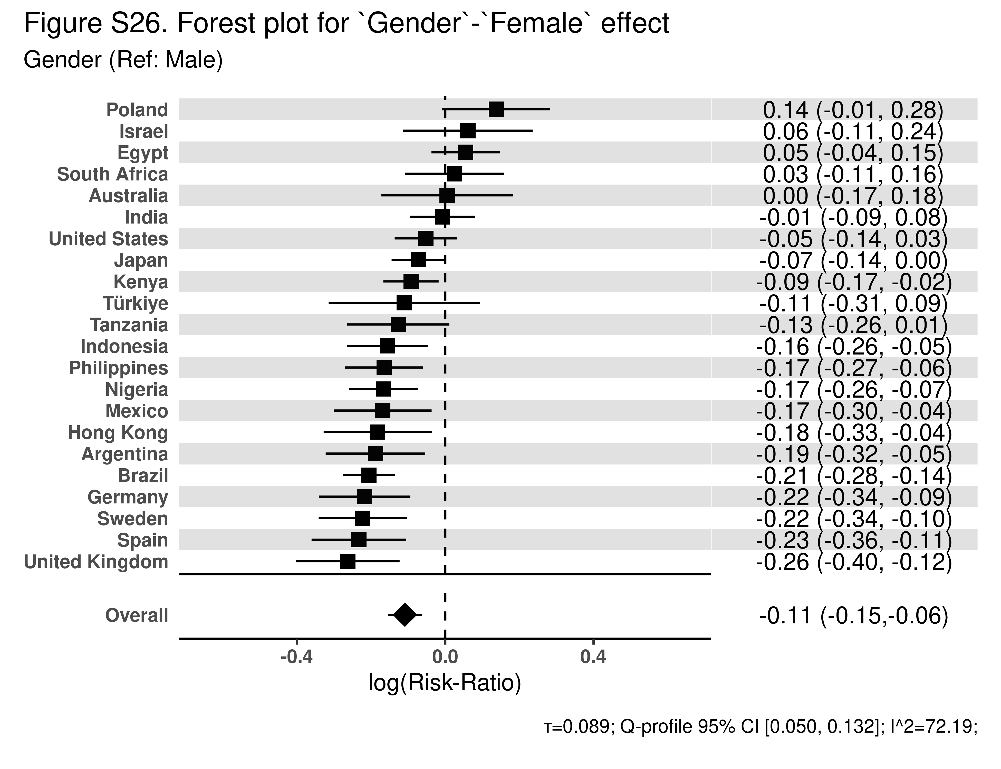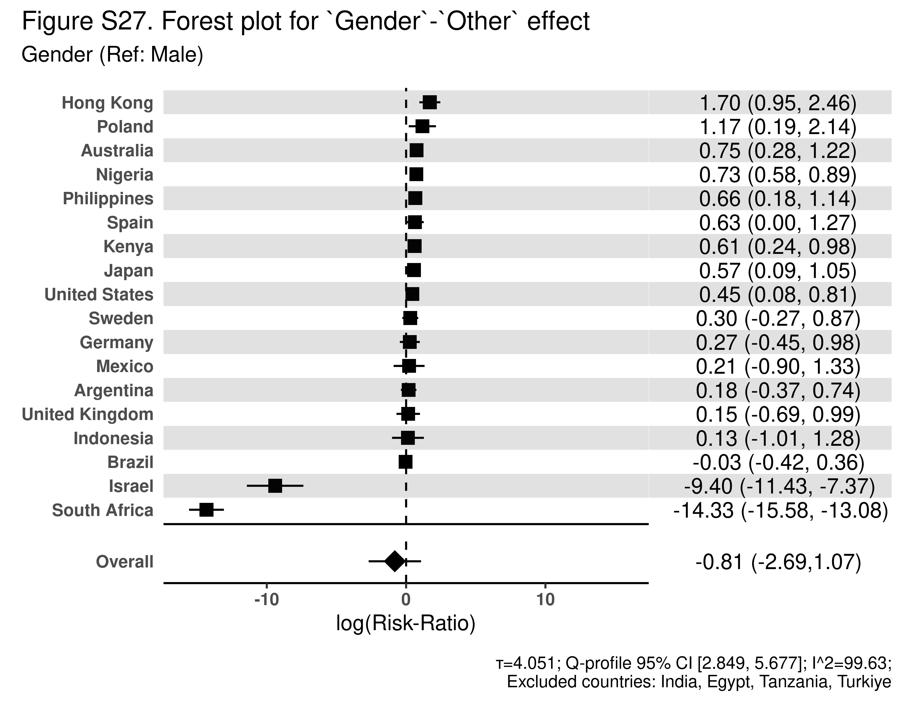

Childhood Predictors of Perceived Discrimination by Country

Table S1c. Nationally representative descriptive statistics for Argentina
Characteristic | N = 6,724¹
Relationship with mother
Very good | 4,463 (66%)
Somewhat good | 1,436 (21%)
Somewhat bad | 299 (4.4%)
Very bad | 216 (3.2%)
Does not apply | 273 (4.1%)
Missing | 36 (0.5%)
Relationship with father
Very good | 3,612 (54%)
Somewhat good | 1,537 (23%)
Somewhat bad | 440 (6.5%)
Very bad | 401 (6.0%)
Does not apply | 694 (10%)
Missing | 39 (0.6%)
Parent marital status
Yes, married | 4,110 (61%)
No, divorced | 637 (9.5%)
Never married | 1,368 (20%)
No, one or both of them had died | 199 (3.0%)
Missing | 410 (6.1%)
Subjective financial status of family growing up
Lived comfortably | 2,042 (30%)
Got by | 2,305 (34%)
Found it difficult | 1,789 (27%)
Found it very difficult | 569 (8.5%)
Missing | 19 (0.3%)
Abuse
Yes | 1,302 (19%)
No | 5,271 (78%)
Missing | 151 (2.2%)
Outsider growing up
Yes | 1,165 (17%)
No | 5,458 (81%)
Missing | 101 (1.5%)
Self-rated health growing up
Excellent | 2,402 (36%)
Very good | 1,819 (27%)
Good | 1,830 (27%)
Fair | 505 (7.5%)
Poor | 156 (2.3%)
Missing | 12 (0.2%)
Immigration status
Born in this country | 6,346 (94%)
Born in another country | 348 (5.2%)
Missing | 29 (0.4%)
Age 12 religious service attendance
At least 1/week | 2,601 (39%)
1-3/month | 1,204 (18%)
<1/month | 1,059 (16%)
Never | 1,808 (27%)
Missing | 53 (0.8%)
Age group
1998-2005; current age: 18-24 | 1,108 (16%)
1993-1998; age: 25-29 | 719 (11%)
1983-1993; age: 30-39 | 1,432 (21%)
1973-1983; age 40-49 | 1,254 (19%)
1963-1973; age 50-59 | 1,014 (15%)
1953-1963; age 60-69 | 730 (11%)
1943 or earlier; age 80+ | 112 (1.7%)
1943-1953; age 70-79 | 356 (5.3%)
Missing | 0 (0%)
Gender
Male | 3,143 (47%)
Female | 3,542 (53%)
Other | 21 (0.3%)
Missing | 18 (0.3%)
Religious affiliation at age 12
Buddhism | 3 (<0.1%)
Christianity | 5,805 (86%)
Hinduism | 2 (<0.1%)
Islam | 11 (0.2%)
Judaism | 51 (0.8%)
No religion/Atheist/Agnostic | 697 (10%)
Primal, Animist, or Folk religion | 17 (0.2%)
Sikhism | 5 (<0.1%)
Some other religion | 10 (0.2%)
Taoism | 1 (<0.1%)
Missing | 122 (1.8%)
Race and ethnicity
Asian | 43 (0.6%)
Black | 95 (1.4%)
Indigenous | 129 (1.9%)
Mestizo(a) | 1,801 (27%)
Mullato(a) | 75 (1.1%)
Other | 104 (1.5%)
White | 3,406 (51%)
Missing | 1,070 (16%)
¹n (%)

Table S1d. Regression of perceived discrimination on childhood predictors for Argentina
Variable | Category | Risk ratio | 95% CI | Global p-value
Relationship with mother (Ref: Very bad/Somewhat bad) | Very good/Somewhat good | 0.82 | (0.67, 1.00) | <.001
Relationship with father (Ref: Very bad/Somewhat bad) | Very good/Somewhat good | 0.90 | (0.75, 1.08) | 0.002
Parent marital status (Ref: Parents married) | No, divorced | 1.02 | (0.82, 1.25) | 0.116
 | Never | 1.03 | (0.87, 1.22)
 | No, one or both of them had died | 0.66 | (0.42, 1.03)
Subjective financial status of family growing up (Ref: Got by) | Lived comfortably | 0.98 | (0.84, 1.15) | 0.699
 | Found it difficult | 1.12 | (0.95, 1.30)
 | Found it very difficult | 1.08 | (0.83, 1.40)
Abuse (Ref: No) | Yes | 1.25 | (1.07, 1.45) | <.001
Outsider growing up (Ref: No) | Yes | 1.36 | (1.16, 1.61) | <.001
Self-rated health growing up (Ref: Good) | Excellent | 0.87 | (0.73, 1.03) | <.001
 | Very good | 0.95 | (0.80, 1.13)
 | Fair | 1.30 | (1.05, 1.59)
 | Poor | 1.13 | (0.74, 1.72)
Immigration status (Ref: Born in this country) | Born in another country | 0.92 | (0.67, 1.27) | 0.902
Age 12 religious service attendance (Ref: Never) | At least 1/week | 1.02 | (0.86, 1.22) | <.001
 | 1-3/month | 1.26 | (1.03, 1.54)
 | <1/month | 0.98 | (0.78, 1.22)
Age group (Ref: 1998-2005; current age: 18-24) | 1993-1998; age: 25-29 | 0.97 | (0.76, 1.24) | <.001
 | 1983-1993; age: 30-39 | 0.94 | (0.78, 1.14)
 | 1973-1983; age 40-49 | 0.80 | (0.65, 1.00)
 | 1963-1973; age 50-59 | 0.55 | (0.43, 0.71)
 | 1953-1963; age 60-69 | 0.51 | (0.38, 0.70)
 | 1943 or earlier; age 80+ | 0.81 | (0.41, 1.60)
 | 1943-1953; age 70-79 | 0.58 | (0.37, 0.89)
Gender (Ref: Male) | Female | 0.83 | (0.72, 0.95) | <.001
 | Other | 1.20 | (0.69, 2.10)
Religious affiliation at age 12 (Ref: No religion/Atheist/Agnostic) | Christianity | 0.98 | (0.78, 1.24) | 1
 | Some other religion | 1.00 | (0.63, 1.61)
Race and ethnicity plurality (Ref: Majority) | Minority | 1.15 | (1.01, 1.31) | <.001

Table S1e. Sensitivity to unmeasured confounding of childhood predictors in Argentina
Variable | Category | E-value for Estimate | E-value for 95% CI
Relationship with mother (Ref: Very bad/Somewhat bad) | Very good/Somewhat good | 1.75 | 1.04
Relationship with father (Ref: Very bad/Somewhat bad) | Very good/Somewhat good | 1.46 | 1.00
Parent marital status (Ref: Parents married) | No, divorced | 1.15 | 1.00
 | Never | 1.21 | 1.00
 | No, one or both of them had died | 2.39 | 1.00
Subjective financial status of family growing up (Ref: Got by) | Lived comfortably | 1.15 | 1.00
 | Found it difficult | 1.46 | 1.00
 | Found it very difficult | 1.38 | 1.00
Abuse (Ref: No) | Yes | 1.80 | 1.34
Outsider growing up (Ref: No) | Yes | 2.07 | 1.58
Self-rated health growing up (Ref: Good) | Excellent | 1.57 | 1.00
 | Very good | 1.30 | 1.00
 | Fair | 1.91 | 1.29
 | Poor | 1.50 | 1.00
Immigration status (Ref: Born in this country) | Born in another country | 1.39 | 1.00
Age 12 religious service attendance (Ref: Never) | At least 1/week | 1.18 | 1.00
 | 1-3/month | 1.83 | 1.21
 | <1/month | 1.18 | 1.00
Age group (Ref: 1998-2005; current age: 18-24) | 1993-1998; age: 25-29 | 1.20 | 1.00
 | 1983-1993; age: 30-39 | 1.32 | 1.00
 | 1973-1983; age 40-49 | 1.79 | 1.05
 | 1963-1973; age 50-59 | 3.01 | 2.17
 | 1953-1963; age 60-69 | 3.31 | 2.20
 | 1943 or earlier; age 80+ | 1.77 | 1.00
 | 1943-1953; age 70-79 | 2.86 | 1.50
Gender (Ref: Male) | Female | 1.71 | 1.30
 | Other | 1.69 | 1.00
Religious affiliation at age 12 (Ref: No religion/Atheist/Agnostic) | Christianity | 1.14 | 1.00
 | Some other religion | 1.07 | 1.00
Race and ethnicity plurality (Ref: Majority) | Minority | 1.57 | 1.13

Table S2c. Nationally representative descriptive statistics for Australia
Characteristic | N = 3,844¹
Relationship with mother
Very good | 2,554 (66%)
Somewhat good | 925 (24%)
Somewhat bad | 218 (5.7%)
Very bad | 107 (2.8%)
Does not apply | 32 (0.8%)
Missing | 7 (0.2%)
Relationship with father
Very good | 2,032 (53%)
Somewhat good | 1,144 (30%)
Somewhat bad | 315 (8.2%)
Very bad | 196 (5.1%)
Does not apply | 148 (3.9%)
Missing | 9 (0.2%)
Parent marital status
Yes, married | 3,048 (79%)
No, divorced | 462 (12%)
Never married | 187 (4.9%)
No, one or both of them had died | 96 (2.5%)
Missing | 52 (1.4%)
Subjective financial status of family growing up
Lived comfortably | 1,756 (46%)
Got by | 1,496 (39%)
Found it difficult | 422 (11%)
Found it very difficult | 154 (4.0%)
Missing | 16 (0.4%)
Abuse
Yes | 995 (26%)
No | 2,790 (73%)
Missing | 59 (1.5%)
Outsider growing up
Yes | 756 (20%)
No | 3,062 (80%)
Missing | 26 (0.7%)
Self-rated health growing up
Excellent | 1,736 (45%)
Very good | 1,087 (28%)
Good | 603 (16%)
Fair | 308 (8.0%)
Poor | 106 (2.8%)
Missing | 4 (<0.1%)
Immigration status
Born in this country | 2,953 (77%)
Born in another country | 885 (23%)
Missing | 6 (0.2%)
Age 12 religious service attendance
At least 1/week | 1,362 (35%)
1-3/month | 486 (13%)
<1/month | 600 (16%)
Never | 1,307 (34%)
Missing | 90 (2.3%)
Age group
1998-2005; current age: 18-24 | 345 (9.0%)
1993-1998; age: 25-29 | 282 (7.3%)
1983-1993; age: 30-39 | 641 (17%)
1973-1983; age 40-49 | 618 (16%)
1963-1973; age 50-59 | 691 (18%)
1953-1963; age 60-69 | 589 (15%)
1943 or earlier; age 80+ | 178 (4.6%)
1943-1953; age 70-79 | 498 (13%)
Missing | 2 (<0.1%)
Gender
Male | 1,861 (48%)
Female | 1,941 (50%)
Other | 36 (0.9%)
Missing | 6 (0.2%)
Religious affiliation at age 12
Baha’i | 5 (0.1%)
Buddhism | 16 (0.4%)
Christianity | 2,678 (70%)
Hinduism | 39 (1.0%)
Islam | 48 (1.2%)
Judaism | 29 (0.8%)
No religion/Atheist/Agnostic | 990 (26%)
Primal, Animist, or Folk religion | 4 (<0.1%)
Sikhism | 6 (0.2%)
Some other religion | 8 (0.2%)
Taoism | 1 (<0.1%)
Missing | 21 (0.5%)
Race and ethnicity
Aboriginal | 53 (1.4%)
Australian | 1,946 (51%)
Australian British/European | 1,047 (27%)
Chinese | 75 (1.9%)
Indian | 58 (1.5%)
Japanese | 1 (<0.1%)
Malay | 11 (0.3%)
New Zealander | 91 (2.4%)
Other | 163 (4.2%)
Other European | 357 (9.3%)
Russian | 7 (0.2%)
Samoan | 4 (0.1%)
Sinhalese | 1 (<0.1%)
Spanish | 2 (<0.1%)
Sri Lankan Moor | 1 (<0.1%)
Sri Lankan Tamil | 7 (0.2%)
Vietnamese | 7 (0.2%)
Missing | 14 (0.4%)
¹n (%)

Table S2d. Regression of perceived discrimination on childhood predictors for Australia
Variable | Category | Risk ratio | 95% CI | Global p-value
Relationship with mother (Ref: Very bad/Somewhat bad) | Very good/Somewhat good | 0.94 | (0.73, 1.20) | 0.452
Relationship with father (Ref: Very bad/Somewhat bad) | Very good/Somewhat good | 1.11 | (0.87, 1.41) | 0.042
Parent marital status (Ref: Parents married) | No, divorced | 0.90 | (0.66, 1.21) | 0.982
 | Never | 0.94 | (0.61, 1.44)
 | No, one or both of them had died | 0.75 | (0.40, 1.40)
Subjective financial status of family growing up (Ref: Got by) | Lived comfortably | 1.05 | (0.86, 1.29) | <.001
 | Found it difficult | 1.42 | (1.12, 1.82)
 | Found it very difficult | 1.57 | (1.09, 2.27)
Abuse (Ref: No) | Yes | 1.52 | (1.25, 1.86) | <.001
Outsider growing up (Ref: No) | Yes | 1.73 | (1.41, 2.15) | <.001
Self-rated health growing up (Ref: Good) | Excellent | 0.75 | (0.59, 0.96) | <.001
 | Very good | 0.83 | (0.64, 1.07)
 | Fair | 1.13 | (0.85, 1.51)
 | Poor | 1.14 | (0.71, 1.81)
Immigration status (Ref: Born in this country) | Born in another country | 1.07 | (0.86, 1.34) | 0.803
Age 12 religious service attendance (Ref: Never) | At least 1/week | 1.04 | (0.82, 1.32) | 0.19
 | 1-3/month | 0.89 | (0.65, 1.20)
 | <1/month | 0.79 | (0.59, 1.08)
Age group (Ref: 1998-2005; current age: 18-24) | 1993-1998; age: 25-29 | 1.05 | (0.67, 1.67) | <.001
 | 1983-1993; age: 30-39 | 1.20 | (0.82, 1.73)
 | 1973-1983; age 40-49 | 1.19 | (0.81, 1.72)
 | 1963-1973; age 50-59 | 1.22 | (0.85, 1.77)
 | 1953-1963; age 60-69 | 0.83 | (0.56, 1.22)
 | 1943 or earlier; age 80+ | 0.55 | (0.29, 1.03)
 | 1943-1953; age 70-79 | 0.64 | (0.41, 1.00)
Gender (Ref: Male) | Female | 1.00 | (0.84, 1.20) | <.001
 | Other | 2.12 | (1.33, 3.38)
Religious affiliation at age 12 (Ref: No religion/Atheist/Agnostic) | Christianity | 1.22 | (0.95, 1.59) | <.001
 | Some other religion | 1.82 | (1.16, 2.85)
Race and ethnicity plurality (Ref: Majority) | Minority | 1.15 | (0.95, 1.39) | 0.032

Table S2e. Sensitivity to unmeasured confounding of childhood predictors in Australia
Variable | Category | E-value for Estimate | E-value for 95% CI
Relationship with mother (Ref: Very bad/Somewhat bad) | Very good/Somewhat good | 1.33 | 1.00
Relationship with father (Ref: Very bad/Somewhat bad) | Very good/Somewhat good | 1.46 | 1.00
Parent marital status (Ref: Parents married) | No, divorced | 1.48 | 1.00
 | Never | 1.32 | 1.00
 | No, one or both of them had died | 2.00 | 1.00
Subjective financial status of family growing up (Ref: Got by) | Lived comfortably | 1.28 | 1.00
 | Found it difficult | 2.21 | 1.47
 | Found it very difficult | 2.52 | 1.41
Abuse (Ref: No) | Yes | 2.42 | 1.80
Outsider growing up (Ref: No) | Yes | 2.87 | 2.16
Self-rated health growing up (Ref: Good) | Excellent | 1.99 | 1.24
 | Very good | 1.71 | 1.00
 | Fair | 1.51 | 1.00
 | Poor | 1.52 | 1.00
Immigration status (Ref: Born in this country) | Born in another country | 1.35 | 1.00
Age 12 religious service attendance (Ref: Never) | At least 1/week | 1.25 | 1.00
 | 1-3/month | 1.51 | 1.00
 | <1/month | 1.82 | 1.00
Age group (Ref: 1998-2005; current age: 18-24) | 1993-1998; age: 25-29 | 1.30 | 1.00
 | 1983-1993; age: 30-39 | 1.68 | 1.00
 | 1973-1983; age 40-49 | 1.65 | 1.00
 | 1963-1973; age 50-59 | 1.75 | 1.00
 | 1953-1963; age 60-69 | 1.72 | 1.00
 | 1943 or earlier; age 80+ | 3.04 | 1.00
 | 1943-1953; age 70-79 | 2.51 | 1.00
Gender (Ref: Male) | Female | 1.08 | 1.00
 | Other | 3.66 | 1.99
Religious affiliation at age 12 (Ref: No religion/Atheist/Agnostic) | Christianity | 1.75 | 1.00
 | Some other religion | 3.04 | 1.60
Race and ethnicity plurality (Ref: Majority) | Minority | 1.57 | 1.00

Table S3c. Nationally representative descriptive statistics for Brazil
Characteristic | N = 13,204¹
Relationship with mother
Very good | 8,369 (63%)
Somewhat good | 3,559 (27%)
Somewhat bad | 483 (3.7%)
Very bad | 214 (1.6%)
Does not apply | 507 (3.8%)
Missing | 73 (0.6%)
Relationship with father
Very good | 6,364 (48%)
Somewhat good | 3,654 (28%)
Somewhat bad | 1,035 (7.8%)
Very bad | 756 (5.7%)
Does not apply | 1,303 (9.9%)
Missing | 93 (0.7%)
Parent marital status
Yes, married | 8,546 (65%)
No, divorced | 1,384 (10%)
Never married | 1,985 (15%)
No, one or both of them had died | 508 (3.8%)
Missing | 781 (5.9%)
Subjective financial status of family growing up
Lived comfortably | 4,998 (38%)
Got by | 4,616 (35%)
Found it difficult | 2,484 (19%)
Found it very difficult | 1,027 (7.8%)
Missing | 79 (0.6%)
Abuse
Yes | 2,606 (20%)
No | 10,147 (77%)
Missing | 451 (3.4%)
Outsider growing up
Yes | 1,659 (13%)
No | 11,234 (85%)
Missing | 311 (2.4%)
Self-rated health growing up
Excellent | 5,312 (40%)
Very good | 3,392 (26%)
Good | 2,873 (22%)
Fair | 1,368 (10%)
Poor | 228 (1.7%)
Missing | 30 (0.2%)
Immigration status
Born in this country | 12,688 (96%)
Born in another country | 153 (1.2%)
Missing | 363 (2.7%)
Age 12 religious service attendance
At least 1/week | 6,306 (48%)
1-3/month | 2,491 (19%)
<1/month | 2,629 (20%)
Never | 1,707 (13%)
Missing | 71 (0.5%)
Age group
1998-2005; current age: 18-24 | 1,986 (15%)
1993-1998; age: 25-29 | 1,468 (11%)
1983-1993; age: 30-39 | 2,908 (22%)
1973-1983; age 40-49 | 2,638 (20%)
1963-1973; age 50-59 | 2,131 (16%)
1953-1963; age 60-69 | 1,435 (11%)
1943 or earlier; age 80+ | 126 (1.0%)
1943-1953; age 70-79 | 510 (3.9%)
Missing | 0 (0%)
Gender
Male | 6,320 (48%)
Female | 6,820 (52%)
Other | 35 (0.3%)
Missing | 30 (0.2%)
Religious affiliation at age 12
Baha’i | 1 (<0.1%)
Buddhism | 27 (0.2%)
Christianity | 11,403 (86%)
Confucianism | 7 (<0.1%)
Hinduism | 1 (<0.1%)
Islam | 15 (0.1%)
Jainism | 4 (<0.1%)
Judaism | 40 (0.3%)
No religion/Atheist/Agnostic | 908 (6.9%)
Primal, Animist, or Folk religion | 17 (0.1%)
Shinto | 4 (<0.1%)
Some other religion | 87 (0.7%)
Spiritism | 336 (2.5%)
Taoism | 1 (<0.1%)
Umbanda, Candomblé, and other African-derived religions | 262 (2.0%)
Missing | 94 (0.7%)
Race and ethnicity
Amarela | 238 (1.8%)
Branca | 5,169 (39%)
Indígena | 131 (1.0%)
Other | 61 (0.5%)
Parda | 5,125 (39%)
Preta | 1,615 (12%)
Missing | 865 (6.6%)
¹n (%)

Table S3d. Regression of perceived discrimination on childhood predictors for Brazil
Variable | Category | Risk ratio | 95% CI | Global p-value
Relationship with mother (Ref: Very bad/Somewhat bad) | Very good/Somewhat good | 0.97 | (0.86, 1.09) | 0.382
Relationship with father (Ref: Very bad/Somewhat bad) | Very good/Somewhat good | 0.94 | (0.86, 1.03) | <.001
Parent marital status (Ref: Parents married) | No, divorced | 1.02 | (0.93, 1.13) | 0.011
 | Never | 1.02 | (0.92, 1.12)
 | No, one or both of them had died | 0.82 | (0.68, 0.98)
Subjective financial status of family growing up (Ref: Got by) | Lived comfortably | 0.95 | (0.87, 1.03) | <.001
 | Found it difficult | 1.01 | (0.91, 1.11)
 | Found it very difficult | 1.20 | (1.05, 1.36)
Abuse (Ref: No) | Yes | 1.31 | (1.21, 1.41) | <.001
Outsider growing up (Ref: No) | Yes | 1.51 | (1.39, 1.63) | <.001
Self-rated health growing up (Ref: Good) | Excellent | 0.96 | (0.87, 1.05) | <.001
 | Very good | 0.94 | (0.85, 1.04)
 | Fair | 1.15 | (1.02, 1.28)
 | Poor | 1.02 | (0.81, 1.30)
Immigration status (Ref: Born in this country) | Born in another country | 1.08 | (0.78, 1.49) | 0.919
Age 12 religious service attendance (Ref: Never) | At least 1/week | 1.06 | (0.94, 1.21) | <.001
 | 1-3/month | 1.17 | (1.02, 1.34)
 | <1/month | 0.99 | (0.87, 1.14)
Age group (Ref: 1998-2005; current age: 18-24) | 1993-1998; age: 25-29 | 1.04 | (0.93, 1.16) | <.001
 | 1983-1993; age: 30-39 | 0.96 | (0.87, 1.05)
 | 1973-1983; age 40-49 | 0.89 | (0.80, 0.99)
 | 1963-1973; age 50-59 | 0.85 | (0.75, 0.96)
 | 1953-1963; age 60-69 | 0.63 | (0.53, 0.76)
 | 1943 or earlier; age 80+ | 0.54 | (0.29, 1.01)
 | 1943-1953; age 70-79 | 0.43 | (0.29, 0.64)
Gender (Ref: Male) | Female | 0.81 | (0.76, 0.87) | <.001
 | Other | 0.97 | (0.66, 1.43)
Religious affiliation at age 12 (Ref: No religion/Atheist/Agnostic) | Christianity | 0.81 | (0.72, 0.91) | <.001
 | Some other religion | 1.01 | (0.86, 1.18)
Race and ethnicity plurality (Ref: Majority) | Minority | 1.02 | (0.96, 1.10) | 0.697

Table S3e. Sensitivity to unmeasured confounding of childhood predictors in Brazil
Variable | Category | E-value for Estimate | E-value for 95% CI
Relationship with mother (Ref: Very bad/Somewhat bad) | Very good/Somewhat good | 1.22 | 1.00
Relationship with father (Ref: Very bad/Somewhat bad) | Very good/Somewhat good | 1.32 | 1.00
Parent marital status (Ref: Parents married) | No, divorced | 1.18 | 1.00
 | Never | 1.15 | 1.00
 | No, one or both of them had died | 1.75 | 1.16
Subjective financial status of family growing up (Ref: Got by) | Lived comfortably | 1.29 | 1.00
 | Found it difficult | 1.10 | 1.00
 | Found it very difficult | 1.68 | 1.29
Abuse (Ref: No) | Yes | 1.94 | 1.71
Outsider growing up (Ref: No) | Yes | 2.38 | 2.13
Self-rated health growing up (Ref: Good) | Excellent | 1.26 | 1.00
 | Very good | 1.31 | 1.00
 | Fair | 1.56 | 1.18
 | Poor | 1.18 | 1.00
Immigration status (Ref: Born in this country) | Born in another country | 1.37 | 1.00
Age 12 religious service attendance (Ref: Never) | At least 1/week | 1.32 | 1.00
 | 1-3/month | 1.61 | 1.17
 | <1/month | 1.10 | 1.00
Age group (Ref: 1998-2005; current age: 18-24) | 1993-1998; age: 25-29 | 1.24 | 1.00
 | 1983-1993; age: 30-39 | 1.26 | 1.00
 | 1973-1983; age 40-49 | 1.50 | 1.13
 | 1963-1973; age 50-59 | 1.63 | 1.24
 | 1953-1963; age 60-69 | 2.54 | 1.96
 | 1943 or earlier; age 80+ | 3.08 | 1.00
 | 1943-1953; age 70-79 | 4.05 | 2.50
Gender (Ref: Male) | Female | 1.76 | 1.55
 | Other | 1.22 | 1.00
Religious affiliation at age 12 (Ref: No religion/Atheist/Agnostic) | Christianity | 1.77 | 1.42
 | Some other religion | 1.10 | 1.00
Race and ethnicity plurality (Ref: Majority) | Minority | 1.19 | 1.00

Table S4c. Nationally representative descriptive statistics for Egypt
Characteristic | N = 4,729¹
Relationship with mother
Very good | 4,110 (87%)
Somewhat good | 505 (11%)
Somewhat bad | 21 (0.4%)
Very bad | 10 (0.2%)
Does not apply | 83 (1.8%)
Missing | 0 (0%)
Relationship with father
Very good | 3,713 (79%)
Somewhat good | 683 (14%)
Somewhat bad | 56 (1.2%)
Very bad | 30 (0.6%)
Does not apply | 233 (4.9%)
Missing | 14 (0.3%)
Parent marital status
Yes, married | 4,049 (86%)
No, divorced | 131 (2.8%)
Never married | 9 (0.2%)
No, one or both of them had died | 485 (10%)
Missing | 55 (1.2%)
Subjective financial status of family growing up
Lived comfortably | 1,251 (26%)
Got by | 2,352 (50%)
Found it difficult | 857 (18%)
Found it very difficult | 268 (5.7%)
Missing | 1 (<0.1%)
Abuse
Yes | 405 (8.6%)
No | 4,293 (91%)
Missing | 30 (0.6%)
Outsider growing up
Yes | 260 (5.5%)
No | 4,456 (94%)
Missing | 13 (0.3%)
Self-rated health growing up
Excellent | 2,687 (57%)
Very good | 1,174 (25%)
Good | 497 (11%)
Fair | 265 (5.6%)
Poor | 106 (2.2%)
Missing | 1 (<0.1%)
Immigration status
Born in this country | 4,713 (100%)
Born in another country | 16 (0.3%)
Missing | 1 (<0.1%)
Age 12 religious service attendance
At least 1/week | 2,307 (49%)
1-3/month | 570 (12%)
<1/month | 629 (13%)
Never | 1,165 (25%)
Missing | 57 (1.2%)
Age group
1998-2005; current age: 18-24 | 960 (20%)
1993-1998; age: 25-29 | 607 (13%)
1983-1993; age: 30-39 | 1,204 (25%)
1973-1983; age 40-49 | 897 (19%)
1963-1973; age 50-59 | 613 (13%)
1953-1963; age 60-69 | 387 (8.2%)
1943 or earlier; age 80+ | 7 (0.2%)
1943-1953; age 70-79 | 54 (1.1%)
Missing | 0 (0%)
Gender
Male | 2,394 (51%)
Female | 2,334 (49%)
Other | 0 (0%)
Missing | 0 (<0.1%)
Religious affiliation at age 12
Christianity | 123 (2.6%)
Islam | 4,602 (97%)
Jainism | 1 (<0.1%)
Taoism | 0 (<0.1%)
Missing | 3 (<0.1%)
Race and ethnicity
Arab | 4,585 (97%)
Bedouin Arab | 4 (<0.1%)
Greek | 1 (<0.1%)
Nubian | 27 (0.6%)
Turkish | 9 (0.2%)
Missing | 102 (2.2%)
¹n (%)

Table S4d. Regression of perceived discrimination on childhood predictors for Egypt
Variable | Category | Risk ratio | 95% CI | Global p-value
Relationship with mother (Ref: Very bad/Somewhat bad) | Very good/Somewhat good | 0.88 | (0.68, 1.13) | 0.005
Relationship with father (Ref: Very bad/Somewhat bad) | Very good/Somewhat good | 0.99 | (0.77, 1.27) | 0.975
Parent marital status (Ref: Parents married) | No, divorced | 0.88 | (0.69, 1.12) | <.001
 | Never | 1.43 | (0.96, 2.16)
 | No, one or both of them had died | 0.90 | (0.77, 1.04)
Subjective financial status of family growing up (Ref: Got by) | Lived comfortably | 0.95 | (0.86, 1.04) | 0.475
 | Found it difficult | 0.99 | (0.89, 1.11)
 | Found it very difficult | 1.08 | (0.94, 1.26)
Abuse (Ref: No) | Yes | 1.35 | (1.22, 1.48) | <.001
Outsider growing up (Ref: No) | Yes | 1.08 | (0.93, 1.25) | 0.277
Self-rated health growing up (Ref: Good) | Excellent | 0.98 | (0.86, 1.13) | 0.096
 | Very good | 0.98 | (0.85, 1.14)
 | Fair | 0.87 | (0.70, 1.07)
 | Poor | 1.16 | (0.92, 1.48)
Immigration status (Ref: Born in this country) | Born in another country | 0.79 | (0.38, 1.65) | 0.781
Age 12 religious service attendance (Ref: Never) | At least 1/week | 0.97 | (0.88, 1.08) | 0.83
 | 1-3/month | 1.02 | (0.92, 1.15)
 | <1/month | 1.05 | (0.93, 1.18)
Age group (Ref: 1998-2005; current age: 18-24) | 1993-1998; age: 25-29 | 1.00 | (0.87, 1.14) | 1
 | 1983-1993; age: 30-39 | 0.98 | (0.86, 1.13)
 | 1973-1983; age 40-49 | 0.97 | (0.85, 1.10)
 | 1963-1973; age 50-59 | 1.00 | (0.85, 1.18)
 | 1953-1963; age 60-69 | 0.94 | (0.77, 1.15)
 | 1943 or earlier; age 80+ | 0.89 | (0.26, 3.01)
 | 1943-1953; age 70-79 | 1.03 | (0.67, 1.57)
Gender (Ref: Male) | Female | 1.05 | (0.96, 1.16) | 0.172
Religious affiliation at age 12 (Ref: Islam) | Some other religion | 1.05 | (0.84, 1.33) | 0.922
Race and ethnicity plurality (Ref: Majority) | Minority | 1.12 | (0.77, 1.62) | 0.81

Table S4e. Sensitivity to unmeasured confounding of childhood predictors in Egypt
Variable | Category | E-value for Estimate | E-value for 95% CI
Relationship with mother (Ref: Very bad/Somewhat bad) | Very good/Somewhat good | 1.53 | 1.00
Relationship with father (Ref: Very bad/Somewhat bad) | Very good/Somewhat good | 1.14 | 1.00
Parent marital status (Ref: Parents married) | No, divorced | 1.53 | 1.00
 | Never | 2.23 | 1.00
 | No, one or both of them had died | 1.48 | 1.00
Subjective financial status of family growing up (Ref: Got by) | Lived comfortably | 1.30 | 1.00
 | Found it difficult | 1.09 | 1.00
 | Found it very difficult | 1.40 | 1.00
Abuse (Ref: No) | Yes | 2.03 | 1.74
Outsider growing up (Ref: No) | Yes | 1.37 | 1.00
Self-rated health growing up (Ref: Good) | Excellent | 1.15 | 1.00
 | Very good | 1.15 | 1.00
 | Fair | 1.58 | 1.00
 | Poor | 1.61 | 1.00
Immigration status (Ref: Born in this country) | Born in another country | 1.86 | 1.00
Age 12 religious service attendance (Ref: Never) | At least 1/week | 1.20 | 1.00
 | 1-3/month | 1.19 | 1.00
 | <1/month | 1.28 | 1.00
Age group (Ref: 1998-2005; current age: 18-24) | 1993-1998; age: 25-29 | 1.04 | 1.00
 | 1983-1993; age: 30-39 | 1.15 | 1.00
 | 1973-1983; age 40-49 | 1.21 | 1.00
 | 1963-1973; age 50-59 | 1.07 | 1.00
 | 1953-1963; age 60-69 | 1.33 | 1.00
 | 1943 or earlier; age 80+ | 1.52 | 1.00
 | 1943-1953; age 70-79 | 1.19 | 1.00
Gender (Ref: Male) | Female | 1.30 | 1.00
Religious affiliation at age 12 (Ref: Islam) | Some other religion | 1.29 | 1.00
Race and ethnicity plurality (Ref: Majority) | Minority | 1.49 | 1.00

Table S5c. Nationally representative descriptive statistics for Germany
Characteristic | N = 9,506¹
Relationship with mother
Very good | 5,497 (58%)
Somewhat good | 3,031 (32%)
Somewhat bad | 496 (5.2%)
Very bad | 187 (2.0%)
Does not apply | 241 (2.5%)
Missing | 54 (0.6%)
Relationship with father
Very good | 4,652 (49%)
Somewhat good | 3,012 (32%)
Somewhat bad | 846 (8.9%)
Very bad | 385 (4.0%)
Does not apply | 538 (5.7%)
Missing | 73 (0.8%)
Parent marital status
Yes, married | 7,620 (80%)
No, divorced | 927 (9.8%)
Never married | 578 (6.1%)
No, one or both of them had died | 245 (2.6%)
Missing | 136 (1.4%)
Subjective financial status of family growing up
Lived comfortably | 3,177 (33%)
Got by | 4,508 (47%)
Found it difficult | 1,481 (16%)
Found it very difficult | 314 (3.3%)
Missing | 26 (0.3%)
Abuse
Yes | 1,086 (11%)
No | 8,321 (88%)
Missing | 99 (1.0%)
Outsider growing up
Yes | 1,105 (12%)
No | 8,262 (87%)
Missing | 139 (1.5%)
Self-rated health growing up
Excellent | 2,633 (28%)
Very good | 3,518 (37%)
Good | 2,582 (27%)
Fair | 612 (6.4%)
Poor | 134 (1.4%)
Missing | 26 (0.3%)
Immigration status
Born in this country | 8,722 (92%)
Born in another country | 744 (7.8%)
Missing | 40 (0.4%)
Age 12 religious service attendance
At least 1/week | 1,943 (20%)
1-3/month | 1,899 (20%)
<1/month | 2,887 (30%)
Never | 2,749 (29%)
Missing | 27 (0.3%)
Age group
1998-2005; current age: 18-24 | 829 (8.7%)
1993-1998; age: 25-29 | 774 (8.1%)
1983-1993; age: 30-39 | 1,438 (15%)
1973-1983; age 40-49 | 1,494 (16%)
1963-1973; age 50-59 | 1,729 (18%)
1953-1963; age 60-69 | 1,915 (20%)
1943 or earlier; age 80+ | 190 (2.0%)
1943-1953; age 70-79 | 1,137 (12%)
Missing | 0 (0%)
Gender
Male | 4,641 (49%)
Female | 4,843 (51%)
Other | 11 (0.1%)
Missing | 11 (0.1%)
Religious affiliation at age 12
Baha’i | 2 (<0.1%)
Buddhism | 25 (0.3%)
Christianity | 5,751 (61%)
Confucianism | 4 (<0.1%)
Hinduism | 15 (0.2%)
Islam | 350 (3.7%)
Jainism | 1 (<0.1%)
Judaism | 18 (0.2%)
No religion/Atheist/Agnostic | 3,163 (33%)
Primal, Animist, or Folk religion | 19 (0.2%)
Sikhism | 5 (<0.1%)
Some other religion | 67 (0.7%)
Missing | 85 (0.9%)
Race and ethnicity
Missing | 9,506 (100%)
¹n (%)

Table S5d. Regression of perceived discrimination on childhood predictors for Germany
Variable | Category | Risk ratio | 95% CI | Global p-value
Relationship with mother (Ref: Very bad/Somewhat bad) | Very good/Somewhat good | 1.06 | (0.86, 1.31) | 0.277
Relationship with father (Ref: Very bad/Somewhat bad) | Very good/Somewhat good | 1.02 | (0.86, 1.22) | 0.919
Parent marital status (Ref: Parents married) | No, divorced | 1.17 | (0.97, 1.41) | 0.001
 | Never | 1.26 | (1.01, 1.58)
 | No, one or both of them had died | 0.82 | (0.53, 1.26)
Subjective financial status of family growing up (Ref: Got by) | Lived comfortably | 1.09 | (0.94, 1.27) | 0.889
 | Found it difficult | 0.97 | (0.81, 1.18)
 | Found it very difficult | 1.08 | (0.80, 1.45)
Abuse (Ref: No) | Yes | 1.52 | (1.30, 1.77) | <.001
Outsider growing up (Ref: No) | Yes | 1.45 | (1.24, 1.68) | <.001
Self-rated health growing up (Ref: Good) | Excellent | 0.70 | (0.58, 0.84) | <.001
 | Very good | 0.83 | (0.71, 0.97)
 | Fair | 1.15 | (0.93, 1.44)
 | Poor | 1.07 | (0.73, 1.57)
Immigration status (Ref: Born in this country) | Born in another country | 1.02 | (0.82, 1.26) | 1
Age 12 religious service attendance (Ref: Never) | At least 1/week | 1.13 | (0.93, 1.38) | 0.001
 | 1-3/month | 1.30 | (1.08, 1.56)
 | <1/month | 1.13 | (0.94, 1.33)
Age group (Ref: 1998-2005; current age: 18-24) | 1993-1998; age: 25-29 | 0.92 | (0.71, 1.21) | <.001
 | 1983-1993; age: 30-39 | 1.11 | (0.88, 1.38)
 | 1973-1983; age 40-49 | 0.97 | (0.76, 1.23)
 | 1963-1973; age 50-59 | 0.81 | (0.63, 1.03)
 | 1953-1963; age 60-69 | 0.70 | (0.54, 0.92)
 | 1943 or earlier; age 80+ | 0.84 | (0.47, 1.51)
 | 1943-1953; age 70-79 | 0.57 | (0.41, 0.79)
Gender (Ref: Male) | Female | 0.80 | (0.71, 0.91) | <.001
 | Other | 1.31 | (0.64, 2.67)
Religious affiliation at age 12 (Ref: No religion/Atheist/Agnostic) | Christianity | 0.79 | (0.68, 0.92) | <.001
 | Some other religion | 1.93 | (1.57, 2.39)

Table S5e. Sensitivity to unmeasured confounding of childhood predictors in Germany
Variable | Category | E-value for Estimate | E-value for 95% CI
Relationship with mother (Ref: Very bad/Somewhat bad) | Very good/Somewhat good | 1.33 | 1.00
Relationship with father (Ref: Very bad/Somewhat bad) | Very good/Somewhat good | 1.18 | 1.00
Parent marital status (Ref: Parents married) | No, divorced | 1.62 | 1.00
 | Never | 1.84 | 1.11
 | No, one or both of them had died | 1.74 | 1.00
Subjective financial status of family growing up (Ref: Got by) | Lived comfortably | 1.40 | 1.00
 | Found it difficult | 1.19 | 1.00
 | Found it very difficult | 1.37 | 1.00
Abuse (Ref: No) | Yes | 2.40 | 1.92
Outsider growing up (Ref: No) | Yes | 2.24 | 1.77
Self-rated health growing up (Ref: Good) | Excellent | 2.22 | 1.67
 | Very good | 1.70 | 1.19
 | Fair | 1.58 | 1.00
 | Poor | 1.35 | 1.00
Immigration status (Ref: Born in this country) | Born in another country | 1.14 | 1.00
Age 12 religious service attendance (Ref: Never) | At least 1/week | 1.52 | 1.00
 | 1-3/month | 1.92 | 1.37
 | <1/month | 1.49 | 1.00
Age group (Ref: 1998-2005; current age: 18-24) | 1993-1998; age: 25-29 | 1.38 | 1.00
 | 1983-1993; age: 30-39 | 1.43 | 1.00
 | 1973-1983; age 40-49 | 1.23 | 1.00
 | 1963-1973; age 50-59 | 1.78 | 1.00
 | 1953-1963; age 60-69 | 2.19 | 1.40
 | 1943 or earlier; age 80+ | 1.65 | 1.00
 | 1943-1953; age 70-79 | 2.92 | 1.86
Gender (Ref: Male) | Female | 1.79 | 1.43
 | Other | 1.93 | 1.00
Religious affiliation at age 12 (Ref: No religion/Atheist/Agnostic) | Christianity | 1.86 | 1.41
 | Some other religion | 3.29 | 2.52

Table S6c. Nationally representative descriptive statistics for India
Characteristic | N = 12,765¹
Relationship with mother
Very good | 11,465 (90%)
Somewhat good | 788 (6.2%)
Somewhat bad | 88 (0.7%)
Very bad | 73 (0.6%)
Does not apply | 269 (2.1%)
Missing | 82 (0.6%)
Relationship with father
Very good | 10,923 (86%)
Somewhat good | 995 (7.8%)
Somewhat bad | 126 (1.0%)
Very bad | 100 (0.8%)
Does not apply | 481 (3.8%)
Missing | 141 (1.1%)
Parent marital status
Yes, married | 5,578 (44%)
No, divorced | 236 (1.8%)
Never married | 1,055 (8.3%)
No, one or both of them had died | 940 (7.4%)
Missing | 4,956 (39%)
Subjective financial status of family growing up
Lived comfortably | 4,946 (39%)
Got by | 3,010 (24%)
Found it difficult | 2,703 (21%)
Found it very difficult | 2,035 (16%)
Missing | 70 (0.5%)
Abuse
Yes | 1,468 (11%)
No | 10,526 (82%)
Missing | 771 (6.0%)
Outsider growing up
Yes | 1,926 (15%)
No | 10,780 (84%)
Missing | 59 (0.5%)
Self-rated health growing up
Excellent | 2,182 (17%)
Very good | 3,882 (30%)
Good | 4,028 (32%)
Fair | 2,202 (17%)
Poor | 424 (3.3%)
Missing | 47 (0.4%)
Immigration status
Born in this country | 12,629 (99%)
Born in another country | 110 (0.9%)
Missing | 26 (0.2%)
Age 12 religious service attendance
At least 1/week | 5,288 (41%)
1-3/month | 2,959 (23%)
<1/month | 2,719 (21%)
Never | 1,478 (12%)
Missing | 321 (2.5%)
Age group
1998-2005; current age: 18-24 | 2,543 (20%)
1993-1998; age: 25-29 | 1,640 (13%)
1983-1993; age: 30-39 | 3,109 (24%)
1973-1983; age 40-49 | 2,275 (18%)
1963-1973; age 50-59 | 1,574 (12%)
1953-1963; age 60-69 | 1,188 (9.3%)
1943 or earlier; age 80+ | 67 (0.5%)
1943-1953; age 70-79 | 370 (2.9%)
Missing | 0 (0%)
Gender
Male | 6,473 (51%)
Female | 6,292 (49%)
Other | 0 (0%)
Missing | 0 (0%)
Religious affiliation at age 12
Buddhism | 180 (1.4%)
Christianity | 254 (2.0%)
Hinduism | 10,417 (82%)
Islam | 1,550 (12%)
Jainism | 9 (<0.1%)
No religion/Atheist/Agnostic | 7 (<0.1%)
Primal, Animist, or Folk religion | 27 (0.2%)
Shinto | 4 (<0.1%)
Sikhism | 126 (1.0%)
Some other religion | 59 (0.5%)
Missing | 131 (1.0%)
Race and ethnicity
General | 3,538 (28%)
Other backward caste | 4,177 (33%)
Schedule caste | 3,599 (28%)
Schedule tribe | 1,185 (9.3%)
Missing | 267 (2.1%)
¹n (%)

Table S6d. Regression of perceived discrimination on childhood predictors for India
Variable | Category | Risk ratio | 95% CI | Global p-value
Relationship with mother (Ref: Very bad/Somewhat bad) | Very good/Somewhat good | 1.07 | (0.79, 1.45) | 0.495
Relationship with father (Ref: Very bad/Somewhat bad) | Very good/Somewhat good | 1.01 | (0.77, 1.31) | 1
Parent marital status (Ref: Parents married) | No, divorced | 1.40 | (1.06, 1.85) | 0.001
 | Never | 1.06 | (0.89, 1.25)
 | No, one or both of them had died | 1.01 | (0.87, 1.18)
Subjective financial status of family growing up (Ref: Got by) | Lived comfortably | 1.09 | (0.98, 1.22) | <.001
 | Found it difficult | 1.03 | (0.90, 1.18)
 | Found it very difficult | 1.23 | (1.09, 1.40)
Abuse (Ref: No) | Yes | 1.55 | (1.39, 1.73) | <.001
Outsider growing up (Ref: No) | Yes | 0.91 | (0.81, 1.02) | 0.014
Self-rated health growing up (Ref: Good) | Excellent | 0.96 | (0.85, 1.10) | 0.987
 | Very good | 0.98 | (0.89, 1.09)
 | Fair | 1.02 | (0.91, 1.15)
 | Poor | 1.11 | (0.90, 1.35)
Immigration status (Ref: Born in this country) | Born in another country | 1.17 | (0.77, 1.80) | 0.623
Age 12 religious service attendance (Ref: Never) | At least 1/week | 1.09 | (0.95, 1.27) | 0.187
 | 1-3/month | 1.07 | (0.93, 1.24)
 | <1/month | 0.99 | (0.86, 1.16)
Age group (Ref: 1998-2005; current age: 18-24) | 1993-1998; age: 25-29 | 0.98 | (0.84, 1.13) | 0.996
 | 1983-1993; age: 30-39 | 1.02 | (0.89, 1.17)
 | 1973-1983; age 40-49 | 1.02 | (0.88, 1.17)
 | 1963-1973; age 50-59 | 1.00 | (0.85, 1.18)
 | 1953-1963; age 60-69 | 0.93 | (0.77, 1.12)
 | 1943 or earlier; age 80+ | 1.15 | (0.64, 2.08)
 | 1943-1953; age 70-79 | 1.14 | (0.88, 1.47)
Gender (Ref: Male) | Female | 0.99 | (0.91, 1.08) | 0.999
Religious affiliation at age 12 (Ref: Hinduism) | Islam | 0.99 | (0.84, 1.17) | 0.127
 | Some other religion | 1.17 | (0.97, 1.41)
Race and ethnicity plurality (Ref: Majority) | Minority | 1.01 | (0.91, 1.11) | 0.998

Table S6e. Sensitivity to unmeasured confounding of childhood predictors in India
Variable | Category | E-value for Estimate | E-value for 95% CI
Relationship with mother (Ref: Very bad/Somewhat bad) | Very good/Somewhat good | 1.35 | 1.00
Relationship with father (Ref: Very bad/Somewhat bad) | Very good/Somewhat good | 1.08 | 1.00
Parent marital status (Ref: Parents married) | No, divorced | 2.14 | 1.30
 | Never | 1.30 | 1.00
 | No, one or both of them had died | 1.12 | 1.00
Subjective financial status of family growing up (Ref: Got by) | Lived comfortably | 1.42 | 1.00
 | Found it difficult | 1.21 | 1.00
 | Found it very difficult | 1.77 | 1.39
Abuse (Ref: No) | Yes | 2.48 | 2.14
Outsider growing up (Ref: No) | Yes | 1.42 | 1.00
Self-rated health growing up (Ref: Good) | Excellent | 1.23 | 1.00
 | Very good | 1.14 | 1.00
 | Fair | 1.18 | 1.00
 | Poor | 1.44 | 1.00
Immigration status (Ref: Born in this country) | Born in another country | 1.63 | 1.00
Age 12 religious service attendance (Ref: Never) | At least 1/week | 1.43 | 1.00
 | 1-3/month | 1.35 | 1.00
 | <1/month | 1.08 | 1.00
Age group (Ref: 1998-2005; current age: 18-24) | 1993-1998; age: 25-29 | 1.18 | 1.00
 | 1983-1993; age: 30-39 | 1.18 | 1.00
 | 1973-1983; age 40-49 | 1.14 | 1.00
 | 1963-1973; age 50-59 | 1.05 | 1.00
 | 1953-1963; age 60-69 | 1.37 | 1.00
 | 1943 or earlier; age 80+ | 1.57 | 1.00
 | 1943-1953; age 70-79 | 1.53 | 1.00
Gender (Ref: Male) | Female | 1.09 | 1.00
Religious affiliation at age 12 (Ref: Hinduism) | Some other religion | 1.62 | 1.00
Race and ethnicity plurality (Ref: Majority) | Minority | 1.09 | 1.00
 | Islam | 1.10 | 1.00

Table S7c. Nationally representative descriptive statistics for Indonesia
Characteristic | N = 6,992¹
Relationship with mother
Very good | 6,238 (89%)
Somewhat good | 583 (8.3%)
Somewhat bad | 50 (0.7%)
Very bad | 26 (0.4%)
Does not apply | 68 (1.0%)
Missing | 27 (0.4%)
Relationship with father
Very good | 6,067 (87%)
Somewhat good | 628 (9.0%)
Somewhat bad | 68 (1.0%)
Very bad | 52 (0.7%)
Does not apply | 115 (1.6%)
Missing | 61 (0.9%)
Parent marital status
Yes, married | 5,557 (79%)
No, divorced | 448 (6.4%)
Never married | 47 (0.7%)
No, one or both of them had died | 735 (11%)
Missing | 205 (2.9%)
Subjective financial status of family growing up
Lived comfortably | 3,408 (49%)
Got by | 2,955 (42%)
Found it difficult | 439 (6.3%)
Found it very difficult | 181 (2.6%)
Missing | 9 (0.1%)
Abuse
Yes | 486 (6.9%)
No | 6,427 (92%)
Missing | 79 (1.1%)
Outsider growing up
Yes | 343 (4.9%)
No | 6,639 (95%)
Missing | 10 (0.1%)
Self-rated health growing up
Excellent | 1,246 (18%)
Very good | 1,968 (28%)
Good | 2,490 (36%)
Fair | 1,233 (18%)
Poor | 55 (0.8%)
Missing | 1 (<0.1%)
Immigration status
Born in this country | 6,958 (100%)
Born in another country | 34 (0.5%)
Missing | 0 (0%)
Age 12 religious service attendance
At least 1/week | 5,363 (77%)
1-3/month | 973 (14%)
<1/month | 329 (4.7%)
Never | 275 (3.9%)
Missing | 51 (0.7%)
Age group
1998-2005; current age: 18-24 | 1,216 (17%)
1993-1998; age: 25-29 | 849 (12%)
1983-1993; age: 30-39 | 1,591 (23%)
1973-1983; age 40-49 | 1,576 (23%)
1963-1973; age 50-59 | 1,169 (17%)
1953-1963; age 60-69 | 490 (7.0%)
1943 or earlier; age 80+ | 17 (0.2%)
1943-1953; age 70-79 | 83 (1.2%)
Missing | 0 (0%)
Gender
Male | 3,461 (50%)
Female | 3,513 (50%)
Other | 7 (<0.1%)
Missing | 11 (0.2%)
Religious affiliation at age 12
Buddhism | 5 (<0.1%)
Christianity | 528 (7.6%)
Confucianism | 1 (<0.1%)
Hinduism | 75 (1.1%)
Islam | 6,373 (91%)
Jainism | 1 (<0.1%)
No religion/Atheist/Agnostic | 2 (<0.1%)
Primal, Animist, or Folk religion | 1 (<0.1%)
Taoism | 0 (<0.1%)
Missing | 8 (0.1%)
Race and ethnicity
Bali | 69 (1.0%)
Banjar/Melayu Banjar | 320 (4.6%)
Batak | 165 (2.4%)
Betawi | 251 (3.6%)
Bugis | 243 (3.5%)
Jawa | 2,846 (41%)
Madura | 262 (3.7%)
Makasar | 91 (1.3%)
Minangkabau | 273 (3.9%)
Other | 1,262 (18%)
Sunda/Parahyangan | 1,172 (17%)
Missing | 38 (0.5%)
¹n (%)

Table S7d. Regression of perceived discrimination on childhood predictors for Indonesia
Variable | Category | Risk ratio | 95% CI | Global p-value
Relationship with mother (Ref: Very bad/Somewhat bad) | Very good/Somewhat good | 1.15 | (0.72, 1.82) | 0.287
Relationship with father (Ref: Very bad/Somewhat bad) | Very good/Somewhat good | 1.26 | (0.88, 1.79) | <.001
Parent marital status (Ref: Parents married) | No, divorced | 1.03 | (0.82, 1.30) | 0.001
 | Never | 1.55 | (1.02, 2.37)
 | No, one or both of them had died | 1.23 | (1.00, 1.54)
Subjective financial status of family growing up (Ref: Got by) | Lived comfortably | 1.08 | (0.96, 1.21) | 0.714
 | Found it difficult | 1.08 | (0.84, 1.41)
 | Found it very difficult | 1.20 | (0.80, 1.78)
Abuse (Ref: No) | Yes | 2.01 | (1.73, 2.34) | <.001
Outsider growing up (Ref: No) | Yes | 1.27 | (0.99, 1.64) | 0.001
Self-rated health growing up (Ref: Good) | Excellent | 1.05 | (0.90, 1.23) | 0.951
 | Very good | 0.99 | (0.87, 1.12)
 | Fair | 1.01 | (0.87, 1.18)
 | Poor | 1.38 | (0.85, 2.23)
Immigration status (Ref: Born in this country) | Born in another country | 1.19 | (0.78, 1.82) | 0.565
Age 12 religious service attendance (Ref: Never) | At least 1/week | 1.02 | (0.77, 1.36) | 0.117
 | 1-3/month | 0.89 | (0.65, 1.21)
 | <1/month | 1.16 | (0.77, 1.74)
Age group (Ref: 1998-2005; current age: 18-24) | 1993-1998; age: 25-29 | 0.92 | (0.78, 1.09) | 0.008
 | 1983-1993; age: 30-39 | 0.86 | (0.73, 1.01)
 | 1973-1983; age 40-49 | 0.78 | (0.66, 0.93)
 | 1963-1973; age 50-59 | 0.77 | (0.62, 0.94)
 | 1953-1963; age 60-69 | 0.67 | (0.48, 0.93)
 | 1943 or earlier; age 80+ | 0.69 | (0.11, 4.37)
 | 1943-1953; age 70-79 | 0.76 | (0.42, 1.36)
Gender (Ref: Male) | Female | 0.85 | (0.77, 0.95) | <.001
 | Other | 1.14 | (0.36, 3.58)
Religious affiliation at age 12 (Ref: Islam) | Christianity | 1.65 | (1.37, 1.98) | <.001
 | Some other religion | 1.03 | (0.73, 1.46)
Race and ethnicity plurality (Ref: Majority) | Minority | 0.95 | (0.82, 1.10) | 0.688

Table S7e. Sensitivity to unmeasured confounding of childhood predictors in Indonesia
Variable | Category | E-value for Estimate | E-value for 95% CI
Relationship with mother (Ref: Very bad/Somewhat bad) | Very good/Somewhat good | 1.56 | 1.00
Relationship with father (Ref: Very bad/Somewhat bad) | Very good/Somewhat good | 1.82 | 1.00
Parent marital status (Ref: Parents married) | No, divorced | 1.21 | 1.00
 | Never | 2.47 | 1.14
 | No, one or both of them had died | 1.78 | 1.00
Subjective financial status of family growing up (Ref: Got by) | Lived comfortably | 1.38 | 1.00
 | Found it difficult | 1.39 | 1.00
 | Found it very difficult | 1.67 | 1.00
Abuse (Ref: No) | Yes | 3.44 | 2.85
Outsider growing up (Ref: No) | Yes | 1.87 | 1.00
Self-rated health growing up (Ref: Good) | Excellent | 1.30 | 1.00
 | Very good | 1.13 | 1.00
 | Fair | 1.11 | 1.00
 | Poor | 2.10 | 1.00
Immigration status (Ref: Born in this country) | Born in another country | 1.66 | 1.00
Age 12 religious service attendance (Ref: Never) | At least 1/week | 1.18 | 1.00
 | 1-3/month | 1.51 | 1.00
 | <1/month | 1.59 | 1.00
Age group (Ref: 1998-2005; current age: 18-24) | 1993-1998; age: 25-29 | 1.39 | 1.00
 | 1983-1993; age: 30-39 | 1.60 | 1.00
 | 1973-1983; age 40-49 | 1.88 | 1.36
 | 1963-1973; age 50-59 | 1.93 | 1.31
 | 1953-1963; age 60-69 | 2.35 | 1.37
 | 1943 or earlier; age 80+ | 2.25 | 1.00
 | 1943-1953; age 70-79 | 1.98 | 1.00
Gender (Ref: Male) | Female | 1.61 | 1.27
 | Other | 1.55 | 1.00
Religious affiliation at age 12 (Ref: Islam) | Christianity | 2.68 | 2.08
 | Some other religion | 1.20 | 1.00
Race and ethnicity plurality (Ref: Majority) | Minority | 1.29 | 1.00

Table S8c. Nationally representative descriptive statistics for Israel
Characteristic | N = 3,669¹
Relationship with mother
Very good | 2,686 (73%)
Somewhat good | 793 (22%)
Somewhat bad | 110 (3.0%)
Very bad | 18 (0.5%)
Does not apply | 45 (1.2%)
Missing | 17 (0.5%)
Relationship with father
Very good | 2,290 (62%)
Somewhat good | 912 (25%)
Somewhat bad | 234 (6.4%)
Very bad | 37 (1.0%)
Does not apply | 171 (4.7%)
Missing | 25 (0.7%)
Parent marital status
Yes, married | 3,172 (86%)
No, divorced | 284 (7.8%)
Never married | 36 (1.0%)
No, one or both of them had died | 130 (3.5%)
Missing | 47 (1.3%)
Subjective financial status of family growing up
Lived comfortably | 923 (25%)
Got by | 1,822 (50%)
Found it difficult | 667 (18%)
Found it very difficult | 239 (6.5%)
Missing | 17 (0.5%)
Abuse
Yes | 0 (0%)
No | 0 (0%)
Missing | 3,669 (100%)
Outsider growing up
Yes | 371 (10%)
No | 3,228 (88%)
Missing | 70 (1.9%)
Self-rated health growing up
Excellent | 1,785 (49%)
Very good | 1,284 (35%)
Good | 480 (13%)
Fair | 105 (2.9%)
Poor | 6 (0.2%)
Missing | 8 (0.2%)
Immigration status
Born in this country | 2,796 (76%)
Born in another country | 868 (24%)
Missing | 5 (0.1%)
Age 12 religious service attendance
At least 1/week | 867 (24%)
1-3/month | 435 (12%)
<1/month | 810 (22%)
Never | 1,539 (42%)
Missing | 17 (0.5%)
Age group
1998-2005; current age: 18-24 | 553 (15%)
1993-1998; age: 25-29 | 407 (11%)
1983-1993; age: 30-39 | 666 (18%)
1973-1983; age 40-49 | 616 (17%)
1963-1973; age 50-59 | 542 (15%)
1953-1963; age 60-69 | 469 (13%)
1943 or earlier; age 80+ | 79 (2.2%)
1943-1953; age 70-79 | 336 (9.2%)
Missing | 0 (0%)
Gender
Male | 1,791 (49%)
Female | 1,872 (51%)
Other | 0 (<0.1%)
Missing | 6 (0.2%)
Religious affiliation at age 12
Baha’i | 1 (<0.1%)
Christianity | 60 (1.6%)
Islam | 647 (18%)
Judaism | 2,873 (78%)
No religion/Atheist/Agnostic | 69 (1.9%)
Primal, Animist, or Folk religion | 3 (<0.1%)
Sikhism | 1 (<0.1%)
Some other religion | 5 (0.1%)
Missing | 10 (0.3%)
Race and ethnicity
Arab | 674 (18%)
Jewish | 2,926 (80%)
Other | 39 (1.1%)
Missing | 30 (0.8%)
¹n (%)

Table S8d. Regression of perceived discrimination on childhood predictors for Israel
Variable | Category | Risk ratio | 95% CI | Global p-value
Relationship with mother (Ref: Very bad/Somewhat bad) | Very good/Somewhat good | 1.25 | (0.82, 1.88) | 0.009
Relationship with father (Ref: Very bad/Somewhat bad) | Very good/Somewhat good | 0.90 | (0.66, 1.23) | 0.162
Parent marital status (Ref: Parents married) | No, divorced | 1.23 | (0.92, 1.63) | <.001
 | Never | 2.36 | (1.60, 3.50)
 | No, one or both of them had died | 1.25 | (0.88, 1.76)
Subjective financial status of family growing up (Ref: Got by) | Lived comfortably | 0.70 | (0.56, 0.87) | <.001
 | Found it difficult | 1.11 | (0.94, 1.31)
 | Found it very difficult | 1.23 | (0.90, 1.67)
Outsider growing up (Ref: No) | Yes | 1.31 | (0.98, 1.74) | 0.002
Self-rated health growing up (Ref: Good) | Excellent | 0.95 | (0.75, 1.22) | <.001
 | Very good | 0.78 | (0.59, 1.01)
 | Fair | 1.43 | (1.05, 1.95)
 | Poor | 0.87 | (0.15, 5.15)
Immigration status (Ref: Born in this country) | Born in another country | 1.25 | (1.01, 1.55) | <.001
Age 12 religious service attendance (Ref: Never) | At least 1/week | 1.27 | (1.02, 1.57) | <.001
 | 1-3/month | 0.94 | (0.73, 1.21)
 | <1/month | 0.90 | (0.72, 1.12)
Age group (Ref: 1998-2005; current age: 18-24) | 1993-1998; age: 25-29 | 1.15 | (0.87, 1.54) | <.001
 | 1983-1993; age: 30-39 | 1.20 | (0.96, 1.51)
 | 1973-1983; age 40-49 | 0.91 | (0.71, 1.17)
 | 1963-1973; age 50-59 | 0.92 | (0.70, 1.22)
 | 1953-1963; age 60-69 | 0.89 | (0.62, 1.27)
 | 1943 or earlier; age 80+ | 0.68 | (0.36, 1.25)
 | 1943-1953; age 70-79 | 0.66 | (0.48, 0.92)
Gender (Ref: Male) | Female | 1.06 | (0.89, 1.27) | <.001
 | Other | 0.00 | (0.00, 0.00)
Religious affiliation at age 12 (Ref: Judaism) | Islam | 1.09 | (0.56, 2.14) | 0.921
 | Some other religion | 0.84 | (0.48, 1.45)
Race and ethnicity plurality (Ref: Majority) | Minority | 1.79 | (0.92, 3.49) | 0.007

Table S8e. Sensitivity to unmeasured confounding of childhood predictors in Israel
Variable | Category | E-value for Estimate | E-value for 95% CI
Relationship with mother (Ref: Very bad/Somewhat bad) | Very good/Somewhat good | 1.79 | 1.00
Relationship with father (Ref: Very bad/Somewhat bad) | Very good/Somewhat good | 1.46 | 1.00
Parent marital status (Ref: Parents married) | No, divorced | 1.76 | 1.00
 | Never | 4.15 | 2.57
 | No, one or both of them had died | 1.80 | 1.00
Subjective financial status of family growing up (Ref: Got by) | Lived comfortably | 2.22 | 1.56
 | Found it difficult | 1.45 | 1.00
 | Found it very difficult | 1.76 | 1.00
Outsider growing up (Ref: No) | Yes | 1.94 | 1.00
Self-rated health growing up (Ref: Good) | Excellent | 1.27 | 1.00
 | Very good | 1.90 | 1.00
 | Fair | 2.23 | 1.30
 | Poor | 1.56 | 1.00
Immigration status (Ref: Born in this country) | Born in another country | 1.81 | 1.13
Age 12 religious service attendance (Ref: Never) | At least 1/week | 1.85 | 1.18
 | 1-3/month | 1.33 | 1.00
 | <1/month | 1.47 | 1.00
Age group (Ref: 1998-2005; current age: 18-24) | 1993-1998; age: 25-29 | 1.58 | 1.00
 | 1983-1993; age: 30-39 | 1.69 | 1.00
 | 1973-1983; age 40-49 | 1.42 | 1.00
 | 1963-1973; age 50-59 | 1.39 | 1.00
 | 1953-1963; age 60-69 | 1.52 | 1.00
 | 1943 or earlier; age 80+ | 2.32 | 1.00
 | 1943-1953; age 70-79 | 2.39 | 1.41
Gender (Ref: Male) | Female | 1.32 | 1.00
 | Other | 24,202.53 | 3,178.57
Religious affiliation at age 12 (Ref: Judaism) | Some other religion | 1.68 | 1.00
Race and ethnicity plurality (Ref: Majority) | Minority | 2.98 | 1.00
 | Islam | 1.42 | 1.00

Table S9c. Nationally representative descriptive statistics for Japan
Characteristic | N = 20,543¹
Relationship with mother
Very good | 5,630 (27%)
Somewhat good | 9,461 (46%)
Somewhat bad | 2,750 (13%)
Very bad | 799 (3.9%)
Does not apply | 1,838 (8.9%)
Missing | 66 (0.3%)
Relationship with father
Very good | 4,156 (20%)
Somewhat good | 9,081 (44%)
Somewhat bad | 3,446 (17%)
Very bad | 1,223 (6.0%)
Does not apply | 2,580 (13%)
Missing | 57 (0.3%)
Parent marital status
Yes, married | 17,713 (86%)
No, divorced | 1,127 (5.5%)
Never married | 591 (2.9%)
No, one or both of them had died | 754 (3.7%)
Missing | 359 (1.7%)
Subjective financial status of family growing up
Lived comfortably | 8,320 (41%)
Got by | 8,799 (43%)
Found it difficult | 2,398 (12%)
Found it very difficult | 973 (4.7%)
Missing | 52 (0.3%)
Abuse
Yes | 1,482 (7.2%)
No | 18,964 (92%)
Missing | 96 (0.5%)
Outsider growing up
Yes | 1,963 (9.6%)
No | 17,136 (83%)
Missing | 1,444 (7.0%)
Self-rated health growing up
Excellent | 2,711 (13%)
Very good | 7,106 (35%)
Good | 6,689 (33%)
Fair | 3,199 (16%)
Poor | 758 (3.7%)
Missing | 80 (0.4%)
Immigration status
Born in this country | 19,548 (95%)
Born in another country | 158 (0.8%)
Missing | 837 (4.1%)
Age 12 religious service attendance
At least 1/week | 398 (1.9%)
1-3/month | 883 (4.3%)
<1/month | 5,023 (24%)
Never | 14,117 (69%)
Missing | 123 (0.6%)
Age group
1998-2005; current age: 18-24 | 1,589 (7.7%)
1993-1998; age: 25-29 | 806 (3.9%)
1983-1993; age: 30-39 | 2,851 (14%)
1973-1983; age 40-49 | 3,363 (16%)
1963-1973; age 50-59 | 3,770 (18%)
1953-1963; age 60-69 | 4,118 (20%)
1943 or earlier; age 80+ | 493 (2.4%)
1943-1953; age 70-79 | 3,554 (17%)
Missing | 0 (0%)
Gender
Male | 9,847 (48%)
Female | 10,602 (52%)
Other | 28 (0.1%)
Missing | 66 (0.3%)
Religious affiliation at age 12
Baha’i | 7 (<0.1%)
Buddhism | 6,536 (32%)
Christianity | 343 (1.7%)
Confucianism | 25 (0.1%)
Hinduism | 4 (<0.1%)
Islam | 7 (<0.1%)
Jainism | 1 (<0.1%)
No religion/Atheist/Agnostic | 12,950 (63%)
Primal, Animist, or Folk religion | 13 (<0.1%)
Shinto | 382 (1.9%)
Some other religion | 46 (0.2%)
Taoism | 14 (<0.1%)
Missing | 215 (1.0%)
Race and ethnicity
Missing | 20,543 (100%)
¹n (%)

Table S9d. Regression of perceived discrimination on childhood predictors for Japan
Variable | Category | Risk ratio | 95% CI | Global p-value
Relationship with mother (Ref: Very bad/Somewhat bad) | Very good/Somewhat good | 0.92 | (0.84, 1.02) | <.001
Relationship with father (Ref: Very bad/Somewhat bad) | Very good/Somewhat good | 0.90 | (0.81, 0.99) | <.001
Parent marital status (Ref: Parents married) | No, divorced | 0.87 | (0.74, 1.02) | <.001
 | Never | 1.34 | (1.15, 1.57)
 | No, one or both of them had died | 0.98 | (0.80, 1.21)
Subjective financial status of family growing up (Ref: Got by) | Lived comfortably | 0.90 | (0.83, 0.98) | 0.017
 | Found it difficult | 0.99 | (0.88, 1.12)
 | Found it very difficult | 0.95 | (0.81, 1.13)
Abuse (Ref: No) | Yes | 1.22 | (1.09, 1.36) | <.001
Outsider growing up (Ref: No) | Yes | 1.63 | (1.47, 1.82) | <.001
Self-rated health growing up (Ref: Good) | Excellent | 1.16 | (1.02, 1.31) | <.001
 | Very good | 1.05 | (0.96, 1.16)
 | Fair | 0.95 | (0.85, 1.06)
 | Poor | 1.23 | (1.05, 1.45)
Immigration status (Ref: Born in this country) | Born in another country | 1.19 | (0.85, 1.64) | 0.298
Age 12 religious service attendance (Ref: Never) | At least 1/week | 1.75 | (1.42, 2.15) | <.001
 | 1-3/month | 2.20 | (1.95, 2.49)
 | <1/month | 1.27 | (1.16, 1.39)
Age group (Ref: 1998-2005; current age: 18-24) | 1993-1998; age: 25-29 | 1.05 | (0.88, 1.26) | <.001
 | 1983-1993; age: 30-39 | 1.03 | (0.90, 1.19)
 | 1973-1983; age 40-49 | 1.03 | (0.89, 1.18)
 | 1963-1973; age 50-59 | 0.93 | (0.81, 1.07)
 | 1953-1963; age 60-69 | 0.71 | (0.61, 0.82)
 | 1943 or earlier; age 80+ | 0.51 | (0.37, 0.72)
 | 1943-1953; age 70-79 | 0.51 | (0.43, 0.60)
Gender (Ref: Male) | Female | 0.93 | (0.87, 1.00) | <.001
 | Other | 1.77 | (1.09, 2.86)
Religious affiliation at age 12 (Ref: No religion/Atheist/Agnostic) | Buddhism | 1.15 | (1.06, 1.25) | <.001
 | Some other religion | 1.23 | (1.05, 1.47)

Table S9e. Sensitivity to unmeasured confounding of childhood predictors in Japan
Variable | Category | E-value for Estimate | E-value for 95% CI
Relationship with mother (Ref: Very bad/Somewhat bad) | Very good/Somewhat good | 1.38 | 1.00
Relationship with father (Ref: Very bad/Somewhat bad) | Very good/Somewhat good | 1.48 | 1.13
Parent marital status (Ref: Parents married) | No, divorced | 1.57 | 1.00
 | Never | 2.01 | 1.55
 | No, one or both of them had died | 1.16 | 1.00
Subjective financial status of family growing up (Ref: Got by) | Lived comfortably | 1.45 | 1.15
 | Found it difficult | 1.08 | 1.00
 | Found it very difficult | 1.27 | 1.00
Abuse (Ref: No) | Yes | 1.74 | 1.41
Outsider growing up (Ref: No) | Yes | 2.65 | 2.29
Self-rated health growing up (Ref: Good) | Excellent | 1.58 | 1.17
 | Very good | 1.29 | 1.00
 | Fair | 1.28 | 1.00
 | Poor | 1.78 | 1.29
Immigration status (Ref: Born in this country) | Born in another country | 1.65 | 1.00
Age 12 religious service attendance (Ref: Never) | At least 1/week | 2.89 | 2.19
 | 1-3/month | 3.83 | 3.31
 | <1/month | 1.86 | 1.60
Age group (Ref: 1998-2005; current age: 18-24) | 1993-1998; age: 25-29 | 1.29 | 1.00
 | 1983-1993; age: 30-39 | 1.23 | 1.00
 | 1973-1983; age 40-49 | 1.20 | 1.00
 | 1963-1973; age 50-59 | 1.36 | 1.00
 | 1953-1963; age 60-69 | 2.17 | 1.73
 | 1943 or earlier; age 80+ | 3.32 | 2.13
 | 1943-1953; age 70-79 | 3.35 | 2.71
Gender (Ref: Male) | Female | 1.36 | 1.00
 | Other | 2.93 | 1.40
Religious affiliation at age 12 (Ref: No religion/Atheist/Agnostic) | Some other religion | 1.78 | 1.26
 | Buddhism | 1.56 | 1.30

Table S10c. Nationally representative descriptive statistics for Kenya
Characteristic | N = 11,389¹
Relationship with mother
Very good | 9,418 (83%)
Somewhat good | 1,435 (13%)
Somewhat bad | 130 (1.1%)
Very bad | 100 (0.9%)
Does not apply | 240 (2.1%)
Missing | 66 (0.6%)
Relationship with father
Very good | 7,958 (70%)
Somewhat good | 1,896 (17%)
Somewhat bad | 216 (1.9%)
Very bad | 220 (1.9%)
Does not apply | 967 (8.5%)
Missing | 132 (1.2%)
Parent marital status
Yes, married | 9,238 (81%)
No, divorced | 697 (6.1%)
Never married | 681 (6.0%)
No, one or both of them had died | 471 (4.1%)
Missing | 301 (2.6%)
Subjective financial status of family growing up
Lived comfortably | 3,026 (27%)
Got by | 3,279 (29%)
Found it difficult | 4,071 (36%)
Found it very difficult | 994 (8.7%)
Missing | 19 (0.2%)
Abuse
Yes | 1,300 (11%)
No | 10,039 (88%)
Missing | 49 (0.4%)
Outsider growing up
Yes | 1,223 (11%)
No | 10,114 (89%)
Missing | 52 (0.5%)
Self-rated health growing up
Excellent | 4,449 (39%)
Very good | 2,598 (23%)
Good | 2,582 (23%)
Fair | 1,384 (12%)
Poor | 349 (3.1%)
Missing | 26 (0.2%)
Immigration status
Born in this country | 11,270 (99%)
Born in another country | 117 (1.0%)
Missing | 2 (<0.1%)
Age 12 religious service attendance
At least 1/week | 9,189 (81%)
1-3/month | 1,687 (15%)
<1/month | 236 (2.1%)
Never | 198 (1.7%)
Missing | 79 (0.7%)
Age group
1998-2005; current age: 18-24 | 2,868 (25%)
1993-1998; age: 25-29 | 2,035 (18%)
1983-1993; age: 30-39 | 2,564 (23%)
1973-1983; age 40-49 | 1,708 (15%)
1963-1973; age 50-59 | 1,072 (9.4%)
1953-1963; age 60-69 | 710 (6.2%)
1943 or earlier; age 80+ | 67 (0.6%)
1943-1953; age 70-79 | 360 (3.2%)
Missing | 5 (<0.1%)
Gender
Male | 5,567 (49%)
Female | 5,813 (51%)
Other | 2 (<0.1%)
Missing | 7 (<0.1%)
Religious affiliation at age 12
Baha’i | 3 (<0.1%)
Buddhism | 5 (<0.1%)
Christianity | 10,369 (91%)
Islam | 916 (8.0%)
Jainism | 1 (<0.1%)
Judaism | 6 (<0.1%)
No religion/Atheist/Agnostic | 67 (0.6%)
Primal, Animist, or Folk religion | 13 (0.1%)
Sikhism | 0 (<0.1%)
Some other religion | 0 (<0.1%)
Missing | 9 (<0.1%)
Race and ethnicity
Embu | 197 (1.7%)
Kalenjin | 1,377 (12%)
Kamba | 1,299 (11%)
Kenyan Somali/Somali | 396 (3.5%)
Kikuyu | 2,119 (19%)
Kisii | 789 (6.9%)
Luhya | 1,943 (17%)
Luo | 1,120 (9.8%)
Maasai | 237 (2.1%)
Meru | 630 (5.5%)
Miji Kenda tribes | 708 (6.2%)
Other | 548 (4.8%)
Missing | 27 (0.2%)
¹n (%)

Table S10d. Regression of perceived discrimination on childhood predictors for Kenya
Variable | Category | Risk ratio | 95% CI | Global p-value
Relationship with mother (Ref: Very bad/Somewhat bad) | Very good/Somewhat good | 0.88 | (0.74, 1.05) | <.001
Relationship with father (Ref: Very bad/Somewhat bad) | Very good/Somewhat good | 1.01 | (0.86, 1.18) | 0.999
Parent marital status (Ref: Parents married) | No, divorced | 1.07 | (0.94, 1.23) | 0.523
 | Never | 1.05 | (0.92, 1.20)
 | No, one or both of them had died | 0.90 | (0.75, 1.09)
Subjective financial status of family growing up (Ref: Got by) | Lived comfortably | 1.07 | (0.97, 1.18) | <.001
 | Found it difficult | 1.07 | (0.98, 1.17)
 | Found it very difficult | 1.27 | (1.11, 1.45)
Abuse (Ref: No) | Yes | 1.51 | (1.39, 1.64) | <.001
Outsider growing up (Ref: No) | Yes | 1.28 | (1.16, 1.41) | <.001
Self-rated health growing up (Ref: Good) | Excellent | 1.07 | (0.97, 1.18) | 0.014
 | Very good | 1.06 | (0.96, 1.18)
 | Fair | 1.11 | (0.97, 1.26)
 | Poor | 1.27 | (1.06, 1.51)
Immigration status (Ref: Born in this country) | Born in another country | 0.76 | (0.52, 1.09) | 0.027
Age 12 religious service attendance (Ref: Never) | At least 1/week | 0.87 | (0.66, 1.15) | <.001
 | 1-3/month | 0.76 | (0.57, 1.02)
 | <1/month | 1.13 | (0.82, 1.55)
Age group (Ref: 1998-2005; current age: 18-24) | 1993-1998; age: 25-29 | 1.14 | (1.04, 1.25) | <.001
 | 1983-1993; age: 30-39 | 1.13 | (1.03, 1.23)
 | 1973-1983; age 40-49 | 1.01 | (0.90, 1.15)
 | 1963-1973; age 50-59 | 1.04 | (0.91, 1.19)
 | 1953-1963; age 60-69 | 0.89 | (0.71, 1.10)
 | 1943 or earlier; age 80+ | 1.45 | (0.88, 2.37)
 | 1943-1953; age 70-79 | 0.94 | (0.71, 1.26)
Gender (Ref: Male) | Female | 0.91 | (0.85, 0.98) | <.001
 | Other | 1.84 | (1.27, 2.66)
Religious affiliation at age 12 (Ref: Christianity) | Islam | 1.06 | (0.93, 1.20) | 0.939
 | Some other religion | 1.01 | (0.62, 1.65)
Race and ethnicity plurality (Ref: Majority) | Minority | 0.83 | (0.74, 0.93) | <.001

Table S10e. Sensitivity to unmeasured confounding of childhood predictors in Kenya
Variable | Category | E-value for Estimate | E-value for 95% CI
Relationship with mother (Ref: Very bad/Somewhat bad) | Very good/Somewhat good | 1.53 | 1.00
Relationship with father (Ref: Very bad/Somewhat bad) | Very good/Somewhat good | 1.09 | 1.00
Parent marital status (Ref: Parents married) | No, divorced | 1.36 | 1.00
 | Never | 1.27 | 1.00
 | No, one or both of them had died | 1.44 | 1.00
Subjective financial status of family growing up (Ref: Got by) | Lived comfortably | 1.35 | 1.00
 | Found it difficult | 1.34 | 1.00
 | Found it very difficult | 1.85 | 1.46
Abuse (Ref: No) | Yes | 2.39 | 2.13
Outsider growing up (Ref: No) | Yes | 1.88 | 1.60
Self-rated health growing up (Ref: Good) | Excellent | 1.34 | 1.00
 | Very good | 1.33 | 1.00
 | Fair | 1.45 | 1.00
 | Poor | 1.84 | 1.32
Immigration status (Ref: Born in this country) | Born in another country | 1.98 | 1.00
Age 12 religious service attendance (Ref: Never) | At least 1/week | 1.56 | 1.00
 | 1-3/month | 1.94 | 1.00
 | <1/month | 1.50 | 1.00
Age group (Ref: 1998-2005; current age: 18-24) | 1993-1998; age: 25-29 | 1.54 | 1.25
 | 1983-1993; age: 30-39 | 1.50 | 1.21
 | 1973-1983; age 40-49 | 1.13 | 1.00
 | 1963-1973; age 50-59 | 1.26 | 1.00
 | 1953-1963; age 60-69 | 1.51 | 1.00
 | 1943 or earlier; age 80+ | 2.24 | 1.00
 | 1943-1953; age 70-79 | 1.31 | 1.00
Gender (Ref: Male) | Female | 1.42 | 1.15
 | Other | 3.09 | 1.86
Religious affiliation at age 12 (Ref: Christianity) | Some other religion | 1.10 | 1.00
Race and ethnicity plurality (Ref: Majority) | Minority | 1.70 | 1.37
 | Islam | 1.31 | 1.00

Table S11c. Nationally representative descriptive statistics for Mexico
Characteristic | N = 5,776¹
Relationship with mother
Very good | 3,912 (68%)
Somewhat good | 1,340 (23%)
Somewhat bad | 177 (3.1%)
Very bad | 90 (1.6%)
Does not apply | 177 (3.1%)
Missing | 80 (1.4%)
Relationship with father
Very good | 3,089 (53%)
Somewhat good | 1,556 (27%)
Somewhat bad | 335 (5.8%)
Very bad | 267 (4.6%)
Does not apply | 470 (8.1%)
Missing | 60 (1.0%)
Parent marital status
Yes, married | 3,999 (69%)
No, divorced | 341 (5.9%)
Never married | 827 (14%)
No, one or both of them had died | 176 (3.0%)
Missing | 432 (7.5%)
Subjective financial status of family growing up
Lived comfortably | 1,775 (31%)
Got by | 1,872 (32%)
Found it difficult | 1,712 (30%)
Found it very difficult | 369 (6.4%)
Missing | 48 (0.8%)
Abuse
Yes | 905 (16%)
No | 4,604 (80%)
Missing | 267 (4.6%)
Outsider growing up
Yes | 772 (13%)
No | 4,897 (85%)
Missing | 107 (1.9%)
Self-rated health growing up
Excellent | 1,860 (32%)
Very good | 1,350 (23%)
Good | 1,677 (29%)
Fair | 743 (13%)
Poor | 133 (2.3%)
Missing | 14 (0.2%)
Immigration status
Born in this country | 5,517 (96%)
Born in another country | 108 (1.9%)
Missing | 151 (2.6%)
Age 12 religious service attendance
At least 1/week | 2,514 (44%)
1-3/month | 1,162 (20%)
<1/month | 1,087 (19%)
Never | 944 (16%)
Missing | 69 (1.2%)
Age group
1998-2005; current age: 18-24 | 986 (17%)
1993-1998; age: 25-29 | 623 (11%)
1983-1993; age: 30-39 | 1,312 (23%)
1973-1983; age 40-49 | 1,027 (18%)
1963-1973; age 50-59 | 873 (15%)
1953-1963; age 60-69 | 611 (11%)
1943 or earlier; age 80+ | 68 (1.2%)
1943-1953; age 70-79 | 277 (4.8%)
Missing | 0 (0%)
Gender
Male | 2,755 (48%)
Female | 2,997 (52%)
Other | 3 (<0.1%)
Missing | 21 (0.4%)
Religious affiliation at age 12
Baha’i | 1 (<0.1%)
Buddhism | 1 (<0.1%)
Christianity | 5,337 (92%)
Hinduism | 1 (<0.1%)
Islam | 6 (<0.1%)
Judaism | 8 (0.1%)
No religion/Atheist/Agnostic | 328 (5.7%)
Primal, Animist, or Folk religion | 2 (<0.1%)
Shinto | 2 (<0.1%)
Sikhism | 4 (<0.1%)
Some other religion | 7 (0.1%)
Taoism | 5 (<0.1%)
Missing | 74 (1.3%)
Race and ethnicity
Black | 108 (1.9%)
Indigenous | 594 (10%)
Mestizo | 2,762 (48%)
Mulatto | 63 (1.1%)
Other | 339 (5.9%)
White | 1,116 (19%)
Missing | 794 (14%)
¹n (%)

Table S11d. Regression of perceived discrimination on childhood predictors for Mexico
Variable | Category | Risk ratio | 95% CI | Global p-value
Relationship with mother (Ref: Very bad/Somewhat bad) | Very good/Somewhat good | 1.11 | (0.88, 1.39) | 0.039
Relationship with father (Ref: Very bad/Somewhat bad) | Very good/Somewhat good | 1.14 | (0.94, 1.38) | <.001
Parent marital status (Ref: Parents married) | No, divorced | 1.23 | (0.97, 1.58) | 0.062
 | Never | 0.97 | (0.80, 1.18)
 | No, one or both of them had died | 1.06 | (0.75, 1.49)
Subjective financial status of family growing up (Ref: Got by) | Lived comfortably | 0.92 | (0.78, 1.09) | 0.001
 | Found it difficult | 1.15 | (0.98, 1.35)
 | Found it very difficult | 1.15 | (0.89, 1.48)
Abuse (Ref: No) | Yes | 1.32 | (1.13, 1.54) | <.001
Outsider growing up (Ref: No) | Yes | 1.72 | (1.47, 1.99) | <.001
Self-rated health growing up (Ref: Good) | Excellent | 1.20 | (1.01, 1.43) | <.001
 | Very good | 0.93 | (0.78, 1.13)
 | Fair | 1.27 | (1.05, 1.56)
 | Poor | 1.08 | (0.73, 1.59)
Immigration status (Ref: Born in this country) | Born in another country | 1.19 | (0.81, 1.73) | 0.456
Age 12 religious service attendance (Ref: Never) | At least 1/week | 1.07 | (0.86, 1.32) | 0.8
 | 1-3/month | 0.96 | (0.76, 1.22)
 | <1/month | 1.11 | (0.87, 1.40)
Age group (Ref: 1998-2005; current age: 18-24) | 1993-1998; age: 25-29 | 1.12 | (0.91, 1.38) | <.001
 | 1983-1993; age: 30-39 | 0.90 | (0.74, 1.10)
 | 1973-1983; age 40-49 | 0.76 | (0.60, 0.95)
 | 1963-1973; age 50-59 | 0.73 | (0.57, 0.93)
 | 1953-1963; age 60-69 | 0.73 | (0.55, 0.99)
 | 1943 or earlier; age 80+ | 1.22 | (0.70, 2.12)
 | 1943-1953; age 70-79 | 0.39 | (0.23, 0.66)
Gender (Ref: Male) | Female | 0.84 | (0.74, 0.96) | <.001
 | Other | 1.23 | (0.41, 3.77)
Religious affiliation at age 12 (Ref: No religion/Atheist/Agnostic) | Christianity | 0.92 | (0.72, 1.19) | 0.041
 | Some other religion | 1.39 | (0.85, 2.28)
Race and ethnicity plurality (Ref: Majority) | Minority | 1.17 | (1.02, 1.34) | <.001

Table S11e. Sensitivity to unmeasured confounding of childhood predictors in Mexico
Variable | Category | E-value for Estimate | E-value for 95% CI
Relationship with mother (Ref: Very bad/Somewhat bad) | Very good/Somewhat good | 1.45 | 1.00
Relationship with father (Ref: Very bad/Somewhat bad) | Very good/Somewhat good | 1.54 | 1.00
Parent marital status (Ref: Parents married) | No, divorced | 1.78 | 1.00
 | Never | 1.19 | 1.00
 | No, one or both of them had died | 1.30 | 1.00
Subjective financial status of family growing up (Ref: Got by) | Lived comfortably | 1.39 | 1.00
 | Found it difficult | 1.56 | 1.00
 | Found it very difficult | 1.56 | 1.00
Abuse (Ref: No) | Yes | 1.97 | 1.52
Outsider growing up (Ref: No) | Yes | 2.81 | 2.30
Self-rated health growing up (Ref: Good) | Excellent | 1.70 | 1.12
 | Very good | 1.34 | 1.00
 | Fair | 1.87 | 1.27
 | Poor | 1.37 | 1.00
Immigration status (Ref: Born in this country) | Born in another country | 1.65 | 1.00
Age 12 religious service attendance (Ref: Never) | At least 1/week | 1.34 | 1.00
 | 1-3/month | 1.24 | 1.00
 | <1/month | 1.44 | 1.00
Age group (Ref: 1998-2005; current age: 18-24) | 1993-1998; age: 25-29 | 1.49 | 1.00
 | 1983-1993; age: 30-39 | 1.44 | 1.00
 | 1973-1983; age 40-49 | 1.97 | 1.28
 | 1963-1973; age 50-59 | 2.08 | 1.36
 | 1953-1963; age 60-69 | 2.05 | 1.13
 | 1943 or earlier; age 80+ | 1.74 | 1.00
 | 1943-1953; age 70-79 | 4.52 | 2.39
Gender (Ref: Male) | Female | 1.65 | 1.23
 | Other | 1.79 | 1.00
Religious affiliation at age 12 (Ref: No religion/Atheist/Agnostic) | Christianity | 1.37 | 1.00
 | Some other religion | 2.14 | 1.00
Race and ethnicity plurality (Ref: Majority) | Minority | 1.62 | 1.18

Table S12c. Nationally representative descriptive statistics for Nigeria
Characteristic | N = 6,827¹
Relationship with mother
Very good | 5,986 (88%)
Somewhat good | 648 (9.5%)
Somewhat bad | 62 (0.9%)
Very bad | 18 (0.3%)
Does not apply | 104 (1.5%)
Missing | 9 (0.1%)
Relationship with father
Very good | 5,578 (82%)
Somewhat good | 924 (14%)
Somewhat bad | 76 (1.1%)
Very bad | 43 (0.6%)
Does not apply | 177 (2.6%)
Missing | 29 (0.4%)
Parent marital status
Yes, married | 5,568 (82%)
No, divorced | 307 (4.5%)
Never married | 335 (4.9%)
No, one or both of them had died | 462 (6.8%)
Missing | 154 (2.3%)
Subjective financial status of family growing up
Lived comfortably | 2,192 (32%)
Got by | 2,381 (35%)
Found it difficult | 1,661 (24%)
Found it very difficult | 563 (8.3%)
Missing | 29 (0.4%)
Abuse
Yes | 880 (13%)
No | 5,851 (86%)
Missing | 96 (1.4%)
Outsider growing up
Yes | 669 (9.8%)
No | 6,059 (89%)
Missing | 99 (1.5%)
Self-rated health growing up
Excellent | 2,644 (39%)
Very good | 2,613 (38%)
Good | 1,152 (17%)
Fair | 306 (4.5%)
Poor | 98 (1.4%)
Missing | 14 (0.2%)
Immigration status
Born in this country | 6,779 (99%)
Born in another country | 47 (0.7%)
Missing | 1 (<0.1%)
Age 12 religious service attendance
At least 1/week | 5,907 (87%)
1-3/month | 600 (8.8%)
<1/month | 136 (2.0%)
Never | 138 (2.0%)
Missing | 45 (0.7%)
Age group
1998-2005; current age: 18-24 | 1,533 (22%)
1993-1998; age: 25-29 | 1,193 (17%)
1983-1993; age: 30-39 | 1,943 (28%)
1973-1983; age 40-49 | 1,059 (16%)
1963-1973; age 50-59 | 619 (9.1%)
1953-1963; age 60-69 | 296 (4.3%)
1943 or earlier; age 80+ | 50 (0.7%)
1943-1953; age 70-79 | 133 (2.0%)
Missing | 0 (0%)
Gender
Male | 3,371 (49%)
Female | 3,456 (51%)
Other | 0 (<0.1%)
Missing | 0 (0%)
Religious affiliation at age 12
Buddhism | 0 (<0.1%)
Christianity | 3,463 (51%)
Confucianism | 0 (<0.1%)
Islam | 3,314 (49%)
No religion/Atheist/Agnostic | 19 (0.3%)
Primal, Animist, or Folk religion | 17 (0.3%)
Missing | 14 (0.2%)
Race and ethnicity
Edo | 116 (1.7%)
Efik | 48 (0.7%)
Fulani | 266 (3.9%)
Hausa | 2,342 (34%)
Ibibio | 180 (2.6%)
Idoma | 61 (0.9%)
Igala | 77 (1.1%)
Igbo (Ibo) | 1,111 (16%)
Ijaw | 110 (1.6%)
Kanuri | 31 (0.5%)
Other | 1,014 (15%)
Tiv | 198 (2.9%)
Urhobo | 38 (0.6%)
Yoruba | 1,230 (18%)
Missing | 4 (<0.1%)
¹n (%)

Table S12d. Regression of perceived discrimination on childhood predictors for Nigeria
Variable | Category | Risk ratio | 95% CI | Global p-value
Relationship with mother (Ref: Very bad/Somewhat bad) | Very good/Somewhat good | 0.90 | (0.66, 1.26) | 0.314
Relationship with father (Ref: Very bad/Somewhat bad) | Very good/Somewhat good | 0.97 | (0.74, 1.28) | 0.968
Parent marital status (Ref: Parents married) | No, divorced | 1.25 | (1.03, 1.51) | <.001
 | Never | 1.00 | (0.82, 1.21)
 | No, one or both of them had died | 1.16 | (0.97, 1.39)
Subjective financial status of family growing up (Ref: Got by) | Lived comfortably | 1.02 | (0.90, 1.16) | 1
 | Found it difficult | 1.01 | (0.88, 1.15)
 | Found it very difficult | 0.97 | (0.79, 1.19)
Abuse (Ref: No) | Yes | 1.30 | (1.16, 1.46) | <.001
Outsider growing up (Ref: No) | Yes | 0.98 | (0.83, 1.16) | 0.997
Self-rated health growing up (Ref: Good) | Excellent | 1.11 | (0.95, 1.27) | 0.799
 | Very good | 1.01 | (0.88, 1.15)
 | Fair | 1.07 | (0.83, 1.39)
 | Poor | 1.07 | (0.70, 1.65)
Immigration status (Ref: Born in this country) | Born in another country | 1.09 | (0.63, 1.90) | 0.982
Age 12 religious service attendance (Ref: Never) | At least 1/week | 1.17 | (0.73, 1.88) | <.001
 | 1-3/month | 1.13 | (0.69, 1.85)
 | <1/month | 1.65 | (1.00, 2.73)
Age group (Ref: 1998-2005; current age: 18-24) | 1993-1998; age: 25-29 | 0.92 | (0.81, 1.05) | 0.003
 | 1983-1993; age: 30-39 | 0.93 | (0.83, 1.04)
 | 1973-1983; age 40-49 | 0.96 | (0.81, 1.14)
 | 1963-1973; age 50-59 | 0.84 | (0.66, 1.07)
 | 1953-1963; age 60-69 | 0.75 | (0.55, 1.01)
 | 1943 or earlier; age 80+ | 0.42 | (0.11, 1.62)
 | 1943-1953; age 70-79 | 0.42 | (0.20, 0.88)
Gender (Ref: Male) | Female | 0.84 | (0.77, 0.93) | <.001
 | Other | 2.08 | (1.78, 2.44)
Religious affiliation at age 12 (Ref: Christianity) | Islam | 0.96 | (0.84, 1.11) | 0.896
 | Some other religion | 1.31 | (0.71, 2.40)
Race and ethnicity plurality (Ref: Majority) | Minority | 1.32 | (1.12, 1.55) | <.001

Table S12e. Sensitivity to unmeasured confounding of childhood predictors in Nigeria
Variable | Category | E-value for Estimate | E-value for 95% CI
Relationship with mother (Ref: Very bad/Somewhat bad) | Very good/Somewhat good | 1.43 | 1.00
Relationship with father (Ref: Very bad/Somewhat bad) | Very good/Somewhat good | 1.19 | 1.00
Parent marital status (Ref: Parents married) | No, divorced | 1.81 | 1.22
 | Never | 1.07 | 1.00
 | No, one or both of them had died | 1.59 | 1.00
Subjective financial status of family growing up (Ref: Got by) | Lived comfortably | 1.16 | 1.00
 | Found it difficult | 1.11 | 1.00
 | Found it very difficult | 1.22 | 1.00
Abuse (Ref: No) | Yes | 1.92 | 1.58
Outsider growing up (Ref: No) | Yes | 1.15 | 1.00
Self-rated health growing up (Ref: Good) | Excellent | 1.43 | 1.00
 | Very good | 1.09 | 1.00
 | Fair | 1.37 | 1.00
 | Poor | 1.36 | 1.00
Immigration status (Ref: Born in this country) | Born in another country | 1.42 | 1.00
Age 12 religious service attendance (Ref: Never) | At least 1/week | 1.61 | 1.00
 | 1-3/month | 1.52 | 1.00
 | <1/month | 2.69 | 1.00
Age group (Ref: 1998-2005; current age: 18-24) | 1993-1998; age: 25-29 | 1.38 | 1.00
 | 1983-1993; age: 30-39 | 1.35 | 1.00
 | 1973-1983; age 40-49 | 1.24 | 1.00
 | 1963-1973; age 50-59 | 1.67 | 1.00
 | 1953-1963; age 60-69 | 2.01 | 1.00
 | 1943 or earlier; age 80+ | 4.18 | 1.00
 | 1943-1953; age 70-79 | 4.21 | 1.52
Gender (Ref: Male) | Female | 1.65 | 1.36
 | Other | 3.58 | 2.96
Religious affiliation at age 12 (Ref: Christianity) | Some other religion | 1.94 | 1.00
Race and ethnicity plurality (Ref: Majority) | Minority | 1.97 | 1.50
 | Islam | 1.23 | 1.00

Table S13c. Nationally representative descriptive statistics for Philippines
Characteristic | N = 5,292¹
Relationship with mother
Very good | 3,333 (63%)
Somewhat good | 1,703 (32%)
Somewhat bad | 124 (2.3%)
Very bad | 39 (0.7%)
Does not apply | 59 (1.1%)
Missing | 35 (0.7%)
Relationship with father
Very good | 3,443 (65%)
Somewhat good | 1,429 (27%)
Somewhat bad | 159 (3.0%)
Very bad | 58 (1.1%)
Does not apply | 108 (2.0%)
Missing | 95 (1.8%)
Parent marital status
Yes, married | 4,575 (86%)
No, divorced | 64 (1.2%)
Never married | 517 (9.8%)
No, one or both of them had died | 51 (1.0%)
Missing | 85 (1.6%)
Subjective financial status of family growing up
Lived comfortably | 937 (18%)
Got by | 3,006 (57%)
Found it difficult | 1,055 (20%)
Found it very difficult | 291 (5.5%)
Missing | 3 (<0.1%)
Abuse
Yes | 420 (7.9%)
No | 4,837 (91%)
Missing | 35 (0.7%)
Outsider growing up
Yes | 395 (7.5%)
No | 4,884 (92%)
Missing | 13 (0.2%)
Self-rated health growing up
Excellent | 1,041 (20%)
Very good | 559 (11%)
Good | 2,174 (41%)
Fair | 1,246 (24%)
Poor | 272 (5.1%)
Missing | 0 (<0.1%)
Immigration status
Born in this country | 5,284 (100%)
Born in another country | 8 (0.1%)
Missing | 0 (0%)
Age 12 religious service attendance
At least 1/week | 2,453 (46%)
1-3/month | 1,699 (32%)
<1/month | 892 (17%)
Never | 201 (3.8%)
Missing | 47 (0.9%)
Age group
1998-2005; current age: 18-24 | 1,073 (20%)
1993-1998; age: 25-29 | 695 (13%)
1983-1993; age: 30-39 | 1,160 (22%)
1973-1983; age 40-49 | 972 (18%)
1963-1973; age 50-59 | 732 (14%)
1953-1963; age 60-69 | 495 (9.4%)
1943 or earlier; age 80+ | 23 (0.4%)
1943-1953; age 70-79 | 143 (2.7%)
Missing | 0 (0%)
Gender
Male | 2,625 (50%)
Female | 2,643 (50%)
Other | 13 (0.2%)
Missing | 11 (0.2%)
Religious affiliation at age 12
Baha’i | 1 (<0.1%)
Buddhism | 1 (<0.1%)
Christianity | 4,968 (94%)
Islam | 276 (5.2%)
No religion/Atheist/Agnostic | 9 (0.2%)
Primal, Animist, or Folk religion | 14 (0.3%)
Sikhism | 4 (<0.1%)
Some other religion | 9 (0.2%)
Missing | 11 (0.2%)
Race and ethnicity
Aeta | 1 (<0.1%)
Badjao | 2 (<0.1%)
Bicolano/Bikolano | 300 (5.7%)
Cebuano | 656 (12%)
Chinese-Filipino | 3 (<0.1%)
Igorot | 42 (0.8%)
Ilocano/Ilokano | 429 (8.1%)
Ilonggo/Hiligaynon | 428 (8.1%)
Kapampangan | 107 (2.0%)
Maguindanaoan | 84 (1.6%)
Mangyan | 2 (<0.1%)
Maranao | 39 (0.7%)
Masbateno | 54 (1.0%)
Other | 244 (4.6%)
Pangasinense | 107 (2.0%)
Tagalog | 1,691 (32%)
Tausug | 94 (1.8%)
Visayan/Bisaya | 739 (14%)
Waray | 216 (4.1%)
Zamboangueno | 51 (1.0%)
Missing | 3 (<0.1%)
¹n (%)

Table S13d. Regression of perceived discrimination on childhood predictors for Philippines
Variable | Category | Risk ratio | 95% CI | Global p-value
Relationship with mother (Ref: Very bad/Somewhat bad) | Very good/Somewhat good | 0.90 | (0.71, 1.16) | 0.065
Relationship with father (Ref: Very bad/Somewhat bad) | Very good/Somewhat good | 1.08 | (0.86, 1.36) | 0.174
Parent marital status (Ref: Parents married) | No, divorced | 1.19 | (0.78, 1.82) | 0.545
 | Never | 0.97 | (0.80, 1.18)
 | No, one or both of them had died | 1.38 | (0.89, 2.12)
Subjective financial status of family growing up (Ref: Got by) | Lived comfortably | 1.08 | (0.93, 1.28) | 0.378
 | Found it difficult | 1.08 | (0.95, 1.24)
 | Found it very difficult | 1.17 | (0.93, 1.47)
Abuse (Ref: No) | Yes | 1.40 | (1.19, 1.67) | <.001
Outsider growing up (Ref: No) | Yes | 1.34 | (1.11, 1.62) | <.001
Self-rated health growing up (Ref: Good) | Excellent | 1.07 | (0.92, 1.24) | <.001
 | Very good | 0.89 | (0.72, 1.09)
 | Fair | 1.06 | (0.91, 1.23)
 | Poor | 1.43 | (1.15, 1.78)
Immigration status (Ref: Born in this country) | Born in another country | 0.25 | (0.03, 1.97) | 0.082
Age 12 religious service attendance (Ref: Never) | At least 1/week | 1.28 | (0.95, 1.73) | 0.022
 | 1-3/month | 1.21 | (0.89, 1.66)
 | <1/month | 1.07 | (0.78, 1.48)
Age group (Ref: 1998-2005; current age: 18-24) | 1993-1998; age: 25-29 | 0.88 | (0.71, 1.08) | 0.012
 | 1983-1993; age: 30-39 | 0.85 | (0.74, 0.98)
 | 1973-1983; age 40-49 | 0.84 | (0.70, 1.01)
 | 1963-1973; age 50-59 | 0.77 | (0.63, 0.94)
 | 1953-1963; age 60-69 | 0.94 | (0.74, 1.20)
 | 1943 or earlier; age 80+ | 1.54 | (0.85, 2.82)
 | 1943-1953; age 70-79 | 0.83 | (0.53, 1.29)
Gender (Ref: Male) | Female | 0.84 | (0.76, 0.94) | <.001
 | Other | 1.93 | (1.20, 3.12)
Religious affiliation at age 12 (Ref: Christianity) | Islam | 1.15 | (0.91, 1.44) | 0.616
 | Some other religion | 0.82 | (0.37, 1.80)
Race and ethnicity plurality (Ref: Majority) | Minority | 1.07 | (0.94, 1.21) | 0.272

Table S13e. Sensitivity to unmeasured confounding of childhood predictors in Philippines
Variable | Category | E-value for Estimate | E-value for 95% CI
Relationship with mother (Ref: Very bad/Somewhat bad) | Very good/Somewhat good | 1.45 | 1.00
Relationship with father (Ref: Very bad/Somewhat bad) | Very good/Somewhat good | 1.37 | 1.00
Parent marital status (Ref: Parents married) | No, divorced | 1.66 | 1.00
 | Never | 1.21 | 1.00
 | No, one or both of them had died | 2.09 | 1.00
Subjective financial status of family growing up (Ref: Got by) | Lived comfortably | 1.39 | 1.00
 | Found it difficult | 1.39 | 1.00
 | Found it very difficult | 1.63 | 1.00
Abuse (Ref: No) | Yes | 2.17 | 1.67
Outsider growing up (Ref: No) | Yes | 2.02 | 1.46
Self-rated health growing up (Ref: Good) | Excellent | 1.34 | 1.00
 | Very good | 1.50 | 1.00
 | Fair | 1.32 | 1.00
 | Poor | 2.22 | 1.57
Immigration status (Ref: Born in this country) | Born in another country | 7.46 | 1.00
Age 12 religious service attendance (Ref: Never) | At least 1/week | 1.88 | 1.00
 | 1-3/month | 1.72 | 1.00
 | <1/month | 1.35 | 1.00
Age group (Ref: 1998-2005; current age: 18-24) | 1993-1998; age: 25-29 | 1.53 | 1.00
 | 1983-1993; age: 30-39 | 1.63 | 1.15
 | 1973-1983; age 40-49 | 1.67 | 1.00
 | 1963-1973; age 50-59 | 1.93 | 1.32
 | 1953-1963; age 60-69 | 1.31 | 1.00
 | 1943 or earlier; age 80+ | 2.46 | 1.00
 | 1943-1953; age 70-79 | 1.73 | 1.00
Gender (Ref: Male) | Female | 1.64 | 1.32
 | Other | 3.27 | 1.68
Religious affiliation at age 12 (Ref: Christianity) | Some other religion | 1.74 | 1.00
Race and ethnicity plurality (Ref: Majority) | Minority | 1.34 | 1.00
 | Islam | 1.55 | 1.00

Table S14c. Nationally representative descriptive statistics for Poland
Characteristic | N = 10,389¹
Relationship with mother
Very good | 4,879 (47%)
Somewhat good | 4,973 (48%)
Somewhat bad | 285 (2.7%)
Very bad | 58 (0.6%)
Does not apply | 80 (0.8%)
Missing | 112 (1.1%)
Relationship with father
Very good | 4,231 (41%)
Somewhat good | 4,984 (48%)
Somewhat bad | 516 (5.0%)
Very bad | 78 (0.7%)
Does not apply | 407 (3.9%)
Missing | 173 (1.7%)
Parent marital status
Yes, married | 8,972 (86%)
No, divorced | 587 (5.7%)
Never married | 193 (1.9%)
No, one or both of them had died | 313 (3.0%)
Missing | 324 (3.1%)
Subjective financial status of family growing up
Lived comfortably | 1,384 (13%)
Got by | 6,257 (60%)
Found it difficult | 2,133 (21%)
Found it very difficult | 509 (4.9%)
Missing | 106 (1.0%)
Abuse
Yes | 325 (3.1%)
No | 10,009 (96%)
Missing | 55 (0.5%)
Outsider growing up
Yes | 490 (4.7%)
No | 9,615 (93%)
Missing | 284 (2.7%)
Self-rated health growing up
Excellent | 2,676 (26%)
Very good | 5,371 (52%)
Good | 1,779 (17%)
Fair | 406 (3.9%)
Poor | 123 (1.2%)
Missing | 34 (0.3%)
Immigration status
Born in this country | 10,258 (99%)
Born in another country | 108 (1.0%)
Missing | 23 (0.2%)
Age 12 religious service attendance
At least 1/week | 4,751 (46%)
1-3/month | 2,689 (26%)
<1/month | 2,161 (21%)
Never | 354 (3.4%)
Missing | 434 (4.2%)
Age group
1998-2005; current age: 18-24 | 955 (9.2%)
1993-1998; age: 25-29 | 761 (7.3%)
1983-1993; age: 30-39 | 2,159 (21%)
1973-1983; age 40-49 | 1,956 (19%)
1963-1973; age 50-59 | 1,670 (16%)
1953-1963; age 60-69 | 1,909 (18%)
1943 or earlier; age 80+ | 145 (1.4%)
1943-1953; age 70-79 | 833 (8.0%)
Missing | 1 (<0.1%)
Gender
Male | 4,974 (48%)
Female | 5,387 (52%)
Other | 3 (<0.1%)
Missing | 26 (0.2%)
Religious affiliation at age 12
Buddhism | 2 (<0.1%)
Christianity | 9,861 (95%)
Islam | 3 (<0.1%)
No religion/Atheist/Agnostic | 482 (4.6%)
Primal, Animist, or Folk religion | 5 (<0.1%)
Sikhism | 1 (<0.1%)
Missing | 35 (0.3%)
Race and ethnicity
Belarussian | 2 (<0.1%)
German | 4 (<0.1%)
Kashubians | 3 (<0.1%)
Other | 4 (<0.1%)
Polish | 10,309 (99%)
Silesia | 14 (0.1%)
Ukrainian | 38 (0.4%)
Missing | 14 (0.1%)
¹n (%)

Table S14d. Regression of perceived discrimination on childhood predictors for Poland
Variable | Category | Risk ratio | 95% CI | Global p-value
Relationship with mother (Ref: Very bad/Somewhat bad) | Very good/Somewhat good | 1.31 | (0.75, 2.30) | 0.012
Relationship with father (Ref: Very bad/Somewhat bad) | Very good/Somewhat good | 1.12 | (0.72, 1.73) | 0.482
Parent marital status (Ref: Parents married) | No, divorced | 1.88 | (1.48, 2.39) | <.001
 | Never | 1.46 | (0.98, 2.18)
 | No, one or both of them had died | 1.79 | (1.19, 2.65)
Subjective financial status of family growing up (Ref: Got by) | Lived comfortably | 0.84 | (0.64, 1.10) | 0.035
 | Found it difficult | 0.91 | (0.73, 1.14)
 | Found it very difficult | 1.34 | (0.86, 2.09)
Abuse (Ref: No) | Yes | 2.16 | (1.54, 3.01) | <.001
Outsider growing up (Ref: No) | Yes | 1.68 | (1.18, 2.39) | <.001
Self-rated health growing up (Ref: Good) | Excellent | 0.86 | (0.64, 1.16) | 0.032
 | Very good | 0.90 | (0.72, 1.12)
 | Fair | 1.31 | (0.93, 1.84)
 | Poor | 0.75 | (0.41, 1.36)
Immigration status (Ref: Born in this country) | Born in another country | 1.23 | (0.41, 3.65) | 0.97
Age 12 religious service attendance (Ref: Never) | At least 1/week | 0.76 | (0.52, 1.09) | 0.054
 | 1-3/month | 0.85 | (0.58, 1.24)
 | <1/month | 0.73 | (0.49, 1.09)
Age group (Ref: 1998-2005; current age: 18-24) | 1993-1998; age: 25-29 | 1.23 | (0.90, 1.68) | 0.74
 | 1983-1993; age: 30-39 | 1.12 | (0.84, 1.47)
 | 1973-1983; age 40-49 | 1.09 | (0.81, 1.48)
 | 1963-1973; age 50-59 | 0.99 | (0.72, 1.36)
 | 1953-1963; age 60-69 | 1.12 | (0.76, 1.64)
 | 1943 or earlier; age 80+ | 0.55 | (0.17, 1.78)
 | 1943-1953; age 70-79 | 0.85 | (0.53, 1.38)
Gender (Ref: Male) | Female | 1.15 | (0.99, 1.33) | <.001
 | Other | 3.22 | (1.21, 8.53)
Religious affiliation at age 12 (Ref: No religion/Atheist/Agnostic) | Christianity | 1.16 | (0.78, 1.73) | <.001
 | Some other religion | 2.97 | (1.32, 6.72)
Race and ethnicity plurality (Ref: Majority) | Minority | 0.60 | (0.19, 1.92) | 0.5

Table S14e. Sensitivity to unmeasured confounding of childhood predictors in Poland
Variable | Category | E-value for Estimate | E-value for 95% CI
Relationship with mother (Ref: Very bad/Somewhat bad) | Very good/Somewhat good | 1.96 | 1.00
Relationship with father (Ref: Very bad/Somewhat bad) | Very good/Somewhat good | 1.47 | 1.00
Parent marital status (Ref: Parents married) | No, divorced | 3.16 | 2.31
 | Never | 2.29 | 1.00
 | No, one or both of them had died | 2.95 | 1.68
Subjective financial status of family growing up (Ref: Got by) | Lived comfortably | 1.67 | 1.00
 | Found it difficult | 1.43 | 1.00
 | Found it very difficult | 2.02 | 1.00
Abuse (Ref: No) | Yes | 3.73 | 2.45
Outsider growing up (Ref: No) | Yes | 2.75 | 1.64
Self-rated health growing up (Ref: Good) | Excellent | 1.59 | 1.00
 | Very good | 1.46 | 1.00
 | Fair | 1.95 | 1.00
 | Poor | 2.00 | 1.00
Immigration status (Ref: Born in this country) | Born in another country | 1.76 | 1.00
Age 12 religious service attendance (Ref: Never) | At least 1/week | 1.99 | 1.00
 | 1-3/month | 1.63 | 1.00
 | <1/month | 2.08 | 1.00
Age group (Ref: 1998-2005; current age: 18-24) | 1993-1998; age: 25-29 | 1.76 | 1.00
 | 1983-1993; age: 30-39 | 1.46 | 1.00
 | 1973-1983; age 40-49 | 1.41 | 1.00
 | 1963-1973; age 50-59 | 1.12 | 1.00
 | 1953-1963; age 60-69 | 1.47 | 1.00
 | 1943 or earlier; age 80+ | 3.05 | 1.00
 | 1943-1953; age 70-79 | 1.61 | 1.00
Gender (Ref: Male) | Female | 1.56 | 1.00
 | Other | 5.87 | 1.71
Religious affiliation at age 12 (Ref: No religion/Atheist/Agnostic) | Christianity | 1.59 | 1.00
 | Some other religion | 5.40 | 1.96
Race and ethnicity plurality (Ref: Majority) | Minority | 2.70 | 1.00

Table S15c. Nationally representative descriptive statistics for South Africa
Characteristic | N = 2,651¹
Relationship with mother
Very good | 2,186 (82%)
Somewhat good | 263 (9.9%)
Somewhat bad | 51 (1.9%)
Very bad | 39 (1.5%)
Does not apply | 90 (3.4%)
Missing | 21 (0.8%)
Relationship with father
Very good | 1,656 (62%)
Somewhat good | 333 (13%)
Somewhat bad | 86 (3.3%)
Very bad | 159 (6.0%)
Does not apply | 331 (12%)
Missing | 85 (3.2%)
Parent marital status
Yes, married | 1,321 (50%)
No, divorced | 131 (5.0%)
Never married | 904 (34%)
No, one or both of them had died | 140 (5.3%)
Missing | 155 (5.8%)
Subjective financial status of family growing up
Lived comfortably | 1,050 (40%)
Got by | 875 (33%)
Found it difficult | 432 (16%)
Found it very difficult | 289 (11%)
Missing | 5 (0.2%)
Abuse
Yes | 450 (17%)
No | 2,149 (81%)
Missing | 52 (2.0%)
Outsider growing up
Yes | 434 (16%)
No | 2,211 (83%)
Missing | 6 (0.2%)
Self-rated health growing up
Excellent | 1,225 (46%)
Very good | 590 (22%)
Good | 370 (14%)
Fair | 266 (10%)
Poor | 183 (6.9%)
Missing | 17 (0.6%)
Immigration status
Born in this country | 2,511 (95%)
Born in another country | 139 (5.2%)
Missing | 1 (<0.1%)
Age 12 religious service attendance
At least 1/week | 1,681 (63%)
1-3/month | 552 (21%)
<1/month | 175 (6.6%)
Never | 217 (8.2%)
Missing | 26 (1.0%)
Age group
1998-2005; current age: 18-24 | 461 (17%)
1993-1998; age: 25-29 | 364 (14%)
1983-1993; age: 30-39 | 655 (25%)
1973-1983; age 40-49 | 522 (20%)
1963-1973; age 50-59 | 309 (12%)
1953-1963; age 60-69 | 195 (7.4%)
1943 or earlier; age 80+ | 17 (0.6%)
1943-1953; age 70-79 | 120 (4.5%)
Missing | 9 (0.3%)
Gender
Male | 1,288 (49%)
Female | 1,356 (51%)
Other | 2 (<0.1%)
Missing | 4 (0.2%)
Religious affiliation at age 12
Buddhism | 11 (0.4%)
Christianity | 2,323 (88%)
Hinduism | 2 (<0.1%)
Islam | 52 (2.0%)
No religion/Atheist/Agnostic | 107 (4.1%)
Primal, Animist, or Folk religion | 117 (4.4%)
Shinto | 2 (<0.1%)
Some other religion | 7 (0.3%)
Taoism | 1 (<0.1%)
Missing | 27 (1.0%)
Race and ethnicity
Asian/Indian | 6 (0.2%)
Black | 2,381 (90%)
Colored | 252 (9.5%)
Other | 1 (<0.1%)
White | 8 (0.3%)
Missing | 3 (0.1%)
¹n (%)

Table S15d. Regression of perceived discrimination on childhood predictors for South Africa
Variable | Category | Risk ratio | 95% CI | Global p-value
Relationship with mother (Ref: Very bad/Somewhat bad) | Very good/Somewhat good | 0.93 | (0.68, 1.28) | 0.598
Relationship with father (Ref: Very bad/Somewhat bad) | Very good/Somewhat good | 1.00 | (0.84, 1.20) | 0.985
Parent marital status (Ref: Parents married) | No, divorced | 1.22 | (0.92, 1.64) | <.001
 | Never | 1.04 | (0.88, 1.23)
 | No, one or both of them had died | 1.38 | (1.09, 1.76)
Subjective financial status of family growing up (Ref: Got by) | Lived comfortably | 1.16 | (1.00, 1.36) | 0.034
 | Found it difficult | 1.16 | (0.97, 1.39)
 | Found it very difficult | 1.02 | (0.79, 1.33)
Abuse (Ref: No) | Yes | 1.40 | (1.20, 1.64) | <.001
Outsider growing up (Ref: No) | Yes | 0.90 | (0.75, 1.10) | 0.306
Self-rated health growing up (Ref: Good) | Excellent | 0.88 | (0.74, 1.05) | 0.824
 | Very good | 0.90 | (0.73, 1.12)
 | Fair | 0.86 | (0.68, 1.10)
 | Poor | 0.95 | (0.70, 1.28)
Immigration status (Ref: Born in this country) | Born in another country | 1.16 | (0.87, 1.56) | 0.265
Age 12 religious service attendance (Ref: Never) | At least 1/week | 0.96 | (0.70, 1.34) | 1
 | 1-3/month | 0.96 | (0.68, 1.36)
 | <1/month | 0.98 | (0.68, 1.42)
Age group (Ref: 1998-2005; current age: 18-24) | 1993-1998; age: 25-29 | 0.86 | (0.71, 1.05) | <.001
 | 1983-1993; age: 30-39 | 0.96 | (0.81, 1.15)
 | 1973-1983; age 40-49 | 1.06 | (0.88, 1.28)
 | 1963-1973; age 50-59 | 0.94 | (0.73, 1.23)
 | 1953-1963; age 60-69 | 0.68 | (0.44, 1.05)
 | 1943 or earlier; age 80+ | 0.00 | (0.00, 0.00)
 | 1943-1953; age 70-79 | 0.80 | (0.45, 1.44)
Gender (Ref: Male) | Female | 1.03 | (0.90, 1.17) | <.001
 | Other | 0.00 | (0.00, 0.00)
Religious affiliation at age 12 (Ref: No religion/Atheist/Agnostic) | Christianity | 1.35 | (0.79, 2.31) | 0.77
 | Primal, Animist, or Folk religion | 1.46 | (0.85, 2.49)
 | Some other religion | 1.14 | (0.52, 2.49)
Race and ethnicity plurality (Ref: Majority) | Minority | 1.30 | (1.05, 1.60) | <.001

Table S15e. Sensitivity to unmeasured confounding of childhood predictors in South Africa
Variable | Category | E-value for Estimate | E-value for 95% CI
Relationship with mother (Ref: Very bad/Somewhat bad) | Very good/Somewhat good | 1.35 | 1.00
Relationship with father (Ref: Very bad/Somewhat bad) | Very good/Somewhat good | 1.02 | 1.00
Parent marital status (Ref: Parents married) | No, divorced | 1.75 | 1.00
 | Never | 1.25 | 1.00
 | No, one or both of them had died | 2.11 | 1.39
Subjective financial status of family growing up (Ref: Got by) | Lived comfortably | 1.61 | 1.07
 | Found it difficult | 1.59 | 1.00
 | Found it very difficult | 1.18 | 1.00
Abuse (Ref: No) | Yes | 2.15 | 1.68
Outsider growing up (Ref: No) | Yes | 1.44 | 1.00
Self-rated health growing up (Ref: Good) | Excellent | 1.53 | 1.00
 | Very good | 1.45 | 1.00
 | Fair | 1.59 | 1.00
 | Poor | 1.30 | 1.00
Immigration status (Ref: Born in this country) | Born in another country | 1.60 | 1.00
Age 12 religious service attendance (Ref: Never) | At least 1/week | 1.23 | 1.00
 | 1-3/month | 1.25 | 1.00
 | <1/month | 1.16 | 1.00
Age group (Ref: 1998-2005; current age: 18-24) | 1993-1998; age: 25-29 | 1.59 | 1.00
 | 1983-1993; age: 30-39 | 1.23 | 1.00
 | 1973-1983; age 40-49 | 1.32 | 1.00
 | 1963-1973; age 50-59 | 1.30 | 1.00
 | 1953-1963; age 60-69 | 2.31 | 1.00
 | 1943 or earlier; age 80+ | 3,054,898.49 | 1,220,748.66
 | 1943-1953; age 70-79 | 1.80 | 1.00
Gender (Ref: Male) | Female | 1.19 | 1.00
 | Other | 3,342,796.50 | 955,346.09
Religious affiliation at age 12 (Ref: No religion/Atheist/Agnostic) | Christianity | 2.04 | 1.00
 | Some other religion | 1.54 | 1.00
Race and ethnicity plurality (Ref: Majority) | Minority | 1.92 | 1.29
 | Primal, Animist, or Folk religion | 2.27 | 1.00

Table S16c. Nationally representative descriptive statistics for Spain
Characteristic | N = 6,290¹
Relationship with mother
Very good | 4,557 (72%)
Somewhat good | 1,258 (20%)
Somewhat bad | 248 (3.9%)
Very bad | 92 (1.5%)
Does not apply | 107 (1.7%)
Missing | 28 (0.4%)
Relationship with father
Very good | 4,131 (66%)
Somewhat good | 1,397 (22%)
Somewhat bad | 309 (4.9%)
Very bad | 178 (2.8%)
Does not apply | 243 (3.9%)
Missing | 33 (0.5%)
Parent marital status
Yes, married | 5,285 (84%)
No, divorced | 378 (6.0%)
Never married | 312 (5.0%)
No, one or both of them had died | 126 (2.0%)
Missing | 188 (3.0%)
Subjective financial status of family growing up
Lived comfortably | 2,041 (32%)
Got by | 2,956 (47%)
Found it difficult | 1,154 (18%)
Found it very difficult | 110 (1.7%)
Missing | 29 (0.5%)
Abuse
Yes | 659 (10%)
No | 5,510 (88%)
Missing | 122 (1.9%)
Outsider growing up
Yes | 579 (9.2%)
No | 5,637 (90%)
Missing | 75 (1.2%)
Self-rated health growing up
Excellent | 2,450 (39%)
Very good | 2,286 (36%)
Good | 1,235 (20%)
Fair | 164 (2.6%)
Poor | 135 (2.1%)
Missing | 20 (0.3%)
Immigration status
Born in this country | 5,479 (87%)
Born in another country | 788 (13%)
Missing | 23 (0.4%)
Age 12 religious service attendance
At least 1/week | 2,391 (38%)
1-3/month | 1,132 (18%)
<1/month | 1,287 (20%)
Never | 1,445 (23%)
Missing | 36 (0.6%)
Age group
1998-2005; current age: 18-24 | 594 (9.4%)
1993-1998; age: 25-29 | 450 (7.2%)
1983-1993; age: 30-39 | 1,111 (18%)
1973-1983; age 40-49 | 1,396 (22%)
1963-1973; age 50-59 | 1,252 (20%)
1953-1963; age 60-69 | 977 (16%)
1943 or earlier; age 80+ | 43 (0.7%)
1943-1953; age 70-79 | 467 (7.4%)
Missing | 0 (0%)
Gender
Male | 3,142 (50%)
Female | 3,119 (50%)
Other | 6 (0.1%)
Missing | 22 (0.4%)
Religious affiliation at age 12
Buddhism | 8 (0.1%)
Christianity | 5,119 (81%)
Confucianism | 1 (<0.1%)
Hinduism | 5 (<0.1%)
Islam | 132 (2.1%)
Judaism | 5 (<0.1%)
No religion/Atheist/Agnostic | 972 (15%)
Primal, Animist, or Folk religion | 4 (<0.1%)
Sikhism | 2 (<0.1%)
Some other religion | 13 (0.2%)
Missing | 29 (0.5%)
Race and ethnicity
Missing | 6,290 (100%)
¹n (%)

Table S16d. Regression of perceived discrimination on childhood predictors for Spain
Variable | Category | Risk ratio | 95% CI | Global p-value
Relationship with mother (Ref: Very bad/Somewhat bad) | Very good/Somewhat good | 0.91 | (0.72, 1.17) | 0.121
Relationship with father (Ref: Very bad/Somewhat bad) | Very good/Somewhat good | 0.99 | (0.80, 1.22) | 0.967
Parent marital status (Ref: Parents married) | No, divorced | 1.31 | (1.07, 1.59) | 0.001
 | Never | 1.06 | (0.86, 1.32)
 | No, one or both of them had died | 0.98 | (0.66, 1.45)
Subjective financial status of family growing up (Ref: Got by) | Lived comfortably | 1.05 | (0.90, 1.21) | 1
 | Found it difficult | 1.01 | (0.84, 1.21)
 | Found it very difficult | 1.08 | (0.74, 1.59)
Abuse (Ref: No) | Yes | 1.22 | (1.05, 1.43) | <.001
Outsider growing up (Ref: No) | Yes | 1.58 | (1.36, 1.82) | <.001
Self-rated health growing up (Ref: Good) | Excellent | 0.91 | (0.76, 1.10) | 0.001
 | Very good | 1.12 | (0.93, 1.34)
 | Fair | 1.25 | (0.89, 1.74)
 | Poor | 1.28 | (0.86, 1.92)
Immigration status (Ref: Born in this country) | Born in another country | 1.03 | (0.89, 1.19) | 0.973
Age 12 religious service attendance (Ref: Never) | At least 1/week | 1.32 | (1.09, 1.60) | <.001
 | 1-3/month | 1.57 | (1.29, 1.89)
 | <1/month | 1.21 | (0.99, 1.47)
Age group (Ref: 1998-2005; current age: 18-24) | 1993-1998; age: 25-29 | 0.82 | (0.66, 1.02) | <.001
 | 1983-1993; age: 30-39 | 0.78 | (0.64, 0.94)
 | 1973-1983; age 40-49 | 0.72 | (0.60, 0.86)
 | 1963-1973; age 50-59 | 0.52 | (0.41, 0.65)
 | 1953-1963; age 60-69 | 0.39 | (0.29, 0.54)
 | 1943 or earlier; age 80+ | 0.59 | (0.23, 1.57)
 | 1943-1953; age 70-79 | 0.55 | (0.35, 0.85)
Gender (Ref: Male) | Female | 0.79 | (0.70, 0.90) | <.001
 | Other | 1.88 | (1.00, 3.54)
Religious affiliation at age 12 (Ref: No religion/Atheist/Agnostic) | Christianity | 0.95 | (0.80, 1.14) | <.001
 | Some other religion | 1.48 | (1.12, 1.93)

Table S16e. Sensitivity to unmeasured confounding of childhood predictors in Spain
Variable | Category | E-value for Estimate | E-value for 95% CI
Relationship with mother (Ref: Very bad/Somewhat bad) | Very good/Somewhat good | 1.41 | 1.00
Relationship with father (Ref: Very bad/Somewhat bad) | Very good/Somewhat good | 1.10 | 1.00
Parent marital status (Ref: Parents married) | No, divorced | 1.94 | 1.36
 | Never | 1.32 | 1.00
 | No, one or both of them had died | 1.18 | 1.00
Subjective financial status of family growing up (Ref: Got by) | Lived comfortably | 1.27 | 1.00
 | Found it difficult | 1.11 | 1.00
 | Found it very difficult | 1.39 | 1.00
Abuse (Ref: No) | Yes | 1.75 | 1.28
Outsider growing up (Ref: No) | Yes | 2.53 | 2.07
Self-rated health growing up (Ref: Good) | Excellent | 1.40 | 1.00
 | Very good | 1.46 | 1.00
 | Fair | 1.79 | 1.00
 | Poor | 1.89 | 1.00
Immigration status (Ref: Born in this country) | Born in another country | 1.19 | 1.00
Age 12 religious service attendance (Ref: Never) | At least 1/week | 1.98 | 1.41
 | 1-3/month | 2.50 | 1.91
 | <1/month | 1.70 | 1.00
Age group (Ref: 1998-2005; current age: 18-24) | 1993-1998; age: 25-29 | 1.74 | 1.00
 | 1983-1993; age: 30-39 | 1.89 | 1.32
 | 1973-1983; age 40-49 | 2.13 | 1.59
 | 1963-1973; age 50-59 | 3.28 | 2.46
 | 1953-1963; age 60-69 | 4.50 | 3.12
 | 1943 or earlier; age 80+ | 2.74 | 1.00
 | 1943-1953; age 70-79 | 3.06 | 1.65
Gender (Ref: Male) | Female | 1.84 | 1.46
 | Other | 3.18 | 1.05
Religious affiliation at age 12 (Ref: No religion/Atheist/Agnostic) | Christianity | 1.27 | 1.00
 | Some other religion | 2.30 | 1.48

Table S17c. Nationally representative descriptive statistics for Tanzania
Characteristic | N = 9,075¹
Relationship with mother
Very good | 7,739 (85%)
Somewhat good | 796 (8.8%)
Somewhat bad | 84 (0.9%)
Very bad | 84 (0.9%)
Does not apply | 303 (3.3%)
Missing | 70 (0.8%)
Relationship with father
Very good | 6,831 (75%)
Somewhat good | 1,101 (12%)
Somewhat bad | 203 (2.2%)
Very bad | 247 (2.7%)
Does not apply | 550 (6.1%)
Missing | 142 (1.6%)
Parent marital status
Yes, married | 6,929 (76%)
No, divorced | 678 (7.5%)
Never married | 751 (8.3%)
No, one or both of them had died | 313 (3.4%)
Missing | 404 (4.4%)
Subjective financial status of family growing up
Lived comfortably | 2,611 (29%)
Got by | 2,909 (32%)
Found it difficult | 2,679 (30%)
Found it very difficult | 814 (9.0%)
Missing | 61 (0.7%)
Abuse
Yes | 716 (7.9%)
No | 8,328 (92%)
Missing | 32 (0.3%)
Outsider growing up
Yes | 734 (8.1%)
No | 8,320 (92%)
Missing | 22 (0.2%)
Self-rated health growing up
Excellent | 2,406 (27%)
Very good | 2,036 (22%)
Good | 2,946 (32%)
Fair | 1,177 (13%)
Poor | 456 (5.0%)
Missing | 54 (0.6%)
Immigration status
Born in this country | 9,048 (100%)
Born in another country | 25 (0.3%)
Missing | 1 (<0.1%)
Age 12 religious service attendance
At least 1/week | 5,580 (61%)
1-3/month | 2,383 (26%)
<1/month | 333 (3.7%)
Never | 595 (6.6%)
Missing | 184 (2.0%)
Age group
1998-2005; current age: 18-24 | 2,284 (25%)
1993-1998; age: 25-29 | 1,349 (15%)
1983-1993; age: 30-39 | 2,060 (23%)
1973-1983; age 40-49 | 1,503 (17%)
1963-1973; age 50-59 | 912 (10%)
1953-1963; age 60-69 | 575 (6.3%)
1943 or earlier; age 80+ | 93 (1.0%)
1943-1953; age 70-79 | 297 (3.3%)
Missing | 2 (<0.1%)
Gender
Male | 4,299 (47%)
Female | 4,776 (53%)
Other | 0 (0%)
Missing | 0 (0%)
Religious affiliation at age 12
Baha’i | 1 (<0.1%)
Christianity | 5,651 (62%)
Islam | 3,060 (34%)
No religion/Atheist/Agnostic | 345 (3.8%)
Primal, Animist, or Folk religion | 11 (0.1%)
Missing | 7 (<0.1%)
Race and ethnicity
African | 9,060 (100%)
Arab | 11 (0.1%)
Indian | 3 (<0.1%)
Missing | 2 (<0.1%)
¹n (%)

Table S17d. Regression of perceived discrimination on childhood predictors for Tanzania
Variable | Category | Risk ratio | 95% CI | Global p-value
Relationship with mother (Ref: Very bad/Somewhat bad) | Very good/Somewhat good | 0.76 | (0.51, 1.12) | <.001
Relationship with father (Ref: Very bad/Somewhat bad) | Very good/Somewhat good | 0.76 | (0.59, 0.97) | <.001
Parent marital status (Ref: Parents married) | No, divorced | 1.36 | (1.07, 1.72) | <.001
 | Never | 0.90 | (0.72, 1.13)
 | No, one or both of them had died | 1.27 | (0.93, 1.74)
Subjective financial status of family growing up (Ref: Got by) | Lived comfortably | 1.16 | (0.97, 1.38) | 0.018
 | Found it difficult | 1.14 | (0.94, 1.39)
 | Found it very difficult | 1.30 | (1.03, 1.62)
Abuse (Ref: No) | Yes | 1.68 | (1.36, 2.06) | <.001
Outsider growing up (Ref: No) | Yes | 1.22 | (1.01, 1.48) | <.001
Self-rated health growing up (Ref: Good) | Excellent | 1.11 | (0.92, 1.32) | 0.967
 | Very good | 1.07 | (0.90, 1.29)
 | Fair | 0.95 | (0.75, 1.20)
 | Poor | 1.05 | (0.78, 1.43)
Immigration status (Ref: Born in this country) | Born in another country | 1.62 | (0.73, 3.55) | 0.161
Age 12 religious service attendance (Ref: Never) | At least 1/week | 0.83 | (0.58, 1.18) | 0.619
 | 1-3/month | 0.91 | (0.63, 1.32)
 | <1/month | 0.95 | (0.63, 1.42)
Age group (Ref: 1998-2005; current age: 18-24) | 1993-1998; age: 25-29 | 0.98 | (0.79, 1.22) | 0.008
 | 1983-1993; age: 30-39 | 0.93 | (0.75, 1.15)
 | 1973-1983; age 40-49 | 1.11 | (0.90, 1.36)
 | 1963-1973; age 50-59 | 0.99 | (0.78, 1.24)
 | 1953-1963; age 60-69 | 1.03 | (0.75, 1.40)
 | 1943 or earlier; age 80+ | 2.10 | (1.29, 3.43)
 | 1943-1953; age 70-79 | 1.22 | (0.72, 2.06)
Gender (Ref: Male) | Female | 0.88 | (0.77, 1.01) | 0.003
Religious affiliation at age 12 (Ref: No religion/Atheist/Agnostic) | Christianity | 0.84 | (0.54, 1.32) | 0.168
 | Islam | 1.00 | (0.64, 1.58)
 | Some other religion | 0.77 | (0.18, 3.35)
Race and ethnicity plurality (Ref: Majority) | Minority | 1.31 | (0.40, 4.25) | 0.938

Table S17e. Sensitivity to unmeasured confounding of childhood predictors in Tanzania
Variable | Category | E-value for Estimate | E-value for 95% CI
Relationship with mother (Ref: Very bad/Somewhat bad) | Very good/Somewhat good | 1.97 | 1.00
Relationship with father (Ref: Very bad/Somewhat bad) | Very good/Somewhat good | 1.96 | 1.20
Parent marital status (Ref: Parents married) | No, divorced | 2.06 | 1.36
 | Never | 1.46 | 1.00
 | No, one or both of them had died | 1.85 | 1.00
Subjective financial status of family growing up (Ref: Got by) | Lived comfortably | 1.59 | 1.00
 | Found it difficult | 1.55 | 1.00
 | Found it very difficult | 1.91 | 1.21
Abuse (Ref: No) | Yes | 2.74 | 2.07
Outsider growing up (Ref: No) | Yes | 1.75 | 1.14
Self-rated health growing up (Ref: Good) | Excellent | 1.44 | 1.00
 | Very good | 1.36 | 1.00
 | Fair | 1.30 | 1.00
 | Poor | 1.29 | 1.00
Immigration status (Ref: Born in this country) | Born in another country | 2.60 | 1.00
Age 12 religious service attendance (Ref: Never) | At least 1/week | 1.70 | 1.00
 | 1-3/month | 1.41 | 1.00
 | <1/month | 1.30 | 1.00
Age group (Ref: 1998-2005; current age: 18-24) | 1993-1998; age: 25-29 | 1.15 | 1.00
 | 1983-1993; age: 30-39 | 1.36 | 1.00
 | 1973-1983; age 40-49 | 1.44 | 1.00
 | 1963-1973; age 50-59 | 1.14 | 1.00
 | 1953-1963; age 60-69 | 1.19 | 1.00
 | 1943 or earlier; age 80+ | 3.63 | 1.90
 | 1943-1953; age 70-79 | 1.74 | 1.00
Gender (Ref: Male) | Female | 1.53 | 1.00
Religious affiliation at age 12 (Ref: No religion/Atheist/Agnostic) | Christianity | 1.66 | 1.00
 | Some other religion | 1.91 | 1.00
Race and ethnicity plurality (Ref: Majority) | Minority | 1.94 | 1.00
 | Islam | 1.08 | 1.00

Table S18c. Nationally representative descriptive statistics for Turkey
Characteristic | N = 1,473¹
Relationship with mother
Very good | 970 (66%)
Somewhat good | 401 (27%)
Somewhat bad | 48 (3.2%)
Very bad | 26 (1.8%)
Does not apply | 21 (1.4%)
Missing | 7 (0.5%)
Relationship with father
Very good | 795 (54%)
Somewhat good | 425 (29%)
Somewhat bad | 73 (5.0%)
Very bad | 95 (6.5%)
Does not apply | 60 (4.1%)
Missing | 25 (1.7%)
Parent marital status
Yes, married | 1,325 (90%)
No, divorced | 57 (3.9%)
Never married | 7 (0.5%)
No, one or both of them had died | 61 (4.1%)
Missing | 23 (1.5%)
Subjective financial status of family growing up
Lived comfortably | 498 (34%)
Got by | 647 (44%)
Found it difficult | 218 (15%)
Found it very difficult | 108 (7.3%)
Missing | 2 (0.1%)
Abuse
Yes | 158 (11%)
No | 1,290 (88%)
Missing | 25 (1.7%)
Outsider growing up
Yes | 157 (11%)
No | 1,306 (89%)
Missing | 9 (0.6%)
Self-rated health growing up
Excellent | 377 (26%)
Very good | 410 (28%)
Good | 419 (28%)
Fair | 220 (15%)
Poor | 47 (3.2%)
Missing | 0 (<0.1%)
Immigration status
Born in this country | 1,415 (96%)
Born in another country | 58 (4.0%)
Missing | 0 (0%)
Age 12 religious service attendance
At least 1/week | 609 (41%)
1-3/month | 238 (16%)
<1/month | 225 (15%)
Never | 383 (26%)
Missing | 18 (1.2%)
Age group
1998-2005; current age: 18-24 | 222 (15%)
1993-1998; age: 25-29 | 152 (10%)
1983-1993; age: 30-39 | 315 (21%)
1973-1983; age 40-49 | 312 (21%)
1963-1973; age 50-59 | 225 (15%)
1953-1963; age 60-69 | 164 (11%)
1943 or earlier; age 80+ | 18 (1.2%)
1943-1953; age 70-79 | 65 (4.4%)
Missing | 0 (0%)
Gender
Male | 754 (51%)
Female | 719 (49%)
Other | 0 (0%)
Missing | 0 (0%)
Religious affiliation at age 12
Christianity | 1 (<0.1%)
Islam | 1,439 (98%)
Judaism | 1 (<0.1%)
No religion/Atheist/Agnostic | 13 (0.9%)
Missing | 19 (1.3%)
Race and ethnicity
Albanian | 8 (0.5%)
Arab | 51 (3.5%)
Armenian | 1 (<0.1%)
Azeri | 9 (0.6%)
Bosnian | 5 (0.3%)
Circassian | 19 (1.3%)
Georgian | 4 (0.3%)
Greek | 1 (<0.1%)
Kurdish/Zaza | 252 (17%)
Laz | 25 (1.7%)
Other | 58 (3.9%)
Turkish | 1,030 (70%)
Uyghur | 1 (<0.1%)
Missing | 9 (0.6%)
¹n (%)

Table S18d. Regression of perceived discrimination on childhood predictors for Turkey
Variable | Category | Risk ratio | 95% CI | Global p-value
Relationship with mother (Ref: Very bad/Somewhat bad) | Very good/Somewhat good | 1.65 | (0.95, 2.84) | <.001
Relationship with father (Ref: Very bad/Somewhat bad) | Very good/Somewhat good | 0.76 | (0.60, 0.97) | <.001
Parent marital status (Ref: Parents married) | No, divorced | 1.01 | (0.63, 1.64) | 0.192
 | Never | 1.88 | (0.93, 3.82)
 | No, one or both of them had died | 0.73 | (0.35, 1.54)
Subjective financial status of family growing up (Ref: Got by) | Lived comfortably | 0.90 | (0.72, 1.14) | 0.985
 | Found it difficult | 0.91 | (0.69, 1.20)
 | Found it very difficult | 1.04 | (0.70, 1.55)
Abuse (Ref: No) | Yes | 1.73 | (1.36, 2.20) | <.001
Outsider growing up (Ref: No) | Yes | 0.98 | (0.75, 1.30) | 1
Self-rated health growing up (Ref: Good) | Excellent | 0.76 | (0.59, 0.99) | 0.111
 | Very good | 0.76 | (0.58, 0.99)
 | Fair | 0.93 | (0.68, 1.27)
 | Poor | 0.94 | (0.53, 1.69)
Immigration status (Ref: Born in this country) | Born in another country | 0.90 | (0.57, 1.44) | 0.953
Age 12 religious service attendance (Ref: Never) | At least 1/week | 1.03 | (0.80, 1.33) | 0.986
 | 1-3/month | 1.15 | (0.86, 1.53)
 | <1/month | 1.06 | (0.78, 1.45)
Age group (Ref: 1998-2005; current age: 18-24) | 1993-1998; age: 25-29 | 0.91 | (0.67, 1.26) | 0.997
 | 1983-1993; age: 30-39 | 0.86 | (0.66, 1.12)
 | 1973-1983; age 40-49 | 0.87 | (0.67, 1.13)
 | 1963-1973; age 50-59 | 0.79 | (0.56, 1.11)
 | 1953-1963; age 60-69 | 0.79 | (0.50, 1.26)
 | 1943 or earlier; age 80+ | 0.57 | (0.09, 3.60)
 | 1943-1953; age 70-79 | 0.69 | (0.34, 1.42)
Gender (Ref: Male) | Female | 0.90 | (0.73, 1.10) | 0.256
Religious affiliation at age 12 (Ref: Islam) | Some other religion | 1.05 | (0.53, 2.07) | 0.998
Race and ethnicity plurality (Ref: Majority) | Minority | 1.19 | (0.96, 1.46) | 0.013

Table S18e. Sensitivity to unmeasured confounding of childhood predictors in Turkey
Variable | Category | E-value for Estimate | E-value for 95% CI
Relationship with mother (Ref: Very bad/Somewhat bad) | Very good/Somewhat good | 2.67 | 1.00
Relationship with father (Ref: Very bad/Somewhat bad) | Very good/Somewhat good | 1.96 | 1.21
Parent marital status (Ref: Parents married) | No, divorced | 1.14 | 1.00
 | Never | 3.17 | 1.00
 | No, one or both of them had died | 2.08 | 1.00
Subjective financial status of family growing up (Ref: Got by) | Lived comfortably | 1.45 | 1.00
 | Found it difficult | 1.42 | 1.00
 | Found it very difficult | 1.23 | 1.00
Abuse (Ref: No) | Yes | 2.86 | 2.07
Outsider growing up (Ref: No) | Yes | 1.14 | 1.00
Self-rated health growing up (Ref: Good) | Excellent | 1.95 | 1.11
 | Very good | 1.96 | 1.10
 | Fair | 1.36 | 1.00
 | Poor | 1.31 | 1.00
Immigration status (Ref: Born in this country) | Born in another country | 1.43 | 1.00
Age 12 religious service attendance (Ref: Never) | At least 1/week | 1.20 | 1.00
 | 1-3/month | 1.56 | 1.00
 | <1/month | 1.32 | 1.00
Age group (Ref: 1998-2005; current age: 18-24) | 1993-1998; age: 25-29 | 1.40 | 1.00
 | 1983-1993; age: 30-39 | 1.60 | 1.00
 | 1973-1983; age 40-49 | 1.56 | 1.00
 | 1963-1973; age 50-59 | 1.85 | 1.00
 | 1953-1963; age 60-69 | 1.85 | 1.00
 | 1943 or earlier; age 80+ | 2.94 | 1.00
 | 1943-1953; age 70-79 | 2.26 | 1.00
Gender (Ref: Male) | Female | 1.48 | 1.00
Religious affiliation at age 12 (Ref: Islam) | Some other religion | 1.27 | 1.00
Race and ethnicity plurality (Ref: Majority) | Minority | 1.65 | 1.00

Table S19c. Nationally representative descriptive statistics for United Kingdom
Characteristic | N = 5,368¹
Relationship with mother
Very good | 3,435 (64%)
Somewhat good | 1,338 (25%)
Somewhat bad | 325 (6.1%)
Very bad | 150 (2.8%)
Does not apply | 92 (1.7%)
Missing | 27 (0.5%)
Relationship with father
Very good | 2,907 (54%)
Somewhat good | 1,383 (26%)
Somewhat bad | 407 (7.6%)
Very bad | 321 (6.0%)
Does not apply | 321 (6.0%)
Missing | 29 (0.5%)
Parent marital status
Yes, married | 4,343 (81%)
No, divorced | 481 (9.0%)
Never married | 315 (5.9%)
No, one or both of them had died | 154 (2.9%)
Missing | 75 (1.4%)
Subjective financial status of family growing up
Lived comfortably | 2,552 (48%)
Got by | 1,933 (36%)
Found it difficult | 632 (12%)
Found it very difficult | 230 (4.3%)
Missing | 22 (0.4%)
Abuse
Yes | 864 (16%)
No | 4,455 (83%)
Missing | 49 (0.9%)
Outsider growing up
Yes | 1,017 (19%)
No | 4,308 (80%)
Missing | 43 (0.8%)
Self-rated health growing up
Excellent | 2,154 (40%)
Very good | 1,736 (32%)
Good | 995 (19%)
Fair | 332 (6.2%)
Poor | 130 (2.4%)
Missing | 20 (0.4%)
Immigration status
Born in this country | 4,659 (87%)
Born in another country | 682 (13%)
Missing | 27 (0.5%)
Age 12 religious service attendance
At least 1/week | 1,732 (32%)
1-3/month | 733 (14%)
<1/month | 903 (17%)
Never | 1,972 (37%)
Missing | 28 (0.5%)
Age group
1998-2005; current age: 18-24 | 490 (9.1%)
1993-1998; age: 25-29 | 391 (7.3%)
1983-1993; age: 30-39 | 946 (18%)
1973-1983; age 40-49 | 827 (15%)
1963-1973; age 50-59 | 949 (18%)
1953-1963; age 60-69 | 889 (17%)
1943 or earlier; age 80+ | 163 (3.0%)
1943-1953; age 70-79 | 711 (13%)
Missing | 1 (<0.1%)
Gender
Male | 2,557 (48%)
Female | 2,789 (52%)
Other | 14 (0.3%)
Missing | 9 (0.2%)
Religious affiliation at age 12
Baha’i | 5 (<0.1%)
Buddhism | 15 (0.3%)
Christianity | 3,461 (64%)
Confucianism | 3 (<0.1%)
Hinduism | 88 (1.6%)
Islam | 230 (4.3%)
Jainism | 0 (<0.1%)
Judaism | 59 (1.1%)
No religion/Atheist/Agnostic | 1,409 (26%)
Primal, Animist, or Folk religion | 22 (0.4%)
Sikhism | 30 (0.6%)
Some other religion | 24 (0.5%)
Taoism | 2 (<0.1%)
Missing | 21 (0.4%)
Race and ethnicity
Asian | 426 (7.9%)
Black | 152 (2.8%)
Other | 96 (1.8%)
White | 4,647 (87%)
Missing | 47 (0.9%)
¹n (%)

Table S19d. Regression of perceived discrimination on childhood predictors for United Kingdom
Variable | Category | Risk ratio | 95% CI | Global p-value
Relationship with mother (Ref: Very bad/Somewhat bad) | Very good/Somewhat good | 1.04 | (0.82, 1.33) | 0.707
Relationship with father (Ref: Very bad/Somewhat bad) | Very good/Somewhat good | 1.06 | (0.85, 1.32) | 0.446
Parent marital status (Ref: Parents married) | No, divorced | 0.89 | (0.69, 1.16) | 0.99
 | Never | 1.03 | (0.76, 1.39)
 | No, one or both of them had died | 1.01 | (0.60, 1.68)
Subjective financial status of family growing up (Ref: Got by) | Lived comfortably | 0.90 | (0.77, 1.04) | 0.009
 | Found it difficult | 0.78 | (0.62, 0.98)
 | Found it very difficult | 0.76 | (0.52, 1.09)
Abuse (Ref: No) | Yes | 1.65 | (1.41, 1.92) | <.001
Outsider growing up (Ref: No) | Yes | 1.60 | (1.37, 1.86) | <.001
Self-rated health growing up (Ref: Good) | Excellent | 0.95 | (0.78, 1.16) | 0.279
 | Very good | 0.87 | (0.71, 1.06)
 | Fair | 1.04 | (0.79, 1.36)
 | Poor | 1.28 | (0.84, 1.97)
Immigration status (Ref: Born in this country) | Born in another country | 0.89 | (0.72, 1.08) | 0.138
Age 12 religious service attendance (Ref: Never) | At least 1/week | 1.28 | (1.06, 1.55) | <.001
 | 1-3/month | 1.48 | (1.19, 1.84)
 | <1/month | 1.06 | (0.85, 1.32)
Age group (Ref: 1998-2005; current age: 18-24) | 1993-1998; age: 25-29 | 1.02 | (0.74, 1.41) | <.001
 | 1983-1993; age: 30-39 | 1.16 | (0.89, 1.53)
 | 1973-1983; age 40-49 | 0.98 | (0.74, 1.32)
 | 1963-1973; age 50-59 | 0.80 | (0.59, 1.10)
 | 1953-1963; age 60-69 | 0.73 | (0.53, 1.01)
 | 1943 or earlier; age 80+ | 0.76 | (0.43, 1.35)
 | 1943-1953; age 70-79 | 0.63 | (0.43, 0.91)
Gender (Ref: Male) | Female | 0.77 | (0.67, 0.88) | <.001
 | Other | 1.16 | (0.50, 2.70)
Religious affiliation at age 12 (Ref: No religion/Atheist/Agnostic) | Christianity | 0.91 | (0.76, 1.11) | 0.117
 | Islam | 1.26 | (0.91, 1.73)
 | Some other religion | 1.03 | (0.74, 1.44)
Race and ethnicity plurality (Ref: Majority) | Minority | 1.54 | (1.24, 1.92) | <.001

Table S19e. Sensitivity to unmeasured confounding of childhood predictors in United Kingdom
Variable | Category | E-value for Estimate | E-value for 95% CI
Relationship with mother (Ref: Very bad/Somewhat bad) | Very good/Somewhat good | 1.25 | 1.00
Relationship with father (Ref: Very bad/Somewhat bad) | Very good/Somewhat good | 1.31 | 1.00
Parent marital status (Ref: Parents married) | No, divorced | 1.49 | 1.00
 | Never | 1.19 | 1.00
 | No, one or both of them had died | 1.09 | 1.00
Subjective financial status of family growing up (Ref: Got by) | Lived comfortably | 1.48 | 1.00
 | Found it difficult | 1.88 | 1.16
 | Found it very difficult | 1.98 | 1.00
Abuse (Ref: No) | Yes | 2.67 | 2.16
Outsider growing up (Ref: No) | Yes | 2.57 | 2.07
Self-rated health growing up (Ref: Good) | Excellent | 1.29 | 1.00
 | Very good | 1.57 | 1.00
 | Fair | 1.24 | 1.00
 | Poor | 1.88 | 1.00
Immigration status (Ref: Born in this country) | Born in another country | 1.51 | 1.00
Age 12 religious service attendance (Ref: Never) | At least 1/week | 1.88 | 1.31
 | 1-3/month | 2.33 | 1.66
 | <1/month | 1.30 | 1.00
Age group (Ref: 1998-2005; current age: 18-24) | 1993-1998; age: 25-29 | 1.18 | 1.00
 | 1983-1993; age: 30-39 | 1.60 | 1.00
 | 1973-1983; age 40-49 | 1.14 | 1.00
 | 1963-1973; age 50-59 | 1.79 | 1.00
 | 1953-1963; age 60-69 | 2.08 | 1.00
 | 1943 or earlier; age 80+ | 1.96 | 1.00
 | 1943-1953; age 70-79 | 2.57 | 1.44
Gender (Ref: Male) | Female | 1.93 | 1.52
 | Other | 1.60 | 1.00
Religious affiliation at age 12 (Ref: No religion/Atheist/Agnostic) | Christianity | 1.41 | 1.00
 | Some other religion | 1.22 | 1.00
Race and ethnicity plurality (Ref: Majority) | Minority | 2.45 | 1.78
 | Islam | 1.83 | 1.00

Table S20c. Nationally representative descriptive statistics for United States
Characteristic | N = 38,312¹
Relationship with mother
Very good | 20,590 (54%)
Somewhat good | 11,525 (30%)
Somewhat bad | 3,523 (9.2%)
Very bad | 1,874 (4.9%)
Does not apply | 694 (1.8%)
Missing | 106 (0.3%)
Relationship with father
Very good | 15,313 (40%)
Somewhat good | 12,665 (33%)
Somewhat bad | 4,879 (13%)
Very bad | 2,604 (6.8%)
Does not apply | 2,811 (7.3%)
Missing | 38 (0.1%)
Parent marital status
Yes, married | 27,415 (72%)
No, divorced | 6,325 (17%)
Never married | 3,048 (8.0%)
No, one or both of them had died | 1,024 (2.7%)
Missing | 500 (1.3%)
Subjective financial status of family growing up
Lived comfortably | 15,116 (39%)
Got by | 15,682 (41%)
Found it difficult | 5,152 (13%)
Found it very difficult | 2,342 (6.1%)
Missing | 19 (<0.1%)
Abuse
Yes | 10,026 (26%)
No | 28,045 (73%)
Missing | 242 (0.6%)
Outsider growing up
Yes | 10,185 (27%)
No | 27,714 (72%)
Missing | 413 (1.1%)
Self-rated health growing up
Excellent | 16,866 (44%)
Very good | 12,108 (32%)
Good | 6,444 (17%)
Fair | 2,303 (6.0%)
Poor | 520 (1.4%)
Missing | 71 (0.2%)
Immigration status
Born in this country | 34,865 (91%)
Born in another country | 3,020 (7.9%)
Missing | 427 (1.1%)
Age 12 religious service attendance
At least 1/week | 18,609 (49%)
1-3/month | 6,644 (17%)
<1/month | 5,829 (15%)
Never | 7,085 (18%)
Missing | 145 (0.4%)
Age group
1998-2005; current age: 18-24 | 2,682 (7.0%)
1993-1998; age: 25-29 | 3,540 (9.2%)
1983-1993; age: 30-39 | 7,284 (19%)
1973-1983; age 40-49 | 5,649 (15%)
1963-1973; age 50-59 | 6,745 (18%)
1953-1963; age 60-69 | 6,832 (18%)
1943 or earlier; age 80+ | 1,525 (4.0%)
1943-1953; age 70-79 | 4,054 (11%)
Missing | 0 (0%)
Gender
Male | 18,222 (48%)
Female | 19,562 (51%)
Other | 392 (1.0%)
Missing | 136 (0.4%)
Religious affiliation at age 12
Baha’i | 4 (<0.1%)
Buddhism | 172 (0.4%)
Christianity | 30,444 (79%)
Confucianism | 8 (<0.1%)
Hinduism | 203 (0.5%)
Islam | 220 (0.6%)
Jainism | 18 (<0.1%)
Judaism | 787 (2.1%)
No religion/Atheist/Agnostic | 5,845 (15%)
Primal, Animist, or Folk religion | 67 (0.2%)
Shinto | 6 (<0.1%)
Sikhism | 47 (0.1%)
Some other religion | 359 (0.9%)
Taoism | 17 (<0.1%)
Missing | 115 (0.3%)
Race and ethnicity
Asian | 2,466 (6.4%)
Black | 4,501 (12%)
Hispanic | 6,724 (18%)
Other | 997 (2.6%)
White | 23,605 (62%)
Missing | 20 (<0.1%)
¹n (%)

Table S20d. Regression of perceived discrimination on childhood predictors for United States
Variable | Category | Risk ratio | 95% CI | Global p-value
Relationship with mother (Ref: Very bad/Somewhat bad) | Very good/Somewhat good | 0.95 | (0.85, 1.07) | 0.057
Relationship with father (Ref: Very bad/Somewhat bad) | Very good/Somewhat good | 0.96 | (0.86, 1.08) | 0.175
Parent marital status (Ref: Parents married) | No, divorced | 0.92 | (0.82, 1.03) | 0.161
 | Never | 0.83 | (0.66, 1.03)
 | No, one or both of them had died | 0.88 | (0.66, 1.17)
Subjective financial status of family growing up (Ref: Got by) | Lived comfortably | 0.98 | (0.89, 1.08) | 0.418
 | Found it difficult | 1.09 | (0.96, 1.24)
 | Found it very difficult | 1.09 | (0.92, 1.30)
Abuse (Ref: No) | Yes | 1.27 | (1.15, 1.40) | <.001
Outsider growing up (Ref: No) | Yes | 1.48 | (1.34, 1.64) | <.001
Self-rated health growing up (Ref: Good) | Excellent | 0.88 | (0.78, 1.00) | <.001
 | Very good | 0.94 | (0.83, 1.06)
 | Fair | 0.92 | (0.75, 1.14)
 | Poor | 1.32 | (1.04, 1.69)
Immigration status (Ref: Born in this country) | Born in another country | 0.85 | (0.71, 1.02) | 0.006
Age 12 religious service attendance (Ref: Never) | At least 1/week | 0.96 | (0.84, 1.10) | 0.529
 | 1-3/month | 0.90 | (0.77, 1.04)
 | <1/month | 0.92 | (0.78, 1.08)
Age group (Ref: 1998-2005; current age: 18-24) | 1993-1998; age: 25-29 | 1.01 | (0.77, 1.32) | <.001
 | 1983-1993; age: 30-39 | 0.91 | (0.71, 1.16)
 | 1973-1983; age 40-49 | 0.96 | (0.76, 1.22)
 | 1963-1973; age 50-59 | 0.85 | (0.67, 1.08)
 | 1953-1963; age 60-69 | 0.78 | (0.61, 0.98)
 | 1943 or earlier; age 80+ | 0.41 | (0.30, 0.57)
 | 1943-1953; age 70-79 | 0.64 | (0.51, 0.82)
Gender (Ref: Male) | Female | 0.95 | (0.87, 1.03) | <.001
 | Other | 1.57 | (1.09, 2.26)
Religious affiliation at age 12 (Ref: No religion/Atheist/Agnostic) | Christianity | 1.13 | (0.97, 1.31) | <.001
 | Judaism | 1.23 | (1.01, 1.52)
 | Some other religion | 1.34 | (1.04, 1.71)
Race and ethnicity plurality (Ref: Majority) | Minority | 1.38 | (1.27, 1.51) | <.001

Table S20e. Sensitivity to unmeasured confounding of childhood predictors in United States
Variable | Category | E-value for Estimate | E-value for 95% CI
Relationship with mother (Ref: Very bad/Somewhat bad) | Very good/Somewhat good | 1.28 | 1.00
Relationship with father (Ref: Very bad/Somewhat bad) | Very good/Somewhat good | 1.24 | 1.00
Parent marital status (Ref: Parents married) | No, divorced | 1.40 | 1.00
 | Never | 1.70 | 1.00
 | No, one or both of them had died | 1.53 | 1.00
Subjective financial status of family growing up (Ref: Got by) | Lived comfortably | 1.15 | 1.00
 | Found it difficult | 1.40 | 1.00
 | Found it very difficult | 1.41 | 1.00
Abuse (Ref: No) | Yes | 1.86 | 1.57
Outsider growing up (Ref: No) | Yes | 2.32 | 2.01
Self-rated health growing up (Ref: Good) | Excellent | 1.52 | 1.05
 | Very good | 1.33 | 1.00
 | Fair | 1.37 | 1.00
 | Poor | 1.99 | 1.26
Immigration status (Ref: Born in this country) | Born in another country | 1.62 | 1.00
Age 12 religious service attendance (Ref: Never) | At least 1/week | 1.26 | 1.00
 | 1-3/month | 1.49 | 1.00
 | <1/month | 1.40 | 1.00
Age group (Ref: 1998-2005; current age: 18-24) | 1993-1998; age: 25-29 | 1.08 | 1.00
 | 1983-1993; age: 30-39 | 1.43 | 1.00
 | 1973-1983; age 40-49 | 1.23 | 1.00
 | 1963-1973; age 50-59 | 1.63 | 1.00
 | 1953-1963; age 60-69 | 1.90 | 1.17
 | 1943 or earlier; age 80+ | 4.28 | 2.92
 | 1943-1953; age 70-79 | 2.48 | 1.74
Gender (Ref: Male) | Female | 1.29 | 1.00
 | Other | 2.51 | 1.40
Religious affiliation at age 12 (Ref: No religion/Atheist/Agnostic) | Christianity | 1.51 | 1.00
 | Some other religion | 2.00 | 1.23
Race and ethnicity plurality (Ref: Majority) | Minority | 2.11 | 1.85
 | Judaism | 1.78 | 1.08

Table S21c. Nationally representative descriptive statistics for Sweden
Characteristic | N = 15,068¹
Relationship with mother
Very good | 8,743 (58%)
Somewhat good | 4,513 (30%)
Somewhat bad | 1,194 (7.9%)
Very bad | 371 (2.5%)
Does not apply | 216 (1.4%)
Missing | 30 (0.2%)
Relationship with father
Very good | 7,134 (47%)
Somewhat good | 4,885 (32%)
Somewhat bad | 1,588 (11%)
Very bad | 725 (4.8%)
Does not apply | 720 (4.8%)
Missing | 16 (0.1%)
Parent marital status
Yes, married | 10,887 (72%)
No, divorced | 1,927 (13%)
Never married | 1,747 (12%)
No, one or both of them had died | 362 (2.4%)
Missing | 145 (1.0%)
Subjective financial status of family growing up
Lived comfortably | 5,951 (39%)
Got by | 7,717 (51%)
Found it difficult | 1,238 (8.2%)
Found it very difficult | 140 (0.9%)
Missing | 22 (0.1%)
Abuse
Yes | 2,288 (15%)
No | 12,735 (85%)
Missing | 45 (0.3%)
Outsider growing up
Yes | 1,867 (12%)
No | 13,034 (86%)
Missing | 168 (1.1%)
Self-rated health growing up
Excellent | 5,733 (38%)
Very good | 5,124 (34%)
Good | 2,669 (18%)
Fair | 1,108 (7.4%)
Poor | 397 (2.6%)
Missing | 38 (0.2%)
Immigration status
Born in this country | 13,922 (92%)
Born in another country | 1,052 (7.0%)
Missing | 94 (0.6%)
Age 12 religious service attendance
At least 1/week | 955 (6.3%)
1-3/month | 1,362 (9.0%)
<1/month | 6,224 (41%)
Never | 6,472 (43%)
Missing | 54 (0.4%)
Age group
1998-2005; current age: 18-24 | 1,515 (10%)
1993-1998; age: 25-29 | 1,399 (9.3%)
1983-1993; age: 30-39 | 2,398 (16%)
1973-1983; age 40-49 | 2,221 (15%)
1963-1973; age 50-59 | 2,493 (17%)
1953-1963; age 60-69 | 2,168 (14%)
1943 or earlier; age 80+ | 621 (4.1%)
1943-1953; age 70-79 | 2,253 (15%)
Missing | 0 (0%)
Gender
Male | 7,536 (50%)
Female | 7,493 (50%)
Other | 27 (0.2%)
Missing | 12 (<0.1%)
Religious affiliation at age 12
Baha’i | 3 (<0.1%)
Buddhism | 41 (0.3%)
Christianity | 10,617 (70%)
Confucianism | 4 (<0.1%)
Hinduism | 16 (0.1%)
Islam | 462 (3.1%)
Judaism | 51 (0.3%)
No religion/Atheist/Agnostic | 3,738 (25%)
Primal, Animist, or Folk religion | 31 (0.2%)
Shinto | 1 (<0.1%)
Sikhism | 9 (<0.1%)
Some other religion | 69 (0.5%)
Missing | 26 (0.2%)
Race and ethnicity
Missing | 15,068 (100%)
¹n (%)

Table S21d. Regression of perceived discrimination on childhood predictors for Sweden
Variable | Category | Risk ratio | 95% CI | Global p-value
Relationship with mother (Ref: Very bad/Somewhat bad) | Very good/Somewhat good | 0.98 | (0.83, 1.17) | 0.982
Relationship with father (Ref: Very bad/Somewhat bad) | Very good/Somewhat good | 0.94 | (0.81, 1.09) | 0.064
Parent marital status (Ref: Parents married) | No, divorced | 0.90 | (0.77, 1.07) | 0.891
 | Never | 0.92 | (0.78, 1.09)
 | No, one or both of them had died | 0.94 | (0.61, 1.46)
Subjective financial status of family growing up (Ref: Got by) | Lived comfortably | 0.94 | (0.83, 1.08) | <.001
 | Found it difficult | 1.39 | (1.17, 1.64)
 | Found it very difficult | 1.40 | (1.03, 1.93)
Abuse (Ref: No) | Yes | 1.52 | (1.32, 1.75) | <.001
Outsider growing up (Ref: No) | Yes | 1.58 | (1.37, 1.84) | <.001
Self-rated health growing up (Ref: Good) | Excellent | 0.70 | (0.59, 0.84) | <.001
 | Very good | 0.77 | (0.66, 0.91)
 | Fair | 0.97 | (0.80, 1.18)
 | Poor | 1.23 | (0.98, 1.54)
Immigration status (Ref: Born in this country) | Born in another country | 1.52 | (1.28, 1.80) | <.001
Age 12 religious service attendance (Ref: Never) | At least 1/week | 1.75 | (1.41, 2.18) | <.001
 | 1-3/month | 1.82 | (1.52, 2.20)
 | <1/month | 1.30 | (1.13, 1.48)
Age group (Ref: 1998-2005; current age: 18-24) | 1993-1998; age: 25-29 | 0.84 | (0.70, 1.02) | <.001
 | 1983-1993; age: 30-39 | 0.76 | (0.64, 0.91)
 | 1973-1983; age 40-49 | 0.66 | (0.55, 0.81)
 | 1963-1973; age 50-59 | 0.54 | (0.44, 0.67)
 | 1953-1963; age 60-69 | 0.41 | (0.32, 0.52)
 | 1943 or earlier; age 80+ | 0.25 | (0.14, 0.44)
 | 1943-1953; age 70-79 | 0.20 | (0.14, 0.28)
Gender (Ref: Male) | Female | 0.80 | (0.71, 0.90) | <.001
 | Other | 1.35 | (0.76, 2.39)
Religious affiliation at age 12 (Ref: No religion/Atheist/Agnostic) | Christianity | 0.89 | (0.77, 1.03) | <.001
 | Some other religion | 1.68 | (1.36, 2.09)

Table S21e. Sensitivity to unmeasured confounding of childhood predictors in Sweden
Variable | Category | E-value for Estimate | E-value for 95% CI
Relationship with mother (Ref: Very bad/Somewhat bad) | Very good/Somewhat good | 1.14 | 1.00
Relationship with father (Ref: Very bad/Somewhat bad) | Very good/Somewhat good | 1.33 | 1.00
Parent marital status (Ref: Parents married) | No, divorced | 1.44 | 1.00
 | Never | 1.39 | 1.00
 | No, one or both of them had died | 1.30 | 1.00
Subjective financial status of family growing up (Ref: Got by) | Lived comfortably | 1.30 | 1.00
 | Found it difficult | 2.12 | 1.62
 | Found it very difficult | 2.16 | 1.19
Abuse (Ref: No) | Yes | 2.41 | 1.97
Outsider growing up (Ref: No) | Yes | 2.56 | 2.08
Self-rated health growing up (Ref: Good) | Excellent | 2.18 | 1.67
 | Very good | 1.91 | 1.43
 | Fair | 1.20 | 1.00
 | Poor | 1.76 | 1.00
Immigration status (Ref: Born in this country) | Born in another country | 2.41 | 1.89
Age 12 religious service attendance (Ref: Never) | At least 1/week | 2.90 | 2.17
 | 1-3/month | 3.06 | 2.40
 | <1/month | 1.91 | 1.50
Age group (Ref: 1998-2005; current age: 18-24) | 1993-1998; age: 25-29 | 1.66 | 1.00
 | 1983-1993; age: 30-39 | 1.96 | 1.44
 | 1973-1983; age 40-49 | 2.37 | 1.77
 | 1963-1973; age 50-59 | 3.07 | 2.34
 | 1953-1963; age 60-69 | 4.35 | 3.27
 | 1943 or earlier; age 80+ | 7.52 | 3.99
 | 1943-1953; age 70-79 | 9.58 | 6.56
Gender (Ref: Male) | Female | 1.81 | 1.46
 | Other | 2.04 | 1.00
Religious affiliation at age 12 (Ref: No religion/Atheist/Agnostic) | Christianity | 1.49 | 1.00
 | Some other religion | 2.76 | 2.06

Table S22c. Nationally representative descriptive statistics for Hong Kong
Characteristic | N = 3,012¹
Relationship with mother
Very good | 1,077 (36%)
Somewhat good | 1,164 (39%)
Somewhat bad | 293 (9.7%)
Very bad | 49 (1.6%)
Does not apply | 426 (14%)
Missing | 3 (<0.1%)
Relationship with father
Very good | 868 (29%)
Somewhat good | 1,089 (36%)
Somewhat bad | 393 (13%)
Very bad | 102 (3.4%)
Does not apply | 557 (19%)
Missing | 3 (0.1%)
Parent marital status
Yes, married | 2,752 (91%)
No, divorced | 114 (3.8%)
Never married | 40 (1.3%)
No, one or both of them had died | 50 (1.7%)
Missing | 56 (1.8%)
Subjective financial status of family growing up
Lived comfortably | 906 (30%)
Got by | 1,527 (51%)
Found it difficult | 473 (16%)
Found it very difficult | 84 (2.8%)
Missing | 22 (0.7%)
Abuse
Yes | 318 (11%)
No | 2,688 (89%)
Missing | 5 (0.2%)
Outsider growing up
Yes | 664 (22%)
No | 2,224 (74%)
Missing | 124 (4.1%)
Self-rated health growing up
Excellent | 545 (18%)
Very good | 1,073 (36%)
Good | 863 (29%)
Fair | 426 (14%)
Poor | 91 (3.0%)
Missing | 13 (0.4%)
Immigration status
Born in this country | 2,637 (88%)
Born in another country | 321 (11%)
Missing | 53 (1.8%)
Age 12 religious service attendance
At least 1/week | 432 (14%)
1-3/month | 528 (18%)
<1/month | 753 (25%)
Never | 1,295 (43%)
Missing | 4 (0.1%)
Age group
1998-2005; current age: 18-24 | 217 (7.2%)
1993-1998; age: 25-29 | 198 (6.6%)
1983-1993; age: 30-39 | 507 (17%)
1973-1983; age 40-49 | 580 (19%)
1963-1973; age 50-59 | 711 (24%)
1953-1963; age 60-69 | 620 (21%)
1943 or earlier; age 80+ | 15 (0.5%)
1943-1953; age 70-79 | 164 (5.5%)
Missing | 0 (0%)
Gender
Male | 1,390 (46%)
Female | 1,620 (54%)
Other | 2 (<0.1%)
Missing | 0 (0%)
Religious affiliation at age 12
Buddhism | 323 (11%)
Chinese folk/traditional religion | 108 (3.6%)
Christianity | 715 (24%)
Confucianism | 10 (0.3%)
Hinduism | 27 (0.9%)
Islam | 86 (2.9%)
Jainism | 1 (<0.1%)
Judaism | 16 (0.5%)
No religion/Atheist/Agnostic | 1,601 (53%)
Primal, Animist, or Folk religion | 15 (0.5%)
Shinto | 18 (0.6%)
Sikhism | 4 (0.1%)
Some other religion | 5 (0.2%)
Taoism | 81 (2.7%)
Missing | 1 (<0.1%)
Race and ethnicity
Chinese (Cantonese) | 1,930 (64%)
Chinese (Chaoshan) | 201 (6.7%)
Chinese (Fujianese) | 117 (3.9%)
Chinese (Hakka) | 121 (4.0%)
Chinese (Other ethnicity) | 264 (8.8%)
Chinese (Shanghainese) | 89 (2.9%)
East Asian (Korean, Japanese) | 10 (0.3%)
Other | 4 (0.1%)
South Asian (Indian, Nepalese, Pakistani) | 17 (0.6%)
Southeast Asian (Filipino, Indonesian, Thailand) | 46 (1.5%)
Taiwanese | 14 (0.4%)
White | 15 (0.5%)
Missing | 184 (6.1%)
¹n (%)

Table S22d. Regression of perceived discrimination on childhood predictors for Hong Kong
Variable | Category | Risk ratio | 95% CI | Global p-value
Relationship with mother (Ref: Very bad/Somewhat bad) | Very good/Somewhat good | 0.96 | (0.74, 1.24) | 0.845
Relationship with father (Ref: Very bad/Somewhat bad) | Very good/Somewhat good | 0.92 | (0.71, 1.19) | 0.257
Parent marital status (Ref: Parents married) | No, divorced | 1.00 | (0.66, 1.49) | 0.975
 | Never | 0.85 | (0.47, 1.54)
 | No, one or both of them had died | 0.63 | (0.24, 1.58)
Subjective financial status of family growing up (Ref: Got by) | Lived comfortably | 1.04 | (0.88, 1.24) | 0.463
 | Found it difficult | 0.83 | (0.62, 1.10)
 | Found it very difficult | 0.68 | (0.33, 1.38)
Abuse (Ref: No) | Yes | 1.34 | (1.12, 1.59) | <.001
Outsider growing up (Ref: No) | Yes | 1.60 | (1.38, 1.86) | <.001
Self-rated health growing up (Ref: Good) | Excellent | 1.46 | (1.12, 1.91) | <.001
 | Very good | 1.30 | (1.04, 1.62)
 | Fair | 1.00 | (0.74, 1.35)
 | Poor | 1.34 | (0.78, 2.32)
Immigration status (Ref: Born in this country) | Born in another country | 1.03 | (0.76, 1.41) | 0.997
Age 12 religious service attendance (Ref: Never) | At least 1/week | 2.03 | (1.49, 2.75) | <.001
 | 1-3/month | 2.56 | (1.98, 3.30)
 | <1/month | 1.92 | (1.49, 2.48)
Age group (Ref: 1998-2005; current age: 18-24) | 1993-1998; age: 25-29 | 1.00 | (0.79, 1.27) | <.001
 | 1983-1993; age: 30-39 | 0.80 | (0.64, 1.01)
 | 1973-1983; age 40-49 | 0.94 | (0.76, 1.16)
 | 1963-1973; age 50-59 | 0.94 | (0.77, 1.16)
 | 1953-1963; age 60-69 | 0.73 | (0.53, 1.00)
 | 1943 or earlier; age 80+ | 0.00 | (0.00, 0.00)
 | 1943-1953; age 70-79 | 0.40 | (0.15, 1.06)
Gender (Ref: Male) | Female | 0.84 | (0.72, 0.96) | <.001
 | Other | 5.47 | (2.32, 13.00)
Religious affiliation at age 12 (Ref: No religion/Atheist/Agnostic) | Buddhism | 1.25 | (0.95, 1.63) | <.001
 | Chinese folk/traditional religion | 1.86 | (1.44, 2.42)
 | Christianity | 1.49 | (1.19, 1.87)
 | Some other religion | 1.55 | (1.19, 2.02)
Race and ethnicity plurality (Ref: Majority) | Minority | 0.80 | (0.69, 0.93) | <.001
Table S22e. Sensitivity to unmeasured confounding of childhood predictors in Hong Kong
Variable | Category | E-value for Estimate | E-value for 95% CI
Relationship with mother (Ref: Very bad/Somewhat bad) | Very good/Somewhat good | 1.25 | 1.00
Relationship with father (Ref: Very bad/Somewhat bad) | Very good/Somewhat good | 1.38 | 1.00
Parent marital status (Ref: Parents married) | No, divorced | 1.07 | 1.00
 | Never | 1.63 | 1.00
 | No, one or both of them had died | 2.60 | 1.00
Subjective financial status of family growing up (Ref: Got by) | Lived comfortably | 1.26 | 1.00
 | Found it difficult | 1.73 | 1.00
 | Found it very difficult | 2.31 | 1.00
Abuse (Ref: No) | Yes | 2.00 | 1.49
Outsider growing up (Ref: No) | Yes | 2.58 | 2.10
Self-rated health growing up (Ref: Good) | Excellent | 2.29 | 1.49
 | Very good | 1.91 | 1.23
 | Fair | 1.06 | 1.00
 | Poor | 2.02 | 1.00
Immigration status (Ref: Born in this country) | Born in another country | 1.22 | 1.00
Age 12 religious service attendance (Ref: Never) | At least 1/week | 3.47 | 2.35
 | 1-3/month | 4.55 | 3.36
 | <1/month | 3.25 | 2.35
Age group (Ref: 1998-2005; current age: 18-24) | 1993-1998; age: 25-29 | 1.07 | 1.00
 | 1983-1993; age: 30-39 | 1.80 | 1.00
 | 1973-1983; age 40-49 | 1.32 | 1.00
 | 1963-1973; age 50-59 | 1.32 | 1.00
 | 1953-1963; age 60-69 | 2.09 | 1.02
 | 1943 or earlier; age 80+ | 2,555,911.26 | 782,232.64
 | 1943-1953; age 70-79 | 4.48 | 1.00
Gender (Ref: Male) | Female | 1.69 | 1.23
 | Other | 10.45 | 4.06
Religious affiliation at age 12 (Ref: No religion/Atheist/Agnostic) | Christianity | 2.35 | 1.66
 | Some other religion | 2.47 | 1.66
Race and ethnicity plurality (Ref: Majority) | Minority | 1.81 | 1.38
 | Buddhism | 1.80 | 1.00
 | Chinese folk/traditional religion | 3.13 | 2.23

