Supplementary
PFS and OS were significantly associated with NCCN-IPI (3-year PFS: 100% vs 94.1% vs 67.6%, 53.8%, p = 0.004, 3-year OS: 100% vs 93.8% vs 68.3% 53.8%, p = 0.003).
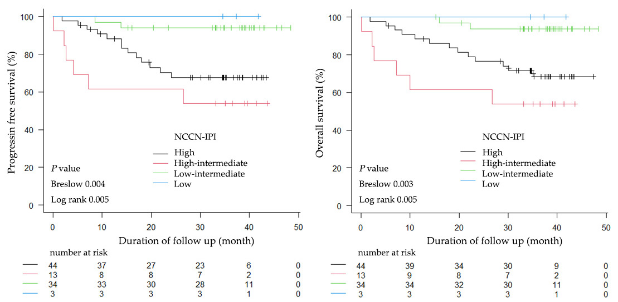Supplementary Figure 1. Kaplan-Meier survival curves of patients with DLBCL according to NCCN-IPI. Survival panels present the 3-year progression-free survival (PFS curves; left) and 3-year overall survival (OS curves, right). Statistical differences were calculated using the Breslow test and log rank test.
Abbreviations: NCCN-IPI, National Comprehensive Cancer Network-IPI

