Three-Dimensional Optical Trapping with a Low-NA Objective using a Flat-top Beam

Laurynas Lialys¹ and Shima Fardad^{1,2,*}
¹Department of Electrical Engineering & Computer Science, University of Kansas, Lawrence, 66045, USA
²I2S, Institute for Information Sciences, University of Kansas, Lawrence, 66045, USA
*sfardad@ku.edu

Extinction Cross-Section Calculation
For a sphere, the extinction cross-section C_{ext} can be expressed in terms of the Mie coefficients a_{n} and b_{n} as [1]:
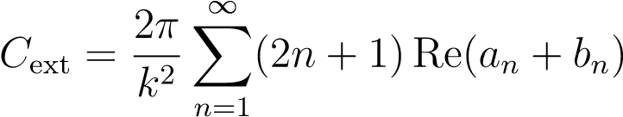
where k = 2πn₂/λ is the wavenumber in the surrounding medium, λ is the vacuum wavelength, and n₂ is the refractive index of the medium. The Mie coefficients a_{n} and b_{n} describe the electric and magnetic multipole scattering amplitudes for a sphere of radius r, relative refractive index m = n₁/n₂, and size parameter q = 2πRn₂/λ, where: r is the radius of the sphere. The number of terms N to retain in the Mie expansion is accurately estimated via the widely used empirical rule [2] N ≈ q + 4q^{1/3} + 2 rounded up to the next integer. This ensures accurate computation of the scattering and extinction efficiencies while maintaining computational efficiency. For our experiments, we considered polystyrene spheres (n₁ = 1.58) in water (n₂ = 1.33) illuminated at a wavelength of λ = 532nm. The number of coefficients to be retained is then N = 23. The computed coefficients are shown in Fig. S1. The resulting extinction cross-section is C_{ext} ≈ 2.2µm².

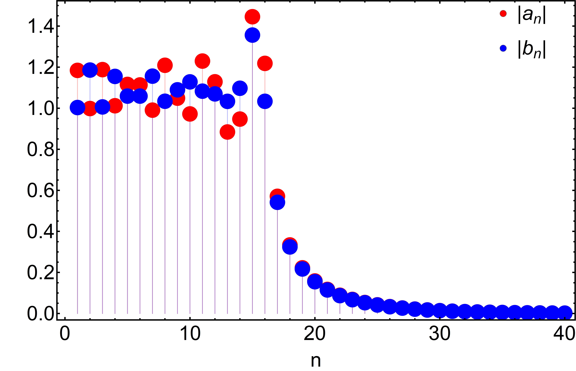
Fig. S1. Magnitude of Mie coefficients |a_{n}| and |b_{n}| as a function of size parameter x. Peaks correspond to electric and magnetic resonances of different orders.

References
- Craig F Bohren and Donald R Huffman. Absorption and scattering of light by small particles. John Wiley & Sons, 2008.
- Warren J Wiscombe. Mie scattering calculations: Advances in technique and fast, vectorspeed computer codes, volume 10. National Technical Information Service, US Department of Commerce, 1979.

