Supplementary Material

Tables
Supplementary Table S1. Estimated number of individuals with different medical conditions at risk for IPD in Region Västra Götaland, Sweden, during 2009–2019.
Disease | Individuals at risk for IPD (estimated) | Registry, Reference
Chronic obstructive pulmonary disease | 40,200 | [10]
Asthma | 152,700 | [11-14]
Malignancy | 33,300 | National Cancer Register (https://www.socialstyrelsen.se/en/statistics-and-data/)
Hematological | 7,300
Multiple myeloma | 650
Chronic lymphocytic leukemia | 900
Solid tumor¹ | 26,000
Lung¹ | 1,200
Breast¹ | 5,500
Colon¹ | 2,400
Prostate¹ | 7,700
Diabetes mellitus | 90,000 | Swedish National Diabetes Register (https://www.ndr.nu/)
Rheumatoid arthritis | 9,300 | [15]
Systemic lupus erythematosus | 1,060 | [16]
Hemodialysis² | 496 | Swedish Renal Registry (https://www.medscinet.net/snr/)
Peritoneal dialysis² | 167 | Swedish Renal Registry (https://www.medscinet.net/snr/)
HIV³ | 838 | InfCareHIV Registry (https://infcarehiv.se/)
MGUS⁴ | 36,400 | [17]
Asplenia | 1,640 | [18]
IPD, invasive pneumococcal disease; MGUS, monoclonal gammopathy of undetermined significance.
¹ For solid tumors the estimate is based on 5-year prevalence data.
² The average number of patients from 2009 to 2019 undergoing hemodialysis and peritoneal dialysis, respectively.
³ The number was calculated as the mean value of the prevalence numbers of HIV in the Region Västra Götaland for the years 2013–2019. Prevalence data for 2009–2012 were not available.
⁴ Based on a prevalence of 4.4% among adults aged 40 years and older.

Supplementary Table S2. Number of IPD episodes 2009–2019 with manifestations other than pneumonia or meningitis, with age distribution.
Other manifestations¹ | Number of episodes in different age groups
Other manifestations¹ | 0–1 yr. | 2–17 yrs. | 18–50 yrs. | 51–64 yrs. | 65–100 yrs. | All ages
Upper respiratory tract infections (URTI)
Acute otitis media and mastoiditis | 8 | 8 | 15 | 20 | 23 | 74
Sinusitis | 1 | 4 | 6 | 13 | 15 | 39
Other URTI | 1 | 0 | 1 | 4 | 11 | 17
Epiglottitis | 0 | 0 | 1 | 1 | 5 | 7
Skin, bone, joint and soft tissue
Septic arthritis | 0 | 0 | 4 | 19 | 57 | 80
Erysipelas, cellulitis, phlegmon, abscess | 2 | 1 | 3 | 10 | 7 | 23
Osteitis | 0 | 0 | 0 | 9 | 8 | 17
Intra-abdominal
Peritonitis | 0 | 0 | 4 | 2 | 3 | 9
Cholecystitis, cholangitis | 0 | 0 | 2 | 0 | 2 | 4
Mycotic aneurysm | 0 | 0 | 0 | 2 | 2 | 4
Intra-abdominal abscess | 0 | 0 | 0 | 2 | 1 | 3
Salpingitis, tubo-ovarian abscess | 0 | 0 | 2 | 0 | 0 | 2
Appendicitis | 0 | 0 | 1 | 0 | 0 | 1
Endocarditis | 0 | 0 | 2 | 9 | 7 | 18
Acute bronchitis | 0 | 0 | 1 | 1 | 7 | 9
Catheter-related infection | 0 | 3 | 0 | 0 | 0 | 3
Endophthalmitis | 0 | 0 | 0 | 0 | 3 | 3
Number of episodes | 11 | 15 | 39 | 77 | 141 | 283
IPD, invasive pneumococcal disease; URTI, upper respiratory tract infection.
¹ In 25 episodes, more than one manifestation other than pneumonia or meningitis was detectable.
Supplementary Table S3. Mortality in invasive pneumococcal disease for 1996–2019: Univariable model and multivariable logistic regression model.
Covariate | Crude/Unadjusted |  |  | Adjusted
Covariate | OR (95% CI) | P value |  | OR (95% CI) | P value
Study period
Pre PCV-vaccine period (1996–2008) | 1.0 (Ref) |  |  | 1.0 (Ref)
Post PCV-vaccine period (2009–2019) | 1.4 (1.1–1.6) | <0.001 |  | 1.1 (0.9–1.3) | 0.32
Age group, yrs.
0–1 | 1.0 (Ref) |  |  | 1.0 (Ref)
2–17 | 0.9 (0.2–3.7) | 0.89 |  | 0.8 (0.2–3.5) | 0.81
18–50 | 1.1 (0.4–3.1) | 0.90 |  | 0.8 (0.3–2.2) | 0.61
51–64 | 2.2 (0.8–6.1) | 0.13 |  | 1.3 (0.5–3.7) | 0.60
65– | 6.9 (2.6–18.8) | <0.001 |  | 4.4 (1.6–12.1) | 0.004
Sex
Female | 1.0 (Ref) |  |  | 1.0 (Ref)
Male | 1.3 (1.1–1.5) | 0.007 |  | 1.3 (1.0–1.5) | 0.14
Predisposing factors¹, No
0 | 1.0 (Ref) |  |  | 1.0 (Ref)
1 | 3.0 (2.3–3.9) | <0.001 |  | 2.3 (1.7–3.0) | <0.001
2 | 3.3 (2.5–4.4) | <0.001 |  | 2.2 (1.7–3.0) | <0.001
3+ | 4.9 (3.6–6.6) | <0.001 |  | 3.0 (2.2–4.2) | <0.001
ICU care
Not admitted | 1.0 (Ref) |  |  | 1.0 (Ref)
Admitted | 2.4 (2.0–2.9) | <0.001 |  | 2.9 (2.4–3.6) | <0.001
Unknown² | 1.0 (0.8–1.4) | 0.89 |  | 1.4 (1.0–1.9) | 0.07
The multivariate model included all variables in the table.
ICU, intensive care unit; OR, odds ratio; PCV, pneumococcal conjugate vaccine.
¹ Smoking was excluded from predisposing factors due to poor data quality in the study period 1996–2008.

² Data missing in six episodes.

Figures
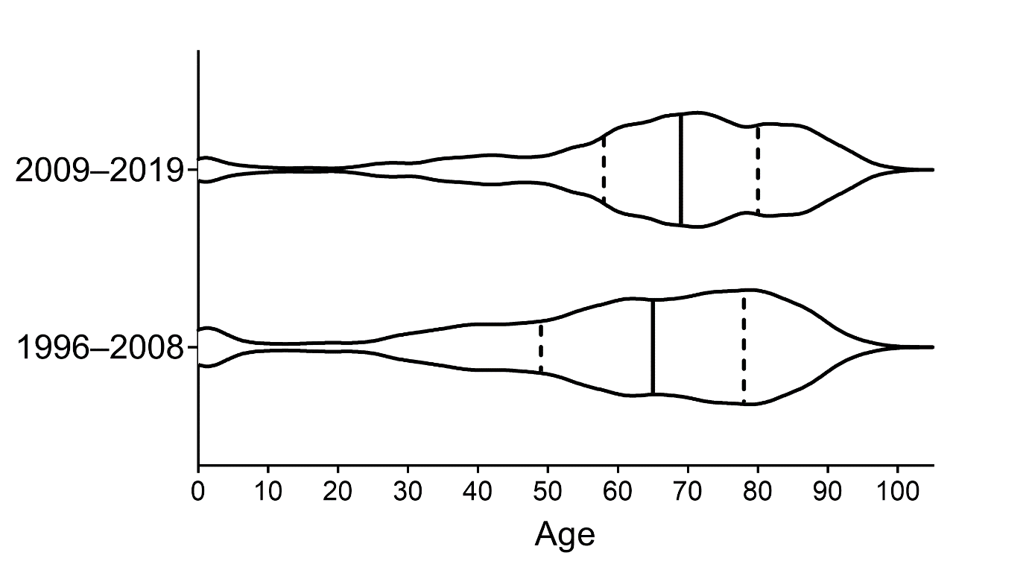
Supplementary Fig. S1. Age structure in invasive pneumococcal disease per study period (1996–2008 vs. 2009–2019). Data shown as violin plot where density indicates the number of episodes. Median marked as solid vertical line, 25th and 75th quartiles marked as dotted vertical lines.

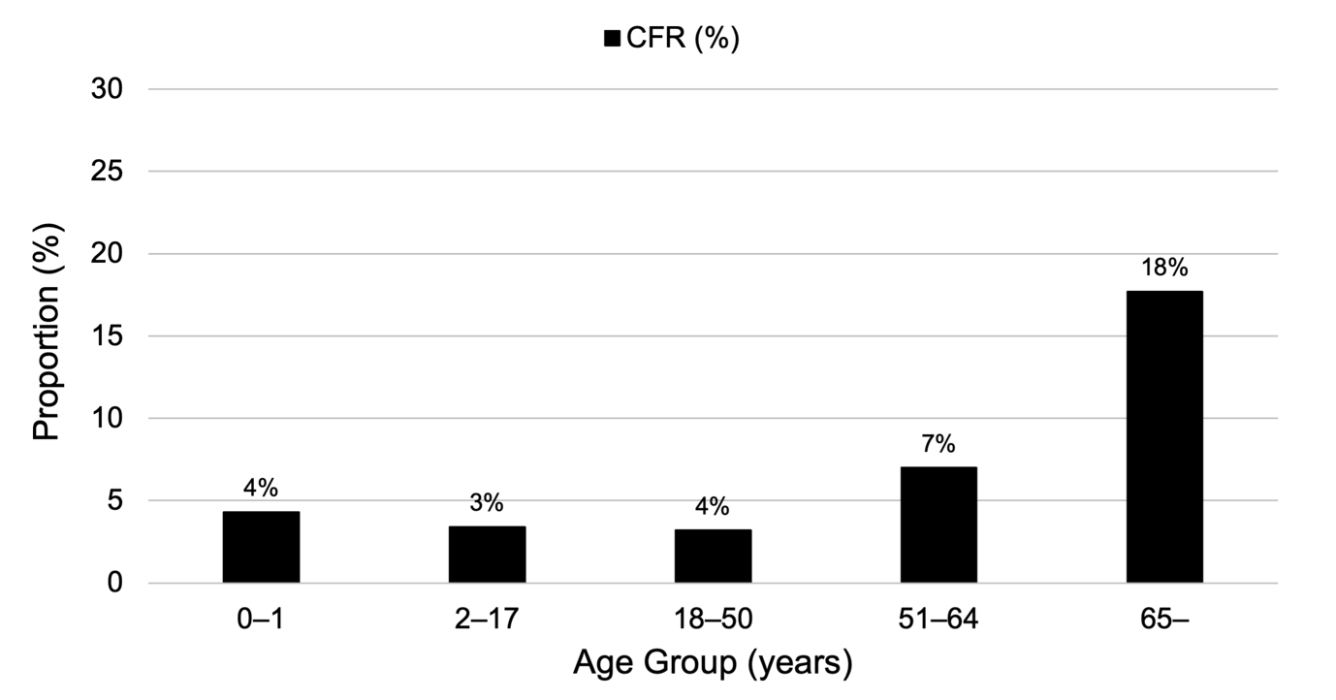
Supplementary Fig. S2. Case fatality rate (CFR) in different age groups with invasive pneumococcal disease during 2009–2019.

