Supplementary Material
The impact of coffee genotype and processing method on the sensory and metabolite profiles of Robusta coffee (Coffea canephora).
Robrecht Bollen^{1,2,}*, Olga Rojo-Poveda³, Benjamin Ntumba Katshela⁴, Ebele Aaron Tshimi⁵, Caroline Stévigny³, Cédric Delporte^{3,6}, Filip Vandelook^{1,2}, Piet Stoffelen¹, Olivier Honnay²
¹ Meise Botanic Garden, 1860 Meise, Belgium
² Plant Conservation and Population Biology, Department of Biology, University of Leuven, 3001 Leuven, Belgium
³ Department of Research in Drug Development (RD3), Pharmacognosy, Bioanalysis and Drug Discovery Unit, Faculty of Pharmacy, Université libre de Bruxelles, 1050 Brussels, Belgium
⁴ University of Kisangani, Kisangani, Democratic Republic of the Congo
⁵ Institut National des Etudes et Recherches Agronomique (INERA), Yangambi, Democratic Republic of the Congo
⁶ Analytical Platform of the Faculty of Pharmacy (APFP), Faculty of Pharmacy, Université libre de Bruxelles, 1050 Brussels, Belgium
* Correspondence: robrecht.bollen@plantentuinmeise.be

Workflow4Metabolomics workflow repositories
Roasted coffee
https://workflow4metabolomics.usegalaxy.fr/u/olga.rojopoveda/h/coffeebridgeprocessingroastedcoffee
Green beans
https://workflow4metabolomics.usegalaxy.fr/u/olga.rojopoveda/h/coffeebridgeprocessinggreenbeans

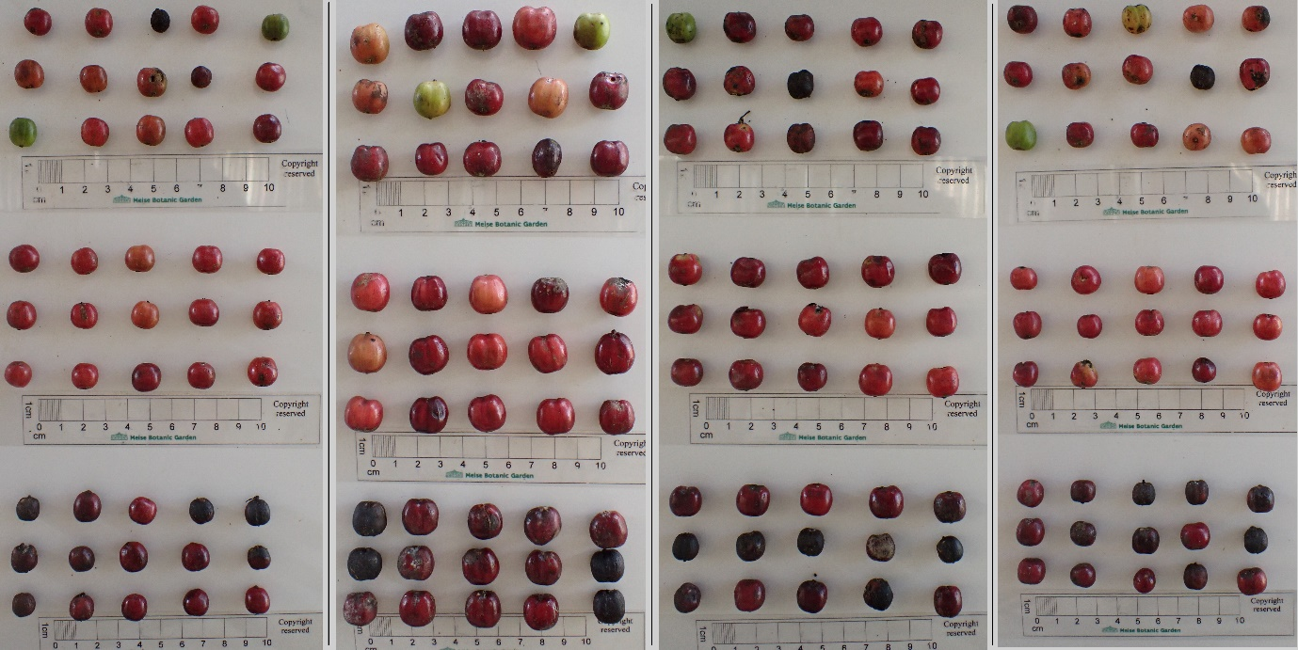
Fig. S1 Samples of coffee cherries from the strip-picked (top), ripe (middle), and overripe (bottom) harvesting methods for the genotypes G0002, G0003, G0005, and G0120 from left to right, respectively.

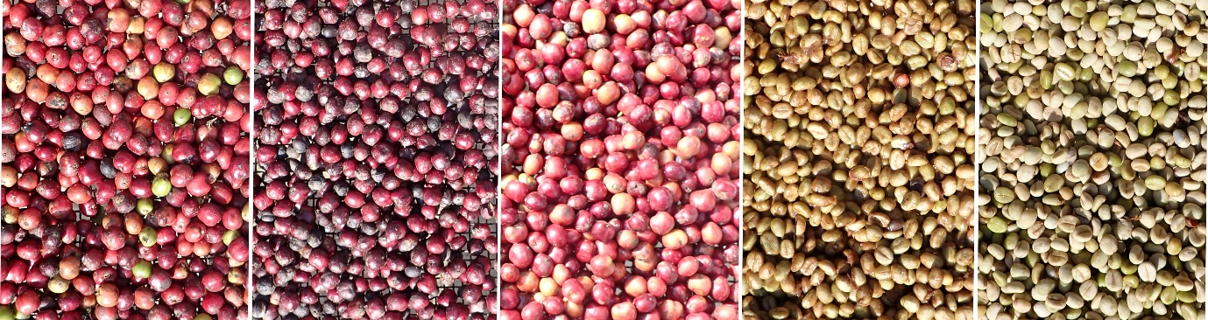
Fig. S2 Coffee cherry processing methods Strip-picked, Overripe, Natural, Pulped, and Washed, from left to right, respectively, for genotype G0005 before sun drying.
Fig. S3 (pdf) Extension of the Standard Fine Robusta cupping form allowing the detailed recording of sensory descriptors.

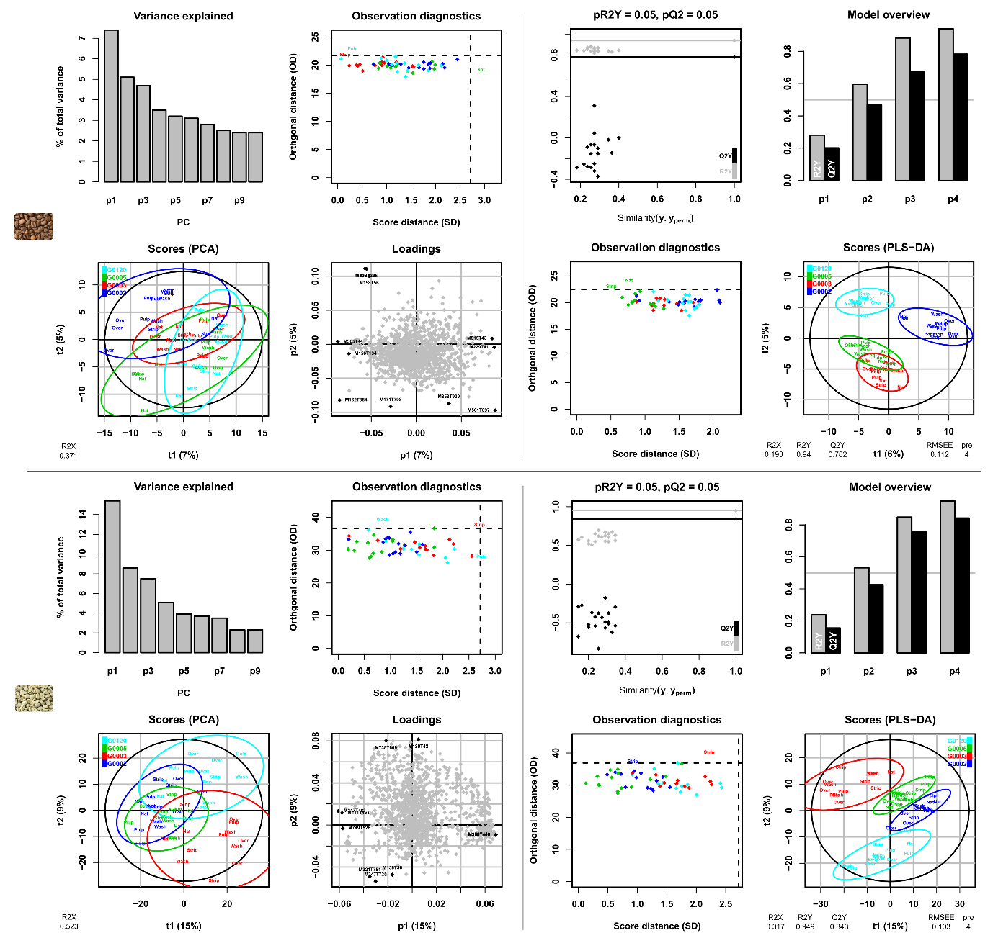
Fig. S4 PCA (left) and PLS-DA (right) models of the genotype classification. Roasted coffee models top row and green beans models bottom row. Genotype classes are G0002 (dark blue), G0003 (red) and, G0005 (green), G0120 (light blue). Processing methods are Strip-picked (Strip), Overripe (Over), Natural (Nat), Pulped (Pulp), and Washed (Wash). The observation diagnostic plot shows the distances within and orthogonal to the selected score plane. The variance explained by the first two principal components and latent variables is shown for PCA and PLS-DA, respectively. The loadings plot indicates the variable names of the six metabolite features with the most extreme values for the first two principal components. For PLS-DA modeling, an additional diagnostic plot shows the Q2Y and R2Y values from the model (horizontal lines) compared with the values from the models obtained after random permutations of the y response (dots).

