Supporting Information
MXene Templated Assembly of Hierarchical Al/CuO/V₂C Nanothermite with Excellent Energy Release Efficiency and Highly Tunable Performance
Momang Tian ª, Ke-Juan Meng ª, Yuxiang Li ª, Iftikhar Hussain ª, Kaili Zhang ^{a,*}
ª Department of Mechanical Engineering, City University of Hong Kong, 83 Tat Chee Avenue, Hong Kong, China
Corresponding author: kaizhang@cityu.edu.hk (Prof. Kaili Zhang)

Table S1. The composition of as-prepared samples.
 | Al (mg) | CuO (mg) | V₂C (mg) | V (mg) | Graphene Oxide (GO) (mg) | Equivalent Ratio (Φ) | Amount of V₂C (wt%)
Al/CuO | 22.7 | 77.3 | 0 | 0 | 0 | 1.3 | 0
Al/V₂C | 20.4 | 0 | 10.0 | 0 | 0 | - | 33.0
CuO/V₂C | 0 | 69.6 | 10.0 | 0 | 0 | - | 12.6
Al/CuO/V₂C | 2.9 | 16.1 | 1.0 | 0 | 0 | 0.8 | 5.0
Al/CuO/V₂C | 3.6 | 15.5 | 1.0 | 0 | 0 | 1.0 | 5.0
Al/CuO/V₂C | 22.5 | 76.5 | 1.0 | 0 | 0 | 1.3 | 1.0
Al/CuO/V₂C | 22.1 | 75.4 | 2.5 | 0 | 0 | 1.3 | 2.5
Al/CuO/V₂C | 21.6 | 73.4 | 5.0 | 0 | 0 | 1.3 | 5.0
Al/CuO/V₂C | 21.0 | 71.5 | 7.5 | 0 | 0 | 1.3 | 7.5
Al/CuO/V₂C | 20.4 | 69.6 | 10.0 | 0 | 0 | 1.3 | 10.0
Al/CuO/V₂C | 3.0 | 13.0 | 4.0 | 0 | 0 | 1.3 | 20.0
Al/CuO/V₂C | 4.8 | 14.2 | 1.0 | 0 | 0 | 1.5 | 5.0
Al/CuO/V₂C | 5.5 | 13.5 | 1.0 | 0 | 0 | 1.8 | 5.0
Al/CuO/V/GO | 20.4 | 69.6 | 0 | 9.0 | 1.0 | 1.3 | 10.0

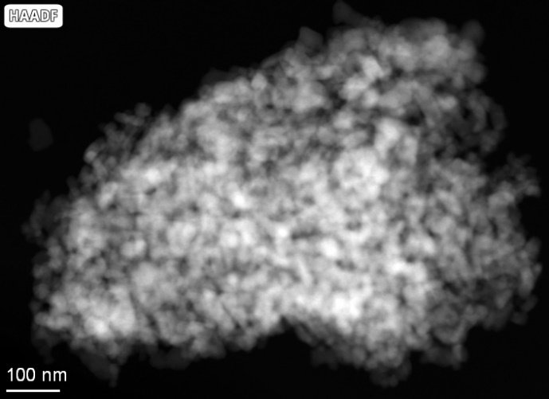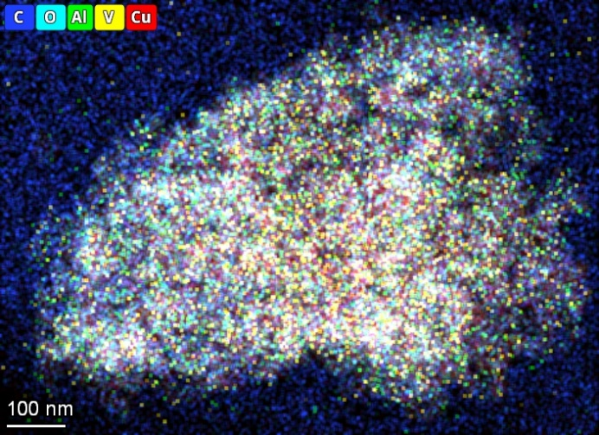
Figure S1. HAADF-STEM images of CuO/V₂C. Left: HAADF image of CuO/V₂C; right: mixing of the elemental mapping results for C, O, Al, V, and Cu.

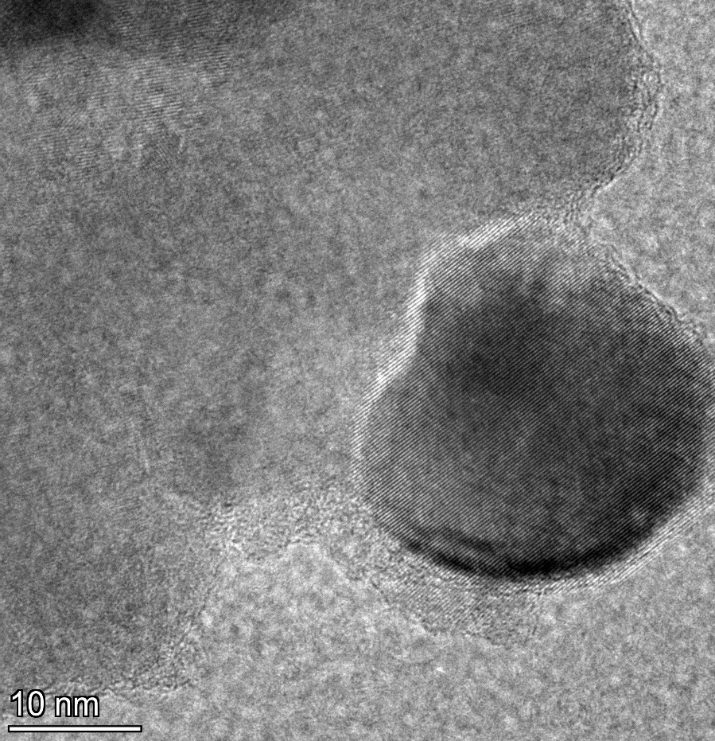
V₂C (0-110)
d=0.25 nm
CuO (1-11)
d=0.24 nm
Figure S2. High-resolution TEM image of CuO/V₂C. Interplanar distances of the V₂C (0 -1 1 0) plane and CuO (1 -1 1) plane are 0.25 nm and 0.24 nm respectively. The red dashed line represents the interface.

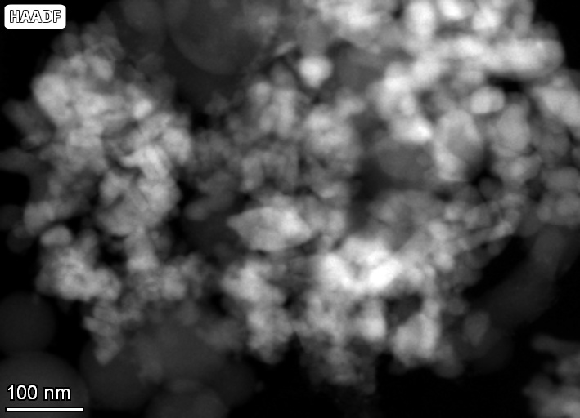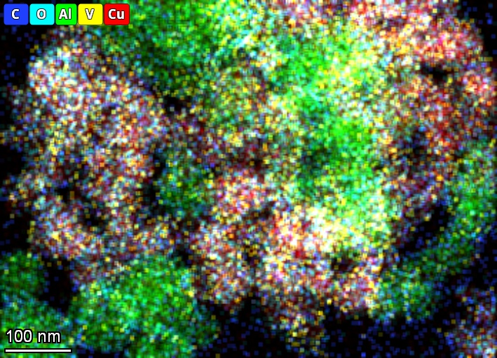
Figure S3. HAADF-STEM images of Al/CuO/V₂C with a 10 wt% concentration of V₂C. Left: HAADF image of CuO/V₂C; right: mixing of the elemental mapping results for C, O, Al, V, and Cu.

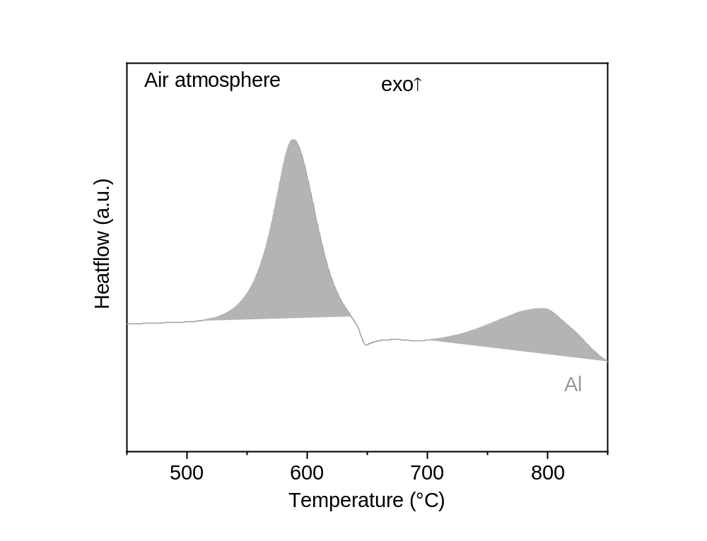
Figure S4. The DSC curve of Al in air atmosphere. Exothermal peaks are upward, and the heating rate is 10 ℃/min.

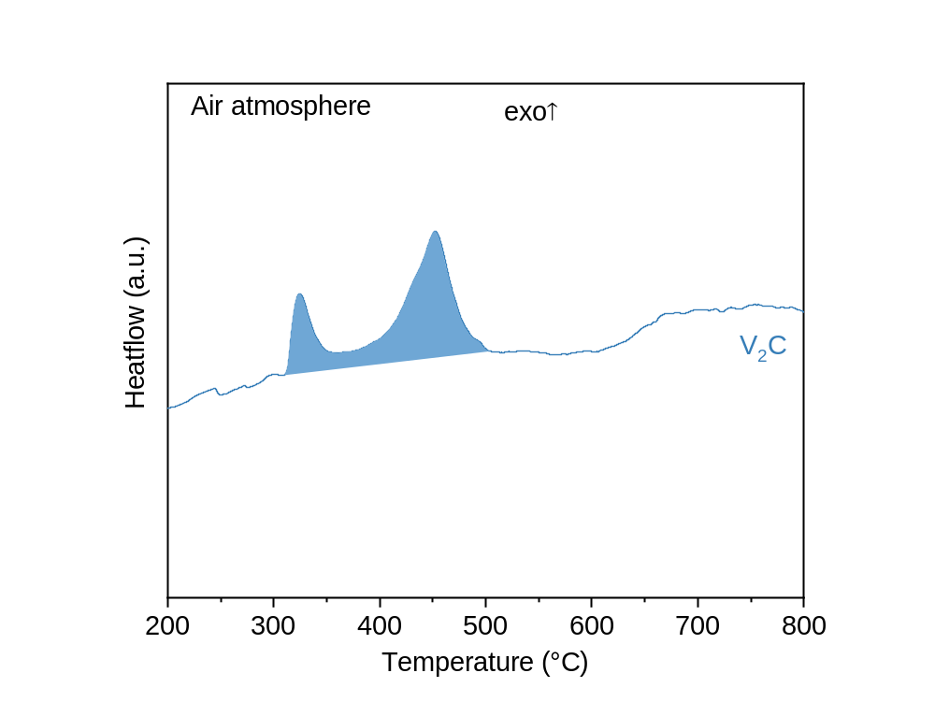
Figure S5. The DSC curve of V₂C in air atmosphere. Exothermal peaks are upward, and the heating rate is 10 ℃/min.

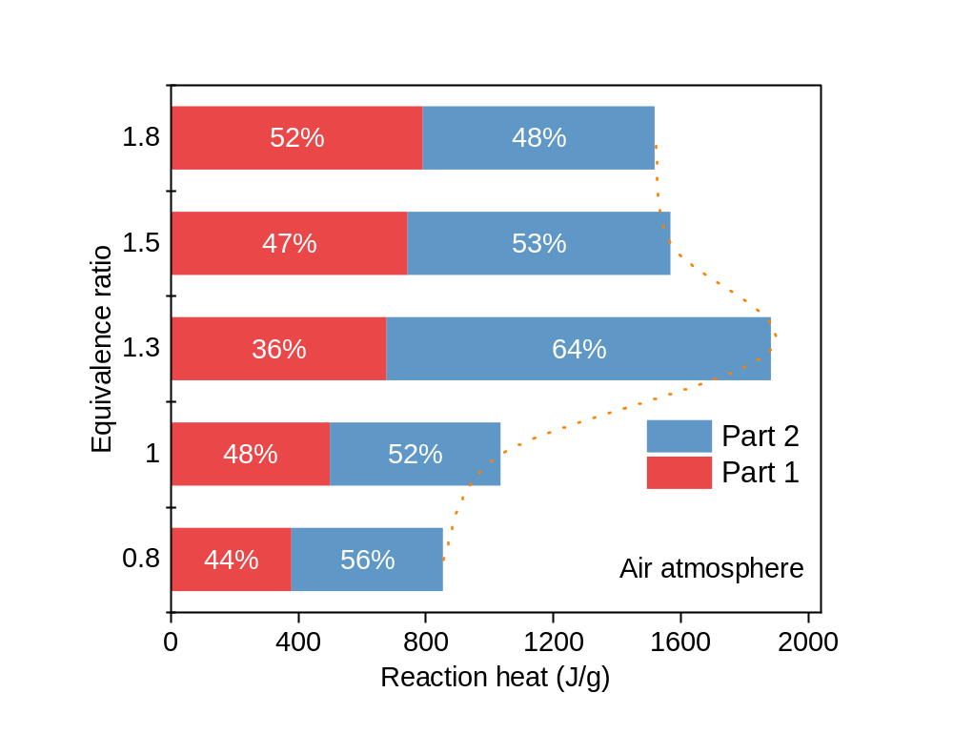
Figure S6. The reaction heat of Al/CuO/V₂C samples (5 wt% V2C content) with different equivalence ratios in air atmosphere. Part 1 and Part 2 represent the first and second exothermic peaks respectively.

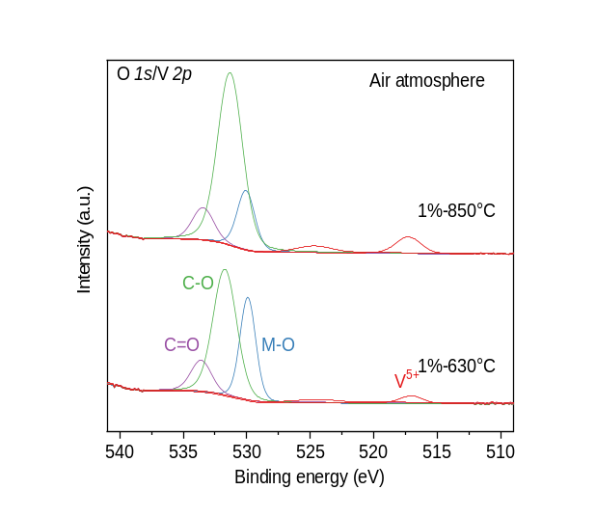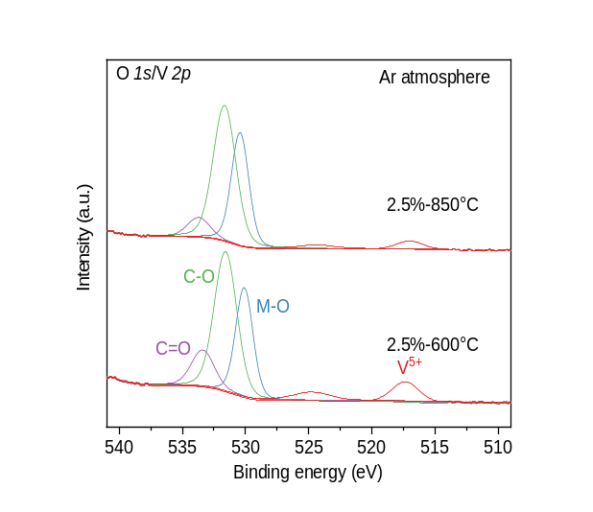
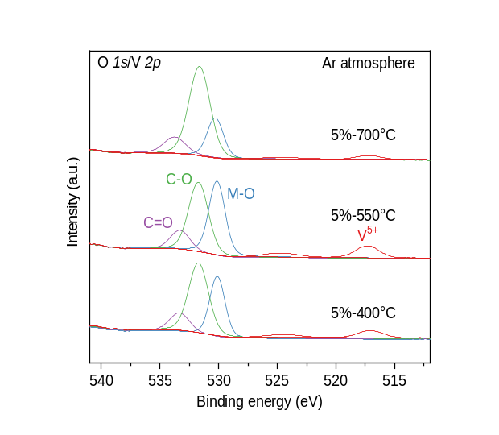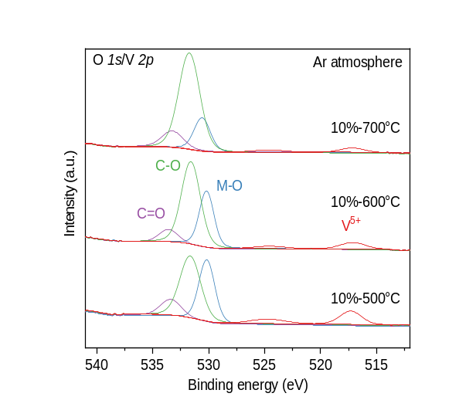
Figure S7. Deconvoluted XPS peaks at O 1s/V 2p region for reaction products of Al/CuO/V₂C with different V₂C content heating at different temperatures, in air or argon atmosphere. The original data and fitted curves are hidden for clarity.

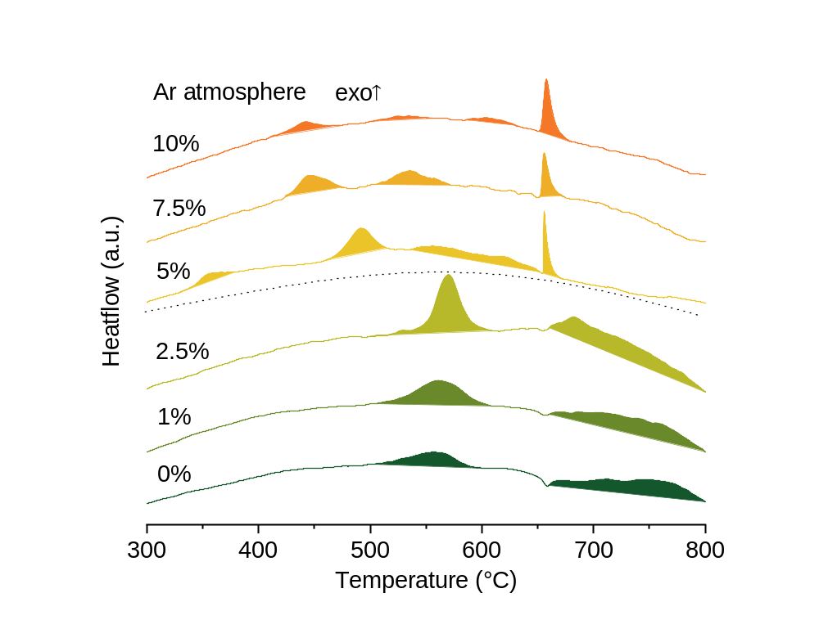
Figure S8. DSC curves of Al/CuO/V₂C samples with different V₂C concentrations in argon atmosphere. Exothermal peaks are upward, and the heating rate is 10 ℃/min.

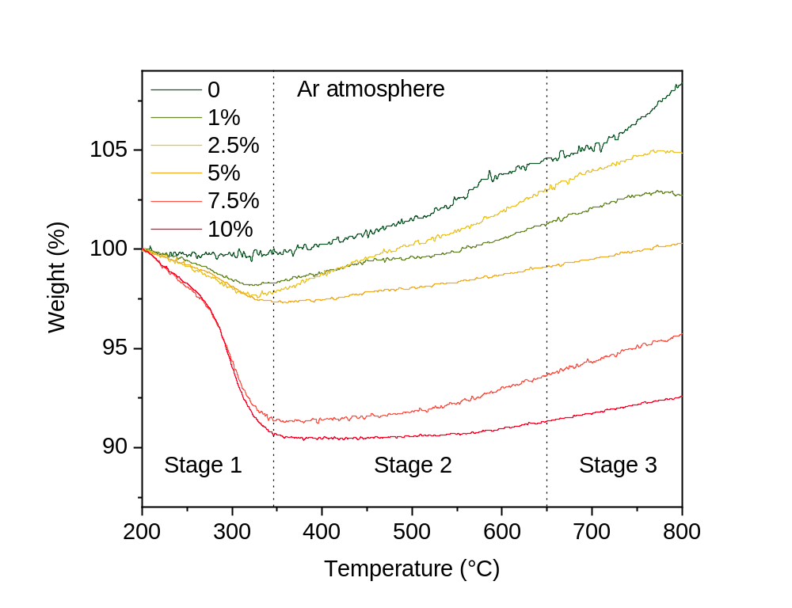
Figure S9. The TG curves of Al/CuO/V₂C samples with different V₂C concentrations in argon atmosphere. The samples are identical to those in the DSC test shown in Figure S4.

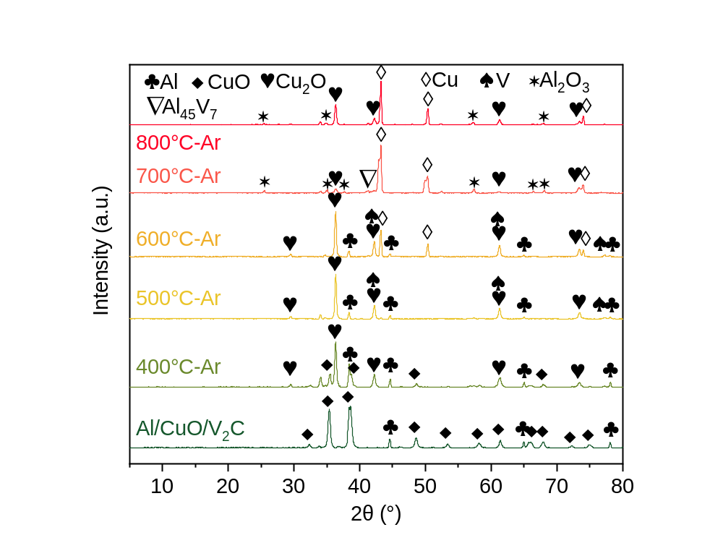
Figure S10. The PXRD curves of reaction products of Al/CuO/V₂C (10 wt% V₂C content) heating at different temperatures in argon atmosphere.

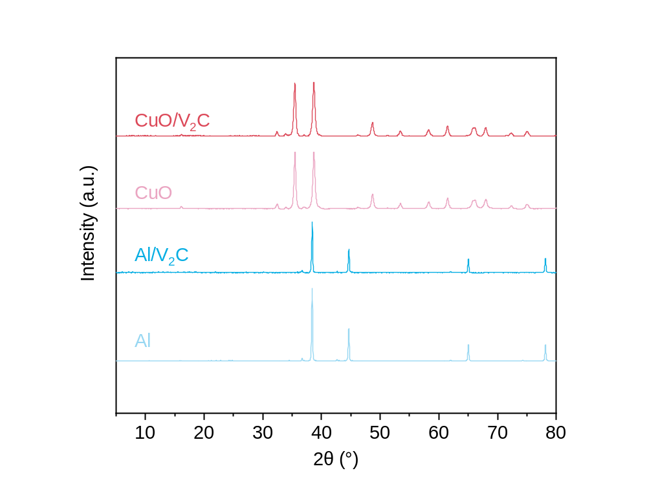
Figure S11. The PXRD comparison of Al/V₂C and CuO/V₂C samples with Al and CuO ingredients.

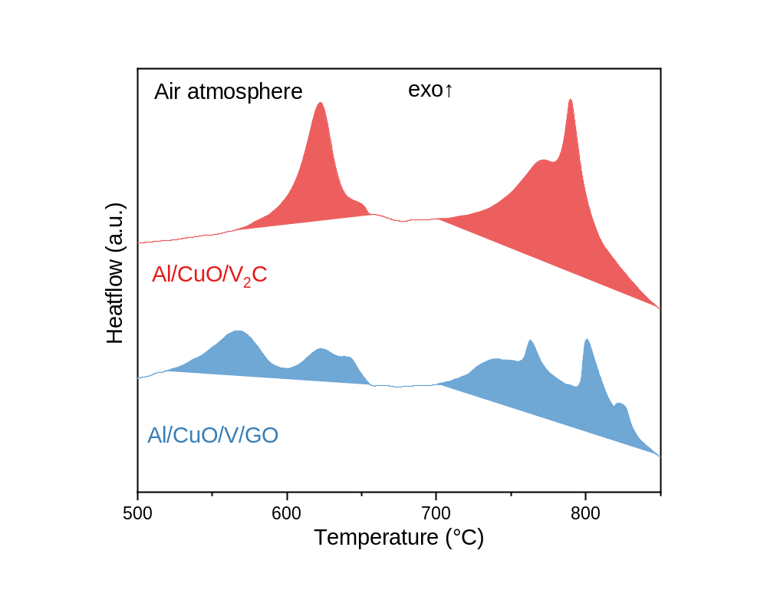
Figure S12. The comparison of DSC curves from Al/CuO/V₂C (10 wt% V₂C content) and Al/CuO/V/GO control group in air atmosphere.

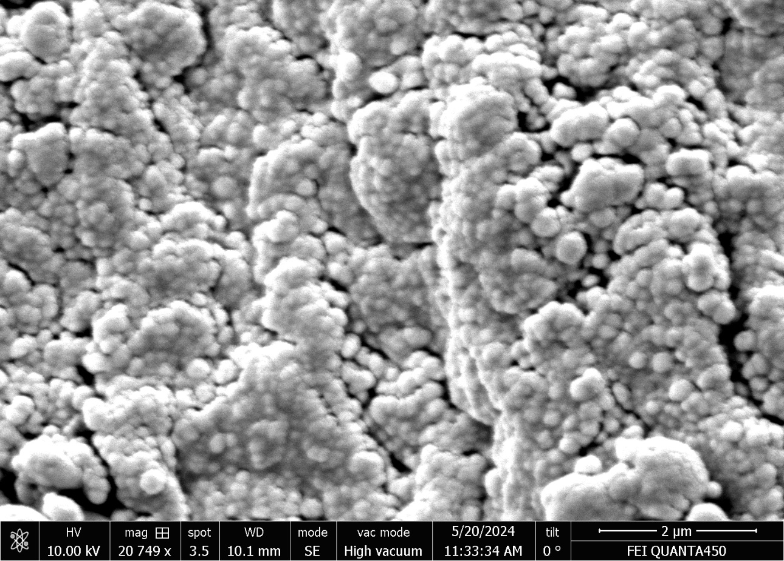
2μm
Figure S13. The SEM image of nano Al powder.

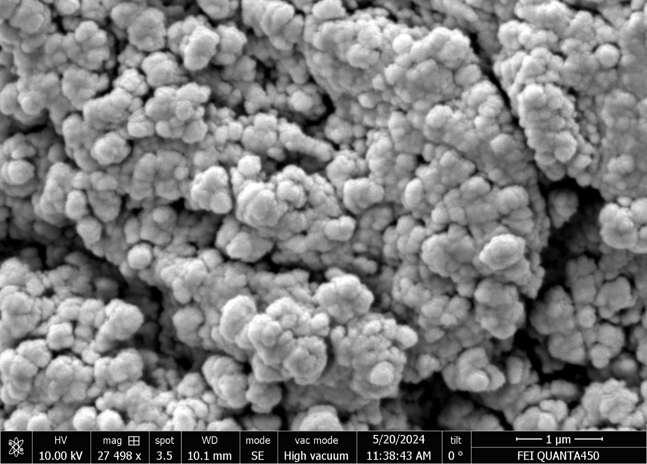
1μm
Figure S14. The SEM image of nano CuO powder.

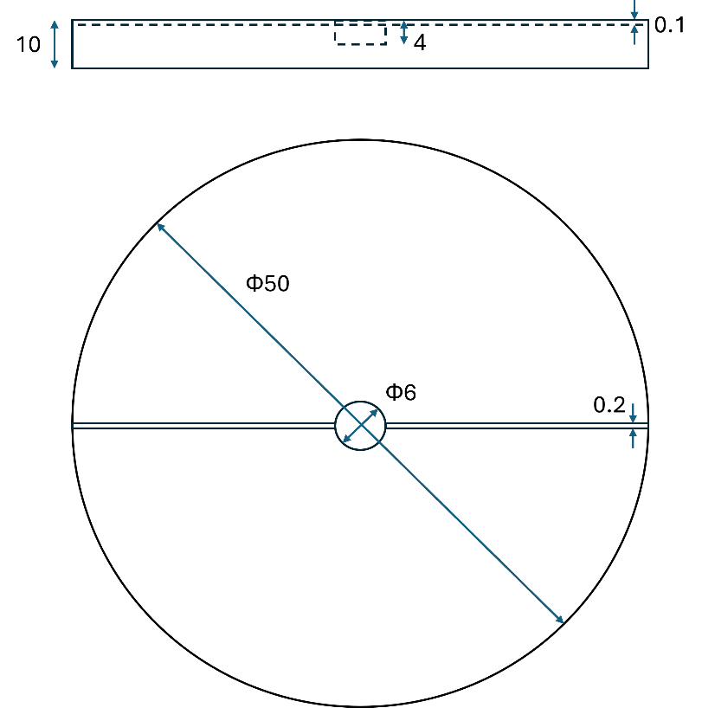
Figure S15. The geometry of the PTFE mold used in the open burn test. Unit: mm.

