Online Resource
Genetic assessment of subspecies composition in bean goose (Anser fabalis) harvest in Sweden, Finland and Estonia
European Journal of Wildlife Research
Johanna Honka¹, Adriaan de Jong², Erika Jumppanen³, Mikko Alhainen⁶, Antti Piironen^{5,6}

¹ Ecology and Genetics Research Unit, University of Oulu, Oulu 90014, Finland. ORCID: 0000-0003-2536-5869
² Department of Wildlife, Fish, and Environmental Studies, Swedish University of Agricultural Sciences, SE 901 83 Umeå, Sweden. ORCID: 0000-0001-8034-912X
³ Department of Forest Science, University of Helsinki, Latokartanonkaari 7, 00014 University of Helsinki, Finland
⁴ Finnish Wildlife Agency, Sompiontie 1, 00730 Helsinki, FI
⁵ Department of Biology, University of Turku, Vesilinnantie 5, 20500 Turku, Finland
⁶ Department of Biology, University of Saskatchewan, 112 Science Place, S7N 5E2 Saskatoon, Saskatchewan, Canada. ORCID: 0000-0003-1986-9593

Corresponding author:
Johanna Honka
e-mail: johanna.honka@oulu.fi

Table S1. Goose species used for reference, GenBank accession numbers and their citation used in haplotype network analyses.
Species common name | Species name | GenBank accession number | Reference
Bean goose | Anser fabalis | AF159951 | Ruokonen et al. 2000
Bean goose | Anser fabalis | EU186807-EU186812, EU186827 | Ruokonen et al. 2008
Bean goose | Anser fabalis | MH491806-MH491819 | Honka et al. 2017
Bean goose | Anser fabalis | MH491826, MH491827 | Honka et al. 2018
Bean goose | Anser fabalis | MT023340-MT023341 | Honka et al. 2022
Pink-footed goose | Anser brachyrhynchus | AF159952-AF159954 | Ruokonen et al. 2000
Greater white-fronted goose | Anser albifrons | AF159957-AF159958 | Ruokonen et al. 2000
Numt |  | AF159970 | Ruokonen et al. 2000

References:
Honka J, Baini S, Searle JB, et al (2022) Genetic assessment reveals inbreeding, possible hybridization, and low levels of genetic structure in a declining goose population. Ecol Evol 12. https://doi.org/10.1002/ece3.8547
Honka J, Heino MT, Kvist L, et al (2018) Over a thousand years of evolutionary history of domestic geese from Russian archaeological sites, analysed using ancient DNA. Genes (Basel) 9. https://doi.org/10.3390/genes9070367
Honka J, Kvist L, Heikkinen ME, et al (2017) Determining the subspecies composition of bean goose harvests in Finland using genetic methods. Eur J Wildl Res 63:19. https://doi.org/10.1007/s10344-017-1077-6
Ruokonen M, Kvist L, Lumme J (2000) Close relatedness between mitochondrial DNA from seven Anser goose species. J Evol Biol 13:532–540. https://doi.org/10.1046/j.1420-9101.2000.00184.x
Ruokonen M, Litvin K, Aarvak T (2008) Taxonomy of the bean goose - pink-footed goose. Mol Phylogenet Evol 48:554–562. https://doi.org/10.1016/j.ympev.2008.04.038

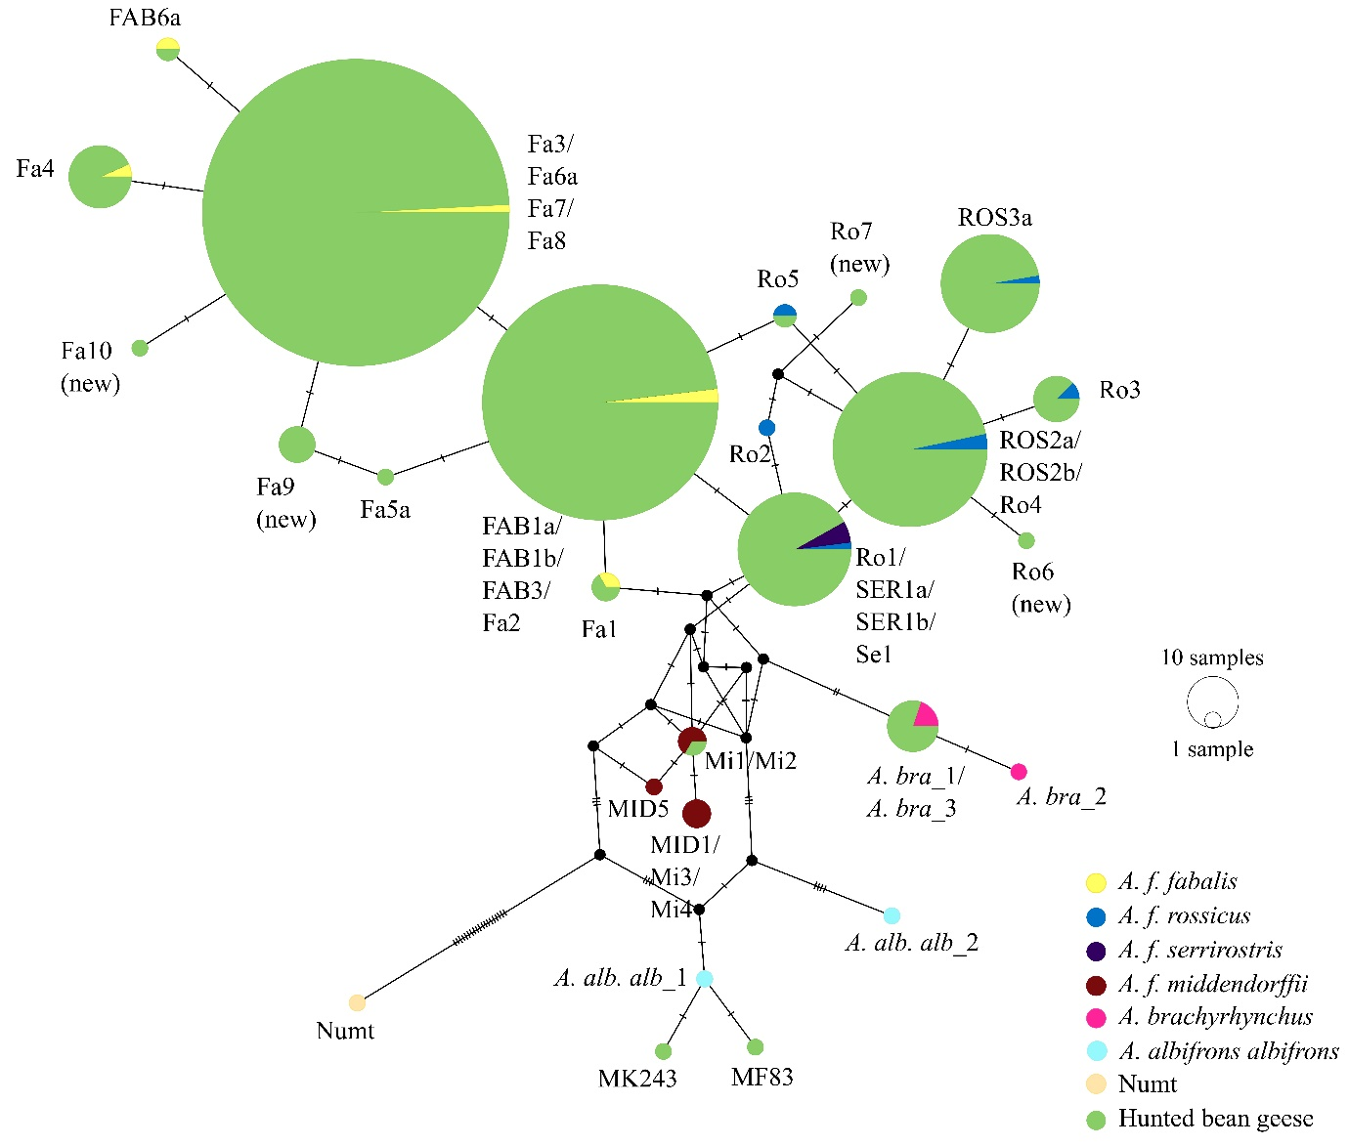
Figure S1. Median joining haplotype network for harvested bean geese from Sweden, Finland and Estonia (hunting seasons 2017/18 – 2019/20; n = 779), bean goose subspecies (Anser fabalis fabalis, A. f. rossicus, A. f. serrirostris and A. f. middendorffii), pink-footed geese (A. brachyrhynchus) and greater white-fronted geese (A. albifrons) indicated by different colours. Individuals with heteroplasmy were included to assign subspecies (n = 23), but this resulted in merging of some haplotypes compared to Fig.1 in the main text. To root the haplotype network a sequence of Numt (accession number: AF159970; nuclear sequence of mitochondrial origin) was used. The frequency of each haplotype is indicated with the size of the circle and the number of mutational differences is indicated with tick marks across branches. Black circles indicate unsampled haplotypes needed to construct the median haplotype network. Haplotypes which were identical in the studied DNA region but differ based on the whole control region sequence are indicated with forward slashes between haplotype names.

Figure S2. Median joining haplotype network for harvested bean geese from Sweden (hunting seasons 2017/18 – 2018/19; n = 602), bean goose subspecies (Anser fabalis fabalis, A. f. rossicus, A. f. serrirostris and A. f. middendorffii), pink-footed geese (A. brachyrhynchus) and greater white-fronted geese (A. albifrons) indicated by different colours. Individuals with heteroplasmy have been omitted. To root the haplotype network, a sequence of Numt (accession number: AF159970; nuclear sequence of mitochondrial origin) was used. The frequency of each haplotype is indicated with the size of the circle and the number of mutational differences is indicated with tick marks across branches. Black circles indicate unsampled haplotypes needed to construct the median haplotype network. Haplotypes which were identical in the studied DNA region but differ based on the whole control region sequence are indicated with forward slashes between haplotype names.
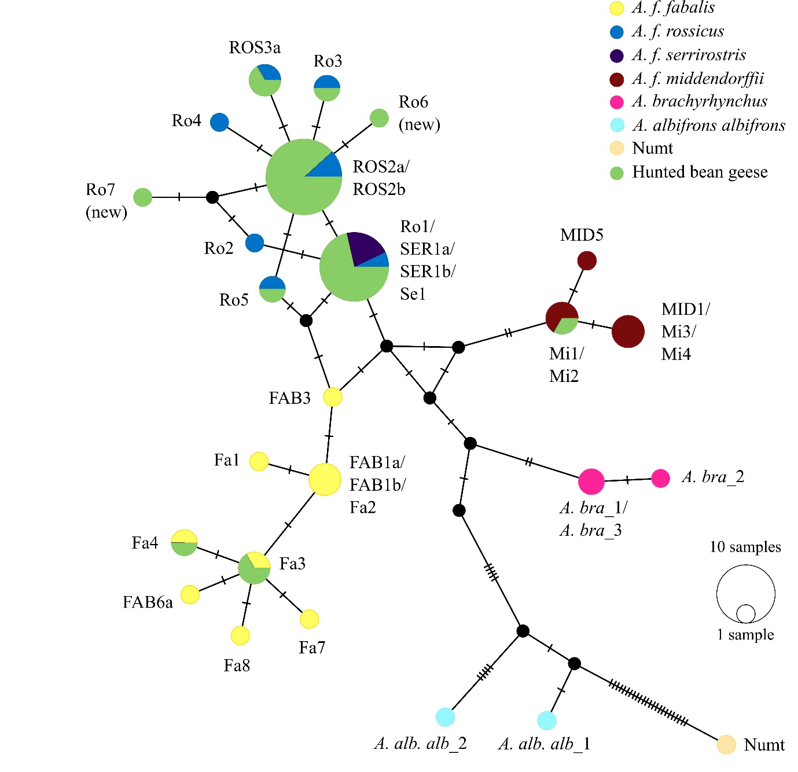
Figure S3. Median joining haplotype network for harvested bean geese from Finland (hunting seasons 2018/19 – 2019/20; n = 35), bean goose subspecies (Anser fabalis. fabalis, A. f. rossicus, A. f. serrirostris and A. f. middendorffii), pink-footed geese (A. brachyrhynchus) and greater white-fronted geese (A. albifrons) indicated by different colours. Individuals with heteroplasmy have been omitted. To root the haplotype network a sequence of Numt (accession number: AF159970; nuclear sequence of mitochondrial origin) was used. The frequency of each haplotype is indicated with the size of the circle and the number of mutational differences is indicated with tick marks across branches. Black circles indicate unsampled haplotypes needed to construct the median haplotype network. Haplotypes which were identical in the studied DNA region but differ based on the whole control region sequence are indicated with forward slashes between haplotype names.

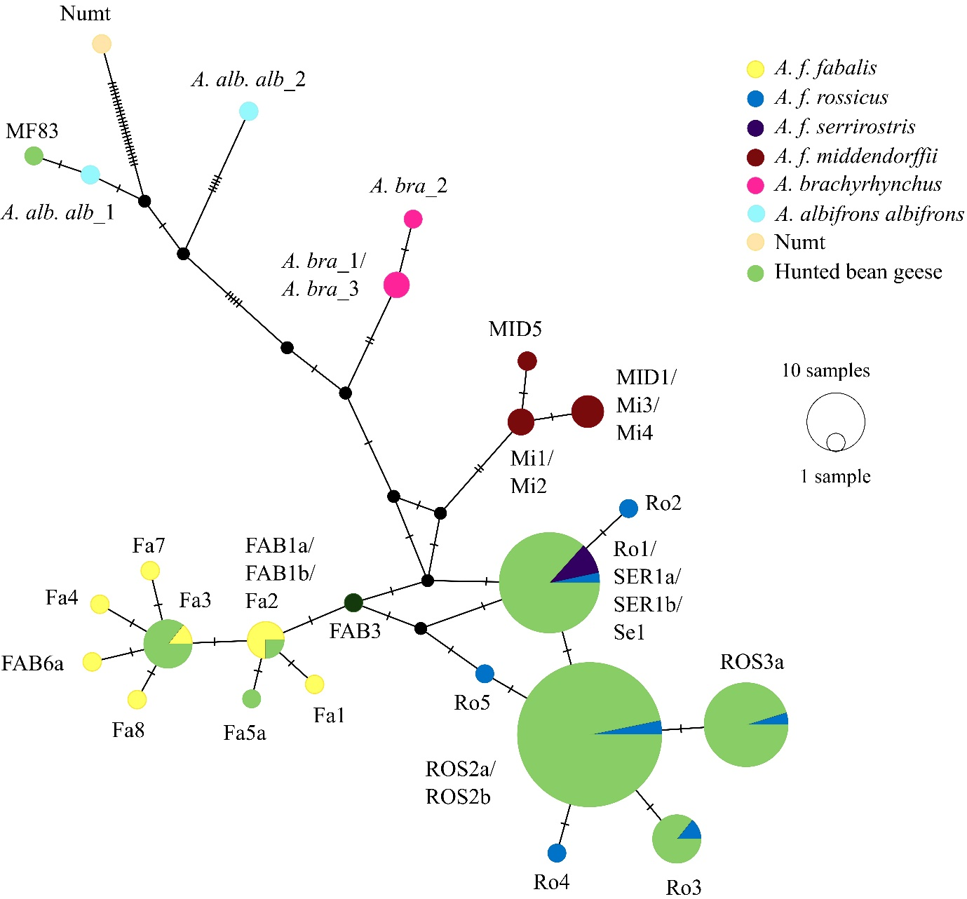
Figure S4. Median joining haplotype network for harvested bean geese from Estonia (hunting seasons 2018/19 – 2019/20; n = 121), bean goose subspecies (Anser fabalis. fabalis, A. f. rossicus, A. f. serrirostris and A. f. middendorffii), pink-footed geese (A. brachyrhynchus) andgreater white-fronted geese (A. albifrons) indicated by different colours. Individuals with heteroplasmy have been omitted. To root the haplotype network a sequence of Numt (accession number: AF159970; nuclear sequence of mitochondrial origin) was used. The frequency of each haplotype is indicated with the size of the circle and the number of mutational differences is indicated with tick marks across branches. Black circles indicate unsampled haplotypes needed to construct the median haplotype network. Haplotypes which were identical in the studied DNA region but differ based on the whole control region sequence are indicated with forward slashes between haplotype names.

