Supplementary data
List of abbreviations:
AA aortic valve atresia
AS aortic valve stenosis
ASD atrial septal defect
AVB atrioventricular block
AVSD atrioventricular septal defect
CHD congenital heart disease
CMA chromosomal microarray
CoA aortic coarctation
DCM dilated cardiomyopathy
DORV double outlet right ventricle
d-TGA dextro - transposition of the great arteries
EFE endocardial fibro-elastosis
HCM hypertrophic cardiomyopathy
HLHS hypoplastic left heart syndrome
ICSI intracytoplasmic sperm-injection
IVF in vitro fertilization
KCA pediatric cardiology
li VCS left vena cava superior
L-TGA levo - transposition of the great arteries
LVOTO left ventricular outflow tract obstruction
LVNC left ventricular noncompaction
MA mitral valve atresia
MS mitral valve stenosis
NGS next generation sequencing
NIPS noninvasive prenatal screening
NS-CHD non-syndromic congenital heart disease
PA pulmonary valve atresia
PAPVR/PAPVU partial abnormal pulmonary venous return
PMA postmenstrual age
PS pulmonary valve stenosis
RAA right turning aortic arch
RV right ventricle
RVTO right ventricular outflow tract obstruction
S-CHD syndromic congenital heart disease
SUA single umbilical artery
SVT supraventricular tachycardia
TA tricuspid valve atresia
TAPVR/TAPVU total abnormal pulmonary venous return
TOF tetralogy of Fallot
TS tricuspid valve stenosis
VSD ventricular septal defect
VUS variant of unknown significance
WES whole exome sequencing
WGS whole genome sequencing
WPW Wolff-Parkinson-White
Supplementary Fig. 1. Flowchart exclusion and outcome fetal files
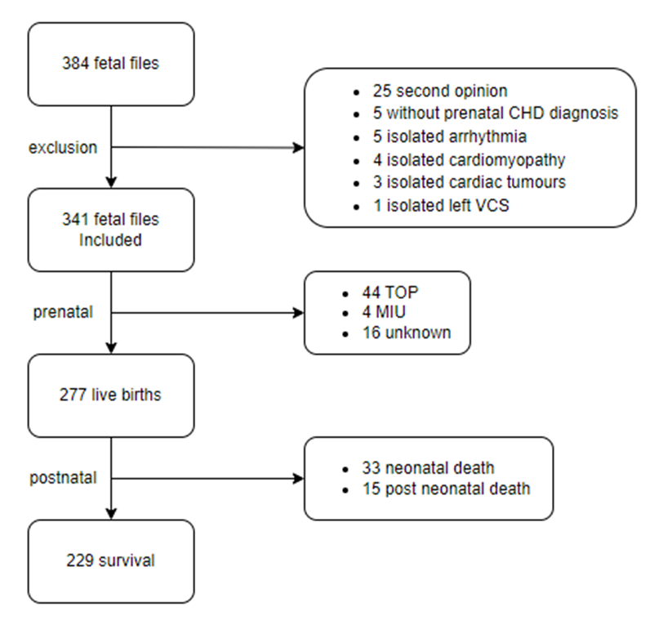
Supplementary Fig. 2. Maternal age at the time of CHD diagnosis. The average maternal age at the time of CHD diagnosis was 30.93 years (range 18-44).
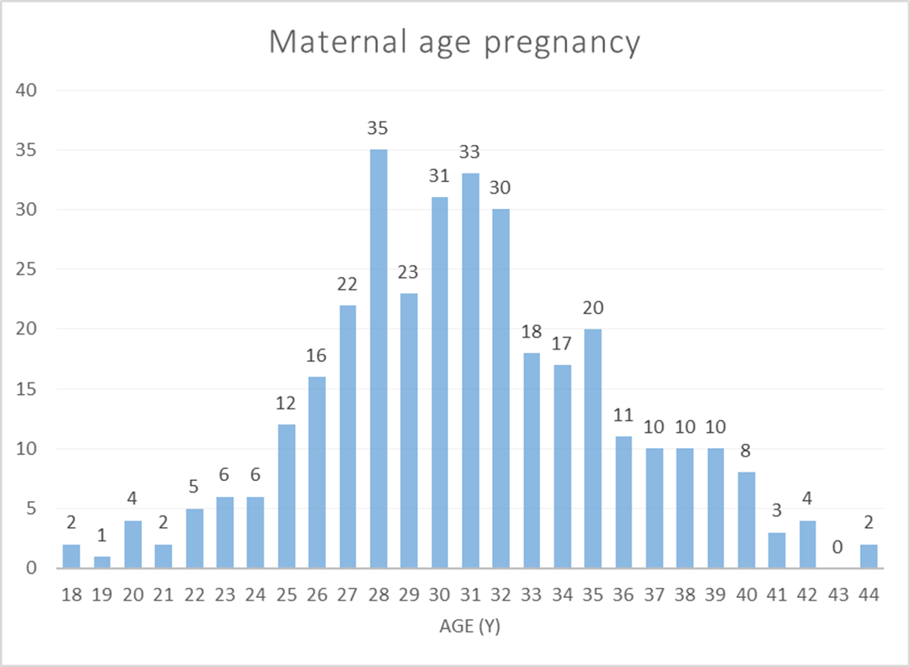

Supplementary Fig. 3. Gravidity of the pregnancy that was complicated by prenatally diagnosed CHD. The majority of pregnancies involved G1 (N=96) and G2 (N=98) pregnancies.
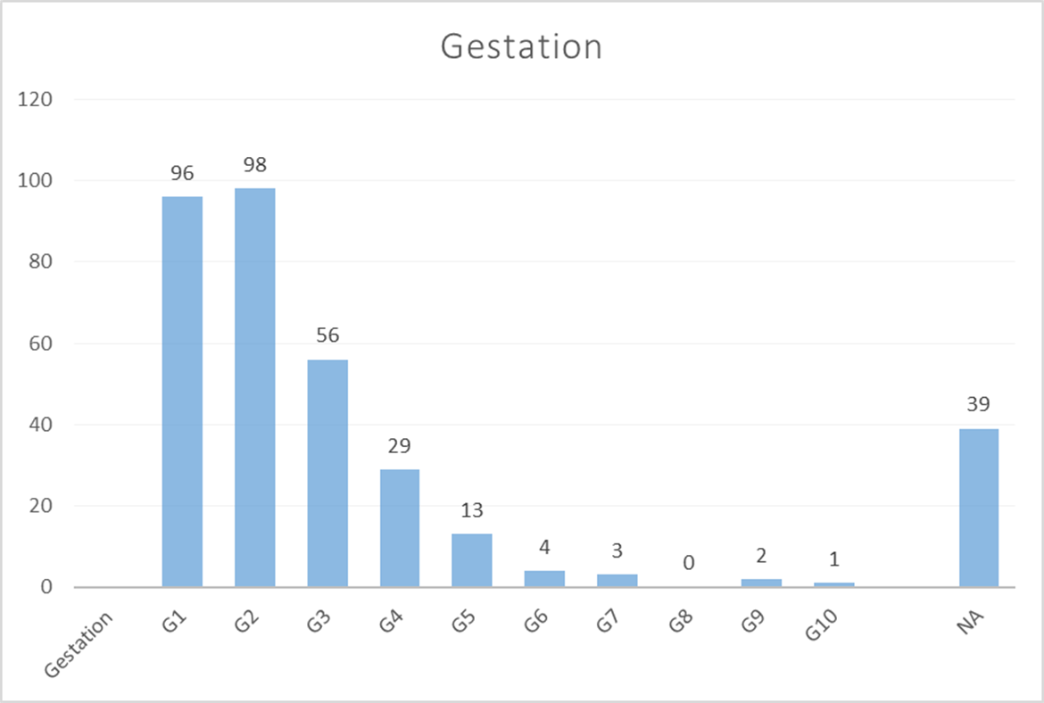
Supplementary Fig. 4. Postmenstrual age at CHD diagnosis. The average postmenstrual age (PMA) at CHD diagnosis at our center was 25.29 weeks. Most diagnoses were made between PMA week 20-23 (corresponding to CHD diagnosis by second trimester ultrasound), at week 30-31 (corresponding to CHD diagnosis by third trimester ultrasound), or at week 36 (corresponding to routine ultrasound at 35-37 weeks PMA).
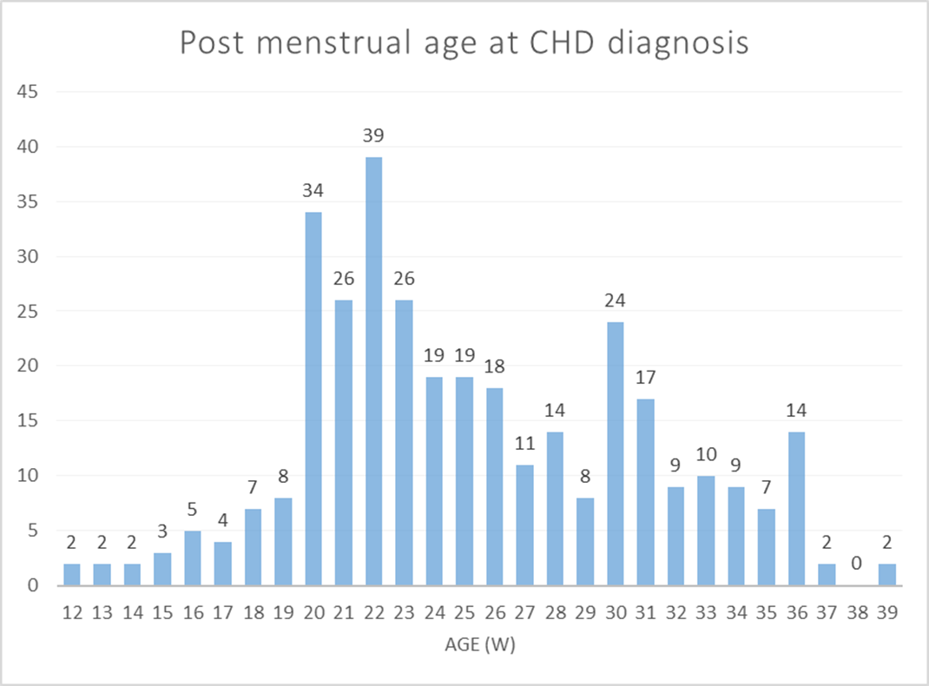

CHD severity scores | Risk | Definition | examples
score A | very high | CHD associated with severe life threatening extracardiac anomalies  or with a prenataly diagnosed genetic disorder that has a unfavorable prognosis (lethal or severe developmental disorder). | diaphragmatic hernia, tracheal atresia, bilateral renal dysplasia/agenesis, bilateral lung hypoplasia, severe skeletal dysplasie, severe neural tube defect, anencephaly etc.
score B | high | Isolated CHD with high mortality preoperatieve, peroperative or postoperative and/or need for multipele surgical corrections with a severe impact on the quality of life. | HLH, truncus arteriosus, complex TGA, PA, TOF with PA, severe AS, DORV, MA/TA, Ebstein anomaly, TAPVR, isomerism, DCM/HCM/LVNC, LV aneurysma, ectopia cordis etc.
score C | moderate | CHD with variable prognosis after surgery | Isolated TGA, TOF, CoA, AVSD, PAPVR etc.
score D | Low | CHD with favorable prognosis after surgery or spontanous recovery | VSD, TI, situs inversus totalis, left VCS etc.
Supplementary Table 1. Classification of CHD severity in accordance with scores provided by Gowda et al. (27)

Pat | definitive CHD diagnosis | pathogenic variant | hg38 coordinates | inheritance | analysis | prenatal  NS/S | postnatal NS/S | prenatal outcome | postnatal outcome
1 | TOF | 15q11.2 deletion | 15:22554982-23110497 | paternal | CMA postnatal | NS | NS | live birth | survival
2 | LVOTO | 19p13.2 duplication (NFIX) | 19:12633946-13159769 | de novo | CMA postnatal | S | S | live birth | survival
3 | d-TGA | 1q21.1q21.2 deletion BP3-BP4 | 1:147105904-147917509 | de novo | CMA postnatal | NS | S | live birth | survival
4 | UVH MS DORV | 22q11.2 deletion LCR22 A-D | 22:18902649-21457728 | de novo | CMA postnatal | S | S | live birth | †7 days
5 | RAA | 22q11.2 deletion LCR22 A-D | 22:18902649-21103321 | de novo | CMA postnatal | NS | S | live birth | survival
6 | TOF | 22q11.2 deletion LCR22 A-D | 22:18902649-21103321 | de novo | CMA postnatal | NS | S | live birth | survival
7 | TOF DORV | 22q11.2 deletion LCR22 A-D | 22:18890274-21108064 | de novo | CMA postnatal | S | S | live birth | survival
8 | LVOTO | 7q11.23 deletion (Williams-Beuren) | 7:73307413-74725194 | de novo | CMA postnatal | S | S | live birth | survival
9 | LVOTO | 9p22.2p13.1 duplication (mos 40%) | 9:17571119-38994055 | de novo | CMA postnatal | NS | NS | live birth | survival
10 | TOF | monosomy X (mos 30%) | mosaic 45,X/46,XX | de novo | CMA postnatal | S | S | MIU | MIU
11 | AVSD | trisomy 21 | T21 | de novo | CMA postnatal | NA | NA | live birth | survival
12 | VSD, AS, HAA | trisomy 22 | T22 | de novo | CMA postnatal | S | S | live birth | †7 days
13 | UVH HAA AVSD | 16q24.1 deletion (FOXF1) | 16:85800946-86902948 | de novo | CMA prenatal | NS | NA | TOP | TOP
14 | TOF PA MAPCA | 17q22q23.3 deletion | 17:58901128-63487563 | de novo | CMA prenatal | S | S | live birth | †1 day
15 | VSD | 20p12.3 deletion (BMP2) | 20:6336604-8078349 | maternal | CMA prenatal | S | S | live birth | survival
16 | TOF RAA | 22q11.2 deletion LCR22 A-D | 22:18907307-21114122 | de novo | CMA prenatal | S | S | live birth | survival
17 | UVH TA VSD PS | 22q11.2 deletion LCR22 A-D | 22:18860448-21186058 | de novo | CMA prenatal | NS | S | live birth | survival
18 | RAA | 22q11.2 deletion LCR22 A-D | 22:18907307-21103321 | de novo | CMA prenatal | S | S | TOP | TOP
19 | IAA VSD | 22q11.2 deletion LCR22 A-D | 22:18902649-21186058 | de novo | CMA prenatal | S | S | TOP | TOP
20 | VSD subAS HAA | 22q11.2 deletion LCR22 A-D | 22:18907307-21103321 | de novo | CMA prenatal | S | S | live birth | survival
21 | IAA VSD BAV | 22q11.2 deletion LCR22 A-D | 22:18902649-21103321 | de novo | CMA prenatal | S | S | live birth | survival
22 | VSD LVOTO | 5p15.33p13.2 deletion (cri-du-chat) | 5:22149-34929002 | de novo | CMA prenatal | S | S | TOP | TOP
23 | AVSD HLH | 8p23.3 deletion; Xq27.3q28 dup (unbalanced translocation) | 8:241605-10867240;  X:147720631-155952524 | de novo | CMA prenatal | NS | S | TOP | TOP
24 | TOF PA | 8q21.1q13.2 deletion; 13q21.33 deletion | 8:56835076-68175800;  13:69345468-72594686 | de novo | CMA prenatal | S | S | TOP | TOP
25 | LVOTO | monosomy X | 45,X | de novo | CMA prenatal | S | S | live birth | survival
26 | AVSD | trisomy 18 | T18 | de novo | CMA prenatal | S | S | TOP | TOP
27 | AVSD | trisomy 21 | T21 | de novo | CMA prenatal | S | S | TOP | TOP
28 | HAA, left VCS | trisomy 21 | T21 | de novo | CMA prenatal | NS | S | TOP | TOP
29 | Ebstein VSD | trisomy 21 | T21 | de novo | CMA prenatal | S | S | TOP | TOP
30 | AVSD | trisomy 21 mosaicism (71%) | mosaic T21 | de novo | CMA prenatal | NS | S | live birth | survival
31 | VSD LVOTO | 22q11.2 deletion LCR22 A-D | 22:18907307-21103321 | de novo | NIPS | S | S | TOP | TOP
32 | AVSD, HLHS | trisomy 18 | T18 | de novo | NIPS | S | S | TOP | TOP
33 | AVSD | trisomy 21 | T21 | de novo | NIPS | NS | S | live birth | survival
34 | asymmetric 4 chamber view | Coffin-Siris syndrome | NM_001128849.1(SMARCA4):c.2653C>T(p.Arg885Cys) | de novo | NGS post-TOP | S | S | TOP | TOP
35 | HAA CoAo | Alveolar capillary dysplasia with misalignment of pulmonary veins | NM_001451.2(FOXF1):c.186_196del (p.Gln62Hisfs*229) | de novo | NGS postnatal | S | S | live birth | †1 day
36 | TOF | Arboleda-Tham syndrome | NM_006766.4(KAT6A):c.3034C>T (p.Arg1012*) | de novo | NGS postnatal | S | S | live birth | survival
37 | LVOTO CoAo | Zhu-Tokita-Takenouchi-Kim (ZTTK) syndrome | NM_032195.2(SON):c.321_324delGTCA (p.Ser108Argfs*40) | de novo | NGS postnatal | S | S | live birth | survival
38 | DORV AS | Kabuki syndrome | NM_003482.3(KMT2D):c.6448delG (p.Val2150Cysfs*114) | de novo | NGS postnatal | S | S | live birth | †2 weeks
39 | LVOTO | Kabuki syndrome | NM_003482.3(KMT2D):c.8047-7T>A | de novo | NGS postnatal | S | S | live birth | †2 mo
40 | AVSD | Noonan syndrome | NM_002880.4(RAF1):c.770C>T (p.Ser257Leu) | de novo | NGS postnatal | S | S | live birth | †9 days
41 | UVH PA TA | Short-rib thoracic dysplasia | NM_001080463.1(DYNC2H1):c.7382G>T (p.Gly2461Val), hom | maternal and paternal | NGS postnatal | S | S | live birth | †7 days
42 | DORV | Noonan syndrome | NM_002834.4(PTPN11):c.5C>T (p.Thr2Ile) | de novo | NGS postnatal | NS | S | live birth | survival
43 | TOF | Hyperpheynlalaninemia** | NM_000277.3(PAH):c.143T>C (p.Leu48Ser); c.442-5C>G | maternal and paternal | NGS postnatal | NS | S | live birth | survival
44 | TOF | CAKUTHED | NM_002585.4(PBX1):c.415dupG (p.Ala139Glyfs*60) | de novo | NGS postnatal | NS | S | live birth | survival
45 | TOF HAA LVH RVH | Noonan syndrome | NM_006912.6(RIT1):c.268A>G (p.Met90Val) | de novo | NGS prenatal | S | S | live birth | survival

Supplementary table 3. Pathogenic chromosomal or single nucleotide variants, including inheritance, CHD diagnosis, pre- and postnatal ECA status and outcomes. **this genetic disorder is not associated with a higher risk of CHD. The genetic cause CHD in patient 43 was unknown. Abbreviations: AS: aortic stenosis; AVSD: atrioventricular septal defect; CoAo: aortic coarctation; DORV: double outlet right ventricle; d-TGA: dextro transposition of the great arteries; HAA: hypoplastic aortic arch; HLHS: hypoplastic left heart syndrome; hom: homozygous; IAA: interrupted aortic arch; LVOTO: left ventricle outflow tract obstruction; MAPCA: major aortopulmonary collateral arteries; MIU: mors in utero (fetal death); mo: months; MS: mitral valve stenosis; NGS: next generation sequencing (whole exome sequencing or targeted gene panel); NIPS: non-invasive prenatal aneuploidy screening; NS: non-syndromic CHD; PA: pulmonary atresia; PS: pulmonary valve stenosis; RAA: right aortic arch; S-CHD: syndromic CHD ; TA: tricuspid atresia; TOF: tetralogy of Fallot; TOP: termination of pregnancy; VCS: superior caval vein; VSD: ventricular septal defect; UVH: univentricular heart.

 | Pathogenic chromosomal variant | % | Pathogenic chromosomal or SNV | % | total number in prenatal CHD cohort
LVOTO | 10 | 15.6% | 13 | 20.3% | 64
conotruncal | 7 | 6% | 11 | 9.6% | 115
septal | 6 | 16.7% | 7 | 19.4% | 36
right-sided | 1 | 3% | 3 | 9.7% | 31
UVH | 3 | 7.7% | 4 | 10.3% | 39
Other:  - RAA  - asymmetric 4 chambers | 3  2  1 | 9.6% | 4  2  2 | 12.9% | 31
Total | 30 |  | 42
Supplementary table 2. The number and percentage of pathogenic chromosomal and/or single nucleotide
Variants (excluding abnormal NIPS results) per CHD category, corrected for the number of fetuses per CHD
category (%). CHD categories without pathogenic CNVs or SNVs are not depicted. Abbreviations:
LVOTO: left ventricle outflow tract obstruction; RAA: right aortic arch; SNV: single nucleotide variant;
UVH: univentricular heart

