Supplementary
Suppl.-Table 1: Summary of the official monitoring programmes for lynx (Lynx lynx) and wolves (Canis lupus) in Lower Saxony and within the natural regions therein. Table continues on the next page.
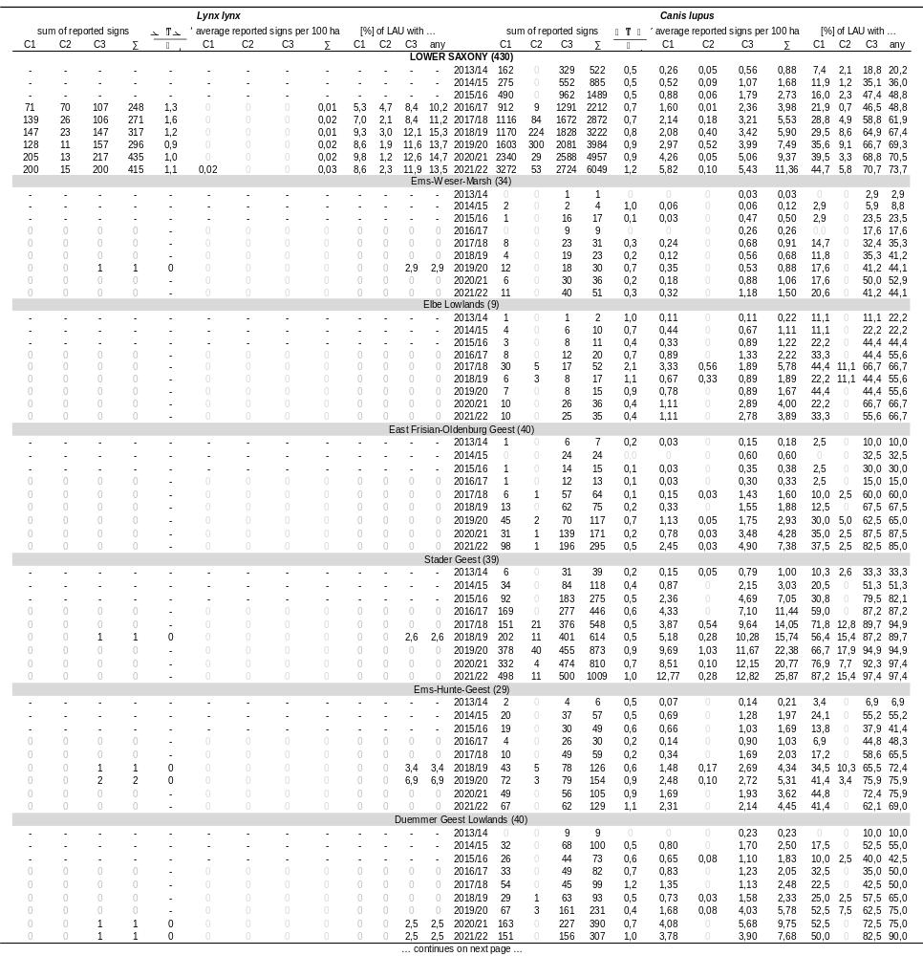

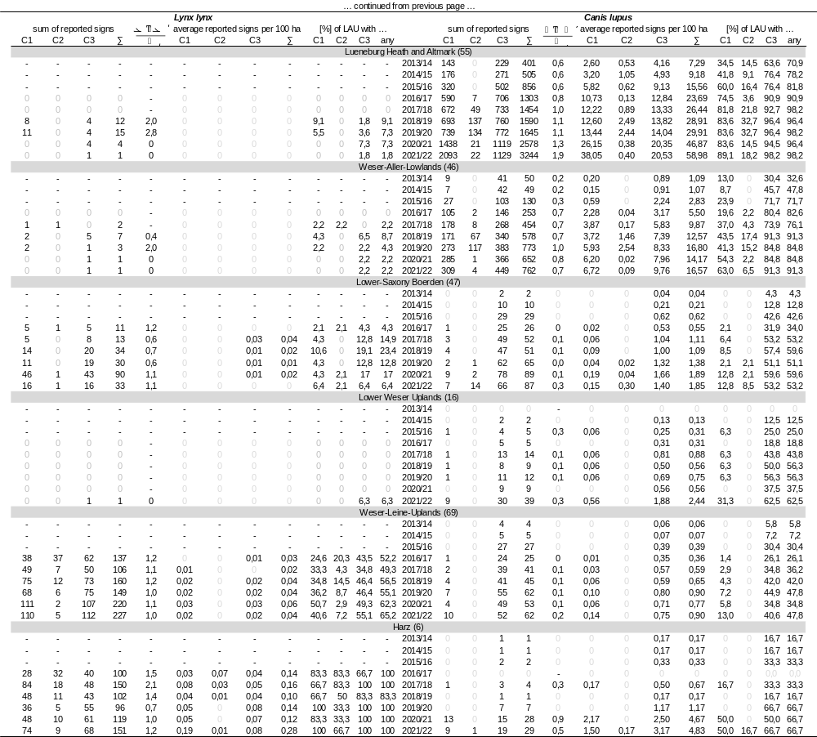

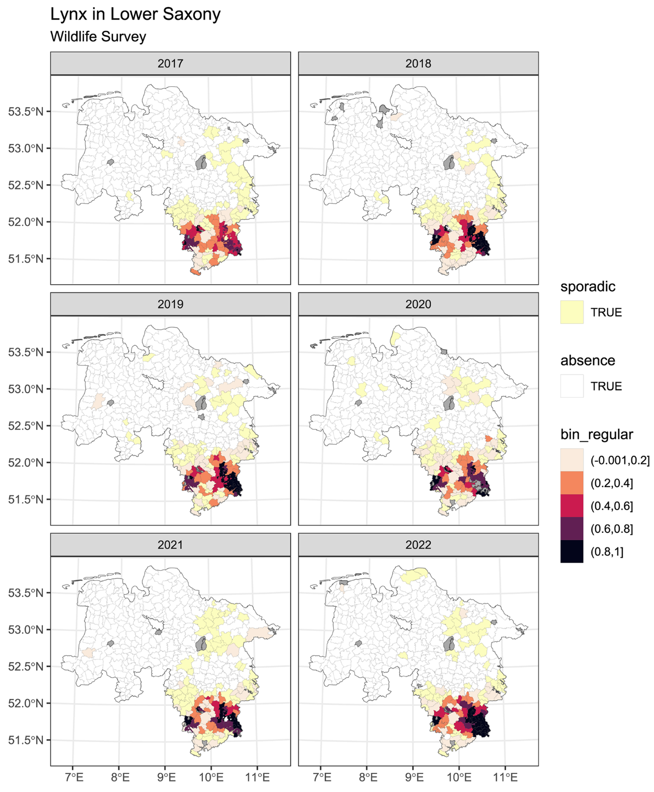
Suppl.-Figure 1: Map showing the distribution of replies according to the wildlife survey programme in Lower Saxony regarding to the occurrence of lynx from the hunting year 2016/17 until 2021/22. Coloured areas (reddish) indicate the relative share of hunting district owners and tenants reporting a regular occurrence within their authorities. Sporadic occurrence (ivory) was layered beneath as binary category. Absence of lynx (white) was considered if the percentage of hunting district owners and tenants reporting no occurrence reached 100. For areas shaded in grey no explicit information within the wildlife survey programme was obtained.

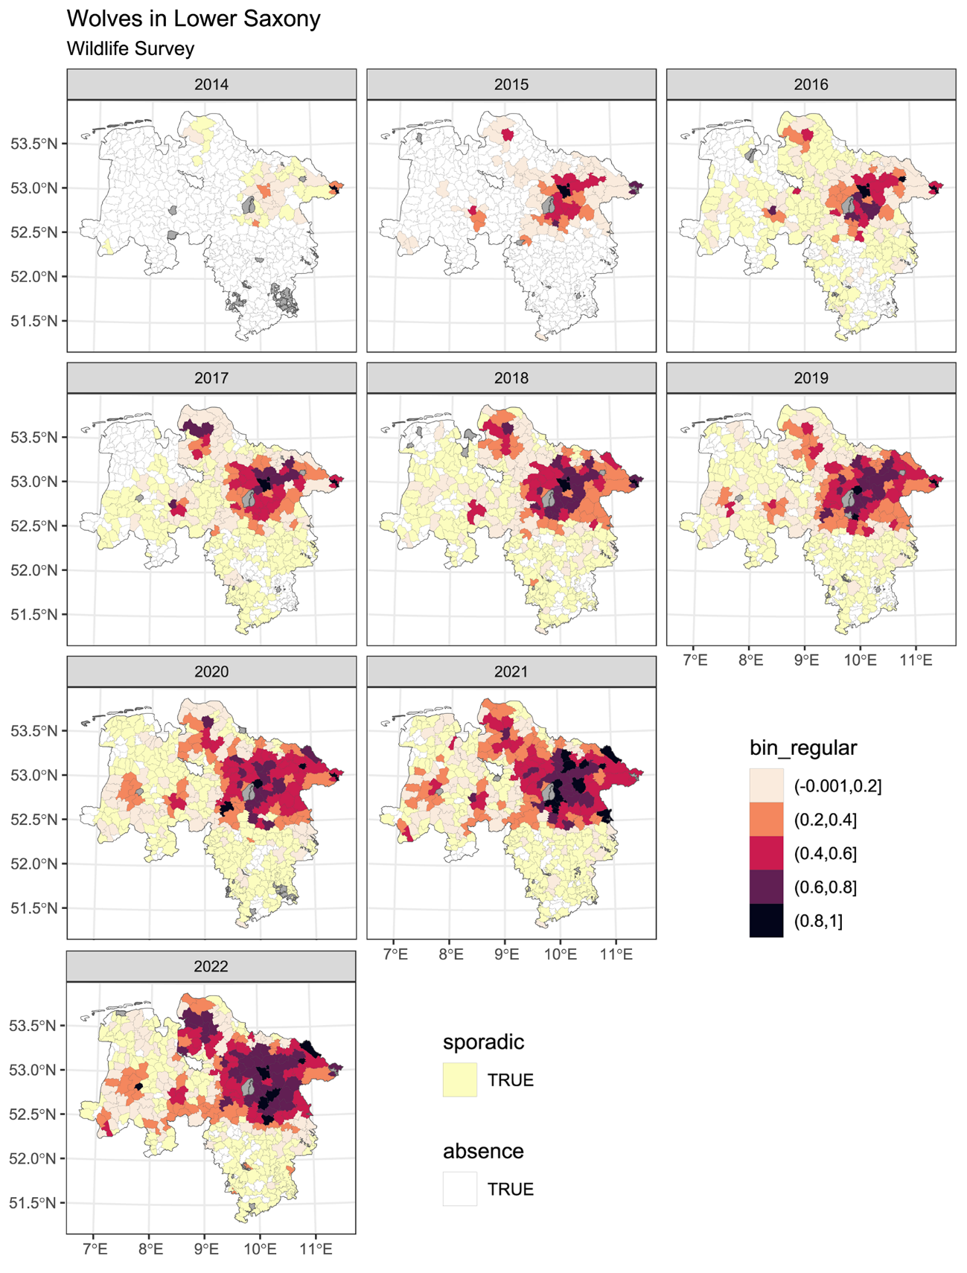
Suppl.-Figure 2: Map showing the distribution of replies according to the wildlife survey programme in Lower Saxony regarding to the occurrence of wolves from the hunting year 2013/14 until 2021/22. Coloured areas (reddish) indicate the relative share of hunting district owners and tenants reporting a regular occurrence within their authorities. Sporadic occurrence (ivory) was layered beneath as binary category. Absence of wolves (white) was considered if the percentage of hunting district owners and tenants reporting no occurrence reached 100. For areas shaded in grey no explicit information within the wildlife survey programme was obtained.

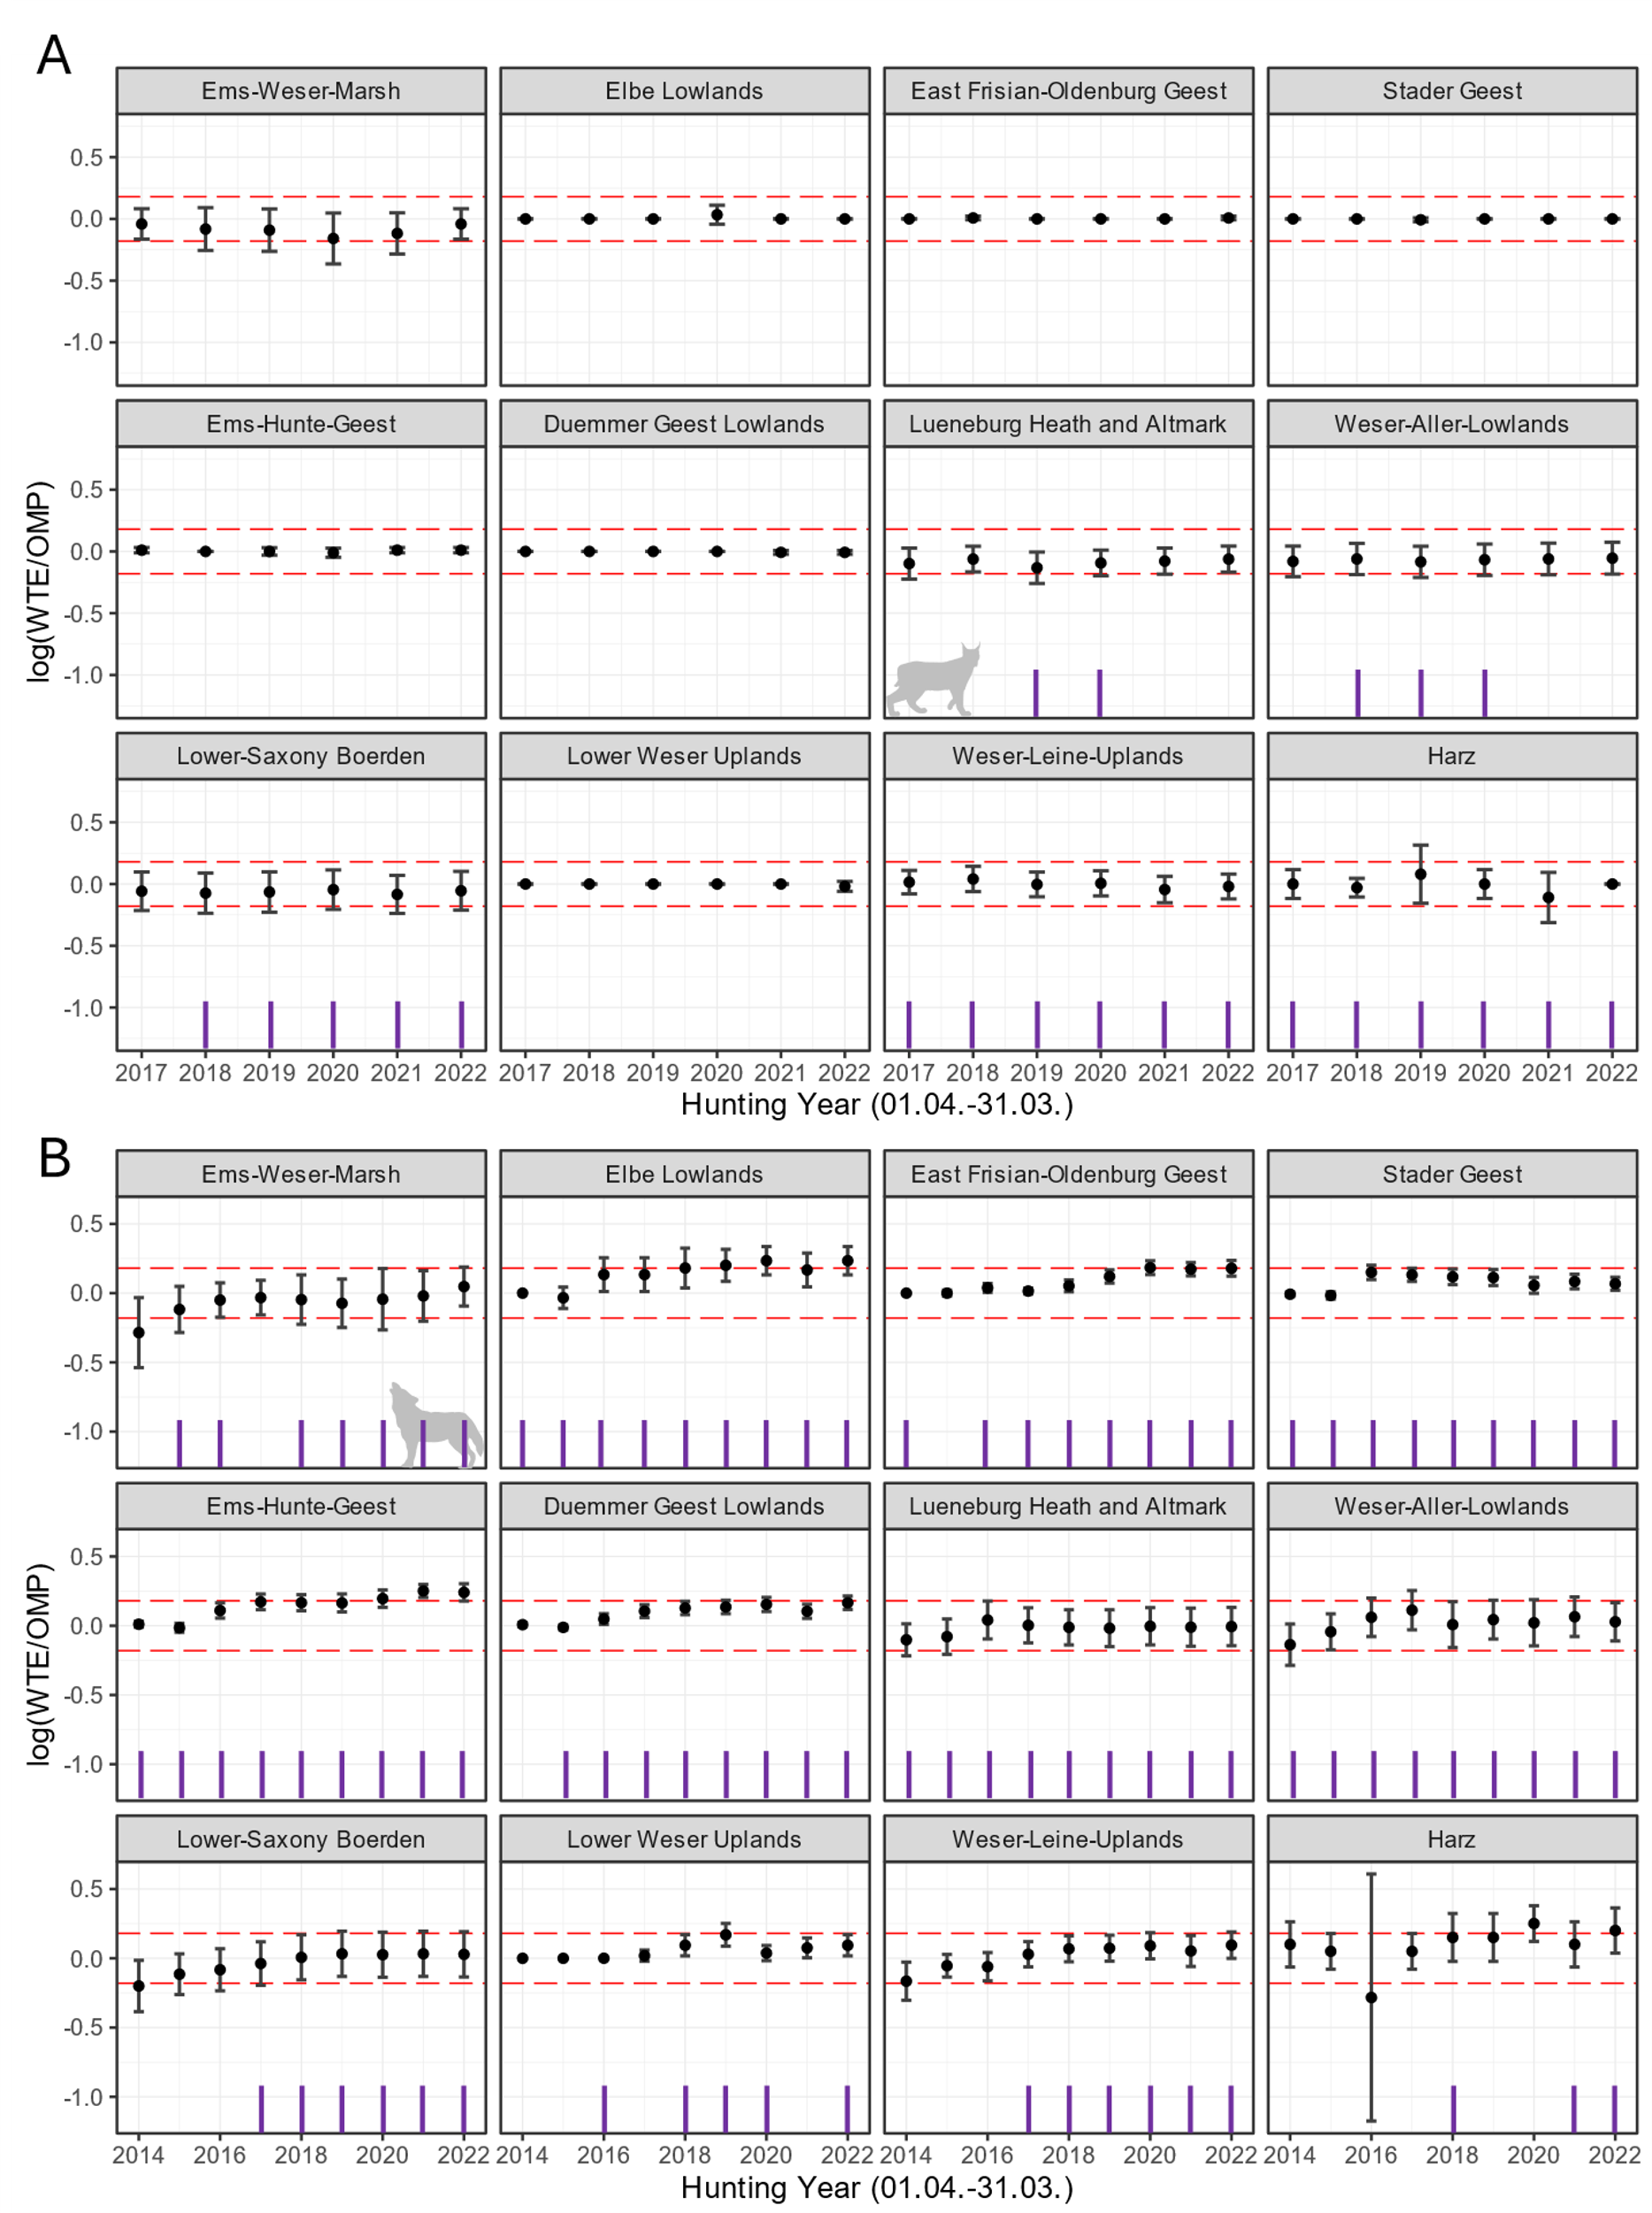
Suppl.-Figure 3: Temporal development of the three-class ratio of agreement (mean ± 95% confidence interval), across the natural regions of Lower Saxony. The red dashed lines indicate a difference of one category. Violet vertical lines indicate years with reported carnivore signs to the official monitoring programmes classified as C1. WTE: occurrence score for the wildlife survey, OMP: occurrence score for the official monitoring programme. A: Wolf. B: Lynx.

