Table S1. Primary Outcome, Secondary Outcome and Bleeding Outcome with CYP2C19 Phenotype
Outcome | 0-365 Days |  | 0-90 Days |  | 91-365 Days
Outcome | Hazard Ratio（95% CI）ª | P value ª | Hazard Ratio（95% CI） | P value | Hazard Ratio（95% CI） | P value
Primary Outcome ^{b}
NLOFM | Reference | — | Reference | — | Reference | —
IM | 1.308 (0.788 - 2.170) | 0.299 | 1.232 (0.544 - 2.790) | 0.616 | 1.641 (0.560 - 4.808) | 0.366
PM | 1.698 (0.865 - 3.3315) | 0.124 | 2.944 (1.184 - 7.321) | 0.020 | 1.194 (0.393 - 3.630) | 0.754
Death from any cause
NLOFM | Reference | — | Reference | — | Reference | —
IM | 1.458 (0.552 - 3.851) | 0.447 | 2.107 (0.532 - 8.339) | 0.288 | 0.952 (0.225 - 4.019) | 0.946
PM | 3.896 (1.368 - 11.093) | 0.011 | 7.600 (1.826 - 31.627) | 0.005 | 1.395 (0.237 - 8.203) | 0.713
Myocardial infarction
NLOFM | Reference | — | Reference | — | Reference | —
IM | 1.035 (0.489 - 2.193) | 0.928 | 1.143 (0.342 - 3.817) | 0.828 | 0.999 (0.380 - 2.624) | 0.998
PM | 1.150 (0.369 - 3.586) | 0.810 | 1.532 (0.289 - 8.118) | 0.616 | 0.924 (0.191 - 4.472) | 0.922
Stent Thrombosis
NLOFM | Reference | — | Reference | — | Reference | —
IM | 1.532 (0.494 - 4.750) | 0.46 | 0.493 (0.043 - 5.708) | 0.572 | 2.267 (0.576 - 8.916) | 0.242
PM | 0.855 (0.097 - 7.502) | 0.887 | 2.499 (0.199 - 31.415) | 0.478 | NA | NA
Ischemic Stroke
NLOFM | Reference | — | Reference | — | Reference | —
IM | 3.011 (0.284 - 31.929) | 0.36 | NA | NA | 3.011 (0.284 - 31.929) | 0.36
PM | NA | NA | NA | NA | NA | NA
Secondary Outcome ^{c}
NLOFM | Reference | — | Reference | — | Reference | —
IM | 1.310 (0.824 - 2.083) | 0.253 | 1.234 (0.546 - 2.794) | 0.613 | 1.372 (0.785 - 2.400) | 0.267
PM | 1.677 (0.898 - 3.131) | 0.105 | 3.309 (1.363 - 8.033) | 0.008 | 0.884 (0.332 - 2.353) | 0.805
Urgent TVR
NLOFM | Reference | — | Reference | — | Reference | —
IM | 1.347 (0.424 - 4.276) | 0.614 | NA | NA | 1.346 (0.424 - 4.276) | 0.614
PM | 1.464 (0.277 - 7.741) | 0.654 | NA | NA | 0.701 (0.080 - 6.151) | 0.748
Bleeding Outcome ^{d, e}
NLOFM | Reference | — | Reference | — | Reference | —
IM | 0.885 (0.455 - 1.721) | 0.718 | 0.366 (0.069 - 1.951) | 0.239 | 1.075 (0.510 - 2.266) | 0.849
PM | 1.152 (0.455 - 2.918) | 0.766 | 1.172 (0.208 - 6.610) | 0.857 | 1.086 (0.352 - 3.346) | 0.886
CI confidence interval, NLOFM non-loss-of-function metabolizer, IM intermediate metabolizer, PM poor metabolizer.
ª Hazard Ratios, confidence intervals and p values were calculated by means of Cox proportional hazard regression models adjusting for age, sex, coronary artery disease presentation, diabetes mellitus, hypertension, multiple-vessel disease, cerebrovascular disease, chronic kidney disease and previous myocardial infarction.
^{b} Primary outcome was the composite of death from any cause, myocardial infarction, definite or probable stent thrombosis and ischemic stroke.
^{c} Secondary outcome was the composite of death from any cause, myocardial infarction, definite or probable stent thrombosis, ischemic stroke and urgent target‑vessel revascularization.
^{d} Bleeding outcome was clinically signiﬁcant bleeding events as defined by Bleeding Academic Research Consortium (BARC) criteria (including BARC 2, BARC 3, BARC 4)
^{e} The BARC criteria were used for grading and categorizing bleeding events, BARC 2 referred to any overt, actionable sign of bleeding that requires medical intervention or evaluation, but not meet criteria for type 3 or higher BARC bleeding; BARC 3 indicated overt bleeding plus a decrease in hemoglobin of more than 3 g/dL, intracranial hemorrhage or intraocular hemorrhage compromising vision; BARC 4 was bleeding related to coronary‑artery bypass grafting.

Table S2. Primary Outcome, Secondary Outcome and Bleeding Outcome Among Acute Coronary Syndromes Patients with CYP2C19 Phenotype
Outcome | 0-365 Days |  | 0-90 Days |  | 91-365 Days
Outcome | Hazard Ratio（95% CI）ª | P value ª | Hazard Ratio（95% CI） | P value | Hazard Ratio（95% CI） | P value
Primary Outcome ^{b}
NLOFM | Reference | — | Reference | — | Reference | —
IM | 1.375 (0.816 - 2.319) | 0.232 | 1.232 (0.544 - 2.790) | 0.616 | 1.381 (0.729 - 2.616) | 0.322
PM | 1.850 (0.932 - 3.671) | 0.079 | 2.944 (1.184 - 7.321) | 0.020 | 0.867 (0.288 - 2.604) | 0.799
Death from any cause
NLOFM | Reference | — | Reference | — | Reference | —
IM | 1.601 (0.614 - 4.173) | 0.336 | 2.107 (0.532 - 8.339) | 0.288 | 1.120 (0.277 - 4.536) | 0.874
PM | 4.110 (1.462 - 11.554) | 0.007 | 7.600 (1.826 - 31.627) | 0.005 | 1.644 (0.300 - 9.018) | 0.567
Myocardial infarction
NLOFM | Reference | — | Reference | — | Reference | —
IM | 1.035 (0.489 - 2.193) | 0.928 | 1.143 (0.342 - 3.817) | 0.828 | 0.999 (0.380 - 2.624) | 0.998
PM | 1.150 (0.369 - 3.586) | 0.810 | 1.532 (0.289 - 8.118) | 0.616 | 0.924 (0.191 - 4.472) | 0.922
Stent Thrombosis
NLOFM | Reference | — | Reference | — | Reference | —
IM | 1.532 (0.494 - 4.750) | 0.46 | 0.494 (0.043 - 5.717) | 0.572 | 2.267 (0.576 - 8.916) | 0.242
PM | 0.855 (0.097 - 7.502) | 0.887 | 2.499 (0.199 - 31.405) | 0.478 | NA | NA
Ischemic Stroke
NLOFM | Reference | — | Reference | — | Reference | —
IM | 3.024 (0.284 - 31.929) | 0.36 | NA | NA | 3.011 (0.284 - 31.929) | 0.36
PM | NA | NA | NA | NA | NA | NA
Secondary Outcome ^{c}
NLOFM | Reference | — | Reference | — | Reference | —
IM | 1.356 (0.856 - 2.150) | 0.194 | 1.234 (0.546 - 2.794) | 0.613 | 1.372 (0.785 - 2.400) | 0.267
PM | 1.722 (0.927 - 3.199) | 0.085 | 3.309 (1.363 - 8.033) | 0.008 | 0.884 (0.332 - 2.353) | 0.805
Urgent TVR
NLOFM | Reference | — | Reference | — | Reference | —
IM | 1.271 (0.404 - 4.006) | 0.682 | NA | NA | 1.272 (0.404 - 4.007) | 0.681
PM | 1.439 (0.279 - 7.418) | 0.663 | NA | NA | 0.719 (0.084 - 6.155) | 0.763
Bleeding Outcome ^{d, e}
NLOFM | Reference | — | Reference | — | Reference | —
IM | 0.864 (0.445 - 1.677) | 0.665 | 0.366 (0.069 - 1.951) | 0.239 | 1.035 (0.493 - 2.176) | 0.927
PM | 1.122 (0.445 - 2.829) | 0.808 | 1.172 (0.208 - 6.610) | 0.857 | 1.075 (0.351 - 3.297) | 0.899
CI confidence interval, NLOFM non-loss-of-function metabolizer, IM intermediate metabolizer, PM poor metabolizer.
ª Hazard Ratios, confidence intervals and p values were calculated by means of Cox proportional hazard regression models adjusting for age, sex, coronary artery disease presentation, diabetes mellitus, hypertension, multiple-vessel disease, cerebrovascular disease, chronic kidney disease and previous myocardial infarction.
^{b} Primary outcome was the composite of death from any cause, myocardial infarction, definite or probable stent thrombosis and ischemic stroke.
^{c} Secondary outcome was the composite of death from any cause, myocardial infarction, definite or probable stent thrombosis, ischemic stroke and urgent target‑vessel revascularization.
^{d} Bleeding outcome was clinically signiﬁcant bleeding events as defined by Bleeding Academic Research Consortium (BARC) criteria (including BARC 2, BARC 3, BARC 4)
^{e} The BARC criteria were used for grading and categorizing bleeding events, BARC 2 referred to any overt, actionable sign of bleeding that requires medical intervention or evaluation, but not meet criteria for type 3 or higher BARC bleeding; BARC 3 indicated overt bleeding plus a decrease in hemoglobin of more than 3 g/dL, intracranial hemorrhage or intraocular hemorrhage compromising vision; BARC 4 was bleeding related to coronary‑artery bypass grafting.

Figure S1. Incidence Curves for the Secondary Outcome
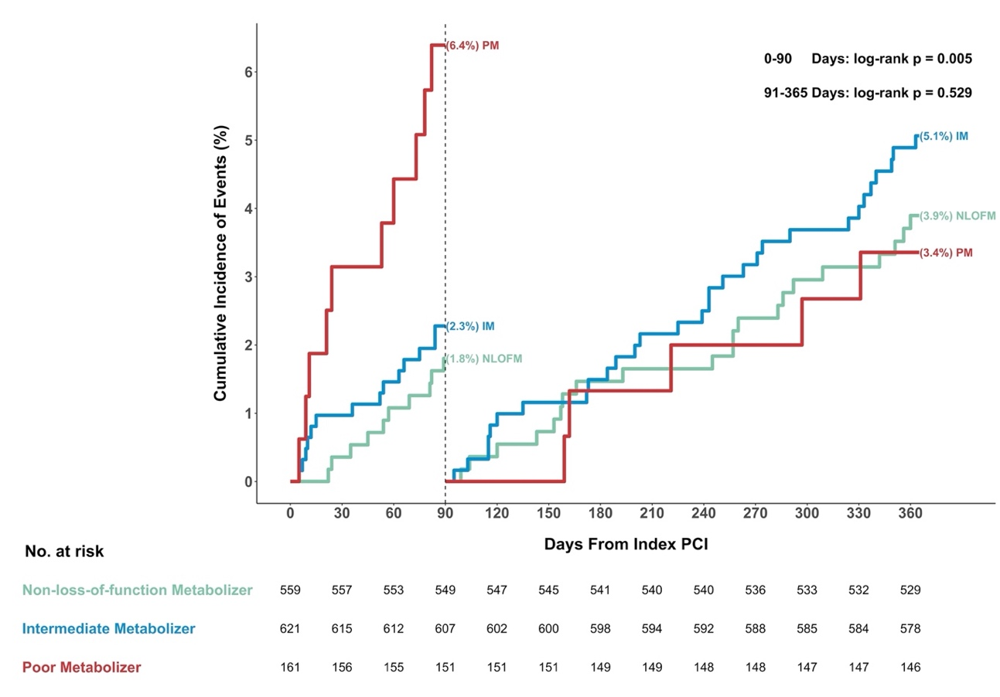
Event rates (%) were the Kaplan-Meier event rate.
NLOFM non-loss-of-function metabolizer, IM intermediate metabolizer, PM poor metabolizer, PCI percutaneous coronary intervention.
Primary outcome was the composite of death from any cause, myocardial infarction, definite or probable stent thrombosis and ischemic stroke.
Landmark analysis was conducted at 90 days after index percutaneous coronary intervention.

