Supplementary Material
to
“New low-cost and compact experimental system for characterization of porous materials by quasi-equilibrated thermodesorption of nonane or water”
by
Wacław Makowski¹*, Nikita Yaremenko¹, Patrycja Gryta^{1,2}, Monika Cieślik-Górna¹, Aleksandra Korzeniowska¹ and Dorota Majda¹
¹ Faculty of Chemistry, Jagiellonian University in Kraków, Gronostajowa 2, 30-387 Kraków, Poland
² Doctoral School of Exact and Natural Sciences, Jagiellonian University in Kraków, Łojasiewicza 11,
30-348 Kraków, Poland
*corresponding author: waclaw.makowski@uj.edu.pl

Table of Contents

1. Detailed description of the new system
2. Estimated costs of the new system
3. Low-temperature isotherms of nitrogen adsorption and desorption on the studied silicas SBA-15
4. XRD patterns of the studied metal-organic frameworks.
5. Details concerning the QE-TPDA of water for MOFs.

1. Detailed description of the new system
In designing and constructing the new QE-TPDA system we focused on its simplicity and low cost, while maintaining its performance and practicality. This system was constructed using MakerBeam profiles and compatible poly(methyl methacrylate) panels (3 mm thick). To some of the panels and profiles small neodymium magnets were attached, allowing quick and secure disassembly and assembly.
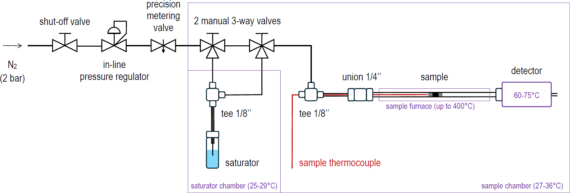
Figure S1. A scheme of the new QE-TPDA system.
The system is presented schematically in Fig. S1 and its photo is shown in Fig. S2. This is a single channel device, equipped with a saturator which may be bypassed. The carrier gas (N₂) line consists of the shutoff valve (Swagelok 1/8’’), in-line pressure regulator (Merck) and precision metering valve (Witt Gmbh). Two 3-way valves (Swagelok) used simultaneously allow directing of the carrier gas flow through the saturator. The saturator was constructed using Mininert® valve (Merck) and compatible glass vial (with 15/425 mm thread). The inlet of the carrier gas to the saturator is a piece of 1/16’’ stainless steel /SS/ tubing, passing through 1/8’’ tube fitting tee (Swagelok). It was placed inside the piece of 1/8’’ SS tubing connected to the tee, which served as the saturator’s outlet. The studied sample (ca. 2-5 mg) was placed in the custom made glass tube (length 15 cm, outer diameter /OD/ 6 mm) between two plugs of silica wool (Shimadzu). For easy and leak free connecting the sample tube to the carrier gas line a special 1/4 tube fitting union was used (SS Ultra-Torr Vacuum Fitting, Swagelok). The same union served as the inlet of the miniature TCD detector. For monitoring the sample temperature the Inconel sheathed thermocouple K (OD 1/16’’, Czaki) was used.
The purple lines in Fig. S1 indicate the heated zones of the QE-TPDA setup. Three of them were thermostated: the saturator chamber (25-29°C) – in order to stabilize the concentration of the adsorptive in the carrier gas, the sample chamber (27-36°C) – to prevent condensation of desorbing probe molecules, the detector (60-75°C) – to ensure its optimal performance. Dedicated electronic system, consisting of temperature sensors (TMP117 Qwiic, SparkFun), resistance heaters, solid state relays and Arduino microprocessor board (RedBoard Qwiic, SparkFun) was used for this purpose. Owing to the accuracy of the temperature sensors and performance of the special adaptive heating algorithm the stability of the temperature in these zones was about ±0.1°C. The sample tube was located inside the coiled heating element (350 W, 230 V AC, Selfa) with 9 mm glass insert. This heater was controlled by another Arduino based system, responsible also for monitoring of the detector signals and temperatures measured in different zones of the system.
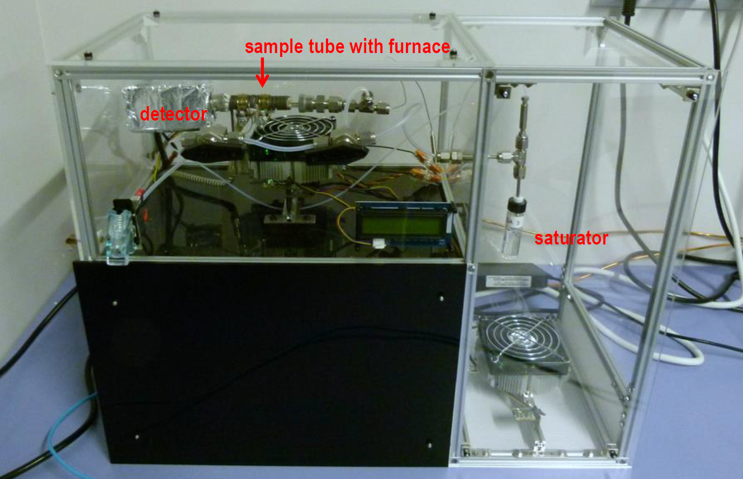
Figure S2. The overall view of the new QE-TPDA system.

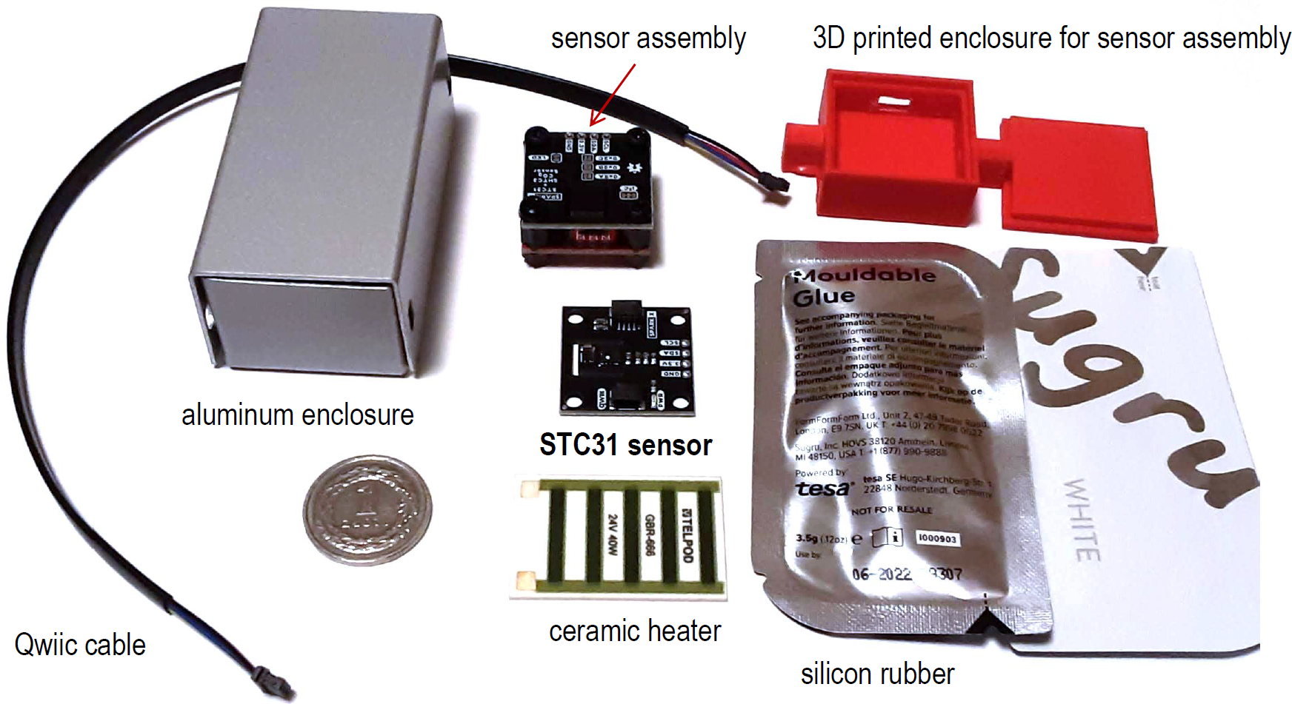
Figure S3. Key elements used for construction of the miniature TCD detector based on the Sparkfun STC31 (Qwiic) sensor module. The coin (diameter 23 mm) serves as a scale marker.
The key elements used for construction of the miniature thermal conductivity detector are shown in Fig. S3. The thermal conductivity sensor (STC31 Qwiic, SparkFun) and temperature sensor (TMP117 Qwiic, SparkFun) were assembled together using 6 mm nylon distance bolts and nuts. The sensor assembly was placed inside the 3D printed enclosure. This enclosure was located inside the aluminum enclosure (2.8 cm × 3.8 cm × 7.2mm, TEKO), after fitting them with the appropriate inlet and outlet. Outside the 3D printed enclosure, in close proximity to the temperature sensor, the ceramic heater (10 W, 12 V DC) was located. The remaining void space of the aluminum enclosure was filled with silicone rubber (Sugru) and glass cloth tape (not shown in Fig. S3). A variant of the assembled miniature TCD is shown in Fig. S4. In this case 6 mm PTFE tubing was used as the inlet and outlet. Two Qwiic cables connected to both sensors and power leads connected to the heater are visible.
The Arduino system responsible for programming of the sample temperature and monitoring of the signals was linked to the MS Windows PC via USB. The experimental procedures including complex temperature profiles were programmed using Arduino IDE. For data acquisition the open source software SerialPlot [19] was used, while for data processing and archiving the open source Octave system was employed [20].
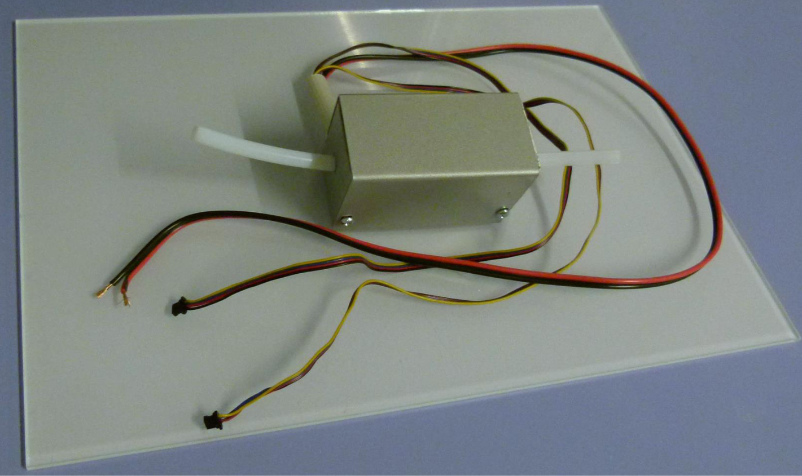
Figure S4. A variant of the assembled TCD detector.

2. Estimated costs of the new QE-TPDA system
The total cost of the new QE-TPDA system (excluding the computer data system and VAT) may be estimated at about 2 kEUR. In Tab. S1 all its main components and their costs are listed. The most expensive part of the system is the carrier gas line, including the bypass and saturator. Since this subsystem was designed and constructed in a simplistic way, it is possible to ugrade it at greater costs. For example, using an electronic mass flow controller instead of the mechanical in-line pressure regulator and precision metering valve would increase the stability of the carrier gas flowrate. However, this would increase the costs by about 2 kEUR.
Table S1. List of the main components of the new QE-TPDA system including their costs
 | price/EUR | items | cost/EUR | subtotal/EUR
electric and electronic parts |  |  |  | 647
sample heater | 120 | 1 | 120
CO₂ Sensor - STC31 (Qwiic) | 70 | 1 | 70
Thermocouple K | 30 | 2 | 60
RedBoard Qwiic | 25 | 2 | 50
Qwiic Thermocouple Amplifier | 25 | 2 | 50
fan with radiator | 25 | 2 | 50
Qwiic cable set | 25 | 1 | 25
Qwiic Temperature Sensor | 15 | 6 | 90
chamber heater | 15 | 2 | 30
solid state relay | 15 | 3 | 45
usb cable | 10 | 4 | 40
detector heater | 5 | 1 | 5
Qwiic connector | 2 | 6 | 12
gas valves and fittings |  |  |  | 1065
presision metering valve | 300 | 1 | 300
in-line pressure regulator | 200 | 1 | 200
saturator | 100 | 1 | 100
UltraTorr SS fitting | 85 | 2 | 170
on-off valve | 70 | 2 | 140
3-way valve | 65 | 1 | 65
bulkhead union | 20 | 3 | 60
tee union | 15 | 2 | 30
construction materials |  |  |  | 350
Makerbeam profiles | 150 | 1 | 150
plexi panels | 100 | 1 | 100
other | 100 | 1 | 100
3. Low-temperature isotherms of nitrogen adsorption and desorption on the studied silicas SBA-15

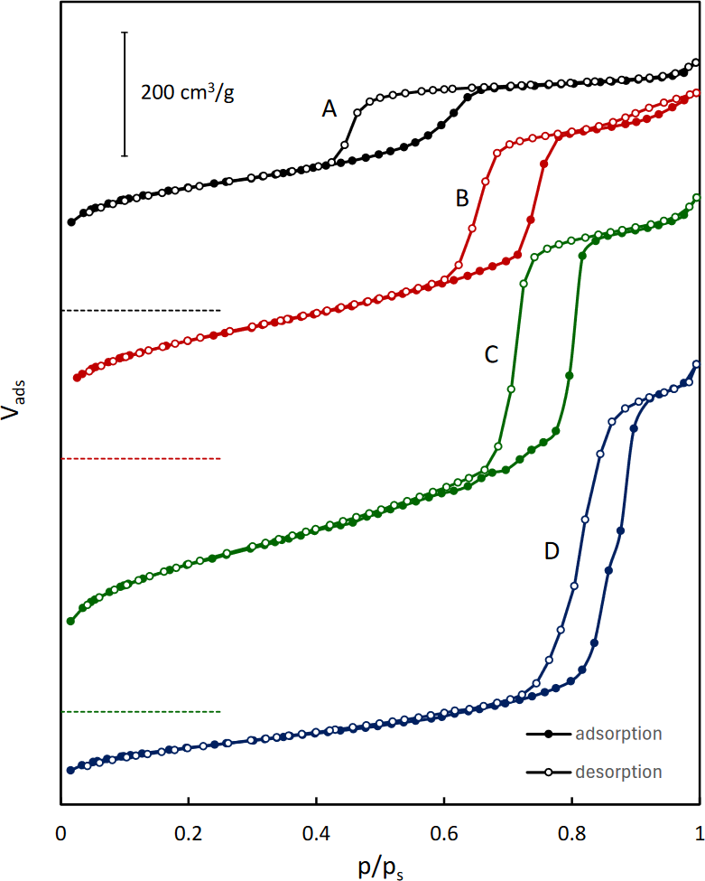
Figure S5. Low-temperature isotherms of nitrogen adsorption and desorption on the studied silicas SBA-15. For better clarity the plots for silicas B, C and D were shifted vertically. The corresponding zero levels are indicated with horizontal dashed lines.

4. XRD patterns of the studied metal-organic frameworks.
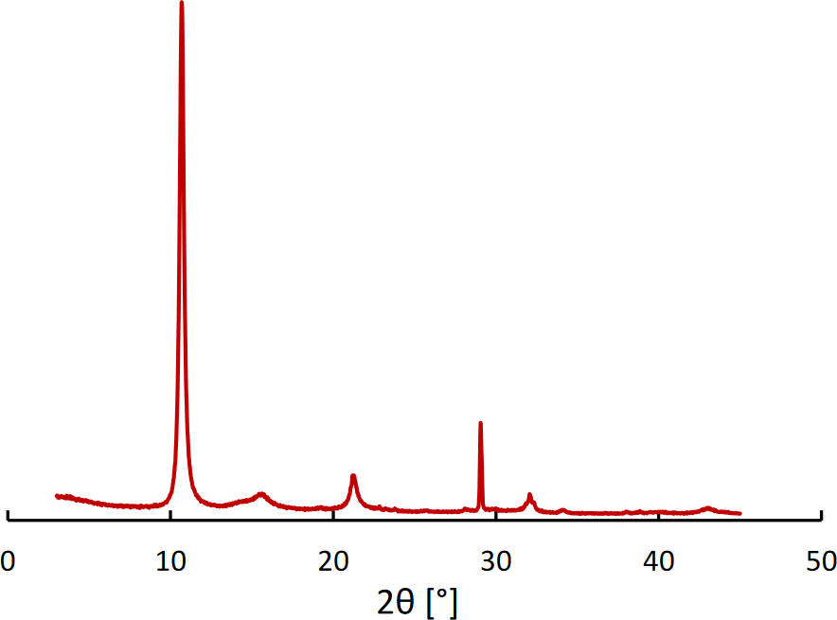
Figure S6. XRD pattern of Al-fum.

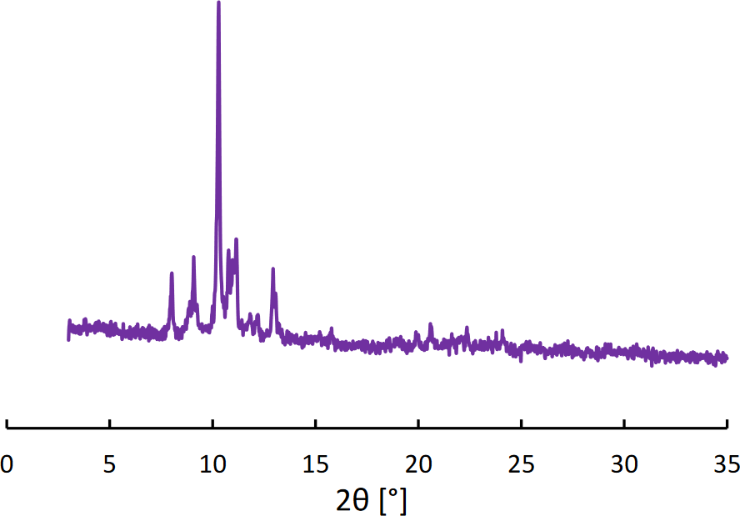
Figure S7. XRD pattern of MIL-88A.

5. Details concerning the QE-TPDA of water for MOFs.

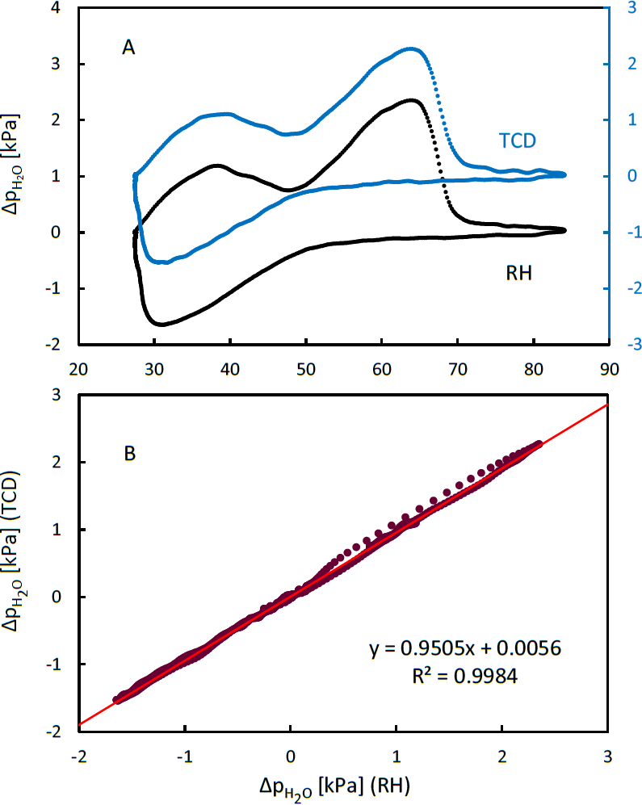
Figure S8. A: Comparison of the QE-TPDA profiles of H₂O on Basolite A520 based on different signals of the detector, either the thermal conductivity signal (TCD) or relative humidity (RH) signal. B: Linear correlation of the H₂O partial pressure changes, calculated from both detector signals.
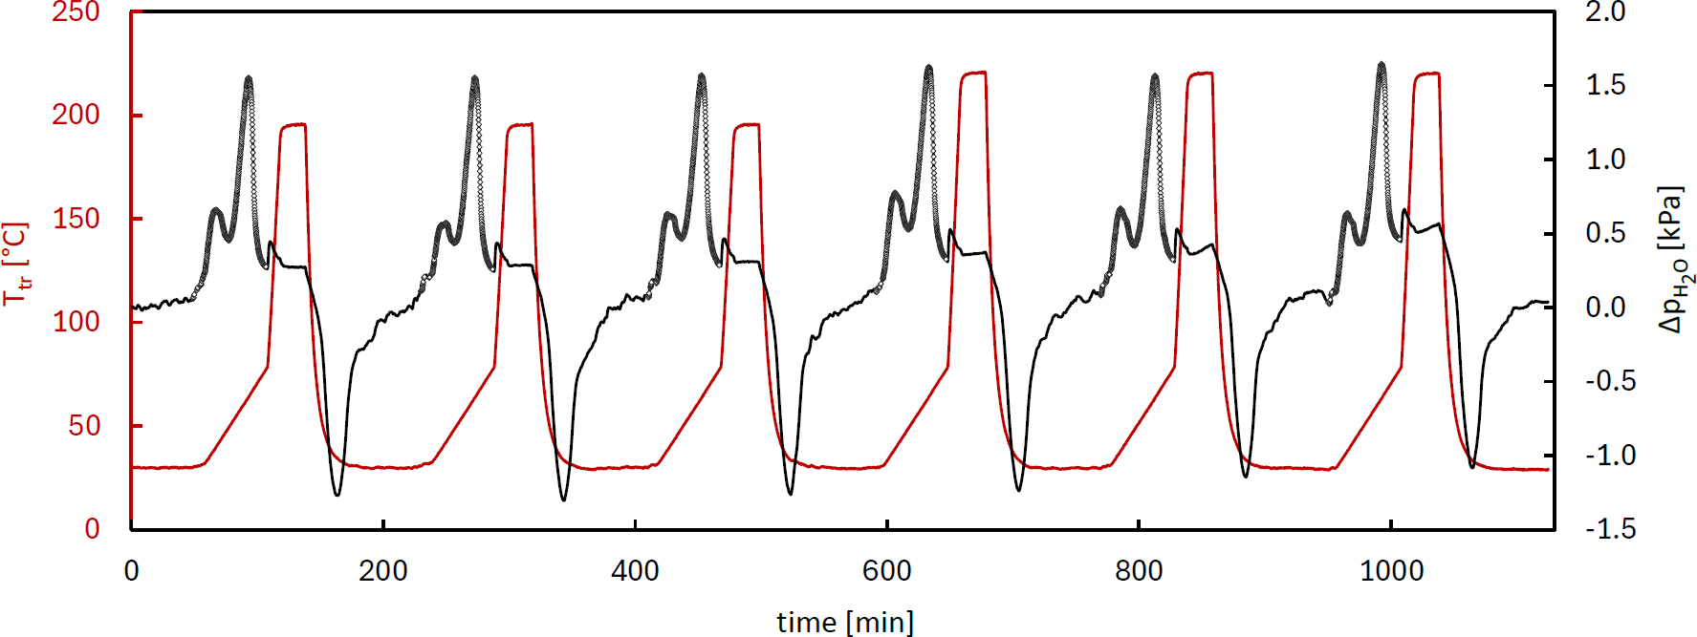
Figure S9. Illustration of the hydrothermal stability test (the first 6 cycles of the experiment for Al-fum, shown in Fig. 8). Each cycle involves slow heating (from 30 to 80°C), followed by fast heating to high temperature, then the isothermal high-temperature treatment (20 min), fast cooling, and isothermal segment at low temperature. After each 3-cycle sequence, the temperature of the fourth (isothermal) segment was increased by 25°C. Only data corresponding to desorption during the slow heating (indicated by points) were used for the interpretation of the outcome of the test.

