APPENDIX
Management of orange peels and chokeberry/red currant seeds via pyrolysis and CO₂-consuming activation using microwave-assisted heating: Changes in textural, surface-chemistry features and detoxifying potential from biomass to activated carbon

Table A.1 Formulas and structures of organic adsorbates
Name | Structure
Rhizobium leguminosarum bv.  trifolii exopolysaccharide (EPS) monomer | 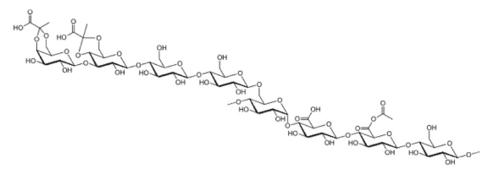(Skorupska et al., 2006)
Cationic polyacrylamide (CtPAM) monomer | 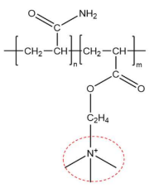  (Estrada et al. 2020)
Anionic polyacrylamide (AnPAM) monomer | 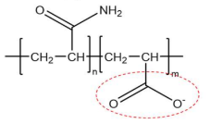  (Estrada et al. 2020)
Diuron, DCMU,  N-(3,4-dichlorophenyl)-N,N-dimethyl-urea | 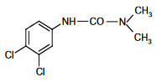  (Giacomazzi and Cochet 2004)
Glyphosate, GLY,  N-(phosphonomethyl) glycine | 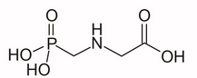  (Peillex and Pelletier 2020)

Table A.2 The equations applied for experimental data modelling
Equation | Formula | References
Pseudo I-order | $q_{t}=\frac{k_{2}∙q_{e}^{2}∙t}{{1+k}_{2}∙q_{e}∙t}$ (3) | (Lagergren, 1988)
Pseudo II-order | $q_{t}=q_{e}∙{(1-e^{-k_{1}∙t)}t}^{\frac{1}{2}}$ (4) | (Ho and McKay, 1999)
IPD | $q_{t}=k_{D}t^{\frac{1}{2}}+C$ (5) | (Ouyang et al., 2020)
Elovich | $q_{t}=\frac{1}{β}ln⁡(1+αβt)$ (6) | (Ouyang et al., 2020)
Langmuir | $q_{e}=\frac{Q_{m}K_{L} C_{e}}{1+K_{L}C_{e}}$ (7) | (Foo and Hameed 2010)
Freundlich | $q_{e}=K_{F}∙C_{e}^{1/n}$ (8) | (Foo and Hameed 2010)
Langmuir-Freundlich | $q_{e}=\frac{A_{m}∙K_{LF}∙C_{e}^{m}}{1+K_{LF∙}{C_{e}}^{m}}$ (9) | (Szewczuk-Karpisz et al., 2021)
Redlich-Peterson | $q_{e}=\frac{K_{R}∙C_{e}}{1+a_{R}{{∙C}_{e}}^{β_{R}}}$ (10) | (Tomczyk et al. 2023)
Temkin | $q_{e}=\frac{RT}{b} lnAC_{e}$ (11) | (Kończyk et al. 2022)
Dubinin-Radushkevich | $q_{e}=q_{D}∙e^{(-β_{D}{[RTln(1+\frac{1}{C_{e}}]}^{2})}$ (12) | (Tomczyk et al., 2023)
q_{t} (mg/g) – the amount adsorbed at time t (min); q_{e} (mg/g) – the amount adsorbed at equilibrium; k₁ (1/min) and k₂ (g/mg·min) – the reaction rate constants; C_{e} (mg/L) – the equilibrium concentration of adsorbate in the solution; C (mg/g) – the constant; k_{D} (g/mg·min^{1/2}) – the IPD rate constant; α (mg/g·min) – the primary rate of adsorption; β – the desorption parameter; Q_{m} (mg/g) – the maximum adsorbed amount in the monomolecular layer; K_{L} (L/mg) – the Langmuir constant; K_{F} (mg/g (mg/L)^{1/n}) – the Freundlich parameter; K_{LF}, (L/mg) – related to the affinity of the adsorbate for active sites; A_{m} (mg/g) – the amount of the available surface sites; m – the parameter determining the shape of the energy distribution function; K_{R} (L/mg) – the Redlich–Peterson adsorption capacity constant; a_{R} [(L/mg)^{β}] – the Redlich–Peterson isotherm constant; β_{R} – the exponent between 0 and 1; A – the Temkin model constant; b (kcal/mol) – the adsorption heat; R (8.314 J/K·mol) – the universal gas constant; T (K) – the absolute temperature; q_{D} (mg/g) – the theoretical isotherm saturation capacity; β_{D} – the Dubinin-Raduskevich isotherm constant.

Tab. A.3 Equilibrium parameters for Cd, Cu, As, and Se adsorption on OB and the OB-derived materials
 |  | As(V) |  |  |  |  | Se(IV) |  |  |  |  | Cd(II) |  |  |  |  | Cu(II)
Model | parameter | OB | OBCC | OBCM | OFC800 | OFM800 | OB | OBCC | OBCM | OFC800 | OFM800 | OB | OBCC | OBCM | OFC800 | OFM800 | OB | OBCC | OBCM | OFC800 | OFM800
Langmuir (linear) | Q_{m} [mg/g] | 2.892 | 2.950 | 4.210 | 7.220 | 5.033 | - | 25.875 | 3.880 | 1.872 | 2.720 | 15.270 | 26.243 | 33.543 | 91.519 | 42.071 | 10.756 | 16.187 | 14.076 | 17.685 | 35.245
Langmuir (linear) | K_{L} [L/mg] | 0.005 | 0.006 | 0.006 | 0.006 | 0.022 | - | 0.001 | 0.017 | 0.013 | 0.074 | 0.045 | 0.016 | 0.028 | 0.004 | 0.022 | 0.226 | 0.036 | 0.183 | 0.132 | 0.165
Langmuir (linear) | R² | 0.802 | 0.378 | 0.320 | 0.538 | 0.956 | - | 0.184 | 0.954 | 0.702 | 0.985 | 0.984 | 0.956 | 0.969 | 0.135 | 0.999 | 0.998 | 0.971 | 0.999 | 0.999 | 0.999
Freundlich (linear) | n | 1.187 | 1.154 | 1.133 | 1.161 | 1.649 | - | 1.042 | 1.550 | 1.367 | 2.422 | 2.039 | 1.968 | 2.345 | 1.051 | 1.631 | 3.764 | 1.891 | 4.026 | 3.604 | 3.260
Freundlich (linear) | K_{F} [mg/g (mg/L)^{1/n}] | 1.023 | 0.823 | 0.564 | 0.346 | 0.286 | - | 0.306 | 0.419 | 0.910 | 0.410 | 0.078 | 0.067 | 0.044 | 0.035 | 0.034 | 0.094 | 0.076 | 0.074 | 0.060 | 0.028
Freundlich (linear) | R² | 0.939 | 0.767 | 0.748 | 0.853 | 0.818 | - | 0.928 | 0.890 | 0.708 | 0.678 | 0.777 | 0.985 | 0.987 | 0.829 | 0.948 | 0.685 | 0.743 | 0.800 | 0.930 | 0.770
Langmuir-Freundlich | A_{m} [mg/g] | 1.798 | 1.588 | 2.171 | 4.104 | 4.177 | - | 6.219 | 3.154 | 1.276 | 2.579 | 13.923 | 46.504 | 58.393 | 34.614 | 39.431 | 10.430 | 13.666 | 13.698 | 19.670 | 36.857
Langmuir-Freundlich | K_{LF} [L/mg] | 0.003 | 0.002 | 0.000 | 0.002 | 0.004 | - | 0.000 | 0.002 | 0.001 | 0.002 | 0.012 | 0.019 | 0.035 | 0.003 | 0.018 | 0.032 | 0.002 | 0.183 | 0.199 | 0.318
Langmuir-Freundlich | m | 1.353 | 1.775 | 2.222 | 1.627 | 1.680 | - | 2.096 | 1.779 | 2.107 | 2.255 | 1.558 | 0.705 | 0.643 | 1.533 | 1.102 | 1.912 | 2.130 | 1.098 | 0.684 | 0.699
Langmuir-Freundlich | R² | 0.999 | 0.998 | 0.996 | 0.997 | 0.999 | - | 0.923 | 0.998 | 0.998 | 0.999 | 0.999 | 0.999 | 0.999 | 0.997 | 0.999 | 0.999 | 0.999 | 0.999 | 0.994 | 0.998
Redlich-Peterson | K_{R} [L/mg] | 0.021 | 0.120 | 0.721 | 0.074 | 0.140 | - | 0.049 | 0.074 | 0.047 | 0.181 | 0.785 | 0.855 | 5.220 | 0.622 | 0.960 | 46.910 | 0.756 | 2.907 | 3.849 | 14.590
Redlich-Peterson | n | 0.899 | 0.678 | 0.612 | 1.000 | 1.000 | - | 1.000 | 1.000 | 1.000 | 1.000 | 1.000 | 0.645 | 0.616 | 1.000 | 1.000 | 0.843 | 1.000 | 1.000 | 0.908 | 0.909
Redlich-Peterson | a_{R} [(L/mg)^{β}] | 0.016 | 0.385 | 2.283 | 0.014 | 0.028 | - | 0.004 | 0.019 | 0.030 | 0.062 | 0.051 | 0.236 | 1.250 | 0.014 | 0.023 | 9.780 | 0.047 | 0.209 | 0.348 | 0.668
Redlich-Peterson | R² | 0.996 | 0.998 | 0.989 | 0.993 | 0.996 | - | 0.989 | 0.998 | 0.997 | 0.999 | 0.997 | 0.999 | 0.998 | 0.991 | 0.995 | 0.996 | 0.998 | 0.999 | 0.999 | 0.998
Temkin | A | 0.101 | 0.154 | 0.163 | 0.128 | 0.243 | - | 0.068 | 0.175 | 0.231 | 0.801 | 0.483 | 0.278 | 0.669 | 0.135 | 0.294 | 5.047 | 0.435 | 7.104 | 4.132 | 6.104
Temkin | b [kcal/mol] | 1.247 | 1.240 | 0.875 | 0.488 | 0.523 | - | 0.295 | 0.669 | 1.602 | 1.042 | 0.178 | 0.125 | 0.108 | 0.058 | 0.070 | 0.347 | 0.170 | 0.287 | 0.217 | 0.114
Temkin | R² | 0.995 | 0.995 | 0.998 | 0.989 | 0.996 | - | 0.999 | 0.997 | 0.997 | 0.999 | 0.997 | 0.999 | 0.998 | 0.985 | 0.994 | 0.997 | 0.998 | 0.996 | 0.993 | 0.996
Dubinin-Radushkevich | K_{DR} | 0.000 | 0.000 | 0.000 | 0.000 | 0.000 | - | 0.000 | 0.000 | 0.000 | 0.000 | 0.000 | 0.000 | 0.000 | 0.000 | 0.000 | 0.000 | 0.000 | 0.000 | 0.000 | 0.000
Dubinin-Radushkevich | q_{D} | 0.974 | 1.315 | 1.904 | 2.856 | 3.418 | - | 4.568 | 2.312 | 1.202 | 2.497 | 11.971 | 11.967 | 17.139 | 21.835 | 20.740 | 10.232 | 12.294 | 12.520 | 14.247 | 29.005
Dubinin-Radushkevich | R² | 0.834 | 0.981 | 0.982 | 0.930 | 0.944 | - | 0.919 | 0.857 | 0.995 | 0.986 | 0.960 | 0.597 | 0.620 | 0.939 | 0.774 | 0.993 | 0.957 | 0.963 | 0.811 | 0.947

Tab. A.4 Kinetic parameters for Cd, Cu, As, and Se adsorption on OB and the OB-derived materials
 |  | As(V) |  |  |  |  | Se(IV) |  |  |  |  | Cd(II) |  |  |  |  | Cu(II)
Model | parameter | OB | OBCC | OBCM | OFC800 | OFM800 | OB | OBCC | OBCM | OFC800 | OFM800 | OB | OBCC | OBCM | OFC800 | OFM800 | OB | OBCC | OBCM | OFC800 | OFM800
PFO (linear) | q_{e} [mg/g] | 0.860 | 1.474 | 1.759 | 2.394 | 1.782 | - | 3.384 | 2.424 | 0.595 | 0.952 | 10.355 | 18.812 | 33.334 | 23.388 | 21.877 | 3.367 | 5.174 | 6.167 | 7.600 | 11.176
PFO (linear) | k₁ [1/min] | 0.013 | 0.026 | 0.047 | 0.033 | 0.017 | - | 0.045 | 0.052 | 0.043 | 0.044 | 0.043 | 0.037 | 0.052 | 0.041 | 0.039 | 0.033 | 0.035 | 0.040 | 0.027 | 0.066
PFO (linear) | R² | 0.951 | 0.997 | 0.948 | 0.906 | 0.901 | - | 0.979 | 0.964 | 0.922 | 0.949 | 0.951 | 0.965 | 0.907 | 0.995 | 0.997 | 0.818 | 0.858 | 0.987 | 0.936 | 0.838
PSO (linear) | q_{e} [mg/g] | 7.573 | 5.170 | 2.945 | 5.046 | 4.073 | - | 3.774 | 3.220 | 1.257 | 2.629 | 20.207 | 20.207 | 20.207 | 24.581 | 26.110 | 10.553 | 12.866 | 13.264 | 16.872 | 29.172
PSO (linear) | k₂ [g/mg·min] | 0.000 | 0.000 | 0.002 | 0.001 | 0.016 | - | 0.009 | 0.007 | 0.065 | 0.058 | 0.000 | 0.000 | 0.000 | 0.001 | 0.001 | 0.014 | 0.006 | 0.008 | 0.005 | 0.005
PSO (linear) | R² | 0.005 | 0.068 | 0.507 | 0.459 | 0.998 | - | 0.999 | 0.973 | 0.999 | 0.999 | 0.176 | 0.176 | 0.176 | 0.991 | 0.993 | 0.999 | 0.998 | 0.999 | 0.999 | 0.999
IPD | k_{D} [g/mg·min^{1/2}] | 0.045 | 0.072 | 0.106 | 0.150 | 0.134 | - | 0.145 | 0.135 | 0.050 | 0.125 | 0.379 | 0.746 | 1.027 | 1.102 | 1.174 | 0.365 | 0.522 | 0.452 | 0.610 | 1.071
IPD | C [mg/g] | 0.000 | 0.000 | 0.094 | 0.210 | 1.250 | - | 0.520 | 0.320 | 0.354 | 1.140 | 0.000 | 0.000 | 0.000 | 1.356 | 2.460 | 4.130 | 4.039 | 5.503 | 5.530 | 11.125
IPD | R² | 0.998 | 0.999 | 0.996 | 0.987 | 0.987 | - | 0.978 | 0.990 | 0.996 | 0.976 | 0.997 | 0.997 | 0.997 | 0.999 | 0.999 | 0.998 | 0.999 | 0.999 | 0.998 | 0.999
Elovich | α [mg/g· min] | 0.013 | 0.021 | 0.077 | 0.137 | 3.736 | - | 0.250 | 0.162 | 0.490 | 5.738 | 0.095 | 0.180 | 0.241 | 0.641 | 1.113 | 14.640 | 4.257 | 100.686 | 10.069 | 49.614
Elovich | β | 3.266 | 2.074 | 1.861 | 1.222 | 2.000 | - | 1.315 | 1.440 | 5.150 | 3.153 | 0.353 | 0.175 | 0.125 | 0.166 | 0.176 | 0.760 | 0.483 | 0.790 | 0.421 | 0.286
Elovich | R² | 0.995 | 0.994 | 0.999 | 0.998 | 0.998 | - | 0.999 | 0.999 | 0.999 | 0.999 | 0.996 | 0.996 | 0.997 | 0.999 | 0.999 | 0.999 | 0.999 | 0.999 | 0.994 | 0.997

a) 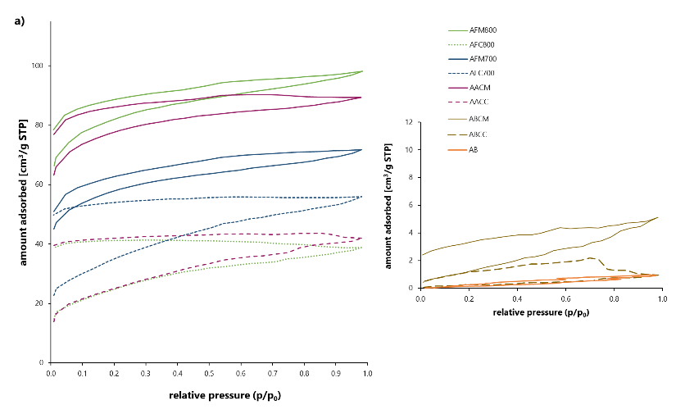
b) 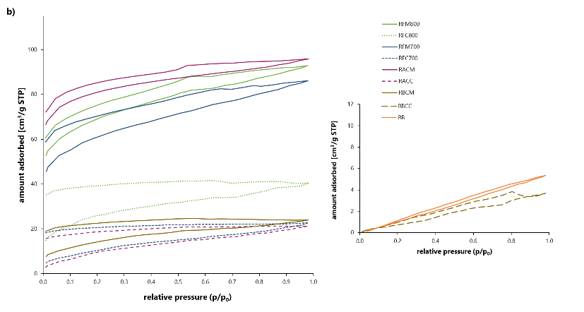
c) 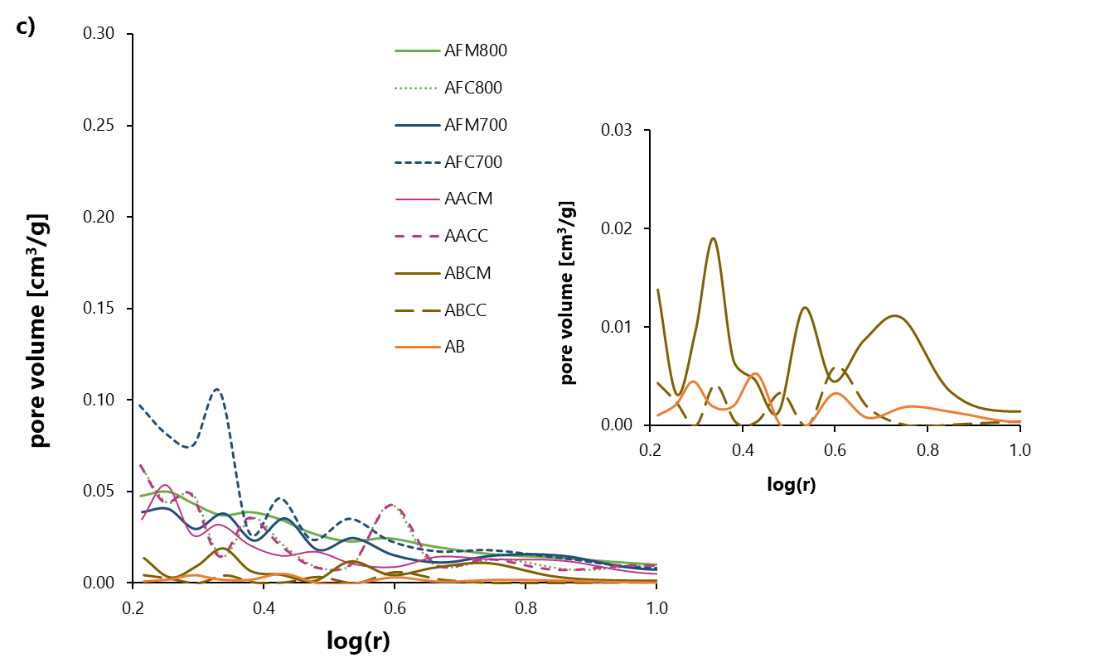
d)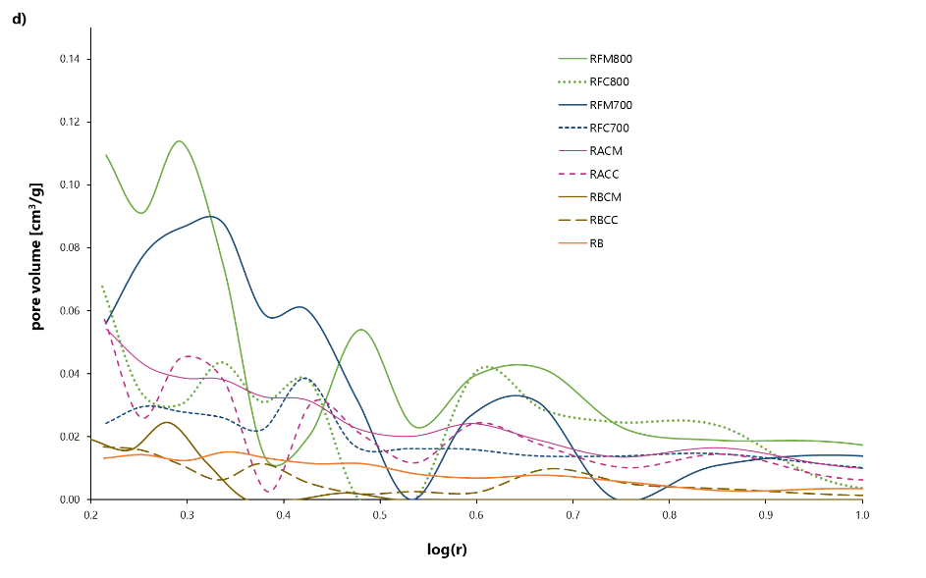
Fig. A.1 N₂ adsorption/desorption isotherms (a, b) and pore size distribution (c, d) for chokeberry seeds and black currant seeds, respectively, as well as BCs and ACs produced from them

a) 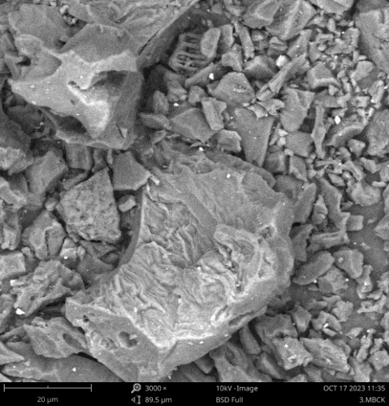 b) 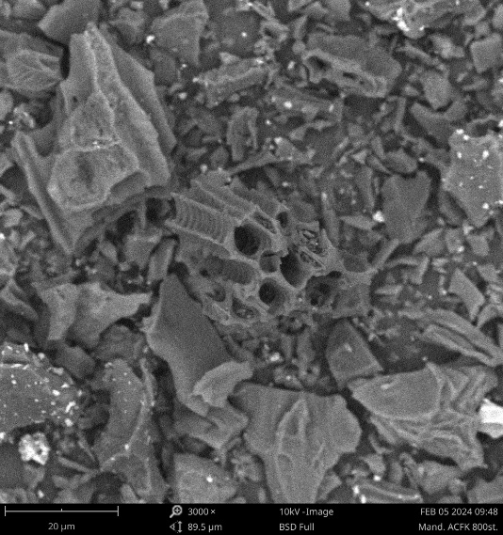
Fig. A.2 SEM images at 3000x magnification of the OBCC (a) and OFC800 (b) samples

a)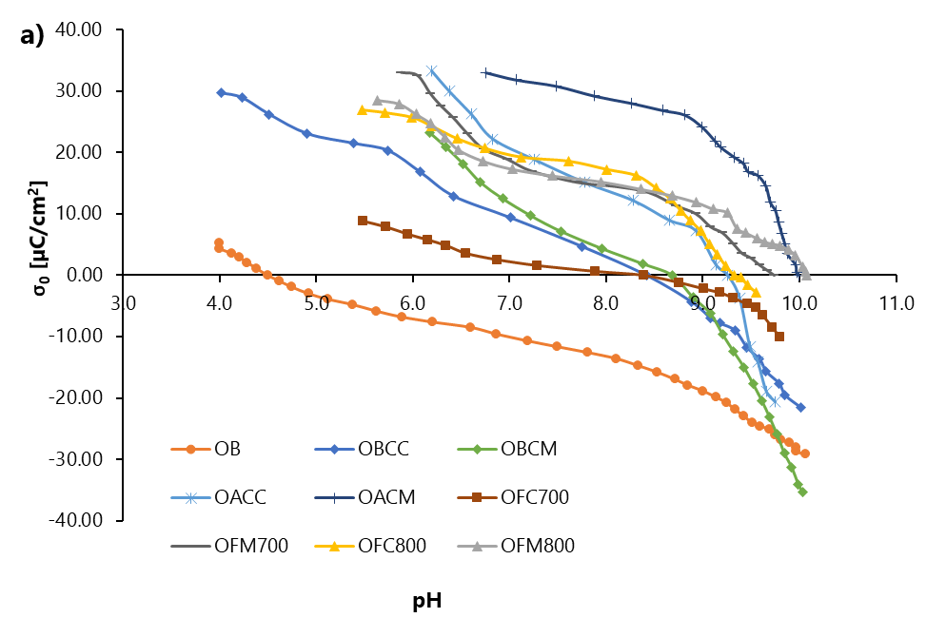
b)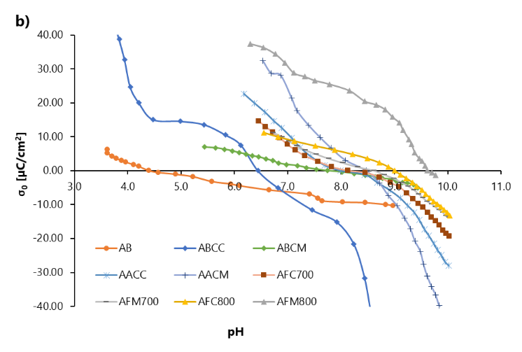
c)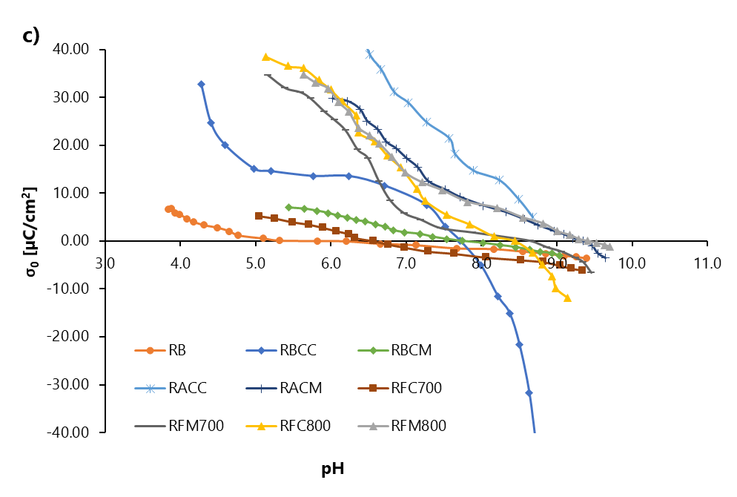
d)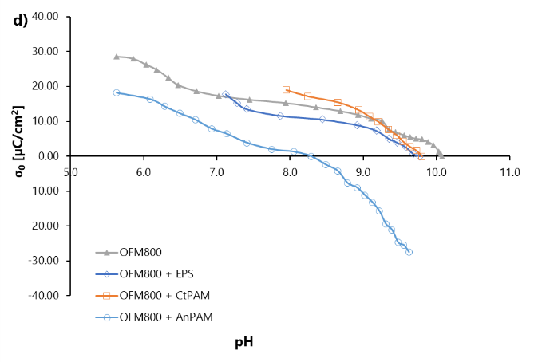
Fig. A.3. Surface charge density as a function of pH value for Bs, BCs, and ACs (a-c) as well as for the OFM800 sample with and without macromolecular compounds (d)
a)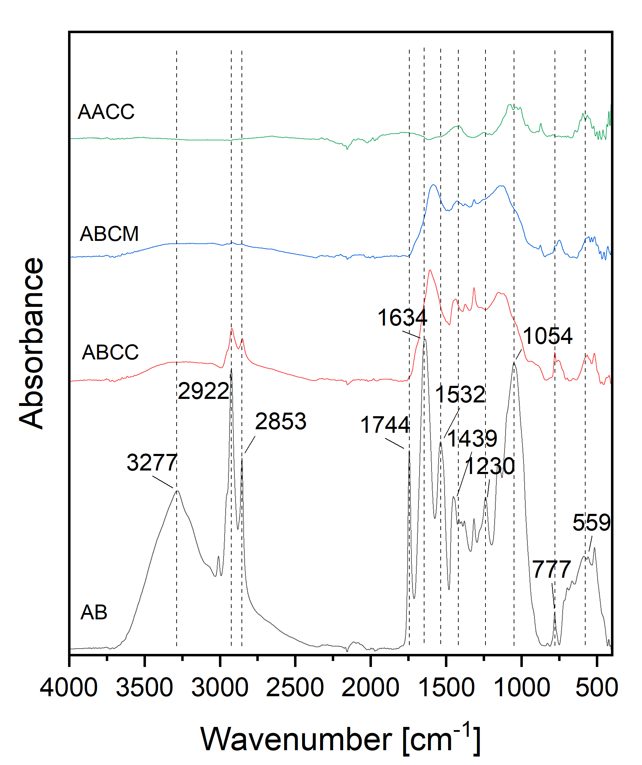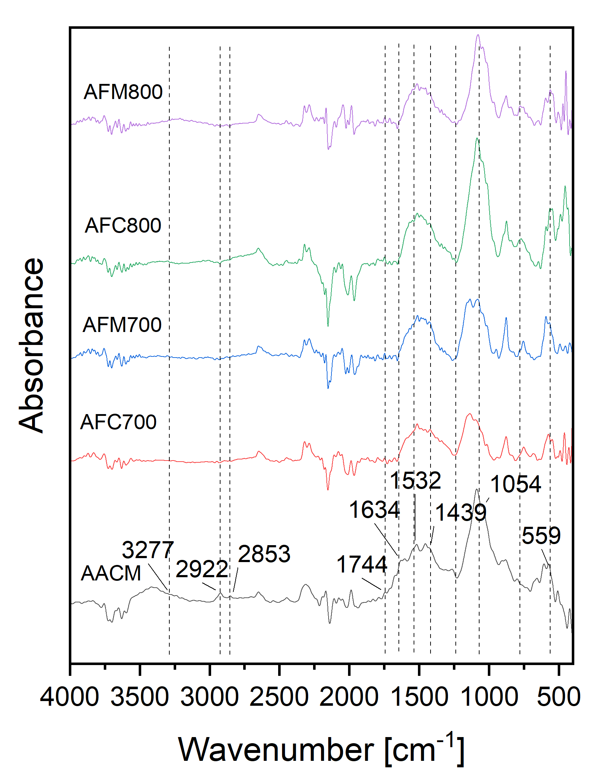
b)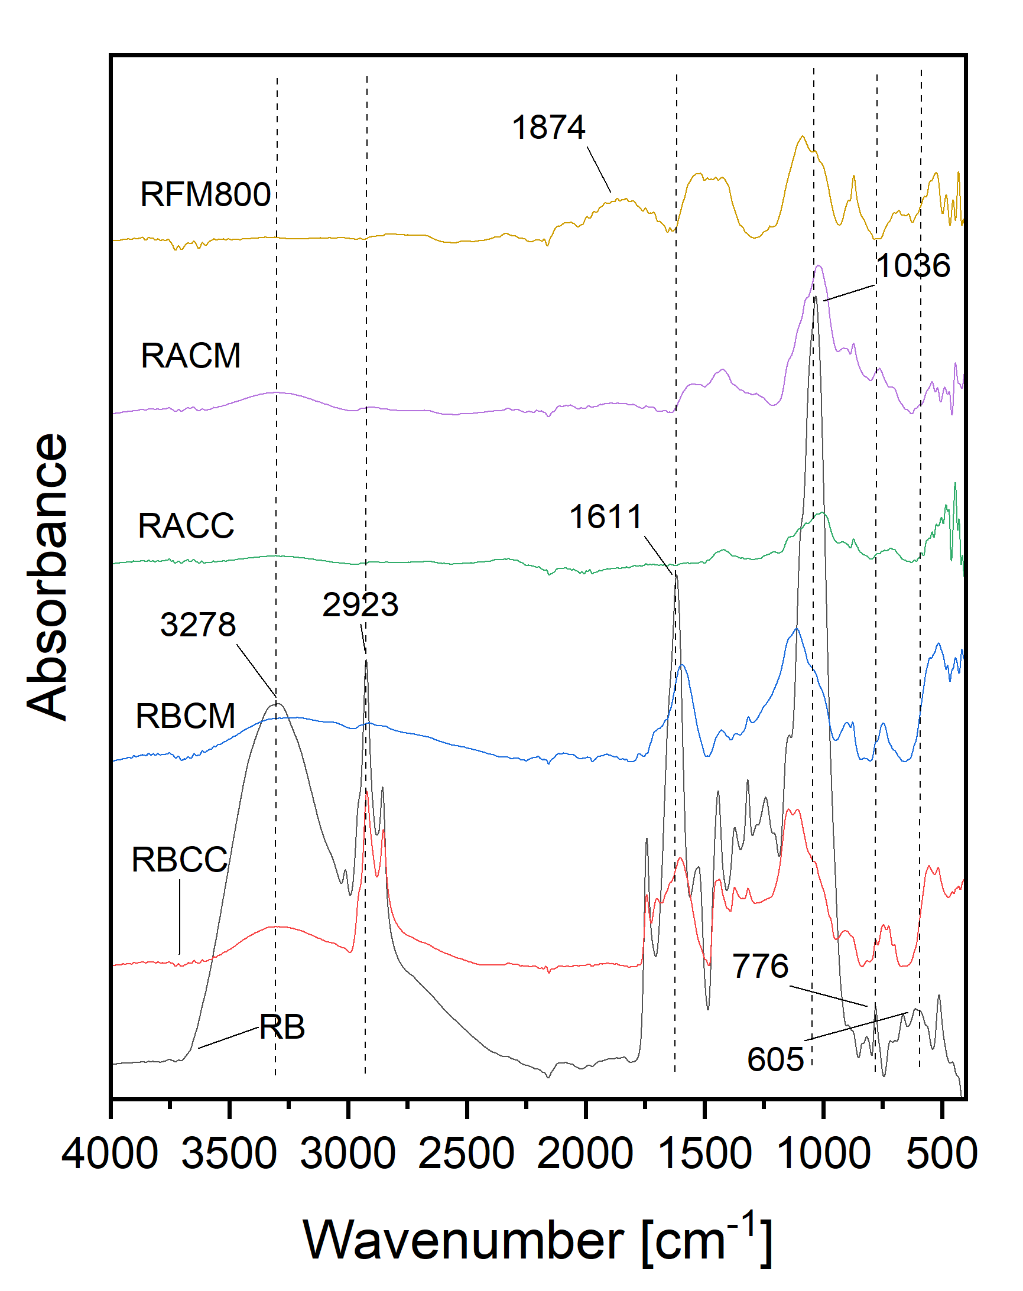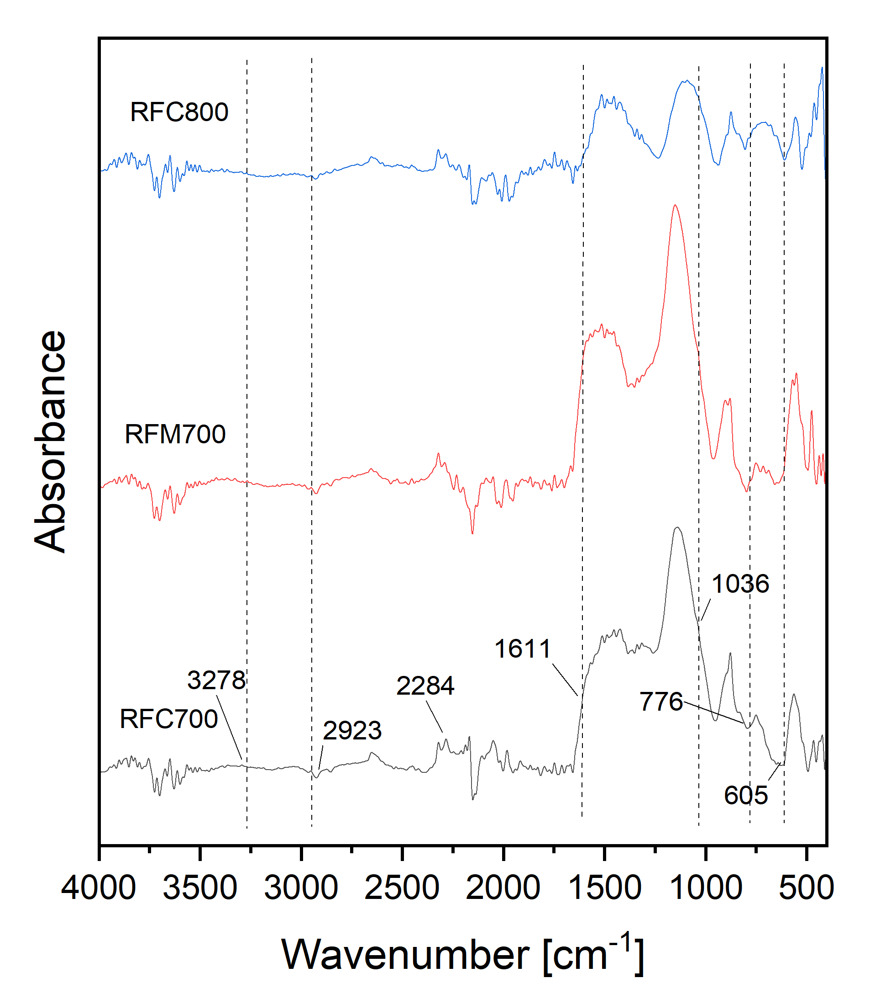
Fig. A.4. FTIR spectra of chokeberry as well as BCs and ACs produced from them (a) and black currant as well as BCs and ACs produced from them (b)
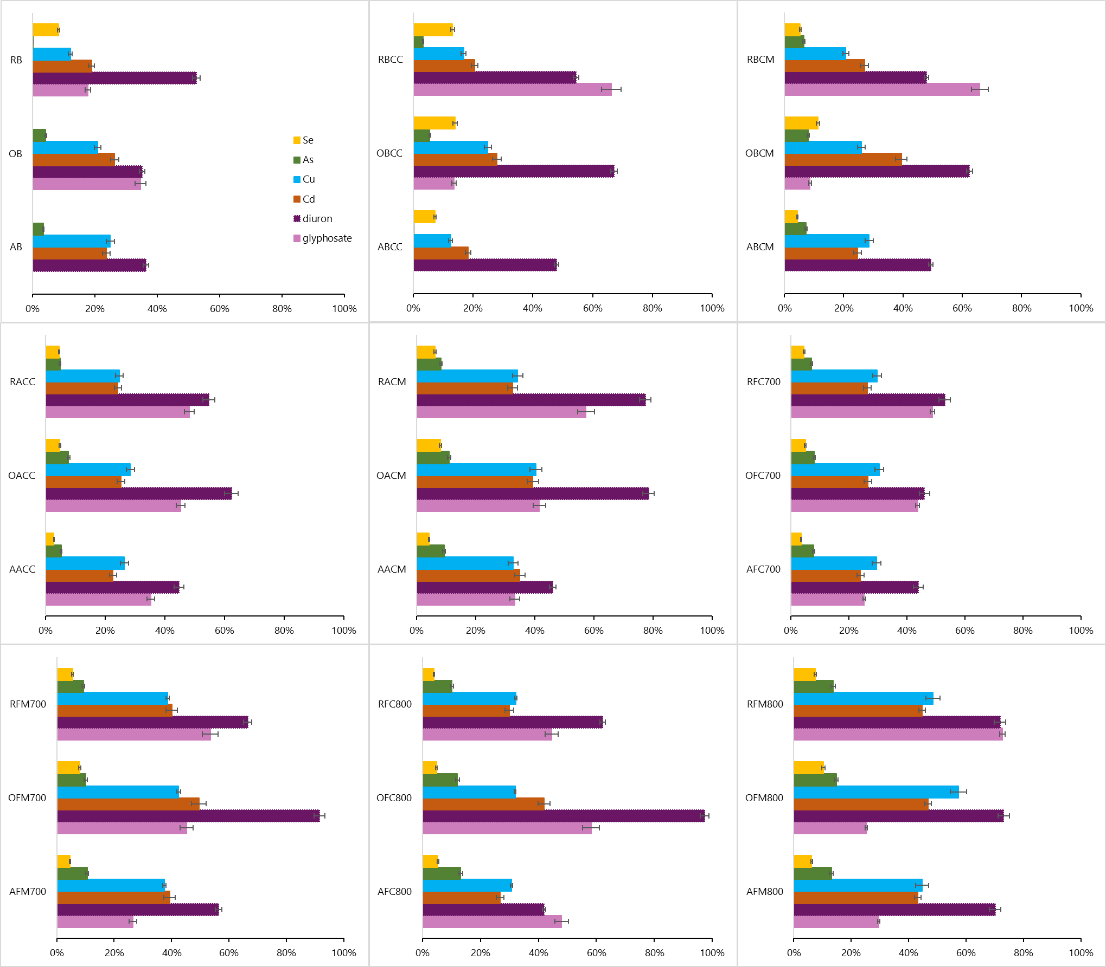
Fig. A.5. Adsorbed amounts of metals, metalloids, and herbicides on Bs and obtained BCs/ACs (initial Cd/Cu/As/Se concentration = 100 mg/L, DCMU/GLY = 10 mg/L)
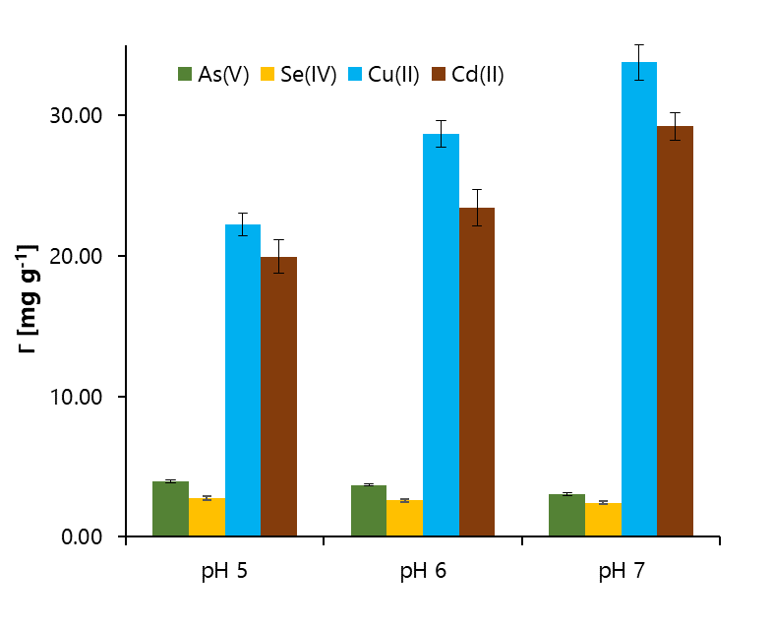
Fig. A.6. Adsorbed amounts of metals and metalloids on the OFM800 sample at various pH values
a) 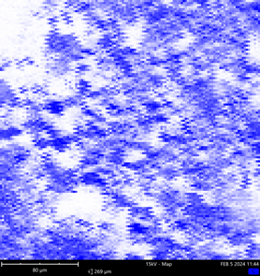 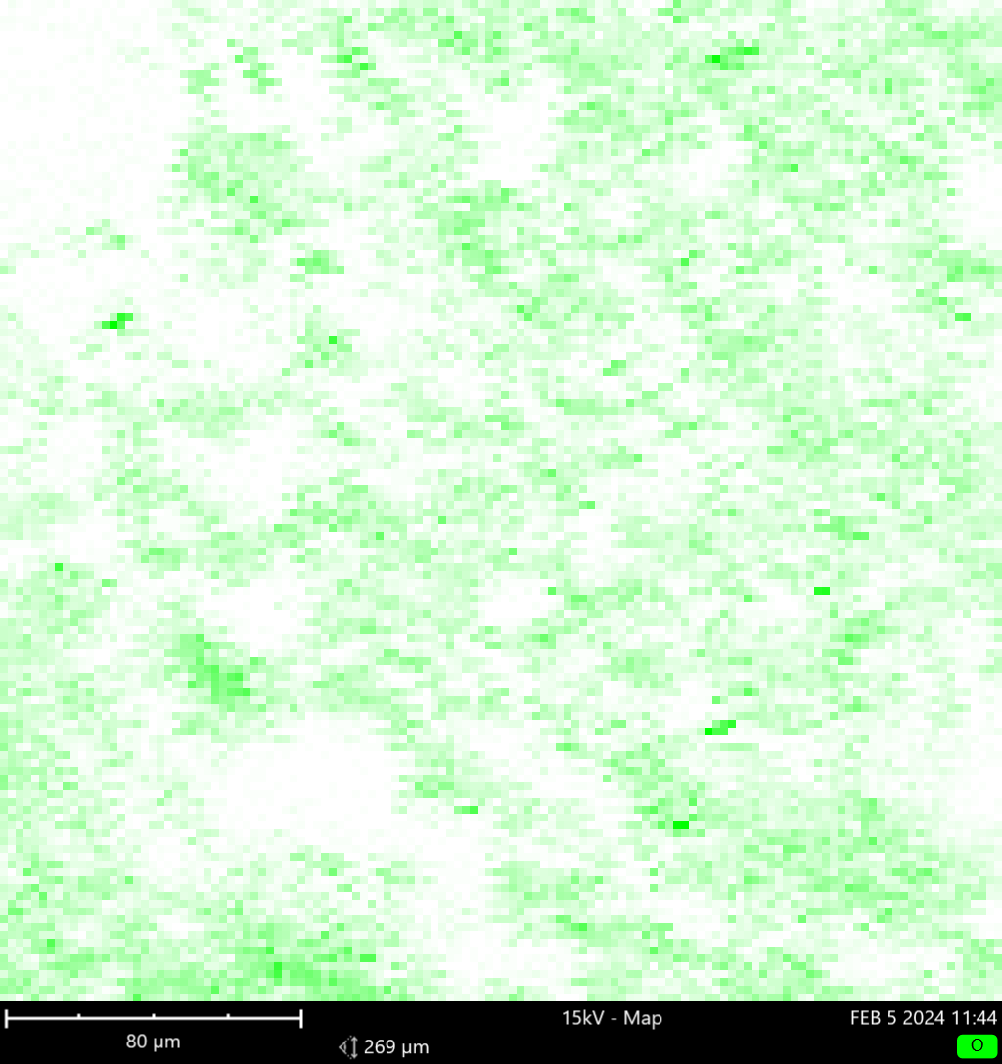 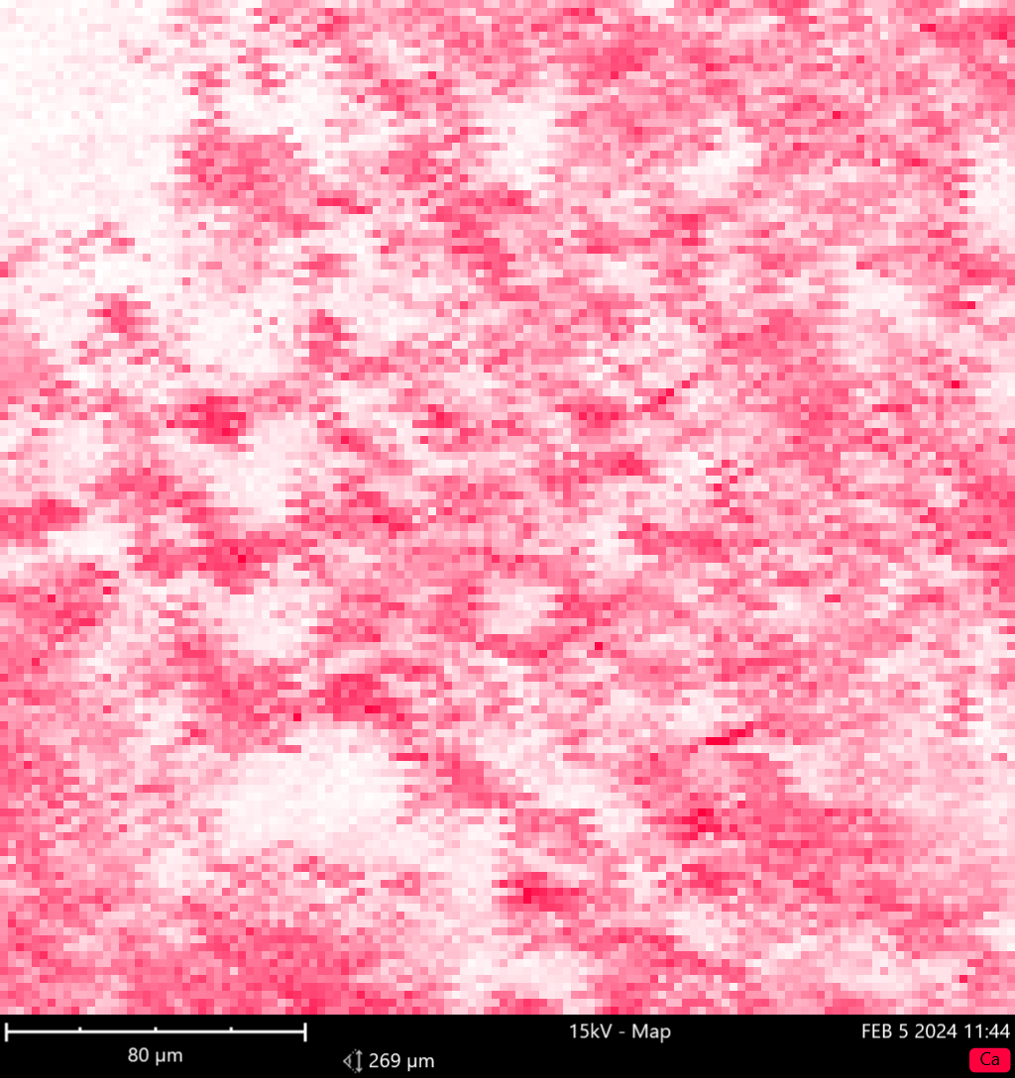
Ca
O
C
b) 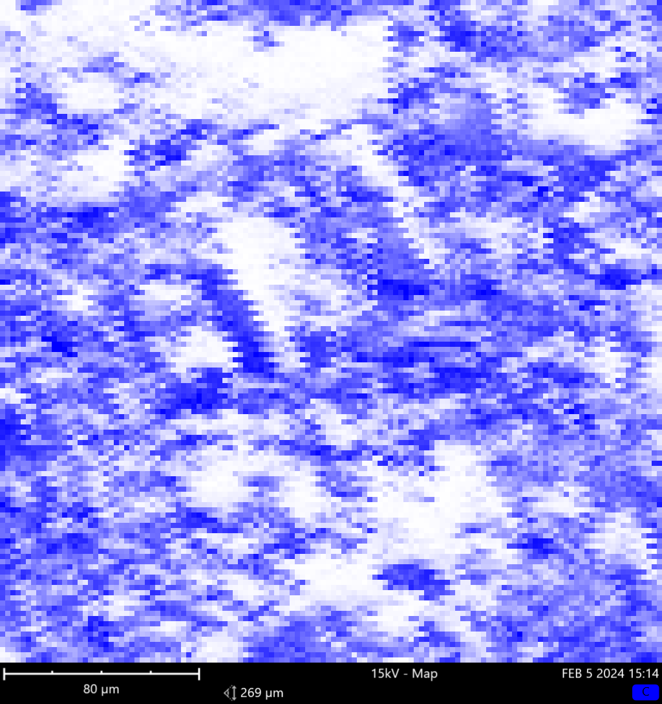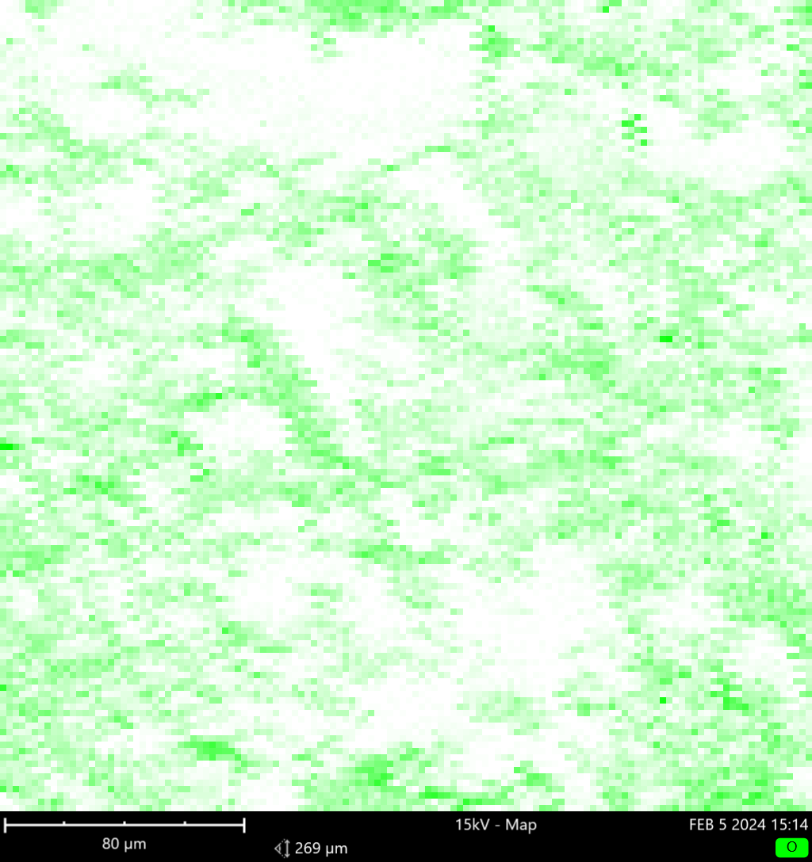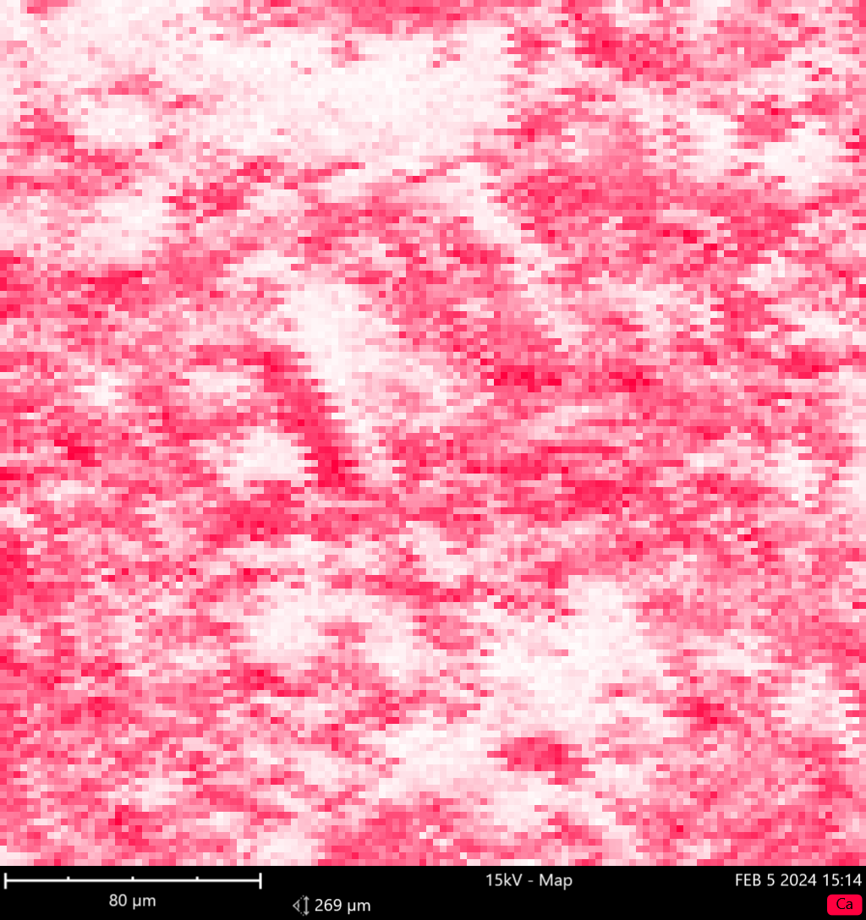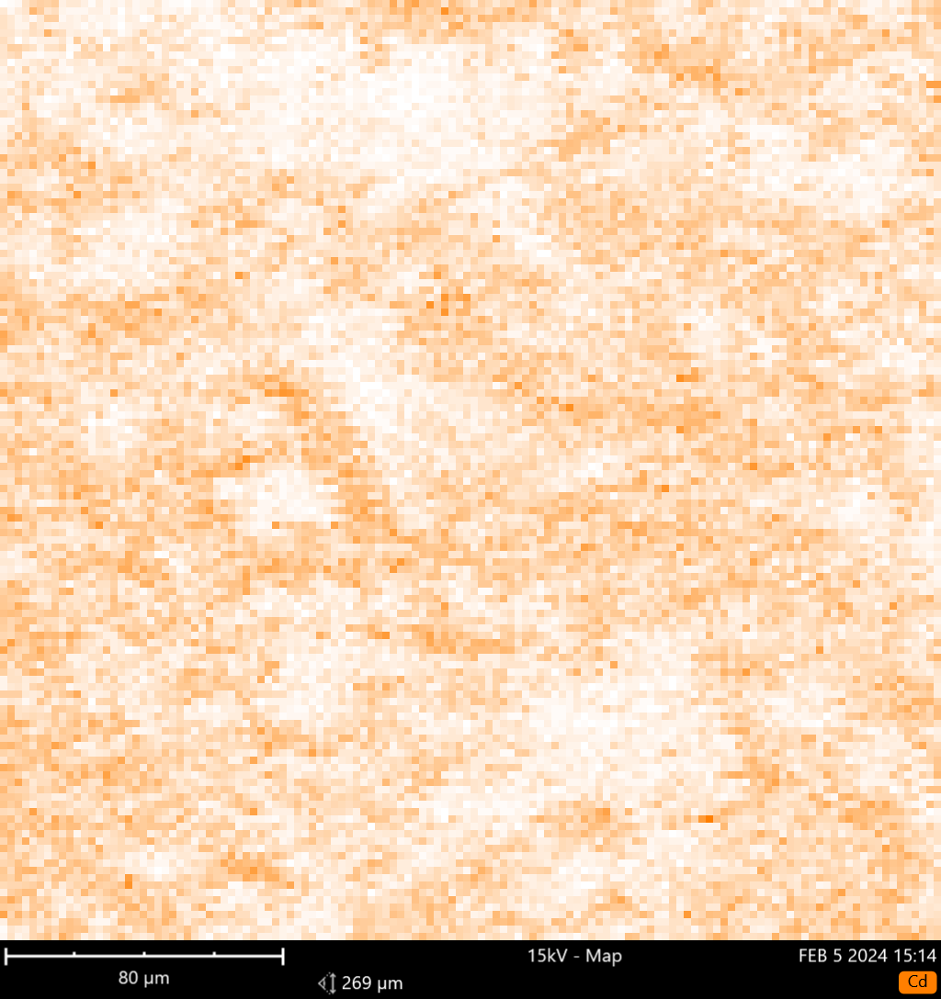
Cd
Ca
O
C
c) 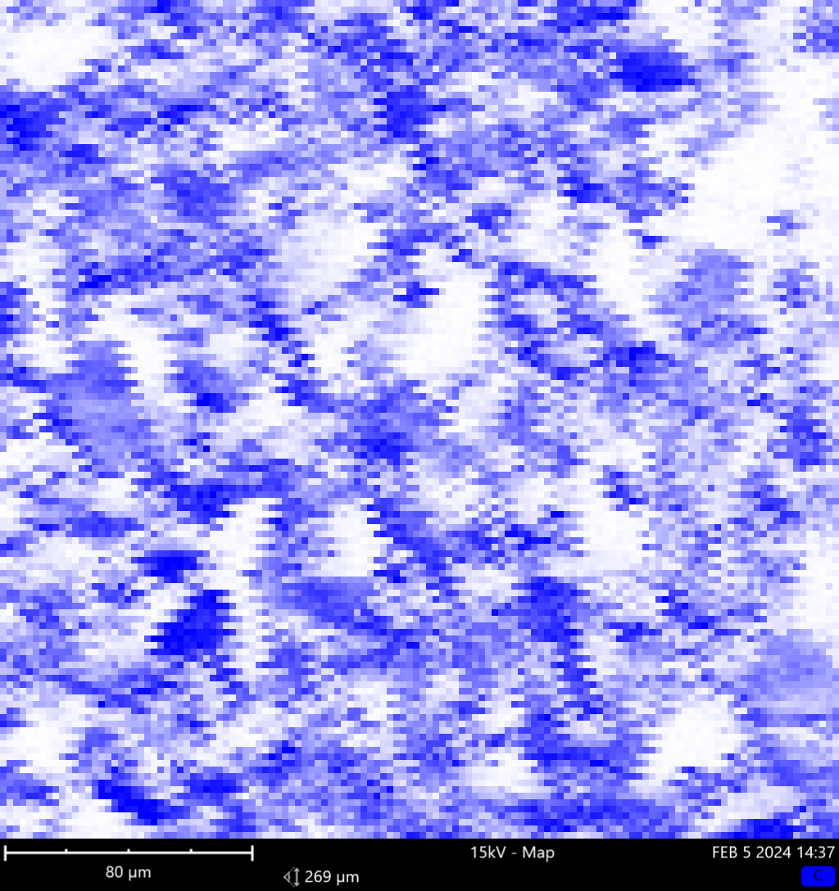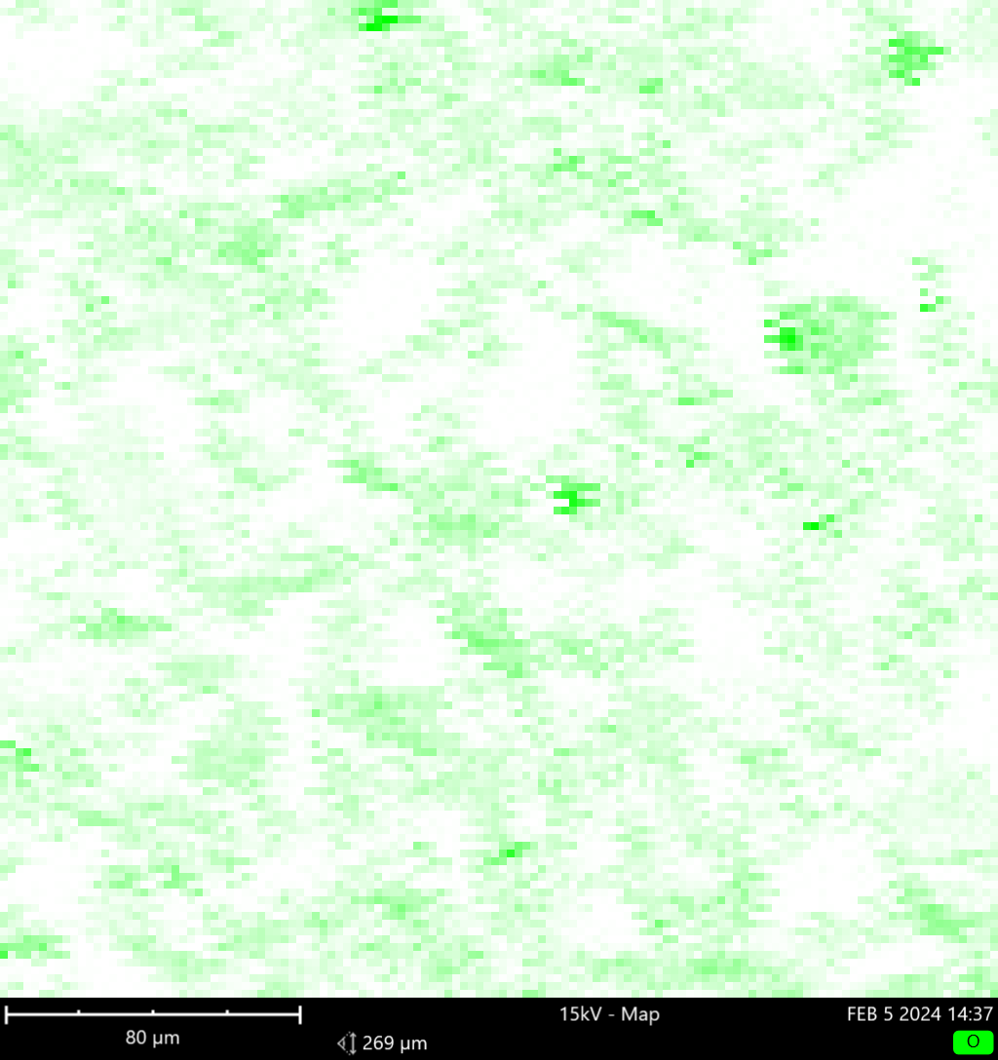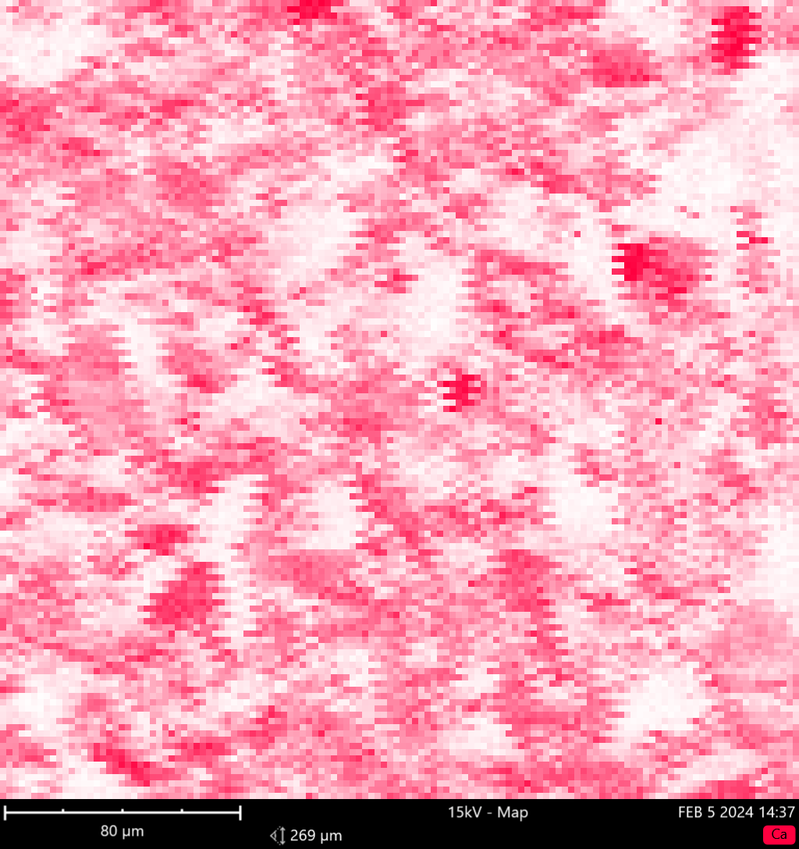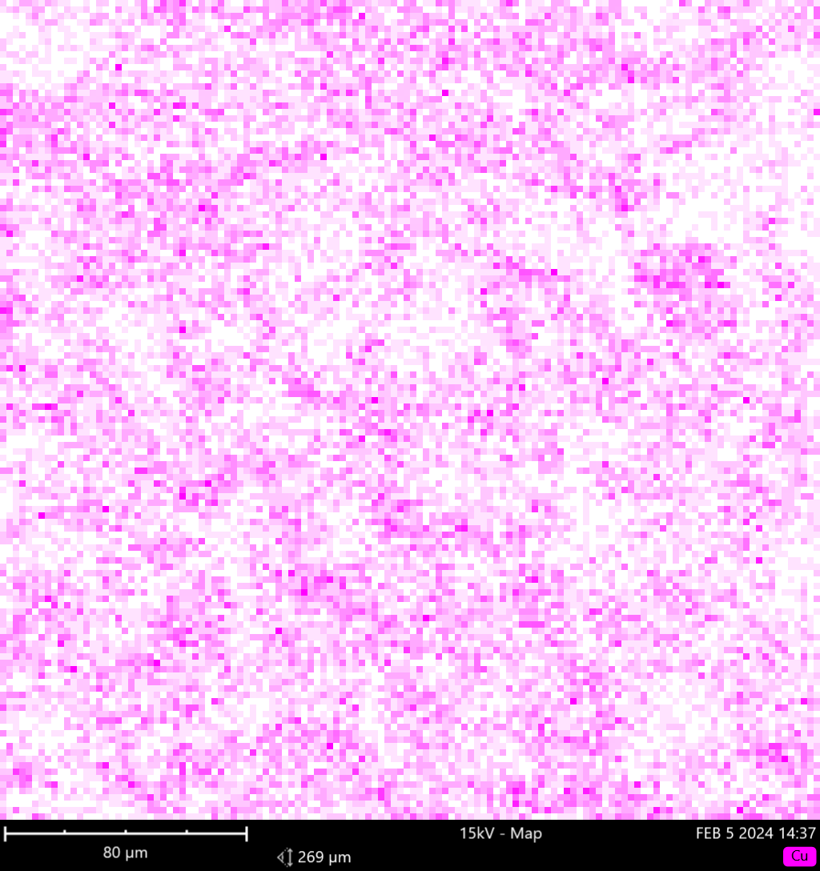
Cu
Ca
O
C
d) 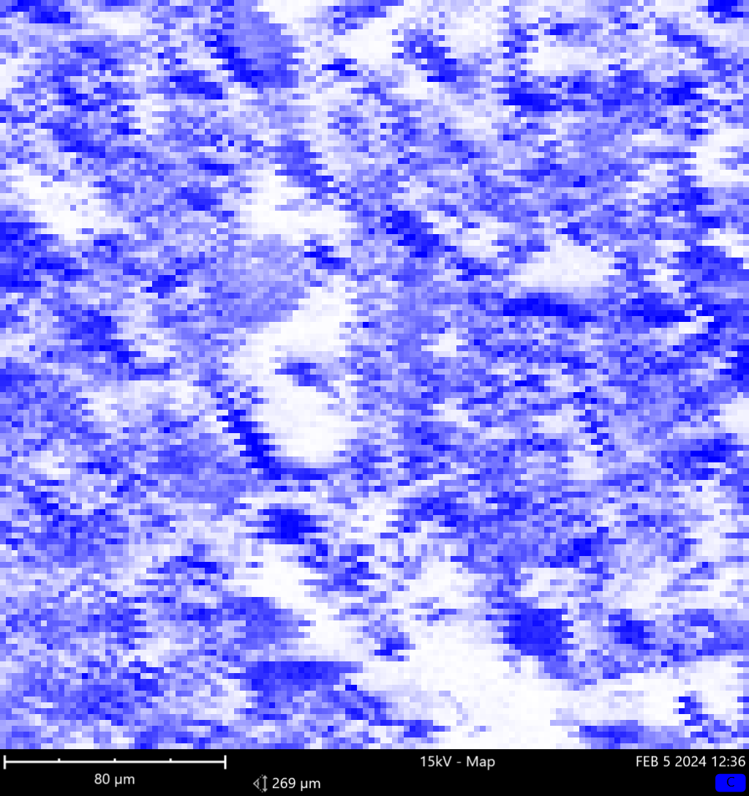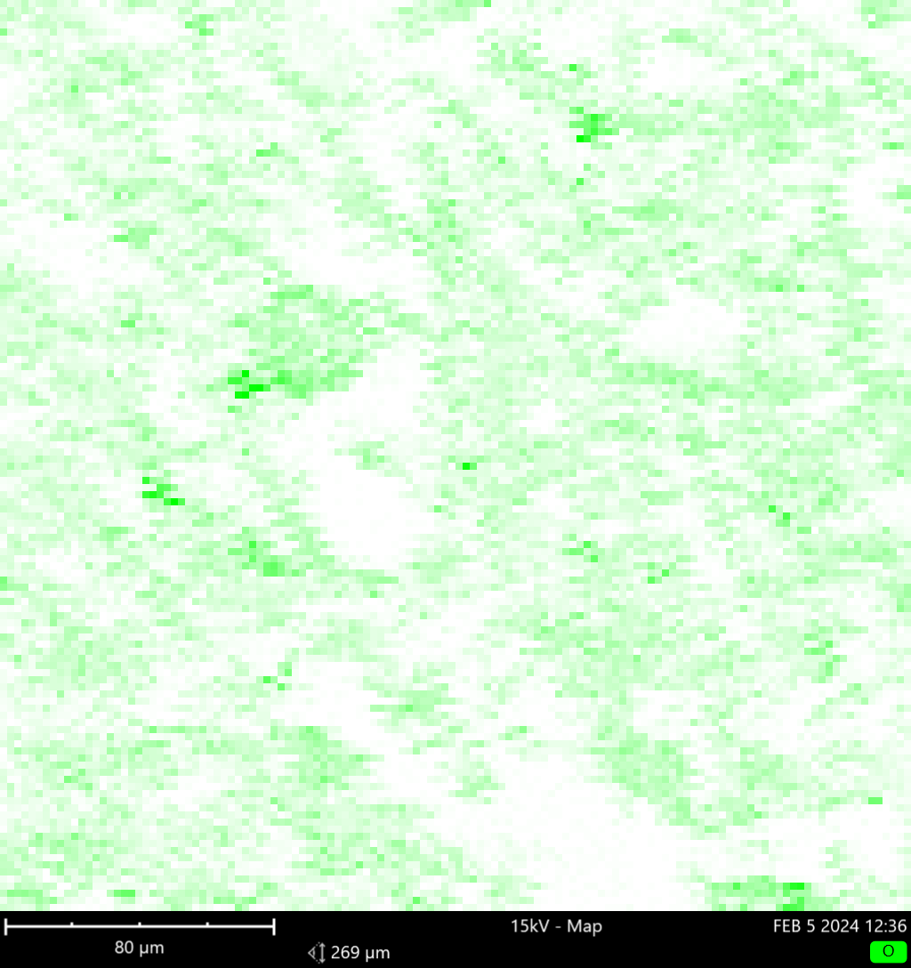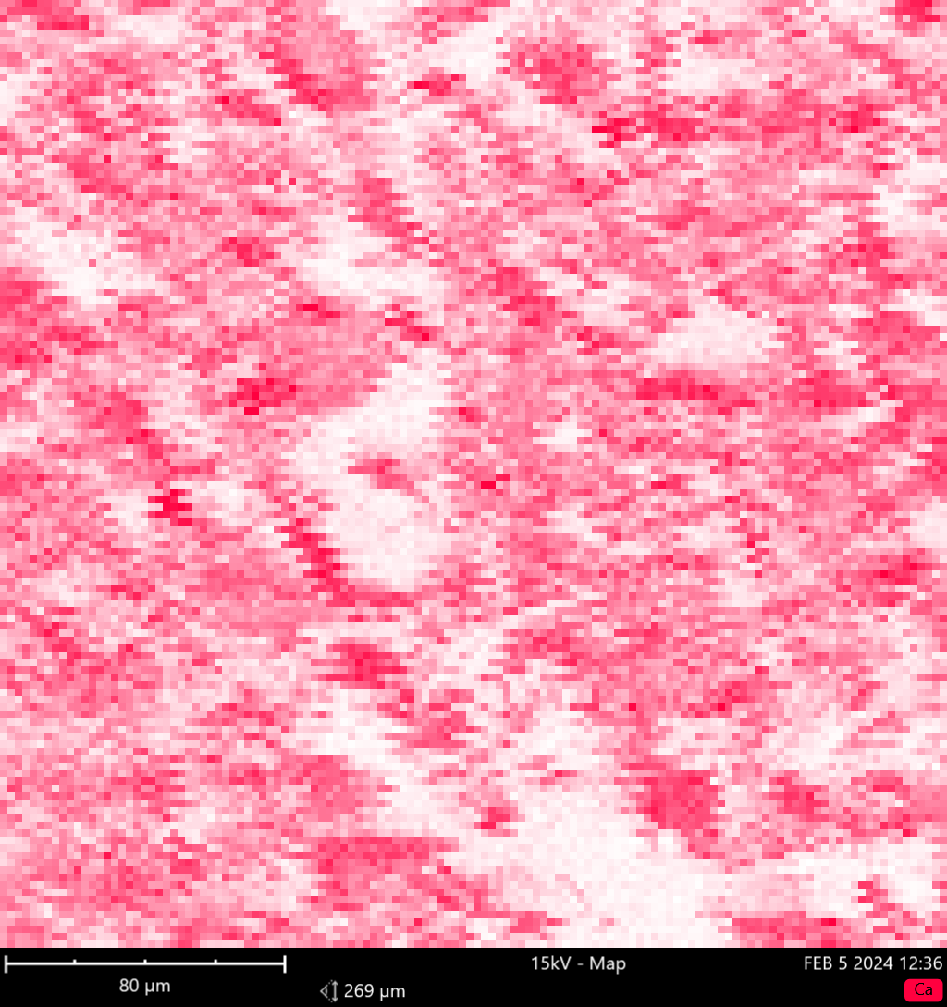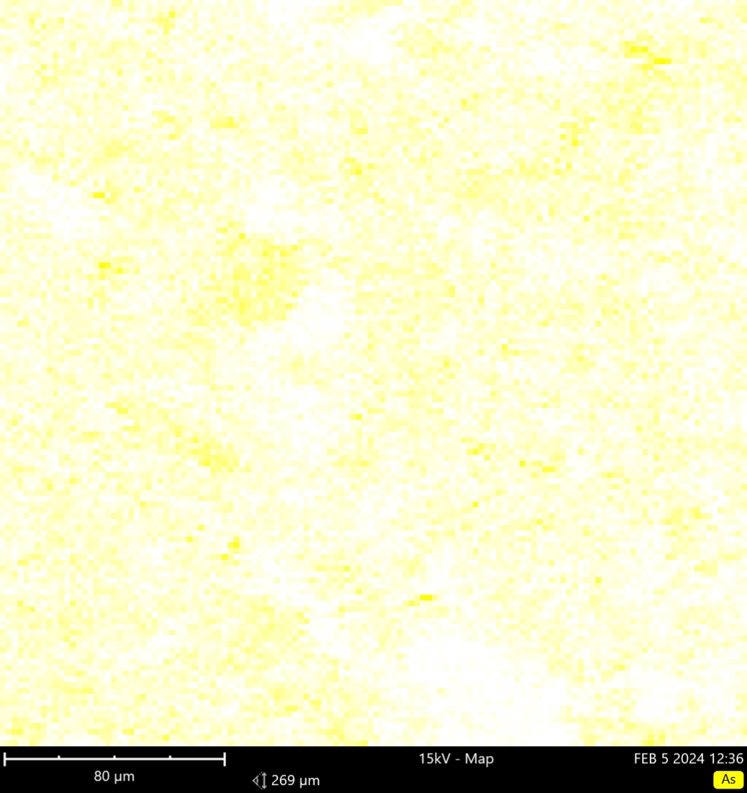
As
C
O
Ca
e) 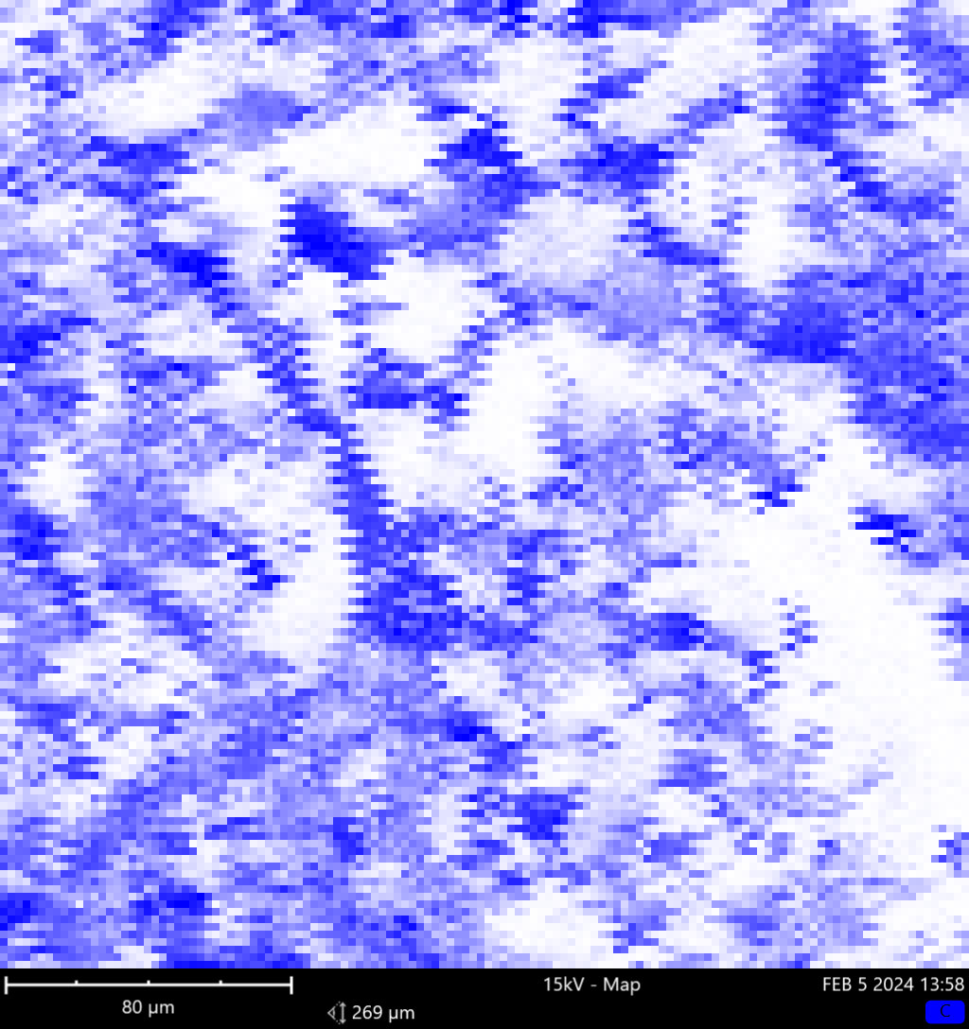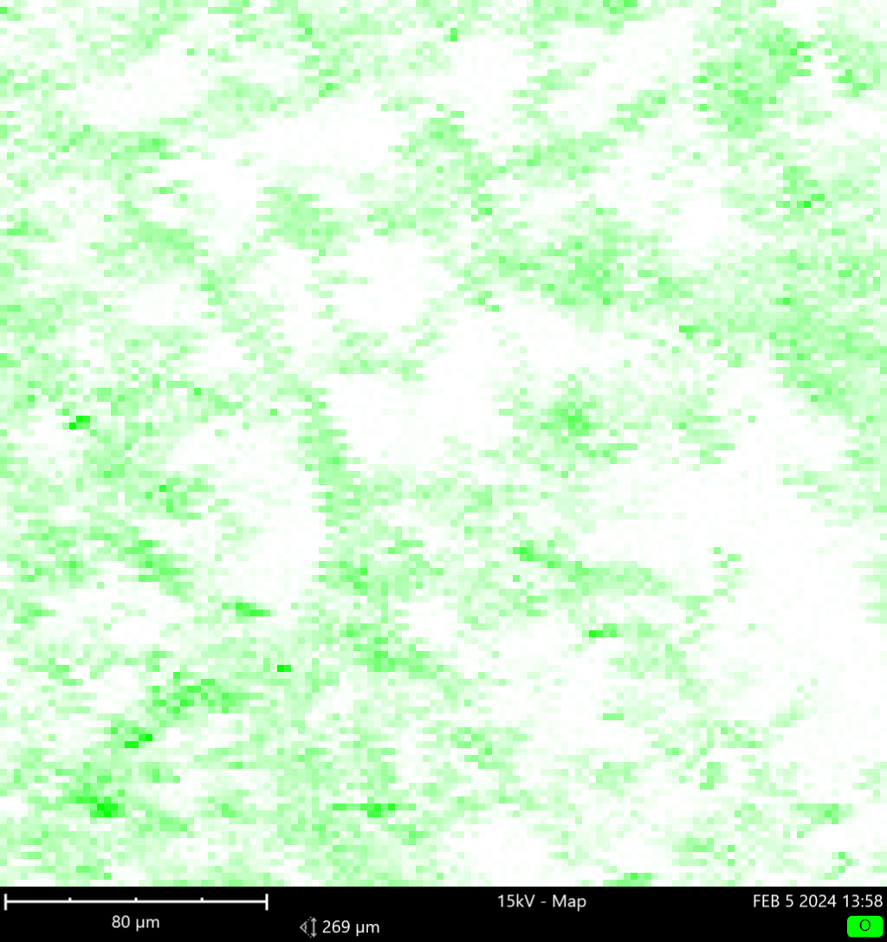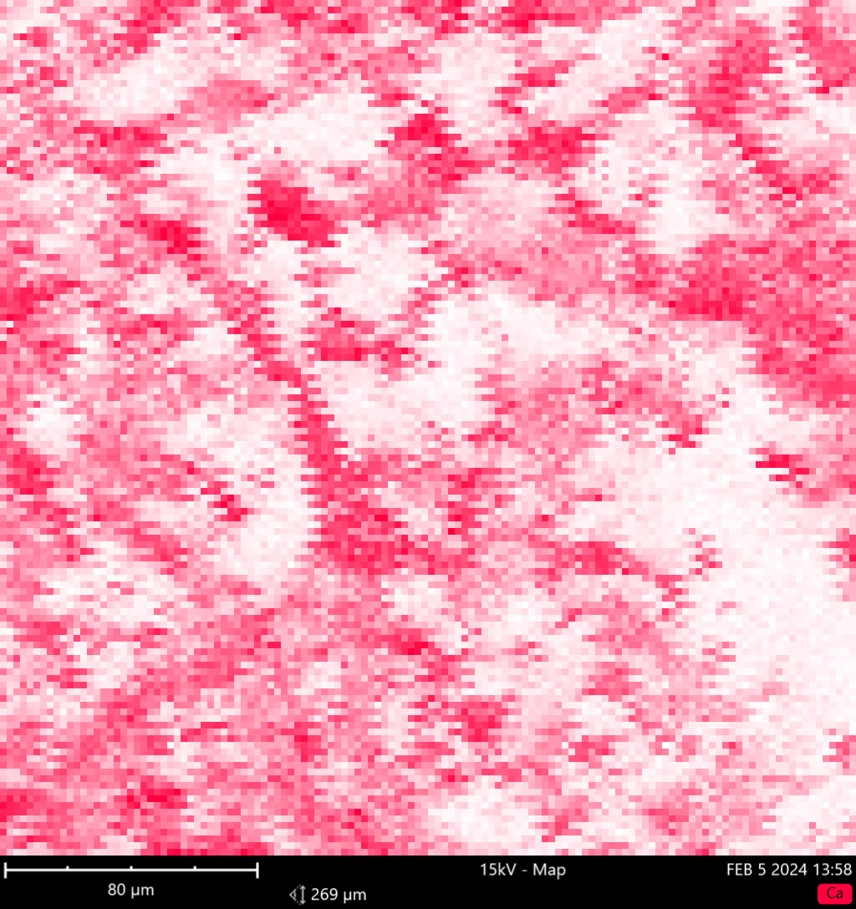
Se
Ca
O
C
Fig. A.7 SEM-EDS maps for the OFM800 (a) sample after adsorption of Cd (b), Cu (c), As (d), Se (e) ions

