SUPPLEMENTARY METHOD DETAILS
ROTAROD
A ROTA-ROD treadmill apparatus (Cat.No.47600, UGO BASILE) was used to assess motor coordination and balance of mice under CNO. The protocol consisted of 2 days (with one “experiment-free” day in between) allowing a randomized saline/CNO comparison were all animals are submitted to the ROTAROD 3 times each day, starting 20min after injection and with 15min in between every ROTAROD session. One session consisted of 300 sec starting with a 4 rotation per minute (RPM) to a 60 RPM (+1 RPM every 5 seconds) and the latency to fall was recorded. All mice had a training session 15min prior the first session on experimental day 1. The average of the 3 measurements was plotted for both saline and CNO conditions.

Stereotaxic Surgeries for Viral Injections
Stereotaxic injections of viral vectors were performed with a stereotaxic apparatus (UNOB.V. model 68U025) under anesthesia with ketamine (75mg/kg i.p.; Narketan, Vetoquinol), dexmedetomidine (1mg/kg i.p.; dexdomitor, Vetoquinol) and carprofen (5mg/kg subcutaneously or s.c., Carporal) injected 30 minutes before surgery. Lidocaine (0.1ml; 10% in saline; B. Braun) was injected s.c. on the skull before surgery. Animals were kept on a heat pad during surgery (≈37 °C). Viral injections were done using a 31G metal needle (Coopers Needleworks) attached to a 10μl Hamilton syringe (model 801RN) via flexible tubing (PE10, 0.28mm ID, 0.61mm OD, Portex) and an automated pump (UNO B.V. model 220). Mice were injected bilaterally with a volume of 300nl per side at an injection rate of 100nl/min with pAAV5-hSyn-DIO-hM4D(Gi)-mCherry (44362-AAV5, AddGene), pAAV-hSyn-DIO-hM3D(Gq)-mCherry (44361-AAV5, AddGene), pAAV-EF1a-double floxed-hChR2(H134R)-mCherry-WPRE-HGHpA (20297-AAV5, AddGene) or pAAV-hSyn-DIO-mCherry (50459-AAV5, AddGene) at titer 3.3*10^12gc/ml in the VTA (AP:-3.2, ML: 1.6, DV: -4.8 from bregma, angle 15°, Paxinos and Franklin). The injection needle was retracted 100μm, 9min after the infusion and withdrawn completely 10min after the infusion. The incision was sutured (V926H, 6/0, VICRYL, Ethicon) and animals were subcutaneously injected with the antagonist atipamezole (50mg/kg; Atipam, Dechra) and 1ml of saline and left to recover on a warm plate of 36°C. Carprofen (0.025mg/L) was provided in the drinking water all along post-surgery welfare monitoring. Experiments were performed 3-6 weeks after AAV stereotaxic injection. Injection sites were checked in all animals by preparing sagittal sections of 250µm for electrophysiology or 50µm after chemogenetic in vivo experiments. As in all mice the VTA was hit, but often with some variable spread to surrounding GABA neurons, we refer to these neurons as midbrain GABA neurons.

Whole-Cell Patch Clamp Recording
Mice were anesthetized with isoflurane at 12 p.m. (corresponding to dark onset) and then rapidly decapitated. The brain was quickly removed and coronal slices (250mm) were prepared with a vibratome (1200 VTs, Leica) in ice-cold carbogenated (95% O2, 5% CO2) cutting solution, containing (in mM) choline chloride 92; ascorbic acid 10; CaCl2 0.5; glucose 25; HEPES 20; KCl 2.5; N-Acetyl L Cysteine 3.1; NaHCO3 25; NaH2PO4 1.2; NMDG 20; MgCl2 7; sodium pyruvate 3; Thiourea 2 and then transferred in the same solution for 5 min at 37°C. Next, they were stored at room temperature in an incubation medium containing (in mM) NaCl 92; ascorbic acid 3; CaCl2 2; glucose 25; HEPES 20; KCl 2.5; NaCl 92; NaHCO3 30; NaH2PO4 1.2; MgCl2 2; sodium pyruvate 3 and Thiourea 2 for at least 60min. During recordings, slices were transferred to a recording chamber and perfused continuously at 1.5-2 mL/min with oxygenated artificial cerebrospinal fluid (ACSF), containing (in mM) CaCl2 2.5; glucose 11; HEPES 5; KCl 2.5; NaCl 124; NaHCO3 26; NaH2PO4 1; MgCl2 1.3 at 31°C. All solutions were prepared with pH≈7.35 and ≈300-310mOsm. Cells were visualized with an epifluorescent microscope (Examiner A1, Zeiss). Patch pipettes (2.7–4 MΩ for whole-cell patch-clamp and 6.0 and 6.5 MΩ for cell attached mode) were pulled from borosilicate glass capillaries (GC150-10, Harvard apparatus, UK) with a pipette puller (P-97, Sutter Instruments). Electrophysiological recordings were performed using an Axopatch 200B amplifier (Molecular Devices) and acquired using a Digidata 1322A digitizer (Molecular Devices), sampled at 20 kHz for current clamp, voltage-clamp recordings and cell-attached recordings, and low-pass filtered at 1 kHz. All data acquisitions were performed using pCLAMP 9.2 software (Molecular Devices). Light pulses were delivered with a pE-300 (CoolLed, UK illumination system). Only cells that maintained a stable access resistance (< 30MΩ, less than 20% increase) were included in analyses. For recordings of basic intrinsic properties, we used the potassium-gluconate internal solution which consisted of (in mM) potassium gluconate 139; HEPES 10; EGTA 0.2; creatine phosphate 10; KCl 5; Na2ATP 4; Na3GTP 0.3; MgCl2 2, pH 7.35. Cesium-chloride internal solution which consisted of (in mM) CsCl 139, NaCl 5, MgCl2 2, EGTA 0.2, HEPES 10, creatine phosphate 10, Na2-ATP 4, Na3-GTP 0.3, spermine 0.1, pH 7.35 was used to record GABA-mediated inhibitory transmission and paired-pulse ratios (PPR). Spontaneous excitatory post-synaptic currents (EPSCs) we recorded with neurons clamped at -65mV). Tetrodotoxin (TTX, 1µM, Tocris 1078) was added to the bath in order to isolate miniature inhibitory postsynaptic currents (mIPSC) and Picrotoxin (PTX, 100µM, Tocris) was used in order to measure GABA_{A} receptors-mediated tonic inhibition and neurons were voltage clamped at -70mV. Recordings of sIPSCs, and mIPSCs were performed at least 10min after patch for 1min. Tonic GABAergic conductance was defined as a difference between the baseline holding current and that obtained after blocking for 5 minutes GABA_{A} receptors with PTX. Electrical stimulations were performed with a bipolar concentric stimulating electrode using a stimulator (Isoflex, AMPI) with electric pulses of 0.18ms; 50-3000μA.

Immunohistochemistry
The viral injection sites were confirmed by immunohistochemistry and fluorescent microscopy and all operated animals were included in the study. For the chemogenetic experiments, mice were transcardially perfused with ice-cold 4% paraformaldehyde in PBS under anesthesia after behavioral experiments. Brains were harvested, postfixed overnight and washed in PBS. 50μm coronal sections were obtained using a vibratome VT1000s (Leica) and incubated in a blocking solution (5% goat serum, 2.5% BSA, 0.2% Tritonx100 in PBS, pH 7.4) for 1h at room temperature (RT). Slices were labeled overnight at 4°C with primary antibodies against TH (mouse; 1:1000, MAB318, Merck). Sections were incubated with fluorescent secondary antibodies (goat anti mouse 488) for 2h at RT and then mounted on slides and coverslipped with the fluorsave reagent (FluorSave Reagent, Merk Millipore). Digital images of colocalization of TH immunostaining and mCherry (AAV-DREADD-mCherry) were acquired using an epifluorescent microscope (Olympus). For the optogenetic experiments, the slices of 250μm were postfixed right after patch-clamp experiment to similarly check for colocalization of endogenous GFP (Pitx3-GFP mice) and mCherry (AAV-ChR2-mCherry).
Table S1 Summary of statistical analysis
Data | Statistical test | n |  | outcome measure | p value
Figure 1
Figure 1B: % iBW | Two-way RM ANOVA | WR : 6 ; ABA : 6 ; FR : 6 |  | % of body weight loss | Group effect: F(2,15)=55.67, p<0.001  Day effect: F(2.403,36.05)=65.33, p<0.001  Interaction: F(10,75)=18.46, p<0.001  WR vs. ABA: p<0.001  WR vs. FR: p<0.001  ABA vs. FR: p<0.05
Figure 1C: FI | Two-way RM ANOVA | WR : 6 ; ABA : 6 ; FR : 6 |  | Food intake (g) | Group effect: F(2,15)=72.26, p<0.001  Day effect: F(2.776,41.63)=10.73, p<0.001  Interaction: F(8,60)=10.35, p<0.001  WR vs. ABA: p<0.001  WR vs. FR: p<0.001  ABA vs. FR: p=0.82
Figure 1E: RWA | Two-way RM ANOVA | WR : 6 ; ABA : 6 |  | Running distance per day (m) | Group effect: F(1,10)=0.088, p=0.77  Day effect: F(5.120,51.20)=15.64.33, p<0.001  Interaction: F(14,140)=1.523, p=0.11
Figure 1F : RWA | Two-way RM ANOVA | WR : 6 ; ABA : 6 |  | Food anticipatory activity (m) | Group effect: F(1,10)=21.10, p<0.001  Day effect: F(2.316,23.16)=2.14, p=0.13  Interaction: F(5,50)=2.31, p<0.058
Figure 2
Figure 2B: Proportion of active VTA_{DA} neurons | Fisher’s test | WR : 27 ; ABA : 52 ; FR: 31  from 7, 11 and 4 animals |  | Proportion silent/active (%) | RW vs. ABA: p value = 0.52  FR vs. ABA: p value = 0.99  RW vs. FR: p value = 0.69
Figure 2D: Frequency of VTA_{DA} AP | Kruskal-Wallis test followed by Dunn’s test | WR : 23 ; ABA : 42 ; FR : 28  from 7, 11 and 4 animals |  | Spontaneous activity (Hz) | p value <0.05  WR vs. ABA: p<0.05  WR vs. FR: p=0.88  ABA vs. FR: p<0.05
Figure 2F: VTA_{DA} I/O plot | Two-way RM ANOVA  mixed-effect model | WR : 24 ; ABA : 39 ; FR : 12  from 9, 10 and 3 animals |  | Input/output curve | Group effect: F(2,74)=0.16, p=0.85  Current effect: F(2.635,189.7)=74.6, p<0.001  Interaction: F(14,504)=0.71, p=0.77
Figure 2G: VTA_{DA} Rmem | Kruskal-Wallis test | WR : 24 ; ABA : 39 ; FR : 12  from 9, 10 and 3 animals |  | Membrane resistance (MOhm) | P value = 0.22
Figure 2H: VTA_{DA} RMP | One-way ANOVA | WR : 24 ; ABA : 39 ; FR : 12  from 9, 10 and 3 animals |  | Resting membrane potential (mV) | F(2,72)=0.05, p=0.95
Figure 2I: VTA_{DA} rheobase | Kruskal-Wallis test | WR : 24 ; ABA : 39 ; FR : 12  from 9, 10 and 3 animals |  | Rheobase (pA) | P value = 0.16
Figure 3
Figure 3B left: sIPSCs frequency | Mann Whitney test | WR : 16 ; ABA : 21  from 7 and 7 animals |  | sIPSCs frequency (Hz) | P value <0.05
Figure 3B right: sIPSCs amplitude | Unpaired t test | WR : 16 ; ABA : 21  from 7 and 7 animals |  | sIPSCs amplitude (pA) | t(34)=0.65, p=0.52
Figure 3F: PPR | Two-way RM ANOVA mixed-effect model | WR : 22 ; ABA : 27  from 5 and 6 animals |  | Paired-pulse ration | Group effect: F(1,47)=9.20, p<0.01  Time interval effect: F(1.6,67.97)=12.26, p<0.001  Interaction: F(2,85)=0.76, p=0.47  PostHoc Test:  200ms: WR vs ABA: p<0.05
Figure 3H: VTA_{GABA} RMP | Unpaired t test | WR : 21 ; ABA : 23  from 7 and 8 animals |  | Resting membrane potential (mV) | t(42)=4.74, p<0.001
Figure 3I: VTA_{GABA} Rmem | Unpaired t test | WR : 21 ; ABA : 23  from 7 and 8 animals |  | Membrane resistance (MOhm) | t(42)=0.51, p=0.61
Figure 3J: VTA_{GABA} rheobase | Mann Whitney test | WR : 21 ; ABA : 23  from 7 and 8 animals |  | Rheobase (pA) | P value <0.001
Figure 3K: VTA_{GABA} AP threshold | Mann Whitney test | WR : 21 ; ABA : 23  from 7 and 8 animals |  | Action potential threshold (mV) | P value =0.66
Figure 3L: VTA_{GABA} I/V plot | Two-way RM ANOVA mixed-effect model | WR : 21 ; ABA : 23  from 7 and 8 animals |  | Current/voltage curve | Group effect: F(1,42)=6.73, p<0.05  Current effect: F(1.15,37.15)=161.5, p<0.001  Interaction: F(9,290)=1.124, p=0.35  PostHoc Test:  -45pA : WR vs ABA: p<0.05  -30pA : WR vs ABA: p<0.01  -15pA : WR vs ABA: p<0.01
Figure 3M: VTA_{GABA} I/O plot | Two-way RM ANOVA | WR : 21 ; ABA : 23  from 7 and 8 animals |  | Input/output curve | Group effect: F(1,42)=3.20, p=0.08  Current effect: F(1.85,77.56)=131.8, p<0.001  Interaction: F(8,336)=0.486, p=0.87
Figure 3N: Proportion of active VTA_{GABA} neurons | Fisher’s test | WR : 21 ; ABA : 23  from 7 and 8 animals |  | Proportion silent/active (%) | P value <0.001
Figure 3O: Frequency of VTA_{GABA} AP | Mann Whitney test | WR : 21 ; ABA : 23  from 7 and 8 animals |  | Spontaneous activity (Hz) | P value <0.001
Figure 4
Figure 4C: FI / DREADD-Gi | Two-way RM ANOVA | ABA-Ctrl: 10 ; ABA-Gi : 14 |  | Food intake 3h post CNO injection(g) | Group effect: F(1,22)=1.49, p=0.24  CNO effect: F(2.744,60.36)=4.05, p<0.05  Interaction: F(4,88)=1.529, p=0.20  PostHoc Test:  ABA-Gi: CNO 0 vs CNO 0.25: p=0.073  ABA-Gi: CNO 0 vs CNO 0.5: p<0.01  ABA-Gi: CNO 0 vs CNO 2: p<0.05
Figure 4D: RWA / DREADD-Gi | Two-way RM ANOVA mixed-effect model | ABA-Ctrl: 10 ; ABA-Gi : 14 |  | Running distance 3h post CNO injection (m) | Group effect: F(1,22)=7.98, p<0.01  CNO effect: F(1.970,42.54)=10.25, p<0.001  Interaction: F(5,108)=8.61, p<0.001  PostHoc Test:  ABA-Gi: CNO 0 vs CNO 0.25: p<0.01  ABA-Gi: CNO 0 vs CNO 0.5: p<0.05  ABA-Gi: CNO 0 vs CNO 1: p=0.08  ABA-Gi: CNO 0 vs CNO 2: p<0.01
Figure 4E: %BW variation / DREADD-Gi | Two-way RM ANOVA | ABA-Ctrl: 10 ; ABA-Gi : 14 |  | % of body weight variation compare to baseline | Group effect: F(1,22)=25.4, p<0.001  CNO effect: F(2.927,64.38)=8.09, p<0.001  Interaction: F(4,88)=5.24, p<0.001  PostHoc Test:  ABA-Gi: CNO 0 vs CNO 0.25: p<0.01  ABA-Gi: CNO 0 vs CNO 0.5: p<0.001  ABA-Gi: CNO 0 vs CNO 1: p<0.01  ABA-Gi: CNO 0 vs CNO 2: p<0.001
Figure 4F: FI / DREADD-Gq | Two-way RM ANOVA | ABA-Ctrl: 10 ; ABA-Gq : 11 |  | Food intake 3h post CNO injection(g) | Group effect: F(1,19)=7.14, p<0.05  CNO effect: F(2.893,54.97)=13.09, p<0.001  Interaction: F(4,76)=8.61, p<0.001  PostHoc Test:  ABA-Gi: CNO 0 vs CNO 0.1: p<0.001  ABA-Gi: CNO 0 vs CNO 0.25: p<0.001  ABA-Gi: CNO 0 vs CNO 0.625: p<0.05
Figure 4G: RWA / DREADD-Gq | Two-way RM ANOVA | ABA-Ctrl: 10 ; ABA-Gq : 11 |  | Running distance 6h post CNO injection (m) | Group effect: F(1,19)=15.74, p<0.001  CNO effect: F(2.358,44.81)=28.12, p<0.001  Interaction: F(5,95)=14.84, p<0.001  PostHoc Test:  ABA-Gi: CNO 0 vs CNO 0.04: p<0.05  ABA-Gi: CNO 0 vs CNO 0.1: p<0.05  ABA-Gi: CNO 0 vs CNO 0.25: p<0.01  ABA-Gi: CNO 0 vs CNO 0.625: p<0.001
Figure 4H: %BW variation / DREADD-Gq | Two-way RM ANOVA | ABA-Ctrl: 10 ; ABA-Gq : 11 |  | % of body weight variation compare to baseline | Group effect: F(1,19)=25.75, p<0.001  CNO effect: F(3.313,62.94)=12.58, p<0.001  Interaction: F(4,76)=10.01, p<0.001  PostHoc Test:  ABA-Gi: CNO 0 vs CNO 0.1: p<0.001  ABA-Gi: CNO 0 vs CNO 0.25: p<0.001  ABA-Ctrl: CNO 0 vs CNO 0.04: p<0.05
Figure 5
Figure 5C: % iBW / DREADD-Gi | Two-way RM ANOVA | ABA-Ctrl: 10 ; ABA-Gi : 14 |  | % of body weight loss | Group effect: F(1,22)=8.48, p<0.01  Day effect: F(3.012,66.27)=581.8, p<0.001  Interaction: F(6,132)=2.269, p<0.05  PostHoc Test:  ABA4: WR vs ABA: p<0.05
Figure 5D: FI / DREADD-Gi | Two-way RM ANOVA | ABA-Ctrl: 10 ; ABA-Gi : 14 |  | Food intake (g) | Group effect: F(1,22)=1.21, p=0.28  Day effect: F(3.588,78.94)=77.77, p<0.001  Interaction: F(5,110)=0.819, p=0.54
Figure 5E: RWA / DREADD-Gi | Two-way RM ANOVA | ABA-Ctrl: 10 ; ABA-Gi : 14 |  | Food anticipatory activity (m) | Group effect: F(1,22)=3.81, p=0.064  Day effect : F(2.408,52.97)=23.79, p<0.001  Interaction: F(5,110)=2.49, p<0.5  PostHoc Test:  ABA3: WR vs ABA: p<0.01
Figure 5F: Survival curves DREADD-Gi ABA | Log-rank (Mantel-Cox) test | ABA-Ctrl: 10 ; ABA-Gi : 14 |  | Percent survival | χ2 = 3.42 ; P Value =0.065
Figure 5G: % iBW / DREADD-Gq | Two-way RM ANOVA | ABA-Ctrl: 8 ; ABA-Gq : 8 |  | % of body weight loss | Group effect: F(1,14)=9.42, p<0.01  Day effect: F(2.217,31.04)=205.7, p<0.001  Interaction: F(7,98)=7.8, p<0.001  PostHoc Test:  ABA3: WR vs ABA: p=0.09  ABA4: WR vs ABA: p=0.08  ABA5: WR vs ABA: p=0.06  ABA6: WR vs ABA: p=0.05
Figure 5H: FI / DREADD-Gq | Two-way RM ANOVA | ABA-Ctrl: 8 ; ABA-Gq : 8 |  | Food intake (g) | Group effect: F(1,14)=1.12, p=0.31  Day effect: F(3.588,50.23)=37.5, p<0.001  Interaction: F(6,84)=2.288, p<0.05  PostHoc Test: all >0.1.
Figure 5I: RWA / DREADD-Gq | Two-way RM ANOVA | ABA-Ctrl: 8 ; ABA-Gq : 8 |  | Food anticipatory activity (m) | Group effect: F(1,14)=17.68, p<0.001  Day effect: F(2.724,38.14)=4.34, p<0.05  Interaction: F(6,84)=2.68, p<0.05  PostHoc Test: all >0.1
Figure 5J: Survival curves DREADD-Gq ABA | Log-rank (Mantel-Cox) test | ABA-Ctrl: 8 ; ABA-Gq : 8 |  | Percent survival | χ2 = 6.98 ; P Value <0.01

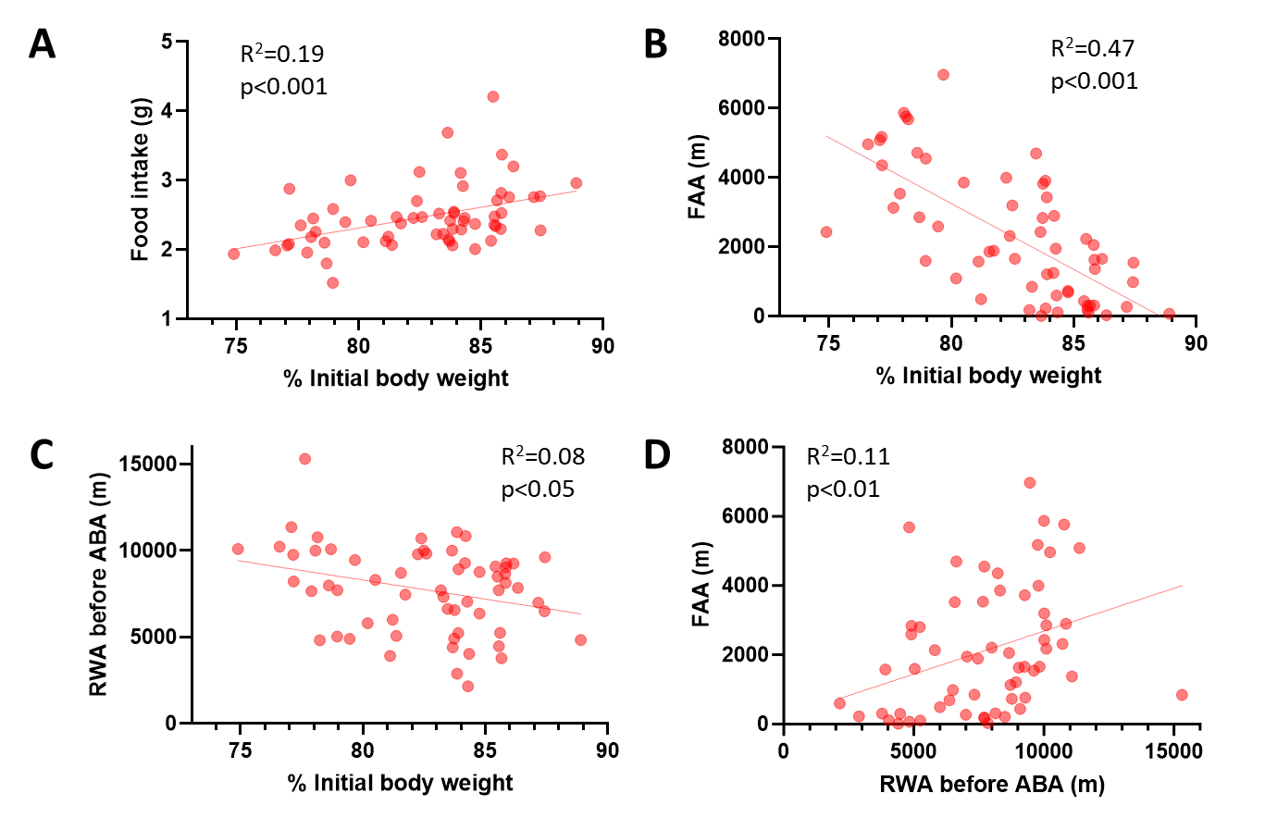
Supplementary Figure 1. (related to Figure 1)
Correlations performed on all ABA-exposed animals used for electrophysiology in this study showing (A) a positive correlation between food intake and body weight loss on ABA day 5, (B) a negative correlation between FAA and body weight loss on ABA day 5, (C) a negative correlation between running wheel activity before ABA exposure and body weight loss on ABA day 5 and (d) a positive correlation between FAA on ABA day 5 and running wheel activity before ABA exposure. *p<0.05, **p<0.01, ***p<0.001. See Table S2 for statistical analyses.

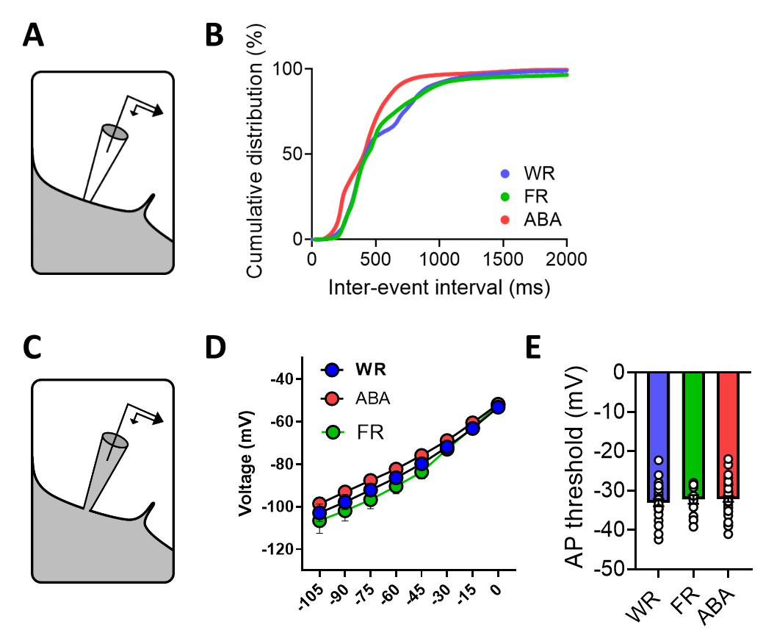
Supplementary Figure 2: (related to Figure 2)
(A) Schematic representation of the cell-attached patch-clamp mode used to record VTADA neurons in Pitx3-GFP mice. (B) Cumulative distribution of action potential inter-event interval. (C) Schematic representation of the whole-cell patch-clamp mode used to record VTADA neurons in Pitx3-GFP mice. (D) Measures of the current-voltage curves. (E) Action potential threshold. Data are means ± SEM. WR, wheel running control group; FR, food restricted control group; ABA, activity-based anorexia group. See Table S2 for statistical analyses.

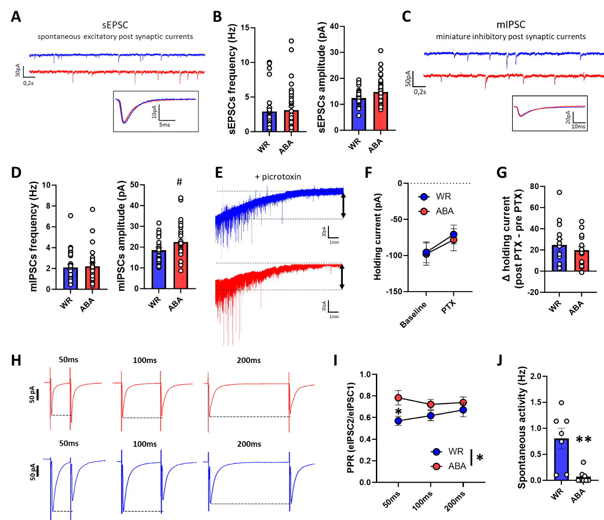
Supplementary Figure 3: (related to Figure 3)
(A) Representative traces of spontaneous EPCSs acquired during voltage clamp recording of VTA_{DA} neurons. (B) Measures of sEPSC frequency (left) and amplitude (right). (C) Representative traces of mIPCSs acquired during voltage clamp recording after 1µM TTX application. (D) Measures of mIPSC frequency (left) and amplitude (right). (E) Representative traces and (F-G) collapsed holding current density prior to and following bath application of picrotoxin (100 μM). (H) Example traces of evoked IPSCs with electrical stimulation performed in coronal slices with an inter-stimulation interval of 50ms (left), 100ms (middle) and 200ms (right). (I) Measure of the PPR obtained by dividing the amplitude of eIPSC2 with amplitude of eIPSC1 for each time interval. (J) VTAGABA firing rate averaged for every animal used (the experimental unit is the animal, not the cell). Data are means ± SEM. #p<0.1, *p<0.05, **p<0.01, ***p<0.001. WR, wheel running control group; ABA, activity-based anorexia group. See Table S2 for statistical analyses.
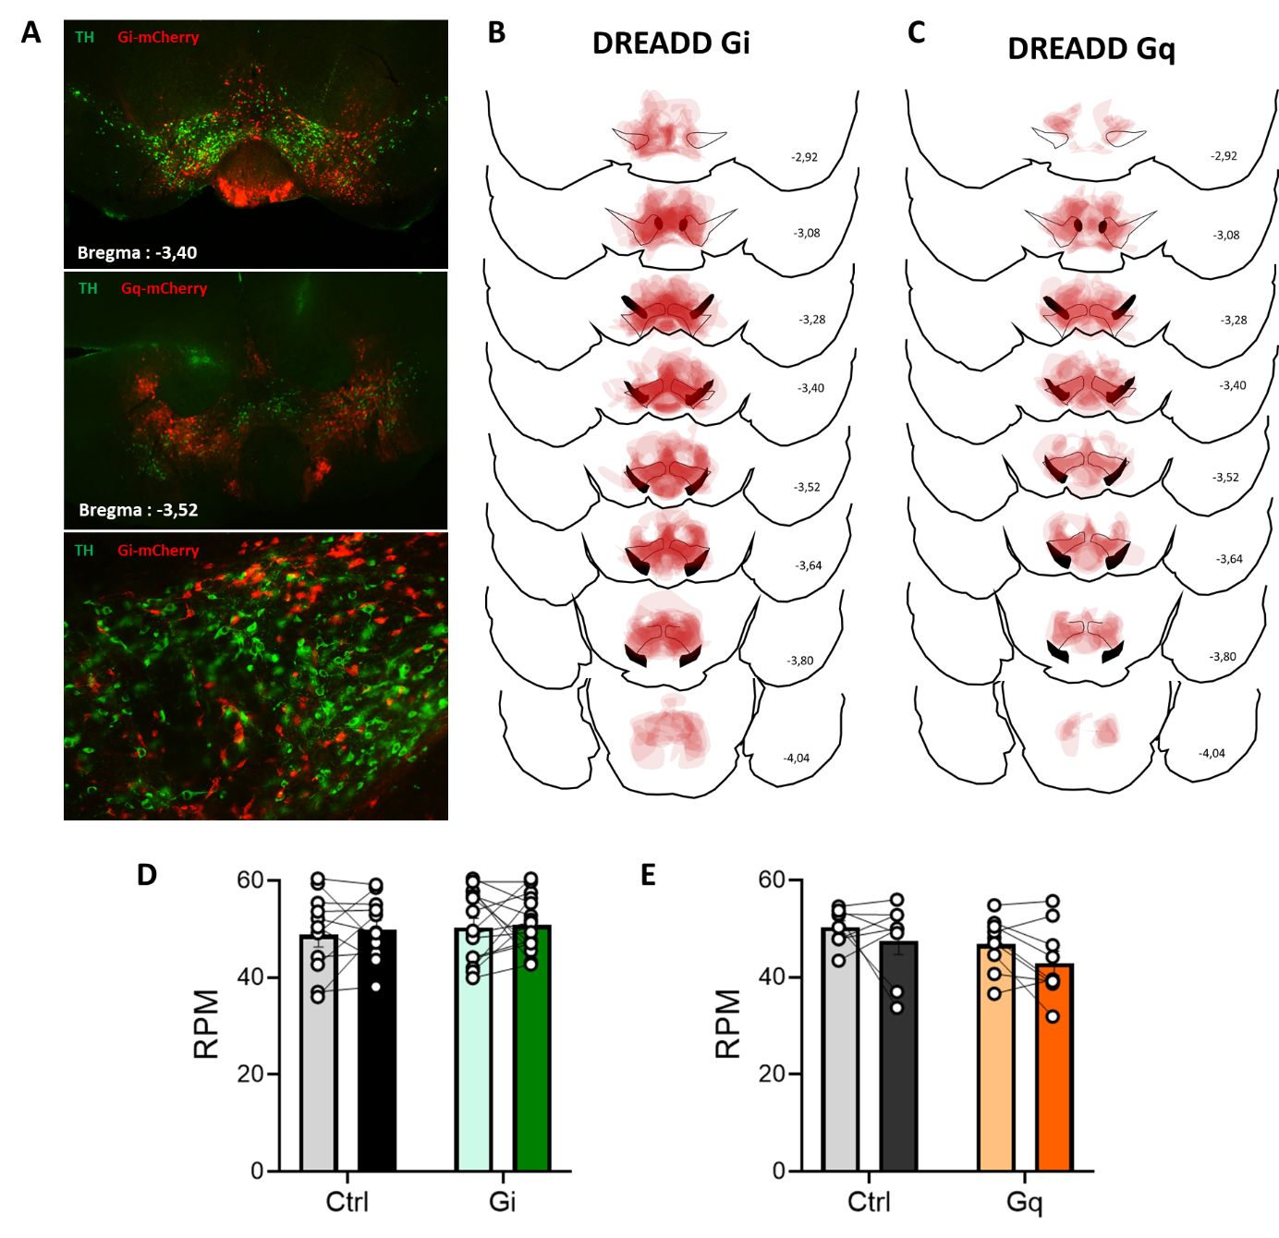
Supplementary Figure 4: (related to Figure 4)
(A) Representative microscopy images showing the expression of DREADD-Gq receptors (top) and DREAD-Gi receptors (middle) mostly in the VTA. The lower image was performed at higher magnification. (B-C) overlay of areas containing DREADD-expressing cells for all animals used in the study for the DREADD-Gi (n=14, C) and the DREADD Gq (n=8, D). (D-E) Rotation per min (RPM) in a rotarod in VGAT-cre mice under inhibition (DREADD-Gi, D) or activation (DREADD-Gq, E) of GABAergic neurons with 0.5mg/kg and 0.25mg/kg of CNO respectively. Data are means ± SEM. TH: tyrosine hydroxylase, Gi: DREADD-Gi receptor-expressing mice, Gq: DREADD-Gq receptor-expressing mice, Ctrl: control group. See Table S2 for statistical analyses.
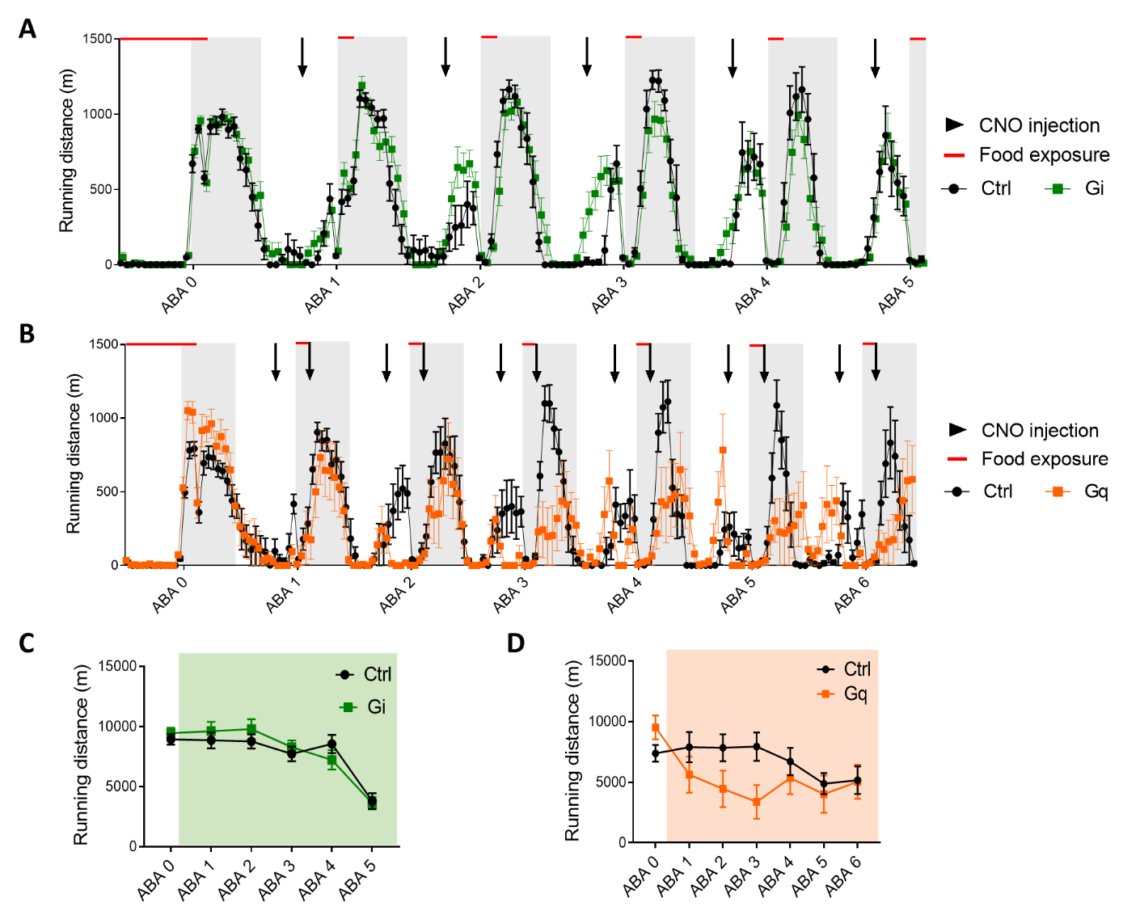
Supplementary Figure 5: (related to Figure 5)
(A) Hour by hour distance travelled in the wheel during ABA day 0 to day 5 with a single 5mg/kg CNO injection per day (black arrows). (B) Hour by hour distance travelled in the wheel during ABA day 0 to day 6 with two 0.25mg/kg CNO injection per day (black arrows). (C) Daily running wheel activity in DREADD-Gi animals for every ABA days. (D) Daily running wheel activity in DREADD-Gq animals for every ABA days. Data are means ± SEM. Gi: DREADD-Gi receptor-expressing mice, Gq: DREADD-Gq receptor-expressing mice, Ctrl: control group, CNO: clozapine-N-Oxide. See Table S2 for statistical analyses.
Table S2 Summary of supplemental statistical analysis
Data | Statistical test | n | outcome measure |  | p value
Suppl. Figure 1
Figure S1A: Correlation of %iBW and FI | Pearson's Correlation Coefficient | ABA : n=61 | Correlation between % of BW loss and food intake (m) |  | r(60)=0.43, R²=0.19, p<0.001
Figure S1B: Correlation of %iBW and FAA | Pearson's Correlation Coefficient | ABA : n=61 | Correlation between % of BW loss and FAA (m) |  | r(60)=-0.69, R²=0.47, p<0.001
Figure S1C: Correlation of %iBW and baseline RWA | Pearson's Correlation Coefficient | ABA : n=61 | Correlation between %BW loss and running wheel activity (m) |  | r(60)=-0.29, R²=0.08, p<0.05
Figure S1D: Correlation of baseline RWA and FAA | Pearson's Correlation Coefficient | ABA : n=61 | Correlation between baseline running wheel activity (m) and FAA (m) |  | r(60)=0.34, R²=0.11, p<0.01
Suppl. Figure 2
Figure S2B: Cumulative fraction of IEI | Descriptive statistics | WR : 23 ; ABA : 42 ; FR : 28  from 7, 11 and 4 animals | Cumulative distribution of action potential inter-event interval |  | WR FR ABA  25% 324.8 328.5 242.2  50% 422.5 434.8 406.7  75% 721.1 654.6 526.1
Figure S2D: VTA_{DA} I/V plot | Two-way RM ANOVA  mixed-effect model | WR : 24 ; ABA : 39 ; FR : 12  from 9, 10 and 3 animals | Current/voltage curve |  | Group effect: F(2,79)=1.305, p=0.27  Current effect: F(1.449,112.8)=387.3, p<0.001  Interaction: F(14,545)=0.97, p=0.49
Figure S2E: VTA_{DA} AP threshold | One-way ANOVA | WR : 24 ; ABA : 38 ; FR : 12  from 9, 10 and 3 animals | Action potential threshold (mV) |  | F(2,71)=0.32, p=0.73
Suppl. Figure 3
Figure S3B left: sEPSCs frequency | Mann Whitney test | WR : 27 ; ABA : 39  from 9 and 10 animals | sEPSCs frequency (Hz) |  | P value =0.65
Figure S3B right: sEPSCs amplitude | Mann Whitney test | WR : 27 ; ABA : 39  from 9 and 10 animals | sEPSCs amplitude (pA) |  | P value =0.11
Figure S3D left: mIPSCs frequency | Mann Whitney test | WR : 27 ; ABA : 28  from 7 and 8 animals | mIPSCs frequency (Hz) |  | P value =0.82
Figure S3D right: mIPSCs amplitude | Mann Whitney test | WR : 27 ; ABA : 28  from 7 and 8 animals | sEPSCs amplitude (pA) |  | P value =0.06
Figure S3H: Tonic inhibition | Two-way RM ANOVA | WR : 14 ; ABA : 16  from 7 and 8 animals | Holding currents (pA) |  | Group effect: F(1,28)=0.06, p=0.81  PTX effect: F(1,28)=5012, p<0.001  Interaction: F(1,28)=0.62, p=0.44  PostHoc Test:  WR: baseline vs PTX: p<0.001  ABA: baseline vs PTX: p<0.001
Figure S3I: Tonic inhibition | Unpaired t test | WR : 14 ; ABA : 16  from 7 and 8 animals | Variation of holding currents (pA) |  | t(28)=0.79, p=0.44
Figure S3K: PPR | Two-way RM ANOVA mixed-effect model | WR : 14 ; ABA : 14  from 7 and 8 animals | Paired-pulse ratio |  | Group effect: F(1,34)=4.28, p<0.05  Current effect: F(1.902,59.92)=0.27, p=075  Interaction: F(2,63)=1.63, p=0.20  PostHoc Test:  50ms : WR vs ABA: p<0.05
Figure S3L: Frequency of VTA_{GABA} AP | Mann Whitney test | WR : 7 ; ABA : 8 | Spontaneous activity (Hz) |  | P value <0.01
Suppl. Figure 4
Figure S4D: ROTAROD / DREADD-Gi | Two-way RM ANOVA | ABA-Ctrl: 11 ; ABA-Gi : 15 | Rotation per minute |  | Group effect: F(1,24)=0.33, p=0.57  CNO effect: F(1,24)=0.23, p=0.64  Interaction: F(1,24)=0.035, p=0.85
Figure S4E: ROTAROD / DREADD-Gq | Two-way RM ANOVA | ABA-Ctrl: 8 ; ABA-Gq: 9 | Rotation per minute |  | Group effect: F(1,15)=2.48, p=0.14  CNO effect: F(1,15)=3.41, p=0.08  Interaction: F(1,15)=0.096, p=0.76  PostHoc Test:  Ctrl: Sal vs CNO: p=0.52  Gq: Sal vs CNO: p=0.26
Suppl. Figure 5
Figure S5C: RWA / DREADD-Gi | Two-way RM ANOVA | ABA-Ctrl: 10 ; ABA-Gi : 14 | Running distance per day (m) |  | Group effect: F(1,22)=0.22, p=0.65  Day effect: F(3.062,67.36)=22.6, p<0.001  Interaction: F(5,110)=0.91, p=0.48
Figure S5D: RWA / DREADD-Gq | Two-way RM ANOVA | ABA-Ctrl: 8 ; ABA-Gq : 8 | Running distance per day (m) |  | Group effect: F(1,14)=1.17, p=0.30  Day effect: F(3.011,42.16)=4.81, p<0.01  Interaction: F(6,84)=3.54, p<0.01  PostHoc Test: all >0.1

