Humid heatwaves are controlled by daily rainfall variability

Supplementary Information
Lawrence S. Jackson ¹, Cathryn E. Birch ¹, Guillaume Chagnaud ², John H. Marsham ¹, and Christopher M. Taylor ²
¹ School of Earth and Environment, University of Leeds, Leeds, LS2 9JT, UK. ² UK Centre for Ecology and Hydrology, Wallingford, OX10 8BB, UK.
Corresponding author: L. S. Jackson (l.s.jackson@leeds.ac.uk)

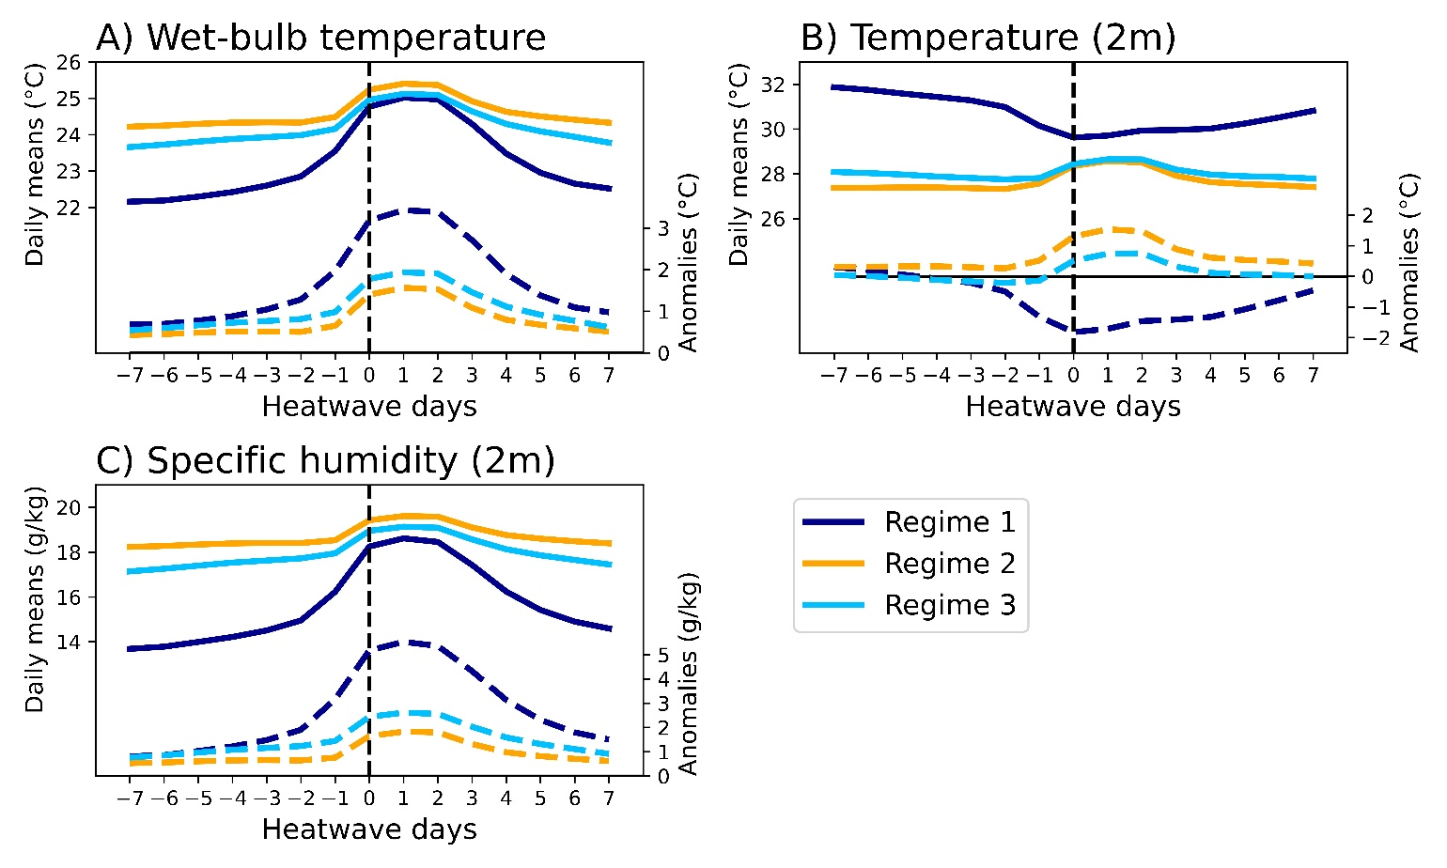
Figure S1. As Figure 3 except that grid cells are included here which are excluded from Figure 3 because they are not statistically significant (i.e., the white regions in Figure 2D).
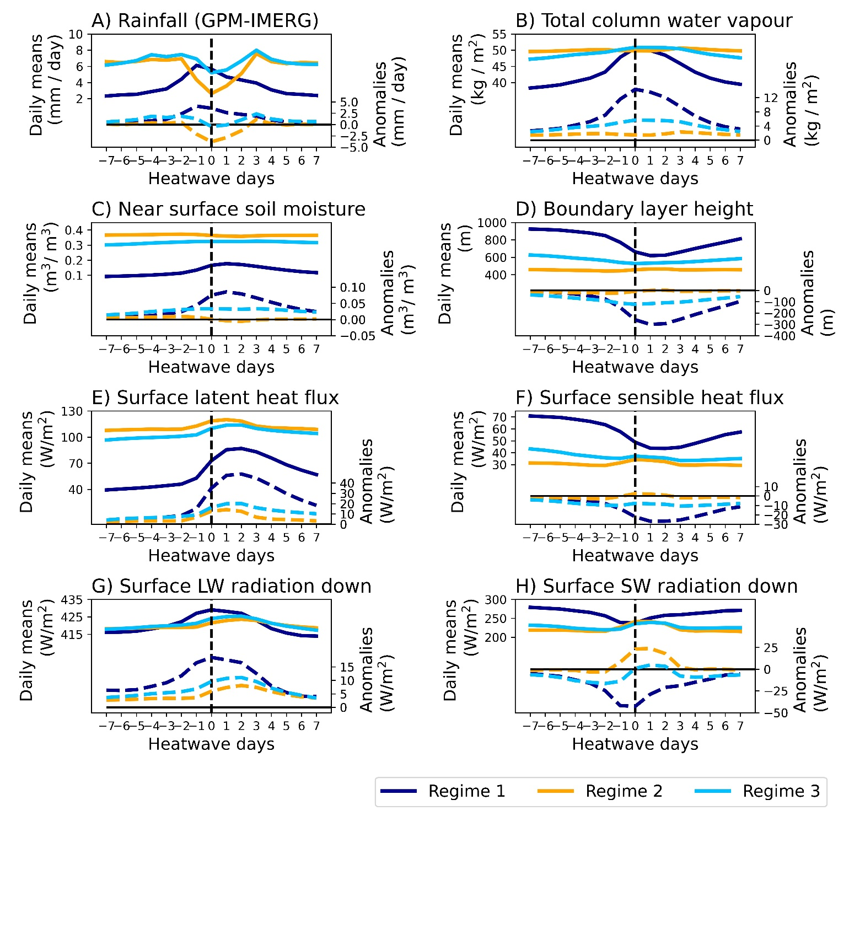
Figure S2. As Figure 4 except that grid cells are included here which are excluded from Figure 4 because they are not statistically significant (i.e., the white regions in Figure 2D).
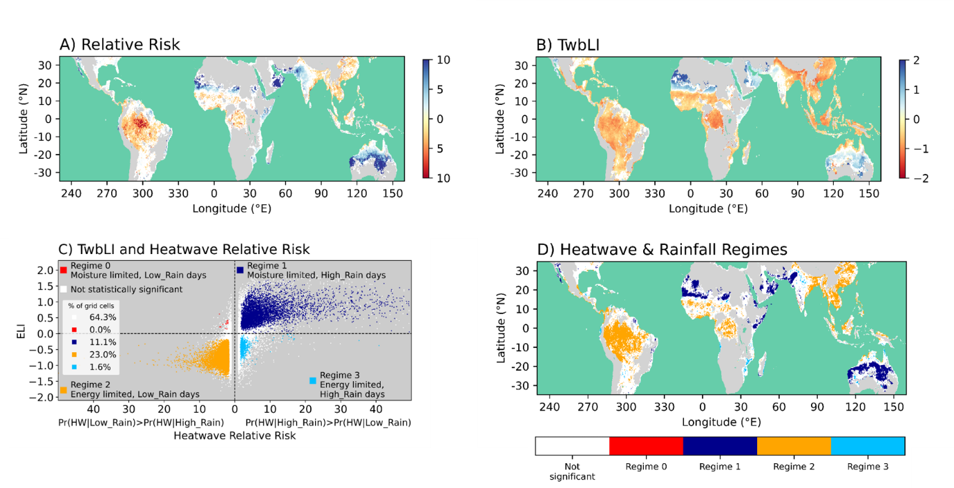
Figure S3. As Figure 2 except that the Twb energy- and moisture limitation index (TwbLI) is used instead of the ELI in panels B-D. TwbLI is calculated using the correlations of Twb with soil moisture and surface downwelling SW radiation (see Methods).
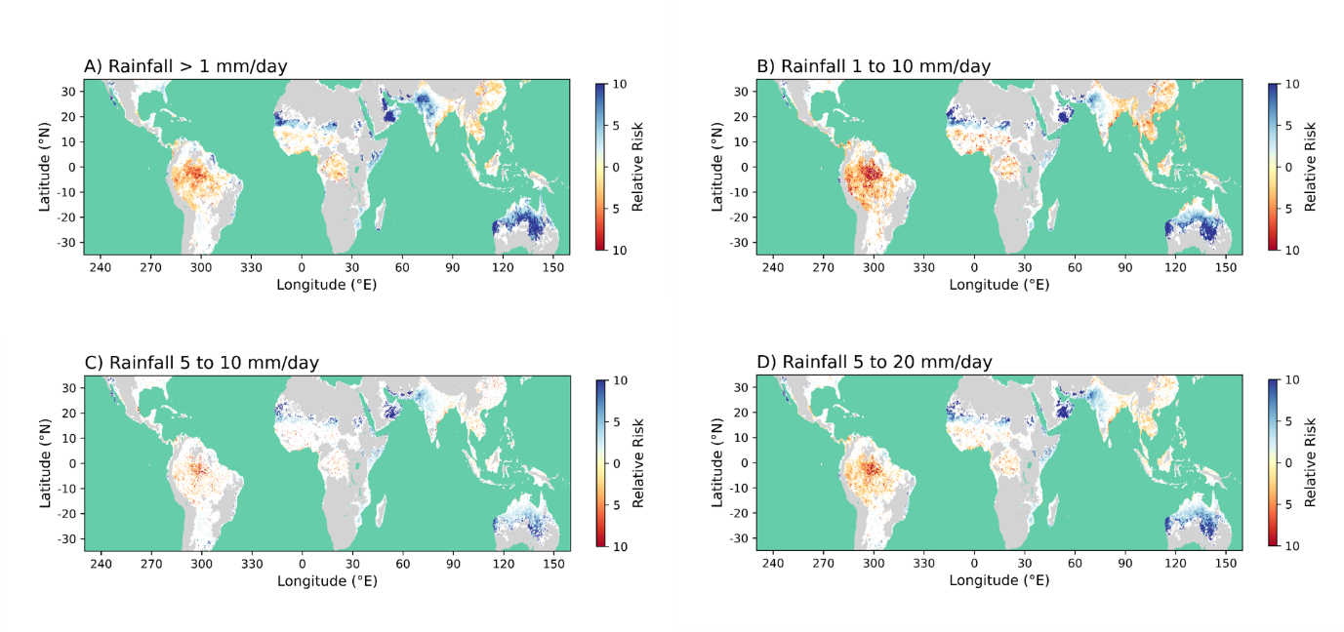
Figure S4. As Figure 2A except that different threshold levels are used for the definition of High_Rain and Low_Rain days (see Methods).
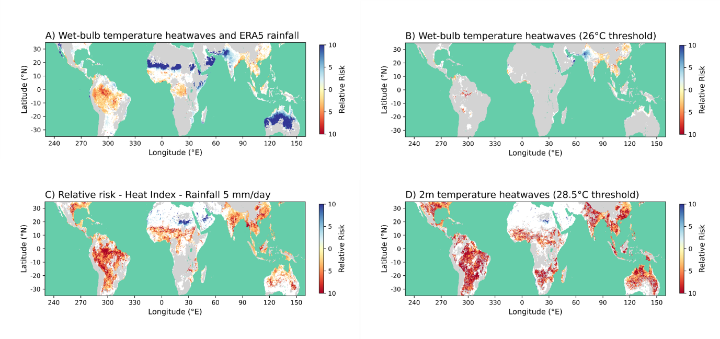
Figure S5. A) As Figure 2A except rainfall is from ERA5 (1993-2022) and the rainfall threshold is 5 mm/day. B) As Figure 2A except that heatwaves are defined using Twb with a minimum threshold of 26°C instead of 24°C. GPM-IMERG with a minimum threshold of 5 mm/day is used for rainfall. C) As Figure 2A except that heatwaves are defined using the Heat Index. On heatwave days, the Heat Index exceeded the local 95th percentile and a minimum threshold of 31°C. Rainfall is from GPM-IMERG with a minimum threshold of 5 mm/day to determine High_Rain and Low_Rain days. D) As Figure 2A except that heatwaves are defined using 2m temperatures. On heatwave days, 2m temperature exceeded the local 95th percentile and a minimum threshold of 28.5°C. Rainfall is from GPM-IMERG with a minimum threshold of 5 mm/day to determine High_Rain and Low_Rain days.

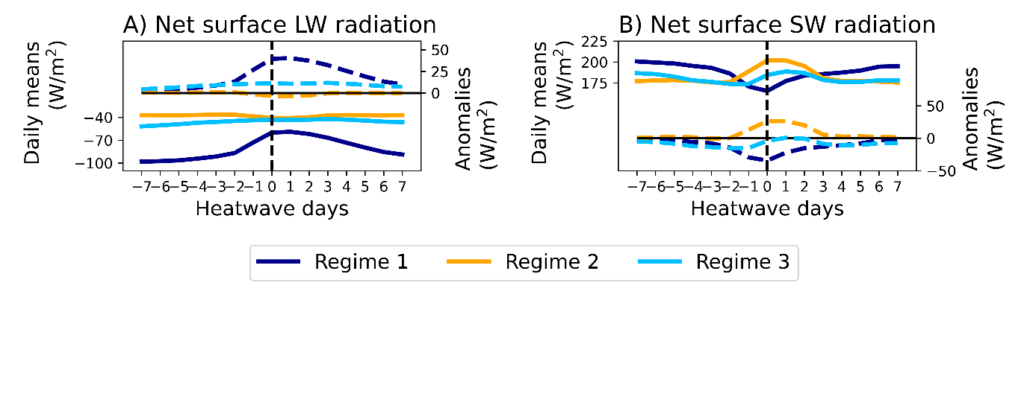
Figure S6. Heatwave composite time series from 7 days before the start of each heatwave (day -7) to 7 days after the start of each heatwave (day 7). Day 0 is the heatwave start day. Solid lines and the y-axis on the left of each panel show daily mean values. Dashed lines and the y-axis on the right show anomalies from the local 1993-2022 daily mean climatology. Positive values represent fluxes from the atmosphere to the land surface. The associated surface turbulent heat and downwelling radiation fluxes are in Figure 4 of the main article.

