Table 1: Percent compositions of ash, carbon and sulfur at 250 μm
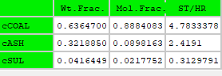

Table 2: Percent compositions of ash, carbon and sulfur at 125 screen size
