Supplementary appendix
Table S1 shows the fraction of the Norwegian population with at least one GP consultation in 2020, and in prior years, broken down on subpopulations. As shown in Figure S1, The Norwegian GP system did not experience a large drop in encounters around the outbreak of the Covid-19 pandemic, relative to prior years, very different from other countries (see Mansfield et al., 2021, for the UK, and Holland et al., 2021, for the US). The reason was a fast transition to electronic encounters. Figure S2 plots the fraction of consultations that were electronic through 2020.

Table S1. GP Coverage rates in Norway 2017-2020.
 |  |  |  |  |  |  | Fraction of Norwegian population with at least one GP consultation in given year
 |  |  |  |  |  |  | 2017 | 2018 | 2019 | 2020
Age 11+ |  |  |  |  |  |  | 0.76 | 0.75 | 0.75 | 0.75
Age 11-17 |  |  |  |  |  |  | 0.68 | 0.67 | 0.67 | 0.65
Age 18-30 |  |  |  |  |  |  | 0.70 | 0.70 | 0.69 | 0.68
Age 31-64 |  |  |  |  |  |  | 0.75 | 0.75 | 0.75 | 0.74
Age 65+ |  |  |  |  |  |  | 0.87 | 0.86 | 0.86 | 0.86
Male |  |  |  |  |  |  | 0.69 | 0.69 | 0.69 | 0.69
Female |  |  |  |  |  |  | 0.82 | 0.82 | 0.81 | 0.80
Urban |  |  |  |  |  |  | 0.82 | 0.83 | 0.83 | 0.79
Rural |  |  |  |  |  |  | 0.73 | 0.73 | 0.72 | 0.73
Population size (million) |  |  |  |  |  |  | 4.57 | 4.61 | 4.65 | 4.70

Notes: The Norwegian population totals are from Statistics Norway (www.ssb.no).
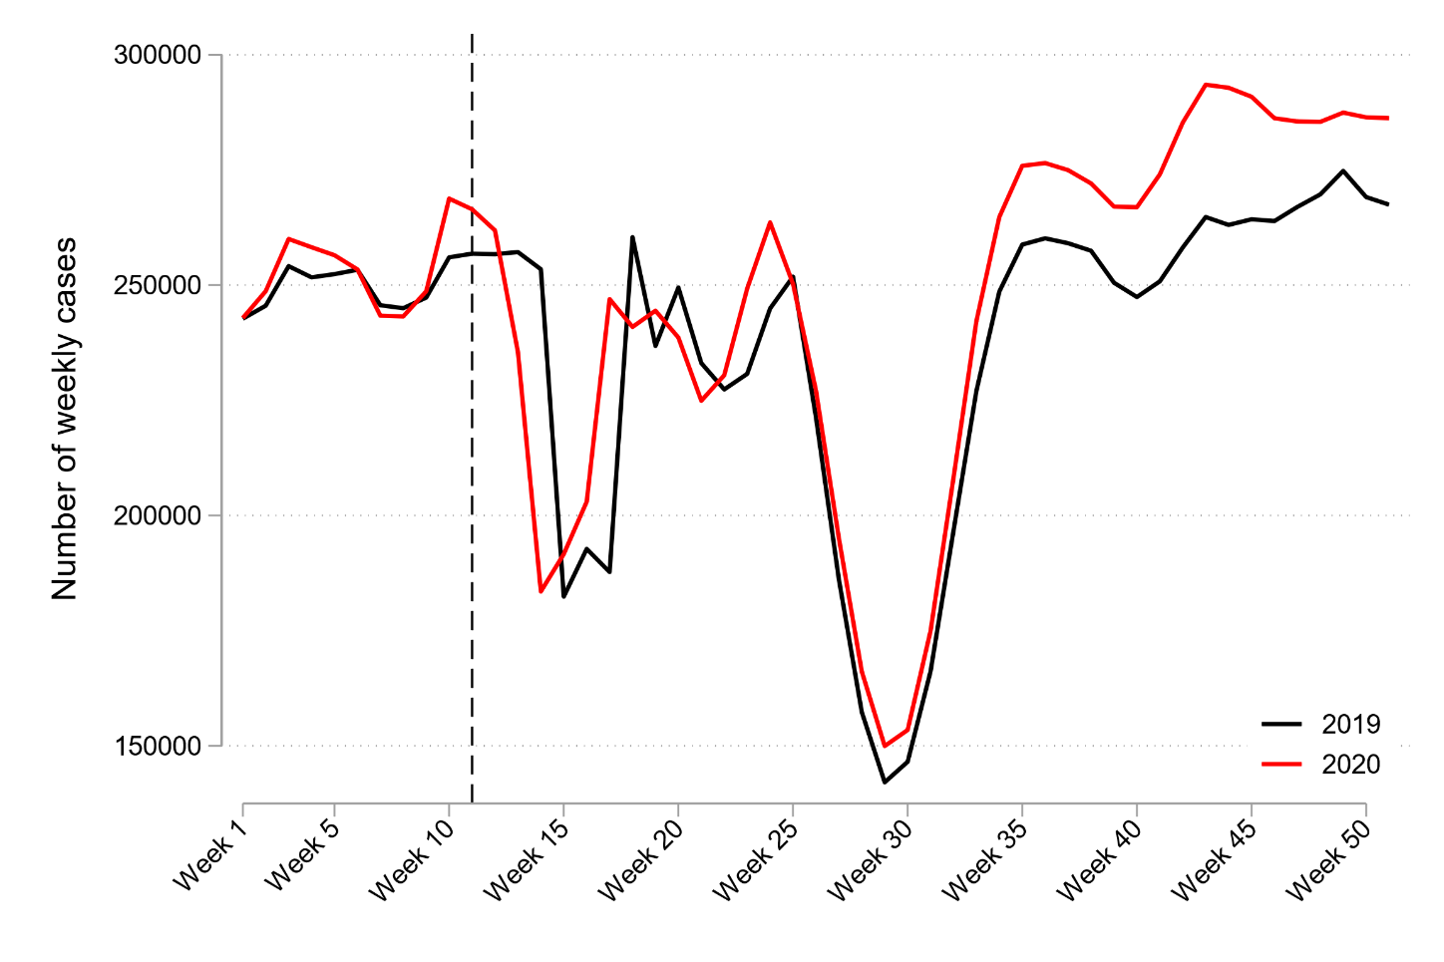
Fig S1. Number of weekly GP consultations in 2020 (red) versus 2019 (black)
Note: The Figure shows overall number (any ICPC-2 diagnosis code) of weekly GP consultations in Norway in 2019 and 2020. The Figure uses three-week moving averages for the outcome variables.

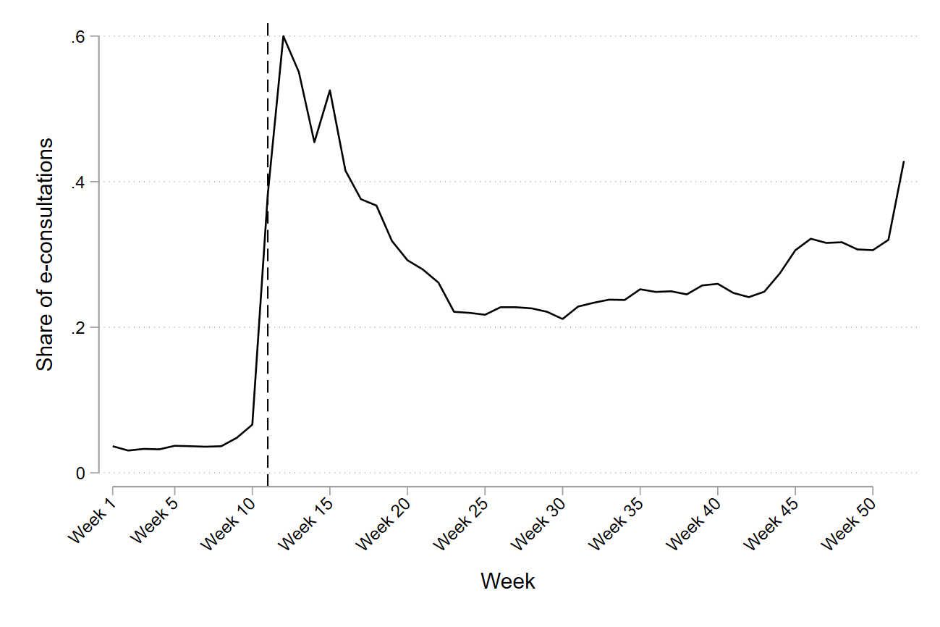
Fig S2. E-consultations as fraction of all consultations, by week of 2020

The homepage of The Norwegian Medical Association contains additional information on the GP refund arrangement, and the transition to electronic consultations during 2020 in Norway. https://normaltariffen.legeforeningen.no/book/Fastlegetariffen-2020/m-02.

