Online Supplementary Material
Monoterpenes in Your Beverage: A Flavoring Catalyst for Faster Aging?
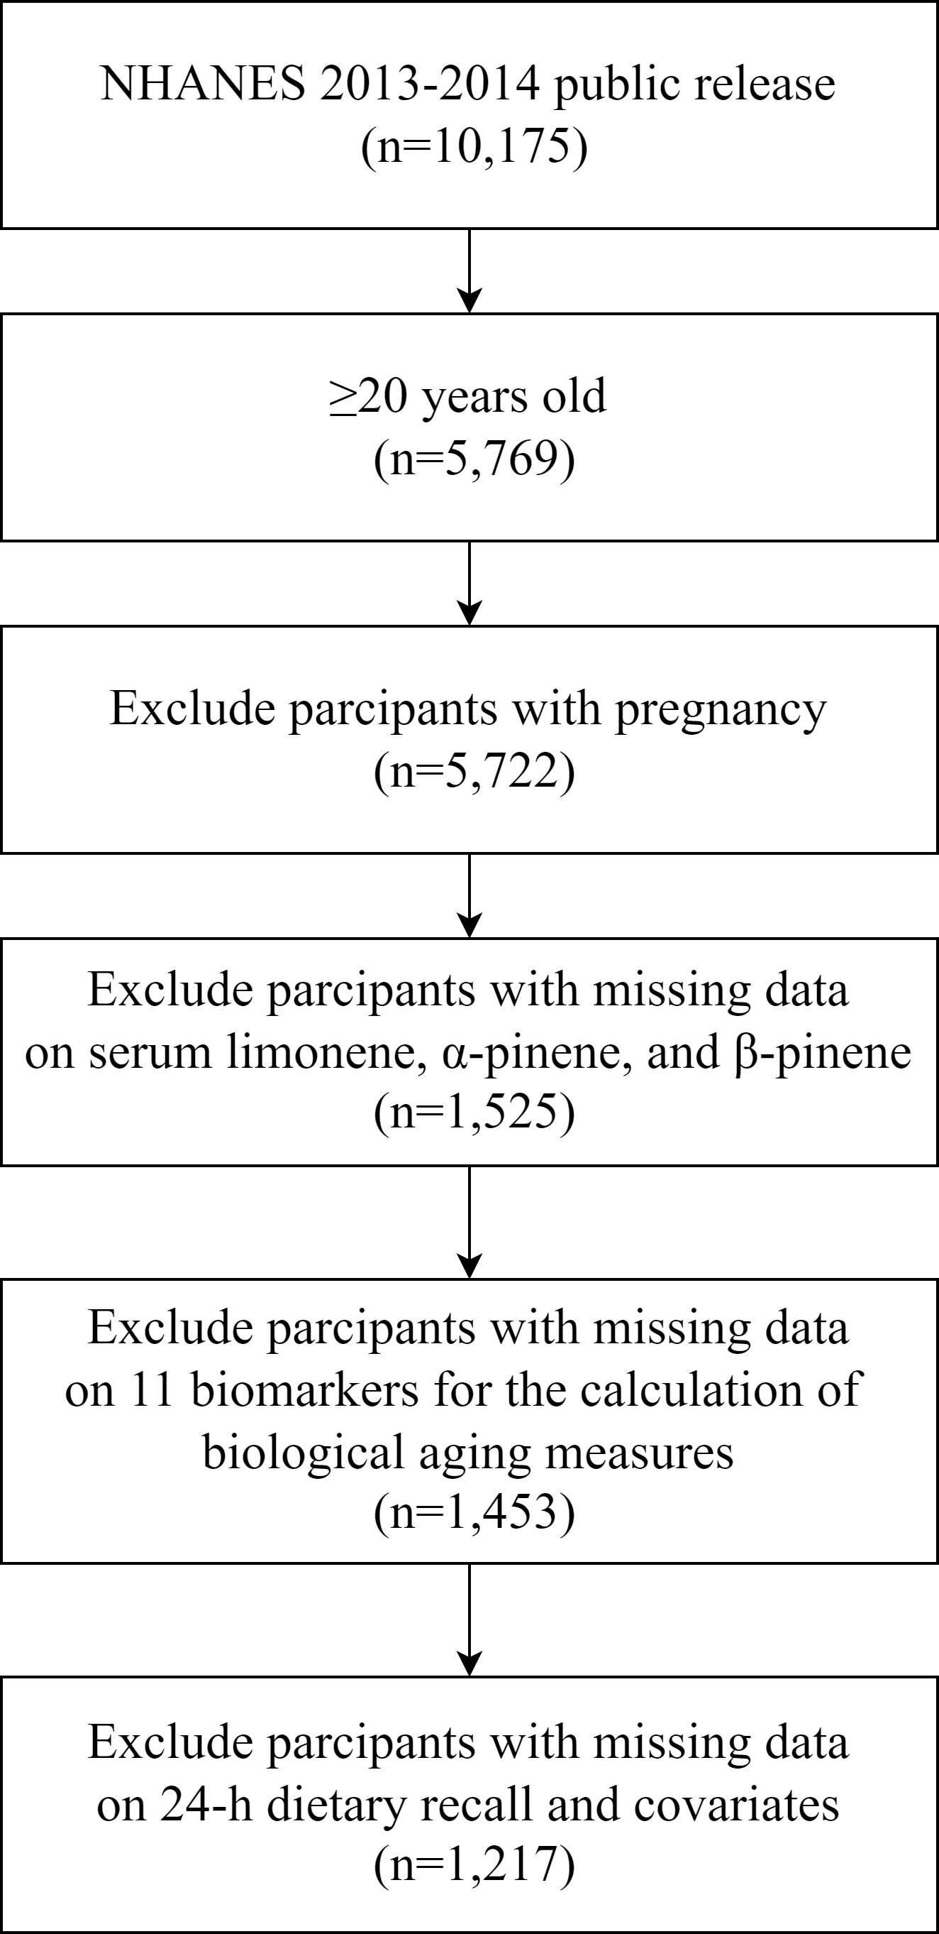
Figure S1. Flowchart of the study participants.
Table S1. Detection rate of three serum monoterpenes in the NHANES 2013-2014 (n=1,217).
 | LLODs | ≥LLODsª
Limonene, ng/mL | 0.162 | 99.9%
α-Pinene, ng/mL | 0.050 | 75.3%
β-Pinene, ng/mL | 0.056 | 74.9%
n, number of participants; LLODs, lower limits of detection;
ª Percentage of concentrations at or above the LLODs.

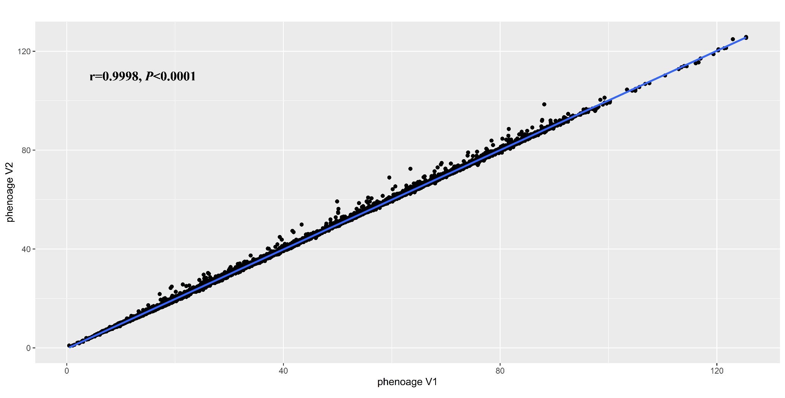
Figure S2. Pearson’s correlations between phenotypic age derived from the biomarker set without CRP and that derived from the biomarker set with CRP

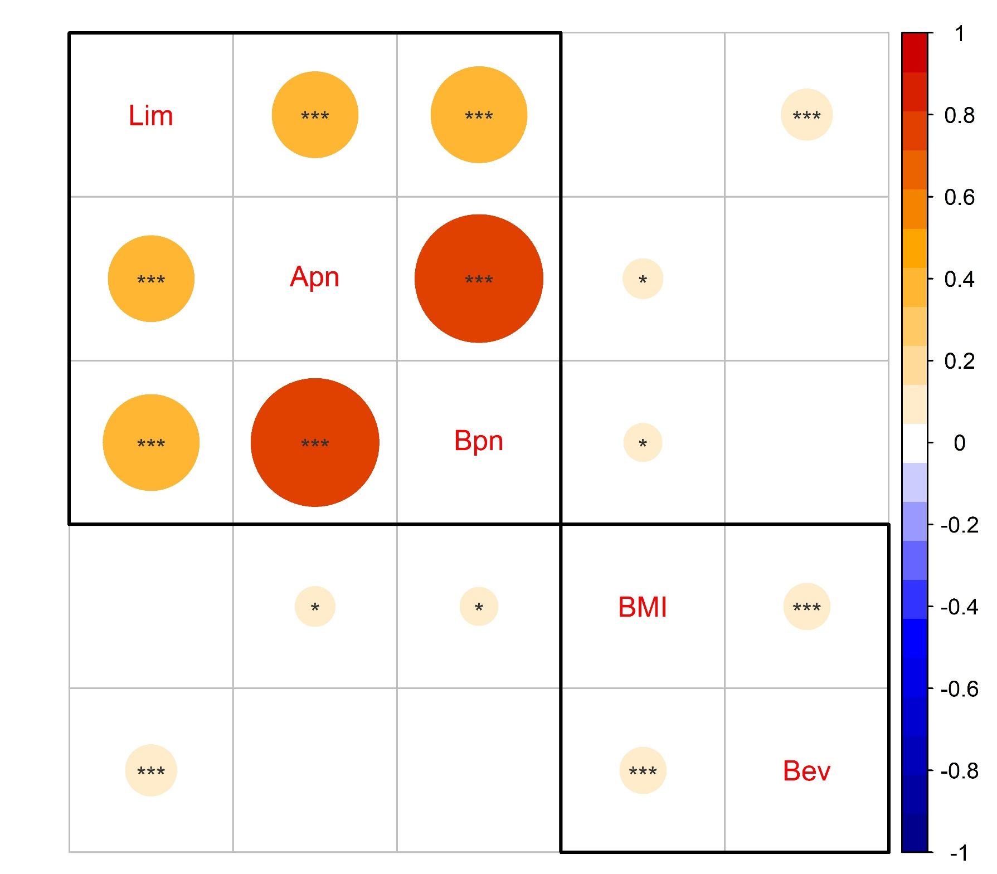
Figure S3. Pearson’s correlations among serum monoterpene levels, BMI and beverage intake. A log transformation was applied to the serum monoterpene levels and beverage intake data; The color and size of the circles represent the magnitude of the correlation; *:P<0.05; **:P<0.01; ***:P<0.001; BMI: body mass index. Lim: limonene; Apn: α-pinene; Bpn: β-pinene; Bev: beverage intake.

