Supporting Information

Floatable Artificial Leaf to Couple Oxygen-Tolerant CO₂ Conversion with Water-Purification
Zhiyong Zhang^{1,2}, Yang Wang³, Yangen Xie^{1,2}, Takemoto Toru^{1,2}, Qi Zhao^{1,2}, Qing Huang^{1,2}, Xingmiao Huang^{1,2}, Boyang Zhang^{1,2}, Wenjing Song^{1,2}, Chuncheng Chen^{1,2}, Hua Sheng^{1,2}* and Jincai Zhao^{1,2}

[1] Zhiyong Zhang, Yangen Xie, Dr. Takemoto Toru, Qi Zhao, Qing Huang, Xingmiao Huang, Boyang Zhang, Prof. Wenjing Song, Prof. Chuncheng Chen, Prof. Hua Sheng, Prof. Jincai Zhao Key Laboratory of Photochemistry, Institute of Chemistry Chinese Academy of Sciences, Beijing National Laboratory for Molecular Sciences, Beijing, 100190, PR China, E-mail: hsheng@iccas.ac.cn

[2] Zhiyong Zhang, Yangen Xie, Dr. Takemoto Toru, Qi Zhao, Qing Huang, Xingmiao Huang, Boyang Zhang, Prof. Wenjing Song, Prof. Chuncheng Chen, Prof. Hua Sheng, Prof. Jincai Zhao University of Chinese Academy of Sciences, Beijing 100049, PR China

[3] Dr. Yang Wang
CAS Key Laboratory of Green Process and Engineering, National Engineering Research Center of Green Recycling for Strategic Metal Resources, Institute of Process Engineering, Chinese Academy of Sciences, Beijing 100190, P.R. China

This file includes:
Supplementary Figures 1–19.
Supplementary Table 1.
Supplementary References.
Results and Discussion.
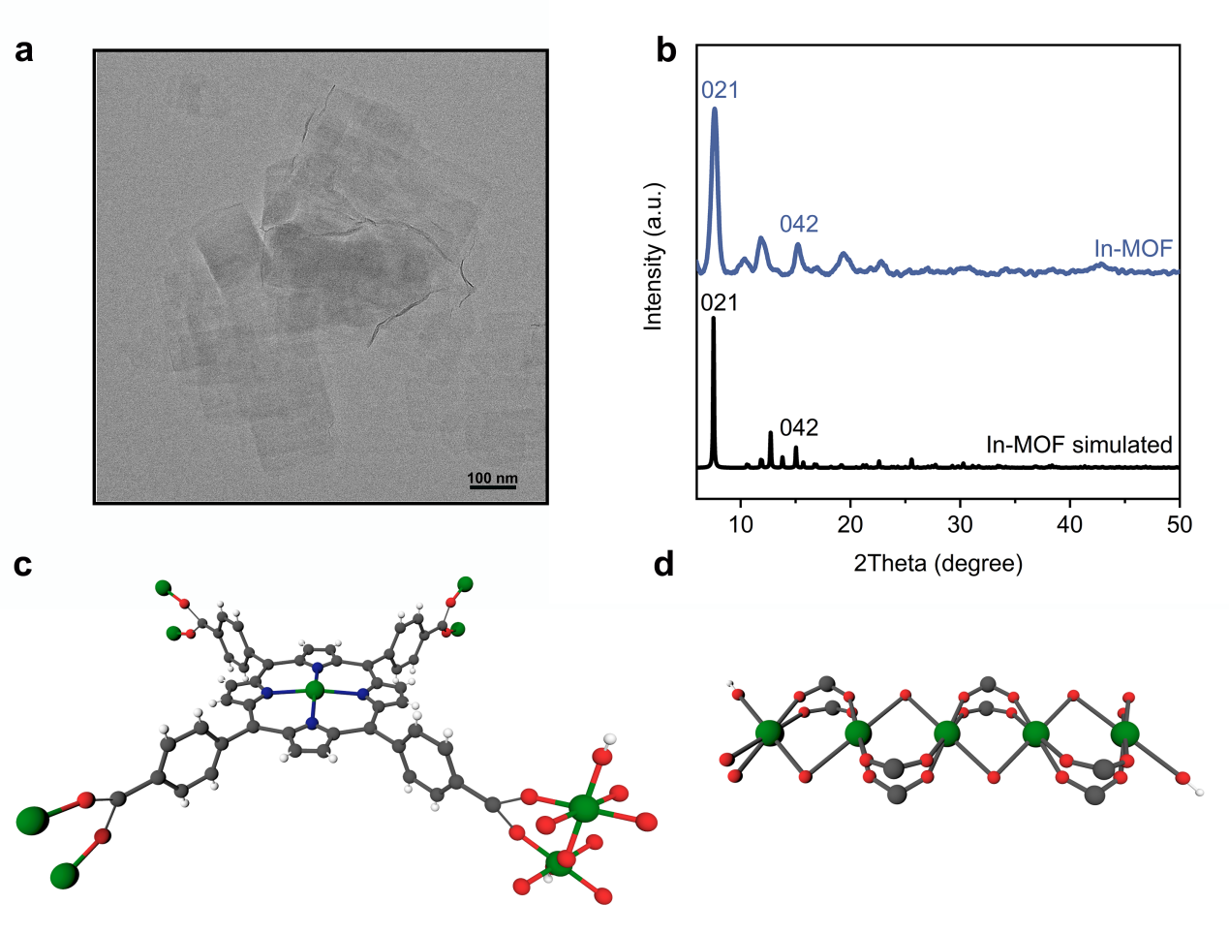Supplementary Fig. 1. TEM image (a) and XRD pattern (b) of In-MOF. (c) The coordination environments of In(III) ions and the TCPP ligand in In-MOF. (d) The structure of InO4(OH)2 chain in the structure of In-MOF. The In, C, O, N and H are shown as green, grey, red, blue and white circles, respectively.

In-MOF nanosheets (Supplementary Fig. 1a) were successfully synthesized via a method reported in the literature. The XRD pattern of the synthesized nanosheets aligns closely with simulated results in the previous report (Supplementary Fig. 1b)¹, which confirms the structure of as-synthesized In-MOF with the presence of hydroxyl groups at the axial positions of the Indium clusters (Supplementary Fig. 1c-d).

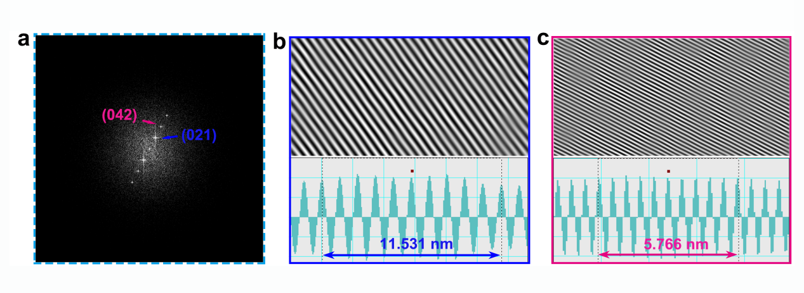
Supplementary Fig. 2. (a) The HR-TEM Fourier-transformed image, wherein regions (b) and (c) denote the respective inverse Fourier-transform-derived lattice fringe patterns representative of the 021 and 042 crystal planes observed in Supplementary Fig. 1a, accompanied by the measured interplanar lattice spacings associated with each.

HR-TEM coupled with Fourier transform analysis revealed distinct features corresponding to the (021) and (042) crystal planes, providing further evidence of the material's crystalline architecture. Specifically, regions (b) and (c) exhibit the derived lattice fringes patterns after inverse Fourier transformation of the aforementioned (021) and (042) planes, respectively. By meticulously measuring the spacing between these fringes, we observed an exact correlation with the interplanar distances deduced from the XRD pattern.
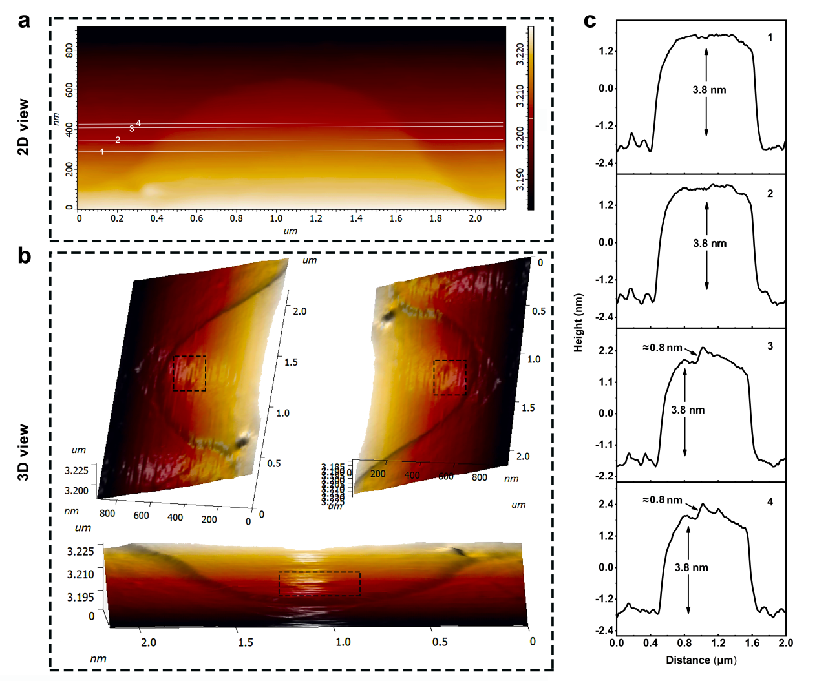Supplementary Fig. 3. Thickness characterization of the In-MOF/GO. (a) two-dimensional view; (b) three-dimensional view; (c) The corresponding thickness assessments derived from the two-dimensional perspectives.

As shown in Supplementary Fig. 3, four typical lines are selected. The line 1 and 2 concern about the GO areas on the substrate, from the 3D view, we can see the surface of GO is rather flat and the thickness measured from both lines is about 3.8 nm. Line 3 and 4 are the areas of the In-MOF/GO parts, different from the flat feature of the GO part, we can see a sudden increase in height when the AFM probe tip reaches to 2D In-MOF, and the height difference is about 0.8 nm for the both areas, indicating the thickness of formed 2D In-MOF sheet being about 0.8 nm.

Supplementary Fig. 4. The TEM image of In-MOF/GO-ex-situ.

From the TEM images of In-MOF/GO-ex-situ, it can be observed that the In-MOF is dispersed around the GO sheets rather than well-grown on them.
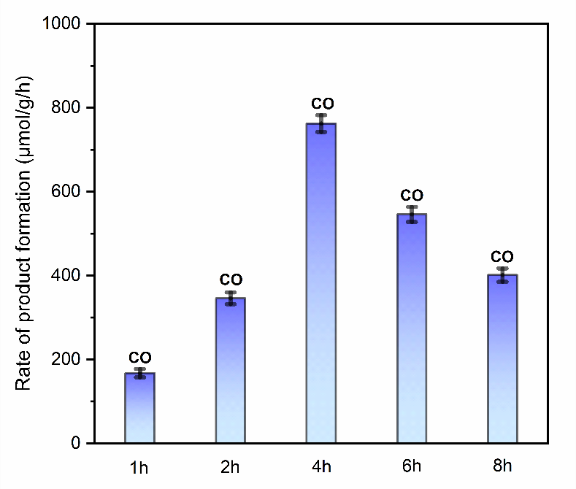
Supplementary Fig. 5. A comparative investigation of the photocatalytic CO₂ reduction performance of In-MOF/GO at distinct growth durations.

The in-situ growth time of In-MOF on GO significantly influences the catalytic performance. We observed that as the growth time increases, the catalytic performance also increases, reaching its maximum with In-MOF/GO-4h grown for 4 hours. Beyond 4 hours, the catalytic performance gradually decreases. The likely reason is that insufficient growth and crystallization of In-MOF on graphene oxide (less than 4 hours) leads to limited surface active sites for CO₂ adsorption and reduction, hindering full catalytic potential. Conversely, overgrowth (more than 4 hours) results in material agglomeration, which hinders effective diffusion and transport of gaseous substances or solutes, ultimately affecting catalytic efficiency. This result favorably underscores the importance of the in-situ growth strategy.

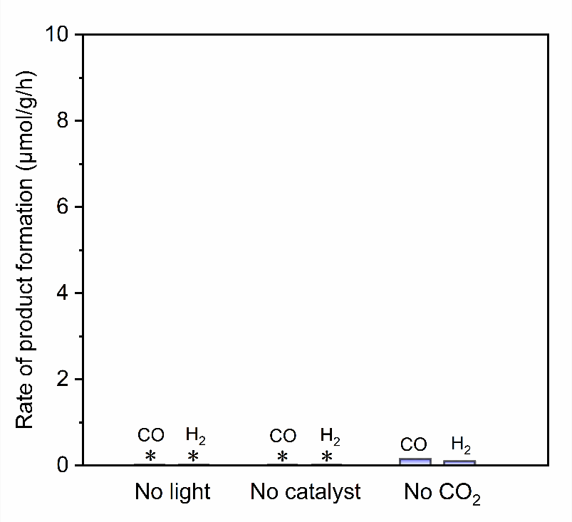
Supplementary Fig. 6. Control experiment without light, catalyst or CO₂.

When the experiment was conducted without light, catalyst or CO₂, no detectable product was formed in the reaction system.
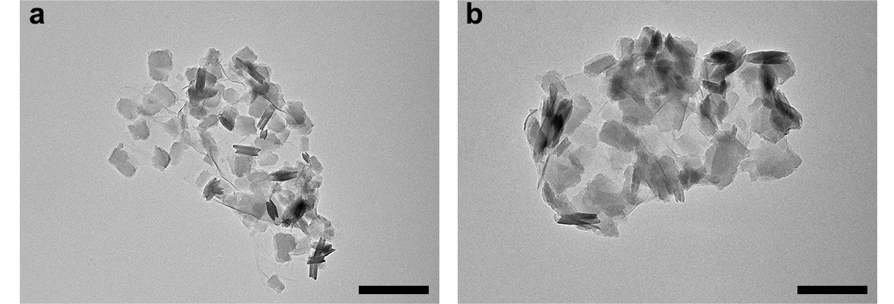Supplementary Fig. 7. TEM image of In-MOF/GO before (a) and after (b) cyclic reactions, with a scale bar of 500 nm.

By observing the TEM images before and after five cycles, we found that the morphology of In-MOF/GO remains unchanged, indicating good stability of the catalyst.
.
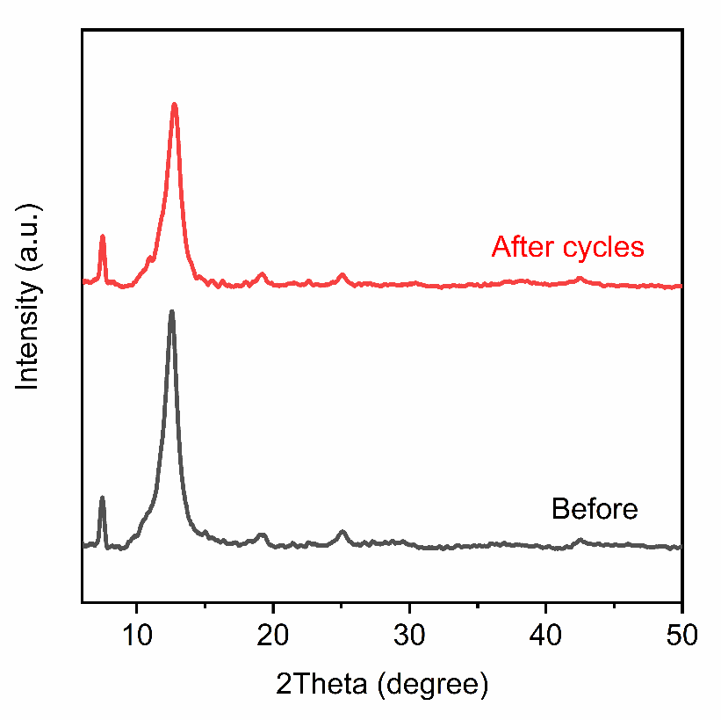
Supplementary Fig. 8. PXRD patterns of In-MOF/GO before and after cyclic reactions.

The XRD patterns of In-MOF/GO before and after five cycles showed no changes, indicating that the structure of In-MOF/GO remains unchanged, thus demonstrating good stability of the catalyst.
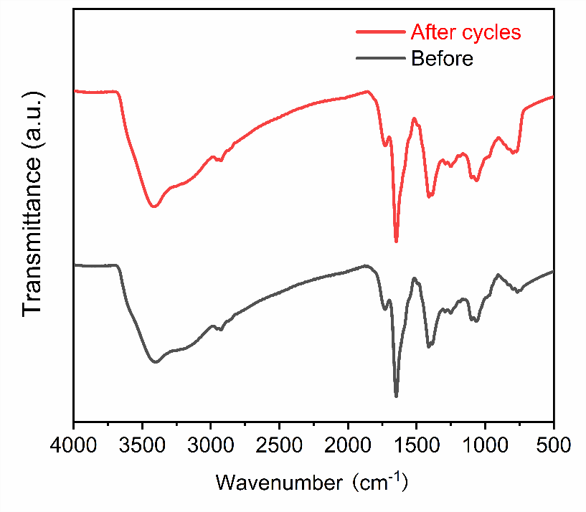
Supplementary Fig. 9. FT-IR spectra of In-MOF/GO before and after cyclic reactions.

The FT-IR spectra of In-MOF/GO before and after five cycles showed no changes, indicating that the functional groups on the surface of In-MOF/GO remain unchanged throughout the cycles, thus demonstrating good stability of the catalyst.

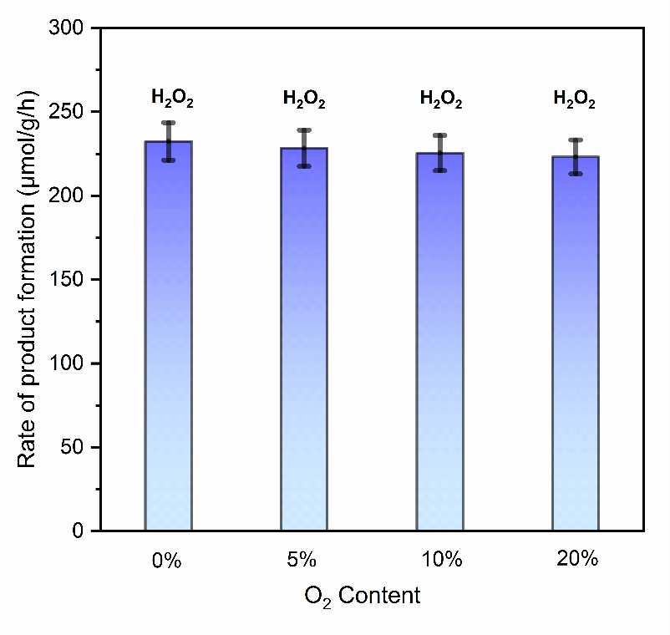
Supplementary Fig. 10. The average evolution rates of H₂O₂ under different O₂ contents.

The amount of hydrogen peroxide produced remained virtually constant at different oxygen concentrations, indicating that the generation of hydrogen peroxide was not influenced by the oxygen concentration and was instead generated through the oxidation of water.
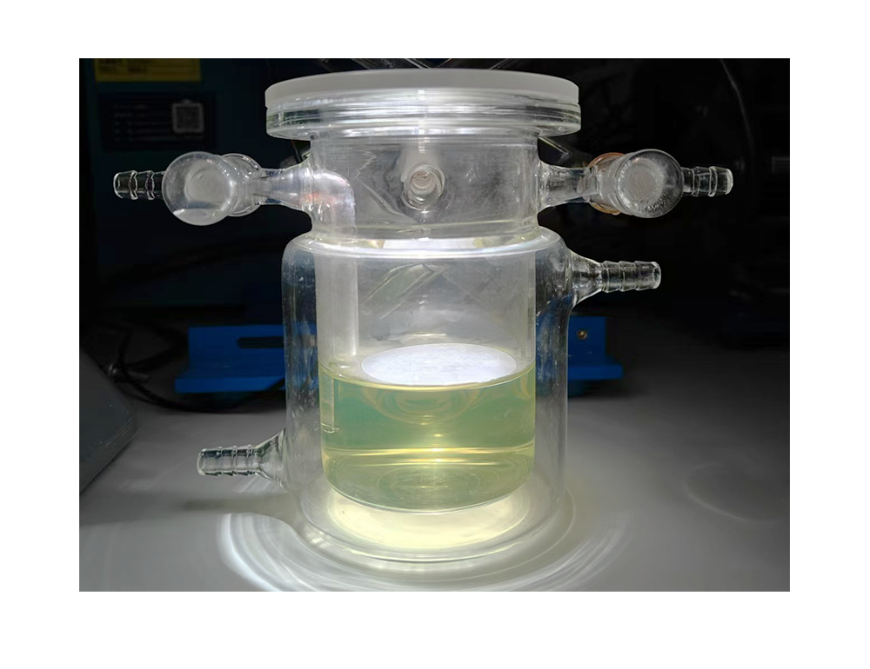
Supplementary Fig. 11. Photograph of the actual floating photocatalytic reaction device (with the use of lake water as liquid phase).

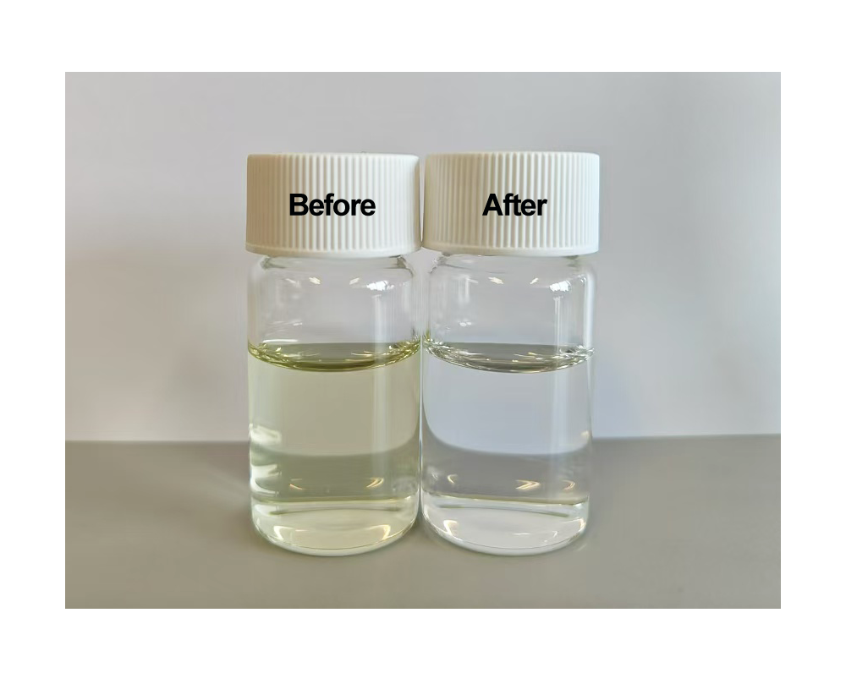
Supplementary Fig. 12. Photographic images of the lake water before and after 6 hours treatment by the floating artificial leaf.

After 6 hours of treatment with the artificial leaf, the color of the collected lake water changed from yellow-green to clear and transparent, indicating effective purification of the lake water. This result is consistent with the effective reduction in the chemical oxygen demand (COD) value of the lake water.
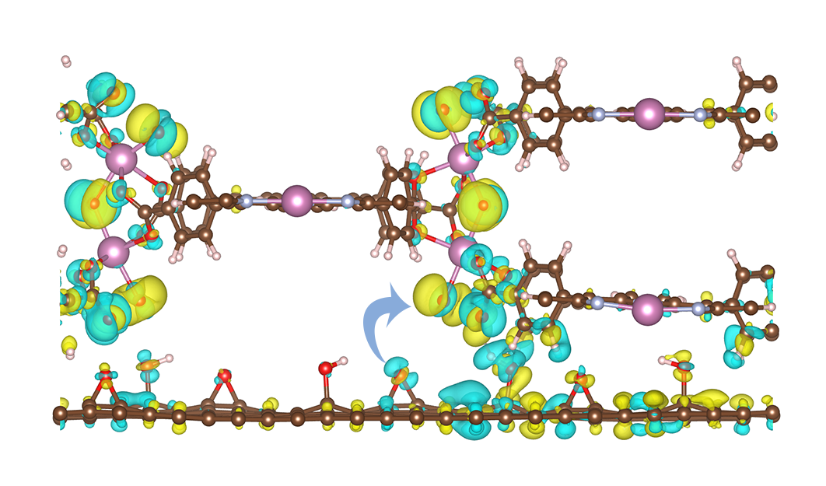
Supplementary Fig. 13. The charge difference plots when In-MOF and GO forms the heterojunction; yellow regions represent regions of electron accumulation, while blue regions denote areas of electron depletion.

Supplementary Fig. 14. High-resolution XPS spectra of In-MOF/GO, In-MOF and GO: (a) In 3d. (b) C 1s.

Through the observation of the In 3d and C 1s spectra, we found that in the In-MOF/GO composite material, the In 3d peak shifts to lower binding energy regions, while the C 1s peak moves to higher binding energy regions. These changes indicate electron transfer from graphene oxide to In-MOF within the In-MOF/GO composite.

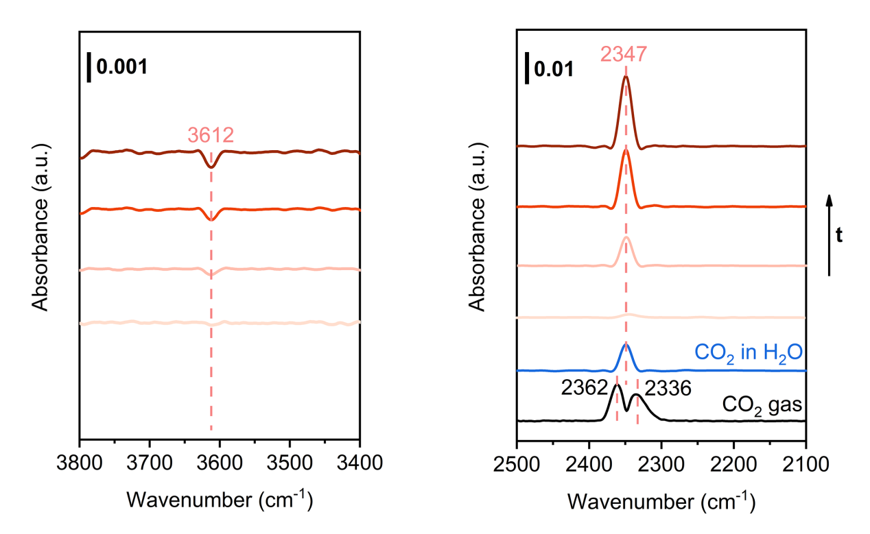
Supplementary Fig. 15. FT-IR spectra sequence collected during the CO₂ adsorption in the dark (The In-MOF/GO sample was pressed into a self-supported pellet allowing IR beam transmittance. To monitor the CO₂ adsorption process, the IR chamber was first inflated with pure Ar, then rapidly switched to 20% CO₂, and a series of time-dependent IR spectra were collected. The background was collected under the atmosphere of dry Ar, just before the introduction of CO₂.) For the right figure, since this IR spectra was collected in a transmittance mode, so both the gaseous free CO₂ and adsorbed CO₂ were displayed in the spectra. To only exhibit the CO₂ interacted with the surface, we deducted the part of gaseous CO₂ by the standard spectrum of gaseous CO₂ (black spectrum). To certify the assignment of the adsorbed CO2, we collected the IR spectra for the dissolved CO₂ in water based on an attenuated total reflection (ATR) mode, which is displayed as the blue spectrum.

For the 2347 cm⁻¹ band in Supplementary Fig. 15, its frequency is very close to that of the free gaseous CO2. However, upon collecting the IR spectra, the gas atmosphere surrounding the sample was switched to dry Ar, the residue of gaseous CO2 was very limited. Moreover, considering that the characteristic IR band of gaseous CO2 split into P and R branches at 2362 and 2336 cm⁻¹ owing to the rotation transition of the CO2 molecule, the singlet 2347 cm⁻¹ band observed here is more similar to the dissolved CO2 in water (blue trace in Supplementary Fig. 15). Therefore, the 2347 cm⁻¹ band is assigned to the asymmetric stretching vibration of molecular CO2 hydrogen-bonded with adjacent water molecules, which limits the rotation of CO2 molecule and results in a singlet IR peak.
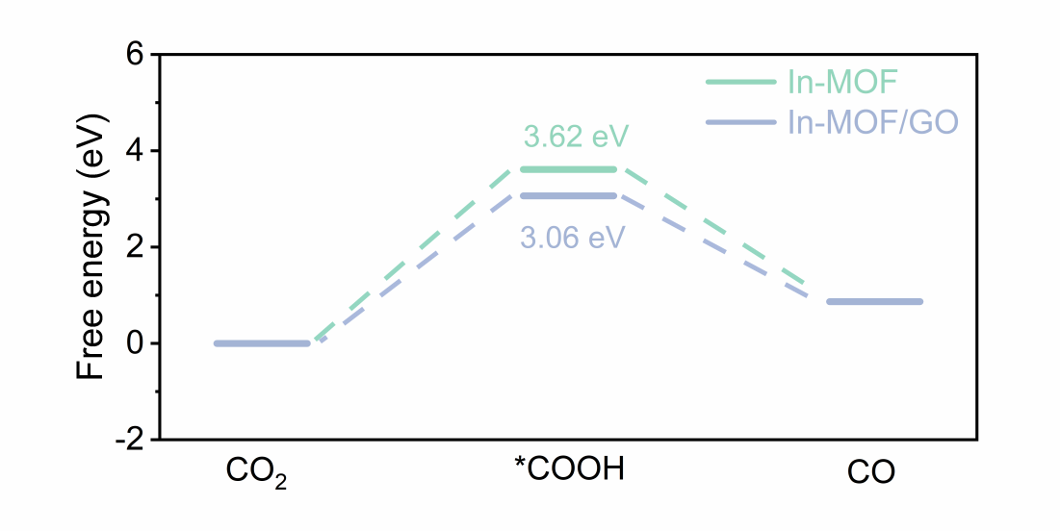
Supplementary Fig. 16. Gibbs free energy diagram of the CO₂ reduction to CO on the individual In-MOF and hybrid In-MOF/GO, respectively.

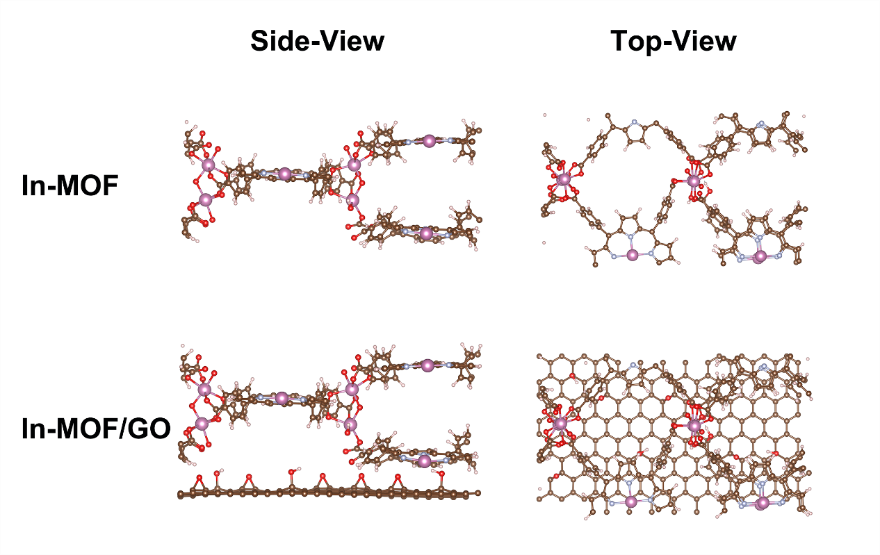Supplementary Fig. 17. The initial structural models of In-MOF and In-MOF/GO applied for theoretical calculations.

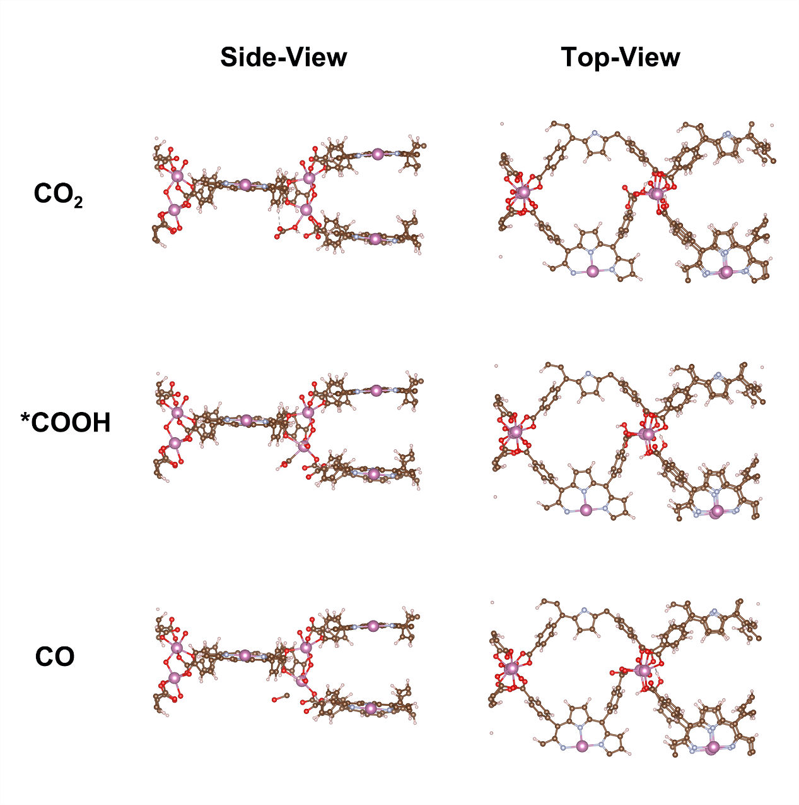Supplementary Fig. 18. The CO₂RR to CO reaction pathway model on In-MOF used in calculation.

The CO₂ reduction mechanism on In-MOF is described as follows:
CO₂ (g) + H⁺ + e⁻ ⟶ *COOH
*COOH + H⁺ + e⁻ ⟶ CO (g) + H₂O (l)

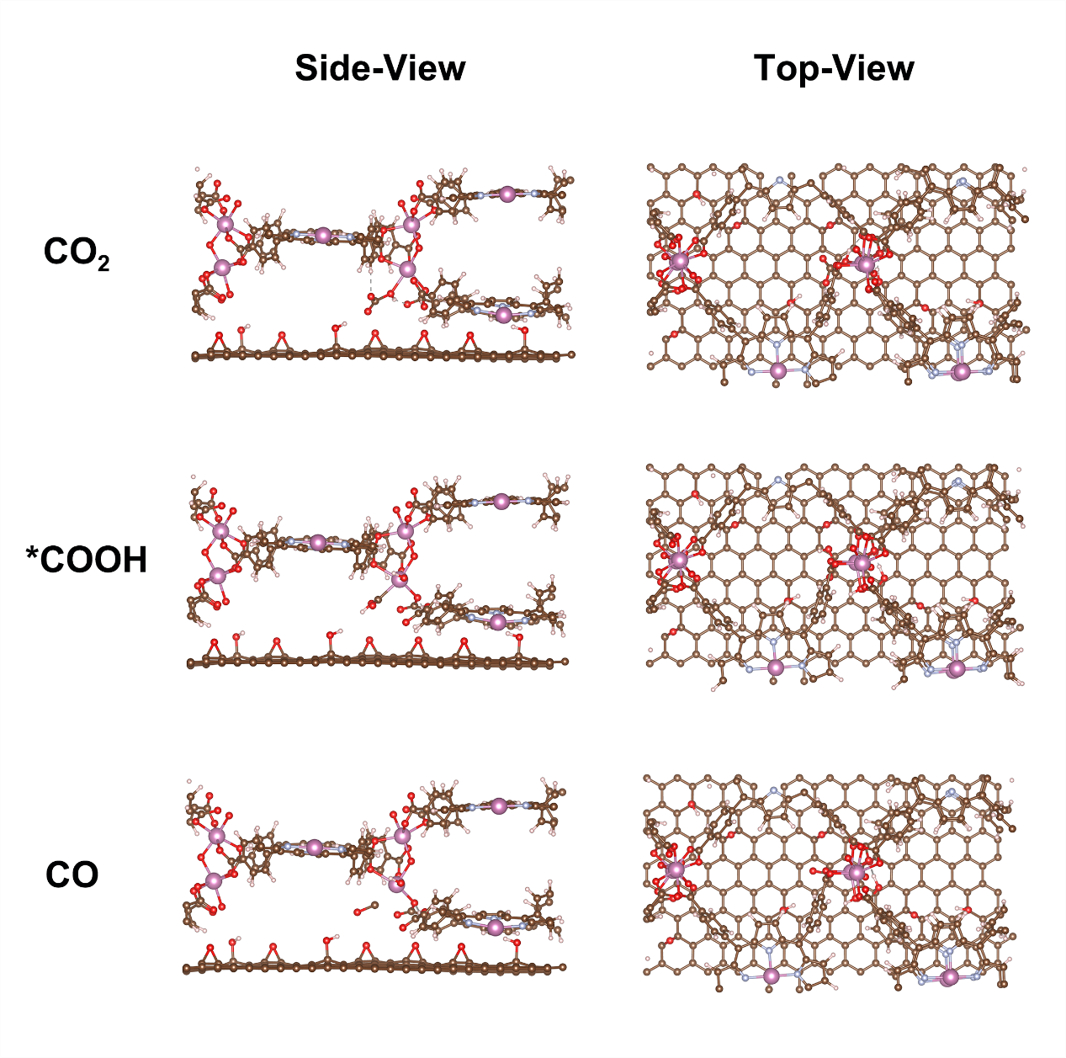Supplementary Fig. 19. The CO₂RR to CO reaction pathway model on In-MOF/GO used in calculation.

The CO₂ reduction mechanism on In-MOF/GO is described as follows:
CO₂ (g) + H⁺ + e⁻ ⟶ *COOH
*COOH + H⁺ + e⁻ ⟶ CO (g) + H₂O (l)

Supplementary Table 1. Performance comparison of recently reported photocatalytic CO₂ reduction to CO and CH₄ Products.

Photocatalyst | Sacrificial agent | Atmosphere | Production | Activity (μmol·g⁻¹·h⁻¹) | Refs.
In-MOF/ GO | - | 10%CO₂+20%O₂+70%Ar | CO | 762.5 | This work
Cu-ZnTCPP/g-C₃N₄ | - | 10%CO₂+20%O₂+70%Ar | CO  CH₄ | 92  11.3 | [2]
Pd-HPP-TiO₂ | - | CO₂ | CO  CH₄ | 34  48 | [3]
TiO₂/PCN-224(Cu) | - | CO₂ | CO | 37.21 | [4]
MAPbI₃@PCN-221(Fe) | - | CO₂ | CO  CH₄ | 4.16  13 | [5]
IHEP-22(Co) | Triethanolamine | CO₂ | CO | 350.9 | [6]
GQDs@PCN-222 | Triethanolamine | CO₂ | CO | 147.8 | [7]
In-Fe_{1.91}TCPP-MOF | L- ascorbgyl  palmitate | CO₂ | CO | 144.54 | [8]
36%Cds/MIL-101 | - | CO₂ | CO | 0.1635 | [9]
MIL-101-EN | Triethanolamine | CO₂ | CO | 47.2 | [10]
Co_{0.1}Ni_{0.9}-MOF | - | CO₂ | CO | 38.74 | [11]
30%-Cu₂O/Ni MOF | - | CO₂ | CO | 21.7 | [12]
UiO-66-NH₂-LV | Triethanolamine | CO₂ | CO | 30.5 | [13]
2-TiMOF | - | 60%CO₂+40%H₂ | CO | 4.3 | [14]
Co-ZIF-9/Cds | Triethanolamine | CO₂ | CO  H₂ | 82  35 | [15]
UiO-66/bulk CN | Triethanolamine | CO₂ | CO | 19.3 | [16]
ZrPP-1-Co | Triethanolamine | CO₂ | CO | 14 | [17]
MOF-525-Co | Triethanolamine | CO₂ | CO | 200.6 | [18]
Fe/Ni-T120 | Triethanolamine | CO₂ | CO | 9.74 | [19]
Cs₂AgBiBr₆@g-C₃N₄-10% | Methanol | CO₂ | CO  CH₄ | 1.6  0.3 | [20]
CN/BOS | - | CO₂ | CO | 37.2 | [21]
Bi₁₂O₁₇Cl₂ | - | CO₂ | CO | 48.6 | [22]
CsPbBr₃/Bi₂WO₆ | isopropanol | CO₂ | CO  CH₄ | 17.2  34.3 | [23]
Cu-CCN | - | CO₂ | CO | 3.09 | [24]
ZnSe/CdS DORs | - | CO₂ | CO | 11.3 | [25]

Supplementary Reference
- Leng, F. et al. Boosting photocatalytic hydrogen production of porphyrinic MOFs: the metal location in metalloporphyrin matters. ACS Catal. 8, 4583-4590 (2018).
- Xie, S. et al. Facilitated photocatalytic CO₂ reduction in aerobic environment on a copper‐porphyrin metal–organic framework. Angew. Chem. Int. Ed. 62, e202216717 (2023).
- Ma, Y. et al. Selective photocatalytic CO₂ reduction in aerobic environment by microporous Pd-porphyrin-based polymers coated hollow TiO₂. Nat. Commun. 13, 1400 (2022).
- Wang, L. et al. Integration of copper (II)-porphyrin zirconium metal–organic framework and titanium dioxide to construct Z-scheme system for highly improved photocatalytic CO₂ reduction. ACS Sustain Chem Eng. 7, 15660-15670 (2019).
- Wu, L. et al. Encapsulating perovskite quantum dots in iron‐based metal–organic frameworks (MOFs) for efficient photocatalytic CO₂ reduction. Angew. Chem. Int. Ed. 58, 9491-9495 (2019).
- Huang, Z. et al. Thermally induced orderly alignment of porphyrin photoactive motifs in metal–organic frameworks for boosting photocatalytic CO₂ reduction. J. Am. Chem. Soc. 145, 18148-18159 (2023).
- Yu, Q. et al. In situ encapsulation of graphene quantum dots in highly stable porphyrin metal-organic frameworks for efficient photocatalytic CO₂ reduction. Molecules, 28, 4703 (2023).
- Wang, S. et al. Encapsulation of single iron sites in a metal–porphyrin framework for high-performance photocatalytic CO₂ reduction. Inorg. Chem. 59, 6301-6307 (2020).
- Ding, D. et al. Impregnation of semiconductor CdS NPs in MOFs cavities via double solvent method for effective photocatalytic CO₂ conversion. J. Catal. 375, 21−31(2019).
- Xie, Y. et al. Creating chemisorption sites for enhanced CO₂ photoreduction activity through alkylamine modification of MIL-101-Cr. ACS Appl. Mater. Interfaces, 11, 27017−27023 (2019).
- Wei, T. et al. Polarization-induced efficient charge separation in an electromagnetic coupling MOF for enhancing CO₂ photocatalytic reduction. J. Colloid Interface Sci. 622, 402−409 (2022).
- Jiang, H. et al. Fabricated local surface plasmon resonance Cu₂O/Ni-MOF hierarchical heterostructure photocatalysts for enhanced photoreduction of CO₂. J. Environ. Chem. Eng. 11, 109504 (2023).
- Wang, S. et al. Defect-engineering of Zr (IV)-based metal-organic frameworks for regulating CO₂ photoreduction. Chem. Eng. J. 429,132157 (2022).
- Crake, A. et al. CO₂ capture and photocatalytic reduction using bifunctional TiO₂/MOF nanocomposites under UV–vis irradiation. Appl. Catal. B-Environ. 210,131−140 (2017).
- Wang, S. et al. Photocatalytic CO₂ reduction by CdS promoted with a zeolitic imidazolate framework. Appl. Catal. B-Environ. 162, 494−500 (2015).
- Shi, L. et al. Electrostatic self‐assembly of nanosized carbon nitride nanosheet onto a zirconium metal–organic framework for enhanced photocatalytic CO₂ reduction. Adv. Funct. Mater. 25, 5360−5367 (2015).
- Chen, E. et al. Acid and base resistant zirconium polyphenolate‐metalloporphyrin scaffolds for efficient CO₂ photoreduction. Adv. Mater. 30, 1704388 (2018).
- Zhang, H. et al. Efficient visible‐light‐driven carbon dioxide reduction by a single‐atom implanted metal–organic framework. Angew. Chem. Int. Ed. 55, 14310−14314(2016).
- Gu, L. et al. Optimization of Fe/Ni organic frameworks with core–shell structures for efficient visible-light-driven reduction of carbon dioxide to carbon monoxide. Nanoscale 14, 15821−15831 (2022).
- Wang, Y. et al. Lead-free perovskite Cs₂AgBiBr₆@ g-C₃N₄ Z-scheme system for improving CH4 production in photocatalytic CO₂ reduction. Appl. Catal. B-Environ. 282, 119570 (2021).
- Li, J. et al. Van der Waals heterojunction for selective visible-light-driven photocatalytic CO₂ reduction. Appl. Catal. B-Environ. 284, 119733 (2021).
- Di, J. et al. Defect‐rich Bi₁₂O₁₇Cl₂ nanotubes self‐accelerating charge separation for boosting photocatalytic CO₂ reduction. Angew. Chem. Int. Ed. 57, 14847-14851 (2018).
- Jiang, Y. et al. Z‐scheme 2D/2D heterojunction of CsPbBr₃/Bi₂WO₆ for improved photocatalytic CO₂ reduction. Adv. Funct. Mater. 30, 2004293 (2020).
- Li, Y. et al. Crystalline carbon nitride supported copper single atoms for photocatalytic CO₂ reduction with nearly 100% CO selectivity. ACS Nano 14, 10552-10561 (2020).
- Xin, Z. et al. Rational design of Dot‐on‐Rod nano‐heterostructure for photocatalytic CO₂ reduction: Pivotal role of hole transfer and utilization. Adv. Mater. 34, e2106662 (2022).

