Environmentally Friendly Shape Memory Smart Composite Materials with Multiple Response Modes
Supplementary Information
Fang Suoª, Zhongyang Bai^{b}, Xiangwei Ma^{c}, Yongtao Yao^{a,}*, Yanju Liu^{d}
ª National Key Laboratory of Science and Technology for Advanced Composites in Special Environments, Harbin Institute of Technology, Harbin 150080, China
^{b} Key Laboratory of Bio-Based Material Science and Technology (Ministry of Education), Material Science and Engineering College, Northeast Forestry University, Harbin 150040, China
^{c} Daqing Inspection and Testing Center, Daqing 163311, China
^{d} Department of Astronautic Science and Mechanics, Harbin Institute of Technology, Harbin 150000, People’s Republic of China

Experiment
Table S1 3D printing parameters
Parameter | Value
Nozzle temperature (℃) | 210
Layer height (mm) | 0.2
Infill density (%) | 100
Printing speed (mm/s) | 40
Nozzle flow rate (%) | 200
Support density (%) | 15
Printing plate temperature (℃) | 25

Results and Discussion
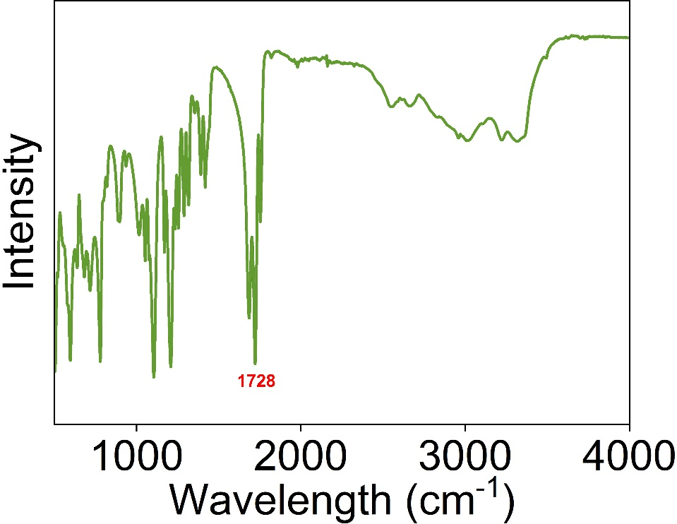
Fig. S1 FTIR of citric acid
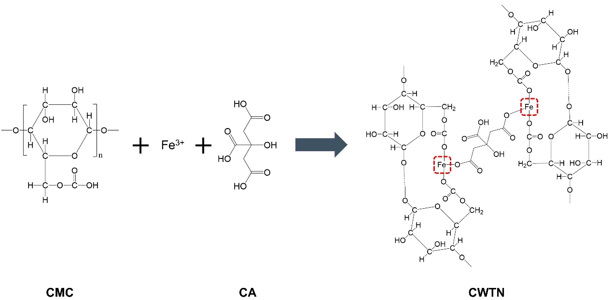
Fig. S2 The reaction mechanism between CMC, Fe³⁺, and CA.
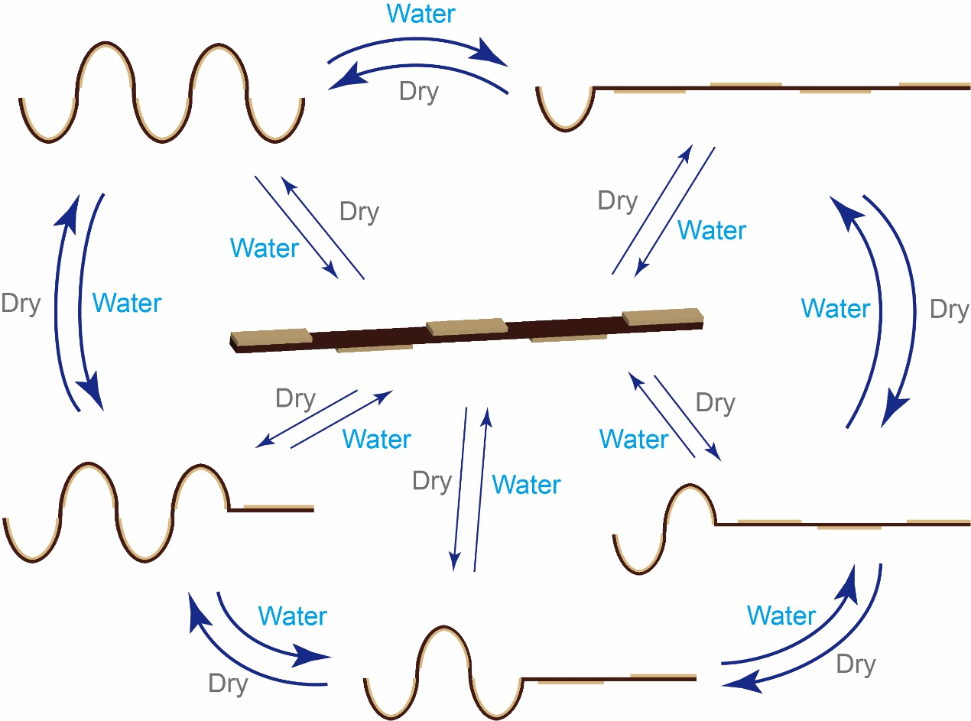
Fig. S3 Water responsive controlled programming.

*Corresponding author. E-mail: yaoyt@hit.edu.cn (Yongtao Yao)

