Supporting information for

Regulating the amount of graphene oxide for enhanced capacitive energy storage of MOF derived materials

Yongji Qin^{a,}*, Jingquan Yangª, Hao Wang^{b}, Meiling Lian^{c}, Peipei Jia^{a,}*, Jun Luo^{a,}*, Xijun Liu^{d} and Junfeng Liu^{e}

ª ShenSi Lab, Shenzhen Institute for Advanced Study, University of Electronic Science and Technology of China, Longhua, Shenzhen 518110, China
^{b} China National Coal Group Corporation, Beijing 100120, China
^{c} Tianjin Engineering Research Center of Civil Aviation Energy Environment and Green Development, School of Transportation Science and Engineering, Civil Aviation University of China, Tianjin, 300300, China
^{d} State Key Laboratory of Featured Metal Materials and Life-cycle Safety for Composite Structures, Guangxi Key Laboratory of Processing for Non-ferrous Metals and Featured Materials, MOE Key Laboratory of New Processing Technology for Nonferrous Metals and Materials, School of Resources, Environment and Materials, Guangxi University, Nanning, 530004 Guangxi, China.
^{e} State Key Laboratory of Chemical Resource Engineering, Beijing University of Chemical Technology, Beijing 100029, China.
* Corresponding authors: qyj@uestc.edu.cn (Y. Qin), jiapeipei@uestc.edu.cn (P. Jia), jluo@uestc.edu.cn (J. Luo).

- Experimental section
  - Chemicals
Graphite (98.0%), iron chloride hexahydrate (FeCl₃.6H₂O, 98.0%) and were bought from Sigma-Aldrich (Shanghai) Trading Co, Ltd. Potassium hydroxide (KOH, 85%) and 2-Aminoterephthalic Acid (NH₂-BDC, 98.0%) were purchased from Shanghai Aladdin Biochemical Technology Co. Ltd. Sulfuric acid (H₂SO₄, 95-97%), phosphoric acid (H₃PO₄, ≥85.0%), potassium permanganate (KMnO₄, ≥98.0%), hydrogen peroxide (H₂O₂, 30 wt% in H₂O), hydrochloric acid (HCl, 34%), N,N-dimethylformamide (DMF, 99.5%) and ethanol (EtOH, ≥99.5%) were obtained from Beijing Chemical Works. Conductive carbon black (Super P, ≥99.0%) was bought from Guangdong Canrd New Energy Technology Co., Ltd. All chemicals were used as received without any purification process.
  - Synthesis of graphene oxide (GO)
GO was prepared by a modified Hummers method. The mixture of H₂SO₄/H₃PO₄ (108 and 12 mL, respectively) and graphite (1 g) were placed in a 250 mL flask with mechanical agitation. When the mixture was cooled with an ice bath, KMnO₄ (3g) was added slowly and carefully. After being stirred for 3 days at room temperature (RT), H₂O₂ solution (10 mL, 30%) was added to stop the oxidation. After 1 h stirring, deionized water (100 mL) was added and the mixture was kept stirring for another 1 h. The products were collected by centrifugation, and washed with 1 M HCl aqueous solution five times to remove metallic impurities and then with deionized water repeatedly until the pH reached 5. During the washing process with deionized water, the graphite was exfoliated, which resulted in a dispersion of GO sheets. Finally, the products were dispersed in 200 mL deionized water.
1.3 Synthesis of FONP-NCG
Typically, a certain amount (1, 2.5, 5 and 7.5 mL, respectively) of GO solution was centrifuged and redispersed in 25 mL DMF and subsequently 135 mg FeCl₃.6H₂O was added. After 30 min stirring, 90 mg NH₂-BDC was added. The mixture was then stirred for an additional 1 h before transferring into an conical flask for crystallization at 120 ℃ for 4h. The resultant dark brown product was collected by centrifugation and washed several times with DMF and EtOH to remove the excess reactants, then dried in an oven. To obtain FONP-NCG composite, the as-prepared Fe-MOF-NH₂/GO was placed in a tube furnace and heated under N₂ gas flow at 500 ℃ for 1h with a heating rate of 5 ℃/min. The FONP-NC composite was synthesized under the same conditions without the addition of GO.
  - Characterization
The morphologies and sizes of samples were characterized by a transmission electron microscope (TEM, Hitachi HT-7700) operated at 100 kV and a scanning electron microscope (SEM, JEOL JSM-7600) with an accelerating voltage of 5 kV. The high-resolution TEM and elemental mapping were performed by a field emission electron microscope (JEM-2100F) operated at 200 kV. Powder X-ray diffraction (XRD) was tested on a Shimadzu XRD-6000 diffractometer with Cu Kα radiation (λ=1.5418 Å). The X-ray photoelectron spectroscopy (XPS) was accomplished on a Thermo ESCALAB 250Xi system with an Al Kα X-ray source. The inductively coupled plasma (ICP) measurement was performed on an inductively coupled plasma-atomic emission spectrometer (ICP-AES, SHIMADZU ICPS-7500).
1.5 Electrochemical measurements
A CHI 660D (Chenhua, Shanghai) workstation was used to test all the electrochemical measurements, using a typical three-electrode system at RT with carbon rod as counter electrode as well as standard calomel electrode (SCE) as reference electrode. All the inks were made by mixing 5 mg samples with 50 μL of 5% Nafion solution and 950 μL ethanol. After 1 h sonication, the 5 μL ink was dried onto glass carbon electrode. The electrochemical results were obtained in 6 M KOH aqueous solution. Electrochemical impedance spectroscopy (EIS) was performed at no-faradic region from 100000 to 10⁻¹ Hz with a 5-mV voltage range.
Figures
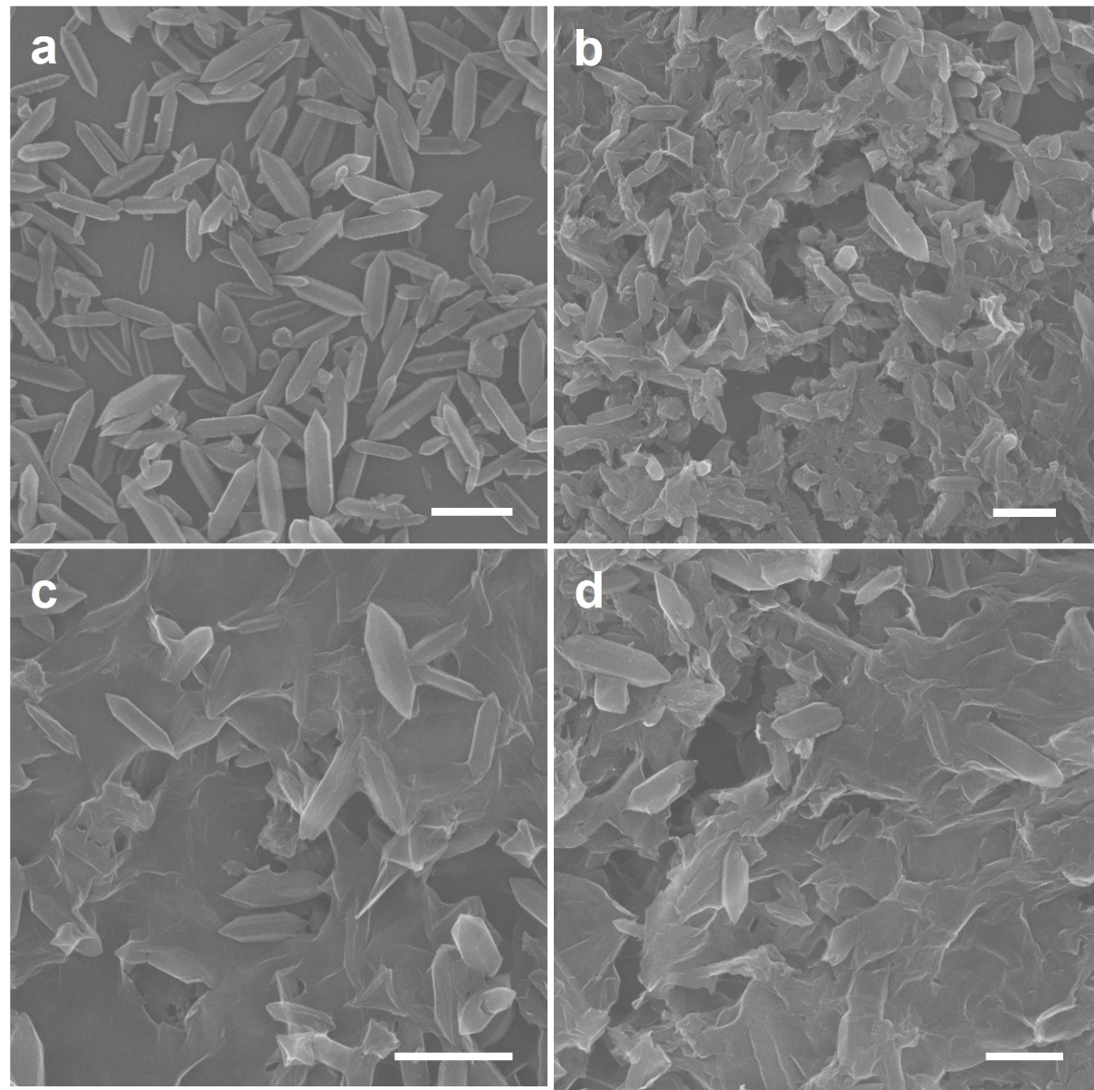
Figure S1. SEM images of as-prepared (a) Fe-MOF-NH₂, (b) Fe-MOF-NH₂ /GO-2.5, (c) N Fe-MOF-NH₂ /GO-5 and (d) Fe-MOF-NH₂ /GO-7.5. All the scale bars: 1 μm.

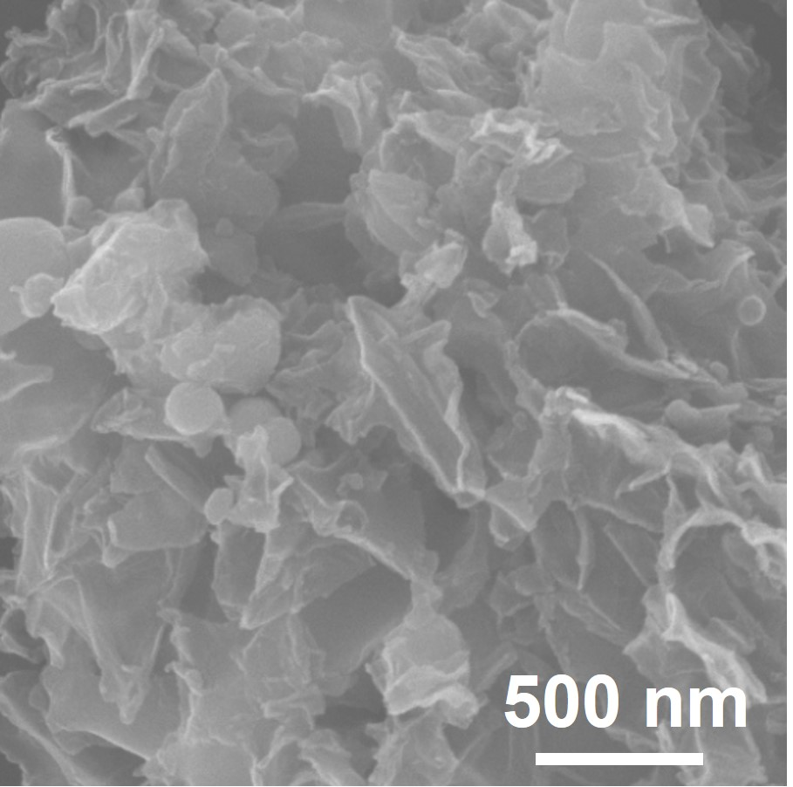
Figure S2. SEM image of FONP-NCG.

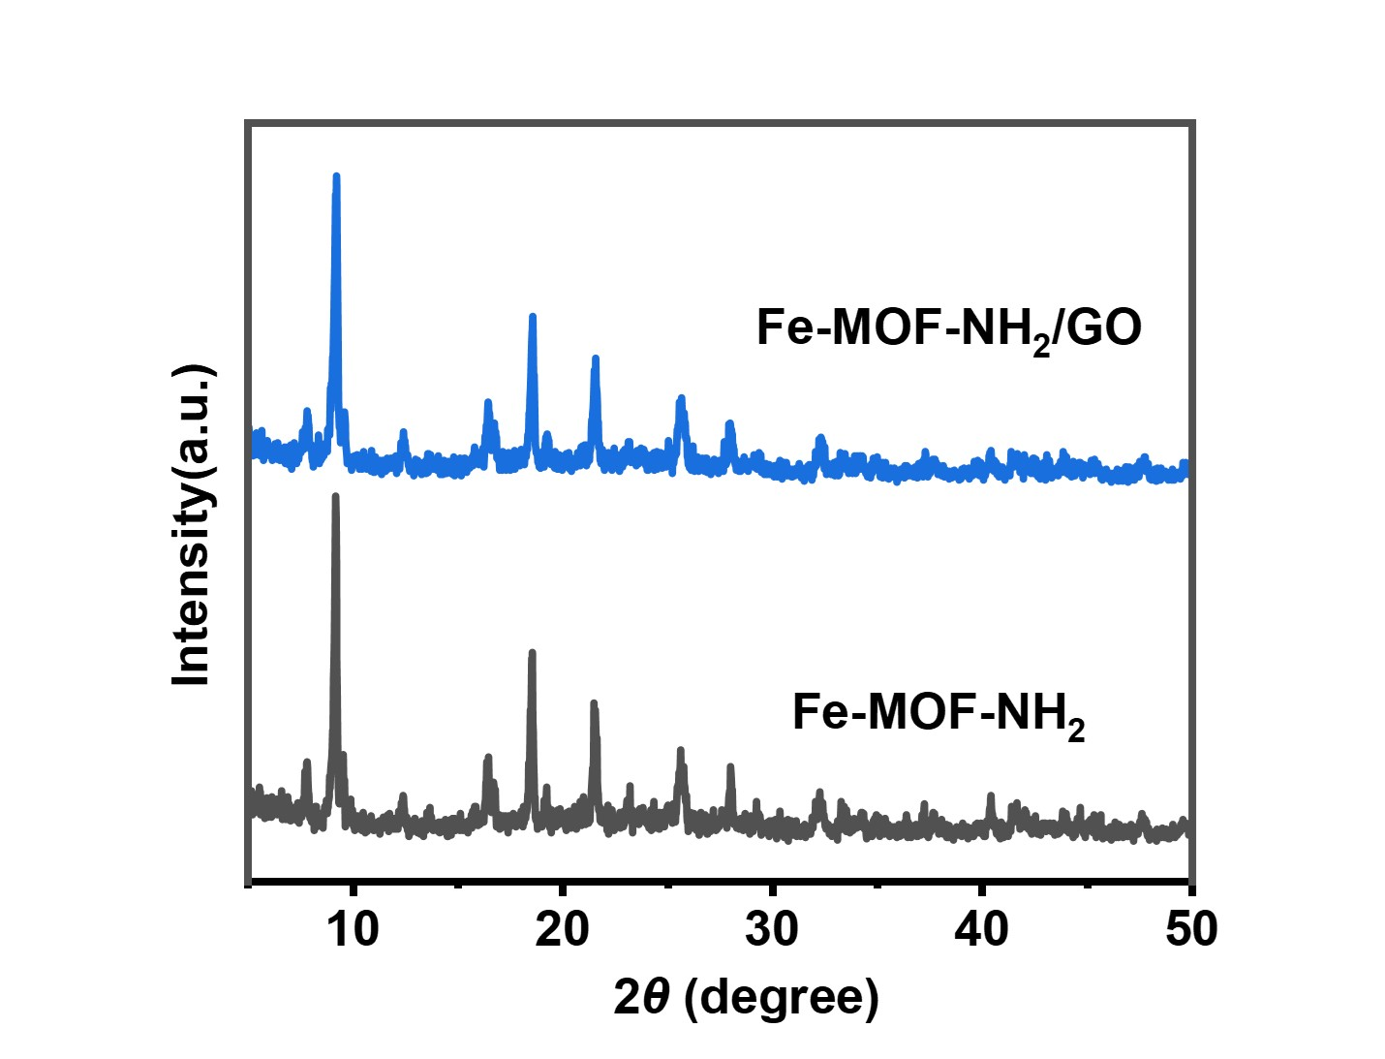
Figure S3. XRD patterns of as prepared Fe-MOF-NH₂, Fe-MOF-NH₂ /GO.

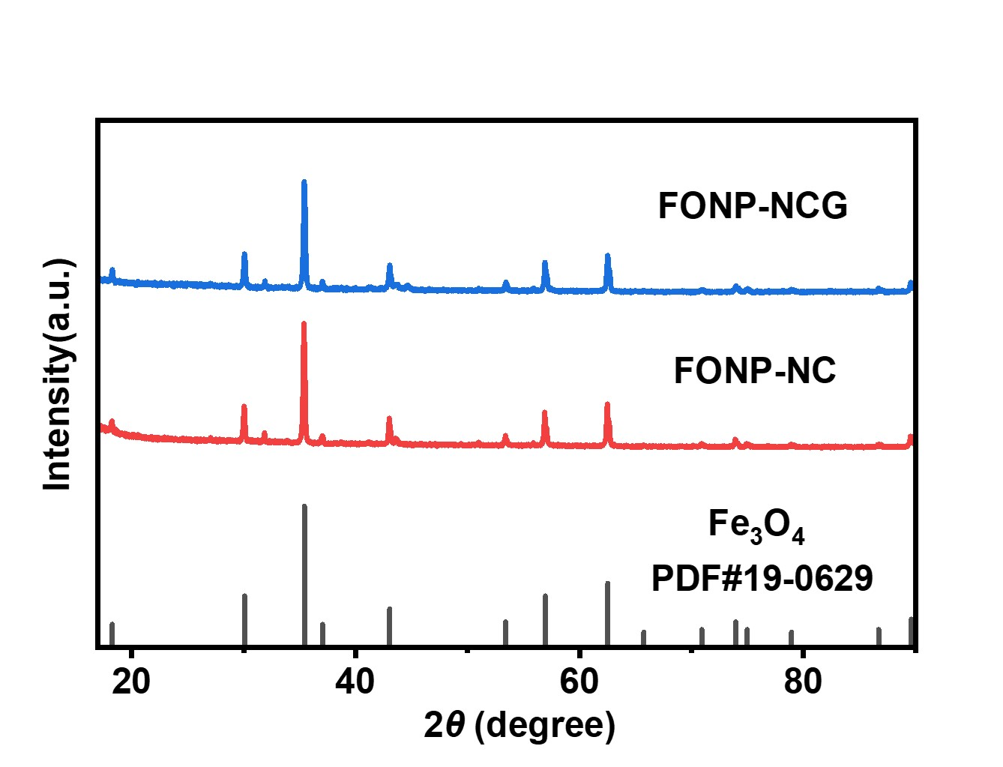
Figure S4. XRD patterns of as prepared FONP-NC and FONP-NCG.

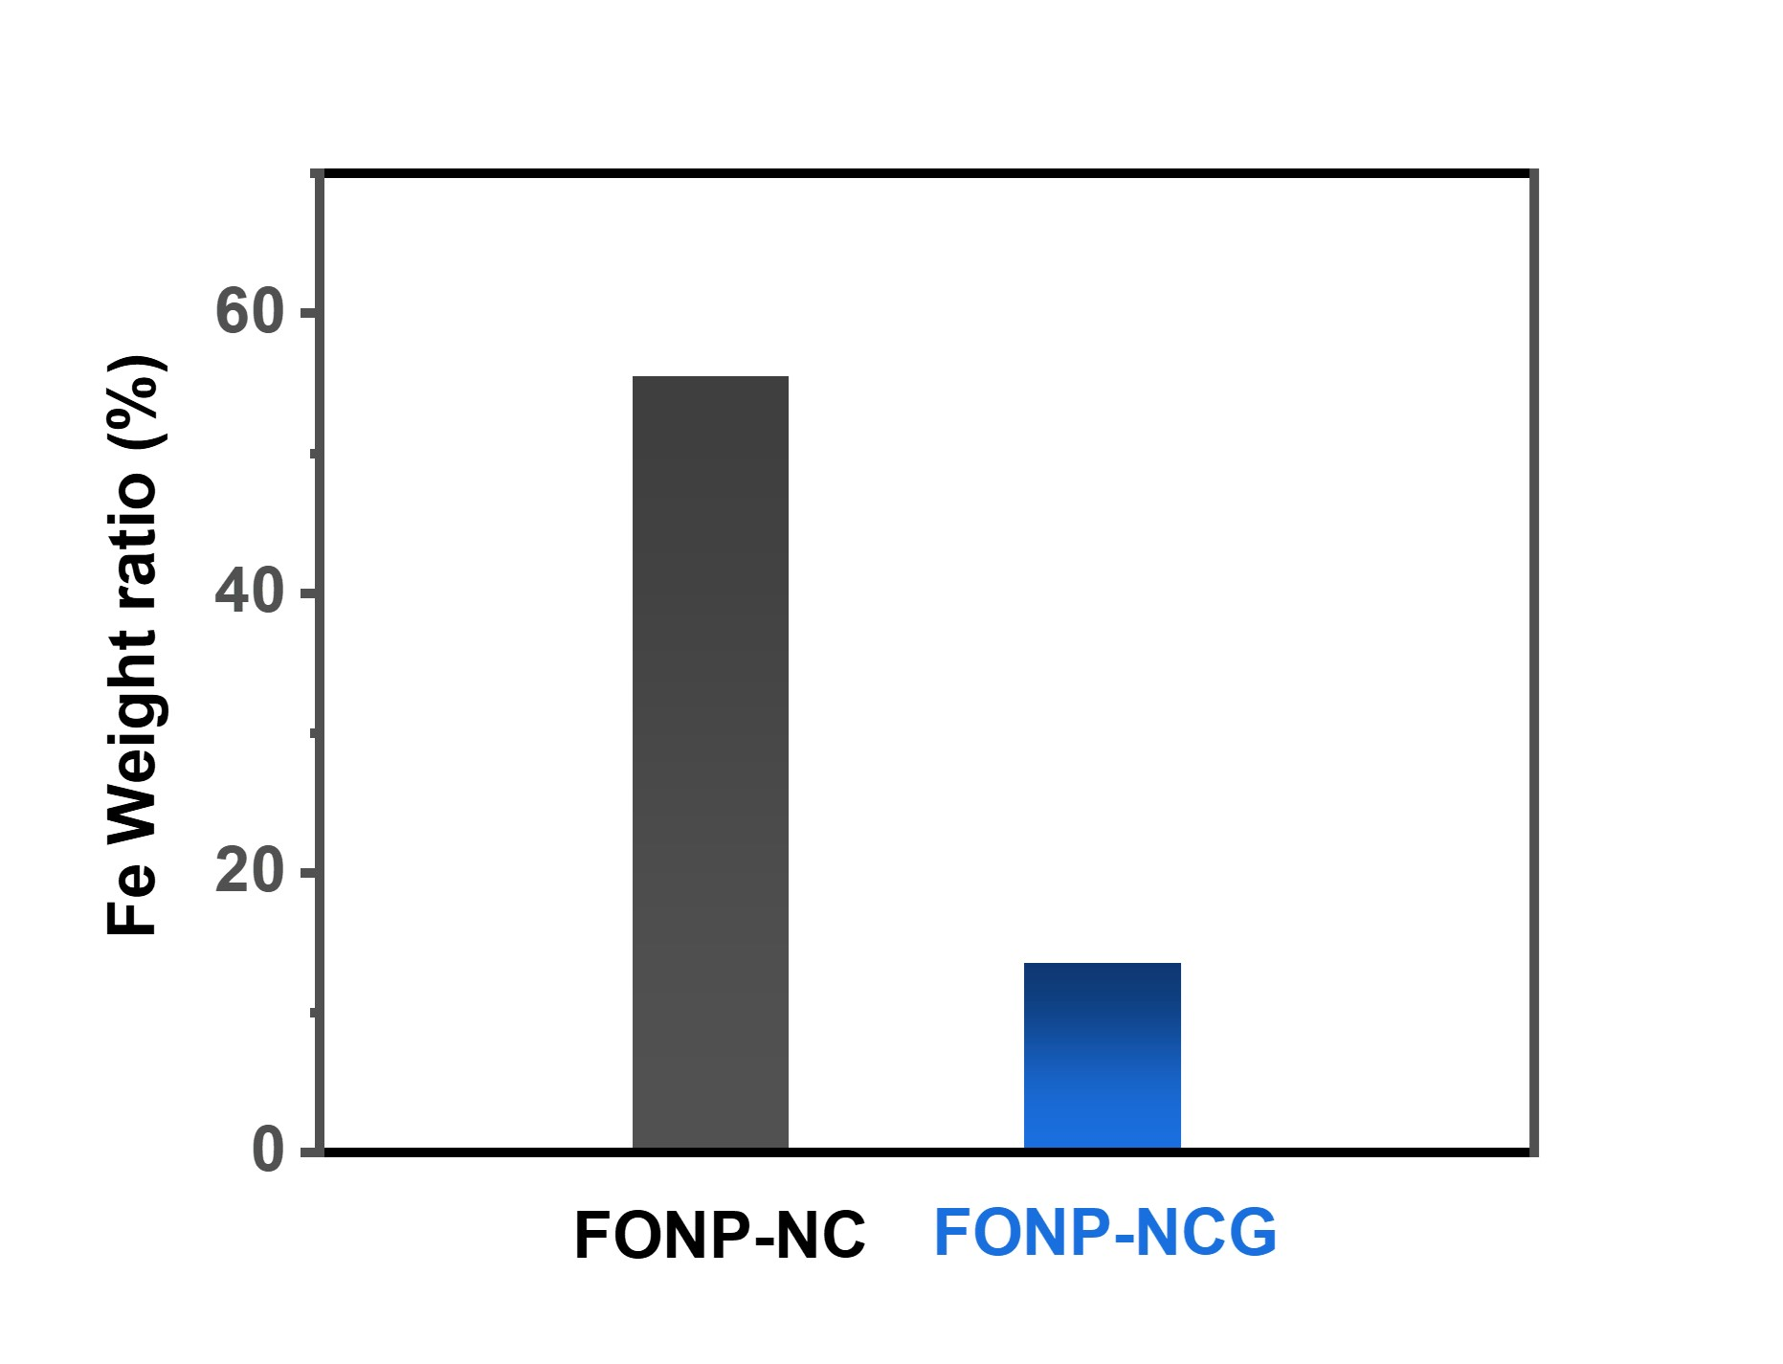
Figure S5. ICP results of Fe loading in FONP-NC and FONP-NCG.

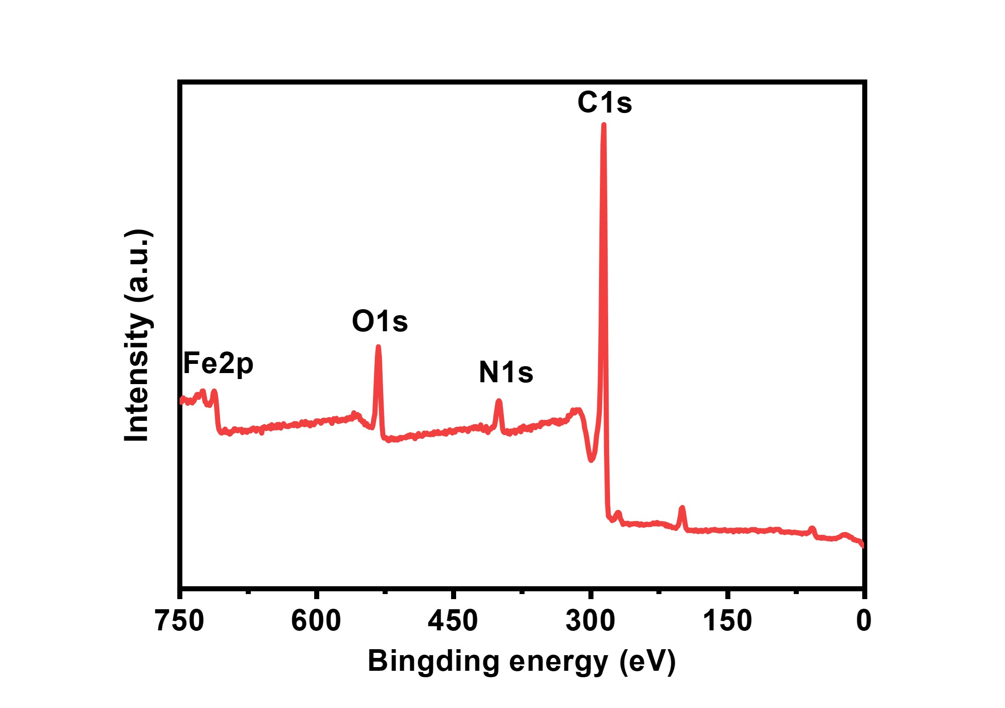
Figure S6. XPS survey spectrum of FONP-NCG.

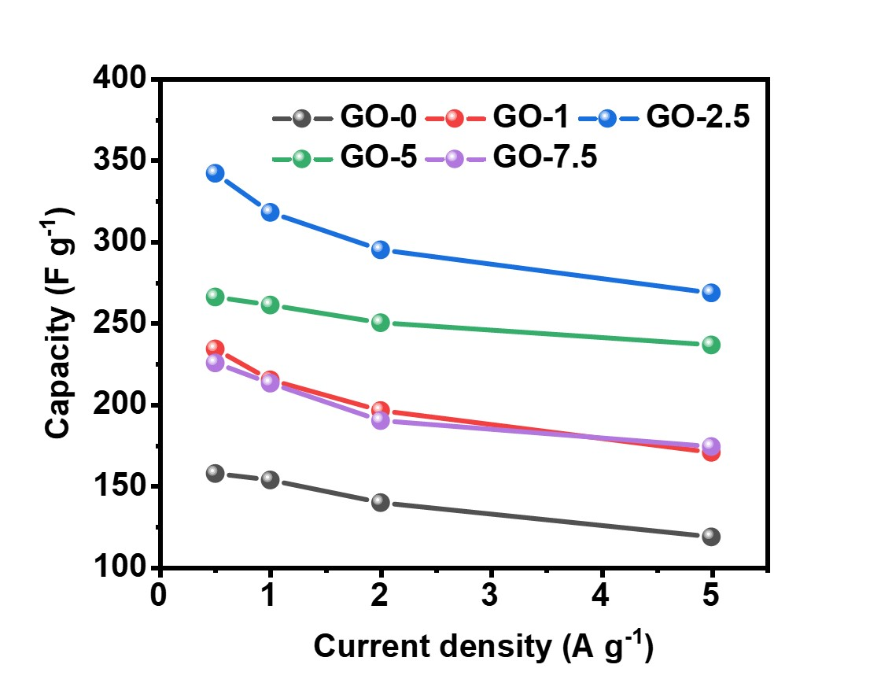
Figure S7. XPS survey spectrum of FONP-NCG with various addition of GO.

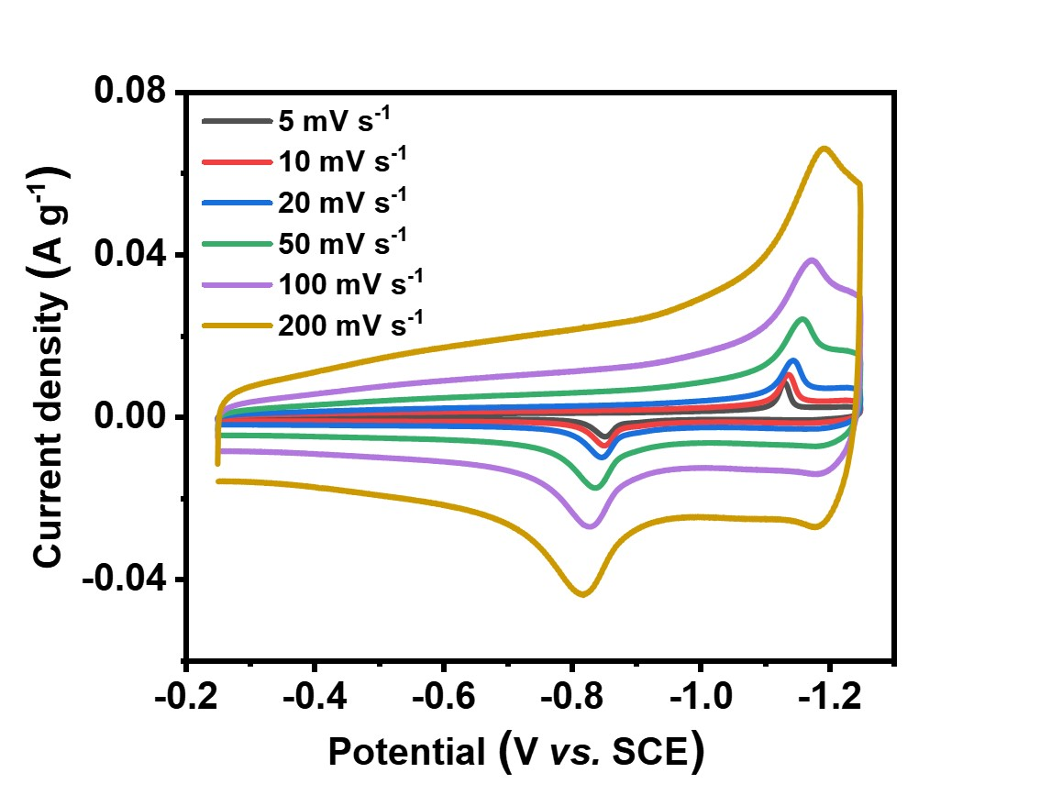
Figure S8. Representative CV curves of FONP-NCG at different scan rate.

