Appendix A: Interview Questions
- For Healthcare Providers:
What are the common barriers to diagnosing autism in ethnic minority children in your region?
  - How do cultural beliefs impact the willingness of families to seek medical help for autism?
  - What resources or support systems are currently available to assist in the diagnosis and treatment of autism in ethnic minority children?
  - How do you perceive the effectiveness of current training programs on autism care in your healthcare system?
  - What improvements do you think are necessary to better support ethnic minority children with autism?
- For Educators:
  - What challenges do you encounter in identifying and supporting children with autism in your classroom, particularly those from ethnic minority backgrounds?
  - How do cultural and linguistic differences affect the educational support provided to children with autism?
  - What strategies have been effective in helping children with autism integrate into mainstream education?
  - What additional training or resources would help you better support ethnic minority children with autism?
- For Families:
  - Can you describe your experience in seeking a diagnosis for your child with autism?
  - What challenges have you faced in accessing healthcare and educational services for your child?
  - How has your community responded to your child’s diagnosis of autism?
  - What types of support (medical, educational, social) have been most helpful for your family?
  - What changes would you like to see in the support systems available for children with autism in your community?
Appendix B: Summary of Key Findings
Theme | Country | Key Findings
Prevalence and Diagnosis | India | Low diagnosis rates in Adivasi children; misdiagnosis common due to cultural beliefs and limited resources.
 | Nigeria | Underreporting due to cultural beliefs attributing autism to spiritual causes; late diagnosis common.
 | Brazil | Afro-Brazilian children often diagnosed late; misdiagnosis and delays linked to discrimination and stigma.
Access to Healthcare | India | Significant barriers in rural and ethnic minority areas due to lack of awareness and healthcare infrastructure.
 | Nigeria | Limited specialized centres: financial constraints hinder access to diagnosis and treatment.
 | Brazil | Language barriers and discrimination in healthcare; limited support in the public healthcare system.
Cultural Perceptions | India | Autism often seen as a curse or punishment; reliance on traditional healers before seeking medical help.
 | Nigeria | Like India, strong cultural stigma associated with neurodevelopmental disorders.
 | Brazil | Increasing awareness, but significant stigma remains, particularly among Afro-Brazilian communities.
Societal Impact | All | Autism leads to social isolation, economic hardship, and long-term developmental challenges for affected children.
Education/Child Development | India, Nigeria, Brazil | Children with autism face significant barriers in education; lack of support exacerbates developmental issues.

Additional Visual Enhancements and Interactive Elements:
To further enhance the article for online publication or presentations, the following visual and interactive elements can be included:
- Infographics:
Figure 1 Global Prevalence of Autism: An infographic illustrating the disparities in autism prevalence between high-income and middle- and low-income countries. (Elsabbagh et al., 2022).
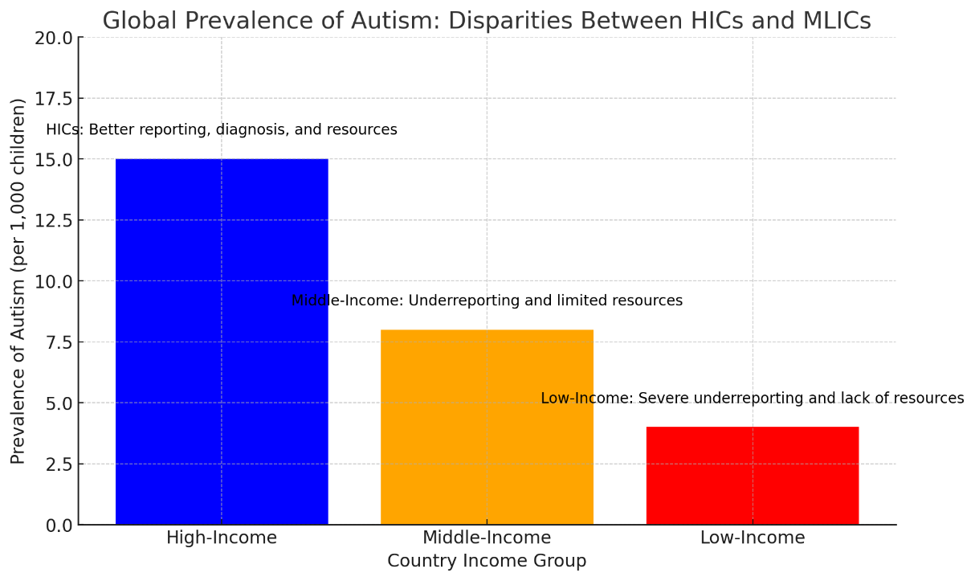
Figure 2: Methodological Gaps in Autism Research in MLICs:
(Tilahun et al., 2019).
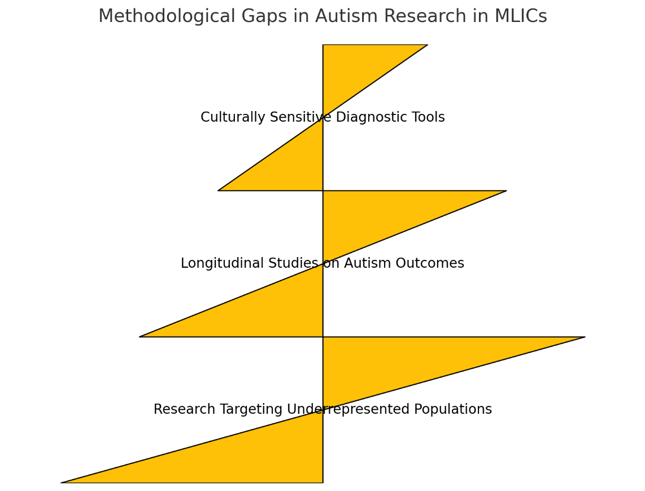

Figure 2 illustrates the prioritized areas of need, starting with "Culturally Sensitive Diagnostic Tools" at the base, followed by "Longitudinal Studies on Autism Outcomes," and "Research Targeting Underrepresented Populations" at the top. This visualization helps highlight the critical areas where research efforts should be concentrated to address the existing gaps in autism research in MLICs. ​
Figure 3: Intersectionality in Autism Care: A Venn diagram showing the intersection of ethnicity, gender, and socioeconomic status in affecting autism care. (Crenshaw,1989)

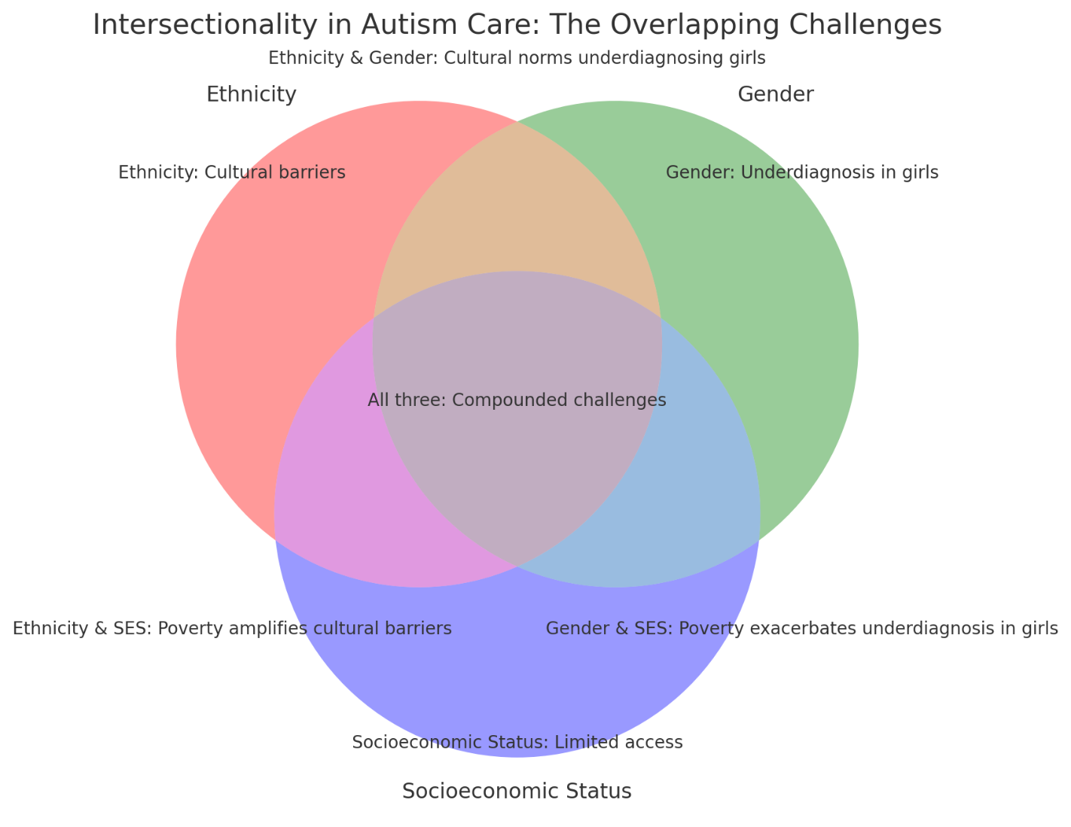
- Global Prevalence of Autism: The bar chart shows significant disparities in autism prevalence rates between high-income countries (HICs) and MLICs. The higher prevalence rates in HICs are attributed to better reporting mechanisms, advanced diagnostic tools, and greater healthcare resources, whereas MLICs struggle with underreporting and lack of resources, leading to lower documented prevalence rates despite potentially high actual cases.
- Intersectionality in Autism Care: The Venn diagram illustrates how ethnicity, gender, and socioeconomic status intersect to create compounded barriers to autism care. Children who fall within multiple marginalized groups face unique challenges such as cultural barriers, limited access to healthcare due to poverty, and gender-based underdiagnosis. This intersectionality exacerbates the difficulties in providing equitable autism care in MLICs
Future Research Directions:
Research Gaps: A visual representation (e.g., a pyramid or matrix) of the identified gaps in current research and the suggested areas for future studies, helping guide researchers in the field.
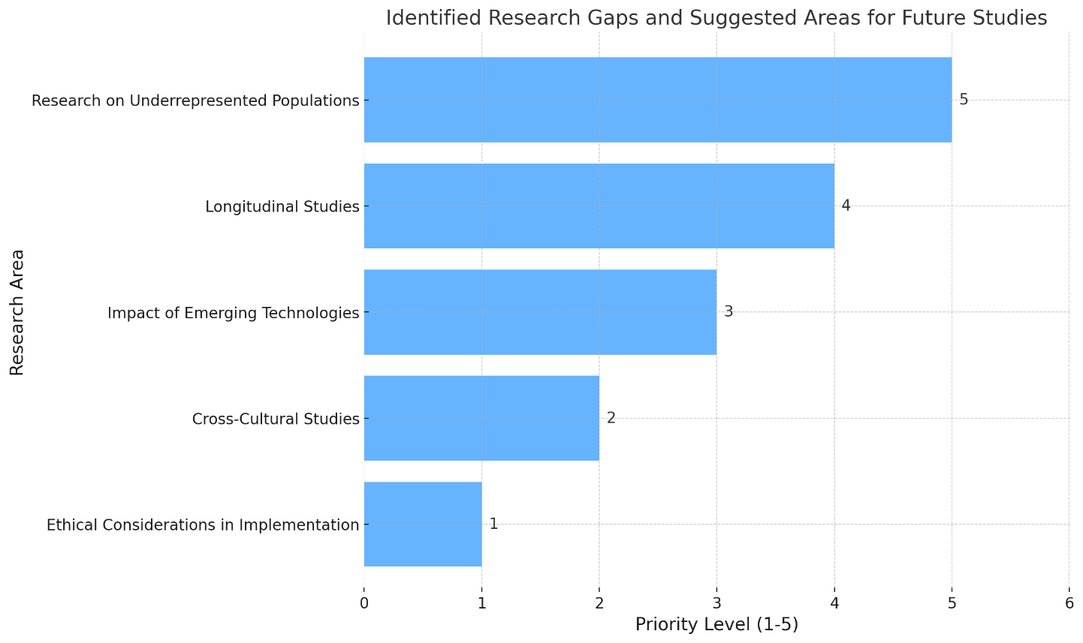
Here is a visual representation in the form of a pyramid chart that highlights the identified research gaps and suggests areas for future studies. The pyramid prioritizes research on underrepresented populations at the top, followed by the need for longitudinal studies, the impact of emerging technologies, cross-cultural studies, and finally, ethical considerations in implementation. Each level of the pyramid indicates the priority of the research area, guiding future researchers in the field.

Appendix C

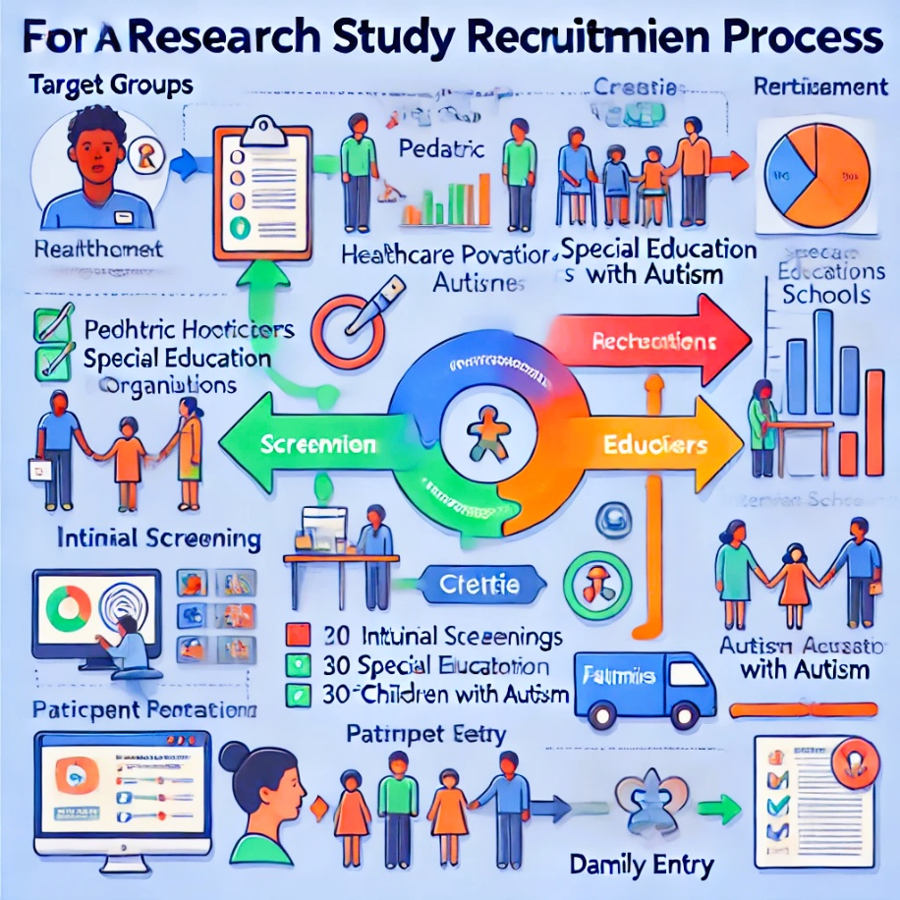

Appendix D Prisma Chart
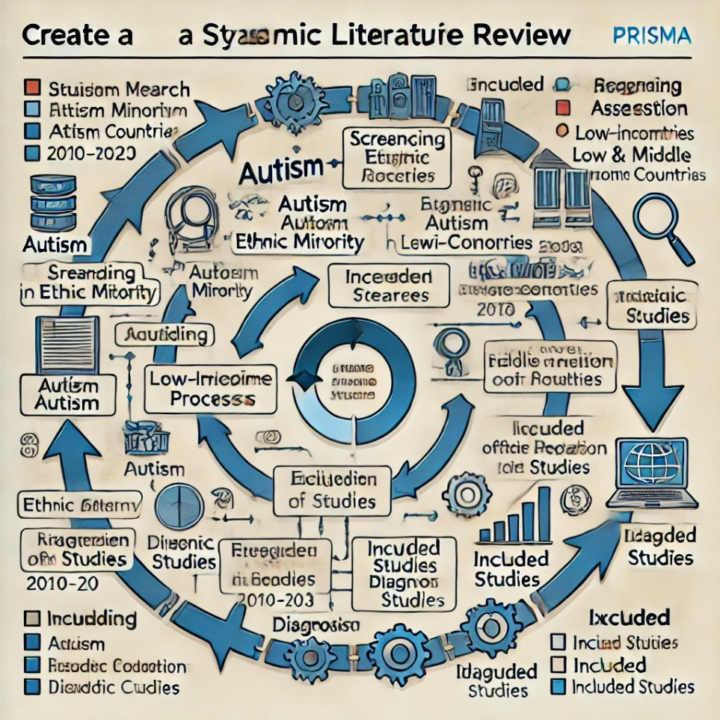

Appendix G: Data Privacy and Participant Anonymity Measures

Overview
This appendix details the rigorous measures implemented to protect data privacy and ensure participant anonymity throughout the study, complying with international standards and local regulations.

Data Collection Protocols
- Anonymized Data Collection:
  - All participant data were collected under assigned identification numbers.
  - Personal identifiers such as names, addresses, and contact information were stored separately from research data and encrypted.
- Secure Data Storage:
  - Electronic data were stored on a secure server with restricted access.
  - Physical documents were kept in locked cabinets in a secure facility.

Data Access and Sharing
- Limited Access:
  - Access to sensitive data was limited to authorized research personnel only.
  - A log of all data access instances was maintained for audit purposes.
- Data Sharing Protocols:
  - Data shared for analysis or publication were stripped of all identifiable information.
  - Sharing agreements explicitly prohibited the re-identification of participants and mandated secure data handling.

Consent and Confidentiality
- Informed Consent Process:
  - The consent form detailed the data privacy measures and participants' rights regarding data use.
  - Participants were informed of their right to withdraw from the study at any time without consequence.
- Confidentiality Assurance:
  - All research team members signed confidentiality agreements.
  - Periodic training on data privacy was provided to ensure awareness and compliance.

Technical Safeguards
- Encryption:
  - All digital data were encrypted using state-of-the-art encryption protocols.
  - Encrypted backups were created regularly to prevent data loss.
- Secure Data Transmission:
  - Data transmitted electronically were secured via encrypted connections (e.g., SSL/TLS).

Compliance and Monitoring
- Regulatory Compliance:
  - The study adhered to GDPR (if applicable) and other relevant local data protection regulations.
  - Regular compliance audits were conducted to ensure adherence to all legal and ethical standards.
- Continuous Monitoring:
  - The data protection officer regularly reviewed data handling and security procedures.
  - Anomalies or breaches were addressed immediately, with a protocol for mitigation and notification.

