The perfect storm: synergistic effects between climate change, El Niño and habitat, increase the epidemiological risk of Hantavirus in Patagonia

Supplementary Material 1

Trinidad Ruiz Barlett ª; Gabriel Martin ^{b}; Adrián Monjeau ª

ª Fundación Bariloche and CONICET, R8402AGP, San Carlos de Bariloche, Río Negro.
^{b}Centro de Investigación Esquel de Montaña y Estepa Patagónica (CIEMEP) CONICET – Universidad Nacional de la Patagonia, CP 9200, Esquel, Chubut.

This Supplementary material shows the evaluation statistics of the models, distribution models generated with the overlay of a digital elevation model (MDE), variable contribution of the models with variables from the year 1997 (Niño Strong) and the year 2007 (Niña Strong).

Table 1. Evaluation statistics of 24 models.

Candidate model | FEATURE | RM | AUC train | AUC diff.  avg | AUC  diff sd | AUC  val avg | AUC  val sd | or 10p avg | or 10p sd | or MTP avg | or MTP sd | AICc | delta AICc | ncoef
fc.H_rm.0.5 | H | 0.5 | 0.95 | 0.05 | 0.04 | 0.90 | 0.05 | 0.23 | 0.15 | 0.05 | 0.05 | 2.32E+19 | 5.29E+19 | 39
fc.H_rm.1 | H | 1 | 0.93 | 0.05 | 0.05 | 0.89 | 0.06 | 0.18 | 0.13 | 0.06 | 0.08 | 2.27E+19 | 2.18E+19 | 22
fc.H_rm.1.5 | H | 1.5 | 0.92 | 0.05 | 0.05 | 0.88 | 0.07 | 0.15 | 0.08 | 0.06 | 0.08 | 2.29E+19 | 2.11E+19 | 23
fc.H_rm.2 | H | 2 | 0.91 | 0.06 | 0.06 | 0.88 | 0.07 | 0.16 | 0.09 | 0.06 | 0.08 | 2.28E+19 | 1.24E+19 | 17
fc.H_rm.2.5 | H | 2.5 | 0.90 | 0.06 | 0.06 | 0.87 | 0.07 | 0.16 | 0.09 | 0.06 | 0.08 | 2.29E+18 | 2.29E+19 | 17
fc.H_rm.3 | H | 3 | 0.89 | 0.06 | 0.06 | 0.87 | 0.08 | 0.16 | 0.09 | 0.04 | 0.07 | 2.29E+19 | 2.02E+19 | 13
fc.L_rm.0.5 | L | 0.5 | 0.81 | 0.10 | 0.05 | 0.81 | 0.10 | 0.11 | 0.06 | 0.01 | 0.02 | 2.39E+19 | 1.21E+19 | 8
fc.L_rm.1 | L | 1 | 0.81 | 0.11 | 0.06 | 0.80 | 0.11 | 0.13 | 0.08 | 0.01 | 0.02 | 2.39E+19 | 1.21E+19 | 7
fc.L_rm.1.5 | L | 1.5 | 0.80 | 0.12 | 0.06 | 0.79 | 0.12 | 0.14 | 0.09 | 0.01 | 0.02 | 2.39E+19 | 1.24E+19 | 7
fc.L_rm.2 | L | 2 | 0.80 | 0.12 | 0.06 | 0.78 | 0.13 | 0.15 | 0.10 | 0.01 | 0.02 | 2.40E+19 | 1.29E+18 | 7
fc.L_rm.2.5 | L | 2.5 | 0.79 | 0.13 | 0.07 | 0.77 | 0.13 | 0.14 | 0.11 | 0.01 | 0.02 | 2.40E+19 | 1.33E+19 | 7
fc.L_rm.3 | L | 3 | 0.78 | 0.13 | 0.07 | 0.77 | 0.13 | 0.14 | 0.11 | 0.01 | 0.02 | 2.40E+17 | 1.36E+19 | 6
fc.LQ_rm.0.5 | LQ | 0.5 | 0.89 | 0.06 | 0.04 | 0.88 | 0.07 | 0.14 | 0.10 | 0.02 | 0.03 | 2.28E+18 | 1.27E+19 | 12
fc.LQ_rm.1 | LQ | 1 | 0.89 | 0.07 | 0.04 | 0.88 | 0.07 | 0.15 | 0.12 | 0.01 | 0.02 | 2.28E+19 | 1.14E+18 | 10
fc.LQ_rm.1.5 | LQ | 1.5 | 0.88 | 0.07 | 0.04 | 0.87 | 0.07 | 0.15 | 0.12 | 0.01 | 0.02 | 2.29E+18 | 2.01E+19 | 11
fc.LQ_rm.2 | LQ | 2 | 0.87 | 0.07 | 0.04 | 0.86 | 0.08 | 0.15 | 0.12 | 0.01 | 0.02 | 2.29E+19 | 2.45E+19 | 10
fc.LQ_rm.2.5 | LQ | 2.5 | 0.87 | 0.07 | 0.04 | 0.86 | 0.08 | 0.15 | 0.12 | 0.01 | 0.02 | 2.30E+17 | 2.86E+18 | 9
fc.LQ_rm.3 | LQ | 3 | 0.87 | 0.07 | 0.04 | 0.86 | 0.08 | 0.15 | 0.12 | 0.01 | 0.02 | 2.30E+19 | 3.47E+17 | 9
fc.LQH_rm.0.5 | LQH | 0.5 | 0.95 | 0.05 | 0.04 | 0.90 | 0.05 | 0.25 | 0.14 | 0.04 | 0.06 | 2.35E+18 | 8.12E+19 | 43
fc.LQH_rm.1 | LQH | 1 | 0.93 | 0.05 | 0.05 | 0.89 | 0.06 | 0.18 | 0.13 | 0.06 | 0.08 | 2.28E+19 | 1.10E+19 | 24
fc.LQH_rm.1.5 | LQH | 1.5 | 0.91 | 0.05 | 0.05 | 0.88 | 0.07 | 0.16 | 0.09 | 0.06 | 0.08 | 2.27E+19 | 0 | 17
fc.LQH_rm.2 | LQH | 2 | 0.90 | 0.06 | 0.06 | 0.87 | 0.07 | 0.17 | 0.11 | 0.07 | 0.07 | 2.27E+19 | 5.75E+19 | 16
fc.LQH_rm.2.5 | LQH | 2.5 | 0.89 | 0.06 | 0.06 | 0.87 | 0.08 | 0.17 | 0.11 | 0.06 | 0.07 | 2.28E+19 | 1.52E+19 | 16
fc.LQH_rm.3 | LQH | 3 | 0.89 | 0.06 | 0.06 | 0.86 | 0.08 | 0.17 | 0.11 | 0.06 | 0.07 | 2.29E+19 | 1.87E+16 | 14

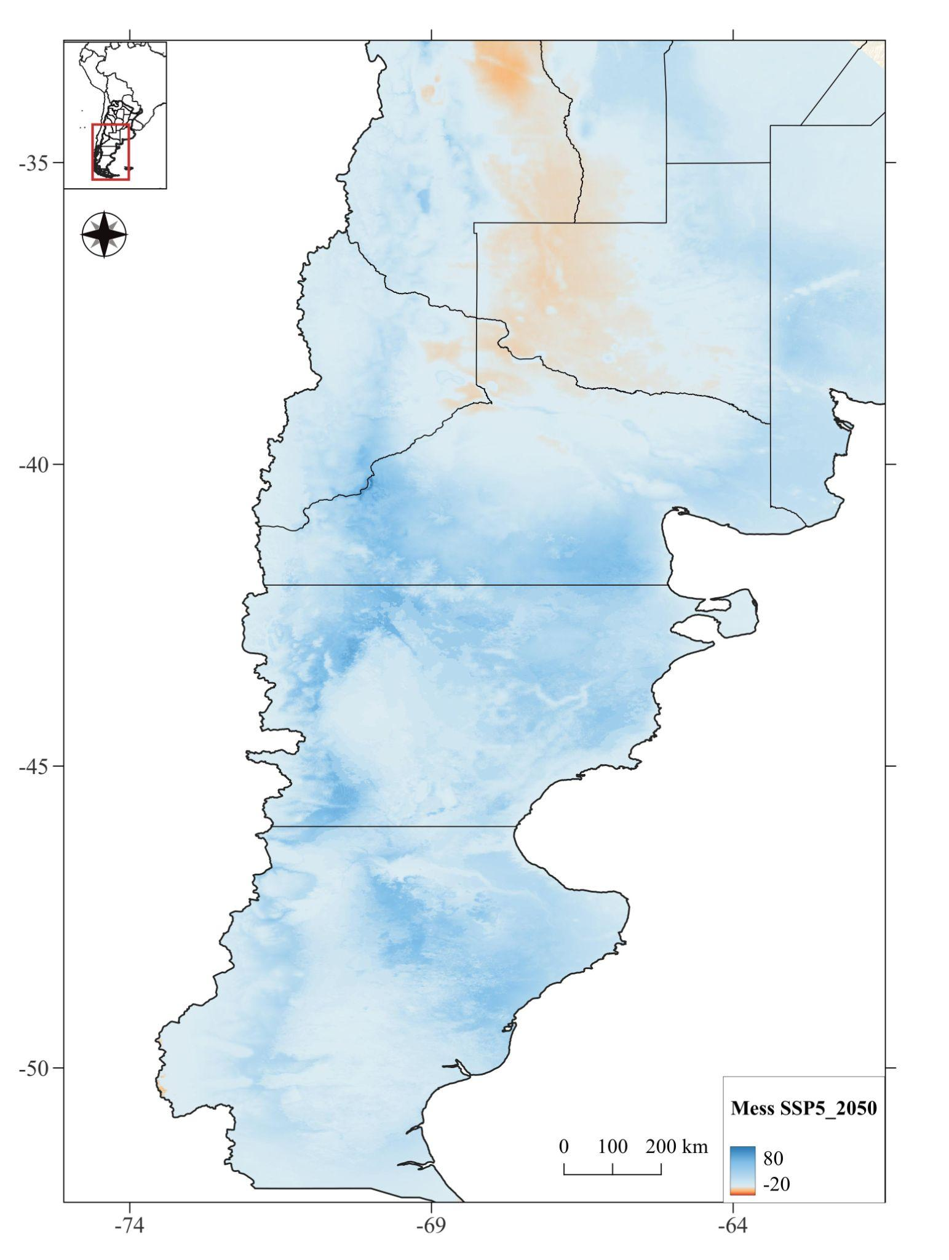
Figure 1 Calculate Environmental Similarity between high emission scenario (SSP5) and the period 1970-2000.

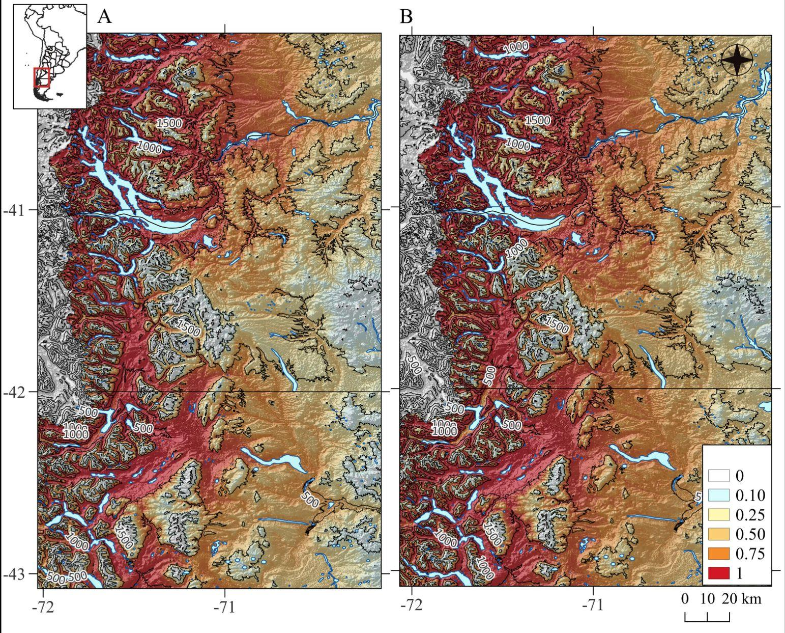
Figure 2 Extended areas of the distribution models generated with the overlay of a digital elevation model (MDE) and contour lines. A: 1970-2000 B: SSP5 2050.

Table 2
Environment variable contribution (%) and permutation values (P) for models with data from 1997 El Niño and 2007 La Niña.

Variable | 1997 (El Niño) |  |  | 2007 (La Niña)
 | %C | P |  | %C | P
Precipitation of the coldest month | 66.7 | 6.6 |  | 62.9 | 7.8
Maximum temperature of the warmest month | 16.4 | 60.6 |  | 22.4 | 56.4
Minimum temperature of the coldest month | 12.4 | 20.9 |  | 3.3 | 5.6
Minimum temperature of warmest month | 2.5 | 0.1 |  | 0.7 | 10.5
Maximum temperature of the coldest month | 1.6 | 10 |  | 3.6 | 11.8
Precipitation of the warmest month | 0.4 | 1.9 |  | 7.2 | 7.9

Table 3
Climatic records of El Bolsón and Bariloche, of the National Meteorological Service. Tmin: minimum temperature ​​in coldest month, ppc: precipitation in coldest month.

Site | Longitude, Latitude | Tmin July |  |  |  | ppc July
Site | Longitude, Latitude | 1997 |  | 2007 |  | 1997 |  | 2007
Bariloche (Rio Negro) | -71.17, -41.15 | -0,43 |  | -2,50 |  | 141,6 |  | 115,60
El Bolsón  (Chubut) | -71.52, -41.97 | 0,48 |  | -0,88 |  | 236 |  | 136,00

