The perfect storm: synergistic effects between climate change, El Niño and habitat, increase the epidemiological risk of Hantavirus in Patagonia

Supplementary material 2

Trinidad Ruiz Barlett ª; Gabriel Martin ^{b}; Adrián Monjeau ª
ª Fundación Bariloche and CONICET, R8402AGP, San Carlos de Bariloche, Río Negro.
^{b} Centro de Investigación Esquel de Montaña y Estepa Patagónica (CIEMEP) CONICET – Universidad Nacional de la Patagonia, CP 9200, Esquel, Chubut.

This Supplementary material shows records of hantavirus cases, and records of temperatures and precipitation from the meteorological stations of El Bolsón and Bariloche, of the National Meteorological Service.

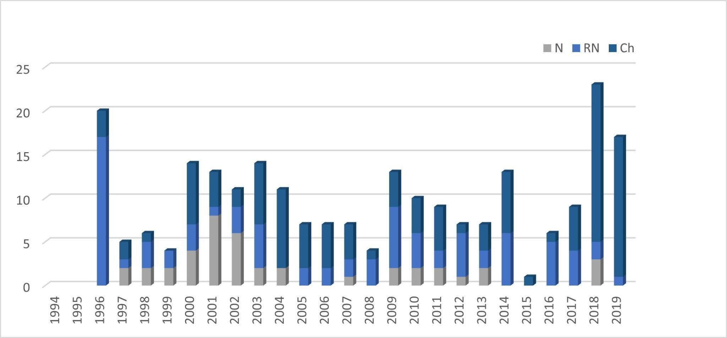

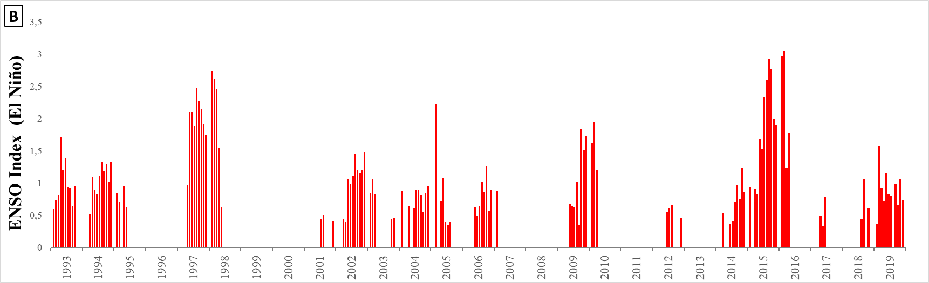
Fig. 1 A. Records of hantavirus cases. N: Neuquén, RN: Río Negro Ch: Chubut. B. Monthly values ​​of the ENSO index (only values ​​>0.4 are shown: indicates presence of El Niño)

Table 1 Records of hantavirus cases, and temperatures and precipitation from the meteorological stations of El Bolsón and Bariloche, of the National Meteorological Service.

Year | ENSO Index |  | Flowering of colihue bamboo/ ratada | Hantavirus cases |  |  |  | Bariloche |  | El Bolsón
Year |  |  | Flowering of colihue bamboo/ ratada | N | RN | Ch | Total | An. Tmin | Ppt. annual | An. Tmin | Ppt. annual
1993 | 0.86 | Niño |  |  |  |  |  | -0.3 | 1208.60 | -0.26 | 945.00
1994 | 0.89 | Niño |  |  |  |  |  | 0.28 | 1042.70 | 0.50 | 1025.20
1995 | 0.22 | Niño |  |  |  |  |  | -0.47 | 848.50 | -0.46 | 857.20
1996 | -0.41 | Niña | 1st fatal case of hantavirus and outbreak in El Bolsón. Identification of the new type of hantavirus: Andes. Interhuman transmission | 0 | 17 | 3 | 20 | 0.15 | 532.30 | -0.27 | 689.80
1997 | 1.42 | Niño (strong) | Ratada in Villa La Angostura (Neuquén) and in Llao Llao (Río Negro). There was no flowering of colihue bamboo. | 2 | 1 | 2 | 5 | 0.68 | 972.10 | 0.19 | 1177.10
1998 | 0.07 | Niño | Presence rodents, maximum annual records occurred at the beginning of summer. | 2 | 3 | 1 | 6 | 0.12 | 407.90 | 0.08 | 475.00
1999 | -1.06 | Niña (strong) |  | 2 | 2 | 0 | 4 | 0.22 | 735.00 | 0.09 | 649.60
2000 | -0.87 | Niña | Flowering in spring and Ratada in Lanín NP. | 4 | 3 | 7 | 14 | -0.09 | 1089.90 | -0.15 | 1148.60
2001 | -0.09 |  | Flowering and ratada in Paraje El Contra, Lanín NP, Río Manso. | 8 | 1 | 4 | 13 | -0.09 | 927.10 | -0.02 | 840.40
2002 | 0.84 | Niño |  | 6 | 3 | 2 | 11 | 0.13 | 1039.50 | 0.49 | 1238.60
2003 | 0.4 | Niño |  | 2 | 5 | 7 | 14 | -0.12 | 777.80 | -0.06 | 960.30
2004 | 0.54 | Niño |  | 2 | 0 | 9 | 11 | 0.57 | 895.30 | 0.61 | 1067.80
2005 | 0.41 | Niño |  | 0 | 2 | 5 | 7 | -0.27 | 875.80 | -0.13 | 1208.60
2006 | 0.29 | Niño |  | 0 | 2 | 5 | 7 | -0.37 | 1018.90 | -0.24 | 1338.80
2007 | -0.28 | Niña (strong) |  | 1 | 2 | 4 | 7 | -0.96 | 514.60 | -1.14 | 657.90
2008 | -0.92 | Niña (strong) |  | 0 | 3 | 1 | 4 | 0.44 | 970.30 | 0.03 | 988.30
2009 | 0.36 | Niño |  | 2 | 7 | 4 | 13 | -0.64 | 1043.10 | -0.36 | 1098.40
2010 | -0.94 | Niña/ Niño | Flowering in Andean zone of Rio Negro, El Manso and Chubut, ratada in winter. | 2 | 4 | 4 | 10 | -0.65 | 699.20 | -0.28 | 796.10
2011 | -1.5 | Niña | Flowering in Nahuel Huapi NP, ratada in Rio Manso. Lago Puelo NP and Chubut. Eruption of the Puyehue-Cordón Caulle volcano. | 2 | 2 | 5 | 9 | -0.02 | 586.10 | 0.16 | 755.10
2012 | -0.04 |  | Flowering in Lanin NP, there was no ratada. | 1 | 5 | 1 | 7 | 0.41 | 741.70 | 0.13 | 878.30
2013 | -0.4 | La Niña | Flowering in Chubut and north of Neuquén. Ratada in Chubut (Los Alerces NP and zone). | 2 | 2 | 3 | 7 | 0.17 | 801.40 | 0.29 | 874.50
2014 | 0.35 | Niño | Flowering in SW of Neuquén, there was no ratada. | 0 | 6 | 7 | 13 | 0.14 | 826.50 | -0.23 | 846.10
2015 | 1.71 | Niño (strong) |  | 0 | 0 | 1 | 1 | 0.14 | 861.00 | 0.66 | 790.40
2016 | 0.43 | Niño (strong)Niña |  | 0 | 5 | 1 | 6 | 0.17 | 574.80 | 0.21 | 574.30
2017 | -0.23 | Niño/ Niña |  | 0 | 4 | 5 | 9 | 0.25 | 706.90 | 0.44 | 971.60
2018 | -0.07 | Niña/ Niño | 1st case HPS in Epuyén and outbreak (El Maitén, El Hoyo, Cholila, Esquel, Lago Puelo and Trevelin). Spring: massive flowering and ratada south of Neuquén, from Lago Villarino to Villa la Angostura (without cases of HPS). | 3 | 2 | 18 | 23 | -0.15 | 783.60 | -0.02 | 995.80
2019 | 0.84 | Niño |  | 0 | 1 | 16 | 17 | -0.1 | 680.80 | -0.22 | 813.60
Total |  |  |  | 41 | 82 | 115 | 238

References: Herrero 2013; Jaksic and Lima 2003; Nuñez 2017; National Meteorological Service; Instituto Nacional de Enfermedades Infecciosas Agudas (Administración Nacional de Laboratorios e Institutos de Salud).
N: Neuquén, RN: Río Negro, Ch: Chubut. Ppt.: precipitation, Tmin: minimum temperature, An: anomaly (difference from the average from 1993 to 2020). NP: National Park.

Fig 2. Records of mean and minimum annual temperatures from the meteorological stations of El Bolsón (Chubut) and Bariloche (Río Negro) of the National Meteorological Service.

- Mean and minimum temperature from El Bolsón. Tme: mean temperature, Tmin: minimum temperature, dotted line: tendency line.

- Precipitation anomaly from El Bolsón.

- Mean and minimum temperature from Bariloche. Tme: mean temperature, Tmin: minimum temperature, dotted line: tendency line.

- Precipitation anomaly from Bariloche.

